Session 1
1.
Home tab | Used for formatting cells, changing fonts, alignment, copying/pasting, and basic editing.
Insert tab | Used to insert tables, charts, pictures, PivotTables, shapes, etc.
Data tab | Used for sorting, filtering, removing duplicates, data validation, and other data-management tasks.
Quick access toolbars Save - saves the current workbook. Undo - reverses the last action.

2.
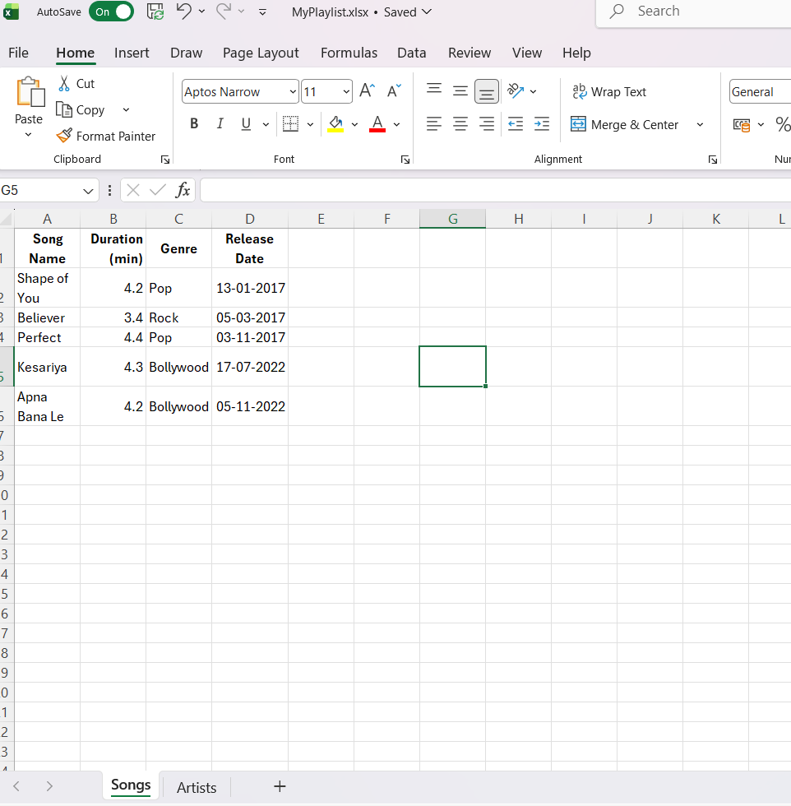
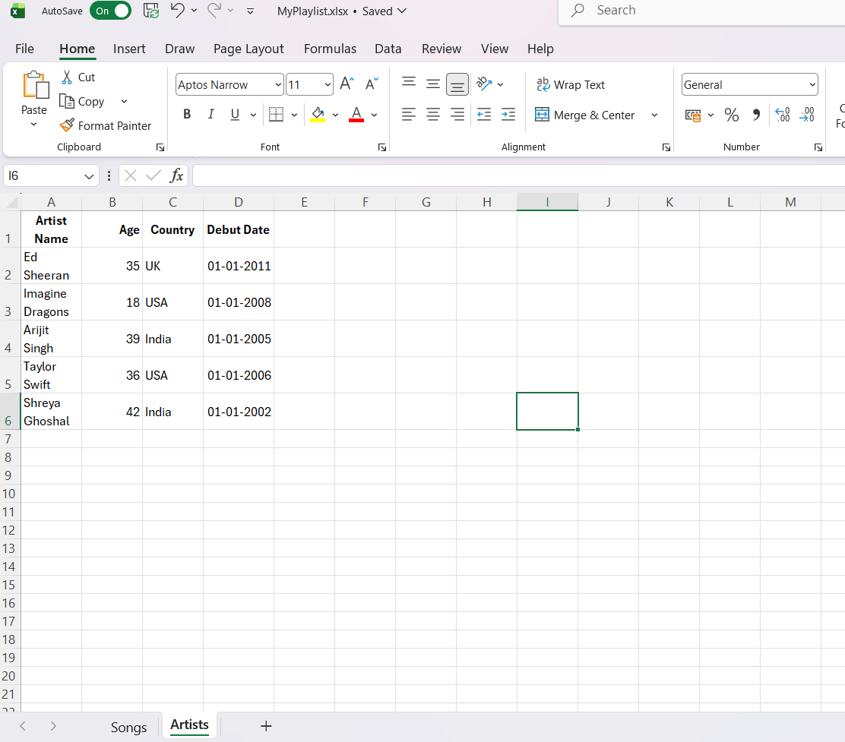

4.
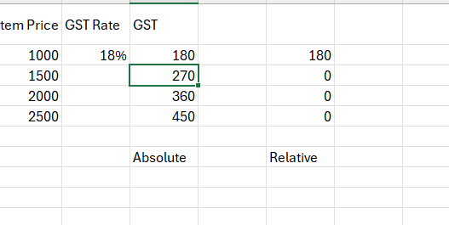
3.
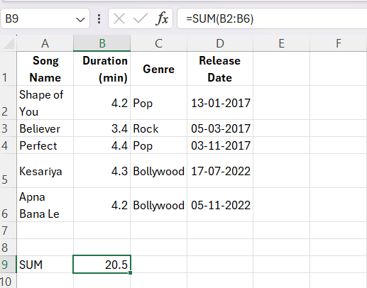

5.
