

##### Palestine Technical University – Kadoorie College of Engineering and Technology Department of Computer Systems Engineering

##### Project title:

# Software Requirements Specification document (SRS)

##### for "Online movie ticket booking system"

##### By:

##### Deema Theeb - 202112898 Leen Foqha - 202010352

##### Shahd Orr - 202010310

##### Supervisor:

##### Dr.Osama Hamed

##### Dr. Nael Salman

#### Tulkarm, Palestine 9 April 2024

SOFTWARE REQUIREMENTS SPECIFICATION DOCUMENT (SRS) 1

1. INTRODUCTION 3
   1. PURPOSE
   2. DOCUMENT CONVENTIONS
   3. INTENDED AUDIENCE AND READING SUGGESTIONS
   4. PROJECT SCOPE
   5. PRODUCT FEATURES

# INTRODUCTION

## PURPOSE

The purpose of this document is to build an online system to manage the process of booking tickets to watch movies in the cinema and dealing with customers to facilitate this process.

## DOCUMENT CONVENTIONS

This document uses the following conventions.

|  |  |
| --- | --- |
| DB | Database |
| ER | Entity Relationship |

## INTENDED AUDIENCE AND READING SUGGESTIONS

This project is a prototype of a cinema ticketing system and was implemented under the guidance of our Software Engineering Dr. This project is useful for the cinema management team, the employees within it, as well as the customers.

## PROJECT SCOPE

The purpose of the online ticket reservation system is to ease the process of booking tickets and to create a convenient and easy-to-use application for customers who want to buy movie tickets. The system relies on a relational database in which all cinema records, information and details of films and reservations are kept, with the functions of managing movie shows, reservations and advance payment. We will have a cinema website that displays many movies at multiple times and The website for the cinema helps to spread it more widely among people and thus increase its customers, as it is considered a marketing method for it and Increasing arrangement inside the cinema, so that each person attends the cinema at the showtime that he booked through the website only. The most important goal of the project is to provide a comfortable ticketing experience for users.

* 1. **PRODUCT FEATURES**

the major features of the cinema database system as shown in below **entity–relationship model (ER model)**

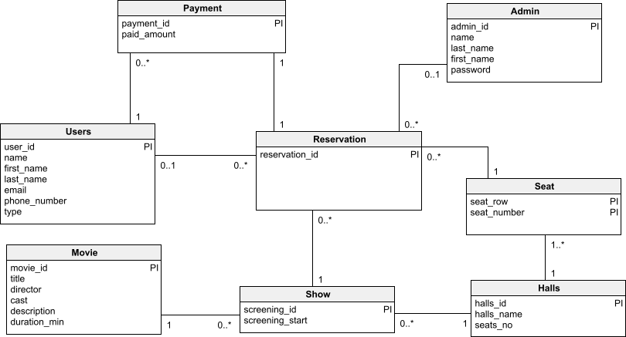

* 1. *ER model*

The diagram shows the layout of cinema database system – entity–relationship mode.