Project Scop

What is Scope Management?

* The process to define all the work required and ONLY the work required.

• Its concerned with defining & controlling what is in and what is not in the project.

• Includes constantly checking to make sure you are completing all the work.

• Involves not letting people randomly add to the scope of the project with out a structured change control system.

• Making sure any changes fit to the charter

• Prevents Gold Plating.

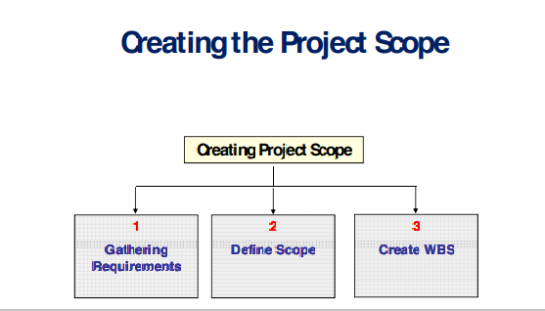

Gathering Requirements ( 1 )

Talk to Stakeholders to define and document their needs about the project objectives.

The project’s success is directly influenced by the care taken in capturing and managing project and product requirements;

– Requirements include:

quantified The تحدید مقدار الشئ

• The documented needs

• Expectation of the sponsor, customer, and other stakeholders

Requirements need to be:

Elicited إستنباط / إستنتاج

• Analyzed

• Recorded in enough detail

• Measurable

– Requirements become the foundation of the Scope / WBS.

– Cost, Schedule, and quality planning are all built upon requirements.

Gathering Requirements ( 2 )

The requirements documentation usually includes all of the following information:

– Business need to solve or the opportunity the project will seize

– Project objectives and goals that can be traced to the requirements

– Functional requirements of the project deliverable, such as features and functions of the thing or condition the project will create

– Nonfunctional requirements of the project deliverable, such as the level of service, performance objectives, security, interoperability, and support

– Quality requirements

– Factors for project acceptance / Completion Criteria

– Effect of the deliverable on the organization, departments, or lines of business

– Effect of the deliverable on entities outside of the organization

– Need for education, training, and ongoing stakeholder competency support

– Identified assumptions and constraints

Gathering Requirements: Tools ( 1)

Interviews

An interview is a formal or informal approach to discover information from stakeholders by talking to them directly, “one-to-one”, and recording their responses.

• Focus groups

Bring together prequalified stakeholders and subject matter expert to learn about their expectations and attitudes about a proposed product, service, or result. A trained moderator guides the group through an interactive discussion.

• Facilitated Workshops

It’s a focused sessions workshop that bring key cross -functional stakeholders together to define product requirement. Workshops are considered a primary technique for quickly defining cross - functional requirement and reconciling stakeholder differences. Good examples for the facilitated Workshops are;

• Joint Application Development/Design (JAD) used in the SW Dev. industry

• Quality Function Deployment (QFD) - known as Voice of Customer (VOC), used in manufacturing industry to determine critical characteristics for new product development process.

Gathering Requirements: Tools (2)

• Questionnaires and Surveys

– Most appropriate with broad audiences, when quick turnaround is needed, and where statistical analysis is appropriate.

• Observations “Job shadowing”

– A direct way of viewing individuals in their environment and how they perform their jobs or tasks and carry out processes.

• Prototypes

– A method of obtaining early feedback on requirements by providing a working model of the expected product before actually building/developing it.

– Since prototypes are tangible, so the model of the final product can be experimented, not only discuss abstract representation

– Since prototypes are tangible, so the model of the final product can be experimented, not only discuss abstract representation.

Define Scope

• Define scope is the process of developing a detailed description of the project and product (Project Scope Statement) as the basis for future project decisions

• Preparation of a detailed project scope statement is critical to the success of the project and builds on the major deliverables, assumptions, and constraints documented during project initiation

• During planning, the project scope is defined and described with greater specificity as more information about the project is known.

• During planning, existing risks, assumptions, and constraints are analyzed for completeness; additional risks, assumptions, and constraints are added as necessary