**Project management program**

" Team members: "

1. عبدالرحمن دسوقي عبده عبدالمنعم
2. عبدالرحمن حامد احمد
3. عائشه حسن شحاته
4. صابرين عصام عبدالمنعم
5. شهد نادي محمد
6. شيماء مرسي حمدي

Group : 1

Section : 8

The project name: “Bankak”

**Application Design**

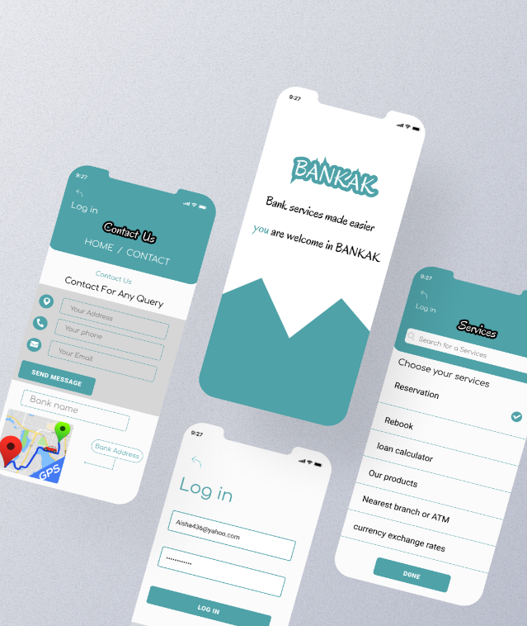

**"Charter part"**

1. Official project name ....(Bankak).

2. Project sponsor and its contact information ...

*Ministry of Finance via offcial page of ministry of finance of the republic of Egypt on Facebook Or going to their branch in Cairo

3. Project manager and its contact information.......

*Online via the official Facebook page ISG company

4. **Purpose of the project:**

*The ability to reserve the role of the customer at the branch, thus saving the customer time and speed in obtaining banking services in the event of going to the branch, and customers can do all their banking transactions online

5."Business Case For The Project:"

*Despite the warning of Corona, overcrowding and congestion in front of banks, at this time, which is the era of Corona, we need this site (application) mainly. Also, because of the number of customers and banking transactions and the demand for services and investments, this is making banks crowded.

6."Key Deliverables of The Project:"

*The project saves time and effort for customers and employees and provides you with a service that is the ease of dealing with any bank and also the speed in ending any service or problem specific to the bank And through this website or (application) you can communicate with one of the employees to solve your problem automatically.

7.."General statement About How The Team Will Approach The work :"

*Teamwork represents a success skill, and requires focus, clarity, codification, objectivity, avoidance of individuality and communication, and aims to develop and solve problems by examining the problem, planning treatment, studying the problem and group discussion. The skills of success at work include the skills of dealing and communicating with others, establishing good human relations, and the ability to work as part of a team. This ability has become an urgent need to meet the requirements of the world of work. Cooperation between people (individuals and groups) and working with them has become a necessity of life. Whether you use direct or indirect communication skills.

8"Baisc Timeline of When The Project Milestones Will be Reached:"

*In the first two weeks, an engineer will collect information about banks

-In the third week, the engineers present the idea to all the banks, and we will know which of them has the right to benefit from this idea.

-For two weeks, a team of programmers will work

Mobile application

-The project is under test for a week

*9. Project resources:*

1_ programming team

2_ Communicate with all banks.

3_ Budget 30000$

*Staff:*

*A team of engineers & A team of programmers.

Vendor: Marketing companies, and internet markets (like Amazon, and Google play)

10. The summary budget: 79000$

* includes :(servers, project licenses, developers, designers, training)

11. Assumptions:

1_ Reduce crowding in banks.

2_ The success of the project.

3_ Save some time for customers.

12. Risks:

1_ Unavailability of internet for our customers.

2_ This project will not be good for people who do not have mobile phones or modern devices, because they will not be able to use the application.

3_ Network downtime. 4_ Some banks do not support the idea of the application.

*******

**" scope part"**

1. Product Scope Description:

*The application has many advantages, including saving time, effort and speed in obtaining services wherever you are and preventing congestion.

The application provides many services ,including a customer's role or inquire about an order in the bank or deposit or withdrawn money and can use its bank account ,credit card management ,deposits ,loans and conversion between customer accounts within the bank and conversion to the other accounts within the bank.

Each user has its own profile contains its full data from them, name, address, national number and account number.

The user can create a new account or log in the account or change its password and can log off the account.

How to create a new account…….

Press creat a new account

Enter your account number or number of your bank card

Then enter the sender's confirmation code on your phone

Approval of terms and conditions and establishes the user name and password

To visit the branch…….

Enter your phone number and enter the sender's confirmation code on your phone

and choose the branch you want to visit and choose time and right history and press confirmation..

you can change the appointment by pressing the responable button.

2. Product Acceptance Criteria:

*Must be using an account with a national number

*3.Project constraints*

▪︎Time

When starting a project, there will be deadlines that will be proposed by the project sponsor.

▪︎project resources

tools, equipment, and scheduling software that will be used are all project resources and project constraints .

▪︎Cost

You need to complete this project with a 79000$ budget and we must complete the project under this budget .

▪︎Quality

Quality comes with cost. If there will be strict quality requirements in a project, this will affect the cost project constraint directly.

▪︎scope

Project scope defines what needs to be completed in a project, therefore it is a very important project constraint .

▪︎Customer Satisfaction

customer satisfaction is a crucial project constraint.

4.Project exclusions

*Everything not specifically documented as in scope is explicitly out of scope as we can't  control the existence of ads in app

New tasks Addition to the project by manager.

**5. project Deliverables**

*deliverable is like reaching a river and building a bridge to cross it. You will have identified that the project path would need to cross several key points and had agreed with the client that when each of these was complete, you would provide it to them.

We have to :

1. Improve process efficiency
2. Improve response procedure.
3. Faster response time
4. Better customer service
5. Finances

(Funding for licenses will be provided by various departments as needed)

6.Assumptions:

*Project assumptions are those things you assume to be true for your project to be successful..

•The supplier will deliver consumables on time.

•All relevant stakeholders will come to the next meeting.

•All equipment is in good condition.

***Assumption log number :***

*for ease of tracking and discussing*

*▪︎Initial date logged .*

* *Name/description of the assumption*
* *Owner who takes responsibility for following up*
* *Due Date: date to validate*
* *Status: Open or closed*
* *Actions/Comments: Action needed or taken.*

**WPS**

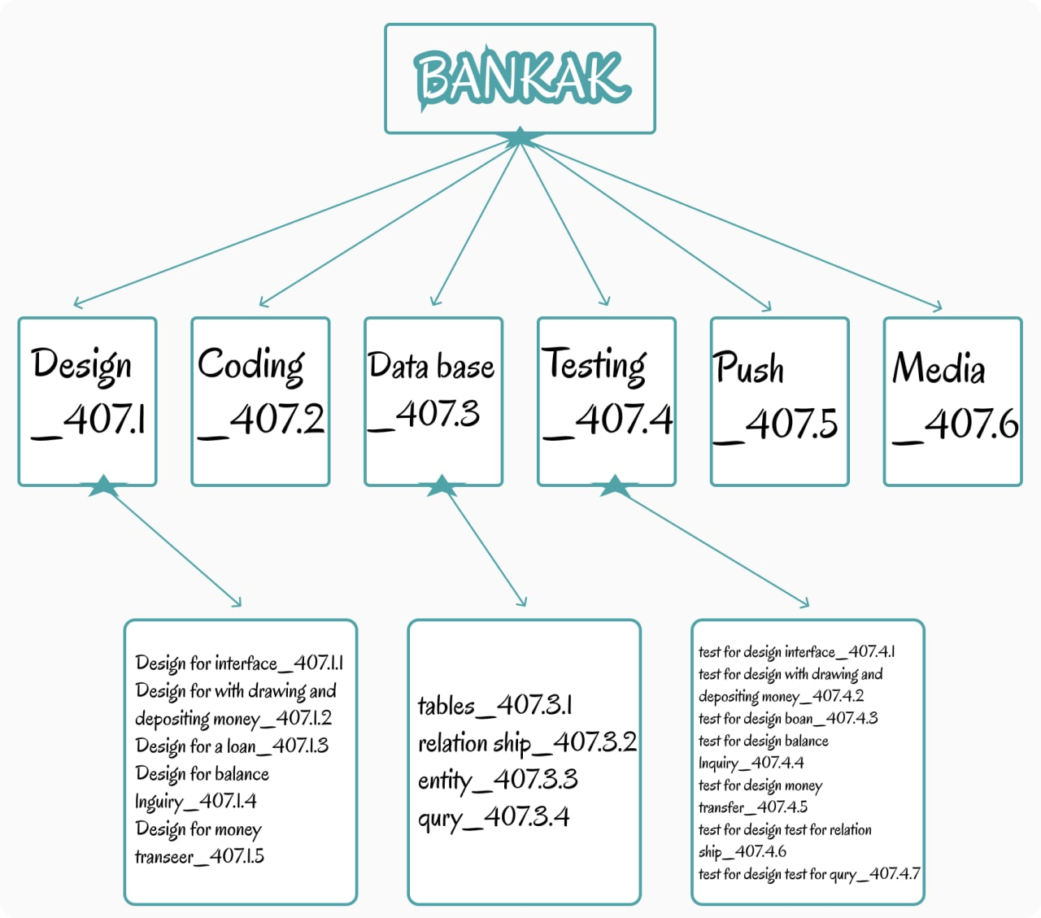

**Dictionary of WBS:**

|  |  |
| --- | --- |
| Work Package ID  Work Package Name  Description  Person  Start Date  End Date | 407.1.1  Design for interface  linking all the part of project togethar  software engineer  1/2/2022  5/2/2022 |
| Work Package ID  Work Package Name  Description  Person  Start Date  End Date | 407.1.2  Deposition Money  Withdrawals Deposit  Users or practice  6/2/2022  10/2/2022 |

|  |  |
| --- | --- |
| Work Package ID  Work Package Name  Description  Person  Start Date  End Date | 407.1.3  Design for balance lunguiry  The balance process  Staff  11/2/2022  15/2/2022 |

|  |  |
| --- | --- |
| Work Package ID  Work Package Name  Description  Person  Start Date  End Date | 407.2  Coding  Stike duck and program code  software engineer  16/2/2022  20/2/2022 |

|  |  |  |
| --- | --- | --- |
| Work Package ID  Work Package Name  Description  Person  Start Date  End Date | 407.3.1  Tables  Orgnizetion shape sor data base  Staff  21/2/2022  25/2/2022 |  |

|  |  |
| --- | --- |
| Work Package ID  Work Package Name  Description  Person  Start Date  End Date | 407.3.2  Relation sip  Relation ship of bata each other  Staff  26/2/2022  30/2/2022 |

|  |  |
| --- | --- |
| Work Package ID  Work Package Name  Description  Person  Start Date  End Date | 407.4.1  Test for design interface  Creat a experience for design interface  Software engineer  31/3/2022  5/3/2022 |

|  |  |
| --- | --- |
| Work Package ID  Work Package Name  Description  Person  Start Date  End Date | 407.4.2  Test for design withdrawing  Creat a experience for withdrawals and deposit  Users or practice  6/3/2022  10/3/2022 |

|  |  |  |  |  |  |  |  |  |
| --- | --- | --- | --- | --- | --- | --- | --- | --- |
| Project  Manager | App. Developer | Network engineer | Designer | Analysis Engineer | Project Sponsor | Senior Stack holder | Testing  Manage | Activities |
| P | A |  | R | P | P | C | A | Create application |
| R | R | R | A |  | P | P | A | Test the application |
| R | P |  | R | P | R |  | R | Package application |
| C |  |  |  |  |  | R | A | Testing application release |
|  |  | A | P | R | P |  | A | Push application to the workstation |
| R | R |  | C | C |  |  | R | Financial plan |
|  | p |  |  |  | P | R | A | Writ Contents |
| P |  |  | R | R | A |  | R | Create Closure report |
| A | A |  | C | C | R | R | A | Create design |

**Responsibility Matrix**:

Here is the legend for this matrix:

A:approves

R:Reviews

P:participant

C:creator

Network:

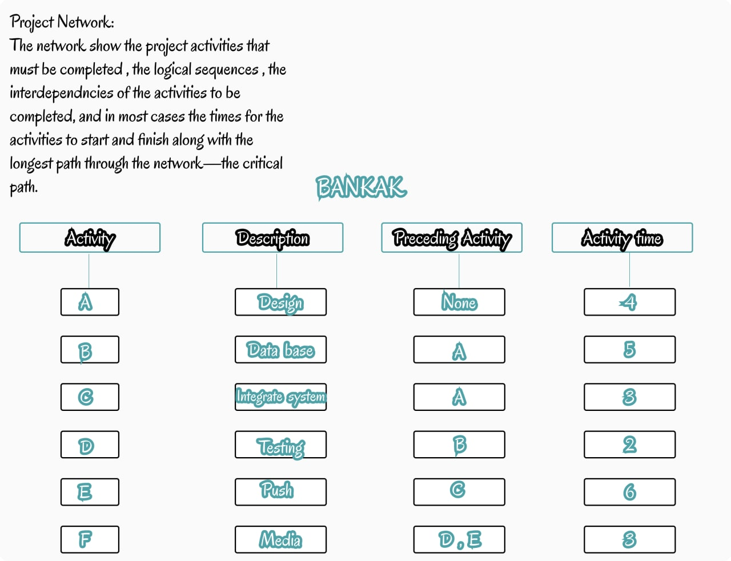

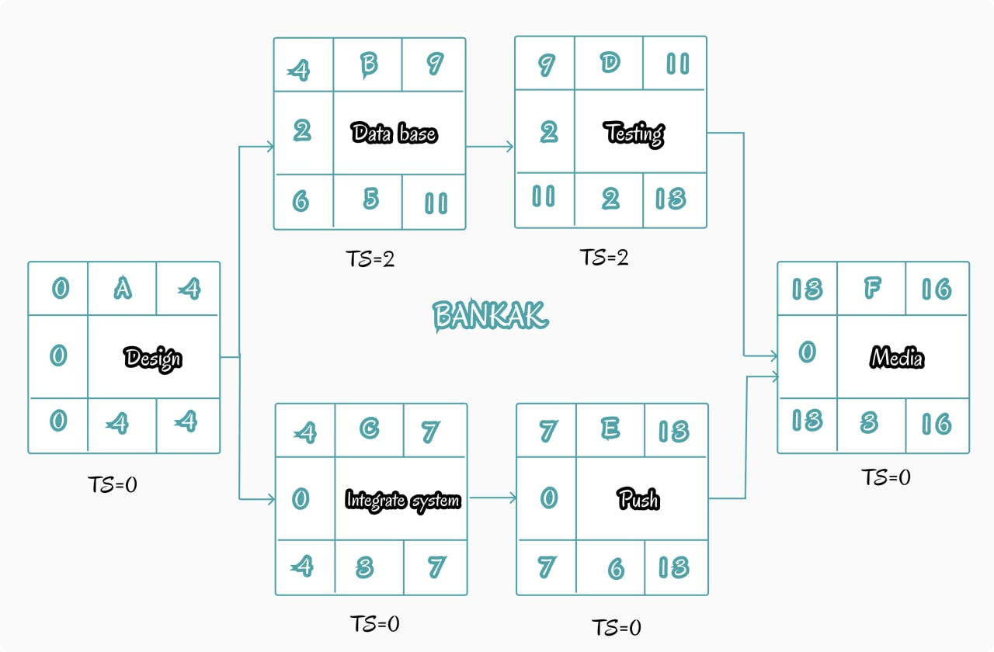

Resources:

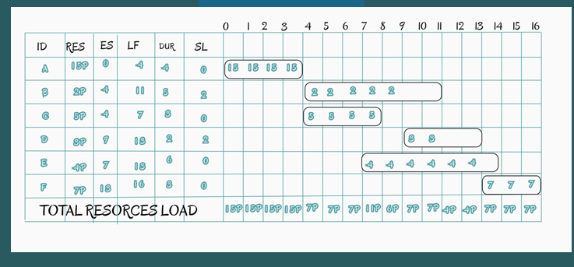

Budget Baseline:

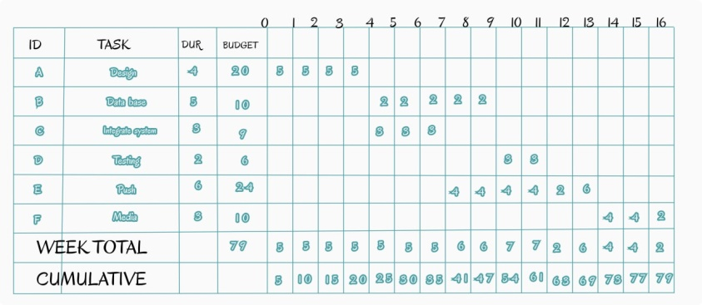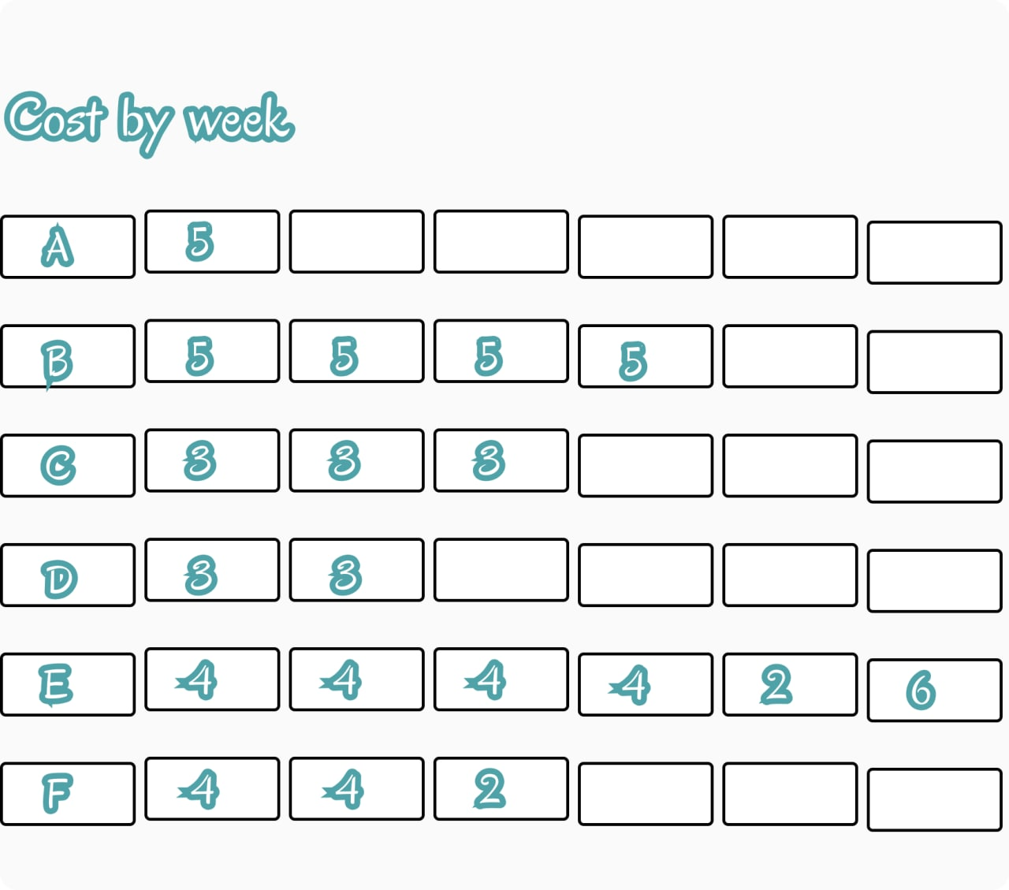

**The risks:**

**The risks that can face the project :**

1_Network or system failure.

2_ Some banks do not support the idea of ​​the application.

To overcome project risks:

1_ Putting technical workers to follow up and supervise the system from time to time and try to make a very strong system to avoid any kind of problems that this system may encounter.

2_ We present the idea of ​​the application to the banks opposing the idea and try to convince them to try the idea on customers for a short period of time in the manner of supply and demand, and when people support this idea, the banks will be convinced of the idea of ​​the application.

Project support:

The project will be supported through funded advertisements by making an advertisement that appears to the largest number of people in which the idea of ​​the application and how to use it will be explained, but this will only happen with the approval of the banks on the idea of ​​the application so that customers are also convinced of the idea.

The end