**ERD**

**Basic Entities :**

▪ **Educational Centers**

**-Center ID (p.k)**

**- CenterName**

**- Location**

**- CenterType**

**- Email**

**-Bio**

▪ **Course**

**- Course ID (p.k)**

**- CourseName**

**- CourseStatus**

**- Description**

▪ **CourseSchedule**

**- Day**

**- Hour**

**- Year**

**-Semester**

▪ **CourseMaterial**

**-Material ID (p.k)**

**- Title**

**-File Type**

**-Description**

▪ **Class Room**

**- ClassID (p.k)**

**- Capacity**

▪ **Student**

**-StudentID (p.k)**

**-StudentName**

**- Email**

**-{Phone}**

**-Date Of Birth**

**- Age()**

**Teacher** **▪**

**-TeacherID (p.k)**

**-TeacherName**

**-Email**

**-Salary**

**-Qulalificiation**

**- {Phone}**

**Admin** ▪

**-AdminID (p.k)**

**-AdminName**

**-Email**

**-Role**

▪ **UserAcount**

**-UserID (p.k)**

**-UserName**

**-Email**

**-{ Phone}**

▪ **Payment**

**-PaymentID(p.k)**

▪ **Notifications**

**-NotificationID (p.k)**

**-Message**

**-DateSent**

**IsRead-**

▪ **Feadback**

**-FeadbackID (p.k)**

**- Message**

**Relationship**

**On our site, any person who owns an account must be either a teacher, a student, or an admin, so that each entity will have its own relationships in addition to the general relationships common between all these entities. On the other hand, there is a set of common attribute, so we used the concept of Specialization.**

**Each user account belongs to only one subclass, so we will use the Disjoint Specialization.**

SuperClass

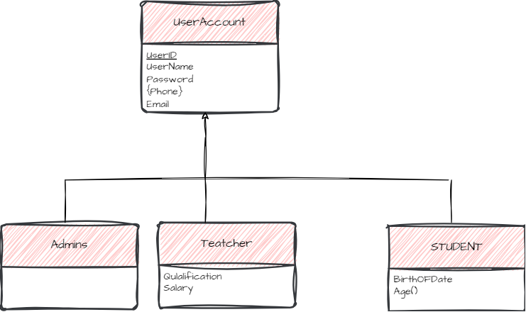

SubClass

**The centers are divided into two types: Academic centers that offer courses in programming and other fields, and Center for school students ,so we decided to use the concept of Specialization To express these types , Since these center is either academic or for school students, we used the Disjoint Specialization (so we have Higher-Level entity set and Lower-Level entity set ).**

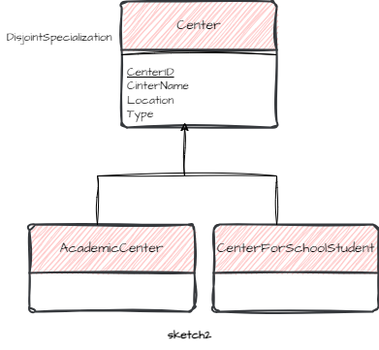

**Attribute and relationship inherited**

**The Super entity center has the attribute center-type so all center evaluated on the defining center-type if it Academic so its belong to the Acadimic Center, Otherwise its belong to center for school student.**

**The center offers many courses, and eatch course is offered by more than one center. Therefore, the relationship between the center and the course is :Many to Many.**

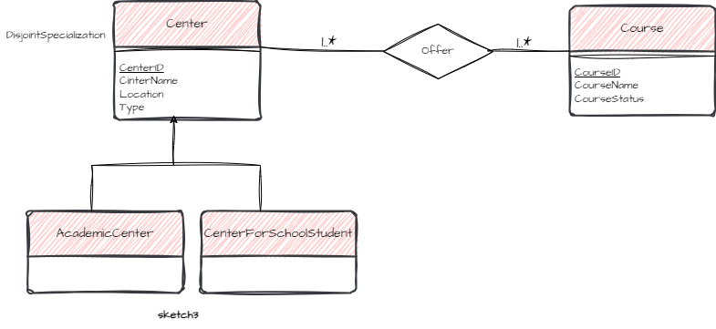

**Each center must offer courses, and each course must be linked to a center** **Total Participation .**

**CourseSchedule is a** **weak entity Because its existence depends on the existence of the course itself .**

**Each course has more than one Appointment and eatch Appointment link with only one course so the relationship between the Course and CourseSchedule is: one to Many**

**Each Appointment is linked to a Course and each Course is linked to an Appointment Total** **Participation**

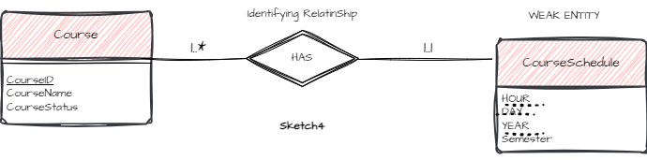

**The relationship between the** **CourseSchedule and Class Room is: Many to one.**

**Partial Participation on the part of CourseSchedule and Class Room .**

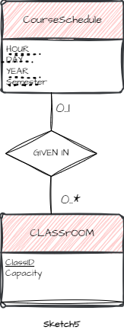

**Each course has several students linked to it, and one student is linked to several courses. To obtain a registration table containing the student’s name, course name, and dates, we linked it to the Corse Schedule table and for the same reson we linked Teacher with it.**

**A Teacher gives more than one course, and one course is given by more than one teacher, so the relationship is Many to Many.**

**The relationship between the user and payment is one to Many .**

**Partial** **participation on the part of user and Total participation on the part of payment.**

**Final ERD**