

Palestine Technical University – Kadoorie College of Engineering and Technology Department of Computer Systems Engineering

Course name:

# Software Engineering

Project title:

DEVELOPING A CENTRALIZED COURSE PORTAL FOR EDUCATIONAL CENTERS IN PALESTINE

By:

# Abrar Arman - 202110760

# Maysam Rashed - 202110544

# Mayar Qasarwa - 202110541

# Shahd Qalalwa - 202110631

# Azza Eid – 202110543

Supervisor:

# Dr. Osama Hamed

Tulkarm, Palestine

Spring Semester 2023-2024

**Abstract:**

Our educational website will play an important role in your career, serving as anything from a CV for job hunting, or a portal where you connect with students and peers.

This website is a dynamic online platform designed to revolutionize the educational landscape. Our mission is to empower learners, academic centers, and instructors by providing seamless access to educational resources, personalized experiences, and efficient communication.

**Table of contact**

**Abstract ……………………………………………………………II**

**Table of contact………………………………………..….III**

**Chapter 1:Introduction ……………………………………1**

1-1 General Background……………………………..……………………1

1-2 Problem Statement……………………………….……………………1

1-3 General Objective……………………………………………………..2

1-4 Spacific Objectives……………………………………………………2

1-5 Scope Of Work………………………………………………………..3

**Chapter 1: Introduction**

**1-1 General Background :**

Over the past four years, students in Palestine have faced significant challenges in their educational journey. These challenges began with the outbreak of the COVID-19 pandemic in 2020, which disrupted and slowed down the educational process. With the aftermath of the COVID-19 pandemic, Palestine witnessed a series of negative events that adversely affected education, including the 2021 war on Gaza, the teachers' strike, and the 2023 war. Students have been affected during this period by a reduction in the quality of education and a decline in their academic performance, as testified by parents and teachers.

Additionally, these challenges have not been limited to school students alone, but have extended to university students and learners in training centers and educational institutions. Everyone has been affected by the disruption of classes and the discontinuation of the educational process, leading to a decline in academic performance and an increase in the educational gap.

**1.2 Problem Statement**

The impact of these adverse conditions on the educational process in Palestine is alarming, leading to a decline in students' academic levels and a deterioration in the quality of education. Therefore, it is imperative to search for technological educational solutions that contribute to enhancing the quality of education and motivating students to learn and grow academically despite the existing challenges.

**1.3 General Objective**

Our goal through our website is to streamline the process of finding suitable educational courses, whether for school students or others. This will be achieved by establishing an organized platform that facilitates searches based on educational materials, geographical location, or the method of course delivery (in-person or online). Simultaneously, it aims to simplify the organization of educational courses within educational institutions, while at the same time enabling them to advertise their services effectively.

**1.4 Objectives**

1. **Educational Session Reservation**: Create a system where students can reserve educational sessions\ Allow them to choose sessions based on their preferences and availability\ Implement booking features to secure their spots.
2. **Educational Center Information**: Gather comprehensive details about educational centers\Include information such as courses offered, schedules, and physical locations\Ensure accurate and up-to-date data.
3. **Student-Friendly Search and Booking**: Design an intuitive search function for students\ Enable easy exploration of available sessions\ Streamline the booking process.
4. **Seamless Communication**: Build channels for communication between students and centers\ Provide support for inquiries, updates, and assistance\ Foster a collaborative environment.

**1.5 Scope of Work**

The scope of this research will focus on developing an online educational platform that aims to facilitate the reservation of educational sessions and provide information about educational centers in **major cities in Palestine**. The platform will include features such as searching for educational centers, viewing available sessions, and booking sessions online. Additionally, the platform will enable communication between students and educational centers, ensuring a seamless experience for both parties.

**Chapter 2: The** **Entity Relationship Data Model**

**2-1** **Entities:**

To make our database ER diagram simpler to understand, we have divided **the entities** into several functional groups:

* **User Management:** Student, UserAccount, Admin, Teachrer.
* **Course Management**: Course, Center, CourseMaterials, CourseSchedule.
* **User Preference:** CenterFotSchoolStudent, AcademicCenter.
* **Scheduling:** CourseSchedule, ClassRoom.
* **Notifications & Communications:** Notifications ,Phone.
* **Financial Transactions:** Payment.
* **Feedback:** Feedback.

**2-2 Entities Description:**

**UserAccount:** Manages login credentials and user profiles. Attributes often include username, password, and user role.

**Admin:** Users with elevated privileges to manage the system. Attributes could include admin ID and access level.

**Teacher:** Instructors responsible for teaching courses. Attributes may include teacher ID, name, and subject expertise.

**Student:** Represents individuals enrolled in the academic center. Holds personal information, academic major, and enrollment status.

**Course:** Contains details of courses offered, including name, associated class rooms, and related materials like syllabus.

**CourseMaterials:** Educational content provided for courses.

**CourseSchedule:** Timetable details for courses- Manages when and where courses are held.

**CenterForSchoolStudent:** Specialized in strengthening courses for school students.

**AcademicCenter:** Specialized centers focused on academic excellence.

**Notifications:** Sends messages to users, such as reminders or alerts, and tracks whether they have been read.

**Phone:** Contact information for communication.

**Payment:** Handles financial transactions related to course enrollments, including payment amounts and methods.

**Feedback:** User-submitted evaluations and comments.

**2-3 Relationships:**

* **Student** to **CourseSchedule**: student can be scheduled for many course sessions, and a course schedule can include many students.
* **Student** to **Course**: A student can review multiple courses, and a course can have multiple reviews.
* **Student** to **Course**: students can list multiple course they wish to take, and a courses can be in many students wish list.
* **Payment** to **Student**: Each student has a payment record.
* **Teacher** to **CourseSchedule**: A teacher can teach many course appointments, and a course can be taught by many teachers.
* **UserAccount** to **Students/Admins**/**Teacher**: A user account is linked to one subclass which represented by disjoint specialization.
* **Notifications** to **UserAccount**: A user account can receive multiple notifications.
* **Feedback** to **UserAccount**: A user can submit multiple feedback entries.
* **Phone** to **UserAccount**: A user can have multiple phone numbers.
* **Center** to **Course**: A center offers multiple courses.
* **Center** to **UserAccount:** multiple users can visit multiple centers.
* **Center** to **AcademicCenter\ CenterForSchoolStudent**: A center is linked to one subclass which represented by disjoint specialization.
* **CourseSchedule** to **Courses**: Each course has multiple schedules.
* **CourseSchedule** to **ClassRoom**: A classroom can be used for many course schedules.
* **CourseMaterials** to **Courses**: A course can have multiple materials.

**2-4 Entity Relationship Model for Educational Center:**

Our Entity Relationship model serves as a foundation for building a robust and efficient database system that supports educational processes, user interactions, and administrative tasks. By understanding these entities and their relationships, we can create a well-structured and reliable database to meet our system’s requirements (shown in Figure **2-1** below).

**Entity Relationship Model**

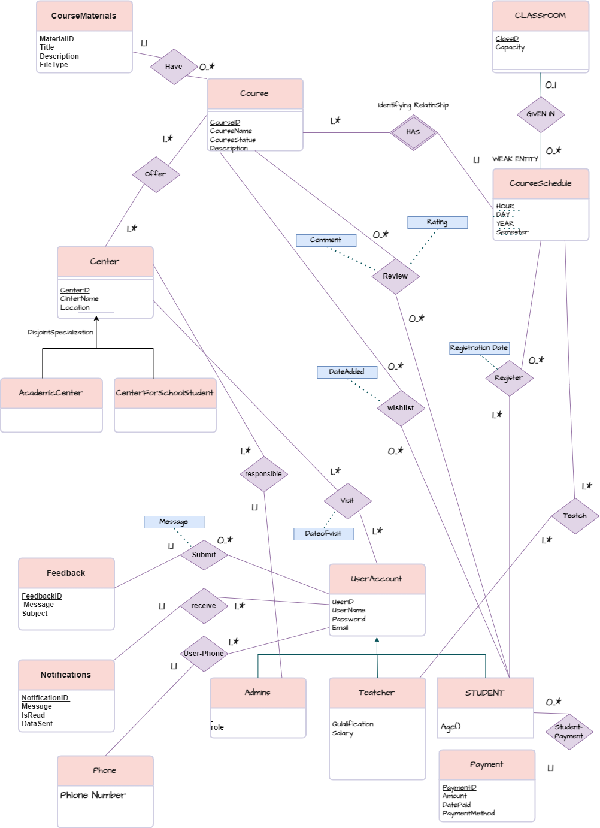

Figure **2-1**