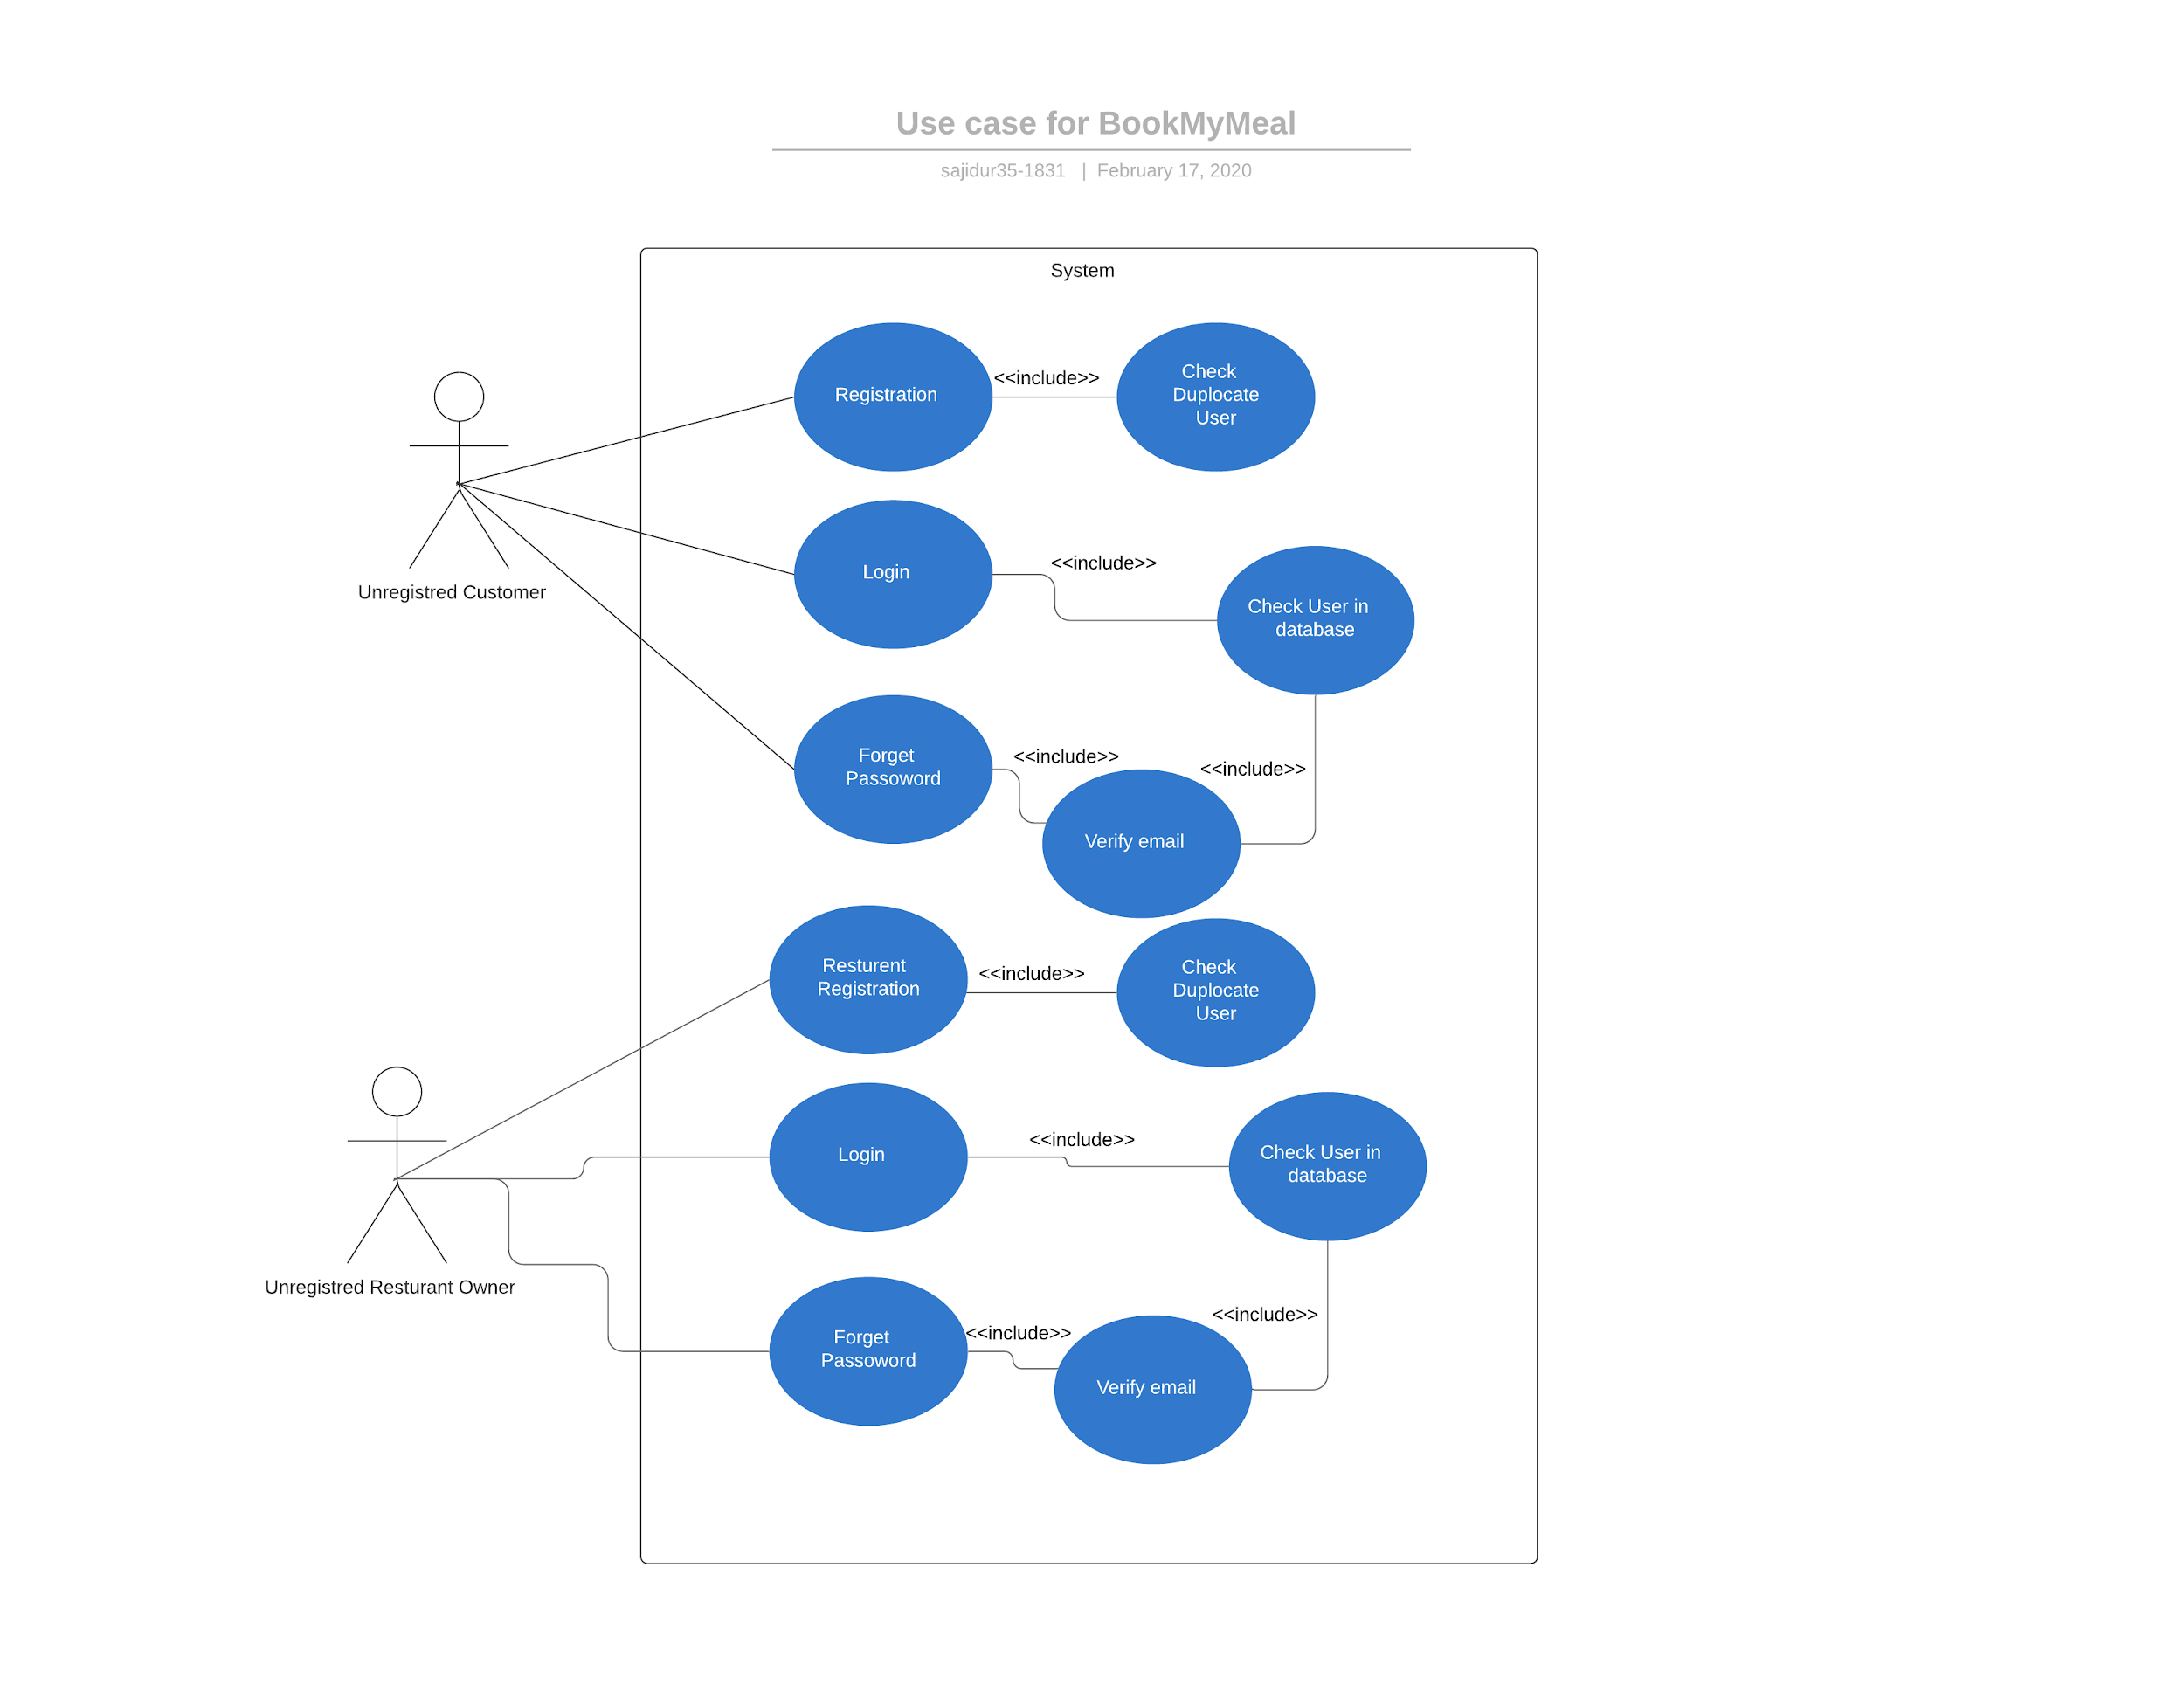

**3.3.2 Use-Case Diagram : Customer**

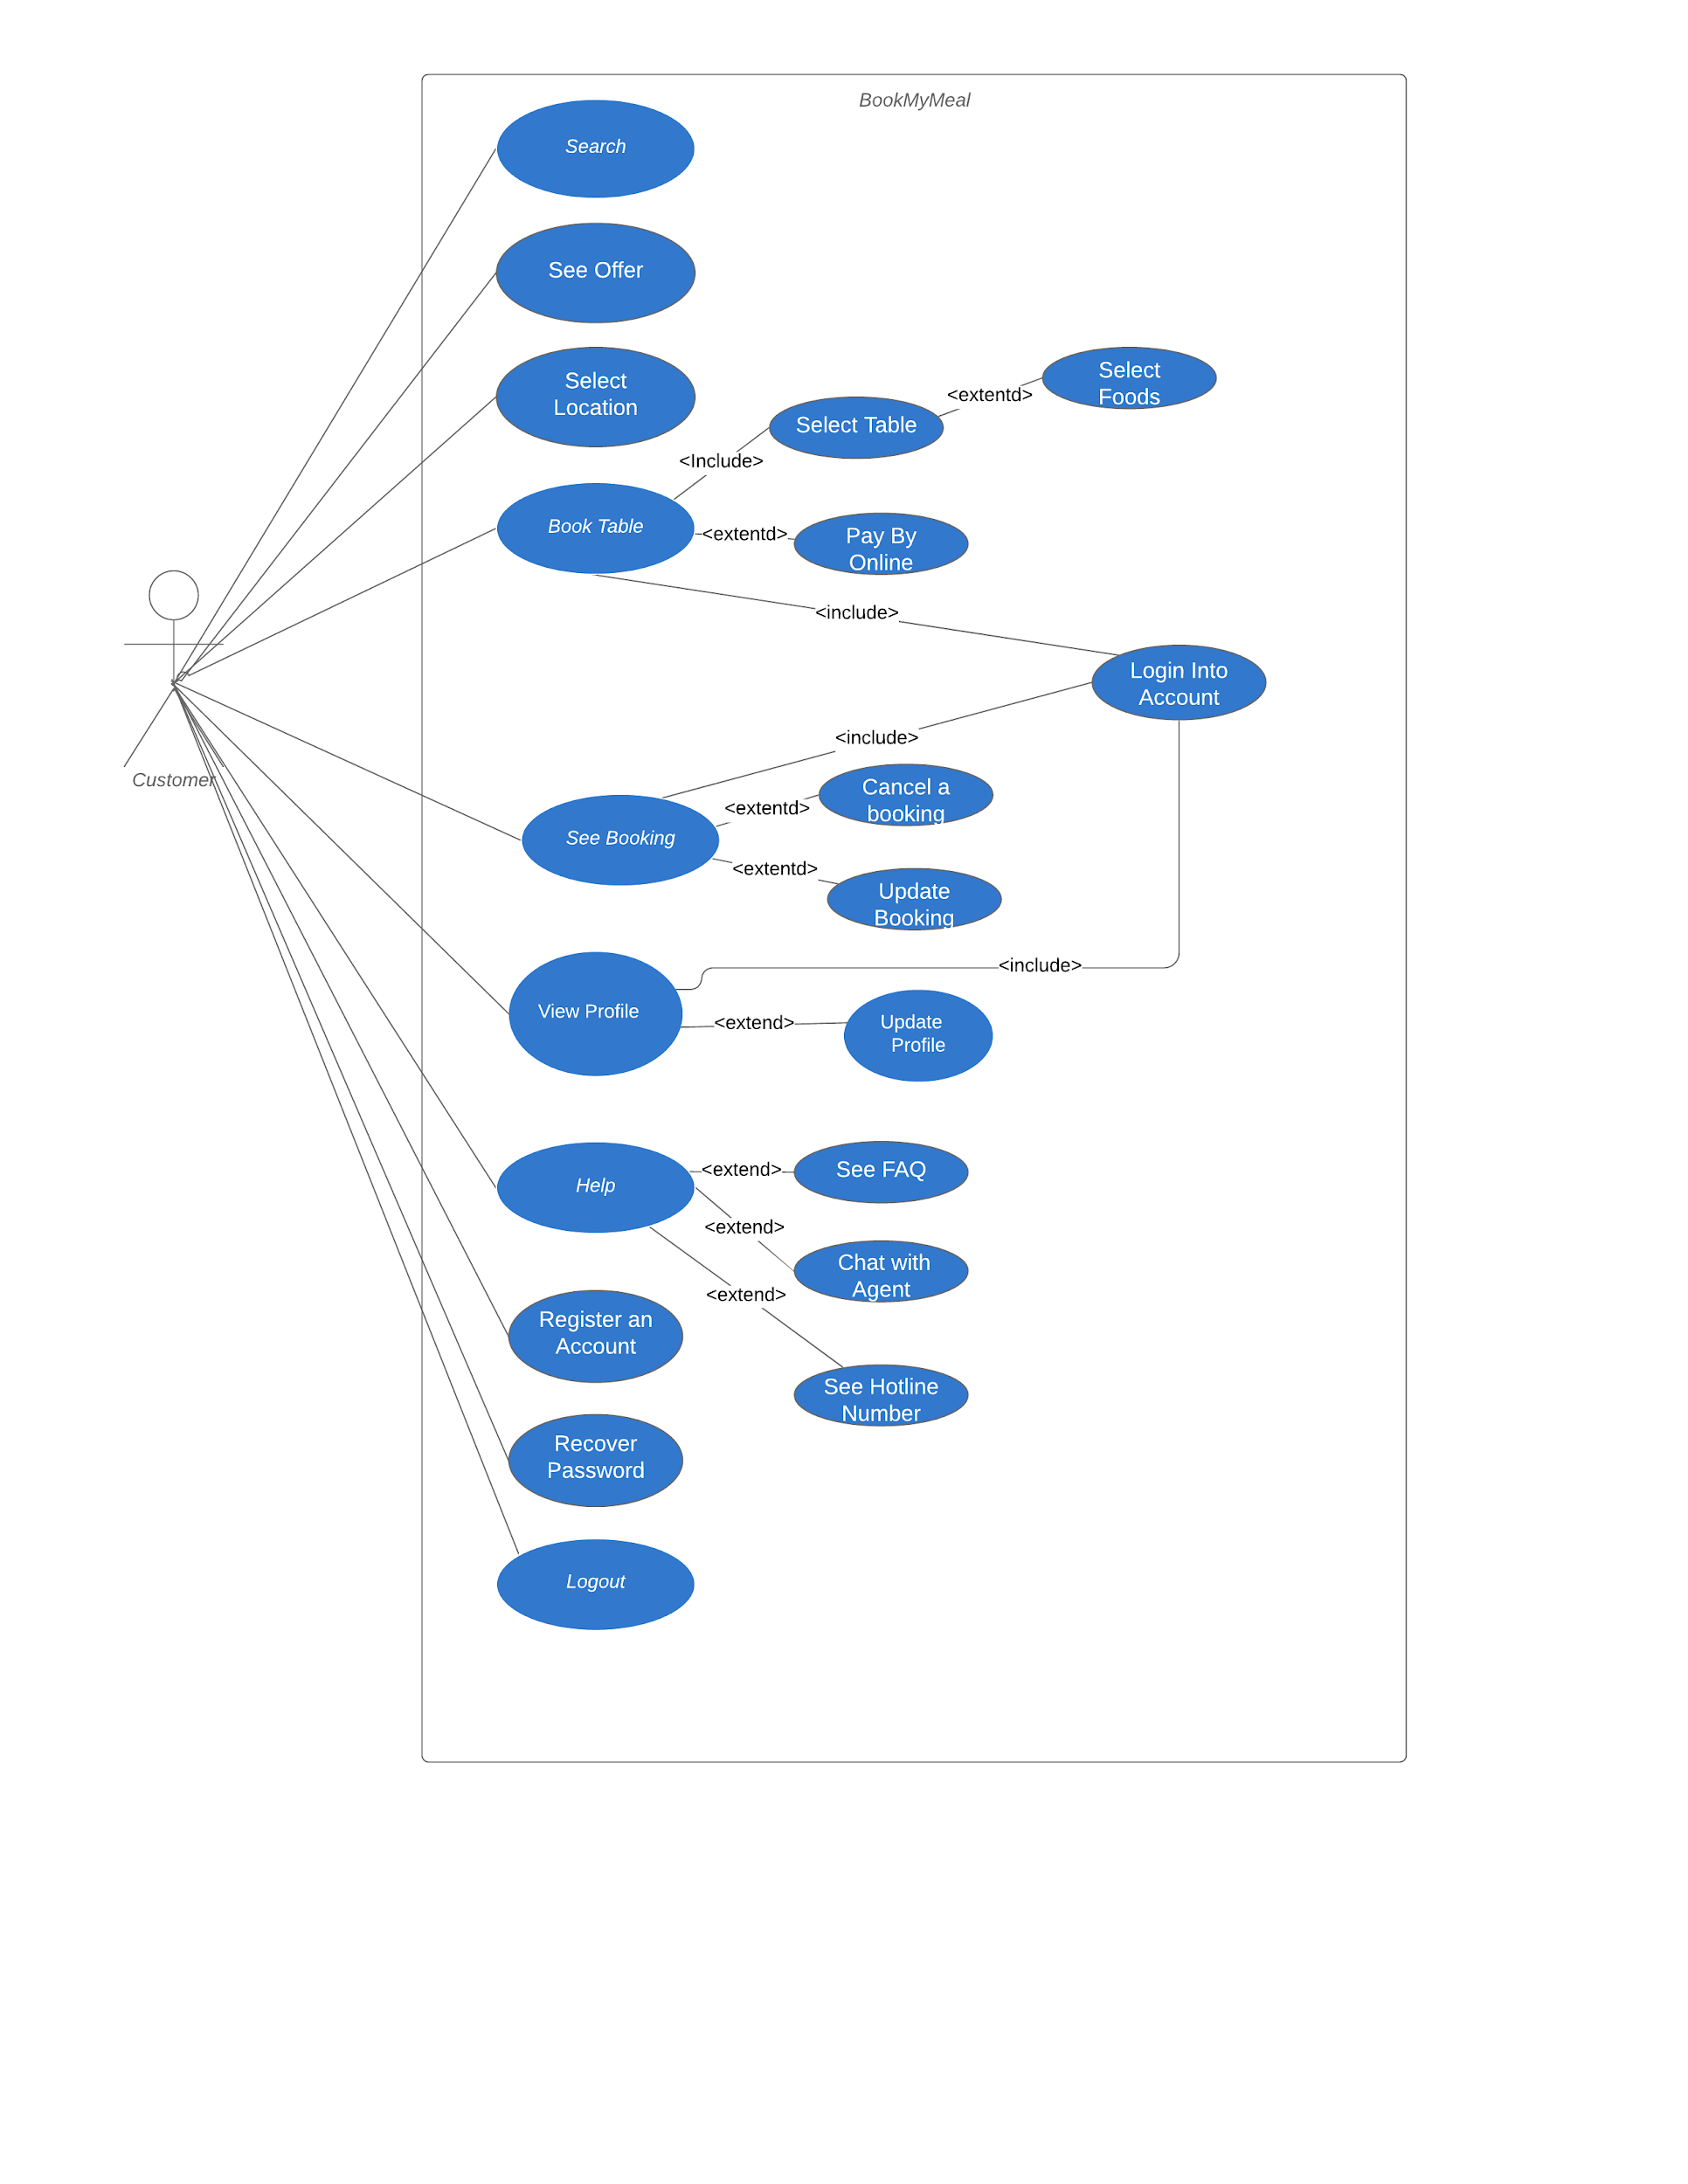

**3.3.3 Use-Case Diagram : Restaurant**

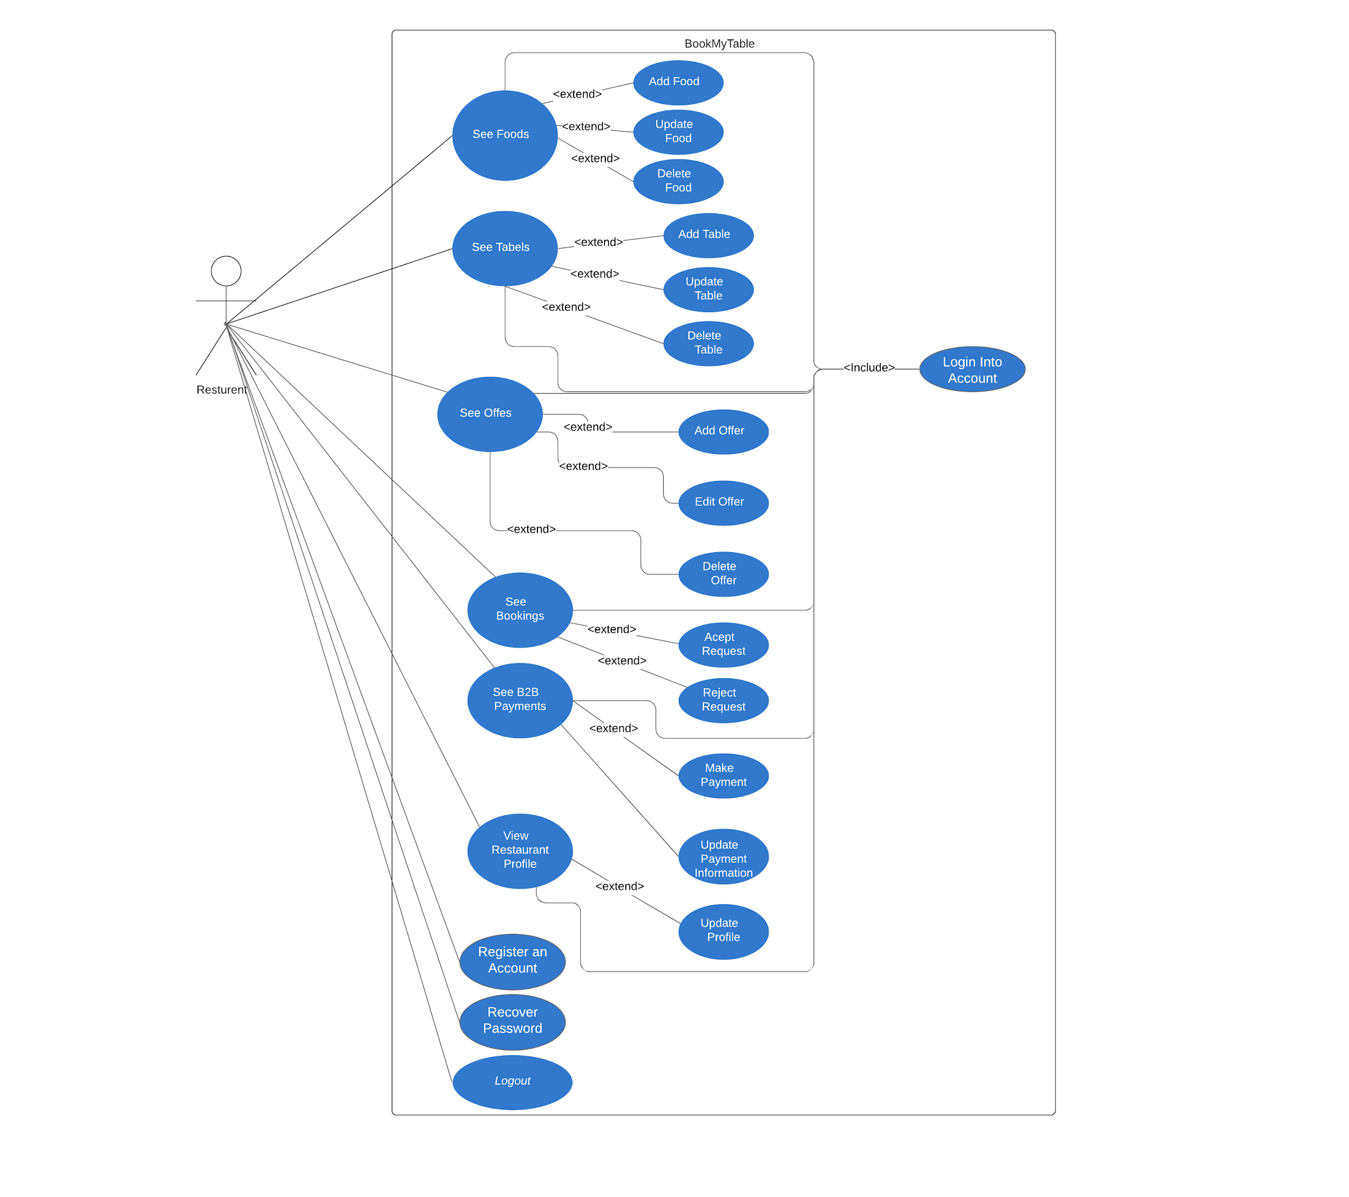

**3.3.4 Use-Case Diagram : Admin**

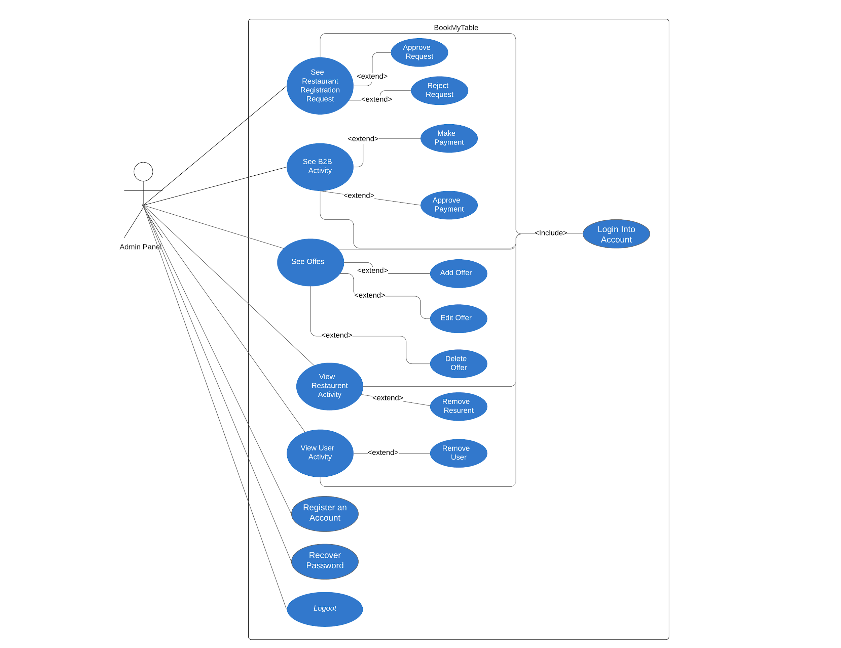

**Chapter 4: UML Diagram**

**4.1 Activity Diagram**

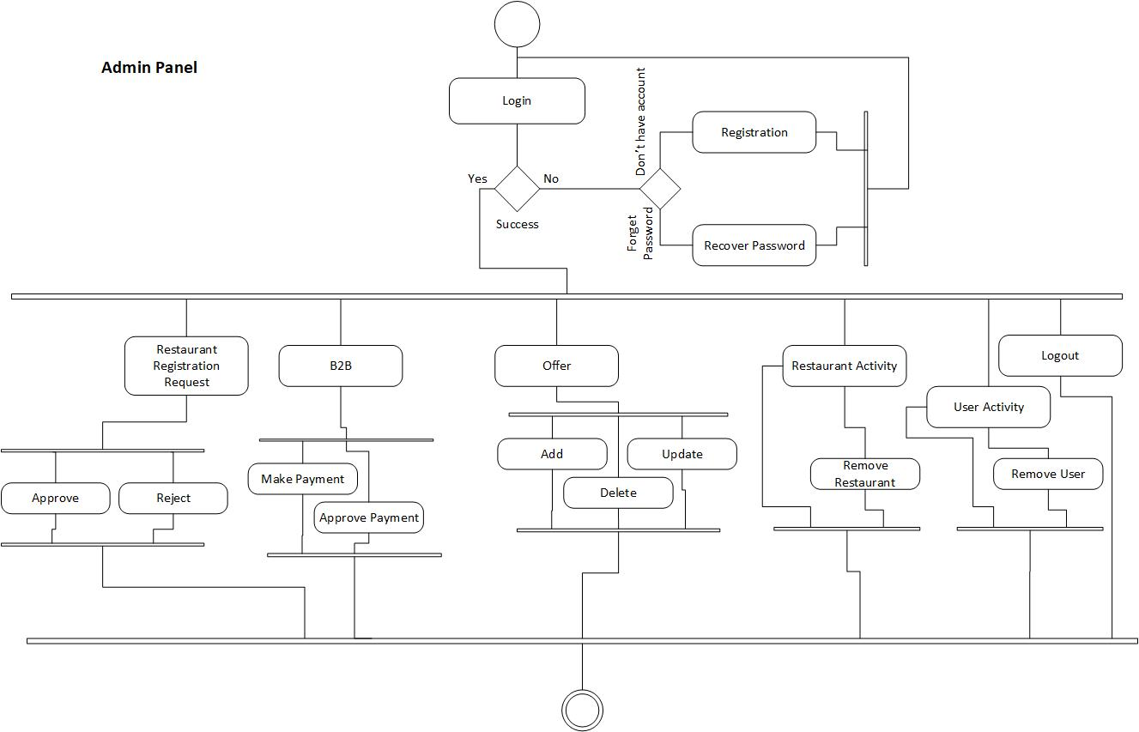

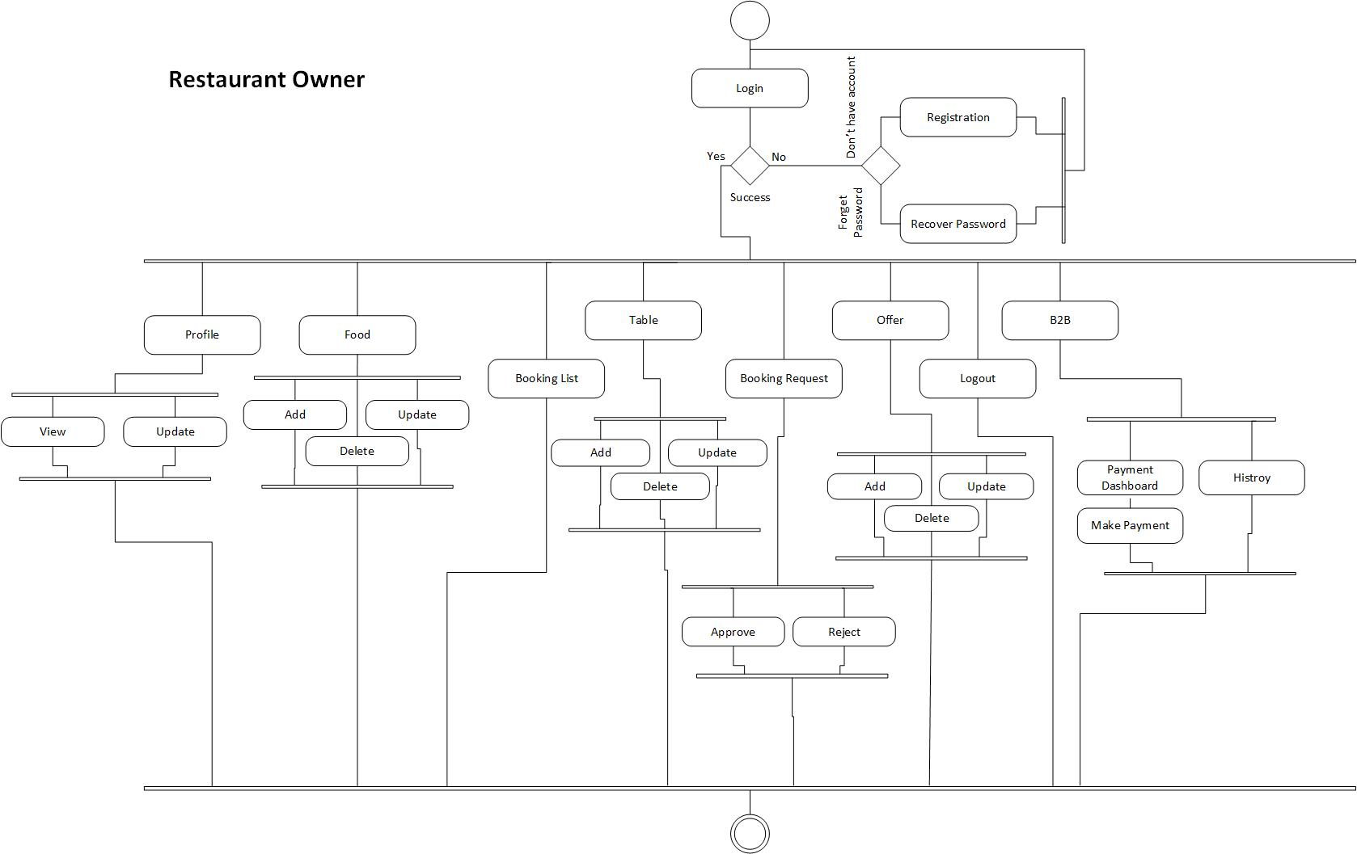

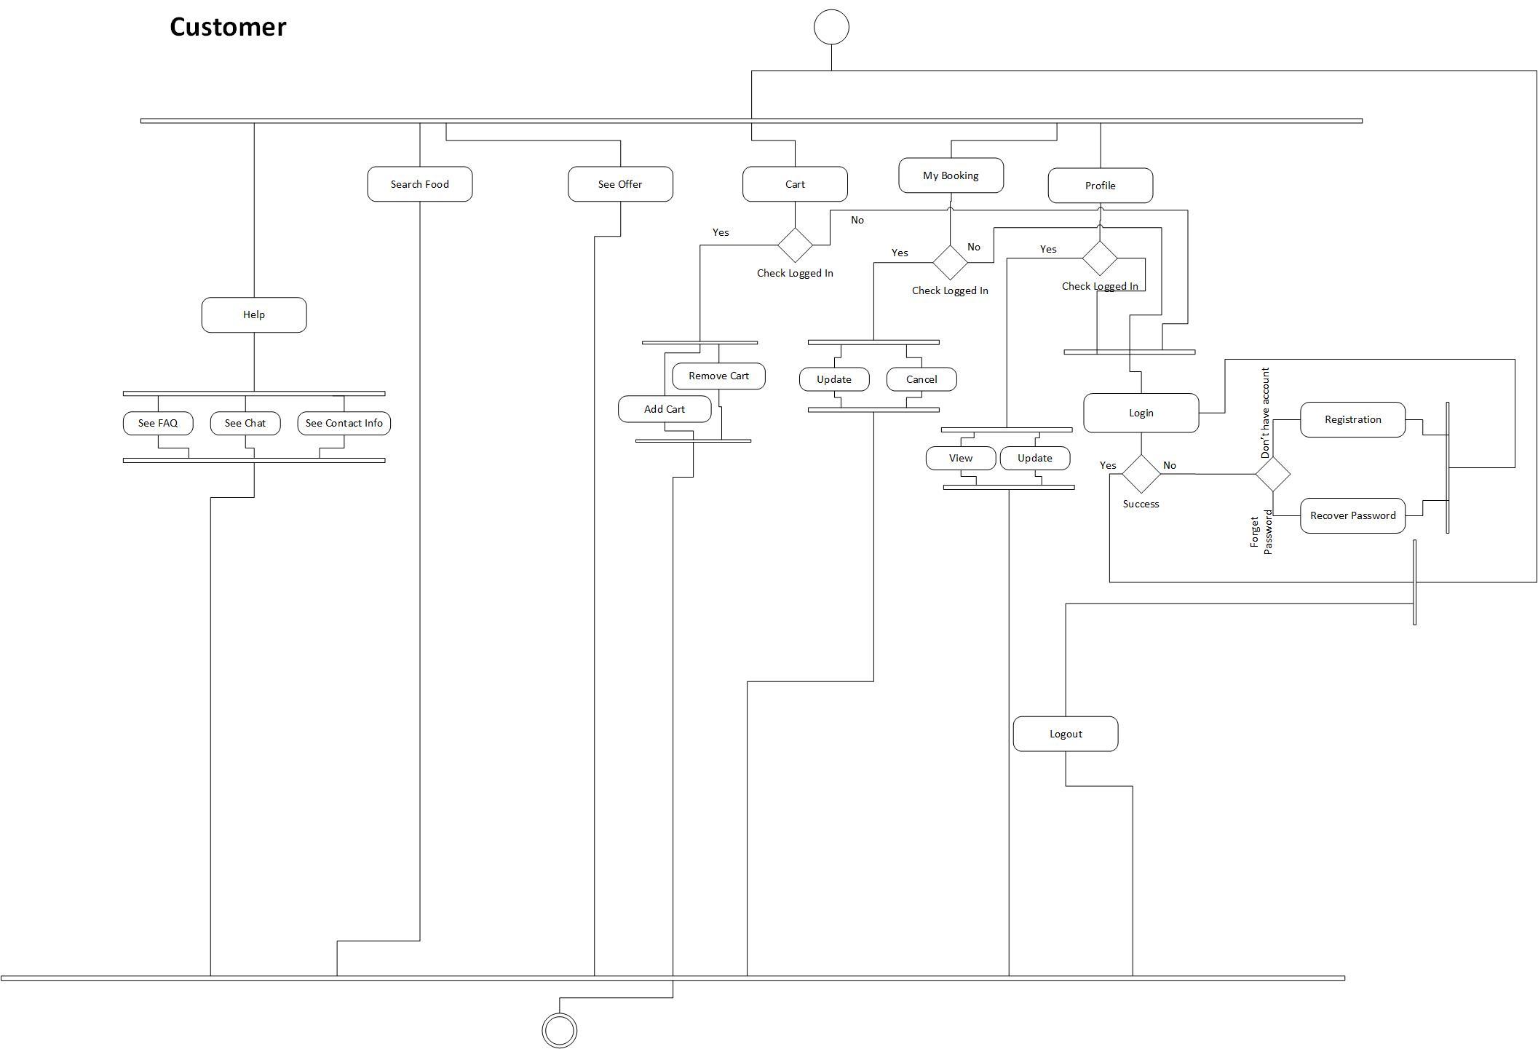

**4.2 Schema Diagram**

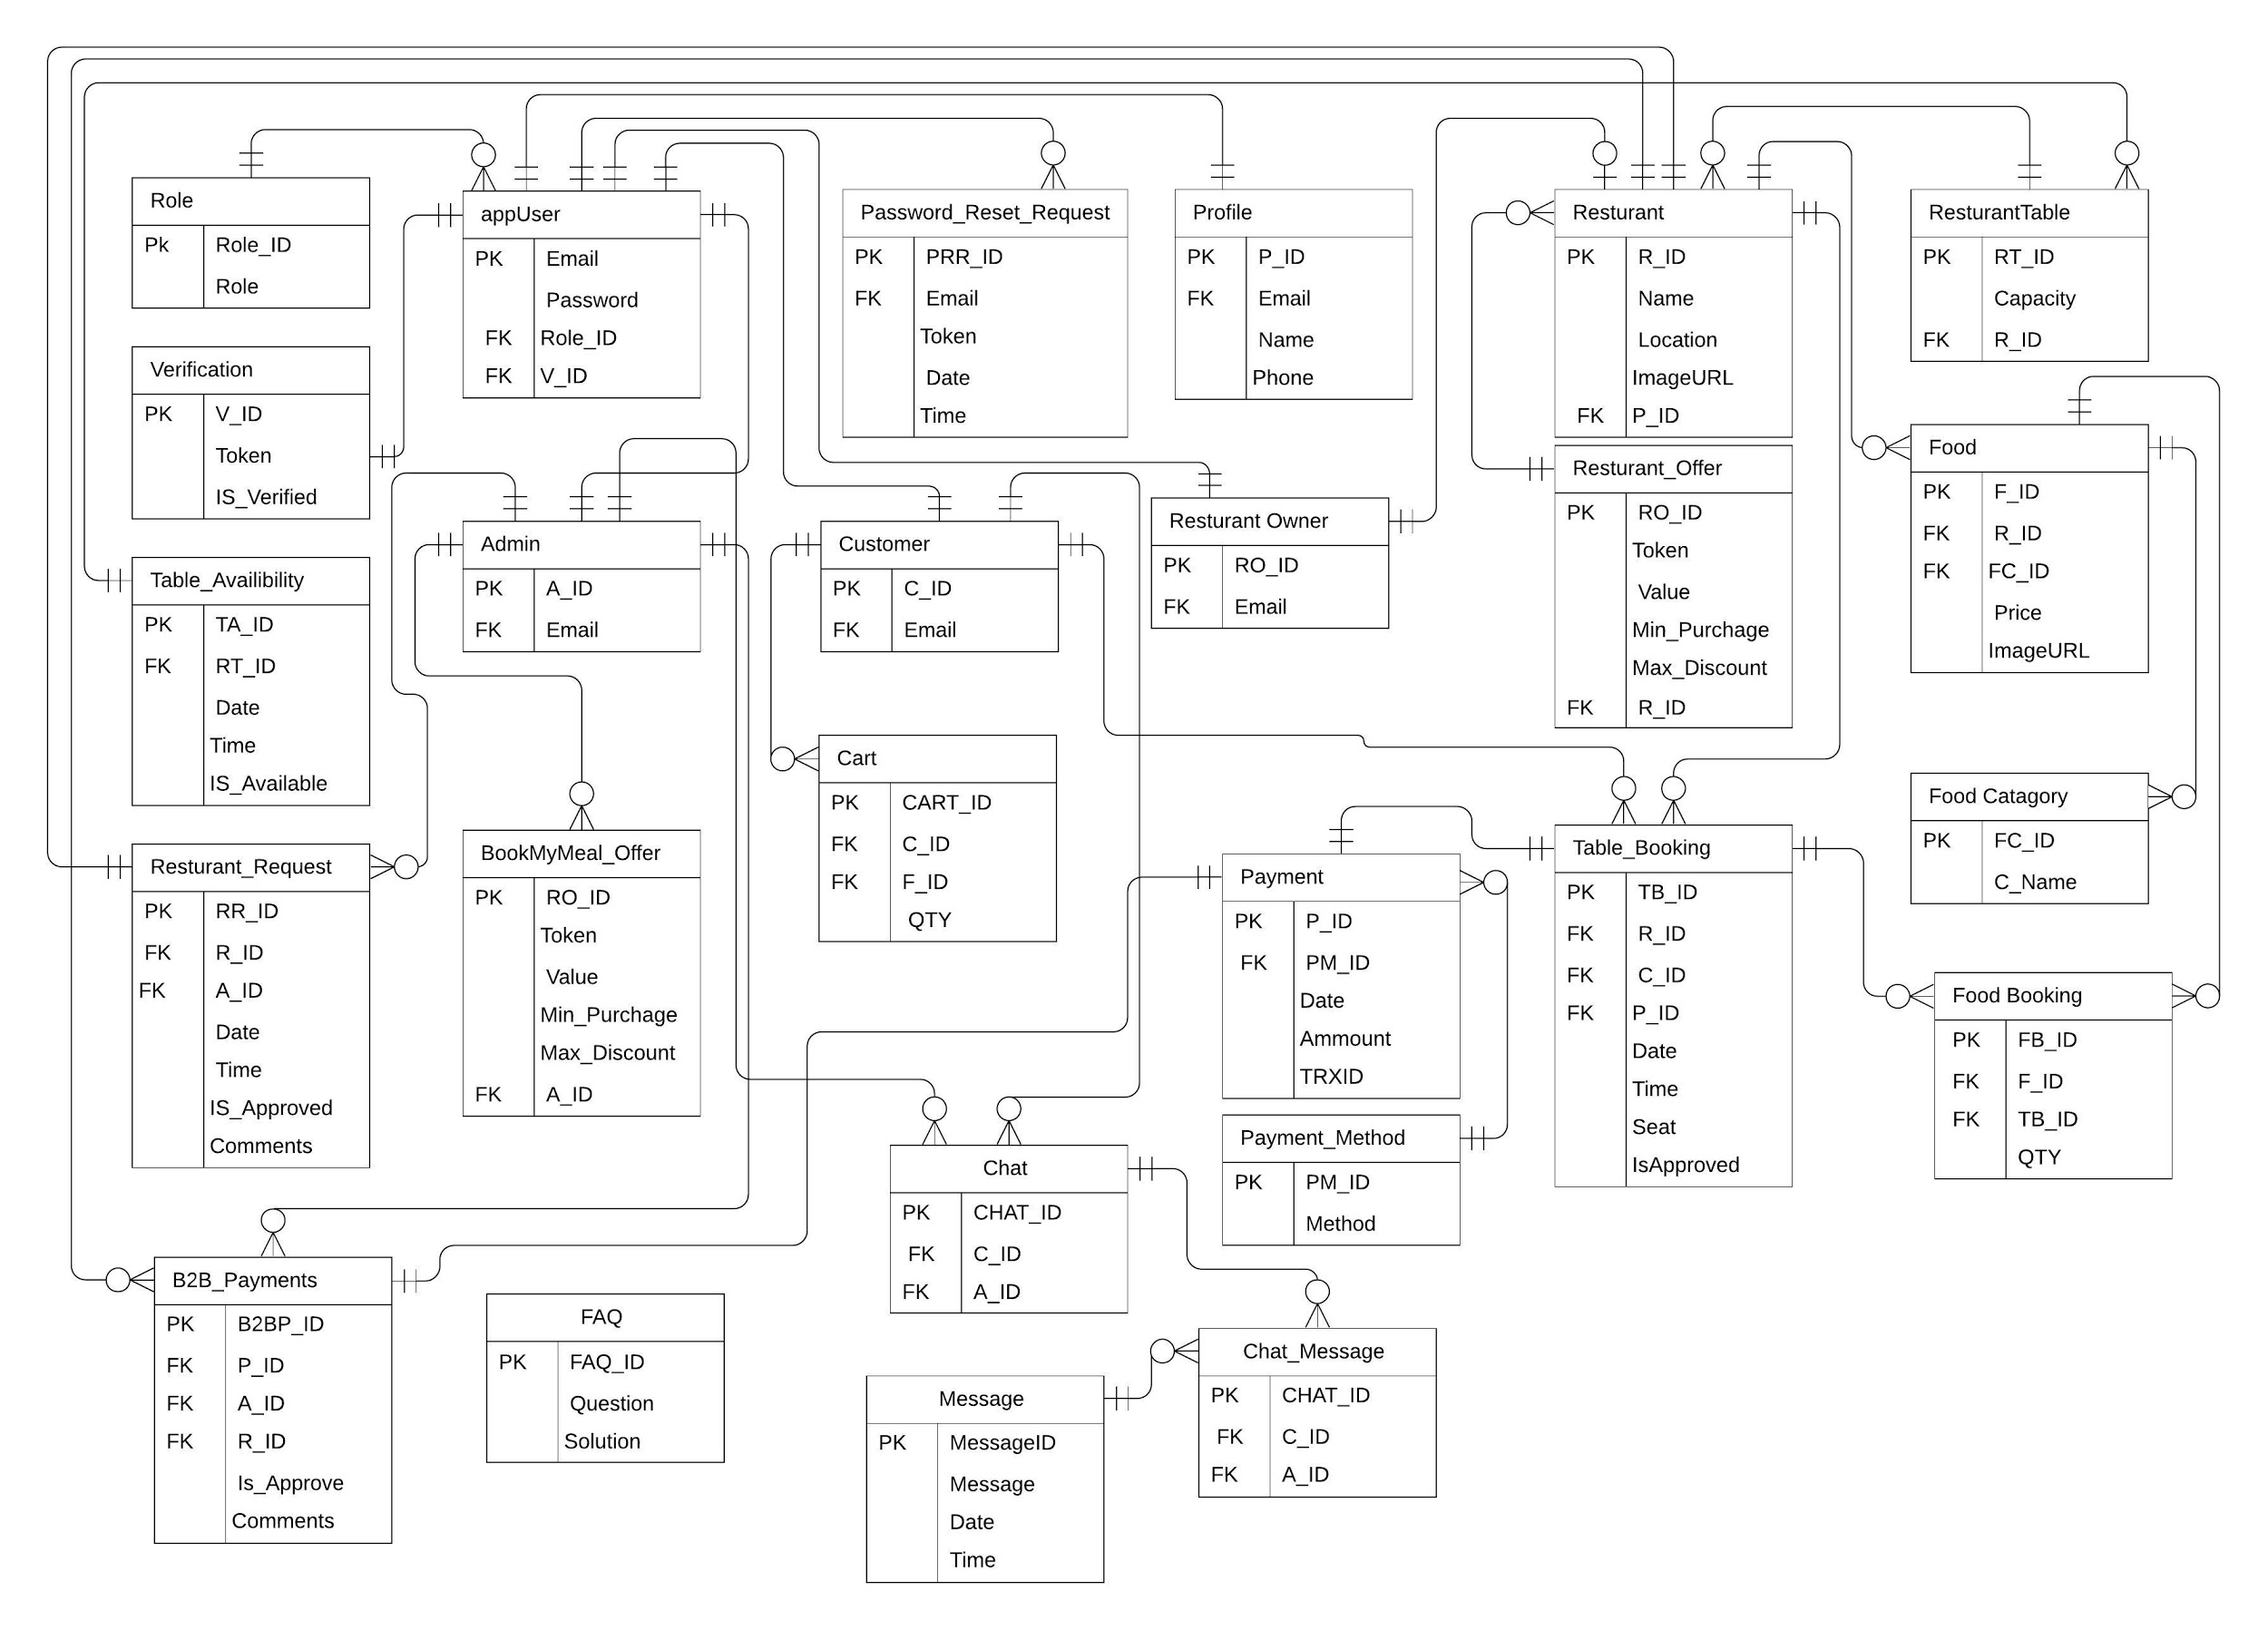

**4.3 Sequence Diagram**

**4.3.1 Registration-Login**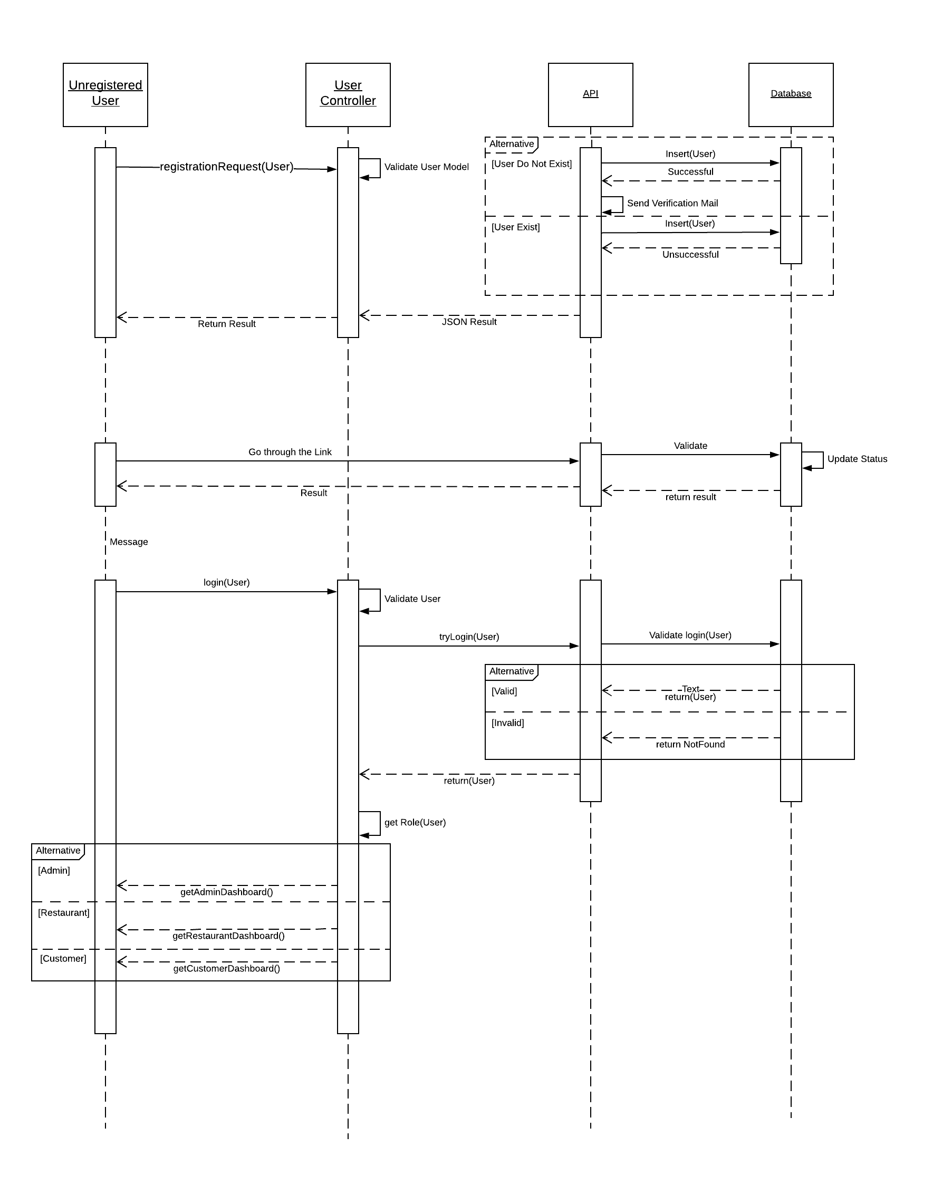

**4.3.2 User Profile**

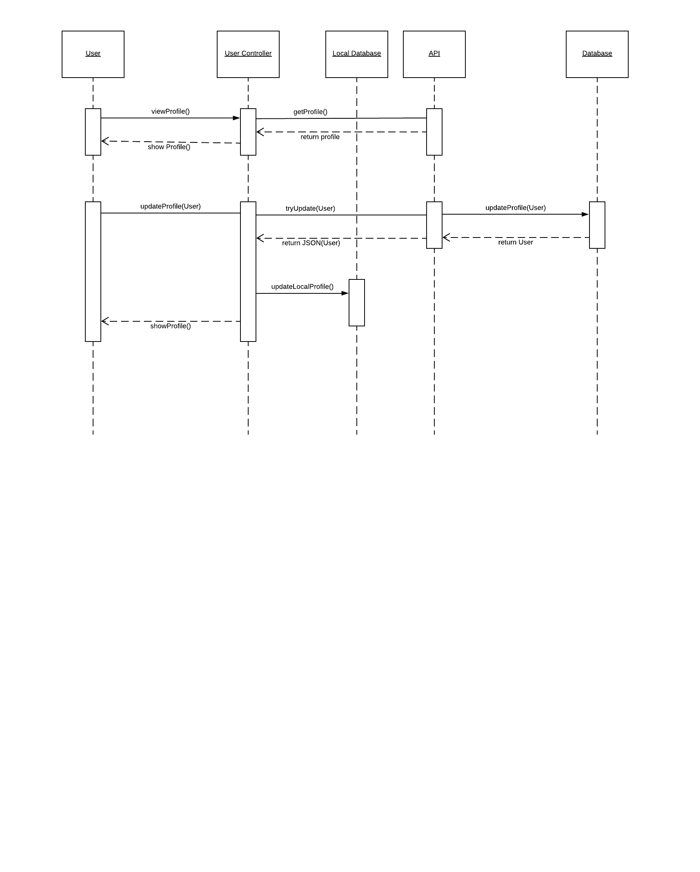

**4.3.3 Food**

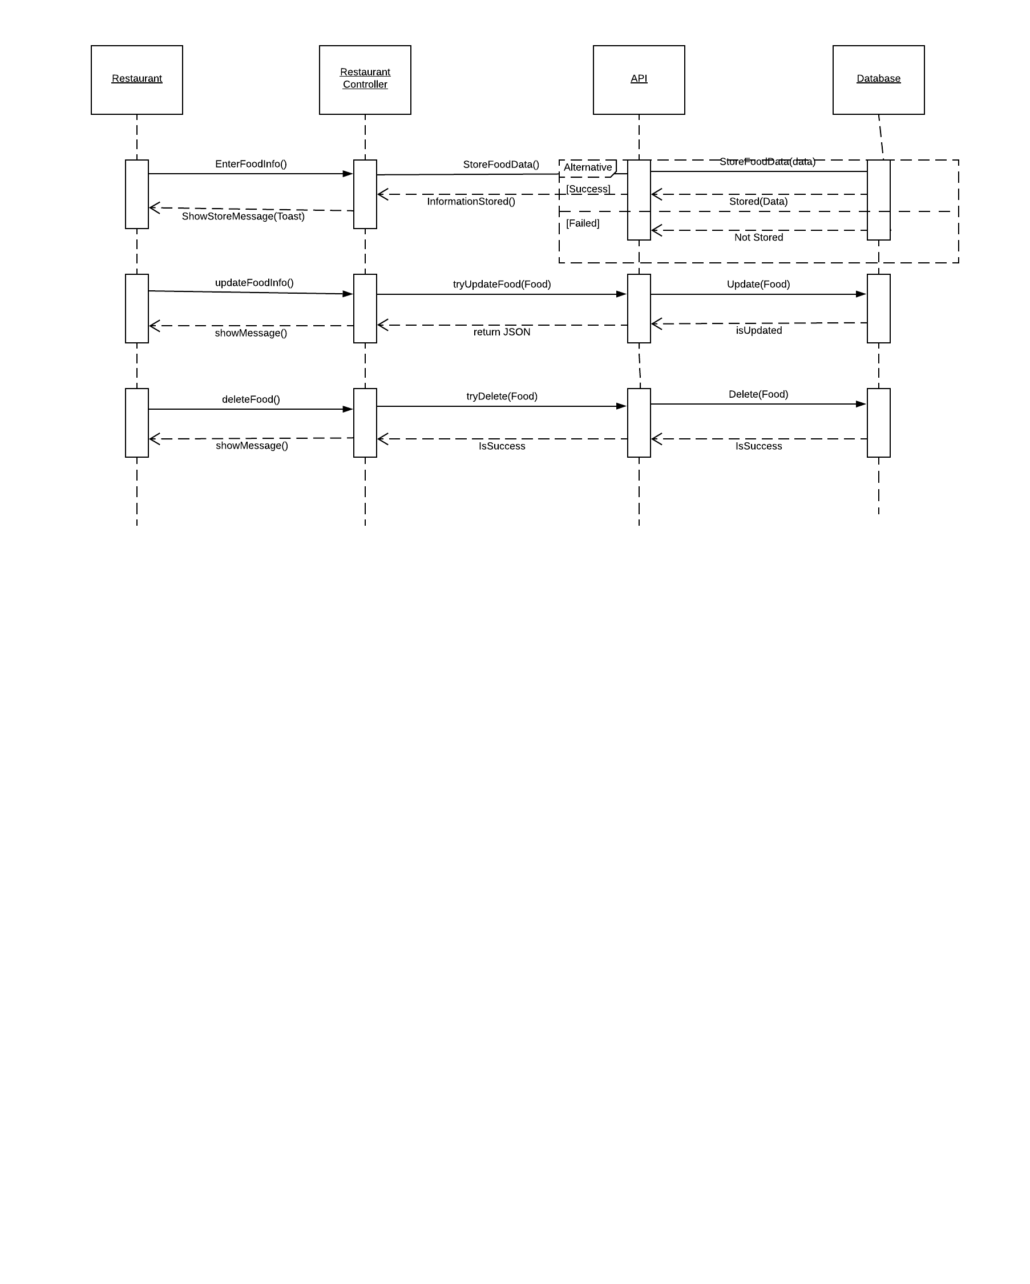

**4.3.4 Manage Table**

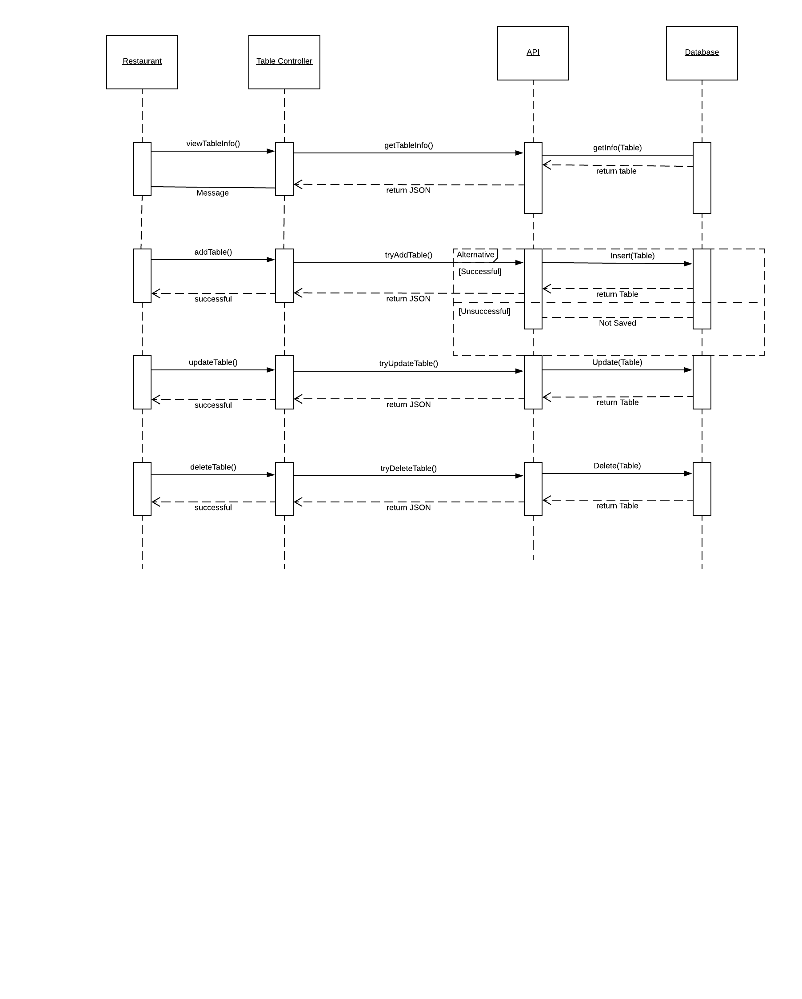

**4.3.5 Offer**

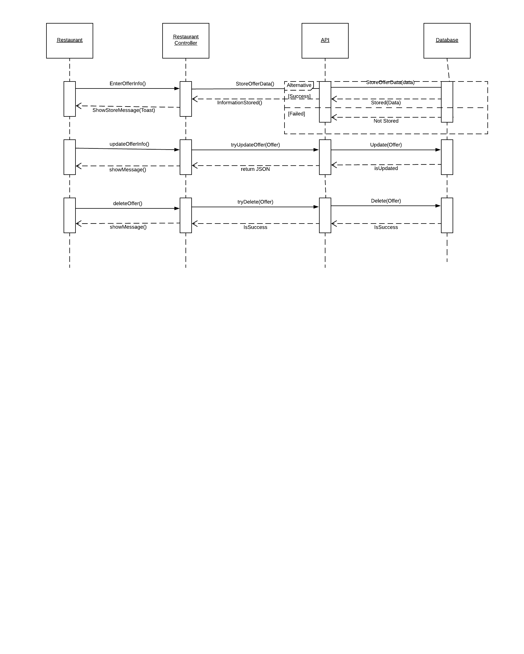

**4.3.6 Booking**

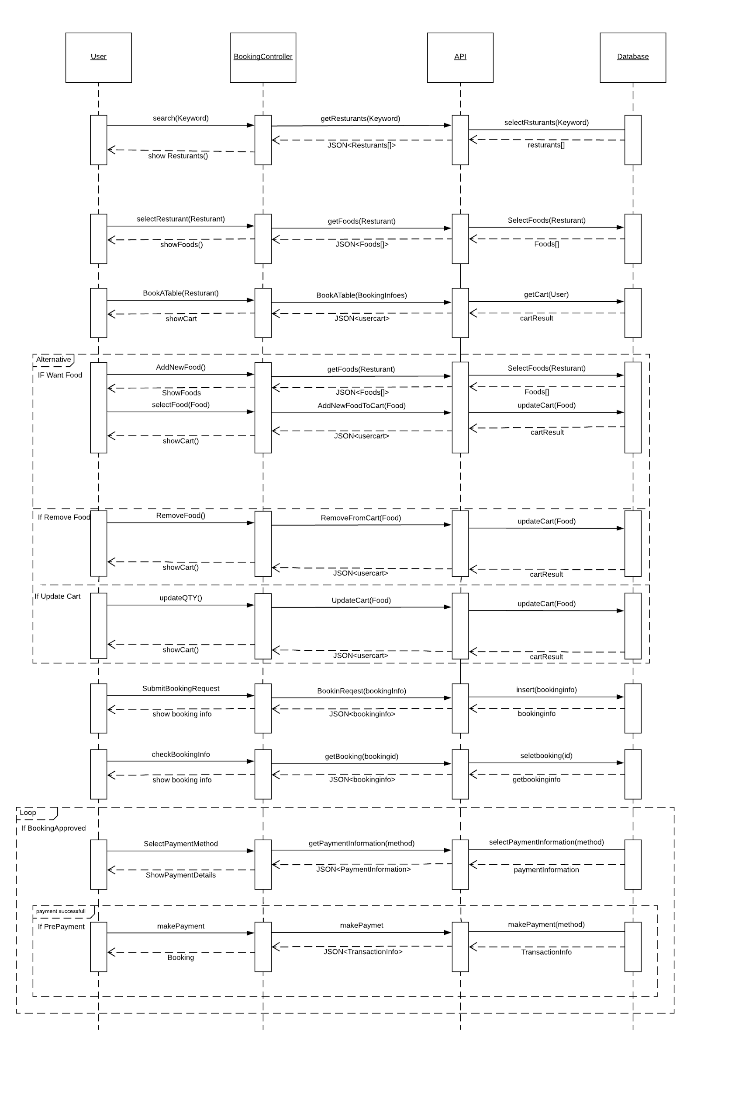

**4.4 Class Diagram**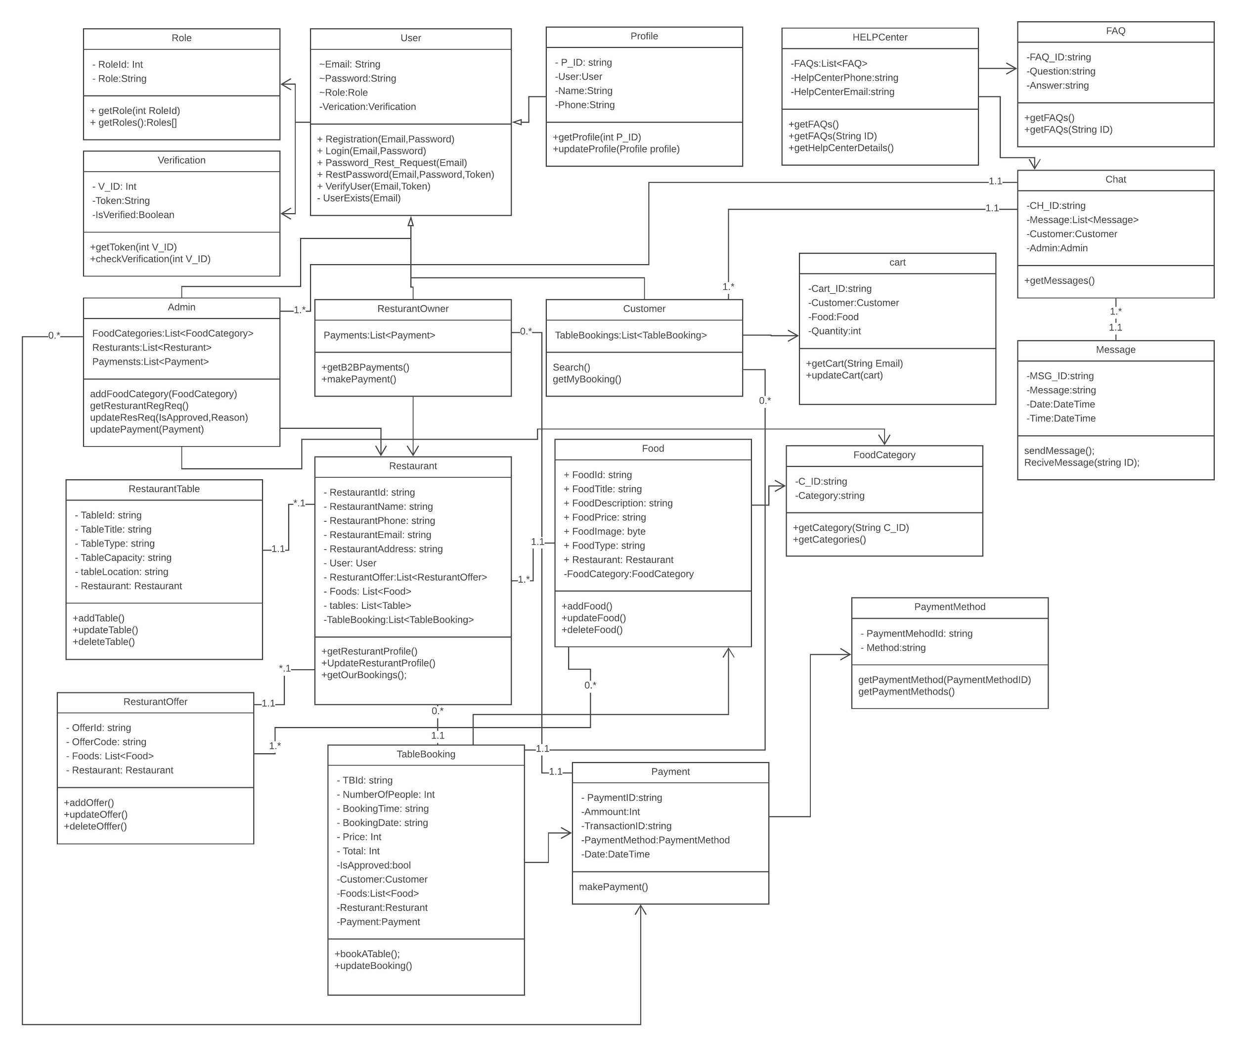

**4.5 System Architecture**

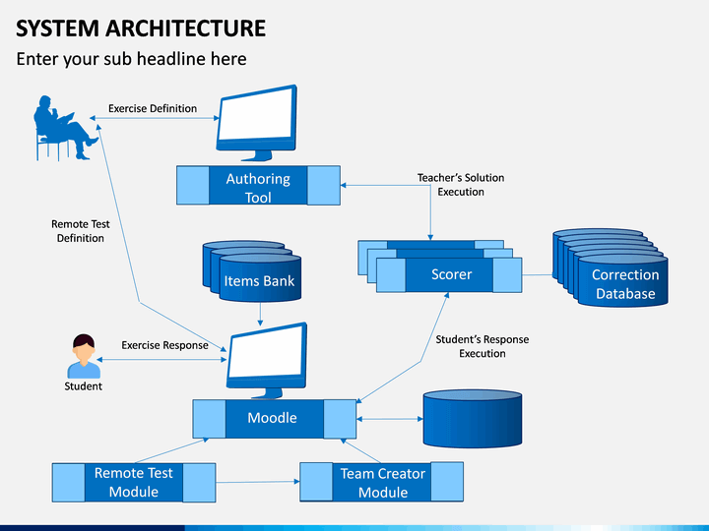

**4.6 Entity Relationship Diagram**

