PingFederate Complete Course

Module 3 — Authentication Building Blocks
Data stores, password credential validators, adapters, policy contracts, RADIUS & Kerberos, selectors, fragments and authentication policies — explained with diagrams and live screenshots from your own PingFederate server.

Item | Detail
Videos covered | PF 14 – PF 19 (8 videos, ~4 h 22 min)
Server | PingFederate 13.1.2 · admin console https://172.22.127.250:9999 · standalone (not clustered)
User directory | OpenDJ on the same VM · localhost:389 · base ou=limbosoft,dc=pingfed,dc=com
Screenshots | Captured with Playwright from your admin console on 29–30 Sep 2026. Sections 1–10: read-only. Section 11: RADIUS objects were created on purpose; demo screens were cancelled.
Updated | 30 Sep 2026 — added section 11 (RADIUS built and tested on the VM; Kerberos lab guide)
Diagrams | Drawn for this document from your actual configuration values.

⚠ Before you start: your licence has expired
The admin console shows "License Error: Expiration date passed on Sep 27 2026 — Transaction processing has stopped."
You can still configure everything in this module, but every runtime endpoint on port 9031 returns 503 until a new licence is installed, so logins cannot be tested. Request a new developer licence (video PF 08) and upload it under System → Server → License Management.
Contents
1. The big picture 4
Building blocks at a glance 4
Your lab directory (OpenDJ) 4
Finding your way around the console 5
2. Data store (PF 14) 7
Concept 7
Key settings 7
Your configuration 8
Lab notes 9
3. Password Credential Validator (PF 15) 10
Concept 10
PCV types available on your server 10
Key LDAP PCV settings 11
Your configuration 11
Troubleshooting: LDAP error 49 13
Hands-on 13
4. IdP adapter (PF 16 part 1) 14
Concept 14
The wizard tabs 14
Key HTML Form settings 14
Your configuration 15
Composite adapter 17
5. Authentication Policy Contract (PF 16 part 2) 19
Concept 19
Key points 19
Your configuration 19
6. RADIUS and Kerberos authentication (PF 16 part 3) 21
RADIUS 21
Kerberos 21
7. Authentication selectors (PF 17) 23
Concept 23
Selector types available on your server 23
Key points 24
Hands-on (after the licence is renewed) 24
8. Policy fragments (PF 18) 25
Concept 25
Fragment fields 25
9. Authentication policy tree (PF 19) 27
Concept 27
Page-level settings 27
Building a tree: node options 28
Proposed tree for your lab 28
Sessions (related screen) 28
10. Findings and next steps 30
Issues found on your server 30
Suggested build order 30
Quick revision 30
11. Module 3 leftovers: RADIUS hands-on and Kerberos lab guide 32
11.1 What was built 32
11.2 NPS concepts you need 33
11.3 How it was configured (commands) 33
11.4 Testing RADIUS directly (without PingFederate) 34
11.5 PingFederate side 35
11.6 Using RADIUS in an authentication policy 38
11.7 End-to-end test after the licence is renewed 39
11.8 Troubleshooting RADIUS 39
11.9 Kerberos lab guide 39

1. The big picture
Module 3 is about how PingFederate proves who a user is. Each video adds one building block. You configure them from the bottom up (the data store first), but at login time PingFederate executes them from the top down (the policy first).
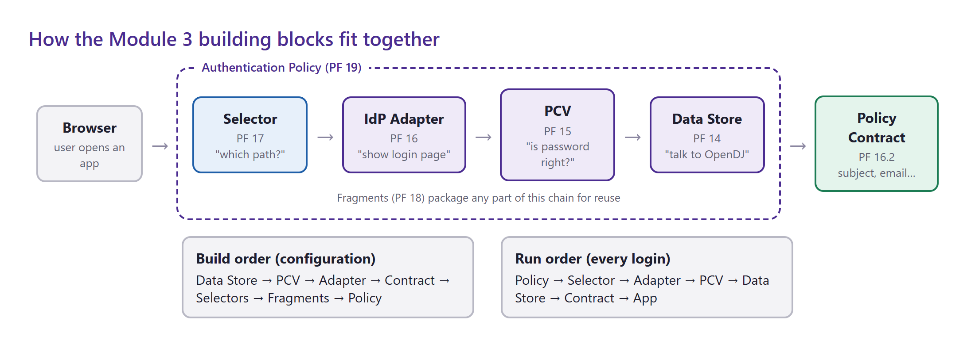
Figure 1 — The Module 3 chain. Blue = decision, purple = authentication, green = the standard output handed to applications.

Building blocks at a glance
Building block | Video | Console location | On your server | Status
Data store | PF 14 | System → Data & Credential Stores → Data Stores | pingfedopendj (LDAP) | ✅ Working
Password Credential Validator | PF 15 | System → Data & Credential Stores → Password Credential Validators | opendjpcv (LDAP), supcv (Simple) | ✅ Working
IdP adapter | PF 16.1 | Authentication → Integration → IdP Adapters | htmlformopendj, htmlformsimplepcv | ⚠ Attribute mapping bug
Composite adapter | PF 16.1 | Authentication → Integration → IdP Adapters | compositeldp | ⚠ Required + Required
Authentication Policy Contract | PF 16.2 | Authentication → Policies → Policy Contracts | pflearning | ✅ Created
RADIUS | PF 16.3 | System → … → Password Credential Validators | NPS on VM · radiuspcv · htmlformradius | ✅ Built (section 11)
Kerberos | PF 16.3 | System → AD Domains/Kerberos Realms | — | ⛔ Needs AD (guide in 11.9)
Selectors | PF 17 | Authentication → Policies → Selectors | — | ❌ None yet
Fragments | PF 18 | Authentication → Policies → Fragments | — | ❌ None yet
Authentication policy | PF 19 | Authentication → Policies → Policies | — (feature switched off) | ❌ Not built

Your lab directory (OpenDJ)
Read over LDAP from ou=limbosoft,dc=pingfed,dc=com. You will use these users and groups in every exercise.
Entry | Object class | Attributes present | Notes
cn=shahed | inetOrgPerson | cn, uid=ctzs, givenName, sn | member of insgc
cn=testa | inetOrgPerson | cn, uid=testa, givenName, sn | member of insgc
cn=testb | inetOrgPerson | cn, uid=testb, givenName, sn | member of todogc
cn=testc | inetOrgPerson | cn, uid=testc, givenName, sn | member of todogc
cn=insgc | groupOfNames | member: testa, shahed | group — useful for rules / isMemberOf
cn=todogc | groupOfNames | member: testb, testc | group

Observation
None of the users has a mail attribute. Anything that maps "email" will be empty until you add mail values in OpenDJ.

Finding your way around the console
PingFederate 13 groups Module 3 screens under two top-level menus. System holds the shared plumbing (data stores, validators); Authentication holds the login logic (adapters, policies, selectors, fragments, contracts).
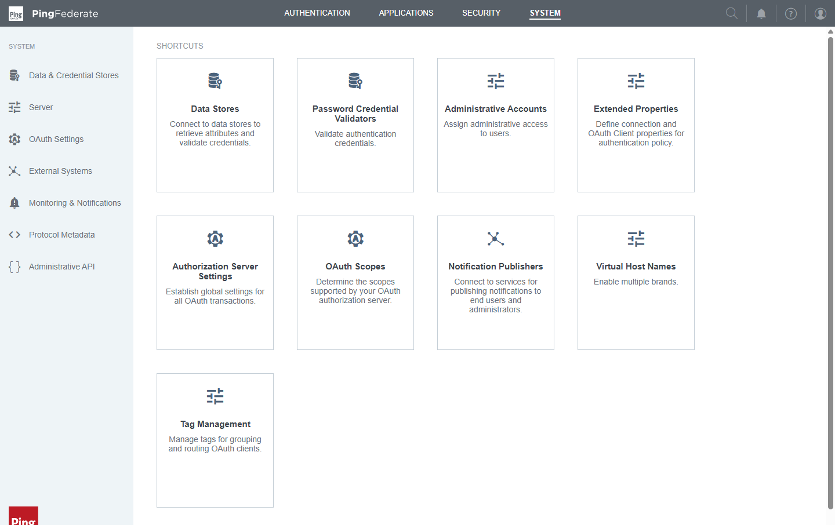
Figure 2 — System menu — Data Stores and Password Credential Validators live here.
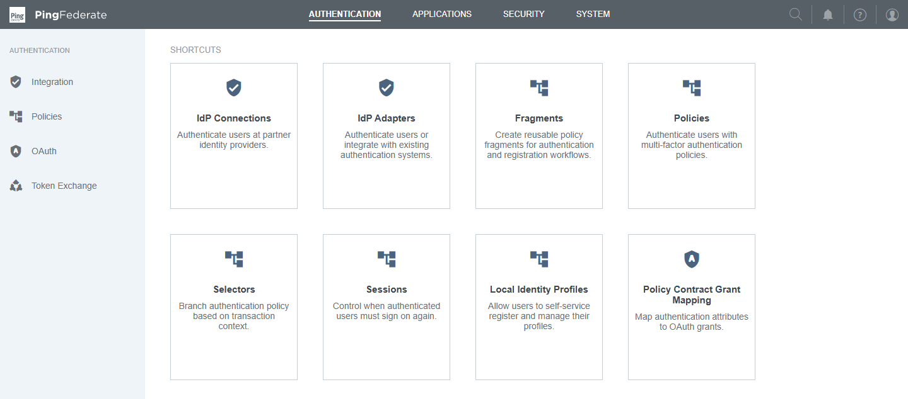
Figure 3 — Authentication menu — IdP Adapters, Policies, Selectors, Fragments, Sessions.

2. Data store (PF 14)
Course video: PF 14 — Datastore configuration (15:45)

Concept
A data store is a saved, pooled connection to a place where user information lives — an LDAP directory (OpenDJ, Active Directory, PingDirectory), a JDBC database, or a custom source. You define it once, and every other component references it by name instead of repeating hostnames and passwords.
- Why it exists: one place to change a hostname, password, TLS setting or pool size.
- Used by: LDAP password validators (to check passwords) and attribute sources (to fetch extra attributes such as email or group membership) in adapters, contracts, SP connections and OAuth mappings.
- Connection pool: PingFederate keeps between Minimum and Maximum connections open, so each login does not pay the cost of a new TCP + bind.
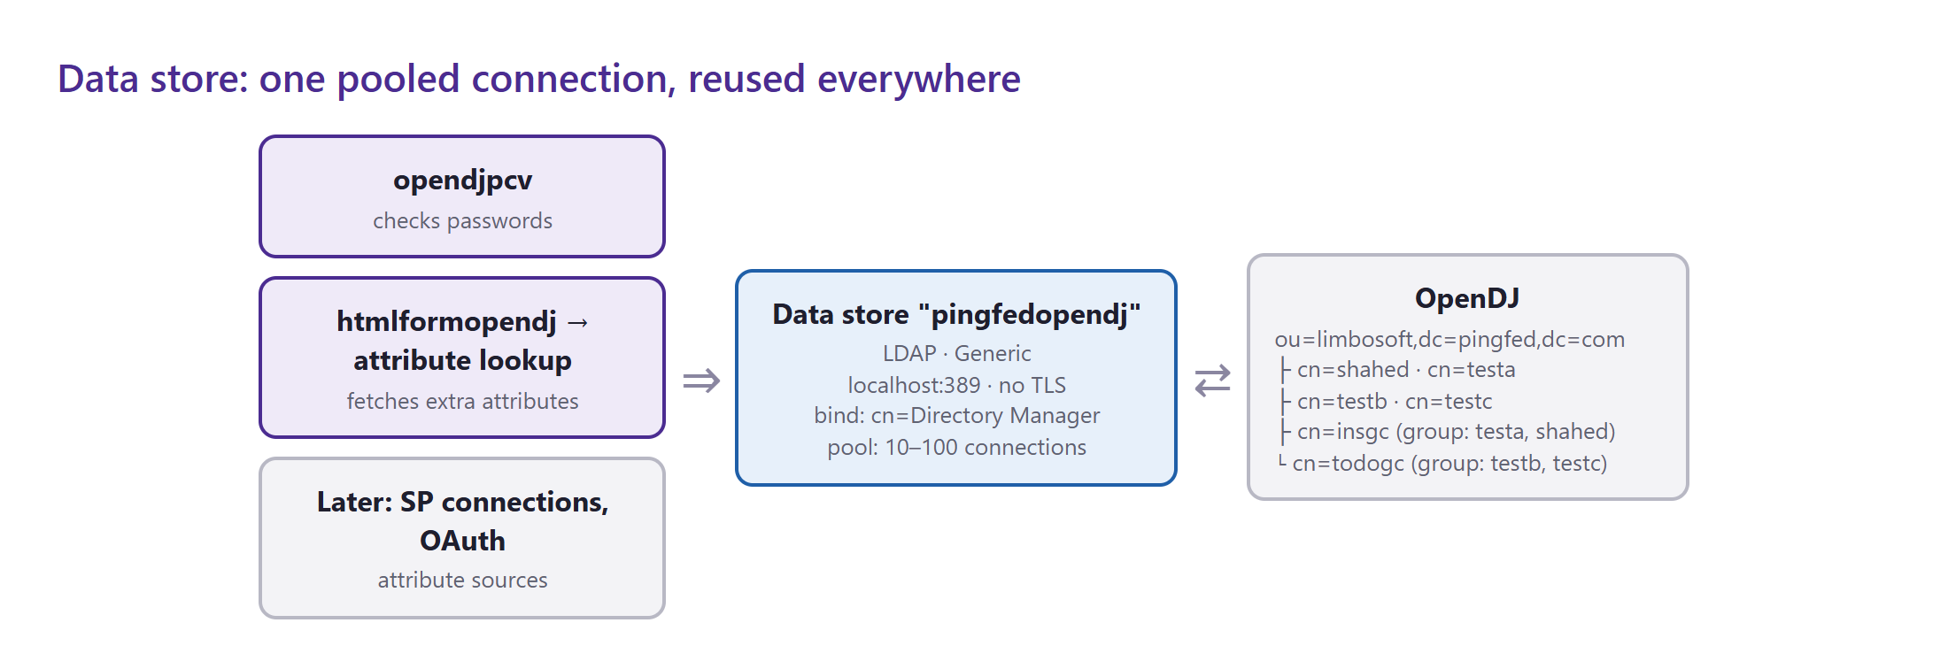
Figure 4 — One data store serves many consumers; it is the only component that talks to OpenDJ directly.
Where in the console: System → Data & Credential Stores → Data Stores

Key settings
Setting | What it means | Your value
Hostname(s) | host:port of the directory; several for fail-over, tags for per-region routing | localhost:389
LDAP Type | Generic, Active Directory, PingDirectory, Oracle… — sets vendor defaults (e.g. memberOf handling) | Generic
Connection Security | None, LDAPS (636) or StartTLS | None
Authentication Method / User DN | The service account PingFederate binds with to search | Simple · cn=Directory Manager
Min / Max Connections | Size of the connection pool | 10 / 100
Test Connection on Borrow / Return | Validate pooled connections before/after use (safer, slightly slower) | false / false
Read / Connection Timeout | How long to wait for the directory | 3000 ms / 3000 ms
Mask Values in Log | Hide attribute values in server logs | false

Your configuration
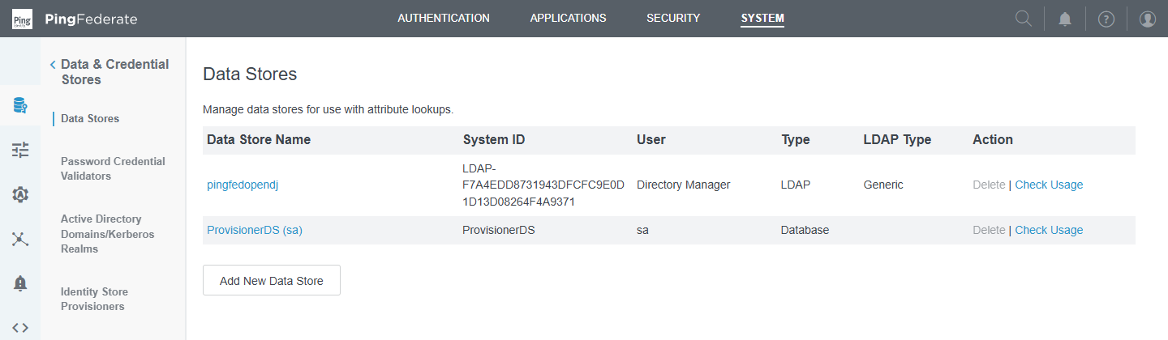
Figure 5 — Data Stores list — pingfedopendj (LDAP) plus the built-in ProvisionerDS (HSQLDB).
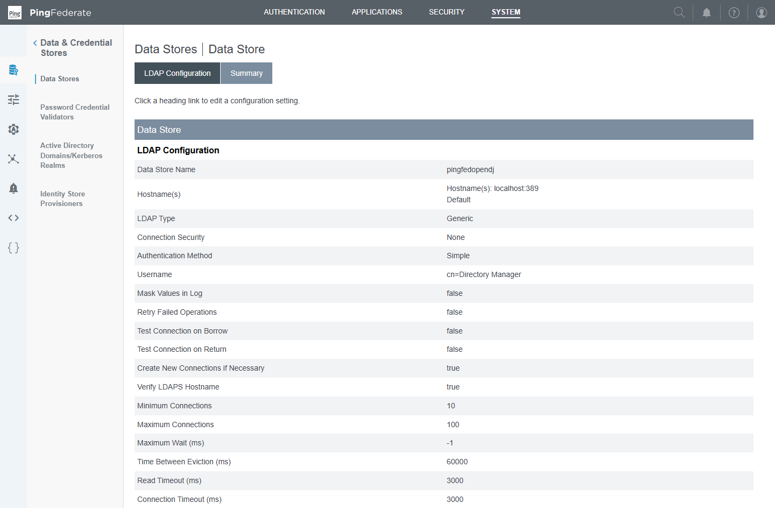
Figure 6 — Summary of pingfedopendj — every setting on one page.
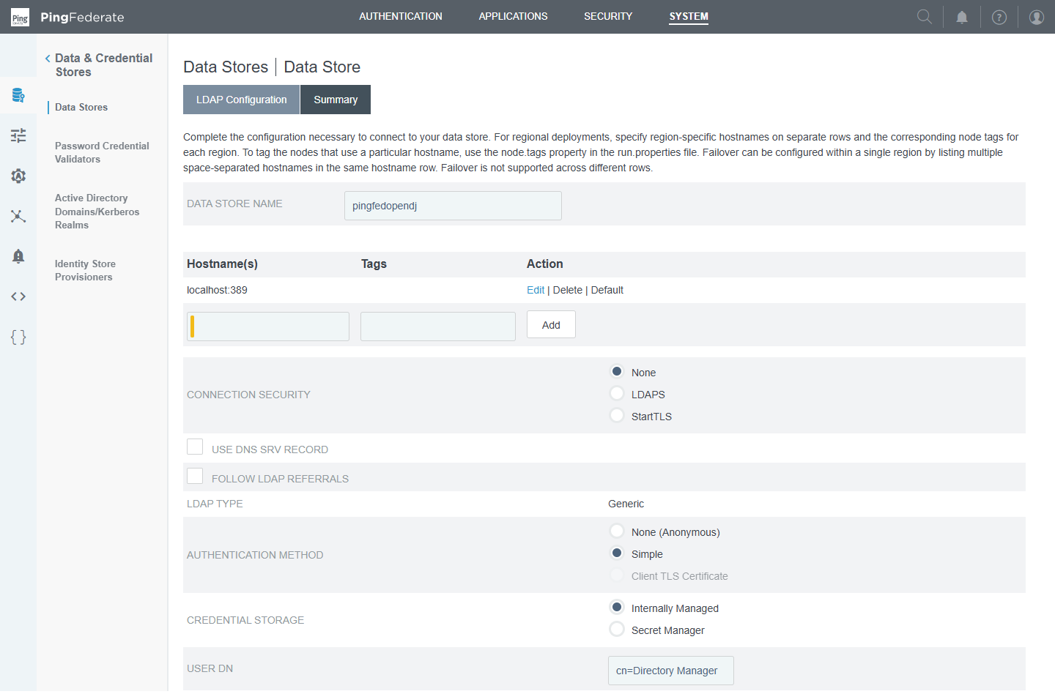
Figure 7 — LDAP Configuration tab — hostnames, connection security, LDAP type and bind account.

Lab notes
- ✅ Works: PingFederate tests the connection when you save, so the host and credentials are correct.
- ⚠ Best practice: binding as cn=Directory Manager (the root account) is fine for a lab only. In production create a read-only service account (e.g. cn=pf-svc,ou=services,…) and use LDAPS.
- Tip: the Check Usage link on the list shows every component that depends on the data store — use it before deleting or changing one.

Check yourself
- Why does PingFederate keep a pool of LDAP connections instead of opening one per login?
- Which component actually checks passwords — the data store or the PCV?

3. Password Credential Validator (PF 15)
Course video: PF 15 — Password Credential Validator configuration (26:48)

Concept
A Password Credential Validator (PCV) answers one question: "Is this username and password correct?" It has no user interface. HTML Form adapters, the OAuth Resource Owner Password grant, the WS-Trust STS and the Authentication API all call PCVs.
The LDAP PCV never reads the password from the directory. It first searches for the user with the data-store account, then tries to bind as that user with the typed password. Only the directory decides whether the bind succeeds.
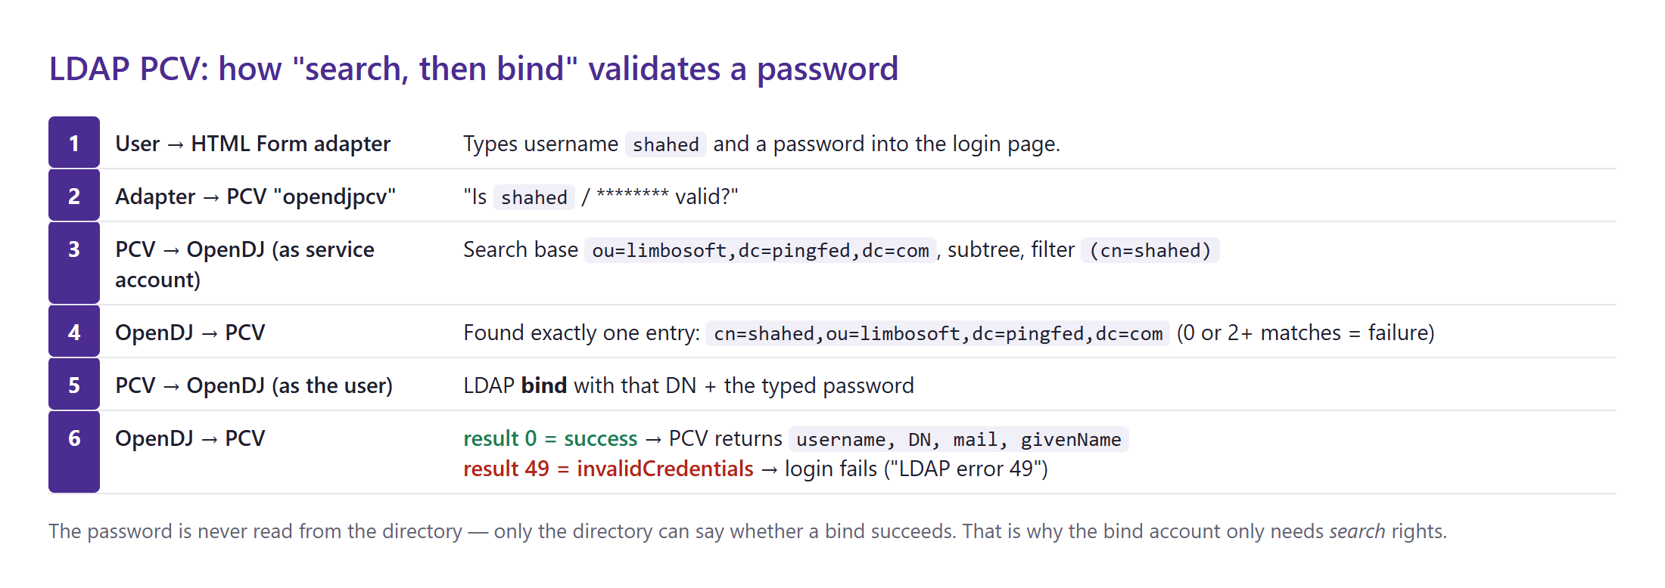
Figure 8 — The LDAP PCV search-then-bind sequence, with your real search base and filter.
Where in the console: System → Data & Credential Stores → Password Credential Validators

PCV types available on your server
Type | Use it for
LDAP Username Password Credential Validator | Directory users (OpenDJ, AD, PingDirectory) — the one you use most
Simple Username Password Credential Validator | A small local user list stored in PingFederate — labs, break-glass accounts
RADIUS Username Password Credential Validator | Sends credentials/OTP to a RADIUS server (MFA tokens) — see section 6
PingID PCV (with integrated RADIUS server) | PingID MFA for VPNs and RADIUS clients
PingOne Password Credential Validator | Users stored in PingOne (cloud directory)
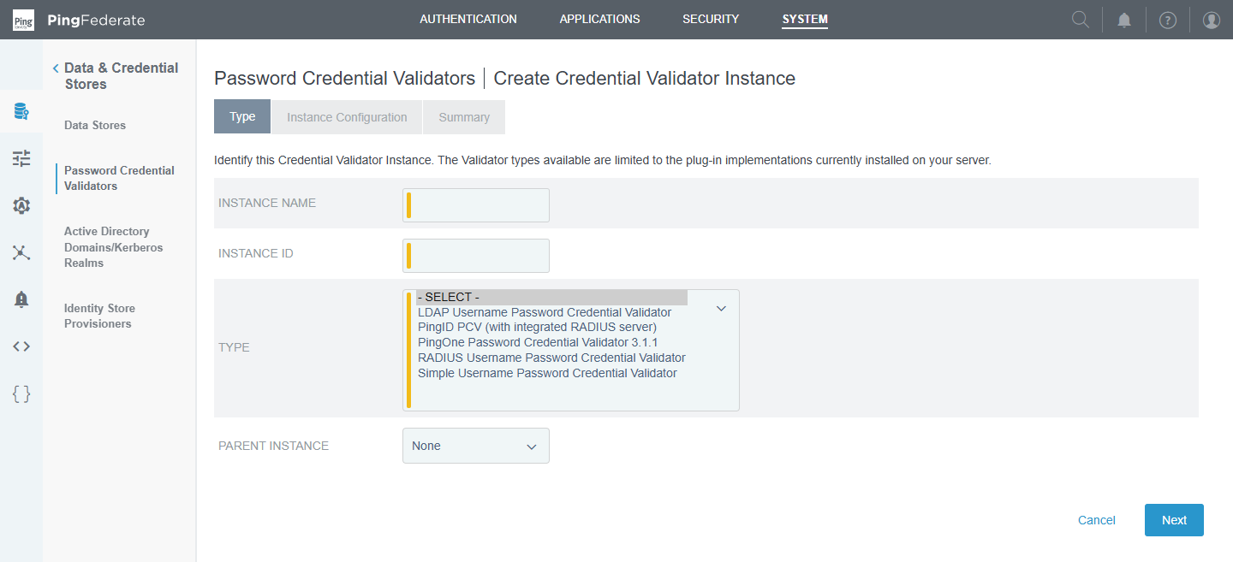
Figure 9 — Create Credential Validator Instance → Type: the five PCV plug-ins installed on your server.

Key LDAP PCV settings
Setting | What it means | opendjpcv
LDAP Datastore | Which data store to search and bind against | pingfedopendj
Search Base | Where in the tree to look for users | ou=limbosoft,dc=pingfed,dc=com
Search Filter | How the typed username becomes an LDAP filter — ${username} is replaced at runtime | cn=${username}
Scope of Search | One Level (direct children) or Subtree (all levels) | Subtree
Case-Sensitive Matching | Whether "Shahed" and "shahed" are treated differently in error matching | true
Display Name / Mail Attribute | Attributes used for display and password-reset e-mails | displayName / mail
Authentication Error Overrides | Map LDAP error text (e.g. AD sub-code 775 = locked) to friendly messages | none
Extended Contract | Extra attributes the PCV returns after success | DN, givenName, mail, username

Your configuration
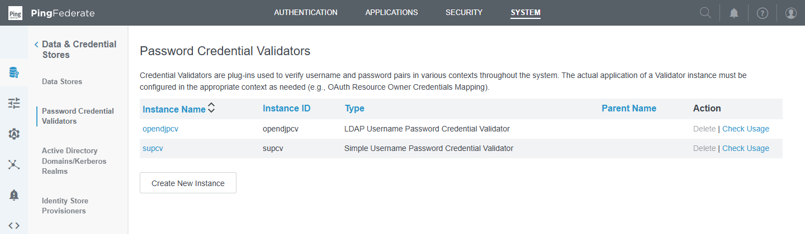
Figure 10 — Two validators: opendjpcv (LDAP) and supcv (Simple).
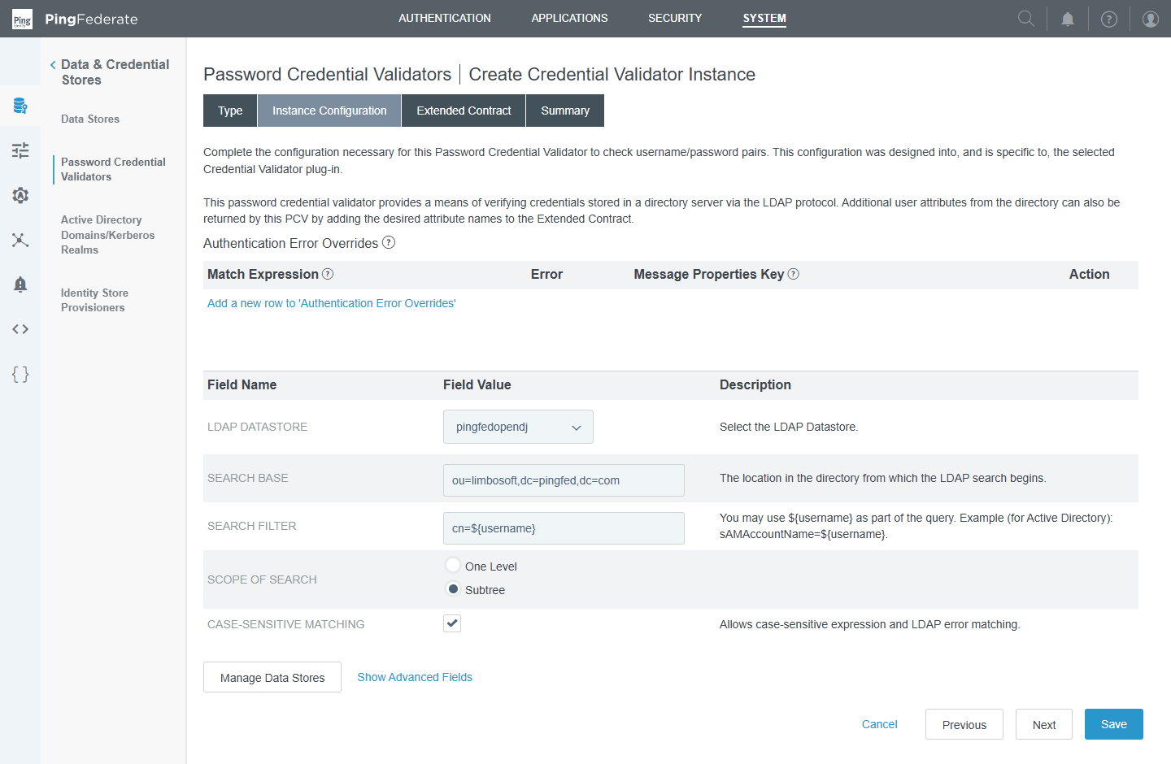
Figure 11 — opendjpcv → Instance Configuration: data store, search base, filter and scope.
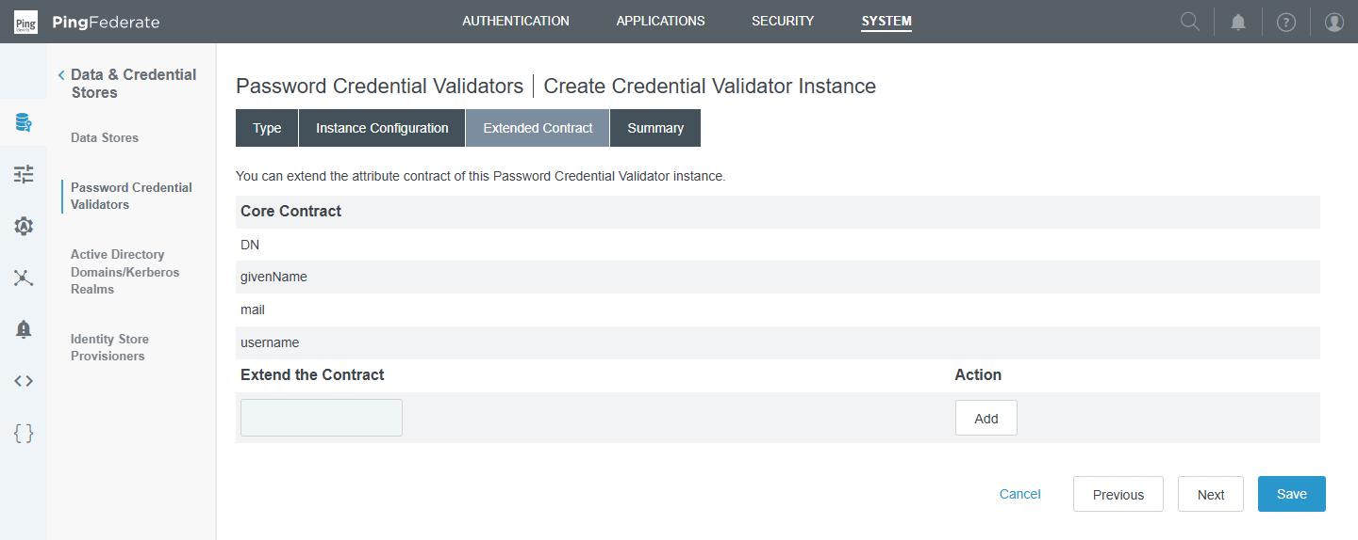
Figure 12 — opendjpcv → Extended Contract: DN, givenName, mail, username are returned on success.
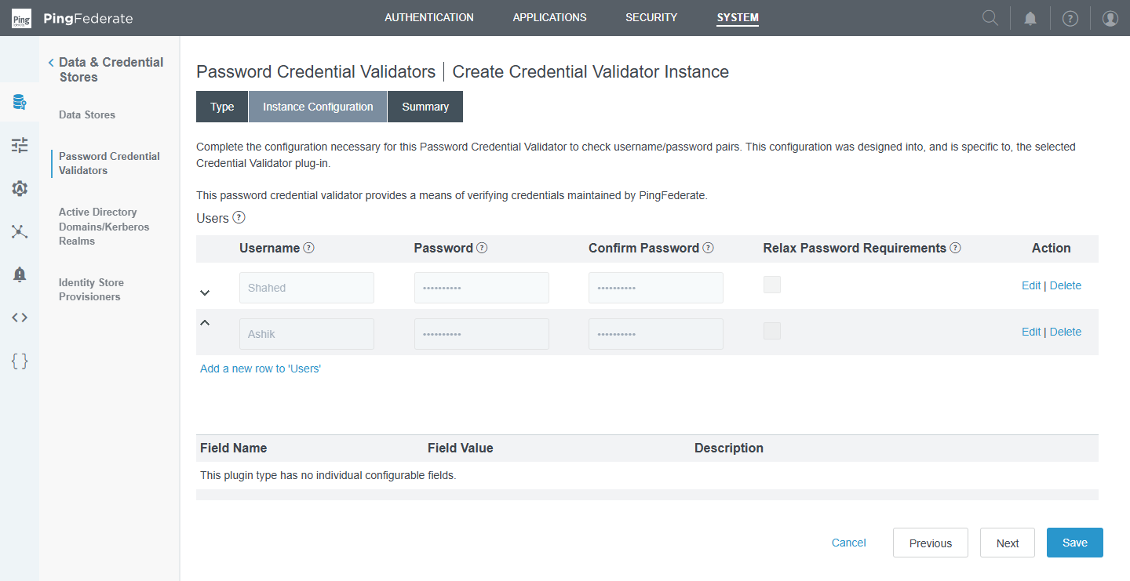
Figure 13 — supcv → Instance Configuration: local users (Shahed, Ashik) with hidden passwords.

Troubleshooting: LDAP error 49
Error 49 = invalidCredentials. You see it in server.log when the bind fails. Common causes: wrong password, the filter found the wrong user, the account is locked or disabled, or (for the data store itself) the service-account password changed. Active Directory adds sub-codes such as 525 (user not found), 52e (bad password), 775 (locked).

Hands-on
- Change the search filter to (|(cn=${username})(uid=${username})) so users can log in with either shahed or ctzs.
- Add sn to the Extended Contract so the surname flows to later steps.
- After the licence is renewed, log in with a wrong password and find the error 49 entry in <pf_install>/pingfederate/log/server.log.

4. IdP adapter (PF 16 part 1)
Course video: PF 16 part 1 — Adapter Configuration (1:39:28)

Concept
An IdP adapter is how the user proves who they are. The HTML Form adapter shows the login page and passes the typed credentials to one or more PCVs. Other adapters handle Kerberos, X.509 certificates, identifier-first, or MFA products (PingID, PingOne MFA…).
An adapter does three jobs: authenticate (via its PCVs), manage a session (so the user is not asked again), and produce attributes (its contract) for the rest of the policy.
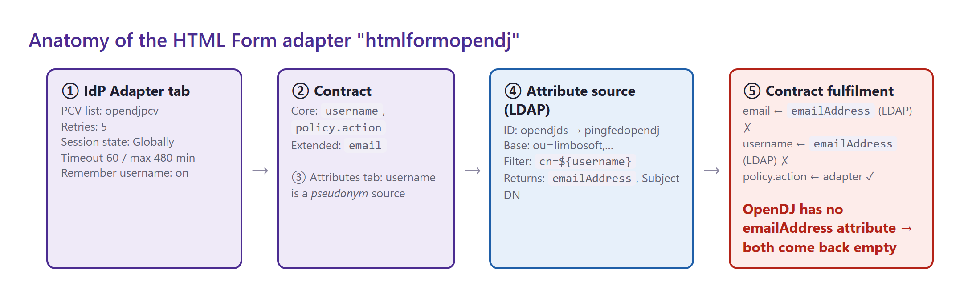
Figure 14 — The five parts of htmlformopendj — and the mapping bug in step ⑤.
Where in the console: Authentication → Integration → IdP Adapters

The wizard tabs
Tab | What you configure
Type | Instance name/ID and the adapter plug-in (e.g. HTML Form IdP Adapter)
IdP Adapter | Instance settings: PCVs, retries, session state/timeouts, templates, password change & reset, "remember my username"
Extended Contract | Attributes beyond the core username / policy.action (you added email)
Adapter Attributes | Which attribute is the pseudonym source (stable user key) and which values are masked in logs
Adapter Contract Mapping | Optional: attribute sources (LDAP/JDBC lookups), contract fulfilment (where each attribute comes from) and issuance criteria
Summary | Review and Save

Key HTML Form settings
Setting | Meaning | htmlformopendj
Credential Validators | PCVs tried in order | opendjpcv
Challenge Retries | Failed attempts before lock-out (per adapter) | 5
Session State | Globally: one session shared with other adapters · Per Adapter: its own session · None: always prompt | Globally
Session Timeout / Max Timeout | Idle and absolute session length (minutes) | 60 / 480
Enable 'Remember My Username' | Cookie pre-fills the username | true
Enable 'This is My Device' | Longer sessions on trusted devices | true
Password Reset Type | None, e-mail link, OTP, PingID… | None
Login Template | Velocity template for the page (customisable in server/default/conf/template) | html.form.login.template.html

Your configuration
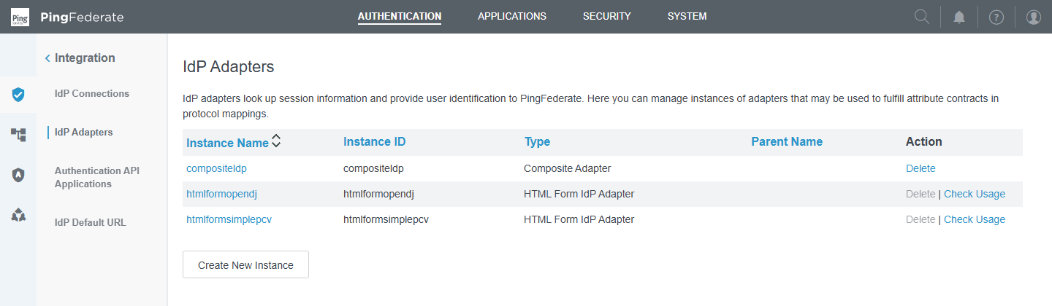
Figure 15 — Three adapter instances: compositeldp, htmlformopendj, htmlformsimplepcv.
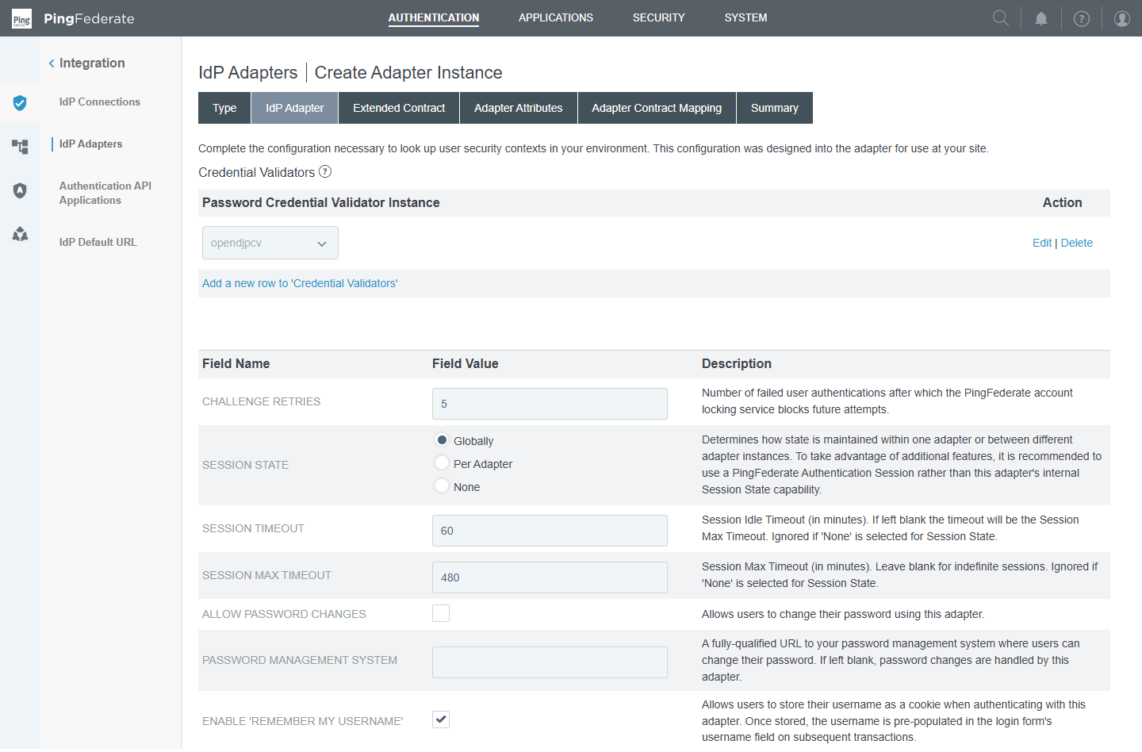
Figure 16 — htmlformopendj → IdP Adapter tab: PCV list, retries, session state and timeouts.
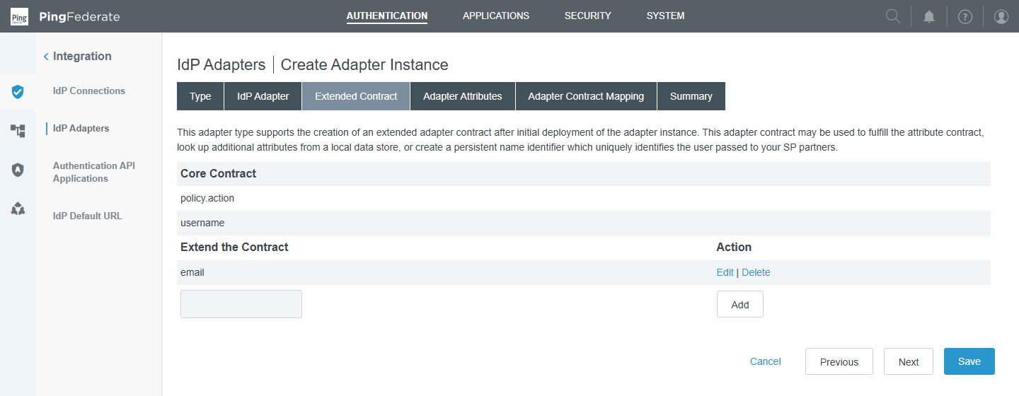
Figure 17 — Extended Contract: core policy.action + username, extended email.
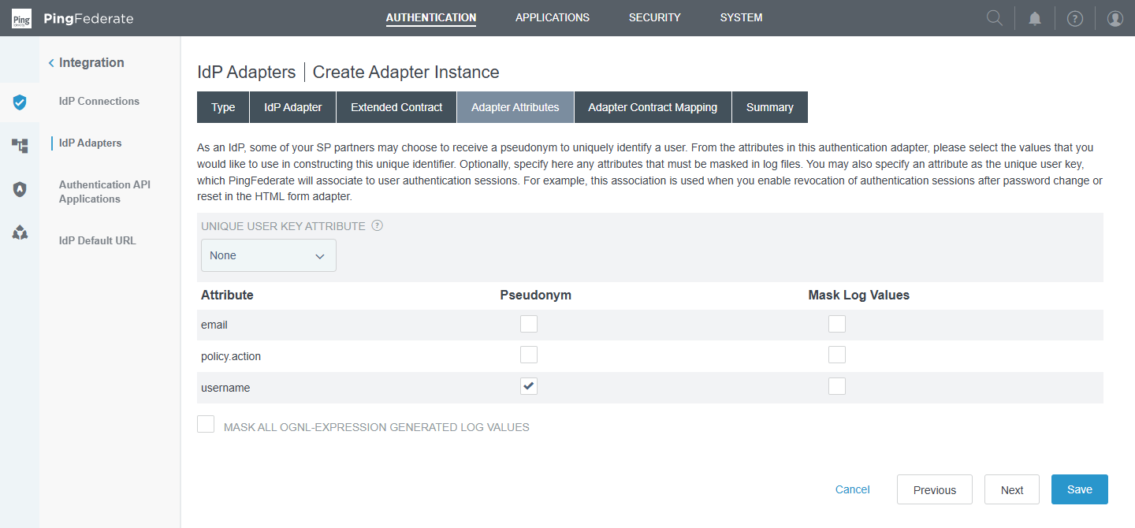
Figure 18 — Adapter Attributes: username is the pseudonym source.
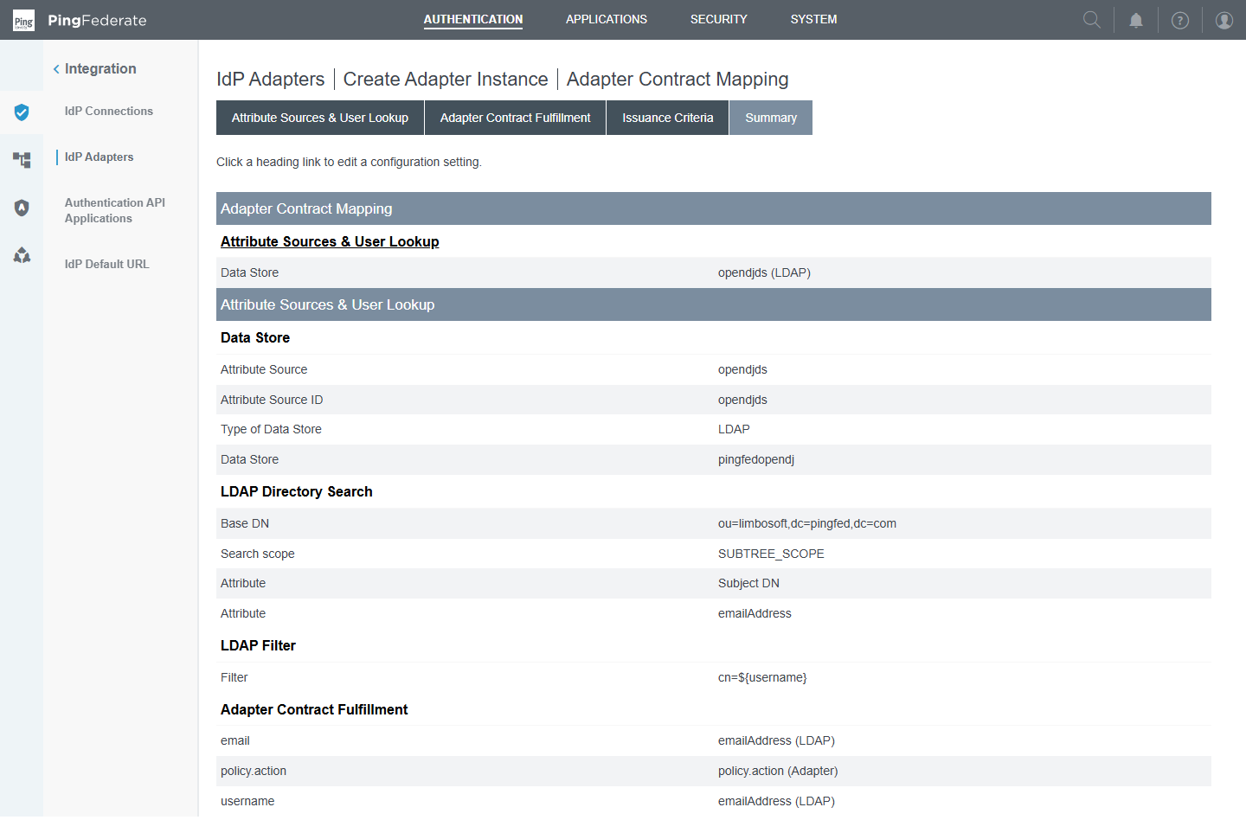
Figure 19 — Adapter Contract Mapping summary — the LDAP lookup returns emailAddress, and both email and username are mapped from it.
⚠ Bug found in your configuration
The attribute source opendjds asks OpenDJ for emailAddress, and contract fulfilment maps both email and username from it.
OpenDJ (inetOrgPerson) has no emailAddress attribute — the standard one is mail — and your users have no mail value anyway. Result: email and username come back empty after a successful password check, which breaks the contract and anything that uses the user key.
Fix: map username from Adapter → username; map email from LDAP → mail; add mail values to your OpenDJ users.

Composite adapter
A composite adapter chains several adapters inside one authentication step. Each child is Required (must succeed) or Sufficient (success ends the chain). "Input User ID Mapping" passes the username from one adapter to the next; "Attribute Name Synonyms" merges attributes with different names.
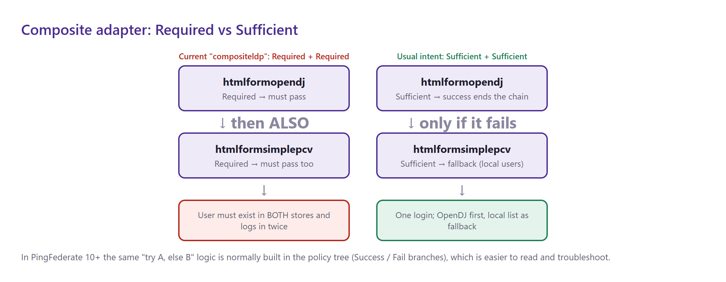
Figure 20 — Required + Required forces two logins; Sufficient + Sufficient gives "OpenDJ first, local list as fallback".
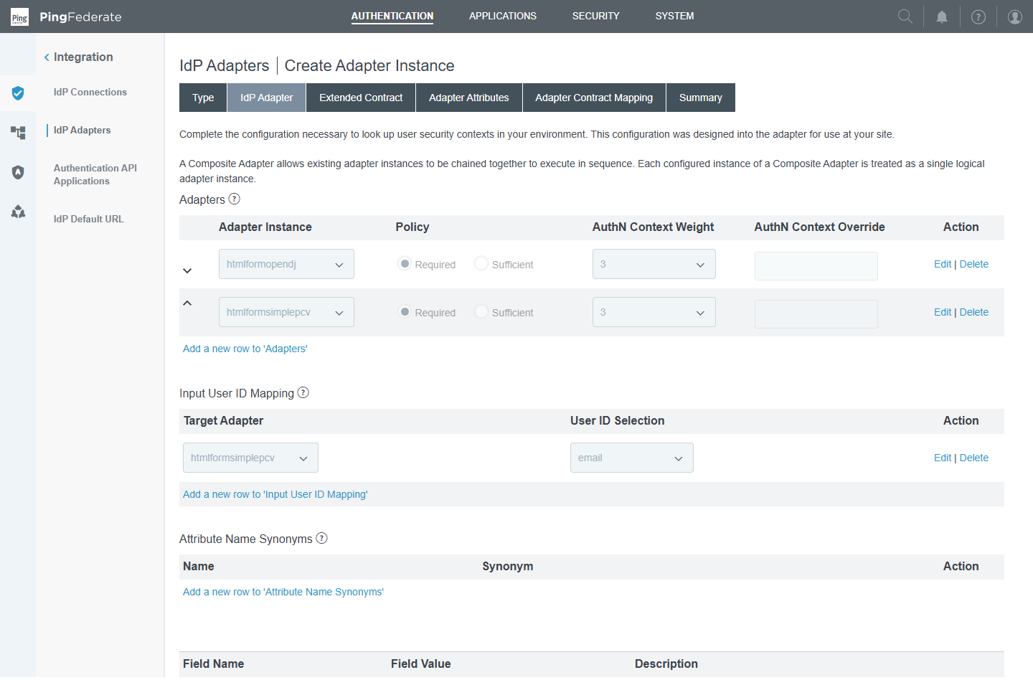
Figure 21 — compositeldp: both children set to Required, and email used as the input user ID for htmlformsimplepcv.
⚠ Probably not what you intended
With both children Required, a user must exist in OpenDJ and in the local list, and log in twice. The input-user-ID mapping passes email (currently empty) to the second adapter.
For a fallback, set both to Sufficient — or, better in PingFederate 10+, drop the composite adapter and build the fallback with Success/Fail branches in a policy tree (section 9).

5. Authentication Policy Contract (PF 16 part 2)
Course video: PF 16 part 2 — Authentication Policy Contract Configuration (14:34)

Concept
An Authentication Policy Contract (APC) is the standard "bag of attributes" produced at the end of a successful policy path. It always contains subject (the user identifier) and any extended attributes you define.
It decouples authentication from applications: adapters feed the contract, and applications (SAML SP connections, OAuth grant mappings, OIDC) read the contract. Swap or add authentication methods and no application connection has to change.
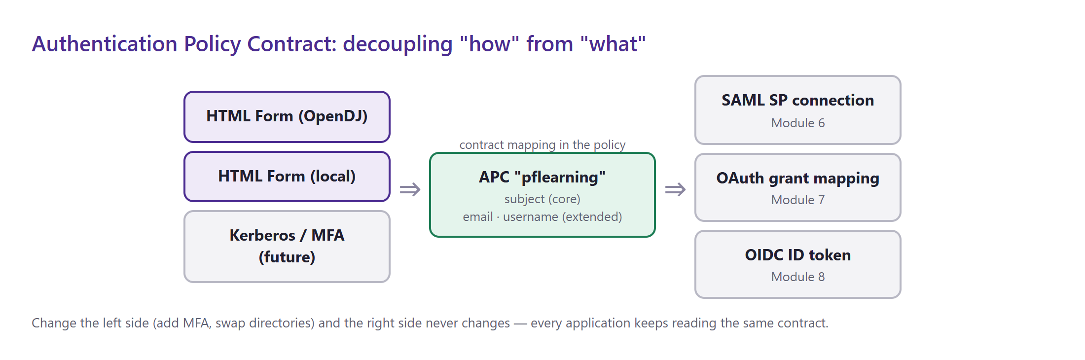
Figure 22 — Many authentication sources → one contract → many applications.
Where in the console: Authentication → Policies → Policy Contracts

Key points
- subject is mandatory and cannot be removed — map it to a stable, unique value (usually username or DN).
- The contract itself only declares attributes; values are filled in by contract mapping at the end of each policy path (section 9), optionally with extra LDAP lookups and issuance criteria.
- Downstream, you map the APC to SAML assertions (Module 6) and to OAuth persistent grants (Module 7) with "Policy Contract Grant Mapping".

Your configuration
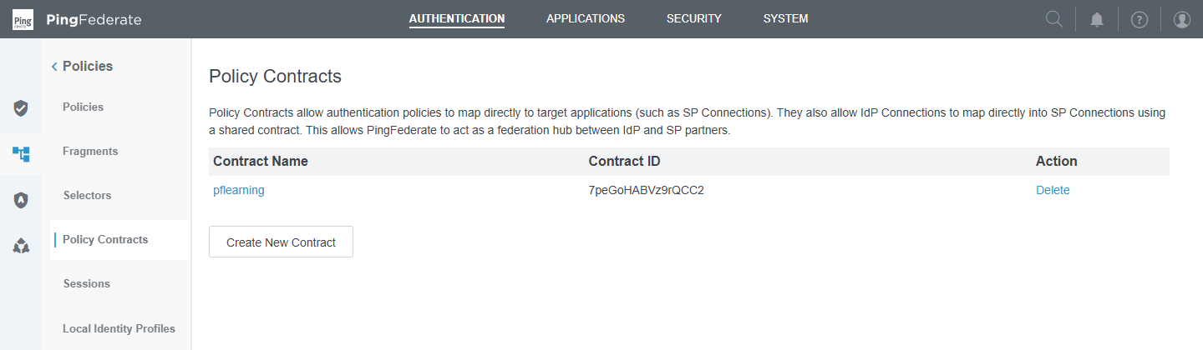
Figure 23 — Policy Contracts list — pflearning.
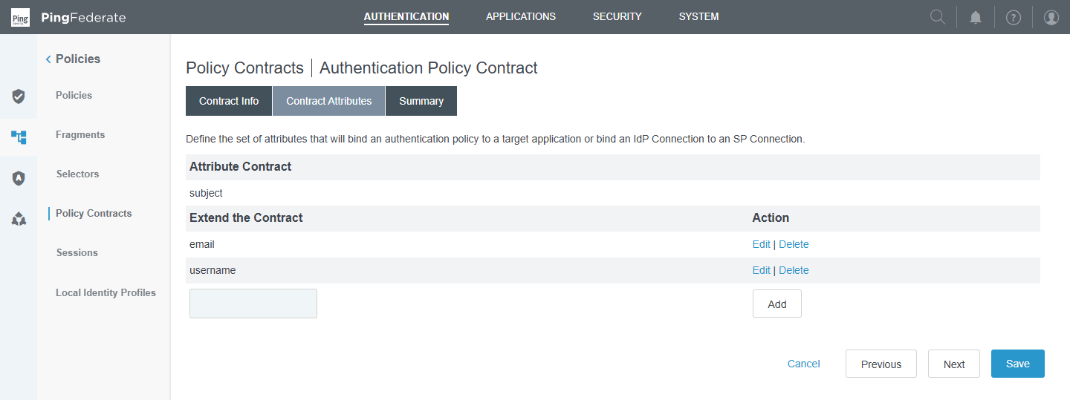
Figure 24 — pflearning → Contract Attributes: subject (core), email and username (extended).

6. RADIUS and Kerberos authentication (PF 16 part 3)
Course video: PF 16 part 3 — Radius and Kerberos Authentication (23:41)

RADIUS
RADIUS is a network authentication protocol (UDP 1812) used by VPNs and MFA/token systems. In PingFederate it is a PCV type: the HTML Form adapter collects username + password/OTP and the RADIUS PCV forwards them to the RADIUS server, which answers Access-Accept or Access-Reject.
- Configure: server host/port, shared secret, timeout, NAS identifier, and the authentication protocol (PAP/CHAP/MSCHAP).
- Typical use: second factor with a hardware or soft token, or reuse of an existing VPN MFA server.

Kerberos
Kerberos provides silent Windows desktop SSO (Integrated Windows Authentication). A domain-joined PC already holds a Kerberos ticket; the browser presents a service ticket for HTTP/<pingfederate-host> and the Kerberos adapter validates it — the user sees no login page.
- Configure first: System → Data & Credential Stores → Active Directory Domains/Kerberos Realms (domain, KDC, service account).
- Requires: an Active Directory domain, a service account with an SPN (setspn -S HTTP/pf.example.com svc-pf), and browsers configured to trust the PingFederate URL as an intranet site.
- Typical policy: try Kerberos first; on Fail fall back to the HTML form (for non-domain devices).
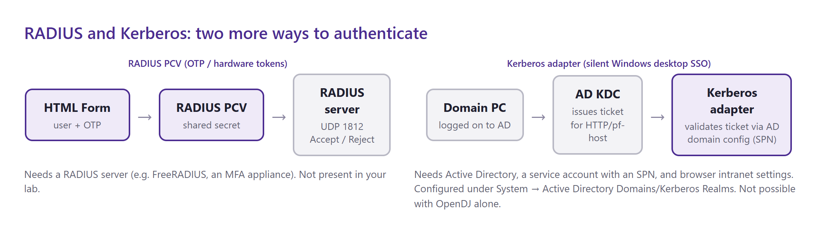
Figure 25 — RADIUS is a credential validator; Kerberos is an adapter backed by Active Directory.
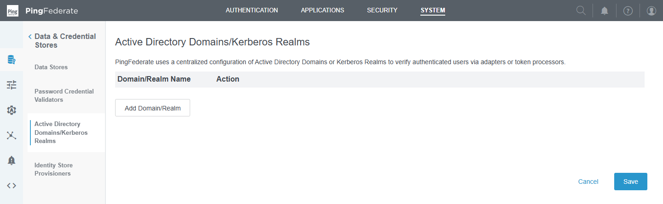
Figure 26 — Active Directory Domains/Kerberos Realms — empty on your server (no AD in the lab).
Update — now hands-on (section 11)
RADIUS: a Windows NPS server was installed on your VM and connected to PingFederate (radiuspcv, htmlformradius), and tested — see section 11.
Kerberos: still needs an Active Directory domain; section 11.9 has the complete lab guide.

7. Authentication selectors (PF 17)
Course video: PF 17 — Authentication Selector Configuration (45:12)

Concept
A selector is an if/else decision point in a policy tree. It inspects the incoming request and chooses which branch to follow. It never authenticates anyone — it decides how the user will be authenticated.
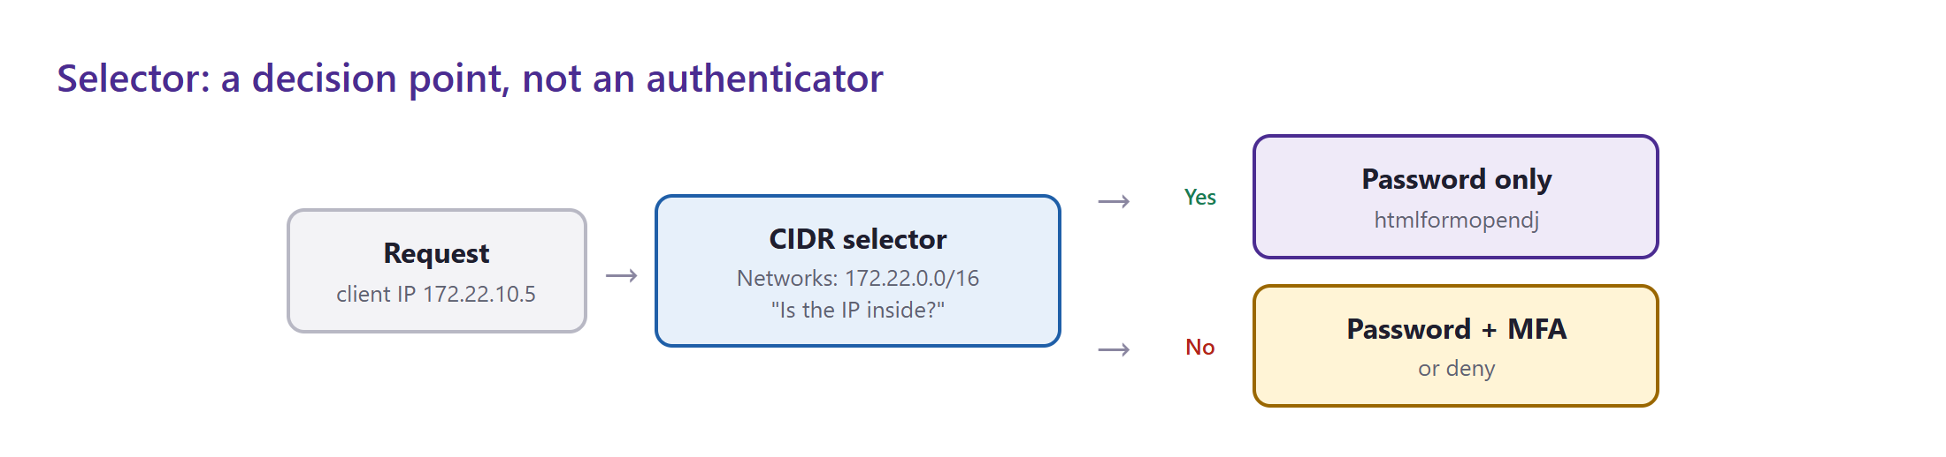
Figure 27 — A CIDR selector sends internal users to password-only login and everyone else to MFA (or deny).
Where in the console: Authentication → Policies → Selectors

Selector types available on your server
Selector | Decides based on | Typical use
CIDR | Client IP address range | Office network vs internet
Cluster Node | Which engine node handled the request | Per-datacentre behaviour
Connection Set (CSAS) | Which SP connection is asking | App A → form login, app B → MFA
Extended Property | Custom property values tagged on connections/clients | Tag apps as risk=high
HTTP Header | Value of a request header | Traffic from a specific proxy
HTTP Request Parameter | Value of a query/form parameter | ?login=local chooses the local user list
OAuth Client Set | Which OAuth client is asking | Same as CSAS, for OAuth
OAuth Scope | Requested OAuth scopes | admin scope requires stronger auth
Requested AuthN Context | AuthnContextClassRef/acr_values requested by the app | App explicitly asks for MFA
Session | Whether an authentication session already exists | Skip steps for returning users
Tag | Tags on virtual host names / sites | Multi-brand deployments
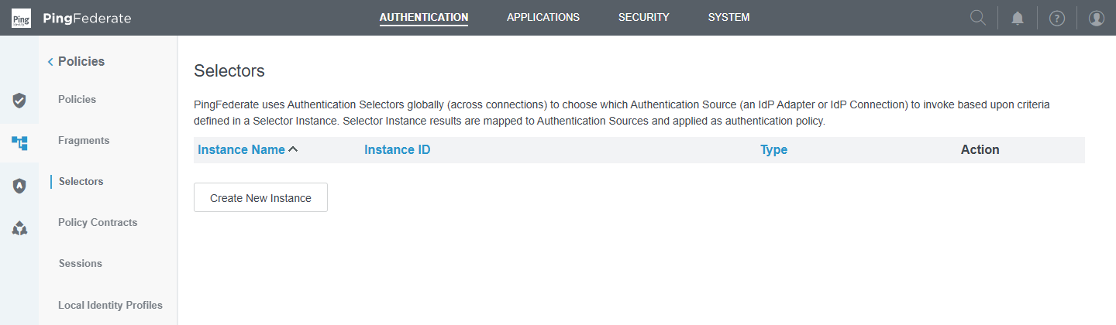
Figure 28 — Selectors list — empty on your server.
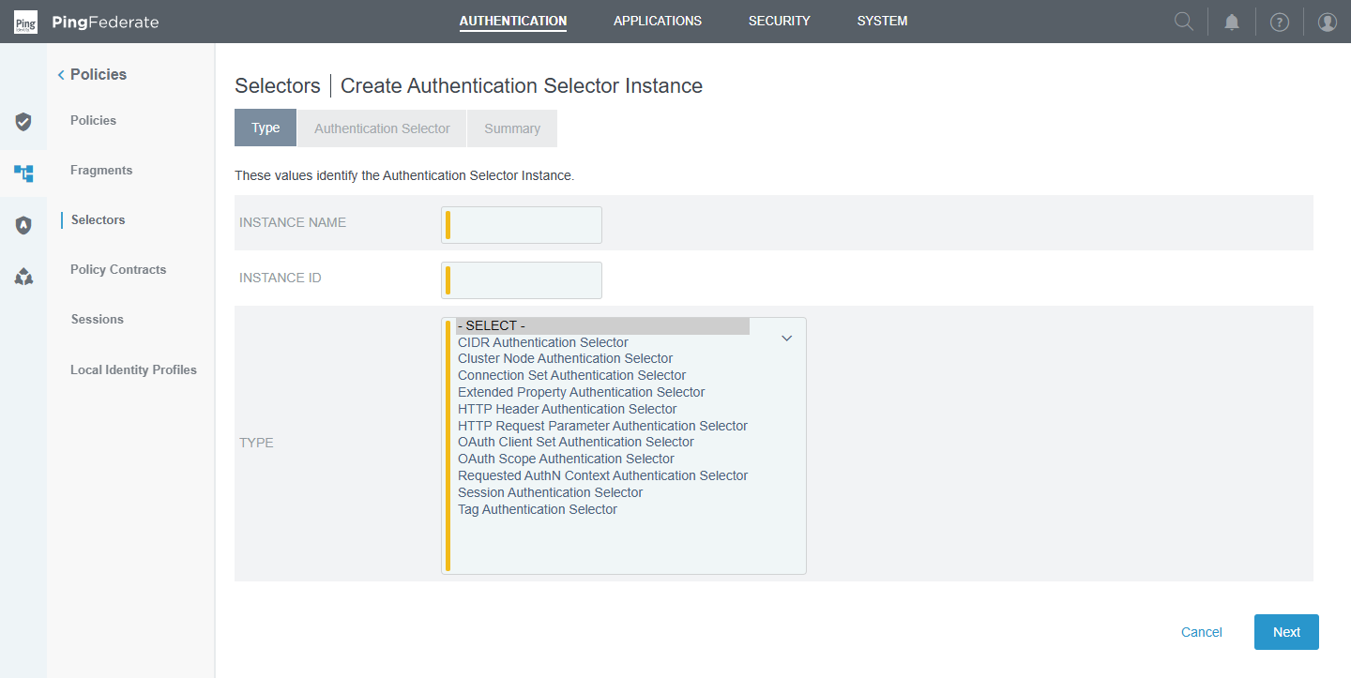
Figure 29 — Create Authentication Selector Instance → Type: the eleven selector plug-ins (list expanded for the screenshot).
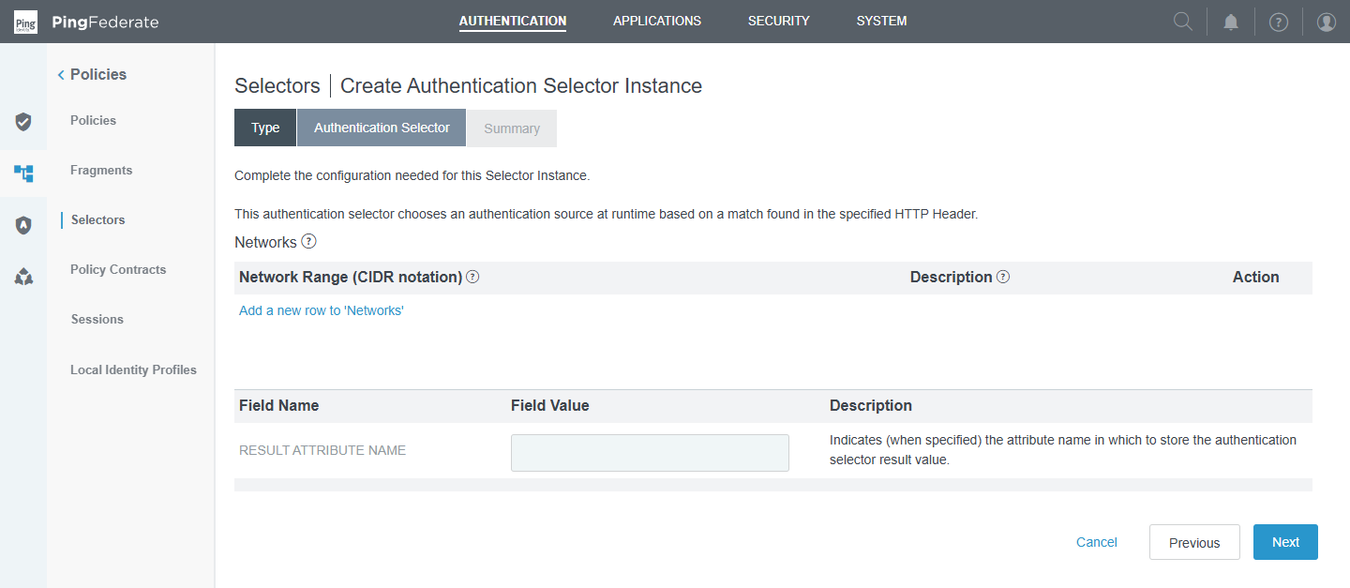
Figure 30 — CIDR selector configuration: add network ranges; optional Result Attribute Name stores the outcome. (Demo only — cancelled, not saved.)

Key points
- Each selector produces result values (e.g. Yes/No for CIDR, or each configured value for HTTP Request Parameter); the policy tree shows one branch per result.
- Result Attribute Name saves the outcome as an attribute you can map into the contract or use in rules later.
- Selectors can be nested: CIDR → Connection Set → adapter.

Hands-on (after the licence is renewed)
- Create a CIDR selector internal-network with 172.22.0.0/16.
- Create an HTTP Request Parameter selector login-type with parameter login and values ldap and local.
- Use them in the policy in section 9 and test from inside and outside the network.

8. Policy fragments (PF 18)
Course video: PF 18 — Fragment Configuration (19:35)

Concept
A fragment is a reusable piece of policy tree — think of it as a function. You build "password then MFA" or "LDAP with local fallback" once, and call it from many policies. Change the fragment and every policy that uses it changes too.
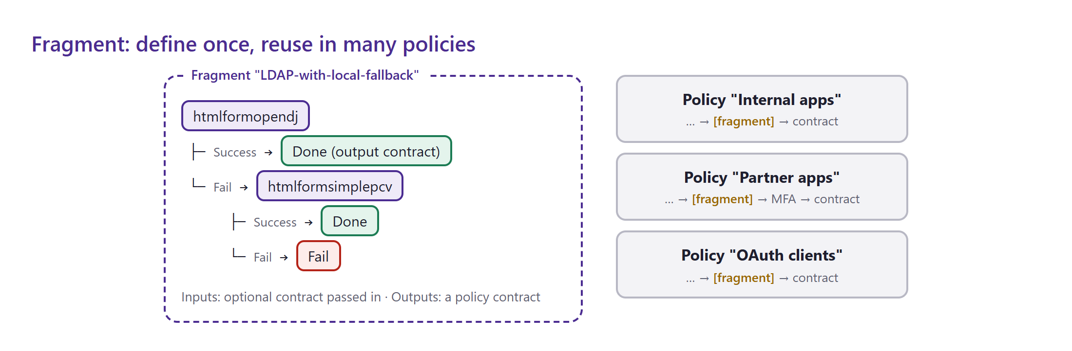
Figure 31 — One fragment, reused in three policies.
Where in the console: Authentication → Policies → Fragments

Fragment fields
Field | Meaning
Name / ID | How policies refer to the fragment
Inputs | Optional policy contract passed into the fragment (e.g. a username already collected by identifier-first)
Outputs | The policy contract the fragment returns on success
Policy | The tree itself: adapters, selectors and other fragments, with Success/Fail branches ending in Done
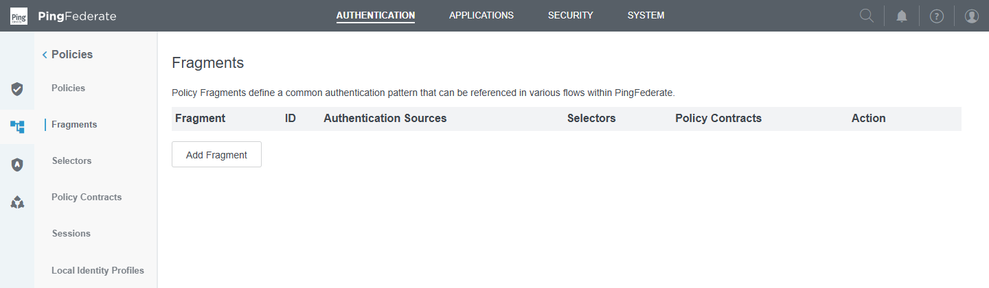
Figure 32 — Fragments list — empty on your server.
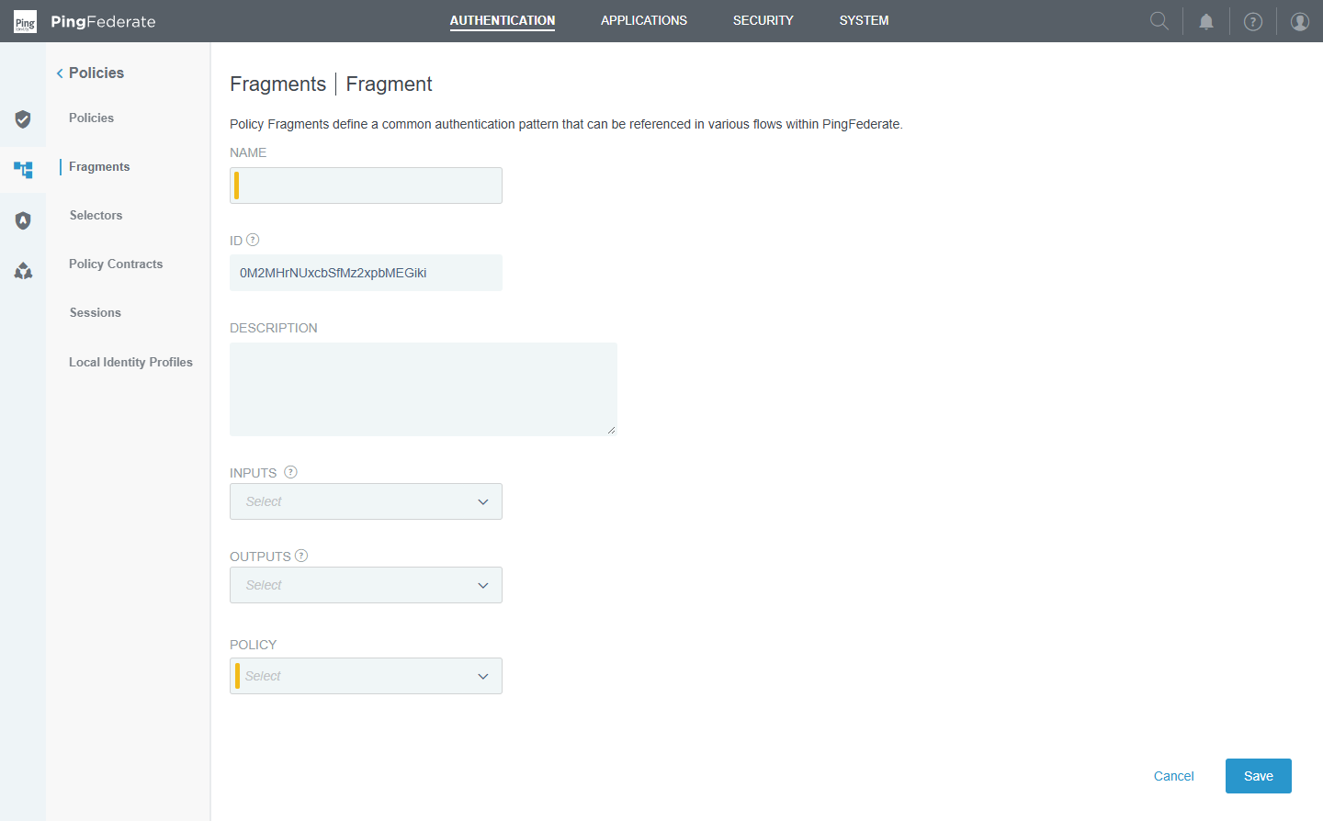
Figure 33 — Add Fragment screen: name, inputs, outputs and the policy tree (demo only — not saved).

9. Authentication policy tree (PF 19)
Course video: PF 19 — Authentication policy building (17:35)

Concept
The authentication policy is the brain that ties everything together. It is an ordered list of policy trees; PingFederate evaluates them top to bottom and uses the first applicable one. Each node is a selector, adapter or fragment with a branch for every outcome (Success/Fail, Yes/No, …). A successful path must end in Done → a policy contract, where you map adapter attributes into the contract.
Where in the console: Authentication → Policies → Policies

Page-level settings
Setting | Meaning | Your server
IDP Authentication Policies | Master switch: use policy trees for IdP-side logins | Off — must be ticked
SP Authentication Policies | Policy trees for SP-side (inbound federation) logins | Off
Fail if policy engine finds no authentication source | Deny instead of falling back to connection-level adapters | Off
Default Authentication Sources (tab) | Adapters used when no policy applies | none
Tracked HTTP Parameters (tab) | Request parameters kept available throughout the policy (for selectors/rules) | none
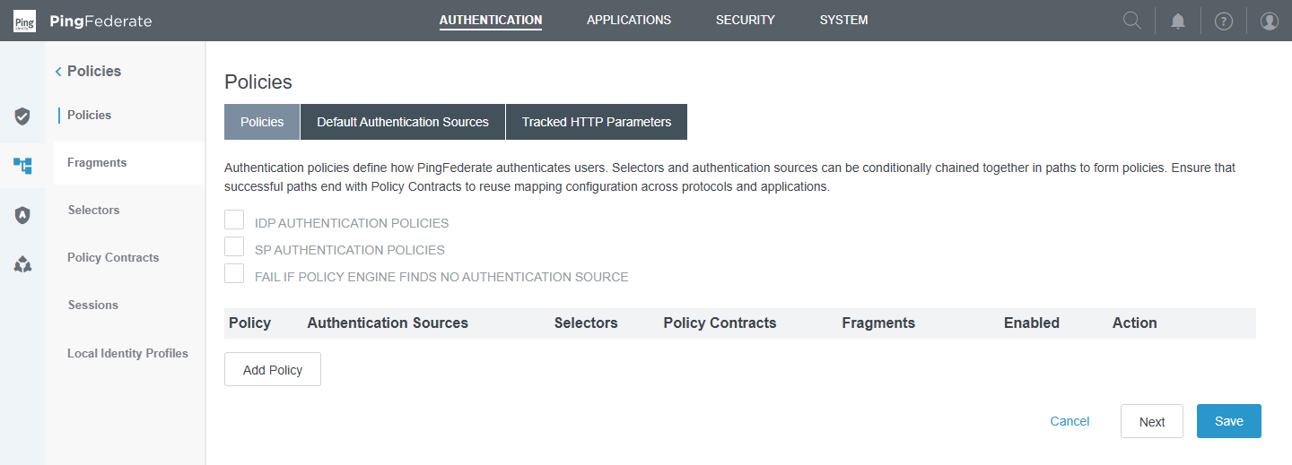
Figure 34 — Policies page — all three check boxes are off and the list is empty.
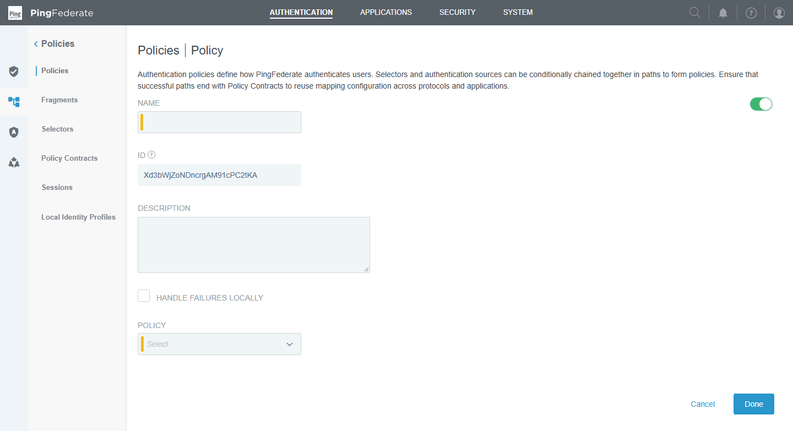
Figure 35 — Add Policy: name, "Handle failures locally", and the first node of the tree (demo only — cancelled).

Building a tree: node options
- Rules (on adapters): branch on an attribute value returned by the adapter — e.g. if memberOf contains insgc go one way, otherwise another.
- Options → Input User ID Mapping: pass the username from a previous step (no re-typing).
- Done → Contract Mapping: fill each contract attribute from adapter values, LDAP lookups, text or expressions; add issuance criteria to deny access conditionally.
- Handle failures locally: show PingFederate's error page instead of returning the error to the application.

Proposed tree for your lab
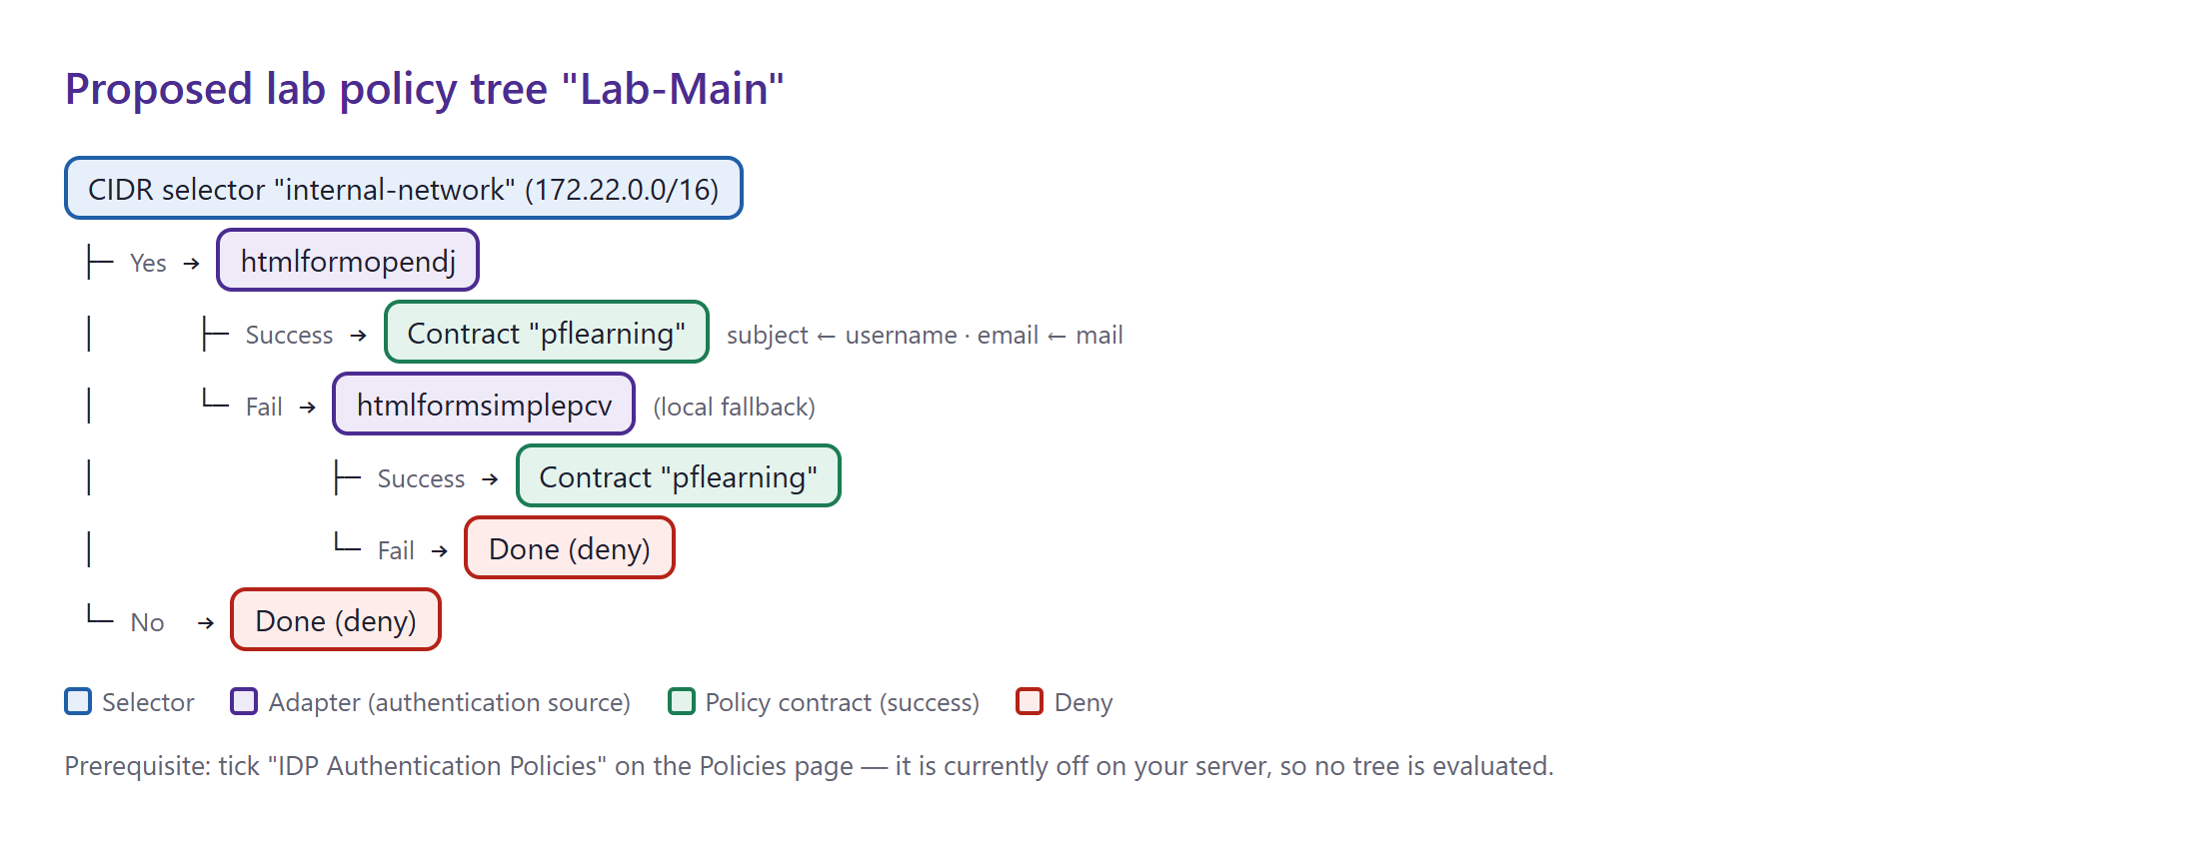
Figure 36 — The tree to build next — internal network only, OpenDJ first, local users as fallback.

Sessions (related screen)
Authentication sessions let a user who has already passed a policy skip re-authentication for the next application. They are configured separately from adapter sessions.
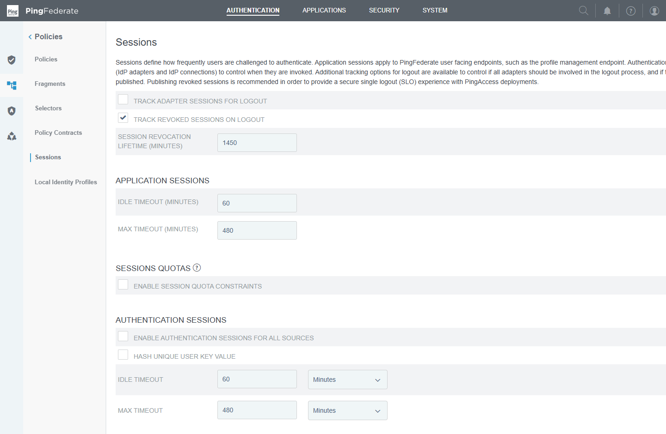
Figure 37 — Sessions: application session timeouts, session quotas and authentication sessions (all defaults on your server).

10. Findings and next steps

Issues found on your server
# | Where | Problem | Fix
1 | Licence | Expired 27 Sep 2026 — runtime returns 503 | Upload a new licence (System → Server → License Management)
2 | htmlformopendj → contract mapping | username and email mapped from emailAddress, which OpenDJ does not have | username ← Adapter username; email ← LDAP mail
3 | OpenDJ users | No mail values | Add mail to shahed, testa, testb, testc
4 | compositeldp | Required + Required → double login; input ID mapped from empty email | Set Sufficient, or replace with a policy tree
5 | Policies page | IDP Authentication Policies switched off; no policy exists | Tick it and build "Lab-Main"
6 | Data store | Binds as cn=Directory Manager over plain LDAP | Service account + LDAPS (production practice)
7 | Server settings | Base URL is https://localhost:9031 — breaks redirects from other machines | Set https://172.22.127.250:9031
8 | Kerberos | No Active Directory domain in the lab | Choose option B or C (section 11.9)

Suggested build order
- Renew the licence and confirm https://172.22.127.250:9031/pf/heartbeat.ping returns OK.
- Fix the base URL, add mail to OpenDJ users, and fix the adapter contract mapping (issues 2–3, 7).
- Create selectors internal-network (CIDR) and login-type (HTTP parameter).
- Create fragment LDAP-with-local-fallback.
- Tick IDP Authentication Policies and build Lab-Main, ending in contract pflearning.
- Test logins as testa (insgc) and testb (todogc), then add a Rule that branches on group membership.
- Continue with Module 4 (certificates), then connect a SAML application to the contract (Modules 5–6).

Quick revision
Term | One-line definition
Data store | Pooled connection to a user repository
PCV | Checks username + password (LDAP: search, then bind)
IdP adapter | How the user authenticates; manages a session and returns attributes
Composite adapter | Chains adapters with Required / Sufficient
Attribute source | Extra lookup (LDAP/JDBC) to fetch more attributes
Contract fulfilment | Where each output attribute comes from
Pseudonym | The attribute used as a stable, unique user key
APC | Standard output of a login: subject + extended attributes
Selector | Decision point that chooses a branch
Fragment | Reusable sub-tree with input/output contracts
Authentication policy | Ordered trees of selectors, adapters and fragments ending in contracts
LDAP error 49 | Invalid credentials during an LDAP bind
RADIUS client / shared secret | Device allowed to query the RADIUS server / password shared by both sides
NPS network policy | Windows rule deciding who may authenticate and with which method
SPN | Service name a Kerberos ticket is issued for, e.g. HTTP/pf.pingfed.lab

11. Module 3 leftovers: RADIUS hands-on and Kerberos lab guide
Section 6 explained RADIUS and Kerberos in theory. This section records what was then actually built on your VM (a working RADIUS server connected to PingFederate) and gives a complete, step-by-step plan for Kerberos, which needs an Active Directory domain that your lab does not have yet.
Item | Status (30 Sep 2026)
RADIUS server | ✅ Windows NPS installed and configured on WIN-60PG2A911IE; tested — accepts and rejects correctly
PingFederate RADIUS PCV | ✅ radiuspcv created, pointing at NPS (172.22.127.250:1812, PAP)
PingFederate adapter | ✅ htmlformradius (HTML Form adapter using radiuspcv)
Browser login through PingFederate | ⏳ Waiting for the licence renewal (runtime port 9031 returns 503)
Kerberos | 📘 Guide only — needs an AD domain (see 11.9); the Kerberos adapter plug-in is installed

11.1 What was built
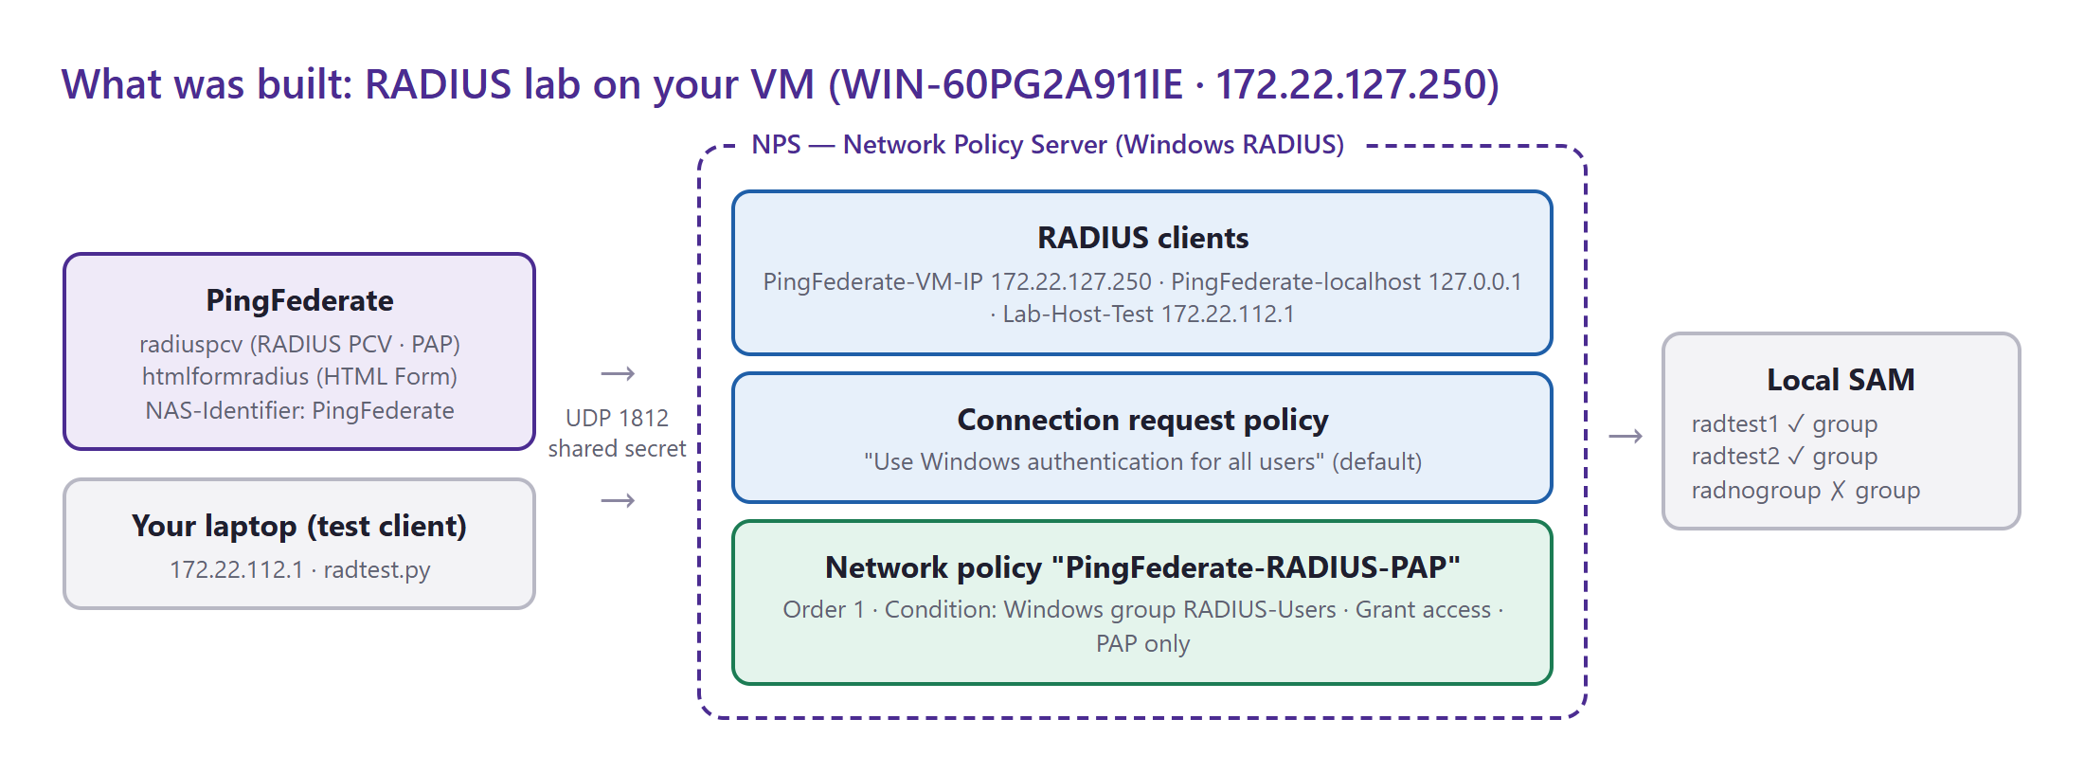
Figure 38 — RADIUS lab: PingFederate and the test laptop send Access-Requests to NPS, which checks Windows accounts and the RADIUS-Users group.
Component | Setting | Value
NPS role | Windows feature | NPAS (Network Policy and Access Services) + management tools · service IAS, automatic
RADIUS clients | Name → address | PingFederate-VM-IP → 172.22.127.250  PingFederate-localhost → 127.0.0.1  Lab-Host-Test → 172.22.112.1 (your laptop, for testing)
 | Shared secret (all clients) | PfRadiusLab2026
Local group | RADIUS-Users | members: radtest1, radtest2
Network policy | PingFederate-RADIUS-PAP | processing order 1 · condition: Windows group RADIUS-Users · grant access · authentication: PAP
Firewall | Network Policy Server rule group | enabled (UDP 1812/1813 + legacy 1645/1646 inbound)
Auditing | auditpol subcategory "Network Policy Server" | Success and Failure → events 6272/6273 in the Security log

Lab test accounts (lab only — not for production)
Username | Password | In RADIUS-Users? | Expected result
radtest1 | Pf!Lab-Alpha26 | Yes | Access-Accept
radtest2 | Pf!Lab-Bravo26 | Yes | Access-Accept
radnogroup | Pf!Lab-Charlie26 | No | Access-Reject (no matching network policy)

11.2 NPS concepts you need
- RADIUS client — any device that sends authentication requests to the RADIUS server: VPN gateways, Wi-Fi controllers… and here PingFederate. NPS only answers clients it knows (by source IP) and that use the right shared secret; anything else is silently dropped.
- Shared secret — a password known to both sides; it scrambles the user's password inside the packet and signs the responses. It must match exactly on PingFederate and NPS.
- Connection request policy — decides where a request is processed: locally (check Windows accounts) or forwarded to another RADIUS server (proxy). The default "Use Windows authentication for all users" is enough here.
- Network policy — decides who is allowed and how: conditions (Windows group, time of day, client…), grant/deny, and allowed authentication methods. Policies are evaluated top-down; the first match wins.
- PAP vs CHAP — PingFederate's RADIUS PCV supports only these two. CHAP needs Windows to store passwords with reversible encryption, so the lab uses PAP (the password is protected with the shared secret; use it only on a trusted network or inside IPsec/RadSec in production).
- Ports — UDP 1812 authentication, 1813 accounting (1645/1646 are the legacy equivalents).
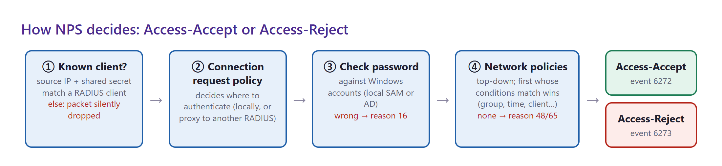
Figure 39 — The four checks NPS performs for every Access-Request, with the reason codes you will see when a check fails.

11.3 How it was configured (commands)
Everything was done remotely over WinRM from PowerShell. To rebuild the lab, run these in an elevated PowerShell on the VM:
# 1. Install the RADIUS server role (no reboot needed)
Install-WindowsFeature NPAS -IncludeManagementTools

# 2. Group + test users
New-LocalGroup -Name 'RADIUS-Users' -Description 'NPS RADIUS users (PingFederate lab)'
New-LocalUser radtest1 -Password (ConvertTo-SecureString 'Pf!Lab-Alpha26' -AsPlainText -Force) -PasswordNeverExpires
New-LocalUser radtest2 -Password (ConvertTo-SecureString 'Pf!Lab-Bravo26' -AsPlainText -Force) -PasswordNeverExpires
New-LocalUser radnogroup -Password (ConvertTo-SecureString 'Pf!Lab-Charlie26' -AsPlainText -Force) -PasswordNeverExpires
Add-LocalGroupMember -Group 'RADIUS-Users' -Member radtest1, radtest2

# 3. RADIUS clients (who may send requests)
New-NpsRadiusClient -Name 'PingFederate-VM-IP' -Address 172.22.127.250 -SharedSecret 'PfRadiusLab2026'
New-NpsRadiusClient -Name 'PingFederate-localhost' -Address 127.0.0.1 -SharedSecret 'PfRadiusLab2026'
New-NpsRadiusClient -Name 'Lab-Host-Test' -Address 172.22.112.1 -SharedSecret 'PfRadiusLab2026'

# 4. Network policy: RADIUS-Users + PAP => grant
$sid = (Get-LocalGroup 'RADIUS-Users').SID.Value
netsh nps add np name="PingFederate-RADIUS-PAP" state="enable" processingorder="1" policysource="0" `
conditionid="0x1fb5" conditiondata="$sid" ` # 0x1fb5 = Windows Groups
profileid="0x100f" profiledata="TRUE" ` # 0x100f = grant access
profileid="0x1009" profiledata="0x1" # 0x1009 = auth type, 0x1 = PAP

# 5. Firewall, auditing, restart
Get-NetFirewallRule -DisplayGroup 'Network Policy Server' | Enable-NetFirewallRule
auditpol /set /subcategory:"Network Policy Server" /success:enable /failure:enable
Restart-Service IAS

The same objects can be seen in the GUI: Server Manager → Tools → Network Policy Server → RADIUS Clients and Servers → RADIUS Clients and Policies → Network Policies.
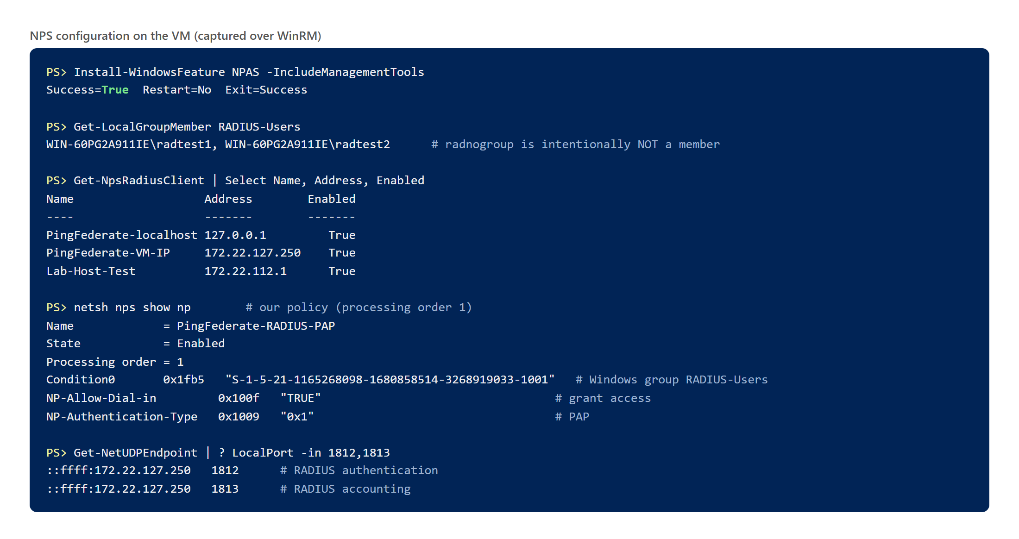
Figure 40 — Resulting NPS configuration read back from the VM.

11.4 Testing RADIUS directly (without PingFederate)
Because the PingFederate runtime is blocked by the licence, NPS was tested with a small RADIUS client (radtest.py, RFC 2865 PAP) running on your laptop, registered in NPS as Lab-Host-Test. Every response was also checked cryptographically (Response Authenticator), which proves the shared secret matches.
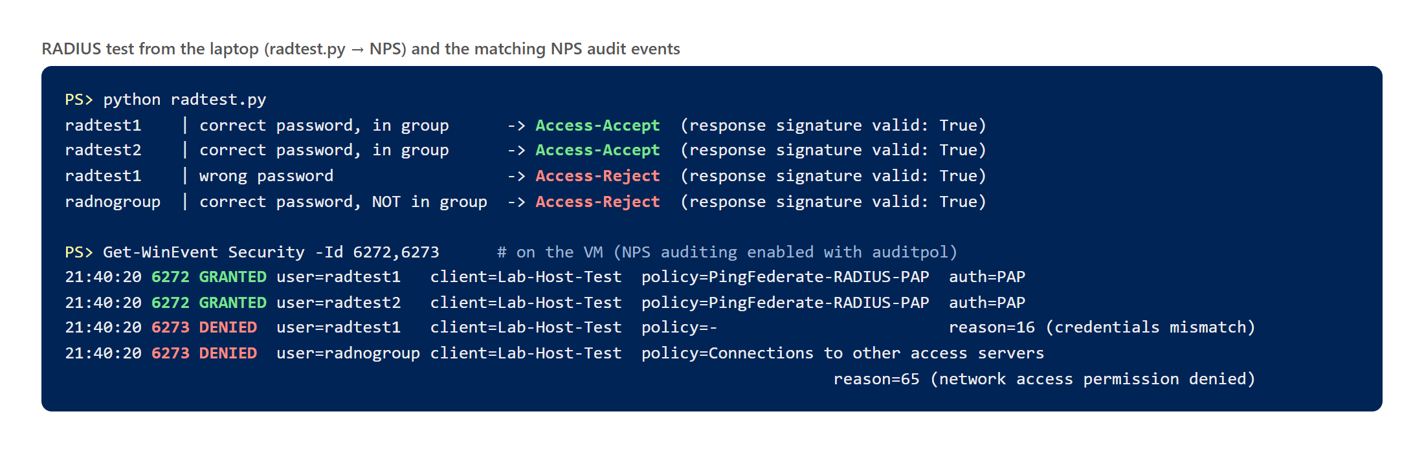
Figure 41 — Test results and the NPS audit events that explain each decision.
Test | Result | Why
radtest1, correct password | ✅ Access-Accept | Password correct; member of RADIUS-Users → matches PingFederate-RADIUS-PAP
radtest2, correct password | ✅ Access-Accept | Same as above
radtest1, wrong password | ❌ Access-Reject | Reason 16 — credentials mismatch (check ③ fails)
radnogroup, correct password | ❌ Access-Reject | Password is fine, but no allowing policy matches; falls to the default deny policy → reason 65

NPS reason codes worth knowing
Code | Meaning | Typical fix
16 | Authentication failed: bad username or password | Check the password / account; for PingFederate, the user typed it wrong
48 | The request did not match any network policy | Add the user to the group or adjust policy conditions
65 | Network access permission is Deny (from user dial-in or a deny policy) | Set dial-in to "Control access through NPS Network Policy"; fix policy order
66 | Authentication method not enabled in the matching policy | PingFederate set to CHAP but policy allows only PAP (or vice versa)
49 | Did not match a connection request policy | Check the connection request policy conditions
(no event, timeout) | Unknown client IP or wrong shared secret → packet dropped | Register the exact source IP as a RADIUS client; re-type the secret on both sides

11.5 PingFederate side

RADIUS Password Credential Validator "radiuspcv"
Created under System → Data & Credential Stores → Password Credential Validators with type RADIUS Username Password Credential Validator.
Field | Meaning | radiuspcv
RADIUS Servers → Hostname | NPS address. NPS listens on 172.22.127.250 (not on 127.0.0.1), so use the VM IP | 172.22.127.250
Authentication Port | RADIUS authentication port | 1812
Authentication Protocol | PAP or CHAP — must be allowed by the NPS network policy | PAP
Shared Secret | Must equal the secret of the matching NPS RADIUS client | (PfRadiusLab2026)
NAS Identifier | Name PingFederate sends in each request (visible in NPS logs; usable as a policy condition) | PingFederate
Timeout / Retry Count | Wait per attempt (ms) / attempts before failing | 3000 / 3
Allow Challenge Retries after Access-Reject | Let the user retry inside a RADIUS challenge flow (OTP servers) | false
Contract | Attributes returned on success | username
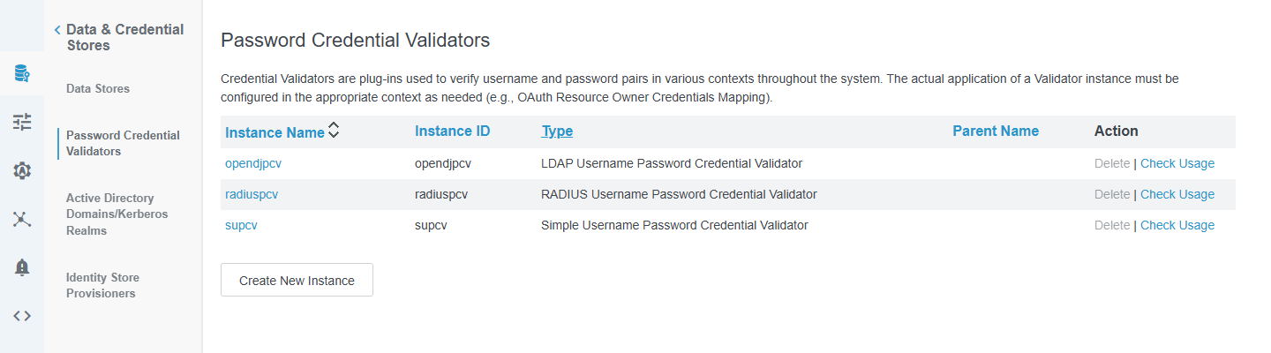
Figure 42 — Password Credential Validators now lists radiuspcv next to opendjpcv and supcv.
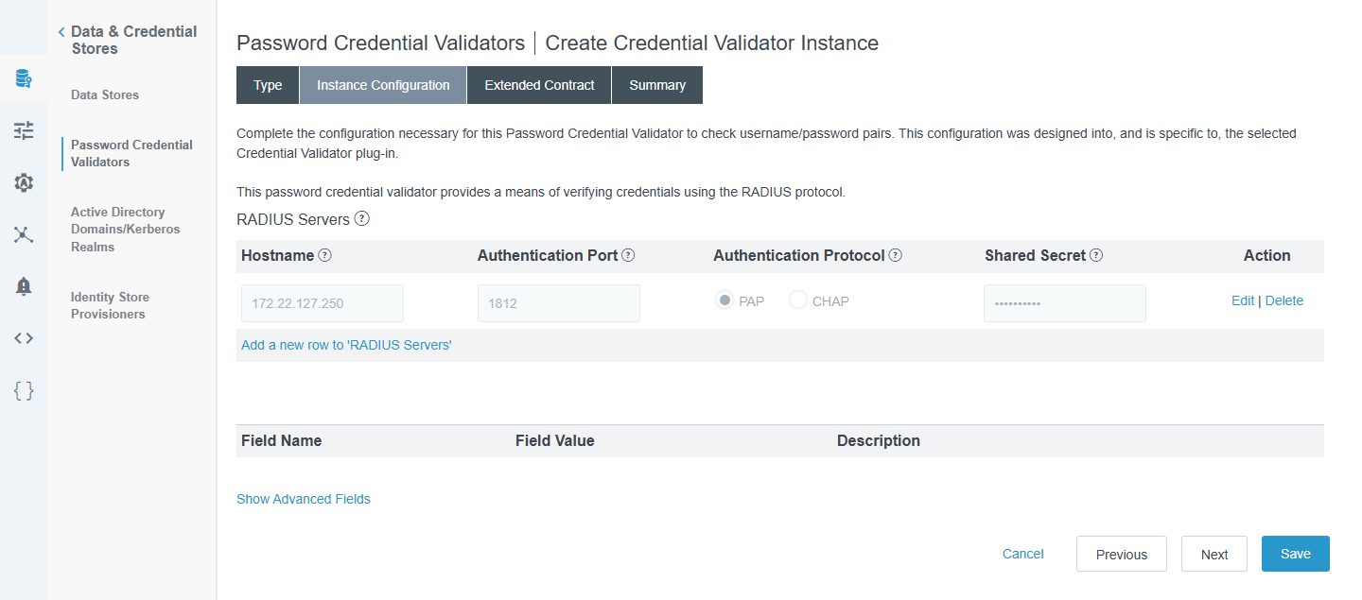
Figure 43 — radiuspcv → Instance Configuration: RADIUS server row (hostname, port, PAP, masked secret).
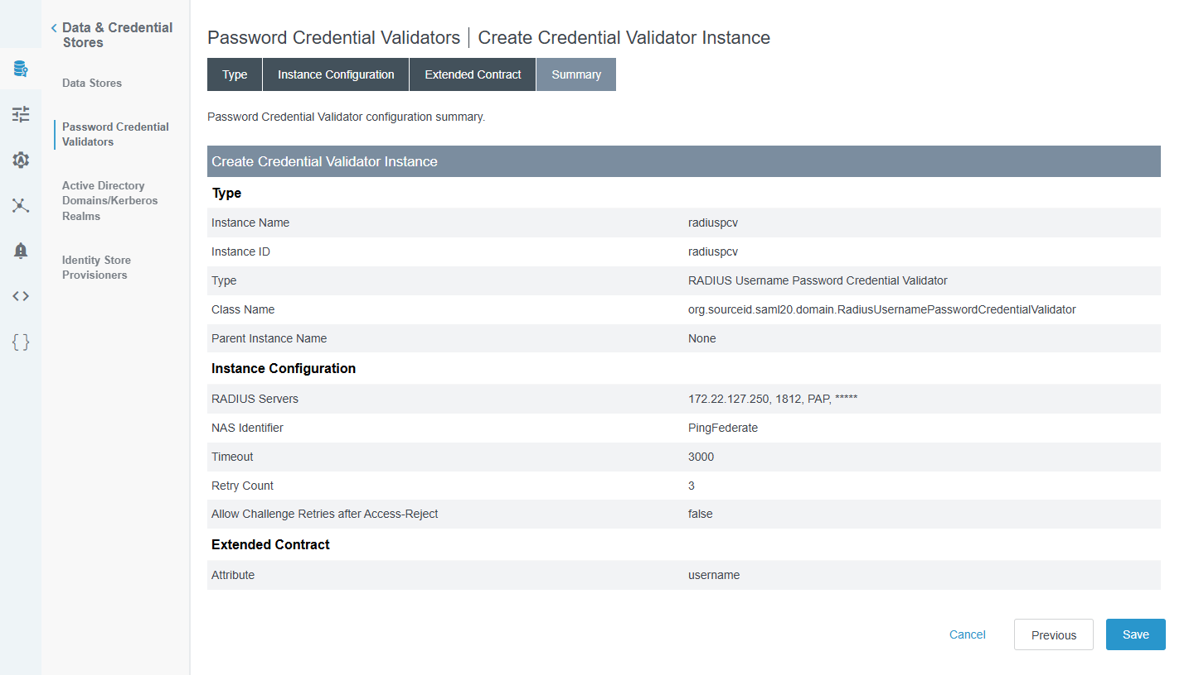
Figure 44 — radiuspcv → Summary: NAS Identifier PingFederate, timeout 3000 ms, 3 retries, contract username.

HTML Form adapter "htmlformradius"
A copy of the local-user form adapter, with its credential validator switched to radiuspcv. Its contract is just username and policy.action, both filled from the adapter itself (no LDAP lookup, so none of the mapping problems from section 4).
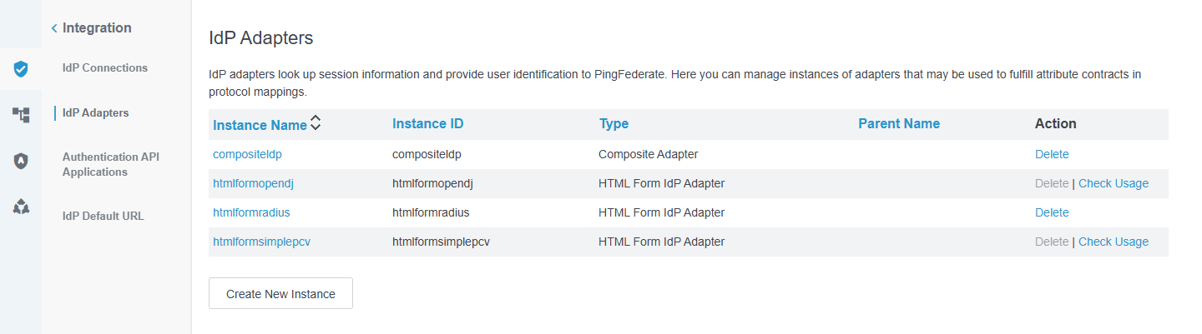
Figure 45 — IdP Adapters now includes htmlformradius.
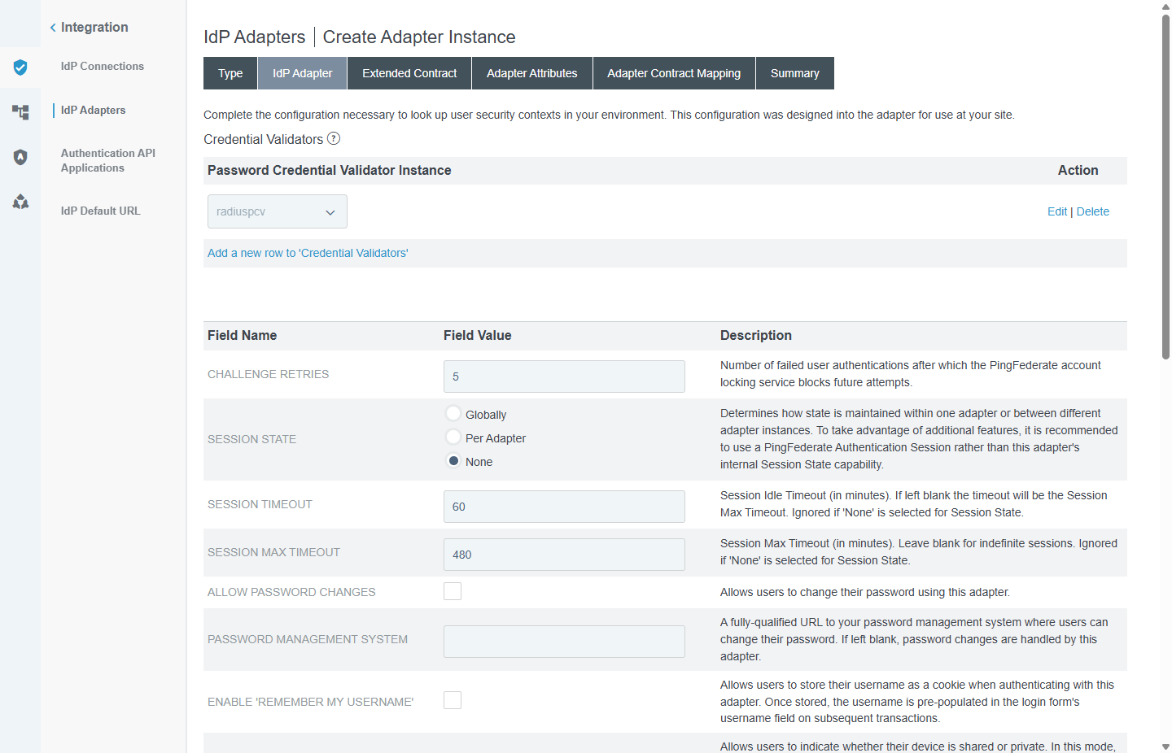
Figure 46 — htmlformradius → IdP Adapter tab: the Password Credential Validator Instance is radiuspcv.

11.6 Using RADIUS in an authentication policy
The most common real-world use is RADIUS as a second factor (a token or OTP server) after the directory password:
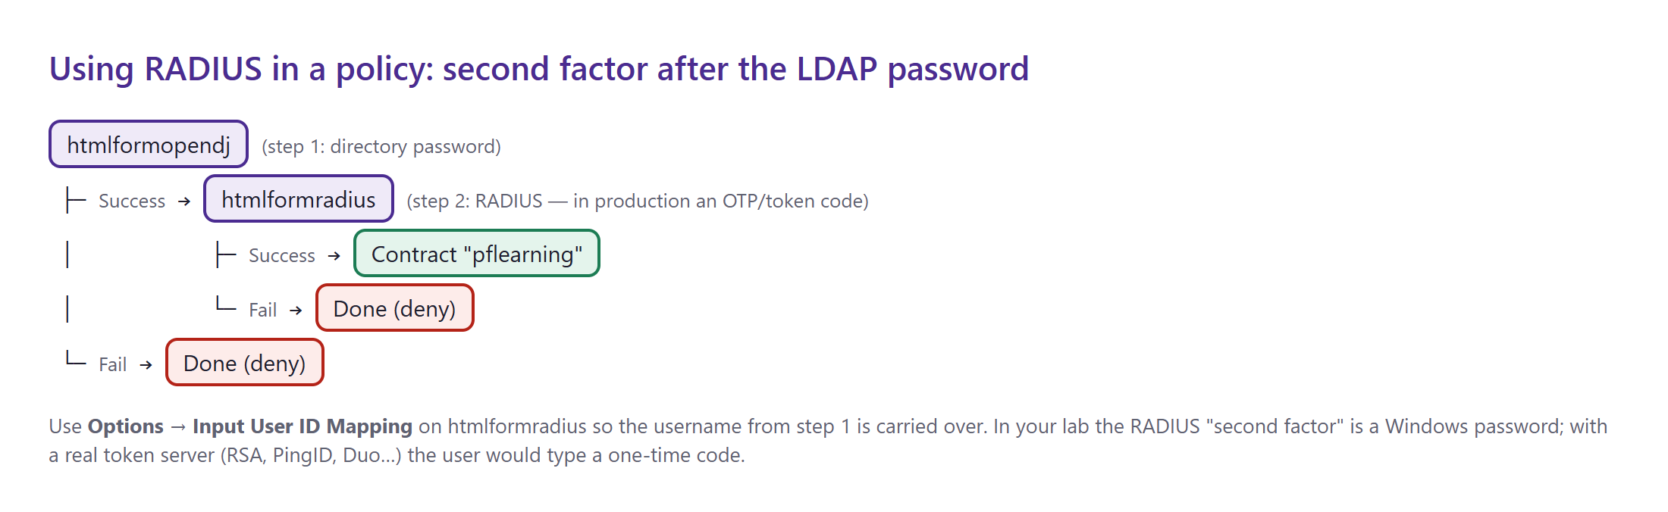
Figure 47 — Two-step policy: OpenDJ password, then RADIUS, then the policy contract.
- Authentication → Policies → Policies: tick IDP Authentication Policies, click Add Policy, name it LDAP-plus-RADIUS.
- First node: htmlformopendj. On its Success branch add htmlformradius; under Options → Input User ID Mapping map the username from htmlformopendj so users are not asked for it again.
- htmlformradius → Success → Done → contract pflearning (subject ← username). Both Fail branches → Done (deny).
- For RADIUS as the only login instead, put htmlformradius as the single node — useful when an organisation already runs NPS for VPN access.
Lab note
In your lab the RADIUS users are Windows accounts (radtest1…) and OpenDJ users are shahed/testa…, so a two-step LDAP + RADIUS login needs the same username in both stores — create e.g. a local Windows user testa in RADIUS-Users, or test htmlformradius as a single-step policy first.

11.7 End-to-end test after the licence is renewed
- Upload the new licence; confirm https://172.22.127.250:9031/pf/heartbeat.ping returns OK.
- Build a policy that uses htmlformradius (11.6) and an application to trigger it (Module 6 SAML or Module 7 OAuth).
- Log in as radtest1 / Pf!Lab-Alpha26 → success. Try radnogroup → the form shows an authentication error.
- Confirm on the VM: the Security log shows event 6272 with client PingFederate-VM-IP, and pingfederate/log/server.log shows the RADIUS PCV result.

11.8 Troubleshooting RADIUS
Symptom | Likely cause | Check
PingFederate log: timeout, no NPS event | PingFederate's source IP is not a RADIUS client, wrong secret, or firewall | NPS → RADIUS Clients; System log event 13 ("request from unknown client"); firewall rule group enabled
Reject, reason 16 | Wrong password / unknown user | Try the user with radtest.py; check the account is enabled
Reject, reason 48/65 | User not in RADIUS-Users, or a deny policy matched first | Group membership; policy processing order
Reject, reason 66 | PAP/CHAP mismatch | PingFederate protocol vs NPS policy authentication methods
Works from laptop, not from PingFederate | Different client entry / secret | Both clients use PfRadiusLab2026? PingFederate hostname is 172.22.127.250?

11.9 Kerberos lab guide
Current status
Not built. Your VM is a standalone workgroup server (no Active Directory): Kerberos port 88 is closed and System → Active Directory Domains/Kerberos Realms is empty. The Kerberos Adapter plug-in is installed in PingFederate and ready to use once a domain exists.

How Kerberos desktop SSO works
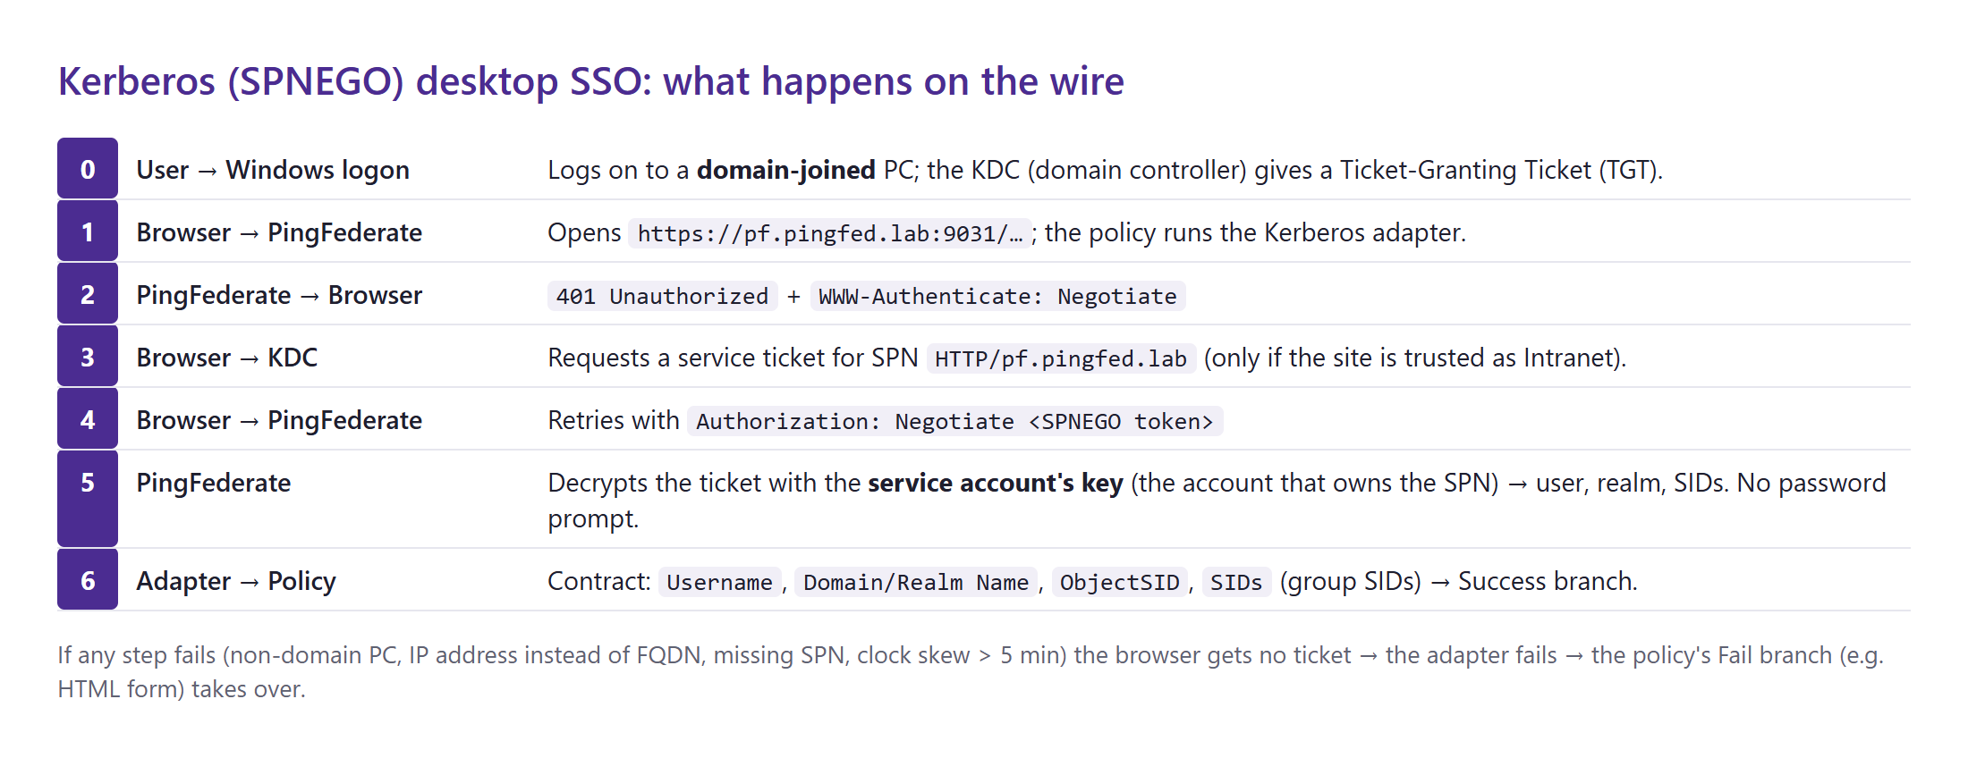
Figure 48 — SPNEGO sequence: the browser gets a service ticket from AD and PingFederate validates it — the user never sees a login page.

Key terms
- KDC (Key Distribution Center) — the domain controller service that issues Kerberos tickets (port 88).
- SPN (Service Principal Name) — the name of the service a ticket is for, e.g. HTTP/pf.pingfed.lab. It must be registered on exactly one AD account (the PingFederate service account).
- Service account — AD user that owns the SPN; PingFederate uses its password-derived key to decrypt tickets. Enable AES encryption on it.
- SPNEGO / Negotiate — the HTTP mechanism (WWW-Authenticate: Negotiate) browsers use to send Kerberos tickets.
- FQDN, not IP — browsers only request Kerberos tickets for host names; https://172.22.127.250 silently falls back to NTLM and the adapter fails.

Options for your lab
Option | What happens | Effort / risk
C (recommended): separate DC VM | New Windows Server VM "DC01" becomes the domain controller for pingfed.lab; the PingFederate VM just points at it | Needs one more VM (~2 GB RAM); no change to OpenDJ or PingFederate ports
B: promote the current VM | Move OpenDJ from 389 to 1389, update the PingFederate data store, install AD DS, reboot, test from the DC itself | Invasive: local accounts become domain accounts; hard to undo
A: theory only | Keep this guide for later | None
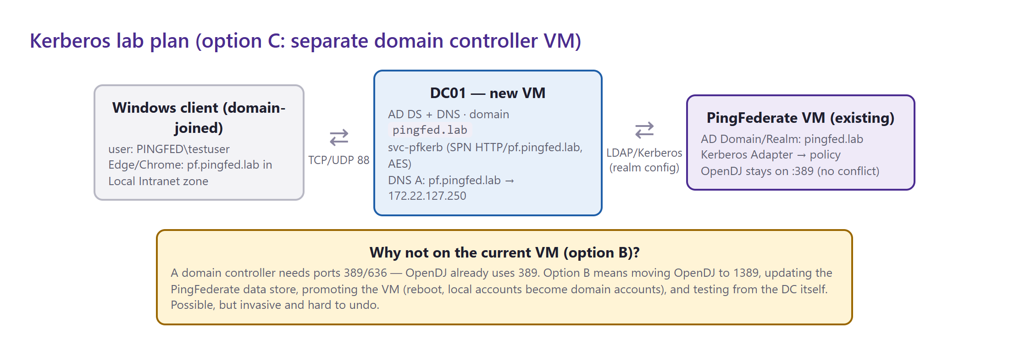
Figure 49 — Recommended Kerberos lab layout (option C).

Step-by-step (option C)
- Create DC01 (Windows Server 2019, 2 vCPU / 2–4 GB RAM) on the same Hyper-V switch with a static IP, e.g. 172.22.127.10.
- Install AD DS and create the forest on DC01 (reboots automatically):
Install-WindowsFeature AD-Domain-Services -IncludeManagementTools
Install-ADDSForest -DomainName 'pingfed.lab' -DomainNetbiosName 'PINGFED' -InstallDns `
-SafeModeAdministratorPassword (Read-Host -AsSecureString 'DSRM password') -Force
- DNS and the service account on DC01:
Add-DnsServerResourceRecordA -ZoneName 'pingfed.lab' -Name 'pf' -IPv4Address '172.22.127.250'
New-ADUser svc-pfkerb -AccountPassword (Read-Host -AsSecureString) -Enabled $true -PasswordNeverExpires $true
setspn -S HTTP/pf.pingfed.lab svc-pfkerb # register the SPN (-S refuses duplicates)
Set-ADUser svc-pfkerb -KerberosEncryptionType AES128,AES256
New-ADUser testuser -AccountPassword (Read-Host -AsSecureString) -Enabled $true
- PingFederate VM: set its DNS server to DC01 (so it can resolve dc01.pingfed.lab); keep clocks in sync (Kerberos allows at most 5 minutes of skew). Joining the domain is not required.
- PingFederate → System → Active Directory Domains/Kerberos Realms → Add Domain/Realm: connection type Direct, domain pingfed.lab, username svc-pfkerb, its password, DC host dc01.pingfed.lab; click Test Domain/Realm Connectivity, then Save.
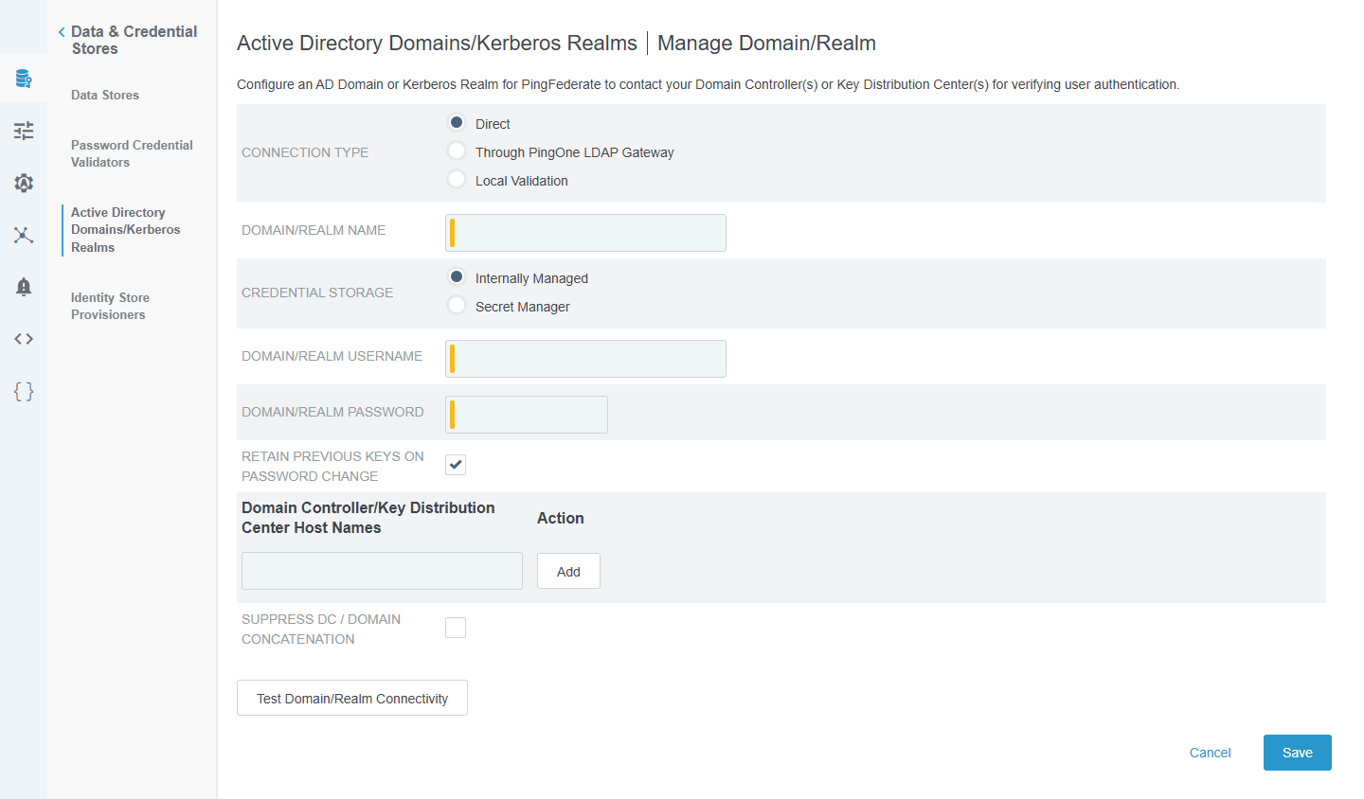
Figure 50 — Add Domain/Realm form (opened for this guide and cancelled): connection type, domain, service account and domain controller host names.
- Authentication → IdP Adapters → Create New Instance, type Kerberos Adapter, then select the domain on the next page. Contract: Username, Domain/Realm Name, ObjectSID, SIDs.
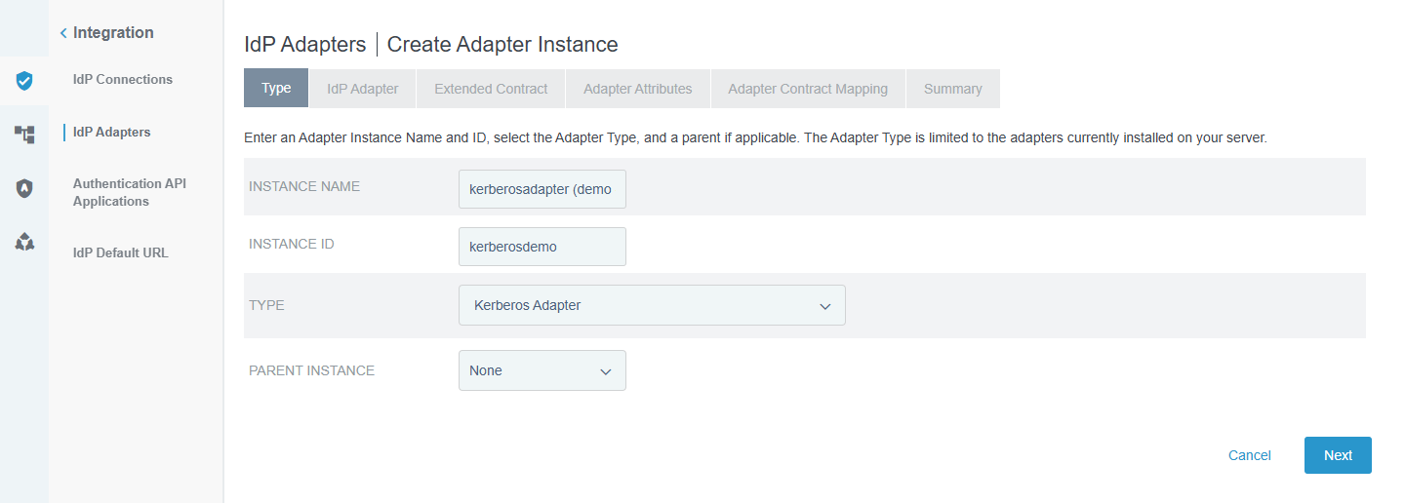
Figure 51 — Creating a Kerberos Adapter instance (demo only — cancelled, not saved).
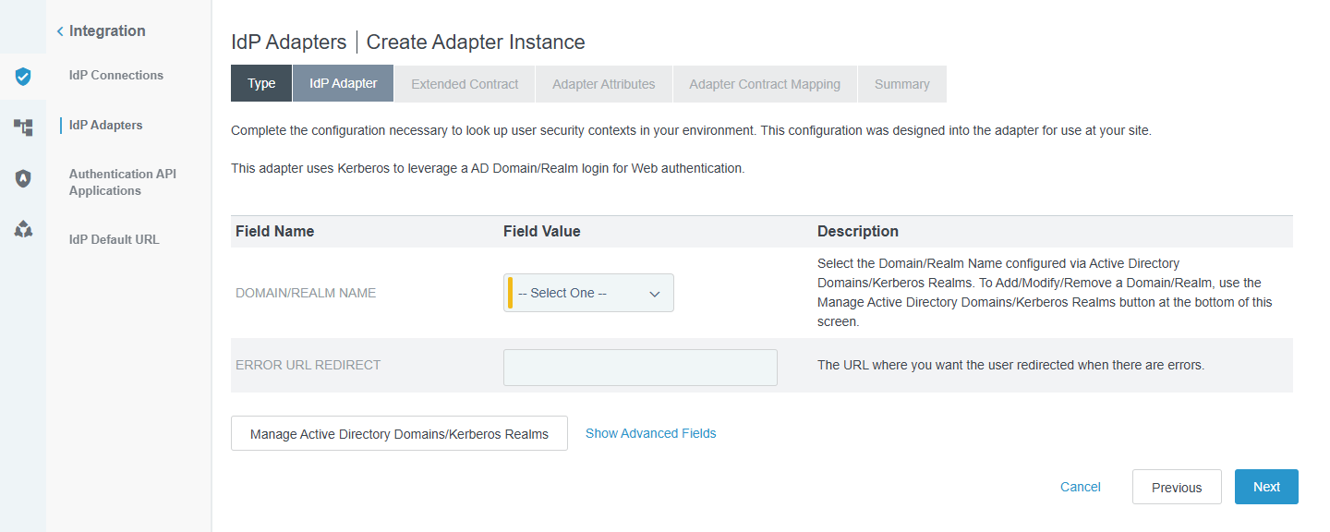
Figure 52 — Kerberos Adapter settings: Domain/Realm Name (from step 5) and an optional error redirect URL.
- Policy: Kerberos adapter first → Success → contract; Fail → htmlformopendj (fallback for non-domain devices).
- Client: a Windows VM joined to pingfed.lab; add https://pf.pingfed.lab to Internet Options → Security → Local intranet → Sites (used by Edge and Chrome). Log on as PINGFED\testuser and open the PingFederate URL.
- Verify: klist on the client lists a ticket for HTTP/pf.pingfed.lab; the user is logged in without a prompt.

Troubleshooting Kerberos
Symptom |  | Cause | Fix
Login form appears instead of SSO |  | Browser did not send a ticket (site not in Intranet zone, IP instead of FQDN, non-domain PC) | Use https://pf.pingfed.lab; add it to Local intranet; use a domain-joined client
KDC_ERR_S_PRINCIPAL_UNKNOWN |  | SPN not registered | setspn -L svc-pfkerb; re-add HTTP/pf.pingfed.lab
Intermittent failures |  | Duplicate SPN on two accounts | setspn -X to find duplicates; keep one
KRB_AP_ERR_SKEW |  | Clocks differ by more than 5 minutes | Sync time with the DC (w32tm /resync)
Decrypt / checksum errors in server.log |  | Service-account password changed or wrong encryption type | Update the password in the Domain/Realm; enable AES on the account
Your choice needed for Kerberos
Reply with C after you have created a second Windows Server VM (give its IP and admin login), or B to convert the current VM (OpenDJ moves to port 1389, VM reboots). I will then build and test Kerberos and add the screenshots here.

