PingFederate Complete Course

Module 4 — Certificates, Signing and Encryption
Certificate types, self-signed vs CA-signed, digital signatures, encryption and certificate management — explained with diagrams, live screenshots from your PingFederate server and hands-on OpenSSL labs.

Item | Detail
Videos covered | PF 20 parts 1–4 (4 videos, ~54 min)
Server | PingFederate 13.1.2 · https://172.22.127.250:9999 (admin) · :9031 (runtime)
Screenshots | Captured with Playwright from your admin console on 30 Sep 2026. Read-only: "Create"/"Import" screens were opened and cancelled.
Labs | Run on your laptop with OpenSSL 3.2 and Python — nothing was changed on the server. Lab files are saved in pingfed\labs\module4.

Key findings on your server
SSL certificate: one self-signed certificate CN=localhost (no Subject Alternative Names) is used for both the admin console and the runtime → browsers warn, and it does not match 172.22.127.250.
Signing certificate: none. PingFederate cannot sign SAML assertions or metadata yet — this blocks Modules 5–6.
Trusted CAs / SSL client keys: none added (fine for now).
Licence: still expired — the runtime (9031) returns 503; certificate configuration itself works.
Contents
1. The big picture 3
2. Certificate management and types of certificates (PF 20 part 1) 5
What a certificate is 5
Types of certificates 5
File formats you will meet 5
3. Self-signed vs CA-signed certificates (PF 20 part 2) 6
Concept 6
Evidence from your server 6
Lab: build a CA and a CA-signed certificate 7
SSL Server Certificates in PingFederate 7
4. Digital signature and encryption (PF 20 part 3) 10
Concept 10
Lab: sign, tamper, encrypt 10
Where this appears in PingFederate 11
5. Certificate management and automation (PF 20 part 4) 13
Other certificate screens 13
Expiry monitoring 14
Rolling over a signing certificate 15
6. Findings and next steps 16
Lab files (pingfed\labs\module4) 16
Check yourself 16
Quick revision 16

1. The big picture
Almost everything PingFederate does with partners relies on public-key cryptography: HTTPS protects the connection, signatures prove a message really came from PingFederate and was not changed, and encryption hides sensitive attributes. Each job uses its own key pair and certificate, stored in its own place in the console.
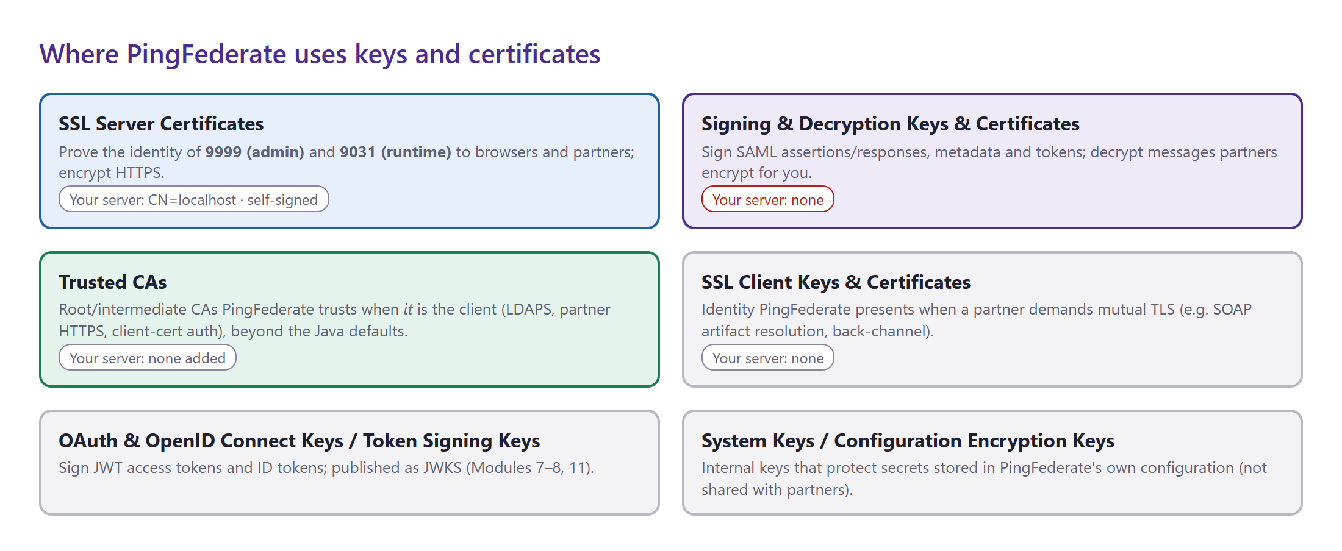
Figure 1 — The certificate stores in PingFederate and what each one is for, with the status of your server.
Where in the console: Security → Certificate & Key Management
Store | Used for | Console location | Your server
SSL Server Certificates | HTTPS on 9999 and 9031 | Security → SSL Server Certificates | 1 · CN=localhost · self-signed · expires 2036-08-29
Signing & Decryption Keys & Certificates | Sign assertions, responses, metadata; decrypt inbound messages | Security → Signing & Decryption Keys & Certificates | ❌ none
Trusted CAs | Trust anchors when PingFederate is the client | Security → Trusted CAs | none added (Java defaults only)
SSL Client Keys & Certificates | Mutual TLS towards partners | Security → SSL Client Keys & Certificates | none
OAuth/OIDC & Token Signing Keys | JWT access / ID tokens (JWKS) | Security → OAuth & OpenID Connect Keys | dynamic keys (default)
Certificate Revocation Checking | OCSP / CRL checks of partner certificates | Security → Certificate Revocation Checking | OCSP on, defaults
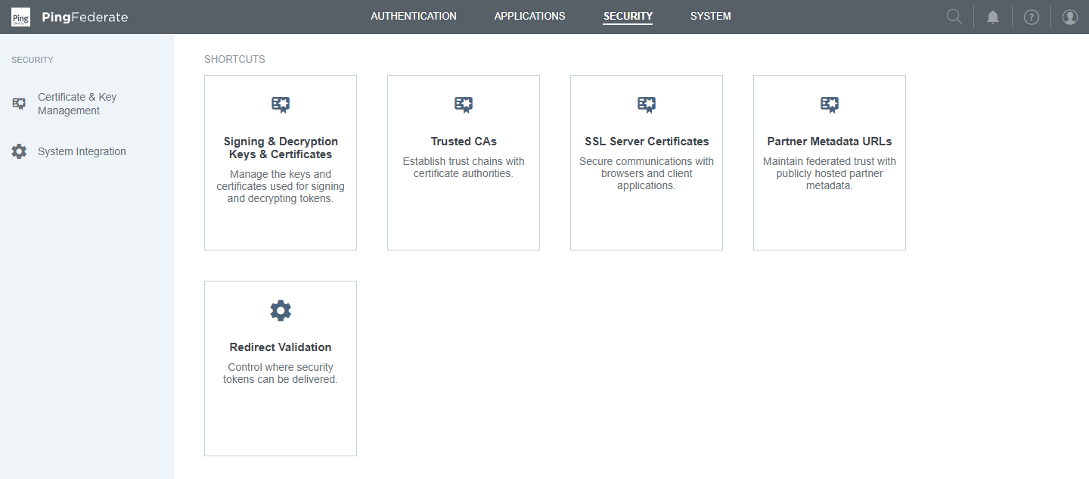
Figure 2 — Security menu — the Certificate & Key Management area.

2. Certificate management and types of certificates (PF 20 part 1)
Course video: PF 20 part 1 — Certificate Management & Types of certificates (12:55)

What a certificate is
An X.509 certificate binds a public key to an identity (a host name, an organisation, a service) and is signed by an issuer. The matching private key stays secret with the owner. Anyone can check the certificate; only the owner of the private key can prove they are that identity.
Field | Meaning | Your SSL certificate
Subject | Who the certificate belongs to (CN = common name) | CN=localhost, OU=Development, O=PingIdentity, L=Denver, ST=CO, C=US
Issuer | Who signed it (a CA — or itself if self-signed) | same as Subject → self-signed
Serial number | Unique number assigned by the issuer | 01:A0:4C:7D:48:0B
Validity | notBefore / notAfter | 2026-08-29 → 2036-08-29
Public key | Algorithm and size | RSA 2048
Subject Alternative Names (SAN) | Host names / IPs the certificate is valid for — browsers check this, not the CN | none
Key Usage / Extended Key Usage | What the key may be used for (signing, encryption, serverAuth, clientAuth…) | none
Basic Constraints | Whether it is a CA certificate | none
Signature algorithm | How the issuer signed it | SHA256withRSA

Types of certificates
By purpose | Description
SSL/TLS server | Presented by a web server (PingFederate 9999/9031). EKU serverAuth; SAN must list the host names.
SSL/TLS client | Presented by a client for mutual TLS (PingFederate calling a partner, or a partner calling PingFederate). EKU clientAuth.
Signing | Used to sign documents/messages — SAML assertions, metadata, JWTs. Key Usage digitalSignature.
Encryption | Its public key is used by others to encrypt data for the owner — e.g. an SP's encryption certificate. Key Usage keyEncipherment.
CA (root / intermediate) | Signs other certificates. Basic Constraints CA:TRUE, Key Usage keyCertSign.

File formats you will meet
Format | Extension | Contains | Typical use in PingFederate
PEM | .pem .crt .cer | Base64 text between -----BEGIN/END----- lines | Import certificates (Trusted CAs, partner signing certs)
DER | .der .cer | Same certificate in binary | Import certificates
PKCS#12 | .p12 .pfx | Private key + certificate + chain, password-protected | Import SSL / signing key pairs; Export a key pair for backup
PKCS#7 | .p7b | Certificate chain, no private key | CA responses to a CSR
CSR (PKCS#10) | .csr | Public key + subject, signed by the requester | Sent to a CA to get a CA-signed certificate

3. Self-signed vs CA-signed certificates (PF 20 part 2)
Course video: PF 20 part 2 — Self-Signed vs CA Signed Certificate (14:40)

Concept
A self-signed certificate is signed by its own private key: it is quick to create but nobody trusts it automatically. A CA-signed certificate is signed by a Certificate Authority that clients already trust (a public CA, or your company CA installed on every machine), so the trust is inherited.
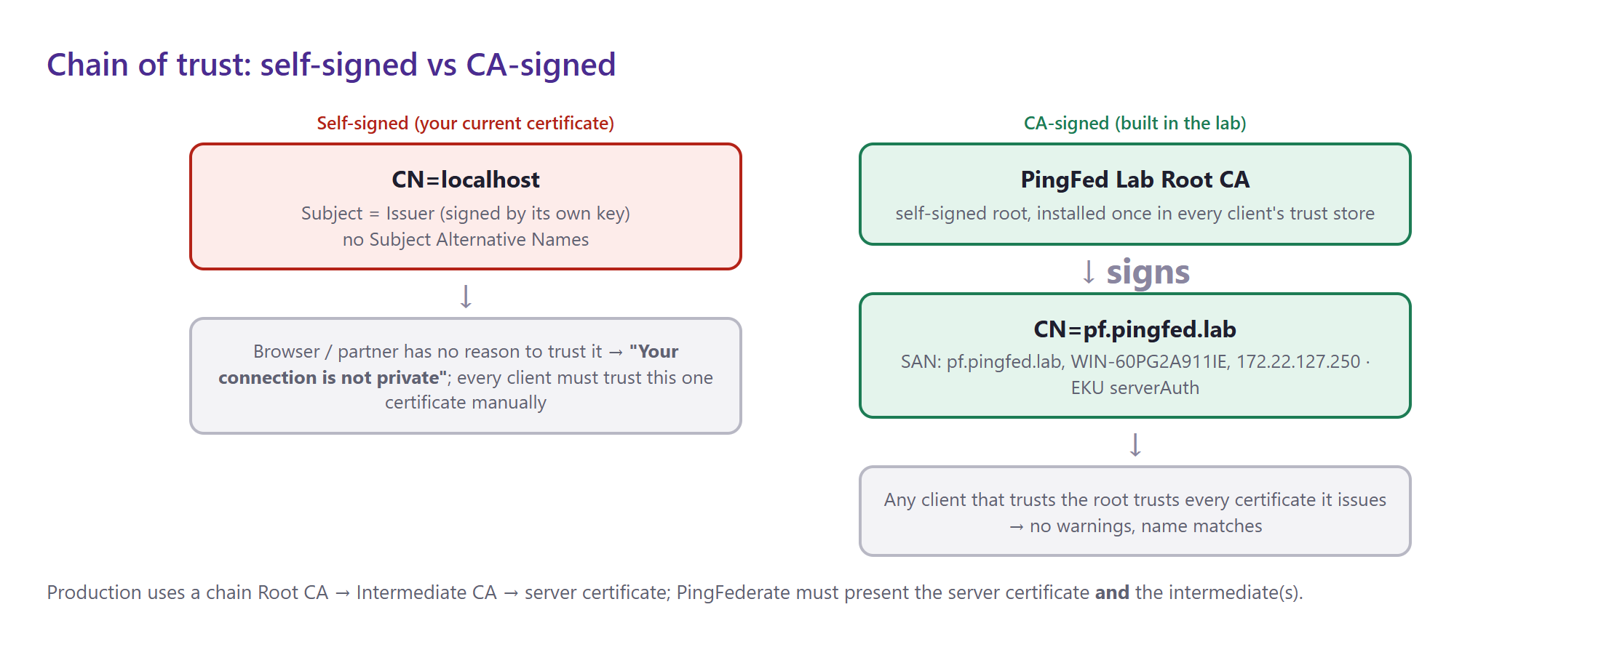
Figure 3 — Your current certificate (left) vs the CA-signed certificate built in the lab (right).
 |  | Self-signed | CA-signed
Trust |  | Every client must trust this exact certificate manually | Automatic for every client that trusts the CA
Browser warning |  | Yes ("Not secure", NET::ERR_CERT_AUTHORITY_INVALID) | No (if the name matches)
Cost / effort |  | None — generated in PingFederate in seconds | CSR + CA approval (internal CA: minutes; public CA: cost + validation)
Good for |  | Labs; SAML signing certificates (partners pin the exact certificate from metadata) | SSL server certificates facing users and partners
Why self-signed is normal for SAML signing
For SSL the browser must trust the issuer, so CA-signed matters. For SAML signing, partners import your exact signing certificate from metadata and trust it directly, so a self-signed signing certificate (2–3 year validity) is common and perfectly valid.

Evidence from your server
The certificate your PingFederate presents on port 9999 was downloaded and inspected live:
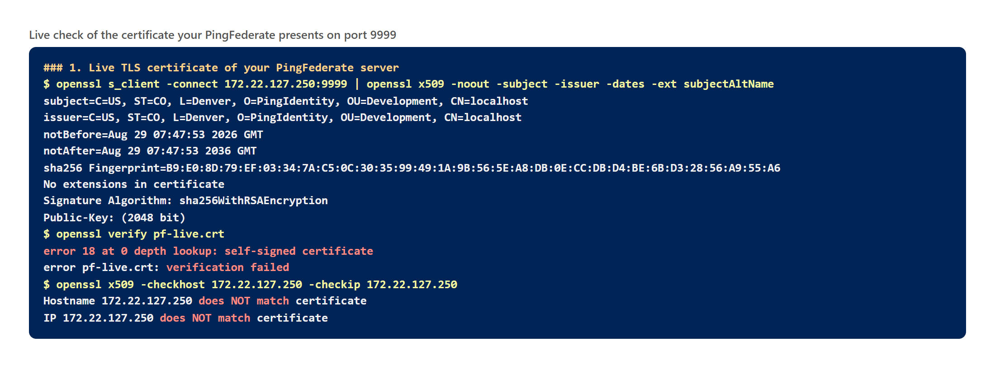
Figure 4 — Live inspection: self-signed (error 18), no extensions/SAN, name and IP do not match.

Lab: build a CA and a CA-signed certificate
To see the difference, a small lab CA "PingFed Lab Root CA" was created and used to issue a proper certificate for PingFederate with SANs for pf.pingfed.lab, WIN-60PG2A911IE and 172.22.127.250, then packaged as PKCS#12 — the file you would import into PingFederate.
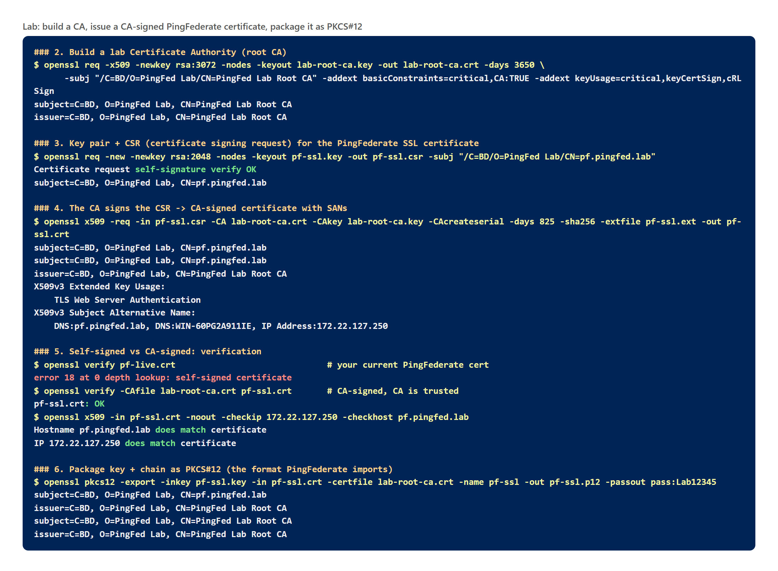
Figure 5 — Lab output: CA → CSR → CA-signed certificate with SANs → verified OK → PKCS#12 package.

SSL Server Certificates in PingFederate
Where in the console: Security → SSL Server Certificates
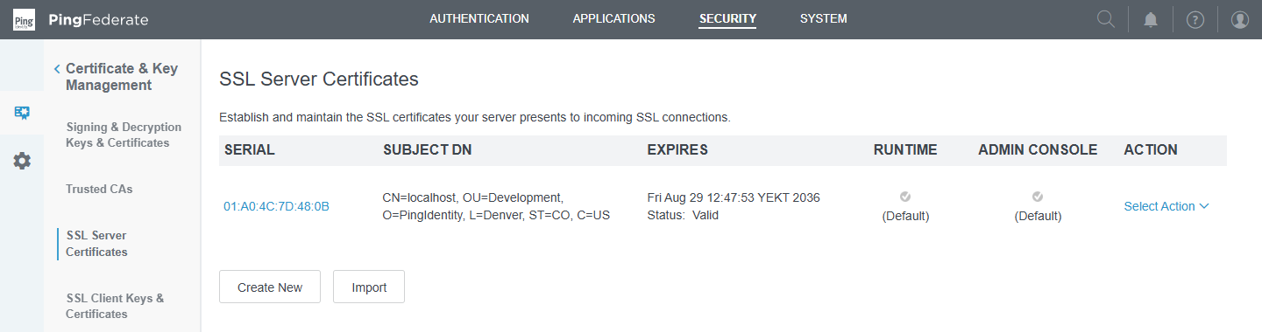
Figure 6 — Your only SSL server certificate — active (Default) for both Runtime and Admin Console.
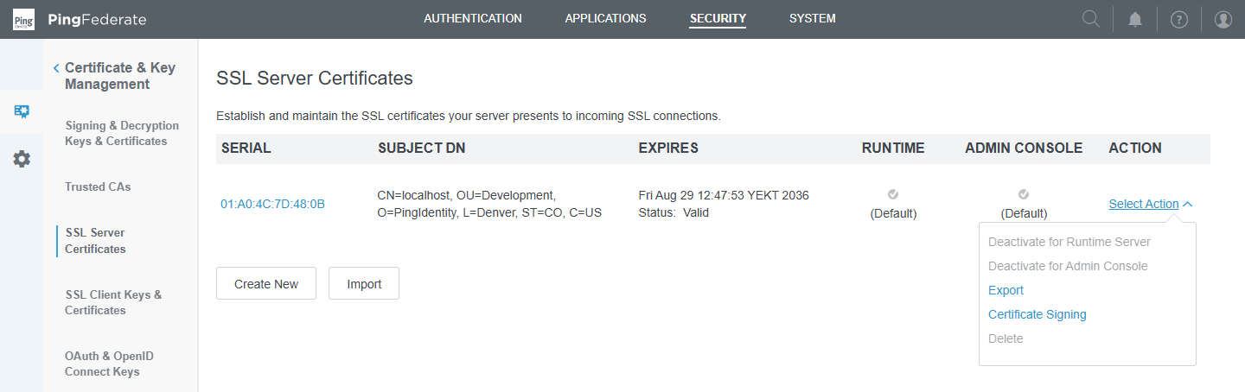
Figure 7 — Select Action menu: Deactivate for Runtime/Admin Console, Export, Certificate Signing (CSR), Delete.
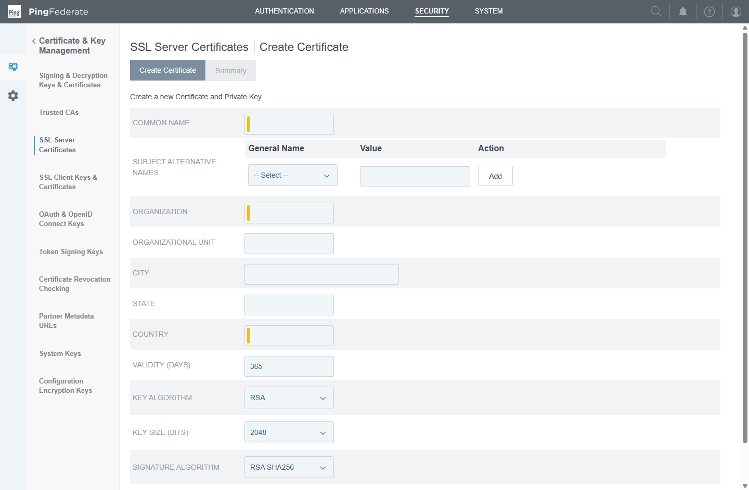
Figure 8 — Create New (opened and cancelled): Common Name, Subject Alternative Names, organisation, validity, key algorithm/size, signature algorithm.

Create-certificate fields
Field | Meaning | Recommended for your lab
Common Name | Primary name (legacy — browsers use SAN) | pf.pingfed.lab
Subject Alternative Names | Every DNS name / IP clients will use | DNS pf.pingfed.lab, DNS WIN-60PG2A911IE, IP 172.22.127.250
Organization / OU / City / State / Country | Identity details (Country = 2-letter code) | PingFed Lab / Lab / Dhaka / – / BD
Validity (days) | Lifetime | 825 (SSL) · 730–1095 (signing)
Key Algorithm / Size | RSA 2048/3072 or EC P-256/P-384 | RSA 2048
Signature Algorithm | How the certificate is signed | RSA SHA256

Replacing the SSL certificate — CSR route
- Security → SSL Server Certificates → Create New with the values above (SANs!).
- Select Action → Certificate Signing → Generate CSR; send the .csr to the CA (in the lab: sign it with the lab CA as shown in section 3).
- Select Action → Certificate Signing → Import CSR Response (the signed certificate, plus chain).
- Select Action → Activate for Runtime Server and Activate for Admin Console; reload the browser.
- Install the CA certificate (lab-root-ca.crt) in the Windows "Trusted Root Certification Authorities" store of each client → no more warnings.
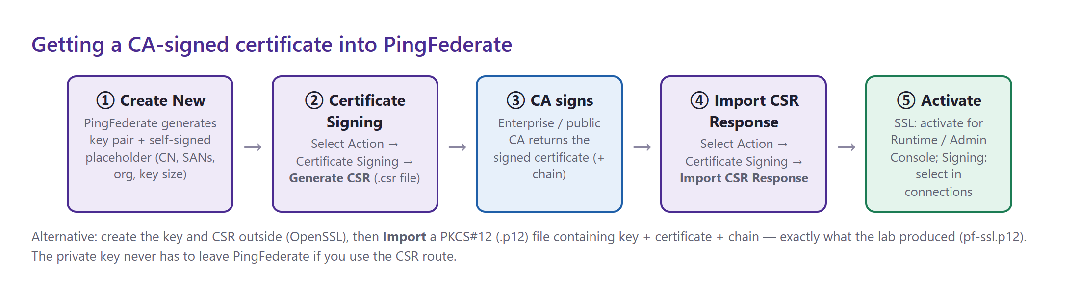
Figure 9 — The CSR workflow inside PingFederate. Alternative: Import the PKCS#12 file from the lab.

4. Digital signature and encryption (PF 20 part 3)
Course video: PF 20 part 3 — Digital Signature and Encryption (19:47)

Concept
- Hash — a fixed-size fingerprint of data (SHA-256). One changed character gives a completely different hash.
- Digital signature — the sender hashes the message and encrypts the hash with its private key. The receiver recomputes the hash and checks it with the sender's public key. Gives integrity (not changed) and authenticity (who sent it), plus non-repudiation. It does not hide the content.
- Encryption — the sender encrypts with the receiver's public key; only the receiver's private key can decrypt. Gives confidentiality. For large data a random AES key encrypts the content and RSA encrypts that AES key (hybrid encryption — this is how SAML assertion encryption works).
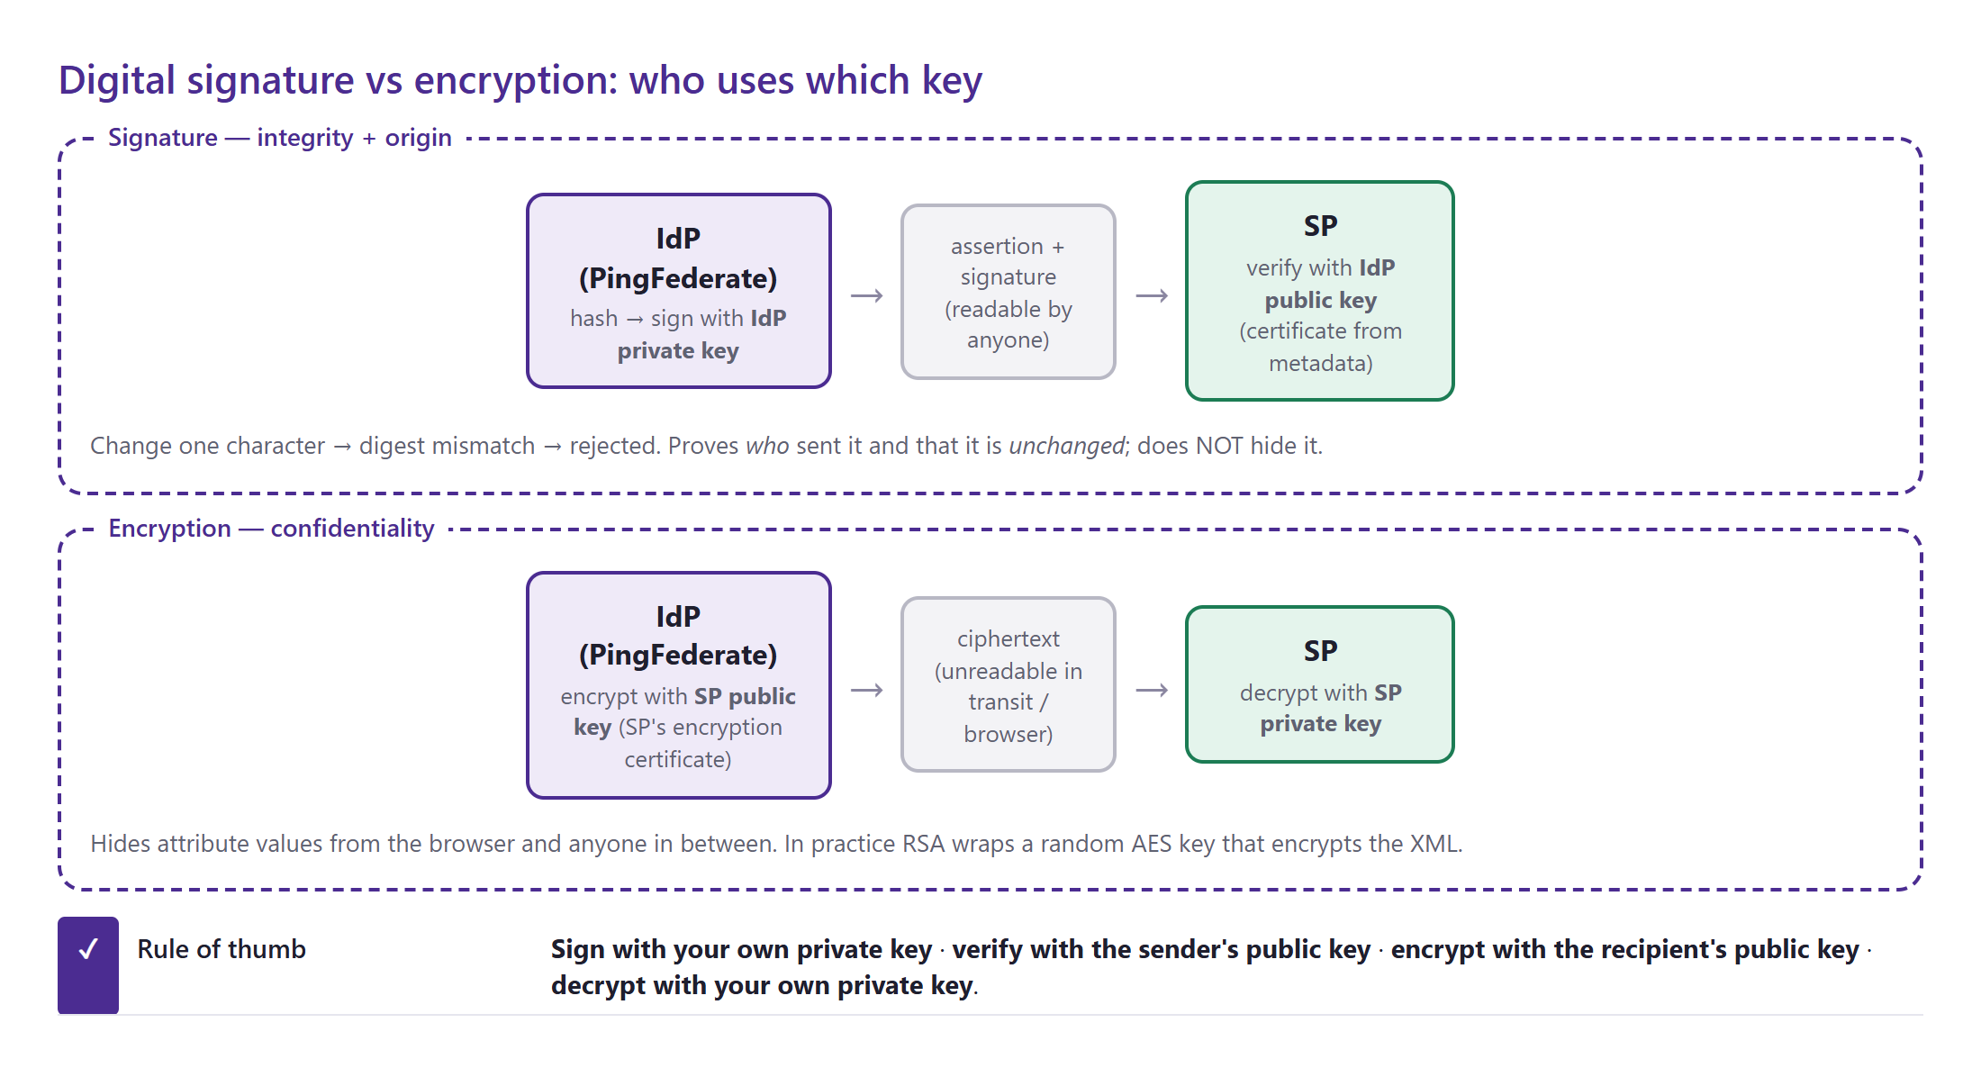
Figure 10 — Who uses which key for signing and for encryption.

Lab: sign, tamper, encrypt
An "IdP signing" key pair and a "Partner SP encryption" key pair were issued by the lab CA. A mini assertion was signed and verified, then modified (testa → admin) — verification fails. It was then encrypted for the SP and decrypted with the SP key; decrypting with the wrong key fails.
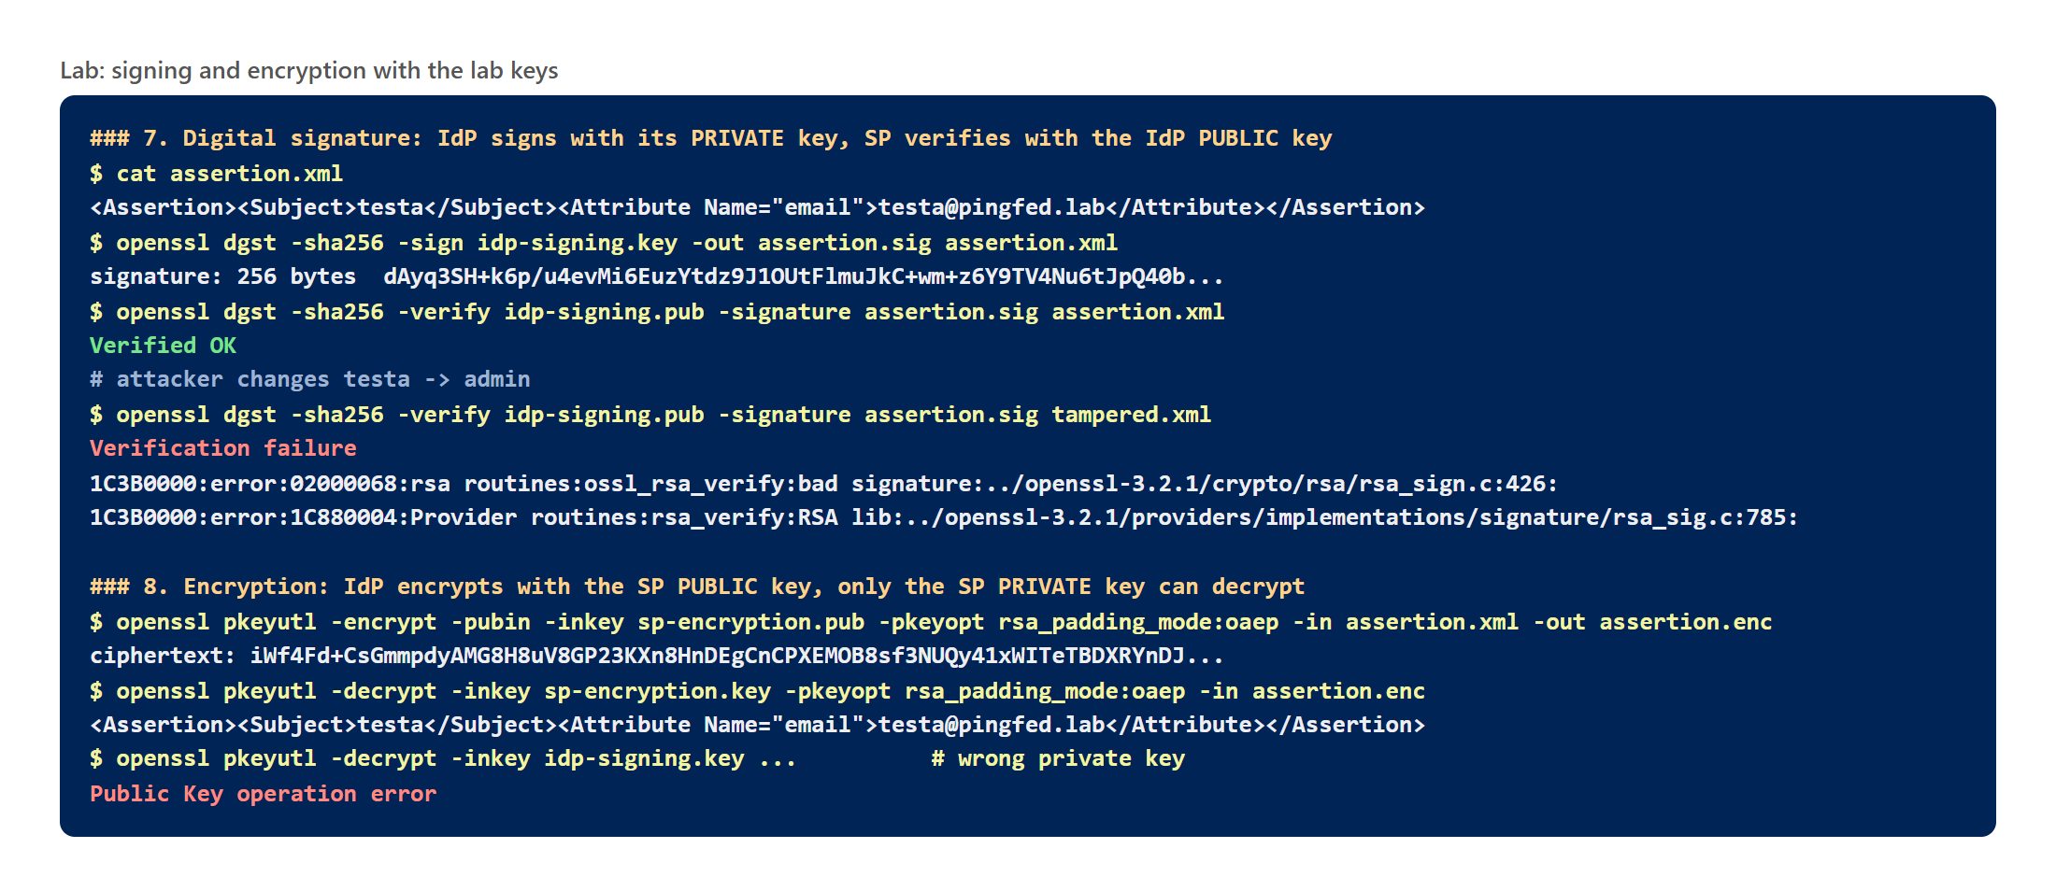
Figure 11 — Signature verification (OK, then failure after tampering) and encryption/decryption with the right and wrong keys.

Where this appears in PingFederate
Setting | Where | Key used
Sign the SAML Response / Assertion | SP connection → Credentials → Digital Signature Settings | Your signing key pair
Require signed AuthnRequests | SP connection → Protocol Settings → Signature Policy | The SP's certificate (imported from its metadata)
Encrypt the assertion / attributes | SP connection → Protocol Settings → Encryption Policy | The SP's encryption certificate
Decrypt assertions sent to you (PingFederate as SP) | IdP connection → Credentials → Decryption Keys | Your decryption key pair (same store as signing)
Sign exported metadata | System → Protocol Metadata → Metadata Signing | Your signing key pair
Where in the console: Security → Signing & Decryption Keys & Certificates
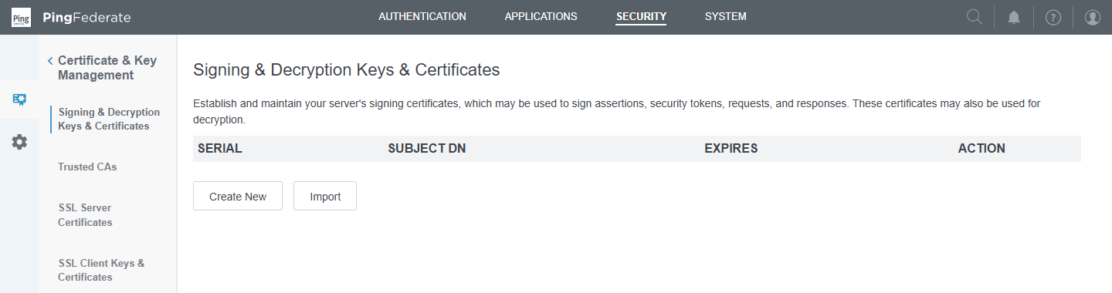
Figure 12 — Signing & Decryption Keys & Certificates — empty on your server.
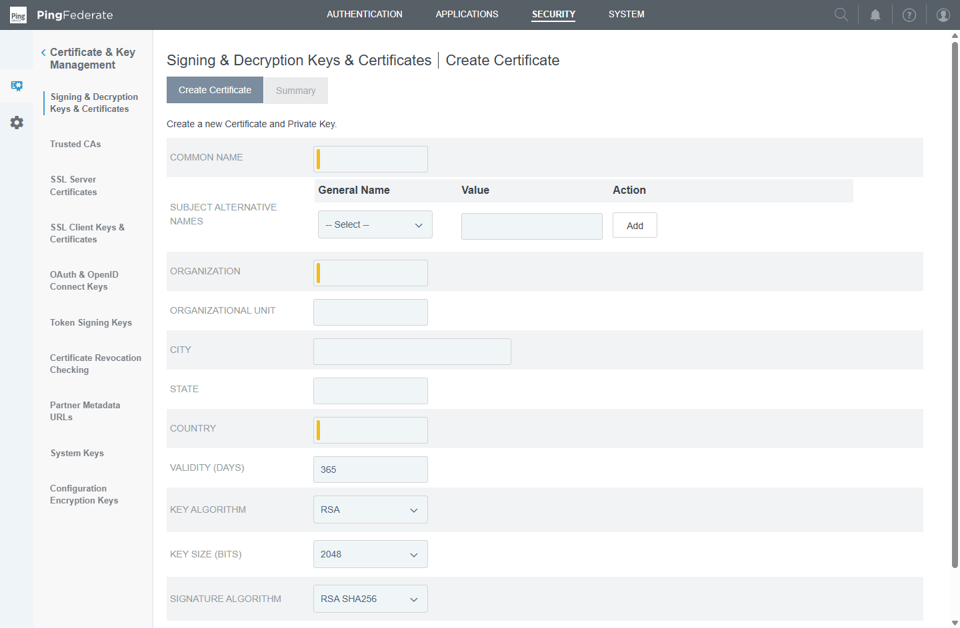
Figure 13 — Create New signing certificate (opened and cancelled) — same fields as the SSL form.
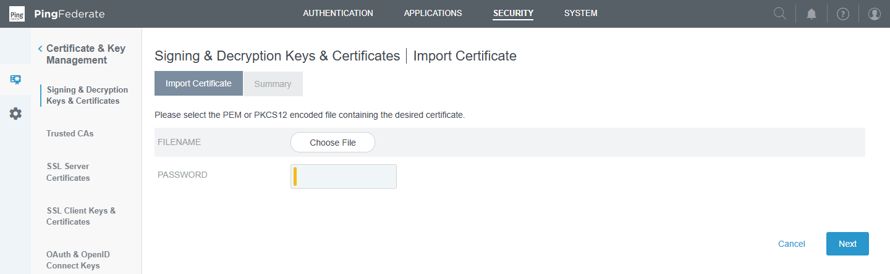
Figure 14 — Import (opened and cancelled): upload a PKCS#12 / PEM file with its password.

5. Certificate management and automation (PF 20 part 4)
Course video: PF 20 part 4 — Certificate Management using VBA Script (6:39)
Expired certificates are one of the most common causes of SSO outages. Certificate management means knowing what you have, when it expires, and rolling it over before it does — without breaking partners.

Other certificate screens
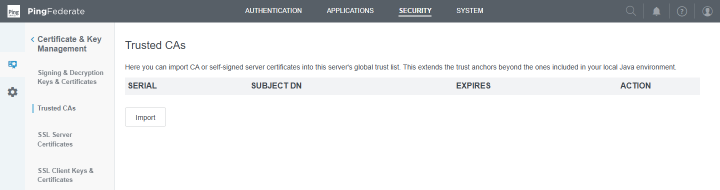
Figure 15 — Trusted CAs — none added. Add your company or lab root CA here when PingFederate must trust servers it calls (LDAPS, partner HTTPS).
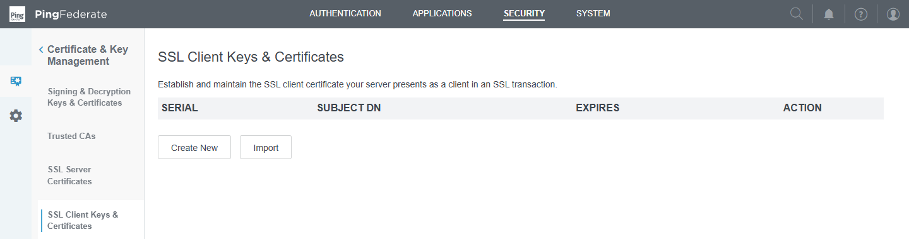
Figure 16 — SSL Client Keys & Certificates — for mutual TLS when PingFederate is the client.
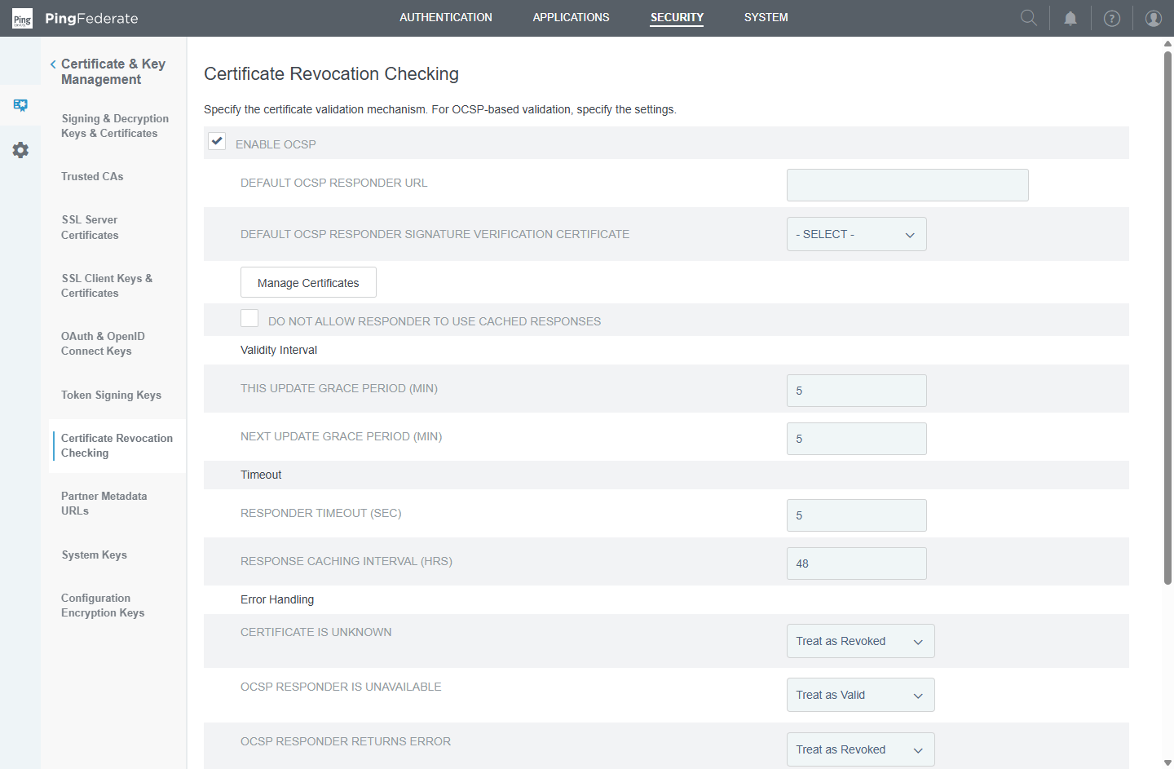
Figure 17 — Certificate Revocation Checking — OCSP enabled with default responder/timeouts; CRL settings below.

Expiry monitoring
- PingFederate already warns in the admin console 14 days before a certificate expires (server setting expiringCertificateAdministrativeConsoleWarningDays = 14 on your server). E-mail notifications can be configured under System → Monitoring & Notifications.
- The course automates the inventory with a VBA script; the same can be done against the Admin API. This Python script lists every certificate with days left:
# cert_report.py (read-only) — saved in pingfed\labs\module4
BASE = 'https://172.22.127.250:9999/pf-admin-api/v1'
STORES = {'SSL server': '/keyPairs/sslServer', 'Signing/decryption': '/keyPairs/signing',
'SSL client': '/keyPairs/sslClient', 'Trusted CA': '/certificates/ca'}
for store, path in STORES.items():
for c in S.get(BASE + path).json()['items']:
days = (parse(c['expires']) - now).days
print(store, c['subjectDN'], c['expires'], days, 'renew soon' if days < 30 else 'ok')

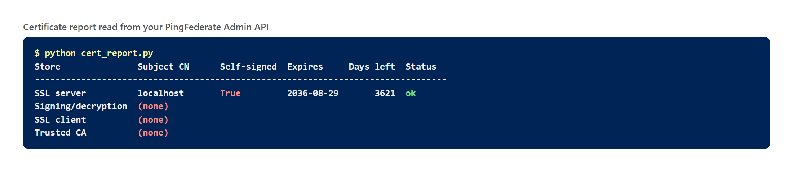
Figure 18 — Report run against your server: one self-signed SSL certificate, 3621 days left; no signing, client or CA certificates.

Rolling over a signing certificate
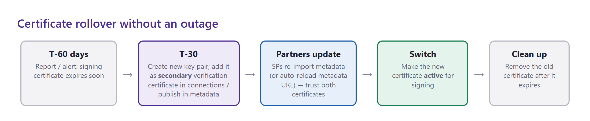
Figure 19 — Rollover plan that avoids an outage for SAML partners.
- Create the new signing key pair well before expiry.
- Give every partner the new certificate in advance (export it, or export updated metadata) so they trust both old and new — most SPs, and PingFederate itself as an SP, accept a primary plus a secondary verification certificate.
- Ask partners to re-import metadata — or give them a metadata URL they reload automatically.
- Switch the active signing certificate to the new one; remove the old one after it expires.

6. Findings and next steps
# | Finding | Impact | Recommended action
1 | No signing certificate | Cannot sign SAML assertions/metadata → no SAML SSO (Modules 5–6) | Create "PingFed Lab IdP Signing" (RSA 2048, 730 days) — or import idp-signing from the lab
2 | SSL cert CN=localhost, self-signed, no SAN | Browser warnings; name mismatch for 172.22.127.250 | Import pf-ssl.p12 (lab CA-signed, password Lab12345) or use the CSR route; trust the lab root CA on clients
3 | Base URL https://localhost:9031 | Metadata and redirects point to localhost | Set https://pf.pingfed.lab:9031 (plus a hosts/DNS entry) or https://172.22.127.250:9031
4 | Licence expired | Runtime 503 | Renew (PF 08)

Lab files (pingfed\labs\module4)
File |  | What it is
lab-root-ca.crt / .key |  | Lab root CA (trust the .crt on clients; keep the .key private)
pf-ssl.crt / .key / .p12 |  | CA-signed SSL certificate for PingFederate (p12 password Lab12345)
idp-signing.crt / .key |  | CA-signed signing key pair (usable as PingFederate signing certificate)
sp-encryption.crt / .key |  | Example partner SP encryption key pair
cert_report.py |  | Certificate expiry report via the Admin API
Lab only
These keys were generated for learning. Never reuse lab private keys in production, and never send a private key to a partner — only certificates (public keys) are shared.

Check yourself
- Which key does PingFederate use to sign an assertion, and which does the SP use to verify it?
- Why do browsers ignore the CN and check the SAN?
- Why is a self-signed signing certificate acceptable for SAML, but not ideal for SSL?
- What file format contains both a private key and its certificate chain?
- What would break if the signing certificate expired, and how do you roll it over safely?

Quick revision
Term | One-line definition
Public / private key | Key pair: public is shared, private never leaves the owner
X.509 certificate | Public key + identity + validity, signed by an issuer
CA | Authority whose signature makes certificates trusted
Self-signed | Issuer = subject; trusted only if pinned manually
CSR | Request containing a public key and subject, sent to a CA
SAN | Names/IPs a certificate is valid for
PKCS#12 | Password-protected bundle of key + certificate + chain
Signature | Integrity + authenticity (private key signs, public key verifies)
Encryption | Confidentiality (recipient public key encrypts, private key decrypts)
OCSP / CRL | Ways to check whether a certificate was revoked

