PingFederate Complete Course

Module 5 — SAML 2.0 Fundamentals
SAML roles and messages, the four bindings (Redirect, POST, Artifact, SOAP), SP- vs IdP-initiated SSO, RelayState and metadata — explained with diagrams, real SAML messages generated for your setup, and live screenshots from your PingFederate server.

Item | Detail
Videos covered | PF 21 parts 1–3, PF 22, PF 23, PF 24 (6 videos, ~1 h 24 min)
Server | PingFederate 13.1.2 · SAML 2.0 IdP and SP roles enabled
Screenshots | Captured with Playwright from your admin console on 30 Sep 2026. Read-only: the SP-connection wizard was walked through and cancelled.
SAML messages | Generated with Python (lxml + signxml) using the lab IdP signing key from Module 4 — real, verifiable XML. Script: pingfed\labs\module5\lab5.py.

Is your server ready to be a SAML IdP?
✅ SAML 2.0 IdP role enabled · ✅ users and adapters exist (Module 3)
❌ SAML 2.0 Entity ID is empty · ❌ Base URL is https://localhost:9031 · ❌ no signing certificate (Module 4) · ❌ no authentication policy (Module 3) · ❌ licence expired
Section 8 lists the fixes in order. Until then, the SAML messages in this document show exactly what PingFederate will send.
Contents
1. SAML 2.0 in one picture 3
Vocabulary 3
2. What is inside a SAML Response (PF 21 part 1) 4
What the SP checks before letting the user in 4
Lab: a real signed assertion 4
3. SAML bindings (PF 21 parts 1–3) 6
HTTP-Redirect and HTTP-POST (PF 21 part 2) 6
HTTP-Artifact (PF 21 part 3) 7
PingFederate SAML endpoints 7
4. SP-initiated vs IdP-initiated SSO (PF 22) 8
SP-initiated 8
IdP-initiated 8
5. RelayState (PF 23) 9
6. Metadata (PF 24) 10
Your PingFederate's metadata (what it will look like) 10
Metadata screens on your server 10
Importing an SP's metadata (preview of Module 6) 12
7. Tools for seeing SAML in action 15
8. Getting your server ready for SAML 16
Suggested order 16
9. Check yourself and quick revision 17

1. SAML 2.0 in one picture
SAML 2.0 (Security Assertion Markup Language) is an XML standard that lets an Identity Provider tell a Service Provider "this user has logged in, and here are their attributes" in a signed message called an assertion. The user's browser carries the messages; the two servers trust each other because they exchanged metadata (entity IDs, URLs and certificates) beforehand.
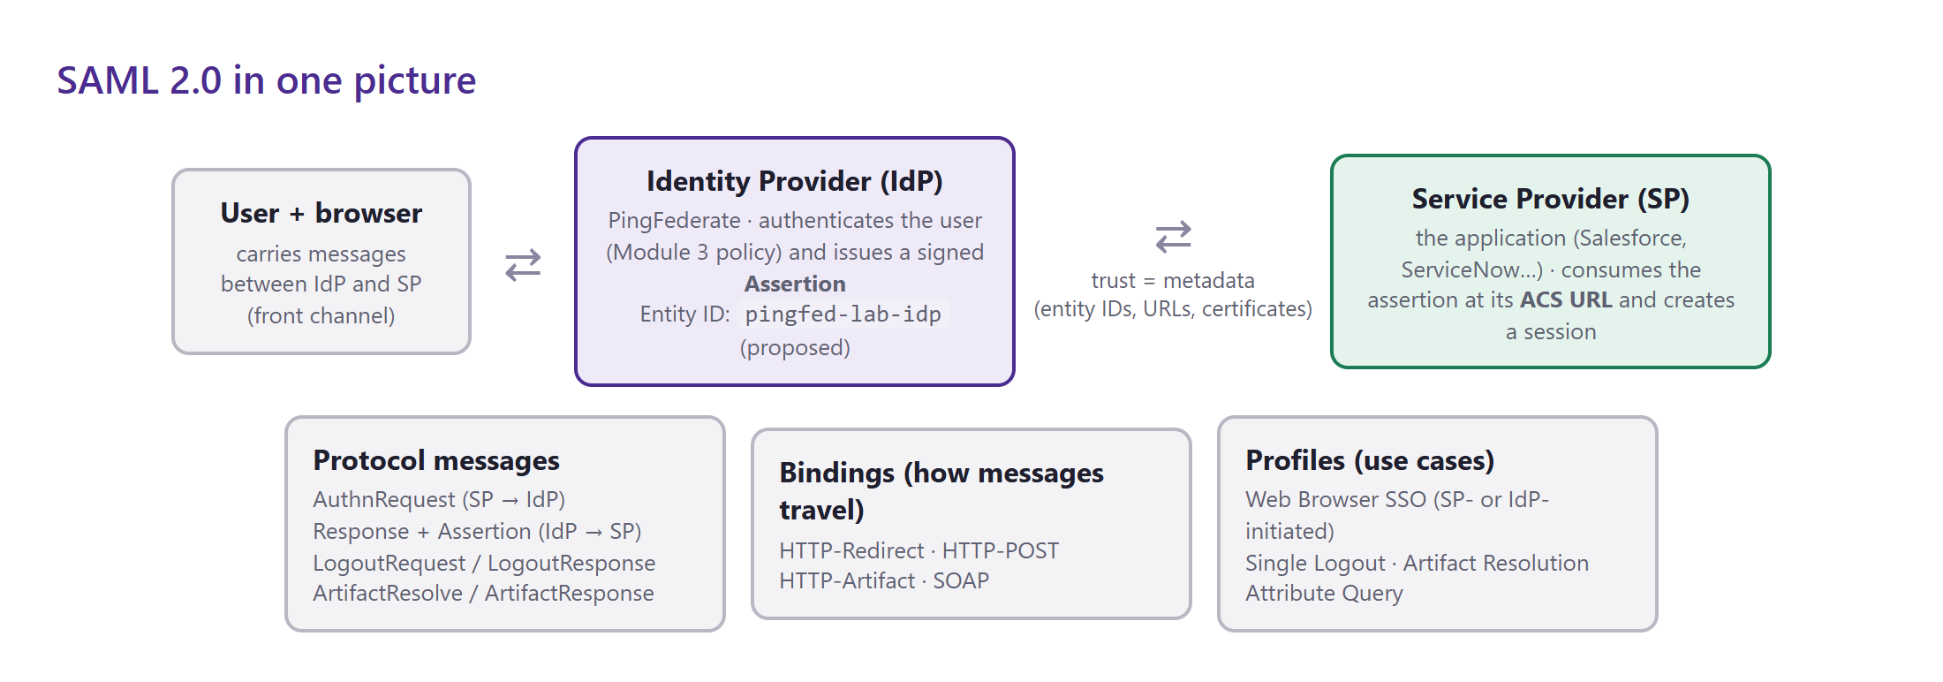
Figure 1 — Roles, messages, bindings and profiles. PingFederate is the IdP; the application is the SP.

Vocabulary
Term | Meaning | In your lab
Identity Provider (IdP) | Authenticates the user and issues assertions | PingFederate
Service Provider (SP) | The application that consumes assertions | e.g. Salesforce (Module 6)
Entity ID | Globally unique name of an IdP or SP (a URI or string) | empty — proposed: pingfed-lab-idp
Assertion | Signed XML statement about the user (subject, conditions, authentication, attributes) | built from the policy contract (Module 3)
SSO service URL | Where the IdP receives AuthnRequests | https://<base-url>/idp/SSO.saml2
ACS URL | Assertion Consumer Service — where the SP receives the Response | provided by the SP
NameID | The user identifier inside the assertion (unspecified, email, persistent, transient…) | e.g. testa
Binding | How a message is transported (Redirect, POST, Artifact, SOAP) | section 3
Profile | A use case combining messages + bindings (Web Browser SSO, Single Logout…) | section 4
Metadata | XML describing an entity: ID, endpoints, certificates | section 6

2. What is inside a SAML Response (PF 21 part 1)
Course video: PF 21 part 1 — SAML and Binding Types (13:21)
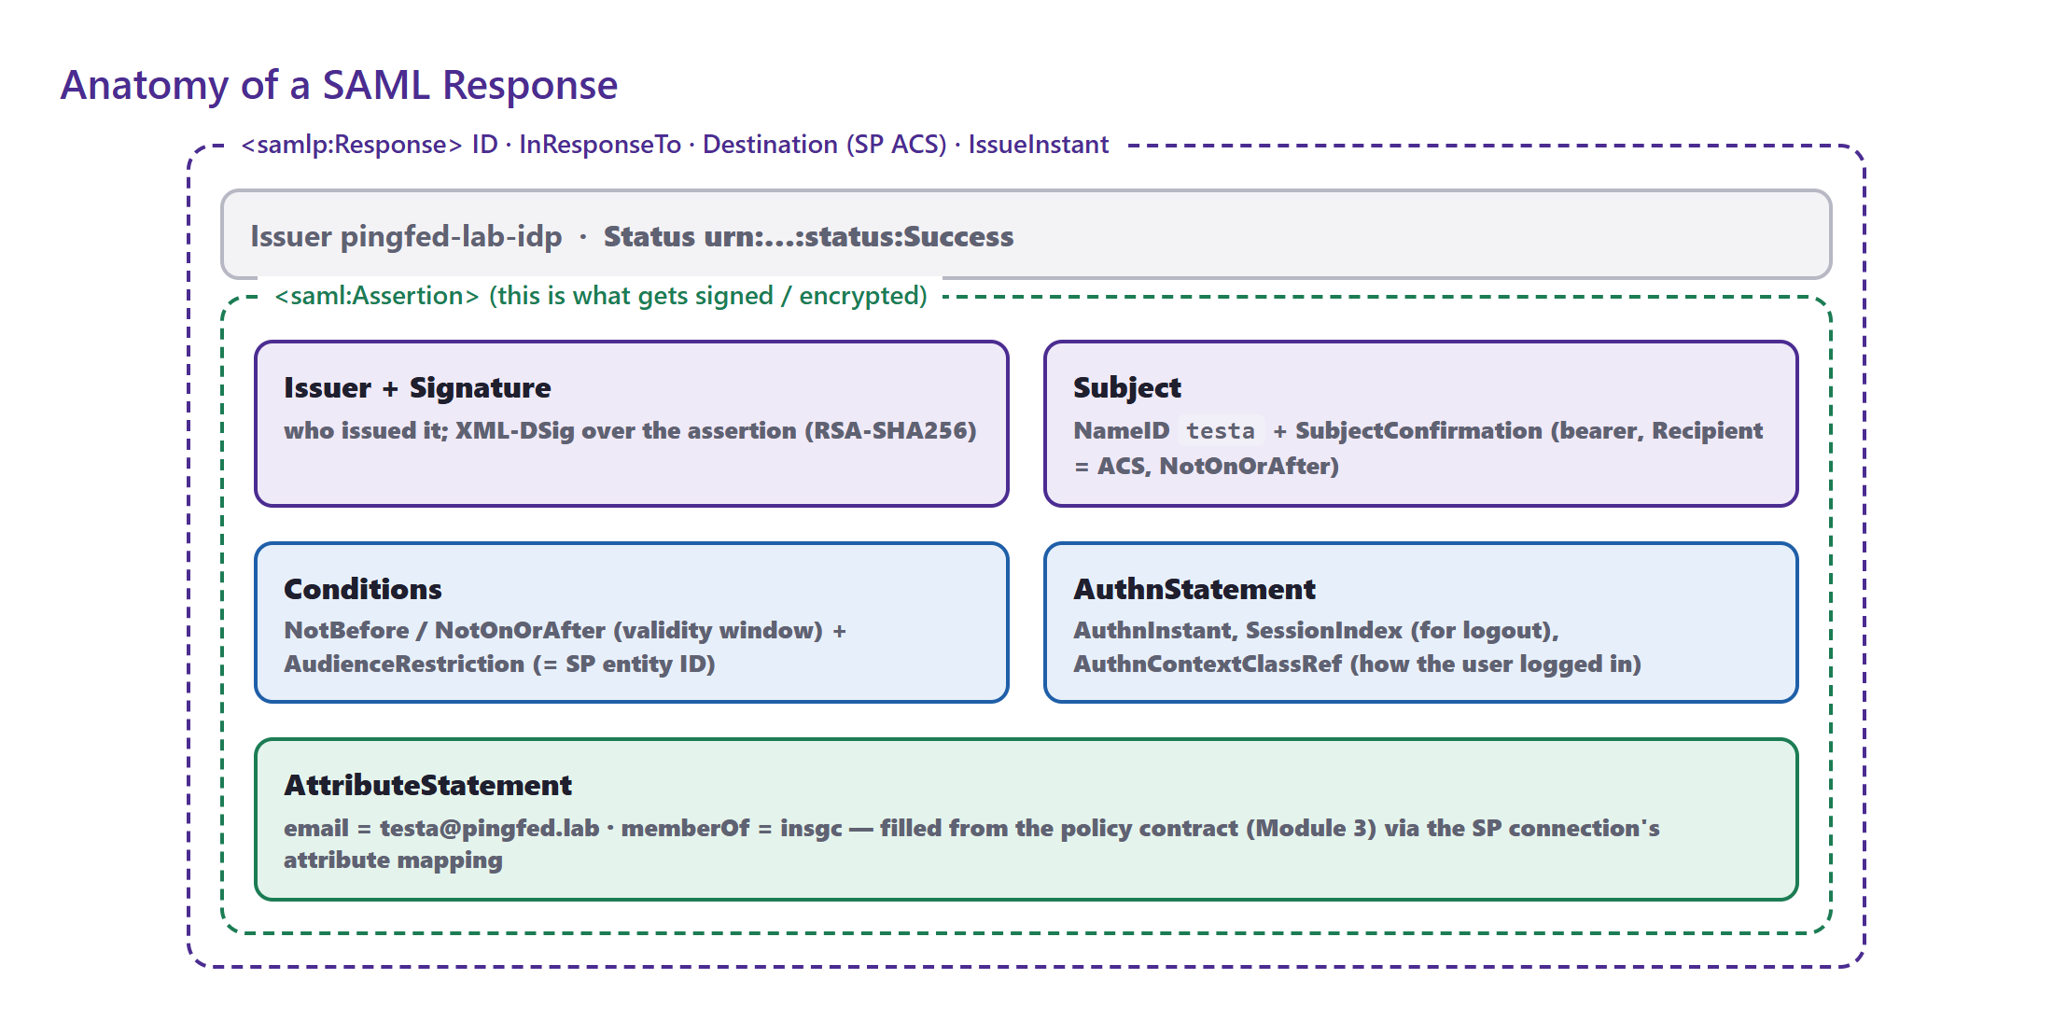
Figure 2 — The Response wraps the Assertion; the Assertion is what gets signed (and optionally encrypted).

What the SP checks before letting the user in
Check | Why
Signature valid with the IdP certificate from metadata | Proves PingFederate issued it and nothing was changed
Issuer = expected IdP entity ID | Rejects assertions from other IdPs
Destination / Recipient = its own ACS URL | Prevents replaying a response meant for another SP
Audience = its own entity ID | The assertion was issued for this SP
NotBefore / NotOnOrAfter | Short validity window (typically 5 minutes) — clocks must be in sync
InResponseTo = the ID of its AuthnRequest | SP-initiated only: ties the response to the request
Assertion ID not seen before | Replay protection

Lab: a real signed assertion
The lab generated a complete Response for user testa (email, memberOf=insgc), signed the Assertion with the Module 4 IdP signing key (XML-DSig, RSA-SHA256, exclusive C14N), verified it, then changed the NameID from testa to admin:
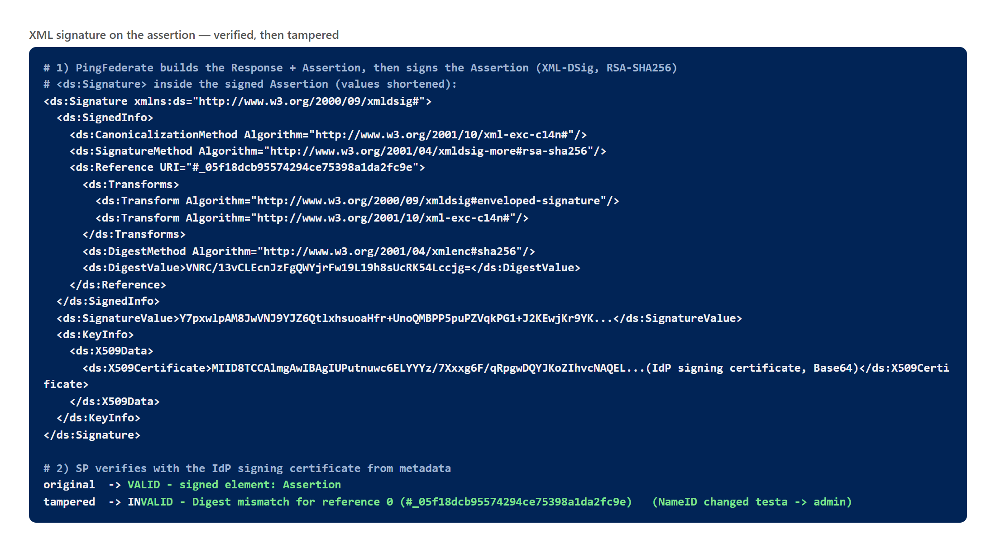
Figure 3 — The <ds:Signature> element and the verification result before and after tampering.
- Reference URI points at the Assertion's ID — that is the part covered by the signature.
- DigestValue is the SHA-256 hash of the canonicalised assertion; SignatureValue is the RSA signature over SignedInfo.
- KeyInfo carries the certificate for convenience — a secure SP still verifies against the certificate it got from metadata, never blindly against KeyInfo.

3. SAML bindings (PF 21 parts 1–3)
A binding defines how a SAML message is carried over HTTP. The same AuthnRequest or Response can be sent in different ways depending on size and security needs.
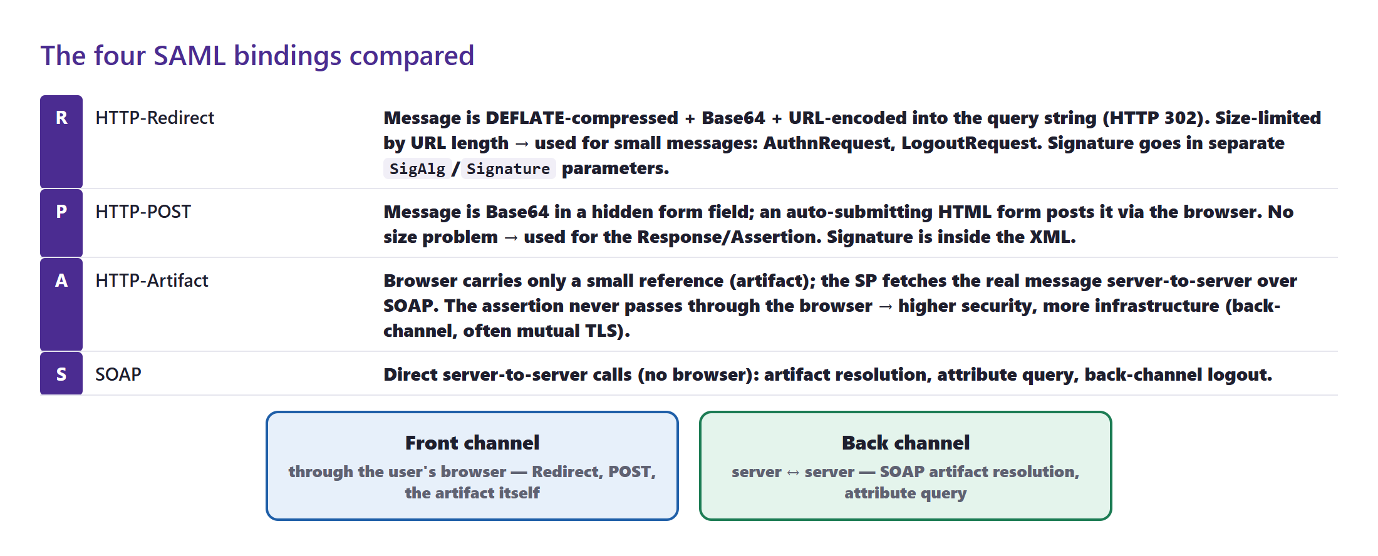
Figure 4 — The four bindings, and which travel through the browser (front channel) or server-to-server (back channel).

HTTP-Redirect and HTTP-POST (PF 21 part 2)
Course video: PF 21 part 2 — HTTP Redirect and HTTP POST Binding (10:50)
HTTP-Redirect puts the message in the URL. Because URLs are limited in length, the XML is DEFLATE-compressed, Base64-encoded and URL-encoded. It is used for small messages — mainly the AuthnRequest. When requests must be signed, the signature is sent as separate SigAlg and Signature query parameters.
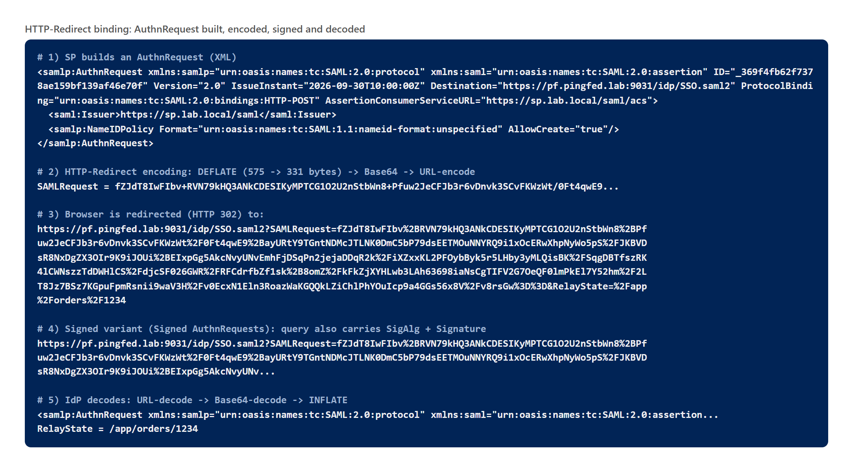
Figure 5 — A real AuthnRequest from an example SP to your PingFederate, encoded for HTTP-Redirect, signed, and decoded back.
HTTP-POST puts the Base64-encoded message into a hidden form field. The IdP returns an HTML page whose JavaScript submits the form to the SP's ACS URL. There is no size limit, so it is the normal binding for the Response/Assertion; the signature is inside the XML.
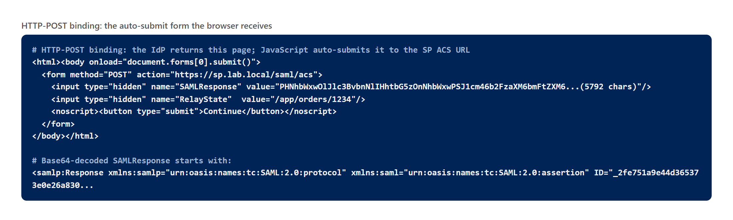
Figure 6 — The auto-submitting form the browser receives from PingFederate (SAMLResponse is ~5.8 KB of Base64).

HTTP-Artifact (PF 21 part 3)
Course video: PF 21 part 3 — HTTP Artifact Binding (10:52)
With HTTP-Artifact the browser carries only a short artifact — a one-time reference. The SP then calls PingFederate's Artifact Resolution Service directly over SOAP (back channel, usually with TLS client authentication) to fetch the real message. The assertion never passes through the browser, at the cost of an extra server-to-server connection.
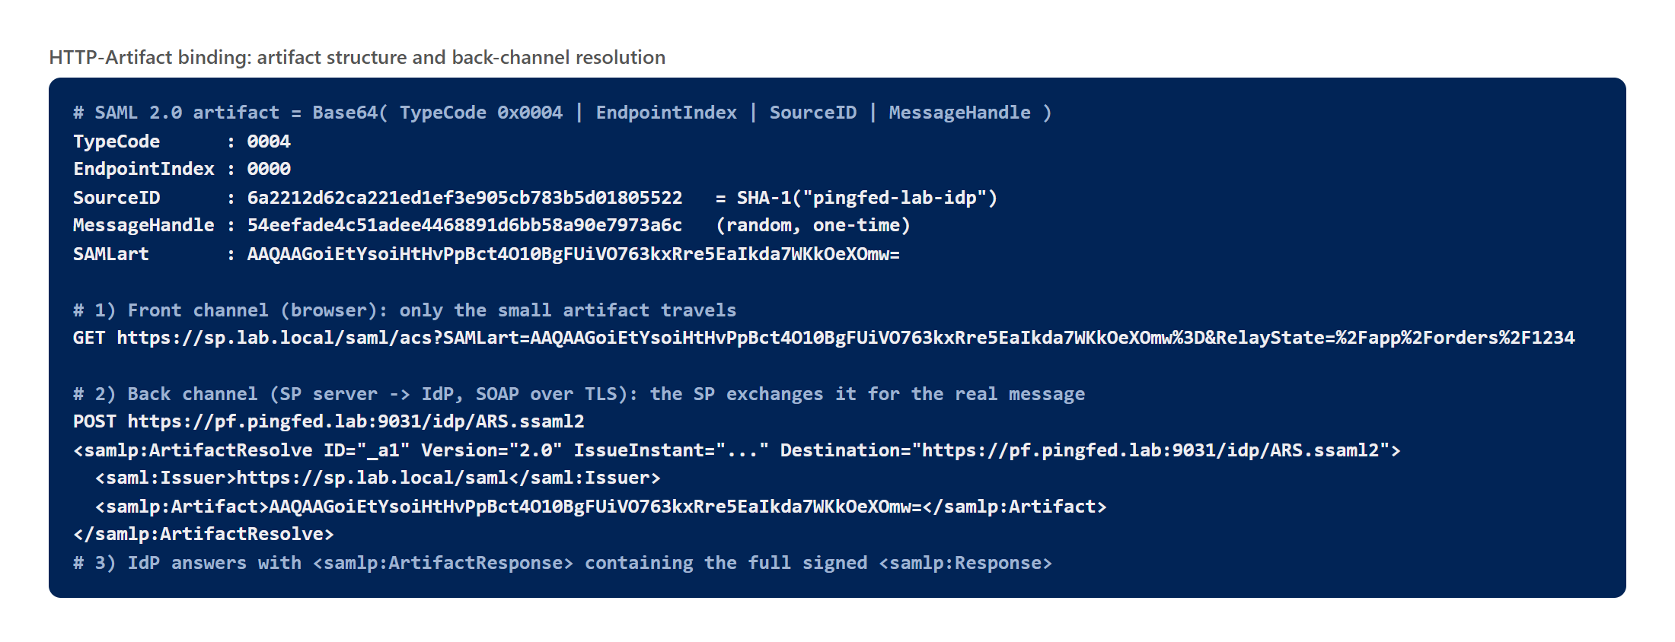
Figure 7 — Artifact structure (type code, endpoint index, SourceID = SHA-1 of the IdP entity ID, random handle) and the back-channel ArtifactResolve call.

PingFederate SAML endpoints
Endpoint | Role | Purpose
/idp/SSO.saml2 | IdP | Receives AuthnRequests (Redirect, POST, Artifact)
/idp/SLO.saml2 | IdP | Single Logout
/idp/ARS.ssaml2 | IdP | Artifact Resolution Service (SOAP)
/idp/startSSO.ping?PartnerSpId=… | IdP | Starts IdP-initiated SSO to a partner SP
/sp/ACS.saml2 | SP | Assertion Consumer Service (PingFederate as SP)
/sp/startSSO.ping?PartnerIdpId=… | SP | Starts SP-initiated SSO to a partner IdP
/pf/federation_metadata.ping | both | Publishes metadata (when enabled)
All are relative to the Base URL (runtime port 9031). With your current base URL they would be advertised as https://localhost:9031/…, which no partner can reach — see section 8.

4. SP-initiated vs IdP-initiated SSO (PF 22)
Course video: PF 22 — SP vs IDP Initiated SSO (15:30)

SP-initiated
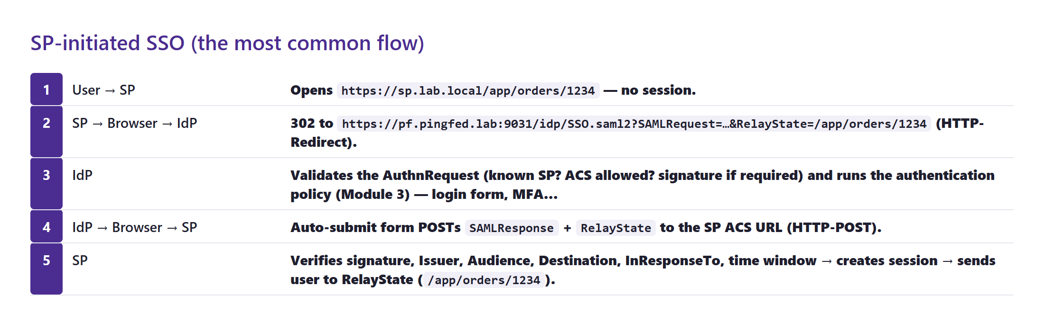
Figure 8 — SP-initiated: the user starts at the application, which sends an AuthnRequest.

IdP-initiated
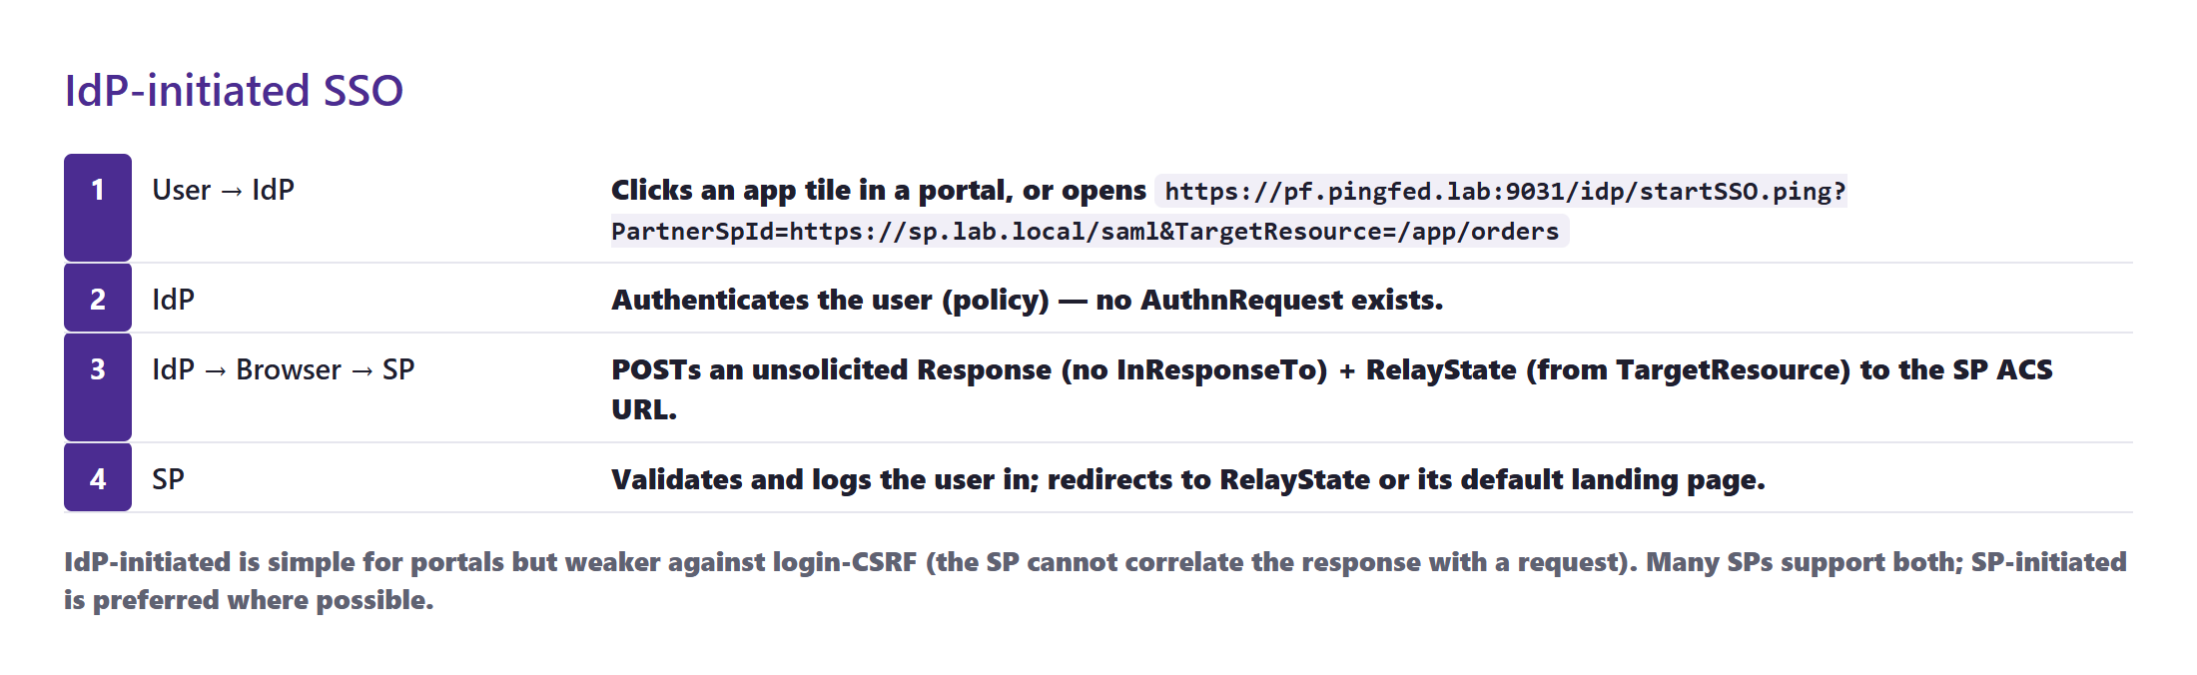
Figure 9 — IdP-initiated: the user starts at PingFederate; the Response is unsolicited.
 | SP-initiated | IdP-initiated
Starts at | The application URL (bookmark, deep link) | A portal / PingFederate start URL
AuthnRequest | Yes — SP → IdP (usually HTTP-Redirect) | No
InResponseTo in Response | Yes | No (unsolicited)
Deep links | Natural — the SP keeps the target in RelayState | Only via TargetResource / RelayState
Security | Stronger — response bound to a request | Weaker against login CSRF; some SPs disable it
PingFederate URL | SP sends to /idp/SSO.saml2 | /idp/startSSO.ping?PartnerSpId=<SP entity ID>&TargetResource=<url>

5. RelayState (PF 23)
Course video: PF 23 — Relay state (26:12)
RelayState is an opaque value the SP sends with its request and gets back unchanged with the response — usually the URL the user originally wanted. The IdP must return it exactly as received.
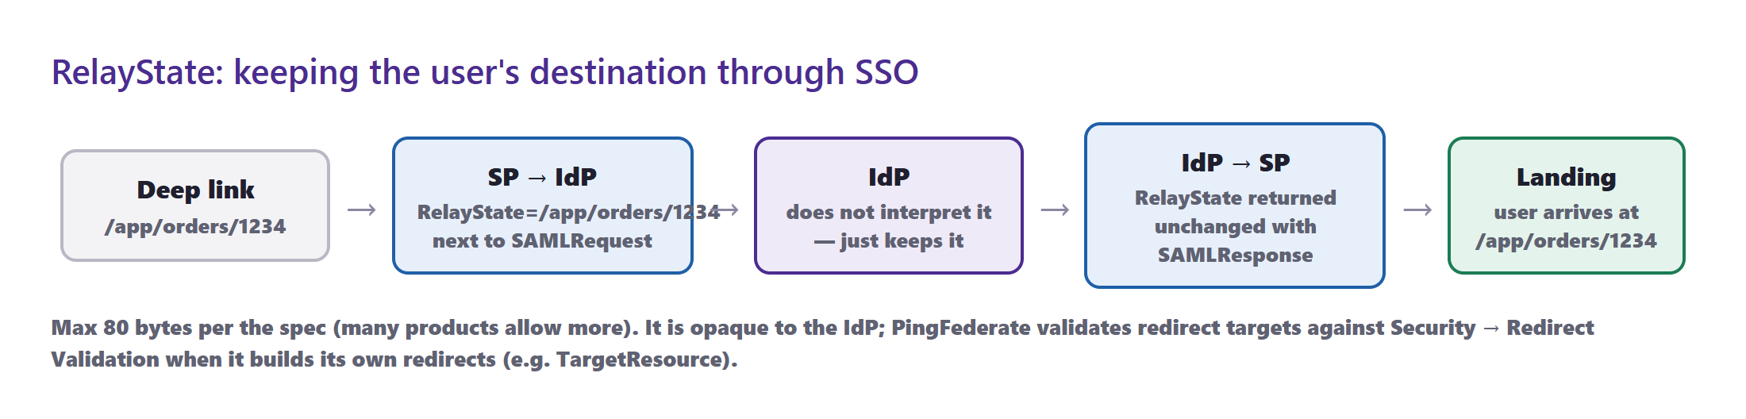
Figure 10 — RelayState carries the deep link /app/orders/1234 through the SSO round trip.
Situation | How RelayState is set
SP-initiated | The SP adds RelayState= next to SAMLRequest; PingFederate echoes it back with SAMLResponse
IdP-initiated (PingFederate) | TargetResource= on /idp/startSSO.ping becomes the RelayState sent to the SP
PingFederate as SP | TargetResource= on /sp/startSSO.ping is where PingFederate sends the user after SSO
Error handling | InErrorResource= gives a URL to go to if SSO fails
- Size: the specification limits RelayState to 80 bytes; many SPs accept more, some store a short key instead of the URL.
- Security: PingFederate only redirects to targets allowed under Security → Redirect Validation — prevents open-redirect abuse.

6. Metadata (PF 24)
Course video: PF 24 — Metadata (7:37)
Metadata is an XML document that describes a SAML entity: its entity ID, its endpoints and bindings, the NameID formats it supports and its certificates. Exchanging metadata sets up trust in one step instead of typing URLs and pasting certificates by hand.
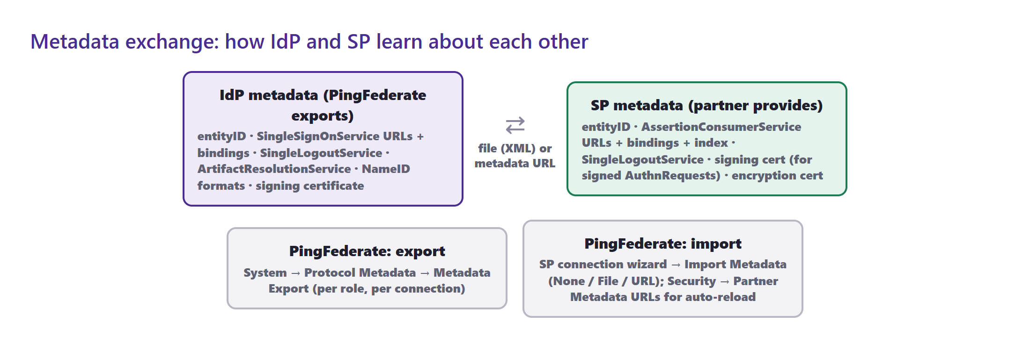
Figure 11 — IdP and SP metadata contents, and where PingFederate exports and imports metadata.

Your PingFederate's metadata (what it will look like)
Once the entity ID, base URL and signing certificate are set, the IdP metadata PingFederate exports will look like this (generated with the lab signing certificate and the proposed values):
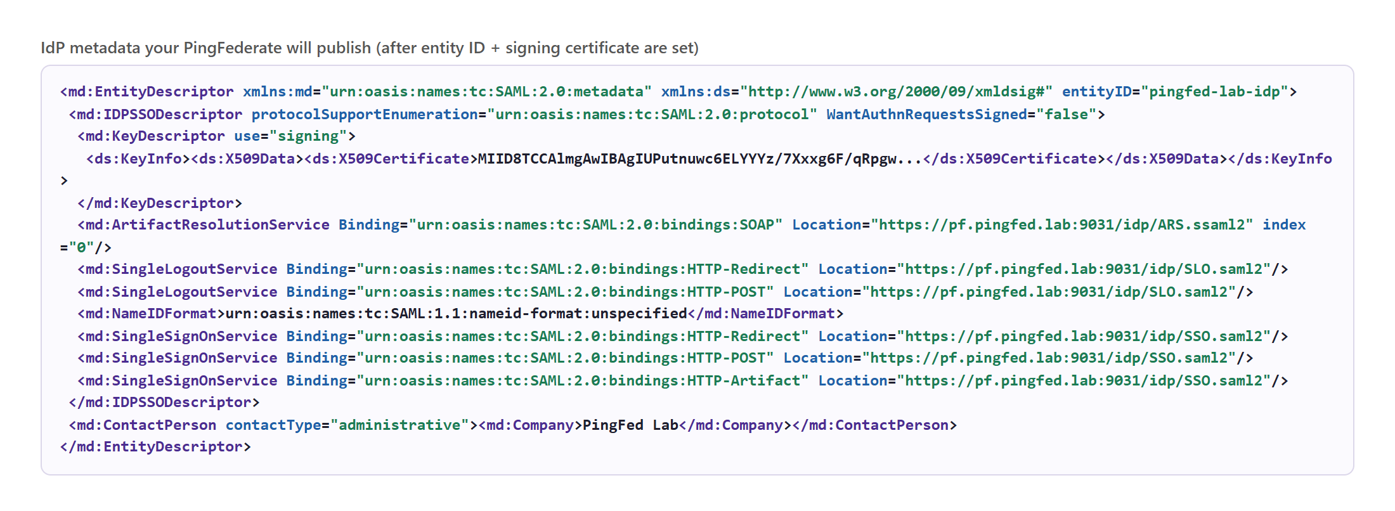
Figure 12 — IdP metadata: entity ID, signing certificate, SSO/SLO/ARS endpoints and bindings.

Metadata screens on your server
Where in the console: System → Server → Protocol Settings → Federation Info
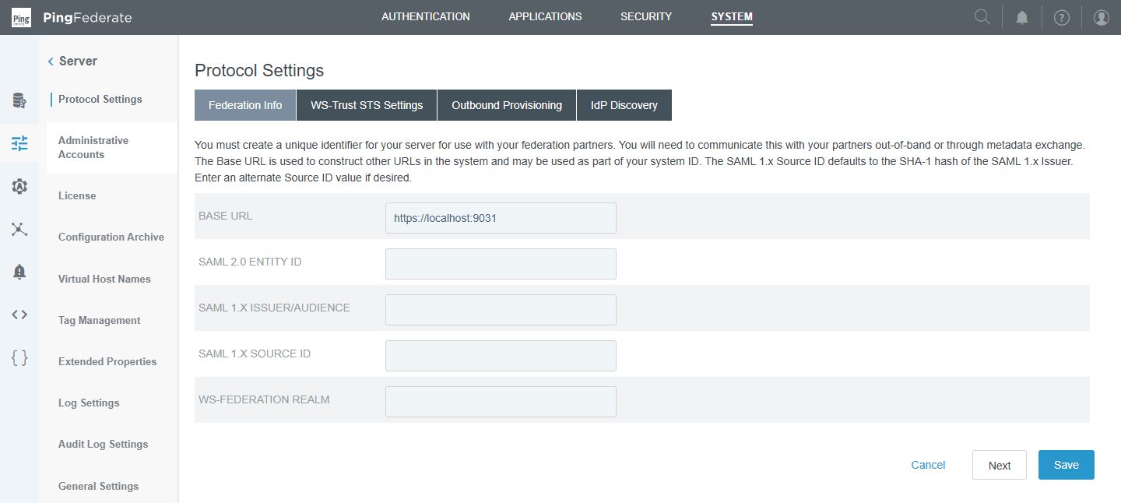
Figure 13 — Federation Info: Base URL is https://localhost:9031 and SAML 2.0 Entity ID is empty — both must be set before any SAML partner can be configured.
Where in the console: System → Protocol Metadata
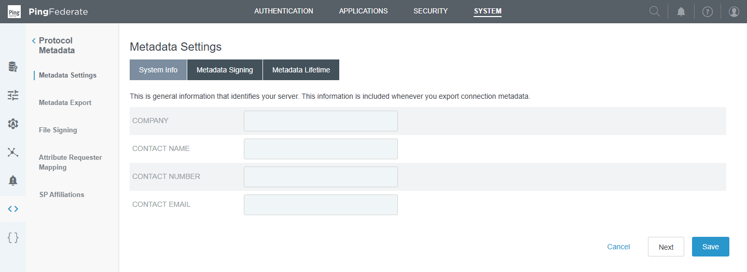
Figure 14 — Metadata Settings → System Info: company and contact details included in exported metadata (empty).
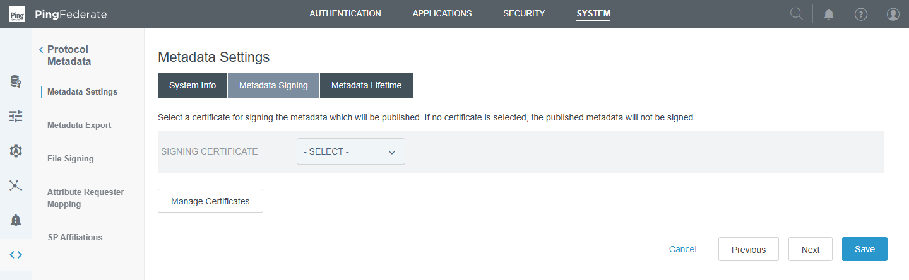
Figure 15 — Metadata Signing: choose a signing certificate to sign exported metadata — none available yet.
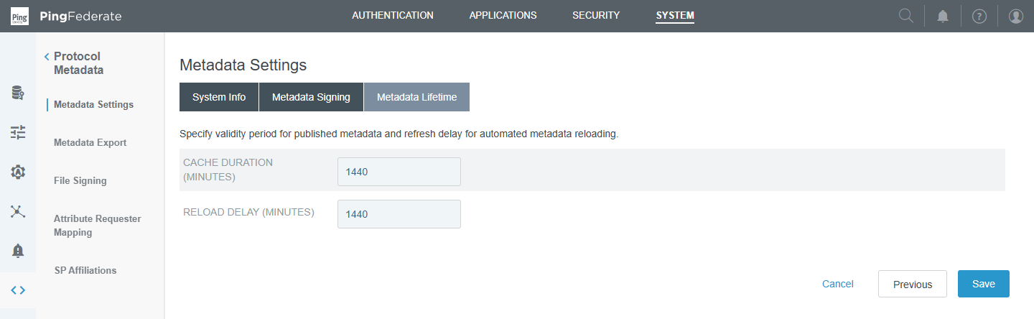
Figure 16 — Metadata Lifetime: cache duration and reload delay (1440 minutes each).
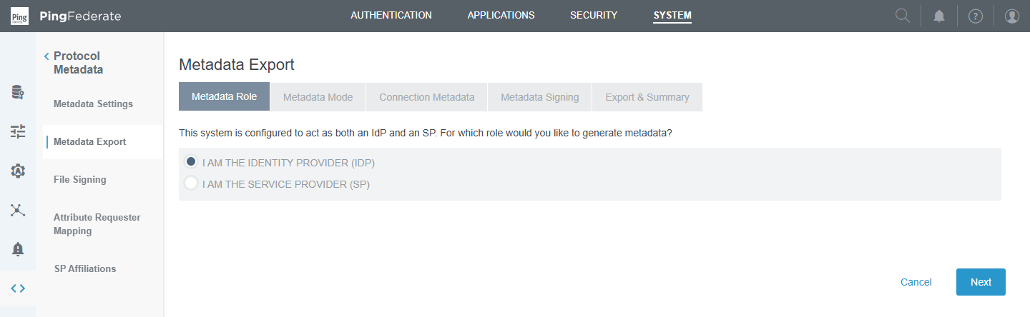
Figure 17 — Metadata Export: choose the role (IdP or SP) to export metadata for.
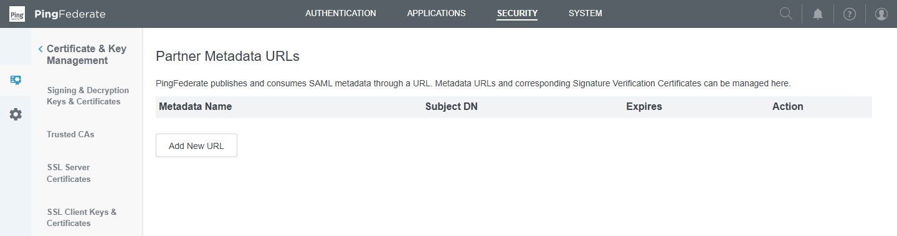
Figure 18 — Security → Partner Metadata URLs: register partner metadata URLs for automatic reloading (none yet).

Importing an SP's metadata (preview of Module 6)
The SP-connection wizard was walked through up to the metadata step and cancelled — nothing was saved:
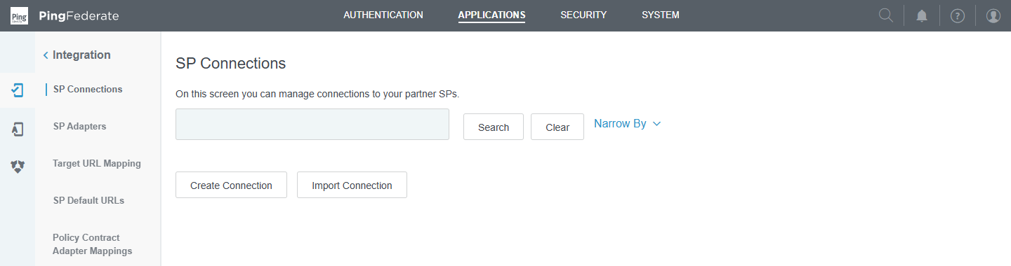
Figure 19 — Applications → SP Connections — empty.
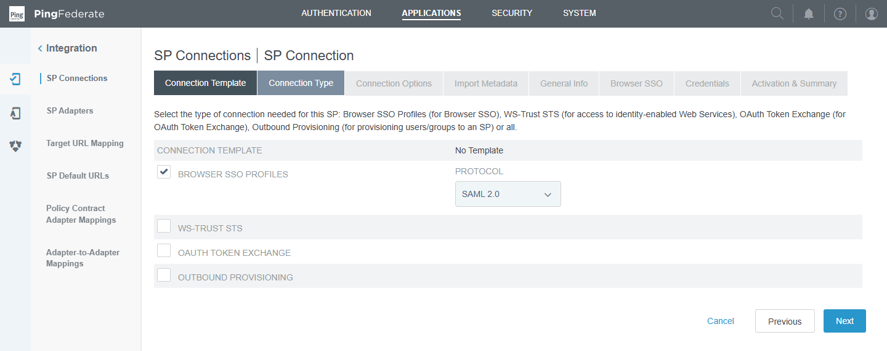
Figure 20 — Connection Type: Browser SSO Profiles with protocol SAML 2.0.
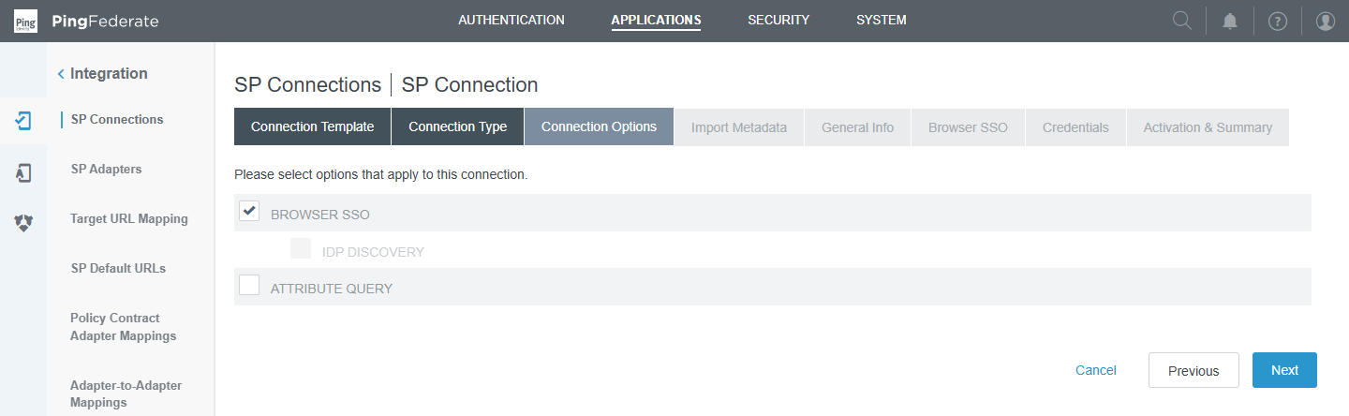
Figure 21 — Connection Options: Browser SSO (plus optional IdP Discovery, Attribute Query).
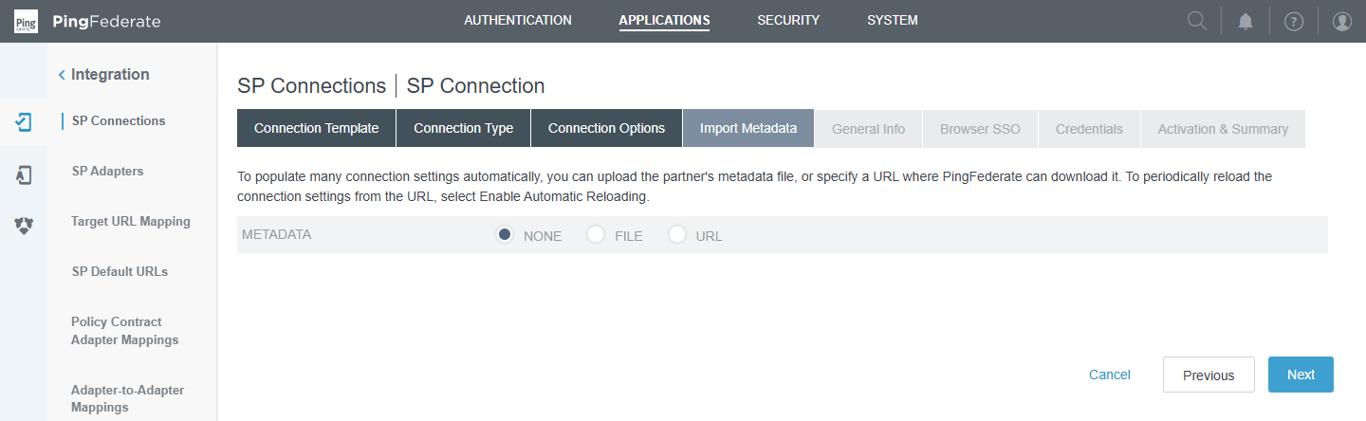
Figure 22 — Import Metadata: None, File or URL — importing fills entity ID, ACS URLs and certificates automatically.
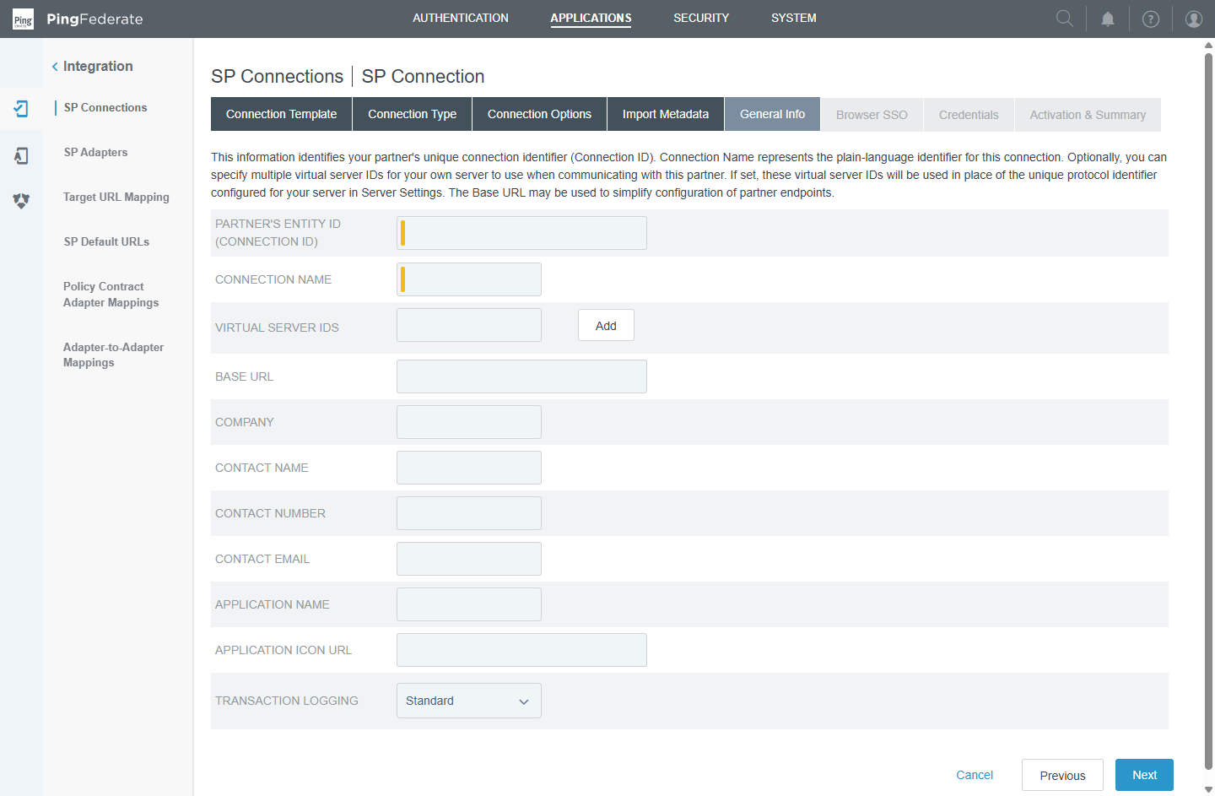
Figure 23 — General Info: the partner's entity ID (connection ID), name, base URL — pre-filled when metadata is imported.

7. Tools for seeing SAML in action
- Browser extension "SAML-tracer" (Firefox/Chrome) — shows every SAML message in a login, decoded.
- Browser developer tools → Network — find the POST to the ACS URL; the SAMLResponse form field is Base64.
- Decode a Redirect-binding request yourself (Python):
import base64, zlib, urllib.parse
saml_request = urllib.parse.unquote('fZJda8IwFIbv...') # value of SAMLRequest from the URL
print(zlib.decompress(base64.b64decode(saml_request), -15).decode()) # raw INFLATE

# POST binding: no compression, just Base64
print(base64.b64decode(saml_response).decode())

- PingFederate logs — log/server.log (errors, signature failures) and log/audit.log (one line per SSO event with partner, subject and status).
- The lab script pingfed\labs\module5\lab5.py regenerates every message in this document; change the user, attributes or entity IDs and run it again.

8. Getting your server ready for SAML
# | Item | Status | Where / how
1 | Licence | ❌ expired | System → Server → License Management
2 | Base URL | ❌ https://localhost:9031 | System → Server → Protocol Settings → Federation Info → https://pf.pingfed.lab:9031 (or the IP)
3 | SAML 2.0 Entity ID | ❌ empty | Same page → e.g. pingfed-lab-idp
4 | Signing certificate | ❌ none | Security → Signing & Decryption Keys & Certificates → Create New / Import (Module 4)
5 | Authentication policy + contract | ❌ policy not built | Module 3 section 9 (contract pflearning exists)
6 | SSL certificate matching the host name | ⚠ CN=localhost | Module 4 section 3 (optional for the lab, required for real partners)
7 | SP connection | — next module | Module 6: Salesforce on-boarding

Suggested order
- Renew the licence.
- Set Base URL and SAML 2.0 Entity ID.
- Create or import the signing certificate; select it under System → Protocol Metadata → Metadata Signing.
- Build the authentication policy ending in contract pflearning (Module 3).
- Export IdP metadata (System → Protocol Metadata → Metadata Export) and compare it with section 6.
- Create the first SP connection (Module 6).

9. Check yourself and quick revision
- Which binding would you use for an AuthnRequest, and which for the Response? Why?
- What does the SP check in an assertion before creating a session?
- Why is IdP-initiated SSO weaker than SP-initiated?
- What happens to RelayState inside the IdP?
- What three kinds of information does metadata give a partner?
- Why does the artifact binding need a back channel, and what does it protect against?

Term | One-line definition
AuthnRequest | SP → IdP: "please authenticate this user"
Response / Assertion | IdP → SP: signed statement about the authenticated user
HTTP-Redirect | Message deflated + Base64 in the URL (small messages)
HTTP-POST | Message Base64 in an auto-submitted form (large messages)
HTTP-Artifact | Browser carries a reference; message fetched over SOAP
Front / back channel | Through the browser / server-to-server
SP- / IdP-initiated | Flow starts at the application / at the IdP
RelayState | Opaque value (usually a target URL) echoed back by the IdP
Entity ID | Unique name of an IdP or SP
ACS URL | SP endpoint that receives the Response
Metadata | XML with entity ID, endpoints and certificates

