**Company Working Area**

**Login Page**

**Company History**

**User Name :**

**Password :**

Brother, We didn't get process, and we have got every information. Th

**Features List**

Module

e rules is follow the Honeywell jar install rules. it will worked. we

have read some Honeywell "QUESTION POSTED BY A COMMUNITY **USER**". they said that same talk.

**Activism along the**

**Agricultural,**

**Fishery, Dairy and**

**Horticulture Value Chain**

**Access to Justice**

**Youth Development**

**(Education, skill,**

**moral and cultural**

**behavior)**

**Climate Emergency,**

**Biodiversity and**

**Disaster Management**

**Climate Emergency,**

**Biodiversity and**

**Disaster Management**

**Health and Nutrition**

**Microfinance**

**Company as a social entrepreneurship**

Dashboard

Project Information

Workplan & Budget

Project Log frame

Setting

User create & access

Reports

Baseline Reports

Inception Reports

Monthly Progress Reports

Quarterly Progress Reports

Annual Progress Reports

Narrative Report

Audit Report

M&E visit Report

Mid Term Evaluation Report

End of Pro

End of Project Report

End of Project Audit

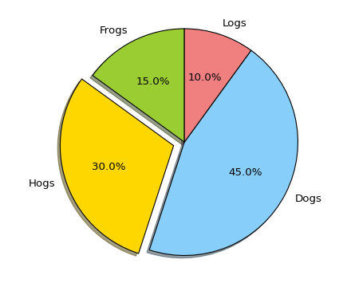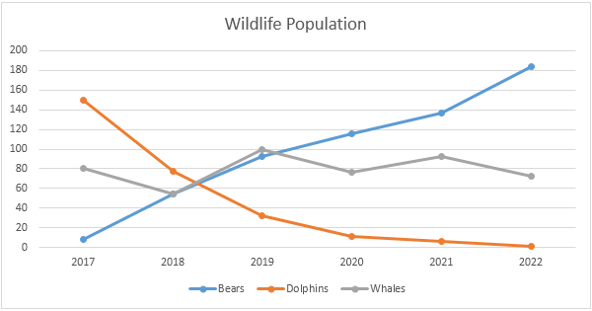

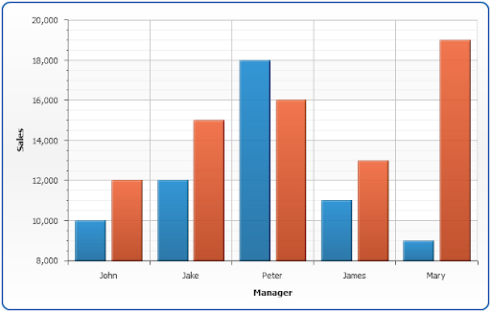‘

**NOTE: Every features dashboard are same**

**Project Information(Form)**

**Step 1**

Title: (Manual Input/Type)

Description: (Manual input/ typing)

Start Date: (Auto select - today)

End Date : (Auto select - today)

Status : (Select From Drop Down)-→(Setting add)

Location : (Manual Input /Typing) -→(Setting add)

Donors :Auto Select (multipal location adding option)-→(Setting add)

Sectors : (Auto Select - Get Which Features Selected—page 2)

Photos: (upto…..KB – Only Image Attachment)

Total Budget : (Manual Input – format – 14,120,565)

Total beneficiary : (row by row add)

Type: (male,Female,boys,girls, physically Challenged etc)--(setting Add)

Count: (Type format - 100,000

|  |  |  |
| --- | --- | --- |
| Male | 10 | Delete |
| Female | 15 | Delete |

Total Expenditure: (Manual input)

**Project Document**

**Step 2**

Project name : (Get title from Step 1)

Report Name : (Get title from Step 1)

Submission Date : (auto select - today)

Attachment: (Attachment ) baseline survey Report < Monthly Quterly AND Annual Report -Qualitative & Quantative ,Indirectors ,Log frame ,result base fram work ,M&e Report ,Travel Report , inpection Report , Audit report ,evalution Report, raqnning Report, Resources – (these list will add from setting)

File Browse : (Upload files – all type)

**Note: All features are same from.**

**LOG FRAME**

**Step 01**

Project name : (List get from Project Form)

Project Goal : (Manual input)

Result base Indirector : (Manual input)

Outcome : (Manual input)

Outcome base Indirector : (Manual input)

**Step 2**

Output: (Manual input)

Output base Indirector : (Manual input)

**Step 3:**

Activity: (Manual input)

**Log frame**

**Step 01 – Indicator**

Project name: (List get from Project Form)

Project Goal: (Manual input)

Result base Indicator: (Manual input)

Outcome: (Manual input)

Outcome base Indicator: (Manual input)

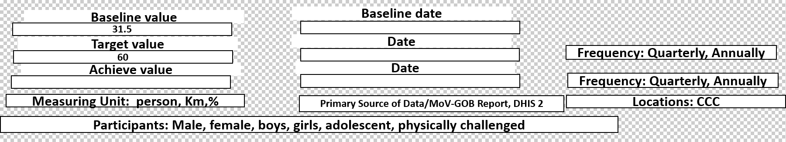

**Note: Calculation will send you soon**

**Step 02 – Name Output**

Output: (Manual input)

Output Base Indicator : (Manual input)

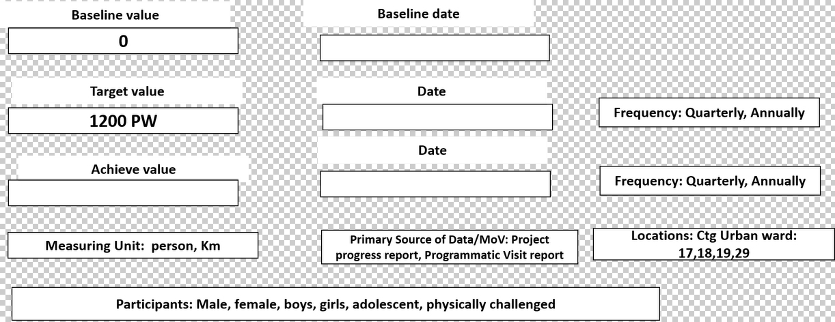

**Step 03 – Name – Activity**

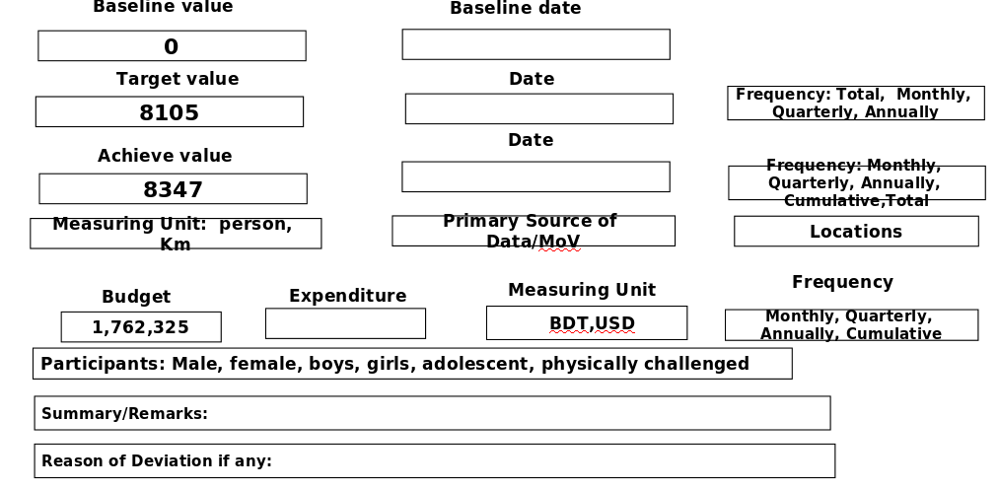

**Project Employee/focal Information (only attachment & view) – (User access – Report list)**

**Beneficiary information : (form design)**

**Survey Form (only attachment & view)**

**Chart (search & generate then view)**

**Map (only attachment & view)**