DESIGN AND DEVELOPMENT OF A WEB-BASED JOB APPLICATION TRACKER SYSTEM
CONCEPTION PHASE: REPORT

Contents
1. Introduction 3
2. Project Scope and Objectives 3
3. Project Planning and Organisation 4
4. Project Risk Assessment 6
5. Development Methodology 7
6. Requirements Engineering 8
6.1 Functional Requirements 8
6.2 Non-Functional Requirements 9
7. Glossary 10
8. System Design and Architecture 10
8.1 System Context Diagram 11
8.2 Use Case Diagram 12
8.3 Building Block Diagram 13
8.4 Technology Selection and Justification 14
9. Conclusion 15
References 16

1. Introduction
Digital recruitment has revolutionized the way that graduates and professionals look for jobs. Career portals like LinkedIn, Indeed and company have made it easier for online job seekers to access job openings and boosted the number of job applications received by individual employers. It's not efficient to manage recruitment activities in spreadsheets or handwritten notes, as candidates may apply for multiple jobs at once. Deadlines for applying for jobs, interview dates, and employer correspondence can be easily missed and make the job search process less effective.
In order to solve these problems, the design of a web based Job Application Tracker System is proposed in this project which will help users to organize and track the recruitment process in one single place. The system is designed to achieve secure user authentication, centralised management of job applications, scheduling reminders and tracking job applications in progress through a user-friendly user interface. The app is designed to be used to streamline administrative workload and enhance organisation and visibility of the recruitment process. This conception phase sets up the project's goals, scope, stakeholders, the development process, requirements and initial software architecture.

2. Project Scope and Objectives
The Job Application Tracker System is a secure and organized system for job seekers to manage their recruitment activities. The project aims to tackle challenges that exist in the process of following up multiple job applications in terms of interview scheduling and follow-up activities using manual approach. Having all recruitment information in one web application will help to improve the organization of the information, avoid missing deadlines and aid in the decision-making process during the recruitment process. The main goal of the project is to develop a Web-based application, which will be user-friendly and easy to maintain, and will allow users to manage the records of their job applications in a secure manner (Alade, Adejumo and Alade, 2022).
The solution will enable users to sign up and log in, to create and manage job applications, track application status, remind users about interviews and visualize the application on the user's dash board. The goals are used to determine the functional capabilities needed to meet user needs and to ensure that the recognized software quality attributes are achieved, e.g., security, usability, maintainability. The scope of the project is kept to the essential functions that would be needed to manage personal job applications. These features are beyond the scope of this project due to the need for external services and would require more time to develop compared to the current development time and are not necessary to the project.
Objective ID | Project Objective
O1 | To design a secure web-based application for managing job applications.
O2 | To provide secure user authentication and account management.
O3 | To enable users to create, update, delete and monitor job application records.
O4 | To allow users to manage interview reminders and recruitment notes.
O5 | To present dashboard summaries to support recruitment monitoring.
O6 | To design scalable system architecture suitable for cloud deployment and future expansion.

Table 1: Project Objectives
Stakeholder | Role and Interest
Job Seekers | Use the application to organise job applications, monitor recruitment progress and manage interview schedules.
Project Developer | Design, implement and maintain a secure, scalable and user-friendly software solution while applying software engineering principles.
Future Developers | Extend and maintain the application using its modular architecture, documented codebase and software documentation.

Table 2: Key Stakeholders

3. Project Planning and Organisation
Effective project planning is a structured way of managing software development activities and ensuring that the project goals are met within the allotted time. In this project, an Agile-inspired iterative development approach was used, which breaks up development into manageable stages, and provides flexibility to ensure that requirements are refined throughout the development process (Al-Oran et al., 2026). The work was carried out as an individual project, however, breaking the work into phases ensured that there was a sense of progression, with the risks of the development minimised and each project phase producing measurable results before moving forward to the next activity.
The project was planned on an 8 weeks time frame with 6 work packages. The first phase involved identifying the requirements for the project, stakeholders and designing the software architecture. The middle stages focused on backend and frontend development, and the final stages involved system integration, testing, deployment and documentation.
Work Package | Activity | Duration | Deliverable
WP1 | Project planning, stakeholder analysis and requirements gathering | Week 1 | Project scope, objectives and requirements
WP2 | System architecture, database design and interface planning | Week 2 | UML diagrams and system design
WP3 | Backend development using Node.js, Express.js and MongoDB Atlas | Weeks 3–4 | REST API and authentication module
WP4 | Frontend development using React.js and Bootstrap | Weeks 5–6 | User interface, dashboard and job management
WP5 | System integration, testing and cloud deployment | Week 7 | Integrated and deployed application
WP6 | Documentation, review and portfolio preparation | Week 8 | Final documentation and submission

Table 3: Project Work Packages

Milestone | Week | Expected Outcome
M1 | Week 1 | Project requirements and scope approved
M2 | Week 2 | Software architecture and database design completed
M3 | Week 4 | Backend implementation completed
M4 | Week 6 | Frontend integrated with backend
M5 | Week 7 | Application tested and deployed
M6 | Week 8 | Documentation completed and project ready for submission

Table 4: Project Milestones
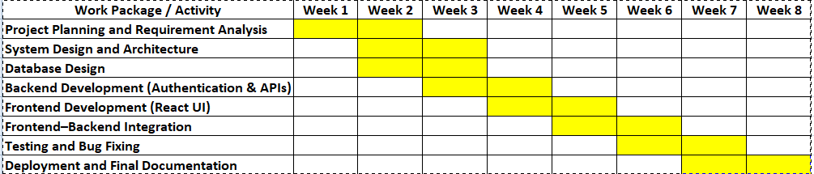

Figure 1: Project Timeline

4. Project Risk Assessment
Risk identification at the conception stage will allow for the implementation of mitigation measures to be planned prior to development. Job Application Tracker System's main risks are related to database connectivity, authentication, system integration and deployment. Earlier risk assessments aid in making decisions and minimize the risk for major problems upon implementation.

Risk ID | Risk Description | Probability | Impact | Mitigation Strategy
R1 | Database connection failures may prevent the application from accessing stored data. | Medium | High | Validate database configuration, connection strings and user permissions before implementation.
R2 | Authentication vulnerabilities may allow unauthorised access to user accounts. | Medium | High | Implement secure authentication mechanisms, encrypt passwords and validate user sessions.
R3 | Integration issues between frontend and backend components may delay development. | Medium | Medium | Adopt modular development and perform regular integration testing throughout the project.
R4 | Development activities may exceed the planned schedule because of debugging or unexpected technical challenges. | Medium | Medium | Divide the project into manageable work packages and monitor progress against milestones.
R5 | Deployment or hosting issues may prevent successful publication of the application. | Low | High | Verify deployment configurations and conduct system validation before release.

Table 5: Project Risk Register

5. Development Methodology
Selecting an appropriate software development methodology is essential to ensure that project activities are organised, requirements are effectively managed and the final software solution satisfies user expectations. As for the Job Application Tracker System, an iterative methodology was chosen based upon the Agile methodology, which involves incremental development and incremental evaluation and flexibility of changing system requirements. Unlike traditional sequential models, Agile software will be built in small segments, so that software functionality will be reviewed and improved throughout the development process.
The project requirements were identified by analysing the problems which would be faced by the job seekers if they have to manage more than one application. These requirements were prioritised according to their importance to the overall functionality of the system. User authentication, Job Application Management were identified as high priority features, whereas other features like Dashboard Analytics and recruitment Notes were added after the essential functionality was decided. This prioritisation allowed for the system to be developed with the most important features, and not too much to the project scope.
The project was broken down into smaller development stages and this minimized project risk, helped problem identification and facilitated system design refinement prior to implementation in a systematic way. The methodology was also compatible with the project's goal of creating a sustainable and scalable web application design, as it enabled for changes in design to happen as the needs became obvious. The Agile-inspired approach was flexible enough to work for an individual software engineering project and structured enough to work for the planning, requirements engineering and system design phase.

6. Requirements Engineering
Requirements for the Job Application Tracker System were extracted from the needs of people who are looking for a job, and want a system that provides an organized and secure way to track their job search. Functional requirements state what the system needs to do and non-functional requirements state what quality attributes the system should have, such as security, usability, maintainability. Unique requirement identifiers also help in traceability throughout the software engineering process, allowing a relationship to be established between the requirement and design, implementation, and testing.

6.1 Functional Requirements
ID | User Story | Priority
FR-01 | As a job seeker, I want to create an account so that I can securely manage my recruitment information. | High
FR-02 | As a registered user, I want to log into the application so that only I can access my data. | High
FR-03 | As a user, I want to create job application records so that I can organise my applications in one place. | High
FR-04 | As a user, I want to edit existing job application records so that I can keep recruitment information up to date. | High
FR-05 | As a user, I want to delete job application records that are no longer required. | Medium
FR-06 | As a user, I want to manage interview reminders to help me remember important recruitment events. | High
FR-07 | As a user, I want to record notes for each application so that I can keep track of important information. | Medium
FR-08 | As a user, I want to view dashboard summaries so that I can monitor my job search progress. | High

Table 6: Functional Requirements

6.2 Non-Functional Requirements
The quality characteristics that affect the whole performance and reliability of the system are called non-functional requirements. These requirements in turn ensure that the application will have the desired functionality and will meet an acceptable level of security, usability, responsiveness and maintainability.
ID | Category | Requirement
NFR-01 | Security | User passwords shall be encrypted before storage.
NFR-02 | Security | Access to protected resources shall require user authentication.
NFR-03 | Performance | The application should respond promptly during normal operation.
NFR-04 | Usability | The interface shall provide clear and consistent navigation across all pages.
NFR-05 | Responsiveness | The application shall support desktop, tablet and mobile devices.
NFR-06 | Maintainability | System components shall be organised using a modular architecture to support future maintenance.
NFR-07 | Scalability | The system architecture shall support future functional enhancements without major redesign.

Table 7: Non-Functional Requirements

Requirements Analysis
The documented requirements are a detailed specification of the proposed system, before the implementation process starts. Functional requirements indicate the services that the users are expecting from the system, and non-functional requirements provide the quality assurance that will guide architectural and design decisions.

7. Glossary
Term | Definition
API (Application Programming Interface) | A set of rules that enables communication between software applications.
CRUD | The four fundamental database operations: Create, Read, Update and Delete.
JWT (JSON Web Token) | A secure token-based authentication mechanism used to verify user identity.
MongoDB | A NoSQL document-oriented database used to store application data.
React.js | A JavaScript library used to develop interactive user interfaces.
Node.js | A JavaScript runtime environment used for server-side application development.
Express.js | A web application framework for Node.js that simplifies API development.
Responsive Design | A design approach that enables a web application to adapt to different screen sizes and devices.
Cloud Deployment | The process of hosting an application on cloud infrastructure, allowing users to access it over the internet.
Software Architecture | The high-level structure of a software system, describing its components and their interactions.

Table 8: Glossary of Terms

8. System Design and Architecture
System design documents the key elements of the proposed system, how the system will interface with users and the technologies chosen to help deliver the project goals (Stefan et al., 2024). The system architecture is developed in the conception phase to minimize design ambiguity, facilitate maintainability and offer good guidance for implementation. A layered client–server architecture was suggested for implementing the Job Application Tracker System to facilitate modularity, scalability, and separation of concerns. The architecture is based on the presentation, application and data layers that allow the various parts of the application to have a specific responsibility and communicate with each other through well defined interfaces.

8.1 System Context Diagram
The system context diagram shows the high-level overview of the proposed application and how it interacts with the outside users and/or services. The Job Seeker is the main actor who registers an account, logs in, creates and updates job applications, sets reminders and views the status of job applications in the Recruitment workflow. An application interfaces with a cloud-based database, storing and accessing recruitment data safely. Use this high-level representation to specify the boundary of the system and the entities outside of the boundary that can interact with the proposed solution.
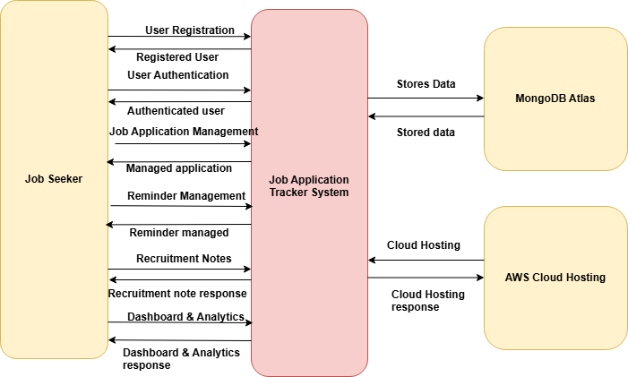

Figure 2: System Context Diagram
(Source: Developed using draw.io)

8.2 Use Case Diagram
The use case diagram is an identifier of the main functions the proposed system will support its user. The Job Seeker is the main player and utilizes the system with a set of key use cases such as account registration, user authentication, job application management, reminder management and dashboard viewing. These use cases describe the functional requirements outlined above and are visuals of services that will be provided by the application once it has been completed.
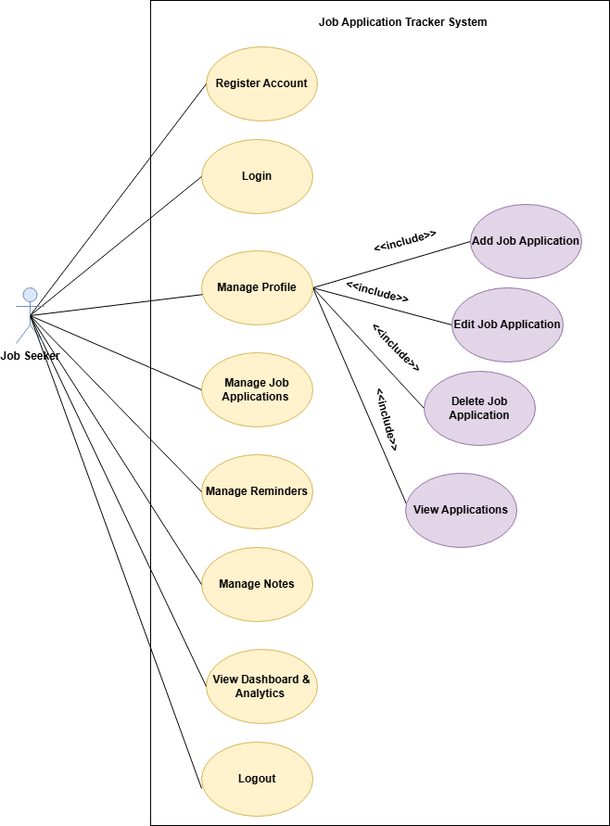

Figure 3: Use Case Diagram
(Source: Developed using draw.io)

8.3 Building Block Diagram
The proposed software architecture is a three layers client server architecture in which the presentation layer, application layer and data layer are present. The presentation layer is the user interface that users interact with when using the application. Business logic, authentication, and request handling are done in the application layer, and persistent storage of data such as user accounts and recruitment information are handled by the data layer. The separation of responsibilities in these layers ensures maintainability, facilitates future modifications, and enables the possibility of future changes to the individual components of the system without affecting the architecture.
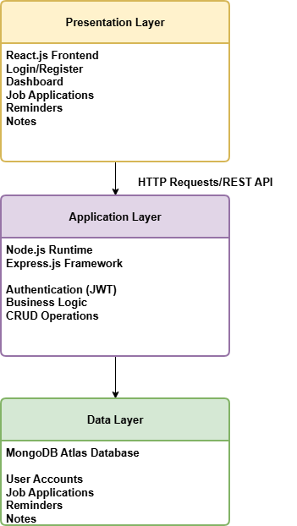
Figure 4: Building Block Diagram
(Source: Developed using draw.io)

8.4 Technology Selection and Justification
Technology | Purpose | Justification
React.js | User Interface | Supports the development of responsive and reusable interface components.
Node.js | Server Runtime | Enables efficient server-side JavaScript execution and supports asynchronous processing.
Express.js | Web Framework | Simplifies the development of RESTful APIs and request handling.
MongoDB | Database | Provides flexible document-based storage suitable for dynamic application data.
JWT | Authentication | Enables secure token-based user authentication and session management.
bcrypt | Password Security | Encrypts user passwords before storage, improving data security.

Table 9: Technology Selection
The chosen technology stack meets the functional and non-functional requirements of the project, while enabling modular software development. The separation of presentation, application and data layers enables individual components to be kept and developed without affecting other parts of the system.

9. Conclusion
The conception phase was used to set up the basis for the rest of the project, including project objectives, scope, stakeholders and software requirements for the Job Application Tracker System. A project plan was created, risk assessment was conducted and Agile-inspired development methodology was suggested to steer the software engineering process and minimise development risks. Functional and non-functional requirements were captured to set expectations for the system and the proposed architecture and technology selection showed how the requirements could be achieved in a modular and maintainable system.

References
Ștefan, A.M., Rusu, N.R., Ovreiu, E. and Ciuc, M., (2024). Empowering healthcare: a comprehensive guide to implementing a robust medical information system—components, benefits, objectives, evaluation criteria, and seamless deployment strategies. Applied System Innovation, 7(3), p.51.
Al-Oran, O., Zebari, S.M., Sorwar, A., Arkam Cm, M., Gupta, S.K. and Buravelli, S.K.P., (2026). THE ROLE OF AGILE METHODOLOGY IN ENGINEERING PROJECT MANAGEMENT. Scientific Culture, 12(5 Part 1), p.503.
Alade, S.M., Adejumo, S. and Alade, T.J., (2022). Design and Implementation of a Web Based Leave Management System. International Journal of Computer Applications Technology and Research, 11, pp.123-144.

