DESIGN AND DEVELOPMENT OF A WEB-BASED JOB APPLICATION TRACKER SYSTEM
DEVELOPMENT PHASE

Table of Contents
1. Introduction and Development Overview 3
2. Development Methodology and Implementation Process 3
3. Software Design and Implementation 4
3.1 Overall System Architecture 4
3.2 Database Design 6
3.3 Backend Implementation 7
3.4 Frontend Implementation 9
3.5 Technology Selection and Engineering Justification 12
4. Testing and Validation 15
5. Challenges, Design Decisions and Critical Reflection 18
5.1 MongoDB Atlas Connection Configuration 18
5.2 Authentication and JWT Validation 19
5.3 API Communication and CORS Configuration 19
5.4 Frontend Navigation and State Management 19
5.5 Lessons Learned 19
6. Conclusion 20
References 21

1. Introduction and Development Overview
The app was built with the MERN stack, with React for the front end, Express and Node for the back end, and MongoDB Atlas for cloud-based data storage. To enhance maintainability and system scalability, client-server architecture was used to separate the presentation, business logic and data management components. Communication was made possible with RESTful APIs, and user authentication and password encryption were used to ensure security. A focus was given to modularity and incremental validation to ensure that the application met the requirements set out in the conception phase.

2. Development Methodology and Implementation Process
Agile methodology made it possible that the system could be built in small, manageable increments. This made it possible to improve the design continuously during the development process, to finish each functional module, test them and integrate them into the next phase of development. The methodology helped to keep the process organized, and there was flexibility to overcome technical problems as they arose.
The initial step in development involved deploying the back-end infrastructure, as data security and authentication were crucial components of the application. The Express.js server was set up, the database was linked using MongoDB Atlas and RESTful API endpoints were created to handle user authentication and job application data. After backend services were up and running, the front-end interface was created with React.js. Individual user interface components were developed for authentication, Dashboard visualisation, Job application management and reminder management. Communication between front end and back end was enabled via REST APIs with Axios, and React Router provided the ability to navigate between pages in the application.
Each module was tested individually, prior to system integration during development. To check the correct handling of requests and interaction with the database, the backend API endpoints were validated with Postman. After API testing, the front end was added to the back end, and the complete functionality of the user, such as registration, authentication and CRUD operations was tested. The software was developed incrementally with version control on GitHub, which allowed for a clear and concise management of project changes and a well-documented history of the software's evolution. The iterative methodology also helped to keep the final application in line with the functional and non-functional requirements of the conception phase, and to plan for maintainability and future enhancements.
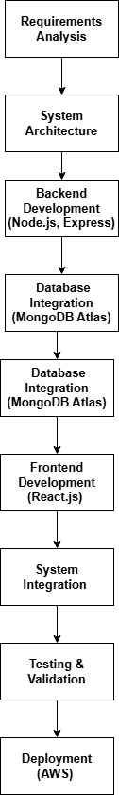

Figure 1: Development Workflow
(Source: Developed using Draw.io)

3. Software Design and Implementation

3.1 Overall System Architecture
The Job Application Tracker System was created with a three-layered client–server structure, which separates application, data management and presentation. By treating architecture in this way, you can achieve modularity, maintainability, and scalability as well as ensuring that each layer of the architecture fulfills a unique role and communicates with the other layers through well-defined interfaces. The front-end displays information to the user and handles user input, while the back-end performs business logic, user authentication and interacts with the database. User credentials and job application information are stored in the data layer using MongoDB Atlas.
Communication between the Frontend and Backend is made possible with RESTful APIs. The React.js interface sends HTTP requests on user actions like user sign up, sign in, and job applications, as well as updating job application status. These requests are handled by the Express.js based server, where the controllers validate the data being sent, perform the necessary business logic and perform interactions with the database via Mongoose based models. The server processes the form data and sends back a response in JSON format, which will be used by the user interface to update in a real-time fashion without reloading the application.
The application was divided into separate layers, making the development and testing of each layer easily separated, which is convenient for development and testing. This design also enhances future maintainability because changes in one layer can sometimes have a minimal impact on the other layers (Alenezi and Akour, 2025). For instance, changes to the user interface of the dashboard can be made without affecting the operation on the database, and the user interface can be extended through new API endpoints without redesigning the user interface.
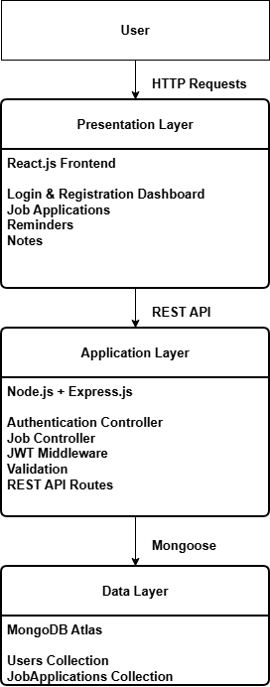

Figure 2: System Architecture
(Source: Developed using Draw.io)

3.2 Database Design
The Job Application Tracker System is powered by a Cloud-based relational database, MongoDB Atlas, to store user accounts and job application records. At the system design phase, the database system was created with the goal of ensuring efficient data retrieval and keeping user information and recruitment data separate. To help maintainability, eliminate data redundancy, and make future system expansion easier, all information was not stored in one collection, but was rather separated into several different collections.
Two main collections were created: Users and JobApplications. The Users collection stores authentication and profile information, including the username, email address and encrypted password. The passwords are stored in a secure manner using the bcrypt hashing algorithm, meaning that passwords are never stored in plain text. A unique identifier is assigned to each registered user, and then used to link the records of a job application to the proper account.
All the information entered by the user related to the recruitment is stored in the JobApplications collection. There are attributes in each document like the company name, job title, application status, application date, notes and reminder information. Each job application will include this unique user identifier and this will result in a 1:M relationship, where a user may be able to manage many job applications but never have access to the records of other users. This is a perfect fit for MongoDB's document-oriented model, due to the fact that each application for a job naturally has a set of related attributes that can be stored within a single document. This was much simpler than connecting a number of relational tables, which would have led to a much more complicated structure. In addition, having recruitment data stored as individual documents allows for flexibility in future enhancements, such as including interview feedback, salary data or uploaded documents, without making extensive changes to the current database structure.
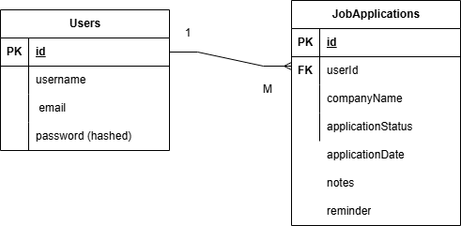

Figure 3: Database Entity Relationship Diagram
(Source: Developed using Draw.io)

3.3 Backend Implementation
The Job Application Tracker System backend was built with Node.js and Express.js, which serve as the server side tools that handle processing of client requests, enforce business logic and communicate with the MongoDB Atlas database. A modular architecture was implemented to enhance the maintainability by separating the routing, controller logic, and middleware and database models as independent units. This modular structure makes the debugging, testing and feature development of this app easier in the future because it minimizes dependency between parts of the app.
The Express.js server is the communication hub between the React front-end and the database. Users carry out activities like sign up, sign in, or administration of job applications and HTTP requests are transferred to set REST API endpoints. All requests first come into contact with the relevant controller which performs input validation and business logic, and only then access the database via Mongoose models. The server processes the request, returns structured JSON responses which are used to update the user interface dynamically by the frontend.
To ensure secure access to protected resources, user authentication was achieved through JSON Web Tokens (JWT) implementation. The passwords are encrypted using the bcrypt hashing algorithm and stored in the Users collection during registration. When the user logs in, the password entered by the user is passed to the process and compared with the stored password, and if the password is correct, a JWT is generated. The token is then added to the requests to protected API endpoints, where the token middleware will check the validity of the token before returning access to user-specific resources. This way only a user can see and edit his job application details.
In order to increase reliability, validation and error handling were integrated into the back-end all the way through. The incoming request is checked before performing database operations, which decreases the chances of storing invalid or incomplete data (Valdés-Rodríguez et al., 2024). Error handling middleware responds with useful HTTP status codes and informative error messages when a user fails to log in or when a requested resource is not found or when the user submits incorrect data. These mechanisms can enhance the robustness of the system and provide valuable information to the user during use.
The backend also includes CRUD operations (Create, Read, Update and Delete) for job applications. There are special API endpoints for creating new application records, getting application records, updating application details, and deleting old application records. Every operation is associated with the identity of an authenticated user and this allows having complete separation between the different users’ data and maintaining data integrity throughout the system.
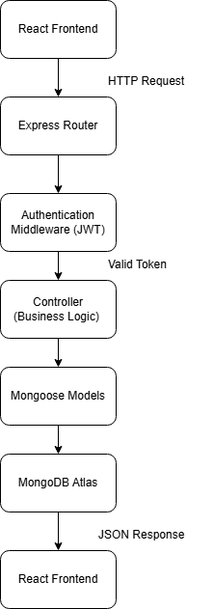

Figure 4: Backend Request Processing Workflow
(Source: Developed using Draw.io)

3.4 Frontend Implementation
The frontend of the tracking system was created with React.js, which offers an intuitive and engaging interface for managing recruitment processes. To ensure code reusability throughout the application, a component-based architecture was chosen. Several interface elements have been created, including for user authentication, dashboard visualization, job application management, reminders, and notes.
To navigate between different pages, React Router was used, which enables users to switch between login screen, register screen, dashboard screen and job management screens without having to load the entire page. This client-side routing method minimizes navigation delays and enhances the user experience, which leads to a smoother application interaction.
The communication between the front and back end was done by sending asynchronous HTTP requests from the front end to the REST API that was created in the back end using Express.js. API calls are executed by the backend and the statuses of the various actions undertaken by the user are registered in the API. When the user registers an account, signs in, submits a job application or changes the status of an application, the API calls are processed and the statuses of the various actions are recorded in the API. Then the data received from the server is used to update the React components dynamically, so that the user can get the feedback without having to refresh the page. This asynchronous communication not only makes the application faster, but also synchronises the user interface and the database.
The use of Bootstrap was added to speed up the process of creating web interfaces and making them behave well on all screen sizes. Predefined layout elements and styling utilities helped to maintain a uniform visual layout and minimize custom CSS code. The responsive design ensures that the app is accessible on desktop computers, tablets and mobile devices, enabling users to manage their job application process across various devices. The dashboard provides users with a structured view of the recruiting process. Job Applications are presented in an organized fashion that enables users to add new applications, edit existing applications, change the status of applications, and delete old applications. Interface features allow for reminder management and note-taking, helping users to plan interview appointments and keep notes during the recruitment process.
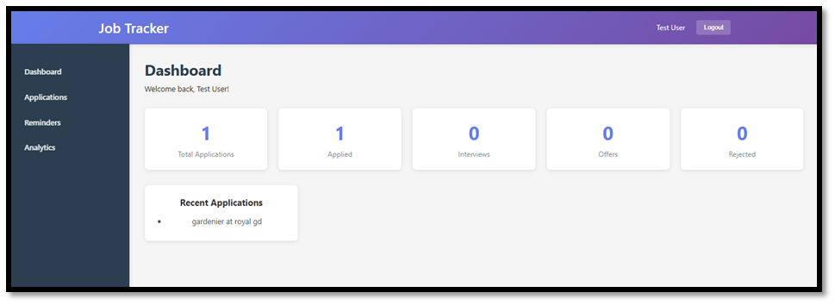

Figure 5: Dashboard displaying an overview of job applications and recruitment activities
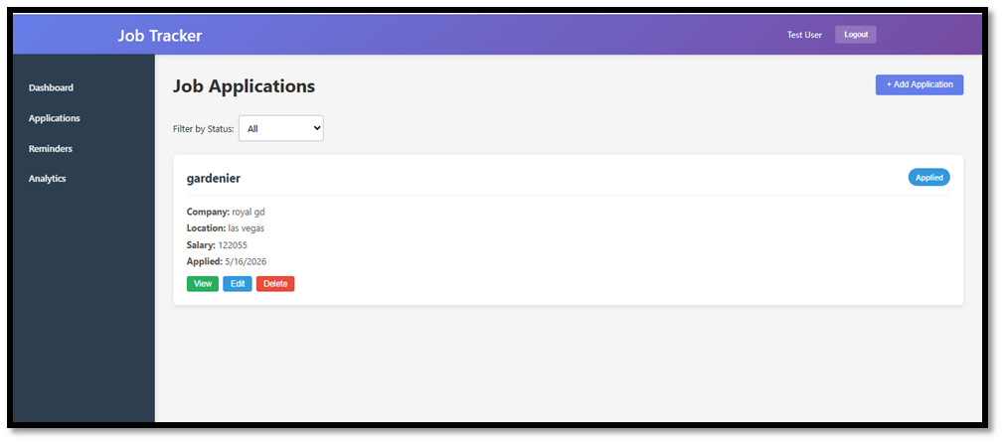

Figure 6: Interface for creating, viewing, updating and deleting job application records
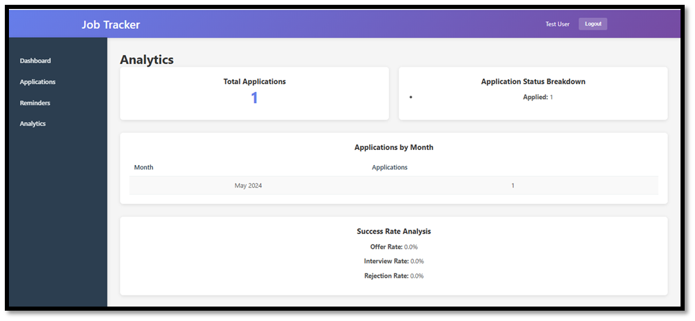

Figure 7: Analytics interface summarising recruitment progress through application statistics
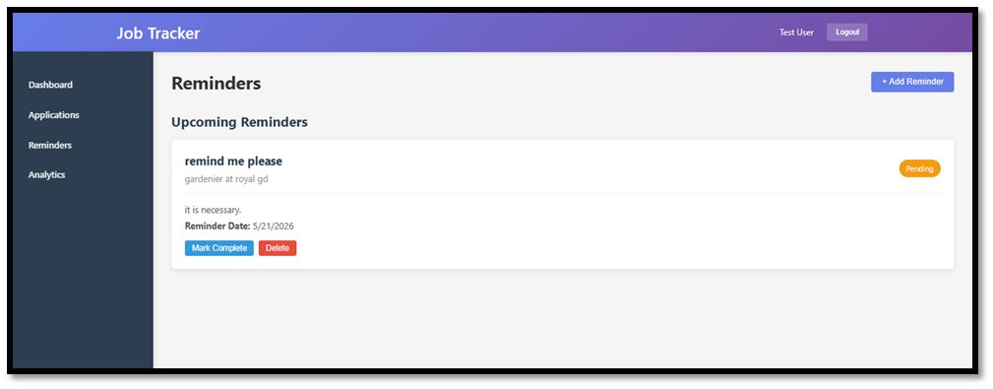

Figure 8: Reminder management interface for tracking interviews and recruitment deadlines
Component | Purpose
Login | Authenticates registered users.
Registration | Creates new user accounts with secure authentication.
Dashboard | Provides an overview of job applications and recruitment progress.
Job Applications | Supports creating, viewing, editing and deleting application records.
Reminders | Enables users to manage interview reminders and deadlines.
Notes | Stores additional observations related to recruitment activities.
Analytics | Displays summary statistics of application statuses.

Table 3: Frontend Components

3.5 Technology Selection and Engineering Justification
One of the crucial design decisions made in designing the Job Application Tracker System is the selection of technologies. Each technology component in the technology stack was chosen based on the functional needs, system architecture and user interactions that were determined in the conception phase, and not because they are typically used together. The technologies chosen for the project are able to provide secure authentication, efficient data management, responsive user interface and future maintainability.
The selection of React.js for the frontend was due to the application's several independent user interface modules such as authentication, dashboard visualisation, job application management, reminders and analytics (Győrödi et al., 2022). These features were implemented using a component-based architecture, which helped to minimize code duplication and made it easier to maintain in the future. Job application records are often being created, updated and deleted, so that React's dynamic rendering allows the interface to update without the need for full page refreshes, giving users a smoother experience (Zheng et al., 2024).
The backend development was chosen to use Node.js and Express.js, which are effective in handling RESTful web services and asynchronous request handling. Data is often sent between the front and backend during user authentication and CRUD operations in the application. Express.js makes it simple to build API endpoints, middleware and client request routing, and Node.js is effective at serving many requests from clients, helping to keep the system performing well during “business hours.”
The decision to use MongoDB Atlas as the database was driven by the fact that every job application had related information like the company name, job title, the status of the application, notes, reminders, and application date (González Moyano et al., 2022). Having these attributes all in one document closely mirrors a job application which makes CRUD operations intuitive and easy, and implementation much simpler. Moreover, when using the cloud-based Atlas service, users can develop with the DB securely from a remote location and deploy in the future without having to set up the local database.
The aim of JWT (JSON Web Token) was to create authenticated sessions and to protect access to secured resources. Once a user logs in, he or she gets a signed authentication token that will be included in all subsequent requests to secured APIs. In this way, users are able to only access their application record for their job and help lower repeated authentication requests during a session. Sensitive credentials were also secured by hashing user passwords before they are stored in the database, with bcrypt, a hash function.
Axios was used for managing communication between the frontend (React) and the backend (Express). Asynchronous interaction plays a crucial role in the application, such as user authentication, pulling job applications and updating the recruitment information. Axios is a great tool to share JSON data in a reliable way between system parts and also allows for structured error handling and response processing (Rathore and Bagui, 2024). Bootstrap was added to speed the interface up, provide reusable layout parts and responsive design utilities so the application is usable from desktop and mobile without lots of custom styling.
Version control during development and an organized history of changes in the project was handled using GitHub. Each commit added incremental implementation progress, helping to identify changes, roll back changes if required and ensure consistency during the development. Version control also was used to support software maintenance and as proof of iterative development of the project.

Technology | Purpose within the Project | Justification
React.js | Frontend user interface | Supports reusable components and dynamic updates when users manage job applications.
Node.js | Server-side runtime | Handles asynchronous client requests efficiently during authentication and CRUD operations.
Express.js | REST API framework | Simplifies routing, middleware and backend service development.
MongoDB Atlas | Cloud database | Stores user accounts and job application records as documents that closely match the application's data model.
JWT | User authentication | Protects secured API endpoints and restricts access to authorised users.
bcrypt | Password security | Encrypts user passwords before storage to improve system security.
Axios | API communication | Exchanges data between frontend and backend without refreshing the application.
Bootstrap | Responsive interface | Provides a consistent user experience across desktop and mobile devices.
GitHub | Version control | Tracks development progress and supports collaborative software engineering practices.

Table 4: Technology Selection and Project Justification

4. Testing and Validation
The System was tested and validated during the development process in order to ensure that all the functional and non-functional requirements identified in the conception stage have been met. Testing was done incrementally, addressing defects discovered and modified as they were developed, before the integration into the system was done (Chen et al., 2024). This helped to minimize the chances of propagation of errors to subsequent phases of development and enhanced the reliability of the application.
Functional testing, API testing, Integration testing and User interface testing were done to check system performance. API testing verified that the front-end and back-end communicated normally, and integration testing confirmed that all the system's components worked together properly without data conflicts. User interface testing was used to assess the navigability, responsiveness and user-friendliness of the key screens of the application.
Also, authentication and security mechanisms were tested to verify that only authorized users have access to secured resources. Security vulnerabilities are reduced, and invalid data is not stored in the database through password encryption, token verification and input validation. The error handling mechanisms were tested by intentionally providing inaccurate or incomplete data, to ensure that meaningful error messages were provided to the user.

Test ID | Requirement ID | Test Scenario | Test Input | Expected Result | Actual Result | Status
TC-01 | FR-01 | Register a new user | Valid username, email and password | User account created successfully and redirected to login page | Account created successfully | Pass
TC-02 | FR-02 | Login with valid credentials | Registered email and correct password | JWT generated and dashboard displayed | Dashboard loaded successfully | Pass
TC-03 | FR-02 | Login with incorrect password | Registered email and incorrect password | Authentication denied and error message displayed | Error message displayed | Pass
TC-04 | FR-03 | Create a job application | Valid company name, job title and status | Job application stored in database and displayed on dashboard | Record created successfully | Pass
TC-05 | FR-04 | Update application status | Change status from Applied to Interview | Database updated and new status displayed | Status updated correctly | Pass
TC-06 | FR-05 | Delete a job application | Select existing application and delete | Record removed from dashboard and database | Record deleted successfully | Pass
TC-07 | FR-06 | Create reminder | Valid reminder information | Reminder saved and displayed | Reminder displayed correctly | Pass
TC-08 | FR-08 | View dashboard | Login as authenticated user | Dashboard statistics and applications displayed | Dashboard loaded correctly | Pass

Table 5: Functional Test Cases
API Validation
First the backend REST API was tested using Postman and then validated before being integrated with the frontend. Each API end point was tested independently to ensure that the API is handling requests, authenticating, and performing database operations (Mukesh, 2024). Successful and invalid requests were performed to ensure that the application returned the correct error message(s) and status codes. Valid and invalid credentials were used to test the authentication endpoints, and CRUD endpoints were tested by creating, reading, updating and deleting job application records. Successful API validation helped to ensure that backend services functioned as planned, prior to integration with the front end (React).
Integration Testing
Front-end integration testing was done after integrating React with Express backend using Axios. Complete user workflows were run to ensure that data from the user interface was being sent correctly to the back-end, processed by the server, and stored in MongoDB Atlas. The registration/login, job application management, reminder management and dashboard features were tested as complete workflows, rather than just standalone functions. This confirmed the correctness of all layers of software and the consistency of data.
User Interface Testing
The user interface was assessed for usability and navigation to the project's requirements. The navigation between authentication pages, dashboard and job management pages was tested and confirmed that there were no browser refreshes needed when navigating between pages to ensure proper page transition. Responsive layouts were also tested on various screen resolutions to ensure that interface elements were accessible across desktop and mobile screens with the help of the responsive grid system in Bootstrap. Empty forms and invalid data were used to test input validation and ensure that users were given clear feedback prior to sending data to the backend.
Validation against Requirements
Each functional requirement identified in the conception phase was followed by its implementation module and validation activity to prove that the implemented system complies with the project requirements.
Requirement ID | Implemented Module | Validation Method
FR-01 | User Registration | TC-01
FR-02 | User Authentication | TC-02, TC-03
FR-03 | Job Application Management | TC-04
FR-04 | Application Status Update | TC-05
FR-05 | Delete Application | TC-06
FR-06 | Reminder Management | TC-07
FR-07 | Notes Management | Functional Testing
FR-08 | Dashboard & Analytics | TC-08

Table 6: Requirement Traceability Matrix

5. Challenges, Design Decisions and Critical Reflection
There were some technical issues that needed to be investigated, debugged and refined during the development process of the Job Application Tracker System. Not only did these issues help to make the application more stable, but they also gave me valuable hands-on experience in full-stack software development.

5.1 MongoDB Atlas Connection Configuration
The integration of MongoDB Atlas with the Express.js backend was one of the initial challenges. The application had no access to the database because it could not open the connection, which was due to the fact that the connection string that was specified in the environment variables wasn't configured properly. Furthermore, the network access settings for the MongoDB Atlas network blocked access of the development machine to the cloud database. After updating the database connection string stored in the .env configuration file and updating the IP whitelist in MongoDB Atlas the issue was resolved. After passing the connection parameters, the application was able to establish connection with the database and user accounts were stored and retrieved properly as well as the record of job applications.

5.2 Authentication and JWT Validation
One of the other problems was to ensure user authentication securely by implementing JSON Web Tokens. In early development, the protected API endpoints were often returning unauthorized responses to authenticated requests due to the user's tokens being expired or sent incorrectly by the authentication middleware. To solve this problem, the authentication flow was examined and it was determined that tokens would be generated correctly once a successful login was made and embedded in the protected request's header, Authorization. The middleware has been updated to ensure that the tokens are always checked before access to secured resources is granted. Addressing this problem enhanced the security of the application and further highlighted the need for the development of a strong authentication system in the designing of Web based applications which manages user specific information.

5.3 API Communication and CORS Configuration
Initially, there were some issues with communications between the React's frontend and the Express.js's backend, due to CORS restrictions and inconsistencies in some API routes. These issues made it difficult for the front-end components to get and update data stored in MongoDB Atlas. This was solved by setting up CORS middleware in the backend and checking the API endpoint annotations to see if the methods and routes were correct as per the request on the frontend. After these changes, the client and server were able to communicate and CRUD operations worked well across the entire application.

5.4 Frontend Navigation and State Management
Another problem arose when using React Router to set up navigation between the authentication pages and the main dashboard. In early testing, users sometimes ended up on the logon screen when they hit a page protected by refresh, due to an inconsistent maintenance of the authentication state. The routing logic was further refined to make sure that the authenticated sessions were handled in the proper manner and the protected pages were not accessible to unauthorized users. Further validations were added to ensure consistency of navigation from various sections of the application. The experience showed that frontend navigation is tightly linked with the authentication management and needs to be meticulously designed, offering a secure and intuitive user experience. .

5.5 Lessons Learned
Developing the Job Application Tracker System provided practical experience in designing, implementing and integrating a complete full-stack web application. Beyond learning individual technologies, the project emphasised the importance of software engineering practices such as modular architecture, version control, incremental testing and systematic debugging. Separating the application into frontend, backend and database layers simplified maintenance and reduced implementation complexity, while GitHub provided a structured record of development progress and facilitated iterative improvements.
The project helped in strengthening the skills in REST API development, database integration, secure authentication and responsive user interface design. It demonstrated that successful software development depends not only on selecting appropriate technologies but also on careful planning, continuous validation and the ability to diagnose and resolve technical problems efficiently. These experiences provide a strong foundation for future full-stack software engineering projects.

6. Conclusion
The application of modern software engineering principles along with the full stack web development technologies was used to convert the proposed system design into a functional job-application-tracking system. It offers safe user authentication, notes on job applications, reminder features, and dashboard visualization in a responsive web interface. Modular client–server architecture was used to enable independent development of the frontend and backend components, while allowing for seamless integration via RESTful APIs throughout the implementation process. The functionality implemented was tested and validated continually throughout the project, ensuring that it met user requirements.

References
Alenezi, M., & Akour, M. (2025). AI-Driven Innovations in Software Engineering: A Review of Current Practices and Future Directions. Applied Sciences, 15(3), 1344. https://doi.org/10.3390/app15031344
Chen, X., Hu, X., Huang, Y., Jiang, H., Ji, W., Jiang, Y., Jiang, Y., Liu, B., Liu, H., Li, X., Lian, X., Meng, G., Peng, X., Sun, H., Shi, L., Wang, B., Wang, C., Wang, J., Wang, T., & Xuan, J. (2024). Deep Learning-based Software Engineering: Progress, Challenges, and Opportunities. ArXiv (Cornell University). https://doi.org/10.1007/s11432-023-4127-5
González Moyano, C., Pufahl, L., Weber, I., & Mendling, J. (2022). Uses of business process modeling in agile software development projects. Information and Software Technology, 152, 107028. https://doi.org/10.1016/j.infsof.2022.107028
Győrödi, C. A., Dumşe-Burescu, D. V., Zmaranda, D. R., & Győrödi, R. Ş. (2022). A Comparative Study of MongoDB and Document-Based MySQL for Big Data Application Data Management. Big Data and Cognitive Computing, 6(2), 49. https://doi.org/10.3390/bdcc6020049
Mishra, A., & Alzoubi, Y. I. (2023). Structured Software Development versus Agile Software development: a Comparative Analysis. International Journal of System Assurance Engineering and Management, 14(4). springer. https://doi.org/10.1007/s13198-023-01958-5
Mukesh Reddy Dhanagari. (2024). MongoDB and Data Consistency: Bridging the Gap between Performance and Reliability. Journal of Computer Science and Technology Studies, 6(2), 183–198. https://doi.org/10.32996/jcsts.2024.6.2.21
Rathore, M., & Bagui, S. S. (2024). MongoDB: Meeting the Dynamic Needs of Modern Applications. Encyclopedia, 4(4), 1433–1453. https://doi.org/10.3390/encyclopedia4040093
Y. Valdés-Rodríguez, J. Hochstetter-Diez, M. Diéguez-Rebolledo, A. Bustamante-Mora, & R. Cadena-Martínez. (2024). Analysis of Strategies for the Integration of Security Practices in Agile Software Development: A Sustainable SME Approach. IEEE Access, 1–1. https://doi.org/10.1109/access.2024.3372385
Zheng, Z., Ning, K., Zhong, Q., Chen, J., Chen, W., Guo, L., Wang, W., & Wang, Y. (2024). Towards an understanding of large language models in software engineering tasks. Empirical Software Engineering, 30(2). https://doi.org/10.1007/s10664-024-10602-0

