Download Visual Studio Code from <https://code.visualstudio.com/>

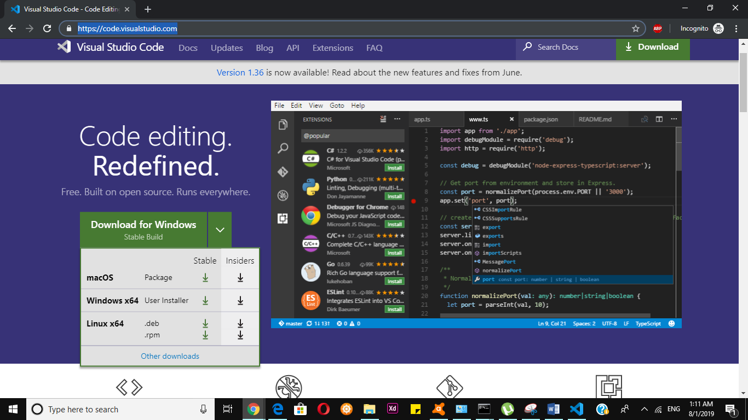

Based on the availability of your current system download it and run the exe file.

In line 301,304 in webspeechdemo.html replace the “B:\webspeechdemo” with the location where the files are kept

In line 20 in orderpage.html replace the “B:\webspeechdemo” with the location where the files are kept

**Flow of the Application**

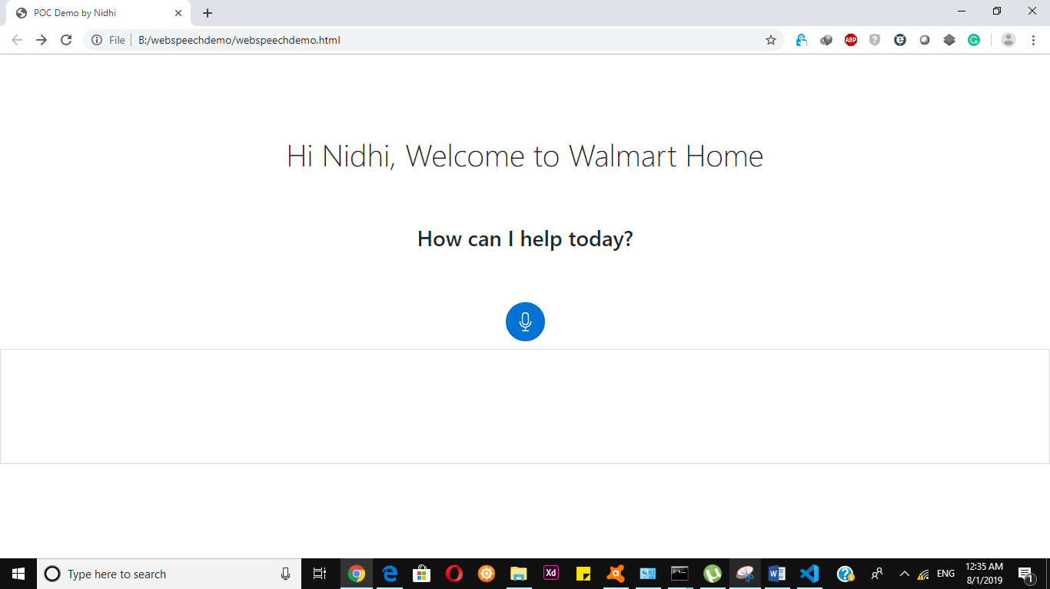

**Navigate to the folder where all files are kept and double click on webspeechdemo.html file which will launch the application as above, make sure internet connection is ON and use google Chrome as browser**

**Click on the speaker button**

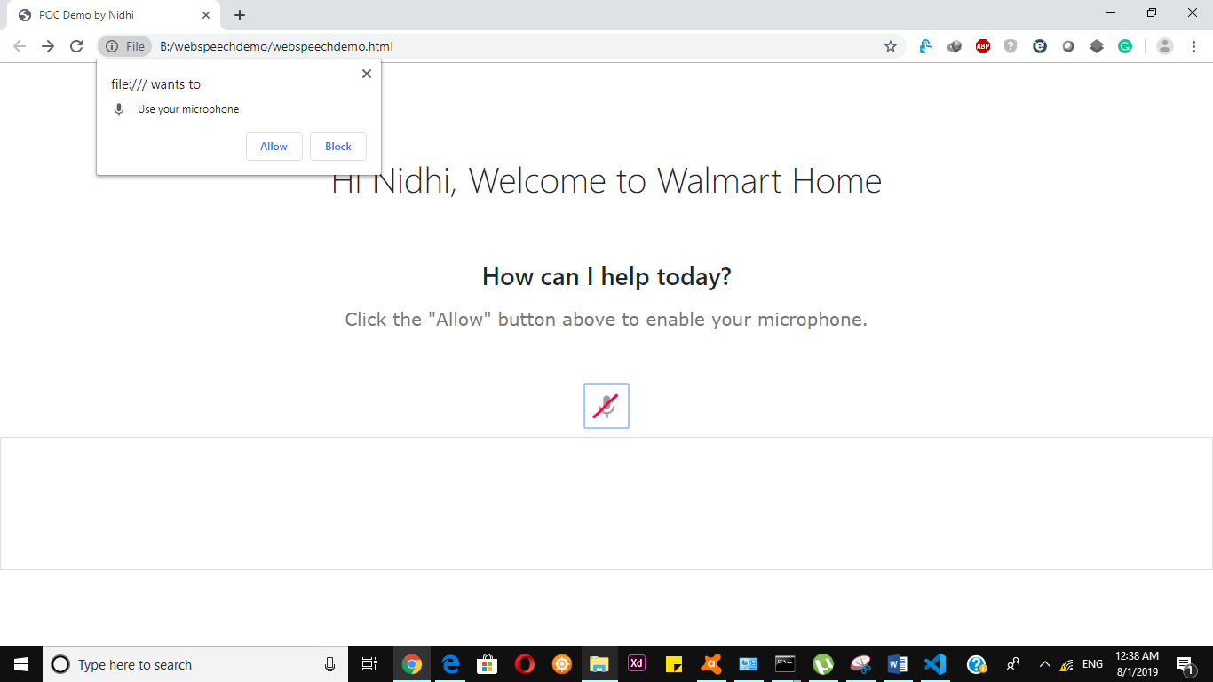

**Give the access to microphone by clicking on allow button**

**Upon giving an access give a statement containing Cook as keyword in statement which will redirect to**

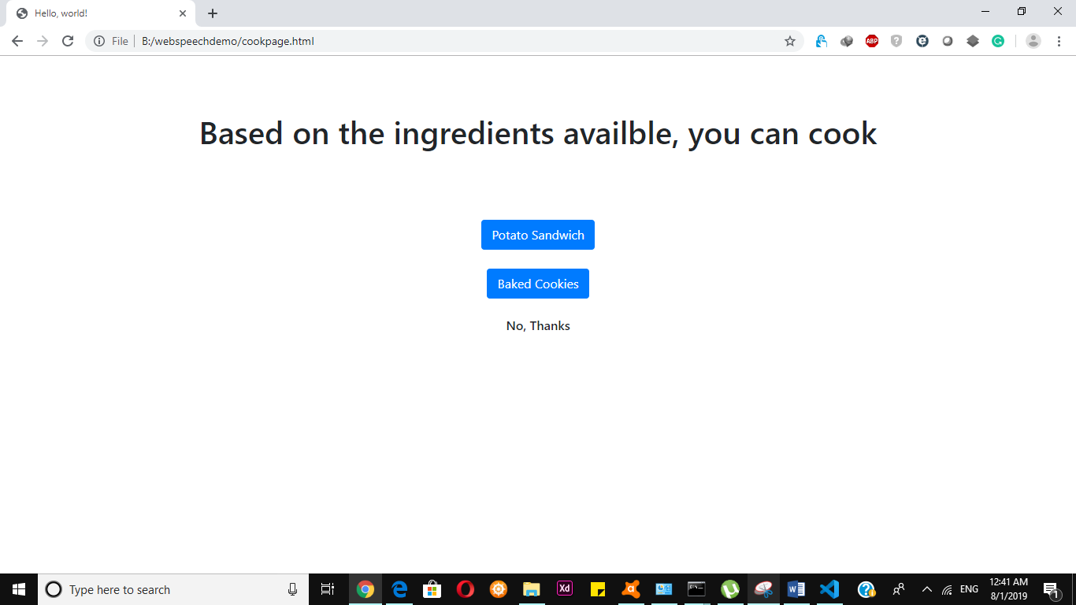

**There are 2 clickable buttons, upon clicking them will redirect to a video of respective preparing dish☺ on youtube.**

**If the search statement contains a keyword “order”**

**it will redirect to page containing**

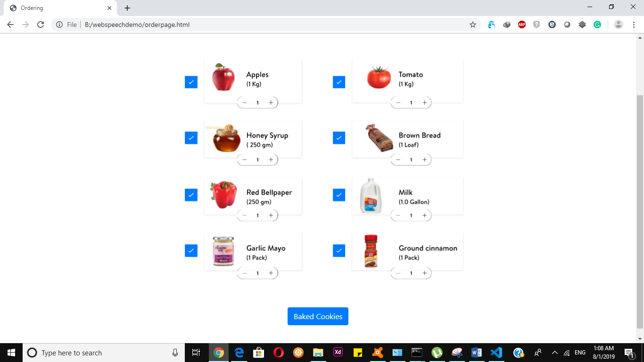

**Upon on clicking Button Order now it will redirect to page of Walmart food**

