Apache Server Log Analysis

SHAHEED VK
PGP DE OCT 2022 COHORT 1

Step 1: Upload the “server-access-log” file to the HDFS

Step 2:Execute the PySpark Commands following the below steps:
- Login to the web console
- To enter the PySpark console run the following command:
Command: pyspark3
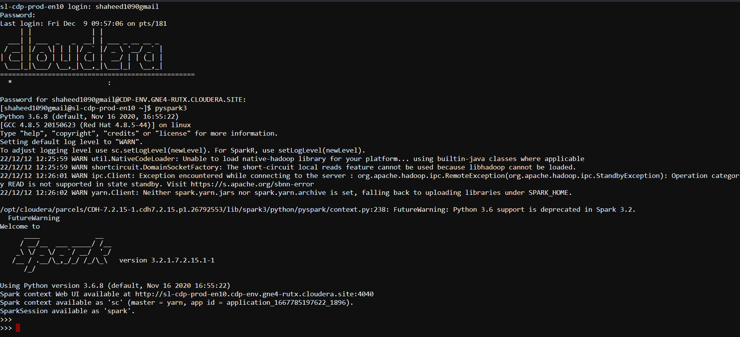
Step 3: Perform the below tasks on the uploaded dataset:

Status code analysis:

- Read the log file as an RDD in PySpark

