Retail Business Analytics

PG DE - Big Data Hadoop and Spark Developer Training

Submitted by,
SHAHEED VK
PGP DE OCT 2022 COHORT 1

Step 1: Upload the “data-files” file to HDFS through FTP
files are uploaded to Retail_business_analysis directory in HDFS.
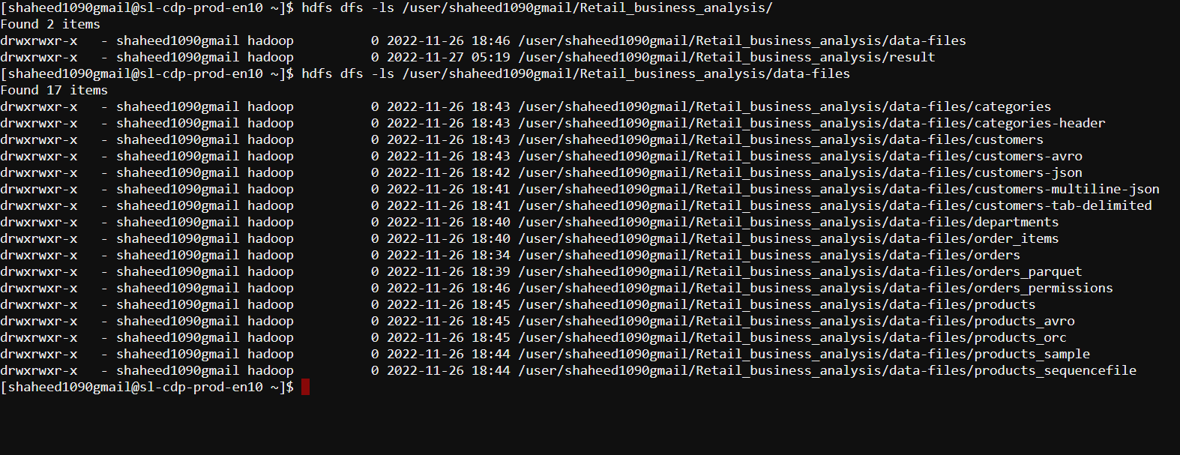
Step 2: Perform the tasks on the uploaded dataset using PySpark
Task 2.1:
Log in to PySpark shell
Logged in to PySpark shell,
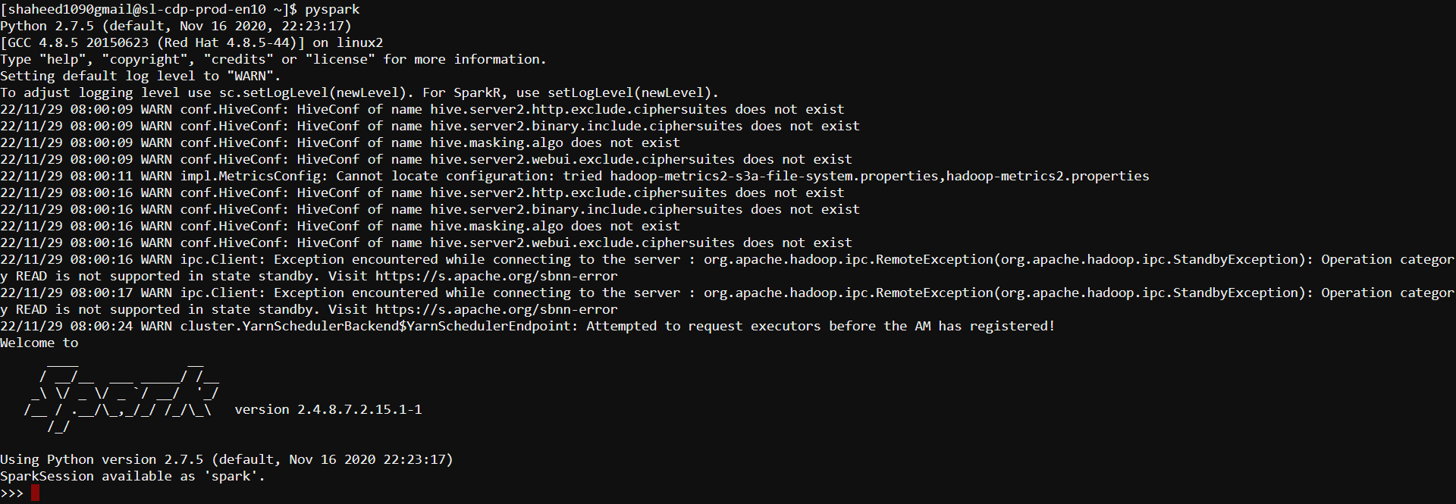

Task 2.2:
Explore the customer records saved in the "customers-tab-delimited" directory on HDFS
- Show the client information for those who live in California
- The final output must be in text format
- Save the results in the result/scenario1/solution folder
- Only records with the state value "CA" should be included in the result
- Only the customer's entire name should be included in the output
Solution
- Explore the customer records in "customers-tab-delimited" directory on HDFS,
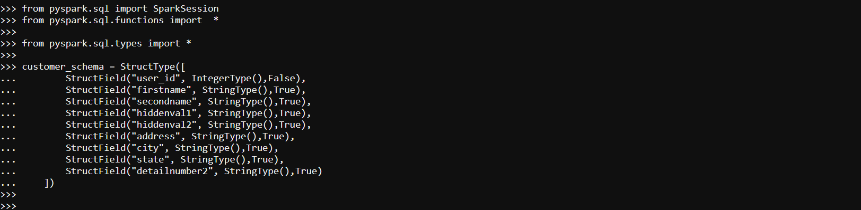
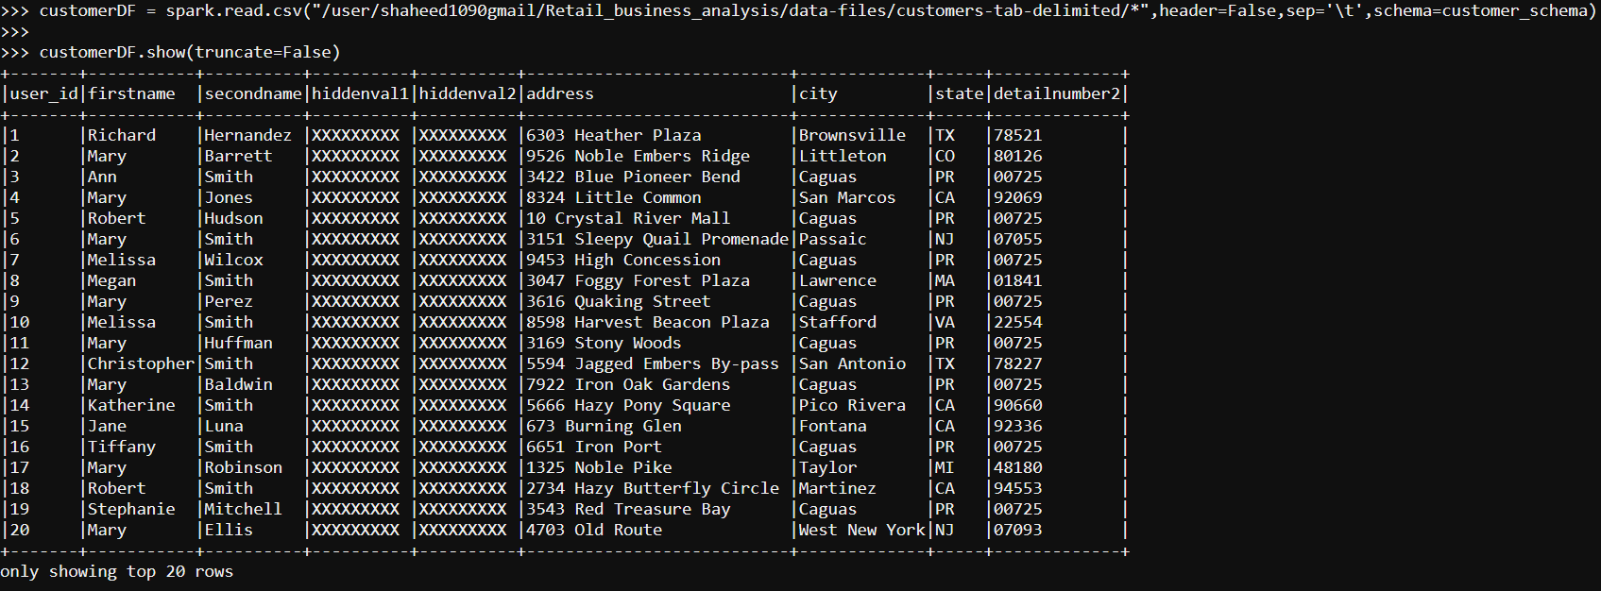
- customer's entire name column from first-name and second name,

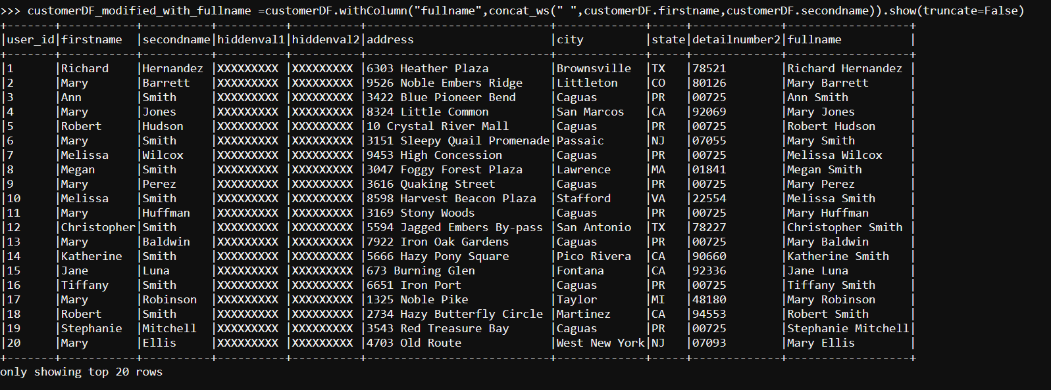
- the client information for those who live in California
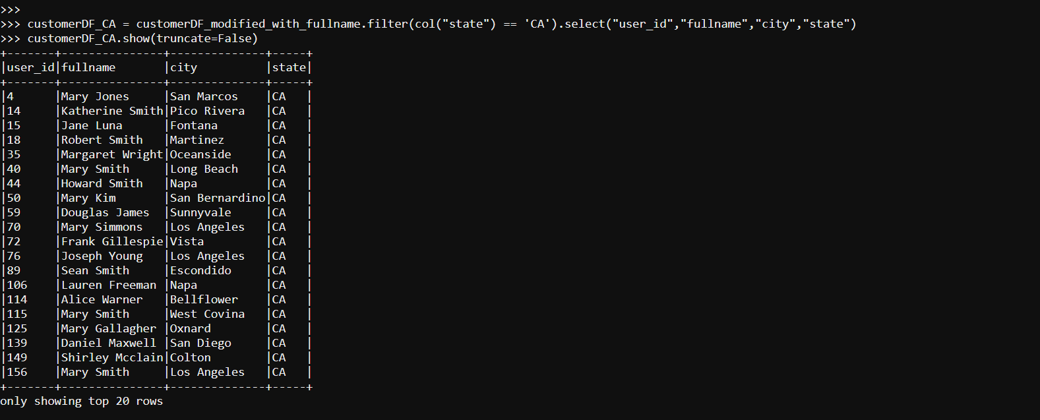
- Saving the result,
Task 2.3:
Explore the order records saved in the “orders parquet” directory on HDFS
- Show all orders with the order status value "COMPLETE"
- The output should be in JSON format
- Save the data in the "result/scenario2/solution" directory on HDFS
- The "order date" column should be in the "YYYY-MM-DD" format
- Use GZIP compression to compress the output
- Only the column names listed below should be included in the output:
(Order number, Order date, Current situation)
Solution
- exploring the order records saved in the “orders parquet” directory on HDFS
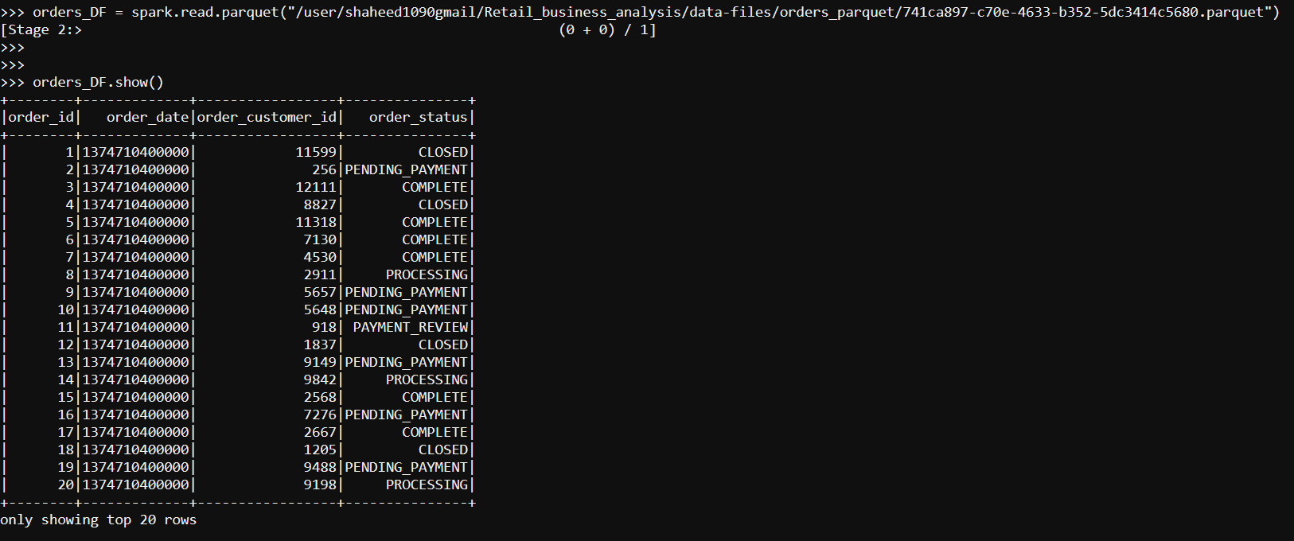
- Show all orders with the order status value "COMPLETE"
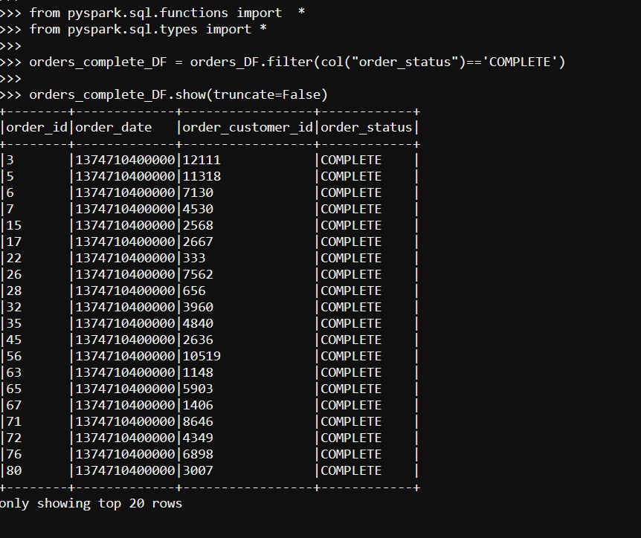
- order_date column format changed to yyyy-MM-dd,
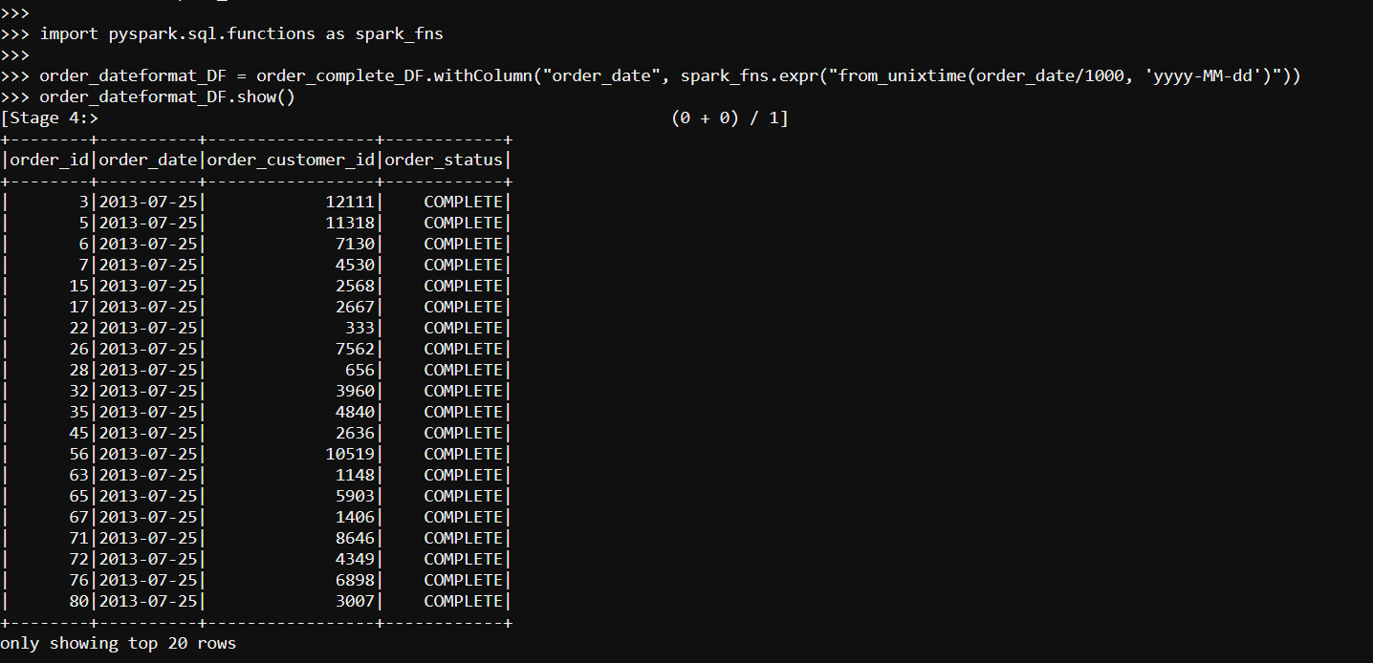
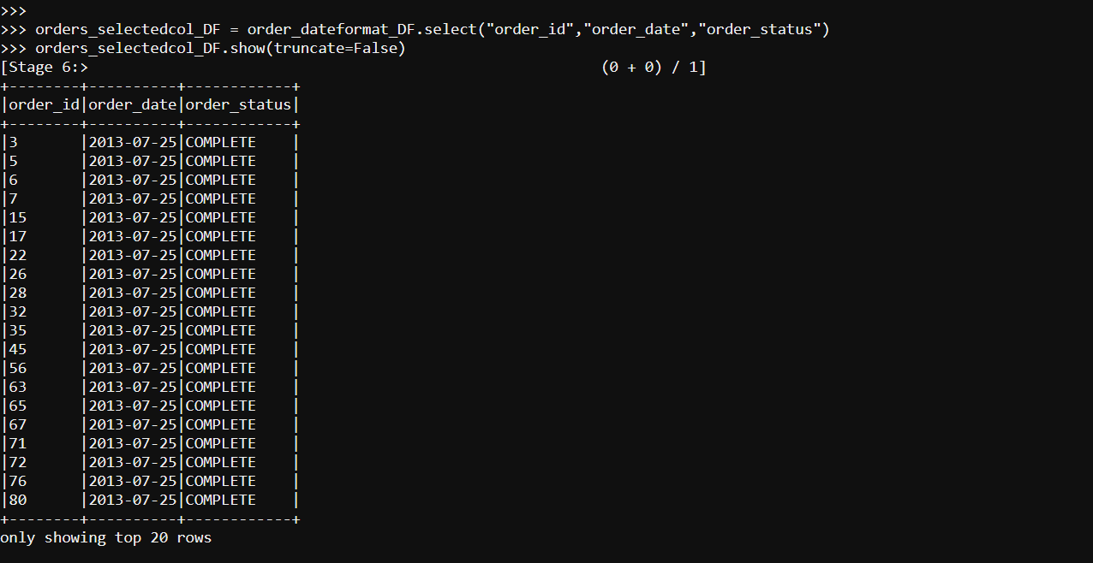
- with selected columns,
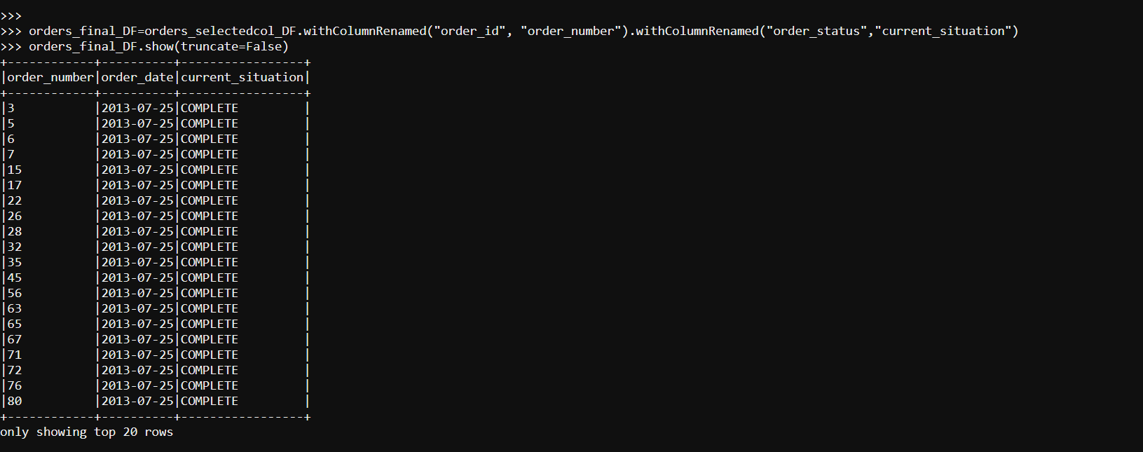
column name renamed,
- Saving - result/scenario2/solution" directory on HDFS

Task 2.4
Explore the customer records saved in the "customers-tab-delimited" directory on HDFS
- Produce a list of all consumers who live in the city of "Caguas"
- Save the data in the result/scenario3/solution directory on HDFS
- The result should only contain records with the value "Caguas" for the customer city
- Use snappy compression to compress the output
- Save the file in the orc format
Solution
- list of customers who live in the city of Caguas
Applying custom schema to data set,
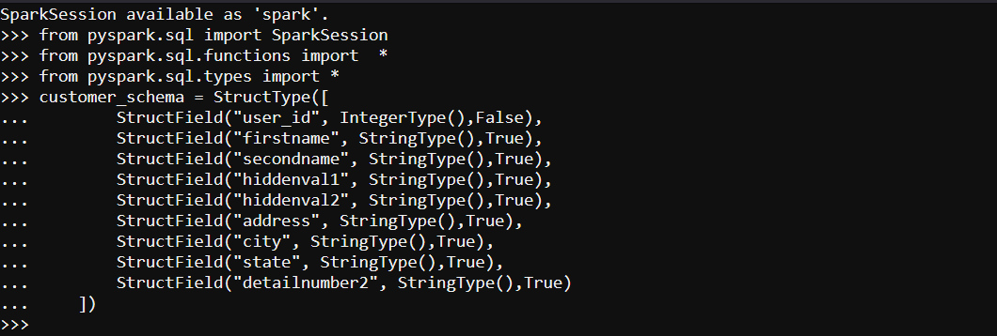
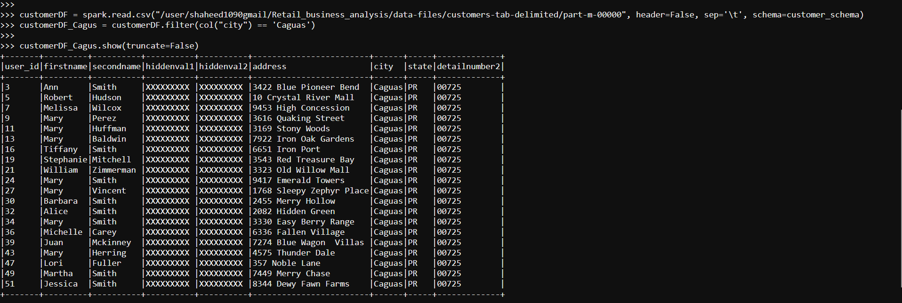
- Saving filtered data to result/scenario3/solution directory on HDFS
- Result saved,
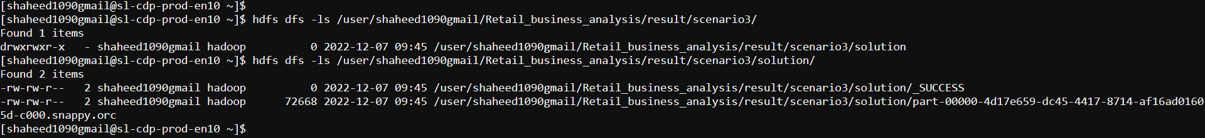
Task 2.5
Explore all the category records stored in the “categories” directory on HDFS
- Save the result files in CSV format
- Save the data in the result/scenario4/solution directory on HDFS
- Use lz4 compression to compress the output
solution
- Exploring category records
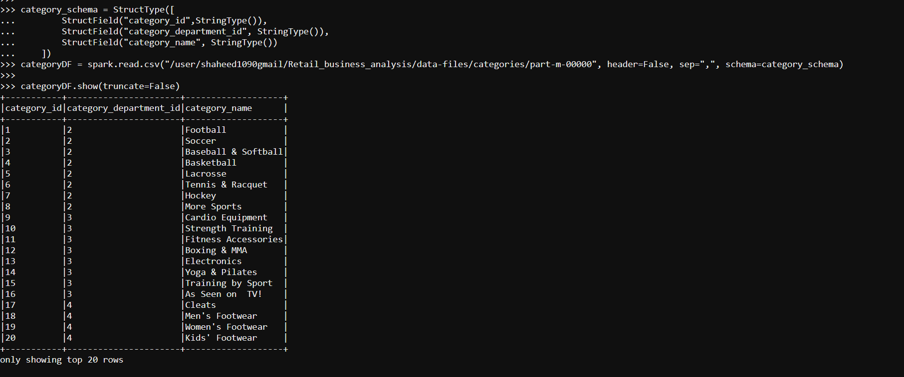
- Save the data in the result/scenario4/solution directory on HDFS
Task 2.6
Explore all product records that are saved in the “products_avro” database
- Only products with a price of more than 1000.0 should be included in the output
- Save the output files in parquet format
- Remove data from the table if the product price is greater than 1000.0
- Save the data in the result/scenario5/solution directory on HDFS
- Use snappy compression to compress the output
Solution
- Reading content from product_avro directory,
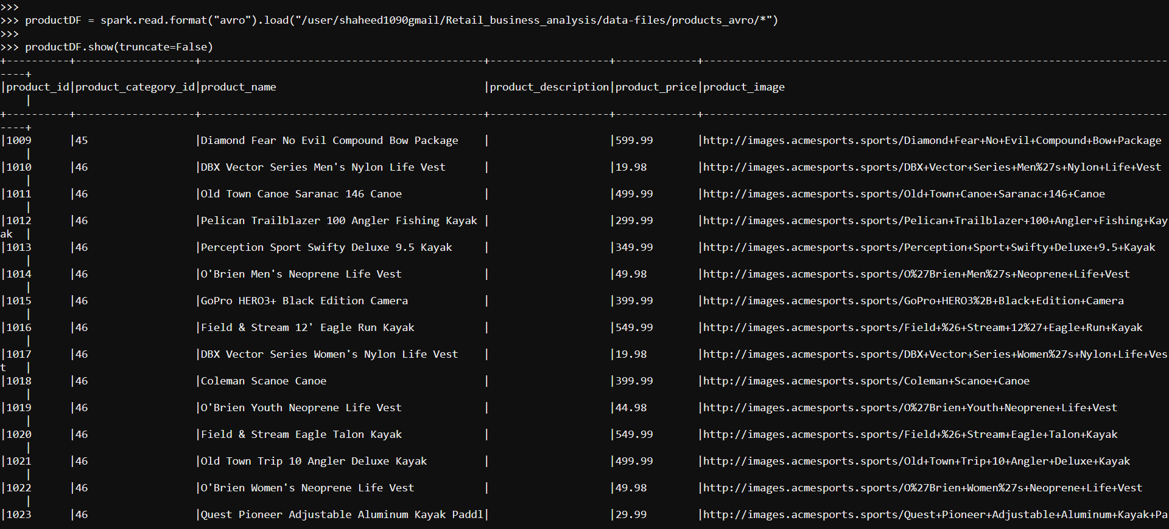
- Filtering the data with product price more than 1000.0
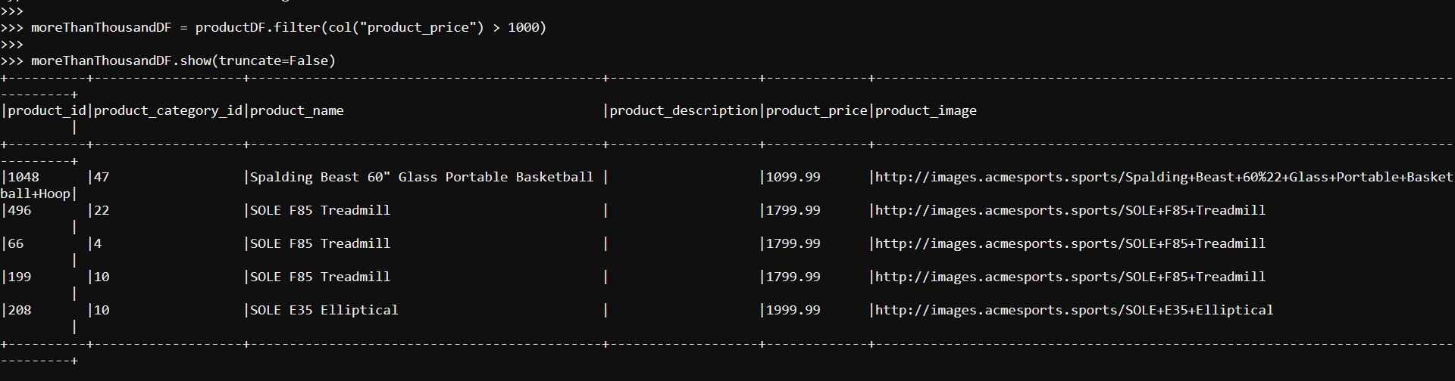

- Saving the data in the result/scenario5/solution directory on HDFS

- Result
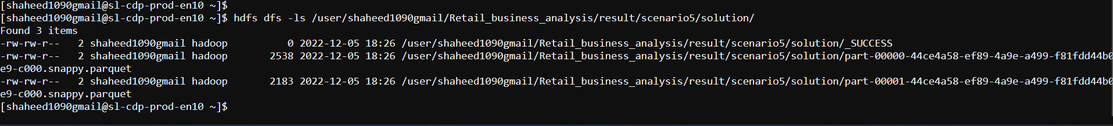

Task 2.7
Explore the “products_avro” stored in product records
- Only products with a price of more than 1000.0 should be in the output
- The pattern "Treadmill" appears in the product name
- Save the output files in parquet format
- Save the data in the result/scenario6/solution directory on HDFS
- Use GZIP compression to compress the output
solution

- pattern ‘Treadmill’ appears in product name & with product price more than 1000.0

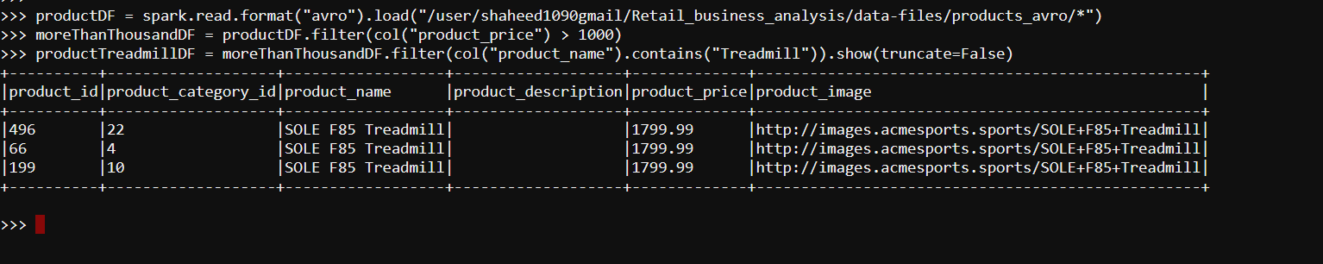
- Saving the data in the result/scenario6/solution directory on HDFS

- Result
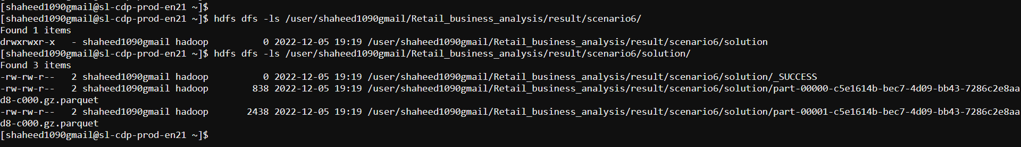

Task 2.8
Explore the order records that are saved in the “orders parquet” table on HDFS
- Output all PENDING orders in July 2013
- Output files should be in JSON format
- Save the data in the result/scenario7/solution directory on HDFS.
- Only entries with the order status value of "PENDING" should be included in the result
- Order date should be in the YYY-MM-DD format
- Use snappy compression to compress the output, which should just contain the order date and order status
solution
- exploring the orders parquet table on HDFS,
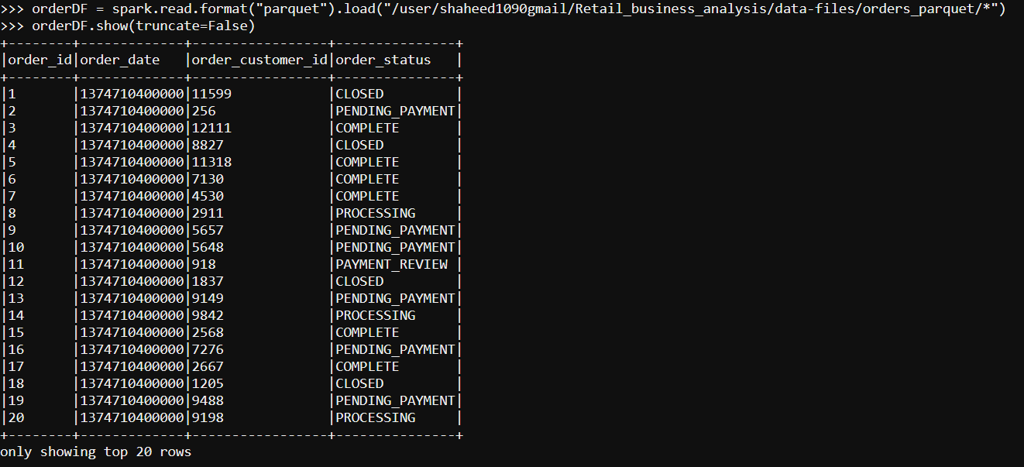
- records with ‘PENDING’ status,
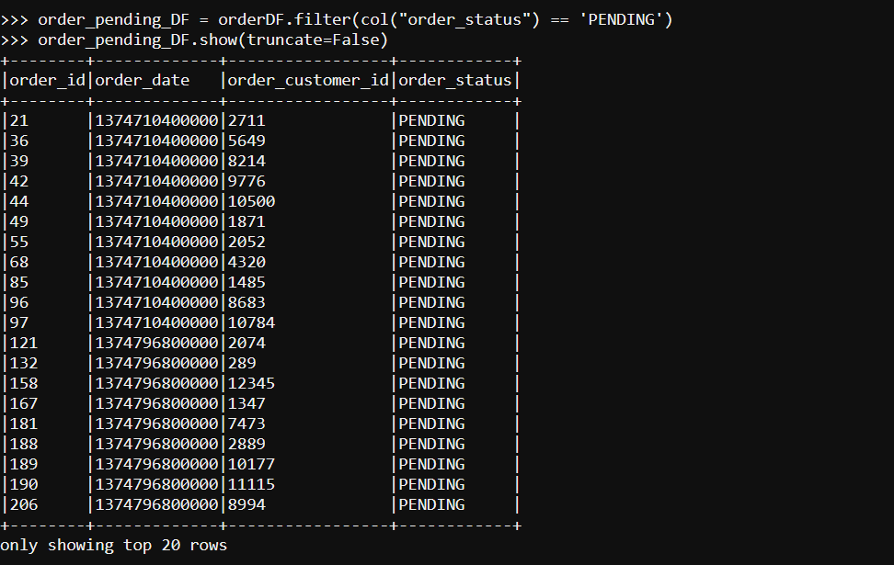
- Order records with PENDING status and order date in -July 2013
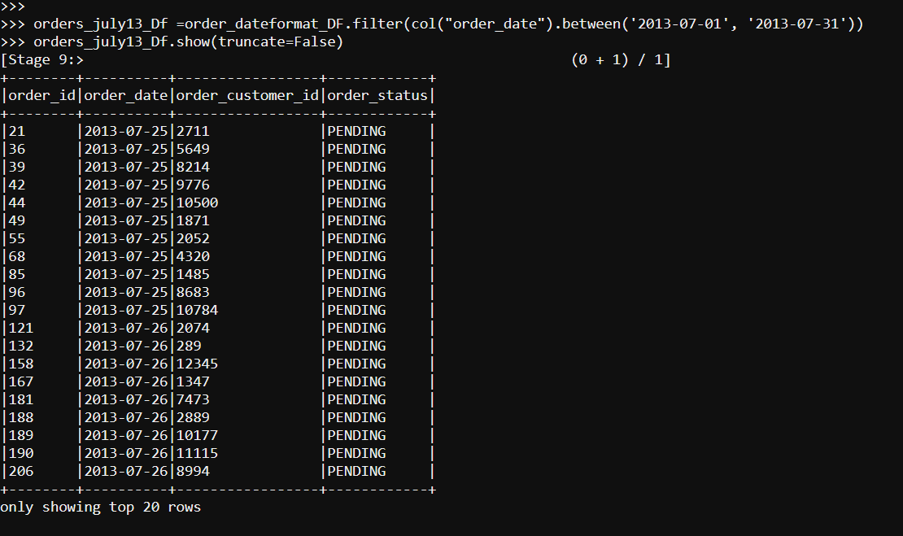
- Final result as output with columns – order date & order status
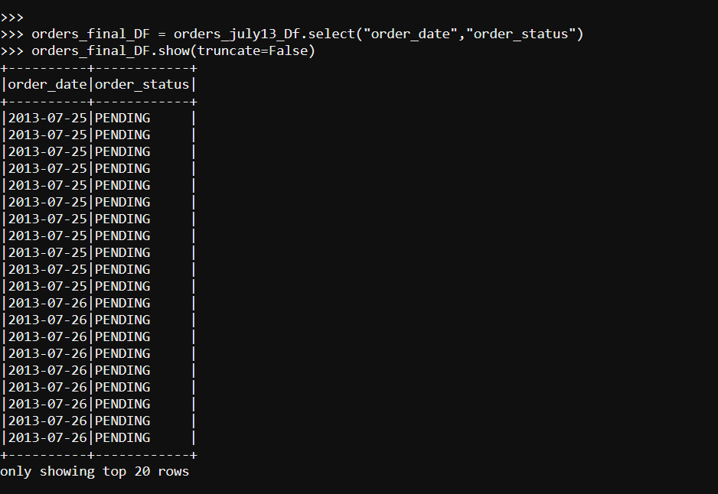
- Saving result/scenario7/solution directory on HDFS.

