2026–27
Budget Statement
Budget Paper No.01
Circulated by The Hon. Daniel Mookhey MLC, Treasurer

Statement of the Secretary
The 2026-27 Budget Papers incorporate the requirements of the Government Sector Finance Act 2018 and the Fiscal Responsibility Act 2012.

Best available information
The Estimated Financial Statements have been prepared to reflect economic and financial data and estimates of Government policy decisions up to 9 June 2026, including information provided in the 2026-27 Australian Government Budget released on 12 May 2026.
Any estimates or assumptions made in calculating revenues, expenses, other economic flows, assets or liabilities are based on the latest information available at the time.

Professional judgement
The Estimated Financial Statements contain projections for the Budget year (2026-27) and the three following years (2027-28 to 2029-30).
The forward-looking nature of these projections means it is necessary to apply professional judgement in their preparation. That judgement includes an informed assessment of the most likely economic and financial outcomes including spending and revenue profiles. Differences between underlying assumptions and eventual outcomes can reflect the reality of an uncertain operating environment and the impact of many variables over which the Government has little or no control.
Treasury has exercised its best professional judgement in preparing the Estimated Financial Statements. These Statements have been prepared in accordance with the Statement of Significant Accounting Policies and Forecast Assumptions.

Michael Coutts-Trotter
Secretary, NSW Treasury
23 June 2026

Table of Contents
Chart, Figure and Table List
Focus Box List
About this Budget Paper i
Chapter 1: Budget overview
1.1 Economic context 1 - 2
1.2 Fiscal context 1 - 3
1.3 Budget priorities and investment outcomes 1 - 7
Chapter 2: The economy
2.1 Demand has been stronger than previously expected 2 - 2
2.2 Outlook for the New South Wales economy 2 - 4
2.3 Productivity as a driver of growth and living standards 2 - 9
2.4 Key risks to the outlook 2 - 10
Chapter 3: Fiscal strategy and outlook
3.1 Returning to surplus while rebuilding essential services 3 - 2
3.2 Keeping the State’s debt in check 3 - 4
3.3 Efficiently managing the State’s cash flows 3 - 5
3.4 Delivering the Government’s essential infrastructure plan 3 - 6
Chapter 4: Revenue
4.1 Revenue 4 - 1
4.2 Revenue measures since the 2025-26 Half-Yearly Review 4 - 3
4.3 Taxation revenue 4 - 4
4.4 Grant revenue 4 - 8
4.5 Non-tax revenue 4 - 12
Chapter 5: Recurrent expenditure
5.1 Sustaining investment while constraining expense growth 5 - 2
5.2 Expense trends and further analysis 5 - 10
Chapter 6: Balance sheet
6.1 Stabilising gross debt 6 - 2
6.2 The State’s net worth remains strong 6 - 3

Chapter 7: Government businesses
7.1 Reforms and initiatives of State Owned Corporations 7 - 1
7.2 Capital expenditure 7 - 6
7.3 Major public financial corporations 7 - 7
7.4 Returns to the Government from the PNFC and PFC sectors 7 - 7
Appendices
A. Statement of Finances A - 1
B. Measures statement B - 1
C. Tax expenditures and concessional charges C - 1
D. Variation details of appropriations during 2025-26 D - 1
E. Fiscal reporting and sensitivities E - 1
F. Economic scenario analysis F - 1

Chart, Figure and Table List
Page
Chapter 1: Budget overview |  |  |  | 1
New South Wales forecasts for real gross state product, Sydney consumer price index and the unemployment rate |  | Table 1.1 |  | 1-2
Sydney CPI and NSW unemployment rate |  | Chart 1.1 |  | 1-2
General government budget result: 2026-27 Budget |  | Chart 1.2 |  | 1-3
Expense growth comparison – NSW and all other Australian governments |  | Chart 1.3 |  | 1-4
Key budget aggregates for the general government sector and non-financial public  sector capital expenditure |  | Table 1.2 |  | 1-6
Change in general government gross debt compared to 2023 Pre-election Budget Update forecast |  | Chart 1.4 |  | 1-7
Increase in Essential Worker’s Starting Salary, 2018-19 to 2022-23 and 2022-23  to 2026-27 |  | Chart 1.5 |  | 1-9
Chapter 2: The economy |  |  |  | 2
NSW economic performance and outlook |  | Table 2.1 |  | 2-1
NSW dwelling additions |  | Chart 2.1 |  | 2-2
NSW unemployment and underutilisation rate |  | Chart 2.2 |  | 2-3
Australia trimmed mean inflation |  | Chart 2.3 |  | 2-3
Sydney daily dwelling prices |  | Chart 2.4 |  | 2-4
Sydney dwelling price growth by price tier |  | Chart 2.5 |  | 2-4
Future prices for crude oil and international refined fuel benchmarks at time of forecasting |  | Chart 2.6 |  | 2-5
Petrol and diesel prices |  | Chart 2.7 |  | 2-5
Financial market cash rate expectations |  | Chart 2.8 |  | 2-6
NSW GSP growth forecasts |  | Chart 2.9 |  | 2-6
Household income and consumption forecasts |  | Chart 2.10 |  | 2-7
Value of private electricity project construction work yet to be done, NSW |  | Chart 2.11 |  | 2-7
Average new owner occupier housing loan size by state |  | Chart 2.12 |  | 2-8
NSW unemployment rate forecasts |  | Chart 2.13 |  | 2-9
Sydney CPI growth forecasts |  | Chart 2.14 |  | 2-9
Mortgage interest charges for employee households, Australia |  | Chart 2.15 |  | 2-10
Chapter 3: Fiscal strategy and outlook |  |  |  | 3
NSW annual expense growth |  | Chart 3.1 |  | 3-3
Reconciliation of 2025-26 Budget to 2026-27 Budget |  | Table 3.1 |  | 3-4
NSW’s gross debt from June 2021 to June 2030 |  | Chart 3.2 |  | 3-5
General government infrastructure investment reconciliation |  | Table 3.2 |  | 3-6
Chapter 4: Revenue |  |  | 4
General government sector – summary of revenue and its components | Table 4.1 |  | 4-2
Revenue reconciliation | Table 4.2 |  | 4-3
Policy measures | Table 4.3 |  | 4-4
General government sector – summary of taxation revenue | Table 4.4 |  | 4-5
Residential property transactions per 1,000 people (seasonally adjusted, quarterly) | Chart 4.1 |  | 4-6
Sydney hedonic dwelling price index (quarterly) | Chart 4.2 |  | 4-6
Grant revenue | Table 4.5 |  | 4-8
National Agreement payments to New South Wales | Table 4.6 |  | 4-9
Federation Funding Agreement payments to New South Wales | Table 4.7 |  | 4-10
State infrastructure funding share vs population share over the four years to 2029-30 | Chart 4.3 |  | 4-10
GST revenue | Table 4.8 |  | 4-11
Sale of goods and services | Table 4.9 |  | 4-12
Fines, regulatory fees and other revenue | Table 4.10 |  | 4-13

Chapter 5: Recurrent expenditure |  | 5
Expenses relative to gross state product since 2016-17 | Chart 5.1 | 5-2
Total employee expenses – average annual growth rates from 2018-19 to 2029-20 | Chart 5.2 | 5-3
Expense reconciliation since the 2025-26 Half-Yearly Review | Table 5.1 | 5-4
Legal Aid NSW total expenses | Table 5.2 | 5-6
General government sector expenses | Table 5.3 | 5-10
Depreciation and amortisation as a proportion of GSP, 2010-11 to 2029-30 | Chart 5.3. | 5-13
Chapter 6: Balance sheet |  | 6
Gross debt comparison against Pre-election Budget Update | Chart 6.1 | 6-2
Key balance sheet aggregates of the general government sector | Table 6.1 | 6-4
Gross debt to GSP projections for Australian states and territories – June 2030 | Chart 6.2 | 6-4
Total annual OneFund investment returns and balances | Chart 6.3 | 6-6
The State’s net proceeds allocated by project category, by bond | Chart 6.4 | 6-7
Chapter 7: Government businesses |  | 7
Capital expenditure of the PNFC sector | Chart 7.1 | 7-6
Total dividend and tax equivalent payments from the PNFC and PFC sectors | Table 7.1 | 7-8
Appendix A: Statement of finances |  | A
General government sector operating statement | Table A.1 | A-6
General government sector balance sheet | Table A.2 | A-8
General government sector cash flow statement | Table A.3 | A-9
General government sector taxes | Table A.4 | A-10
General government sector grant revenue and expense | Table A.5 | A-11
General government sector dividend and income tax equivalent income | Table A.6 | A-12
General government sector expenses by function | Table A.7 | A-12
General government sector purchases of non-financial assets by function | Table A.8 | A-12
Public non-financial corporation sector operating statement | Table A.9 | A-13
Public non-financial corporation sector balance sheet | Table A.10 | A-15
Public non-financial corporation sector cash flow statement | Table A.11 | A-16
Non-financial public sector operating statement | Table A.12 | A-17
Non-financial public sector balance sheet | Table A.13 | A-19
Non-financial public sector cash flow statement | Table A.14 | A-20
Appendix B: Measures statement |  | B
New policy measures since the 2025-26 Half-Yearly Review | Table B.1 | B-1
Appendix C: Tax expenditure and concessional charges statement |  | C
Major tax expenditures by type | Table C.1 | C-2
Estimated tax revenues and expenditures by tax in 2025-26 | Chart C.1 | C-3
Tax expenditure by primary recipient category | Table C.2 | C-3
Top 10 tax expenditures | Table C.3 | C-4
Transfer duty – major tax expenditures | Table C.4 | C-5
General insurance duty – major tax expenditures | Table C.5 | C-8
Life insurance duty – major tax expenditures | Table C.6 | C-9
Motor vehicle stamp duty – major tax expenditures | Table C.7 | C-10
Payroll tax – major tax expenditures | Table C.8 | C-11
Land tax – major tax expenditures | Table C.9 | C-14
Vehicle weight tax – major tax expenditures | Table C.10 | C-17
Gambling and betting taxes – major tax expenditures | Table C.11 | C-18
Parking space levy – major tax expenditures | Table C.12 | C-19
Proportion of total concessions and proportion of total number of clubs by annual  gaming machine profit, 2024-25 | Chart C.2 | C-21
Total value and number of exemptions and concessions for first home buyer  transactions by $50,000 price brackets in 2024-25 | Chart C.3 | C-22
Distribution of First Home Buyers Assistance Scheme exemptions and concessions  in Greater Sydney and the rest of New South Wales, 2024-25 | Chart C.4 | C-23
Total 20 local government areas by value of First Home Buyers Assistance Scheme exemptions and concessions, 2024-25 | Chart C.5 | C-23
Concessions by function | Table C.13 | C-24
Public order and safety – major concessions | Table C.14 | C-24
Education – major concessions | Table C.15 | C-25
Health – major concessions | Table C.16 | C-26
Transport – major concessions | Table C.17 | C-27
Housing and community – major concessions | Table C.18 | C-29
Social protection – major concessions | Table C.19 | C-31
Economic affairs – major concessions | Table C.20 | C-31
Recreation, culture and religion – major concessions | Table C.21 | C-31
Environmental protection – major concessions | Table C.22 | C-32
Appendix D: Variation details of appropriations during 2025-26 |  | D
Details of appropriations affected by transfer of functions between GSF agencies  during 2025-26 | Table D.1 | D-2
Variation details of annual appropriations for Commonwealth Grants during 2025-26 | Table D.2 | D-3
Details of payments made from State contingencies appropriation to Treasurer  during 2025-26 | Table D.3 | D-4
Appendix E: Fiscal reporting and sensitivities |  | E
Performance against the FRA object, targets, and principles | Table E.1 | E-1
Forecasting revenue – What weighting is given to different variables | Table E.2 | E-2
Operating statement risks and sensitivities: estimated impact on the general  government sector budget result with 1 percentage point increase in each factor | Table E.3 | E-4
Contingent assets | Table E.4 | E-6
Quantifiable contingent liabilities | Table E.5 | E-6
General government sector operating statement aggregates | Table E.6 | E-8
General government sector balance sheet and financing indicators | Table E.7 | E-9
Non-financial public sector operating statement aggregates | Table E.8 | E-10
Non-financial public sector balance sheet and financing indicators | Table E.9 | E-11
Appendix F: Economic scenario analysis |  | F
Effect on major NSW economic parameters from higher energy prices (1a) | Table F.1 | F-2
Impact on NSW domestic activity from higher energy prices (Scenario 1a) | Chart F.1 | F-3
Effect on major NSW economic parameters from higher energy prices (1b) | Table F.2 | F-3
Impact on NSW domestic activity from higher energy prices (Scenario 1b) | Chart F.2 | F-4
Effect on major revenue parameters | Table F.3 | F-5
Productivity growth assumptions | Table F.4 | F-5
Effect on major NSW economic parameters from a productivity shock | Table F.5 | F-6
Impact on NSW domestic activity from a productivity shock | Chart F.3 | F-6
Effect on major revenue parameters | Table F.6 | F-7

Focus Box List
Page

Chapter 1: Budget overview |  | 1
Support for victims and community in response to the Bondi terror attack | Box 1.1 | 1-5
Keeping the State’s debt in check | Box 1.2 | 1-7
Ongoing cost-of-living support delivered so far | Box 1.3 | 1-8
Health investments delivered to the people of New South Wales so far | Box 1.4 | 1-10
Investments to support our education system delivered so far | Box 1.5 | 1-11
Initiatives to support affordable and safe housing delivered so far | Box 1.6 | 1-12
Social, community, justice and emergency service investments delivered so far | Box 1.7 | 1-14
Regional and primary industry investments delivered so far | Box 1.8 | 1-16
Investments delivered to New South Wales’ First Nations communities so far | Box 1.9 | 1-17
Chapter 2: The economy |  | 2
Energy price forecasts and their effect on inflation | Box 2.1 | 2-5
Inflation and interest rates have uneven effects across households | Box 2.2 | 2-10
Chapter 3: Fiscal strategy and outlook |  | 3
Managing expense growth through the cycle | Box 3.1 | 3-3
Keeping the State’s debt in check | Box 3.2 | 3-5
Chapter 4: Revenue |  | 4
Productivity Commission Inquiry into 2018 GST Distribution Reforms | Box 4.1 | 4-11
Chapter 5: Recurrent expenditure |  | 5
Industrial reforms to better support essential service workers | Box 5.1 | 5-3
Affordable and accessible healthcare | Box 5.2 | 5-5
Investments for Legal Aid NSW | Box 5.3 | 5-6
Delivering for First Nations people in New South Wales | Box 5.4 | 5-7
Artificial Intelligence in Government | Box 5.5 | 5-8
Investments in Integrity Agencies | Box 5.6 | 5-8
Tomago Aluminium Smelter | Box 5.7 | 5-9
Strengthening the State’s frontline workforces to improve services | Box 5.8 | 5-11
Chapter 6: Balance sheet |  | 6
Managing the State’s debt portfolio to manage interest expenses and refinancing risk | Box 6.1 | 6-3
Managing investments and insurance liabilities with OneFund | Box 6.2 | 6-5
NSW Sustainability Bond Programme | Box 6.3 | 6-7
Chapter 7: Government businesses |  | 7
Update on the Build to Rent program | Box 7.1 | 7-2
Independent Pricing and Regulatory Tribunal water pricing determinations | Box 7.2 | 7-3

About this Budget Paper

Purpose and scope
Budget Paper No. 1 Budget Statement provides information on the State finances in aggregate. The objectives of this paper are to:
- inform citizens of the State’s fiscal position and the Government’s fiscal strategy
- meet requirements under the Government Sector Finance Act 2018, which prescribes the content of the budget papers, including providing four-year projections of all major economic and financial variables, revised estimates for the preceding budget year and explanations of any significant variations
- meet requirements under s.8 of the Fiscal Responsibility Act 2012, including providing a statement of the Government’s fiscal strategy, a report on performance against the fiscal objectives, targets and principles contained in the Act and an assessment of the impact of any budget measures on the State’s long-term fiscal gap
- enable interstate comparisons by reporting in line with the Australian Bureau of Statistics Government Finance Statistics framework.
The scope of the Budget is the general government sector (GGS). However, this budget paper also includes estimated financial statements for the public non-financial corporations (PNFC) and the non-financial public sector (NFPS). The statements provide a comprehensive picture of the State’s fiscal position and strategy.
Where comparisons are made to previously published estimates, unless otherwise stated, the comparison is to the 2025-26 Half-Yearly Review.
For a list of definitions used in the budget papers, please see How to Read the Budget Papers.

Reporting of Actual and Budget data
The actual results for 2024-25 reflect the audited financial statements for the GGS as presented in the Total State Sector Accounts 2024-25.
The Estimated Financial Statements of the general government sector (2026-27 to 2029-30) in these budget papers are prepared on an accrual basis of accounting, in accordance with Australian Accounting Standards, the Uniform Presentation Framework and the principles and rules contained in the Australia Bureau of Statistics, Australian System of Government Finance Statistics: Concepts, Sources and Methods 2015 (Cat. No. 5514) (ABS-GFS Manual).
Aggregated financial data is presented on an eliminated basis – that is, intra government transactions between entities are eliminated.

Notes
The budget year refers to 2026-27, while the forward estimates period refers to 2027-28, 2028-29 and 2029-30. Figures in tables, charts and text may have been rounded. Discrepancies between totals and the sum of components reflect rounding:
- estimates under $100,000 are rounded to the nearest thousand
- estimates midway between rounding points are rounded up
- percentages are based on the underlying unrounded values.
For the budget result, parentheses indicate a deficit, while no sign indicates a surplus.
One billion equals one thousand million.
The following notations are used:
- n.a. means data is not available
- N/A means not applicable
- no. means number
- 0 means not zero, but rounded to zero
- … means zero
- ‘000 means thousand
- $m means millions of dollars
- $b means billions of dollars.
Differences between harmonised government finance statistics (GFS) and generally accepted accounting principles (GAAP) information, as shown in the budget papers, and pure GFS information, as reported by the Australian Bureau of Statistics, are known as convergence differences. Such differences are not departures from Accounting Standards but merely variations in measurement or treatments between GAAP and GFS frameworks.
Unless otherwise indicated, the data source for tables and charts is NSW Treasury.

Budget overview
- Global conflict and rising inflationary pressures have created a more challenging environment for the economic and fiscal outlook of New South Wales since the 2025-26 Half-Yearly Review. The Reserve Bank of Australia has increased interest rates three times since early 2026, leading to an $8.4 billion deterioration in the State’s property taxation revenues. New South Wales is more sensitive to interest rate increases than the rest of Australia, given greater average housing loans, which amplifies the effects on property prices, consumption and disposable incomes.
- In a world of heightened uncertainty and volatility, budget repair and ongoing fiscal discipline are even more important. Significant progress to control expense growth and stabilise debt has laid the foundation for new measures to support families through the current cost-of-living pressures and global uncertainty.
- New South Wales is not immune from global economic and fiscal headwinds that have increased short-term pressure on the budget result. However, the budget result has still been reduced from a deficit of $10.6 billion in 2022-23 to a deficit of $3.0 billion in 2025-26. The NSW Government has continued to improve the operating position year-on-year and remains on track for a return to budget surplus of $1.1 billion in 2027-28 and projected surpluses in 2028-29 and 2029-30, all while delivering new measures to support households.
- The State’s return to surplus is supported by the Government’s commitment to keeping expense growth in check, which is projected to average 2.7 per cent between 2025-26 and 2029-30 (down from an average of 9.7 per cent between 2018-19 and 2022-23).
- Gross debt is projected to be $178.5 billion by June 2026, which is $9.7 billion lower than the $188.2 billion projected at the 2023 Pre-election Budget Update, saving the State approximately $400 million per annum in interest expenses.
- The net cash operating position is projected to grow to $11.4 billion by 2029-30. This allows the Government to sustainably deliver the State’s four-year infrastructure program of $116.7 billion, while reducing associated infrastructure debt funding in this Budget from 83 per cent in the 2022-23 Budget to 53 per cent over 2025-26 and the following four financial years. This has been achieved without resorting to further increasing costs for households through privatisation.
- The Government’s strong financial management means that short-term relief measures can be provided to households in this Budget, while continuing to invest to meet the future needs of the community. This includes:
- short-term cost-of-living relief, combined with investment to improve the longer-term reliability and security of Australia’s energy supply
- uplifting healthcare system capacity, through expansions of hospitals and emergency departments and extra health workers
- investing in safe and secure communities, including a 50 per cent increase in six core frontline domestic, family and sexual violence services to support victim-survivors
- investing in the resilience, productivity and manufacturing capacity of New South Wales through major investment in new electric buses and electric bus depots, as well as essential road, rail and renewable energy infrastructure upgrades.

- Economic context
The NSW economy is being affected by sizeable domestic and international challenges, which have curtailed forecast growth.
The economy grew solidly over the latter part of 2025 and into early 2026, supported by earlier reductions in interest rates. Growth was driven by private demand, with household spending lifting as cost-of-living pressures eased while business investment rebounded.
Despite the positive signs in late 2025 and early 2026, capacity constraints remained. This saw the re-emergence of inflationary pressures in the latter part of 2025.
The escalation of conflict in the Middle East in late February has added a further negative shock to the NSW economy. Disruptions to global oil supply have led to sharp increases in fuel prices.
In response to re-emerging inflationary pressures, the Reserve Bank of Australia has raised the cash rate by a cumulative 75 basis points in 2026.
The New South Wales economy is more sensitive to interest rates than the economies of other Australian states and territories due to higher household debt. Economic growth is expected to slow over the forecast period as higher interest rates weigh on household consumption and dwelling investment.
Table 1.1 outlines how the change in economic outlook since the 2025-26 Half-Yearly Review has impacted forecast gross state product (GSP) growth.
- New South Wales forecasts for real gross state product, Sydney consumer price index and the unemployment rate^{(a)}
 | 2024-25 | 2025-26 | 2026-27 | 2027-28 | 2028-29 | 2029-30
 | Outcome | Forecast | Forecast | Forecast | Forecast | Forecast
Real gross state product | 0.9 | 1¾ (1½) | 1 (2½) | 1 (2¼) | 2 | 2
Sydney consumer price index | 2.4 | 3¾ (3¼) | 3¾ (2¾) | 2½ | 2½ | 2½
Unemployment rate^{(b)} | 4.1 | 4¼ (4½) | 4½ (4¼) | 4¾ (4) | 4½ (4) | 4½

- Forecasts are rounded to the nearest quarter point and are annual average per cent change, unless otherwise indicated. 2025-26 Half-Yearly Review forecasts in parentheses where different.
- June quarter, per cent.

- Sydney CPI and NSW unemployment rate

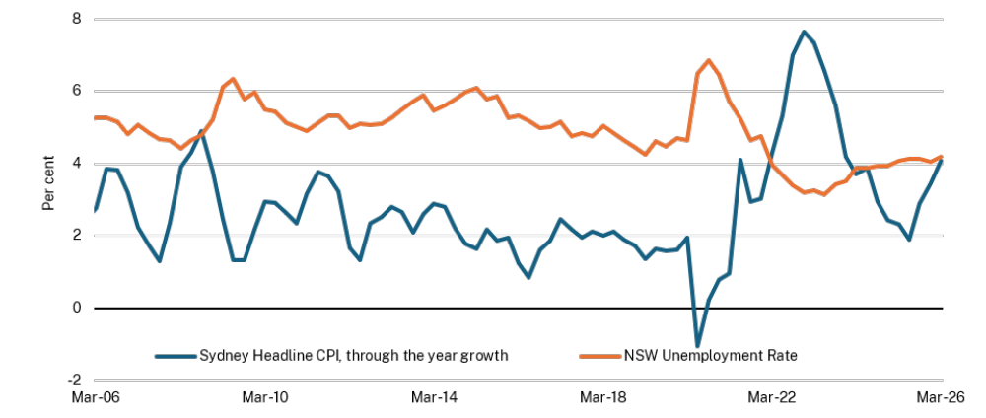
Source: ABS and NSW Treasury

- Fiscal context
The 2026-27 Budget continues the improvement in the State’s net operating position since the budget deficit of $10.6 billion in 2022-23 which has been reduced to a projected deficit of $3.0 billion in 2025-26.
New South Wales is not immune from global economic and fiscal headwinds which have increased short-term pressure on the budget result, with a deficit of $2.3 billion projected in 2026-27.
Despite short-term pressures and new measures to support families, the NSW Government has continued to improve the operating position year-on-year and remains on track for a return to surplus in 2027-28 (see Chart 1.2).
The budget result is projected to improve to a surplus of $1.1 billion by 2027-28, with surpluses projected for 2028-29 ($1.8 billion) and 2029-30 ($1.9 billion).
The improvement in the operating position is supported by the Government commitment to keep expense growth in check while investing in the delivery of essential services and infrastructure for the future. Expense growth, which averaged 9.7 per cent per annum between 2018-19 and 2022-23, was down to 1.8 per cent in 2024-25.
The 2026-27 Budget demonstrates the Government’s commitment to financial management with:
- expense growth projected to average 2.7 per cent between 2025-26 and 2029-30
- gross debt projected to be $178.5 billion by June 2026, which is $9.7 billion lower than the 2023 Pre-election Budget Update projection of $188.2 billion. This is saving the State approximately $400 million per annum in interest expenses
- gross debt projected to stabilise around 20 per cent of gross state product over the four years to June 2030, helping take pressure off the State’s interest expenses
- the cash operating position projected to grow from a surplus of $6.1 billion in 2025-26 to $11.4 billion in 2029-30. This is supporting the sustainability of the State’s infrastructure program, with this Budget reducing debt funding of the infrastructure program from 83 per cent in the 2022-23 Budget to 53 per cent over 2025-26 and the following four financial years, without resorting to increasing costs for households through privatisation.
- General government budget result: 2026-27 Budget
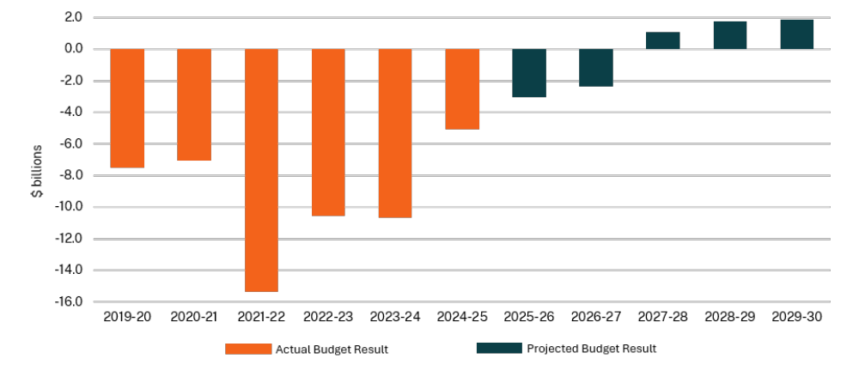
Source: NSW Treasury

This improved trajectory has been achieved despite higher interest rates, persistent inflationary pressures, deterioration in property taxation revenues, as well as the State’s increased co-funding obligations under agreements with the Australian Government.
This strong financial management enables continued investment in essential services and infrastructure that meet the needs of the community, including:
- a 12-month Transport Affordability Package totalling $561.4 million to help people with unavoidable daily costs, whether they drive to work, use toll roads, or rely on public transport
- $10.3 billion over the four years to 2029-30 to grow the health workforce, expand hospital capacity and meet rising demand
- $631.9 million over five years to 2030-31 to commence the Australian Government’s Thriving Kids early intervention supports for children aged 8 and under with developmental delay and/or autism who have low to moderate support needs
- $184.1 million over the four years to 2029-30 to strengthen responses to domestic and family violence, through a 50 per cent uplift to six existing crisis response programs.
Expense pressures remain, including the risk of ongoing high inflation and further interest rate increases, exacerbated by strained global supply chains and record high oil prices.
- Expense growth comparison – NSW and all other Australian governments
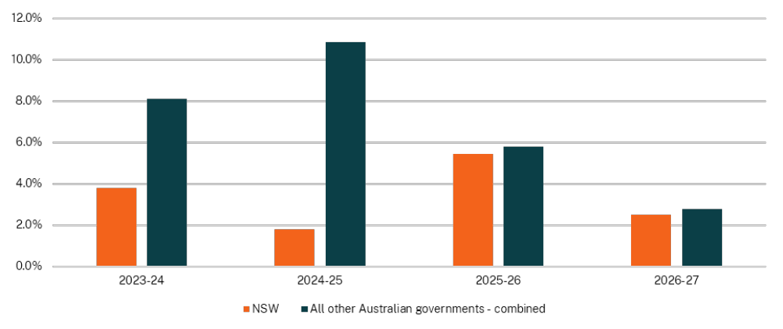
Source: Latest Budget Papers or Half-Yearly Reviews of Australian State, Territory and Federal Governments as at 23 June 2026; NSW Treasury

- Support for victims and community in response to the Bondi terror attack
The Bondi terror attack on 14 December 2025 was the worst terrorist attack on Australian soil. Its effects continue to be felt in communities all across New South Wales and Australia. In response, the NSW Government has provided support to the victims, survivors and wider Bondi community, including:
- enhancements to NSW’s existing victim support scheme, including increased financial support for injured victims and their immediate families and practical support including access to urgent counselling for victims and truncated application processes for the families of the deceased
- legal and administrative support including immediate financial support to fund legal aid and legal services and case coordination and outreach for affected individuals and families
- financial support for small business in the immediate vicinity of the attack
- financial support and community grants for local not-for-profit and Jewish organisations.
In response to the Bondi Beach attack, the NSW Police have strengthened their handling of major public gatherings and high-risk events with enhanced law enforcement capability beyond short-term surge responses. This new capability in the 2026-27 Budget includes:
- $94.3 million for the establishment of an Australian-first Armed Response Command, with 250 police officers with long arm capability, 28 civilian staff, a fleet of high-performance rapid-response vehicles, and a 24/7 Specialist Operation Centre to support tasking, real-time coordination, and surge management – including training, logistics and intelligence to inform targeting and prevention
- $26.9 million for 30 additional Multicultural Liaison Officers to support social and community cohesion and strengthen community engagement
- tougher firearms regulation with $42.8 million over 10 years for the NSW Firearms Registry to strengthen checks, process licence renewals and upgrade systems.
In addition to these individual and community supports, the NSW Government has introduced some of the toughest firearm laws in Australia and committed to participating in the National Gun Buyback Scheme, continuing to work with the Australian Government on the funding and parameters of the Scheme.
The 2026-27 Budget includes further $8.3 million funding for the creation of a lasting memorial, and support for recovery and building community resilience in the wake of the attack.

A measured approach to financial management
Despite significant fiscal challenges and pressures, the Government remains committed to the two fiscal principles adopted in the 2023-24 Budget to guide the State’s fiscal strategy:
- returning to a sustainable operating position
- stabilising and then maintaining a sustainable debt position.
Consistent with these principles, this Budget shows the Government is projecting:
- a return to budget surplus by 2027-28
- expense growth maintained at around 2.7 per cent over the forward estimates
- a general government infrastructure program at around 2 per cent of GSP
- gross debt at around 20 per cent of GSP.

Implementation of this fiscal strategy has resulted in an improved overall fiscal position with:
- an improvement in the budget result from a $10.6 billion deficit in 2022-23 to a projected $1.1 billion surplus in 2027-28
- an improvement in cash operating position, with a projected surplus of $5.5 billion in 2026-27 from a deficit of $0.2 billion in 2022-23
- gross debt projected to be $178.5 billion by June 2026, which is $9.7 billion lower than the $188.2 billion projected in the 2023 Pre-election Budget Update.
The improved fiscal position has been underpinned by delivering the lowest average expense growth of any Australian Government over the last three years, keeping it at this low level over the four years to 2029-30, and despite the State’s increased co-funding obligations under agreements with the Australian Government.

Stabilising the State’s debt trajectory
The Government has stabilised the State’s gross debt position while maintaining a large infrastructure program to support the long-term economic growth of New South Wales and its growing population, without shifting costs onto households through privatisation.
The Government’s total infrastructure investment in the non-financial public sector is $116.7 billion over the four years to 2029-30, including:
- additional investments in transport, health and education infrastructure which maintains the general government infrastructure program at $84.8 billion over the next four years. An overview of the State’s infrastructure program can be found in Budget Paper No.3 Infrastructure Statement
- a public non-financial corporation infrastructure program of $31.9 billion over the next four years. An overview of the government businesses’ infrastructure programs can be found in Chapter 7 Government businesses.
- Key budget aggregates for the general government sector and non-financial public sector capital expenditure
 | 2024-25 | 2025-26 | 2026-27 | 2027-28 | 2028-29 | 2029-30
 | Actual | Revised | Budget | Forward Estimates
Revenue ($m) | 118,009 | 126,719 | 130,687 | 135,609 | 141,225 | 146,122
Per cent of GSP | 13.8 | 14.0 | 13.8 | 13.8 | 13.8 | 13.7
Expenses ($m) | 123,078 | 129,769 | 133,032 | 134,498 | 139,465 | 144,243
Per cent of GSP | 14.4 | 14.3 | 14.0 | 13.7 | 13.6 | 13.5
Budget result ($m) | -5,069 | -3,049 | -2,345 | 1,110 | 1,760 | 1,879
Per cent of GSP | -0.6 | -0.3 | -0.2 | 0.1 | 0.2 | 0.2
Cash operating position ($m) | 4,345 | 6,113 | 5,459 | 10,247 | 11,190 | 11,382
Per cent of GSP | 0.5 | 0.7 | 0.6 | 1.0 | 1.1 | 1.1
Gross debt ($m) | 165,991 | 178,482 | 193,840 | 202,891 | 210,016 | 219,392
Per cent of GSP | 19.4 | 19.7 | 20.5 | 20.7 | 20.5 | 20.5
Capital expenditure ($m) | 21,623 | 22,924 | 21,876 | 21,342 | 21,037 | 20,590
Per cent of GSP | 2.5 | 2.5 | 2.3 | 2.2 | 2.1 | 1.9
NFPS capital expenditure ($m) | 27,480 | 30,109 | 30,171 | 30,049 | 29,019 | 27,503
- Keeping the State’s debt in check
This Budget continues to manage the growth of gross debt and target stabilisation of debt levels at around 20 per cent of GSP. This has been achieved while the Government continues to support long-term economic growth through sustainable delivery of the State’s significant infrastructure program.
Responsible management of the State’s borrowings helps ease the State’s interest expense burden and support a strong credit rating. By reducing the June 2026 projected gross debt by $9.7 billion in comparison to the 2023 Pre-election Budget Update, the NSW Government will save around $400 million in annual interest expenses.
- Change in general government gross debt compared to 2023 Pre-election Budget Update forecast
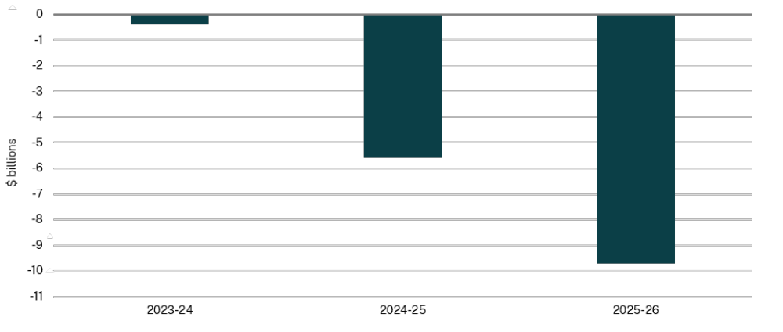
Source: NSW Treasury

- Budget priorities and investment outcomes
The 2026-27 Budget continues to invest responsibly in the Government’s priorities such as health, housing, education and strengthening communities, to foster a strong and resilient future for the State. It delivers short-term cost-of-living relief while continuing long-term reform of the energy sector and providing ongoing investment in the essential services the people of New South Wales rely on.
Budget Paper No. 2 Performance and Wellbeing Statement provides detailed information on the performance of government services and the wellbeing of the people of New South Wales.

Relief for NSW households
The people of New South Wales are facing rising cost-of-living pressures, against the back drop of high inflation and rising interest rates. Despite short term fiscal pressures, the 2026-27 Budget prioritises household budgets by delivering immediate relief where it can.
The Government is helping households with everyday costs now, while making longer-term reforms to ease pressure on housing, energy, transport and essential services. Short-term cost-of-living relief measures in this Budget include:
- a temporary reduction in the weekly toll cap to $50 in 2026-27 (down from the previous $60 weekly cap)
- a $100 cut on private vehicle registration (excluding caravans and trailers) in 2026-27 ($80 off registration for motorcycles)
- providing commuters with relief through an Opal fare freeze, maintaining 2025 prices
- $557.1 million in interest-free loans and discounts to install energy technologies under the NSW Home Energy Saver Program.
The Government will also remove administration fees associated with toll notices, with the fees to be switched off from July as part of the continued shift to making tolling communications digital-first.

- Ongoing cost-of-living support delivered so far
Immediate relief in this Budget is supported by continuation of broader measures to help with cost-of-living and affordability, including energy and housing costs. Key measures include:
- stronger protections for more than 2.3 million renters, including a ban on no-grounds eviction, fee-free ways to pay rent, limits to rent increases to once a year, and easier pet approvals
- more than 94,000 first home buyers supported through transfer duty exemptions and concessions, with average savings of around $20,400
- a $10,000 First Home Owner Grant for eligible buyers of newly built homes
- supporting households through energy social programs, including six energy rebates and the Energy Accounts Payment assistance for households facing financial hardship, crisis or an emergency
- supporting workforce stability in critical service areas including health, education and transport through the NSW Government’s Fair Pay and Bargaining Policy
- delivery of toll relief measures, including the weekly toll cap and truck multiplier reduction, representing over $600 million in value and providing significant cost-of-living support to drivers. More than $284 million has been returned via over 862,000 claims (as at May 2026)
- enhancements to improve data and reporting capability and security of the FuelCheck application and website.

Delivering more essential service workers with better pay and conditions
The NSW Government has been improving public services while fairly paying its workforce and carefully managing expense growth. Overall employee expense growth was 6.2 per cent per annum over the three years to 2025-26. This is lower than the 6.4 per cent average annual employee expense growth in the four years to 2022-23.
The NSW Government has been able to achieve lower employee expense growth while paying fair wages through reforms, such as:
- a 15 per cent reduction to Public Sector Senior Executive (PSSE) headcount
- workers compensation reforms to ensure the long-term sustainability of the scheme and improve outcomes for workers and employers
- reforms to the Police Blue Ribbon Insurance Scheme (PBRI)
- a two-year remuneration freeze for Members of Parliament and PSSEs
- implementation of budget improvement and reprioritisation measures through the Comprehensive Expenditure Review which contributed to moderating employee expense growth.
Over the budget and forward estimates, employee expenses growth is projected to further moderate to an average of 3.9 per cent per annum.
Lower wages can have a significant impact on frontline services. Real wages for the NSW Government workforce fell by 1 per cent during the legislated wage cap period. There were also growing insurance costs, declining police numbers, high teacher vacancies and 1,112 nurses (FTE) not funded beyond 2022-23.
In 2023-24, the NSW Government adopted the Fair Pay and Bargaining Policy which introduced mutual gains bargaining. The jurisdiction of the Industrial Relations Commission (IRC) was strengthened to independently assess wage claims without the restriction of a wages cap, including work value and gender undervaluation claims.
The IRC has since made several decisions following claims brought forward by public sector workforces. This Budget includes an additional $2.9 billion to implement the IRC’s decision for pay increases over three years for NSW nurses and midwives.
The NSW Government’s industrial reforms have led to significant pay increases since 2022-23 for key workforces, as demonstrated by Chart 1.5 below.
- Increase in Essential Worker's Starting Salary, 2018-19 to 2022-23 and 2022-23 to 2026-27
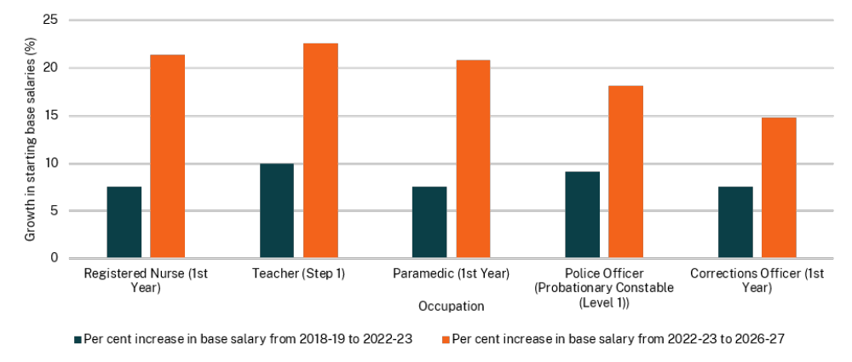
These reforms have also supported growth in essential workforces, including:
- teacher vacancies are down 71 per cent from November 2022 to Term 1 2026, and the number of fully-staffed schools has increased
- the largest police class in more than 14 years, with 349 probationary constables being sworn in (Class 368) on 1 May 2026, representing around 2 per cent of the total police workforce
- an additional 481 firefighters joined Fire and Rescue NSW in the first half of 2026, following a record recruitment year in 2025 when 648 firefighters joined the service
- since 2023, more than 5,300 full time equivalent (FTE) nurses have been employed to support healthcare, including 1,112 made permanent in 2024-25. More than 740 additional paramedics (FTE) have been deployed across New South Wales since 2023. 116 paramedic interns and 21 emergency medical call takers were inducted in April 2026.
For further information, see Chapter 5 Recurrent expenditure.

Investing in the health of NSW residents
Significant measures supported in this Budget will assist in caring for our community and keeping them healthy. This includes a historic $10.3 billion increase in health funding, delivered with the Australian Government, to grow the health workforce, expand hospital capacity and meet rising demand.
This will deliver:
- 9,000 more health workers
- capacity for an extra 33,000 Emergency Department presentations each year
- 2,900 extra planned surgeries each year
- around 16,000 inpatient services including emergency surgeries each year
- a boost to available renal dialysis care by 11,000 sessions each year.

- Health investments delivered to the people of New South Wales so far
- Historic pay rise for nurses and midwives:
- A stronger health workforce through pay rises of 16 per cent for registered nurses and midwives, 18 per cent for enrolled nurses and 28 per cent for assistants in nursing over three years.
- Northern Beaches Hospital returned to public hands:
- Northern Beaches Hospital is now publicly owned, with all 494 beds and more than 1,800 staff transferred to NSW Health.
- Significant investments in frontline emergency services and healthcare, including:
- more than 5,300 nurses (FTE) employed since 2023 to support healthcare, including 1,112 made permanent in 2024-25
- more than 740 additional paramedics (FTE) have been deployed across New South Wales since 2023
- 116 paramedic interns and 21 emergency medical call takers were inducted in April 2026.
- Emergency Department Relief Package investments delivered include:
- $70.1 million investment for short stay units, with 22 additional treatment spaces delivered and operational, increasing capacity across five hospitals. This is estimated to reduce emergency department wait times by nearly 80,000 hours
- $53.9 million investment for Discharge Patient Flow Concierge.
- Other investments include:
- McGrath Foundation Cancer Centre nursing workforce, through the investment of $18.6 million over four years, bringing the total to 45 NSW Government funded nurses across New South Wales
- $170.8 million to improve take‑home pay for more than 50,000 healthcare workers through better salary packaging
- supporting over 22,600 contacts from children and young people across New South Wales in 2024-25, through the investment of $17.1 million over four years to Kids Helpline to expand service capacity and respond to rising demand.

Building education and training skills
Investment in education and training ensures people have jobs and enjoy prosperity in the future. This Budget includes initiatives which aim to enhance training opportunities and improve educational outcomes for students in New South Wales, such as:
- $42.6 million to extend the 3-Year-Old Fee Relief Trial Payment in Long Day Care to the end of 2027
- continuation of the Year 1 phonics and number checks
- continuation of state wide small group tuition
- a significant investment of $3.44 billion in skills and TAFE.

- Investments to support our education system delivered so far
The Government has focused on addressing teacher vacancies and positions.
- Teacher vacancies have reduced by 71 per cent since the teacher shortage in November 2022 when there were 3,311 vacancies for permanent teachers.
- Between March 2023 and December 2025, 14,672 teachers and 10,363 school support staff moved from temporary employment into permanent roles through the Temporary Workforce Transition initiative and ongoing recruitment and staffing processes, improving educational outcomes for students in the State’s public schools.
Investment in school infrastructure has included $100 million for 33 projects to deliver High Potential and Gifted Education Partner School Program. This program expands opportunities and broadens curriculum offerings for students across New South Wales. Works completed to date include:
- sporting facilities, marine studies lab and other specialist facilities at Lake Macquarie High School
- a creative and performing arts area, visual arts room and science labs at Bowral High School, with construction underway of food technology facilities
- refurbishment of three existing science labs and two food technology facilities at Batemans Bay High School.

Investing in our transport network
In this Budget, the Government is continuing to invest in our critical transport infrastructure and services, including:
- $6.5 billion over ten years for the New Electric Bus Program to reduce our reliance on imported fuels, meet the needs of our growing community and provide cleaner ways to travel. The program will support manufacturing jobs in New South Wales by providing pipeline certainty to build new electric buses over ten years
- new investment of $2.4 billion for Parramatta Light Rail Stage 2
- improving rail reliability with a record $2.1 billion annual investment in heavy rail for maintenance, signalling, systems and station upgrades, as well as funding to strengthen incident response and service recovery across the Sydney Trains network by expanding the Rail Operations Centre and establishing rapid incident response teams
- $18.2 million over four years to 2029-30 to equip and train firefighters and senior officers in rail safety and tunnel operations, safeguarding public safety across the expanding metro network.

Improving affordable housing and the planning system
In this Budget, the Government is investing in initiatives that improve access to safe and quality housing, including:
- establishing the Development Coordination Authority to operate as a one-stop shop from 1 July 2026 to coordinate and streamline agency inputs on development applications and planning proposals
- expanding the Pre-Sale Finance Guarantee program to target registered, not-for-profit community housing providers and smaller residential developments, particularly in regional areas
- surcharge purchaser duty relief to support investment in retirement villages and build-to-rent properties
- through the investment of $14.0 million in the NSW Digital Planning System
- an expression of interest to establish a Modern Methods of Construction manufacturing facility which will scale prefabrication, automate processes, reduce build costs, accelerate delivery of high-quality homes and improve sustainability
- $32.3 million for the Building Commission to improve housing productivity through a new buildings approvals system in the NSW Planning Portal, creating a Modern Methods of Construction Regulatory Framework to decrease the cost of construction, pilot of an enhanced dispute resolution process and the use of AI technology to improve and streamline licensing.

- Initiatives to support affordable and safe housing delivered so far
- Abolishing transfer duty for first home buyers purchasing a home worth up to $800,000 and offering a concessional rate to first home buyers purchasing a property up to $1 million.
- $1 billion Pre-sale Finance Guarantee program where NSW Government can commit to purchase up to 50 per cent of eligible residential housing pre-sales, to help accelerate housing delivery. The program is expanding support to target registered, not-for-profit community housing providers and smaller residential developments, particularly in regional areas.
- The establishment of the NSW Rental Commissioner, as an advocate and voice for renters, to identify barriers to increasing housing supply for renting, look for practices and gaps that erode the rights of renters and gather data on renting to help future policy making.
- Introduction of the Infill Affordable Housing Bonus Scheme, which permits additional height and floor space for residential developments that include the required amount of affordable housing. Since being introduced, more than 12,100 homes have been approved under this scheme, including 3,800 affordable homes (see further details in Budget Paper No. 2 Performance and Wellbeing Statement).
- Smart Rental Bonds, making it easier and more affordable for renters to secure a home without needing to pay a full upfront bond. The scheme has progressed through key delivery milestones. The digital platform has been built and is currently in testing, with the service planned to go-live in the middle of 2026.

Protecting and supporting communities
The NSW Government continues to support the most vulnerable in our community and build stronger and safer communities across the State, with well resourced and capable emergency services. Investments made in this Budget include:
- $184.1 million to provide a 50 per cent uplift over four years to 2029-30 to six frontline services that help to keep women and children escaping violence stay safe
- $76.1 million for the Safer Pathway program, to provide coordinated support for victim survivors
- $54.0 million for the Staying Home Leaving Violence and Integrated Domestic and Family Violence Services programs to help women and children remain safely in their homes after violence, and provide intensive case management support to high-risk families
- $19.3 million to support the Men’s Behaviour Change programs, to reduce and prevent violent and abusive behaviour
- $17.5 million to support the Domestic Violence Response Enhancement program for after-hours assistance to people experiencing domestic and family violence
- $17.2 million for Specialist Workers for Children and Young People, providing support and trauma-informed services for children and young people escaping violence
- $631.9 million over five years to 2030-31 to support the commencement of Thriving Kids services for children aged 8 and under with developmental delay and/or autism who have low to moderate support needs, as part of a $1.1 billion package co-funded by the Australian Government
- $94.3 million for the Armed Response Command with 250 police officers with long arm capability, 28 civilian staff, a fleet of high performance rapid-response vehicles, and a Specialist Operations Centre will support with tasking, real-time coordination and surge management
- additional resources for the NSW Firearms Registry to implement and administer tough new firearms laws, stricter licensing and storage requirements, costing $42.8 million over ten years
- investing $108.8 million in the newest technology and upgrades to fight crime and transform NSW Police’s digital infrastructure and capability
- investment of $8.5 million to establish an independent Victims of Crime Commissioner to act as a dedicated advocate for victims of crime
- $6.0 million to support the Office of the Children’s Guardian with expanded compliance capacity to oversee child-related organisations.

- Social, community, justice and emergency service investments delivered so far
- In the 2023-24 Budget, the NSW Government allocated $4.0 billion of natural disaster support and response programs. Along with providing relief to communities, businesses and primary producers, these programs have led to:
- buybacks of 793 flood-affected properties in the Northern Rivers as at 31 March 2026, through the Resilient Homes Program
- completion of 260 Essential Public Asset Restoration projects from the 316 approved that year, including local, regional and state roads.
- As part of the 2024-25 Budget, $6.1 billion was allocated towards delivering new and replacement social homes and undertaking urgent repairs and maintenance. This has so far delivered 1,534 new and replacement social homes and upgraded 14,704 social homes.
- The 2025-26 Budget provided a $1.2 billion package to increase support and protection for children and young people in out of home care. This has supported the following outcomes:
- The new Child Protection Employees Award commenced in September 2025. The total number of Department of Communities and Justice (DCJ) caseworkers increased from 2,167 (March quarter 2025) to 2,178 (December quarter 2025). Additionally, caseworker vacancy rates have improved from 9 per cent (September quarter 2024) to 4 per cent (March quarter 2026).
- The foster care allowance increased by 20 per cent from 1 January 2026. This was the first real increase in 20 years and applied to DCJ statutory care, supported care, guardianship and adoption allowances.
- Implemented reforms that have reduced the number of children in High-Cost Emergency Arrangements by 158 between November 2023 and May 2026, a 31 per cent decrease.
- Upgraded residential care homes are coming online through the renovation and reconfiguration of existing government-owned assets. The first newly constructed, purpose-built homes are expected from 2027, with demolition and site preparation commencing in 2026.
- Other investments include the following:
- Implementing legislative reforms to bolster community safety via tightened gun laws and further protecting high profile public buildings, places of worship and mass gatherings around Sydney.
- The largest police class in more than 14 years, with 349 probationary constables being sworn in on 1 May 2026.
- Victims Register reforms:
- $150,000 in 2025-26 to support the implementation and ongoing operational requirements of direct notification to victims of serious offences through the Corrective Services NSW (CSNSW) Victims Register
- a direct notification process has been established and since the proclamation of the legislative amendment on 1 September 2025, the CSNSW Victims Register has registered 51 victims associated with serious offenders.

- Piloting a NSW Police Force program providing Specialist Victims Liaison Officers across six Commands supporting victims of serious crimes, especially high risk, vulnerable and reluctant victims, in a trauma informed and victim centric manner. These officers also provide guidance on investigative processes and manage referrals to other support services.
- Upgrades to NSW State Emergency Service Zone Headquarter and Incident Control centre facilities. A new Level 3 Zone Headquarter and Incident Control centre was completed in Tamworth and opened in October 2024. A new Western Zone Headquarter and Incident Control centre is also nearing completion in Dubbo.
- $2.0 million refurbishment of the Moss Vale Fire Station completed in January 2026, delivering upgraded amenities and improved operational capability for firefighters in the Southern Highlands.

Protecting the environment
The Government remains committed to protecting and restoring the environment through a range of initiatives, including:
- $195.2 million over 3 years to 2028-29 to transition threatened species management towards a landscape-scale and integrated approach to support nature recovery at the ecosystem level
- keeping national park visitor facilities and experiences open and safe for the public across New South Wales by investing $130.0 million in 2026-27.

Supporting regional communities and primary industries
The Government remains committed to a strong and sustainable regional economy, through investment to protect and strengthen our regional agricultural and industrial sectors, including:
- $470.1 million over 10 years to implement the NSW Government’s response to the Parliamentary inquiry into the assets, premises and funding of the NSW Rural Fire Service. This includes the transfer of ownership, operation and maintenance responsibilities for red fleet firefighting assets from local councils to the NSW Rural Fire Service
- $291.4 million in 2026-27 on upgrades to regional roads to support the transportation of equipment to renewable energy zones
- $16.3 million in 2026-27 to continue broadscale control programs targeting feral pigs and other priority pest animal species in key locations across the State
- $13.7 million in 2026-27 for an extension of the grant funding to the RSPCA and Animal Welfare League for enforcement of the Prevention of Cruelty to Animals Act 1979, and to establish the Office of Animal Welfare
- delivering drought support through farm business plans, coaching, capability building, and community resilience activities of the Farm Business Resilience Program, in partnership with the Australian Government
- $2.2 million over two years to 2027-28 to coordinate youth crime services in regional New South Wales
- the investment of $1.9 million in 2026-27 to strengthen emergency response capability and the resilience of local water utilities, ensuring safe and reliable drinking water for regional communities across New South Wales.

- Regional and primary industry investments delivered so far
- Delivery of road and bridge upgrades across rural and regional New South Wales using the $334 million Regional Roads Fund. This fund has supported 29 projects to date improving safety, addressing crash blackspots, and enhancing connectivity for regional communities.
- Supporting regional economic growth by providing $41.2 million of primary industry research funding, in addition to delivering $59.6 million of upgrades to regional facilities.
- Development of an Economic and Environmental Recovery Plan for the Northern Rivers region and Tenterfield Shire, allocating $250,000 to support recovery and strengthen resilience across eight local government areas, helping communities better prepare for and respond to future natural disasters.
- Enhancements to the State’s biosecurity response capacity, with $4.9 million for the introduction of new technologies in the detection and management of pests and diseases to detect and eradicate incursions sooner and faster.
- Upgrades to aquaculture infrastructure at the Narrandera Fisheries Centre, improving the ability of the hatchery to breed and restock native fish species in rivers and waterways impacted by periods of drought.
- Upgrades to the Orange Agricultural Institute, including restoration of sheds, glasshouses and the State Emergency Centre, following damage caused by a natural disaster.
- Construction of purpose-built artificial reefs off the NSW coast, supporting new fishing tourism opportunities and ecological benefits for local aquatic organisms and fish.
- Introduction of a critical minerals royalty deferral scheme to support the development of critical mineral projects in New South Wales, increase investment, create jobs and stimulate regional growth.
- Expansion of the Shark Management program, with a range of measures to mitigate the risks to ocean users, including SMART drumlines, beach netting, surveillance drones and listening stations.
- Allocation of $60.9 million from the Regional Economic Development Community Investment Program to support projects across the state that promote regional economic development and support employment creation and retention.

Investment in First Nations communities
This Budget invests $154.2 million to improve outcomes for First Nations communities, including:
- $45.3 million in new funding for continued delivery of Closing the Gap commitments
- $5.0 million over two years to plan future investment to improve housing, infrastructure and living standards in discrete Aboriginal communities
- $2.4 million in 2026-27 for continued delivery of commitments from the Unfinished Business Report in partnership with Stolen Generations organisations
- $1.6 million in 2026-27 to continue the Aboriginal Business Taskforce and Aboriginal Business Roundtables to support the growth of the NSW Aboriginal business sector.

- Investments delivered to New South Wales’ First Nations communities so far
- The $154.2 million new investment in First Nations outcomes follows the record $731.8 million investment last budget.
- Total Closing the Gap investment by the NSW Government from 2022-23 to 2029-30 is now $489.4 million – almost half a billion dollars. $362.9 million of NSW Government funding was provided to Aboriginal Community-Controlled Organisations (ACCOs) for First Nations programs and services in 2024-25 – an 8.2 per cent increase since 2021-22.

The economy
- A tight labour market and elevated capacity pressures contributed to higher-than-expected inflation at the end of 2025 and in the first half of 2026. The conflict in the Middle East has added to near-term inflationary pressures and increased uncertainty about the economic outlook.
- The Reserve Bank of Australia’s Monetary Policy Board had raised the cash rate in the first two meetings at the start of 2026. This was followed by a third 25 basis points rate rise in May, which has returned the cash rate to the peak seen during the previous interest rate cycle.
- Interest rates are currently about 100 basis points higher-than-expected at the time of the 2025-26 Half-Yearly Review, when financial markets had expected further cuts to interest rates.
- Economic growth is expected to slow over the forecast period, as higher interest rates weigh on household consumption and dwelling investment. Households in New South Wales have higher exposure to interest rates, and therefore rate increases will have a disproportionate impact on NSW families.
- Inflation is expected to ease from 2027 as temporary shocks fade and demand slows, allowing interest rates to normalise and growth to recover.

- NSW economic performance and outlook^{(a)}
 | 2024-25 | 2025-26 | 2026-27 | 2027-28 | 2028-29 | 2029-30
 | Outcome | Forecast | Forecast | Forecast | Forecast | Forecast
Real state final demand | 1.2 | 2¾ (2) | 1¼ (2½) | 1 (2½) | 2¼ (2½) | 2¼
Real gross state product | 0.9 | 1¾ (1½) | 1 (2½) | 1 (2¼) | 2 | 2
Employment | 1.5 | 1 (¾) | 1¼ | 1 (1¾) | 1½ | 1½
Unemployment rate^{(b)} | 4.1 | 4¼ (4½) | 4½ (4¼) | 4¾ (4) | 4½ (4) | 4½
Sydney consumer price index | 2.4 | 3¾ (3¼) | 3¾ (2¾) | 2½ | 2½ | 2½
Wage price index | 3.2 | 3½ | 3½ (3) | 3 | 3 | 3
Nominal gross state product | 4.1 | 5¾ (3½) | 4¾ (5¼) | 3¾ (4¾) | 4½ (5) | 4¼
Population^{(c)} | 1.2 (1.3) | 1.2 (1.1) | 1.1 (1.0) | 1.0 | 1.0 | 1.0

- Forecasts are rounded to the nearest quarter point and are annual average per cent change, unless otherwise indicated. 2025-26 Half-Yearly Review forecasts are in parentheses where different.
- June quarter, per cent.
- Per cent change through the year to 30 June. Forecasts are rounded to the nearest 0.1 percentage point.
Note: Forecasts were finalised 15 May, prior to the publication of the March quarter 2026 National Accounts by the Australian Bureau of Statistics (ABS). This reflects data up to 8 May.
Source: ABS and NSW Treasury

- Demand has been stronger than previously expected
Growth in the NSW economy picked up over the course of 2025. Rising real wages, and the Reserve Bank of Australia’s (RBA) cumulative 75 basis points cut to the cash rate from February to August 2025 have boosted private demand in the economy by more than anticipated at the time of the Half-Yearly Review. Total real NSW state final demand (SFD) grew by 2.6 per cent over the year to the December quarter 2025. The private sector contributed almost 80 per cent of this growth.
Household consumption in New South Wales rose by 2.2 per cent over the year to the March quarter 2026. Growth was strongest in consumption of essential goods and services (+2.5 per cent) as opposed to discretionary items (+1.7 per cent). Over the first half of 2025 cost-of-living pressures eased slightly and discretionary consumption strengthened, reflecting cuts to mortgage interest rates, increases in real wages and the Stage 3 income tax cuts. Growth in discretionary household consumption has been more constrained in the March quarter 2026.
The pick-up in private demand was also supported by stronger outcomes for business investment. Business investment rose by more than 20 per cent over the year to the March quarter 2026. Significant drivers of this improvement included investment in data centres, renewable energy infrastructure, and other machinery and equipment. Investment in intellectual property products, such as computer software was strong, and continues to grow as a share of total business investment.
Dwelling investment grew solidly over the year to the March quarter 2026, as lower interest rates and the NSW Government planning reforms helped support an increase in approvals and commencements over the course of 2025. This follows a period of weak dwelling construction since 2021. Over the year to December quarter 2025, new housing commencements increased by 53 per cent. Meanwhile, dwelling approvals in the 12 months to April 2026 have risen by 13 per cent (compared to the prior 12 months), suggesting that the recent strength in commencements is likely to be sustained (see Chart 2.1).
- NSW dwelling additions
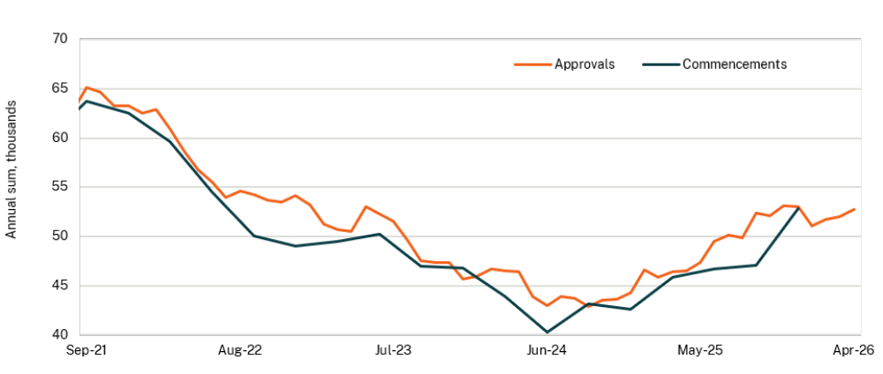
Source: ABS and NSW Treasury

Capacity pressures persist and inflationary pressures have emerged
The resilience of demand has been accompanied by ongoing capacity pressures, particularly in the labour market. Strong and sustained labour demand has underpinned solid employment growth, with NSW trend employment rising by 1.2 per cent over the year to April 2026 and trend total hours worked rising by 3.0 per cent. Despite this strength in labour demand, strong growth in the number of people in the labour force has led to the unemployment rate moving higher to 4.5 per cent. The unemployment rate, however, remains low by historical standards.
The underutilisation rate, which includes not only those people who are unemployed but also those who would like to work more hours than they currently do, was 9.9 per cent in April (Chart 2.2). This was broadly in line with its level of a year ago and below the average of the past decade of 11.8 per cent.
The preferred hours-based measure of the underutilisation rate, which measures the additional number of hours people are willing and able to work, was 5.3 per cent in February, which is well below the average recorded over the past 10 years of 6.2 per cent.
Inflationary pressures re-emerged in the second half of 2025, reflecting the pick-up in final demand against the backdrop of still tight supply capacity. The conflict in the Middle East and subsequent oil crisis has added further to inflation. Sydney retail petrol prices rose by over 30 per cent in the month of March. The Sydney consumer price index (CPI) increased by 4.2 per cent over the year to April 2026, from a low of 1.7 per cent over the year to June 2025.
- NSW unemployment and underutilisation rate | - Australia trimmed mean inflation
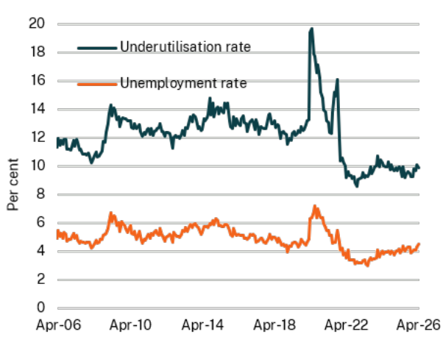 | 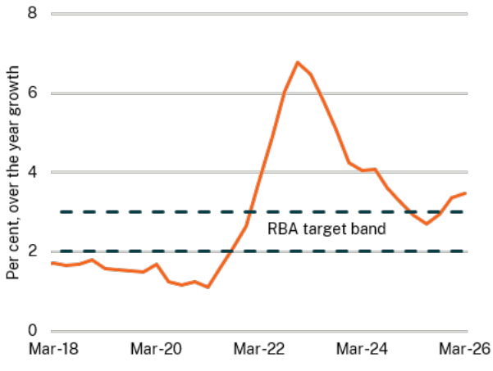
Source: ABS and NSW Treasury | Source: ABS, RBA and NSW Treasury

Monetary policy has tightened in response to the inflation outlook
The RBA’s preferred measure of underlying inflation, year-ended growth in the national quarterly trimmed mean CPI, rose to 3.5 per cent in the March quarter 2026 (Chart 2.3).
Monetary policy has responded to the increased inflation risk. The RBA’s Monetary Policy Board raised the cash rate in the first two meetings at the start of 2026. This was followed by a third 25 basis points rate rise in May, which returned the cash rate to the peak seen during the previous interest rate hiking cycle.

Dwelling prices are falling in response to interest rate increases
While the full effects of the increases in the cash rate will take some time to emerge, conditions in the housing market have weakened over the past six months or so. Dwelling prices in Sydney have fallen by 2.1 per cent since their peak in November 2025 (Chart 2.4). Falls in dwelling prices in Sydney have been particularly evident in higher-value segments of the market (Chart 2.5).
- Sydney daily dwelling prices | - Sydney dwelling price growth by price tier
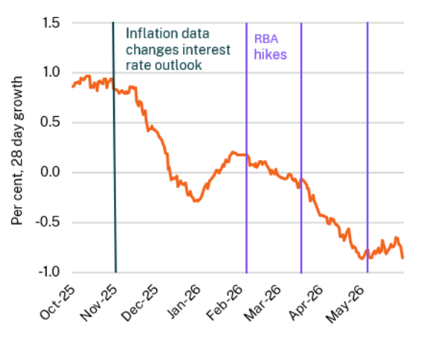 | 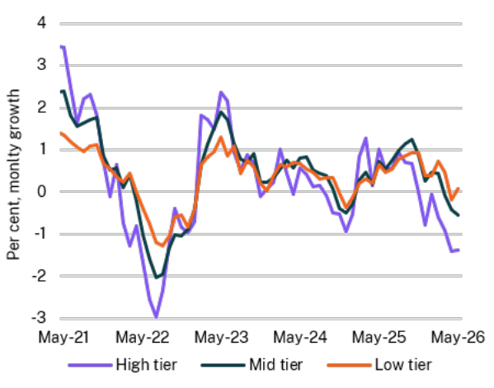
Source: Cotality and NSW Treasury | Source: Cotality and NSW Treasury

The Middle East conflict has added to inflation and weakened confidence
The conflict in the Middle East has been a material external shock to both the Australian and NSW economies. The most immediate impact of disruptions to crude oil supply has been on inflation, as the closure of the Strait of Hormuz has resulted in a sharp spike in fuel prices.
The combination of increased uncertainty, higher inflation and the expectation of tighter monetary policy has had a notable impact on consumer sentiment and business confidence.
Household spending on fuel purchases lifted sharply in March, then fell back in April following a temporary reduction in the fuel excise which eased some of the pressure on prices. Notwithstanding the cut to the excise rate, petrol prices in May 2026 were higher than a year ago. There are emerging signs that uncertainty arising from the conflict, alongside the rise in interest rates, is beginning to weigh on discretionary consumer spending.
- Outlook for the New South Wales economy

Developments in the Middle East will continue to affect the outlook
The closure of the Strait of Hormuz had a significant impact on global energy markets and has led to heightened uncertainty about the global and domestic outlook. While recent events indicate supply chain disruptions may be resolved, there is significant uncertainty about how long it will take for global oil supplies to return to their pre-conflict levels.
The economic forecasts underpinning the Budget have been informed by futures market prices for Brent crude oil prices as at the first week of May which suggested there would be an easing in the disruption to global oil supply in the second half of the year. These assumptions are outlined in more detail in Box 2.1.
Higher expected oil prices are a significant but temporary price shock to the economy. This increases inflation through both the direct effect of higher fuel prices and indirect effects resulting from higher fuel costs for businesses that are passed through to consumers over time. Inflation is expected to remain elevated through most of 2026.
- Energy price forecasts and their effect on inflation
The conflict in the Middle East has resulted in a severe shock to the global supply of oil, liquefied natural gas and other commodities such as fertiliser. Consequently, crude oil and fuel prices have increased sharply.
International benchmark prices of refined fuel – which accounted for around 40 per cent of the retail price of fuel in Australia prior to the war – have increased by even more than the price of crude oil since the start of the conflict. This has placed additional upward pressure on fuel prices in Australia, especially for diesel. Nevertheless, the temporary reduction in the fuel excise of 32 cents per litre has helped to ease some of the pressures on Australian fuel prices in the June quarter 2026.
Pricing in the futures market at the time of finalisation of the 2026-27 Budget forecasts suggested that crude oil and refined fuel prices would remain elevated in the near-term before easing later in 2026 (see Chart 2.6). Fuel prices in Australia were assumed to broadly follow this expectation after accounting for changes in the fuel excise, as well as wholesale and retail margins, and GST. Even in light of recent announcements, these assumptions are reasonable given that it is likely to take some months for trade and oil prices to normalise.
Sydney inflation is directly affected by higher automotive fuel prices for households, which is around 3 per cent of the Sydney CPI basket. There is also expected to be an indirect effect on Sydney inflation as higher costs borne by businesses are passed through the supply chain into the prices of other goods and services. For example, higher fuel prices are increasing the costs of transporting and producing goods while the cost of jet fuel is important for air travel prices. The disruption in oil supply has also affected chemical and plastics production, increasing costs for a range of goods such as construction materials and consumer goods packaging.
The combined effect of higher energy prices on Sydney headline inflation is expected to peak at a little under one percentage point in the September quarter 2026. This is primarily due to the direct effect which impacts inflation quickly, while the indirect effect continues to keep inflation elevated in the first half of 2027.
- Futures prices for crude oil and international refined fuel benchmarks at time of forecasting | - Petrol and diesel prices
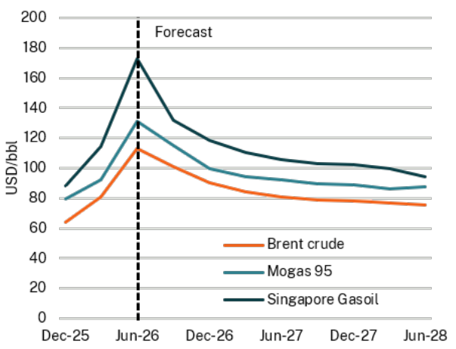 | 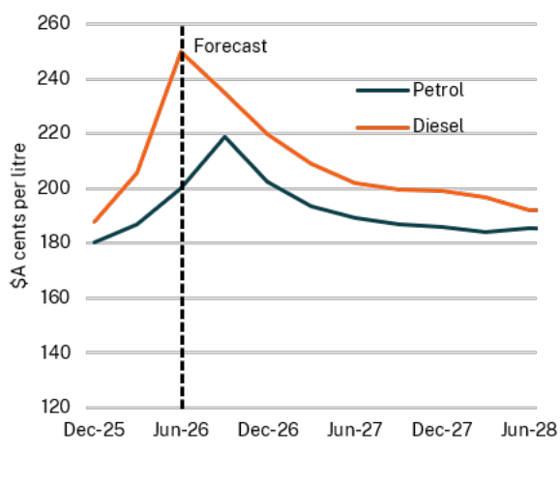
Source: Bloomberg and NSW Treasury | Source: Bloomberg and NSW Treasury

Higher interest rates will constrain economic growth
At the time of the Half-Yearly Review in late 2025, financial markets were anticipating further cuts to the cash rate in response to declining inflation pressures and a gradual easing of labour market conditions.
Since then, the outlook for interest rates has changed significantly (Chart 2.8), reflecting an unforeseen broad-based pick-up in inflationary pressures, followed by an escalation of the conflict in the Middle East.
Having already raised the cash rate by a cumulative 75 basis points in 2026, financial markets expected the RBA to raise the cash rate by a further 25 basis points in the September quarter 2026 at the time the Budget forecasts were finalised. This would take the cash rate to a peak of 4.6 per cent.
The higher path for the cash rate compared to expectations in late 2025 and elevated uncertainty arising from the conflict are expected to weigh on growth in demand over the course of the next two years. The NSW economy is forecast to grow by 1 per cent in both 2026-27 and 2027-28. This compares to expectations at the Half-Yearly Review for growth of 2½ per cent in 2026-27 and 2¼ per cent the following year (Chart 2.9).
- Financial market cash rate expectations | - NSW GSP growth forecasts
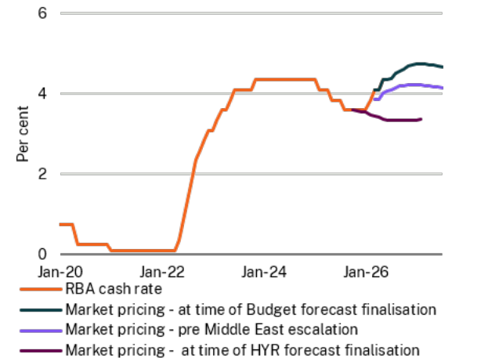 | 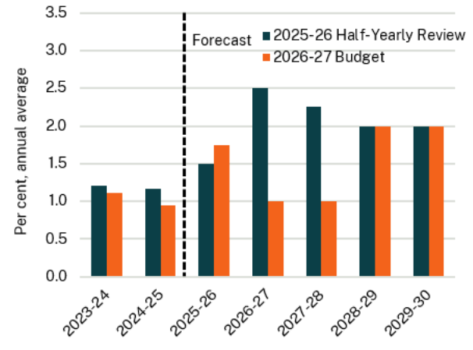
Source: RBA, Bloomberg and NSW Treasury | Source: ABS and NSW Treasury

Interest rates are impacting households
Forecasts for household consumption (Chart 2.10) and dwelling investment have been most impacted by higher interest rates.
Dwelling investment is particularly sensitive to changes in interest rates, as rising rates simultaneously reduce the purchasing power of prospective home buyers while also raising the costs for businesses in developing housing projects.
Dwelling investment is forecast to have grown solidly in the 2025-26 financial year, supported by the cuts to interest rates in 2025. The rise in interest rates since the start of 2026 is expected to lower the pace of growth in dwelling investment. This slowing is expected to be relatively modest by historical standards, given the strong pipeline of dwelling construction in the near-term, partly the result of a range of recent planning reforms to support feasibility.

Ongoing strength in business investment, notably for data centres and renewable energy investment, is expected to partially offset downside impacts on dwelling investment and household consumption growth. The pipeline of electricity projects, including renewable energy projects, continues to grow and is particularly strong in New South Wales. The value of private electricity generation, transmission and pipeline work still under construction was 67.0 per cent higher in the December quarter 2025 compared to a year earlier (Chart 2.11). A large proportion of this increase is due to the commencement of the NSW Government’s Renewable Energy Zones. Investment is expected to continue to grow over the forecast horizon from elevated levels.
- Household income and consumption forecasts | - Value of private electricity project construction work yet to be done, NSW
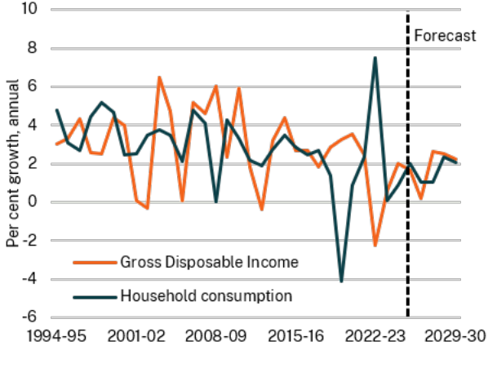 | 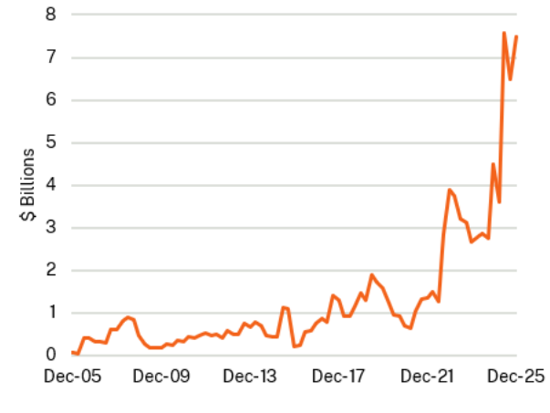
Source: ABS and NSW Treasury | Source: ABS and NSW Treasury

New South Wales is particularly sensitive to interest rate movements
- The expected weakening in economic growth due to higher interest rates is greater in New South Wales than in the rest of Australia. The sensitivity arises from the higher level of house prices and the resulting larger mortgage payment burden relative to income for New South Wales households, which amplifies the effects of higher interest rates on disposable incomes, consumption, and housing market conditions.
- For example, in the March quarter 2026, the average new housing loan for owner occupiers in New South Wales was $860,000 (Chart 2.12). This is 28 per cent more than the equivalent in Victoria. This is despite the fact that average weekly ordinary time earnings of full-time adult workers in New South Wales are only around 3.5 per cent higher than in Victoria.
The NSW economy is expected to respond similarly to the recent increase in interest rates as it did to the last interest rate cycle when the cash rate target peaked at 4.35 per cent. In 2023-24, in response to the significant increase in interest rates recorded since May 2022, New South Wales household consumption grew by just 0.1 per cent compared to growth across the whole of Australia of 1.0 per cent.

- Average new owner occupier housing loan size by state
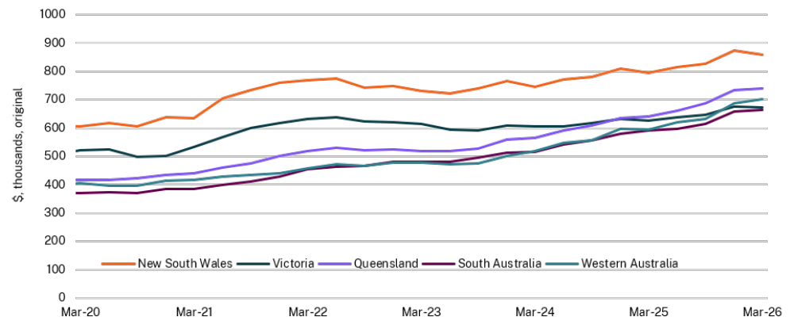
Source: ABS and NSW Treasury

Labour market conditions to gradually ease
Labour market conditions in New South Wales are expected to ease gradually as economic growth slows. The adjustment in the labour market is expected to occur primarily through reductions in average hours worked rather than a significant increase in the unemployment rate.
Employment growth is expected to slow, and the unemployment rate is forecast to rise modestly to around 4¾ per cent by the June quarter 2028. The hours-based underutilisation rate is expected to rise to around 6 per cent, slightly below its average of the last decade.
From late 2028, as growth begins to recover, the unemployment rate is expected to decline gradually to around 4½ per cent by 2028-29 (Chart 2.13).

Inflation expected to come down from elevated levels
Inflation is forecast to ease from early 2027 once the effects of the higher fuel prices begin to fade (Chart 2.14). The impact of elevated interest rates in slowing demand and reducing capacity pressures in the economy is forecast to result in inflation returning to the RBA’s inflation target of 2.5 per cent by the end of 2027.
As interest rates begin to normalise and falling inflation supports an improvement in real household income, economic activity is expected to recover, led by a pick-up in consumer spending.
Wage growth is forecast to remain strong in the near-term, reflecting the current tightness in the labour market and expected increases in award wages.

- NSW unemployment rate forecasts | - Sydney CPI growth forecasts
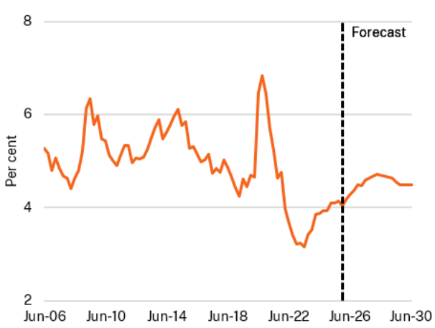 | 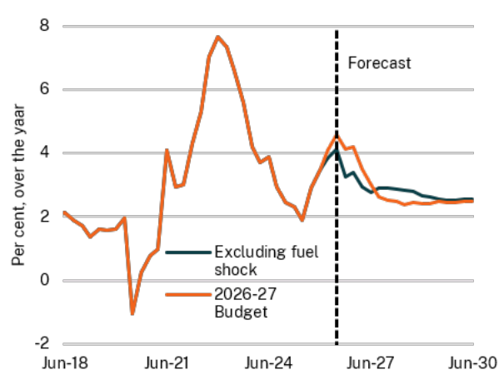
Source: ABS and NSW Treasury | Source: ABS and NSW Treasury
- Productivity as a driver of growth and living standards

Unlocking productivity growth is vital as the NSW economy evolves
In the medium term, economic growth and improvements in living standards depend on productivity growth.
NSW labour productivity growth averaged 1.8 per cent over the 1990s, but has gradually declined since then, averaging 0.8 per cent over the past 20 years. This is consistent with trends across advanced economies and reflects a mix of factors, including a slowdown in the rate of capital deepening per worker, slower diffusion of technology between firms, a less dynamic business environment, tighter financial constraints, a decline in competitive pressures and a shift towards service industries with slower productivity growth.
Important government initiatives to lift productivity growth include significant ongoing investment in infrastructure and the establishment of the Investment Delivery Authority, which promotes a more supportive investment environment. Further reforms include planning reforms to increase construction feasibility, reforms to workers’ compensation, which keep people engaged in the workforce and potential reform of the Emergency Services Levy, which could improve the efficiency of the State’s tax system.

- Inflation and interest rates have uneven effects across households

The effects of recent increases in inflation and interest rates are not uniform between households, because households in different circumstances have different living expenses and exposure to mortgages.
Historically, periods of rising interest rates have disproportionately increased living expenses for households with mortgages, but the impact varies across households.
- Households with new mortgages and limited savings buffers have relatively less capacity to absorb higher mortgage costs. Younger mortgage holders are significantly more likely to spend more than 30 per cent of their post-tax income on housing costs (mortgage and rates payments).
- Households with older mortgages are generally better able to manage increases, often due to larger offset or redraw balances.
- Households without a mortgage, including those that own their home outright, experience few negative impacts from rising interest rates and those with large savings balances may benefit from higher interest income.
Living Cost Indexes (LCI) are measures of purchasing power across different household types that, unlike CPI, include mortgage interest costs. LCI data show that employee households, which are more likely to have a mortgage, are the most sensitive to interest rate increases (Chart 2.15).
- Mortgage interest charges for employee households, Australia
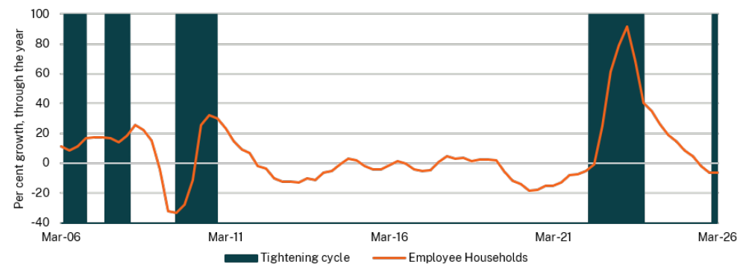
Source: ABS, RBA, and NSW Treasury

- Key risks to the outlook

Geopolitical uncertainty remains elevated
The situation in the Middle East remains a major source of ongoing risk. The closure of the Strait of Hormuz has had a dramatic impact on global energy markets. The baseline forecast assumes global oil supply will return to pre-conflict levels as the year progresses, but there is still a risk of renewed conflict, which would see a further escalation of oil prices and potential oil shortages in the global economy. The potential outcomes of a situation like this are explored in Appendix F Economic scenario analysis.

Apart from the Middle East conflict, risks centre around inflation and the response of monetary policy to bring inflation back to the RBA’s target. Should inflation prove to be more persistent than expected, the RBA may feel compelled to either increase interest rates further or maintain them at their expected peak of 4.6 per cent for longer than the baseline forecasts assume. This would weigh on economic growth and employment outcomes.
There is also a risk that interest rates constrain dwelling prices and activity by more than expected in the current uncertain environment. The previous cycle in interest rates over 2022 to 2023 was associated with a larger decline in dwelling prices than is currently forecast. At the same time, per capita household consumption is not currently expected to decline this cycle, in contrast to falls seen in both 2023-24 and 2024-25.

Fiscal strategy and outlook
- The State’s fiscal context has changed since the 2025-26 Half-Yearly Review. The Reserve Bank of Australia has increased interest rates three times due to re-emerging inflationary pressures. This has placed pressure on the Budget through a combination of higher interest expenses and pressure on some State revenues (e.g. lower projected transfer duty and land tax revenue).
- The 2026-27 Budget continues the improvement in the State’s operating position with the budget deficit of $10.6 billion in 2022-23 reducing to a deficit of $3.0 billion in 2025-26. New South Wales is not immune from global economic and fiscal headwinds which have increased short-term pressure on the budget result, with a deficit of $2.3 billion now projected in 2026-27.
- Despite short-term pressures from global headwinds and new measures to support families, the NSW Government has continued to improve the operating position and remains on track for a return to surplus in 2027-28. The budget result is projected to improve to a surplus of $1.1 billion by 2027-28, with surpluses projected for 2028-29 ($1.8 billion) and 2029-30 ($1.9 billion).
- The Government remains committed to keeping expense growth in check while investing in the delivery of essential services and infrastructure for the future. Expense growth, which averaged 9.7 per cent per annum between 2018-19 and 2022-23, was down to 1.8 per cent in 2024-25.
- The NSW Government is also seeking to stabilise the State’s gross debt levels. Gross debt is projected to be $178.5 billion by June 2026, which is $9.7 billion lower than the 2023 Pre-election Budget Update projection of $188.2 billion. This is saving the State approximately $400.0 million per annum in interest expenses.
- The 2026-27 Budget further details the Government’s commitment to financial management with:
- gross debt projected to stabilise at around 20 per cent of gross state product over the four years to June 2030, helping take pressure off the State’s interest expenses
- the cash operating position projected to grow from a surplus of $6.1 billion in 2025-26 to $11.4 billion in 2029-30. This is supporting the sustainability of the State’s infrastructure program with debt funding of the infrastructure program reducing from 83 per cent in the 2022-23 Budget to 53 per cent in this Budget, without resorting to increasing costs for households through privatisation
- the State’s infrastructure program is being maintained at sustainable levels of around 2 per cent of gross state product.
\

- Returning to surplus while rebuilding essential services
Since the 2025-26 Half-Yearly Review, the State’s fiscal outlook has been impacted by heightened levels of uncertainty and volatility including three interest rate rises as well as high global oil prices and supply chain disruptions triggered by the Middle East conflict. The Government remains committed to managing the State’s finances through the cycle to support the essential public services that the people of New South Wales rely upon.
The NSW Government inherited a significant budget deficit when coming into office in 2023. Through a strong commitment to keeping expense growth low by redirecting expenditure to essential services and priorities, the Government has been able to reduce the deficit from $10.6 billion in 2022-23 to a projected deficit of $3.0 billion in 2025-26.
During this period of heightened economic uncertainty, the Government is balancing its support for households and budget repair. The State is projected to return to surplus in 2027-28 and remain in surplus in 2028-29 and 2029-30 as the Government rebuilds fiscal buffers.
The NSW Government has also focused on rebuilding the State’s cash operating position from a deficit of $0.2 billion in 2022-23 to a projected $6.1 billion surplus in 2025-26. Over the forward estimates, the general government net cash operating position is projected to improve to $11.4 billion by 2029-30.
The Government’s strong financial management has laid the foundation for short-term relief measures that can be provided to households in this Budget (without adding to ongoing cost pressures over the long-term), while continuing to invest in essential public services and infrastructure to meet the future needs of the community. Relief and investments in this Budget include:
- short-term cost-of-living relief, combined with investment to improve the longer-term reliability and security of Australia’s energy supply
- $561 million to provide 12 months of relief through the Transport Affordability Package, including $100 off motor vehicle registration for private cars and $80 for motorcycle (trailers and caravans excluded), a $50 toll cap for 12 months and freezing Opal fares at 2025 prices
- investments to strengthen access to healthcare by growing the health workforce, expanding hospital capacity, and supporting increased demand for services across the State ($10.3 billion over four years to 2029-30)
- investing in safe and secure communities, including a 50 per cent increase in frontline domestic, family and sexual violence services to support victim-survivors
- investing in the essential infrastructure to maintain our hospitals and rail network
- support for jobs and manufacturing through new electric buses, the low emissions manufacturing grants and new upgrades to the Rural Fire Service ‘red fleet’
- supporting $77 billion of private investment in renewable energy, creating more than 11,000 regional jobs in construction and operation
- funding for the commencement of the Australian Government’s Thriving Kids early intervention supports for children aged 8 and under with developmental delay and/or autism (NSW contribution of $631.9 million towards a $1.1 billion package over five years to 2030-31, co-funded with the Australian Government).
The State continues to face significant pressures on expenses largely driven by interest expenses as the Government refinances debt incurred during COVID-19 and the deficits in the years that followed (see Box 3.1).

- Managing expense growth through the cycle
Between 2011-12 and 2021-22, expenses grew at an average rate of 7.4 per cent per year. Over the past year, the Government has been able to maintain expense growth at 1.8 per cent, while continuing to deliver essential services to the community.
Expense growth is projected to rise temporarily to 5.4 per cent in 2025-26 as the Government prioritises immediate support for households in the short term, before tightening expense growth over the four years to 2029-30 (see Chart 3.1).
Over the last three years New South Wales has delivered the lowest expense growth of any Australian government at an average 3.6 per cent a year, less than half the average 8.3 per cent a year recorded by Australia’s other eight governments. This also compares to 9.7 per cent average annual expense growth in New South Wales between 2018-19 and 2022-23.
The Australian Government has prepaid forecast reimbursements for natural disasters that occurred as far back as 2020-21. This has helped improve the cash position of the NSW Government in 2025-26.
Timing adjustments to Commonwealth grants payments for natural disasters have temporarily increased revenue in 2025-26 and an acceleration of funding for Sydney Trains has temporarily increased expenses in 2025-26. While this will have a limited impact on borrowings, these movements will impact revenue and expense growth rates in 2025-26.
Over the forward estimates expense growth is expected to average around 2.7 per cent. This is possible due to the Government’s disciplined approach to fiscal management and delivery of strategic reforms over the past three years.
- NSW annual expense growth
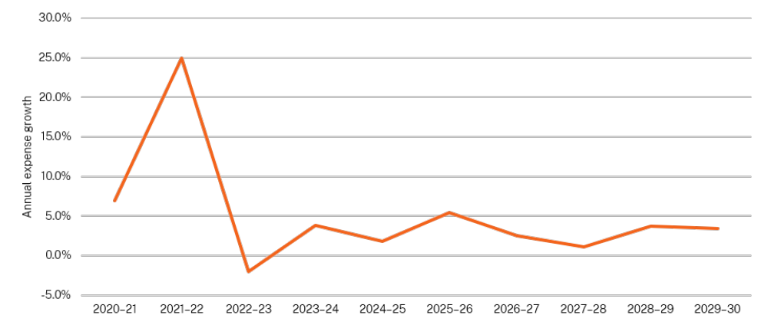
Source: NSW Treasury

For more information on the variation in the budget result from the 2025-26 Budget and 2025-26 Half-Yearly Review see Table 3.1 below.
- Reconciliation of 2025-26 Budget to 2026-27 Budget^{(a)}
 | 2025-26 | 2026-27 | 2027-28 | 2028-29 | 2029-30
 | Revised | Budget | Forward Estimates
 | $m | $m | $m | $m | $m
Budget result: 2025-26 Budget | (3,427) | (1,148) | 1,132 | 1,058 | n.a
Changes from the 2025-26 Budget to 2025-26 Half-Yearly Review
Revenues | 1,713 | 1,476 | 953 | 484 | n.a
Expenses | 1,434 | 1,454 | 737 | 387 | n.a
Total budget result impact | 280 | 22 | 216 | 97 | n.a
Budget result: 2025-26 Half-Yearly Review | (3,147) | (1,126) | 1,348 | 1,155 | n.a
Changes from the 2025-26 Half-Yearly Review to 2026-27 Budget
Revenues | 852 | 1,173 | 1,424 | 3,606 | n.a
Expenses | 754 | 2,392 | 1,661 | 3,000 | n.a
Total budget result impact | 98 | (1219) | (237) | 605 | n.a
Budget result: 2026-27 Budget | (3,049) | (2,345) | 1,110 | 1,760 | 1,879
- Positive amounts reflect an increase in revenue or an increase in expenses.
- Keeping the State’s debt in check
This Budget continues to stabilise gross debt at around 20 per cent of gross state product (GSP), while investing in essential services and infrastructure.
Gross debt is projected to be $178.5 billion by June 2026. The 2026-27 Budget projection for gross debt for June 2026 is $9.7 billion lower than the Pre-election Budget Update projection of $188.2 billion (equivalent to around $1,116.7 per person in New South Wales or around 1.1 per cent of GSP). This is estimated to save the State approximately $400.0 million per annum in interest expenses, which is especially important as New South Wales is facing the highest interest expenses in the State’s history.

- Keeping the State’s debt in check
To help stabilise the State’s gross debt at around 20 per cent of GSP over the four years to June 2030 (see Chart 3.2), the NSW Government is focused on managing expenses, increasing cash operating surpluses to reduce the reliance on borrowings and maintain a large infrastructure program that can be sustainably delivered without privatisation.
The State’s cash operating position is projected to grow from a surplus of $722.9 million in 2023-24 to $11.4 billion in 2029-30. This improvement means the State is less reliant on borrowings to fund its infrastructure program. Debt-funding of the State’s infrastructure program has reduced from 83 per cent of debt in the 2022-23 Budget to 53 per cent in this Budget.
A strong net cash operating position means that the State can reduce its reliance on borrowings to fund infrastructure while aiming to maintain the State’s infrastructure program at a sustainable level of around 2 per cent of GSP.
- NSW’s gross debt from June 2021 to June 2030
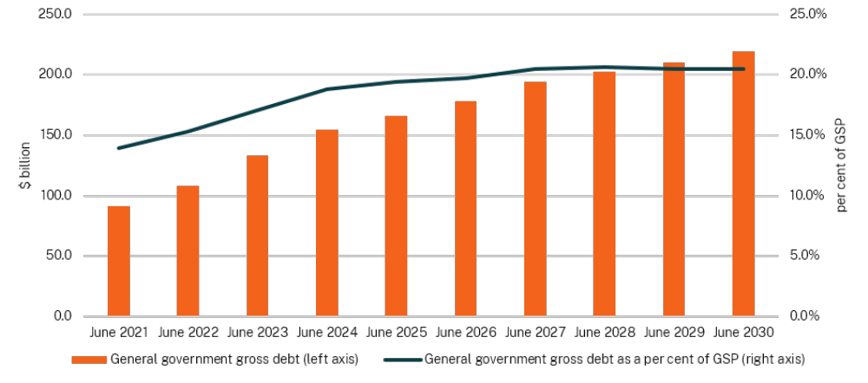
Source: NSW Treasury

- Efficiently managing the State’s cash flows
The NSW Government is managing the State’s cash operating position to enable continued investment in critical infrastructure and take pressure off the State’s borrowing requirements.
Over the four years to 2029-30, the net cash operating position is projected to improve from $5.5 billion in 2026-27 to $11.4 billion in 2029-30. This is primarily due to the Government’s careful management of cash payments by keeping expense growth low across the forward estimates.
The NSW Government will generate $38.3 billion of net operating cash surplus over the next four years. By maintaining a strong cash operating surplus, the Government can continue to invest in infrastructure while reducing our reliance on debt and reducing interest payments. This allows for critical investment in essential infrastructure without the need for privatisation. Debt will now be used to fund just 53 per cent of general government infrastructure investment in this Budget, down from 83 per cent in the 2022-23 Budget.

- Delivering the Government’s essential infrastructure plan
The 2026-27 Budget provides $116.7 billion in infrastructure investment over four years to 2029-30, with investment prioritised to improving access to better services, particularly in education, health and transport as well as securing the energy future of New South Wales by delivering the energy transition.
The State’s infrastructure program funding is comprised of state investment, public non-financial corporation own source revenue, and Australian Government grants. The majority of state investment is through borrowings, with around 53 per cent of the general government infrastructure program projected to be funded by borrowings between 2025-26 and 2029-30. This Budget sees the Government maintaining its commitment to not privatise major assets to fund its infrastructure program, noting the Budget does not include any revenue associated with the Bays West Precinct, with any revenue expected to offset corresponding expenses.
See Table 3.2 for changes in the general government infrastructure program since the Half-Yearly Review. For more detailed analysis of the Government’s infrastructure program, see Budget Paper No. 3 Infrastructure Statement.
- General government infrastructure investment reconciliation
 |  | 2025-26 | 2026-27 | 2027-28 | 2028-29 | 2029-30
 |  | Revised | Budget | Forward Estimates
 |  | $m | $m | $m | $m | $m
Capital – 2025-26 Half-Yearly Review |  | 20,549 | 20,579 | 20,587 | 20,443 | n.a
Capital measures |  | 68 | 2,712 | 1,248 | 2,518 | n.a
Parameter and other variations |  | 2,307 | (1,416) | (493) | (1,924) | n.a
Capital – 2026-27 Budget |  | 22,924 | 21,876 | 21,342 | 21,037 | 20,590
n.a = not available

Revenue
- Taxation revenue has been revised down by $192.1 million in 2025-26 and $7.1 billion over the four years to 2029-30. A weaker outlook for the property market following a material shift in the cash rate since the 2025-26 Half-Yearly Review has placed significant downward pressure on property prices and transaction volumes. As a result, transfer duty and land tax have been revised down by $8.4 billion over the four years to 2029-30.
- Revenue from other dividends and distributions has been revised up by $5.3 billion over the four years to 2029-30, largely driven by investment fund distributions supported by the successful implementation of the OneFund strategy through 2025-26.
- The NSW GST relativity will fall in 2026-27 following the Commonwealth Grants Commission’s 2026 Update driven by changes to the relativity methodology agreed as part of the 2018 GST distribution reforms. However, forecast increases in the national GST pool, and an expected recovery in the NSW relativity from 2027-28 onwards, is expected to result in an overall upward revision to GST revenue of $346.0 million in 2025-26 and $5.6 billion over the four years to 2029-30, offsetting some of the decline in taxation revenues.
- In January 2026, states and territories secured a Health and Disability deal following negotiations with the Australian Government. The new National Health Reform Agreement (NHRA) Addendum includes a guaranteed level of additional funding for hospital activity. As part of the Disability Agreement, state and territory National Disability Insurance Scheme (NDIS) contributions will be adjusted to be in line with actual scheme growth, capped at 8 per cent, from 1 July 2028. New South Wales will also commence delivery of the Commonwealth’s Thriving Kids program from October 2026, which will be jointly funded with the Australian Government.
- Payments to New South Wales from the Australian Government excluding general purpose grants have increased by $4.7 billion over the four years to 2029-30 due primarily to the new NHRA Addendum and implementation of the new agreement on Foundational Supports.
- Revenue
General government sector revenue is projected to be $126.7 billion in 2025-26. This is $851.8 million higher than forecast at the 2025-26 Half-Yearly Review. This revision is largely due to the timing of Disaster Recovery Funding Arrangement payments from the Australian Government, including prepayment of essential asset reconstruction works. Total revenue is expected to grow at an average annual rate of 3.6 per cent over the four years to 2029-30.

- General government sector – summary of revenue and its components
 | 2024-25 | 2025-26 | 2026-27 | 2027-28 | 2028-29 | 2029-30 | % Average growth p.a. 2025-26 to 2029-30
 | Actual | Revised | Budget | Forward Estimates |  |  | % Average growth p.a. 2025-26 to 2029-30
 | $m | $m | $m | $m | $m | $m | % Average growth p.a. 2025-26 to 2029-30
Revenue from transactions
Taxation | 48,206 | 51,776 | 52,149 | 55,592 | 58,619 | 60,700 | 4.1
Grant revenue (including GST) | 46,940 | 52,156 | 52,822 | 53,325 | 55,909 | 58,303 | 2.8
Sale of goods and services | 10,379 | 10,859 | 11,676 | 11,996 | 12,831 | 12,770 | 4.1
Interest income | 810 | 531 | 646 | 638 | 642 | 659 | 5.6
Dividends and income tax equivalents from other sectors | 650 | 1,004 | 1,046 | 1,069 | 1,184 | 1,199 | 4.5
Other dividends and distributions | 4,219 | 3,633 | 5,018 | 5,265 | 4,873 | 5,163 | 9.2
Royalties | 3,215 | 3,234 | 3,432 | 3,212 | 3,183 | 3,052 | (1.4)
Fines, regulatory fees and other revenues | 3,591 | 3,526 | 3,898 | 4,511 | 3,984 | 4,276 | 4.9
Total revenue | 118,009 | 126,719 | 130,687 | 135,609 | 141,225 | 146,122 | 3.6
Annual change | 7.1% | 7.4% | 3.1% | 3.8% | 4.1% | 3.5%

Over the four years to 2029-30, forecast revenue is expected to be $10.9 billion higher than at the 2025-26 Half-Yearly Review.
Main drivers of this revision are:
- $5.3 billion increase in revenue from other dividends and distributions associated with investment fund distributions and an uplift in returns from OneFund
- increases in other revenues associated with the recognition of NSW Rural Fire Service fleet assets transferred from local councils
- a larger forecast national GST pool and a higher forecast of New South Wales’ share in the later years, reflecting relatively strong property market conditions and higher mining revenues in Queensland and Western Australia
- increases in funding from the Australian Government under the new National Health Reform Agreement Addendum.
These revisions are partially offset by:
- lower transfer duty and land tax revenue reflecting a weaker outlook for the property market following a material shift in the cash rate pathway since the 2025-26 Half-Yearly Review.
The outlook for the property market remains a downside risk for the 2026-27 Budget. Higher residential property prices and corresponding household debt levels compared to any other Australian state or territory, exposes the NSW property market to greater sensitivity to changes in interest rates.

- Revenue reconciliation
 | 2025-26 | 2026-27 | 2027-28 | 2028-29 | 2029-30 | Four years
 | Revised | Budget | Forward Estimates |  |  | to 2029-30
 | $m | $m | $m | $m | $m | $m
Revenue – 2025-26 Half-Yearly Review | 125,868 | 129,514 | 134,185 | 137,619 | 141,429 | 542,747
Policy changes since 2025-26 Half-Yearly Review
Taxation | (48) | (264) | 286 | 389 | 141 | 552
Grant revenue | 238 | 827 | 1,040 | 1,298 | 1,387 | 4,551
Sale of goods and services | 4 | 76 | 47 | 125 | 102 | 349
Other dividends and distributions | ... | (3) | (3) | (3) | (4) | (13)
Fines, regulatory fees and other revenues | 51 | 51 | 602 | 18 | 16 | 687
Total policy measures | 245 | 687 | 1,971 | 1,827 | 1,642 | 6,127
Parameter changes since 2025-26 Half-Yearly Review
Taxation
Transfer duty | 187 | (2,346) | (1,420) | (767) | (873) | (5,406)
Insurance duty | (43) | (41) | (42) | (44) | (46) | (173)
Motor vehicle stamp duty | (50) | (105) | (93) | (49) | (35) | (282)
Payroll tax | 317 | 303 | 217 | 224 | 199 | 943
Land tax | (362) | (540) | (848) | (1,035) | (1,108) | (3,532)
Taxes on motor vehicles | (0) | 5 | 31 | 57 | 70 | 163
Gambling and betting taxes | 86 | 141 | 149 | 164 | 180 | 634
Other taxes | (280) | (17) | 19 | 7 | (21) | (11)
Grant revenue
GST revenue | 346 | 500 | 770 | 1,569 | 2,714 | 5,553
National Agreement payments | 27 | 11 | (26) | (57) | 240 | 168
Federation Funding Agreement payments | 909 | 740 | (1,559) | (139) | 877 | (82)
Other grant revenue | 6 | 24 | (17) | 51 | 3 | 61
Sale of goods and services | (293) | 52 | 263 | 499 | (177) | 636
Interest income | (70) | 43 | 46 | 49 | 91 | 229
Dividends and income tax equivalents | 2 | 3 | 92 | 114 | 5 | 214
Other dividends and distributions | (211) | 1,700 | 1,760 | 1,075 | 774 | 5,309
Royalties | 84 | 186 | (8) | (19) | 21 | 180
Fines, regulatory fees and other revenues | (49) | (171) | 119 | 81 | 136 | 165
Total parameter changes and other variations | 607 | 486 | (548) | 1,779 | 3,051 | 4,768
Total changes since 2025-26 Half-Yearly Review | 852 | 1,173 | 1,424 | 3,606 | 4,693 | 10,895
Revenue – 2026-27 Budget | 126,719 | 130,687 | 135,609 | 141,225 | 146,122 | 553,643
- Revenue measures since the 2025-26 Half-Yearly Review
New revenue measures since the 2025-26 Half-Yearly Review are forecast to improve revenue by $250.2 million over the four years to 2029-30.
Expenditure and capital decisions (with an indirect impact on revenue) are forecast to have a net positive impact on revenue of $5.9 billion over the four years to 2029-30. This is primarily due to decisions relating to Australian Government payments.
Key revenue decisions since the 2025-26 Half-Yearly Review are set out below.

Private motor vehicle registration discount
As part of the Government’s cost-of-living package, eligible motorists will receive a $100 discount on private vehicle registration for one year ($80 discount on registration for motorcycles). The discount will be deducted from the total fee displayed on registration notices issued for eligible vehicles. This measure is estimated to reduce revenue by $435.1 million.

Maintain Revenue NSW tax integrity program at existing levels
Revenue NSW’s tax integrity program is continuing at current levels, supporting a fair and equitable tax system by ensuring all taxpayers meet their obligations. This is estimated to ensure $696.0 million of tax owed is collected over the four years to 2029-30, which reflects maintaining prior years’ activity and compliance levels.
- Policy measures
 |  |  |  |  | Four years
 | 2026-27 | 2027-28 | 2028-29 | 2029-30 | to 2029-30
 | $m | $m | $m | $m | $m
Revenue measures
Maintain NSW tax integrity program | 154 | 184 | 214 | 144 | 696
Private motor vehicle registration discount | (435) | … | … | … | (435)
Surcharge purchaser duty relief for certain retirement village developers and operators | (3) | (4) | (4) | (4) | (15)
Surcharge purchaser duty relief for operational build-to-rent properties | 0 | 0 | 0 | 0 | 0
Additional assurance activities on wagering and gaming operators | 5 | … | … | … | 5
Total revenue measures | (280) | 180 | 210 | 140 | 250
Revenue related to expense, capital and other measures | 967 | 1,791 | 1,617 | 1,502 | 5,877
Total policy measures | 687 | 1,971 | 1,827 | 1,642 | 6,127
- Taxation revenue
Taxation revenue is expected to be $51.8 billion in 2025-26 which is $192.1 million lower than forecast at the 2025-26 Half-Yearly Review. The downgrade is largely driven by lower-than-expected land tax collections.
Over the four years to 2029-30, taxation revenue has been revised down by $7.1 billion. The downgrade is mostly due to a weaker outlook for the property market, resulting in a lower forecast for transfer duty and land tax.

- General government sector – summary of taxation revenue
 | 2024-25 | 2025-26 | 2026-27 | 2027-28 | 2028-29 | 2029-30 | % Average growth p.a. 2025-26 to 2029-30
 | Actual | Revised | Budget | Forward Estimates |  |  | % Average growth p.a. 2025-26 to 2029-30
 | $m | $m | $m | $m | $m | $m | % Average growth p.a. 2025-26 to 2029-30
Stamp duties
Transfer duty | 12,224 | 14,263 | 12,598 | 13,604 | 14,802 | 15,164 | 1.5
Insurance | 1,694 | 1,747 | 1,860 | 1,970 | 2,085 | 2,207 | 6.0
Motor vehicles | 1,180 | 1,190 | 1,198 | 1,266 | 1,355 | 1,421 | 4.5
Other | (1) | (1) | 0 | 0 | 0 | 0 | …
 | 15,097 | 17,199 | 15,656 | 16,840 | 18,242 | 18,792 | 2.2
Payroll tax | 13,368 | 14,184 | 14,945 | 15,782 | 16,623 | 17,470 | 5.3
Taxes on land
Land tax | 8,270 | 8,462 | 8,969 | 9,225 | 9,483 | 9,762 | 3.6
Property tax | 14 | 14 | 13 | 12 | 10 | 9 | (10.8)
 | 8,284 | 8,476 | 8,982 | 9,237 | 9,493 | 9,771 | 3.6
Taxes on motor vehicle
ownership and operation
Weight tax | 3,270 | 3,486 | 3,248 | 3,915 | 4,132 | 4,339 | 5.6
Vehicle transfer fees | 63 | 67 | 70 | 74 | 77 | 79 | 4.2
Road user charge | … | … | … | 64 | 140 | 236 | …
Other motor vehicle taxes | 56 | 58 | 61 | 65 | 68 | 71 | 5.0
 | 3,389 | 3,612 | 3,379 | 4,118 | 4,417 | 4,725 | 6.9
Gambling and betting taxes
Wagering | 62 | 61 | 64 | 66 | 67 | 68 | 2.6
Point of consumption tax | 300 | 298 | 313 | 325 | 340 | 356 | 4.5
Club gaming devices | 1,032 | 1,122 | 1,155 | 1,185 | 1,219 | 1,254 | 2.8
Hotel gaming devices | 1,473 | 1,633 | 1,769 | 1,898 | 2,037 | 2,184 | 7.5
Lotteries and lotto | 567 | 553 | 601 | 619 | 636 | 654 | 4.3
Casino | 224 | 161 | 167 | 166 | 175 | 185 | 3.4
Other gambling & betting | 20 | 18 | 18 | 19 | 20 | 20 | 3.5
 | 3,679 | 3,847 | 4,087 | 4,278 | 4,494 | 4,721 | 5.3
Other taxes and levies
Health insurance levy | 210 | 228 | 276 | 290 | 302 | 315 | 8.4
Parking space levy | 124 | 136 | 131 | 136 | 140 | 143 | 1.3
Emergency services levy contributions | 1,318 | 1,396 | 1,512 | 1,665 | 1,629 | 1,456 | 1.1
Emergency services council contributions | 221 | 239 | 264 | 259 | 231 | 237 | (0.2)
Waste and environment levies | 877 | 899 | 998 | 998 | 998 | 998 | 2.6
Government guarantee fee | 373 | 368 | 384 | 427 | 484 | 542 | 10.2
Passenger services levy | 104 | 99 | 100 | 100 | 72 | … | (100.0)
Pollution control licences | 16 | 20 | 18 | 18 | 18 | 18 | (3.1)
Other taxes | 1,147 | 1,073 | 1,416 | 1,446 | 1,477 | 1,513 | 9.0
 | 4,390 | 4,458 | 5,100 | 5,338 | 5,350 | 5,221 | 4.0
Total taxation revenue | 48,206 | 51,776 | 52,149 | 55,592 | 58,619 | 60,700 | 4.1
Annual change | 8.1% | 7.4% | 0.7% | 6.6% | 5.4% | 3.6%

Payroll tax
Since the 2025-26 Half-Yearly Review, payroll tax revenue has been revised up by $317.2 million in 2025-26 and by $942.9 million over the four years to 2029-30. Payroll tax revenue is being supported by stronger-than-expected growth in both employment and the average compensation of employees. Over the forward estimates period, dampening business sentiment in response to higher interest rates and uncertainty associated with tensions in the Middle East is expected to put downward pressure on growth in payroll tax revenue.

Transfer duty
Over the four years to 2029-30, transfer duty revenue has been revised down by $5.3 billion since the 2025-26 Half-Yearly Review. This reflects a weaker outlook for the property market following a material shift in the cash rate since the 2025-26 Half-Yearly Review, driven by stronger-than-expected inflation. This has dampened sentiment and placed downward pressure on property prices and transaction volumes (see Chart 4.1 and 4.2). The property market is expected to recover from the second half of 2027 following an easing in monetary policy.
- Residential property transactions per 1,000 people (seasonally adjusted; quarterly) | - Sydney hedonic dwelling price index (quarterly)
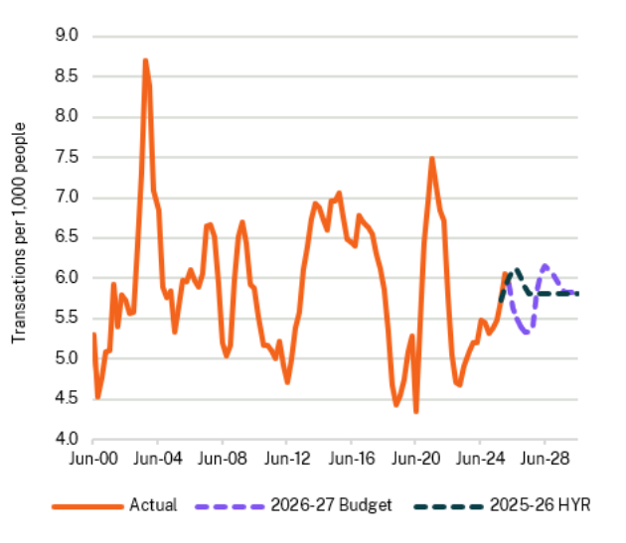  Source: NSW Treasury | 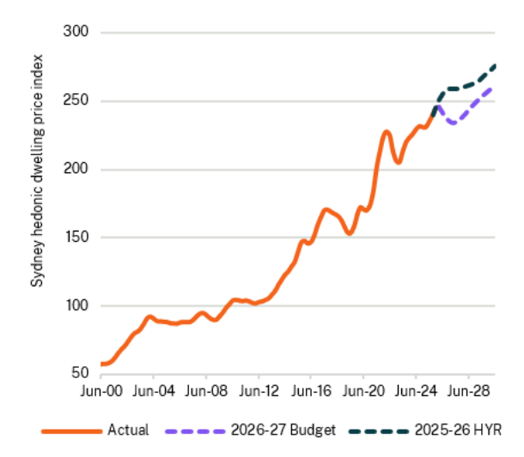  Source: Cotality, NSW Treasury

Given the sensitivity of residential housing transaction volumes and prices to the cash rate, uncertainty about future inflationary pressures and monetary policy decisions remain a risk for the outlook.
Despite weakness in the property market, transfer duty has been revised up by $187.0 million in 2025-26 due to a number of large commercial transactions.

Land tax
Land tax revenue has been revised down by $361.9 million in 2025-26 and $3.1 billion over the four years to 2029-30, partly as a result of the weaker outlook for property price growth since the 2025-26 Half-Yearly Review in response to higher interest rates. The downward revision in the current year is largely explained by lower-than-expected revenue collections. This lower base and an improvement in the way compliance revenue is modelled have an ongoing impact over the forward estimates.

Gambling and betting taxes
Gambling and betting taxes have been revised up by $86.5 million in 2025-26 and by $638.2 million over the four years to 2029-30, which includes additional compliance activity in 2025-26.

Taxes on motor vehicle ownership and operation
Motor vehicle taxes have been revised down by $280.2 million over the four years to 2029-30 since the 2025-26 Half-Yearly Review. This reflects the decision to provide cost-of-living relief through a $100 vehicle registration discount for motorists ($80 discount on registration for motorcycles) which reduces total revenue by $435.1 million in 2026-27. This measure forms part of the Government’s transport affordability package, which provides temporary relief to support households to offset the impact of the increased cost of fuel and broader cost-of-living pressures.
Based on current electric vehicle uptake rates, the Electric Vehicle Road User Charge is expected to commence on 1 July 2027, per the Electric Vehicles (Revenue Arrangements) Act 2021. Future revenue may be affected by developments in national road user charging reform. The NSW Government continues to engage with the national reform process and monitor developments, noting uncertainty regarding the timing, design and scope of any national model.

Other stamp duties
Insurance duty has been revised down by $43.0 million in 2025-26 and $173.0 million over the four years to 2029-30 since the 2025-26 Half-Yearly Review. This is largely attributed to weaker year-to-date collections as a result of insurance premium prices moderating throughout 2025-26.
Motor vehicle registration duty has been downgraded by $50.0 million in 2025-26 and $282.0 million over the four years to 2029-30 compared to the 2025-26 Half-Yearly Review. Higher interest rates and a sharp increase in petrol prices have contributed to a decline in vehicle registrations that is expected to continue as ongoing cost-of-living pressures weigh on new vehicle demand.

Other taxes and levies
There has been a $105.9 million downward revision in 2025-26 because of a reduction in expected dust diseases levy contributions. These lower contributions stem from a more favourable impact of economic assumptions (inflation and discount rates) which is resulting in a lower dust diseases liability valuation.
Revenues from the emergency services levy insurer contribution and the emergency services council contribution are forecast to increase by $559.4 million over the four years to 2029-30 compared to the 2025-26 Half-Yearly Review.
Parking space levy revenue has been revised up by $9.0 million in 2025-26 and $41.0 million over the four years to 2029-30 due primarily to stronger-than-expected collections in 2025-26.
Long service levy revenue has been revised down by $105.0 million in 2025-26 and $243.3 million over the four years to 2029-30. The revision is primarily driven by a temporary reduction in the Community Services Industry portable long service leave scheme levy rate for 2025-26 and updated assumptions for the numbers registered in the Scheme.
Government guarantee fee revenue has been revised down by $8.9 million in 2025-26 and $166.1 million over the four years to 2029-30 due to lower government guarantee fee rates applied to State Owned Corporations (SOCs) and NSW Treasury Corporation (TCorp).
Compulsory third party premium levy revenue is forecast to increase by $104.4 million over the four years to 2029-30 compared to the 2025-26 Half-Yearly Review. This movement is driven by an increase in expected costs for hospital and ambulance services provided to injured motorists.

- Grant revenue
Grant revenue is primarily received from the Australian Government and consists of:
- specific purpose payments, in the form of National Agreement payments
- Federation Funding Agreements (FFA)
- general purpose grants (including GST).
- Grant revenue
 | 2024-25 | 2025-26 | 2026-27 | 2027-28 | 2028-29 | 2029-30 | % Average growth p.a.  2025-26 to  2029-30
 | Actual | Revised | Budget | Forward Estimates |  |  | % Average growth p.a.  2025-26 to  2029-30
 | $m | $m | $m | $m | $m | $m | % Average growth p.a.  2025-26 to  2029-30
Australian Government - general purpose grants | 26,100 | 28,522 | 28,722 | 29,932 | 31,783 | 33,902 | 4.4
GST revenue (including "no worse off" payments) | 26,099 | 28,522 | 28,723 | 29,932 | 31,783 | 33,902 | 4.4
Other general purpose grants | 1 | … | (2) | 0 | 0 | 0 | …
Australian Government - National Agreement payments | 13,646 | 14,367 | 15,983 | 16,931 | 18,021 | 19,066 | 7.3
Australian Government - Federation Funding Agreement payments | 6,101 | 8,180 | 6,876 | 5,307 | 4,917 | 4,020 | (16.3)
Other Australian Government payments | 311 | 256 | 392 | 350 | 399 | 461 | 15.8
Total Australian Government grants | 46,159 | 51,325 | 51,973 | 52,521 | 55,120 | 57,449 | 2.9
Annual change in Australian Government grants | 2.3% | 11.2% | 1.3% | 1.1% | 4.9% | 4.2%
Other grants | 781 | 831 | 850 | 804 | 789 | 854 | 0.7
Total grant revenue | 46,940 | 52,156 | 52,822 | 53,325 | 55,909 | 58,303 | 2.8

National Agreements
The NSW Government negotiates National Agreements with the Australian Government to secure funding for essential services. National Agreements govern payments for specific purposes from the Australian Government to the states and territories under the:
- National Health Reform Agreement (NHRA)
- Better and Fairer Schools Agreement (BFSA)
- National Agreement on Social Housing and Homelessness (NASHH)
- National Skills Agreement (NSA).
Revenue across all National Agreements in the four years to 2029-30 has increased by $2.9 billion relative to the 2025-26 Half-Yearly Review. This reflects the outcome of negotiations with the Australian Government, which have secured improved funding arrangements for New South Wales.
The largest driver of the increase is recognition of an additional $2.6 billion in Australian Government grants for hospital activity under the new NHRA. Overall, additional Australian Government funding under the NHRA totals $4.5 billion. This increase will support the NSW Government’s $10.3 billion uplift to health funding, which will cover 33,000 more emergency department presentations, an additional 2,900 planned surgeries and approximately 16,000 inpatient services including emergency surgeries. The uplift will also support recruitment of an additional 9,000 health workers over the next four years, alongside an additional $2.9 billion from the NSW Government to boost wages for nurses and midwives.
Payments under the NSA have also increased by $193.0 million over four years relative to the 2025-26 Half-Yearly Review. This is driven by increased flexible funding entitlement for New South Wales, and joint investment with the Australian Government for specific policy initiatives under the NSA including National TAFE Network, expanded First Nations vocational education and training, and TAFE Centres of Excellence in Construction and Digital.
- National Agreement payments to New South Wales
 | 2024-25 | 2025-26 | 2026-27 | 2027-28 | 2028-29 | 2029-30 | % Average growth p.a.  2025-26 to 2029-30
 | Actual | Revised | Budget | Forward Estimates |  |  | % Average growth p.a.  2025-26 to 2029-30
 | $m | $m | $m | $m | $m | $m | % Average growth p.a.  2025-26 to 2029-30
Health | 8,897 | 9,497 | 10,905 | 11,777 | 12,720 | 13,566 | 9.3
Education | 3,405 | 3,555 | 3,693 | 3,837 | 4,040 | 4,339 | 5.1
Skills and workforce development | 685 | 763 | 821 | 739 | 672 | 558 | (7.5)
Affordable housing | 540 | 551 | 565 | 578 | 590 | 603 | 2.3
Other | 120 | … | … | … | … | … | …
Total National Agreements | 13,646 | 14,367 | 15,983 | 16,931 | 18,021 | 19,066 | 7.3

Federation Funding Agreements
The Australian Government provides payments to support specified projects, ongoing service delivery or service delivery improvements through Federation Funding Agreements (FFA).
NSW Government FFA revenue has been revised up by $1.1 billion in 2025-26 due to the timing of payments under the Disaster Recovery Funding Arrangements.
FFA revenue is expected to be $1.3 billion higher over the four years to 2029-30 compared to the 2025-26 Half-Yearly Review.
This increase is mainly due to:
- $354.0 million under the new agreement on Foundational Supports to support implementation of Thriving Kids which will deliver disability support services for children aged 8 and under with low to moderate developmental delay and/or autism
- $145.3 million to extend the Social Housing Energy Performance Initiative Expansion which supports the delivery of a range of high value energy performance upgrades to households
- $137.5 million to extend the FFA Schedule on Public Dental Services for Adults which will support ongoing delivery of dental services to eligible adult patients
- $120.0 million for a new maternity and birthing services department within Rouse Hill Hospital
- $117.4 million for the Capacity Investment Scheme, supporting the NSW Electricity Infrastructure Roadmap
- $112.4 million for the NSW Murrumbidgee Irrigation Channel Lining and Piping Project to improve water delivery efficiency and reduce seepage and evaporation losses.
The increase in revenue over the forward estimates is partially offset by a $475.7 million decrease in payments under the Disaster Recovery Funding Arrangements (DRFA) due to the timing of payments from the Australian Government. These timing adjustments impact the payments made under the Environment FFA category. Note that when the expiry of time-bound funding agreements affects revenue across the forward estimates for FFA categories, revenue is recognised when new agreements are reached.

- Federation Funding Agreement payments to New South Wales
 | 2024-25 | 2025-26 | 2026-27 | 2027-28 | 2028-29 | 2029-30 | % Average growth p.a.  2025-26 to 2029-30
 | Actual | Revised | Budget | Forward Estimates |  |  | % Average growth p.a.  2025-26 to 2029-30
 | $m | $m | $m | $m | $m | $m | % Average growth p.a.  2025-26 to 2029-30
Transport | 3,435 | 3,211 | 3,086 | 2,609 | 2,328 | 1,982 | (11.4)
Education and skills | 316 | 255 | 221 | 117 | ... | ... | (100.0)
Disability | ... | ... | 89 | 89 | 89 | 89 | …
Health | 194 | 655 | 216 | 195 | 102 | 64 | (44.0)
Environment | 306 | 2,714 | 2,655 | 1,051 | 544 | 57 | (61.9)
Other | 1,850 | 1,345 | 610 | 1,247 | 1,855 | 1,827 | 8.0
Total Federation Funding  Agreement payments | 6,101 | 8,180 | 6,876 | 5,307 | 4,917 | 4,020 | (16.3)

Of all FFA funding received by New South Wales, infrastructure funding will comprise 45 per cent. The 2026-27 Australian Government Budget indicates that New South Wales will receive $3.7 billion in infrastructure funding in 2025-26 and $11.7 billion over the four years to 2029-30.
This equates to 22 per cent of total Australian Government infrastructure funding in 2025-26 or 18 per cent over four years to 2029-30. This is a decrease from 26 per cent in 2024-25 and an average of 27 per cent from 2019-20 and 2022-23. This is below New South Wales’ forecast average share of the national population of around 31 per cent.
Chart 4.3 compares each state’s share of total Australian Government infrastructure expenditure relative to their share of the national population.
- State infrastructure funding share vs population share over the four years to 2029-30^{(a)}
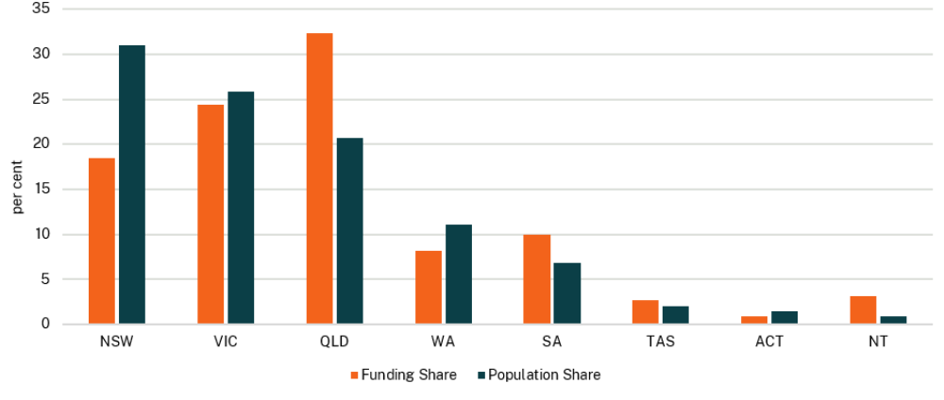
- Data sourced from the 2026-27 Australian Government Budget
Note: the 2026-27 Australian Government data excludes infrastructure related payments provided under education, environment and health national partnership agreements.

GST revenue
In March 2026 the Commonwealth Grants Commission released the 2026 Update, recommending a 2026-27 GST relativity for New South Wales of 0.82. This was lower than the 2025-26 relativity of 0.86 and was also lower than the forecast in the 2025-26 Half-Yearly Review. The movement partly reflects the 2018 GST distribution reforms, which changed the equalisation benchmark from the strongest state to the stronger of New South Wales and Victoria, and introduced the temporary “no worse off” payment. This lower relativity for New South Wales has resulted in $457.0 million less GST revenue to New South Wales in 2026-27.
Over the forward estimates, the NSW relativity is expected to improve as a result of stronger property market conditions and improved mining revenues in both Queensland and Western Australia, as well as a lower New South Wales share of Commonwealth infrastructure funding. However, the NSW relativity is forecast to remain low by historical standards. Over the four years to 2029-30, improvements to the NSW relativity are expected to increase GST revenue by $3.2 billion compared to forecasts in the 2025-26 Half-Yearly Review.
The national GST pool is also forecast to be higher compared to the 2025-26 Half-Yearly Review. Strong collections in 2025-26 as a result of higher-than-anticipated household consumption has contributed to a $374.0 million upgrade to NSW GST revenue in 2025-26. Over the four years to 2029-30, improvements to the national GST pool contributes a further $3.0 billion in GST revenue to New South Wales compared to the 2025-26 Half-Yearly Review. The NSW forecast for the national GST pool in 2026-27 is aligned with the Australian Government, with differing growth rates over the forward estimates reflecting weaker assumptions in household consumption and dwelling investment (see Chapter 2 The economy for further details).
A downward revision to New South Wales’ population share is expected to reduce GST revenue by $624.0 million over the four years to 2029-30 compared to the 2025-26 Half-Yearly Review.
Compared to the 2025-26 Half-Yearly Review, GST revenue has been revised up by $346.0 million in 2025-26 and $5.6 billion over the four years to 2029-30.
- GST revenue
 | 2025-26 | 2026-27 | 2027-28 | 2028-29 | 2029-30 | Four years to 2029-30
 | Revised | Budget | Forward Estimates |  |  | Four years to 2029-30
 | $m | $m | $m | $m | $m | $m
2025-26 Half-Yearly Review | 28,176 | 28,223 | 29,162 | 30,214 | 31,188 | 118,787
Updates since 2025-26 Half-Yearly Review:
Change in relativities | … | (457) | 340 | 1,070 | 2,238 | 3,191
Change in pool | 374 | 995 | 550 | 683 | 758 | 2,986
Change in population | (28) | (38) | (120) | (184) | (282) | (624)
2026-27 Budget | 28,522 | 28,723 | 29,932 | 31,783 | 33,902 | 124,340
Change since 2025-26 Half-Yearly Review | 346 | 500 | 770 | 1,569 | 2,714 | 5,553

- Productivity Commission Inquiry into 2018 GST Distribution Reforms
The Productivity Commission (PC) has commenced its inquiry into the 2018 GST distribution reforms. The Inquiry is mandated by the Treasury Laws Amendment (Making Sure Every State and Territory Gets Their Fair Share of GST) Act 2018 (the 2018 legislative changes). The Inquiry will assess whether the 2018 legislative changes to the GST distribution system are operating efficiently, effectively and as intended, and the fiscal implications for each state and territory (the states) and the Australian Government. The Inquiry will also consider alternative arrangements.
The 2018 legislative changes have favoured Western Australia. If the No Worse Off Guarantee expires as currently scheduled in 2029-30, the benefits for Western Australia will increasingly come at the expense of other large states, particularly New South Wales.
New South Wales’ initial submission to the PC recommends a phased introduction of an equal per capita (EPC) distribution of GST grants with top-ups from outside the GST pool for the fiscally weakest states to achieve a reasonable level of fiscal equalisation. An EPC distribution would remove the complexity of the current system and result in a higher level of transparency.
While New South Wales prefers an EPC distribution, we recognise the need for a broad national consensus. Given this, New South Wales’ initial submission presents a series of alternative policy changes for consideration, which would reduce volatility and address the factors which drove the 2018 changes.

Other Australian Government payments
Revenue from other Australian Government payments is expected to be $453.8 million higher over the four years to 2029-30 compared to the 2025-26 Half-Yearly Review. This is mainly driven by the provision of expected Australian Government contributions for the delivery of Foundational Supports, as agreed by National Cabinet.
- Non-tax revenue

Sale of goods and services
Sale of goods and services revenue is estimated to be $10.9 billion in 2025-26, $289.7 million lower than forecast at the 2025-26 Half-Yearly Review. This mainly reflects:
- a reduction in recoveries revenue due to lower psychological claims under the Enhanced Police Support Scheme.
Over the four years to 2029-30, revenue in this category has been revised up by a total of $985.0 million, reflecting:
- the reprofiling of construction project revenue from 2025-26 and administrative services provided by Transport for NSW on behalf of other transport portfolio entities
- the reclassification of revenue from fines, regulatory fees and other revenue to fees for service under the sale of goods and services.
- Sale of goods and services
 | 2024-25 | 2025-26 | 2026-27 | 2027-28 | 2028-29 | 2029-30 | % Average growth p.a. 2025-26 to 2029-30
 | Actual | Revised | Budget | Forward Estimates |  |  | % Average growth p.a. 2025-26 to 2029-30
 | $m | $m | $m | $m | $m | $m | % Average growth p.a. 2025-26 to 2029-30
Sale of goods | 628 | 549 | 676 | 716 | 823 | 728 | 7.3
Rents and leases | 538 | 468 | 423 | 438 | 485 | 514 | 2.4
Fee for service | 2,009 | 1,174 | 1,399 | 1,298 | 1,395 | 1,389 | 4.3
Entry fees | 59 | 62 | 81 | 85 | 85 | 83 | 7.7
Patient fees and other hospital charges | 2,832 | 3,025 | 2,997 | 3,077 | 3,151 | 3,228 | 1.6
Court fees | 190 | 200 | 196 | 195 | 191 | 196 | (0.5)
Road tolls^{(a)} | 137 | 142 | 160 | 179 | 359 | 539 | 39.6
Licences | 935 | 987 | 1,028 | 1,082 | 1,131 | 1,156 | 4.0
Insurance contributions, premiums and recoveries | 379 | 423 | 527 | 552 | 573 | 590 | 8.7
Other sales of goods and services | 2,673 | 3,828 | 4,188 | 4,374 | 4,637 | 4,347 | 3.2
Sale of goods and services | 10,379 | 10,859 | 11,676 | 11,996 | 12,831 | 12,770 | 4.1

- Forecast road toll revenue will be impacted by the opening of the Western Harbour Tunnel

Other dividends and distributions
Revenue from other dividends and distributions in 2025-26 has been revised down by $210.7 million since the 2025-26 Half-Yearly Review. Meanwhile, revenue forecasts over the four years to 2029-30 have been upgraded by $5.3 billion. These movements mainly reflect investment fund distributions and an uplift in returns from the successful implementation of OneFund reforms.

Interest income
Interest income includes returns on managed bond investments, including investments made by NSW Treasury Corporation (TCorp), and interest earned on bank deposits and funding facilities. Interest revenue has been revised down in 2025-26 by $70.4 million largely reflecting lower operating cash balances.
Over the four years to 2029-30, interest income has increased since the 2025-26 Half-Yearly Review by $228.6 million primarily driven by expectations of higher interest rates, greater availability of cash reserves and the unwinding of amortised interest from Sydney Metro property sales.

Dividends and income tax equivalents
State Owned Corporations (SOCs) and TCorp pay dividends that provide appropriate returns on the Government’s equity investment in these entities. They also make income tax equivalent payments to ensure competitive neutrality.
Dividends and income tax equivalents are estimated to be $214.0 million higher over the four years to 2029-30 relative to the 2025-26 Half-Yearly Review. This is mainly due to higher dividend payments from water entities following the Independent Pricing and Regulatory Tribunal’s final price determination and Landcom’s dividends now being recognised as revenue. The increase is partly offset by a forecast decrease in income tax equivalents from Sydney Water due to higher expenses and from Landcom reflecting higher construction and finance costs. See Chapter 7 Government businesses for further details.

Fines, regulatory fees and other revenue (excluding royalties)
Fines, regulatory fees and other revenue has been revised up by $852.5 million over the four years to 2029-30 relative to the 2025-26 Half-Yearly Review.
This is primarily driven by:
- the transfer in ownership of the “red fleet” firefighting vehicles from local government to the NSW Rural Fire Service resulting in the recognition of $587.9 million in non-cash revenues in 2027-28 only. Over the four years to 2029-30, this transfer will also result in additional expenditures (excluding depreciation) of $208.8 million and depreciation of $194.5 million
- additional rental income from continued operation of disability assets owned by the Department of Communities and Justice.
This is partly offset by the reclassification of revenue to the sale of goods and services.
- Fines, regulatory fees and other revenue
 | 2024-25 | 2025-26 |  | 2026-27 | 2027-28 | 2028-29 | 2029-30 | % Average growth p.a. 2025-26 to 2029-30
 | Actual | Revised |  | Budget | Forward Estimates |  |  | % Average growth p.a. 2025-26 to 2029-30
 | $m | $m |  | $m | $m | $m | $m | % Average growth p.a. 2025-26 to 2029-30
Fines | 865 |  | 869 | 860 | 858 | 853 | 868 | (0.0)
Regulatory fees | 334 |  | 321 | 325 | 369 | 356 | 363 | 3.1
Developer and industry contributions | 840 |  | 766 | 945 | 1,706 | 1,141 | 1,213 | 12.2
Other revenues | 1,552 |  | 1,570 | 1,768 | 1,578 | 1,633 | 1,831 | 3.9
Total fines, regulatory fees and other  revenues | 3,591 |  | 3,526 | 3,898 | 4,511 | 3,984 | 4,276 | 4.9

Royalties
Since the 2025-26 Half-Yearly Review, royalties have been revised up by $84.0 million in 2025-26 and $186.0 million in 2026-27 to reflect higher thermal coal prices in response to major disruptions to the flow of oil and gas resulting from the conflict in the Middle East.
Since the outbreak of the conflict, thermal coal prices have increased by more than 20 per cent, resulting from energy security concerns and gas-to-coal switching by major Asian trading partners. From 2027-28 onwards, royalties revenue is broadly unchanged since the 2025-26 Half-Yearly Review with expectations that coal prices will gradually return to pre-conflict levels.

Recurrent expenditure
- General government expenses are projected to be $133.0 billion in 2026-27.
- The Government is managing expense growth while investing in the delivery of essential services. Expense growth, which averaged 9.7 per cent per annum between 2018-19 and 2022-23, was down to 1.8 per cent in 2024-25.
- Over the budget and forward estimates, expense growth is projected to average 2.7 per cent per annum.
- Low expense growth has been maintained without a wages cap. Employee expenses are projected to grow at 3.9 per cent between 2025-26 and 2029-30, down from an average of 6.4 per cent per annum between 2018-19 and 2022-23. The Comprehensive Expenditure Review, reductions in the senior executive service, and reforms to NSW insurance and compensation schemes have helped moderate employee expense growth.
- This disciplined approach to managing expense growth has enabled the Government to provide support for families in response to the fuel crisis while undertaking substantial investments in essential services.
- Measures in this Budget deliver immediate relief to those in need, including:
- a $100 discount on private vehicle registration (excluding caravans and trailers) in 2026-27
- freezing public transport fares at 2025 prices for the next 12 months
- providing a temporary reduction to the weekly toll cap to $50 (from $60) for 2026-27
- lower household energy costs through interest free loans and discounts under the existing Home Energy Saver Program
- extending the 3-Year-Old Fee Relief Trial Payment in Long Day Care to the end of the 2027 calendar year
- providing a $1,000 cost-of-living payment for more than 120,000 NSW Government employees, because annual growth in Sydney consumer price index (CPI) exceeded 4 per cent between the March quarter 2025 and 2026.
- Despite challenging global conditions, alongside immediate relief, the Government is investing in essential services through the economic cycle, including:
- increasing affordable access to quality health services and stronger pay and conditions for nurses and midwives with a $10.3 billion investment in healthcare
- fostering safer and stronger communities, including a 50 per cent increase in frontline domestic, family and sexual violence services to support victim-survivors
- investing in essential infrastructure to maintain our hospitals and rail network
- supporting domestic manufacturing in New South Wales through the New Electric Bus Program and investment in low-carbon industrial products
- additional investments in skills and education to support jobs growth and a higher wages economy.
- Sustaining investment while constraining expense growth
Government expenses are projected to be $133.0 billion in 2026-27. This is an upward revision to the outlook in the 2025-26 Half-Yearly Review ($130.6 billion). Additional expenditure is being targeted to provide immediate household relief to meet the challenges of today, while new investments in health and essential services are made to improve service delivery into the future. In many cases, increasing expenditure is offset by revenue from new National Agreements. Key investments in this Budget include:
- responding to the fuel crisis by combining short-term cost relief while continuing delivery of electricity network infrastructure to enhance reliability and security over the long-term
- strengthening access to healthcare by growing the health workforce, expanding hospital capacity and supporting increased demand for services across the State
- investing in rail and bus services for more reliable and accessible transport, while supporting new manufacturing jobs in New South Wales.
Expenses are projected to grow at an average rate of 2.7 per cent per annum over the budget and forward estimates. The two areas of highest expense growth over this period are interest expenses (9.5 per cent) and depreciation and amortisation (4.4 per cent).
Expense growth, which averaged 9.7 per cent per annum between 2018-19 and 2022-23, was down to 1.8 per cent in 2024-25. The Government has achieved this while continuing to deliver and maintain essential services. Total expenses as a proportion of gross state product (GSP) are also projected to decline over the forward estimates (see Chart 5.1).
- Expenses relative to gross state product since 2016-17
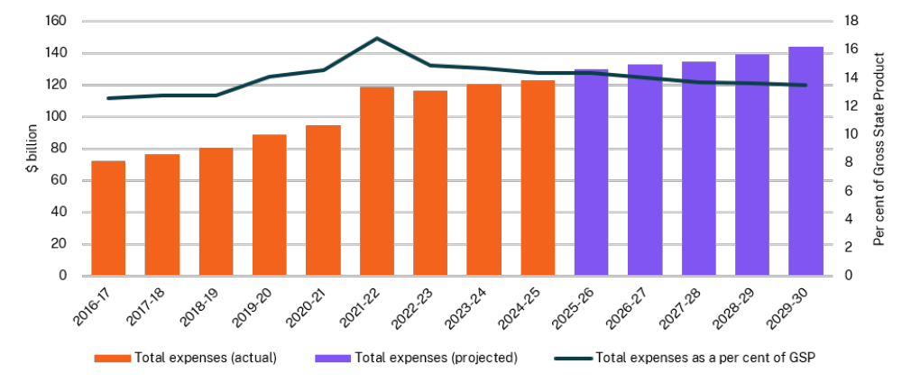

The Government is also ensuring employee expense growth remains in check, while delivering wage increases for essential workers, as outlined in Chart 5.2.
- Total employee expenses – average annual growth rates from 2018-19 to 2029-30
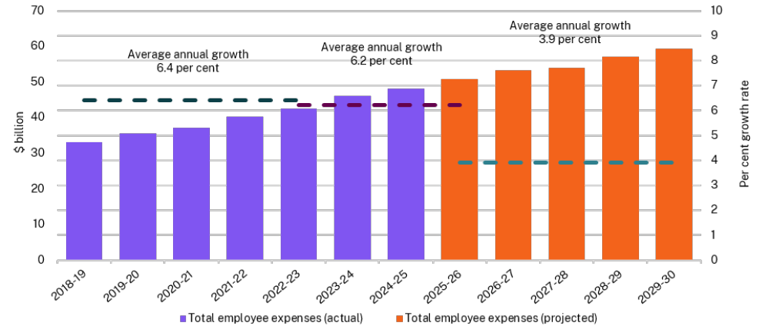

Since 2023, the Government has reformed the State’s industrial relations system to support pay increases for essential workers, as detailed in Box 5.1.

- Industrial reforms to better support essential workers
Real wages for the NSW Government workforce fell by 1 per cent during the period of the legislated wages cap.
Despite this, employee related expenses grew on average by 4.8 per cent per annum from 2011-12 to 2022-23. This growth included the addition of over 1,200 senior executives from 2018 to 2023, equating to growth of almost 40 per cent in five years in the number of senior executives.
In addition to a fall in real wages, there were growing insurance costs (including through the former Police Blue Ribbon Insurance Scheme), declining police numbers, high teacher vacancies and 1,112 nurses that were not funded beyond 2022-23.
In 2023-24, the NSW Government adopted the Fair Pay and Bargaining Policy which introduced the mutual gains approach to bargaining. The jurisdiction of the Industrial Relations Commission (IRC) was strengthened to independently assess wage claims without the restriction of a wages cap, including work value and gender undervaluation claims.
The Police Association of New South Wales engaged in mutual gains bargaining, which informed the redesign of the Police Blue Ribbon Insurance Scheme into the Enhanced Police Support Scheme. The new scheme supports improved rehabilitation and return to work strategies, aimed at addressing attrition and workforce shortages. The benefits of the reforms were shared directly with the workforce, with the savings redirected to an increase in pay and allowances without placing additional pressure on the State’s budget.
The IRC has since made several judgements following claims brought forward by public sector workforces. Most recently, the IRC awarded NSW nurses and midwives an increase of 16 to 28 per cent over three years. An additional $2.9 billion is included in this Budget to account for the IRC decision.
The Government’s industrial relations reforms have led to improved outcomes for essential workforces including police, teachers, and nurses and midwives. These are outlined in Box 5.8.
- Expense reconciliation since the 2025-26 Half-Yearly Review
 | 2025-26 | 2026-27 | 2027-28 | 2028-29 | 2029-30
 | Revised | Budget | Forward Estimates
 | $m | $m | $m | $m | $m
Expenses – 2025-26 Half-Yearly Review | 129,015 | 130,640 | 132,837 | 136,465 | n.a.
Policy measures - new expenses^{(a)} | 883 | 2,997 | 2,720 | 3,420 | 4,113
Reforms, savings and offsets^{(b)} | (407) | (471) | (822) | (1,053) | (1,206)
Other budget variations | 278 | (134) | (237) | 634 | n.a.
Expenses – 2026-27 Budget^{(c)(d)} | 129,769 | 133,032 | 134,498 | 139,465 | 144,243

- Further information on new measures is provided in Appendix B Measures statement.
- This captures the expense impacts from (i) savings to programs and initiatives since the 2025-26 Half-Yearly Review, and (ii) offsets for new expense measures.
- Total estimated expenses include an annual allowance for the established tendency for parameter and technical adjustments (non-discretionary changes in expenses to existing programs) to increase expenses over time. This allowance is for estimate purposes only.
- Total estimated expenses include an allowance for the established tendency of expenditure to be delayed and carried forward to future years.

Budget new measures
New expense measures in the 2026-27 Budget include:
- investment to strengthen access to healthcare by growing the health workforce, sustaining and expanding hospital capacity, and supporting increased demand for services across the State ($10.3 billion over four years to 2029-30). This includes the largest pay increase to nurses and midwives in more than two decades (an additional $2.9 billion over four years to 2029-30)
- funding for the commencement of Thriving Kids early intervention supports for children aged 8 and under with developmental delay and/or autism (NSW contribution of $631.9 million over five years to 2030-31). This is part of a $1.1 billion package co-funded with the Australian Government and includes:
- General Supports for families who have concerns about their child’s development. Services include supported playgroups and peer support and parenting programs to provide families with resources and skills to improve their child’s learning and development through everyday activities
- Targeted Supports for children who need extra help for a specific period of time. Services include group and individual allied health therapies delivered by qualified clinicians alongside access to family support coordination
- enhancing bushfire and emergency response to better protect communities by transferring ownership and management of the State’s red fleet from councils to the NSW Rural Fire Service, while maintaining the State’s partnership with councils ($470.1 million over 10 years, including capital expenditure)
- transitioning threatened species management towards a landscape-scale and integrated approach to support recovery at the ecosystem level ($195.2 million over three years to 2028-29, including capital expenditure for land)
- strengthening responses to domestic, family and sexual violence, including a 50 per cent uplift for six existing crisis response programs ($184.1 million over four years to 2029-30).

This Budget includes additional investments being delivered in partnership with the Australian Government. Expenditure under National Agreements, Federation Funding Agreements and other Australian Government Payment programs is expected to be part funded by $4.7 billion in Australian Government revenue over four years to 2029-30.
To create capacity to invest in essential workforces, savings measures and reforms have been implemented over the last three years to support the sustainable growth of employee expenses. This includes:
- a 15 per cent reduction to Public Sector Senior Executive (PSSE) headcount
- workers compensation reforms to ensure the long-term sustainability of the scheme and improve outcomes for workers and employers
- reforms to the Police Blue Ribbon Insurance Scheme (PBRI)
- a two-year remuneration freeze for Members of Parliament and PSSEs
- implementation of the NSW public sector mobility policy, which enables employees to move between roles and agencies to retain talent, build skills and efficiently fill vacancies
- implementation of budget improvement and reprioritisation measures through the Comprehensive Expenditure Review, which have also contributed to moderating employee expense growth.
Delivery of these savings and reform measures provides fiscal capacity for investments in securing the future of our essential services. This includes additional investments in key health system supports to improve affordability and access, as detailed in Box 5.2.

- Affordable and accessible healthcare
Patients and their families across New South Wales will benefit from a historic $10.3 billion increase in health funding, delivered with the Australian Government, to grow the health workforce, expand hospital capacity and meet rising demand.
This will deliver:
- more than 9,000 health workers
- capacity for an extra 33,000 emergency department presentations per year
- 2,900 extra planned surgeries per year
- around 16,000 inpatient services including emergency surgeries per year
- a boost to available renal dialysis care by 11,000 sessions per year.
This investment includes:
- the largest pay increase for nurses and midwives in more than two decades through a further $2.9 billion for higher wages and improved conditions
- $4.5 million for easier and cheaper access to the oral contraceptive pill, including by allowing eligible pharmacists to prescribe it for women aged 18 and over
- more flexible staffing across the health system through $26.5 million for the NSW Health Locum Agency
- $147.5 million boost to the high cost, highly specialised therapy program.
Future of Healthcare
A Future of Healthcare package will reduce pressure on clinicians, improve patient flow and scale health innovations, including:
- Artificial Intelligence scribe technology for 6,000 clinicians through $38.7 million
- an aged care reform package to improve patient flow through $35.7 million
- rapid-support funding for promising healthcare innovations through $3.0 million.
Mental Health
Additional investments in mental health services, including:
- critical mental health and suicide prevention services maintained statewide through $64.8 million, in partnership with the Australian Government
- $43.3 million for immediate crisis support through Lifeline services
- stronger mental health peak bodies and community-managed services through $4.3 million, supporting consumer, carer and community voices.
Regional Health
Additional investments in regional health services including:
- better emergency care in regional New South Wales through an additional $67.4 million to continue delivering the three new regional helicopter bases
- robotic surgery research and capability at Orange Health Service through $9.9 million
- planning for future paediatric oncology services in Hunter New England and North Coast through $1.0 million
- support for patients travelling long distances for care through $71.7 million for the Isolated Patients Travel and Accommodation Assistance Scheme.

The Government’s continued investment in Legal Aid NSW is detailed in Box 5.3.

- Investments for Legal Aid NSW
This Budget includes $638.2 million recurrent expenditure for Legal Aid NSW in 2026-27, up 21.0 per cent since 2023-24, as detailed in Table 5.2. This includes expenditure to:
- support the implementation of various legislative reforms introduced and passed through the Parliament in the previous year
- improve victim experiences in sexual assault or domestic and family matters, by improving and expanding access to special measures and certain protections when giving evidence in court
- provide legal assistance to parents and children in the Children’s Court
- support bail hearings in the Local Court
- support the hearing of matters in the District Court relating to child sexual assault
- support the Early Appropriate Guilty Plea program, which encourages early resolution of criminal matters, reduces court delays, and lessens the emotional and financial burden on victims, witnesses and defendants.
The measures are designed to increase access to justice and improve the efficiency of court processes to allow individuals to have greater confidence in the justice system.
- Legal Aid NSW total expenses
$m | 2017-18 | 2018-19 | 2019-20 | 2020-21 | 2021-22 | 2022-23 | 2023-24 | 2024-25 | 2025-26  Revised | 2026-27  Budget | % Avg. growth^{(a)}
Total expenses | 318.2 | 374.6 | 374.5 | 404.7 | 426.0 | 479.3 | 527.5 | 608.5 | 662.0 | 638.2 | 8.0%

- Average per annum per cent growth from 2017-18 to 2026-27. Expenditure reflects actual expenditure from 2017-18 to 2024-25, projected expenditure in 2025-26 and budgeted expenditure for 2026-27.

This Budget invests $154.2 million over four years to 2029-30 to improve outcomes for First Nations people in New South Wales, building on the record $731.8 million investment last Budget, as detailed in Box 5.4.
In addition, the Australian Government and NSW Government are jointly investing $100.0 million under the National Skills Agreement to expand First Nations vocational education and training in New South Wales. This will strengthen Aboriginal Community Controlled and First Nations-owned training organisations, and support outreach training delivered in local communities.

- Delivering for First Nations people in New South Wales
This Budget includes $45.3 million for continued delivery of Closing the Gap initiatives developed in partnership with the NSW Coalition of Aboriginal Peaks Organisations:
- $11.8 million over three years for Aboriginal Child and Family Advocacy and Support services to keep Aboriginal children safely connected to family and community
- $10.7 million over two years to increase First Nations ownership of water through the first phase of the NSW Aboriginal Water Strategy
- $10.5 million over three years for Aboriginal Legal Service bail support programs to deliver better justice outcomes for Aboriginal women and young people
- $9.3 million over three years for culturally safe mental health care delivered by Aboriginal Community Controlled Health Organisations and Local Health Districts
- $3.0 million in 2026-27 to fund one-off projects developed by local First Nations community organisations and deliver scalable community-led solutions.
A $96.7 million investment will improve First Nations land, water and housing outcomes:
- $74.9 million over four years to 2029-30 (including capital expenditure) for continued implementation of commitments in Native Title Indigenous Land Use Agreements by the Government
- $9.9 million in 2026-27 to provide critical housing and tenancy support services, community programs and sector development initiatives for First Nations people
- $6.9 million over two years for air conditioning and passive energy upgrades for Aboriginal Housing Office properties, benefiting over 600 eligible tenants
- $5.0 million over two years to plan future improvements in housing, infrastructure and living standards in discrete Aboriginal communities.
A further $12.2 million in 2026-27 will support First Nations economic, cultural and social outcomes, including $4.0 million for First Nations education and cultural programs.

Box 5.5 outlines how the Government is harnessing Artificial Intelligence (AI) to improve service delivery for the community.

- Artificial Intelligence in Government
AI is reshaping government services and how we work, offering opportunities to lift productivity and improve service delivery for the people of New South Wales. These opportunities must be pursued safely, ethically and transparently to maintain public trust.
The Government already uses AI across areas like bushfire intelligence, environmental monitoring and education services, including NSW EduChat. Evolving technologies, including generative AI, present further opportunities to improve service delivery and outcomes for the community.
New investments in AI for the 2026-27 Budget include:
- $38.7 million to implement AI scribe technology for 6,000 clinicians to reduce pressure on clinicians and improve patient flow
- a pilot of an AI model to improve the Building Commission’s processing times for assessing trade licence applications.
The NSW Digital Assurance Framework and the NSW AI Assessment Framework have been enhanced to reflect developments in generative AI. These revisions strengthen risk management requirements and apply to all NSW Government agencies. The AI Review Committee has also been established to assess high risk initiatives.

The Budget includes additional investments for Integrity Agencies, as detailed in Box 5.6.

- Investments in Integrity Agencies
This Budget includes $582.5 million for Integrity Agencies in 2026-27 to maintain public trust and improve public integrity, transparency and accountability in government. This is $160.9 million, or 38 per cent higher, than the 2022-23 Budget and includes:
- $84.6 million (or 34 per cent higher) for the New South Wales Electoral Commission, including measures to improve cyber security, funding disclosure and compliance, improving electoral integrity and delivery of the 2027 State General Election
- $26.6 million (or 77 per cent higher) for the Independent Commission Against Corruption, including system and staffing to respond to growing complexity and number of investigations
- $23.3 million (or 33 per cent higher) for the Audit Office of New South Wales, including continued investment in capabilities and resources to deliver quality audits and reviews.
Other measures include additional funding for IT-related improvements and resources for the Ombudsman Office and the Law Enforcement and Conduct Commission to reflect the growing number of complaints and complexity (including sensitivity) of investigations.
Further, the budget for the Office of the Anti-Slavery Commissioner for New South Wales has increased from $1.5 million in 2022-23 to $2.8 million in 2026-27 to support its work building capacity to prevent modern slavery.

Box 5.7 outlines the NSW Government’s support of the Tomago Aluminium Smelter.

- Tomago Aluminium Smelter
In October 2025, the Tomago Aluminium Smelter, majority owned by Rio Tinto, announced it was contemplating closure when its current electricity contract expired in December 2028.
Electricity purchases comprise over 40 per cent of the Smelter’s current operating costs. The owners’ view is they cannot procure electricity for the period after December 2028 at a market price low enough to guarantee continued operations.
The NSW Government is working closely with the Australian Government, which is undertaking direct negotiations with the smelter on a new power purchase arrangement.
The NSW Government stands ready to support local workers, while seeking to ensure value for taxpayers.
Unlike the Australian and Queensland Governments, New South Wales no longer owns any electricity generation businesses and cannot directly offer a power purchase agreement.
The 2026-27 Budget includes a provision for NSW to contribute, pending the Australian Government finalising its negotiations with the smelter.

Budget variations
Budget variations are changes to the cost and timing of existing projects and services, including changes in demand, the timing of project delivery, input costings, variations in Australian Government grants, technical accounting and actuarial adjustments.
Major variations since the 2025-26 Half-Yearly Review include:
- higher interest expenses ($3.7 billion over four years to 2029-30). A key driver of the increase is the refinancing of lower cost debt incurred in prior years – including before and during the COVID-19 pandemic – at higher interest rates
- higher depreciation and amortisation expenses across the general government sector, which are driven by asset revaluations and adjustments to the timing of capital projects ($631.0 million over four years to 2029-30)
- higher expenditure to restore essential public assets damaged by natural disasters and other eligible events in partnership with the Australian Government ($559.9 million over four years to 2029-30)
- higher superannuation interest costs due to higher forecast discount rates and inflation increasing the value of the liability for defined benefit superannuation ($484.9 million over four years to 2029-30)
- higher expenditure on water management to reflect Independent Pricing and Regulatory Tribunal determinations and water rebates in 2026-27 for Sydney Water Corporation and Hunter Water Corporation customers ($347.2 million over four years to 2029-30)
- higher NSW Government school expenses ($135.9 million over four years to 2029-30) to fund NSW’s obligations under the Better and Fairer School Agreement
- lower projected expenses for NSW Self Insurance Corporation insurance and compensation schemes ($2.6 billion over four years to 2029-30), driven by police insurance reform and workers compensation reforms.

- Expense trends and further analysis
- General government sector expenses
 | 2025-26 | 2026-27 | 2027-28 | 2028-29 | 2029-30 | % Average growth p.a. 2025-26 to 2029-30
 | Estimate | Budget | Forward Estimates |  |  | % Average growth p.a. 2025-26 to 2029-30
 | $m | $m | $m | $m | $m | % Average growth p.a. 2025-26 to 2029-30
Employee | 50,940 | 53,352 | 53,929 | 57,014 | 59,375 | 3.9
Superannuation | 6,997 | 7,187 | 7,149 | 7,336 | 7,456 | 1.6
Depreciation and amortisation | 10,304 | 10,728 | 11,208 | 11,865 | 12,233 | 4.4
Interest | 7,678 | 8,950 | 9,606 | 10,164 | 11,027 | 9.5
Other operating expense | 28,092 | 27,872 | 28,720 | 28,505 | 30,265 | 1.9
Grants, subsidies, and other transfers | 25,756 | 24,942 | 23,886 | 24,581 | 23,887 | -1.9
Total expenses | 129,769 | 133,032 | 134,498 | 139,465 | 144,243 | 2.7
Annual change | 5.4% | 2.5% | 1.1% | 3.7% | 3.4% | n.a.

Employee expenses
Employee expenses are the largest component of recurrent expenses and include wages and salaries, long service leave and workers compensation.
Employee expenses are projected to be $53.4 billion in 2026-27, or 40.1 per cent of total expenses, broadly consistent with the proportion of overall expenses in 2025-26. The change in employee expenses since the 2025-26 Half-Yearly Review ($52.8 billion) is largely driven by an increase in pay and conditions for nurses and midwives, growth in the broader health workforce, the conversion of the Parklea Correctional Centre to public ownership and additional expenditure for NSW Government schools.
Over three years to 2025-26, employee expenses have grown on average by 6.2 per cent per annum while delivering record pay increases for essential workforces. This is marginally lower than the average growth of 6.4 per cent per annum over four years to 2022-23, during the period of the legislated wages cap.
Over the budget and forward estimates, employee expense growth is projected to moderate to an average rate of 3.9 per cent per annum. See Chart 5.2 for the average annual growth rates from 2018-19 to 2029-30.
Since 2023, despite the moderated growth in employee expenses, strategic investments by the NSW Government have been made to enhance the ongoing delivery of essential services to the community, alongside record increases to pay and conditions and growth of essential workforces (refer to Box 5.8).
Active decisions have also been taken by the Government to return essential services and assets back to being publicly operated, including the Northern Beaches Hospital, Parklea Correctional Centre, Junee Correctional Centre and school cleaning services in the Hunter and Central Coast. These decisions in aggregate have resulted in a change in expenses from grants or other operating to employee expenses.

- Strengthening the State’s frontline workforces to improve services
The Government’s investment in its essential workforces has delivered key outcomes for the New South Wales community, including:
- more permanent teachers in public schools: teacher vacancies are down 71 per cent, from 3,311 in November 2022 to 971 in Term 1 2026. The number of fully-staffed schools has also increased by 42.7 per cent, from 1,172 in Term 1 2023 to 1,672 in Term 1 2026
- a stronger police force: the largest police class in more than 14 years, with 349 probationary constables being sworn in (Class 368) on 1 May 2026, representing 2.2 per cent of the total police workforce of 15,748 (headcount) in 2025-26. The once-in-a-generation pay rise for police officers and paid study for new recruits is boosting frontline capabilities to keep communities safe
- a historic pay rise for nurses and midwives: following a decision by the Industrial Relations Commission, nurses and midwives will receive a pay increase of between 16 and 28 per cent over three years, the largest increase in more than two decades. These record increases are complemented by the introduction of safe staffing levels and an increase to the night shift penalty rates to further boost our health workforce and enhance patient care
- record recruitment of firefighters: an additional 481 firefighters joined Fire and Rescue NSW in the first half of 2026, following a record recruitment year in 2025 when 648 firefighters joined the service. The new recruits represent nearly 16 per cent of the total firefighter workforce of 7,066 (headcount)
- a boost to frontline emergency services and healthcare: since 2023, more than 5,300 full time equivalent (FTE) nurses have been employed to support healthcare, including 1,112 made permanent in 2024-25. More than 740 additional paramedics (FTE) have been deployed across New South Wales since 2023. 116 paramedic interns and 21 emergency medical call takers were inducted in April 2026
- paramedics professional credentials recognised and remunerated with average increases of 25 per cent over four years provided from 2023
- improved pay and conditions for child protection caseworkers who received increases of up to $17,000, as well as better overtime provisions, supporting those workers who keep our most vulnerable children safe.
The Government’s mutual gains approach provides an avenue to negotiate and deliver fair and reasonable pay for workers by implementing productivity, efficiency, reform and/or cost-saving measures.
Following the significant reset to pay and conditions, the Government is offering pay increases of 3 per cent per annum for public sector workers moving forward.
The Industrial Relations Commission will continue to act as an independent umpire for public sector workers.

Superannuation expenses
Superannuation expenses include defined contribution plans (such as compulsory superannuation), as well as defined benefit plans and their associated interest costs.
Superannuation expenses are projected to be $7.2 billion in 2026-27, or 5.4 per cent of total expenses. This is a slight upward revision on the outlook at the 2025-26 Half-Yearly Review ($6.9 billion) reflecting higher forecast discount rates and inflation increasing the value of the liability for defined benefit superannuation. Higher superannuation costs are also associated with wage increases for nurses and midwives and the growth in the broader health workforce.
Over the budget and forward estimates, superannuation expenses are projected to grow at an average rate of 1.6 per cent per annum.

Other operating expenses
Other operating expenses are mainly the day-to-day running costs incurred in the delivery of government services and programs.
This is the second largest category of expenses and is projected to be $27.9 billion in 2026-27, or 21.0 per cent of total expenses. This is an upward revision to the outlook at the 2025-26 Half-Yearly Review ($26.9 billion). Key drivers of this increase include adjustments to NSW Self Insurance Corporation for the latest insurance scheme liability valuations and revised accounting for insurance contracts. Investments in essential services such as health, the NSW bus fleet, visitor infrastructure maintenance in national parks, and threatened species conservation, have also contributed to the increase.
Over the budget and forward estimates, other operating expenses are projected to grow at an average rate of 1.9 per cent per annum.

Grants, subsidies and other transfer expenses
Grants, subsidies and transfer expenses include payments to other government sectors (for example State Owned Corporations), the Australian Government, local government, individuals, households, community groups and non-government organisations. They also support the delivery of services and infrastructure projects.
Grants, subsidies and transfers are projected to be $24.9 billion in 2026-27, or 18.7 per cent of total expenses. This is a lower revision since the 2025-26 Half-Yearly Review ($25.4 billion). A key driver of this reduction is the reprofiling of expenditure to match changes in the timing of delivery of projects.
Over the budget and forward estimates, grants, subsidies and other transfer expenses are projected to decrease by an average rate of 1.9 per cent per annum.

Depreciation and amortisation
Depreciation and amortisation are accounting methods used to systematically allocate the cost of assets over their useful life.
Depreciation and amortisation expenses are projected to be $10.7 billion in 2026-27, or 8.1 per cent of total expenses. This is broadly consistent with the 2025-26 Half-Yearly Review ($10.5 billion). Relative to that outlook, key drivers include asset revaluations and timing adjustments to capital projects.
Over the budget and forward estimates, depreciation and amortisation expenses are projected to grow by an average rate of 4.4 per cent per annum.
See Chart 5.3 for the growth in depreciation and amortisation expenses as a portion of GSP since 2010-11.
- Depreciation and amortisation as a proportion of GSP, 2010-11 to 2029-30
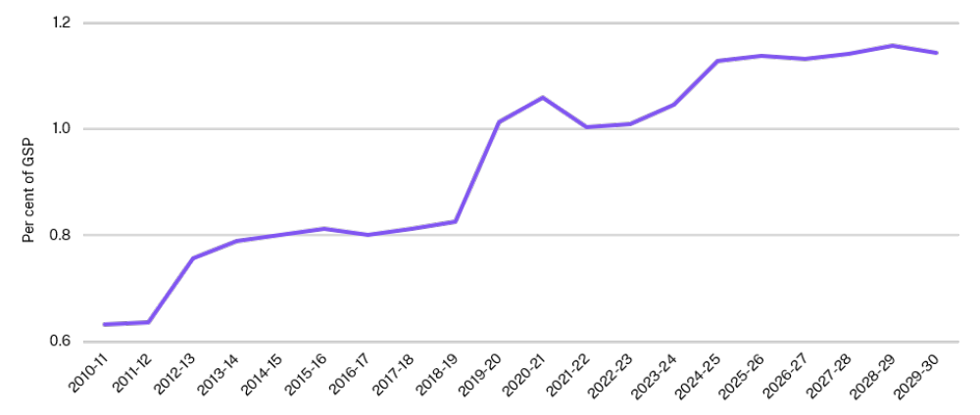

Interest
Interest expenses are the costs incurred by the State for borrowing funds to support the delivery of essential public services and investment in infrastructure.
Interest expenses are projected to be $9.0 billion in 2026-27 (6.7 per cent of total expenses). This is higher than projections in the 2025-26 Half-Yearly Review ($8.1 billion), as persistent inflation has resulted in higher interest rates. Since the 2025-26 Half-Yearly Review, the Reserve Bank of Australia has increased interest rates three times.
Over the budget and forward estimates, interest expenses (excluding superannuation interest) are projected to increase by an average rate of 9.5 per cent per annum.
Responsible management of borrowings has helped ease the State’s interest expense burden. By reducing the June 2026 projected gross debt by $9.7 billion in comparison to the 2023 Pre-election Budget Update, the NSW Government will save around $400 million in annual interest expenses.

Balance sheet
- The NSW Government is stabilising the State’s debt position. Gross debt is projected to be $178.5 billion by June 2026 which is $9.7 billion lower compared to the Pre-election Budget Update projection of $188.2 billion, saving the State approximately $400 million in annual interest expenses.
- Despite the recent oil price shock, the NSW Government’s OneFund reforms continue to deliver stronger than expected returns. Since its establishment in August 2024, OneFund has returned an average 9.8 per cent per annum, compared to the ‘CPI+4.5 per cent’ return objective of 7.0 per cent per annum, over rolling 10-year periods.
- The NSW Government is undertaking several reforms to help strengthen the State’s balance sheet, including:
- adjusting annual contributions to meet defined benefit superannuation obligations by $140 million per annum, improving longer-term debt outcomes while ensuring Government remains on track to meet its 2040 full-funding target date
- further diversifying the State’s sources of debt funding by exploring opportunities to issue debt in offshore markets to broaden the investor base and unlock new sources of demand, and with green and sustainability bonds, with $15.5 billion in net proceeds raised across the bonds on issue and a further $12.6 billion currently available for ongoing issuance
- implementation of OneFund Phase 3 by aligning the investment strategy of the State Super-administered defined benefit superannuation pools with that of OneFund, with funds under the Government’s OneFund strategy now projected to reach around $115 billion by June 2030
- better liquidity management, including returning $1 billion of the $3.2 billion deposited into the Treasury Managed Fund over the last four years
- centralising valuations of property, plant and equipment through Value NSW to drive greater consistency and comparability across the sector, starting with land and building assets.
- Key balance sheet movements are:
- financial assets at fair value are projected to increase from $57.5 billion in June 2026 to $69.0 billion by June 2030 as better than expected performance in 2025-26 results in higher starting fund balances, supporting higher future investment returns
- total assets are projected to be $695.2 billion at June 2026 and to grow to $743.7 billion by June 2030 as the State continues to invest in essential infrastructure
- a return to strong net cash operating surplus, forecast to reach $11.4 billion by the end of the forward estimates, reducing the reliance on debt for funding of the State’s infrastructure
- the infrastructure investment program, which was 83 per cent debt funded in the 2022-23 Budget, will be 53 per cent debt funded in this Budget
- gross debt to gross state product is projected to be 19.7 per cent by June 2026 and remain around 20 per cent of gross state product over the four years to June 2030
- net worth is projected to be $396.9 billion at June 2026 and increasing to $400.0 billion by June 2030.
- Stabilising gross debt
This Budget continues to stabilise the State’s gross debt while investing in essential services and infrastructure through the economic cycle.
The 2023 Pre-election Budget Update projected gross debt to be $188.2 billion by June 2026. Through responsible balance sheet reforms (e.g. NSW Generations Fund contributions suspension, the Transport Asset Holding Entity reforms, workers compensation reforms, OneFund, etc.), the Government is projecting gross debt to be $178.5 billion by June 2026, which is $9.7 billion lower than projected at the Pre-election Budget Update. The lower debt levels mean the State is saving approximately $400 million annually in interest expenses.
Compared to the 2025-26 Half-Yearly Review, general government borrowings are projected to increase by $12.3 billion over the four years to June 2029 as the Government invests in essential services and infrastructure. This includes investment in strengthening access in healthcare and funding for the commencement of Thriving Kids early intervention support.
By June 2030, gross debt is projected to be 20.5 per cent of gross state product (GSP), keeping to the Government’s objective of stabilising gross debt at around 20 per cent of GSP.
- Gross debt comparison against Pre-election Budget Update
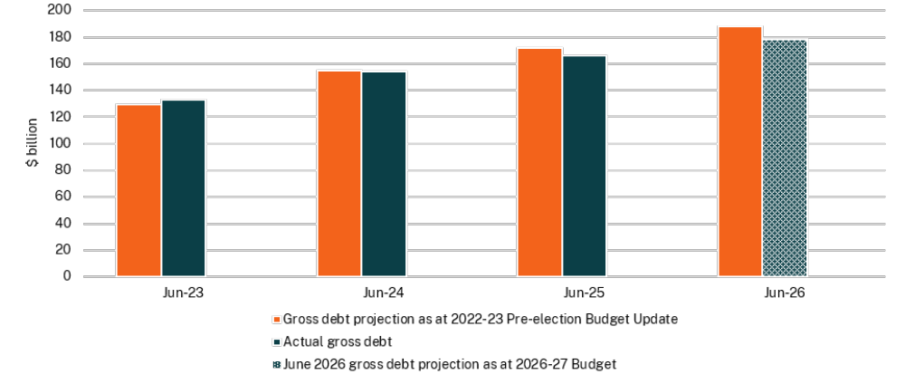

- Managing the State’s debt portfolio to manage interest expenses and refinancing risk
The NSW Government places a strong emphasis on managing the affordability of the State’s interest expenses and its refinancing risk. Between 2023-24 and 2025-26, interest expenses grew from $6.0 billion to $7.7 billion and are projected to grow further to $11.0 billion by June 2030.
Since January 2020, NSW Treasury Corporation (TCorp) 10-year bond yields have ranged from a low of around 1.0 per cent (in November 2020) to approximately 5.4 per cent on 29 May 2026. This is primarily driven by the Reserve Bank of Australia adjusting the cash rate to respond to prevailing and expected economic conditions. The average interest rate payable on new Crown borrowings was around 5.3 per cent during 2025-26 and is forecast to be 5.2 per cent over the forward estimates as interest rates are expected to stabilise at higher levels relative to recent history.
Reducing gross debt by $9.7 billion below the 2023 Pre-election Budget Update projection is expected to avoid approximately $400 million annually in interest expenses. In upcoming years, the State will need to refinance significant amounts of debt that was originally borrowed at much lower rates compared to prevailing rates. This is expected to put significant upward pressure on State interest expenses. The State is taking an active approach to managing this refinancing risk and interest expense impact through its debt manager, TCorp.
In addition, TCorp will explore opportunities for issuance in offshore markets to broaden its investor base and unlock new sources of demand. Expanding the international investor base enhances funding flexibility, lowers reliance on domestic markets, and strengthens NSW’s resilience to financial shocks. All offshore issuance is hedged back to Australian dollars. There is no foreign currency or foreign interest rate exposure to the State.
The Government’s interest expense as a percentage of revenue is estimated to be 7.2 per cent in 2028-29, 0.5 percentage points higher compared with the 2025-26 Half-Yearly Review. See Appendix E Fiscal reporting and sensitivities for more information on interest rate risk.
The NSW Government continues to actively manage the debt portfolio maturity profile to mitigate future funding and refinancing risk through issuing new debt at the longest possible tenors, strategically refinancing upcoming maturities and introducing new benchmark lines.

- The State’s net worth remains strong
General government net worth is projected to be $396.9 billion at June 2026, $26.3 billion higher than the projection in the 2025-26 Half-Yearly Review. This is primarily driven by the increase in the State’s equity investments in other public sector entities.
Over the four years to June 2030, net worth is projected to grow from $396.9 billion at June 2026 to $400.0 billion by June 2030 supported by growth in financial assets and asset revaluations.
All key balance sheet metrics, including gross debt and net debt, are shown in Table 6.1.

- Key balance sheet aggregates of the general government sector
 | June 2025 | June 2026 | June 2027 | June 2028 | June 2029 | June 2030
 | Actual | Revised | Budget | Forward Estimates
Total Assets ($m) | 660,591 | 695,201 | 703,162 | 713,594 | 727,501 | 743,702
Financial Assets ($m) | 241,546 | 258,139 | 254,923 | 254,517 | 260,959 | 267,876
Non-Financial Assets ($m) | 419,045 | 437,062 | 448,239 | 459,077 | 466,542 | 475,826
Total Liabilities ($m) | 289,038 | 298,344 | 317,224 | 329,249 | 335,264 | 343,750
Net Worth ($m) | 371,553 | 396,857 | 385,938 | 384,344 | 392,237 | 399,952
Net Worth as a per cent of GSP^{(a)} | 43.4 | 43.8 | 40.7 | 39.1 | 38.3 | 37.4
Net Debt ($m) | 105,194 | 117,446 | 129,348 | 135,653 | 139,453 | 144,806
Net Debt as a per cent of GSP^{(a)} | 12.3 | 13.0 | 13.7 | 13.8 | 13.6 | 13.5
Gross Debt ($m) | 165,991 | 178,482 | 193,840 | 202,891 | 210,016 | 219,392
Gross Debt as a per cent of GSP^{(a)} | 19.4 | 19.7 | 20.5 | 20.7 | 20.5 | 20.5

- Nominal GSP for New South Wales for 2025-26 to 2029-30 is forecast by NSW Treasury.

Table 6.1 shows the State’s total assets are projected to grow by $40.5 billion to $743.7 billion between June 2027 and June 2030. This is driven by a $13.0 billion increase in financial assets supported by OneFund and a $27.6 billion increase in non-financial assets supported by the Government’s infrastructure program – see Budget Paper No. 3 Infrastructure Statement. New South Wales’ projected gross debt as a share of the economy remains lower than most comparable Australian states and territories by June 2030 (see Chart 6.2).
- Gross debt to GSP projections for Australian states and territories – June 2030
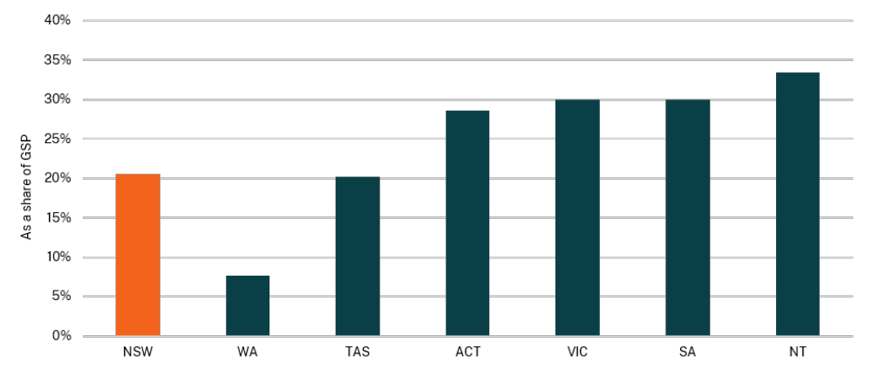
Note: Queensland is excluded as its 2026-27 Budget had not been released at the time of this analysis, and therefore June 2030 Queensland gross debt projection is not shown in the chart.
Source: NSW Treasury, 2026-27 Budget Papers for Western Australia, Tasmania, Australian Capital Territory, Victoria, South Australia, and Northern Territory.

- Managing investments and insurance liabilities with OneFund
In the 2024-25 Budget, the Government announced the OneFund initiative, whereby the State’s investment funds would be pooled together through a ‘master fund’ structure, with all funds sharing a common risk appetite statement and investment strategy.
OneFund aims for more efficient investment arrangements and enables greater investment opportunities by removing liquidity constraints of individual portfolios.
The Government has now implemented Phases One and Two of OneFund, which has brought together $70 billion of funds as at 30 April 2026. This Budget continues the implementation of OneFund by aligning the investment strategy of the State Super-administered defined benefit superannuation pools with that of OneFund. $115 billion is now projected to be managed under the Government’s OneFund strategy by June 2030.
Despite the financial market volatility experienced since the onset of the Middle East conflict, OneFund has continued to perform well. In the financial year to 30 April 2026, OneFund has returned 7.0 per cent, and 9.8 per cent per annum since it began in August 2024. In dollar-terms, this translates into total returns of $4.6 billion during 2025-26 to 30 April 2026 and around $9.7 billion since its establishment.
OneFund remains resilient despite this volatility due to its diversification across different asset types and geographical areas, supported by the implementation of risk-management measures. OneFund’s investment settings are reviewed regularly to ensure they remain fit for purpose and enable the Government to achieve its various policy purposes longer term.
A substantial portion of the investments in OneFund are held against insurance liabilities. As of 30 June 2026, it is projected that the Treasury Managed Fund (TMF) will have insurance liabilities totaling $21.6 billion and the Enhanced Police Support Scheme (EPSS) will have $300.0 million.
The funding position of these schemes has strengthened due to a range of reform initiatives undertaken by Government in recent years. Reforms to the Police Blue Ribbon Insurance scheme, with the introduction of the EPSS, has reduced Police insurance costs while maintaining critical supports to injured police officers. Workers compensation reforms will help ensure the long-term sustainability of the scheme and improve outcomes for workers and employers. Stronger investment returns from implementing the OneFund initiative are enhancing the value of the assets supporting these schemes. Investments held against those insurance liabilities have investment returns in line with OneFund, resulting in expected funding ratios of around 180 per cent for the EPSS and around 102 per cent for the TMF as at 30 June 2026.
The improved funding position and sustainability resulting from these reform efforts have allowed for $1 billion to be returned from the TMF in 2025-26, the first such return since 2017-18. This is in contrast to the $3.2 billion in additional transfers into the TMF over the past four years. This return will help keep borrowings and interest costs lower and support investment in other services and activities across government.
- Total annual OneFund investment returns and balances
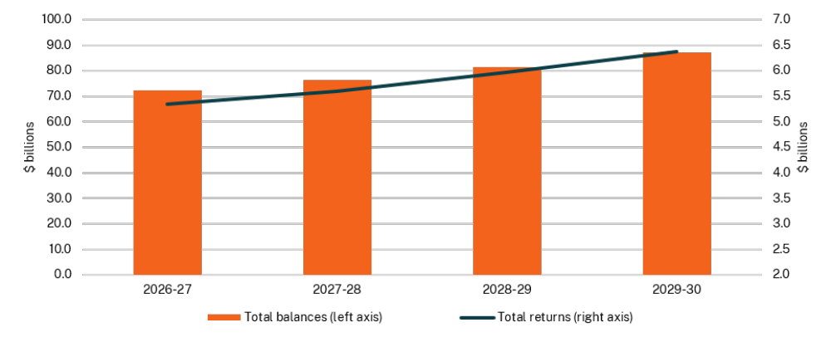
Note: Totals include returns and balances from the Lifetime Care and Support Authority Fund (LCSAF) and the Motor Accident Injuries Treatment and Care Benefits Fund (MAITCBF), which sit outside the General Government Sector.

Total liabilities are projected to increase by $26.5 billion between June 2027 and June 2030. Borrowings are the largest liability category on the general government sector balance sheet and are projected to increase from $190.7 billion at June 2027 to $216.2 billion by June 2030 as the State uses its balance sheet to help fund its infrastructure program.
TCorp is the State’s central borrowing authority and seeks to mitigate financing risk through diversification of funding sources and funding types. This includes the issuance of green and sustainability bonds through the NSW Sustainability Bond Programme (see Box 6.3), lengthening the maturity profile and issuing different types of debt instruments to appeal to a broader set of investors, including the potential to issue foreign currency debt in offshore markets.
One of the largest liabilities for the Government is its defined benefit superannuation liability. The liability is projected to be $31.9 billion at 30 June 2026 and remains on track to be fully funded by 2040. The NSW Government’s ability to meet this full funding commitment will be improved through implementation of OneFund Phase 3. This will see the investment strategy of defined benefit superannuation Pooled Funds aligned to that of OneFund, helping enhance investment returns.

- NSW Sustainability Bond Programme
The NSW Sustainability Bond Programme enables the NSW Government to facilitate capital flows towards its environmental and social goals. To date, $15.5 billion in total net proceeds has been raised across the bonds on issue and a further $12.6 billion is currently available for ongoing issuance. Proceeds are earmarked to refinance eligible projects with positive environmental and/or social outcomes, including:
- clean transportation
- sustainable water and wastewater management
- access to essential services
- affordable basic infrastructure
- affordable housing.
In January 2026, TCorp reclassified two existing sustainability bonds as benchmark bonds, enhancing their role in supporting TCorp’s funding activities. TCorp has raised $4.3 billion in net proceeds over this financial year, a 126 per cent increase compared to the amount raised, on average, in previous years.
- The State’s net proceeds allocated by project category, by bond
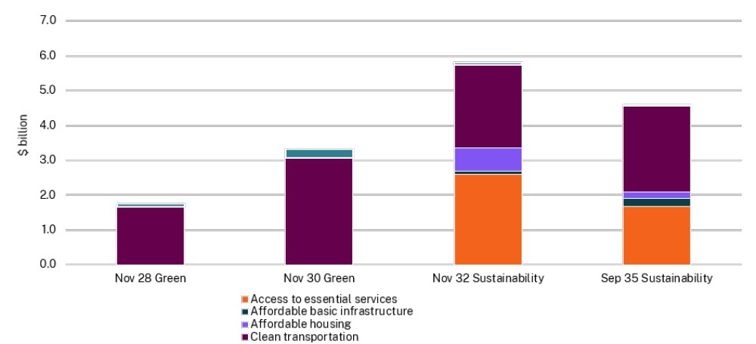
Note: Nov 28, Nov 30 Green bonds mature in November 2028 and November 2030 respectively, and the bond proceeds are used to support green assets. Nov 32 and Sep 35 Sustainability bonds mature in November 2032 and September 2035 respectively, and the bond proceeds are used to support green and social assets.

Government businesses
- The NSW Government owns and oversees a range of public sector commercial entities that are critical to delivering essential services and driving the State’s economic growth. These entities are required to balance public policy objectives with commercial performance and accountability.
- The commercial entities include State Owned Corporations (SOCs), as well as other public non-financial corporations (PNFCs) and public financial corporations (PFCs). They operate independently from the Government and are governed by Treasury’s Commercial Policy Framework.
- Government businesses are contributing to the State’s goal of increasing housing supply. Landcom continues to expand affordable housing supply in metropolitan and regional New South Wales. Sydney Water and Hunter Water remain committed to delivering essential water, wastewater and stormwater infrastructure to support housing.
- SOCs continue to adapt to the State’s energy transition by prioritising the decarbonisation of the energy sector and supporting the shift to renewable energy. They are also exploring a broad range of renewable energy solutions, including renewable energy generation, energy storage and efficient connections to the network.
- The total dividend and tax equivalent payments by entities in the PNFC and PFC sectors were $1.0 billion in 2025-26 and are forecast to be $4.5 billion over the budget year and forward estimates to 2029-30.

- Reforms and initiatives of State Owned Corporations

Property

Landcom
Landcom is the State’s land and property development organisation that develops land to achieve both public outcomes and financial benefits for the State and people of New South Wales.
Since 2023-24, Landcom has secured new sites capable of delivering over 5,000 lots and continues to pursue opportunities through the NSW Government land audit and private market.
Over recent years, the Government has provided additional funding to Landcom to meet its various housing targets, including:
- $450.0 million equity injection in the 2024-25 Budget for the Essential Workers Build to Rent program
- $300.0 million dividend reinvestment in the 2023-24 Budget to accelerate investment in affordable and market housing
- $60.0 million in the 2023-24 Budget, and an additional $5.0 million in the 2024-25 Budget, to deliver 110 build-to-rent homes on the South Coast and Northern Rivers regions.

Over the forward estimate years, Landcom is focusing on the following areas:
- delivering built form faster and in more innovative ways
- impactful presence in regional New South Wales
- leading in the delivery of affordable housing
- increasing market housing supply.
Outside of Greater Sydney, Landcom's portfolio spans the Hunter region, the Northern Rivers, the South Coast, and Central Tablelands. In 2025, Landcom secured development approvals and rezonings for projects in Annandale, Bulli, Bomaderry, East Lismore, Edmondson Park, Lachlan’s Line, Orange and Burdekin Road Schofields.
Landcom’s new built form function is piloting modern methods of construction to explore new approaches to productivity and delivery. This initiative will test modular building techniques for medium-density housing, including the Pattern Book, with the goal of accelerating timelines and reducing costs while maintaining design integrity and comfort.

- Update on the Build to Rent program
For the first time, Landcom is delivering build-to-rent housing in both metropolitan Sydney and regional New South Wales, with over 500 units to be held on Landcom’s balance sheet. These projects will offer secure, long-term rental options for essential workers and communities in need.
In 2025, Landcom commenced construction for two regional build-to-rent pilot projects on the NSW South Coast and Northern Rivers Regions, targeting completion by December 2026.
Landcom is also making progress on delivering 400 build-to-rent dwellings for essential workers in metropolitan Sydney. The development of the Joinery Annandale site will create a revitalised mixed-use precinct that will include 220 build-to-rent units for essential workers.
Landcom is transforming a former Sydney Metro construction site in Chatswood into hundreds of new homes, including 180 build-to-rent apartments for essential workers such as health workers, teachers and paramedics.
The build-to-rent dwellings in metropolitan Sydney are anticipated for completion in late 2028.

Water
The NSW Government owns three SOCs in the water sector – WaterNSW, Sydney Water Corporation (Sydney Water) and Hunter Water Corporation (Hunter Water). WaterNSW supplies bulk water to metropolitan and regional areas while Sydney Water and Hunter Water deliver essential water and wastewater services to households in Greater Sydney, Illawarra and the Lower Hunter. These businesses play a pivotal role in safeguarding public health and the environment through sustainable water management.
The revenues for these businesses are subject to regulation by the Independent Pricing and Regulatory Tribunal (IPART), which generally hands down pricing determinations every five years.

- Independent Pricing and Regulatory Tribunal water pricing determinations
The forecast financial results of the water businesses, and the distributions they make to the NSW Government, are impacted by the outcomes of IPART’s pricing reviews. In 2025-26, IPART undertook pricing reviews for the following three water services and published the final pricing determinations in June 2026:
- WaterNSW’s regional and rural bulk water services
- WaterNSW’s Murray River to Broken Hill pipeline services
- Essential Energy’s water and wastewater services, which is provided by its water operating division - Essential Water, in the Broken Hill area.
The businesses will update their financial forecasts following the 2026-27 Budget to reflect IPART's Final Determination outcomes.

Sydney Water Corporation
Water infrastructure sits at the heart of the city’s biggest priorities – new homes, thriving precincts and a more productive, resilient economy.
IPART has set Sydney Water’s prices for 2025-2030, which fund Sydney Water’s program of capital works to support Sydney's housing growth and long-term water security needs, in line with the Greater Sydney Water Strategy.
During the 2025-26 financial year, Sydney Water opened the $250.0 million major upgrade to the West Camden water resources recovery facility. This doubled the treatment capacity of the plant to ensure sufficient capacity to service up to 72,000 new dwellings in the catchment by 2046.
Key projects underway include the following:
- Over $2.0 billion in major North-West Treatment Hub upgrades of water resource recovery facilities at Rouse Hill, Castle Hill, Richmond, Riverstone and Quakers Hill. This will accommodate significant population growth across Sydney’s north-west over the next decade.
- The $1.2 billion Upper South Creek Advanced Water Recycling Centre (Stage 1), which will be completed in line with the opening of the Western Sydney International Airport in 2026. As well as servicing the new airport, the centre will provide reliable wastewater services to 400,000 people in south-west Sydney by 2056.
- Over $1.0 billion for works at the Liverpool and Glenfield water resource recovery facilities to upgrade the Malabar wastewater system. This services over one-third of Sydney’s population and is expected to cater for a population increase in the catchment from 2.3 million people in 2026 to 2.9 million in 2056.
- Approximately $1.0 billion being invested in the Upper South Creek Networks program. This services 130,000 new dwellings and will create 217,000 new jobs by 2056 across catchments stretching from North Luddenham in the north, Catherine Fields in the south, Badgerys Creek in the east and Duncans Creek to the west.
- $644.0 million, funded by developer contributions, is being spent to develop the stormwater management scheme across the Mamre Road precinct to deliver 850 hectares of industrial land and 17,000 ongoing jobs, with work commencing on stormwater management for the Aerotropolis precincts.
Sydney Water has reduced approval times for developer servicing and infrastructure approvals through streamlined processes and improved engagement with industry, enabling faster progression from planning to construction and supporting the timely delivery of housing.
Sydney Water’s strategy for servicing data centres focuses on enabling timely and reliable connections to support economic growth while protecting broader customer outcomes. Recognising rapid growth, high reliability needs and demand uncertainty, Sydney Water is adopting a staged, location specific servicing approach. This approach is supported by principles of full cost recovery, water efficiency, and ensuring that servicing large users does not adversely impact system capacity, service levels, or prices for other customers.

Hunter Water Corporation
Hunter Water is investing in a safe, secure and sustainable water supply for the Lower Hunter, while balancing customer affordability.
Hunter Water is delivering the Belmont Desalination Plant. Once complete, the plant will produce up to 30 million litres of drinking water per day, representing approximately 15 per cent of the region’s average demand. The plant will be powered by 100 per cent renewable energy through on-site solar and market purchases. Construction is underway with first water expected in 2028.
In addition to improving water security, enabling growth is a strategic priority for Hunter Water. It will invest $36.1 million in 2026-27 to support regional growth and economic prosperity, including facilitating new housing. Key projects underway include:
- Cessnock Trunk Water Main upgrade
- upgrades to Burwood Beach (Stage 3) and Morpeth Wastewater Treatment Works (Stage 4)
- upgrades at Grahamstown Water Treatment Plant.
Hunter Water recognises cost-of-living pressures in its community and is committed to keeping bills as low as possible. Hunter Water has implemented a Cost Efficiency Strategy and is realising productivity improvements to keep downward pressure on customer bills. To help ensure equitable access to essential water and wastewater services, Hunter Water and the NSW Government have strengthened customer support and hardship assistance programs.
Hunter Water is progressing towards net zero Scope 1 and 2 greenhouse gas emissions by 2035, aligning with its commitment to environmental sustainability and the views of its customers and community. Key initiatives include a power purchase agreement to achieve 100 per cent renewable electricity supply for large sites by 2030, and expansion of onsite renewable energy generation.

WaterNSW
WaterNSW’s Renewable Energy and Long Duration Storage programs continue to support the development of renewable energy projects that contribute to the NSW Government’s net zero targets and a sustainable WaterNSW by leveraging the organisation’s existing asset base.
In February 2026, two projects under the Renewable Energy program were declared Critical State Significant Infrastructure:
- the Western Sydney Pumped Hydro project near Lake Burragorang, developed by ZEN Energy
- the Phoenix Pumped Hydro project near Lake Burrendong, developed by ACEN Australia.
The pumped hydro projects at Glenbawn and Glennies Creek dams continue to progress and are currently in the early stages of development. WaterNSW’s pre-feasibility studies have identified three more shortlisted sites for pumped hydro, at Blowering, Burrendong and Hume dams.

WaterNSW continues to support the NSW Government’s Town Water Risk Reduction Program by sharing expertise with local water utilities, identifying upstream risks, providing raw water quality safety guidance, and equipping councils with practical tools to manage source water risks.

Energy

Essential Energy
Essential Energy operates and maintains one of Australia’s largest electricity distribution networks. Essential Energy focuses on the future needs of customers in regional, rural and remote communities.
Essential Energy is developing projects to facilitate utility scale renewable generation connections to its distribution network in the Dubbo region and across other parts of New South Wales. It is also undertaking a market process for the deployment of high voltage battery storage on land adjacent to Essential Energy zone substations. Increased use of the network in these ways helps to maintain reliability and security of supply for rural and regional customers in New South Wales.

Ports

Port Authority of NSW (Port Authority)
Port Authority is responsible for all commercial marine functions in the ports of Sydney Harbour, Port Botany, Newcastle Harbour, Port Kembla, Port of Eden and Port of Yamba. These include the statutory Harbour Master’s function, pilotage and navigation services, port safety functions, and port and terminal operations.
Port Authority established a dedicated working group to oversee and drive decarbonisation of its vessel fleet focused on identifying and developing opportunities for gradual transition from traditional fossil fuel engines to low or zero carbon fuels and exploring alternative propulsion technologies.
Shore power infrastructure at the White Bay Cruise Terminal will be operational in 2026-27. Powered by 100 per cent renewable energy, shore power enables vessels to switch off their engines while at berth, resulting in a substantial reduction in greenhouse gas emissions, improved local air quality and decreased noise pollution.
The Berthing Infrastructure Project at the Overseas Passenger Terminal (OPT) involves the installation of a long term engineered scour protection solution to protect the OPT wharf structure and seabed from scour and accretion caused by cruise ship activity. The project is critical to maintaining safe, efficient and reliable berthing at the OPT and safeguarding the long term availability of the cruise terminal.
Port Authority is continuing to work closely with Government on the transition of Glebe Island, maintaining safe and efficient harbour operations, while supporting the Government’s long-term objectives for the precinct. As part of the transformation of the Bays West precinct, bulk port operations – including cement, gypsum and sugar handling – will cease on Glebe Island by no later than 2030. The expected corresponding decrease in Port Authority’s dividends from a reduction in lease and associated revenue has been included in the budget forecast. No potential revenue has been forecast as any revenue is expected to support related infrastructure.

Forestry

Forestry Corporation of NSW (Forestry Corporation)
Forestry Corporation manages State forests. It delivers a range of public services including firefighting, tourism, conservation and recreation, and produces renewable hardwood and softwood timber for a range of purposes including public infrastructure and housing construction.
Forestry Corporation is progressing with explorations into wind farm opportunities within the State Forest Pine Plantations as part of efforts to support renewable electricity generation across New South Wales.
On 7 September 2025, the Government announced a temporary moratorium on timber harvesting within the proposed boundary of the Great Koala National Park, along with a comprehensive worker and industry support package. The corresponding impact from the moratorium on Forestry Corporation’s financials and subsequent industry adjustments have been included in the budget forecast.
- Capital expenditure
In 2025-26, capital expenditure within the PNFC sector is projected to be $7.4 billion, which is $318.8 million lower than projected in the 2025-26 Half-Yearly Review.
Over the budget year and forward estimates, capital expenditure within the PNFC sector is projected to be $32.2 billion. This is $4.0 billion higher than projected in the comparative forecast periods in the 2025-26 Half-Yearly Review.
Key drivers include a:
- $1.4 billion increase from Sydney Trains due to the reprofiling of Transport Asset Manager licence fees
- $1.2 billion increase from Essential Energy primarily driven by the Dubbo Distribution Project
- $469.9 million increase from WaterNSW due to capital projects being brought forward from future years to address priority asset and operational risks
- $367.6 million and $151.8 million increases from Sydney Water and Hunter Water respectively, due to changes in project timing and the reprofiling of major projects, including the Belmont Desalination Plant.
- Capital expenditure of the PNFC sector
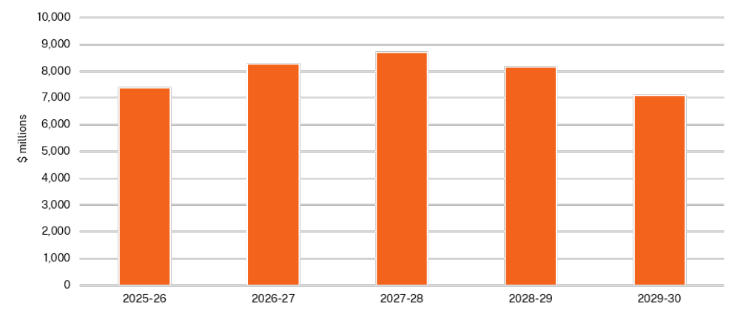

- Major public financial corporations

NSW Treasury Corporation (TCorp)
TCorp is the State's investment management agency and central financing authority. TCorp's total funds under management was around $125.3 billion as at 30 April 2026, making it one of Australia's largest fund managers.
As at 30 April 2026, TCorp has raised $26.0 billion face value in debt funding and had maturities of $3.9 billion face value during 2025-26. The NSW Sustainability Bond Programme remains at $16.4 billion face value outstanding, making TCorp one of the largest Government issuers of sustainability bonds in Australia.

Insurance and Care NSW (icare)
icare supports people, businesses, and communities across New South Wales through the delivery of affordable and sustainable insurance and quality care. Its roles include providing workers compensation insurance for nearly 4 million workers and volunteers, and protecting around $533.0 billion of the State's assets.
A key focus for icare is to strengthen its financial and commercial performance to support the long-term sustainability of its insurance schemes and deliver on its statutory objectives. This includes a sustained focus on improving operational efficiency and reducing core operating costs, supported by structural and organisational changes. Key initiatives have included bringing together the Nominal Insurer and Treasury Managed Fund workers compensation schemes under a single group executive, simplifying organisational layers, and removing like roles.
icare is strengthening its performance framework, including aligning enterprise metrics more closely to financial outcomes, improving transparency, and lifting accountability for delivery against targets agreed with the Board and NSW Treasury.
Further efficiencies are being driven through a targeted program of capital and operational investment focused on improving operational capability, governance, and service delivery. icare has forecast targeted operational savings of $175.0 million over the four years to 2029-30, supporting a disciplined transformation agenda that prioritises cost control, operational effectiveness, and risk management.
Collectively, these initiatives are intended to improve operational performance, strengthen financial oversight, and reinforce icare’s accountability to government, while supporting the efficient delivery of scheme outcomes.
- Returns to the Government from the PNFC and PFC sectors
SOCs and TCorp pay dividends to the State as a return on the Government’s investments in these entities. These entities also pay tax equivalents and debt neutrality charges (government guarantee fees) to ensure competitive neutrality.
Total dividend and tax equivalent payments from the PNFC and PFC sectors are forecast to be $1.0 billion for 2025-26, which is $2.3 million higher than the forecast in the 2025-26 Half-Yearly Review.
Over the budget year and forward estimates, total dividend and tax equivalent payments to the Government from the PNFC and PFC sector are forecast to be $4.5 billion, which is $214.0 million higher than the forecast in the 2025-26 Half-Yearly Review.

Key movements include:
- $211.0 million and $91.1 million increases in Sydney Water and Hunter Water’s dividends respectively, reflecting increased revenue certainty from IPART’s final price determinations for the 2025-26 to 2029-30 pricing period
- a $124.1 million increase from Landcom’s dividends as revenue transactions which are included in the total dividends and tax equivalent payments, instead of ‘other economic flows’ as in previous years, following accounting advice
- $89.4 million decrease in Sydney Water’s income tax equivalents, which was caused by higher interest expense due to increased interest rates and higher operating costs associated with an increase in delivering their Software-as-a-Service and cloud-based projects.
Government guarantee fees are projected to be $367.9 million in 2025-26 and are forecast to total $1.8 billion over the budget year and forward estimates. This is a $174.9 million decrease over the projection, budget year and forward estimates from the 2025-26 Half-Yearly Review, with fee estimates updated to reflect prevailing market rates.
Key movements over the budget year and forward estimates include decreases in the government guarantee fees of $113.3 million for Sydney Water, $28.9 million for Hunter Water and $26.5 million for Essential Energy compared to the 2025-26 Half-Yearly Review.
- Total dividend and tax equivalent payments from the PNFC and PFC sectors
 | 2025-26 | 2026-27 | 2027-28 | 2028-29 | 2029-30
 | Projection | Budget | Forward Estimates
 | $m | $m | $m | $m | $m
Public non-financial corporations
Essential Energy | - | - | 48 | 41 | -
Forestry Corporation of NSW | - | - | - | - | -
Hunter Water Corporation | 66 | 80 | 105 | 128 | 142
Landcom | 25 | 29 | 50 | 58 | 68
Port Authority of NSW | 43 | 28 | 30 | 25 | 20
Sydney Water Corporation | 583 | 601 | 480 | 556 | 593
WaterNSW | 51 | 68 | 76 | 88 | 78
Public financial corporations
NSW Treasury Corporation | 237 | 240 | 279 | 289 | 298
TOTAL DIVIDEND AND TAX EQUIVALENT PAYMENTS | 1,004 | 1,046 | 1,069 | 1,184 | 1,199

A. Statement of Finances
This appendix presents the financial aggregates for the 2026-27 Budget.
Financial aggregates in this appendix are prepared in line with:
- the Uniform Presentation Framework (UPF) administered by the Council on Federal Financial Relations (CFFR)
- Australian Accounting Standard AASB 1049 Whole of Government and General Government Sector Financial Reporting (AASB 1049), which adopts a harmonised Government Finance Statistics (GFS)/Generally Accepted Accounting Principles (GAAP) reporting basis.
A six-year time series is provided from 2024-25 to 2029-30 for the general government sector (GGS), public non-financial corporations (PNFC) sector and consolidated non-financial public sector (NFPS).
An analysis of general government expenses is presented in Chapter 5: Recurrent expenditure and looks at each element of expenses by the Classification of Functions of Government - Australia (COFOG-A) category.
How to Read the Budget Papers outlines the accounting policies and forecast assumptions adopted in the Budget. The UPF tables quantify the impact of these policies and assumptions on the forward estimates from 2026-27 to 2029-30. These forecasts also include the impact from the adoption of new accounting standard AASB 17 Insurance Contracts from 2026-27.

- Introduction
This appendix presents financial aggregates for the GGS, PNFC sector and NFPS. These aggregates are prepared in line with the revised UPF agreed by the Council on Federal Financial Relations in February 2019.
The objective of the UPF is to facilitate a better understanding of an individual government’s budget and provide for more meaningful comparisons of each government’s financial results and projections.
The format of the aggregates is based on reporting standards set out by AASB 1049, which adopts a harmonised GFS/GAAP reporting basis.
The UPF financial aggregates:
- allow consistent comparisons between the financial positions of Australian governments
- facilitate time series comparisons since they are relatively unaffected by changes in public sector administrative structures
- permit an assessment of how public sector transactions affect the economy by providing data classified by economic type.
- Uniform Presentation Framework
The NSW Government financial tables in this appendix are prepared under the UPF. Additional disclosures explain matters specific to New South Wales.

Framework
The UPF tables are in line with AASB 1049 which:
- adopts GAAP definitions, including recognition and measurement principles in almost all cases
- amends presentation requirements to encompass a comprehensive result that retains the GAAP classification system but overlays it with the transactions and other economic flows classification system based on GFS
- expands the disclosure requirements to include key fiscal aggregates required by GFS.
Due to differences in reporting classifications, GFS financial aggregates released by the Australian Bureau of Statistics (ABS) will differ from UPF aggregates. For more information on other differences, see the primary financial statements later in this appendix. For details and amounts of the key 2024-25 convergence differences, refer to Note 35: Government Finance Statistics in the 2024-25 Report on State Finances.

Historical series

To ensure a consistent historical series of fiscal aggregates, all jurisdictions have agreed to back cast published historical data on a best endeavours basis. For example, historical information in the consolidated operating statements has been recast on the basis of available dissections between GFS transactions and other economic flows.

Fiscal measures
UPF reporting measures evaluate the soundness of a government’s fiscal position and the effect of fiscal policy on the economy. The fiscal measures in the UPF framework are:
- net operating balance
- net lending/borrowing (fiscal balance)
- net worth
- change in net worth (comprehensive result)
- net debt
- net financial worth
- net financial liabilities
- cash surplus/(deficit).
Definitions of these measures are set out in the glossary in the How to Read the Budget Papers guide.
Flow measures (net operating balance, net lending/borrowing and change in net worth) show changes in the fiscal position during the reporting period, reflecting the impact of government decisions and actions, and re-measurement effects during that time. Flows represent the creation, transformation, exchange, transfer or extinction of economic value.
Stock measures (net worth, net debt, net financial worth and net financial liabilities) highlight a government’s fiscal position at a point in time, providing information on the aggregate results of past decisions.
- Primary financial statements

UPF presentation
Public sector estimates and outcomes are presented on an accrual accounting basis in three AASB 1049 based primary statements: the operating statement, including other economic flows; the balance sheet; and the cash flow statement. AASB 1049 adopts GFS principles where this does not conflict with GAAP. Details of key convergence differences between GFS and GAAP are explained in this appendix. The following statements form the UPF’s core reporting requirements.

Operating statement and balance sheet
The operating statement:
- presents information on transactions (revenue and expenses) and other economic flows (revaluations and other adjustments)
- captures the composition of revenues and expenses and the net cost of government activities within a fiscal year
- shows the full cost of resources consumed by the government in achieving its objectives and the extent that these costs are met from various revenue sources
- shows information on capital expenditure and asset sales to derive a net lending/borrowing position.

The operating statement also reports three major fiscal measures:
- net operating balance which is calculated as revenue minus expenses from transactions. New South Wales recognises its budget result as the net operating balance for the general government sector
- total change in net worth (comprehensive result) which starts with the net operating balance and includes other economic flows such as revaluations
- net lending/borrowing (fiscal balance) which starts with the net operating balance and includes net capital expenditure but excludes depreciation, giving the best indicator of a jurisdiction’s call on financial markets.
The balance sheet:
- records the value of financial and non-financial assets and liabilities of the State, at the end of each financial year
- shows the resources at the State’s disposal and the type and valuation of its liabilities
- reveals the make-up of the State’s financial assets, its fixed asset holdings and the extent of liabilities such as borrowings and unfunded superannuation.
The UPF balance sheet fiscal aggregates include net worth, net financial worth, net financial liabilities and net debt.

Cash flow statement
The cash flow statement reveals how a government obtains and expends cash. It shows how government cash inflows and outflows are allocated between various activities, and their net impact on cash held.
This statement requires cash flows to be categorised into:
- operating activities comprising activities linked to collecting taxes, distributing grants and providing goods and services
- investing activities comprising activities linked to acquiring and disposing financial and non-financial assets
- financing activities comprising activities linked to changing the size and composition of a government’s financial structure.
The sign convention within the cash flow statement is that all inflows carry a positive sign and all outflows carry a negative sign (regardless of whether they are gross or net cash flows).
The cash flow statement reports two fiscal measures:
- net increase in cash held which is the sum of net cash flows from all operating, investing and financing activities
- cash surplus/(deficit) which comprises net cash from operating activities, plus sales and less purchases of non-financial assets.
New South Wales uses the AASB 1049 cash result as its headline cash result.

Institutional sectors
The list of the NSW public sector entities is provided in How to Read the Budget Papers. These NSW-controlled entities have been classified according to their government sector. These sectors are defined in the ABS GFS manual.

- UPF tables
These tables are set out by institutional sectors showing the order of operating statement, balance sheet and cash flow statement.
In addition to the UPF minimum disclosure requirements, these tables include a time series for historical and forward years. The tables for general government sector also include:
- tax revenues by type
- a dissection of grant revenue and expense
- dividend and income tax equivalent income by sector
- total expenses by function (COFOG-A)
- purchase of non-financial assets by function (COFOG-A).

- General government sector operating statement
 | 2024-25 | 2025-26 | 2026-27 | 2027-28 | 2028-29 | 2029-30
 | Actual | Revised | Budget | Forward Estimates
 | $m | $m | $m | $m | $m | $m

Revenue from Transactions
Taxation | 48,206 | 51,776 | 52,149 | 55,592 | 58,619 | 60,700
Grants | 46,940 | 52,156 | 52,822 | 53,325 | 55,909 | 58,303
Sale of Goods and Services | 10,379 | 10,859 | 11,676 | 11,996 | 12,831 | 12,770
Interest | 810 | 531 | 646 | 638 | 642 | 659
Dividend and Income Tax Equivalents from Other Sectors | 650 | 1,004 | 1,046 | 1,069 | 1,184 | 1,199
Other Dividends and Distributions | 4,219 | 3,633 | 5,018 | 5,265 | 4,873 | 5,163
Fines, Regulatory Fees and Other | 6,806 | 6,760 | 7,330 | 7,723 | 7,167 | 7,328
Total Revenue from Transactions | 118,009 | 126,719 | 130,687 | 135,609 | 141,225 | 146,122
Expenses from Transactions
Employee | 48,193 | 50,940 | 53,352 | 53,929 | 57,014 | 59,375
Superannuation
Superannuation Interest Cost | 1,623 | 1,549 | 1,566 | 1,503 | 1,430 | 1,376
Other Superannuation | 5,007 | 5,449 | 5,621 | 5,646 | 5,906 | 6,079
Depreciation and Amortisation | 9,653 | 10,304 | 10,728 | 11,208 | 11,865 | 12,233
Interest | 7,137 | 7,678 | 8,950 | 9,606 | 10,164 | 11,027
Other Operating Expenses | 27,713 | 28,092 | 27,872 | 28,720 | 28,505 | 30,265
Grants, Subsidies and Other Transfers | 23,752 | 25,756 | 24,942 | 23,886 | 24,581 | 23,887
Total Expenses from Transactions | 123,078 | 129,769 | 133,032 | 134,498 | 139,465 | 144,243
BUDGET RESULT - SURPLUS/(DEFICIT)  [Net Operating Balance] | (5,069) | (3,049) | (2,345) | 1,110 | 1,760 | 1,879

Table A.1: General government sector operating statement (cont)
 | 2024-25 | 2025-26 | 2026-27 | 2027-28 | 2028-29 | 2029-30
 | Actual | Revised | Budget | Forward Estimates
 | $m | $m | $m | $m | $m | $m

Other Economic Flows - included in the Operating Result
Gain/(Loss) from Other Liabilities | (484) | 1,616 | (427) | (247) | 49 | 59
Other Net Gains/(Losses) | 1,568 | 1,325 | 127 | (135) | 679 | 793
Share of Earnings/(Losses) from Associates and Joint Ventures | (246) | 34 | (110) | (168) | (279) | (419)
Dividends from Asset Sale Proceeds | 40 | ... | ... | ... | ... | ...
Deferred Income Tax from Other Sectors | 85 | 70 | 103 | 180 | 176 | 136
Other | (337) | (192) | (40) | (40) | (41) | (41)
Other Economic Flows - included in Operating Result | 627 | 2,853 | (346) | (410) | 585 | 527
Operating Result | (4,442) | (196) | (2,691) | 700 | 2,344 | 2,407
Other Economic Flows - Other Comprehensive Income
Items that will not be Reclassified to Operating Result | 8,840 | 25,499 | (8,254) | (2,294) | 5,548 | 5,309
Revaluations | 6,967 | 4,679 | 1,882 | 1,980 | 1,905 | 1,849
Share of Associate's Other Comprehensive Income/(Loss) that will not be Reclassified Subsequently to Operating Result | (335) | 3 | ... | ... | ... | ...
Remeasurements of Post-Employee Benefits | 296 | 5,619 | (2,220) | (914) | 886 | 851
Net Gain/(Loss) on Equity Instruments at Fair Value through Other Comprehensive Income | 1,628 | 15,166 | (8,005) | (3,447) | 2,668 | 2,514
Deferred Tax Direct to Equity | 375 | 82 | 61 | 58 | 61 | 64
Other | (92) | (49) | 29 | 29 | 29 | 30
Items that may be Reclassified Subsequently to Operating Result | 0 | (0) | ... | ... | ... | ...
Net Gain/(Loss) on Financial Instruments at Fair Value | 0 | (0) | ... | ... | ... | ...
Other Economic Flows - Other Comprehensive Income | 8,840 | 25,499 | (8,254) | (2,294) | 5,548 | 5,309
Comprehensive Result - Total Change in Net Worth | 4,398 | 25,303 | (10,945) | (1,593) | 7,893 | 7,715
Key Fiscal Aggregates
Comprehensive Result - Total Change in Net Worth | 4,398 | 25,303 | (10,945) | (1,593) | 7,893 | 7,715
Less: Net Other Economic Flows | (9,466) | (28,353) | 8,600 | 2,704 | (6,133) | (5,836)
Equals: Budget Result - Net Operating Balance | (5,069) | (3,049) | (2,345) | 1,110 | 1,760 | 1,879
Less: Net Acquisition of Non-Financials Assets
Purchases of Non-Financials Assets^{(a)} | 20,103 | 22,049 | 21,104 | 20,541 | 20,358 | 19,903
Sales of Non-Financial Assets | (417) | (1,028) | (1,602) | (1,585) | (2,864) | (764)
Less: Depreciation | (9,653) | (10,304) | (10,728) | (11,208) | (11,865) | (12,233)
Plus: Change in Inventories | 240 | 71 | 50 | 129 | (410) | (68)
Plus: Other Movements in Non-Financials Assets
Assets Acquired Using Leases^{(a)} | 815 | 745 | 661 | 780 | 679 | 687
Assets Acquired Using Service Concession Arrangements under
- Finance Liability Model^{(a)} | 706 | 130 | 111 | 20 | ... | ...
- Grant of Right to the Operator Model | 1,772 | 1,675 | 1,309 | 756 | 140 | 36
Other | (639) | (439) | (989) | (449) | (984) | (238)
Equals: Total Net Acquisition of Non-Financial Assets | 12,926 | 12,899 | 9,915 | 8,985 | 5,053 | 7,323
Equals: Net Lending/(Borrowing) [Fiscal Balance] | (17,994) | (15,948) | (12,260) | (7,875) | (3,294) | (5,443)
OTHER FISCAL AGGREGATES
Capital Expenditure^{(a)} | 21,623 | 22,924 | 21,876 | 21,342 | 21,037 | 20,590

- Capital expenditure comprises purchases of non-financial assets plus assets acquired using leases and assets acquired using Service Concession Arrangements under the Financial Liability Model.

- General government sector balance sheet
 | June 2025 | June 2026 | June 2027 | June 2028 | June 2029 | June 2030
 | Actual | Revised | Budget | Forward Estimates
 | $m | $m | $m | $m | $m | $m

Assets
Financial Assets
Cash and Cash Equivalents | 1,653 | 280 | 1,021 | 1,013 | 967 | 955
Receivables | 14,467 | 15,325 | 15,443 | 15,153 | 15,135 | 15,186
Current Tax Receivable | 33 | 40 | 66 | 78 | 82 | 87
Investment, Loan and Placements at Fair Value | 55,178 | 57,546 | 59,297 | 61,609 | 64,928 | 68,977
Investment, Loan and Placements at Amortised Cost | 3,025 | 2,190 | 2,569 | 2,619 | 2,788 | 2,753
Advances Paid | 940 | 1,020 | 1,604 | 1,998 | 1,880 | 1,901
Equity Investments
Investments in Other Public Sector Entities | 156,439 | 171,892 | 165,172 | 162,375 | 165,756 | 169,010
Investments in Associates and Joint Ventures | 9,791 | 9,826 | 9,716 | 9,638 | 9,386 | 8,973
Other Equity Investments | 20 | 20 | 35 | 35 | 35 | 35
Total Financial Assets | 241,546 | 258,139 | 254,923 | 254,517 | 260,959 | 267,876
Non-Financial Assets
Contract Assets | 81 | 54 | 55 | 56 | 57 | 57
Reinsurance Contract Assets | ... | ... | 209 | 184 | 166 | 148
Inventories | 1,493 | 779 | 829 | 949 | 553 | 485
Forestry Stock and Other Biological Assets | 21 | 21 | 21 | 21 | 21 | 21
Assets Classified as Held for Sale | 409 | 868 | 313 | 724 | 286 | 286
Property, Plant and Equipment
Land and Buildings | 147,987 | 152,759 | 157,417 | 160,093 | 162,570 | 164,872
Plant and Equipment | 16,171 | 16,238 | 16,317 | 16,400 | 15,575 | 14,607
Infrastructure Systems | 234,915 | 247,841 | 254,658 | 262,238 | 269,210 | 277,494
Right-of-Use Assets | 6,524 | 6,506 | 6,445 | 6,384 | 6,275 | 6,207
Intangibles | 5,448 | 5,556 | 5,706 | 5,548 | 5,098 | 4,705
Deferred Tax Assets^{(e)} | 4,487 | 4,640 | 4,806 | 5,043 | 5,280 | 5,480
Other Non-Financial Assets | 1,510 | 1,799 | 1,462 | 1,437 | 1,452 | 1,464
Total Non-Financial Assets | 419,045 | 437,062 | 448,239 | 459,077 | 466,542 | 475,826
Total Assets | 660,591 | 695,201 | 703,162 | 713,594 | 727,501 | 743,702
Liabilities
Deposits Held | 351 | 353 | 2,671 | 2,726 | 2,770 | 2,805
Payables | 10,224 | 9,911 | 9,992 | 10,277 | 10,245 | 10,210
Current Tax Payable | 46 | 0 | ... | ... | ... | ...
Borrowings and Derivatives at Fair Value | 14 | 30 | 30 | 30 | 30 | 30
Borrowings at Amortised Cost | 165,223 | 177,580 | 190,649 | 199,684 | 206,804 | 216,177
Advances Received | 402 | 520 | 489 | 451 | 412 | 379
Contract Liabilities | 970 | 1,061 | 1,003 | 1,006 | 988 | 988
Insurance Contract Liabilities | ... | ... | 2,044 | 2,105 | 2,171 | 2,225
Employee Benefits Liabilities | 32,310 | 33,745 | 35,040 | 36,083 | 36,786 | 37,732
Superannuation Provision^{(a)} | 37,801 | 31,897 | 33,963 | 34,701 | 33,479 | 32,130
Other Provisions | 19,111 | 18,537 | 16,785 | 16,983 | 17,492 | 18,144
Deferred Tax Liabilities | 17 | 15 | 15 | 15 | 15 | 15
Other Liabilities | 22,568 | 24,695 | 24,542 | 25,187 | 24,071 | 22,914
Total Liabilities | 289,038 | 298,344 | 317,224 | 329,249 | 335,264 | 343,750
NET ASSETS | 371,553 | 396,857 | 385,938 | 384,344 | 392,237 | 399,952
NET WORTH
Accumulated Funds | 66,637 | 73,777 | 70,603 | 71,844 | 76,520 | 81,228
Reserves | 304,916 | 323,079 | 315,335 | 312,500 | 315,717 | 318,725
TOTAL NET WORTH | 371,553 | 396,857 | 385,938 | 384,344 | 392,237 | 399,952
OTHER FISCAL AGGREGATES
Net Debt^{(b)} | 105,194 | 117,446 | 129,348 | 135,653 | 139,453 | 144,806
Net Financial Liabilities^{(c)} | 203,931 | 212,097 | 227,473 | 237,108 | 240,061 | 244,883
Net Financial Worth^{(d)} | (47,491) | (40,205) | (62,301) | (74,733) | (74,305) | (75,873)

- The superannuation provision is reported net of prepaid superannuation contribution assets.
- Net debt comprises the sum of deposits held, borrowings and advances received, minus the sum of cash and cash equivalents, investments, loans and placements and advances paid.
- Net financial liabilities equal total liabilities less financial assets excluding equity investments in other public sector entities.
- Net financial worth equals total financial assets minus total financial liabilities.
- Reclassifications have been made to the 2024-25 comparative disclosures for deferred tax assets between financial assets and non-financial assets. The reclassifications net to nil and have been applied to GGS comparatives including any related fiscal aggregates. The reclassifications were made to more accurately reflect the nature of the underlying balances.
- General government sector cash flow statement
 | 2024-25 | 2025-26 | 2026-27 | 2027-28 | 2028-29 | 2029-30
 | Actual | Revised | Budget | Forward Estimates
 | $m | $m | $m | $m | $m | $m

Cash Receipts from Operating Activities
Taxation | 46,979 | 51,494 | 52,160 | 55,573 | 58,589 | 60,663
Sales of Goods and Services | 10,864 | 10,944 | 12,173 | 12,474 | 12,965 | 13,221
Grants | 46,824 | 52,982 | 52,797 | 53,675 | 55,573 | 57,897
Interest | 702 | 443 | 470 | 455 | 437 | 441
Dividend and Income Tax Equivalents from Other Sectors | 560 | 673 | 1,119 | 1,104 | 1,146 | 1,285
Other | 12,894 | 12,599 | 12,673 | 12,716 | 12,499 | 12,348
Total Cash Receipts from Operating Activities | 118,822 | 129,136 | 131,391 | 135,997 | 141,209 | 145,856
Cash Payments from Operating Activities
Employee Related | (44,977) | (49,283) | (53,094) | (53,637) | (56,827) | (58,993)
Superannuation | (6,667) | (7,283) | (7,341) | (7,324) | (7,673) | (7,954)
Payments for Goods and Services | (27,327) | (27,180) | (27,740) | (28,002) | (27,352) | (28,924)
Grants and Subsidies | (22,787) | (24,764) | (23,539) | (22,461) | (23,250) | (23,255)
Interest | (5,241) | (5,641) | (6,310) | (7,153) | (7,681) | (8,263)
Other | (7,477) | (8,872) | (7,909) | (7,171) | (7,236) | (7,086)
Total Cash Payments from Operating Activities | (114,477) | (123,023) | (125,932) | (125,750) | (130,019) | (134,474)
Net Cash Flows from Operating Activities | 4,345 | 6,113 | 5,459 | 10,247 | 11,190 | 11,382
Cash Flows from Investments in Non-Financial Assets
Proceeds from Sale of Non-Financial Assets | 800 | 1,001 | 969 | 1,774 | 2,569 | 763
Purchases | (20,260) | (22,303) | (20,730) | (20,339) | (20,399) | (20,024)
Net Cash Flows from Investments in Non-Financial Assets | (19,460) | (21,302) | (19,761) | (18,565) | (17,830) | (19,261)
Cash Flows from Investments in Financial Assets for Policy Purposes
Receipts | 155 | 808 | 400 | 391 | 581 | 764
Payments | (220) | (436) | (1,392) | (1,397) | (1,038) | (1,403)
Net Cash Flows from Investments in Financial Assets for Policy Purposes | (65) | 372 | (993) | (1,006) | (456) | (639)
Cash Flows from Investments in Financial Assets for Liquidity Purposes
Proceeds from Sale of Investments | 3,428 | 6,318 | 6,509 | 5,827 | 5,721 | 5,348
Purchase of Investments | (2,636) | (3,624) | (3,688) | (3,495) | (3,804) | (4,054)
Net Cash Flows from Investments in Financial Assets for Liquidity Purposes | 792 | 2,694 | 2,822 | 2,332 | 1,917 | 1,294
Net Cash Flows from Investing Activities | (18,732) | (18,235) | (17,932) | (17,239) | (16,369) | (18,606)
Cash Flows from Financing Activities
Advances (Net) | (58) | 30 | (51) | (56) | (54) | (47)
Proceeds from Borrowings | 10,381 | 20,564 | 13,470 | 8,267 | 6,438 | 8,413
Repayment of Borrowings | (1,176) | (9,847) | (2,526) | (1,283) | (1,294) | (1,187)
Deposits (Net) | 7 | 2 | (63) | 55 | 44 | 35
Other (Net) | (0) | 0 | (0) | (0) | (0) | (0)
Net Cash Flows from Financing Activities | 9,154 | 10,750 | 10,830 | 6,983 | 5,135 | 7,214
Net Increase/(Decrease) in Cash Held | (5,233) | (1,373) | (1,644) | (9) | (44) | (10)
Opening Cash and Cash Equivalents | 6,886 | 1,653 | 280 | 1,021 | 1,013 | 967
Cash Acquired on Assumption of Directly Related Liabilities | 0 | 0 | 2,384 | 0 | 0 | 0
Closing Cash and Cash Equivalents | 1,653 | 280 | 1,021 | 1,013 | 967 | 955
Other Fiscal Aggregates
Net Cash Flows from Operating Activities | 4,345 | 6,113 | 5,459 | 10,247 | 11,190 | 11,382
Net Cash Flows from Investments in Non-Financial Assets | (19,460) | (21,302) | (19,761) | (18,565) | (17,830) | (19,261)
Cash Surplus/(Deficit) | (15,115) | (15,189) | (14,302) | (8,317) | (6,640) | (7,880)

- General government sector taxes
 | 2024-25 | 2025-26 | 2026-27
 | Actual | Revised | Budget
 | $m | $m | $m

Taxes on Employers’ Payroll and Labour Force | 13,368 | 14,184 | 14,945
Taxes on Property
Land Taxes | 8,270 | 8,462 | 8,969
Other | 216 | 229 | 226
Total Taxes on Property | 8,486 | 8,691 | 9,195
Taxes on the Provision of Goods and Services
Excises and Levies | 104 | 99 | 100
Taxes on Gambling | 3,679 | 3,847 | 4,087
Taxes on Insurance | 4,238 | 4,218 | 4,810
Stamp Duties on Financial and Capital Transactions | 12,596 | 14,630 | 12,982
Total Taxes on the Provision of Goods and Services | 20,617 | 22,793 | 21,980
Taxes on Use of Goods and Performance of Activities
Motor Vehicle Taxes | 4,569 | 4,802 | 4,577
Franchise Taxes | ... | ... | 0
Other | 1,166 | 1,306 | 1,453
Total Taxes on Use of Goods and Performance of Activities | 5,735 | 6,107 | 6,030
Total Taxation Revenue | 48,206 | 51,776 | 52,149

- General government sector grant revenue and expense^{(a)}
 | 2024-25 | 2025-26 | 2026-27
 | Actual | Revised | Budget
 | $m | $m | $m

Current Grant Revenue
Current Grants from the Commonwealth^{(a)}
General Purpose Grants | 26,100 | 28,522 | 28,722
Specific Purpose Payments | 13,646 | 14,367 | 15,983
National Partnership Payments | 2,580 | 4,706 | 3,563
Other Commonwealth Payments | 310 | 252 | 380
Total | 42,636 | 47,847 | 48,648
Other Grants | 719 | 824 | 794
Total Current Grant Revenue | 43,355 | 48,671 | 49,443
Capital Grant Revenue
Capital Grants from the Commonwealth^{(a)}
General Purpose Payments | ... | ... | ...
Specific Purpose Payments | ... | ... | ...
National Partnership Payments | 3,521 | 3,474 | 3,313
Other Commonwealth Payments | 2 | 4 | 12
Total | 3,523 | 3,478 | 3,324
Other Grants | 62 | 8 | 55
Total Capital Grant Revenue | 3,584 | 3,486 | 3,380
Total Grant Revenue | 46,940 | 52,156 | 52,822
Current Grant and Subsidy Expenses
State/Territory Government | 10 | 0 | 0
Local Government^{(a)} | 2,099 | 1,952 | 2,335
Private and Not-for-Profit Sector^{(a)} | 11,289 | 11,994 | 11,589
Other Sectors of Government | 8,138 | 10,219 | 9,568
Total Current Grant and Subsidy Expenses | 21,537 | 24,165 | 23,492
Capital Grant and Subsidy Expenses
State/Territory Government | 0 | 0 | 0
Local Government^{(a)} | 410 | 432 | 1,040
Private and Not-for-Profit Sector^{(a)} | 637 | 357 | 236
Other Sectors of Government | 1,168 | 802 | 175
Total Capital Grant and Subsidy Expenses | 2,216 | 1,591 | 1,450
Total Grant and Subsidy Expenses | 23,752 | 25,756 | 24,942
Transfer Receipts and Payments from the Commonwealth Government on-passed by
New South Wales to Third Parties
Transfer Receipts
Current Transfer Receipts for Specific Purposes | 7,107 | 8,132 | 6,859
Capital Transfer Receipts for Specific Purposes | ... | ... | ...
Total Receipts | 7,107 | 8,132 | 6,859
Current Transfer Payments
Local Government | 683 | 1,414 | 221
Private and Not-For-Profit Sector | 6,424 | 6,718 | 6,639
Capital Transfer Payments
Local Government | ... | ... | ...
Private and Not-For-Profit Sector | ... | ... | ...
Total Payments | 7,107 | 8,132 | 6,859

- Grant revenue and expense above exclude the transfer receipts from the Australian Government that New South Wales passes on to third parties (transfer payments). They are not recorded as New South Wales revenue and expense as the State has no control over the amounts that it passes on.

- General government sector dividend and income tax equivalent income
 | 2024-25 | 2025-26 | 2026-27
 | Actual | Revised | Budget
 | $m | $m | $m

Dividend and Income Tax Revenue from the PNFC Sector | 439 | 767 | 806
Dividend and Income Tax Revenue from the PFC Sector | 211 | 237 | 240
Other Dividends and Distributions | 4,219 | 3,633 | 5,018
Total Dividend and Income Tax Equivalent Income | 4,869 | 4,637 | 6,064

- General government sector expenses by function
 | 2024-25 | 2025-26 | 2026-27
 | Actual | Revised | Budget
 | $m | $m | $m

General Public Services | 14,553 | 14,195 | 16,018
Defence | ... | ... | ...
Public Order and Safety | 12,283 | 13,098 | 12,904
Economic Affairs | 5,343 | 5,628 | 5,688
Environmental Protection | 1,872 | 1,598 | 2,208
Housing and Community Amenities | 1,987 | 2,473 | 3,415
Health | 32,170 | 34,860 | 36,320
Recreation, Culture and Religion | 1,658 | 1,815 | 1,592
Education | 23,841 | 25,952 | 26,240
Social Protection | 11,608 | 12,113 | 11,171
Transport | 17,764 | 18,036 | 17,475
Total Expenses | 123,078 | 129,769 | 133,032

- General government sector purchases of non-financial assets by function
 | 2024-25 | 2025-26 | 2026-27
 | Actual | Revised | Budget
 | $m | $m | $m

General Public Services | 462 | 395 | 416
Defence | ... | ... | ...
Public Order and Safety | 1,569 | 1,621 | 1,794
Economic Affairs | 1,133 | 1,048 | 1,314
Environmental Protection | 391 | 433 | 609
Housing and Community Amenities | 136 | 135 | 304
Health | 2,673 | 3,127 | 2,931
Recreation, Culture and Religion | 138 | 312 | 328
Education | 2,644 | 3,314 | 2,804
Social Protection | 243 | 244 | 219
Transport | 12,235 | 12,294 | 11,157
Total Purchases | 21,623 | 22,924 | 21,876

- Public non-financial corporation sector operating statement
 | 2024-25 | 2025-26 | 2026-27 | 2027-28 | 2028-29 | 2029-30
 | Actual | Revised | Budget | Forward Estimates
 | $m | $m | $m | $m | $m | $m

Revenue from Transactions
Grants | 5,668 | 6,955 | 5,461 | 4,832 | 5,781 | 5,377
Sale of Goods and Services | 9,129 | 9,743 | 10,218 | 10,970 | 11,661 | 12,212
Interest | 198 | 162 | 153 | 114 | 96 | 100
Other Dividends and Distributions | 53 | 13 | 6 | 7 | 7 | 7
Fines, Regulatory Fees and Other | 749 | 801 | 1,389 | 1,622 | 1,740 | 1,909
Total Revenue from Transactions | 15,797 | 17,674 | 17,228 | 17,544 | 19,284 | 19,605
Expenses from Transactions
Employee | 3,006 | 3,095 | 3,185 | 3,313 | 3,386 | 3,497
Personnel Services Expense | 135 | 136 | 148 | 151 | 155 | 163
Superannuation
Superannuation Interest Cost | 31 | 41 | 29 | 30 | 29 | 25
Other Superannuation | 362 | 409 | 410 | 419 | 428 | 438
Depreciation and Amortisation | 4,076 | 4,264 | 4,403 | 4,524 | 4,601 | 4,801
Interest | 1,612 | 1,819 | 2,041 | 2,225 | 2,378 | 2,478
Income Tax Equivalents | 101 | 137 | 273 | 336 | 414 | 517
Other Operating Expenses | 6,595 | 6,960 | 7,612 | 7,569 | 7,787 | 7,983
Grants, Subsidies and Other Transfers | 72 | 78 | 73 | 74 | 73 | 70
Total Expenses from Transactions | 15,991 | 16,939 | 18,174 | 18,641 | 19,250 | 19,972
NET OPERATING BALANCE - SURPLUS/(DEFICIT)  AFTER TAX | (194) | 735 | (946) | (1,096) | 34 | (367)

Table A.9: Public non-financial corporation sector operating statement (cont)
 | 2024-25 | 2025-26 | 2026-27 | 2027-28 | 2028-29 | 2029-30
 | Actual | Revised | Budget | Forward Estimates
 | $m | $m | $m | $m | $m | $m

Other Economic Flows - included in the Operating Result
Gain/(Loss) from Other Liabilities | (17) | (3) | (0) | (0) | (0) | (0)
Other Net Gains/(Losses) | (129) | (136) | (142) | (209) | (3) | 67
Deferred Income Tax from Other Sectors | (75) | (70) | (103) | (180) | (176) | (136)
Other | (8) | (4) | (5) | (5) | (5) | (5)
Other Economic Flows - included in Operating Result | (229) | (213) | (250) | (394) | (183) | (74)
Operating Result | (423) | 522 | (1,196) | (1,490) | (149) | (441)
Other Economic Flows - Other Comprehensive Income
Items that will not be Reclassified to Operating Result | 7,210 | 3,254 | 2,243 | 2,338 | 2,829 | 2,843
Revaluations | 7,423 | 2,855 | 2,423 | 2,443 | 2,838 | 2,866
Remeasurements of Post-Employee Benefits | 69 | 468 | (119) | (47) | 52 | 41
Deferred Tax Direct to Equity | (375) | (82) | (61) | (58) | (61) | (64)
Other | 93 | 13 | 0 | (0) | ... | ...
Items that may be Reclassified Subsequently to Operating Result | 0 | (0) | ... | ... | ... | ...
Net Gain/(Loss) on Financial Instruments at Fair Value | 0 | (0) | ... | ... | ... | ...
Other Economic Flows - Other Comprehensive Income | 7,210 | 3,254 | 2,243 | 2,338 | 2,829 | 2,843
Comprehensive Result - Before Transactions with Owners in their capacity as Owners | 6,786 | 3,776 | 1,047 | 848 | 2,680 | 2,402
Dividends Distributed | (378) | (630) | (533) | (454) | (481) | (385)
Net Equity Injections/(Transfers) | (1,155) | 287 | 1,285 | 650 | 713 | 740
Total Change in Net Worth | 5,253 | 3,434 | 1,799 | 1,045 | 2,912 | 2,757
Key Fiscal Aggregates
Comprehensive Result - Before Transactions with Owners in their capacity as Owners | 6,786 | 3,776 | 1,047 | 848 | 2,680 | 2,402
Less: Net Other Economic Flows | (6,981) | (3,041) | (1,993) | (1,945) | (2,645) | (2,768)
Equals: Budget Result - Net Operating Balance | (194) | 735 | (946) | (1,096) | 34 | (367)
Less: Net Acquisition of Non-Financials Assets
Purchases of Non-Financials Assets^{(a)} | 6,357 | 7,227 | 8,187 | 8,620 | 8,097 | 7,014
Sales of Non-Financial Assets | (975) | (328) | (562) | (585) | (524) | (445)
Less: Depreciation | (4,076) | (4,264) | (4,403) | (4,524) | (4,601) | (4,801)
Plus: Change in Inventories | 190 | 217 | 295 | 105 | (11) | (26)
Plus: Other Movements in Non-Financials Assets
Assets Acquired Using Leases^{(a)} | 101 | 151 | 99 | 81 | 58 | 73
Assets Acquired Using Service Concession Arrangements under
- Finance Liability Model^{(a)} | ... | ... | ... | ... | ... | ...
- Grant of Right to the Operator Model | 2 | ... | ... | ... | ... | ...
Other | 384 | 393 | 421 | 429 | 440 | 454
Equals: Total Net Acquisition of Non-Financial Assets | 1,983 | 3,396 | 4,037 | 4,125 | 3,458 | 2,269
Equals: Net Lending/(Borrowing) [Fiscal Balance] | (2,177) | (2,661) | (4,982) | (5,222) | (3,424) | (2,635)
OTHER FISCAL AGGREGATES
Capital Expenditure^{(a)} | 6,457 | 7,379 | 8,286 | 8,700 | 8,155 | 7,087
Dividends Accrued^{(b)} | 378 | 630 | 533 | 454 | 481 | 385

- Capital expenditure comprises purchases of non-financial assets plus assets acquired using leases and assets acquired using Service Concession Arrangements under the Financial Liability Model.
- Net borrowing for the PNFC sector excludes the impact of dividends accrued and so may not fully reflect the sector’s call on the financial markets.

- Public non-financial corporation sector balance sheet
 | June 2025 | June 2026 | June 2027 | June 2028 | June 2029 | June 2030
 | Actual | Revised | Budget | Forward Estimates
 | $m | $m | $m | $m | $m | $m

Assets
Financial Assets
Cash and Cash Equivalents | 4,384 | 4,227 | 3,114 | 1,405 | 759 | 236
Receivables | 1,585 | 1,704 | 1,911 | 1,991 | 2,051 | 2,177
Current Tax Receivable | 43 | 0 | ... | ... | ... | ...
Investment, Loan and Placements at Fair Value | 582 | 625 | 656 | 702 | 693 | 739
Investment, Loan and Placements at Amortised  Cost | 779 | 784 | 673 | 680 | 712 | 748
Advances Paid | 54 | 52 | 2 | 2 | 2 | 2
Total Financial Assets | 7,427 | 7,391 | 6,355 | 4,779 | 4,217 | 3,902
Non-Financial Assets
Contract Assets | 128 | 97 | 61 | 33 | 2 | 2
Inventories | 982 | 1,197 | 1,492 | 1,597 | 1,586 | 1,559
Forestry Stock and Other Biological Assets | 814 | 814 | 814 | 814 | 814 | 814
Assets Classified as Held for Sale | 28 | 47 | 22 | 57 | 52 | 5
Investment Properties | 642 | 705 | 881 | 1,054 | 1,165 | 1,166
Property, Plant and Equipment
Land and Buildings | 100,214 | 102,626 | 104,619 | 106,410 | 108,269 | 110,179
Plant and Equipment | 6,543 | 6,915 | 7,428 | 7,785 | 8,193 | 7,974
Infrastructure Systems | 74,911 | 77,922 | 82,152 | 86,413 | 90,430 | 94,085
Right-of-Use Assets | 4,072 | 3,966 | 3,772 | 3,561 | 3,330 | 3,106
Intangibles | 1,025 | 1,130 | 1,325 | 1,503 | 1,672 | 1,779
Deferred Tax Assets^{(e)} | 17 | 26 | 30 | 35 | 42 | 51
Other Non-Financial Assets | 633 | 706 | 674 | 300 | 224 | 131
Total Non-Financial Assets | 190,008 | 196,150 | 203,270 | 209,563 | 215,780 | 220,853
Total Assets | 197,435 | 203,542 | 209,625 | 214,343 | 219,997 | 224,755
Liabilities
Deposits Held | 38 | 37 | 37 | 37 | 37 | 37
Payables | 2,875 | 2,981 | 2,965 | 2,967 | 3,036 | 3,124
Current Tax Payable | 9 | 22 | 46 | 56 | 60 | 63
Borrowings and Derivatives at Fair Value | 2 | 2 | 2 | 2 | 2 | 2
Borrowings at Amortised Cost | 38,775 | 41,375 | 45,518 | 49,092 | 51,607 | 53,465
Advances Received | 267 | 250 | 232 | 215 | 199 | 184
Contract Liabilities | 304 | 166 | 198 | 179 | 165 | 165
Employee Benefits Liabilities | 1,503 | 1,490 | 1,511 | 1,532 | 1,554 | 1,577
Superannuation Provision^{(a)} | 1,025 | 599 | 683 | 693 | 600 | 512
Other Provisions | 738 | 925 | 817 | 725 | 764 | 680
Deferred Tax Liabilities | 4,487 | 4,650 | 4,821 | 5,063 | 5,307 | 5,517
Other Liabilities | 353 | 551 | 504 | 445 | 417 | 423
Total Liabilities | 50,375 | 53,048 | 57,333 | 61,005 | 63,747 | 65,749
NET ASSETS | 147,060 | 150,493 | 152,293 | 153,338 | 156,249 | 159,006
NET WORTH
Accumulated Funds | 53,496 | 54,339 | 54,118 | 53,171 | 53,631 | 53,875
Reserves | 93,566 | 96,154 | 98,174 | 100,167 | 102,619 | 105,131
TOTAL NET WORTH | 147,060 | 150,493 | 152,293 | 153,338 | 156,249 | 159,006
OTHER FISCAL AGGREGATES
Net Debt^{(b)} | 33,283 | 35,977 | 41,344 | 46,556 | 49,679 | 51,963
Net Financial Liabilities^{(c)} | 42,949 | 45,657 | 50,977 | 56,226 | 59,530 | 61,847
Net Financial Worth^{(d)} | (42,949) | (45,657) | (50,977) | (56,226) | (59,530) | (61,847)

- The superannuation provision is reported net of prepaid superannuation contribution assets.
- Net debt comprises the sum of deposits held, borrowings and advances received, minus the sum of cash and cash equivalents, investments, loans and placements and advances paid.
- Net financial liabilities equal total liabilities less financial assets excluding equity investments in other public sector entities.
- Net financial worth equals total financial assets minus total financial liabilities.
- Reclassifications have been made to the 2024-25 comparative disclosures for deferred tax assets between financial assets and non-financial assets. The reclassifications net to nil and have been applied to GGS comparatives including any related fiscal aggregates. The reclassifications were made to more accurately reflect the nature of the underlying balances.

- Public non-financial corporation sector cash flow statement

 | 2024-25 | 2025-26 | 2026-27 | 2027-28 | 2028-29 | 2029-30
 | Actual | Revised | Budget | Forward Estimates
 | $m | $m | $m | $m | $m | $m

Cash Receipts from Operating Activities
Sales of Goods and Services | 9,215 | 10,055 | 10,479 | 11,291 | 12,054 | 12,624
Grants | 5,654 | 6,940 | 5,463 | 4,828 | 5,777 | 5,373
Interest | 170 | 132 | 122 | 82 | 64 | 66
Other | 1,864 | 1,415 | 2,114 | 2,451 | 2,603 | 2,683
Total Cash Receipts from Operating Activities | 16,903 | 18,542 | 18,179 | 18,652 | 20,498 | 20,747
Cash Payments from Operating Activities
Employee Related | (2,957) | (3,351) | (3,399) | (3,494) | (3,584) | (3,700)
Personnel Services | (312) | (320) | (375) | (388) | (378) | (392)
Superannuation | (407) | (407) | (474) | (484) | (496) | (509)
Payments for Goods and Services | (6,532) | (7,018) | (7,790) | (7,597) | (7,727) | (7,817)
Grants and Subsidies | (72) | (72) | (73) | (74) | (73) | (70)
Interest | (1,326) | (1,553) | (1,764) | (1,998) | (2,169) | (2,304)
Distributions Paid | (90) | (70) | (243) | (320) | (404) | (504)
Other | (1,492) | (1,320) | (1,265) | (1,255) | (1,274) | (1,234)
Total Cash Payments from Operating Activities | (13,187) | (14,112) | (15,383) | (15,610) | (16,104) | (16,529)
Net Cash Flows from Operating Activities | 3,716 | 4,429 | 2,796 | 3,041 | 4,394 | 4,218
Cash Flows from Investments in Non-Financial Assets
Proceeds from Sale of Non-Financial Assets | 972 | 331 | 562 | 585 | 523 | 445
Purchases | (6,409) | (6,937) | (8,243) | (8,727) | (8,076) | (7,023)
Net Cash Flows from Investments in Non-Financial Assets | (5,437) | (6,606) | (7,681) | (8,142) | (7,553) | (6,577)
Cash Flows from Investments in Financial Assets for Policy Purposes
Receipts | 5 | 14 | 50 | 0 | 0 | 0
Payments | (5) | (14) | 0 | 0 | 0 | 0
Net Cash Flows from Investments in Financial Assets for Policy Purposes | 0 | (0) | 50 | 0 | ... | ...
Cash Flows from Investments in Financial Assets for Liquidity Purposes
Proceeds from Sale of Investments | 9 | 28 | 99 | 26 | 65 | 11
Purchase of Investments | (21) | (10) | ... | (1) | (9) | (11)
Net Cash Flows from Investments in Financial Assets for Liquidity Purposes | (12) | 18 | 99 | 25 | 56 | 0
Net Cash Flows from Investing Activities | (5,449) | (6,588) | (7,532) | (8,117) | (7,497) | (6,577)
Cash Flows from Financing Activities
Advances (Net) | 20 | 224 | 451 | 614 | 646 | 690
Proceeds from Borrowings | 3,766 | 3,572 | 4,472 | 3,986 | 3,058 | 2,533
Repayment of Borrowings | (1,108) | (1,405) | (664) | (694) | (786) | (896)
Dividends Paid | (324) | (378) | (630) | (533) | (454) | (481)
Deposits (Net) | 4 | (1) | ... | ... | ... | ...
Other (Net) | 13 | (11) | (4) | (5) | (7) | (10)
Net Cash Flows from Financing Activities | 2,370 | 2,001 | 3,624 | 3,367 | 2,457 | 1,836
Net Increase/(Decrease) in Cash Held | 637 | (157) | (1,112) | (1,709) | (646) | (523)
Opening Cash and Cash Equivalents | 3,746 | 4,384 | 4,227 | 3,114 | 1,405 | 759
Closing Cash and Cash Equivalents | 4,384 | 4,227 | 3,114 | 1,405 | 759 | 236
Other Fiscal Aggregates
Net Cash Flows from Operating Activities | 3,716 | 4,429 | 2,796 | 3,041 | 4,394 | 4,218
Net Cash Flows from Investments in Non-Financial Assets | (5,437) | (6,606) | (7,681) | (8,142) | (7,553) | (6,577)
Dividends Paid | (324) | (378) | (630) | (533) | (454) | (481)
Cash Surplus/(Deficit) | (2,046) | (2,555) | (5,515) | (5,634) | (3,613) | (2,841)

- Non-financial public sector operating statement
 | 2024-25 | 2025-26 | 2026-27 | 2027-28 | 2028-29 | 2029-30
 | Actual | Revised | Budget | Forward Estimates
 | $m | $m | $m | $m | $m | $m

Revenue from Transactions
Taxation | 47,572 | 51,122 | 51,488 | 54,881 | 57,845 | 59,861
Grants | 46,857 | 52,095 | 52,758 | 53,294 | 55,862 | 58,222
Sale of Goods and Services | 16,880 | 17,994 | 19,110 | 20,002 | 21,375 | 22,194
Interest | 812 | 545 | 660 | 641 | 657 | 675
Dividend and Income Tax Equivalents from Other Sectors | 211 | 237 | 240 | 279 | 289 | 298
Other Dividends and Distributions | 4,272 | 3,646 | 5,024 | 5,272 | 4,880 | 5,170
Fines, Regulatory Fees and Other | 7,458 | 7,483 | 8,657 | 9,285 | 8,846 | 9,176
Total Revenue from Transactions | 124,061 | 133,121 | 137,937 | 143,653 | 149,754 | 155,596
Expenses from Transactions
Employee | 51,184 | 53,999 | 56,509 | 57,215 | 60,379 | 62,850
Superannuation
Superannuation Interest Cost | 1,654 | 1,590 | 1,596 | 1,533 | 1,459 | 1,401
Other Superannuation | 5,369 | 5,858 | 6,030 | 6,064 | 6,333 | 6,517
Depreciation and Amortisation | 13,702 | 14,543 | 15,109 | 15,715 | 16,449 | 17,017
Interest | 8,552 | 9,350 | 10,852 | 11,730 | 12,460 | 13,421
Other Operating Expenses | 31,043 | 32,128 | 32,382 | 32,958 | 32,736 | 35,037
Grants, Subsidies and Other Transfers | 18,039 | 18,582 | 19,279 | 18,914 | 18,638 | 18,306
Total Expenses from Transactions | 129,543 | 136,051 | 141,756 | 144,129 | 148,454 | 154,549
NET OPERATING BALANCE - SURPLUS/(DEFICIT) | (5,482) | (2,930) | (3,820) | (475) | 1,299 | 1,046

Table A.12: Non-financial public sector operating statement (cont)
 | 2024-25 | 2025-26 | 2026-27 | 2027-28 | 2028-29 | 2029-30
 | Actual | Revised | Budget | Forward Estimates
 | $m | $m | $m | $m | $m | $m

Other Economic Flows - included in the Operating Result
Gain/(Loss) from Other Liabilities | (501) | 1,613 | (427) | (247) | 49 | 58
Other Net Gains/(Losses) | 1,312 | 1,009 | (47) | (373) | 624 | 860
Share of Earnings/(Losses) from Associates and Joint Ventures | (246) | 34 | (110) | (168) | (279) | (419)
Deferred Income Tax from Other Sectors | 0 | 0 | 0 | 0 | (0) | (0)
Other | (346) | (196) | (46) | (46) | (47) | (47)
Other Economic Flows - included in Operating Result | 219 | 2,461 | (628) | (833) | 348 | 453
Operating Result | (5,262) | (469) | (4,448) | (1,308) | 1,648 | 1,500
Other Economic Flows - Other Comprehensive Income
Items that will not be Reclassified to Operating Result | 9,660 | 25,773 | (6,497) | (285) | 6,245 | 6,216
Revaluations | 14,393 | 7,707 | 4,305 | 4,423 | 4,743 | 4,715
Share of Associate's Other Comprehensive Income/(Loss) that will not be Reclassified Subsequently to Operating Result | (335) | 3 | ... | ... | ... | ...
Remeasurements of Post-Employee Benefits | 364 | 6,087 | (2,339) | (960) | 937 | 893
Net Gain/(Loss) on Equity Instruments at Fair Value through Other Comprehensive Income | (4,774) | 12,011 | (8,492) | (3,777) | 536 | 578
Deferred Tax Direct to Equity | 0 | 0 | (0) | ... | 0 | 0
Other | 11 | (34) | 29 | 29 | 29 | 30
Items that may be Reclassified Subsequently to Operating Result | 0 | (0) | ... | ... | ... | ...
Net Gain/(Loss) on Financial Instruments at Fair Value | 0 | (0) | ... | ... | ... | ...
Other Economic Flows - Other Comprehensive Income | 9,660 | 25,773 | (6,497) | (285) | 6,245 | 6,216
Comprehensive Result - Total Change in Net Worth | 4,398 | 25,304 | (10,945) | (1,593) | 7,893 | 7,715
Key Fiscal Aggregates
Comprehensive Result - Before Transactions with Owners in their capacity as Owners | 4,398 | 25,304 | (10,945) | (1,593) | 7,893 | 7,715
Less: Net Other Economic Flows | (9,880) | (28,234) | 7,125 | 1,118 | (6,594) | (6,669)
Equals: Budget Result - Net Operating Balance | (5,482) | (2,930) | (3,820) | (475) | 1,299 | 1,046
Less: Net Acquisition of Non-Financials Assets
Purchases of Non-Financials Assets^{(a)} | 25,860 | 29,115 | 29,300 | 29,168 | 28,282 | 26,743
Sales of Non-Financial Assets | (523) | (996) | (2,165) | (2,170) | (3,210) | (1,031)
Less: Depreciation | (13,702) | (14,543) | (15,109) | (15,715) | (16,449) | (17,017)
Plus: Change in Inventories | 283 | 74 | 345 | 234 | (421) | (94)
Plus: Other Movements in Non-Financials Assets
Assets Acquired Using Leases^{(a)} | 914 | 864 | 760 | 861 | 737 | 760
Assets Acquired Using Service Concession Arrangements under
- Finance Liability Model^{(a)} | 706 | 130 | 111 | 20 | ... | ...
- Grant of Right to the Operator Model | 1,774 | 1,675 | 1,309 | 756 | 140 | 36
Other | (251) | (57) | (599) | (48) | (573) | 187
Equals: Total Net Acquisition of Non-Financial Assets | 15,060 | 16,261 | 13,952 | 13,106 | 8,505 | 9,583
Equals: Net Lending/(Borrowing) [Fiscal Balance] | (20,542) | (19,191) | (17,772) | (13,581) | (7,206) | (8,537)
OTHER FISCAL AGGREGATES
Capital Expenditure^{(a)} | 27,480 | 30,109 | 30,171 | 30,049 | 29,019 | 27,503

- Capital expenditure comprises purchases of non-financial assets plus assets acquired using leases and assets acquired using Service Concession Arrangements under the Financial Liability Model.

- Non-financial public sector balance sheet
 | June 2025 | June 2026 | June 2027 | June 2028 | June 2029 | June 2030
 | Actual | Revised | Budget | Forward Estimates
 | $m | $m | $m | $m | $m | $m

Assets
Financial Assets
Cash and Cash Equivalents | 6,037 | 3,683 | 4,140 | 2,382 | 1,635 | 1,030
Receivables | 14,781 | 15,535 | 15,935 | 15,895 | 15,854 | 16,049
Current Tax Receivable | 20 | 18 | 20 | 22 | 23 | 23
Investment, Loan and Placements at Fair Value | 55,760 | 58,171 | 59,950 | 62,312 | 65,622 | 69,716
Investment, Loan and Placements at Amortised Cost | 3,004 | 2,911 | 3,234 | 3,294 | 3,500 | 3,505
Advances Paid | 727 | 821 | 1,374 | 1,784 | 1,682 | 1,718
Equity Investments
Investments in Other Public Sector Entities | 9,446 | 21,456 | 12,965 | 9,187 | 9,723 | 10,301
Investments in Associates and Joint Ventures | 9,791 | 9,826 | 9,716 | 9,638 | 9,386 | 8,973
Other Equity Investments | 20 | 20 | 35 | 35 | 35 | 35
Total Financial Assets | 99,587 | 112,441 | 107,369 | 104,547 | 107,460 | 111,351
Non-Financial Assets
Contract Assets | 84 | 151 | 116 | 89 | 59 | 59
Reinsurance Contract Assets | ... | ... | 209 | 184 | 166 | 148
Inventories | 1,787 | 1,977 | 2,321 | 2,546 | 2,138 | 2,045
Forestry Stock and Other Biological Assets | 835 | 835 | 835 | 835 | 835 | 835
Assets Classified as Held for Sale | 437 | 915 | 336 | 781 | 339 | 291
Investment Properties | 642 | 705 | 881 | 1,054 | 1,165 | 1,166
Property, Plant and Equipment
Land and Buildings | 248,201 | 255,386 | 262,035 | 266,503 | 270,838 | 275,050
Plant and Equipment | 22,714 | 23,152 | 23,745 | 24,185 | 23,768 | 22,581
Infrastructure Systems | 310,574 | 325,730 | 336,760 | 348,581 | 359,550 | 371,466
Right-of-Use Assets | 10,453 | 10,319 | 10,086 | 9,833 | 9,510 | 9,234
Intangibles | 6,473 | 6,686 | 7,032 | 7,052 | 6,770 | 6,485
Other Non-Financial Assets | 2,139 | 2,502 | 2,134 | 1,735 | 1,673 | 1,593
Total Non-Financial Assets | 604,339 | 628,359 | 646,490 | 663,377 | 676,811 | 690,953
Total Assets | 703,925 | 740,799 | 753,859 | 767,924 | 784,271 | 802,304
Liabilities
Deposits Held | 389 | 390 | 2,708 | 2,763 | 2,807 | 2,842
Payables | 12,180 | 12,061 | 12,101 | 12,489 | 12,470 | 12,461
Borrowings and Derivatives at Fair Value | 16 | 32 | 32 | 32 | 32 | 32
Borrowings at Amortised Cost | 203,146 | 217,977 | 236,095 | 248,712 | 258,355 | 269,594
Advances Received | 402 | 520 | 489 | 451 | 412 | 379
Contract Liabilities | 1,271 | 1,217 | 1,190 | 1,175 | 1,142 | 1,143
Insurance Contract Liabilities | ... | ... | 2,021 | 2,088 | 2,159 | 2,217
Employee Benefits Liabilities | 33,800 | 35,223 | 36,538 | 37,602 | 38,327 | 39,295
Superannuation Provision^{(a)} | 38,826 | 32,496 | 34,646 | 35,394 | 34,079 | 32,642
Other Provisions | 19,469 | 18,831 | 17,067 | 17,253 | 17,773 | 18,437
Other Liabilities | 22,872 | 25,197 | 25,035 | 25,621 | 24,476 | 23,310
Total Liabilities | 332,372 | 343,943 | 367,921 | 383,580 | 392,033 | 402,352
NET ASSETS | 371,553 | 396,857 | 385,938 | 384,344 | 392,237 | 399,952
NET WORTH
Accumulated Funds | 110,441 | 117,858 | 113,108 | 112,687 | 116,865 | 120,818
Reserves | 261,112 | 278,999 | 272,830 | 271,657 | 275,372 | 279,134
TOTAL NET WORTH | 371,553 | 396,857 | 385,938 | 384,344 | 392,237 | 399,952
OTHER FISCAL AGGREGATES
Net Debt^{(b)} | 138,425 | 153,332 | 170,626 | 182,187 | 189,168 | 196,877
Net Financial Liabilities^{(c)} | 242,231 | 252,958 | 273,517 | 288,220 | 294,297 | 301,302
Net Financial Worth^{(d)} | (232,785) | (231,502) | (260,552) | (279,032) | (284,574) | (291,001)

- The superannuation provision is reported net of prepaid superannuation contribution assets.
- Net debt comprises the sum of deposits held, borrowings and advances received, minus the sum of cash and cash equivalents, investments, loans and placements and advances paid.
- Net financial liabilities equal total liabilities less financial assets excluding equity investments in other public sector entities.
- Net financial worth equals total financial assets minus total liabilities.
- Non-financial public sector cash flow statement

 | 2024-25 | 2025-26 | 2026-27 | 2027-28 | 2028-29 | 2029-30
 | Actual | Revised | Budget | Forward Estimates
 | $m | $m | $m | $m | $m | $m

Cash Receipts from Operating Activities
Taxation | 46,343 | 50,834 | 51,513 | 54,907 | 57,871 | 59,886
Sales of Goods and Services | 17,472 | 18,256 | 19,911 | 20,845 | 21,860 | 23,017
Grants | 46,742 | 52,913 | 52,733 | 53,641 | 55,523 | 57,814
Interest | 691 | 442 | 467 | 452 | 433 | 436
Dividend and Income Tax Equivalents from Other Sectors | 198 | 215 | 242 | 245 | 281 | 291
Other | 14,806 | 13,927 | 14,772 | 15,153 | 15,089 | 15,017
Total Cash Receipts from Operating Activities | 126,252 | 136,588 | 139,639 | 145,244 | 151,057 | 156,461
Cash Payments from Operating Activities
Employee Related | (47,722) | (52,369) | (56,254) | (56,887) | (60,168) | (62,444)
Superannuation | (7,074) | (7,691) | (7,815) | (7,809) | (8,169) | (8,463)
Payments for Goods and Services | (31,089) | (31,464) | (32,950) | (32,799) | (31,999) | (33,970)
Grants and Subsidies | (17,107) | (17,606) | (17,876) | (17,489) | (17,307) | (17,675)
Interest | (6,386) | (7,062) | (7,949) | (9,066) | (9,783) | (10,495)
Other | (9,010) | (10,102) | (9,181) | (8,479) | (8,557) | (8,371)
Total Cash Payments from Operating Activities | (118,387) | (126,294) | (132,025) | (132,528) | (135,983) | (141,418)
Net Cash Flows from Operating Activities | 7,865 | 10,294 | 7,614 | 12,715 | 15,074 | 15,043
Cash Flows from Investments in Non-Financial Assets
Proceeds from Sale of Non-Financial Assets | 903 | 1,094 | 1,533 | 2,223 | 2,915 | 1,030
Purchases | (25,860) | (29,120) | (28,984) | (28,937) | (28,303) | (26,873)
Net Cash Flows from Investments in Non-Financial Assets | (24,958) | (28,026) | (27,452) | (26,714) | (25,388) | (25,843)
Cash Flows from Investments in Financial Assets for Policy Purposes
Receipts | 90 | 56 | 361 | 357 | 553 | 736
Payments | (174) | (150) | (909) | (752) | (363) | (685)
Net Cash Flows from Investments in Financial Assets for Policy Purposes | (84) | (94) | (548) | (395) | 189 | 51
Cash Flows from Investments in Financial Assets for Liquidity Purposes
Proceeds from Sale of Investments | 3,427 | 6,339 | 6,602 | 5,846 | 5,779 | 5,351
Purchase of Investments | (2,657) | (3,634) | (3,688) | (3,496) | (3,813) | (4,065)
Net Cash Flows from Investments in Financial Assets for Liquidity Purposes | 770 | 2,705 | 2,914 | 2,350 | 1,966 | 1,286
Net Cash Flows from Investing Activities | (24,272) | (25,415) | (25,085) | (24,759) | (23,233) | (24,505)
Cash Flows from Financing Activities
Advances (Net) | (58) | 720 | 5 | (53) | (54) | (47)
Proceeds from Borrowings | 14,147 | 22,476 | 17,886 | 12,250 | 9,496 | 10,946
Repayment of Borrowings | (2,274) | (10,430) | (2,283) | (1,968) | (2,073) | (2,076)
Deposits (Net) | 11 | 1 | (63) | 55 | 44 | 35
Other (Net) | (14) | 0 | (0) | (0) | (0) | (0)
Net Cash Flows from Financing Activities | 11,811 | 12,767 | 15,546 | 10,284 | 7,414 | 8,859
Net Increase/(Decrease) in Cash Held | (4,596) | (2,354) | (1,926) | (1,760) | (745) | (603)
Opening Cash and Cash Equivalents | 10,633 | 6,037 | 3,683 | 4,140 | 2,382 | 1,635
Cash Acquired on Assumption of Directly Related Liabilities | 0 | 0 | 2,384 | 0 | 0 | 0
Closing Cash and Cash Equivalents | 6,037 | 3,683 | 4,140 | 2,382 | 1,635 | 1,030
Other Fiscal Aggregates
Net Cash Flows from Operating Activities | 7,865 | 10,294 | 7,614 | 12,715 | 15,074 | 15,043
Net Cash Flows from Investments in Non-Financial Assets | (24,958) | (28,026) | (27,452) | (26,714) | (25,388) | (25,843)
Cash Surplus/(Deficit) | (17,093) | (17,732) | (19,838) | (13,999) | (10,314) | (10,800)

B. Measures statement
This Appendix lists new policy measures since the 2025-26 Half-Yearly Review. It categorises new measures by portfolio, with whole-of-government measures detailed in the final table.
This Appendix is not exhaustive of all new measures, and does not include non-discretionary adjustments for existing programs and projects, known as Parameter and Technical Adjustments. Some measures in this statement are partially or fully funded from offsets and savings.
Further details on new policy measures can be found in:
- Budget Paper No.1 Budget Statement
- Chapter 1 Budget overview
- Chapter 4 Revenue
- Chapter 5 Recurrent expenditure
- Budget Paper No.3 Infrastructure Statement.
- New policy measures since the 2025-26 Half-Yearly Review
 | 2025-26 |  | 2026-27 | 2027-28 | 2028-29 |  | 2029-30 | Five Year Total
 |  |  | Budget | Forward Estimates |  |  |  | Five Year Total
 | $m |  | $m | $m | $m |  | $m | $m
Grand Total^{(a)}
Expense |  | 475.8 | 2,525.6 | 1,897.6 |  | 2,366.8 | 2,907.5 | 10,171.8
Revenue |  | 244.5 | 687.3 | 1,971.2 |  | 1,827.1 | 1,641.9 | 6,371.5
Capital |  | 67.7 | 2,712.3 | 1,247.6 |  | 2,518.1 | 2,819.5 | 9,364.9

- The aggregates in this table account for the net impact of both additional expenses, and savings and offsets for new policy measures. See Table 5.1 in Chapter 5 Recurrent expenditure.

Cabinet
 | 2025-26 |  | 2026-27 | 2027-28 | 2028-29 |  | 2029-30 | Five Year Total
 |  |  | Budget | Forward Estimates |  |  |  | Five Year Total
 | $m |  | $m | $m | $m |  | $m | $m
Cabinet, all new measures
Expense |  | 0.5 | 8.4 | 7.2 |  | 2.0 | 2.0 | 20.0
Revenue |  | 0.0 | 0.0 | 0.0 |  | 0.0 | 0.0 | 0.0
Capital |  | 0.0 | 0.0 | 0.0 |  | 0.0 | 0.0 | 0.0

Material Measures
- Continuing to deliver gender equality action across government.
- Establishing an Election Project Management Office to support preparedness for the 2027 NSW election.

Climate Change, Energy, the Environment and Water
 | 2025-26 |  | 2026-27 | 2027-28 | 2028-29 |  | 2029-30 | Five Year Total
 |  |  | Budget | Forward Estimates |  |  |  | Five Year Total
 | $m |  | $m | $m | $m |  | $m | $m
Climate Change, Energy, the Environment and Water, all new measures
Expense |  | 8.7 | 314.1 | 170.4 |  | 157.1 | 66.0 | 716.0
Revenue |  | 0.9 | 149.1 | 140.5 |  | 100.8 | 44.8 | 435.7
Capital |  | 4.1 | 314.4 | 161.3 |  | 207.2 | 100.7 | 787.7

Material Measures
- Transition threatened species management towards a landscape-scale and integrated approach to support nature recovery at the ecosystem level.
- Contribute to the Australian Government’s plan to support the Tomago Aluminium smelter’s operations.
- Keep national park visitor facilities and experiences open and safe for the public across New South Wales.
- Continued implementation of commitments endorsed in Native Title Indigenous Land Use Agreements by the Government.
- Prepare for the implementation of the first NSW Nature Strategy and commence on-ground ecosystem restoration initiatives.
- Targeted upgrades to key road corridors in regional New South Wales to strengthen connectivity, enhance freight productivity, improve road safety and support the delivery of Renewable Energy Zones.
- Accelerate delivery of key network infrastructure for the South West Renewable Energy Zone, to enable new network capacity by 2029 for wind, solar and battery projects.

Communities and Justice
 | 2025-26 | 2026-27 | 2027-28 | 2028-29 | 2029-30 | Five Year Total
 |  | Budget | Forward Estimates |  |  | Five Year Total
 | $m | $m | $m | $m | $m | $m
Communities and Justice, all new measures
Expense | 52.0 | 493.8 | 487.5 | 476.2 | 477.7 | 1,986.5
Revenue | 19.1 | 122.0 | 704.3 | 116.9 | 117.5 | 1,079.8
Capital | 0.0 | 102.5 | 96.8 | 47.9 | 44.8 | 292.3

Material Measures
- Strengthening responses to domestic, family and sexual violence, including uplifting existing frontline crisis response programs.
- Funding for temporary accommodation which provides short-term emergency accommodation for people experiencing or at risk of rough sleeping, homelessness or cannot safely remain in their current home.
- Investment to Department of Communities and Justice to implement the Australian Government’s Thriving Kids program for children aged 8 and under with developmental delay and/or autism who have low-to-moderate support needs.
- Establishing a permanent Armed Response Command within the NSW Police Force.
- 30 additional multicultural liaison officers for the NSW Police Force.
- Additional resources for the NSW Firearms Registry to implement and administer legislative changes to the firearm licensing regime.
- Equipping the NSW Police Force with nation-leading digital ICT infrastructure and capability to police smarter.
- Funding for new fire stations at Marsden Park and Engadine.
- Enhancing bushfire and emergency response to better protect communities by transferring ownership and management of the State’s red fleet from councils to the NSW Rural Fire Service.
- Equipping Fire and Rescue NSW to provide emergency response services across the existing and future metro networks.
- Improvements to the Offender Telephone System to enable faster connection to family and friends to reduce unnatural deaths in custody.
- Additional judicial roles at the Land and Environment Court of NSW to maintain judicial capacity and support timely decisions.
- Additional resources for the Industrial Relations Commission to manage increased caseload.
- Enabling the Legal Aid Commission of NSW to continue managing Early Appropriate Guilty Pleas to reduce lengthy trials.
- Enabling the Legal Aid Commission of NSW to support state-wide implementation of the Child Sexual Offence Evidence Program.

Creative Industries, Tourism, Hospitality and Sport
 | 2025-26 | 2026-27 | 2027-28 | 2028-29 | 2029-30 | Five Year Total
 |  | Budget | Forward Estimates |  |  | Five Year Total
 | $m | $m | $m | $m | $m | $m
Creative Industries, Tourism, Hospitality and Sport, all new measures
Expense | 5.1 | 215.8 | 22.2 | 17.3 | 13.8 | 274.2
Revenue | 13.6 | (0.6) | 8.2 | 31.7 | 8.7 | 61.6
Capital | 0.0 | 26.3 | 15.8 | 8.5 | 15.0 | 65.6

Material Measures
- Delivery of the NSW Visitor Economy Strategy 2035.
- Delivery of the Government’s commitment to support the NSW contemporary music sector.
- Deliver commitments under the Creative Communities Policy and arts sub-sector strategies.
- Continuing the functions of the Office of the 24-Hour Economy Commissioner.
- Redeveloping the State Library of NSW rooftop, doubling the area accessible to the public, to be funded from non-government sources.
- Continued support for State Sporting Organisations.

Customer Service
 | 2025-26 | 2026-27 | 2027-28 | 2028-29 | 2029-30 | Five Year Total
 |  | Budget | Forward Estimates |  |  | Five Year Total
 | $m | $m | $m | $m | $m | $m
Customer Service, all new measures
Expense | 16.6 | 119.2 | 91.3 | 63.6 | 47.0 | 337.2
Revenue | (48.0) | 12.1 | 22.5 | 11.3 | 10.6 | 8.6
Capital | 1.4 | 50.6 | 31.3 | 36.5 | 44.4 | 164.3

Material Measures
- Ongoing operation and enhancements of FuelCheck, an essential tool providing fuel price transparency for consumers during a cost-of-living crisis.
- Essential expenditure on the Public Safety Network, which is the communications system for police and emergency services in emergency events.
- Establish a new small business advisory program as a successor to Business Connect.
- Meeting expanded responsibilities under the Duties Act 1997.
- Maintain Revenue NSW’s tax integrity program at existing levels.
- Housing productivity measures to improve building sector productivity, enhance dispute resolution, and speed up licensing, including the development of the Modern Methods of Construction regulatory framework.

Education, Early Childhood Education, Skills & TAFE
 | 2025-26 | 2026-27 | 2027-28 | 2028-29 | 2029-30 | Five Year Total
 |  | Budget | Forward Estimates |  |  | Five Year Total
 | $m | $m | $m | $m | $m | $m
Education, Early Childhood Education, Skills & TAFE, all new measures
Expense | 83.8 | 85.2 | 96.0 | 98.2 | 102.1 | 465.3
Revenue | 75.5 | 58.6 | 53.4 | 65.3 | 39.8 | 292.5
Capital | (0.1) | 734.7 | (114.2) | (159.3) | 271.0 | 731.9

Material Measures
- Building new schools and upgrades:
- Austral South new primary school with co-located public early learning
- Austral new high school
- Bella Vista new high school
- Bella Vista West new primary school with co-located public early learning
- Cherrybrook Public School Upgrade
- Cooranbong new primary school with co-located public early learning
- East Cobbitty new primary school and co-located public early learning
- Flinders new high school
- Googong West new primary school
- Marsden Park South new primary school with co-located public early learning
- Menangle Park new primary school with co-located public early learning
- Nangamay Public School Upgrade – Stage 2
- Oran Park North new primary school with co-located public early learning
- Orchard Hills new primary school with co-located public early learning
- Pottsville Community Open Space – Stage 1
- Rhodes East new primary school with co-located public early learning
- Rydalmere new high school
- Spring Farm Public School Upgrade
- Chisholm new primary school with co-located public early learning
- Maitland Grossmann new high school (relocation).
- Delivering new co-located public early learning on school sites through the Building Early Education Fund agreement with the Australian Government at:
- Cessnock East
- Chester Hill North
- Eden
- Googong West
- Inverell
- Muswellbrook
- Wattawa Heights.
- Continuation of the 3-Year-Old Fee Relief Trial Payment for children in Long Day Care until the end of 2027.
- Joint investment with the Australian Government under the National Skills Agreement for:
- expanding First Nations vocational education and training in New South Wales
- establishing a National TAFE Network to deliver contemporary and innovative training in critical industries
- upgrading the Institutes of Applied Technology to TAFE Centres of Excellence in Construction and Digital.

Health
 | 2025-26 | 2026-27 | 2027-28 | 2028-29 | 2029-30 | Five Year Total
 |  | Budget | Forward Estimates |  |  | Five Year Total
 | $m | $m | $m | $m | $m | $m
Health, all new measures
Expense | 707.9 | 1,810.8 | 1,959.7 | 2,244.5 | 2,523.4 | 9,246.2
Revenue | 17.0 | 849.9 | 1,063.2 | 1,296.9 | 1,354.0 | 4,581.1
Capital | 1.1 | 243.6 | 299.9 | 179.0 | 104.3 | 827.8

Material Measures
- Strengthening access to healthcare by growing the health workforce, expanding hospital capacity and supporting increased demand for services across New South Wales.
- Increased Australian Government funding under the new National Health Reform Agreement 2026-2031 with a stronger focus on outcomes-based funding, equity of access, and targeted support for priority cohorts, including rural and remote communities.
- Supporting a stronger health workforce to deliver better patient care through higher wages and improved conditions for nurses and midwives.
- Implementing a statewide capital renewal program to replace high risk, end of life medical equipment, critical clinical systems, and essential building plant and engineering services.
- Continuing delivery of three new regional helicopter ambulance bases to improve access to emergency services in rural and remote areas.
- Maintaining continuity for a statewide network of critical health and suicide prevention services.
- Providing Lifeline crisis support over telephone, text and webchat to people who could benefit from immediate and short-term assistance to cope with crisis or distress.
- Implementing a rollout of Artificial Intelligence Scribe technology to 6,000 clinicians statewide to reduce administrative burden and to support up to four foundational proof-of-concept initiatives.
- Delivering aged care reform pilots to address the growing number of older patients in NSW public hospitals exceeding their recommended date of discharge and provide immediate health system relief.
- Continuing delivery of the NSW Health Internal Locum Agency to drive more flexible staffing across the health system.
- Supporting the management of post-operative care for children with cochlear implants.
- New maternity unit at Grafton Base Hospital.
- Supporting the Government’s commitments toward the National Agreement on Closing the Gap.

Integrity Agencies
 | 2025-26 | 2026-27 | 2027-28 | 2028-29 | 2029-30 | Five Year Total
 |  | Budget | Forward Estimates |  |  | Five Year Total
 | $m | $m | $m | $m | $m | $m
Integrity Agencies, all new measures
Expense | 1.2 | 14.2 | 13.2 | 13.0 | 11.0 | 52.6
Revenue | 0.0 | 0.0 | 0.0 | 0.0 | 0.0 | 0.0
Capital | 0.0 | 0.0 | 0.0 | 0.0 | 0.0 | 0.0

Material Measures
- Increase to Administration Funding maximum entitlements for registered parties and independent members under the Electoral Funding Act 2018.
- Increase in staffing and resourcing for the Independent Commission Against Corruption to meet the growing number and complexity of investigations.

The Legislature
 | 2025-26 | 2026-27 | 2027-28 | 2028-29 | 2029-30 | Five Year Total
 |  | Budget | Forward Estimates |  |  | Five Year Total
 | $m | $m | $m | $m | $m | $m
The Legislature, all new measures
Expense | 0.5 | 3.4 | 0.0 | 0.0 | 0.0 | 3.9
Revenue | 0.0 | 0.0 | 0.0 | 0.0 | 0.0 | 0.0
Capital | 0.0 | 0.0 | 0.0 | 0.0 | 0.0 | 0.0

Material Measures
- The Critical Parliamentary Business Systems measure enables the NSW Parliament to develop and maintain critical systems underpinning the operations of the Legislative Assembly, Legislative Council and Hansard.
- The Critical Ongoing Funding for the Parliament of NSW Security Team measure establishes a capability within the NSW Parliament to implement a structured, intelligence-led proactive security model.

Planning, Housing and Infrastructure
 | 2025-26 | 2026-27 | 2027-28 | 2028-29 | 2029-30 | Five Year Total
 |  | Budget | Forward Estimates |  |  | Five Year Total
 | $m | $m | $m | $m | $m | $m
Planning, Housing and Infrastructure, all new measures
Expense | 9.2 | 104.9 | 64.6 | 63.5 | 53.1 | 295.3
Revenue | 4.2 | 9.8 | 53.1 | 46.6 | 42.0 | 155.7
Capital | 0.0 | 108.2 | 65.4 | 59.4 | 19.9 | 252.8

Material Measures
- Engaging with industry to investigate opportunities to scale modern methods of manufacturing in Sydney with the potential for wide-ranging government support options to meet specific industry needs.
- Establishing the Development Coordination Authority.
- Improvements to the planning system to support housing delivery.
- Expansion of the NSW Pre-Sale Finance Guarantee to support the accelerated commencement and early completion of residential development and Community Housing Development projects with approved finance in the National Housing Accord period.
- Revitalising the Gosford Waterfront by improving access and increasing amenity to invigorate the waterfront area.
- Additional funding for the delivery of priority precincts.
- Delivering new off-park business hubs in Ropes Creek and Prospect to support ongoing capital improvements and maintenance across the Greater Sydney Parklands estate.
- Undertaking strategic land acquisitions to support biodiversity efforts in Western Sydney Growth Areas.
- Continued implementation of commitments endorsed in Native Title Indigenous Land Use Agreements by the Government.

Premier
 | 2025-26 | 2026-27 | 2027-28 | 2028-29 | 2029-30 | Five Year Total
 |  | Budget | Forward Estimates |  |  | Five Year Total
 | $m | $m | $m | $m | $m | $m
Premier, all new measures
Expense | 26.3 | 83.1 | 47.3 | 19.0 | 4.0 | 179.7
Revenue | 78.4 | 13.5 | 4.2 | 13.2 | 3.4 | 112.6
Capital | 0.0 | 1.7 | 1.0 | 1.0 | 0.2 | 3.9

Material Measures
- Establishing an Independent Victims of Crime Commissioner to act as a dedicated advocate for victims of crime.
- Establishing a State-led Designated Area Migration Agreement with the Australian Government to support targeted skilled migration to address critical skills gaps in regional New South Wales.
- Supporting local tourism business and job creation as part of establishing the Great Koala National Park.
- Supporting the Investment Delivery Authority to undertake targeted investment attraction rounds, including for energy and fuel security projects.
- Coordinating regional youth crime services in regional New South Wales.
- Supporting the Government’s commitments toward the National Agreement on Closing the Gap.
- Continuing delivery of commitments from the Unfinished Business Report in partnership with Stolen Generations Organisations.
- Continuing the NSW Aboriginal Business Taskforce and delivery of Aboriginal Business Roundtables to support the growth of the NSW Aboriginal business sector.
- Supporting the operation of Aboriginal Regional Alliances representing local Aboriginal communities in partnership with the NSW Government.
- Restoration of the Greek Orthodox Archdiocese of Australia site in Redfern, funded by the Australian Government.
- Continuing the Unsolicited Proposal and Commercial Transaction functions.
- Creating a lasting memorial, supporting wellbeing and recovery, and building community resilience in the wake of the Bondi terrorist attack.

Primary Industries and Regional Development
 | 2025-26 | 2026-27 | 2027-28 | 2028-29 | 2029-30 | Five Year Total
 |  | Budget | Forward Estimates |  |  | Five Year Total
 | $m | $m | $m | $m | $m | $m
Primary Industries and Regional Development, all new measures
Expense | (3.9) | 96.3 | 46.0 | (1.2) | 3.9 | 141.2
Revenue | 0.0 | 0.0 | 0.0 | 0.0 | 0.0 | 0.0
Capital | 0.0 | 4.0 | 1.5 | 1.5 | 1.5 | 8.5

Material Measures
- Delivering shark mitigation and ocean beach safety measures across coastal New South Wales.
- Supporting the Forestry Corporation of NSW in undertaking non-commercial land management activities, including fire prevention, road maintenance, weed and feral pest control, forest access and recreation facilities.
- Supporting the animal welfare functions of Approved Charitable Organisations and to support the Independent Office of Animal Welfare.
- Continuing management of invasive species by improving coordination, strengthening compliance with pest control obligations and enhancing seasonal responsiveness to emerging pest risks.
- Replacing heavy machinery used by the Soil Conservation Service to deliver bushfire and flood mitigation, dam construction, land rehabilitation and regional land protection.
- Delivering the Greater Western Highway Closure Small Business Assistance Package.
- Continuing the Farm Business Resilience Program to support farmers develop financial skills, adopt new technologies, provide mental health support and deliver targeted workshops, in partnership with the Australian Government.
- Continued implementation of commitments endorsed in Native Title Indigenous Land Use Agreements by the Government.

Transport and Infrastructure
 | 2025-26 | 2026-27 | 2027-28 | 2028-29 | 2029-30 | Five Year Total
 |  | Budget | Forward Estimates |  |  | Five Year Total
 | $m | $m | $m | $m | $m | $m
Transport and Infrastructure, all new measures
Expense | 65.2 | 241.9 | 176.5 | 233.9 | 188.9 | 906.4
Revenue | 83.8 | 147.8 | 122.9 | 122.8 | 252.9 | 730.1
Capital | 221.6 | 1,563.0 | 949.7 | 1,152.6 | 1,739.9 | 5,626.6

Material Measures
- Freezing Opal fares at 2025 prices.
- Implementing a temporary reduction to the weekly toll cap to $50 (from $60) for 2026-27.
- The NSW Government New Electric Bus Program will deliver thousands of new electric buses and electric bus depots to reduce reliance on foreign fuels, meet the needs of the growing community, and underpin a revival of domestic manufacturing.
- Delivering Parramatta Light Rail Stage 2 – with Stage 2a (Parramatta to Wentworth Point) currently in procurement.
- Delivering the Windsor Road Upgrade at Rouse Hill.
- Delivering the M1 Pacific Motorway Upgrade between Wahroonga and Beresfield.
- Funding to fast-track and deliver more of the Fifteenth Avenue and Elizabeth Drive upgrades.
- Funding to plan future upgrades on the M1 between Tweed and Byron Bay, and the Barton Highway.
- Delivering safer alternative routes for the Great Western Highway through targeted road and detour upgrades.
- Investing in local roads and infrastructure as part of the Australian Government’s Safer Local Roads and Infrastructure Program.
- Delivering key bus infrastructure in the Bankstown Transport Oriented Development in Western Sydney.
- Using dormant Opal funds to improve active transport connections to public transport, and add bike parking at interchanges.
- Strengthening incident response and service recovery by investing in the Rail Operations Centre.
- Restoring the reliability of intercity rail services, including investments to reduce employee fatigue and safety risks.
- Delivering upgrades to the Sydney to Canberra rail corridor.
- Delivering RegStar Phase 1 to enable future reduced reliance on legacy road licensing and registration systems and improve system reliability.
- Targeted upgrades to key road corridors in regional New South Wales to strengthen connectivity, enhance freight productivity, improve road safety and support the delivery of Renewable Energy Zones.
- Delivering road safety projects, including safety infrastructure on country roads, urban corridors and urban places.

Treasury
 | 2025-26 | 2026-27 | 2027-28 | 2028-29 | 2029-30 | Five Year Total
 |  | Budget | Forward Estimates |  |  | Five Year Total
 | $m | $m | $m | $m | $m | $m
Treasury, all new measures
Expense | 68.1 | (138.6) | (188.6) | (213.8) | (223.0) | (696.0)
Revenue | 0.0 | 31.8 | (5.6) | (7.1) | (7.5) | 11.5
Capital | 0.0 | 0.0 | 0.0 | 0.0 | 0.0 | 0.0

Material Measures
- NSW workers compensation reform, which will support the financial sustainability of the Treasury Managed Fund, protect future injured worker entitlements and free up capacity to invest in the State’s essential workforce.
- NSW contribution to the Australian Government as part of the Intergovernmental Agreement on Fuel Excise Relief 2026.

Whole of Government
 | 2025-26 | 2026-27 | 2027-28 | 2028-29 | 2029-30 | Five Year Total
 |  | Budget | Forward Estimates |  |  | Five Year Total
 | $m | $m | $m | $m | $m | $m
Whole of Government, all new measures
Expense | (565.4) | (926.9) | (1,095.7) | (806.5) | (362.4) | (3,756.7)
Revenue | 0.0 | (706.7) | (195.5) | 28.7 | (224.3) | (1,097.7)
Capital | (160.4) | (436.7) | (260.9) | 983.8 | 477.8 | 603.6

Material Measures
- A $100 discount on private vehicle registration (excluding caravans and trailers) in 2026-27.
- Changes to central provisions for:
- the implementation of the Australian Government’s Thriving Kids and Foundational Supports, with funds to be distributed to relevant agencies as required in the future
- programs under continuing negotiation with the Australian Government
- risks and pressures relating to the delivery of essential services
- the Digital Restart Fund
- the Restart NSW Fund
- the Snowy Hydro Legacy Fund
- measures that have now been allocated into agency budgets.
- Decisions taken but not announced where financial impacts are held in a central provision.
- Additional emergency services funding target revenues, driven by new expenditure on measures strengthening the frontline response to emergencies and natural disasters.
- Additional revenue from maintaining Revenue NSW’s tax integrity program at existing levels.
- Providing a $1,000 cost-of-living payment for more than 120,000 NSW Government employees, because annual growth in the Sydney Consumer Price Index (CPI) exceeded 4 per cent between the March quarter 2025 and 2026.

Tax expenditures and concessional charges
The tax expenditures and concessional charges statement provides estimates of revenue forgone from tax expenditures and concessional charges.
A tax expenditure refers to favourable tax treatment granted to certain individuals, groups or organisations to support policy objectives. This may take the form of specific tax exemptions, allowances and deductions, reduced tax rates, deferral of tax liabilities or tax credits. The revenue forgone is estimated by measuring the additional tax that would have been payable if ‘benchmark’ (or standard) tax structures had been applied to all taxpayers, and economic behaviour had remained unchanged.
A concessional charge refers to lower fees or service charges provided to certain users for goods and services provided by government agencies to achieve economic or social policy goals such as reducing the cost of living. The provision of these concessions may be supported directly from the Budget or indirectly through a reduction in agency obligations to make dividends or other payments, or a reduction in agency retained earnings. These concessions have a budget cost, regardless of whether they are the subject of a specific intragovernment transfer. The revenue forgone is estimated with reference to the fee or charge that is payable by the wider community.
Judgement is required in delineating the ‘concessional’ and ‘structural’ features of a particular tax or service delivery scheme. The approach adopted is to treat the general application of a tiered tax schedule or charging regime as a structural element of the benchmark, rather than a concession to those paying less than the highest marginal rate of tax. For example, providing lower public transport fares for all children is included in the benchmark rather than as a concession. However, subsidised travel for eligible school children and senior citizens is treated as a concession. Provisions to prevent double taxation or to otherwise support the conceptual structure of a tax, rather than provide a benefit to a particular group of taxpayers, are generally excluded.
Caution should be exercised when using these estimates. They may not be comparable to estimates in other jurisdictions, which may use different definitions of the ‘structural’ and ‘concessional’ elements of taxes and charges. Similarly, changes to the benchmark definition and the classification of concessions may limit the comparability of some estimates to those in earlier budgets. Importantly, the estimates do not represent the additional revenues that could be expected if the concessional treatment was abolished, nor do they provide a reliable indication of the economic costs and benefits. This is because the concessions themselves influence behaviour patterns and levels of activity, which could be different in their absence.

This Appendix is structured as follows:
- Section C.1 provides an overview of total tax expenditures and concessions for 2026-27
- Section C.2 provides tax expenditure estimates, including a breakdown by taxation line
- Section C.3 provides a distributional analysis of certain tax expenditures
- Section C.4 provides estimates of concessional charges, including a breakdown by policy function line.

Where possible, an estimate of the costs associated with each of the major items is provided to assist comparison with the budgetary cost of direct outlays. Tax expenditure measures and concessions that have an impact over $1 million are itemised in a table. Those with an impact of less than $1 million are then summarised.
- Overview
In 2026-27, total tax expenditures and concessions provided by the NSW Government are estimated at $16.8 billion, equivalent to 12.9 per cent of total NSW revenue.
This comprises of:
- $14.0 billion in tax expenditures
- $2.9 billion in concessional charges.
- Tax expenditures

Overview of tax expenditures
Table C.1 provides a summary of the total estimated value of major tax expenditures (those valued at $1 million or greater) for each of the main tax revenue sources. The estimates are for the financial years 2024-25, 2025-26 and 2026-27. The total value of major quantifiable tax expenditures is an estimated $14.0 billion or 26.8 per cent of taxation revenue in 2026-27.
- Major tax expenditures by type
 | 2024-25 |  | 2025-26 |  | 2026-27
Tax | Tax Exp.  $m | % of each tax’s total revenue | Tax Exp.  $m | % of each tax’s total revenue | Tax Exp.  $m | % of each tax’s total revenue
Transfer Duty | 1,479 | 12.1 | 1,306 | 9.2 | 1,353 | 10.7
General and Life Insurance Duty | 1,285 | 75.9 | 1,358 | 77.7 | 1,450 | 78.0
Payroll Tax | 3,358 | 25.1 | 3,466 | 24.4 | 3,621 | 24.2
Land Tax | 4,003 | 48.4 | 4,124 | 48.7 | 4,957 | 55.3
Taxes on Motor Vehicles | 738 | 16.2 | 782 | 16.3 | 1,249 | 27.3
Gambling and Betting Taxes | 1,124 | 30.6 | 1,223 | 31.8 | 1,252 | 30.6
Parking Space Levy | 82 | 66.2 | 84 | 61.8 | 85 | 64.9
Total | 12,069 | 25.0 | 12,343 | 23.8 | 13,967 | 26.8

Chart C.1 demonstrates estimated NSW tax revenues and tax expenditures in 2025-26. The estimated value of tax expenditures do not represent the additional revenue that would be collected in the absence of expenditures, given that expenditures influence behaviour patterns and levels of activity, which could be different in their absence.

- Estimated tax revenues and expenditures by tax in 2025-26
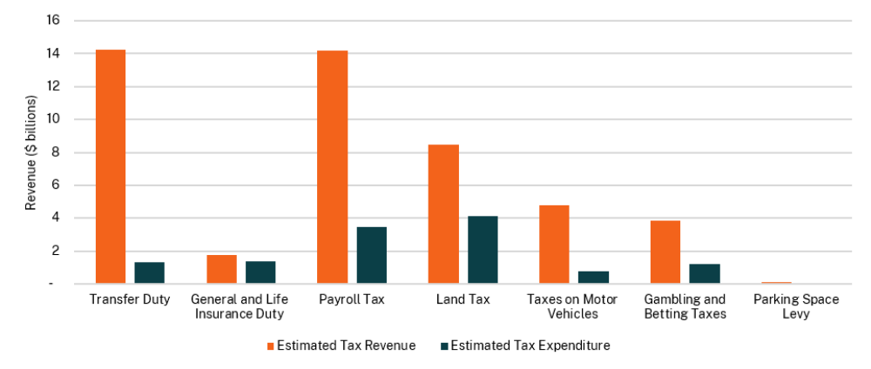
Table C.2 shows a breakdown of the total value of tax expenditures for the financial years 2024-25, 2025-26 and 2026-27, by the broad category of recipient obtaining the benefit of the tax exemption.
- Tax expenditure by primary recipient category
 | 2024-25 |  | 2025-26 |  | 2026-27
Primary recipient category | Tax Exp.  $m | Per cent  of total  % | Tax Exp.  $m | Per cent  of total  % | Tax Exp.  $m | Per cent  of total  %
Individuals / families | 1,674 | 13.9 | 1,685 | 13.7 | 2,092 | 15.0
Government / public entities | 1,470 | 12.2 | 1,560 | 12.6 | 1,633 | 11.7
Charitable / non-profit organisations / clubs | 3,565 | 29.5 | 3,762 | 30.5 | 3,955 | 28.3
Rural | 2,677 | 22.2 | 2,739 | 22.2 | 3,335 | 23.9
Business | 1,717 | 14.2 | 1,601 | 13.0 | 1,880 | 13.5
Pensioners / concession card holders / disadvantaged | 506 | 4.2 | 529 | 4.3 | 567 | 4.1
Religious institutions | 440 | 3.6 | 447 | 3.6 | 482 | 3.5
Other | 20 | 0.2 | 20 | 0.2 | 23 | 0.2
Total | 12,069 | 100 | 12,343 | 100 | 13,967 | 100

Policy changes relating to tax expenditures
The 2026-27 Budget provides a new surcharge purchaser duty relief measure for purchases of operational build-to-rent properties from 1 July 2026. A new surcharge purchaser duty relief measure will also apply from 1 July 2026 for eligible retirement village developers and operators.
As part of the Government’s cost of living package, private vehicle registrations (excluding caravans and trailers) will receive a $100 discount for one year ($80 discount on registration for motorcycles). The discount will be deducted from the total fee displayed on registration notices issued for eligible vehicles.

Top 10 tax expenditures
Table C.3 sets out the top 10 tax expenditures, based on the estimated sum of tax expenditures for the financial years 2024-25, 2025-26 and 2026-27. The table also indicates the tax expenditures for which distributional analysis is presented in Section C.3 Distributional analysis of tax expenditures.
- Top 10 tax expenditures
# | Tax Expenditure | Tax | Category of primary recipient | 2024-25  ($m) | 2025-26  ($m) | 2026-27  ($m) | Distributional analysis included
1 | Land tax exemption granted for land used for primary production | Land tax | Rural | 2,441 | 2,564 | 3,171
2 | Payroll tax exemption to non-profit charitable institutions | Payroll tax | Charitable / non-profit organisations / clubs | 1,089 | 1,155 | 1,206
3 | Concessional taxes for gaming machines installed in clubs | Gambling and betting taxes | Charitable / non-profit organisations / clubs | 1,042 | 1,133 | 1,160 | Yes
4 | Payroll tax exemption to public hospitals, Local Health Districts and Ambulance Service of NSW | Payroll tax | Government / public entities | 1,038 | 1,112 | 1,162
5 | Land tax exemption for charitable bodies | Land tax | Charitable / non-profit organisations / clubs | 636 | 636 | 717
6 | First Home Buyers Assistance Scheme | Transfer duty | Individuals / families | 687 | 664 | 600 | Yes
7 | General insurance duty exemption for workers compensation premiums | General insurance duty | Business | 533 | 573 | 610
8 | Payroll tax exemption for schools and colleges | Payroll tax | Charitable / non-profit organisations / clubs | 480 | 509 | 532
9 | Vehicle weight tax exemption to selected social security recipients | Vehicle weight tax | Pensioners / concession card holders / disadvantaged | 403 | 427 | 453
10 | Land tax exemption for religious societies | Land tax | Religious institutions | 409 | 415 | 448

Transfer duty (including landholder duty)
The benchmark tax base includes all transfers of dutiable property as defined in Chapter 2 of the Duties Act 1997, including New South Wales land, land use entitlements, transferable floor space and partnership interests. Indirect acquisition of land under Chapter 4 of the Duties Act 1997 (landholder duty) is also included.
The benchmark tax structure comprises a tiered rate scale with marginal tax rates varying from 1.25 to 5.5 per cent over six steps. A premium marginal rate of 7 per cent applies for residential property valued above $3,721,000.
Under the benchmark tax base, fixed or nominal duties are imposed on various transactions, including duplicates of instruments and certain transfers eligible for concessional duty rates (such as transfers related to trusts, superannuation and deceased estates). These fixed duty charges are set at $20, $100, $500 or $750.
Surcharge purchaser duty of 9 per cent applies to purchases of residential land by foreign persons.
The Duties Act 1997 includes a number of exemptions designed to exclude the application of duty (apart from a nominal charge) to transactions where duty has already been applied to an associated legal instrument. Exemptions that fall under this category are not included as a tax expenditure, as exemptions of this nature are designed to avoid the double taxation that could occur if the exemptions were not provided.
- Transfer duty – major tax expenditures^{(a)}
 | 2024-25  $m | 2025-26 $m | 2026-27 $m
Individuals / families
First Home Buyers Assistance Scheme
Eligible first home buyers are provided with an exemption from duty for the purchase of a home up to a value of $800,000, with concessional rates for homes up to a value of $1 million. Eligible purchases of vacant land for homebuilding are exempt from duty up to a value of $350,000, with a concession rate applied to land valued between $350,000 and $450,000. | 687 | 664 | 600
Transfer of residences between spouses or de facto partners^{(b)}
An exemption is granted, subject to the property being their principal place of residence and jointly held after transfer. | 59 | 62 | 60
Transfers of matrimonial property consequent upon divorce^{(b)}
An exemption is provided under the Duties Act 1997 for transfers of property in the break-up of marriage, de facto or domestic relationships as defined under the Family Law Act 1975 (Cth). | 150 | 155 | 149
Government / public entities
Councils and county councils
An exemption is granted under the Duties Act 1997 for the transfer of property to a council or county council as defined under the Local Government Act 1993. | 20 | 15 | 16
Charitable / non-profit organisations / clubs
Charitable and benevolent bodies
An exemption is granted for transactions by charitable or benevolent organisations, as set out in Section 275 of the Duties Act 1997. | 89 | 86 | 85

Table C.4: Transfer duty – major tax expenditures (cont)
 | 2024-25  $m | 2025-26  $m | 2026-27  $m
Rural
Intergenerational rural transfers
An exemption is granted for transfers of land used for primary production between generations, or between siblings. | 139 | 147 | 134
Interest in a primary producer
Acquisition of an interest in a primary producer that is not ‘land rich’. | 74 | 4 | 6
Business
Corporate reconstructions
Duty charged on corporate reconstruction transactions is 10 per cent of the duty that would otherwise be payable. | 112 | 74 | 214
Surcharge purchaser duty exemptions
An exemption or refund of surcharge purchaser duty for foreign persons is provided for:  - the transfer of residential-related property to Australian-based developers for certain development on or use of the land,  - the transfer of build-to-rent property subject to conditions (from 1 July 2026) or residential-related property that has build-to-rent property subsequently constructed on it, and  - the transfer of retirement villages subject to conditions (from 1 July 2026) or residential-related property that has a retirement village subsequently constructed on it (from 1 July 2026). | 149 | 99 | 89

- The table has been populated using updated data, based on lodgement date, and updated forecasting methodologies.
- The historical tax expenditure relating to transfers between spouses or de facto partners, or upon divorce, is based on NSW Treasury estimates.

Transfer duty – other major tax expenditures (> $1 million)
For ‘off the plan’ purchases by owner occupiers, duty may be deferred until completion of the sale or 12 months after the contract, whichever occurs first.

Transfer duty – minor tax expenditures (< $1 million)
Minor exemptions from transfer duty include:
- purchase of land as their principal place of residence by tenants of Housing NSW and Aboriginal Housing Office
- approved equity release schemes for aged homeowners
- certain purchases of manufactured relocatable homes (caravans)
- certain transfers of property granted in other legislation
- call option assignments, subject to certain conditions
- transfer of a liquor licence in certain circumstances under the Liquor Act 2007
- transfer of property related to a joint government enterprise that has the function of allocating funds for water savings projects
- transfers where public hospitals are the liable party
- transfer of properties gifted to a special disability trust
- instruments executed by or on behalf of a council or county council under the Local Government Act 1993, not connected with a trading undertaking
- transfers for the purpose of amalgamation or de-amalgamation of clubs under the Registered Clubs Act 1976
- instruments executed by or on behalf of agencies within the meaning of the Convention on the Privileges and Immunities of the Specialised Agencies approved by the General Assembly of the United Nations in 1947
- transfers between associations of employees or employers registered under the Workplace Relations Act 1996 (Cth) for the purpose of amalgamation
- transfer of property to the New South Wales Aboriginal Land Council or Local Aboriginal Land Councils
- transfers of property between licensed insurers, and between the State Insurance Regulatory Authority (SIRA) and licensed insurers, under the Workers Compensation Act 1987.
Minor concessions include:
- acquisitions in unit trust schemes, private companies or listed companies with land holdings in New South Wales of $2 million or more, where the acquisition is for the purpose of securing financial accommodation
- buy-back arrangements of widely held unit trust schemes for the purpose of re-issuing or reoffering the units for sale, subject to certain criteria
- amalgamations of certain Western Lands leases under the Western Lands Act 1901 where transfer duty has been paid on the transfer of other such leases in the previous three years.
The following is a minor exemption from surcharge purchaser duty:
- holders of subclass 410 (retirement) and 405 (investor retirement) visas from 1 July 2019.

General insurance duty
The benchmark tax base for general insurance is all premiums paid for insurance policies. General insurance does not include life insurance or life insurance riders. The benchmark tax rate is 9 per cent of the premium paid.
- General insurance duty – major tax expenditures
 | 2024-25  $m | 2025-26 $m | 2026-27 $m
Individuals / families
Concessional rates for Type B general insurance, as identified in Section 233 of the Duties Act 1997
A concessional rate of 5 per cent is applied to certain categories of general insurance, including motor vehicle (excluding compulsory third party), aviation, disability income, occupational indemnity, and hospital and ancillary health benefits (where not covered by private health insurers). | 404 | 417 | 444
Compulsory third party motor vehicle insurance
An exemption is provided for third party motor vehicle personal injury insurance (green slip), as per the Motor Accidents Act 1988 and the Motor Accidents Compensation Act 1999. | 222 | 239 | 258
Business
Exemption for workers compensation premiums
An exemption applies to worker compensation premiums made in accordance with the Workplace Injury Management and Workers Compensation Act 1998. | 533 | 573 | 610
Marine and cargo insurance
An exemption is provided for marine insurance covering hulls of commercial ships and cargo carried by land, sea or air. | 12 | 12 | 13
Small business exemptions
An insurance duty exemption is provided to small businesses for commercial vehicles, commercial aviation, professional indemnity, and product and public liability. | 104 | 107 | 114

General insurance duty – minor tax expenditures (< $1 million)
Minor exemptions from insurance duty include:
- insurance by non-profit organisations with the main aim being a charitable, benevolent, philanthropic or patriotic purpose
- crop and livestock insurance taken out from 1 January 2018
- societies or institutions whose resources are used wholly or predominantly for the relief of poverty, the promotion of education, or any purpose directly or indirectly connected with defence or the amelioration of the condition of past or present members of the naval, military or air forces of the Australian Government or their dependants or any other patriotic objectives
- insurance by the New South Wales Aboriginal Land Council or Local Aboriginal Land Councils
- insurance covering mortgages or pools of mortgages acquired for issuing mortgage-backed securities
- separate policies covering loss by fire of tools, implements of work or labour used by any working mechanic, artificer, handcrafter or labourer
- redundancy insurance in respect of a housing loan that does not exceed $124,000
- reinsurance.

Life insurance duty
For temporary or term life insurance policies, life insurance riders, and trauma or disability insurance policies, the benchmark tax base is the first year’s premium on the policies and the benchmark rate is 5 per cent. For group term insurance policies, duty of 5 per cent of the premium payable in any succeeding year in respect of any additional life covered by the policy is also charged.
The benchmark tax base for all other life insurance policies is the total sum insured. The benchmark tax rate is $1 on the first $2,000 and 20 cents for every additional $200 or part thereof.
- Life insurance duty – major tax expenditures
 | 2024-25  $m | 2025-26 $m | 2026-27 $m
Individuals / families
Superannuation
An exemption is granted to all group superannuation investment policies that benefit more than one member. | 3 | 3 | 3
Annuities
An exemption is granted to annuities issued, created or sold by a life company or purchased by a person from a life company. | 7 | 7 | 8

Motor vehicle stamp duty
The benchmark tax base is the value of all purchases and transfers of motor vehicles. The benchmark tax rate for passenger vehicles is $3 per $100, or part thereof, for vehicles valued up to $44,999, and $1,350 plus $5 per $100, or part thereof the vehicle’s value over $45,000 for vehicles valued at $45,000 or more.
- Motor vehicle stamp duty – major tax expenditures
 | 2024-25  $m | 2025-26 $m | 2026-27 $m
Individuals / families
Caravans and camper trailers
An exemption is provided for transfers of registration of caravans and camper trailers. | 79 | 80 | 80
Transfers on divorce or breakdown of a de facto relationship
An exemption is granted for the transfer of registration to one of the parties to a divorce or separation in a de facto relationship. | 4 | 3 | 4
Transfer of ownership of a deceased registered owner
An exemption is granted for the transfer of registration to a nominated legal personal representative or to the person beneficially entitled to the vehicle in the estate. | 13 | 13 | 13
Electric and hydrogen vehicles
An exemption was available for certain electric vehicles and hydrogen fuel cell vehicles purchased between 1 September 2021 and 31 December 2023. | 4^{(a)} | 0 | 0
Government / public entities
Local councils
An exemption is granted for the transfer of registration into the name of a local council, not for a trading undertaking. | 14 | 12 | 12
Ambulances
An exemption is granted for motor vehicles specially constructed and solely used for the ambulance work of carrying sick and injured persons. | 2 | 0 | 0
Charitable / non-profit organisations / clubs
Charitable institutions
An exemption is granted to non-profit organisations that have a charitable, benevolent, patriotic or philanthropic purpose. | 7 | 7 | 7
Business
New demonstrator motor vehicle
An exemption is granted to licensed motor dealers and wholesalers under the Motor Dealers Act 1974. | 115 | 136 | 137
Pensioners / concession card holders / disadvantaged
War veterans and impaired members of the Defence Force
An exemption is granted to Department of Veterans’ Affairs (DVA) pensioners who meet certain pension or disability criteria. | 3 | 4 | 4

- Transitional arrangements apply to people who purchased or placed a deposit on their vehicle before or on 31 December 2023, to receive an exemption upon application. The figure for 2024-25 is based on actual exemptions granted within the 2025-26 financial year. Estimates for 2025-26 are based on monthly averages from November 2024 to May 2025. It is expected that this will be a minor concession in future years.

Motor vehicle stamp duty – minor tax expenditures (< $1 million)
Minor exemptions from motor vehicle stamp duty include:
- applications to register a heavy vehicle trailer, not previously registered under the Australian Government or another Australian jurisdiction
- applications to register a heavy vehicle trailer, previously registered in the name of the applicant under the Australian Government or another Australian jurisdiction
- vehicles specially constructed for mine rescue work
- vehicles weighing less than 250kg used for transporting disabled people
- vehicles registered by a Livestock Health and Pest Authority (now administered by Local Land Services), established under the Rural Lands Protection Act 1998
- vehicles registered by the New South Wales Aboriginal Land Council or Local Aboriginal Land Councils
- motor vehicles registered conditionally under the Road Transport Act 2013.
A concessional rate of duty applies to vehicles modified for use by disabled persons.

Payroll tax
The payroll tax benchmark is aggregate annual gross remuneration in excess of $1.2 million paid by a single or group taxpayer. The benchmark tax rate is 5.45 per cent.
- Payroll tax – major tax expenditures
 | 2024-25  $m | 2025-26 $m | 2026-27 $m
Government / public entities
Public hospitals, Local Health Districts and Ambulance Service of NSW
An exemption is granted for wages paid to persons engaged exclusively in the normal work of these organisations.^{(a)} | 1,038 | 1,112 | 1,162
Local councils
An exemption is granted to councils, county councils and their wholly owned subsidiaries, except for wages paid in connection with certain activities, such as the supply of electricity, gas, water or sewerage services, or the conduct of parking stations, hostels, or coal mines. A full list of exclusions can be found in the Payroll Tax Act 2007. | 325 | 349 | 365
Charitable / non-profit organisations / clubs
Charitable institutions
An exemption is granted to non-profit charitable, benevolent, patriotic, or philanthropic organisations for wages paid to employees engaged exclusively in the normal work of these institutions.^{(b)} | 1,089 | 1,155 | 1,206
Not-for-profit private hospitals
An exemption is granted to non-profit private hospitals for wages paid to persons engaged exclusively in work of a kind ordinarily performed by a hospital.^{(b)} | 62 | 66 | 69
Not-for-profit schools and colleges
An exemption is granted to not-for-profit schools and colleges (other than technical schools, technical colleges or those carried on by or on behalf of the State of New South Wales) which provide education at or below, but not above, the secondary level of education.^{(b)} | 480 | 509 | 532

Table C.8: Payroll tax – major tax expenditures (cont)
 |  | 2024-25  $m | 2025-26 $m | 2026-27 $m
Business
Medical Centres (Bulk-Billing Support Initiative)
From 4 September 2024, a payroll tax rebate applies to medical centres in respect of contractor GP wages, if they meet specified bulk-billing thresholds. Past payroll tax liabilities of medical centres with respect to contractor general practitioner wages that have been incurred but unpaid up to 4 September 2024 are exempt and were included in the 2024-25 Budget. |  | 111 | 9 | 10
Jobs Plus
Payroll tax relief is available to eligible businesses for up to four years for every new job created where a business has created at least 30 net new jobs in metropolitan New South Wales or 20 net new jobs in non-metropolitan New South Wales up to 30 June 2024. Applications for this program closed on 30 June 2022. |  | 7 | 6 | 5
Apprentices
A full exemption / rebate is provided for wages paid to approved apprentices under the Apprenticeship and Traineeship Act 2001 and those employed by approved non-profit group training organisations. |  | 93 | 99 | 103
Trainees
A full exemption / rebate is provided for wages paid to approved new trainees under the Apprenticeship and Traineeship Act 2001 and those employed by approved non-profit group training organisations. |  | 39 | 41 | 43
Maternity Leave
An exemption is granted for maternity leave payments for a period of up to 14 weeks, or its equivalent, at a reduced rate of pay. |  | 61 | 65 | 68
 | Redundancy payments
 | An exemption is provided for the Australian Government tax-free part of a genuine redundancy or approved early retirement scheme payment. | 24 | 25 | 26
Religious Institutions
 | Religious institutions
 | An exemption is granted for wages paid to persons engaged exclusively in work of a kind ordinarily performed by religious bodies.^{(b)} | 29 | 30 | 32

- This exemption does not have a budget impact as it reduces the payroll tax liability of general government agencies rather than forgone revenue from outside government.
- A methodology change has been applied to these tax expenditures in the current year and backcast. This impacts estimates compared to previous years.

Payroll tax – minor tax expenditures (< $1 million)
Minor exemptions from payroll tax include:
- wages paid to an employee who is on leave from employment by reason of service in the Defence Force
- wages paid to persons employed under the Community Development Employment Project administered by Aboriginal and Torres Strait Islander Corporations
- wages paid by the Australian-American Fulbright Commission
- wages paid by the Commonwealth War Graves Commission
- wages paid to members of the official staff by a consular or other non-diplomatic representative of another country or by a Trade Commissioner in Australia representing any other part of the Commonwealth of Nations
- wages paid for a joint government enterprise that has the function of allocating funds for water saving projects
- wages paid by the Governor of a State
- wages paid to employees while the employees are providing volunteer assistance to the State Emergency Services or Rural Fire Brigades (but not in respect of wages paid or payable as recreation leave, annual leave, long service leave or sick leave)
- adoption leave payments for a period of up to 14 weeks, or its equivalent, at a reduced rate of pay
- paternity leave payments for a period of up to 14 weeks, or its equivalent, at a reduced rate of pay.

Land tax
The benchmark tax base is the average of the last three years’ unimproved land value of all land owned, on 31 December of the previous year, that is above the threshold (as defined in the Land Tax Management Act 1956). This excludes land used:
- for owner-occupied residences
- by the Australian Government
- by the NSW Government.
The benchmark tax rate for the 2026 land tax year is $100 plus 1.6 per cent of the land value between the thresholds of $1,075,000 and $6,571,000, and $88,036 plus 2 per cent of land value thereafter.
Surcharge land tax applies to residential land owned by foreign persons at the rate of 5 per cent per year. The benchmark tax base for surcharge land tax excludes certain commercial residential property.
Property exempted under one category may also qualify under other categories. Tax expenditures are included and counted only once in such circumstances.

- Land tax – major tax expenditures
 | 2024-25  $m | 2025-26 $m | 2026-27 $m
Individuals / families
Early payment discount
A discount of 0.5 per cent is available where the full amount of land tax is paid within 60 days of issue of the notice of assessment in the land tax year. | 20 | 18 |  | 14
Government / public entities
Cemeteries and crematoriums
An exemption is provided for land owned by or held in trust and used for a public cemetery or crematorium. | 1 | 1 | 1
Public and private hospitals^{(a)}
An exemption is provided for land owned by or held in trust and used for public or private hospitals (including nursing homes) and Local Health Districts. | 9 | 9 | 9
Aboriginal Land Councils^{(a)}
An exemption is provided for land owned by the New South Wales Aboriginal Land Council or a Local Aboriginal Land Council constituted under the Aboriginal Land Rights Act 1983 or a registered native title body corporate within the meaning of the Native Title Act 1993 of the Commonwealth. | 46 | 47 | 52
Public gardens
An exemption is provided for the land owned by or held in trust and used for a public garden, public recreation ground or public reserve. | 8 | 8 | 9
Charitable / non-profit organisations / clubs
Charitable bodies^{(a)}
An exemption is provided for land owned by or in trust for a charitable body. | 636 | 636 |  | 717
Game or Sports Clubs
An exemption is granted for land owned by or in trust for any club or body of persons which is used primarily for the purpose of a game or sport and not for the pecuniary profit of the members. | 12 | 13 |  | 14
Non-pecuniary profit society, club or association
An exemption is granted for a building owned and solely occupied by a society, club or association not carried on for pecuniary profit. | 63 | 64 |  | 70
Rural
Land used for primary production
An exemption is granted for land used for primary production. To qualify, land must be used for primary production for the purpose of profit on a continuous or repetitive basis. | 2,441 | 2,564 |  | 3,171

Table C.9: Land tax – major tax expenditures (cont)
 | 2024-25  $m | 2025-26 $m | 2026-27 $m
Business
Racing clubs
An exemption is granted for land owned by or held in trust for any club for promoting or controlling horse racing, trotting or greyhound racing used mainly for their meetings. | 3 | 3 | 3
Employer and employee organisations
An exemption is granted for land owned by or held in trust for employer and employee organisations for that part not used for a commercial activity open to members of the public. | 3 | 3 | 3
Co-operatives
An exemption is granted for land owned by a co-operative under the Co-operatives National Law (NSW) that has its objects listed in the Co-operation Act 1923. | 2 | 2 | 2
Childcare centres and schools
An exemption is granted for land used as an approved education and care service within the meaning of the Children (Education and Care Services) National Law (NSW) and the Children (Education and Care Services) Supplementary Provisions Act 2011 or a school registered under the Education Act 1990. | 50 | 54 | 62
Australian-Based Developers
An exemption or refund of surcharge land tax is provided for Australian based developers that are foreign persons, for certain development on or use of residential land. | 166 | 156 | 228
Build-to-rent (BTR)
A concession in the form of a 50 per cent reduction in land value for land tax purposes is available to eligible new BTR developments. An exemption or refund of surcharge land tax is also provided to Australian based developers that are foreign persons, subject to satisfying requirements relating to the construction of BTR properties. | 14 | 13 | 21
Pensioners / concession card holders / disadvantaged
Retirement villages
An exemption is granted for land used as retirement villages, and residential parks predominantly occupied by retired persons. | 79 | 86 | 99
Boarding houses for low-income persons
An exemption is granted for land used for boarding houses for which the rent charged is less than the amount prescribed by the guidelines. | 19 | 11 | 10
Low-cost rental accommodation
An exemption is provided for low-cost rental accommodation within a 5km radius of 1 Martin Place, Sydney. | 2 | 1 | 1
Religious institutions
Religious societies
An exemption is provided for land owned by or in trust for a religious society carried on solely for religious, charitable or educational purposes, and / or religious societies’ places of worship and residences of clergy, ministers or orders of the society. | 409 | 415 | 448

Table C.9: Land tax – major tax expenditures (cont)
 | 2024-25  $m | 2025-26 $m | 2026-27 $m
Other
Mixed use developments
The land value of mixed development land or mixed-use land on which is situated a single dwelling or flat is to be reduced by the allowable proportion in relation to the dwelling or flat for land tax purposes. | 18 | 18 | 20
Conservation and biodiversity agreements and Water Savings Projects
An exemption is provided for land that is the subject of a biodiversity stewardship agreement, conservation agreement under the Biodiversity Conservation Act 2016 or the National Parks and Wildlife Act 1974, land in which Biodiversity Conservation Trust holds an interest and land that is vested in, owned by or held in trust by or for, or leased by a joint government enterprise that has the function of allocating funds for water savings projects (As under sections 10(1)(p)-p(3) of the Land Tax Management Act 1956). | 2 | 2 | 3

- Indicated amounts include tax expenditure where multiple exemptions can apply.

Land tax – other major tax expenditures (> $1 million)
Major exemptions from land tax include:
- land used for the Sydney Light Rail
- land owned by local councils.

Land tax – minor tax expenditures (< $1 million)
Minor exemptions from land tax include:
- land used to hold agricultural shows, which is owned by, or held in trust for, a society established for the purpose of holding, promoting and funding such shows
- Primary Products Marketing Boards, Local Land Services and Agricultural Industry Service committees
- land owned by a society registered under the Friendly Societies (New South Wales) Code
- fire brigades, ambulances or mines rescue stations
- land used solely as a police station
- land owned by Returned & Services League of Australia (New South Wales Branch), being Anzac House.
The holders of subclass 410 (retirement) and 405 (investor retirement) visas are exempt from surcharge land tax.

Vehicle weight tax
The benchmark tax base is all vehicles (except Australian Government vehicles) intended for on-road use. The benchmark tax rates, which vary by vehicle type, weight, usage and other factors, are updated annually by the NSW Government.
From 1 July 2025, charges for cars, station wagons and trucks up to 4.5 tonnes Gross Vehicle Mass are based on a 12-step graduated weight scale, ranging from:
- $270 (0 – 975 kg) to $1,481 (4,325 - 4,500 kg) for private use vehicles
- $436 (0 – 975 kg) to $2,468 + $333 (4,325 - 4,500 kg) for business use vehicles.
From 1 July 2025, charges for trailers and caravans up to 4.5 tonnes Gross Vehicle Mass are based on a 14-step graduated weight scale, ranging from:
- $0 (0 – 254 kg) to $1,481 (4,325 - 4,500 kg) for private use vehicles
- $133 (0 – 254 kg) to $2,468 (4,325 - 4,500 kg) for business use vehicles.
- Vehicle weight tax – major tax expenditures
 | 2024-25  $m | 2025-26 $m | 2026-27 $m
Individuals / families
Motor Vehicle Tax – Low Emission Vehicles
Transport for NSW provides owners of vehicles with low emissions a concession on motor vehicle tax. | 12 | 14 | 14
Private vehicle registration discount
$100 discount on private vehicle registrations (excluding caravans and trailers) for one year. $80 discount on registration for motorcycles. | 0 | 0 | 435
Government / public entities
Roadwork equipment
An exemption is granted for any motor vehicle, plough, bulldozer, mechanical scoop or shovel, road grader, road roller or similar machinery owned by a local council that is used for the purposes of road repair, maintenance or construction, removal of garbage or night soil, bushfire fighting or civil defence work, or for any roller, lawn mower or similar machinery used solely or principally for the rolling or maintenance of tennis courts, cricket pitches, lawns or pathways. | 6 | 6 | 6
Australian Government vehicles
Any vehicle leased to an Australian Government Authority is exempt from tax under Section 16, Part 3, (2) (d) of Commonwealth Vehicles (Registration and Exemption from Taxation) Act 1997 (Cth). | 1 | 1 | 1
Rural
Primary producers
Primary producer concessions include, for motor vehicles not greater than 4.5 tonnes of gross vehicle mass, private rates rather than business rates for cars and station wagons and 55 per cent of business rates for trucks, tractors, and trailers. | 23 | 24 | 24
Business
General purpose plant
Concessions are provided for machines that cannot carry any load other than tools and accessories necessary for the operation of the vehicle. | 50 | 53 | 56
Other
Concessions provided under Part 4, section 16 and 17 of the Motor Vehicles Taxation Act 1988 including vehicles specially constructed for the work of conveying sick or injured persons or to carry out mine rescue, and agricultural vehicles that do not travel on a road. | 2 | 2 | 3

Table C.10: Vehicle weight tax – major tax expenditures (cont)
 | 2024-25  $m | 2025-26 $m | 2026-27 $m
Pensioners / concession card holders / disadvantaged
Selected social security recipients
An exemption is granted for any motor vehicle used substantially for non-business purposes owned by holders of Pensioner Concession Cards, DVA Totally and Permanently Incapacitated Cards or DVA Gold War Widows Cards. | 403 | 427 | 453

Vehicle weight tax – minor tax expenditures (< $1 million)
Minor exemptions from vehicle weight tax include:
- motor vehicles (not government owned) used principally as an ambulance
- motor vehicles (not government owned) used by the State Emergency Service
- motor vehicles on which a trader’s plate is being used in accordance with the Road Transport (Vehicle Registration) Act 1997 or the regulations under that Act
- motor vehicles owned by Aboriginal Land Councils
- motor vehicles of consular employees and trade missions.
Minor concessions include:
- a concessional rate of 55 per cent of business rates (or 30 per cent when operated outside the Sydney, Newcastle or Wollongong metropolitan areas) is applied to tow trucks constructed to partially lift and tow other vehicles
- a concessional rate of 88 per cent is provided for mobile cranes used for private use
- a concessional rate of tax is applied to any motor vehicle that is owned by a Livestock Health and Pest Authority (now administered by Local Land Services) and is used solely for carrying out the functions of the board
- a rebate of $100 for vehicle registration is given to first and second-year apprentices registered with the NSW Department of Education.

Gambling and betting taxes
The benchmark for gaming machines in hotels and registered clubs is the rates of taxation
applying to hotels, which vary based on a progressive rate scale depending on the level of
annual profits from gaming machines.
- Gambling and betting taxes – major tax expenditures
 | 2024-25  $m | 2025-26 $m | 2026-27 $m
Charitable / non-profit organisations / clubs
Club gaming machines
Gaming machines installed in clubs registered under the Registered Clubs Act 1976 are taxed at lower rates than gaming machines installed in hotels. | 1,042 | 1,133 | 1,160
ClubGRANTS
Registered clubs may receive a tax rebate on eligible ClubGRANTS expenditure of up to 1.85 per cent of a club’s gaming machine profits over $1 million during a tax year. | 82 | 90 | 92

Gambling and betting taxes – other tax expenditures
A full tax rebate is provided to racing clubs operating non-TAB Ltd pools.

Parking space levy
The benchmark tax base is the number of off-street parking spaces in Category 1 areas (Sydney CBD, North Sydney and Milsons Point business districts) or Category 2 areas (Chatswood, Parramatta, St Leonards and Bondi Junction business districts).
The benchmark levy is indexed annually to movements in the Sydney CPI, over the year to the previous March quarter. For 2025-26, the benchmark levy is $3,030 per space in Category 1 areas and $1,080 per space in Category 2 areas.
Further details on the exemptions can be found in the NSW Parking Space Levy Regulation 2019. While these exemptions are grouped for the purpose of this exercise by beneficiary type, in all cases the exemption applies to the owner or occupier of the parking space, based on prescribed use of the space.
- Parking space levy – major tax expenditures

 | 2024-25  $m | 2025-26 $m | 2026-27 $m
Individuals / families
Spaces used for parking bicycles or motorcycles
Parking spaces used exclusively for the parking of bicycles or motorcycles. | 1 | 1 | 1
Spaces designated as disabled parking
Parking spaces by persons who hold mobility parking scheme authorities providing the space complies with the relevant standards. | 3 | 3 | 3
Spaces used for loading or unloading goods or passengers
Parking spaces used exclusively for the loading or unloading of goods or passengers. | 4 | 4 | 4
Spaces used for service / delivery vehicles
Parking spaces used exclusively by service or delivery vehicles that are owned by the premises owner or occupier and garaged overnight at the premises. | 2 | 2 | 2
Charitable / non-profit organisations / clubs
Spaces used by public charities
Parking spaces provided at no cost and used exclusively by persons accessing the charitable services of a public charity. | 3 | 3 | 3

Table C.12: Parking space levy – major tax expenditures (cont)
 | 2024-25  $m | 2025-26 $m | 2026-27 $m
Business
Unleased tenant parking spaces
Parking spaces attached to commercial premises that are not leased or made available for use by tenants. | 36 | 38 | 39
Unused casual parking spaces
Casual parking spaces that are not made available for use during the relevant levy period. | 19 | 19 | 19
Spaces used by retail customers
Parking spaces used by customers for the purpose of shopping at retail premises in Category 2 areas. | 10 | 10 | 10
Spaces used by retail employees in certain shopping centres
Parking spaces used by retail employees in shopping centres prescribed under Schedule 2 of the regulation, in Category 2 areas. | 1 | 1 | 1
Spaces used by hotel or motel guests
Parking spaces used by guests of hotels or motels located in Category 2 areas. | 1 | 1 | 1
Religious institutions
Spaces used by religious bodies
Parking spaces provided at no cost and used exclusively by religious bodies for premises covered by a proclamation under the Marriage Act 1961. | 2 | 2 | 2

Parking space levy – other major tax expenditures (> $1 million)

Parking spaces used exclusively by residents of the premises, or of adjoining residential premises.

Parking space levy– minor tax expenditures (< $1 million)
Minor exemptions from the parking space levy include:
- all areas (Category 1 or Category 2) when used exclusively for the following purposes:
- heavy or special-purpose vehicles (including cranes, forklifts, tractors)
- emergency service vehicles garaged overnight
- council-owned premises by persons other than council staff
- persons providing services to a premises on a casual basis.
- Category 2 only when used exclusively for the following purposes:
- registered club members and guests
- restaurant customers
- medical centre patients
- customers of vehicle sales, servicing or car wash businesses
- funeral home clients and guests
- vehicles displayed or stored for sale or hire.
From July 2024, spaces in Central Park used exclusively by residents are also exempt.

- Distributional analysis of tax expenditures
This section provides information on the types of recipients or transactions that benefit from large tax expenditures, to provide an indication of how the benefits of these tax expenditures are distributed. The analysis presented in this section is intended to enhance transparency with regards to the distribution of tax expenditures across different recipient groups.
The scope of distributional analysis is limited by the availability of data. The NSW Government generally does not collect information on the individuals that benefit from tax expenditures and therefore is unable to undertake distributional analysis according to income levels and other factors such as gender, age and occupation.
Distributional analysis is presented for the following two tax expenditures (where there is sufficient data to provide meaningful analysis):
- concessional tax rates for gaming machines installed in clubs
- the First Home Buyers Assistance Scheme.

Tax concessions for gaming machines located in registered clubs
Registered clubs in New South Wales pay concessional rates of tax on their gaming machine profits compared to the tax rates levied on hotel gaming machine profits. Tax rates for clubs and hotels are based on a progressive scale depending on the level of annual profits from gaming machines.
Chart C.2 shows the proportion of the total value of the tax concession provided to clubs by annual gaming machine profit bands (left axis) and the proportion of clubs within each of the annual gaming machine profit bands (right axis) for 2024-25 (the chart does not include the ClubGRANTS tax rebate). It shows that clubs with profit greater than $20 million, which account for 6 per cent of clubs (not including clubs with nil or negative gaming machine profits), receive about half of the total concession provided to clubs. Clubs with gaming profits less than $200,000 do not receive any concession as both clubs and hotels do not pay tax on gaming machine profits below $200,000.
- Proportion of total concessions and proportion of total number of clubs by annual gaming machine profit, 2024-25
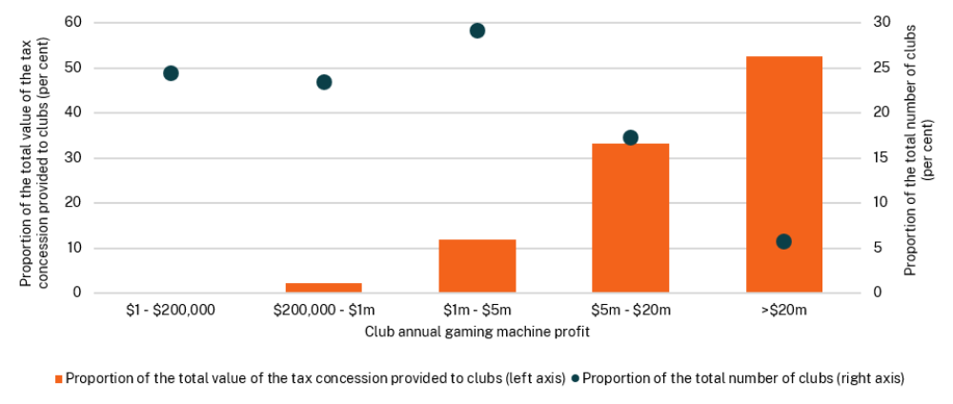

First Home Buyers Assistance Scheme
The First Home Buyers Assistance Scheme (FHBAS) provides eligible first home buyers a full exemption from transfer duty when purchasing a home valued up to $800,000, or a concessional rate of transfer duty when purchasing a home valued between $800,000 and $1 million. For vacant land purchased with the intention to build a home, eligible first home buyers can receive a full exemption from transfer duty for land valued up to $350,000, or a concessional rate of transfer duty for land valued between $350,000 and $450,000.
In 2024-25, around 33,600 transfer duty exemptions or concessions were granted under the FHBAS, for a total value of more than $687 million and reflecting an average value of approximately $20,000 per transaction. The previous year (2023-24) saw a similar uptake of the FHBAS, with around 34,100 first home buyer transactions receiving assistance under the scheme, for a total value of $696 million.
Chart C.3 shows the distribution of the FHBAS exemptions and concessions across property prices by $50,000 bands in 2024-25.
First home buyer purchases valued between $750,000 and $800,000, representing the highest price band that is eligible for a full exemption under the FHBAS, continued to account for the largest share of assistance ($106 million across approximately 3,600 transactions).
The overall distribution of assistance across price bands remained broadly consistent with the 2023-24 financial year.
- Total value and number of exemptions and concessions for first home buyer transactions by $50,000 price brackets in 2024-25
Vacant land exemption threshold
Existing/new home concession cut-off
Existing / new home exemption threshold

Vacant land concession cut-off

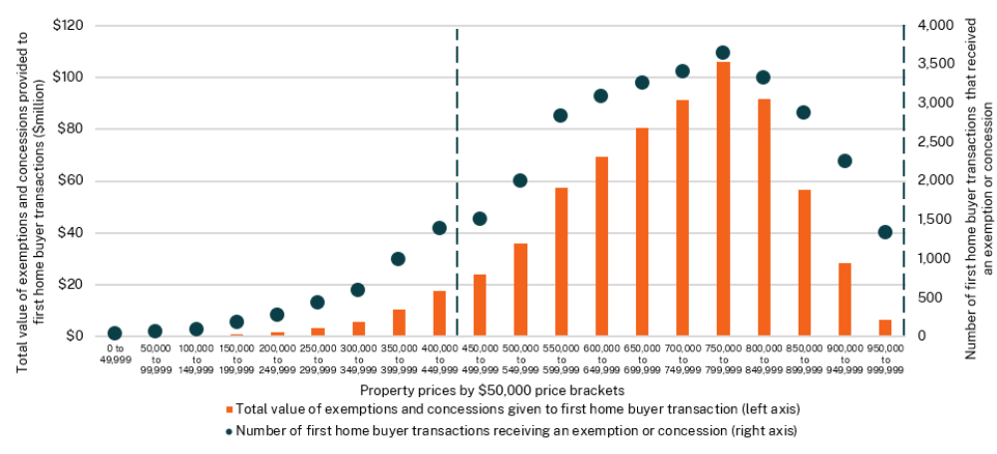
Chart C.4 shows the FHBAS tax exemptions and concessions distribution between Greater Sydney and the rest of New South Wales in 2024-25. Of the total transactions receiving an exemption or concession under the FHBAS, 62 per cent (totalling $443 million) were first home buyer transactions occurring in Greater Sydney, with the balance of 38 per cent from transactions made in the rest of New South Wales (totalling $244 million).

- Distribution of First Home Buyers Assistance Scheme exemptions and concessions in Greater Sydney and the rest of New South Wales, 2024-25
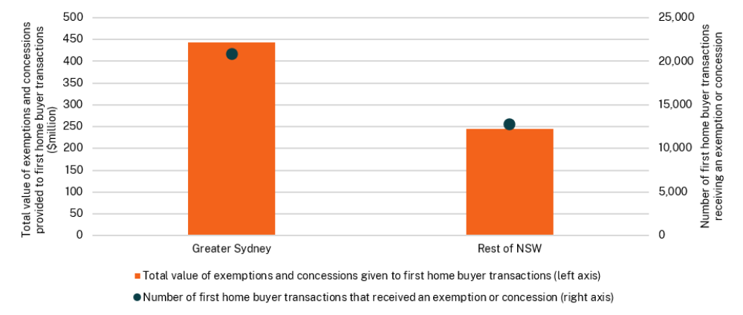

Note: Greater Sydney includes metropolitan Sydney and surrounding areas up to and including the Central Coast, Blue Mountains, Wollondilly and Sutherland council areas. Categorisation based on Local Government Areas (LGAs).

Chart C.5 shows the top 20 local government areas (LGAs) by total value of exemptions and concessions provided under the FHBAS in 2024-25. Parramatta received the highest total value of exemptions and concessions ($45 million), while Blacktown had the highest number of transactions receiving an exemption or concession (around 2,100 transactions).
- Top 20 local government areas by value of First Home Buyers Assistance Scheme exemptions and concessions, 2024–25
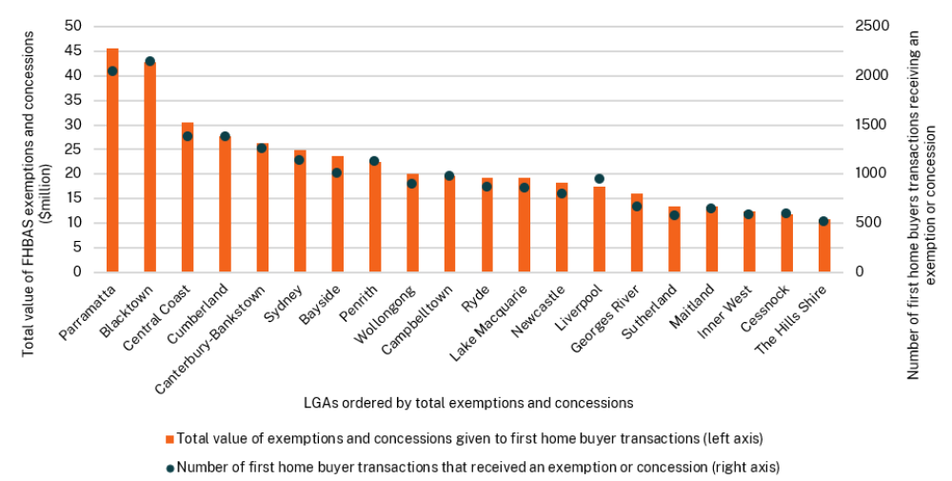

- Concessional charges

Overview of concessional charges
Table C.13 classifies, by function, the major concessions provided by the NSW Government. The total value of major concessions, which accrue primarily to pensioners, older Australians and school students, is estimated at $2.9 billion in 2026-27.
- Concessions by function
Function | 2024-25  $m | 2025-26  $m | 2026-27  $m
Public Order and Safety | 16 | 17 | 18
Education | 764 | 766 | 780
Health | 386 | 410 | 440
Transport | 998 | 931 | 995
Housing and Community | 594 | 592 | 591
Social Protection | 16 | 17 | 16
Economic Affairs | 11 | 11 | 11
Recreation, Culture and Religion | 8 | 12 | 7
Environmental Protection | 12 | 16 | 16
Total | 2,805 | 2,772 | 2,874

The following sections provide a breakdown by policy function line. Details of concessions that have an impact over $1 million are itemised in a table. Examples of concessions with an impact of less than $1 million are listed.

Public order and safety
- Public order and safety – major concessions
 | 2024-25  $m | 2025-26 $m | 2026-27 $m
Government / public entities
Concessions for NSW State Hallmark Events
The NSW Police Force does not charge for all additional police costs associated with crowd control and traffic management services for designated ‘NSW State Hallmark Events’ such as Australia Day, Vivid Festival, and Tamworth Music Festival. | 5 | 6 | 6
Pensioners / concession card holders / disadvantaged
Court interpreting and translation services
Multicultural NSW provides free translation and interpreting services for people in NSW from a non-English speaking background. | 8 | 8 | 9
Court and tribunal fee concessions
Court and tribunal fees may be reduced or waived, subject to guidelines issued by the Attorney General, in circumstances where a person’s capacity to pay may otherwise limit his or her access to justice. | 3 | 3 | 3

Public order and safety – minor concessions (< $1 million)
- The NSW Police Force does not charge for additional policing services for minor sporting events and agricultural shows in Regional NSW, or for some or all the additional policing services provided to non-commercial events run by charities and not-for-profit organisations meeting criteria established in State Government policy on user charges.

Education
- Education – major concessions
 | 2024-25  $m | 2025-26 $m | 2026-27 $m
Individuals / families
School Student Transport Scheme
The School Student Transport Scheme provides subsidised travel to and from school for eligible students on government and private bus, rail and ferry services, long-distance coaches and in private vehicles where no public transport services exist. | 621 | 628 | 643
Pensioners / concession card holders / disadvantaged
Smart and Skilled – Vocational Education and Training (VET) concessions and exemptions
Fee concessions are available to Australian Government welfare beneficiaries, people with a disability, and their dependents and partners, undertaking Certificate IV and below qualifications. Fee exemptions are available to students with a disability, as well as their dependents and partners, for their first qualification in a calendar year. Fee exemptions are also available to Aboriginal students. | 95 | 89 | 92
Smart and Skilled – VET concessions and exemptions
Skilling for Recovery – Additional full qualifications fee free training places. | 1 | 0 | 0
Skilling for Recovery – Additional fee gap on existing full qualification training places. | 1 | 0 | 0
NSW Fee Free Tranche 1 – Existing fee free full qualification and part qualification. | 13 | 2 | ...^{(a)}
NSW Fee Free Tranche 2 – Existing fee free full qualification and part qualification. | 32 | 36 | 36
NSW Fee Free Tranche 3 Construction - Existing fee free full qualification and part qualification. | 1 | 11 | 9

- Nil in 2026-27 given that NSW Fee Free Tranche 1 concession was completed in 2023-24.

Health
- Health – major concessions
 | 2024-25  $m | 2025-26 $m | 2026-27 $m
Pensioners / concession card holders / disadvantaged
Ambulance service for concessional patients
Free ambulance transport is provided to holders of Pensioner, Health Care, or Department of Veterans’ Affairs concession cards. | 304 | 329 | 356
Ambulance service for corrective services
Free ambulance transport is provided for patients being transferred to or from a correctional institution. | 1 | 2 | 2
Ambulance service for police custody
Free ambulance transport is provided for patients in police custody. | 4 | 4 | 4
Ambulance service provided under Section 20, Mental Health Act 2007
Free ambulance transport is provided to patients experiencing mental illness. | 8 | 8 | 9
Ambulance service provided under Section 22, Mental Health Act 2007
Free ambulance transport is provided to patients experiencing mental illness. | 6 | 5 | 5
Ambulance service provided for sexual / domestic assault
Free ambulance transport is provided to patients who are treated and / or transported as a result of domestic or sexual assault. | 2 | 2 | 2
Outpatient Pharmaceutical Scheme for S100 Concessional Public Patients
Concessions provided to concessional patients up to the safety threshold. | 2 | 2 | 2
Outpatient Pharmaceutical Scheme for S100 General Public Patients
Concessions provided to general patients up to the safety threshold. | 8 | 7 | 6
Concessional car parking fees at NSW public hospitals
Eligible for patients who are required to attend a hospital facility for a course of treatment, those who hold specific concessions cards, and for carers of long-term patients who visit frequently. | 25 | 26 | 27
Free parking at rural and regional hospitals
Free parking is available to staff, patients and their families at rural and regional hospitals across New South Wales. | 5 | 5 | 5
Life Support Rebate
Assistance is provided for households that use electricity to run equipment to sustain life. | 13 | 12 | 14
Medical Energy Rebate
Assistance is provided for households that use air conditioning to assist with a medically diagnosed inability to manage body temperature. | 2 | 2 | 2
NSW Spectacles Program
Vision Australia provides free optical appliances to the most disadvantaged and vulnerable of NSW residents who, in the absence of a subsidy, might otherwise forego necessary vision aids due to financial and other challenges. | 6 | 6 | 6

Health – minor concessions (< $1 million)

Minor concessions include:
- Free ambulance treatment and/or transport for other groups not listed above including children at risk, emergency workers, cases involving the death of an infant between 0-2 years, and patients eligible to participate under the Lifetime Care and Support Authority Act 2006.

Transport
- Transport – major concessions
 |  | 2024-25  $m | 2025-26 $m | 2026-27 $m
Individual / families
2024 Toll Relief Program
An earlier Toll relief program provided motorists who spent $402 or more on eligible tolls in the 2023-24 financial year ($375 or more in the 2022₋23 financial year) a 40 per cent rebate upon claim. Toll spend must be accumulated on NSW toll roads, with a NSW tolling account. | 70 |  | 1 | ...^{(a)}
M5 Cash Back
Residents can claim back the value of tolls (exc. GST) paid while using a vehicle registered in New South Wales for private, pensioner or charitable use of the M5 South-West Motorway. |  | 137 | 144 | 158
Weekly Toll Cap Relief
A toll relief program was introduced from 1 January 2024 for private motorists, with the introduction of a $60 weekly cap for NSW residents who spend more than $60 on eligible toll roads. From 1 July 2026 to 30 June 2027 the weekly cap will be reduced to $50 for NSW residents as a cost-of-living measure. |  | 129 | 154 | 211
Opal Card Travel Cap
Adults are eligible for a $50 weekly cap, and child / youth and concession Opal customers for a $25 weekly cap respectively on all travel by trains, buses, ferries and light rails in New South Wales. |  | 89 | 107 | 113

Table C.17: Transport – major concessions (cont)
 | 2024-25  $m | 2025-26 $m | 2026-27 $m
Business
Truck Multiplier Relief
A one third rebate for heavy vehicles using the M5 East and M8 tunnels. | 16 | 16 | 8^{(b)}
Pensioners / concession card holders / disadvantaged
Public transport concessions
Pensioners, seniors, welfare beneficiaries and students travel for less than full fare on bus, rail, taxi and ferry services. | 290 | 310 | 317
Driver’s Licence – Selected social security recipients
Transport for NSW provide a driver’s licence fee exemption to holders of Pensioner Concession Cards, DVA Totally and Permanently Incapacitated Cards and DVA Gold War Widows Cards, subject to income and disability rate thresholds, where the vehicle owned by the licence holder is used substantially for social and domestic purposes. | 66 | 66 | 50
Taxi Transport Subsidy Scheme
To provide transport support for NSW residents who cannot use public transport because of a severe and permanent disability. | 37 | 42 | 44
Commonwealth Home Support Program, Community Transport Program and NSW Health’s Non-Government Organisations Grants Program
Transport for NSW provides funding to community transport operators to provide services under three government programs. The Commonwealth Home Support Program provides funding for older eligible individuals and is aimed at supporting individuals in staying independent and in their own home for longer. The Community Transport Program assists individuals who are transport disadvantaged owing to physical, social, cultural and / or impacted by geographic factors. Transport for NSW also administers contract management of NSW Health's Non-Government Organisations Grants Program (on behalf of NSW Health) to support the provision of non-emergency health-related transport programs that enhance access to health care by catering for the travel needs of people who are transport disadvantaged. | 95 | 19^{(c)} | 19
Motor Vehicle Registration Fees - Selected social security recipients
An exemption is granted to holders of Pensioner Concession Cards, DVA Totally and Permanently Incapacitated Cards and DVA Gold War Widows Cards (subject to income and disability pension rate thresholds) for a single vehicle used substantially for social or domestic purposes. | 69 | 72 | 75

- Claims for eligible tolls incurred in the 2023-24 financial year under the Toll Relief Program closed on 30 June 2025. 2025-26 costs are from claims made in the last week of June 2025, that were paid in July 2025,
- The one third toll rebate for heavy vehicles is due to end December 2026.
- From 1 July 2025, funding for the Commonwealth Home Support Program will be administered by the Australian Government, not Transport for NSW.

Transport – minor concessions (< $1 million)
- Transport for NSW offers a concession on private mooring licences to holders of Pensioner Concession Cards and Repatriation Health Cards.
- A motor vehicle registration fee exemption is provided for Mobile Disability Conveyance.
- The Driver Knowledge Test is free for some learner drivers - New South Wales State Emergency Service, New South Wales Rural Fire Service and New South Wales Volunteer Rescue Association volunteers / personnel, participants in the Driver Licensing Access Program and drivers undertaking the test within a Correctional Centre or Juvenile Justice Centre.
- Driving Tests – Pensioners are able to sit driving tests for free.
- Motorcycle Operator Skill Test – Pensioners are able to sit their motorcycle operator skills test for free.
- Pensioners and other concession card holders get free Mobility Parking Scheme permits (if they also have a mobility disability).
- NSW Photo Cards are free for pensioners and senior card holders.
- 1,000 free places for the Safer Drivers Course are available each year for learner drivers from disadvantaged backgrounds. The course combines theory and practical lessons for eligible drivers under 25 years old and includes 20 hours of logbook credit on completion.
- Large Towed Recreational Vehicle Toll Rebates are given on Sydney motorways to drivers towing certain privately registered caravans, boats and horse floats (in line with the toll charge to those travelling in a regular car). The rebate is capped at eight tolled trips per monthly billing period.

Housing and community
- Housing and community – major concessions
 | 2024-25  $m |  | 2025-26 $m |  | 2026-27 $m
Individuals / families
Energy Accounts Payment Assistance
Energy bill rebates are available to assist people experiencing a short-term financial crisis or emergency to pay their electricity or gas bill. | 23 |  | 32 |  | 25
Family Energy Rebate
Energy bill rebates are available to families with dependent children who have received the Family Tax Benefit. | 6 |  | 5 |  | 8
Gas Rebate
A rebate is provided to eligible households to assist with gas bills. | 32 | 32 |  | 31
Hardship and Low-Income Schemes
Funding is provided to Sydney Water Corporation and Hunter Water Corporation to provide concessions to customers in financial hardship. | 3 | 2 |  | 2
Seniors Energy Rebate
Assistance for independent retirees who hold a valid Commonwealth Seniors Health Card to help pay their energy bills. | 10 | 7 |  | 11

Table C.18: Housing and community – major concessions (cont)
 | 2024-25  $m | 2025-26 $m | 2026-27 $m
Charitable / non-profit organisations / clubs
Crown land rent concessions
Rent concessions to various Crown land tenure holders in circumstances where individuals or organisations experience difficulty making payments by the due date, and in circumstances to recognise the level of community benefit provided by groups and organisations. | 20 | 15 | 14
Exempt properties water rate concession
Funding is provided to Sydney Water Corporation and Hunter Water Corporation for discounted charges to owners of properties used for non-profit provision of community services and amenities (principally councils, religious bodies, and charities):
- Sydney Water Corporation | 17 | 19 | 18
- Hunter Water Corporation | 3 | 3 | 3
- Essential Water Corporation. | 1 | 1 | 1
Pensioners / concession card holders / disadvantaged
Low Income Household Rebate
Energy bill rebates are available to customers who hold eligible concession cards. | 269 | 234 | 225
Pensioner water rate concession
Funding is provided to Sydney Water Corporation and Hunter Water Corporation to provide Pensioner Concession Card holders, who are direct customers, with concessions for their water and sewerage charges.
- Sydney Water Corporation | 124 | 150 | 153
- Hunter Water Corporation | 17 | 19 | 21
Local council rates concession
Local council rates are reduced for holders of Pensioner Concession Cards. | 69 | 73 | 79

Housing and community – minor concessions (< $1 million)
- Department of Climate Change, Energy, the Environment and Water funds a partial discount on Essential Water Corporation charges to Pensioners, Concession Card holders, who are direct customers, a rebate for their water and sewerage charges.
- Sydney Water Corporation provides concessions to Blue Mountains customers requiring septic tank pump out services when not connected to the main sewerage system.
- Sydney Water Corporation and Hunter Water Corporation provides assistance to customers experiencing financial hardship through registered community welfare agencies.
- Hunter Water Corporation provides concessions for costs incurred for facilitating concessions involved in administering the schemes relevant to housing and community initiatives.
- Essential Water provides concessions on water, sewerage and drainage charges to eligible customers.

Social protection
- Social protection – major concessions
 | 2024-25  $m | 2025-26 $m | 2026-27 $m
Individuals / families
Working with Children and NDIS Check concession
Volunteers, students on a professional placement, potential adoptive parents or authorised carers are entitled to free Working with Children Checks and NDIS Workers Check. | 16 | 17 | 16

Economic affairs
- Economic affairs – major concessions
 | 2024-25  $m | 2025-26 $m | 2026-27 $m
Pensioners / concession card holders / disadvantaged
Fishing licence concession
Fishing licence concessions are provided to eligible persons. | 9 | 9 | 9
Will and power of attorney concession
3000 free wills are provided annually to eligible persons receiving government benefits including age pension and DVA. | 2 | 2 | 2

Recreation, culture and religion
- Recreation, culture and religion – major concessions
 | 2024-25  $m | 2025-26 $m | 2026-27 $m
Individuals / families
Discounted entry to zoological parks
The Taronga Conservation Society Australia provides discounted entry to its zoological parks (including Taronga Zoo in Sydney and the Taronga Western Plains Zoo in Dubbo) for concession card holders, tertiary education students and school students. | 2 | 2 | 2
Free swimming lessons
Free Learn-to-Swim lessons for at risk populations, including children, youth and adults, from low socio-economic areas, multicultural communities, and in regional and remote New South Wales. 15 providers procured to deliver in locations across the State. | 1 | 5 | ^{n.a}
Pensioners / concession card holders / disadvantaged
Discounted entry to exhibitions
Discounted entry to paid exhibitions at the Art Gallery of NSW for students and concession card holders. | 1 | 1 | 1
Recreational vessel registration and boat driving licence
Transport for NSW provides a 50 per cent concession on recreational vessel registration and recreational boating licences to holders of Pensioner Concession Cards and Repatriation Health Cards. | 4 | 4 | 4

Recreation, culture and religion – minor concessions (< $1 million)
- A 10 per cent discount is provided to Friends of the Library (members) at the State Library of New South Wales shop and cafe. If the Friend has been a member for 10 years, this increases to a 20 per cent discount at the shop.
- A loan fee waiver applies to NSW public libraries who borrow collection material from the State Library of New South Wales, and discretionary discounts and waivers are provided for digital images.
- The Sydney Opera House provides concessional charges on guided tours for children, pensioners, seniors, students and school group tours. Concession tickets are available to many Sydney Opera House productions for Australian pensioners / seniors, full-time students and children.
- The Sydney Opera House provides a supported venue hire rate to select charitable organisations, community groups or arts organisations that the Sydney Opera House supports or has an existing relationship with, on a case-by-case basis.
- The Sydney Opera House, through the Access Program, provides accessible performances and programs for people with disabilities, including free tailored excursions and tours, performing arts workshops, and supported music programs.
- The Australian Museum provides concessional ticket pricing for selected paid exhibitions to children, students and concessional card holders.
- A 10 per cent discount is provided to Australian Museum staff and members at the Australian Museum shop.
- The Museum of History New South Wales supports students from disadvantaged NSW Schools and Specialist Schools to attend in-house curriculum-linked programs up to a value of $20 per student.

Environmental protection
- Environmental protection – major concessions
 | 2024-25  $m | 2025-26 $m | 2026-27 $m
Pensioners / concession card holders / disadvantaged
Entry fee to national parks
Holders of Pensioner Concession Cards, seniors, volunteers and community groups receive free or discounted entry to national parks. | 12 | 16 | 16

D. Variation details of appropriations during 2025-26
Each year, an Appropriation Act, and an Appropriation (Parliament) Act, are passed in the NSW Parliament which appropriate out of the Consolidated Fund sums to Ministers, and the Legislature, for the services of the Government for that annual reporting period.
In certain circumstances, the Government Sector Finance Act 2018 (GSF Act) enables the sum of appropriated money to be varied to meet the service objectives of the Government.
Where there is a variation to appropriations, the GSF Act requires the details of these payment variations to be included in the Budget Papers for the next annual reporting year.
As per the reporting requirements of the GSF Act, the following tables provide the variation details of annual appropriations during the 2025-26 reporting period.

- Details of appropriations affected by transfer of functions between GSF agencies during 2025-26
Sec. 4.9
GSF Act
Amount
 | $’000
Minister for Regional New South Wales
Net appropriation transfer from Department of Primary Industries and Regional Development | (717)
Total – Minister for Regional New South Wales | (717)
Minister for Transport
Net appropriation transfer from Department of Transport | (642,432)
Total – Minister for Transport | (642,432)
Premier
Net appropriation transfer to Premier’s Department | 650,817
Total – Premier | 650,817
Treasurer
Net appropriation transfer from Treasury | (7,668)
Total – Treasurer | (7,668)
TOTAL – SECTION 4.9 GSF ACT | 0

- Variation details of annual appropriations for Commonwealth Grants during 2025-26
Sec. 4.11
GSF Act
Amount
 | $’000
Minister for Climate Change
Commonwealth Funding Adjustment - Department of Climate Change, Energy, the Environment and Water | 17,788
Total – Minister for Climate Change | 17,788
Attorney General
Commonwealth Funding Adjustment - Department of Communities and Justice | 10,128
Total – Attorney General | 10,128
Minister for Jobs and Tourism
Commonwealth Funding Adjustment - Department of Creative Industries, Tourism, Hospitality and Sport | 13,600
Total – Minister for Jobs and Tourism | 13,600
Minister for Education and Early Learning
Commonwealth Funding Adjustment - Department of Education | 136,972
Total – Minister for Education and Early Learning | 136,972
Minister for Health
Commonwealth Funding Adjustment - Ministry of Health | 11,014
Total – Minister for Health | 11,014
Minister for Planning and Public Spaces
Commonwealth Funding Adjustment - Department of Planning, Housing and Infrastructure | 13,861
Total – Minister for Planning and Public Spaces | 13,861
Premier
Commonwealth Funding Adjustment - Premier's Department | 10,223
Total – Premier | 10,223
Minister for Regional New South Wales
Commonwealth Funding Adjustment – Department of Primary Industries and Regional Development | 3,401
Total – Minister for Regional New South Wales | 3,401
Minister for Transport
Commonwealth Funding Adjustment – Department of Transport | 83,959
Total – Minister for Transport | 83,959
TOTAL – SECTION 4.11 GSF ACT | 300,946
- Details of payments made from State contingencies appropriation to Treasurer during 2025-26
Sec. 4.12
GSF Act
Amount
$’000
Minister for Families and Communities
Office of the Children’s Guardian
Special Appropriation Adjustment through delegation | 2,647
Total – Office of the Children’s Guardian | 2,647
Total – Minister for Families and Communities | 2,647
Minister for Regional New South Wales
Department of Primary Industries and Regional Development
Special Appropriation Adjustment through delegation | 39,930
Total – Department of Primary Industries and Regional Development | 39,930
Total – Minister for Regional New South Wales | 39,930
Treasurer
Treasury
Special Appropriation Adjustment through delegation | 1,400
Total – Treasury | 1,400
Administered Items
Special Appropriation Adjustment through delegation | 96,492
Total – Administered Items | 96,492
Special Appropriation
Special Appropriation Adjustment through delegation | (140,469)
Total – Special Appropriation | (140,469)
Total – Treasurer | (42,577)
TOTAL - SECTION 4.12 GSF ACT | 0
Only $140.5 million of the $868.5 million special appropriation to the Treasurer was used in 2025-26 and only $34.7 million of the $500.6 million in 2024-25.
The NSW Government has successfully managed key risks, allowing for a lower expenditure of these contingency funds. Expenditure from the 2025-26 special appropriation has largely been related to the Great Koala National Park.
Appropriations to the Treasurer remain an important way to manage risk and will continue to be used prudently by the Government.

E. Fiscal reporting and sensitivities
This Appendix covers reporting of:
- performance against the Fiscal Responsibility Act 2012 (FRA)
- fiscal risks and sensitivities
- the Government Sector Finance Act 2018 requirements for contingent assets and liabilities
- historical fiscal information.
- Fiscal Responsibility Act 2012 reporting
The FRA requires the Government to report on its performance against the Act’s object, targets, and principles (see Table E.1).
- Performance against the FRA object, targets, and principles
Fiscal object, targets, and principles | Comments
Object: Maintain the triple-A credit rating | Fitch reaffirmed triple-A (AAA) rating in September 2025.  Moody’s maintained triple-A (Aaa) rating in March 2026.  S&P Global maintained double-A plus (AA+) rating and revised the outlook from stable to negative in November 2024. This rating was maintained in February 2026.
Target 1: Annual expense growth less than long term average revenue growth (5.6 per cent). | Across the budget and forward estimates, the Government is forecasting annual expense growth to remain below the long-term revenue growth rate. Expense growth is projected to decrease to 2.5 per cent in 2026-27 from 5.4 per cent in 2025-26.
Target 2: Elimination of the State's unfunded superannuation liabilities by 2030. | In 2021, New South Wales re-anchored its superannuation liability target to 2040, freeing up fiscal capacity to address the COVID-19 pandemic.  The State is on track to eliminate its unfunded superannuation liabilities by 2040.
Principle 1. Responsible and sustainable spending, taxation and infrastructure investment. | The State aims to align its revenue and expenditure policies with best practices. Taxation policies have been broadly stable. The infrastructure program was reviewed as part of the 2023-24 Budget.
Principle 2. Effective financial and asset management, including sound policies and processes. | The Government has actively managed the State’s balance sheet, investment decisions and risk management supported by advice from the Treasury-chaired Asset and Liability Committee. See Chapter 6 Balance sheet for more details.
Principle 3. Achieving intergenerational equity. | The fiscal gap measures how fiscal pressures might build in the long term under current policy settings. It measures the projected change in revenues less recurrent and capital expenditures (excluding interest) as a percentage of gross state product (GSP). The change is measured between the base year, 2018-19, and the end of the projection period in 2060-61.  The 2021-22 NSW Intergenerational Report projected that long-term trends in revenue and expense growth would lead to a fiscal gap of 2.6 per cent of GSP by 2060-61. This assumes no change in current government policy and the persistence of economic and demographic trends. The measures announced as part of this Budget are projected to increase the fiscal gap by 0.1 percentage points.  The forthcoming 2026-27 NSW Intergenerational Report will provide an updated assessment of the State’s long-term fiscal pressures and fiscal gap.

- Fiscal risks
The preparation of the 2026-27 Budget is informed by a range of forecasts and assumptions that are inherently uncertain. This Appendix provides insight into potential fiscal risks and sensitivities that cannot be determined with sufficient certainty to be incorporated into the Budget. The Appendix does not consider the policy risks associated with future extensions or changes to financial decisions made by the NSW Government or the Australian Government.

Operating statement risks

State taxation revenue
The state of the economy affects the level of tax collected. Changes in macroeconomic drivers can lead to major changes in the level of tax collected, increasing or decreasing government revenues accordingly. NSW Treasury’s own forecasts for key macroeconomic variables (as set out in Table E.2 below) across the budget and forward estimates are used to inform the revenue forecasts.
- Forecasting revenue – What weighting is given to different variables^{(a)(b)}
 | Forecast weightings
 | GST | Payroll tax | Transfer duty | Mineral royalties | Land tax | Gambling taxes | Motor vehicle taxes
Employment | Medium | High | N/A | N/A | N/A | Medium | High
Wages | Medium | High | N/A | N/A | N/A | Medium | Medium
Consumption | High | N/A | N/A | N/A | N/A | High | Medium
Dwelling investment | High | N/A | Medium | N/A | N/A | N/A | N/A
Dwelling prices | Low | N/A | High | N/A | High | N/A | Medium
Population growth | High | Low | Medium | N/A | Low | Low | Low
AUD exchange rate | N/A | N/A | N/A | High | N/A | N/A | N/A
Energy demand | N/A | N/A | N/A | Low | N/A | N/A | N/A

- High, medium and low provide only a broad indication of the model weighting for illustration.
- N/A indicates only that the factor is not directly included as a variable in the relevant forecasting model and does not signify that there is no relationship between the respective variable and the tax.
The main driver of payroll tax is total employee compensation, which in turn is a function of both wage and employment levels. A resilient labour market has continued to support payroll tax revenue throughout 2025-26. While the outlook for payroll tax over the forward estimates remains strong, the impact of higher interest rates on business sentiment is likely to dampen growth and this has been exacerbated by more persistent inflation and uncertainty, related to the conflict in the Middle East. Payroll tax revenues are forecast by applying forecast growth rates for NSW average compensation of employees and NSW employment, to underlying payroll tax levels. See Table E.3 for payroll tax sensitivities for these variables.
Transfer duty revenue is expected to fall in 2026-27 in response to the effects of monetary policy tightening and weaker sentiment on conditions in the housing market. There is uncertainty around the cash rate pathway and the responsiveness of the property market to shifts in monetary policy. A higher-than-expected cash rate or a stronger than expected property market downturn in response to the higher mortgage interest rates that have already been assumed represent significant downside risks to the outlook for revenue.
Conversely, a faster than anticipated easing of interest rates could see property prices and transactions volumes increase more strongly than currently forecast. Additionally, changes to taxation arrangements for investment properties announced in the Australian Government’s 2026-27 Budget could contribute to downside risks to residential prices, with short-term impacts on transaction volumes more uncertain. However, the impacts of these policy changes are likely to be small relative to recent shifts in monetary policy.

GST revenue
GST is collected by the Australian Government and then apportioned to the states. Three main factors determine how much GST New South Wales receives:
- how much is collected across the nation by the Australian Government (i.e. pool size)
- New South Wales’ share of the national population (called the population share)
- the relative per person allocation of the pool to New South Wales (i.e. the relativity).
Table E.3 illustrates the sensitivity of forecast GST distribution to New South Wales to a one percentage point increase in taxable consumption and dwelling investment (the main drivers of the GST pool size), and NSW population share (in absolute terms). These drivers are exposed to various economic risks.
The Commonwealth Grants Commission assesses states’ GST needs based on the average spending and revenue policies of all states. The averages vary over time due to underlying changes in state policies as well as updated or new data that are often provided by the states. As such, GST relativity projections are subject to a high degree of uncertainty.
The Productivity Commission is undertaking an inquiry into the 2018 GST distribution reforms. The inquiry may recommend changes to the GST distribution arrangements, which could affect how GST relativities are determined and NSW's share of GST revenue. Any changes to the current arrangements could result in outcomes that differ from current projections.

Royalties
A large share of revenue from royalties is generated from thermal and coking coal exports, which means that the amount of royalties collected are sensitive to changes in:
- coal production volumes – an increase in coal volumes increases the quantity of coal that royalties are charged on, hence increasing royalties revenue
- coal prices – an increase in US dollar coal prices increases the value of coal sold to domestic and international customers, also increasing royalties revenue, all else equal
- exchange rates – an appreciation of the Australian-US exchange rate reduces the Australian dollar value of coal exports because coal exports are typically transacted in US dollars (see Table E.3).
Uncertainty around how long it will take for trade and energy markets to normalise following the conflict in the Middle East poses a risk to coal volumes and prices. Since the outbreak of the conflict, thermal coal prices have increased considerably in response to growing concerns for energy security resulting in gas-to-coal switching amongst major Asian trading partners.

Investment revenue

Overall financial market performance in 2025-26 has been generally positive, despite the pick-up in market volatility since the start of the conflict in the Middle East in March 2026. This positive performance in turn drove solid investment return outcomes for state funds. Financial markets remain volatile and there is significant uncertainty about whether investment returns, and therefore investment revenue, will be above or below current estimates.

Expense risks
There is a variety of expense risks where the impact to the Budget is unknown or where events are yet to occur, including:
- employee-related expenses can be impacted by new wage agreements, future wage policies, decisions by the NSW Industrial Relations Commission or the Fair Work Commission, changes to workers’ compensation valuations, and changes to the workforce size and composition
- differences between budget assumptions and actual costs incurred by government, including inflation and costs of borrowings
- changes to parameters that influence the value of liabilities and associated expenses for superannuation, long service leave, other employee provisions and insurance provisions (see below for further balance sheet risks and sensitivities)
- additional risks and pressures within agency budgets, for example unforeseen legal expenses, ceasing programs, higher than budgeted maintenance, depreciation (including impacts of revaluations) and operating costs
- infrastructure market capacity risks, including labour shortages and cost escalations
- cyber security events as the volume and sophistication of cyber-attacks are increasing and the timing and financial impact of a cyber incident is uncertain
- exogenous risks, e.g. Australian Government payments, inflation, interest rate changes or natural disasters.
- Operating statement risks and sensitivities: estimated impact on the general government sector budget result with 1 percentage point increase in each factor
Sensitivity | Factors | 2026-27 | 2027-28 | 2028-29 | 2029-30
Sensitivity | Factors | Budget | Forward estimates
Sensitivity | Factors | $m | $m | $m | $m
Payroll tax | Average compensation of employees | 168 | 176 | 185 | 192
Payroll tax | Employment | 172 | 180 | 189 | 196
Transfer duty | Residential prices (average transacted price) | 122 | 136 | 149 | 153
Transfer duty | Residential transaction volumes | 98 | 111 | 121 | 123
GST | Taxable consumption | 237 | 246 | 265 | 286
GST | Dwelling investment | 55 | 59 | 65 | 73
GST | NSW population share^{(a)} | 970 | 1,008 | 1,065 | 1,129
Royalties | Coal prices | 32 | 30 | 29 | 28
Royalties | Coal volumes | 31 | 29 | 28 | 27
Royalties | Exchange rate ($A vs $US) | (34) | (32) | (33) | (31)
Investment revenue | Rate of return | 266 | 299 | 339 | 389
Expense | Employee Expenses (excl super) | (534) | (539) | (570) | (594)
Expense | Interest expenses (cost of borrowings) | (241) | (433) | (614) | (807)

- GST relativities held fixed at baseline forecasts.

Balance sheet risks

Investments
OneFund comprises several investment funds, including the NSW Generations Fund, the NSW Infrastructure Future Fund, the Social and Affordable Housing Fund, the Snowy Hydro Legacy Fund, the Energy Security Corporation Fund and the Treasury Managed Fund.
All funds invested in OneFund have the same risk appetite and investment strategy, which has been developed with a whole-of-state perspective in mind. The investment allocation incorporates individual fund needs, while also taking advantage of the ability to pool funds’ cashflow requirements. NSW Treasury continues to work alongside NSW Treasury Corporation (TCorp) to closely monitor and manage the risk exposure of the State’s investment funds.

Superannuation and long service leave liabilities
Forecast liabilities for superannuation and long service leave are based on a wide range of parameters, including assumptions around salary growth, inflation, investment returns and discount rates. A change in any of these parameters may affect the valuation of the liabilities for superannuation and long service leave. The long service leave liability is also subject to variations in the rate of employee retention.

Insurance
Insurance risks are managed through the State’s self-insurance schemes (with the largest being the Treasury Managed Fund) and commercial reinsurance. There are pressures on the State’s insurance liabilities driven by workers’ compensation, notable claims, historic sexual abuse, cyber security risks, climate risk, contractual liability risks and other emerging risks. These pressures may result in higher than currently estimated costs.

Economic risks

Global economic and policy uncertainty
Oil and fuel are critical to the functioning of supply chains and upstream industries. Virtually every stage of the supply chain—from the extraction of raw materials to manufacturing, distribution, and delivery—relies on energy sources such as diesel, gasoline, and other fuels. Upstream industries, such as mining, agriculture, and manufacturing, require significant amounts of energy for machinery, equipment, and processing activities. When oil and fuel prices rise, the costs of these operations increase, which can lead to higher prices for finished goods, disrupt production schedules, and even constrain the availability of essential materials.
The baseline forecast assumes that global oil supply disruptions will ease significantly as the year progresses. Notwithstanding indications that supply chain disruptions may be resolved in coming months, the situation in the Middle East remains a major source of ongoing risk. A renewed conflict would see a further escalation of oil prices and potential shortages of oil supply in the economy, with potentially significant impacts on the real economy.

Inflation
Apart from the situation in the Middle East, there is uncertainty about the extent of inflationary pressures and the risk that monetary policy will be tightened further to bring inflation back to the Reserve Banks of Australia’s (RBA) target. Should inflation prove to be more persistent than expected, the RBA may increase the cash rate by more than has been assumed in the baseline forecast. This would weigh on interest rate sensitive sectors of the economy, including household consumption and dwelling investment, negatively impacting revenues from GST collections, transfer duties and land tax, while escalating the costs faced by governments.

Other economic risks
There is a risk that the interest rate path assumed in the forecasts may constrain dwelling prices and overall activity by more than is currently expected. The last cycle in interest rates from 2022 to 2023 was associated with a larger decline in dwelling prices than is currently forecast for the current cycle. At the same time, annual per capita consumer spending is not expected to decline in this cycle, in contrast to falls seen in both 2023-24 and 2024-25.
- Contingent assets and liabilities reporting
To support its focus on sound financial management and budgeting, the NSW Government monitors and reports on its contingent assets and liabilities. Unlike assets and liabilities that are recognised on the general government balance sheet, contingent assets and liabilities are uncertain and depend on a particular event occurring before being realised.

Contingent assets
Details are summarised in the table below of the most significant contingent assets which are all fully disclosed in the accounts of individual agencies (see Table E.4).
- Contingent assets
Contingent assets
Outstanding claims, caveats, or rights on assets | The Land and Housing Corporation has contingent assets from outstanding claims, caveats or rights on assets which are subject to third party conditions and long-term leases which the State has granted to third parties. While the outcomes of these are uncertain and cannot be reliably measured at balance date, the net outstanding claims to the State from private sector parties and property caveats have been estimated at $6 million and the long-term leases at $27 million.
Investigation and potential recoveries of grant funding from fraudulent and non-compliant claims | As part of its ordinary operations, Service NSW reviews and investigates its grant payments to the NSW public for fraud and non-compliance. Depending on the findings, Service NSW is anticipated to take steps to recover amounts overpaid due to fraudulent activities, non-compliance, or in the case of incorrect bank account deposits. The total amount of $118 million is being actively investigated by law enforcement authorities which involve potentially fraudulent activities and the outcome of the investigations will determine the recoverability of the funds.

Contingent liabilities
Details are summarised in the tables below of the most significant quantifiable contingent liabilities (see Tables E.5).
- Quantifiable contingent liabilities
 | General
 | Government Sector
 | 30 June 2025 | 30 June 2024
 | $m | $m
Department of Communities and Justice^{(a)} | 1,705 | 1,570
Transport for NSW^{(b)} | 836 | 738
Sydney Metro^{(c)} | 600 | 1,300
Other Agencies^{(d)} | 190 | 175
 | 3,331 | 3,783

- The Victims’ Support Scheme (VSS) was created on 3 June 2013 through legislation known as the Victims’ Rights and Support Act 2013. The amount attributable under the VSS for child sexual assault could reasonably lie within the range of $872 million to $1,705 million.
- Transport for NSW has an estimated contingent liability in the order of $810 million due to a number of compulsory property acquisition matters under litigation where claims differ from the Valuer General's determined amount, and several contractual disputes with an estimated contingent liability of $26 million.
- Sydney Metro has an estimated contingent liability of $600 million due to a number of compulsory property acquisition matters under litigation where claims differ from the Valuer General's determined amount.
- Mainly consists of Office of the Independent Review Officer with contingent liability of $150 million across 40,575 open cases relating to Independent Legal Assistance and Review Service cases.

The State also faces a range of potential obligations that are non-quantifiable, including:
- Native Title Act 1993 (Cth)
- Aboriginal Land Claims
- Claims and Litigation – Transport Major Projects
- Crown Land Contamination and Remediation
- Per-and Poly-fluoroalkyl Substances (PFAS) Remediation
- Unclaimed Money – Consolidated Fund
- Recoveries of merchant service fees
- Stolen Generations Reparations Scheme
- Anti-Discrimination Act 1977
- Transactions related to facilities at Port Kembla, Port Botany and Port of Newcastle
- Other Claims and Litigation.
For more details, please see Note 29: Contingent Liabilities and Contingent Assets in Report on State Finances 2024-25.

Warranties, guarantees and indemnities
Guarantees are provided to facilitate the provision of certain services and the construction of several infrastructure assets, which may give rise to contingent liabilities, including:
- Guarantee of TCorp Borrowing Program
- TCorp Local Government Lending Facility
- TCorp Undertakings
- Co-Operative Housing Societies
- Delta, Eraring Energy, Vales Point Power Station, and Colongra Power Station and Macquarie Generation – Warranties
- Vales Point Power Station, Colongra Power Station and Macquarie Generation – Guarantees and Indemnities
- Contracts with Private Sector Parties
- Employer’s Superannuation Guarantee Contributions – Ex-Public Sector Employees
- Pre-existing environmental damage or contamination
- Contaminated Land.
For more details, please see Note 29: Contingent Liabilities and Contingent Assets in Report on State Finances 2024-25.

- Historical fiscal indicators
This section reports the key fiscal indicators for the general government and non-financial public sectors from 2000-01 (see Tables E.6, E.7, E.8 and E.9). Datasets are presented in accordance with Australian Accounting Standard AASB 1049 Whole of Government and General Government Sector Financial Reporting, consistent with Appendix A Statement of finances.
- General government sector operating statement aggregates
 | Revenue |  | Expenses |  | Budget Result |  | Capital Expenditure |  | GSP^{(a)}
 | $b | % Growth | $b | % Growth | $b | % of GSP | $b | % of GSP | $b
2000-01 | 32.1 | 5.0 | 30.6 | 7.2 | 1.5 | 0.6 | 2.9 | 1.1 | 255.2
2001-02 | 33.8 | 5.5 | 32.3 | 5.5 | 1.6 | 0.6 | 3.1 | 1.2 | 264.6
2002-03 | 36.1 | 6.6 | 34.3 | 6.4 | 1.8 | 0.6 | 3.3 | 1.2 | 279.1
2003-04 | 37.7 | 4.4 | 36.5 | 6.4 | 1.2 | 0.4 | 3.3 | 1.1 | 300.1
2004-05 | 39.2 | 4.2 | 38.8 | 6.4 | 0.4 | 0.1 | 3.3 | 1.1 | 315.9
2005-06 | 41.7 | 6.3 | 41.5 | 6.8 | 0.2 | 0.1 | 3.9 | 1.2 | 332.4
2006-07 | 44.8 | 7.4 | 44.7 | 7.7 | 0.1 | 0.0 | 4.3 | 1.2 | 353.0
2007-08 | 47.4 | 5.9 | 47.3 | 5.9 | 0.1 | 0.0 | 4.7 | 1.2 | 376.6
2008-09 | 49.7 | 4.7 | 51.3 | 8.4 | (1.6) | (0.4) | 5.3 | 1.3 | 394.5
2009-10 | 56.3 | 13.4 | 56.5 | 10.1 | (0.1) | (0.0) | 7.3 | 1.8 | 413.3
2010-11 | 57.1 | 1.4 | 57.0 | 1.0 | 0.1 | 0.0 | 7.0 | 1.6 | 444.5
2011-12 | 59.0 | 3.3 | 59.6 | 4.5 | (0.6) | (0.1) | 5.9 | 1.3 | 464.8
2012-13 | 60.1 | 1.9 | 61.9 | 3.8 | (1.8) | (0.4) | 7.9 | 1.6 | 479.9
2013-14 | 66.0 | 9.8 | 64.8 | 4.6 | 1.2 | 0.3 | 8.5 | 1.7 | 495.3
2014-15 | 69.6 | 5.5 | 66.7 | 3.1 | 2.9 | 0.6 | 9.5 | 1.8 | 513.5
2015-16 | 74.1 | 6.5 | 69.9 | 4.7 | 4.3 | 0.8 | 9.4 | 1.7 | 538.5
2016-17 | 78.1 | 5.4 | 72.5 | 3.8 | 5.6 | 1.0 | 10.5 | 1.8 | 576.7
2017-18 | 80.7 | 3.2 | 76.3 | 5.1 | 4.4 | 0.7 | 12.1 | 2.0 | 604.4
2018-19 | 81.7 | 1.3 | 80.5 | 5.5 | 1.2 | 0.2 | 16.6 | 2.7 | 625.4
2019-20 | 81.4 | (0.4) | 88.9 | 10.5 | (7.5) | (1.2) | 20.4 | 3.3 | 624.6
2020-21 | 88.0 | 8.1 | 95.0 | 6.9 | (7.1) | (1.1) | 18.8 | 2.9 | 643.1
2021-22 | 103.5 | 17.6 | 118.8 | 25.0 | (15.3) | (2.2) | 20.6 | 3.0 | 697.4
2022-23 | 105.9 | 2.3 | 116.5 | (2.0) | (10.6) | (1.4) | 22.1 | 2.8 | 777.3
2023-24 | 110.2 | 4.1 | 120.9 | 3.8 | (10.7) | (1.3) | 22.9 | 2.8 | 820.8
2024-25 | 118.0 | 7.1 | 123.1 | 1.8 | (5.1) | (0.6) | 21.6 | 2.5 | 855.4
2025-26^{(b)} | 126.7 | 7.4 | 129.8 | 5.4 | (3.0) | (0.3) | 22.9 | 2.5 | 905.4
2026-27^{(c)} | 130.7 | 3.1 | 133.0 | 2.5 | (2.3) | (0.2) | 21.9 | 2.3 | 947.3
2027-28^{(c)} | 135.6 | 3.8 | 134.5 | 1.1 | 1.1 | 0.1 | 21.3 | 2.2 | 981.8
2028-29^{(c)} | 141.2 | 4.1 | 139.5 | 3.7 | 1.8 | 0.2 | 21.0 | 2.1 | 1,025.2
2029-30^{(c)} | 146.1 | 3.5 | 144.2 | 3.4 | 1.9 | 0.2 | 20.6 | 1.9 | 1,069.3

- Gross state product (current prices).
- Revised.
- Forecast estimate.

- General government sector balance sheet and financing indicators
 | Net Lending/Borrowings |  | Gross Debt^{(a)} |  | Net Debt^{(b)} |  | Interest Expense
 | $b | % of GSP | $b | % of GSP | $b | % of GSP | $b | % of Revenue
2000-01 | 0.5 | 0.2 | 13.6 | 5.3 | 6.9 | 2.7 | 1.0 | 3.2
2001-02 | 0.6 | 0.2 | 12.2 | 4.6 | 5.4 | 2.0 | 0.9 | 2.6
2002-03 | 0.5 | 0.2 | 12.0 | 4.3 | 3.6 | 1.3 | 0.8 | 2.2
2003-04 | 0.0 | 0.0 | 12.5 | 4.2 | 3.0 | 1.0 | 0.8 | 2.1
2004-05 | (0.7) | (0.2) | 13.1 | 4.2 | 2.8 | 0.9 | 1.2 | 3.0
2005-06 | (0.3) | (0.1) | 13.1 | 3.9 | 1.5 | 0.4 | 1.2 | 2.9
2006-07 | (1.8) | (0.5) | 13.7 | 3.9 | 3.6 | 1.0 | 1.3 | 2.9
2007-08 | (1.8) | (0.5) | 14.1 | 3.7 | 5.7 | 1.5 | 1.3 | 2.8
2008-09 | (3.9) | (1.0) | 17.5 | 4.4 | 8.2 | 2.1 | 1.5 | 3.0
2009-10 | (3.7) | (0.9) | 20.0 | 4.8 | 9.2 | 2.2 | 1.7 | 3.0
2010-11 | (4.1) | (0.9) | 24.7 | 5.6 | 8.0 | 1.8 | 1.9 | 3.3
2011-12 | (3.3) | (0.7) | 28.9 | 6.2 | 14.1 | 3.0 | 2.1 | 3.5
2012-13 | (4.1) | (0.9) | 30.9 | 6.4 | 11.9 | 2.5 | 2.2 | 3.7
2013-14 | (1.2) | (0.2) | 31.9 | 6.5 | 6.9 | 1.4 | 2.2 | 3.4
2014-15 | (0.1) | (0.0) | 32.5 | 6.3 | 5.5 | 1.1 | 2.2 | 3.2
2015-16 | 0.4 | 0.1 | 32.8 | 6.1 | (0.1) | (0.0) | 2.2 | 3.0
2016-17 | 3.0 | 0.5 | 33.7 | 5.8 | (9.3) | (1.6) | 2.1 | 2.8
2017-18 | (2.6) | (0.4) | 33.4 | 5.5 | (11.2) | (1.9) | 1.8 | 2.2
2018-19 | (9.3) | (1.5) | 38.7 | 6.2 | (10.4) | (1.7) | 1.8 | 2.2
2019-20 | (22.0) | (3.5) | 72.6 | 11.6 | 22.7 | 3.6 | 2.1 | 2.6
2020-21 | (21.4) | (3.3) | 91.3 | 14.2 | 37.1 | 5.8 | 2.2 | 2.5
2021-22 | (27.0) | (3.9) | 108.4 | 15.5 | 55.8 | 8.0 | 2.5 | 2.4
2022-23 | (24.6) | (3.2) | 132.9 | 17.1 | 74.9 | 9.6 | 4.2 | 4.0
2023-24 | (24.4) | (3.0) | 154.3 | 18.8 | 93.4 | 11.4 | 6.0 | 5.5
2024-25 | (18.0) | (2.1) | 166.0 | 19.4 | 105.2 | 12.3 | 7.1 | 6.0
2025-26^{(c)} | (15.9) | (1.8) | 178.5 | 19.7 | 117.4 | 13.0 | 7.7 | 6.1
2026-27^{(d)} | (12.3) | (1.3) | 193.8 | 20.5 | 129.3 | 13.7 | 9.0 | 6.8
2027-28^{(d)} | (7.9) | (0.8) | 202.9 | 20.7 | 135.7 | 13.8 | 9.6 | 7.1
2028-29^{(d)} | (3.3) | (0.3) | 210.0 | 20.5 | 139.5 | 13.6 | 10.2 | 7.2
2029-30^{(d)} | (5.4) | (0.5) | 219.4 | 20.5 | 144.8 | 13.5 | 11.0 | 7.5

- Gross debt is the sum of borrowings and derivatives at fair value, borrowings at amortised cost, deposits held, and advances received.
- Net debt is gross debt less the sum of cash, advances paid, financial assets at fair value and other financial assets.
- Revised.
- Forecast estimate.

- Non-financial public sector operating statement aggregates
 | Revenue | Expenses | Budget Result |  | Capital Expenditure |  | GSP^{(a)}
 | $b | $b | $b | % of GSP | $b | % of GSP | $b
2000-01 | 44.0 | 41.7 | 2.2 | 0.9 | 5.4 | 2.1 | 255.2
2001-02 | 43.7 | 41.3 | 2.3 | 0.9 | 6.1 | 2.3 | 264.6
2002-03 | 45.9 | 44.2 | 1.7 | 0.6 | 6.7 | 2.4 | 279.1
2003-04 | 47.9 | 46.7 | 1.2 | 0.4 | 6.7 | 2.2 | 300.1
2004-05 | 48.1 | 47.8 | 0.3 | 0.1 | 6.9 | 2.2 | 315.9
2005-06 | 51.5 | 49.1 | 2.5 | 0.7 | 8.3 | 2.5 | 332.4
2006-07 | 54.3 | 51.5 | 2.9 | 0.8 | 9.7 | 2.7 | 353.0
2007-08 | 57.7 | 55.6 | 2.1 | 0.6 | 11.1 | 3.0 | 376.6
2008-09 | 61.0 | 60.4 | 0.6 | 0.2 | 13.3 | 3.4 | 394.5
2009-10 | 64.7 | 62.0 | 2.7 | 0.7 | 16.3 | 4.0 | 413.3
2010-11 | 67.5 | 66.8 | 0.7 | 0.2 | 14.9 | 3.3 | 444.5
2011-12 | 70.2 | 68.9 | 1.3 | 0.3 | 13.1 | 2.8 | 464.8
2012-13 | 70.3 | 68.9 | 1.5 | 0.3 | 14.1 | 2.9 | 479.9
2013-14 | 75.2 | 72.8 | 2.3 | 0.5 | 13.9 | 2.8 | 495.3
2014-15 | 78.2 | 74.1 | 4.2 | 0.8 | 13.4 | 2.6 | 513.5
2015-16 | 81.1 | 77.3 | 3.8 | 0.7 | 16.2 | 3.0 | 538.5
2016-17 | 82.1 | 78.0 | 4.0 | 0.7 | 18.2 | 3.2 | 576.7
2017-18 | 85.5 | 82.8 | 2.7 | 0.4 | 17.9 | 3.0 | 604.4
2018-19 | 85.0 | 86.1 | (1.1) | (0.2) | 21.8 | 3.5 | 625.4
2019-20 | 84.6 | 94.7 | (10.1) | (1.6) | 24.8 | 4.0 | 624.6
2020-21 | 90.2 | 98.9 | (8.7) | (1.4) | 24.5 | 3.8 | 643.1
2021-22 | 106.2 | 120.5 | (14.3) | (2.1) | 25.8 | 3.7 | 697.4
2022-23 | 110.2 | 118.1 | (7.8) | (1.0) | 27.6 | 3.6 | 777.3
2023-24 | 115.4 | 126.3 | (10.9) | (1.3) | 31.1 | 3.8 | 820.8
2024-25 | 124.1 | 129.5 | (5.5) | (0.6) | 27.5 | 3.2 | 855.4
2025-26^{(b)} | 133.1 | 136.1 | (2.9) | (0.3) | 30.1 | 3.3 | 905.4
2026-27^{(c)} | 137.9 | 141.8 | (3.8) | (0.4) | 30.2 | 3.2 | 947.3
2027-28^{(c)} | 143.7 | 144.1 | (0.5) | (0.0) | 30.0 | 3.1 | 981.8
2028-29^{(c)} | 149.8 | 148.5 | 1.3 | 0.1 | 29.0 | 2.8 | 1,025.2
2029-30^{(c)} | 155.6 | 154.5 | 1.0 | 0.1 | 27.5 | 2.6 | 1,069.3

- Gross state product (current prices).
- Revised.
- Forecast estimate.

- Non-financial public sector balance sheet and financing indicators
 | Net Lending/Borrowings |  | Gross Debt^{(a)} |  | Net Debt^{(b)} |  | Interest Expense
 | $b | % of GSP | $b | % of GSP | $b | % of GSP | $b | % of Revenue
2000-01 | 1.1 | 0.4 | 25.2 | 9.9 | 18.3 | 7.2 | 1.8 | 4.0
2001-02 | 0.0 | 0.0 | 24.0 | 9.1 | 15.6 | 5.9 | 1.6 | 3.7
2002-03 | (0.7) | (0.3) | 24.4 | 8.7 | 13.1 | 4.7 | 1.6 | 3.4
2003-04 | (1.0) | (0.3) | 25.3 | 8.4 | 11.8 | 3.9 | 1.5 | 3.2
2004-05 | (2.2) | (0.7) | 27.0 | 8.5 | 12.0 | 3.8 | 2.0 | 4.1
2005-06 | (1.2) | (0.4) | 28.6 | 8.6 | 9.8 | 2.9 | 2.0 | 3.9
2006-07 | (2.1) | (0.6) | 32.9 | 9.3 | 20.5 | 5.8 | 2.2 | 4.0
2007-08 | (3.8) | (1.0) | 33.4 | 8.9 | 22.6 | 6.0 | 2.3 | 4.0
2008-09 | (7.1) | (1.8) | 40.7 | 10.3 | 28.9 | 7.3 | 2.8 | 4.5
2009-10 | (6.1) | (1.5) | 46.5 | 11.3 | 32.7 | 7.9 | 3.1 | 4.8
2010-11 | (6.5) | (1.5) | 53.2 | 12.0 | 32.4 | 7.3 | 3.5 | 5.2
2011-12 | (5.5) | (1.2) | 57.4 | 12.4 | 39.6 | 8.5 | 3.9 | 5.5
2012-13 | (5.1) | (1.1) | 61.2 | 12.8 | 40.1 | 8.4 | 3.9 | 5.6
2013-14 | (3.5) | (0.7) | 64.6 | 13.0 | 37.7 | 7.6 | 4.0 | 5.3
2014-15 | (1.2) | (0.2) | 65.0 | 12.7 | 36.4 | 7.1 | 4.0 | 5.1
2015-16 | (4.0) | (0.7) | 65.2 | 12.1 | 29.4 | 5.5 | 3.7 | 4.6
2016-17 | (2.7) | (0.5) | 55.6 | 9.6 | 9.0 | 1.6 | 3.1 | 3.8
2017-18 | (6.7) | (1.1) | 59.2 | 9.8 | 9.9 | 1.6 | 3.2 | 3.7
2018-19 | (13.8) | (2.2) | 63.3 | 10.1 | 11.3 | 1.8 | 2.8 | 3.3
2019-20 | (26.0) | (4.2) | 100.2 | 16.0 | 48.4 | 7.7 | 3.0 | 3.6
2020-21 | (25.1) | (3.9) | 120.2 | 18.7 | 63.5 | 9.9 | 3.1 | 3.4
2021-22 | (29.2) | (4.2) | 138.2 | 19.8 | 82.2 | 11.8 | 3.4 | 3.2
2022-23 | (24.7) | (3.2) | 164.2 | 21.1 | 101.5 | 13.1 | 5.1 | 4.6
2023-24 | (29.2) | (3.6) | 189.3 | 23.1 | 124.3 | 15.1 | 7.1 | 6.2
2024-25 | (20.5) | (2.4) | 204.0 | 23.8 | 138.4 | 16.2 | 8.6 | 6.9
2025-26^{(c)} | (19.2) | (2.1) | 218.9 | 24.2 | 153.3 | 16.9 | 9.3 | 7.0
2026-27^{(d)} | (17.8) | (1.9) | 239.3 | 25.3 | 170.6 | 18.0 | 10.9 | 7.9
2027-28^{(d)} | (13.6) | (1.4) | 252.0 | 25.7 | 182.2 | 18.6 | 11.7 | 8.2
2028-29^{(d)} | (7.2) | (0.7) | 261.6 | 25.5 | 189.2 | 18.5 | 12.5 | 8.3
2029-30^{(d)} | (8.5) | (0.8) | 272.8 | 25.5 | 196.9 | 18.4 | 13.4 | 8.6

- Gross debt is the sum of borrowings and derivatives at fair value, borrowings at amortised cost, deposits held, and advances received.
- Net debt is gross debt less the sum of cash, advances paid, financial assets at fair value and other financial assets.
- Revised.
- Forecast estimate.

Economic scenario analysis
The 2026-27 Budget is based on assumptions and forecasts about the future performance of the economy, derived from the information available when the budget was prepared. These forecasts are inherently uncertain for a number of reasons, including potential shifts in behaviour, changes in how economic variables interact, and the possibility of unforeseen events or shocks.
This Appendix adds to the central economic outlook presented in Chapter 2 The economy, by quantifying some of the significant risks to that outlook. It examines how changes in key economic parameters could influence both the overall economic forecast and government tax revenues.
The selected scenarios are designed to reflect credible economic developments that could affect New South Wales during the forecast period. The modelling considers connections among major international, national, and state economic indicators. This type of scenario analysis captures the complex interdependencies within the economy that a simple sensitivity analysis may not address.
The summary of these findings should be treated cautiously, as economic events are typically unique. The scenarios outlined in this Appendix are not forecasts but provide a way of understanding how the outlook could change should actual events deviate from what is captured in the central forecasts for the economic and revenue outlook.
- Impact of variations in key forecast assumptions
The economic and revenue impacts of Scenarios 1a and 1b were modelled using NSW Treasury forecasting models. The Centre of Policy Studies (CoPS) Victoria University Regional Model Tax (VURMTAX-GREEN) was used for the economic impacts in Scenario 2, while the revenue results are a combination of VURMTAX-GREEN and internal NSW Treasury estimates. Results are presented as deviations from the baseline budget forecasts.

Scenario 1: Middle East conflict escalates again
Previous negotiations to end the current conflict in the Middle East have proved to be fragile. Despite a ceasefire being in place since early April, sporadic maritime incidents in the Strait of Hormuz, broader military actions and tightening sanctions have continued to unsettle energy markets.
Recent indications suggest that supply chain disruptions may be resolved in coming months, broadly in line with the baseline forecasts behind the Budget. Notwithstanding this, the situation remains both fragile and uncertain. Renewed conflict— including renewed sanctions and disruptions to shipping—remains a significant risk that, were it to eventuate, could see global oil and commodity prices rise even more sharply than before, reflecting both actual and perceived supply risks. This is especially the case given that global fuel reserves have been drawn down significantly since February, and that concerns about how quickly fuel supply can return to previous levels escalate the longer it takes for the conflict to be resolved.

In this scenario, a higher path for both crude oil and fuel refining margins than assumed in the baseline forecast is modelled. Rather than assuming that crude oil prices will gradually decline to around US$80 per barrel by mid-2027, the scenario anticipates crude oil prices spiking up to around US$180 per barrel in the September quarter 2026 (compared to US$100 in the baseline forecasts). Prices are assumed to remain at this higher level throughout the whole of the 2026-27 financial year before declining.
In addition, the scenario assumes an increase in Singapore refinery margins and wholesale margins for both petrol and diesel as seen during the peak of the initial conflict in late March and early April. The average quarterly domestic retail petrol price under this scenario peaks at A$3.38 per litre, while the average quarterly retail diesel price peaks at A$4.28 per litre.
Scenario 1a does not include second round effects on inflation (via higher inflation expectations and wages) and assumes the RBA (and other central banks) do not respond. Scenario 1b assumes there are second round effects and that there is a monetary policy response determined by a forward-looking “Taylor rule”. This is a similar approach to that adopted by the Bank of England in scenario modelling it completed in its April Monetary Policy Report.

Impact on the NSW macroeconomy
Scenario 1a—Higher energy prices have both a direct and indirect impact on domestic inflation, with the Sydney headline consumer price index (CPI) increasing by a maximum of 3¾ per cent relative to baseline by the June quarter 2027. National underlying consumer prices, which exclude the direct impact of higher energy prices, deviate from the baseline by a maximum of 2 per cent by the end of 2027.
Higher inflation weighs on economic activity, primarily through lower household consumption. This leaves state final demand (SFD) 1¼ per cent lower than baseline forecasts by 2027-28. Weaker global economic activity also constrains exports. Import volumes, on the other hand, contract in line with weaker domestic economic activity. These offsetting effects from international trade mean that the impact on gross state product (GSP) is more muted than the effect on SFD in the short term, but is more negative than SFD from 2027-28 (see Table F.1).
Households respond to the fall in real disposable income resulting from higher inflation and weaker employment (see below) by lowering their consumption (Chart F.1). Real household consumption in New South Wales falls by 1¾ per cent relative to baseline by 2026-27. Lower asset prices (see below) also constrain consumer spending, although the impact is relatively modest.
- Effect on major NSW economic parameters from higher energy prices (1a)^{(a)}
Financial year estimate^{(a)} | 2026-27 | 2027-28 | 2028-29 | 2029-30
State final demand | (1¼) | (1¼) | (1) | (¾)
Gross state product | (1) | (1½) | (1¼) | (¾)
Employment | (½) | (¾) | (¾) | (½)
Unemployment rate | ½ | ¾ | ½ | ½
Consumer price index (Sydney) | 2¾ | 3¼ | 1½ | ¼
Household Disposable Income | 0 | ¼ | ¼ | ¼
Productivity | (¼) | (½) | (¼) | 0

- Figures reported are the per cent change in the level of each parameter relative to the baseline. The unemployment rate is in percentage points deviation. Values in parentheses are negative. Figures are rounded to the nearest quarter point.
Source: NSW Treasury

Dwelling investment falls by 3¾ per cent relative to baseline by 2027-28 due to weaker economic conditions and higher construction costs, while house prices also decline. Higher operating costs and weaker economic conditions are also expected to weigh on business investment.
Weaker domestic economic activity leads to lower employment growth and an increase in the unemployment rate. The unemployment rate peaks higher (by around ¾ percentage points) than in the baseline forecast.
- Impact on NSW domestic activity from higher energy prices (Scenario 1a)
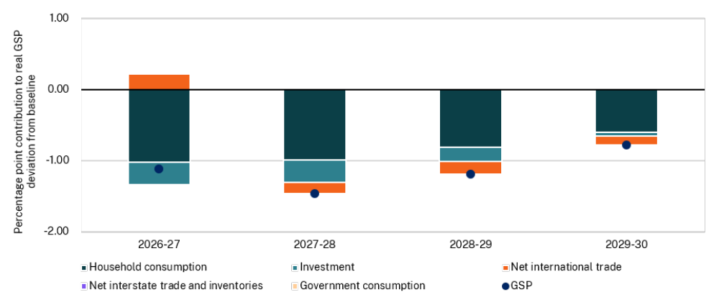
Source: NSW Treasury

Scenario 1b—Accounting for second round effects on inflation, and a monetary policy response by the RBA, amplifies the impact of the higher oil prices in the short term but allows the economy to gradually return towards the baseline.
Second round effects arise from higher inflation expectations and stronger wage bargaining aimed at maintaining the level of real wages. With second round effects included, the level of the Sydney headline CPI increases by a maximum of 5¾ per cent relative to baseline by late 2027. National underlying consumer prices deviate from the baseline by a maximum of 5¼ per cent by early 2029.
While there is a larger impact on domestic economic activity through the channels discussed in Scenario 1a, this is mitigated somewhat by the assumption that nominal wages increase initially to maintain the level of real wages in the short run.
- Effect on major NSW economic parameters from higher energy prices (1b)^{(a)}
Financial year estimate^{(a)} | 2026-27 | 2027-28 | 2028-29 | 2029-30
State final demand | (1¾) | (1¾) | (1¼) | (½)
Gross state product | (1¼) | (1¾) | (1) | (½)
Employment | (¾) | (1) | (½) | (¼)
Unemployment rate | ¾ | 1 | ½ | ¼
Consumer price index (Sydney) | 3½ | 5¾ | 5¼ | 5
Household Disposable Income | 0 | (¼) | ¼ | ¾
Productivity | (¼) | (½) | ¼ | ¼

- Figures reported are the per cent change in the level of each parameter relative to the baseline. The unemployment rate is in percentage points deviation. Values in parentheses are negative. Figures are rounded to the nearest quarter point.
Source: NSW Treasury

Meanwhile, higher interest rates dampen household consumption and private business investment through several channels. These include:
- saving and investment channel—higher interest rates increase incentives to save and lower incentives to invest
- wealth channel—higher interest rates weigh on asset values, which can reduce borrowing capacity for some borrowers by lowering the value of collateral that can be borrowed against. Additionally, changes in savings rates tend to be negatively correlated to changes in wealth, meaning that people will save more when their wealth is declining
- cash flow channel—higher interest rates increase interest expenses for borrowers, lowering disposable income, although there is some offset from higher interest earned on deposits held by savers
- exchange rate channel—if interest rates rise more in Australia relative to the rest of the world, this tends to attract foreign investors and result in a higher exchange rate, which can potentially weigh on exports and domestic activity.
Under Scenario 1b, NSW SFD falls by 1¾ per cent relative to baseline by 2027-28, compared to -1¼ per cent under scenario 1a. Dwelling investment and consumption are particularly sensitive to higher interest rates, falling by 5 per cent and 2½ per cent in 2027-28 relative to baseline respectively. The peak impact on GSP is 1¾ per cent below baseline (Chart F.2).
The resulting decline in the demand for labour sees employment fall by 1 per cent relative to baseline and the peak in the unemployment rate is 1 percentage points higher than baseline (Table F.2).
- Impact on NSW domestic activity from higher energy prices (Scenario 1b)
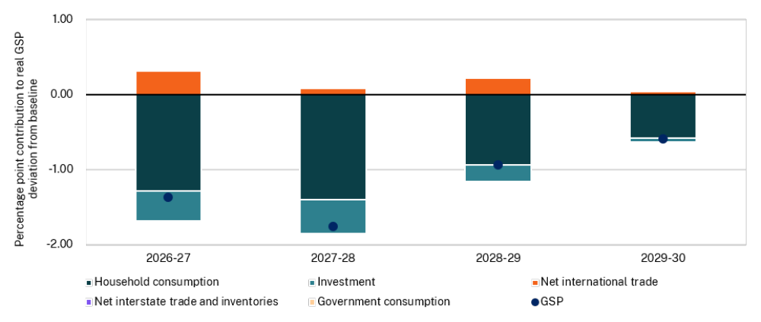
Source: NSW Treasury

Revenue impact of Scenario 1b on the Budget and over the forward estimates
Weaker domestic economic activity flows through to lower transfer duty, particularly in 2027-28 and 2028-29 (see Table F.3). However, this is more than offset by higher royalties and GST revenue, reflecting higher coal prices and the contribution of inflationary pressures to nominal consumer spending. Payroll tax is also up as inflation expectations drive higher wages, offsetting lower employment.

- Effect on major revenue parameters^{(a)}
Financial year estimate^{(a)} | 2026-27 | 2027-28 | 2028-29 | 2029-30
 | $m | $m | $m | $m
Payroll tax | 232 | 96 | 114 | 143
Transfer duty | (568) | (1,503) | (1,377) | (634)
Land tax | 0 | (127) | (310) | (428)
Royalties | 918 | 962 | 403 | 33
GST revenue | 278 | 769 | 707 | 862
Total revenue | 860 | 197 | (463) | (24)

- Figures reported are the change in the level of each parameter relative to the baseline. Values in parentheses are negative.
Source: NSW Treasury

Scenario 2: A positive shock to productivity in New South Wales
Productivity plays a critical role in economic performance by determining how efficiently labour and capital are used. Over the long term, it is the main source of economic growth and the primary driver of rising real wages and living standards.
Australia and New South Wales have highly productive economies that produce some of the highest value output per hour worked in the world. This level of productivity is reflected in our high average incomes and standards of living.
Growth in productivity, however, has slowed markedly since the period of economic reform in the 1990s, lowering growth in real per capita income. Labour productivity growth, defined as growth in output per hour worked, has been particularly weak since the onset of COVID-19, averaging just 0.2 per cent per year in New South Wales in the six years to 2024-25. Based on the 20-year average growth rate, the forecasts assume that potential growth in labour productivity in New South Wales is 0.8 per cent per annum. NSW Treasury forecasts assume productivity growth remains below its long-run potential rate over the next two years as higher interest rates reduce growth in private market sector activity, before rising to its long-run potential rate by the end of the Budget horizon (Table F.4).
Scenario 2 assumes that labour productivity grows in line with the long-run equilibrium assumption of 0.8 per cent per annum on average over the Budget projection period to 2029-30. This includes the weak productivity growth result anticipated for 2025-26, with most of the ‘catch-up’ assumed to occur in 2026-27. This compares to an average of 0.5 per cent per annum under the baseline. In this scenario, the level of productivity is around 1.6 per cent higher in the 2029-30 financial year than in the baseline.
- Productivity growth assumptions^{(a)}
Financial year estimate^{(a)} | 2025-26 | 2026-27 | 2027-28 | 2028-29 | 2029-30 | Average
Productivity growth – baseline | 0.2 | 0.5 | 0.5 | 0.7 | 0.8 | 0.5
Productivity growth – scenario | 0.2 | 1.7 | 0.7 | 0.8 | 0.8 | 0.8

- Productivity measured as gross state product per hour worked.
Source: NSW Treasury

Impact on the macroeconomy
Higher labour productivity growth means that firms can increase their output using unchanged labour inputs, or alternatively that they need less labour to produce the same amount of output. Both these possibilities are consistent with a lower cost of production for each unit of labour, which will improve firms’ competitiveness. This can be passed through to lower final prices, higher wages, higher firm margins, or a combination of all three.
In response, businesses expand production and increase their demand for labour relative to the baseline forecast. In this specific scenario, employment would be expected to rise by almost 0.1 per cent in the near term and the unemployment rate would be approximately ¼ percentage points lower over the projection period (Table F.5).
An expansion in economic activity increases demand for capital, lifting non-dwelling investment by around ¾ per cent relative to baseline by 2029-30.
The scenario modelling suggests that higher productivity lowers production costs and places downward pressure on prices, making CPI inflation around ¾ of a percentage point lower than the baseline forecast in 2026-27.
Lower prices result in nominal wage growth being slightly lower than in the baseline forecast, but real wages increase by around ½ per cent relative to baseline by 2028-29 as nominal wage growth exceeds product price growth.
Stronger real wages and higher employment boost household incomes, driving an increase in real household consumption of around 1¾ per cent relative to baseline by 2029-30.
SFD increases overall, but the rise in GSP is larger as improved competitiveness supports export growth. GSP is 1½ per cent higher than baseline by 2029-30 (Chart F.3).
- Effect on major NSW economic parameters from a productivity shock^{(a)}
Financial year estimate^{(a)} | 2026-27 | 2027-28 | 2028-29 | 2029-30
State final demand | ¾ | 1 | 1¼ | 1¼
Gross state product | 1¼ | 1½ | 1½ | 1½
Employment | 0 | 0 | 0 | 0
Unemployment rate | (¼) | (¼) | (¼) | (¼)
Consumer price index (Sydney) | (¾) | (¾) | (¾) | (¾)
Household Disposable Income | ½ | 1 | 1¼ | 1¼
Productivity | 1¼ | 1½ | 1½ | 1½

- Figures reported are the per cent change in the level of each parameter relative to the baseline. The unemployment rate is in percentage points deviation. Values in parentheses are negative. Figures are rounded to the nearest quarter point.
Source: Victoria University Regional Model and NSW Treasury

- Impact on NSW domestic activity from a productivity shock
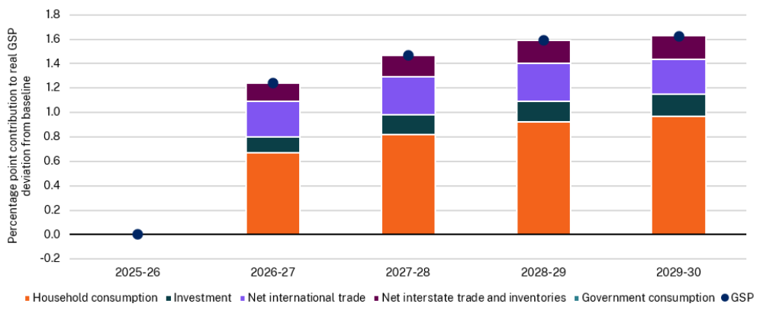
Source: Victoria University Regional Model and NSW Treasury

Revenue impact on the Budget and over the forward estimates
This scenario results in an increase in tax collections for the Government across several categories of government revenue. The main exception is payroll tax. Although real wages increase, broader disinflationary pressures lower nominal prices and payroll tax revenues. Residential and commercial transfer duty collections are marginally higher, consistent with an increase in dwelling and non-dwelling investment as well as higher household disposable income. Royalties also rise as lower production costs relative to global prices (due to higher domestic productivity), reflected in a real exchange rate depreciation, contributes to greater exports. The State’s GST revenue increases, reflecting an increase in household consumption and dwelling investment.
- Effect on major revenue parameters^{(a)}
Financial year estimate^{(a)} | 2026-27 | 2027-28 | 2028-29 | 2029-30
 | $m | $m | $m | $m
Payroll tax | (102) | (86) | (58) | (25)
Transfer duty | 32 | 71 | 111 | 140
Land tax | 0 | 9 | 21 | 39
Royalties | 52 | 75 | 97 | 115
GST revenue | 124 | 209 | 288 | 358
Total revenue | 106 | 278 | 459 | 627

- Figures reported are the change in the level of each parameter relative to the baseline. Values in parentheses are negative.
Source: VURMTAX-GREEN model and NSW Treasury

The expense growth average for all other Australian governments has been calculated by aggregating the expenses for all other jurisdictions and averaging this data.
Figures adjusted to 2024-25 dollars.
AIHW, 2025, Housing affordability, Figure 2
Includes timing adjustments related to movements in project delivery schedules. Also includes central adjustments for capital slippage as informed by historical data.
This is a revenue measure.
This figure includes recurrent expenditure associated with both new measures and variations and includes additional investments made since the 2025-26 Budget but prior to the 2025-26 Half-Yearly Review.
This figure includes recurrent expenditure associated with both new measures and variations.
The complete Uniform Presentation Framework is available on the Commonwealth Treasury website www.treasury.gov.au. Extracts from the manual are included in this appendix to explain key concepts while the glossary to “How to Read the Budget Papers” also includes key UPF terms.
Where the value of the tax expenditure is estimated to be more than $1 million in at least one year, but there is insufficient data available on which to base a reliable estimate.
Where the value of the tax expenditure is estimated to be more than $1 million in at least one year, but there is insufficient data available on which to base a reliable estimate.
³ Items listed under the ‘other tax expenditures’ heading are those where there is insufficient data available on which to base a reliable estimate.
The 2026-27 Tax expenditures and concessional charges statement contains a more detailed breakdown of Parking Space Levy exemptions compared to prior year statements.
Data only includes clubs with positive gaming machine revenue.
Data is based on lodgement date.
- The Budget includes allowances for parameter and technical adjustments and anticipated timing changes. See Chapter 5 Recurrent expenditure for more information.
VURMTAX is a dynamic computable general equilibrium model of Australia’s six states and two territories, with each region modelled as an economy in its own right. See Adams, Philip, Dixon, Janine and Horridge, Mark (2015), ‘The Victoria University Regional Model (VURM): Technical Documentation, Version 1.0’, CoPS/IMPACT Working Paper Number G-254 for more detail on the model.

