6. Security Mitigation and Verification
The process of mitigation involved maintaining the same functionality for the demonstration programs while also ensuring that the attack vectors used to exploit the vulnerabilities were not possible anymore. The secure versions were implemented in separate mitigated folders to enable comparison between the vulnerable version and the secure version of the programs. Verification involved the use of test cases as well as the attack vectors.

6.1 NoSQL Injection Mitigation

6.1.1 Mitigation Objective
The objective of the NoSQL Injection mitigation was to prevent attacker-controlled JSON objects from reaching the MongoDB/Mongoose query filter where they could be interpreted as query operators. The login endpoint is intended to receive a username and password as ordinary text values. The secure design therefore enforces that both credential fields are primitive strings before constructing or executing the database query.

6.1.2 Security-Enhanced Code
The main mitigation is implemented in nosql-injection/mitigated/routes/auth.js. The route validates the expected credential types and lengths before any values are used in User.findOne().
1. function isValidCredentialString(value, maxLength) {
2. return typeof value === 'string' && value.length > 0 && value.length <= maxLength;
3. }
4. if (!isValidCredentialString(username, MAX_USERNAME_LENGTH) ||
5. !isValidCredentialString(password, MAX_PASSWORD_LENGTH)) {
6. console.log('[AUTH-SECURE] Rejected: invalid credential type or length.');
7. return res.status(400).json({
8. status: 'error',
9. message: 'Username and password must be valid strings.'
10. });
11. }
12.
13. const safeUsername = username.trim();
14. const queryFilter = {
15. username: safeUsername,
16. password: password
17. };
18. const user = await User.findOne(queryFilter);

6.1.3 Mitigation Technique
- Type enforcement: username and password must both be primitive JavaScript strings. Nested objects and arrays are rejected before the query is created.
- Basic input constraints: empty values and credentials that exceed the preset maximum lengths are rejected.
- Username normalization: leading and trailing whitespace is removed from the username before the equality query is constructed.
- Security logging: the secure route records the received input types and whether the request was rejected, thus helping us support later verification and tracing.

6.1.4 Why the Mitigation works against the exploit
The vulnerable code accepts any non-undefined JSON value and adds it to the filter in the Mongoose query without validation. In this way, a field from the request is parsed as an object that contains MongoDB operator. The mitigation code checks the data type first of all. Because the injected operator payload is received as an object rather than a primitive string, the type-validation check rejects the request with HTTP 400 before User.findOne() is executed. In this way, MongoDB gets only string equality conditions for the 'username' and 'password' fields.
1. {"username":{"$ne":""},"password":{"$gt":""}}

6.1.5 Verification Method
Validation tests were performed on both the security and functionality aspects of the secure code.
- Valid credentials: validates that the legitimate credentials can authenticate successfully.
- Wrong password: validates that the ordinary wrong password is still rejected.
- Password-object payload sends the original payload again but with valid username and an object-valued password.
- Full-object payload sends the original payload with an object-valued username and password to verify that both are rejected.
- Log check validates whether the secure path logs the object input type and rejects the payload before the database query is made.

6.1.6 Verification Results
Test | Vulnerable Version | Mitigated Version | Outcome
Valid login | Successful authentication | HTTP 200 - successful authentication | Normal functionality is preserved
Wrong password | HTTP 401- rejected | HTTP 401 - rejected | Normal functionality is preserved
Password-bypass payload | Authentication bypass demonstrated in vulnerable version | HTTP 400 - rejected | Must be rejected before the query execution
Full-object bypass | Authentication bypassed | HTTP 400 - rejected | Mitigation Successful

6.1.7 Verification Evidence
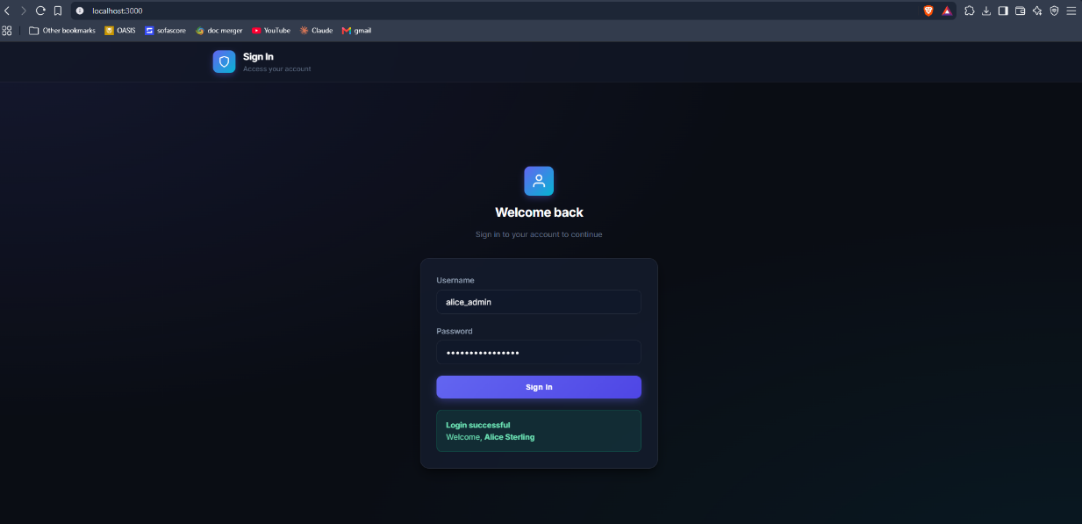
Figure 1 - NoSQL valid login result
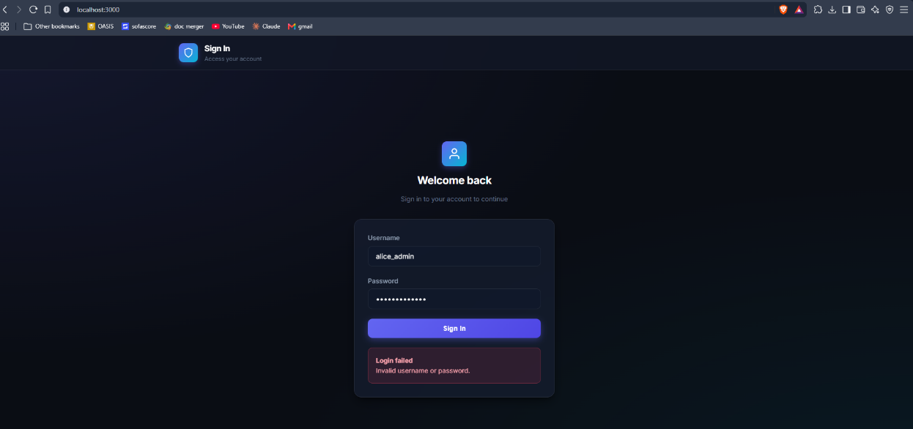
Figure 2 - NoSQL invalid login result
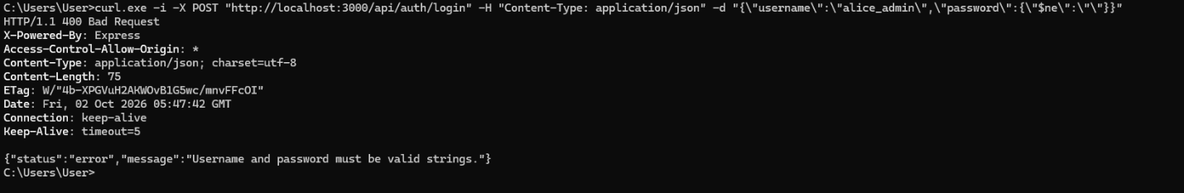
Figure 3 - NoSQL password bypass result
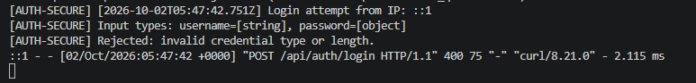
Figure 4 - NoSQL password bypass log result
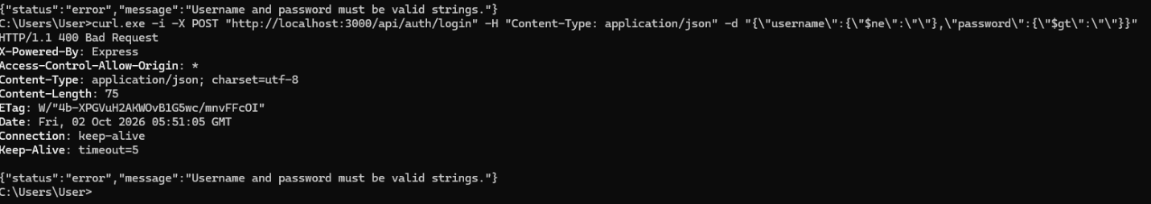
Figure 5 - NoSQL full bypass result
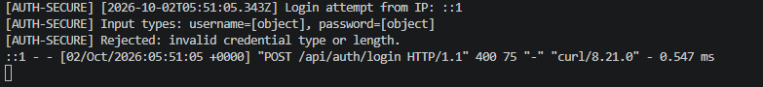
Figure 6 - NoSQL full bypass log result

6.1.8 NoSQL Mitigation Summary
The security-enabled login path alters the trust boundary of the application through credential validation prior to database operations. String credentials will still perform the intended equality query, whereas structured credentials with potential MongoDB queries will be blocked prior to being processed in Mongoose. The raw-JSON verification results confirm that the original object-based password bypass is rejected before the database query is executed.

6.2 Path Traversal Mitigation

6.2.1 Mitigation Objective
This is aimed at making sure that file requests controlled by users cannot get out of the directory containing the allowed demo files. The protected server should continue providing access to the text documents allowed while denying any components or resolved targets not within the allowed directory limits.

6.2.2 Security-Enhanced Code
Mitigation is implemented in path-traversal/mitigated/routes/documents.js. It combines filename validation with a resolved-path boundary check.
1. if (path.basename(fileName) !== fileName || fileName.includes('/') || fileName.includes('\\')) {
2. console.log(`[DOC-SECURE] [${new Date().toISOString()}] Blocked path component from IP: ${clientIp} | file="${fileName}"`);
3. return res.status(403).json({
4. status: 'fail',
5. message: 'Requested path is outside the permitted document directory.'
6. });
7. }
8. if (path.extname(fileName).toLowerCase() !== '.txt') {
9. console.log(`[DOC-SECURE] [${new Date().toISOString()}] Blocked disallowed extension from IP: ${clientIp} | file="${fileName}"`);
10. return res.status(403).json({
11. status: 'fail',
12. message: 'Only permitted text documents may be retrieved.'
13. });
14. }
15. const targetFilePath = path.resolve(PERMITTED_DOCUMENT_DIR, fileName);
16. const permittedPrefix = PERMITTED_DOCUMENT_DIR + path.sep;
17. if (!targetFilePath.startsWith(permittedPrefix)) {
18. console.log(`[DOC-SECURE] [${new Date().toISOString()}] Boundary check blocked request from IP: ${clientIp} | target="${targetFilePath}"`);
19. return res.status(403).json({
20. status: 'fail',
21. message: 'Requested path is outside the permitted document directory.'
22. });
23. }

6.2.3 Mitigation Technique
- Filename Validation: The endpoint requires that file be a non-null string.
- Path Component Blocking: Path components including directory separators and resolving to a different basename are not allowed, ensuring that invalid requests like ../ will not be recognized as filenames.
- Canonical Path Construction: path.resolve() is employed to build a canonical target path.
- Boundary Check on Directory: The constructed target is validated for the allowed directory prefix prior to any filesystem operations.
- Security Logging: Denied path requests are logged along with the provided file argument for auditing purposes.

6.2.4 Why Mitigation works against the exploit
The vulnerable version used the supplied filename to construct a filesystem path without enforcing the final directory boundary. A traversal sequence could therefore be resolved outside the intended document directory. In the mitigated version, a value containing traversal path components is rejected immediately. A second resolved-path boundary check provides defence in depth before fs.readFile() is reached. The original traversal value used during exploitation therefore cannot be used to retrieve the demonstration file outside the permitted directory.

6.2.5 Verification Method
The secure Path Traversal function was tested using both valid and invalid file requests as well as the traversal request sent by Kavin. It was necessary to show that all valid functionality was possible, but out-of-directory access was prevented.
- Valid file request: GET audit_report_2026.txt and verify HTTP 200 response with expected file content.
- Missing file request: GET nonexistent .txt filename and verify 404 response as usual.
- Path Traversal request: repeat ../../config/.env.secrets request and verify that the secure route responds with HTTP 403 rather than file content.
- Verify server logs for path component rejection.

6.2.6 Verification Results
Test | Vulnerable Version | Mitigated Version | Outcome
Valid document | HTTP 200-document previewed | HTTP 200 - document previewed | Normal functionality preserved
Missing document | HTTP 404 | HTTP 404 | Normal error handling preserved
Traversal request | Unauthorized document is previewed | HTTP 403 - blocked | Mitigation successful

6.2.7 Verification Evidence
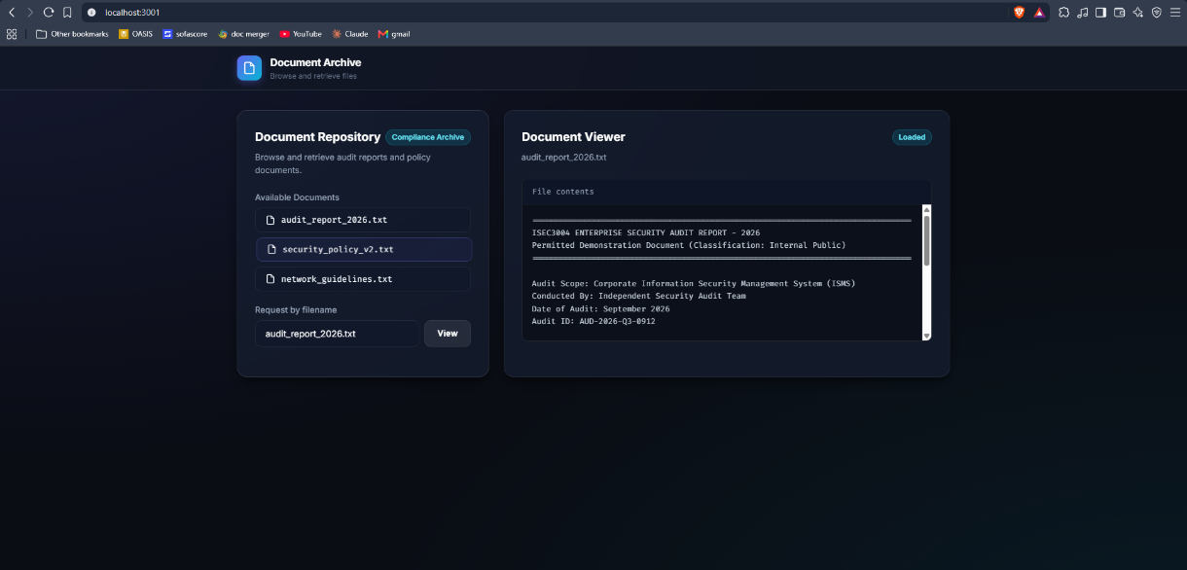
Figure 7 - path traversal valid file
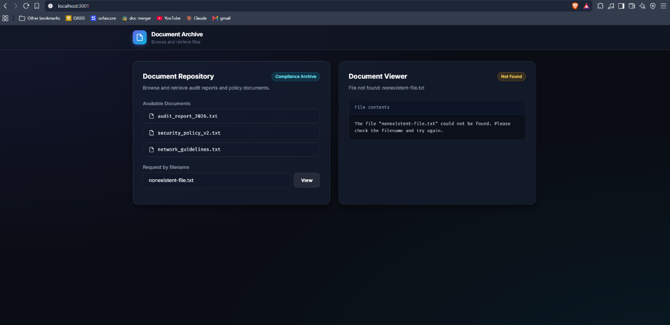
Figure 8 - path traversal missing file
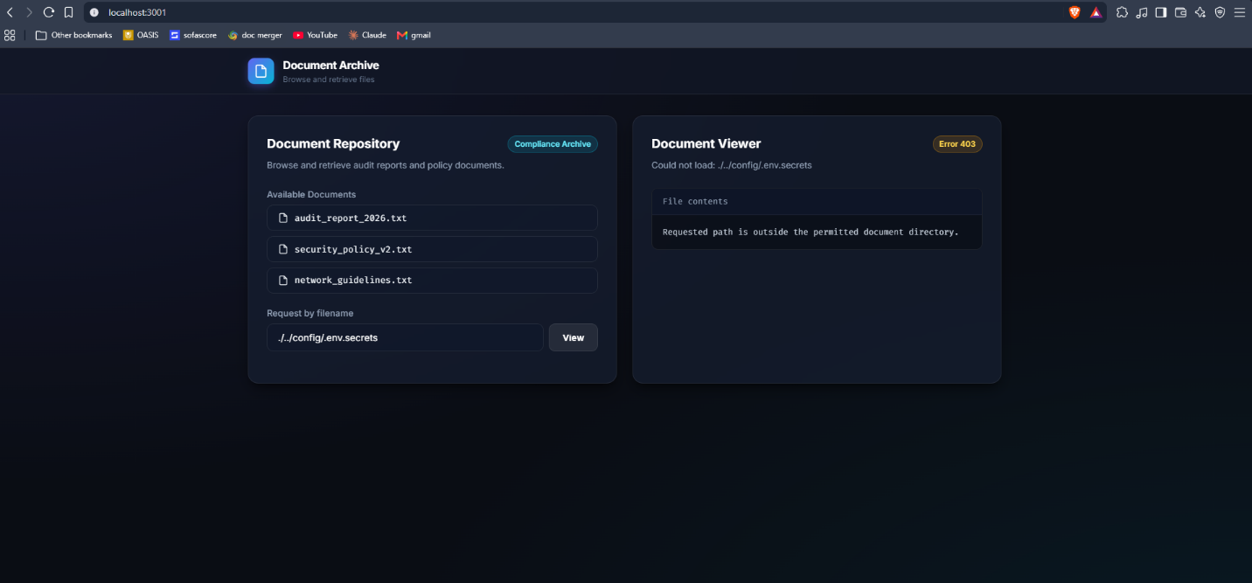
Figure 9 - path traversal blocked attempt
Figure 10 - path traversal blocked attempt log proof

6.2.8 Path Traversal Mitigation Summary
Mitigation of the Path Traversal attack does not affect document availability while ensuring a strict boundary on the allowed document directory. User supplied variables which include any path elements are disallowed, and the path resolution of the final target is verified prior to accessing the filesystem. Verification indicates that valid documents can be accessed, invalid documents will generate expected error responses, and the initial traversal request will be blocked.

