Adjacency Matrix

|  |  |  |  |  |  |  |  |
| --- | --- | --- | --- | --- | --- | --- | --- |
| Vertex List |  | 0 | 1 | 2 | 3 | 4 | 5 |
| 0 | 0 | **0** | **1** | **0** | **0** | **0** | **1** |
| 1 | 1 | **1** | **0** | **0** | **1** | **1** | **1** |
| 2 | 2 | **1** | **0** | **0** | **1** | **1** | **1** |
| 3 | 3 | **1** | **0** | **1** | **0** | **0** | **1** |
| 4 | 4 | **0** | **0** | **1** | **0** | **0** | **1** |
| 5 | 5 | **0** | **1** | **1** | **1** | **1** | **0** |

Adjacency List

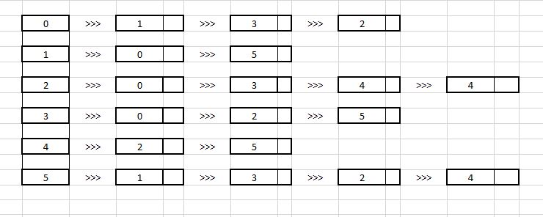

Dijkstra Algorithm

