
ISLAMIC UNIVERSITY OF TECHNOLOGY

SAP-1 Architecture Based 8-Bit Computer Design & Implementation

Team: Silicon 6
Course Code: EEE 4308
Course Name: Digital Electronics Lab
Group Members:
- Ishrak Samin – 230021303
- Nafis Shahriar Ahmed – 230021137
- Shaheen Rahman Dibya – 230021315
- Mutassim Al Shahriar Zeem - 230021320
- Raian Ratul - 230021115
- Shaker Abdullah – 230021123
Table of Contents
- Phase A: Clock Generator & Program Counter
- Phase B: Registers & Memory System
- Phase C & D: ALU, Controller, Multiplier & Output
- Conclusion

Phase A: Clock Generator & Program Counter
1.1 Clock Pulse Generator
Overview
The clock signal is generated using a 555 timer IC with two modes of operation: Auto and Manual. Both modes are connected via an OR-gate to select the desired clock pulse signal.
Modes of Operation:
- Auto Mode (Astable Multivibrator): Free-running oscillator producing a continuous square-wave signal. Duty cycle is approximately 48% with a time period of 0.33s.
- Manual Mode (Monostable Multivibrator): Requires an external trigger (push button). Each press generates one clock pulse, allowing manual advancement of the instruction cycle.
- Halt Control: The clock pulse input is ANDed with the NOT of the HALT input. When HALT is active (Logic 1), the clock generator input becomes zero, halting operation.
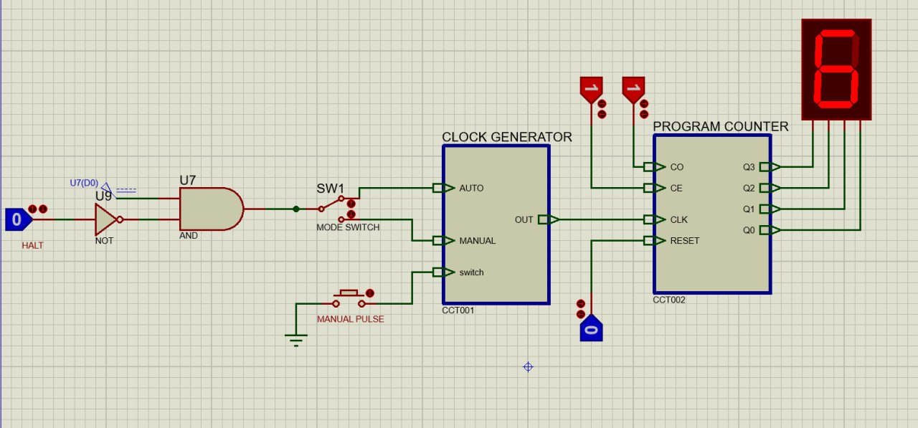
Fig – Circuit for Phase A
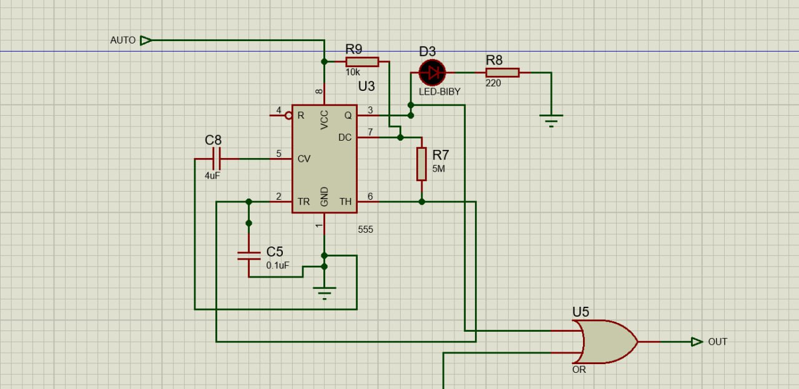
Fig- Astable multivibrator for auto mode
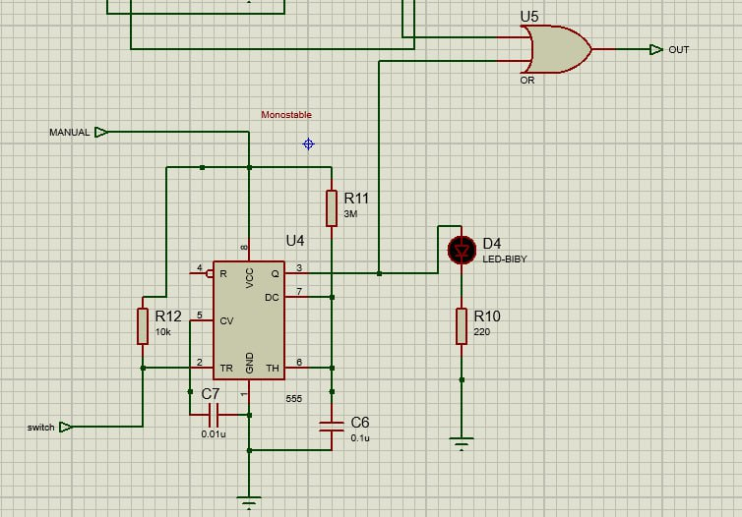
Fig- Monostable Multivibrator for manual mode

1.2 Program Counter Module
Overview
The Program Counter (PC) is a 4-bit register capable of counting from 0000 to 1111. It stores and provides the memory address of the next instruction. After each instruction cycle, the PC automatically increments.
Pin Configuration
Pin | Type | Function
CE | Input | Program Counter Enable: Increments PC on next clock cycle.
CO | Input | Program Counter Out: Places current value onto the bus.
RESET | Input | Resets the program counter to 0000.
CLK | Input | Clock pulse input.
OUT | Out | 4-bit counter output.

Working Principle
The circuit consists of 4 D flip-flops with input D connected to output Q'. This configuration allows the flip-flop to toggle with each clock pulse. A 3-bit counter counts to 6 to match the 6-clock pulse instruction cycle. The output is connected to a tri-state buffer to ensure no output is given to the bus when CO is low.
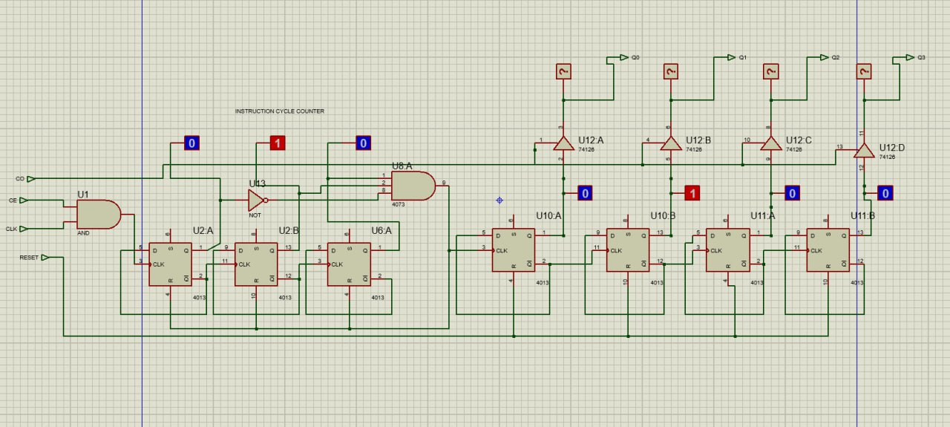
Fig: Program counter

Phase B: Registers & Memory System

2.1 Registers (Accumulator, B-Register, MAR)
Overview
Three primary registers were implemented using D flip-flops (IC 4013) and tri-state buffers. They store data and control transfer on the common bus.
1. Accumulator (A-Register)
Primary working register storing arithmetic results.
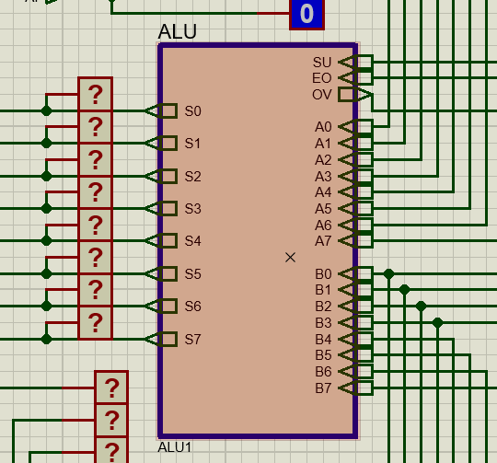
Fig – Accumulator Block Diagram
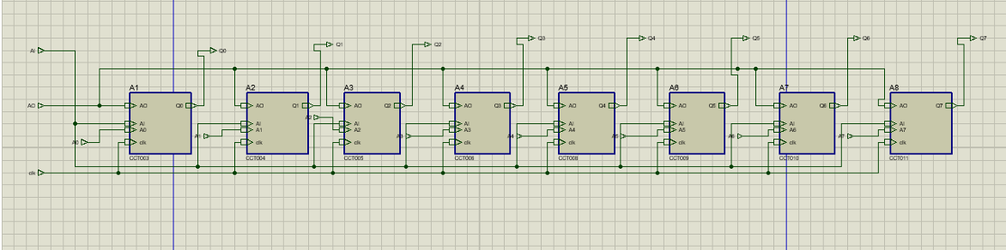
Fig – Accumulator Internal Circuit

Pin | Type | Function
AI | Input | Accumulator In: Stores bus values into Accumulator.
AO | Input | Accumulator Out: Sends stored content to bus.
A0–A7 | Input | Takes input from the bus.
CLK | Input | Clock pulse input.
Q0–Q7 | Output | Stored accumulator value/result.

2. B-Register
Stores 8-bit value from bus as a fixed operand for the ALU. Does not drive the system bus (no output-enable pin).
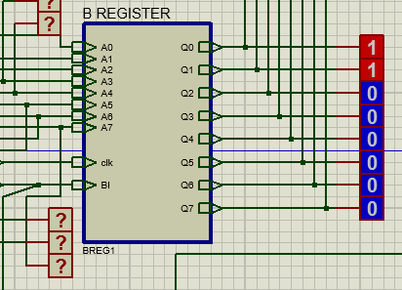
Fig - B-Register Block Diagram
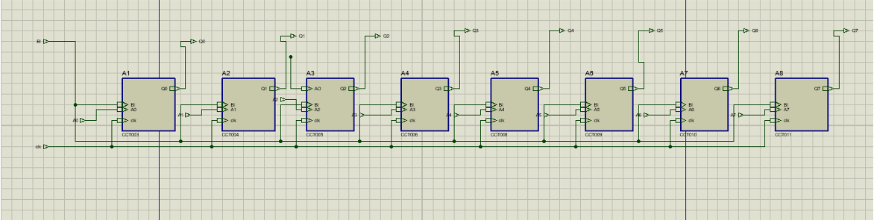
Fig - B-Register Internal Circuit
Pin | Type | Function
BI | Input | B-Register In: Stores bus values into B-Register.
A0–A7 | Input | Takes input from the bus.
CLK | Input | Clock pulse input.
Q0–Q7 | Output | Stored B-Register value.

3. Memory Address Register (MAR)
4-bit register storing the address of the memory location in RAM to be accessed.
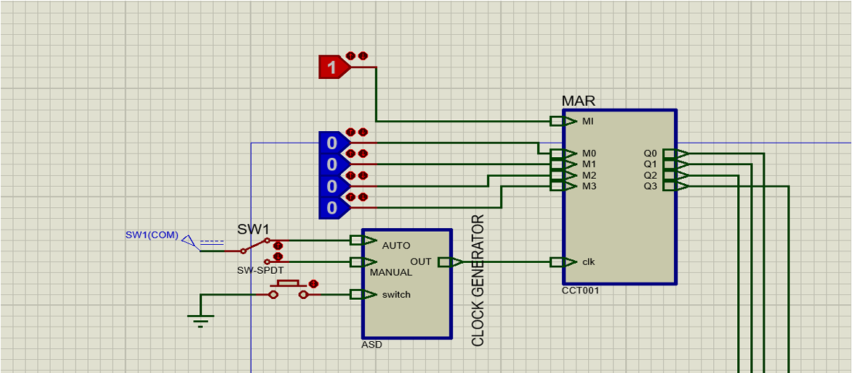
Fig - MAR Block Diagram
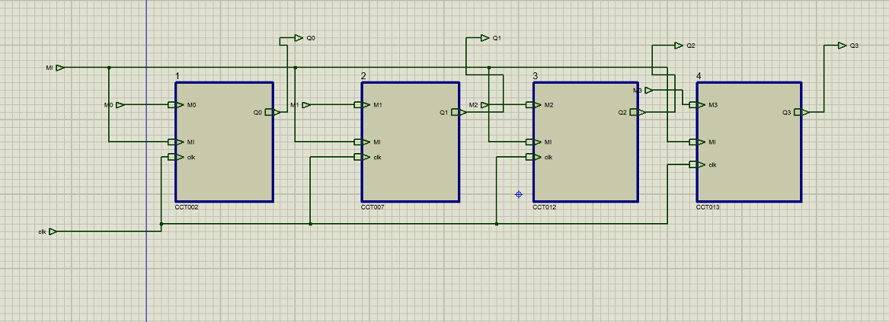
Fig - MAR Internal Circuit
Pin | Type | Function
MI | Input | Memory Address In: Stores bus values into MAR.
M0-M3 | Input | Takes input from the bus.
CLK | Input | Clock pulse input.
Q0–Q3 | Output | Stored 4-bit address output to RAM.

2.2 RAM System with Input & Selector Unit
Overview
Integrates an 8x16 RAM with an Input Unit and Selector for dual-mode operation (Manual Programming vs. Automated Run).
RAM Components
Uses two 74LS189 ICs (split-bus configuration) for 8-bit data within 16-byte address space.
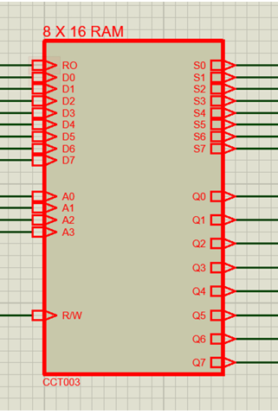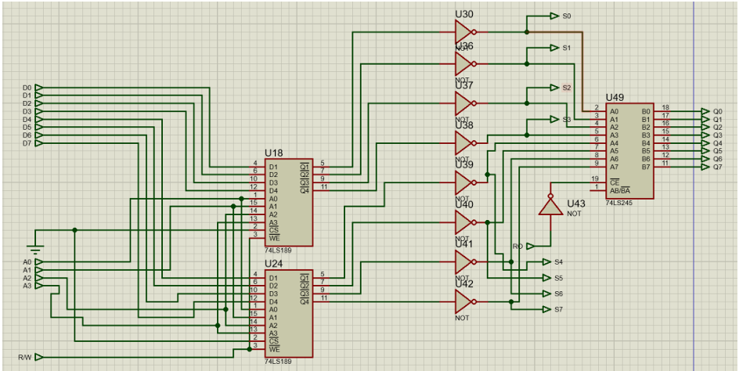
fig – Block and Circuit Diagram of RAM
Pin | Type | Function
RO | Input | Output Enabler: Controls 74LS245 to place RAM Data onto Bus.
D0-D7 | Input | Data Inputs from switches.
A0-A3 | Input | Address Inputs (Selects 1 of 16 memory slots).
R/W | Input | Read/Write Signal.
Q1-Q7 | Output | Bus Data Outputs.
S0-S7 | Output | Preview Data Outputs (LEDs).

Input Unit
Provides manual data and address control via physical switches. Controls R/W and Run/Prog states.
Selector Unit
Multiplexer toggling RAM address source between Manual Input (Program Mode) and MAR (Run Mode).
Additional Features
- Address Display: Visual reference for current memory location.
- Preview Signal: Debugging output for RAM data before bus release.
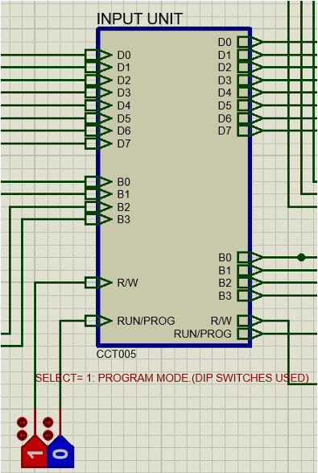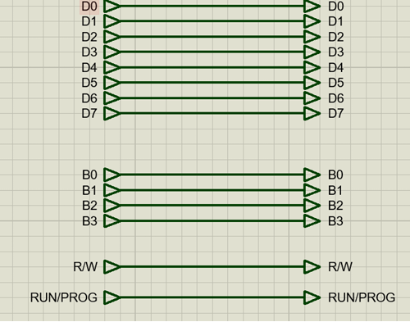
Fig – Block and Circuit Diagram of Input Unit
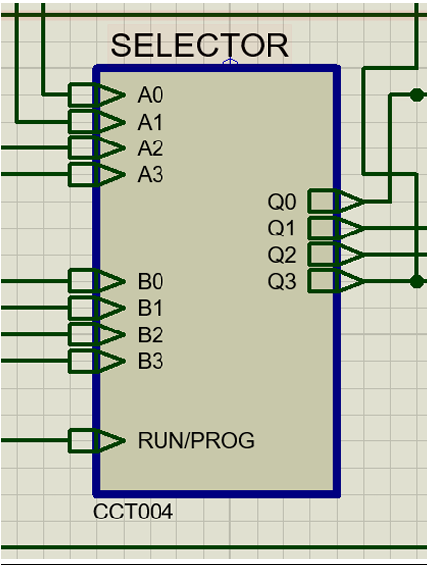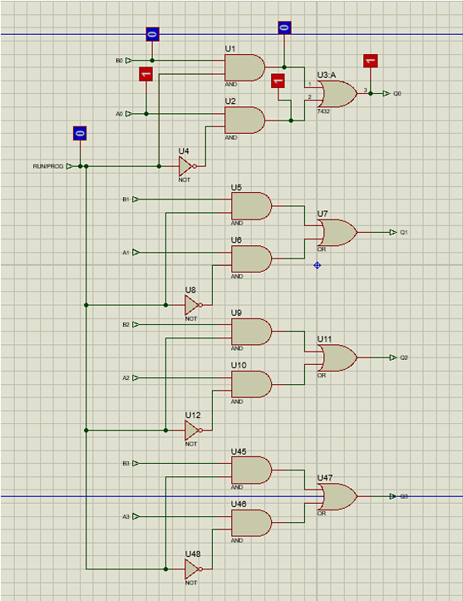
Fig – Block and Circuit Diagram of Selector Unit

Phase C & D: ALU, Controller, Multiplier & Output
Overview
The system is built around an 8-bit data bus that interconnects all modules. Each module communicates through tri-state logic ensuring only one device drives the bus at a time.
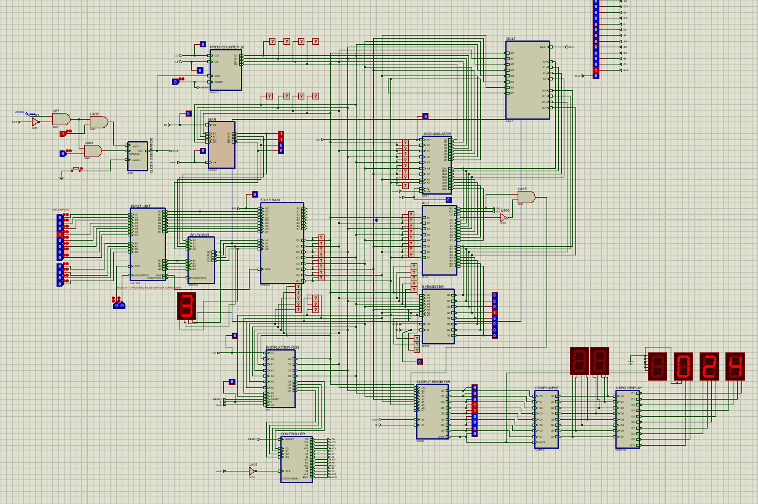
3.1 Arithmetic Logic Unit (ALU)
Components Used
- Two 4-bit adders (4008)
- XOR gates (for subtraction)
- 74LS245 (tri-state buffer)
- Control signals: SU, EO
Working Principle (Refined)
The ALU performs addition and subtraction using a cascaded 8-bit adder:
- Addition (SU = 0):
Direct addition of A and B.
- Subtraction (SU = 1):
Implemented using 2’s complement:
  - XOR gates invert B → 1’s complement
  - Carry-in = 1 → forms 2’s complement
  - Result = A – B
The output is enabled onto the bus using EO via the tri-state buffer.
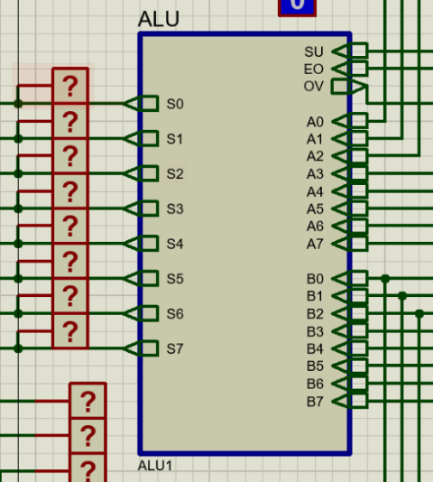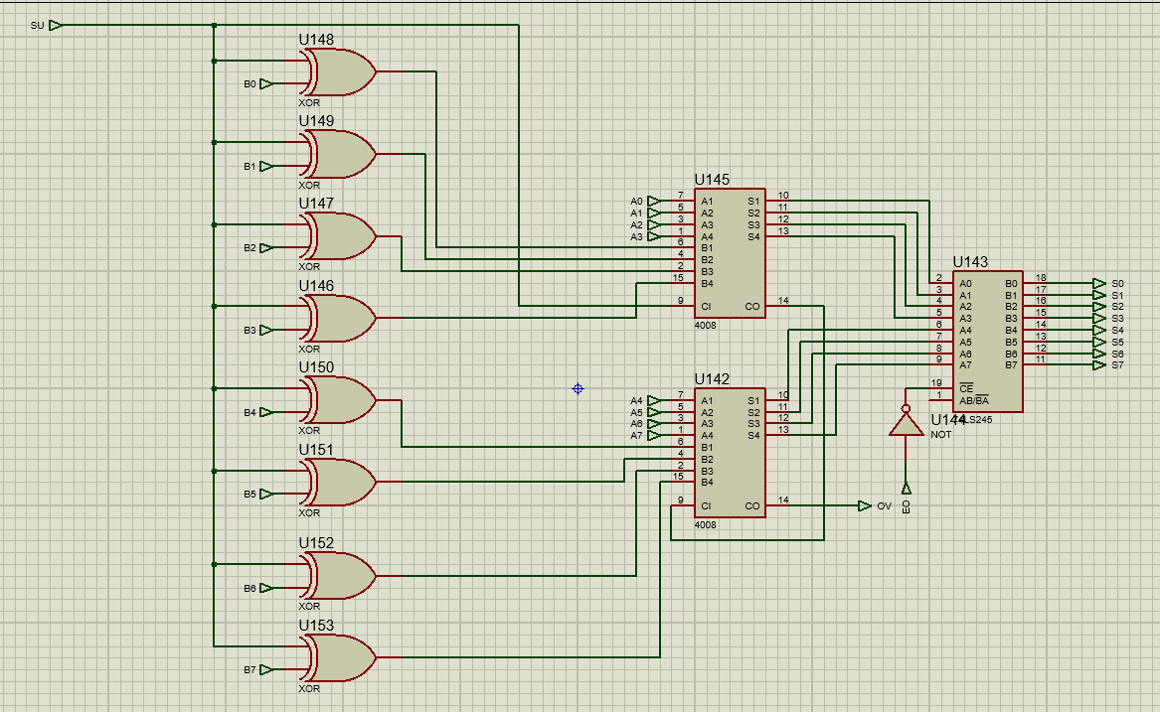
Fig – ALU Circuit
Pin | Type | Function
A0-A7 | Input | Takes the 8 bit data from the Accumulator
B0-B7 | Input | Takes the 8 bit data from the B Register
SU | Input | When SU=0, addition operation and when SU=1,  subtraction operation will be executed.
EO | Input | Puts the ALU output onto the bus.
S0-S7 | Output | The 8-bit result of the calculation.
OV | Output | Is HIGH when the subtraction result is negative

3.2 Instruction Register (IR)
Components Used
- D Flip-Flops (4013)
- NOT, AND, OR gates
- Tri-state buffer (74126)
Working Principle
- Stores 8-bit instruction from RAM
- Splits into:
  - Opcode (Q4–Q7) → sent to controller
  - Operand (Q0–Q3) → sent to MAR
Acts as a buffer ensuring stable instruction execution.
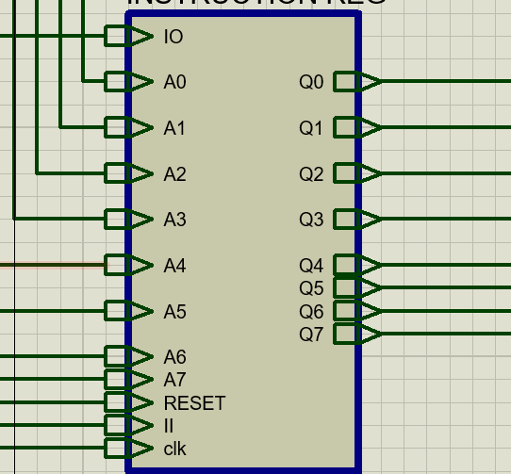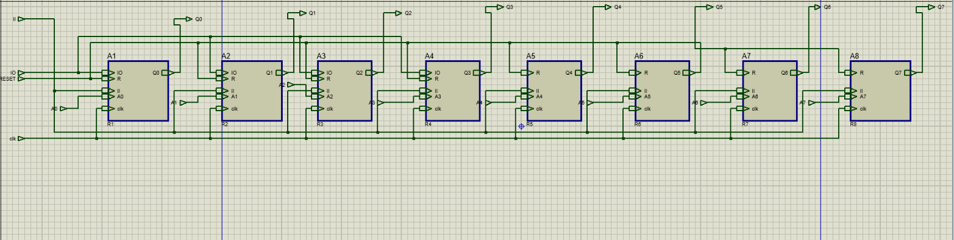
Fig – Instruction Register
Pin | Type | Function
A0-A7 | Input | Receive the full 8-bit instruction (OpCode + Operand) sent from the RAM through the bus
II (Instruction In) | Input | Writes the current values of the bus into the instruction register.
clk (Clock) | Input | The clock input from the clock pulse generator
Q0- Q3 | Output | Operand Output: Sends address
Q4-Q7 | Output | OpCode Output: They are sent directly to the Controller to be decoded (e.g., identifying the command as LDA, ADD, or OUT).
IO | Output | Sends the stored data (only lower nibble) onto the bus. Otherwise these bits are disconnected

3.3 Controller Sequencer
Components Used
- D Flip-Flops
- AND, OR, NOT gates
Working Principle
Generates control signals for all modules based on:
- Opcode
- Timing states (T1–T6)
Instruction Cycle
Fetch Cycle (T1–T3)
- T1: PC → MAR
- T2: PC increment
- T3: RAM → IR
Execution Cycle (T4–T6)
Depends on instruction:
- LDA, ADD, SUB, MULT, OUT, HLT

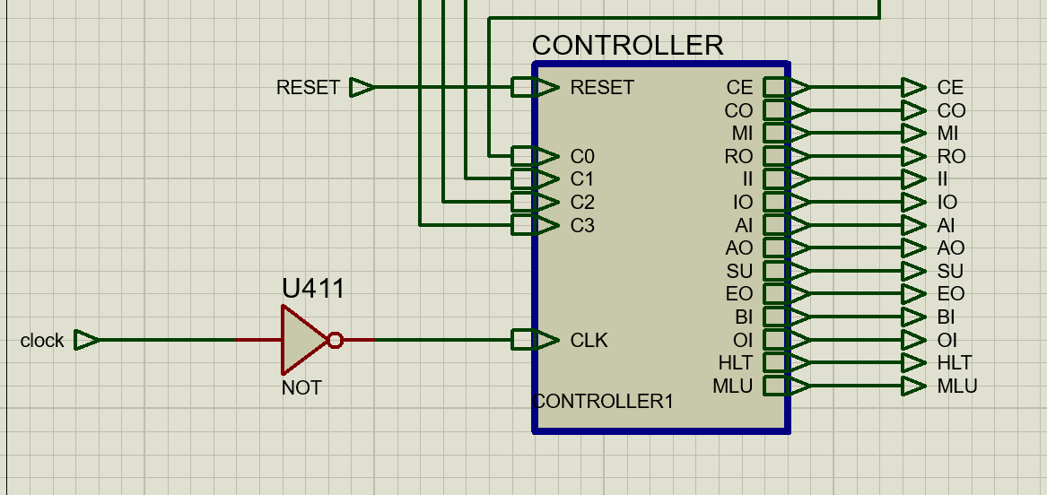
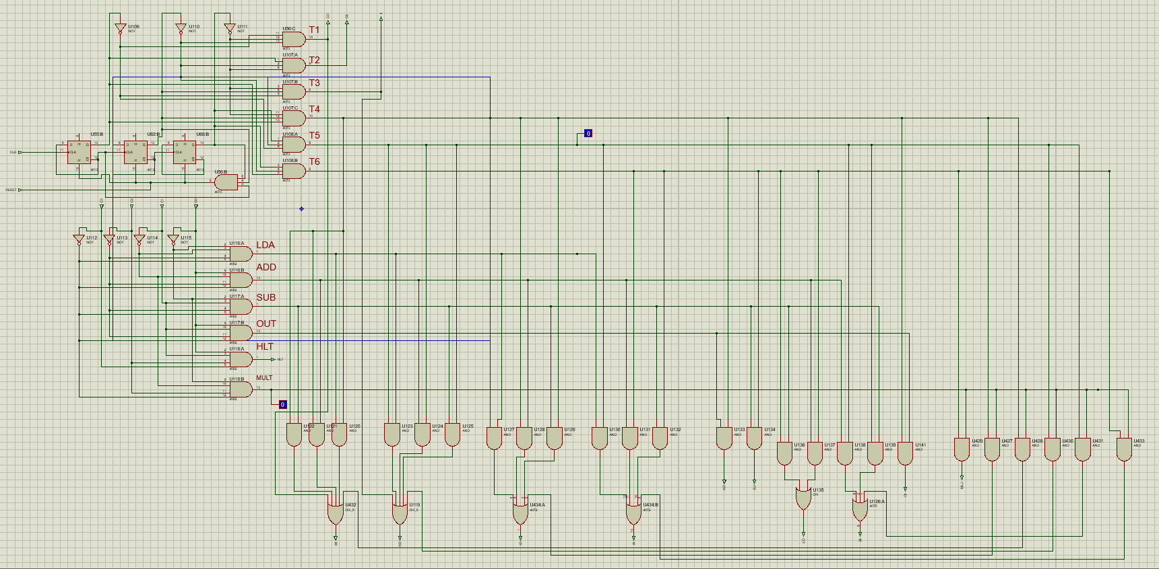
Fig - Controller Sequencer
Pin | Type | Function
C0-C3 | Input | Instruction Register opcode inputs. Represent the current instruction opcode
RESET | Input | Resets the internal timing counter (T-state counter) to initial state T1.
CLK | Input | The clock input from the clock pulse generator
CE | Output | Increment program counter
CO | Output | Enables program counter output to bus
MI | Output | Loads MAR from bus
RO | Output | Enables RAM to output data onto bus
II | Output | Loads instruction into IR
IO | Output | Outputs lower 4 bits(Q0-Q3) of IR to bus
AI | Output | Loads data into A register
AO | Output | Places A register content onto bus
SU | Output | Controls ALU operation mode
EO | Output | Enables ALU output onto bus
BI | Output | Loads data into B register
OI | Output | Loads data to output register from bus
HLT | Output | Stops system clock
MLU | Output | Enables the multiplier unit

3.4 Multiplier Unit
Implements a 4-bit binary multiplier producing an 8-bit result.
Working Principle
- Partial Products: Generated using AND gates
- Addition: Using Half & Full Adders
- Output Formation:
  - M0 → direct
  - M1–M6 → summed outputs
  - M7 → final carry
Control Signal (MLU)
The MLU signal is routed through logic (including an inverter and control block). It acts as an enable/ disable control and is linked to the controller unit of our total circuit.
We also added a new controller sequence with the opcode 0100 for multiplication.
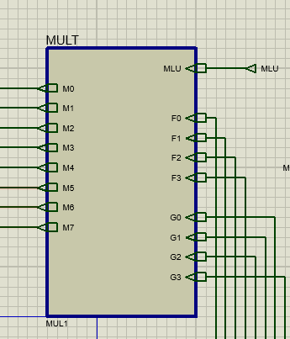
Fig - Multiplier Outer Circuit 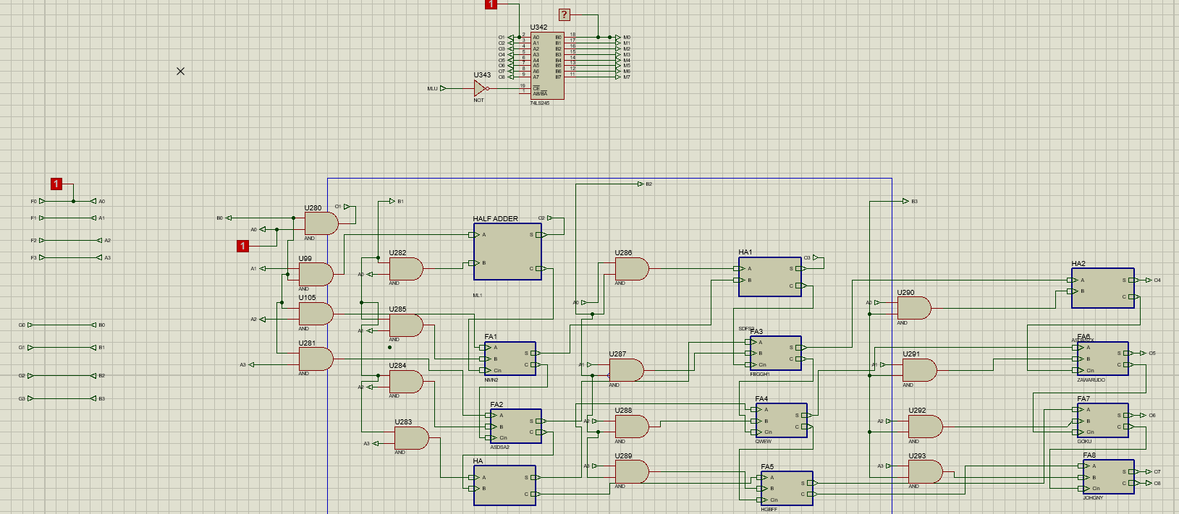
Fig - Multiplier Internal Circuit
3.5 Bus System Integration
Working Principle
- 8-bit bus connects all modules
- Only one module outputs at a time
- Tri-state buffers prevent contention
Connected Modules
- PC, MAR, RAM
- IR, ALU, Multiplier
- Registers and Output Unit
Fig – Bus Integration
3.6 Output Unit
Components
- Output Register
- Display modules (Hex + Decimal)
- Complement Generator
Working Principle
- Loads data using OI signal
- Uses OV flag → NEG signal
- Negative values:
  - Converted using 2’s complement
  - Displayed with negative sign
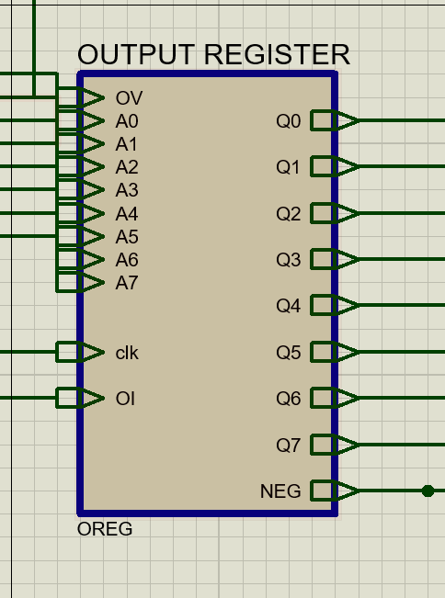
Fig – Outer Circuit of Output Register
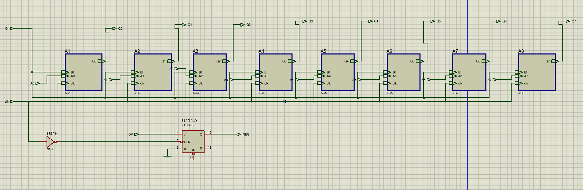
Fig – Inner Circuit of Output Register
Pin | Type | Function
A0-A7 | Input | Takes the 8 bit data from the bus
OV | Input | Overflow input from ALU
OI | Input | Controls whether to receive data from the bus or not
Q0-Q7 | Output | Stored 8-bit output value to be displayed
NEG | Output | Signal indicating negative result and negative sign display

3.7 BCD Converter for Decimal Display
Objective: Convert 8-bit binary output into readable decimal digits.
Working Principle
- Uses Shift-and-Add-3 (Double Dabble) method
- Implemented using cascaded META blocks
- Each META block:
  - Adds 3 if input ≥ 5
  - Built using combinational logic
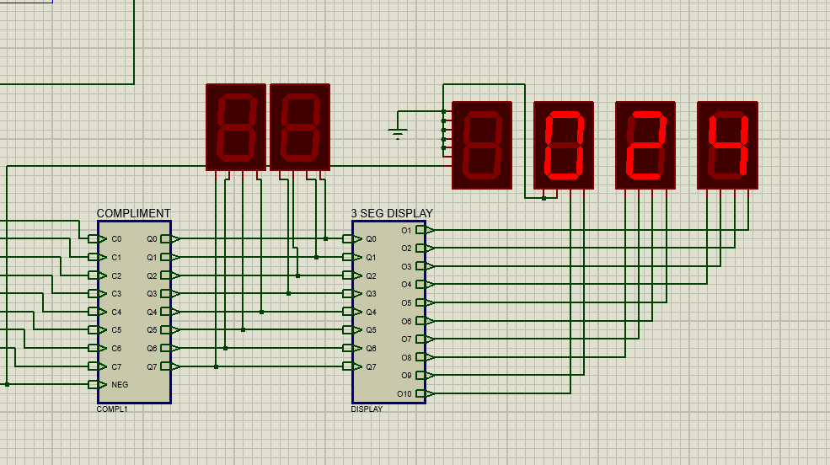
Fig - Top-level BCD converter connection with complement and display blocks.
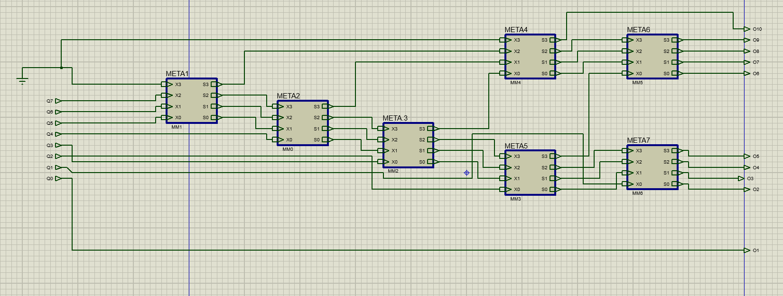
Fig - Internal implementation of the 3 SEG DISPLAY block using cascaded META modules
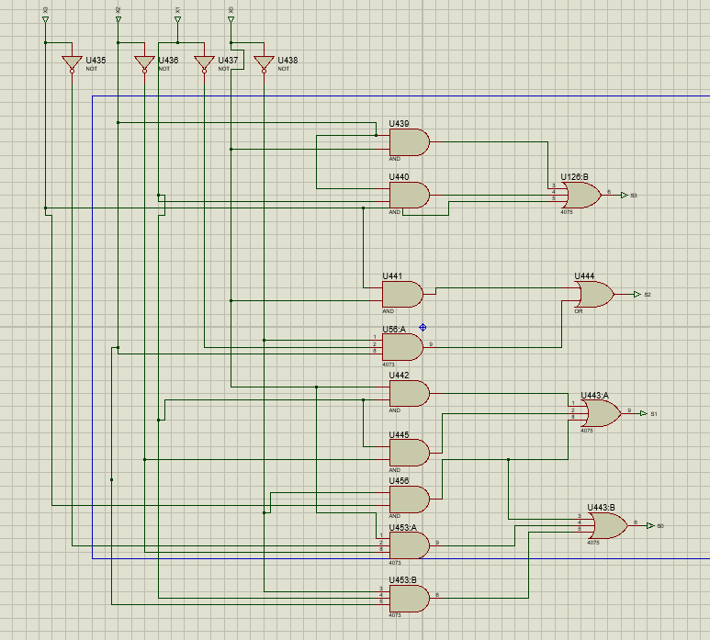
Fig - Gate-level implementation of a META block using NOT, AND, and OR gates.

Key Logic (META Block)
- Performs conditional +3 correction
- Ensures valid BCD output

Truth Table and Boolean Equations of META Block
Each META block adds 3 to the input when the input value is 5 or greater. The truth table is given below.
Input (X3 X2 X1 X0) | Decimal | Output (S3 S2 S1 S0)
0000 | 0 | 0000
0001 | 1 | 0001
0010 | 2 | 0010
0011 | 3 | 0011
0100 | 4 | 0100
0101 | 5 | 1000
0110 | 6 | 1001
0111 | 7 | 1010
1000 | 8 | 1011
1001 | 9 | 1100
For inputs 1010 to 1111, the states are not used in normal BCD conversion and may be treated as don’t care conditions.
The simplified output equations of the META block are given below. Here, the apostrophe (') denotes complemented input.
S₃ = X₃ + X₂X₁ + X₂X₀
S₂ = X₃X₀ + X₂X₁'X₀'
S₁ = X₁X₀ + X₁X₂' + X₃X₀'
S₀ = X₃X₀' + X₁X₂X₀' + X₀X₂'X₃'
The BCD converter is a useful additional feature of the project. It improves output readability by converting the 8-bit result into decimal digits and displaying them clearly, which makes the overall system more practical and user-friendly.

3.8 Complement Generation module:
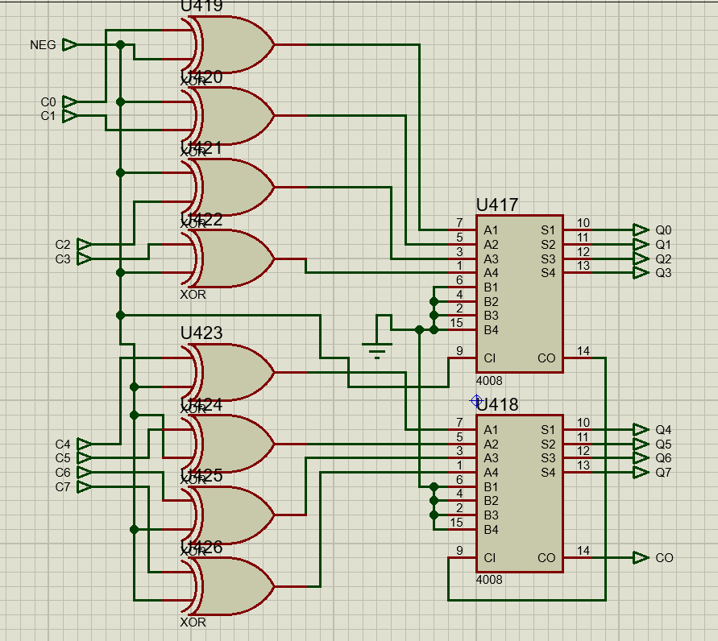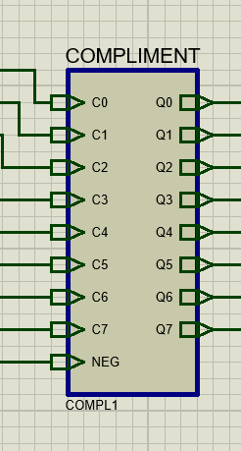
This module operates under control of the NEG signal (derived from the OV flag) and conditionally transforms the input data before it is displayed. This module ensures that positive values are displayed normally, while negative values would be 2’s complemented to produce their magnitude form.
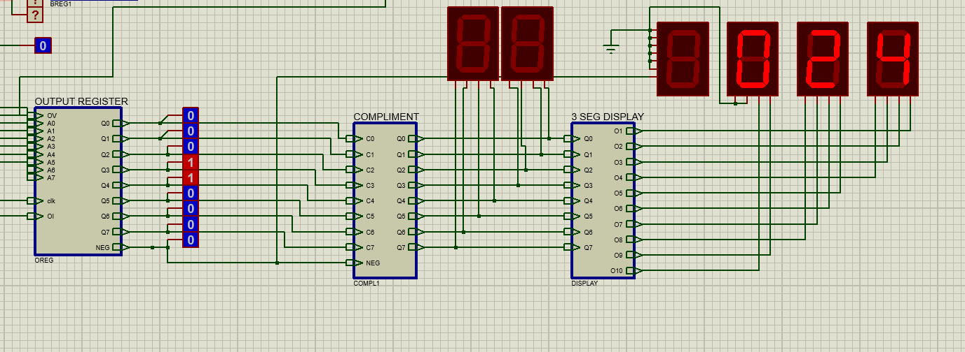
Figure: Full output unit
3.9 Negative sign display:
We added an additional display with the output displays. When the output number is negative and the NEG pin is triggered, the magnitude of the negative number is shown in the regular 7-seg displays and there is another display in front which shows the negative (-) sign in that case.

Features of the System
- 8-bit arithmetic operations
- 4-bit multiplication
- Decimal display using BCD
- Negative number handling
- Modular SAP-1 architecture

12. Conclusion
The system successfully integrates multiple digital modules into a functional SAP-1 architecture. The addition of the multiplier and BCD converter enhances computational capability and output readability, making the system more practical and user-friendly.

