Name: Shaheen Jalal

Internship Report

Reg No: 12008333

LPU

Organization name: Teleperformance Jaipur

Role: Customer Service Executive

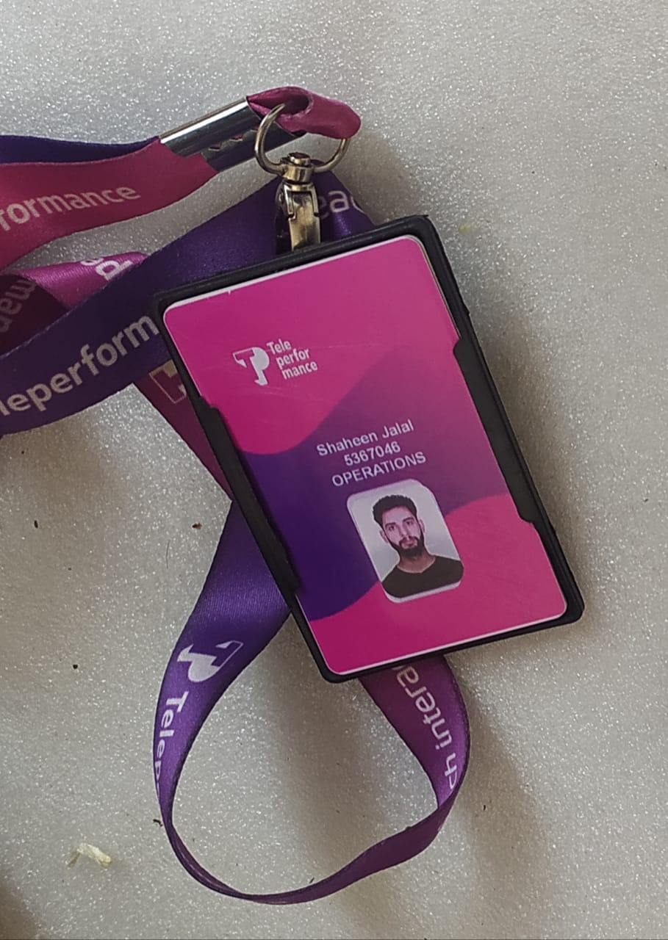

What is customer service:

## Customer service executives are essential to maintaining strong relationships between an organization and its clients. They act as the frontline representatives, ensuring customer satisfaction and loyalty through effective communication and problem-solving. **Key Responsibilities**

**1. Customer Support**

* **Assistance:** Provide support to customers via phone, email, or in-person regarding inquiries, product usage, and service issues.
* **Guidance:** Offer advice on product features, services, and troubleshooting.

**2. Communication Management**

* **Response Handling:** Address customer inquiries promptly and professionally.
* **Information Sharing:** Inform customers about new products, services, and promotions.

**3. Problem Resolution**

* **Issue Management:** Identify and resolve customer complaints effectively.
* **Escalation:** Know when to escalate issues to higher management for resolution.

**4. Administrative Duties**

* **Record Keeping:** Maintain accurate records of customer interactions and transactions.
* **Data Management:** Update customer databases and CRM systems with relevant information.

**5. Collaboration with Teams**

* **Interdepartmental Coordination:** Work closely with sales, marketing, and technical teams to provide comprehensive support.
* **Feedback Sharing:** Relay customer feedback to relevant departments to enhance products and services.

**6. Customer Relationship Management**

* **Building Rapport:** Foster positive relationships with customers to encourage loyalty.
* **Follow-Up:** Conduct follow-ups to ensure customer satisfaction post-interaction.

**7. Training and Development**

* **Continuous Learning:** Stay informed about product updates, company policies, and customer service best practices.
* **Mentoring:** Assist in training new staff on customer service protocols.

**Skills Required**

**1. Communication Skills**

* Strong verbal and written skills for effective interaction with customers.

**2. Problem-Solving Skills**

* Ability to assess situations and develop effective solutions quickly.

**3. Interpersonal Skills**

* Empathy and understanding to connect with diverse customer backgrounds.

**4. Organizational Skills**

* Strong organizational abilities to manage multiple tasks and maintain accurate records.

**5. Technical Proficiency**

* Familiarity with CRM software, data entry tools, and standard office applications.

**Importance of Customer Service**

**1. Customer Satisfaction**

* High-quality customer service leads to increased customer satisfaction and retention.

**2. Brand Loyalty**

* Positive experiences contribute to brand loyalty and repeat business.

**3. Reputation Management**

* Effective customer service enhances the organization’s reputation in the marketplace.

**Challenges Faced**

**1. High Volume of Inquiries**

* Managing a large number of customer requests can lead to pressure and potential burnout.

**2. Diverse Customer Needs**

* Addressing varying customer expectations and needs requires adaptability.

**3. Resource Constraints**

* Limited resources can affect the ability to provide timely and comprehensive support.

## Negative Aspects of Customer Service

### 1. **High Stress Levels**

* Customer service roles can be highly stressful due to constant demand and difficult interactions with unhappy customers.

### 2. **Burnout**

* The repetitive nature of the job and dealing with complaints can lead to employee burnout and high turnover rates.

### 3. **Limited Authority**

* Customer service representatives often have limited authority to resolve complex issues, leading to customer frustration.

### 4. **Negative Interactions**

* Frequent exposure to irate customers can impact morale and job satisfaction.

### 5. **Inconsistent Service**

* Variability in service quality among different representatives can lead to confusion and dissatisfaction.

### 6. **Resource Constraints**

* Insufficient staffing or inadequate tools can hinder the ability to provide timely and effective service.

### 7. **Miscommunication**

* Poor communication can lead to misunderstandings and further issues, damaging customer relationships.

### 8. **Impact on Reputation**

* Negative customer experiences can quickly spread through word-of-mouth or online reviews, affecting the organization's reputation.

### 9. **Training Gaps**

* Inadequate training can leave customer service staff ill-equipped to handle complex inquiries or complaints effectively.

### 10. **Dependency on Scripts**

* Over-reliance on scripted responses can make interactions feel impersonal and robotic, leading to customer dissatisfaction.

Working with unknown people in an office environment offered me valuable insights and lessons:

### 1. **Adaptability**

* Learning to adjust to different personalities and work styles enhances flexibility in collaboration.

### 2. **Communication Skills**

* Developing effective communication strategies is crucial for clear interactions and understanding.

### 3. **Team Dynamics**

* Observing how diverse teams function helps in appreciating the importance of roles and contributions.

### 4. **Conflict Resolution**

* Navigating misunderstandings teaches valuable conflict resolution skills and negotiation techniques.

### 5. **Empathy and Understanding**

* Engaging with diverse backgrounds fosters empathy and a broader perspective on challenges others face.

### 6. **Networking Opportunities**

* Building relationships with colleagues can open doors for professional growth and collaboration.

### 7. **Problem-Solving Skills**

* Collaborating with others can enhance creative problem-solving by bringing different viewpoints together.

### 8. **Cultural Awareness**

* Working with people from various backgrounds increases cultural sensitivity and awareness.

### 9. **Patience and Tolerance**

* Learning to be patient with different working styles and pace is essential for teamwork.

### 10. **Personal Growth**

* Each interaction contributes to personal development, helping you grow both professionally and personally.

These experiences collectively contribute to a more cohesive and productive work environment.

Working with unknown people in an office has significantly contributed to my professional growth in several ways:

### 1. **Enhanced Communication Skills**

* Improved my ability to articulate ideas clearly and listen actively, fostering better collaboration.

### 2. **Broadened Perspective**

* Exposure to diverse viewpoints has enriched my understanding of different approaches to problem-solving.

### 3. **Networking**

* Built valuable connections that can lead to future opportunities and collaborations within the industry.

### 4. **Teamwork and Collaboration**

* Developed strong teamwork skills, learning how to contribute effectively to group dynamics and projects.

### 5. **Adaptability**

* Increased my ability to adjust to varying work styles and preferences, making me more flexible in dynamic environments.

### 6. **Conflict Resolution**

* Gained experience in navigating disagreements, enhancing my ability to resolve conflicts constructively.

### 7. **Leadership Skills**

* Engaging with different personalities has prepared me to take on leadership roles by understanding team dynamics.

### 8. **Cultural Competence**

* Strengthened my ability to work in diverse environments, making me more culturally aware and sensitive.

### 9. **Self-Confidence**

* Successfully collaborating with various individuals has boosted my confidence in my skills and contributions.

### 10. **Continuous Learning**

* Each interaction presents a learning opportunity, fostering a mindset of continuous improvement and professional development.

These experiences have collectively equipped me with essential skills and insights that enhance my effectiveness in any professional setting.  
  
  
  
  
  
About Company:

Hilton Hotels is a global hospitality company known for its extensive portfolio of hotels and resorts. Here are some key points about Hilton:

### Overview

* **Founded:** 1919 by Conrad Hilton.
* **Headquarters:** McLean, Virginia, USA.
* **Brands:** Operates a wide range of brands including Hilton Hotels & Resorts, Waldorf Astoria, Conrad, DoubleTree, and Hampton by Hilton.

### Key Features

* **Global Presence:** Over 6,500 properties in more than 100 countries.
* **Loyalty Program:** Hilton Honors, which rewards members with points for stays, exclusive offers, and more.

### Commitment to Sustainability

* Focus on eco-friendly practices, including energy conservation and waste reduction initiatives.

### Innovations

* Emphasis on digital check-in and room selection through the Hilton Honors app, enhancing guest convenience.

### Notable Properties

* The original Hilton hotel in Cisco, Texas, and iconic properties like the Waldorf Astoria in New York City.

Summary:

Working as a customer service executive involves being the primary point of contact for customers, addressing their inquiries, and resolving issues to ensure satisfaction. Key responsibilities include:

* **Customer Support:** Assisting customers via phone, email, or in-person with product information and problem resolution.
* **Communication Management:** Handling inquiries efficiently and sharing important updates about services and promotions.
* **Problem Resolution:** Identifying and resolving customer complaints, escalating issues when necessary.
* **Administrative Tasks:** Maintaining accurate records of customer interactions and updating databases.
* **Team Collaboration:** Coordinating with various departments to provide comprehensive support and relay customer feedback.  
    
    
    
    
    
    
   Thank you