PROJECT REPORT
Artificial Intelligence
Dynamic Pathfinding Agent
Informed Search Algorithms for Real-Time Grid Navigation

Name | M,Shaheer
Section | 4A
Roll no | 24F-0804
Assignment | AI Assignment no 2

1. Introduction
This project implements a Dynamic Pathfinding Agent designed to navigate a grid-based environment in real time. The agent uses Informed Search Algorithms, specifically A* Search and Greedy Best-First Search (GBFS), to find an optimal or near-optimal path from a defined Start node to a Goal node.
What makes this project particularly challenging and realistic is the Dynamic Mode: obstacles can appear on the grid while the agent is still in motion, requiring the agent to detect path obstructions and immediately re-plan its route. This simulates real-world robotic navigation scenarios where the environment is not fully known or static.

1.1 Objective
The goal of this project is to develop a Dynamic Pathfinding Agent capable of navigating a grid-based environment. The agent must implement Informed Search Algorithms that can navigate a grid where obstacles appear randomly while the agent is in motion, necessitating real-time path detection and re-planning.

1.2 Tools & Technologies
Component | Technology Used
Programming Language | Python 3.11
GUI Framework | Pygame
Search Algorithms | A* Search, Greedy Best-First Search
Heuristic Functions | Manhattan Distance, Euclidean Distance
Development Environment | Visual Studio Code
2. Algorithmic Implementation
Two informed search strategies are implemented, both sharing the same grid representation and neighbour-generation logic. The grid is a 2D list where 0 represents a free cell and 1 represents a wall. Movement is restricted to four cardinal directions (up, down, left, right).

2.1 Greedy Best-First Search (GBFS)
GBFS selects the next node to expand purely based on how close it appears to the goal, ignoring the cost already incurred. The evaluation function is:
f(n) = h(n)
where h(n) is the heuristic estimate of the distance from node n to the goal.

GBFS Implementation Steps
1. Push the Start node into a min-heap (priority queue) with priority h(start, goal).
2. Pop the node with the lowest h value.
3. If it is the goal, trace back the came_from dictionary to reconstruct the path.
4. Otherwise, expand all valid unvisited neighbours, add them to the queue with h(neighbour, goal).
5. Repeat until the goal is found or the queue is empty (no path exists).

2.2 A* Search
A* combines the actual cost from the start with the heuristic estimate to the goal, making it both complete and optimal (given an admissible heuristic). The evaluation function is:
f(n) = g(n) + h(n)
where g(n) is the exact cost (number of steps) from the Start to node n, and h(n) is the heuristic estimate to the Goal.

A* Implementation Steps
1. Push the Start node with f = g(0) + h(start, goal).
2. Pop the node with the lowest f value from the priority queue.
3. If it is the goal, reconstruct and return the path.
4. For each valid unvisited neighbour: compute new_g = g(current) + 1.
5. If neighbour not seen yet, or new_g is cheaper, update g_score, came_from, and push to queue.
6. Repeat until goal found or queue is empty.

2.3 Heuristic Functions
Both algorithms support two interchangeable heuristics selectable from the GUI:

Heuristic | Formula | Best Used When
Manhattan Distance | h = |x1-x2| + |y1-y2| | Grid movement (4 directions only)
Euclidean Distance | h = sqrt((x1-x2)² + (y1-y2)²) | When diagonal or free movement is allowed

Manhattan Distance is the more suitable heuristic for this project because the agent can only move in four cardinal directions. It never overestimates the actual cost, making it admissible and therefore guaranteeing an optimal path with A*.
3. Dynamic Obstacles & Re-Planning
The Dynamic Mode simulates a real-world environment where obstacles can appear unexpectedly while the agent is navigating. This is the most advanced feature of the project.

3.1 Spawning Logic
When Dynamic Mode is enabled and the search is complete, the agent begins moving along the computed path one cell at a time (advancing every 10 frames at 30 FPS). On each movement step, a random number is generated. If it falls below the spawn probability threshold (7%), a random cell on the grid is selected and converted into a wall. The Start, Goal, and the agent's current cell are protected and can never become walls.

3.2 Re-Planning Mechanism
After every new wall is spawned, the system checks whether the new wall falls on any of the remaining cells in the agent's planned path (i.e., the cells it has not yet visited). This check is done using a simple Python list membership test, which is efficient because the remaining path is typically short.
If the new wall does intersect the remaining path:
- A fresh search (A* or GBFS, whichever is currently selected) is run immediately from the agent's current cell to the Goal.
- If a new path exists, it replaces the obstructed portion of the old path.
- If no path exists (agent is completely blocked), the path is cleared and navigation stops.
If the new wall does not intersect the remaining path, no re-planning occurs. This satisfies the efficiency requirement: the search is not reset unless strictly necessary.

3.3 Efficiency Consideration
The re-planning only triggers when a new obstacle directly blocks the remaining path. The agent does not restart the entire search from the beginning; instead, it searches only from its current position. This reduces the search space significantly, especially when the agent is already partway to the goal.
4. GUI & Visualisation
The Graphical User Interface is built entirely in Pygame and consists of two main areas: the interactive grid on the left and the control panel on the right.

4.1 Visual Elements
Element | Colour | Meaning
Empty Cell | Light Gray | Passable grid cell
Wall | Dark Gray / Black | Impassable obstacle
Start Node (S) | Teal | Agent starting position
Goal Node (G) | Orange | Target destination
Frontier Nodes | Yellow | Nodes in the priority queue (open set)
Visited Nodes | Blue | Nodes already expanded
Final Path | Green | Calculated optimal path
Agent (Dynamic) | Purple dot | Current agent position during dynamic traversal

4.2 Real-Time Metrics Dashboard
The right panel displays a live Metrics box that updates after every search:
- Nodes Visited: Total count of nodes that were expanded (popped from the priority queue and processed).
- Path Cost: Total number of steps in the final path (number of cells minus one).
- Time (ms): Wall-clock execution time for the search algorithm, measured in milliseconds using Python’s time module.
- Algorithm: Currently selected algorithm (A* or GBFS).
- Heuristic: Currently selected heuristic (Manhattan or Euclidean).
- Anim Speed: Current animation playback speed (steps processed per frame).
- Grid: Current grid dimensions (rows × columns).

4.3 Control Panel
All controls are grouped into clearly labelled sections on the right panel:
Section | Controls
Actions | Run Search, Clear Path, Reset Grid, Generate Maze
Algorithm | A* Search, Greedy BFS (toggle)
Heuristic | Manhattan, Euclidean (toggle)
Edit Mode | Draw Wall, Set Start, Set Goal
Dynamic | Dynamic Mode ON/OFF toggle
Speed | Increase / Decrease animation speed
Density | Increase / Decrease maze obstacle density
Grid Size | Enlarge / Shrink the grid

5. Algorithm Comparison: Pros & Cons
Based on experimental testing across various grid configurations and obstacle densities, the following observations were made:

5.1 A* Search
Aspect | Detail
Completeness | Complete – always finds a path if one exists
Optimality | Optimal – finds the shortest path (with admissible heuristic)
Nodes Expanded | More nodes than GBFS in many cases, but never unnecessary ones
Memory Usage | Higher – maintains g-scores and came_from for all explored nodes
Speed | Slightly slower than GBFS but more reliable
Best Case | Open grid with direct line of sight to goal – expands very few nodes
Worst Case | Dense maze where many paths of equal cost must be explored

5.2 Greedy Best-First Search (GBFS)
Aspect | Detail
Completeness | Complete in finite spaces (may revisit nodes without a visited set)
Optimality | NOT optimal – ignores actual path cost, may find suboptimal paths
Nodes Expanded | Generally fewer nodes than A* – rushes directly toward the goal
Memory Usage | Lower – no g-score tracking required
Speed | Faster than A* in many scenarios
Best Case | Open grid where the heuristic direction perfectly matches the true path
Worst Case | Mazes where the shortest path requires moving away from the goal temporarily

5.3 Head-to-Head Summary
Criterion | A* Search | Greedy BFS
Optimal Path? | Yes (always) | No (often suboptimal)
Speed | Moderate | Fast
Nodes Expanded | Moderate | Low (usually)
Works in Mazes? | Reliably | Sometimes fails or loops
Re-planning? | Excellent | Works, less efficient
Recommended For | Accuracy-critical tasks | Speed-critical previews
6. Test Cases & Scenarios
The following scenarios were designed to demonstrate the behaviour of each algorithm under favourable and challenging conditions. Screenshots of the GUI output should be attached in the submission.

6.1 A* Search – Best Case
Scenario: Open Grid, Short Path
Outcome: A* expands very few nodes because the path from S to G is nearly direct with minimal obstacles.
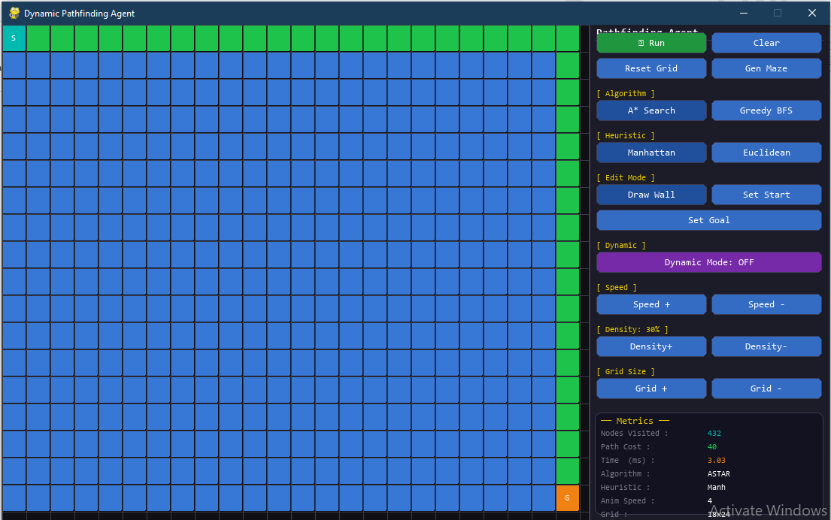

6.2 A* Search – Worst Case
Scenario: Dense Maze, Complex Path
Outcome: A* must explore a large portion of the grid to find a path through the maze, expanding many nodes.
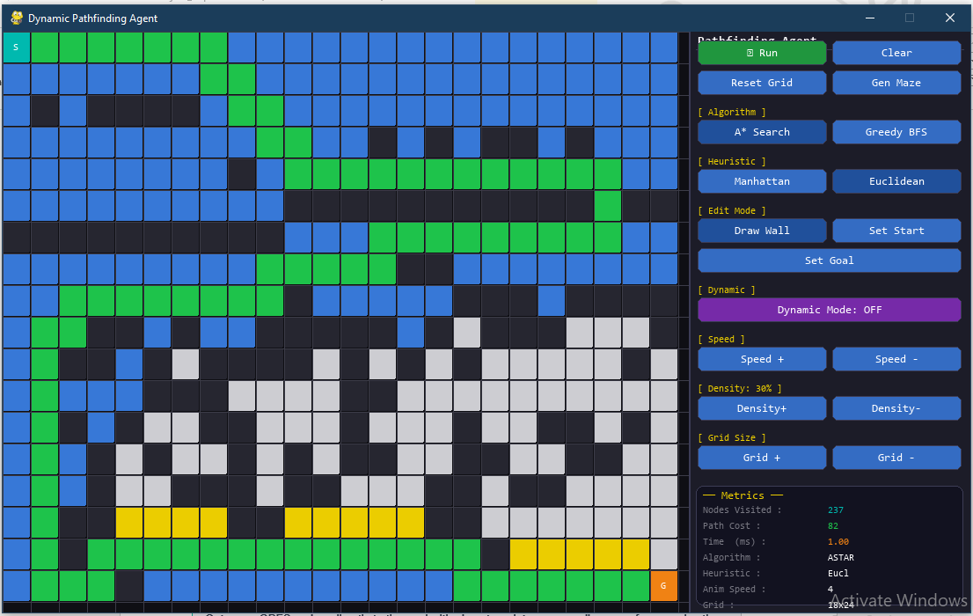

6.3 Greedy BFS – Best Case
Scenario: Open Grid, Heuristic Aligns With True Path.
Outcome: GBFS rushes directly to the goal with almost no detour, expanding even fewer nodes than A*.
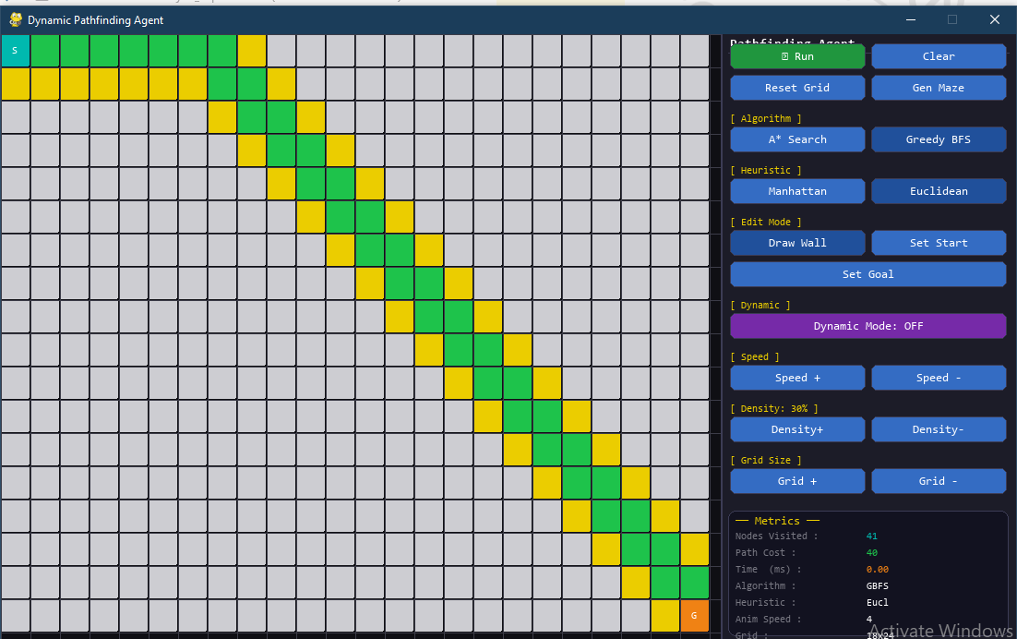

6.4 Greedy BFS – Worst Case
Scenario: Maze Where Path Requires Going Away From Goal
Outcome: GBFS gets misled by the heuristic and explores many dead ends, finding a non-optimal path.
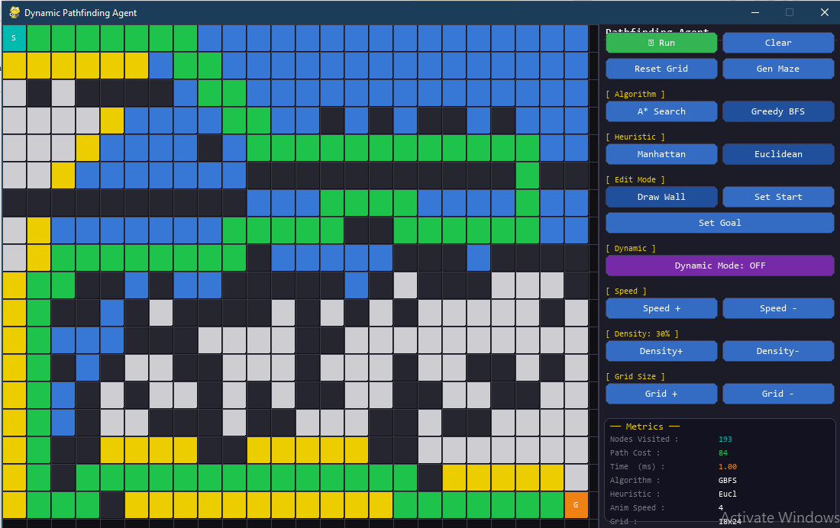
7. Conclusion
This project successfully demonstrates the implementation of two informed search algorithms, A* and Greedy Best-First Search, in a visually interactive grid-based environment. Both algorithms were implemented from scratch using Python and visualised in real time using the Pygame library.
The key findings from testing are:
- A* consistently finds the optimal (shortest) path at the cost of exploring more nodes. It is the more reliable algorithm for pathfinding tasks where correctness matters.
- Greedy BFS is faster and expands fewer nodes on open grids, but can fail or produce suboptimal paths in complex mazes where the heuristic direction conflicts with the true shortest route.
- Manhattan Distance is the superior heuristic for this project because movement is restricted to four cardinal directions; it is perfectly admissible and never overestimates.
- The Dynamic Re-planning mechanism works efficiently: it only triggers a new search when a newly spawned obstacle directly blocks the remaining path, avoiding unnecessary computation.

Overall, this project provides a strong foundation for understanding real-world pathfinding challenges such as those faced by autonomous robots, GPS navigation systems, and video game AI agents.

