# Model Tuning and Performance Evaluation

## 1. Introduction

This document provides a detailed overview of the hyperparameter tuning process and the final performance of different models used for classification. Various tuning methods, including GridSearchCV, RandomizedSearchCV, and BayesSearchCV, were applied to optimize model performance.

## 2. Dataset and Preprocessing

- The dataset was preprocessed using scaling and resampling techniques.  
- The dataset was split into training (80%) and testing (20%) sets using train_test_split.  
- The models were trained on X_train and evaluated on X_test.

## 3. Models and Hyperparameter Tuning

### 3.1 Base Models

- Random Forest (default parameters)  
- XGBoost (default parameters)

### 3.2 Hyperparameter Tuned Models

#### Random Forest

- Grid Search (rf_grid_search): Exhaustively searched the best parameters.  
- Randomized Search (rf_random): Sampled a subset of hyperparameter combinations.  
- Bayesian Optimization (rf_bayes): Used probabilistic optimization to find the best configuration.

#### XGBoost

- Grid Search (xgb_grid_search): Systematically searched for the best parameters.  
- Randomized Search (xgb_random): Randomly selected configurations for efficiency.  
- Bayesian Optimization (xgb_bayes): Found optimal parameters using Gaussian processes.

## Feature Importance

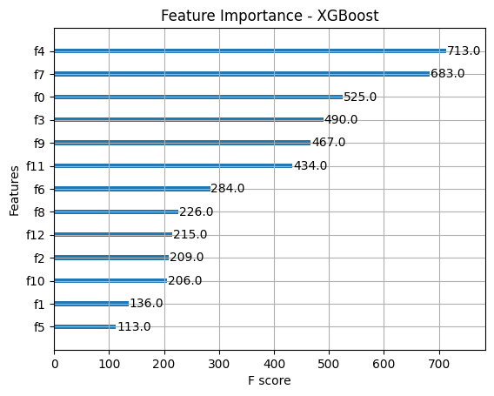

## 4. Model Performance Evaluation

### 4.1 Performance Metrics

The following metrics were used to evaluate models:  
- Accuracy  
- Precision  
- Recall  
- F1-score

### 4.2 Results Summary

## 5. Conclusion and Best Model Selection

- XGBoost (BayesSearchCV) achieved the highest performance with an accuracy of 91%.  
- Random Forest (BayesSearchCV) also performed well with an accuracy of 89%.  
- Bayesian optimization consistently outperformed grid and random searches.  
- XGBoost models performed slightly better than Random Forest models across all tuning techniques.