

DEPARTMENT OF COMPUTER SCIENCES

**DATA COMMUNICATION & NETWORKING (LAB)**

**Project Title**

**BUSINESS INCUBATION CENTER NETWORK**

|  |  |
| --- | --- |
| **GROUP MEMBERS:** |  |
| **Haroon Khalid Janjua** | **[02-134192-048]** |
| **Moaz Rafique** | **[02-134192-064]** |
| **Ammar Anis**  **Shaheer Suleman** | **[02-134192-073]**  **[02-134192-009]** |

**CLASS & SECTION:**

**BS (CS) 4-B**

**SESSION:**

**Spring 2021**

|  |
| --- |
| **COURSE INSTRUCTOR:** |
| **SIR MUHAMMD IQBAL** |
|  |
| **LAB INSTRUCTOR:** |
| **SIR WAQAS BAIG** |

TABLE OF CONTENTS

1. Abstract

2. Introduction

3. Literature Review

4. Components and Tools Description.

5. Block Diagram/Flow Chart

6. Methodology

6.1 Circuit/ Simulation Diagram......................................................…...

6.2 Circuit / Simulation Description……………………………………

7. Results and Discussions 1

8. Conclusion and Future Work

9. Project Summary

10. Project Pictures

11. References

**ABSTRACT:**

This project is going to present business incubation Centre network as it provides entrepreneurial start-ups with critical network resources. This project will show how two or more computers are connected with one another for the purpose of communicating data electronically.

The focus in this project is to study whether business incubation can provide entrepreneurial start-ups with critical network resources. We make a distinction between incubator-provided network resources and start-ups’ “own” external network resources that are unrelated to the incubator context. Although there has been an increasing number of studies examining incubated entrepreneurs’ network resources, to our knowledge, this is the first study that explicitly compares incubator-provided network resources and start-ups’ own external network resources. They played a crucial role in terms of (non-generic) knowledge generation as drivers of innovation, catalysts for financial contributors, and as a means to organizational reputation and market access. Nevertheless, internal networking with other incubator firms and external network resources facilitated by the incubator were also helpful and complementary, but they were more generic in nature and provided limited idiosyncratic resources.

## **INTRODUCTION:**

The focus in this project is to study whether business incubation can provide entrepreneurial start-ups with critical network resources. The study aims to consider the impact of the project in terms of developing and supporting entrepreneurial activity

The focus in this paper is to study whether business incubation can provide entrepreneurial start-ups with critical network resources. A business incubator is defined as a more or less formalized entity with an infrastructure intended to nurture incubated start-ups with critical resources in the pursuit of survival and growth

Business incubation can provide the start-ups with resources such as office space, counseling, and other basic services, but their purpose is also to stimulate internal networking and exchange of knowledge between entrepreneurial start-up firm

Furthermore, business incubators should help tenants to build networks with external companies, organizations, and other individuals .All in all, one can argue that business incubators may foster network resources, which we define as a firm’s access to information, knowledge, reputation, and input factors from a variety of sources such as customers, suppliers, competitors, R&D institutions, and governmental bodies

The importance of entrepreneurial start-ups’ network resources is clearly recognized in the scholarly literature entrepreneurs can use network resources to generate or test ideas, develop new technology, identify market opportunities obtain access to financial funding, and gain legitimacy, to mention a few benefits.

As Entrepreneurs can use network resources to generate or test ideas, develop new technology, identify market opportunities so it is necessary to have an efficient network communication which this network model is hopefully going to ensure plus Security will be implemented in a better way. This network will allow data sharing among all the pc’s and administrator pc can access all the pc’s present in the topology

The focus in this paper is to study whether business incubation can provide entrepreneurial start-ups with critical network resources. A business incubator is defined as a more or less formalized entity with an infrastructure intended to nurture incubated start-ups with critical resources. Entrepreneurs can use network resources to generate or test ideas, develop new technology, identify market opportunities. To assess the potential benefits of business incubation, it is therefore critical to study network resources provided by incubators, which include both internal networks and external networks facilitated by the incubator

**LITERATURE REVIEW**

Literature confirms that through support of entrepreneurial activates incubation centers have been able to reduce failure rate of small businesses. Incubators have received increasing attention as a tool for fostering entrepreneurship, both in developed countries and in developing countries. They will be an integral part for framework of business assistance to provide critical support to the newly established companies Realizing their importance, all individual and organization involved in business incubation industry try to define, identify, measure, formulate and evaluate various aspects related to these programs. Business incubation initiatives have emerged with different success in different parts of the world, especially in the last decade

A network encompasses a set of relationships with various agents or organizations (Walter et al. [2006](https://innovation-entrepreneurship.springeropen.com/articles/10.1186/s13731-016-0038-8#ref-CR43); Lechner and Dowling [2003](https://innovation-entrepreneurship.springeropen.com/articles/10.1186/s13731-016-0038-8#ref-CR22)). Each of these can provide a focal firm with critical resources. The capability to acquire network resources is critical for entrepreneurial firms (Lechner et al. [2006](https://innovation-entrepreneurship.springeropen.com/articles/10.1186/s13731-016-0038-8#ref-CR23)). Walter et al. ([2006](https://innovation-entrepreneurship.springeropen.com/articles/10.1186/s13731-016-0038-8#ref-CR43)) define firm capabilities such as the ability to initiate, maintain, and utilize relationships with various external partners. According to Walter et al. ([2006](https://innovation-entrepreneurship.springeropen.com/articles/10.1186/s13731-016-0038-8#ref-CR43)), relationships are also an important means of learning about customers’ needs, so that the firm can develop marketable offerings. They found that the performance of university spinoffs was positively influenced by their network capability. Mort and Weera wardena ([2006](https://innovation-entrepreneurship.springeropen.com/articles/10.1186/s13731-016-0038-8#ref-CR27)) found that networking capability facilitates the development of knowledge-intensive products and allows firms to identify and exploit performance opportunities in international markets.

Building networks shortens and accelerates firms’ learning processes. This is particularly vital for start-ups in their pursuit of development and growth their networks are therefore likely to change over time. According to identity-based networks, in which the social identity of the ties matters more than the economic functions, are most important in the early stages of growth. However, over time, calculative networks, in which purpose and functions are more important than the identity of the ties, become essential. This dynamic network evolution is seen as reflecting start-ups’ need for resources and the availability of and access to network resources in the various stages of firm development. Thus, in the early growth stage, start-ups basically rely on identity-based networks that are path-dependent because preexisting relationships make them easy to access. Path-dependent networks can provide critical resources but are more restricted, smaller, and less diverse than calculative networks.

**COMPONENTS AND TOOL DESCRIPTION**

For this project, we used CISCO Packet Tracer to demonstrate the network connection of the given description as we had stated earlier. We used the Packet Tracer to represent how the data between three buildings are being sent to one another. IP Address, Default Gateway, Routers, and Switches are configured according to their given respective protocols.

**BLOCK /FLOW DIAGRAM**

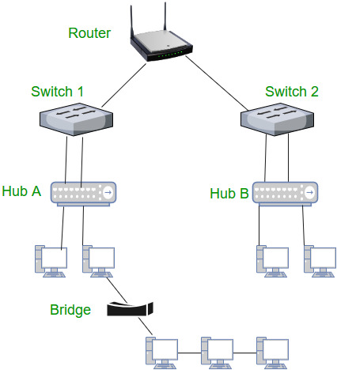

**METHODOLOGY**

This project is based on two levels i.e.: level 1, level2

The first floor of both BIC(Business Incubation Centre) is accompanied with eight cubicles which has their own server and printer. A router is also used to connect these cubicles together to make a network, so that they can make a successful communication path for the data to be transferred.

A similar network is also created which is connected with a router. These two router will be connected to a third network namely Administration Network. This network has its manager and reception area which is connected to the main server. Now the switch will be used to connect the administration network with the routers of level 1 and level 2.Hence a transmission path for the network will be created to deliver message from one router to another router.

**CIRCUIT / SIMULTAION DISCRIPTION**

**HUB:**

A hub is a physical layer networking device which is used to connect multiple devices in a network. They are generally used to connect computers in a LAN. ... A computer which intends to be connected to the network is plugged in to one of these ports.

**Types of Hub**

Active Hub: - These are the hubs which have their own power supply and can clean, boost and relay the signal along with the network. It serves both as a repeater as well as wiring Centre. These are used to extend the maximum distance between nodes.

Passive Hub: - These are the hubs which collect wiring from nodes and power supply from active hub. These hubs relay signals onto the network without cleaning and boosting them and can’t be used to extend the distance between nodes.

**SWITCHES:**

A switch is a multiport bridge with a buffer and a design that can boost its efficiency (a large number of ports imply less traffic) and performance. A switch is a data link layer device. The switch can perform error checking before forwarding data, which makes it very efficient as it does not forward packets that have errors and forward good packets selectively to correct port only.  In other words, switch divides collision domain of hosts, but broadcast domain remains same. The switch has a default IP address "10.0. 0.1" and a secondary IP address "10.0.0.3".

**ROUTERS:**

A router is a device like a switch that routes data packets based on their IP addresses. Router is mainly a Network Layer device. Routers normally connect LANs and WANs together and have a dynamically updating routing table based on which they make decisions on routing the data packets. Router divide broadcast domains of hosts connected through it.

**NETWORKING CABLES:**

Networking cables are networking hardware used to connect one network device to other network devices or to connect two or more computers to share printers, scanners etc. Different types of network cables, such as coaxial cable, optical fiber cables.

**GATEWAYS:**

A gateway, as the name suggests, is a passage to connect two networks together that may work upon different networking models. They basically work as the messenger agents that take data from one system, interpret it, and transfer it to another system. Gateways are also called protocol converters and can operate at any network layer. Gateways are generally more complex than switch or router.

**RESULTS AND DISCUSSION**

We describe the external networks of the start-ups that go beyond the incubator and stem from the tenants’ “private” path-dependent trajectory of personal or professional relations. Then, we explain the internal networking within the incubator; finally, we focus on extended network resources facilitated by the incubator management. In the analyses, we emphasize the general experience of the start-ups, and we attempt to reveal their network opportunities both within and beyond the incubator.

he majority of the entrepreneurs had acquired diverse network resources through education or work experience, which proved valuable for their ventures in their critical start-up phase (i.e., identity-based networks, Four of the firms in the emergence phase, and one early growth firm, had entrepreneurial teams composed of people with whom they had preexisting relations, such as friends or acquaintances from previous work or study. One informant stated that the firm’s present network was mostly composed of “those people we knew before locating at the incubator.”

**CONCLUSION AND FUTURE WORK**

This Network will let various users of the incubation Centre and their employees connect to the main Server. The objective is to allow only authorized user to access Network including all servers and network devices. This idea will Provide greater speed & reduce time consumption in communication. Business incubation provide the start-ups with resources such as office space, counseling, and other basic services, but their purpose is also to stimulate internal networking and exchange of knowledge between entrepreneurial start-up firms. So having secure network is a must. also, Administrator pc can assess the configurations of pc’s and determine if they have received the proper updates and will be helpful to ensure that all pc’s are operating properly and securely.

**PROJECT SUMMARY**

The main role of a business incubation center is to make quick development of entrepreneurial start-up so that these companies survive, grow and become profitable even after graduation from the incubator when the necessary services by incubators are absent. This role is affected by various practices, which have been the focus of attention for many research studies, wherein attempts have been made to isolate and measure their influence on the performance of business incubation centers. These incubation best practices have evolved over time and improve the initiation, survival and growth of newly established businesses. It is desirable that the business incubation centers implement them to tackle initial challenges, optimize execution, and maximize success. However, it is important to note that no good incubator practice can guarantee success. Instead, it is a combination of several practices that deliver the best results.

**PROJECT PICTURES**

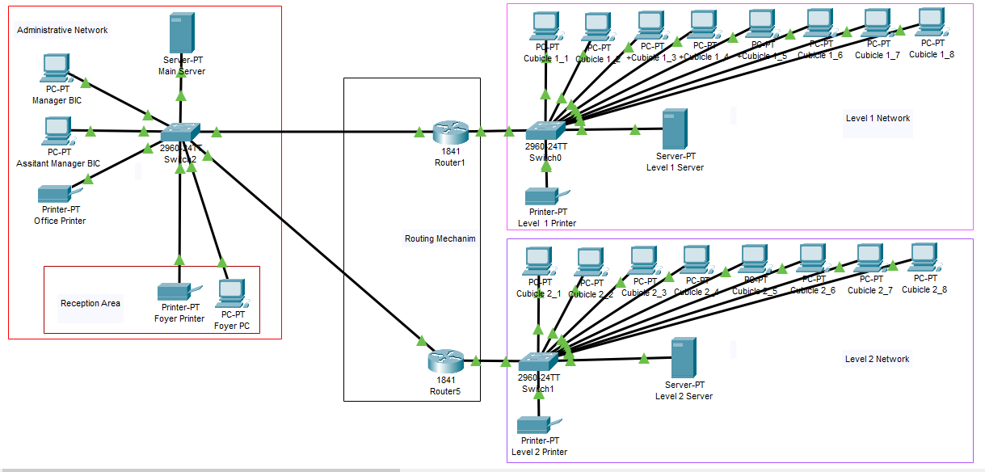

**This network is divided into 3 smaller local networks:**

**Level 1:**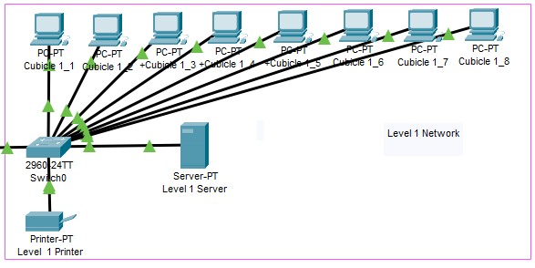

**Level 2:**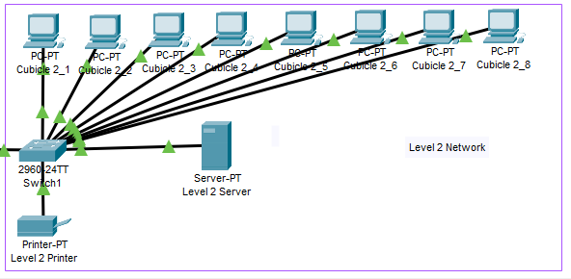

**Administrative Network:**

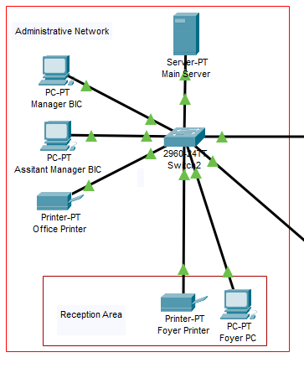

**Successful Packets:**



**REFERENCES**

YouTube tutorials on networking by Wiki Info.

Mcit books.

Data communication and networking 7th edition.