

**DEPARTMENT OF COMPUTER SCIENCES**

**DATA BASE MANAGEMENT SYSTEM**

**PROJECT TITTLE**

**UNIVERSITY MANAGEMENT SYSTEM**

|  |  |
| --- | --- |
| Presented by: |  |
| **Haroon Khalid Janjua** | **[02-134192-048]** |
| **Moaaz Rafique** | **[02-134192-064]** |
| **Ammar Anis**  **Shaheer Suleman** | **[02-134192-073]**  **[02-134192-009]** |

**CLASS & SECTION:**

**BS (CS) 4-B**

**SESSION:**

Spring 2021

|  |
| --- |
| **COURSE INSTRUCTOR:** |
| **SIR MALIK M.ALI**  **LAB ENGINEER:**  **MISS SABA IMTIAZ** |
|  |
|  |

**ACKNOWLEDGEMENT**

I take this opportunity to express my profound gratitude and deep regards to our teachers. **Miss Saba** for her exemplary guidance, monitoring and constant encouragement throughout the course of this project. We also take this opportunity to express the deep sense of gratitude of our course teacher **SIR MALIK M. ALI.** The blessing, help and guidance given by her time to time shall carry me a long way in the journey of life on which I am about to embark. Lastly, I thank Almighty Allah, my parents and friends for their constant encouragement without which this project would not be possible.

**TABLE OF CONTENT**

**1. INTRODUCTION**

1.1 PROJECT AIMS AND OBJECTIVES

1.2 BACKGROUND OF PROJECT

1.3 OPERATION ENVIRONMENT

**2. SYSTEM ANALYSIS**

2.1 SOFTWARE REQUIREMENT SPECIFICATION

2.2 SOFTWARE TOOL USED

**3. SYSTEM DESIGN**

**4. SYSTEM IMPLEMENTATION**

4.1 MODULE DESCRIPTION

4.2 SCREEN SHOTS

**5. SYSTEM TESTING**

5.1 UNIT TESTING

5.2 INTEGRATION TESTING

**6. CONCLUSION & FUTURE SCOPE**

**7. REFERENCES**

**ABSTRACT**

UNIVERSITY MANAGEMENT SYSTEM (UMS) deals with the maintenance of university, college, faculty, student information within the university. UMS is an automation system, which is used to store the college, faculty, student, courses and information of a college. Starting from registration of anew student in the college, it maintains all the details regarding the attendance and marks of the students. The project deals with retrieval of information through an INTRANET based campus wide portal. It collects related information from all the departments of an organization and maintains files, which are used to generate reports in various forms to measure individual and overall performance of the students

Overall this project of ours has been built for the sole purpose of helping the Admin/Visitor of a Airline park to keep track of everything, from Airlines to everything will be available on this System and will help in reducing Human Workload, Minimizing Errors and Speeding up performance and efficiency.

**CHAPTER 1**

**INTRODUCTION**

This chapter gives an overview about the aim, objectives, background and operation environment of the system.

* 1. **PROJECT AIMS AND OBJECTIVES:**

1. UNIVERSITY MANAGEMENT SYSTEM [UMS] deals with the maintenance of university, , student information within the university. This project ofUMS involved the automation of student information that can be implemented in different managements the project deals with retrieval of information through an INTRANET based campus wide portal. It collects related information from all the departments of an organization and maintains files, which are used to generate reports in various forms to measure individual and overall performance of the students.
   1. **BACKGROUND OF THE OBJECT:**

This system consists of basic admission details of a student, course registration details etc. it provides you Timetable will be provided, plus details of every student with fee billing status will be stored.

Administration can view multiple forms of data with just single query, it will be reliable to create and manage data in database. Student details will be stored safely. If they are successfully enrolled then this info will be transferred into their respective student profile/CMS.Course Registration, Basically it will provide students with suitable courses in order to provide a better guidance. Each course details will be provided and its benefits will be given so that student shouldn’t have much confusion in deciding a suitable option for themselves. Fee collection, now every course fee will be totaled in order to provide fee challan to each student. It will be automatically generated. Plus, it will keep track of students those who have paid their subject fee or not. You can also check each course fee’s individually. Timetable, it will be dependent on teacher’s availability. It will also be automatically generated depending on course. Proper timings will be provided to students.

* 1. **OPERATION ENVIRONMENT :**

|  |  |
| --- | --- |
| PROCESSOR | Intel Core Processor @ 2.4GHz or better |
| OPERATING SYSTEM | Windows 7, 8, 8.1, 10. |
| MEMORY | 8 GB Ram |
| HARD DISK SPACE | Minimum 500mb for optimal performance. |

**CHAPTER 2**

**SYSTEM ANALYSIS**

In this chapter, we will discuss and analyze about the developing process of University Management System including software requirement specification (S). The functional and nonfunctional requirements are included in SRS part to provide complete description and overview of system requirement before the developing process is carried out. Besides that, existing vs proposed provides a view of how the proposed system will be more efficient than the existingone**.**

**2.1 SOFTWARE REQUIRMENT SPECIFICATION**

**2.1.1 GENERAL DISCRIPTION**

**PRODUCT DESCRIPTION**:

We are making university management system which is easy-to-use software. It automates those system’s which a university requires in order to operate of student’s for e.g. course registration, admission forms etc. It reduces the time it takes to register student’s courses and checking the courses prerequisites, classes and exams scheduling, and average calculations. This software is responsible to processes and maintains students registration data, providing them with a proper timetable and a proper fee Collection Billing structure.

The University management system also operates and manages the data of our various departments across the University. Moreover, potential donors also have the availability to view our partnership agreements with them.

There were several problems which occur during the manual method of Airline management system some are discussed here:

* **Difficult to search record:** When there is no computerized system there is always a difficulty in searching of records if the records are large in number
* **Space consuming**: After the number of records become large the space for physical storage of file and records also increases if no computerized system is implemented.
* **File damaged:** When a computerized system is not there file is always lost due to some accident like spilling of water by some member on file accidentally. Besides some natural disasters like floods or fires may also damage the files.
* **File lost:** When computerized system is not implemented file is always lost because of human environment. So, as there is no computerized system to add each record paper will be needed which will increase the cost for the management of library.

**2.1.2 SYSTEM MODULES:**

The main modules of the system are as follows:

Quality services to customers aren’t possible with defined business principles. This airline management system has several modules rules that apply from its own staffs to third party sales agents and potential customers. For each, business rules are as per listed below:

1. Admission:

Student details will be stored safely. If they are successfully enrolled then this info will be transferred into their respective student profile/CMS

1. Course Registration:

Basically it will provide students with suitable courses in order to provide a better guidance. Each course details will be provided and its benefits will be given so that student shouldn’t have much confusion in deciding a suitable option for themselves

1. Fee Challan and billing:

Now every course fee will be totaled in order to provide fee challan to each student. It will be automatically generated. Plus, it will keep track of students those who have paid their subject fee or not. You can also check each course fee’s individually.

1. Timetable :

It will be dependent on teacher’s availability. It will also be automatically generated depending on course. Proper timings will be provided to students.

**2.1.3 SYSTEM REQUIREMENT:**

* **USABILITY REQUIREMENT**

The system is designed for a user friendly environment so that user can perform the various tasks easily and in an effective way.

* **EFFICIENCY REQUIREMENT** When an Airline management system will be implemented user will easily view the types and species of Airlines as searching, add, and delete options would be made more feasible.
* **IMPLEMENTATION REQUIREMNTS** In implementing whole system will be designed using Oracle 12-C
* **FUNCTIONAL REQUIREMENT :**

**2.1.4 SOFTWARE AND HARDWARE REQUIREMENT:**

This section describes the software and hardware requirements of the system.

**SOFTWARE REQUIREMENTS:**

Operating system: Windows 10 is used as the operating system as it is stable and supports more features and is more user friendly.

Development tools and Programming language: Oracle 12-C leverages users with the power of a Relational Database Management System.

**HARDWARE REQUIREMENTS:**

Intel core i5 2nd generation is used as a processor because it is fast than other processors an provide reliable and stable and we can run our pc for longtime. By using this processor, we can keep on developing our project without any worries.

Ram 1 GB is used as it will provide fast reading and writing capabilities and will in turn support in processing.

**2.3 SOFTWARE TOOL USED**

* Oracle 12-C:

Oracle Database 12c, released in 2013, was designed for the Cloud, featuring a new Multitenant architecture, In-Memory column store, and support for JSON documents. Oracle Database 12c helps customers make more efficient use of their IT resources, while continuing to reduce costs and improve service levels for users.

. **PROJECT MODEL DIAGRAM**

**ENTITY RELATIONSHIP DIGRAM:**

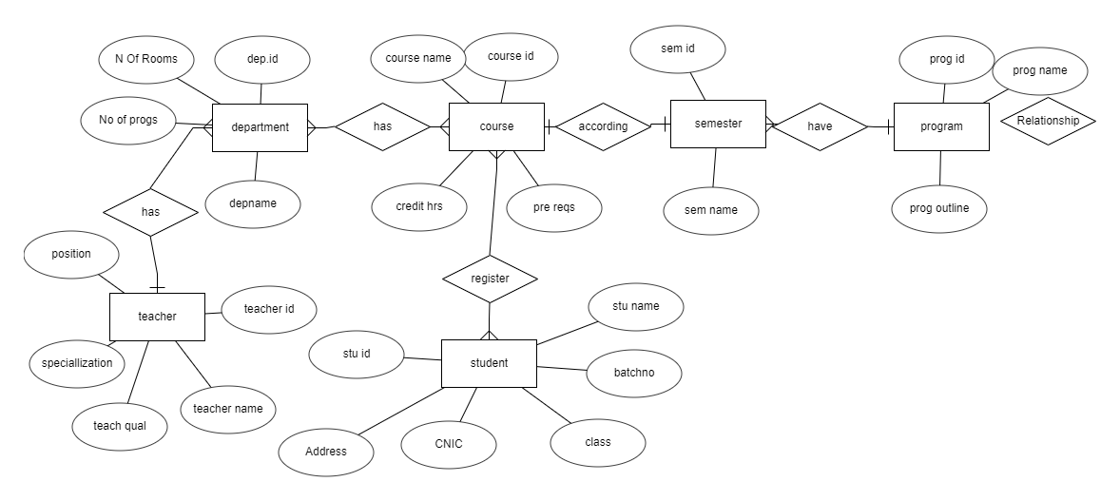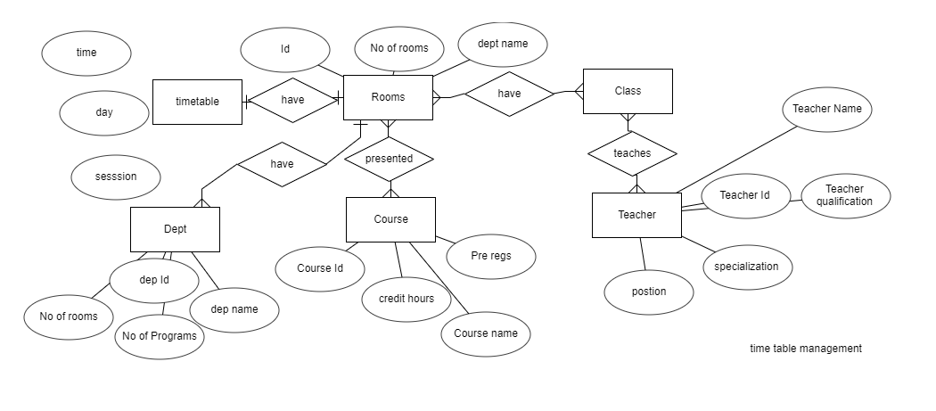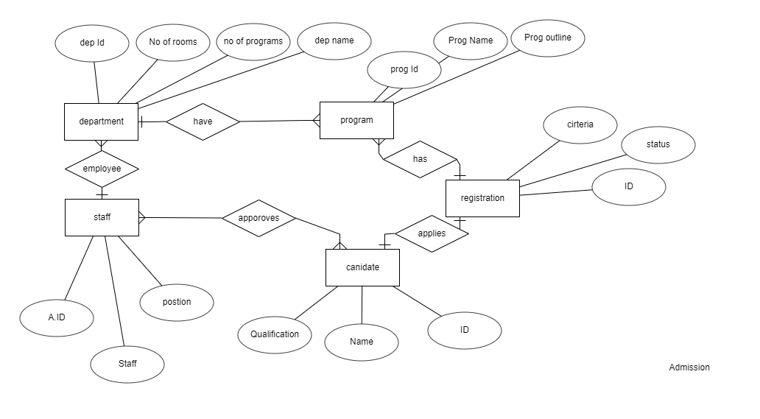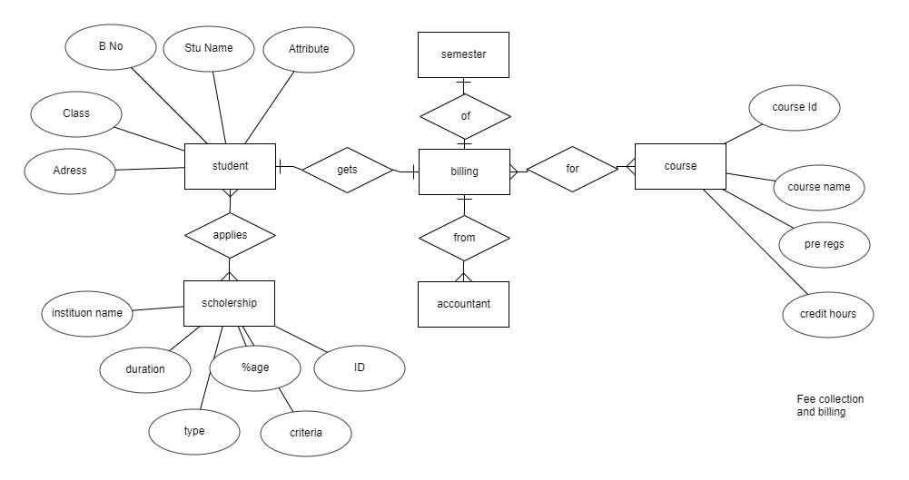

**NORMALIZATION:**

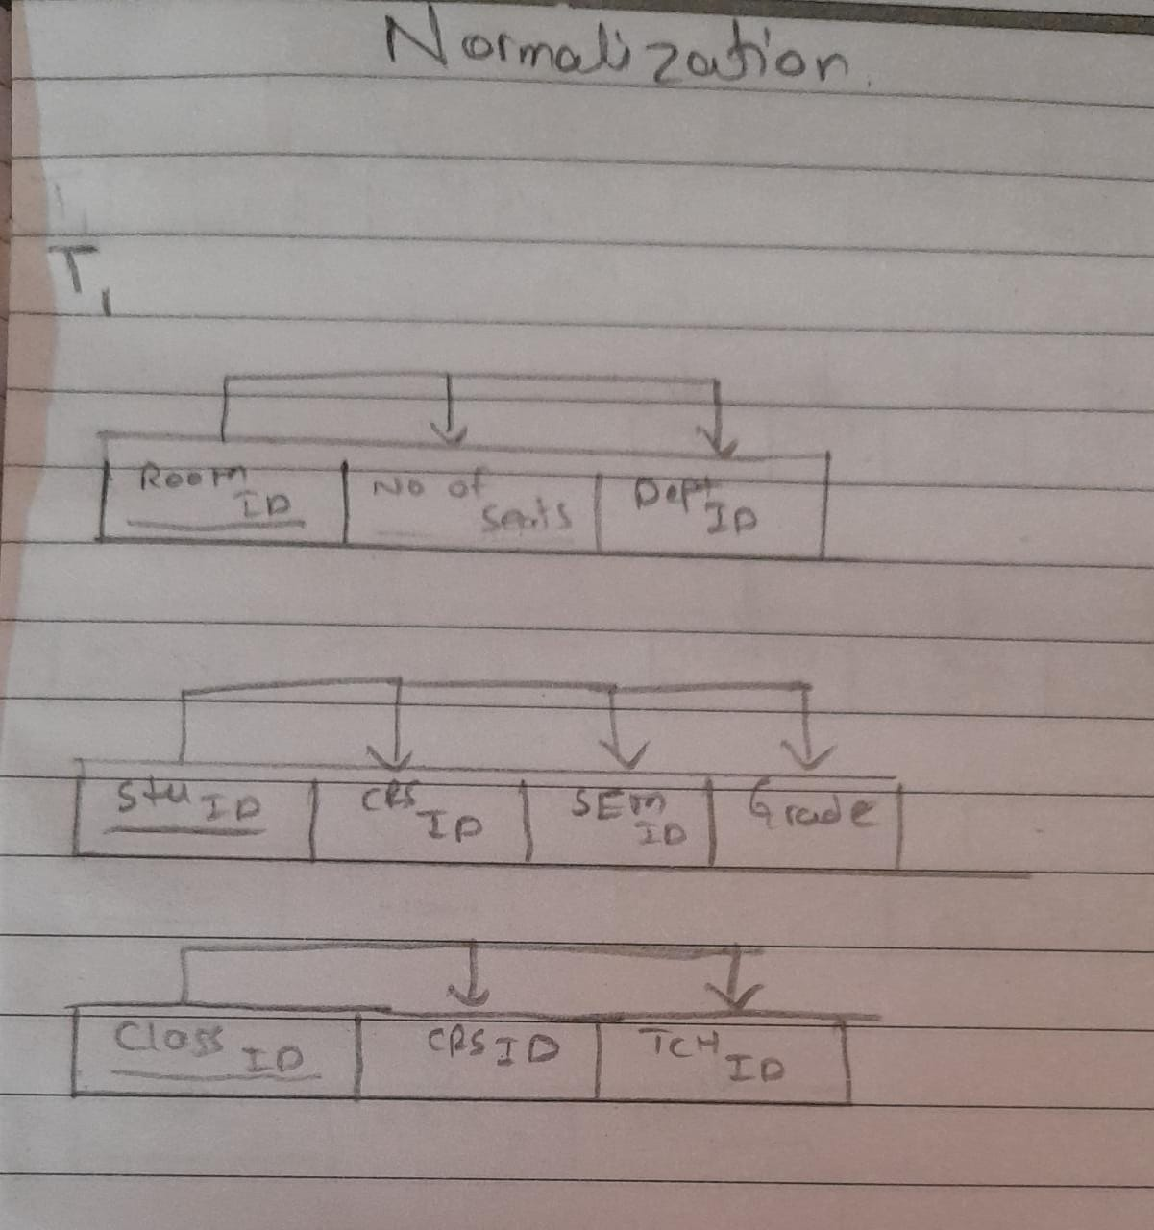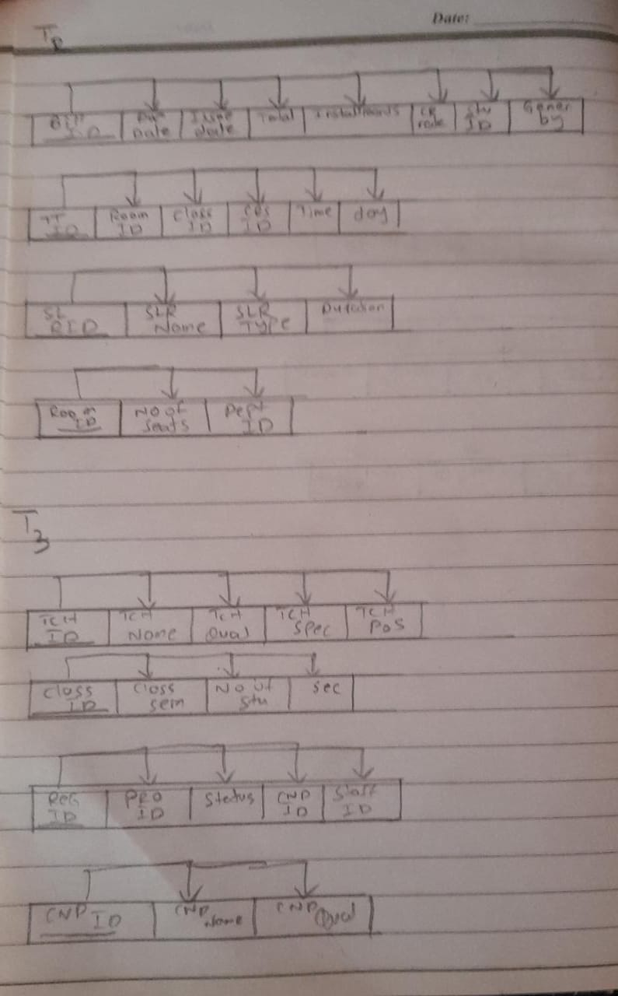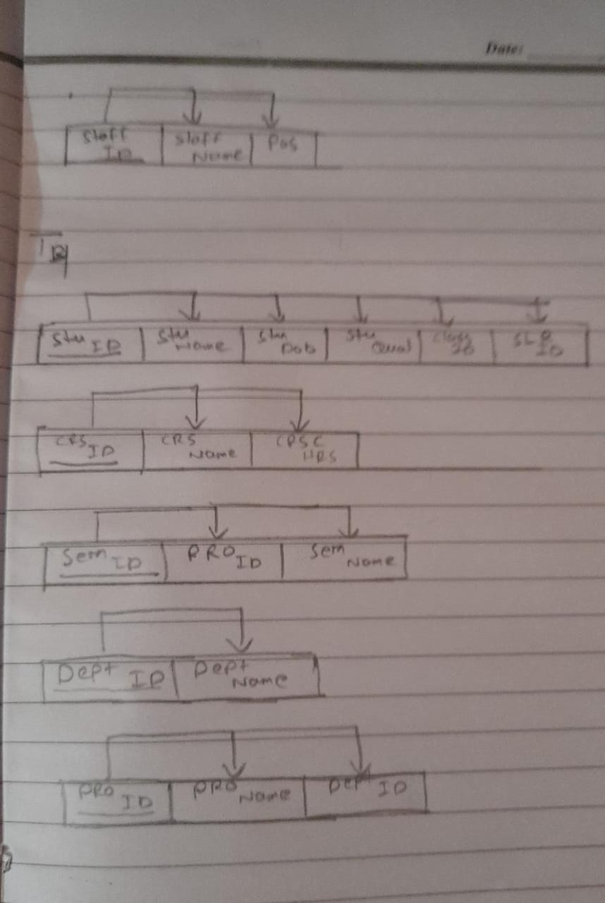

**CHAPTER 4**

**SYSTEM IMPLEMENTATION**

This chapter will include all the modules description step by step with screen shots.

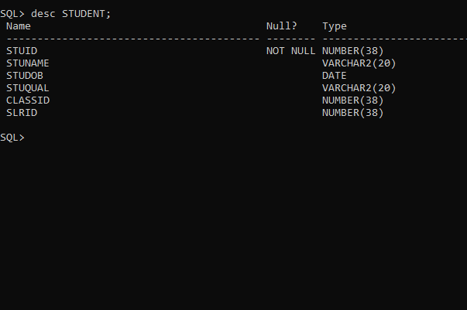

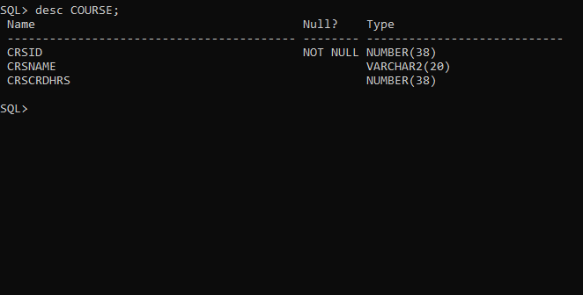

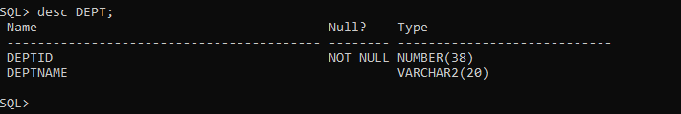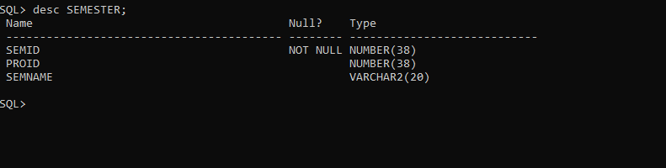

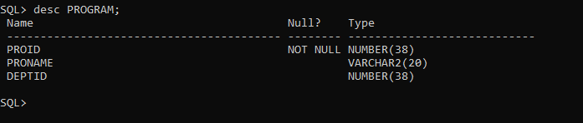

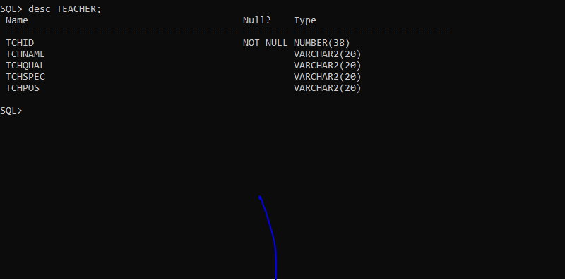

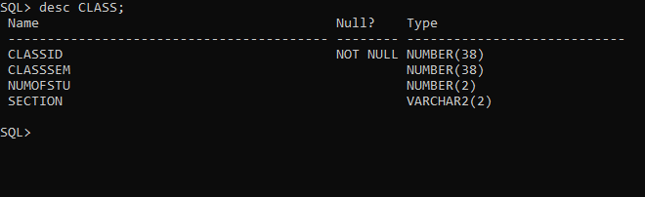

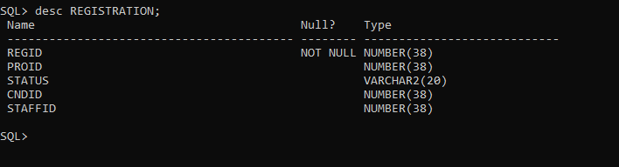

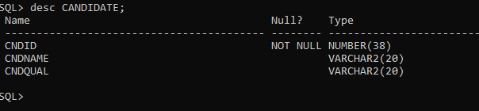

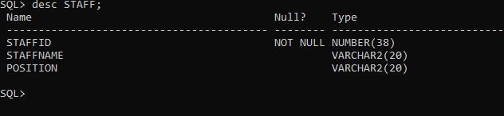

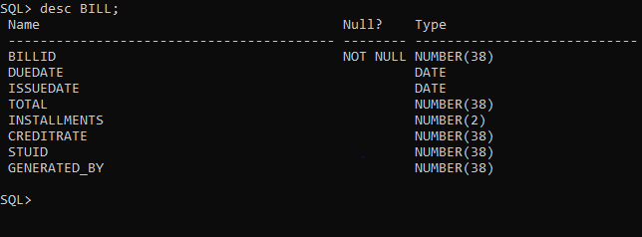

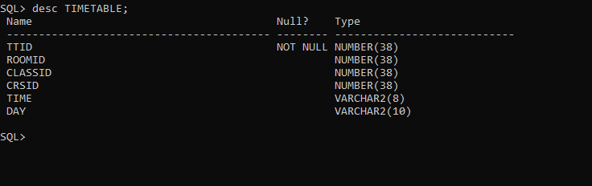

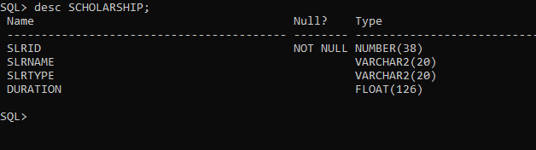

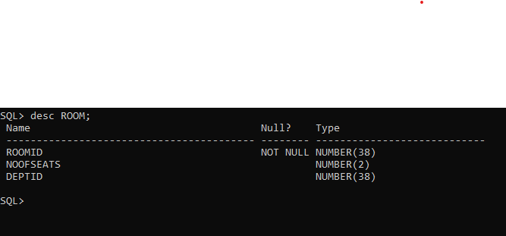

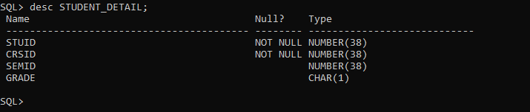

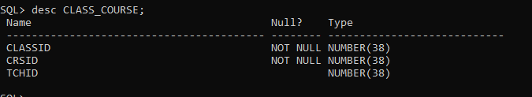

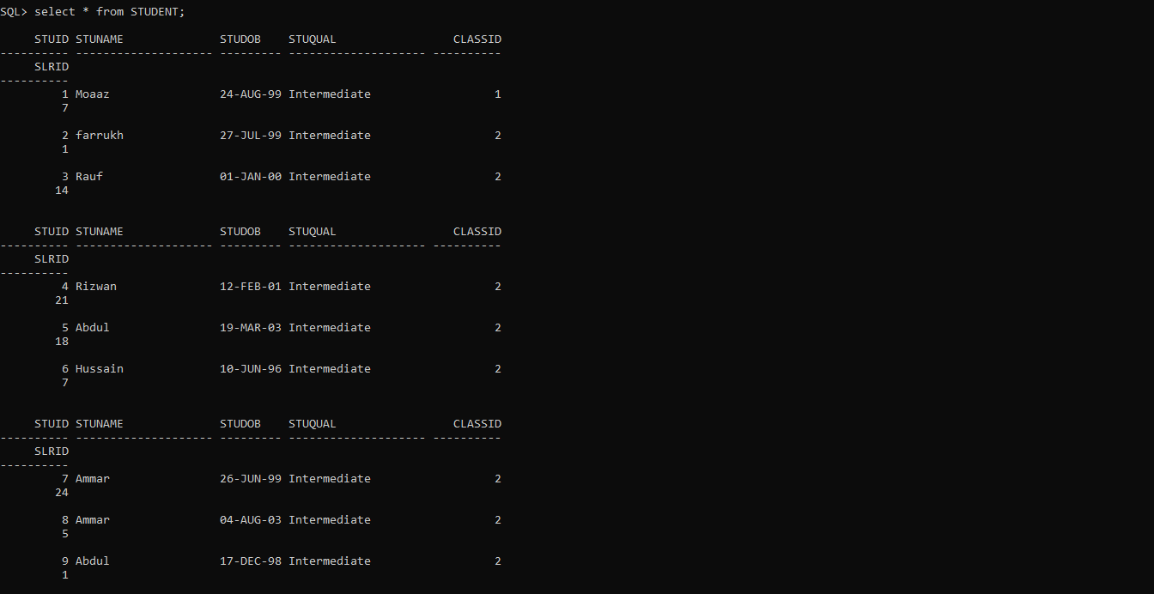

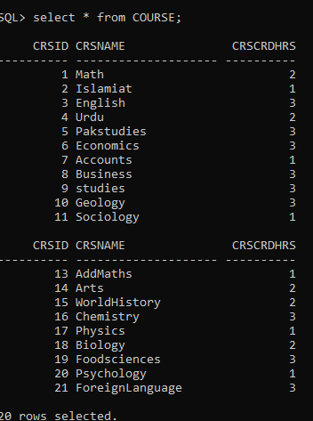

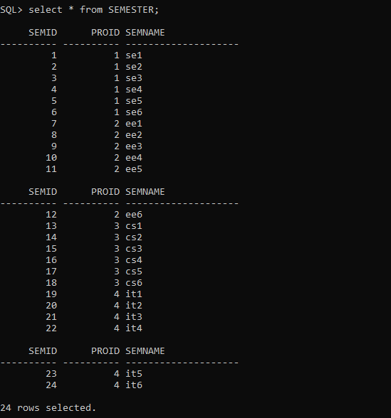

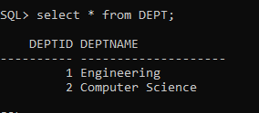

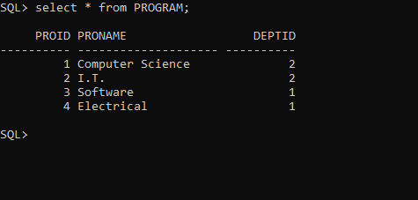

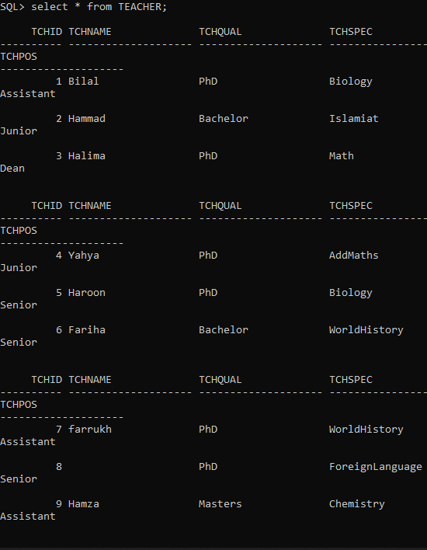

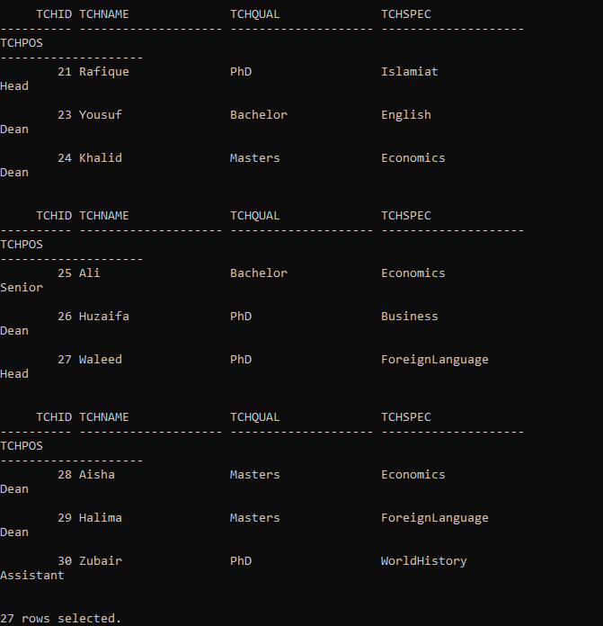

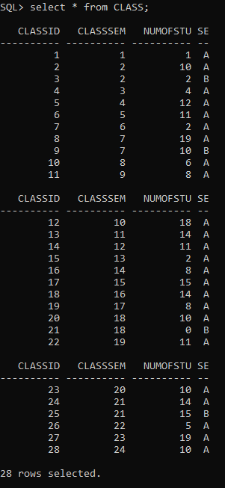

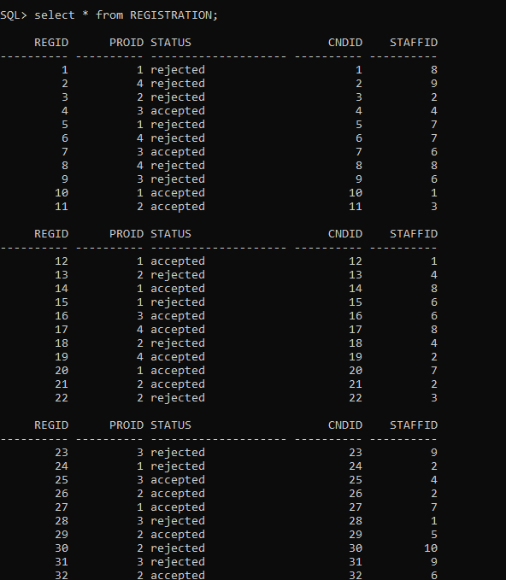

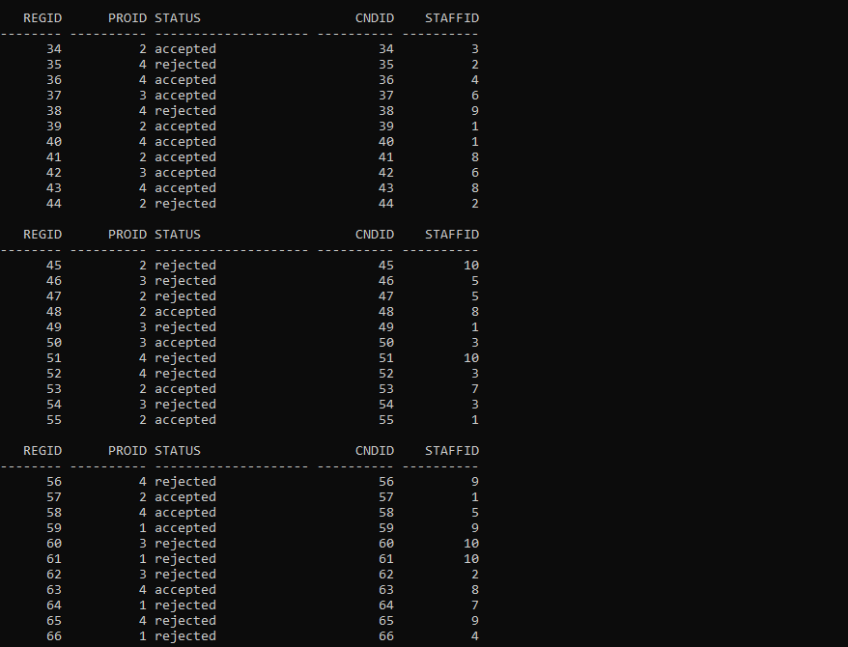

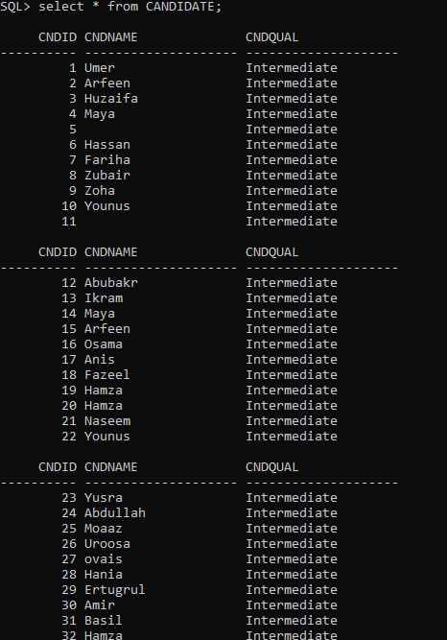

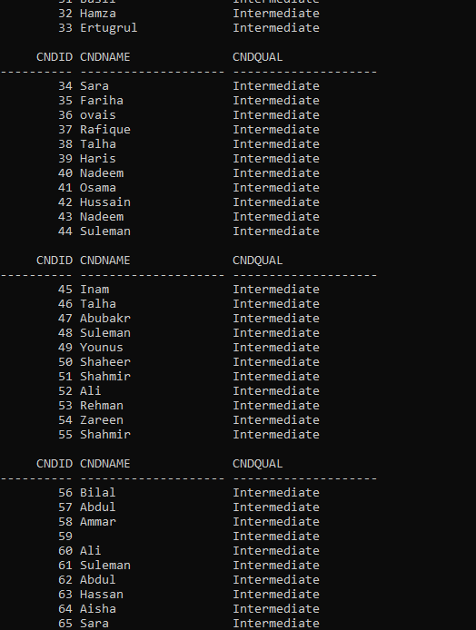

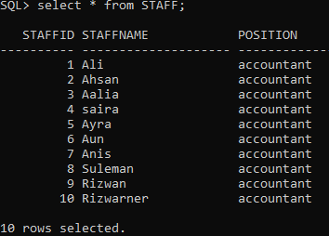

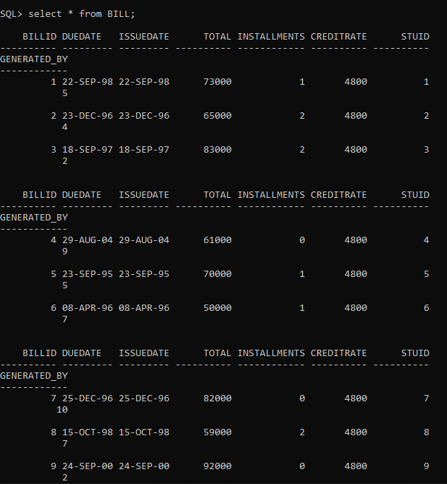

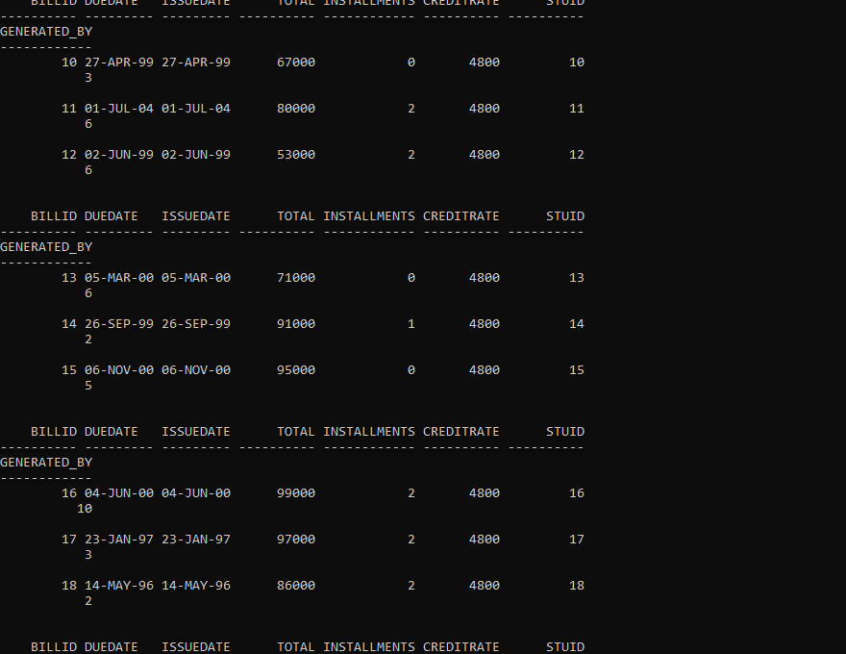

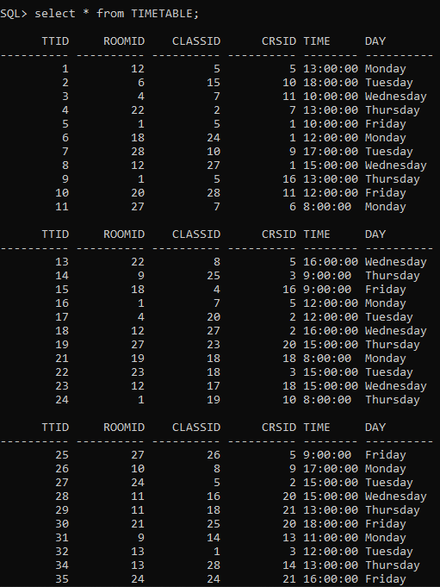

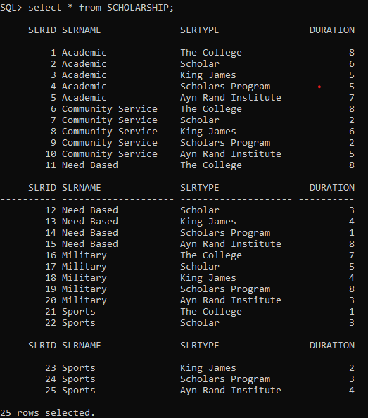

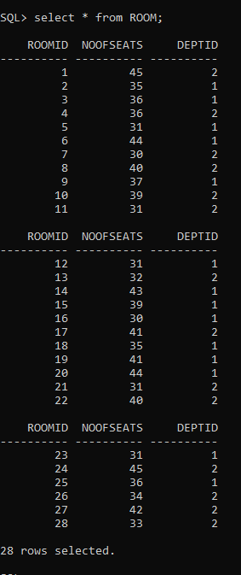

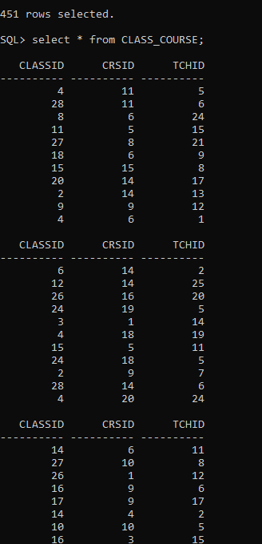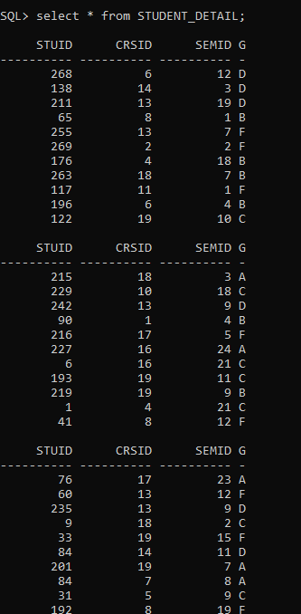

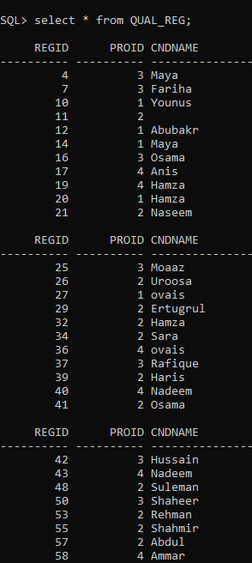

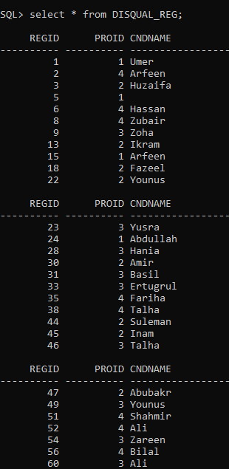

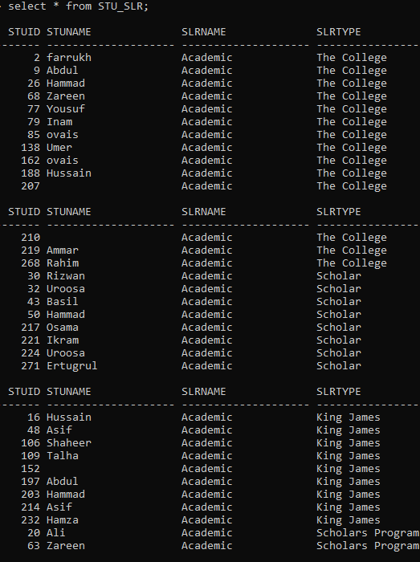

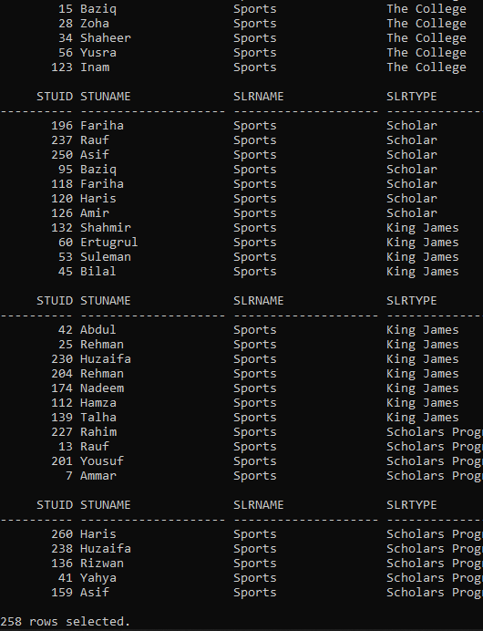

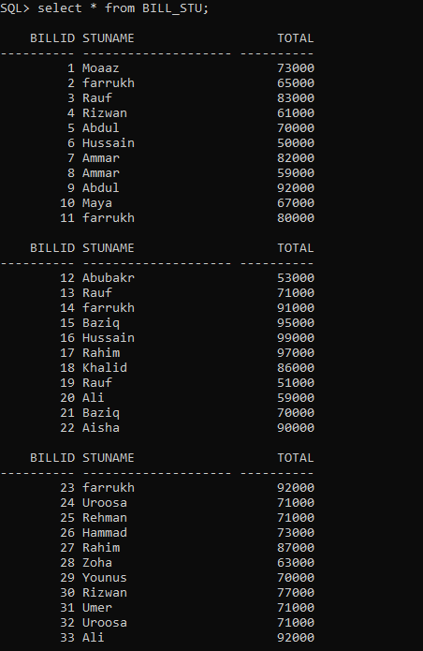

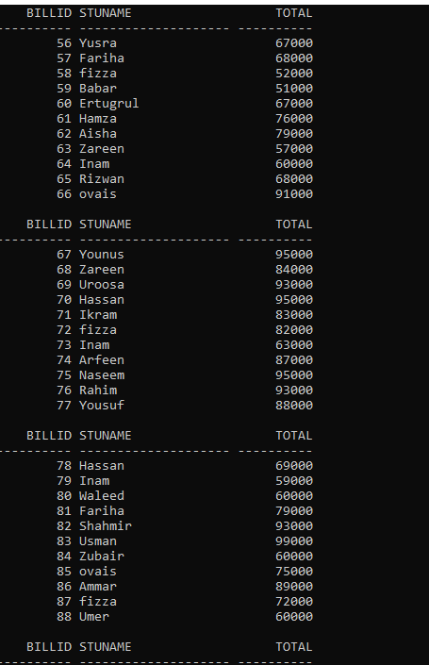

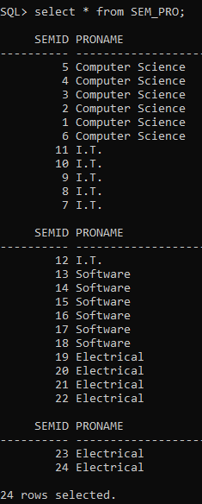

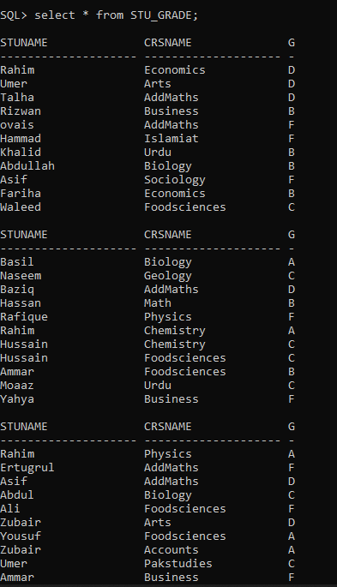

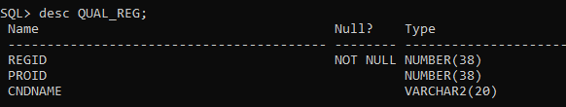

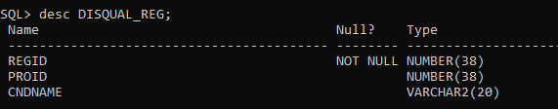

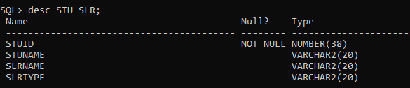





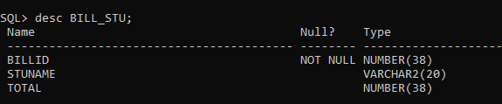

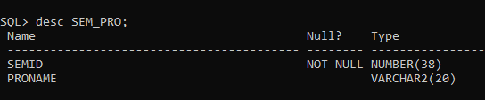

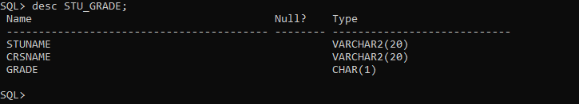

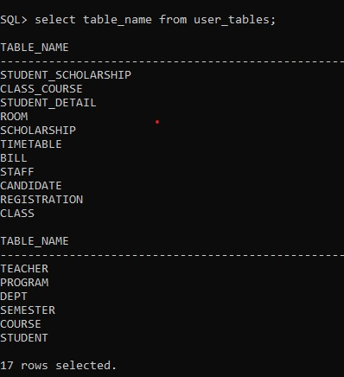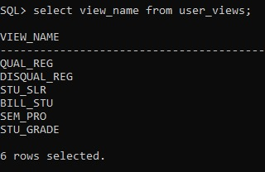

**CHAPTER 5**

**SYSTEM TESTING**

The aim of the system testing process was to determine all defects in our project .The program was subjected to a set of test inputs and various observations were made and based on these observations it will be decided whether the program behaves as expected or not. As we discussed earlier the main objective of the system in chapter 2.

**TIME SAVING**: Yes, the system works well and it also saves time. User is able to search record by using few clicks of mouse and few search keywords thus saving his valuable time.

**MORE MANAGEABLE WORK**: Now the work is more manageable and easy.

**IMPROVEMENT IN CONTROL AND PERFORMANCE**: The system is developed to cope up with the current issues and problems of account .The system can add user, validate user and is also bug free.

**NO MORE FILE LOST AND DAMAGED**: The main objective was to prevent the loss and damages of the data and finally there is no more loss of record in case of any mishappening.

**EASY TO SEARCH RECORD**: Now it’s easier to search any record in no time. So, yes our system worked well.

**CHAPTER 6**

**CONCLUSION AND FUTURE WORK**

**CONCLUSION:**

This project is developed to nurture the needs of a user in an UMS by embedding all the tasks taking place in it. Updating is perhaps the most fundamental workflow to move the data going in and out of a text file, but advancements in technology have added frameworks for feasibility.

Great skills have been achieved during the development of this project, time management being one of them, research in various areas of web and database development and at the end of the day it can be said that the task has been a great success incorporated with extraordinary challenges. All in all the sleepless nights, stressful days and hard work have paid off and besides some good moments were also experienced. These experiences will be used for ever. On our Graduation course we learned many theoretical comprehensions. Using that knowledge and Observing live operational system. Our project is a fundamental approach of these. We develop the project “University Management System”.

**FUTURE WORK:**

I also want to modify my application for the Future Work .I hope this work will help us in or future work. **1.** The aim of this project is to manage each and every section. Such as every Student, Teacher and Staff.

**2.** There will be a system for downloading Admission form For New Applicant.

3. It will show every updated notice given by the university authorities.