**LAB 5**

**OBJECT:**

**Create a class tollbooth. Two data types items are int which holds the number of vehicles (cars, bikes, vans) and the amount of money collected for each. A constructor initializes to zero. A number of functions increments the value of vehicle respectively and add Rs 10/-, Rs 5/- and Rs 20/- accordingly. Another member function display.**

**PROGRAM:**

**#include<iostream>**

**#include<conio.h>**

**using namespace std;**

**class tollbooth{**

**private:**

**int totalVehicles,totalCars,totalVans,totalBikes,total;**

**public:**

**tollbooth(){**

**totalVehicles=0;**

**totalCars=0;**

**totalVans=0;**

**totalBikes=0;**

**total=0;**

**}**

**void cars(){**

**cout<<" A car passed\n";**

**totalCars++;**

**total+=10;**

**totalVehicles++;**

**}**

**void bike(){**

**cout<<" A bike passed\n";**

**totalBikes++;**

**total+=5;**

**totalVehicles++;**

**}**

**void van(){**

**cout<<" A van passed\n";**

**totalVans++;**

**total+=20;**

**totalVehicles++;**

**}**

**void display(){**

**cout<<"\nTotal cars = "<<totalCars<<endl;**

**cout<<"Total bikes = "<<totalBikes<<endl;**

**cout<<"Total vans = "<<totalVans<<endl;**

**cout<<"Total vehicles = "<<totalVehicles<<endl;**

**cout<<"Total amount = "<<total<<endl;**

**}**

**};**

**int main(){**

**tollbooth t;**

**char ch;**

**cout<<"1 = Cars"<<endl;**

**cout<<"2 = Bike"<<endl;**

**cout<<"3 = Van"<<endl;**

**cout<<"4 = Display"<<endl;**

**do**

**{**

**ch=getche();**

**if(ch=='1')**

**t.cars();**

**if(ch=='2')**

**t.bike();**

**if(ch=='3')**

**t.van();**

**}while(ch != '4');**

**t.display();**

**return 0;**

**}**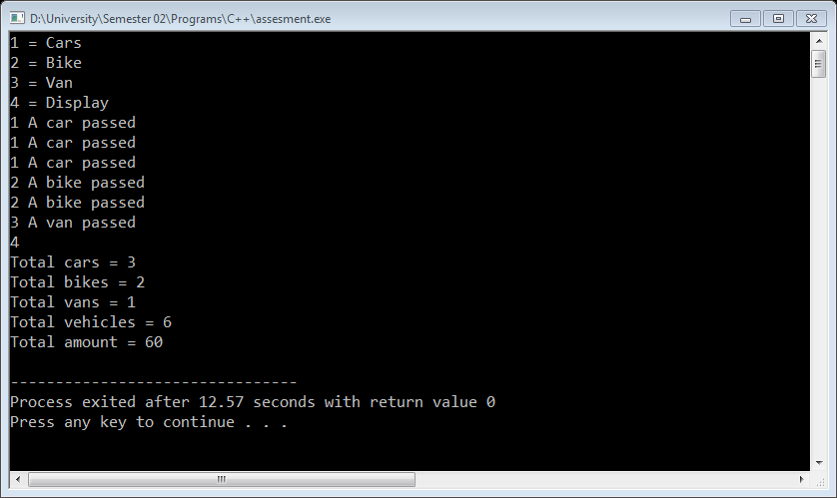

**OBJECT:**

**Create a series of overloaded function with same name that works with data type int, float, char, double. Write a program to use these overloaded functions to calculate the factorial of a number.**

**PROGRAM:**

**#include<iostream>**

**#include<conio.h>**

**using namespace std;**

**class factorial{**

**public:**

**int fact(int x){**

**if(x==1 || x==0)**

**return 1;**

**else**

**return x*fact(x-1);**

**}**

**int fact(double x){**

**if(int(x)==1 || int(x)==0)**

**return 1;**

**else**

**return int(x)*fact(int(x)-1);**

**}**

**int fact(char x){**

**int y=int(x);**

**if(y==1 || y==0)**

**return 1;**

**else**

**return y*fact(y-1);**

**}**

**float fact(float x){**

**if(x==1 || x==0)**

**return 1;**

**else**

**return x*fact(x-1);**

**}**

**};**

**int main(){**

**factorial f;**

**cout<<f.fact(4)<<endl;**

**cout<<f.fact(5)<<endl;**

**cout<<f.fact(3)<<endl;**

**cout<<f.fact(6)<<endl;**

**return 0;**

**}**

