Documentation of Changes Made to ‘Mouza Census-2020-Original’:

Section 1: Total Number of Settlements
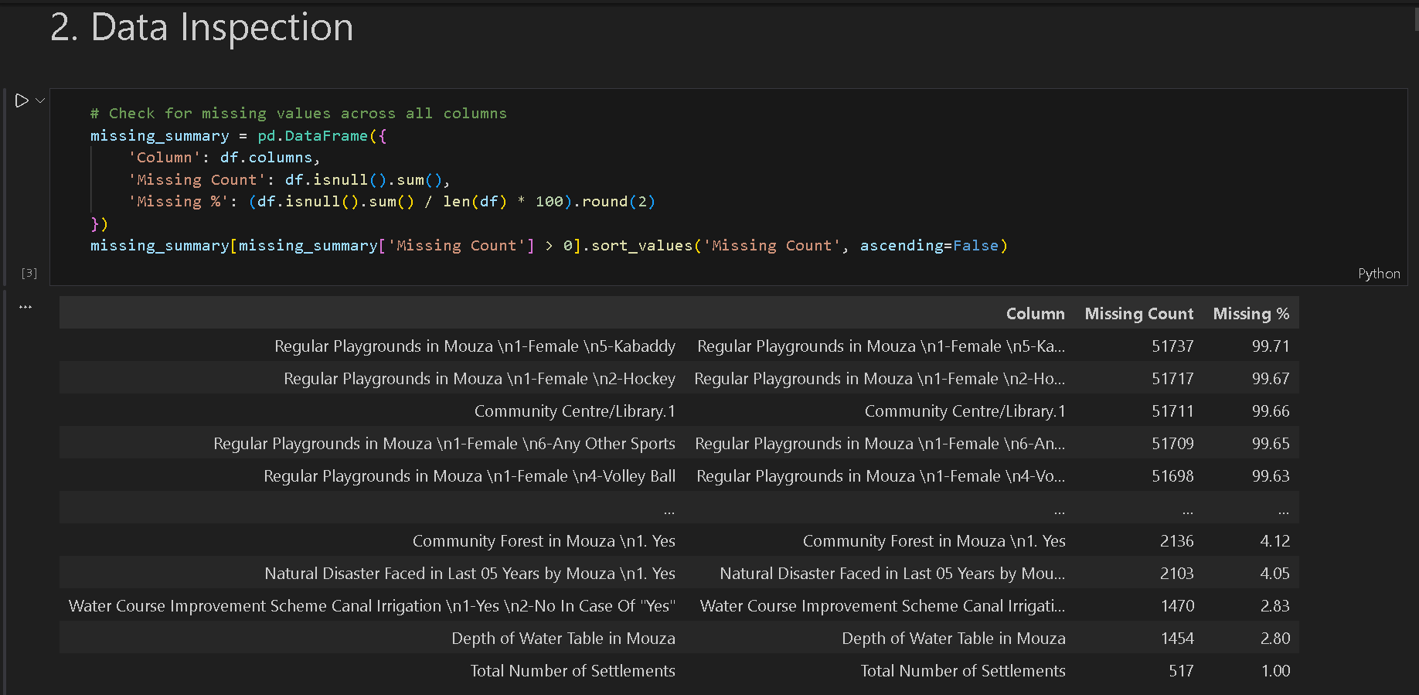

Taking care of the data inspection, we calculated the columns and their percentage of empty values. Based on that, data cleaning will be done to by assigning the appropriate calculation to the field.
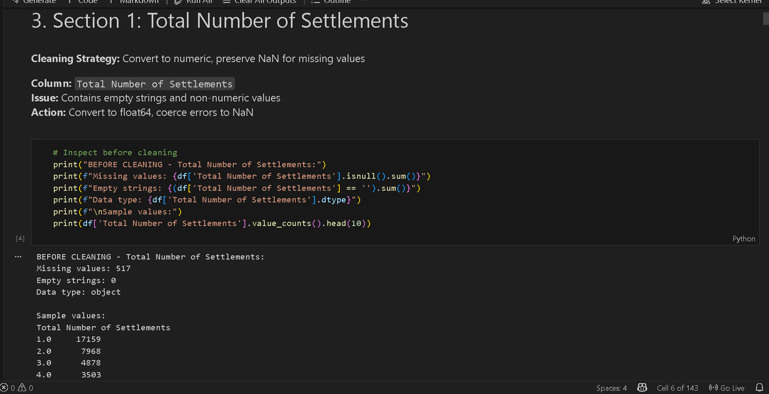

Total Number of Settlements:
This field is contains numeric data, with the information of the of number of ‘abadi numbers’ within the administrative unit (mouza).
For missing values, it was taken as there is no abadi within that region and they will counted to NaN. (no settlement)
The values went from 517 missing records to 0 records.

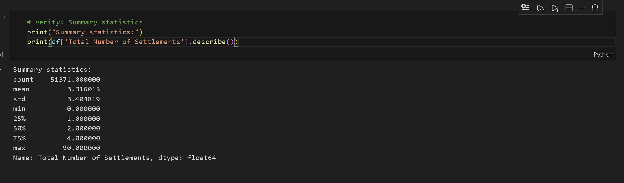

Final Values & Insights:
Calculating the statistical measures, we get an average number of settlements within records of 51371 count, there are 3.3 approx. To 3 settlements. Majority of mouza’s have 4 settlements or more while the 25% has 1 or less settlements in there region.

Section 2: Agriculture & Irrigation:
Before the cleaning:
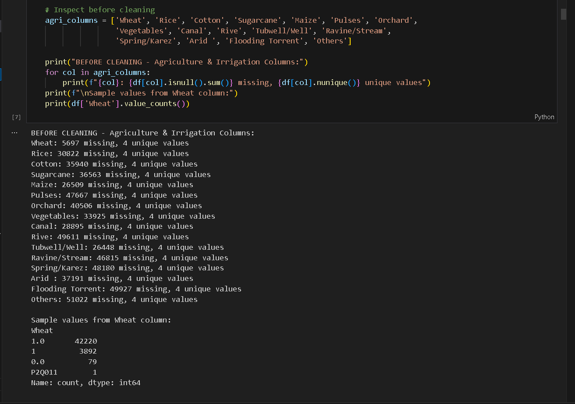

What’s the problem ?
There are inconsistencies in the values of the data so that, multiple representations of the same data are given. e.g 1,1.0,0.0, and missing values. The issue was consistent for all the columns relevant to the Agriculture and Irrigation.
There were columns with no records or on the questionnaire no options were selected for them. So there were columns with no values for a question as well.

The Solution:
The solution applied was to make all the values consistent, with 1.0, to represent the presence of a crop or an irrigation source. 0.0 displayed missing values and the mouza’s for which there was no answer, they were quoted as Nan. 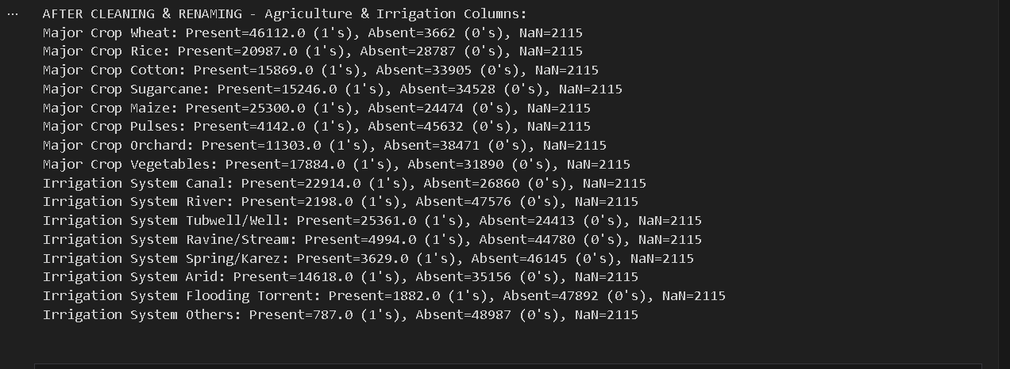

Verification:
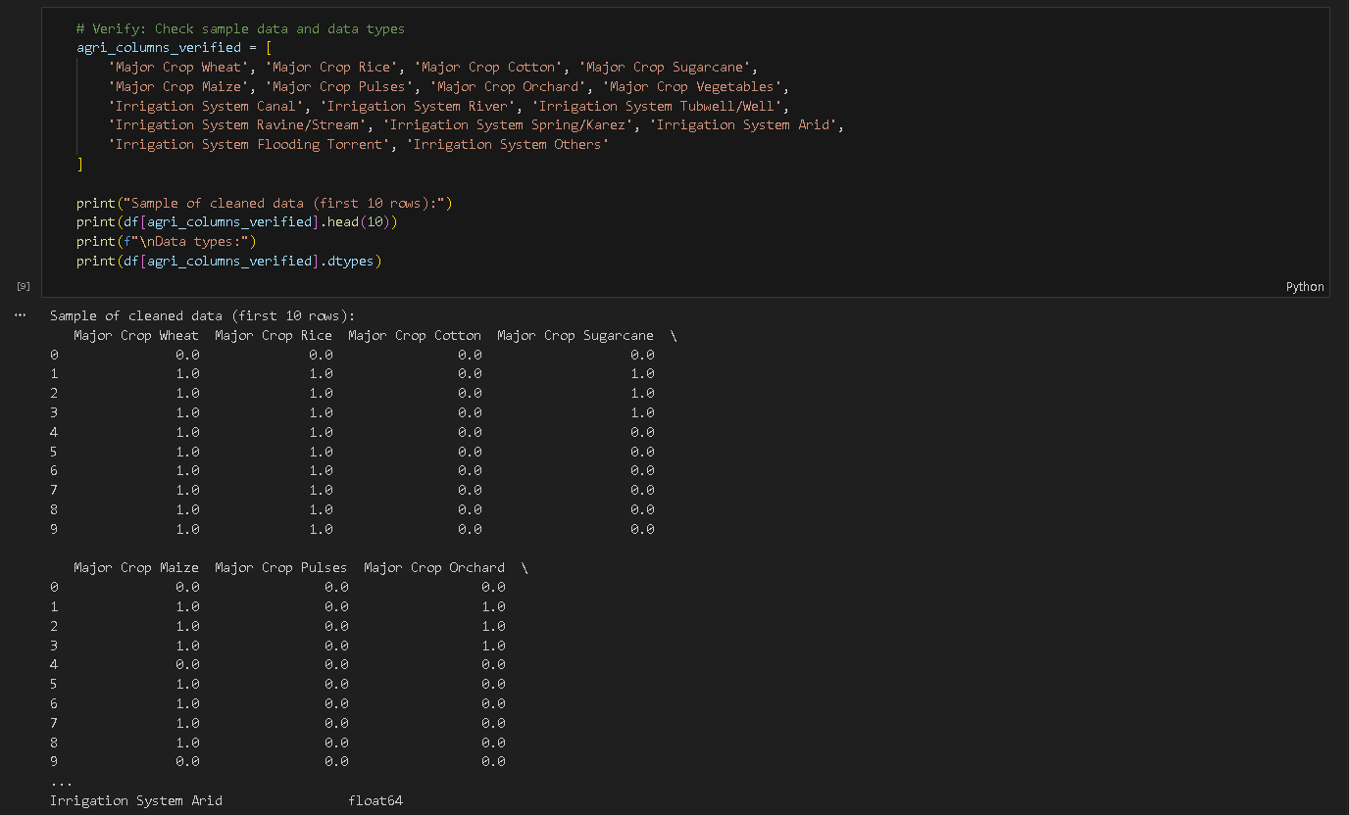

Section 3: Water Course Improvement Scheme

Binary encoding for improvement status + conditional numeric cleaning
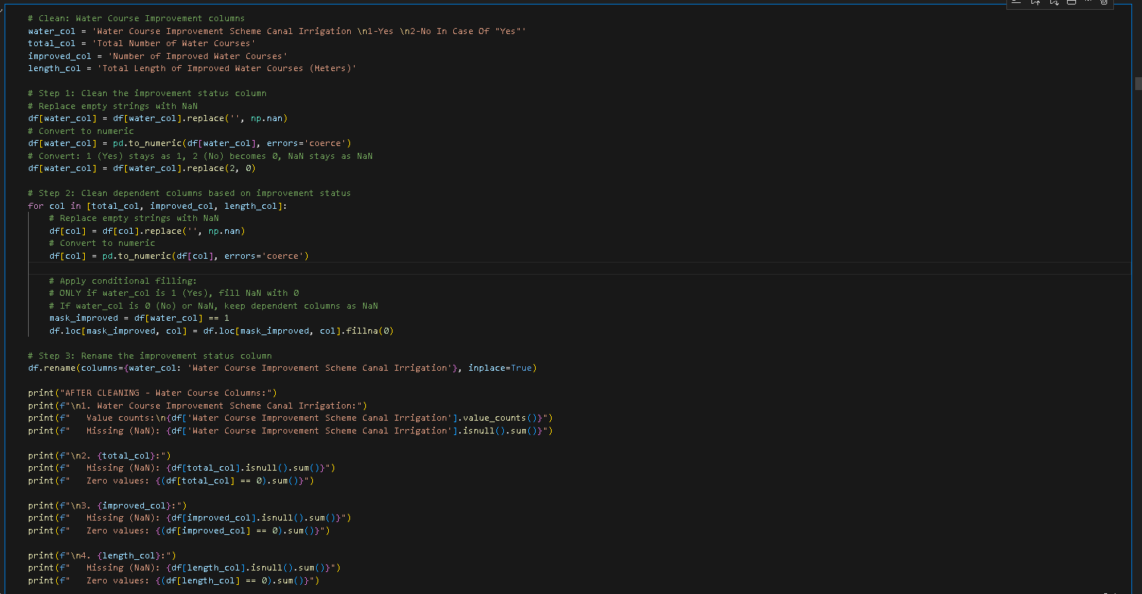

What’s the problem?
Values in the column are quoted with {1, 2}, ‘1 to represent the absence, and 2 to represent the presence’. The dependant variables are not actually taking care of the absence of condition.

The Solution:
  - Values were changed to {0 – to represent ‘no course improvement scheme for canals’, 1- to represent the presence of improvement scheme for canals.’ }
  - Where there was no improvement scheme, the dependent variables were assigned NaN.
  - Where the scheme was present, the dependent variables were assigned appropriate value.

Section 4: Modern Technology for Irrigation

Conditional numeric cleaning based on "None" indicator
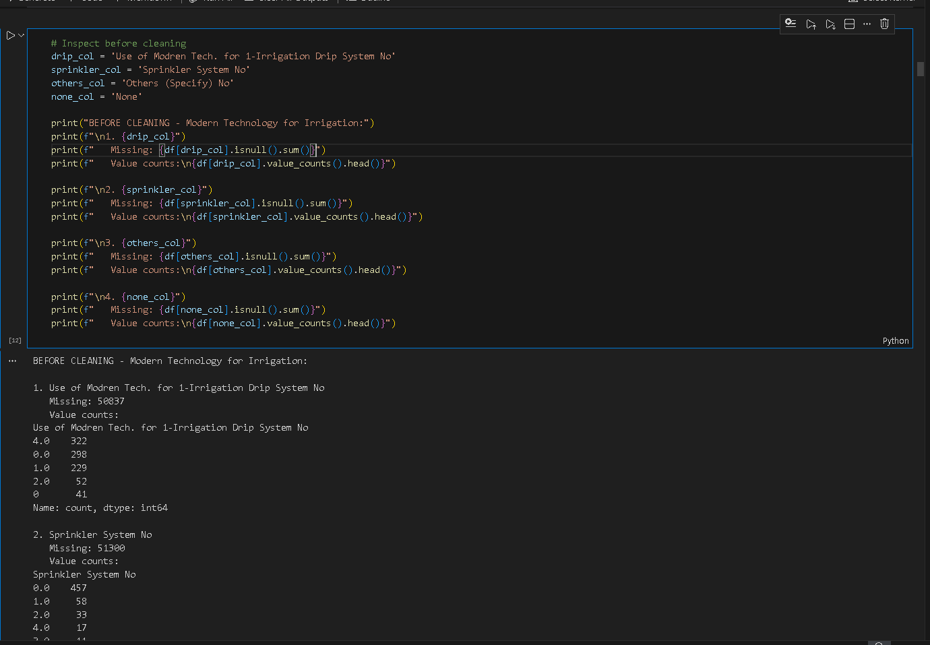

What’s the problem?
In the question of ‘Use of modern technology for irrigation’, there were inconsistencies based on the data quoted. The data value was entered based on the option chosen, presence of the mode of tech and the count.

Solution:
Data is formatted into 3 separate columns, for keeping a separate column to record the absence of the modern technology of irrigation. This not only made the data visual to be easily understandable, but keeping the count and absence of record easily understandable. The mouza for which there was no recorded information, they were coded with NaN.

Section 5: Depth of Water Table in Mouza

- Column ‘AI’ name was replaced with ‘Depth of Water Table in ft’
- Column ‘AI’ values were coerce to ‘Numeric’ in feet and the empty values were catered.
- Where the values were supposed to be empty, information for that records were not collected (or not found) and were assigned ‘Nan’ in the data.

Section 6: Construction Type & Street Status

- Construction Type of Majority of Houses (1-Bricked, 2-Mud Made, 3-Bricks & Mud, 4-Others)
- Status Type of Majority of Streets (1-Metaled, 2-Cemented/Concret, 3-Bricked/Soling, 4-Dirt Roads)
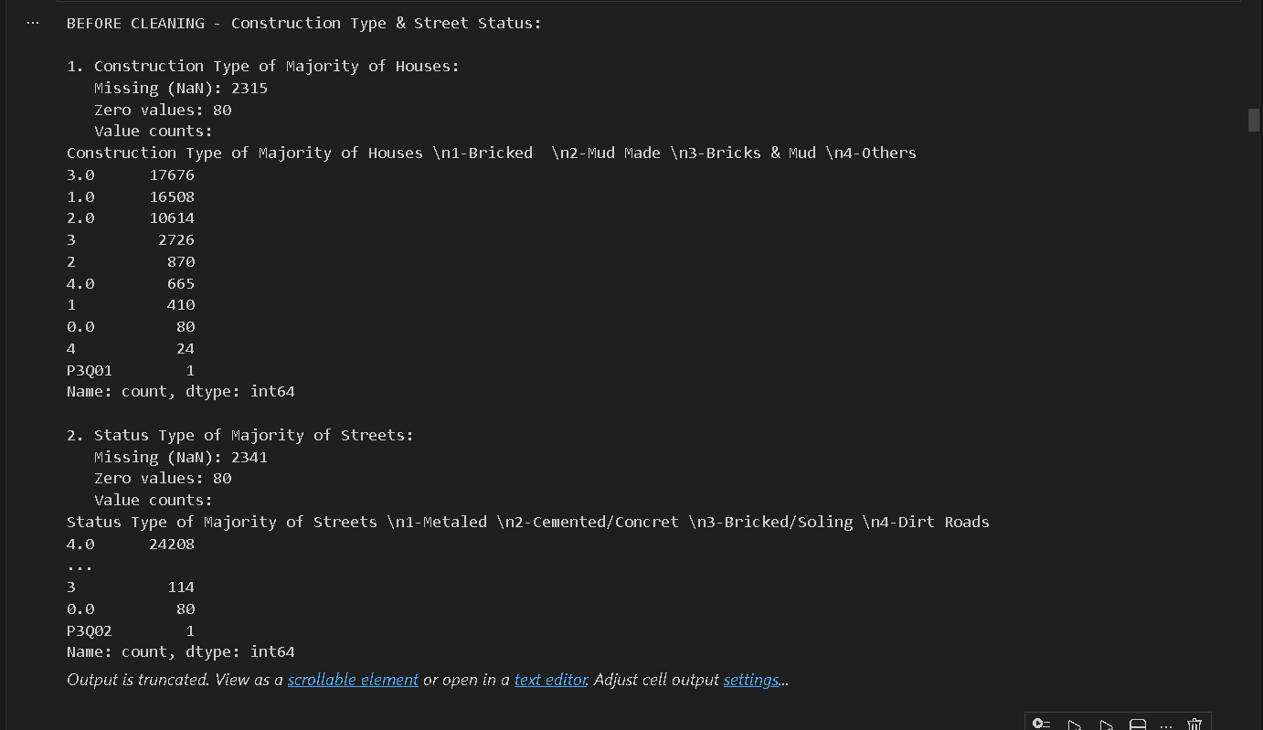

What’s the problem:
There were two representations of missing data, either empty or ‘0’. The value of the variable was considered string which was coerced to integer.
The Solution:
The categorical variable describing each variable, was coerced and standardized. The strings and occurrences of ‘0’ were considered as ‘data not recorded/found’ and then were converted to NaN.
The names of the columns were replaced to keep the variable identification readable, concise and meaningful.

Section 7: Waste Management System
Binary for waste management + rename type column

- Yes In Case of 'Yes'ť the Waste Management (1=Government, 2=Private) → Waste Management (1=Yes, 0=No)
- No (waste type indicator) → Waste Management Type (1=Government, 2=Private, 0=None)
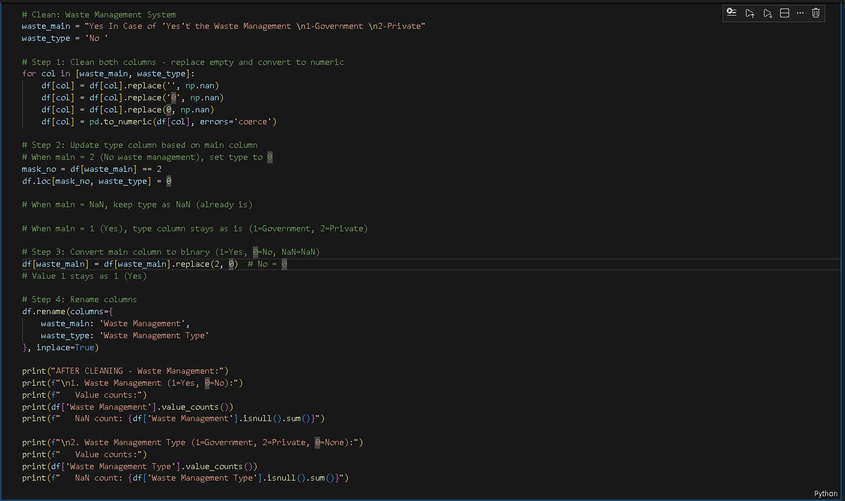

What’s the Problem:
  - The column names are not user friendly or concise.
  - There were many values and no standardization in the values of the variables. ‘1’, ‘1.0’, ’2’, ‘2.0’ and missing.
  - Where there was no service of waste management the values were not appropriate for the dependent variables (government/private).

The Solution:
Values of the columns were standardized and binarized to carefully define the presence or absence of waste management. {1 – presence of waste management in the mouza, 0 – no waste management service in the mouza}. Similarly, the values were standardized to display answer in {0.0, 1.0} set only. When the waste management is not present in the mouza, the dependent variables are standardized to represent ‘0.0’ in their values.

Section 8: Underground Water Quality

- Taste of Underground Water (1=Sweet, 2=Not Sweet) → Sweet Underground Water (1=Yes, 0=No)
- Distance travelled to get Sweet Water → Distance to Sweet Water in km

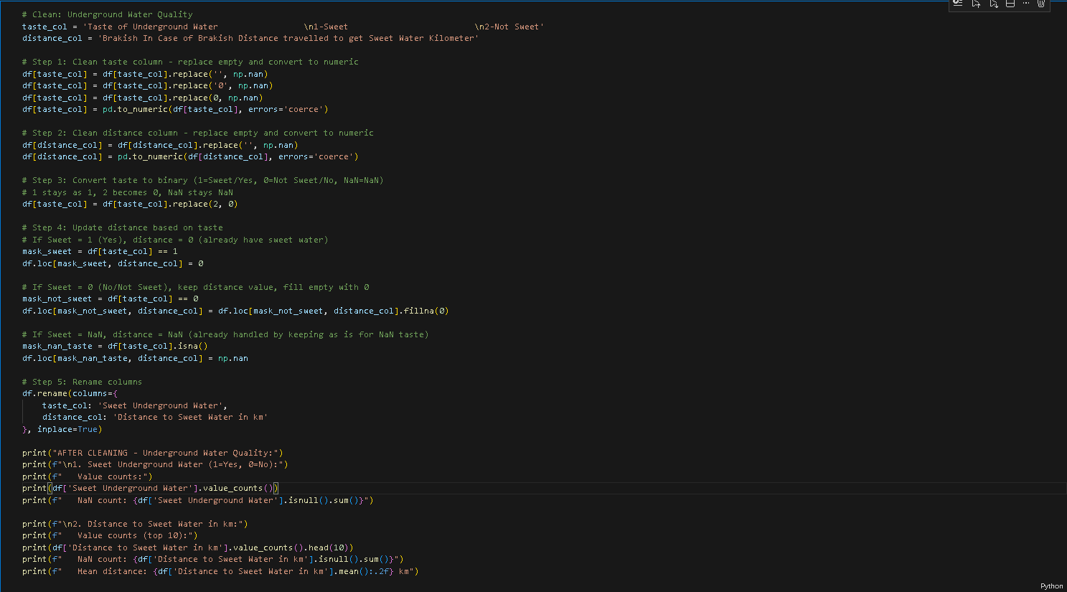

Problem Identification and Solution:
Responses describing the taste of underground water were standardized by converting the blank or invalid values to missing and recording the taste indicator into a binary format (1 = sweet, 0 = not sweet). The accompanying distance variable, which records the distance travel to find the sweet water in case of brackish water was cleaned and coerced to numeric values.
Logical constraints were applied, where sweet underground water was found, the distance was set to 0. Where the water was not sweet and distances were missing, the distances were imputed to zero. Where the taste was not given, the values were considered missing.
Variable names were updated to keep the readability of the user.

Section 9: Source of Drinking Water

Cleaning Strategy: Binary encoding (1=present, 0=absent) + Conditional NaN handling
Columns: 10 drinking water source columns with descriptive ren

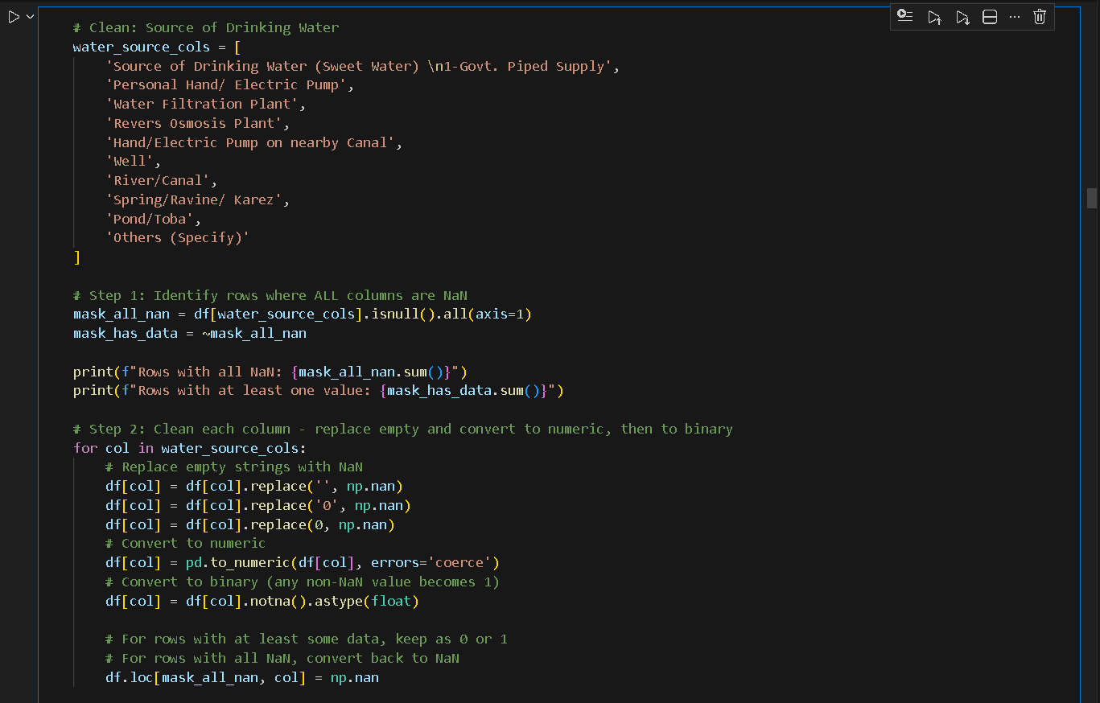

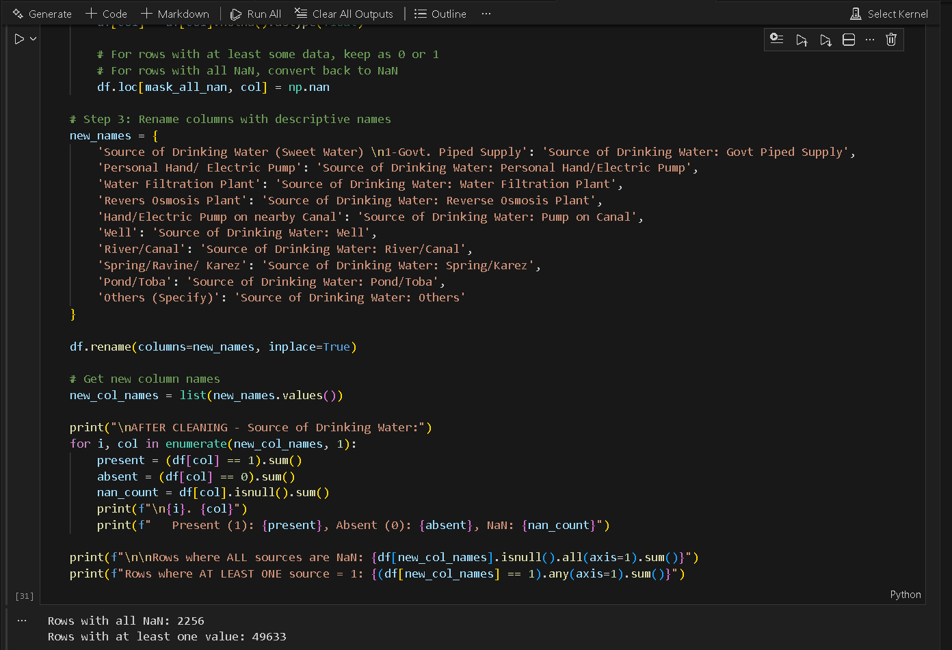

What’s the Problem and the Solution?
All the variables’ values were standardized and binary encoding {1= presence of drinking water source, 0 = absence of drinking water source in mouza} was done to display the presence of a source of the drinking water. This removed the unnecessary weight to display the relation or computation in the analysis or visualization. Column names were updated to display the variables in user friendly way and better in visualization.

Section 10: Toilet Facility & Sewerage System

Cleaning Strategy: Convert 0 values and empty to NaN, keep valid categories
Columns:
- Toilet Facility in Majority of Houses (1=Inside, 2=Open Place)
- Sewerage System in Mouza - Cemented Drain (1=All, 2=Mostly, 3=Same, 4=None)
- Sewerage System (1=All, 2=Mostly, 3=Same, 4=None)
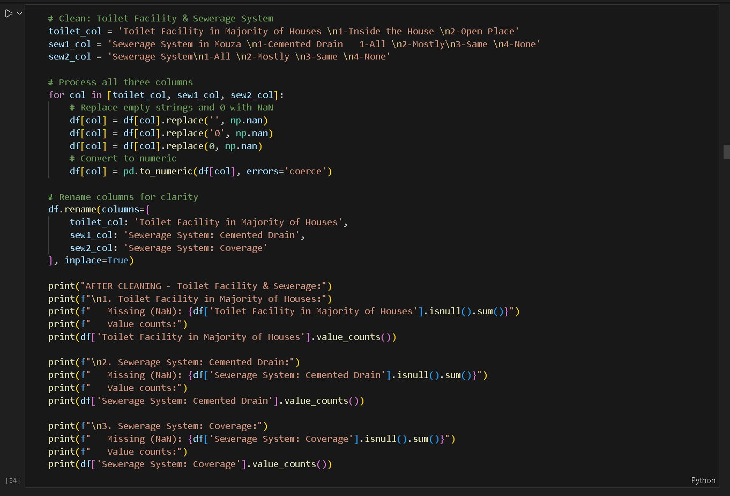

What’ s the Problem and the Solution?
The values for toilet and sewerage facilities were inconsistently recorded across all three columns, using mixed numeric and non-numeric formats such as 0, '0', empty strings, or strings representing category codes. These inconsistencies made category interpretation unclear and created incorrect representation for missing answers. The meaning of each column was also buried inside long labels, making them hard to read and use for reporting.
To standardize, all occurrences of empty strings and zeros were treated as missing information and converted to proper missing values. The variables were coerced into numeric categories based on their coded responses while invalid entries were dropped during this conversion. Column names were rewritten to clearer, concise labels, separating toilet facility status from the two sewerage system questions and making each variable understandable and ready for further analysis.

Section 11: Health Facilities in Mouza
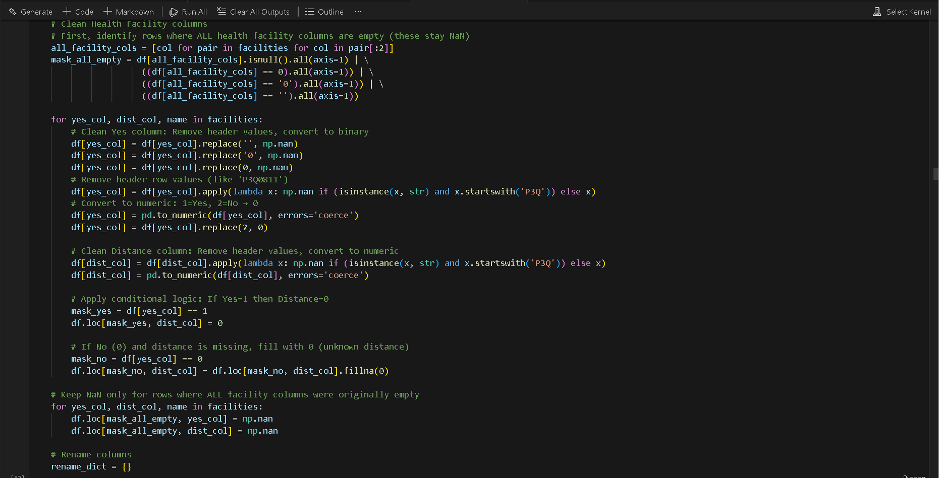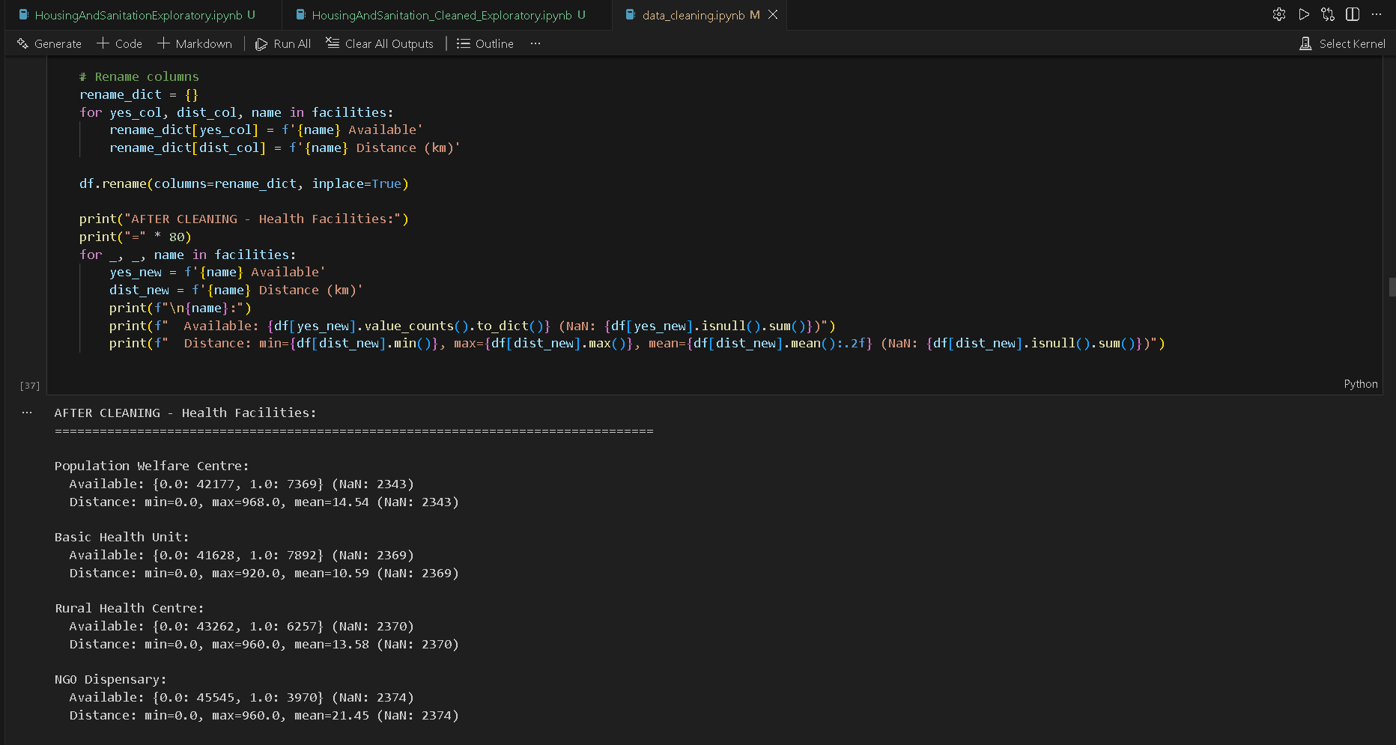

What’s the Problem and the Solution?
The health facility variables contained a mix of header-like strings, zeros, and empty values in both the availability and distance fields, making it unclear whether a service was actually present or the data was simply not recorded. The original coding also used numeric categories where “2” meant absence, leading to confusion when translating to a clean yes/no structure. Additionally, distances were kept even in cases where the facility existed within the mouza, and missing information was not consistently handled when no service was available at all.
To correct this, availability values were standardized by removing header entries, converting the indicators into a clear binary format, and treating the absence category as zero. Distances were cleaned by eliminating header values, coercing numbers, and applying logical rules: when a facility exists, distance is set to zero; when it does not exist, missing distances are replaced with zero to show unknown distance. Records with no information for all facilities were kept as missing. Column names were rewritten into readable availability and distance fields for each facility, making the information consistent and interpretable for further analysis.

Section 12: Educational Institutions in Mouza
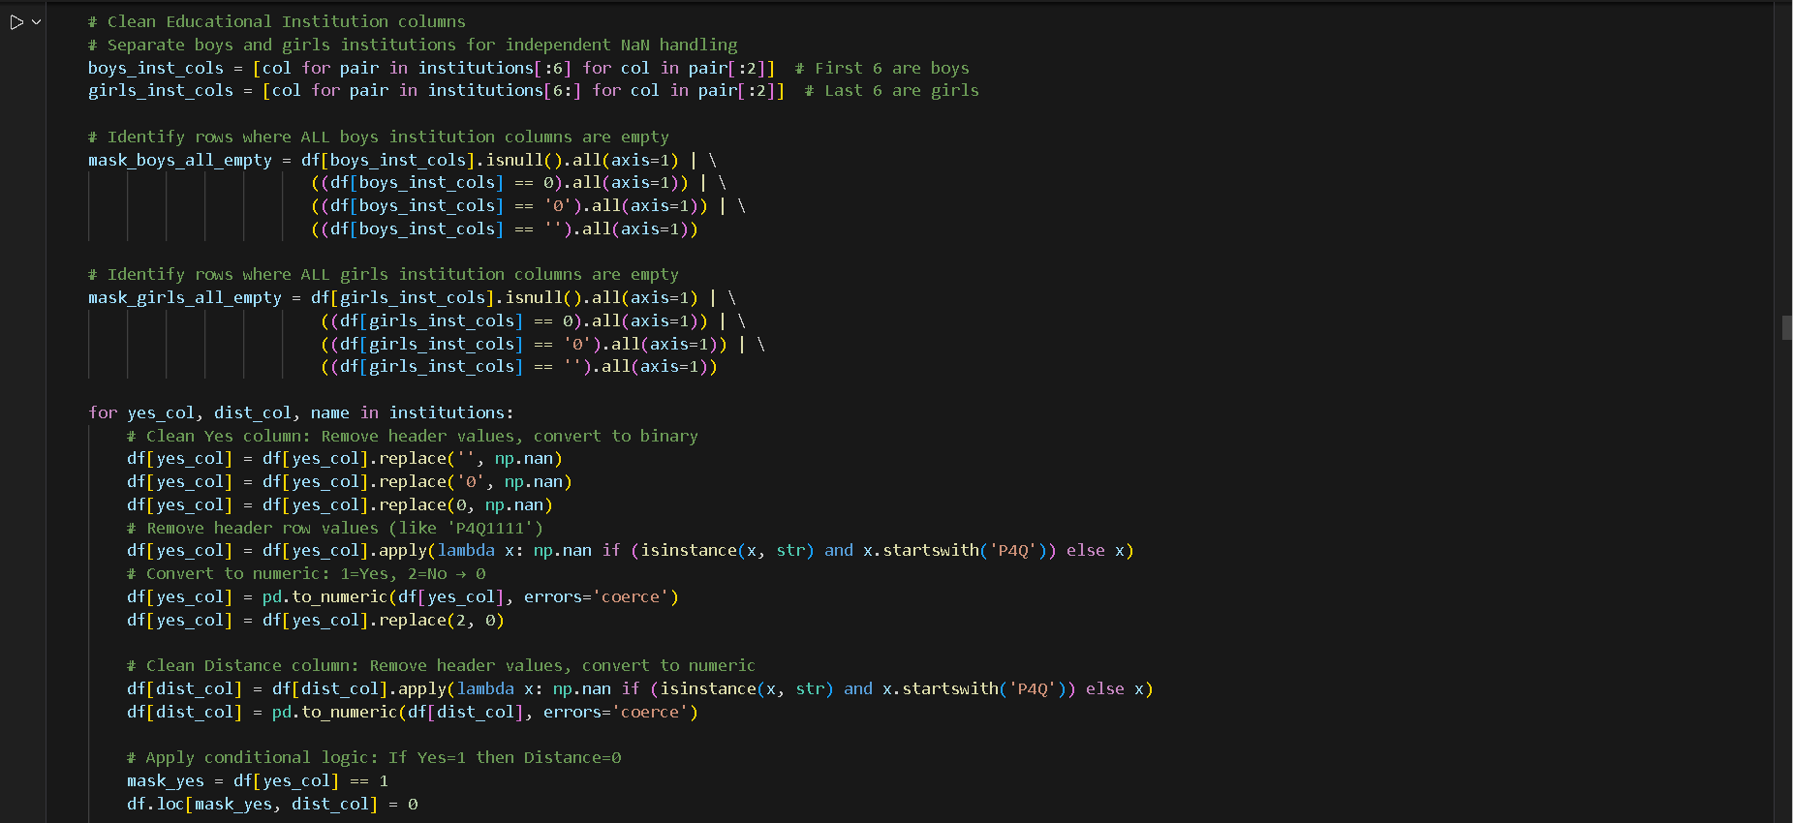
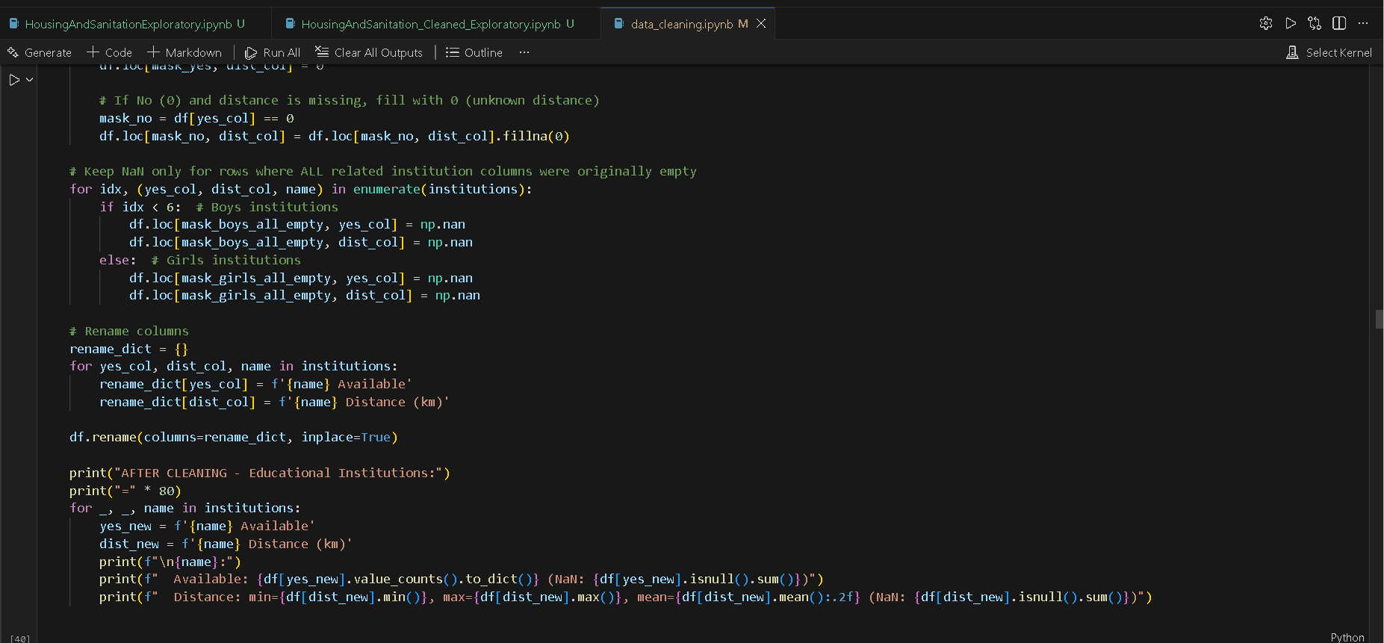

What’s the Problem and the Solution?
Educational institution fields for boys and girls were mixed with inconsistent representations such as zeros, empty strings, and header-like text, making it impossible to distinguish between actual absence of an institution and simply missing or mis-entered information. Availability was coded with numeric categories where “2” meant no facility, distances were kept even when institutions existed locally, and rows with no information for all institutions were not cleanly separated from genuinely missing data. Because boys’ and girls’ facilities are independent in the questionnaire, treating all columns together would incorrectly assign values to one group when only the other was answered.
To fix this, availability indicators were cleaned by removing header entries, converting them into a binary format, and standardizing “2” as absence. Distances were coerced to numeric values, with logical rules that set distance to zero when the institution exists and replace missing distances with zero for absent institutions. Boys’ and girls’ sets were handled separately, ensuring that rows with no information for all boys’ institutions or all girls’ institutions remain missing only for the relevant group. Column names were rewritten into clear availability and distance fields for each type of institution, making interpretation straightforward and ready for reliable analysis.

Section 13: Regular Playgrounds in Mouza
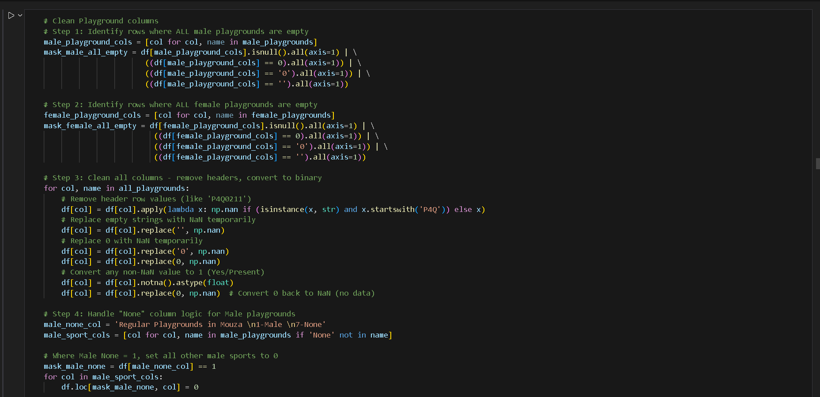
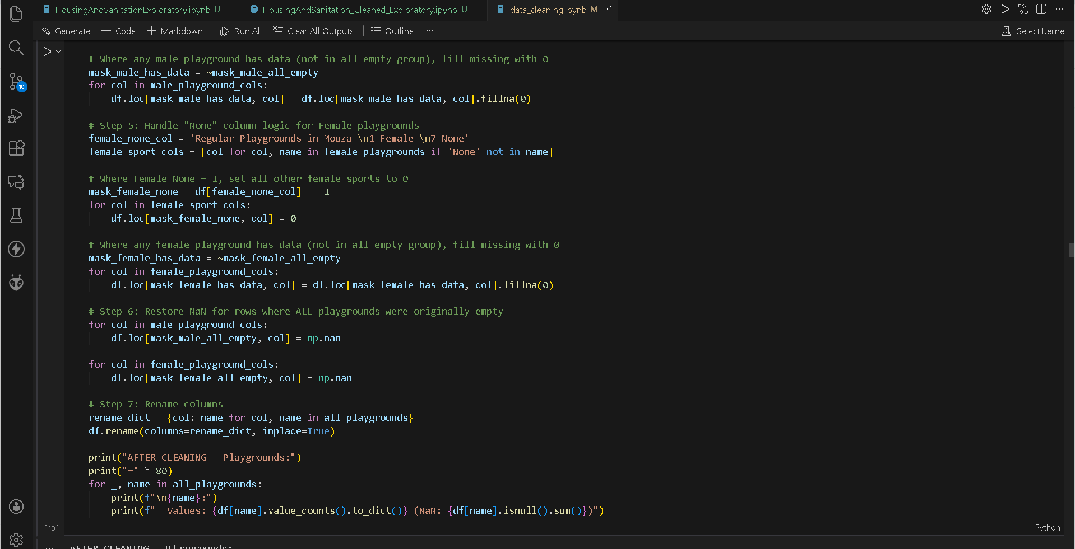

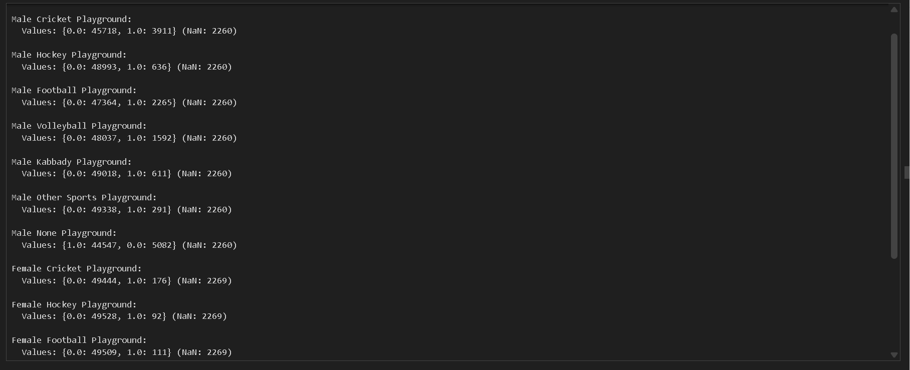

What’s the Problem and the Solution?
The playground data mixed header text, zeros, and empty strings in a way that made it unclear whether a specific sports facility actually existed or the answer was just missing. Male and female playground indicators were lumped together even though the questionnaire treats them separately. The “None” option added extra confusion: if a mouza marked “None,” other sports fields could still appear non-empty due to leftover values, making interpretation unreliable. All of this prevented you from cleanly answering a basic question: which sports facilities are genuinely available for boys and girls?
The cleaning enforces a simple, consistent logic. Header artifacts are removed, temporary empties are standardized, and each non-missing entry becomes a clear presence indicator. Male and female sets are processed independently, so missing information in one doesn’t contaminate the other. If “None” is ticked, all other sports for that gender are forced to zero, and when facilities exist, missing values are sensibly filled with zeros. Rows that originally reported nothing are restored to genuine missing values. Finally, column names are rewritten into readable labels, giving you clean, interpretable availability data for each playground type.

Section 15: Farm Types in Mouza Premises
Columns to clean (4 columns):
- Number of Farms in Mouza Premises 1-None
- Number of Farms in Mouza Premises 2-Poultry Farms
- Number of Farms in Mouza Premises 3-Livestock/Dairy Farms
- Number of Farms in Mouza Premises 4-Fish Farms
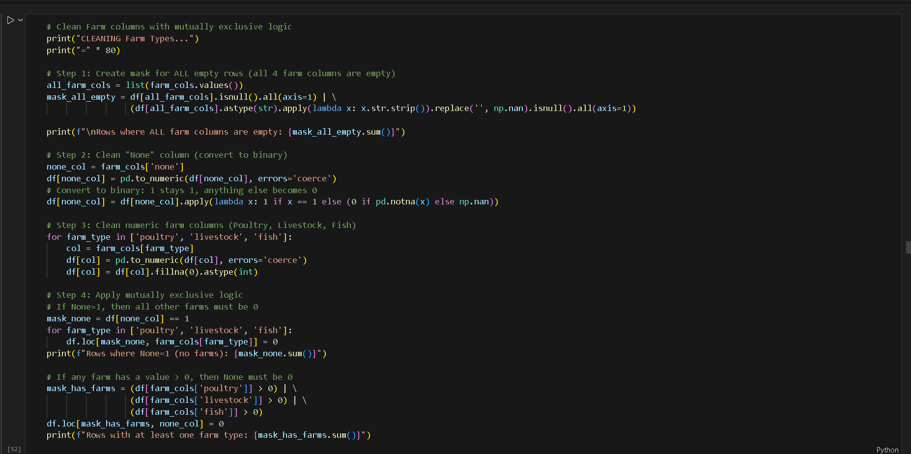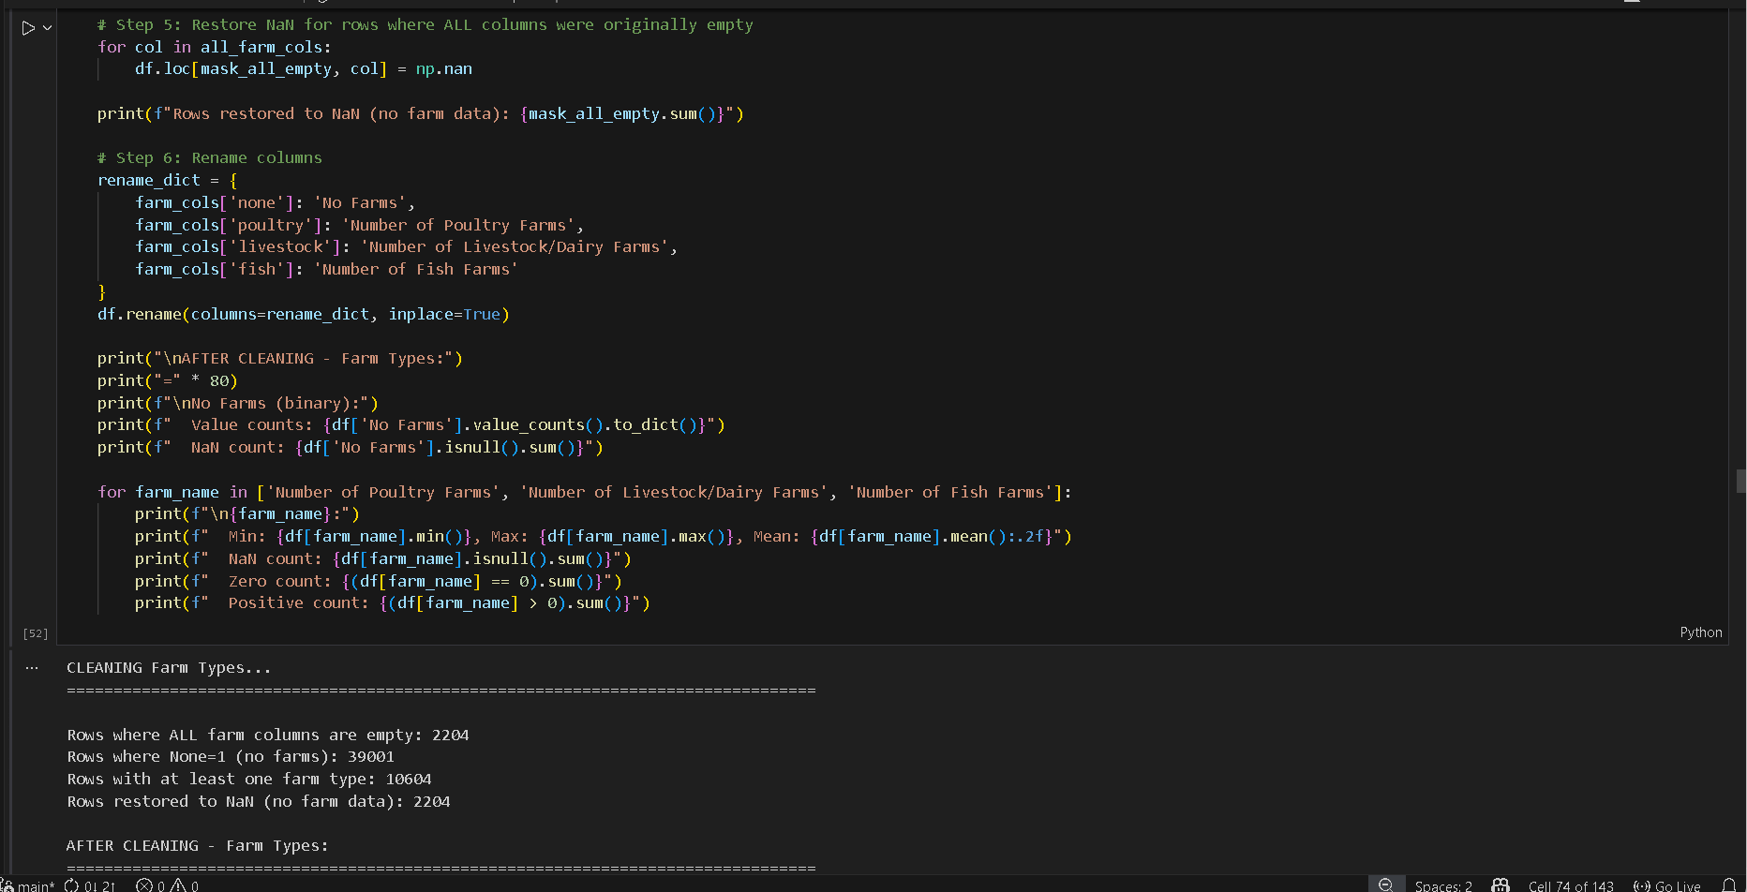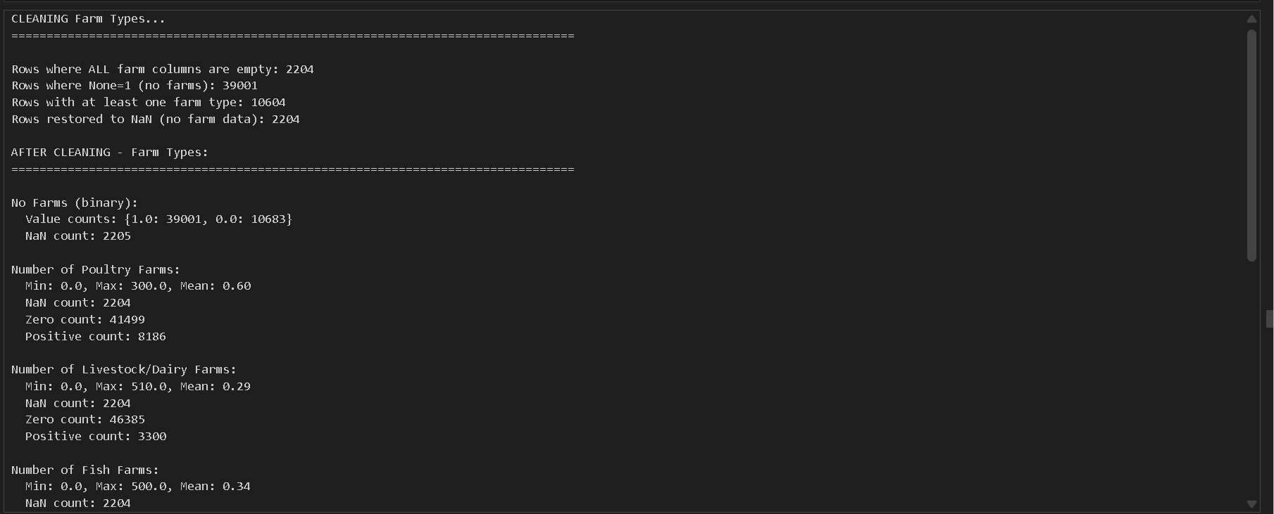

What’s the Problem and the Solution:
Farm information was recorded in four columns, three numeric farm counts and one “None” flag, but the answers didn’t behave like a coherent system. “None” might be filled even when other farm counts were positive, missing values looked the same as real zeros, and fully blank rows were impossible to distinguish from genuine “no farms” situations. On top of that, the data isn’t supposed to allow both “None” and actual farm counts at the same time, so leaving things as-is would mislead any downstream analysis about agricultural activity in the mouza.
The cleanup forces a consistent, mutually exclusive logic. Numeric farm fields are standardized, “None” is converted into a proper binary flag, and if “None” is marked, other farms are zeroed out; if any farm count is positive, “None” is forced off. Rows that were originally empty across all farm fields are restored to real missing values instead of being misread as zero. Renaming the columns turns them into clear, interpretable variables that accurately show whether a mouza has no farms or specific types of farms and how many. This sets you up for reliable analysis without second-guessing the meaning of each value.

Section 16: Electricity Availability

Columns to clean (2 columns):
- Availability of Electricity to Inhabitants of Mouza 1.All
- Mostly (Distance in km when None)
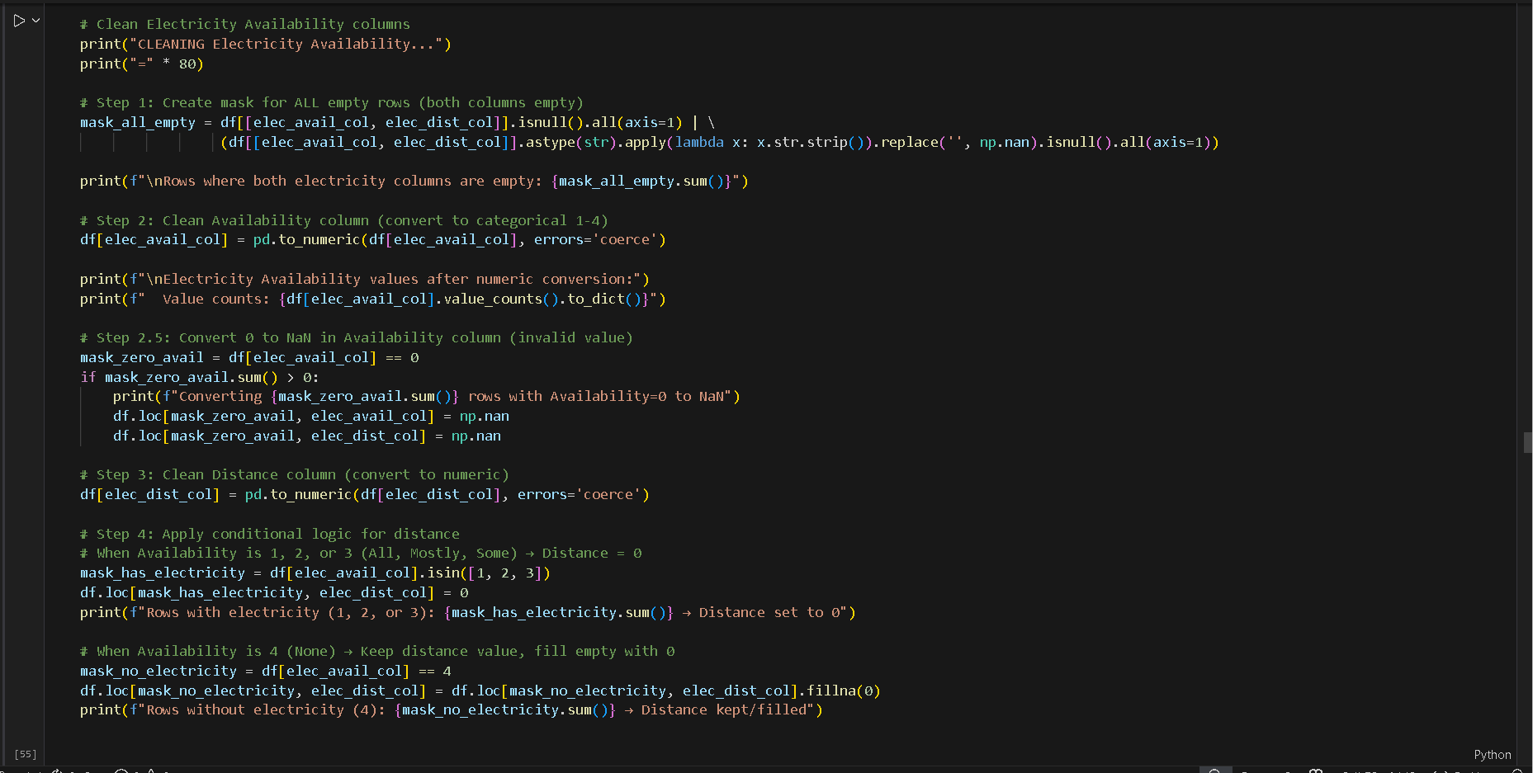
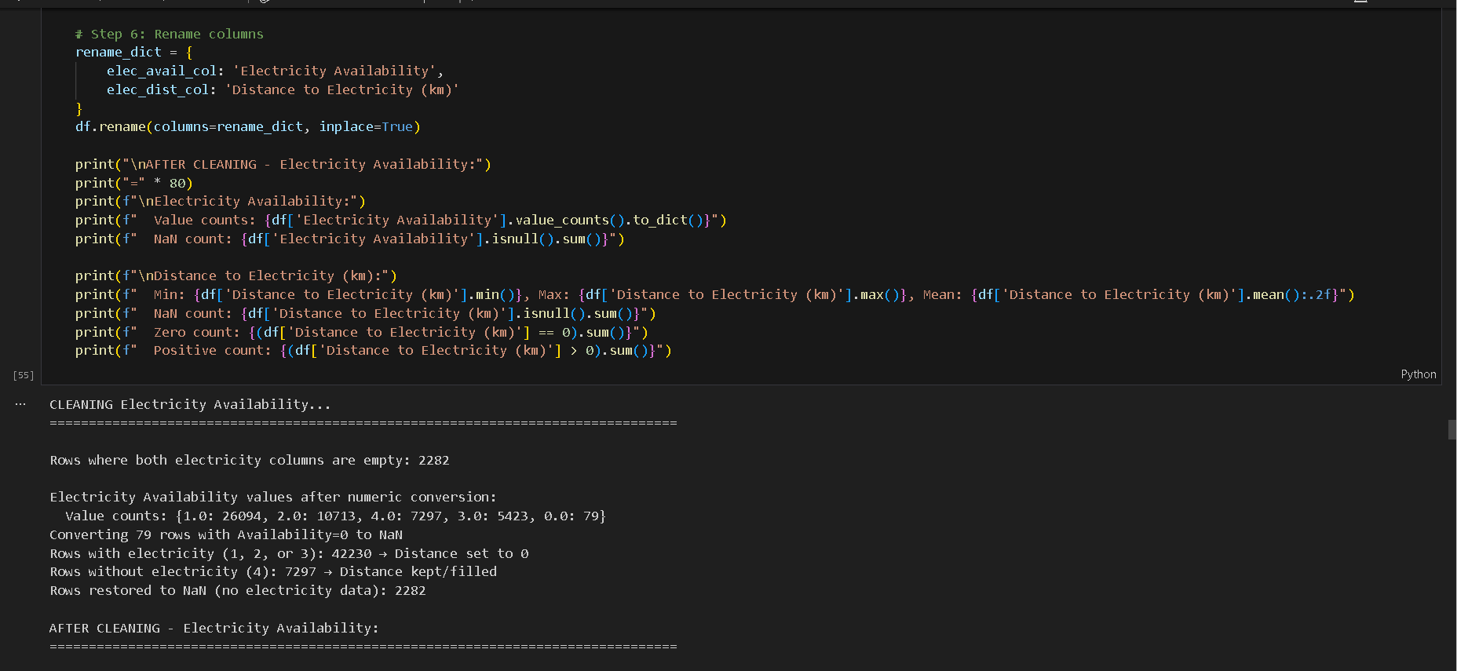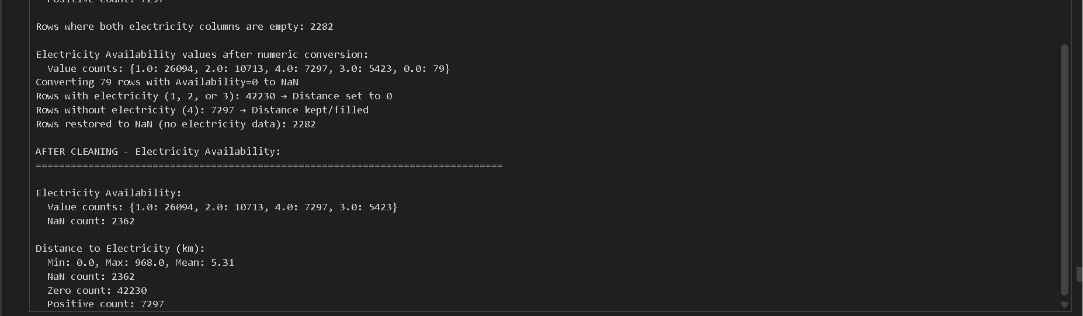

What’s the Problem and the Solution:
Electricity availability and distance were stored in two columns that didn’t agree with each other. Values like 0 or blanks could mean “not answered”, “no electricity”, or just a bad entry. Some rows claimed availability but still had a non-zero distance, and completely empty rows were impossible to distinguish from real “no electricity” cases. This made the variable logically unreliable for any spatial or service-access analysis.
Force both fields into a single consistent rule set. Convert availability to valid categories only (1–4), treat 0 as invalid and send it to missing, and re-type distance numerically. If the place has electricity (1–2–3), distance is automatically zero. If it has none (4), distance stays and blanks become zero to reflect an actual positive separation. Rows that were originally empty in both fields are restored to real missing values, and both columns are renamed into clear, readable indicators.

Section 17: Alternate Electricity Sources

Columns to clean (5 columns):
- Alternate Sources of Electricity 1.Solar Enery (typo in original)
- Bio Gas
- Generator
- Others (Specify)
- None

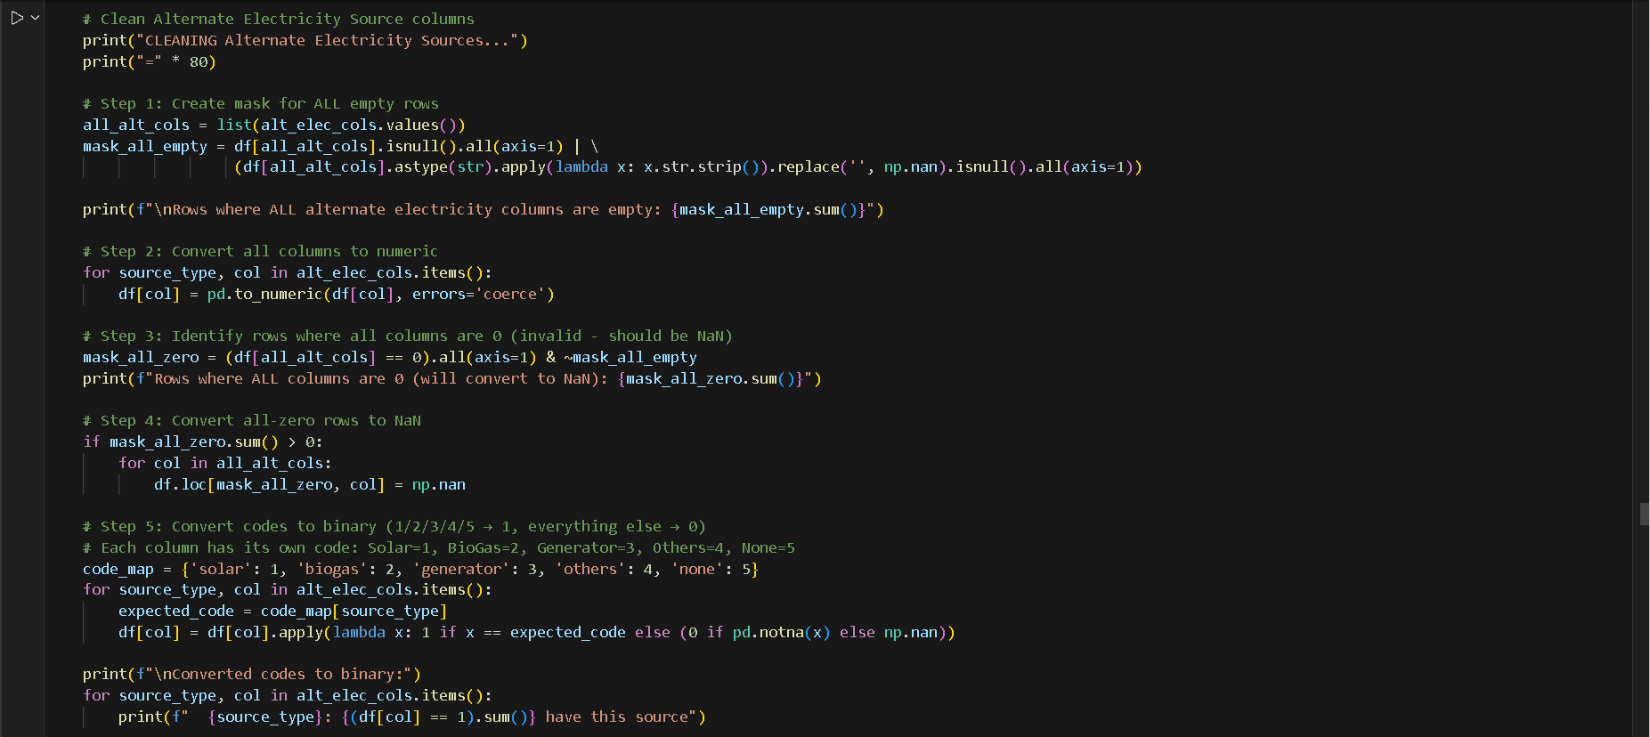

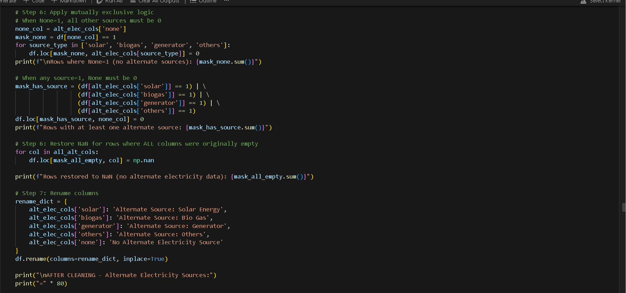
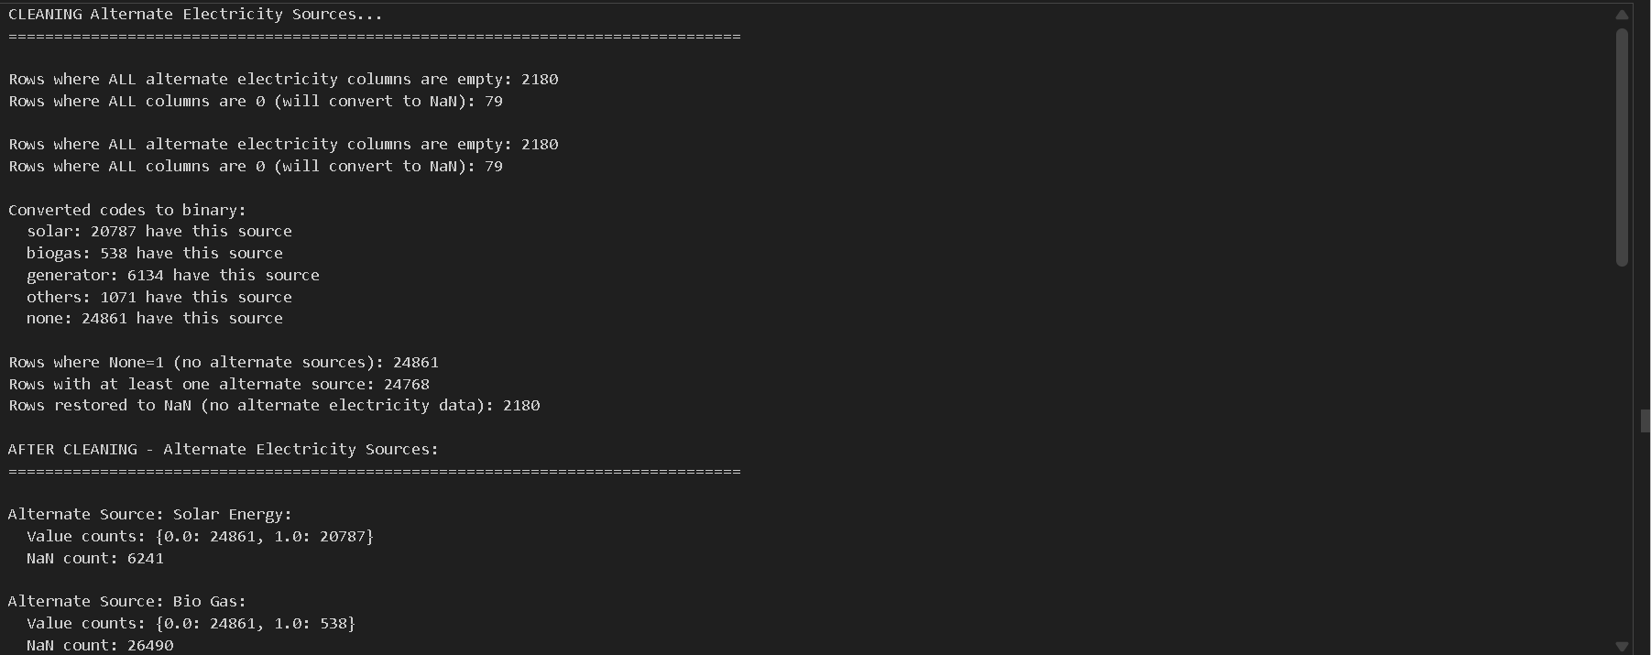

What’s the Problem and the Solution?
The alternate-electricity fields were stored using different numeric codes per column, mixed with zeros and blanks that meant different things. That made it impossible to distinguish missing data from a true “no”, and rows could even show “None” together with real sources, which is logically wrong. The fix was to treat all-empty or all-zero rows as missing, convert each column into a clean binary indicator based on its expected code, and enforce mutual exclusivity between “None” and all real sources. After restoring original missing rows to NaN and renaming columns, the data now consistently shows exactly which alternate source is present (if any).

Section 18: Fuel Availability

Columns to clean (5 columns):
- Fuel Availability for Mouza 1. Sui Gass (natural gas)
- LPG (liquefied petroleum gas)
- Kerosene Oil
- Wood
- Coal

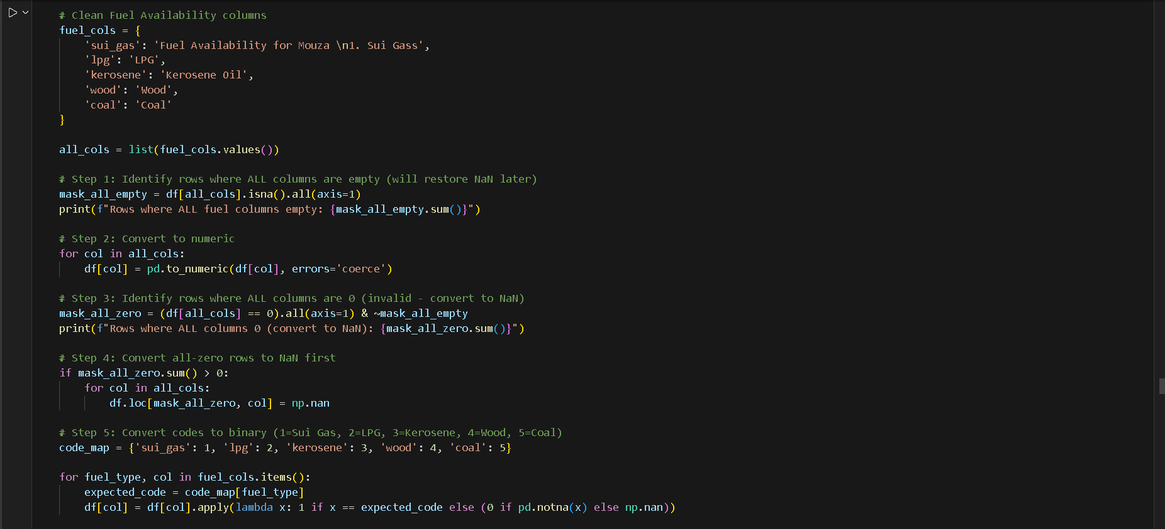
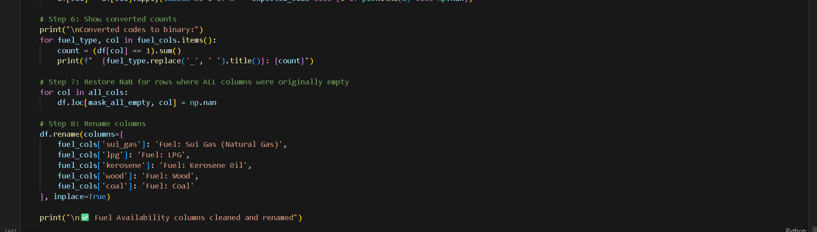

What’s the Problem and the Solution?
The fuel-availability answers were encoded with different numeric values per column, while zeros and blanks were mixed together, so you couldn’t reliably tell whether a mouza actually had a given fuel type or the data was simply missing. Some rows had every fuel recorded as 0, which doesn’t make sense if at least one option should apply. The solution was to treat all-empty or all-zero rows as missing, convert each coded field into a clear binary indicator based on the expected code, and then restore original empty rows to NaN. After renaming the columns, the dataset now cleanly shows whether a mouza uses Sui Gas, LPG, Kerosene, Wood, or Coal—without confusion from mixed codes or invalid zeros.

Section 19: Road Facility to Mouza
Columns to clean (2 columns):
- Road Facility to Mouza 1. Metaled (categorical: 1=Metaled, 2=Cemented/Concrete, 3=Brick Road, 4=Unmetalled)
- Cemented/ Concrete (appears to be distance/length in km)
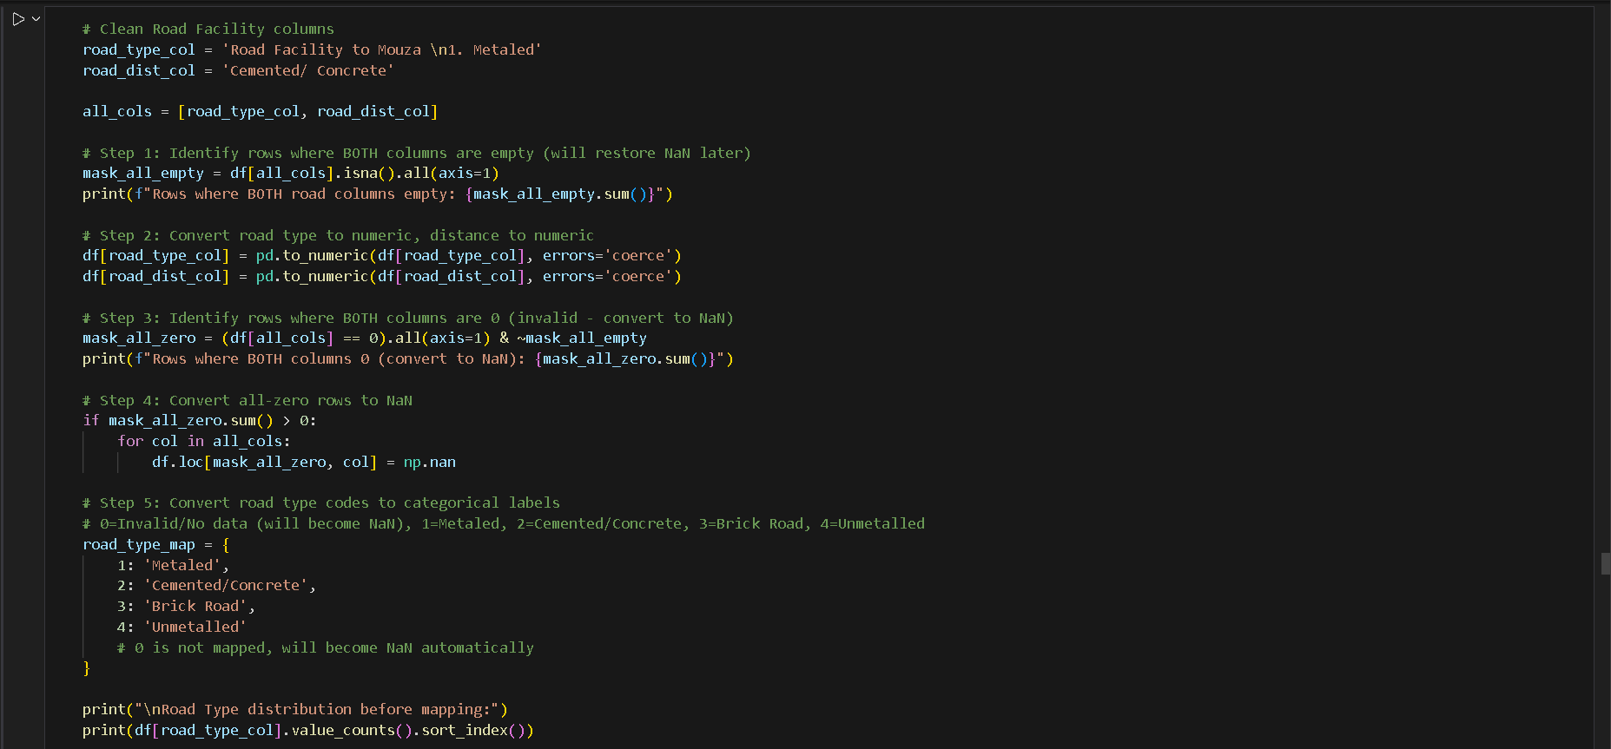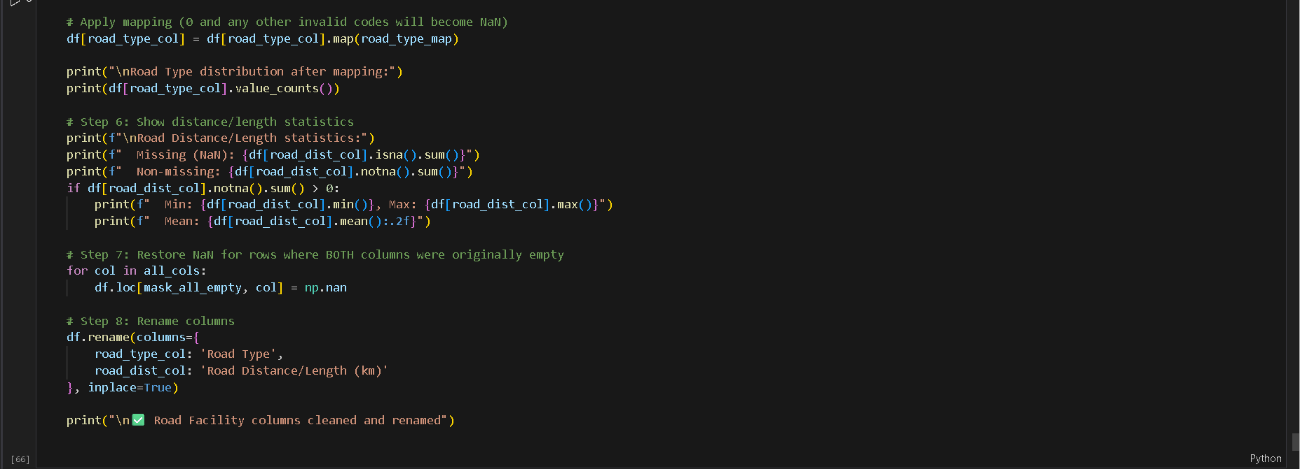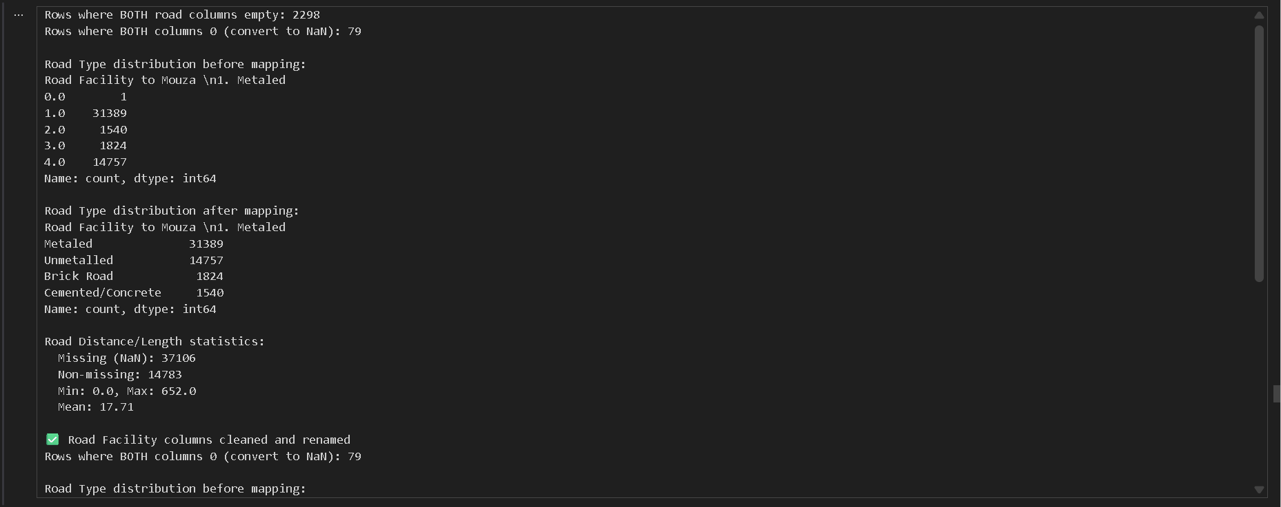

What’s the Problem and the Solution?
The road-facility data mixed category codes, zeros, and blank cells in a way that made it unclear whether a mouza actually had a certain road type or the information was simply missing. Some rows even had both fields equal to zero, which is not a valid description of road type or distance. The fix was to treat rows with both values empty or zero as missing, convert the numeric codes into meaningful road-type labels, and keep the distance field purely numeric. After restoring the original missing rows to NaN and renaming the columns, the dataset now clearly shows the actual road type and its length, without confusing placeholders or invalid codes.

Section 20: Media Sources in Mouza
Columns to clean (5 columns):
- Media Sources in Mouza 1. Radio
- TV
- Cable
- Newspaper
- None.2

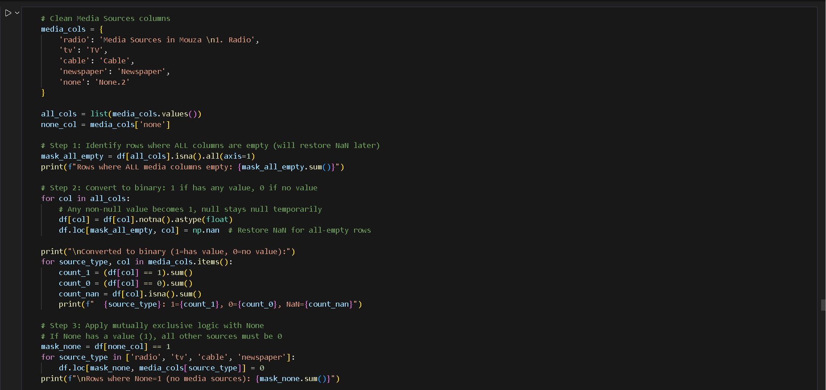
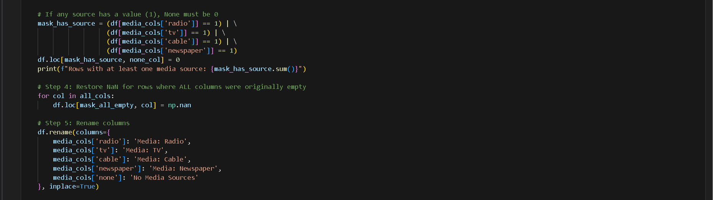
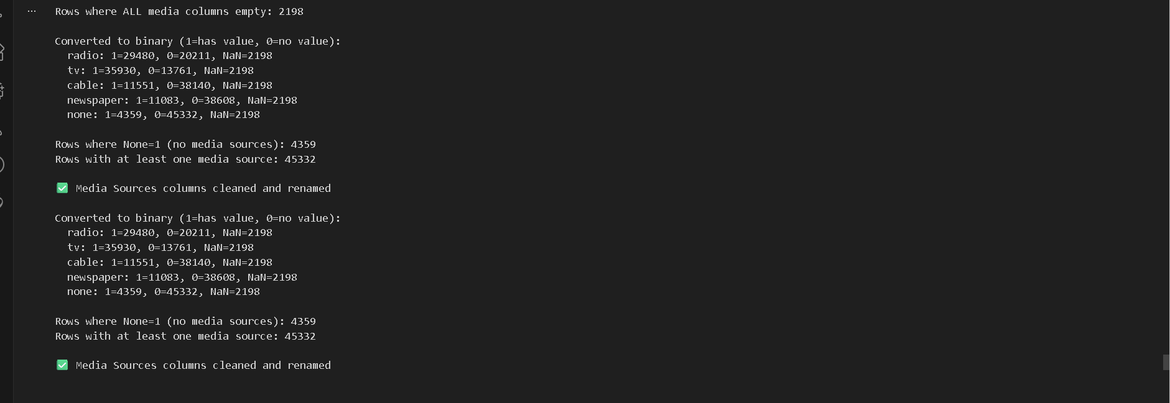
What’s the Problem and the Solution?
The media-source fields arrived as messy flags where any non-empty value implied “yes,” but blanks, zeros, and a “None” column all mixed together. That made it impossible to tell whether a mouza genuinely had no media source or the data was simply missing. Rows where everything was blank also had to be handled carefully so they didn’t get turned into false zeros. The fix was to convert each column into a clean binary indicator, enforce the rule that if “None” is active all other media must be off (and vice-versa), and restore true missing rows to NaN. After renaming, the dataset now reliably shows which media sources exist in each mouza without confusing blanks or contradictory flags.

Section 21-27: Facility Availability & Distance Pairs
These sections contain facility availability columns paired with distance columns:
  - First column: 1 = Present, 2 = Not present, 0 = No data
  - Second column: Distance in km (0 if present, actual distance if not present, NaN if no data)
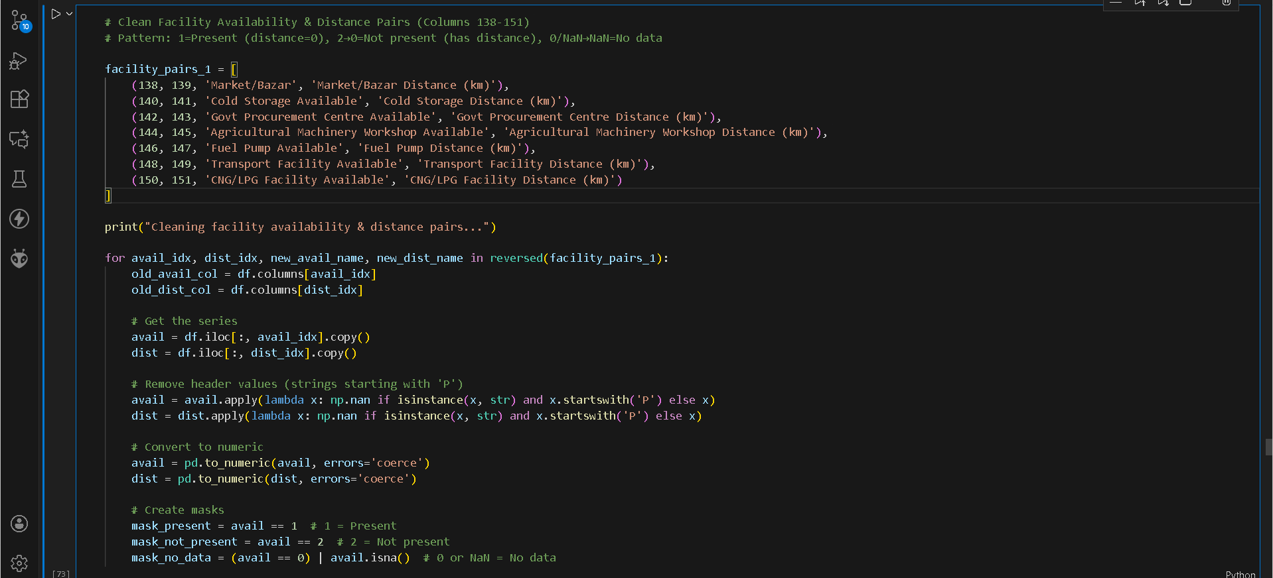
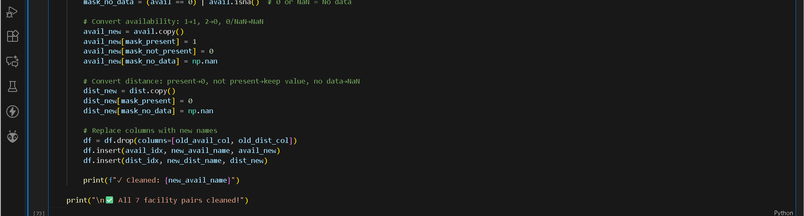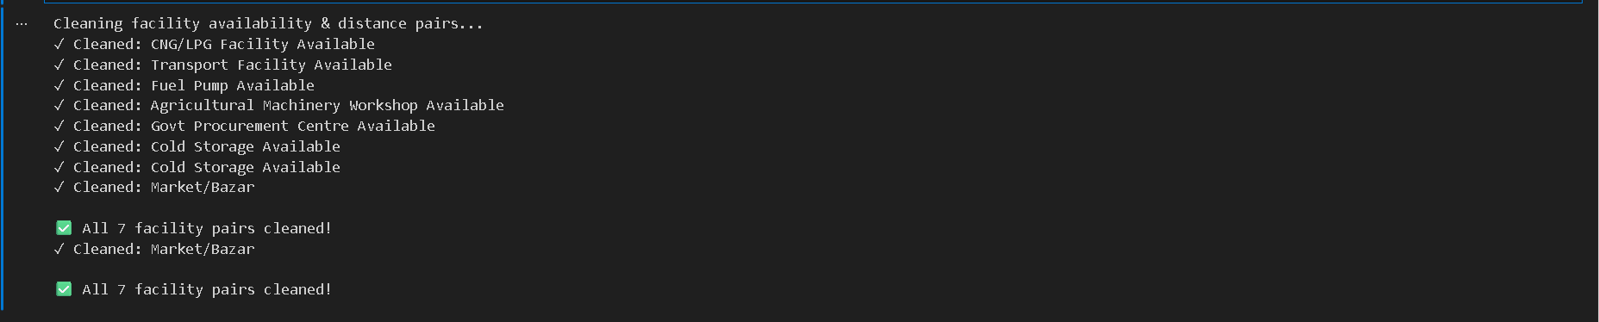
What’s the Problem and the Solution?
These facility columns were coded awkwardly: “1” meant the facility existed (distance should then be zero), “2” meant it didn’t exist (but distance then contains the nearest location), and “0/blank” really meant no information at all. On top of that, stray header strings showed up in the data. This mixture made availability and distance ambiguous and sometimes logically contradictory. The fix was to strip out header artifacts, map availability into a clear binary indicator (present = 1, not present = 0, no data = NaN), and apply consistent rules to distance (0 if present, actual distance if not present, otherwise NaN). After renaming the columns, each facility now has a clean availability flag and a correct distance value, making the information reliable for analysis.

Section 28-35: Wholesale Markets & Communication Facilities
These sections contain 8 more facility pairs for wholesale markets (Livestock, Grains, Fruits/Vegetables) and communication facilities (PCO, Mobile Signals, Internet types).
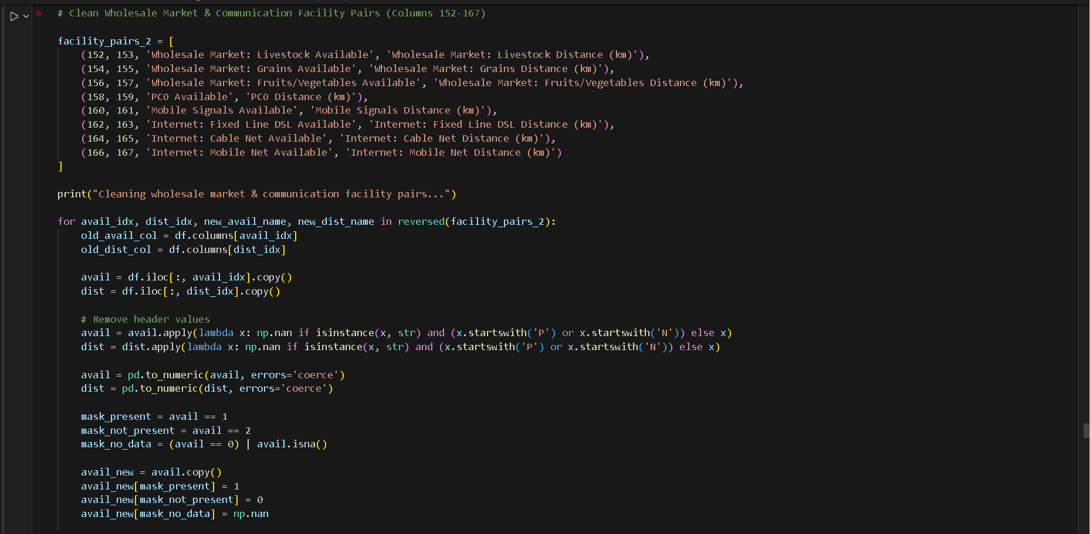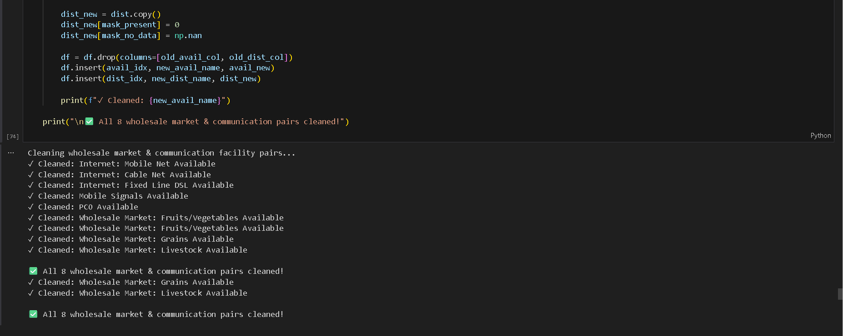
What’s the Problem and the Solution?
These wholesale market and communication fields were encoded with confusing values: “1” meant available, “2” meant not available, and “0” or blanks really meant the data wasn’t provided at all. On top of that, leftover header strings (like starting with “P” or “N”) polluted the cells, and the distance values didn’t always match the availability status. The cleaned approach removes the header noise, converts availability into a clear binary indicator, and forces distance to zero only when the facility is present while keeping actual distances for the “not present” case and using missing values when information is unknown. After renaming, each pair now consistently reflects whether a facility exists and how far the nearest one is, making the dataset ready for sensible analysis.

Section 36-37: Community Facilities
Clean Community Grazing Land and Community Forest availability & distance pairs.
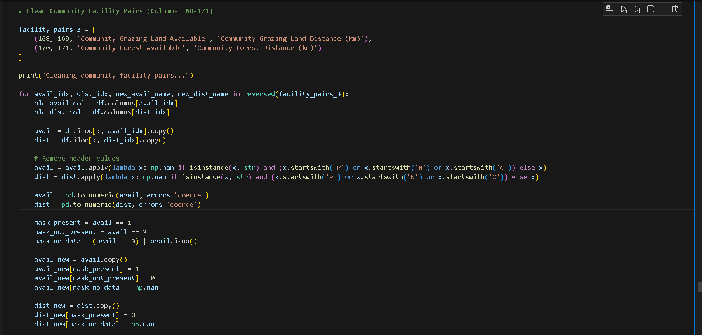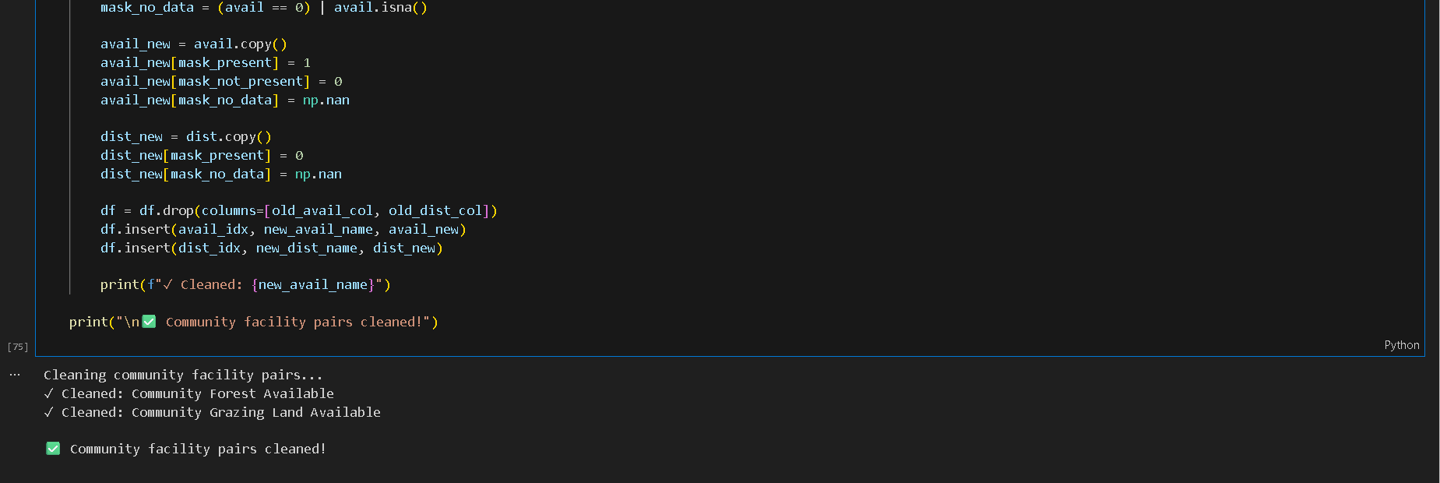

What’s the Problem and the Solution?
The community facility columns had inconsistent data: availability was coded as 1=present, 2=not present, and 0 or blanks meant missing data. Additionally, leftover header strings (starting with “P”, “N”, or “C”) were present in the cells, and distance values did not consistently match availability. The cleaning process removes all header noise, converts availability into a clear binary indicator (1=present, 0=not present, NaN=unknown), sets distance to 0 when the facility is present, keeps actual distance when not present, and preserves NaN for missing data. After renaming, each community facility pair now reliably reflects both availability and distance for accurate analysis.

Section 38: Natural Disasters

Clean natural disaster data:
  - Main column: 1 = Yes (disaster occurred), 2→0 = No, 0/NaN → NaN
  - Disaster types (Drought, Flood, Earthquake, Others):
    - If disaster=Yes: keep marked types, fill unmarked with 0
    - If disaster=No: all types = 0
    - If disaster=NaN: all types = NaN
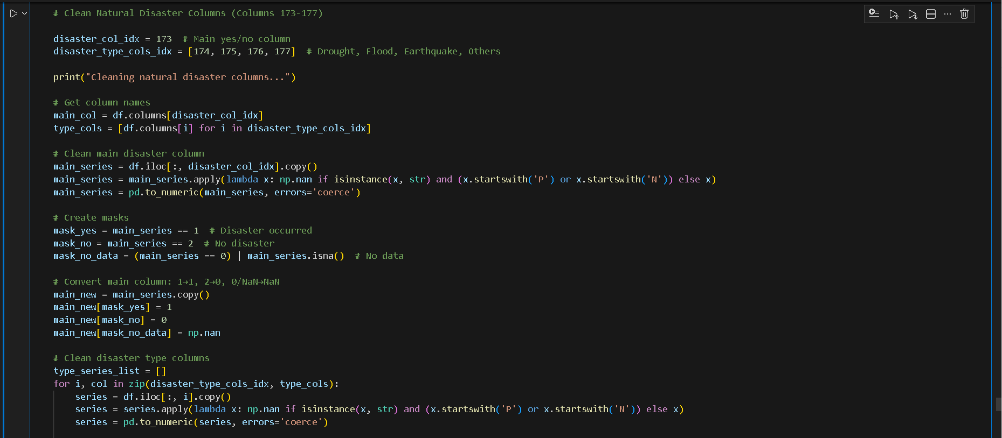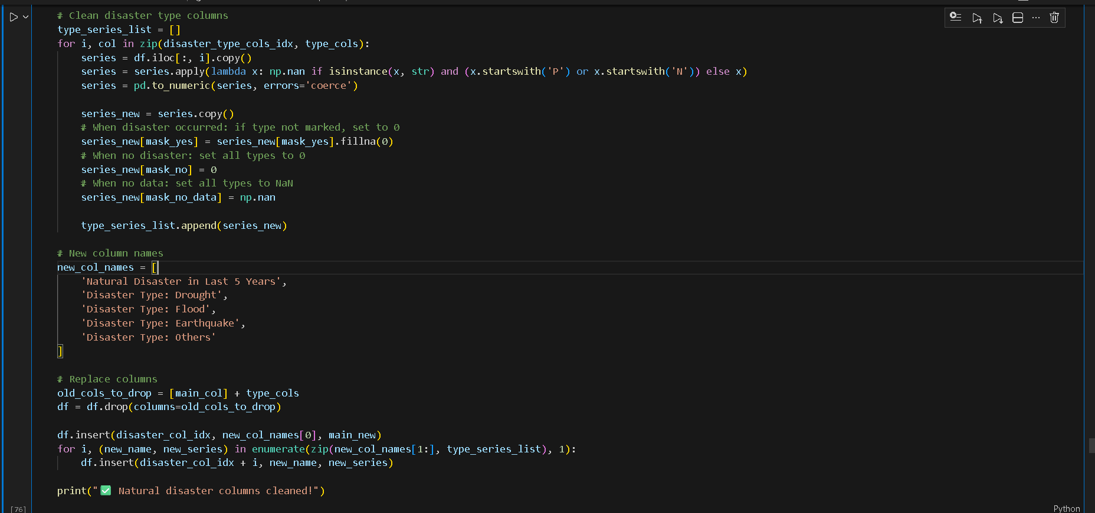

What’s the Problem and the Solution?
The natural disaster columns had inconsistent and messy data: the main column and disaster type columns contained codes (1=Yes, 2=No, 0 or blank=missing) mixed with header strings (starting with “P” or “N”). Disaster type columns were not aligned with the main disaster column, so some types were left blank even when a disaster occurred, or had invalid entries when no disaster happened.
The solution cleans the data by removing header noise, converting the main column to binary (1=disaster occurred, 0=no disaster, NaN=unknown), and aligning the disaster type columns accordingly: when a disaster occurred, missing types are set to 0; when no disaster occurred, all types are 0; when no data, all are NaN. This ensures all natural disaster data is consistent, interpretable, and ready for analysis.

Section 39: Credit Sources

Clean credit source columns (9 sources) - convert to binary:
  - 1 = Has access to this credit source
  - 0 = Does not have access
  - NaN = No data (only when ALL sources are empty)
Group NaN rule: If any source has a value, all empty ones become 0.
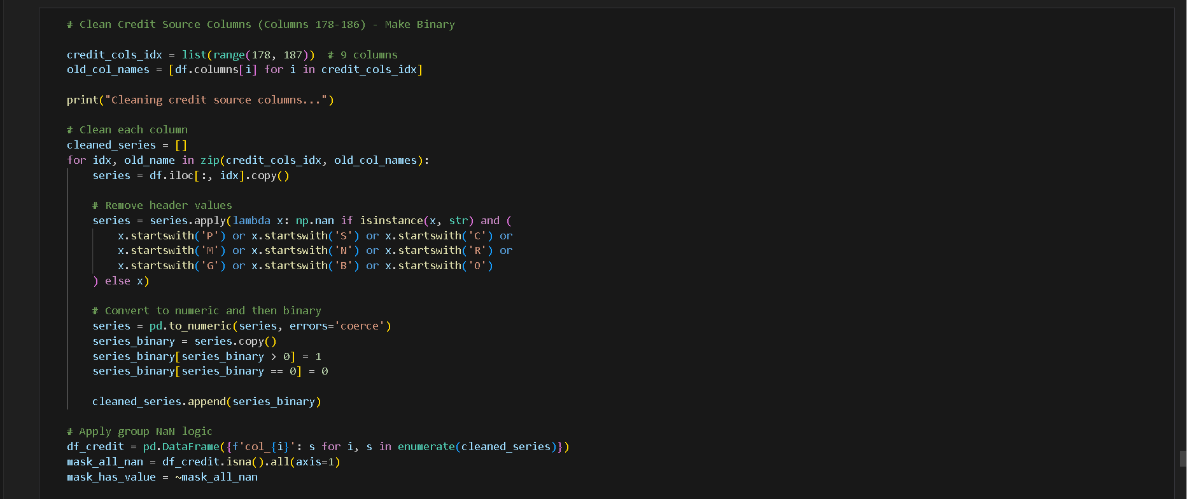
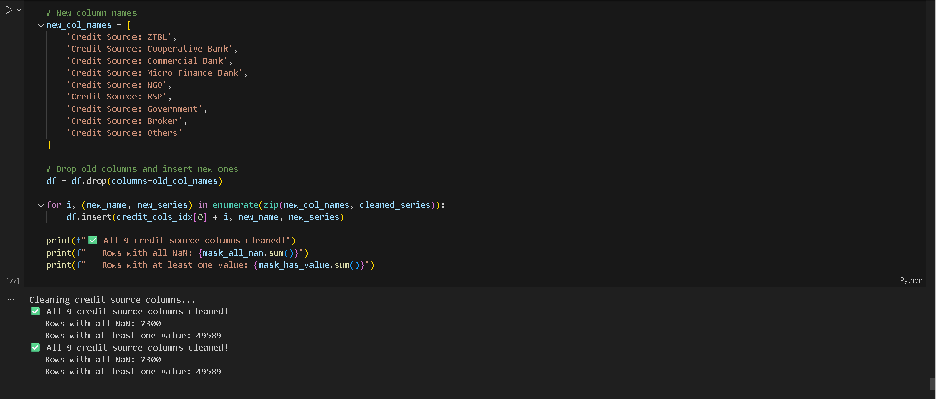

What’s the Problem and the Solution?
The credit source columns were inconsistent and messy: they contained header strings, missing values, and numeric entries representing presence of a credit source, but not in a consistent binary format. Some rows had all columns empty or partially filled, making it hard to analyze which credit sources were actually used.
The solution removes header noise, converts all numeric entries to binary (1=credit source used, 0=not used), and ensures consistency across rows. For rows where at least one credit source is present, any remaining NaNs are filled with 0 to indicate absence. Rows where all columns were originally empty are left as NaN. This results in clean, interpretable binary columns for all nine credit sources, ready for analysis.

Section 40-43: Additional Facility Pairs
Clean Online Commercial Bank, Reconciliation Committee, Post Office, and Police Station pairs. 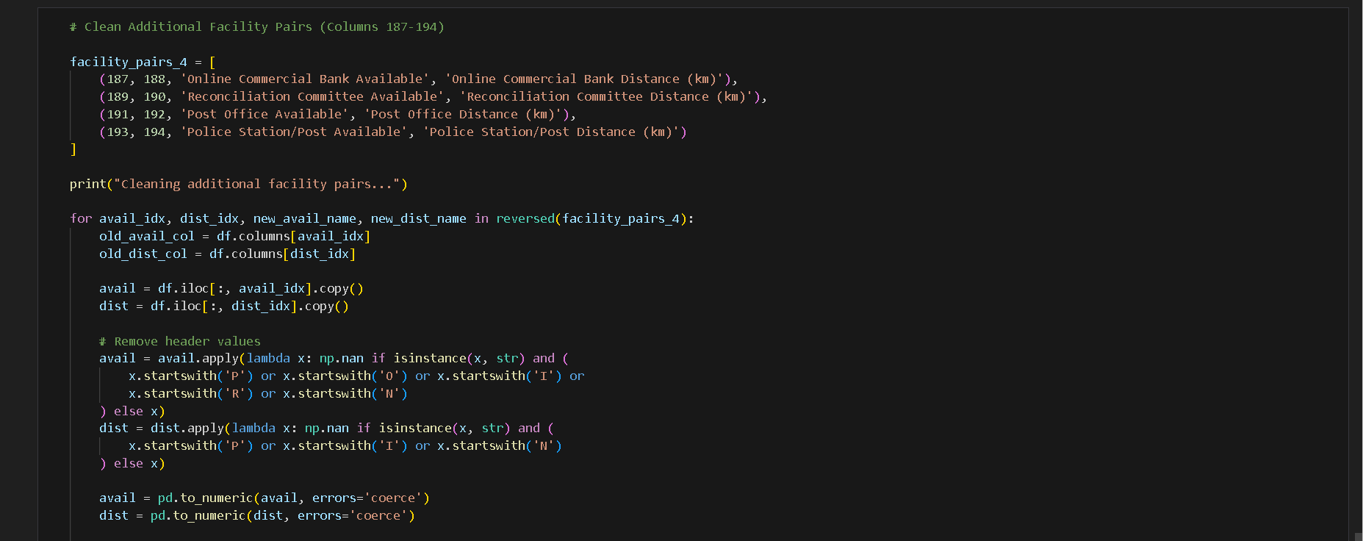

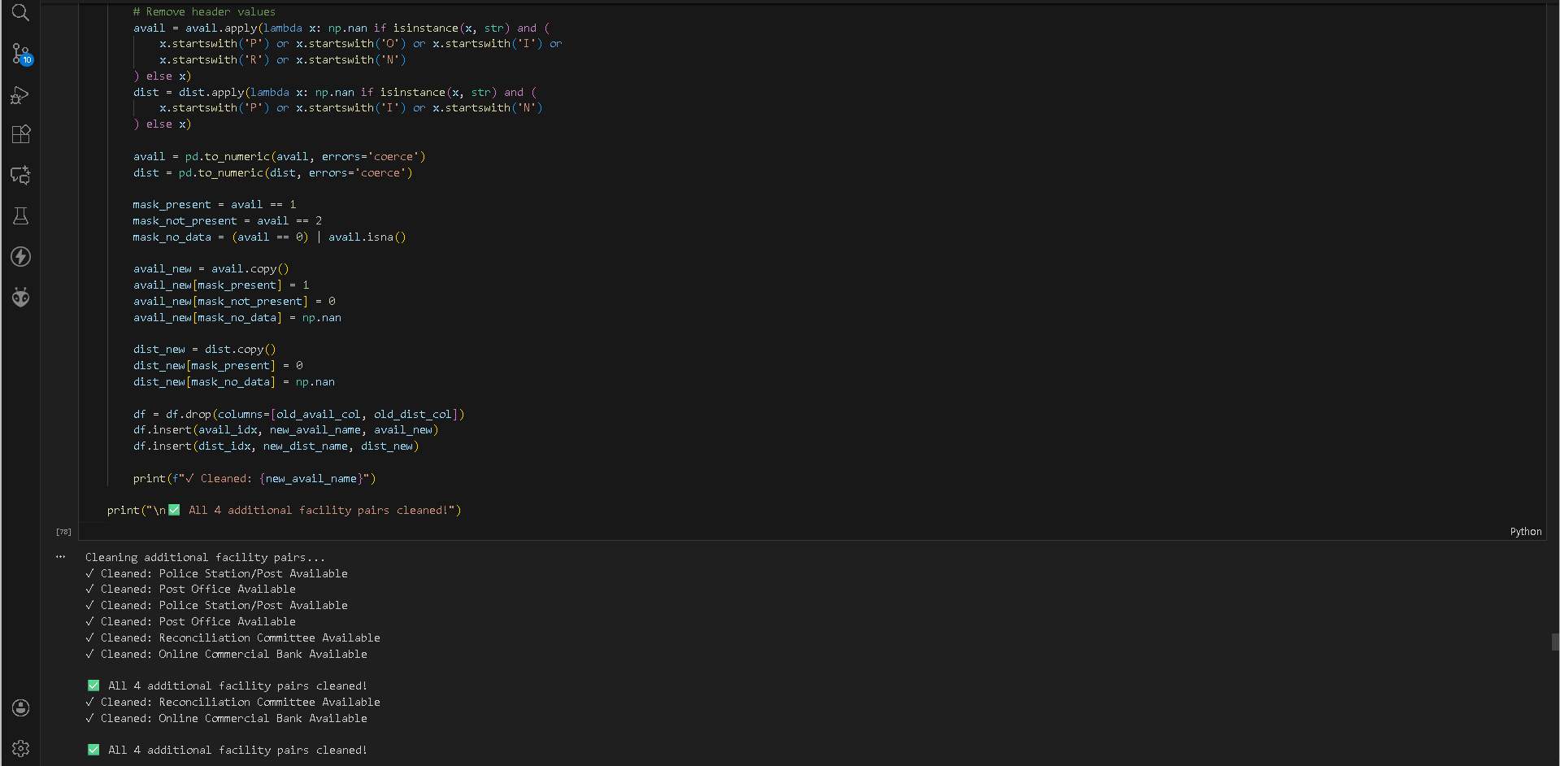
What’s the Problem and the Solution?
The additional facility columns were messy and inconsistent, containing header strings, missing values, and numeric codes (1=present, 2=not present, 0 or NaN=no data) for both availability and distance. This made it unclear which facilities were truly present and how far they were.
The solution cleans these columns by removing header noise, converting availability to binary (1=present, 0=not present, NaN=no data), and setting distances to 0 when a facility is present, keeping valid distances when not present, and NaN when no data exists. This ensures that all four facility pairs are standardized, interpretable, and ready for analysis.

Section 44: NGOs in Mouza

Clean NGO columns - 2 groups (Male and Female), each with 5 columns:
  - 4 NGO types: Male NGO, Community Org, Citizen Community Board, Community Centre/Library
  - 1 "None" column
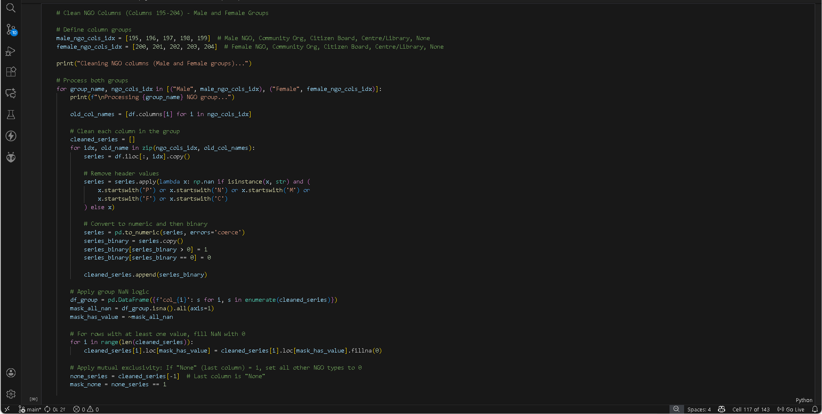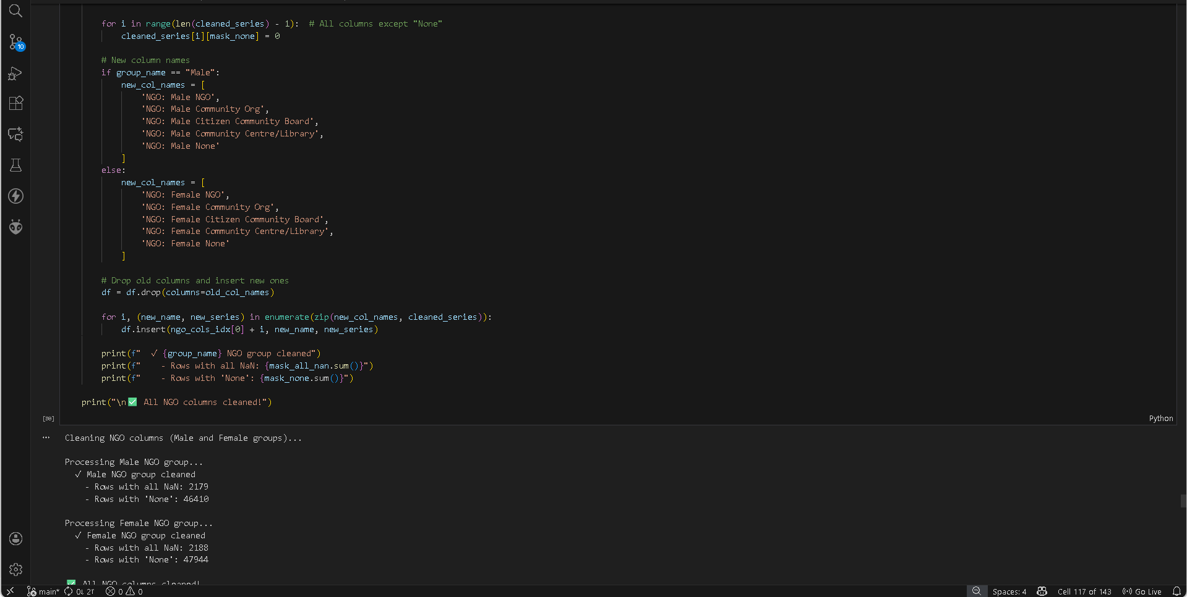
What’s the Problem and the Solution?
The NGO-related columns for male and female groups were messy, containing header strings, missing values, and numeric codes, which made it unclear which types of NGOs were active or absent in each mouza. Some rows also had a "None" indicator that conflicted with other NGO types.
The solution cleans these columns by removing header noise, converting all numeric values to binary (1=present, 0=absent, NaN=no data), and applying mutual exclusivity for the "None" column—if "None" is 1, all other NGO types are set to 0. Rows with all missing values are restored as NaN, ensuring both male and female NGO data are standardized, interpretable, and ready for analysis.

Section 45: Industries in Mouza
Columns 205-209: 5 industry scale columns (Large Scale, Medium Scale, Small Scale, Cottage Industries, None)
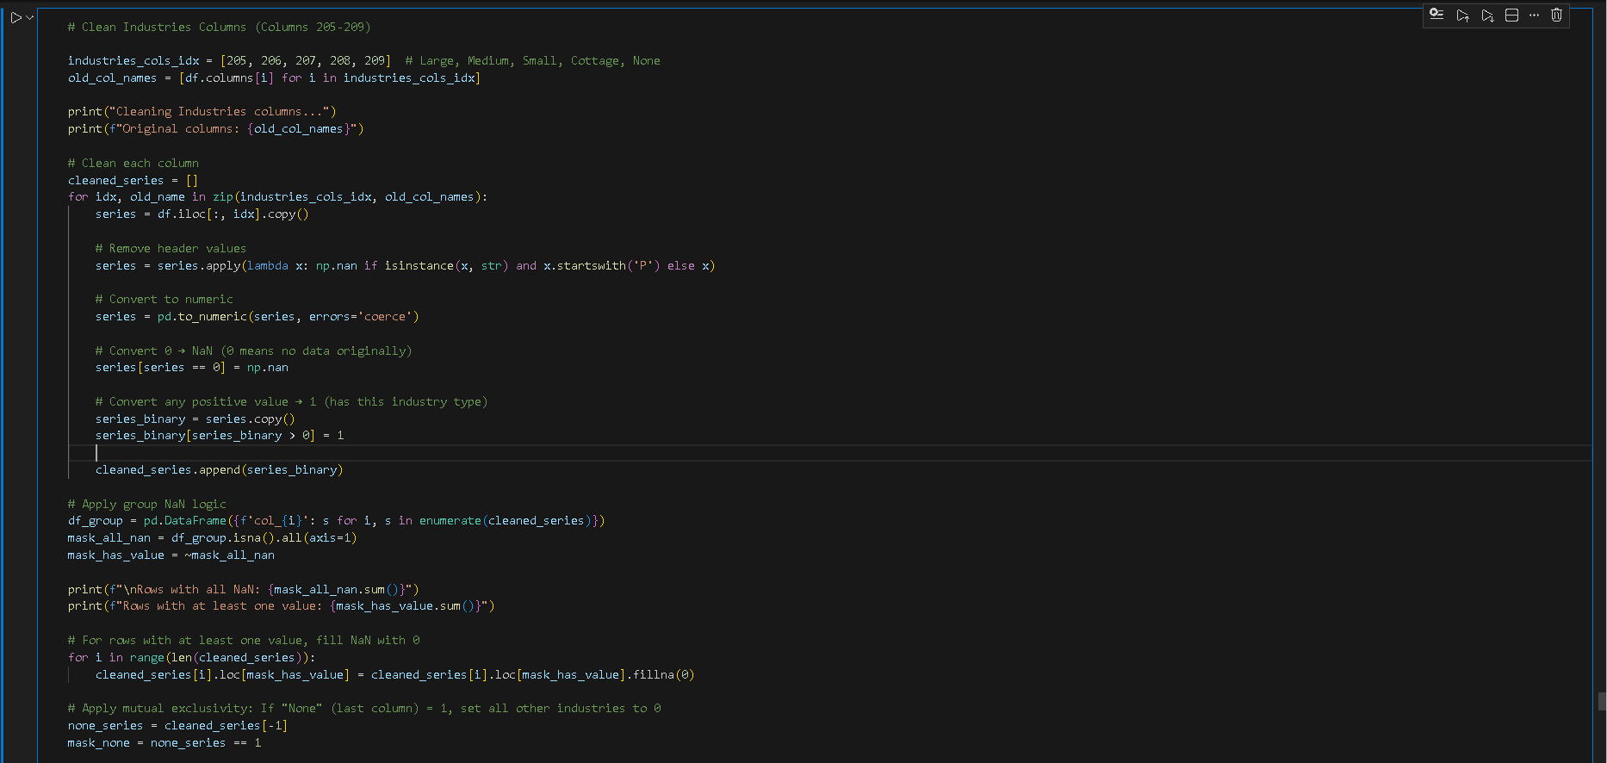
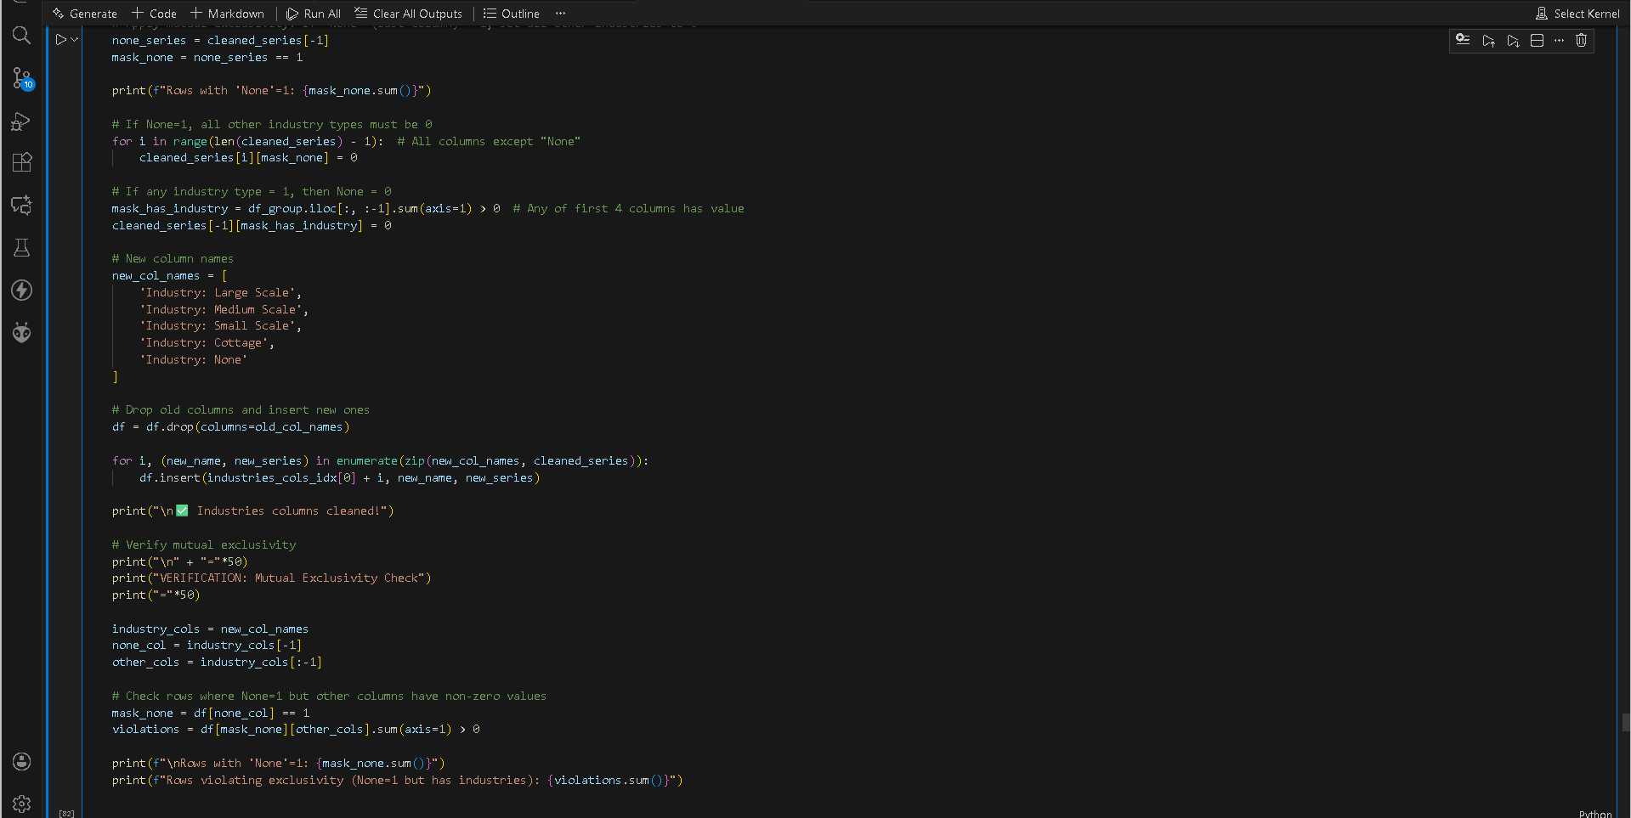
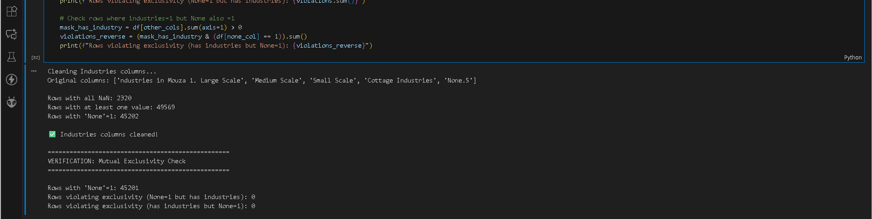

What’s the Problem and the Solution?
The industry-related columns contained inconsistent data, including header strings, zeros, and mixed numeric codes. Zeros were ambiguous (sometimes representing “no data”), positive values were inconsistent, and the “None” column conflicted with other industry types, making it unclear which industries were present in a mouza.
The solution cleans these columns by removing header noise, converting all positive values to binary 1 (industry present) and zeros to NaN (no data), and applying mutual exclusivity for the "None" column. If “None” = 1, all other industry types are set to 0, and if any industry type = 1, then “None” = 0. This ensures the data is standardized, mutually exclusive, and ready for analysis, with proper handling of missing values and verification of exclusivity rules.

Section 46: Sources of Employment of Populace

Columns 210-223: 14 employment source columns (7 Male + 7 Female)
Structure:
  - Male group (columns 210-216): Service, Agriculture, Trade, Industry, Personal Business, Overseas Employment, Labour
  - Female group (columns 217-223): Same 7 employment sources
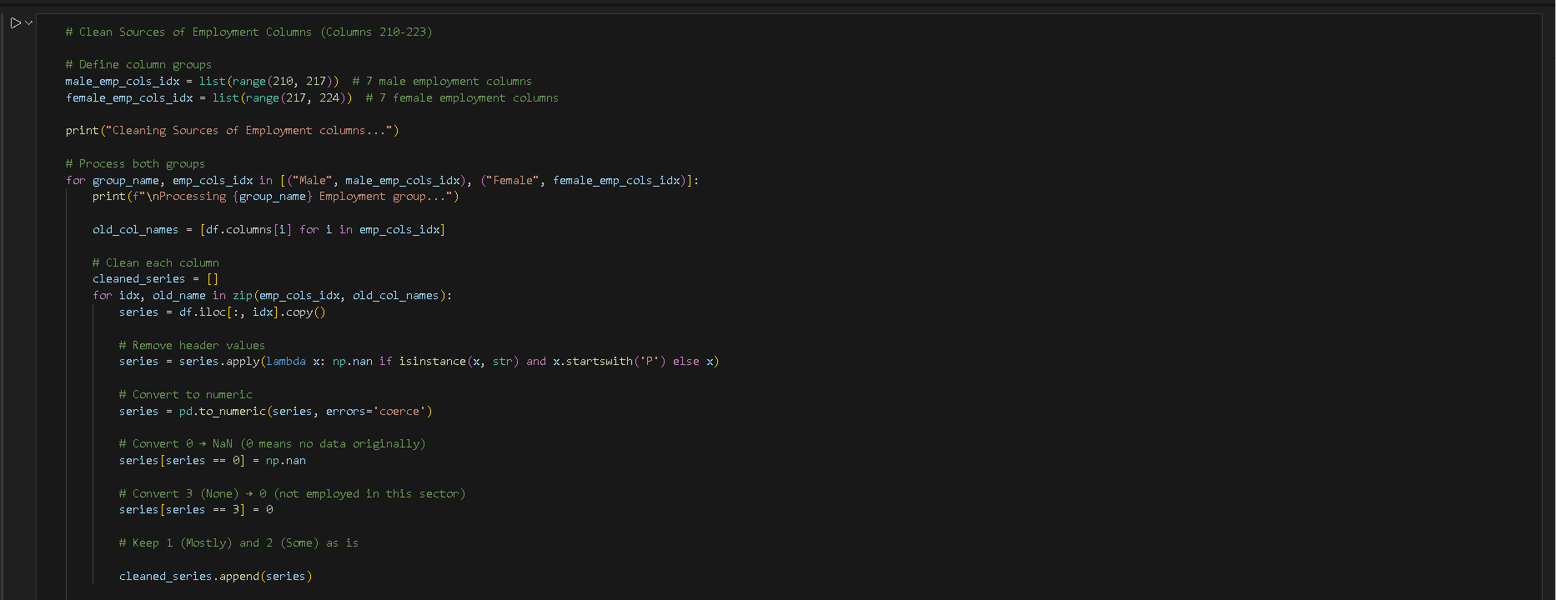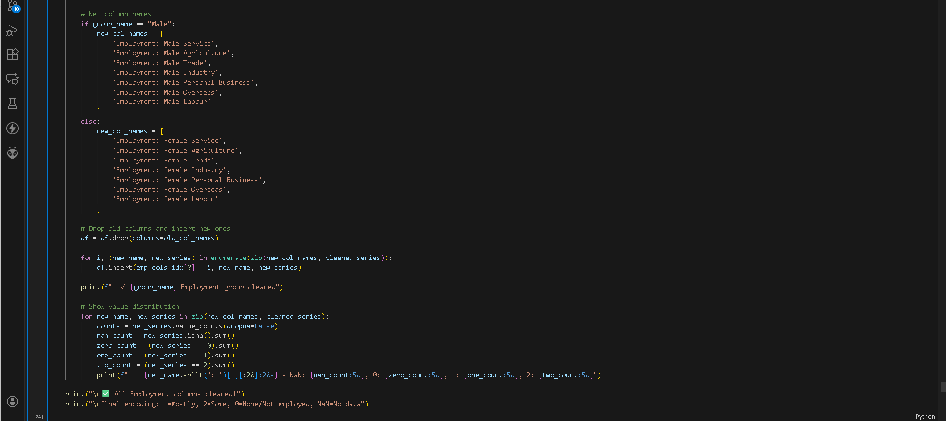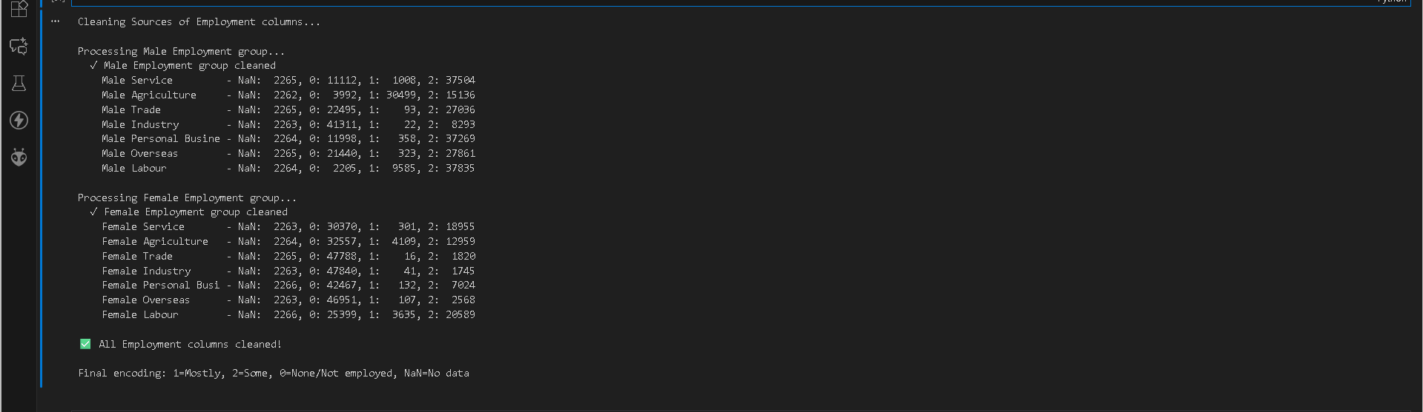
What’s the Problem and the Solution?
The employment columns for males and females had inconsistent data, including header strings, zeros, and codes like 3 for “None,” making it unclear how many people were employed in each sector. Zeros were ambiguous, and the values 1 and 2 were mixed with invalid entries.
The solution cleans these columns by removing header noise, converting zeros to NaN (representing no data), mapping 3 (“None”) to 0 (not employed), and retaining 1 (Mostly) and 2 (Some) as meaningful employment indicators. This standardizes the data across all sectors, ensures clarity between “not employed” and missing data, and preserves value distributions for analysis.

Section 47: PCO and Mobile Signals Facility Pairs
Columns 158-161: 2 facility pairs (PCO and Mobile Signals)
Pattern:
- Availability column originally had distance values mixed with availability
- Logic:
  - If original value = 0 → Facility available in mouza (convert to 1, distance = 0)
  - If original value > 0 → Not available, that value is the distance (convert to 0, distance = value)
  - If both empty → Keep as NaN
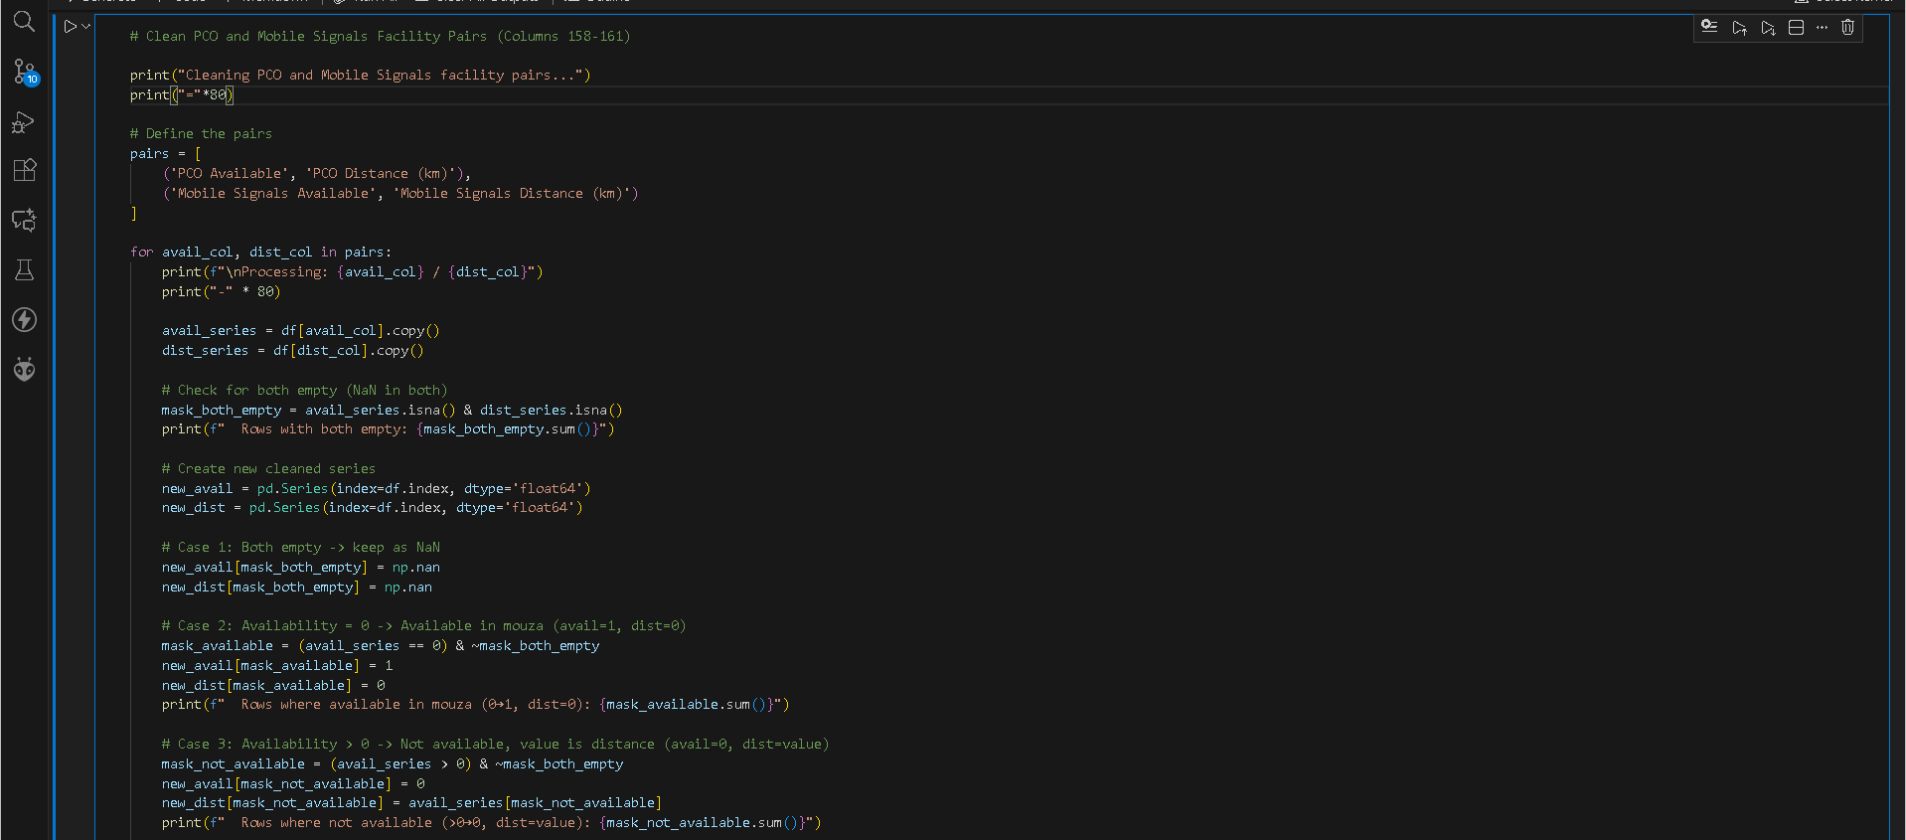
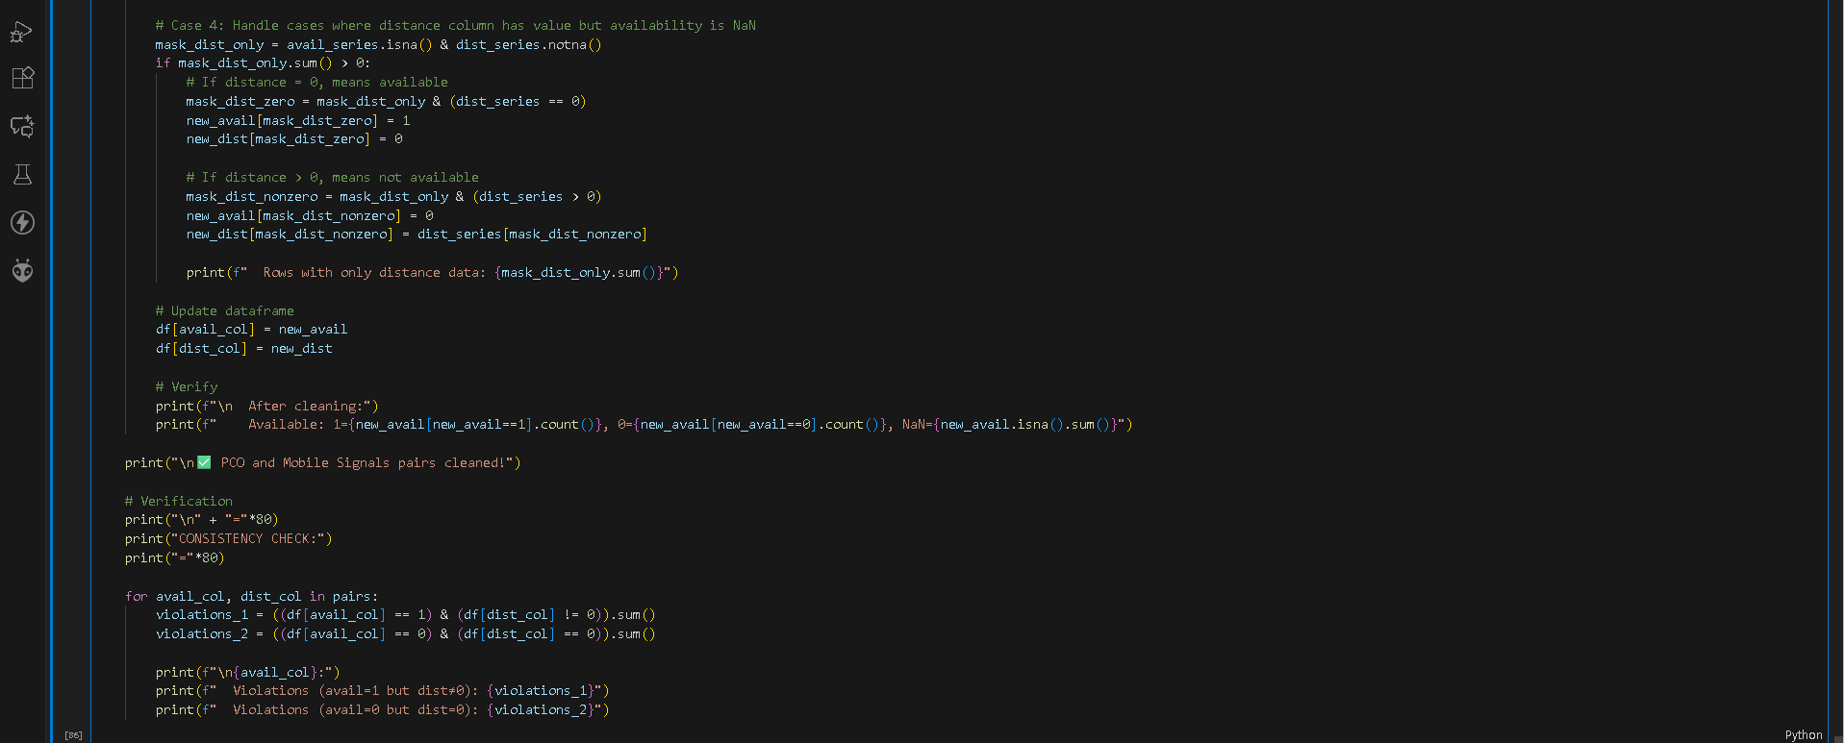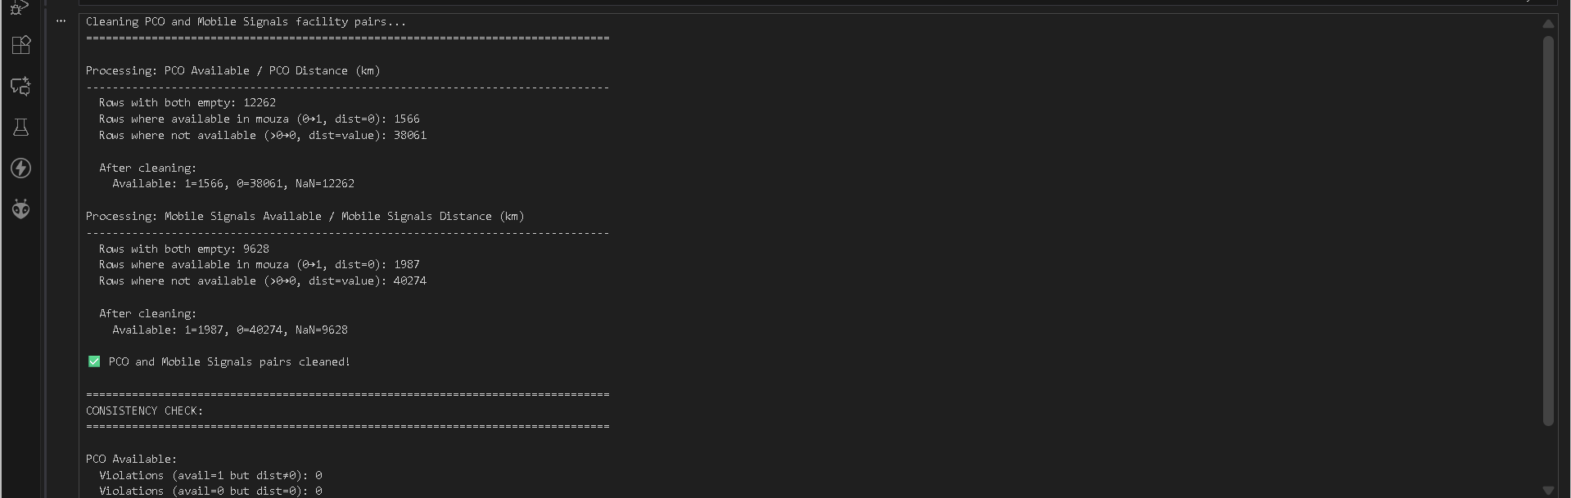
What’s the Problem and the Solution?

The PCO and Mobile Signals facility columns had inconsistent and ambiguous data: availability codes and distance values were mixed, some rows had only distances without availability, and zeros or NaNs were not clearly interpreted. This made it unclear whether a facility was present in the mouza, absent, or missing.

The solution standardizes the data by:
- Treating both columns empty as NaN.
- Mapping availability 0 to “available” (1) with distance 0.
- Mapping availability values >0 to “not available” (0) with the given distance.
- Handling cases where only distance is present: distance 0 → available, distance >0 → not available.
This ensures clear, consistent encoding (1=available, 0=not available, NaN=no data) and correct distance values, with verification to catch any inconsistencies.

Section 48: Internet Facility Pairs
Columns 163-168: 3 internet facility pairs (Fixed Line DSL, Cable Net, Mobile Net)
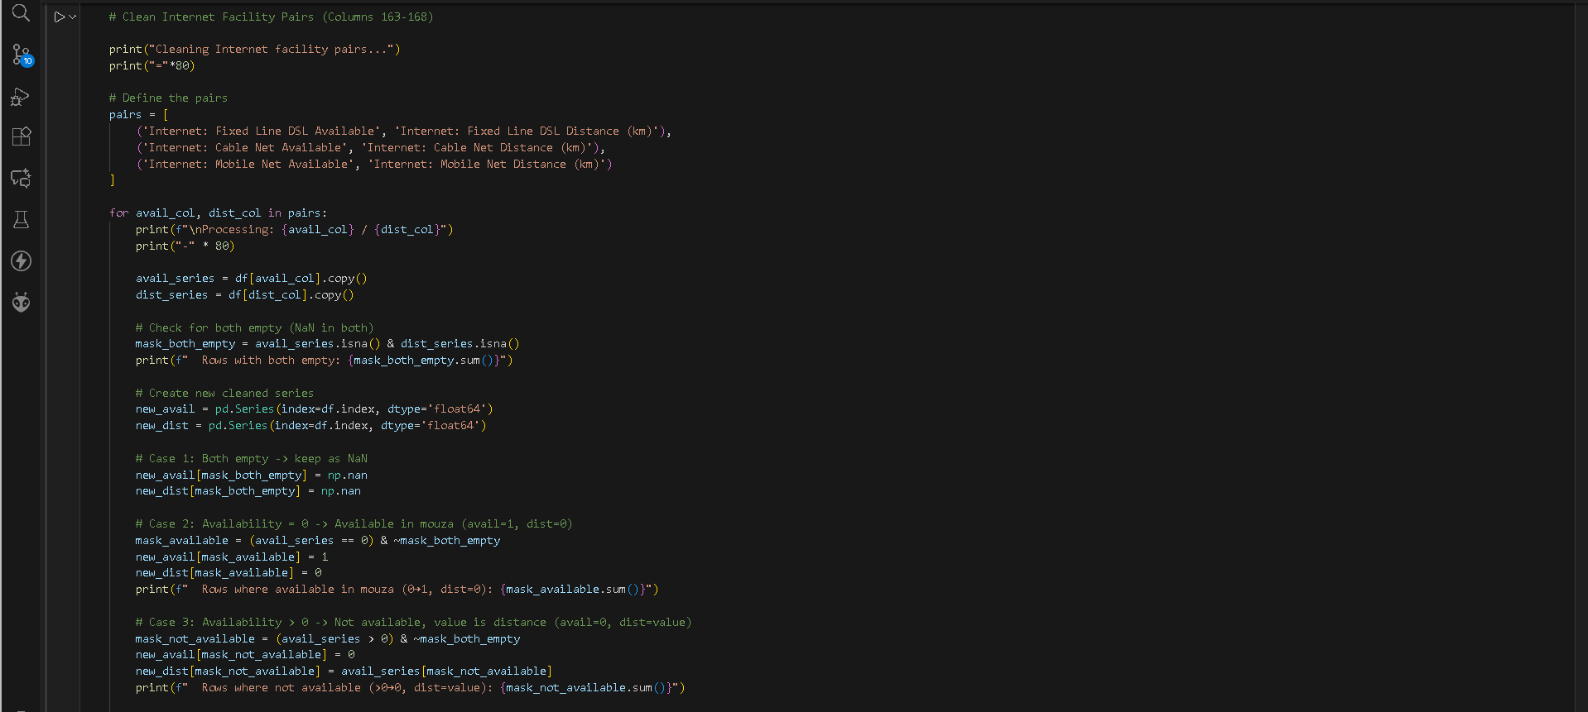
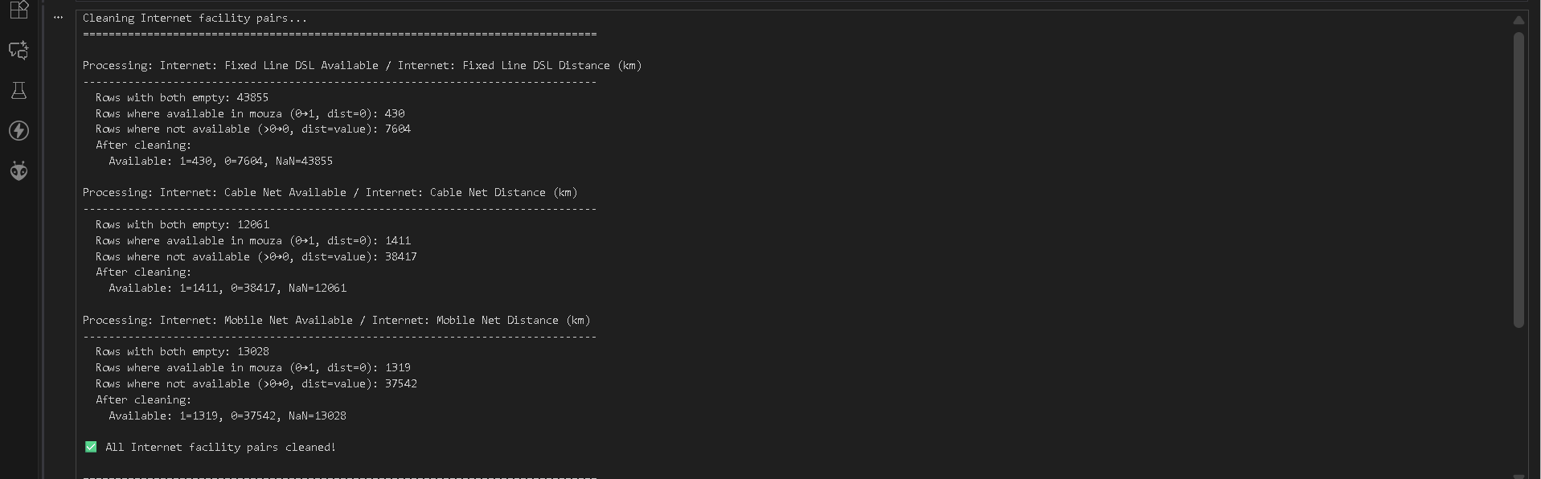



What’s the Problem and the Solution?
The Internet facility columns were inconsistent: availability codes and distance values were mixed, some rows had only distances without availability, and zeros or NaNs were not clearly interpretable. This made it unclear whether a particular Internet service (DSL, Cable, Mobile) was present in the mouza, absent, or missing.
The solution standardizes the data by:
- Keeping both columns as NaN if originally empty.
- Converting availability 0 to “available” (1) with distance 0.
- Converting availability values >0 to “not available” (0) while keeping the distance value.
- Handling rows where only distance is present: distance 0 → available, distance >0 → not available.
This approach ensures consistent encoding (1=available, 0=not available, NaN=no data) for all Internet facilities, with distances correctly aligned, and includes verification to detect any violations of the availability-distance logic.

END

