Predictive Maintenance
for Industrial Robotic Arms
Comparative Analysis of Machine Learning Models
Using the CWRU Bearing Dataset

Course Project - Machine Learning for Robotics

Group Members
Shaheer Zafar
Group Member 2
Group Member 3
Group Member 4
Group Member 5

April 2026

Table of Contents
1 Introduction & Problem Statement
2 Dataset Description
3 Data Preprocessing & Feature Engineering
4 Exploratory Data Analysis (EDA)
5 Model Implementation
5.1 Classification - K-Nearest Neighbors (KNN)
5.2 Classification - Support Vector Machine (SVM)
5.3 Classification - Decision Tree
5.4 Polynomial Regression
5.5 K-Means Clustering
5.6 Reinforcement Learning - Q-Learning
6 Ensemble Learning
7 Evaluation & Comparative Analysis
8 Suitability for Robotics Applications
9 Conclusions
10 References

1. Introduction & Problem Statement
Industrial robotic arms are critical assets in modern manufacturing, performing tasks such as welding, assembly, painting, and material handling with high precision and repeatability. These robots rely heavily on rolling element bearings in their joints and actuators. Bearing failures are one of the most common causes of unplanned downtime in industrial automation, accounting for approximately 40-50% of all rotating machinery failures.
Predictive maintenance leverages machine learning to detect early signs of mechanical degradation before catastrophic failure occurs. Unlike reactive maintenance (fix after failure) or preventive maintenance (fix on schedule), predictive maintenance uses real-time sensor data to predict when and where a fault will occur, allowing maintenance teams to intervene at the optimal time.
This project implements a comprehensive predictive maintenance system using the Case Western Reserve University (CWRU) Bearing Dataset - one of the most widely-used benchmark datasets in bearing fault diagnosis research. The system addresses three key challenges:
- Fault Classification: Identifying whether a bearing has a Ball fault, Inner Race fault, Outer Race fault, or is operating normally.
- Severity Prediction: Estimating the fault diameter (0.007", 0.014", or 0.021") using polynomial regression.
- Maintenance Decision-Making: Using reinforcement learning (Q-Learning) to recommend optimal maintenance actions.
The project compares multiple machine learning algorithms across classification, regression, clustering, and reinforcement learning paradigms, providing a comprehensive comparative analysis of their strengths, weaknesses, and suitability for real-time robotic maintenance applications.

2. Dataset Description

2.1 CWRU Bearing Dataset Overview
The Case Western Reserve University (CWRU) Bearing Dataset is a widely-cited benchmark in the field of bearing fault diagnosis. The data was collected from a test rig consisting of a 2-HP Reliance Electric motor driving a shaft with a torque transducer and dynamometer. Accelerometer sensors were placed at the drive end and fan end of the motor housing to record vibration signals.
Artificial faults of varying diameters (0.007", 0.014", and 0.021" inches) were seeded into the bearings using electro-discharge machining (EDM) at three locations: the inner race, outer race, and rolling elements (balls). Vibration data was collected at a sampling rate of 48,000 Hz under motor load 1 (approximately 1 HP).

2.2 Feature-Engineered Dataset
The raw vibration signals were segmented into windows of 2,048 samples each, and 9 time-domain statistical features were extracted from each window. The resulting dataset has the following characteristics:
Property | Value
Total Samples | 2,300
Features | 9 (time-domain statistical)
Target Classes | 10 (fault type + severity combos)
Grouped Classes | 4 (Normal, Ball, InnerRace, OuterRace)
Sampling Rate | 48,000 Hz
Window Size | 2,048 samples
Motor Load | Load 1 (~1 HP)
Missing Values | 0 (clean dataset)

2.3 Feature Description
Feature | Description | Physical Meaning
max | Maximum amplitude | Peak vibration intensity
min | Minimum amplitude | Negative peak vibration
mean | Mean value | Signal DC offset / bias
sd | Standard deviation | Signal energy / spread
rms | Root mean square | Overall vibration intensity
skewness | Third moment | Asymmetry of vibration distribution
kurtosis | Fourth moment | Impulsiveness / peakedness
crest | Crest factor (peak/RMS) | Ratio of peak to average energy
form | Form factor (RMS/mean) | Signal shape indicator

2.4 Class Distribution
The dataset is perfectly balanced with 230 samples per fault condition (10 classes). When grouped into 4 fault types, each class has: Normal (230), Ball (690), InnerRace (690), OuterRace (690). The three severity levels (0.007", 0.014", 0.021") are equally represented within each fault type.
Fault Condition | Severity (inches) | Samples | Fault Type Group
Normal_1 | 0.000 | 230 | Normal
Ball_007_1 | 0.007 | 230 | Ball
Ball_014_1 | 0.014 | 230 | Ball
Ball_021_1 | 0.021 | 230 | Ball
IR_007_1 | 0.007 | 230 | InnerRace
IR_014_1 | 0.014 | 230 | InnerRace
IR_021_1 | 0.021 | 230 | InnerRace
OR_007_6_1 | 0.007 | 230 | OuterRace
OR_014_6_1 | 0.014 | 230 | OuterRace
OR_021_6_1 | 0.021 | 230 | OuterRace

2.5 Descriptive Statistics
Stat | MAX | MIN | MEAN | SD | RMS | SKEWNESS | KURTOSIS | CREST | FORM
count | 2300.0 | 2300.0 | 2300.0 | 2300.0 | 2300.0 | 2300.0 | 2300.0 | 2300.0 | 2300.0
mean | 1.5751 | -1.551 | 0.0157 | 0.3416 | 0.3423 | -0.0423 | 2.6644 | 4.1731 | 26.5448
std | 1.5784 | 1.6027 | 0.0065 | 0.3053 | 0.3048 | 0.1808 | 4.4111 | 1.1483 | 29.2097
min | 0.1573 | -6.2926 | 0.0032 | 0.0591 | 0.0611 | -1.0899 | -0.8038 | 2.4285 | 3.4844
25% | 0.4564 | -2.175 | 0.0112 | 0.1355 | 0.1364 | -0.1034 | -0.0152 | 3.2604 | 7.4134
50% | 0.7945 | -0.7337 | 0.0137 | 0.1886 | 0.1907 | -0.0025 | 0.817 | 3.9216 | 13.1228
75% | 2.2784 | -0.427 | 0.0186 | 0.5556 | 0.5557 | 0.0611 | 3.9023 | 4.8159 | 39.9119
max | 6.8259 | -0.1602 | 0.0384 | 1.2566 | 1.2563 | 1.0595 | 30.3853 | 8.8216 | 313.7426

3. Data Preprocessing & Feature Engineering

3.1 Data Cleaning
The dataset was checked for missing values, duplicates, and anomalies. No missing values were found across all 2,300 samples and 10 columns. All 9 numerical features are of type float64, and the fault label column is a string. No duplicate rows were detected. The data quality is excellent, which is expected from a controlled laboratory experiment.

3.2 Feature Engineering
Two derived features were created from the raw fault labels:
- fault_type: Categorical grouping of the 10 original fault classes into 4 types - Normal, Ball, InnerRace, OuterRace. This simplifies the classification task from 10-class to 4-class.
- severity: Numerical fault diameter extracted from the fault name (0.0 for Normal, 0.007, 0.014, or 0.021 inches for faulty bearings). This serves as the regression target.
The 9 original time-domain features were retained as they capture essential statistical properties of the vibration signal: central tendency (mean), dispersion (sd, rms), extremes (max, min), and shape characteristics (skewness, kurtosis, crest factor, form factor). These features are commonly used in vibration-based condition monitoring and provide a compact representation of the raw signal.

3.3 Feature Scaling (Normalization)
StandardScaler from scikit-learn was applied to normalize all features to zero mean and unit variance. This step is critical for distance-based algorithms (KNN, SVM with RBF kernel) and accelerates convergence for gradient-based methods. The scaler was fit on the training set only and then applied to the test set to prevent data leakage.

3.4 Label Encoding
The categorical fault_type labels were encoded to integers using scikit-learn LabelEncoder: Ball=0, InnerRace=1, Normal=2, OuterRace=3. This encoding enables the use of classification algorithms that require numerical targets.

3.5 Train-Test Split
The dataset was split into 80% training (1,840 samples) and 20% testing (460 samples) using stratified sampling to maintain class proportions across both sets. A fixed random_state=42 was used for reproducibility.

4. Exploratory Data Analysis (EDA)
Before building models, exploratory data analysis was performed to understand the data distribution, identify patterns, and assess feature relationships.

4.1 Class Distribution
The dataset is perfectly balanced across all 10 fault conditions, with exactly 230 samples each. This eliminates the need for oversampling or class weighting techniques.
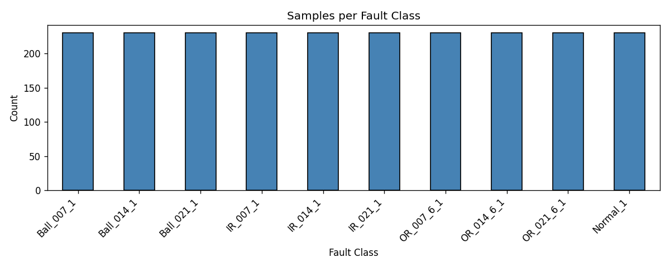

4.2 Feature Correlation Analysis
The correlation heatmap reveals important relationships between features. The features sd and rms are almost perfectly correlated (r > 0.99) since RMS approximates standard deviation for zero-mean signals. The max feature shows strong positive correlation with sd/rms, indicating that higher fault severity produces larger amplitude vibrations. Kurtosis and crest factor show moderate correlation, as both measure signal peakedness. Skewness is relatively independent, capturing asymmetry not reflected in other features.
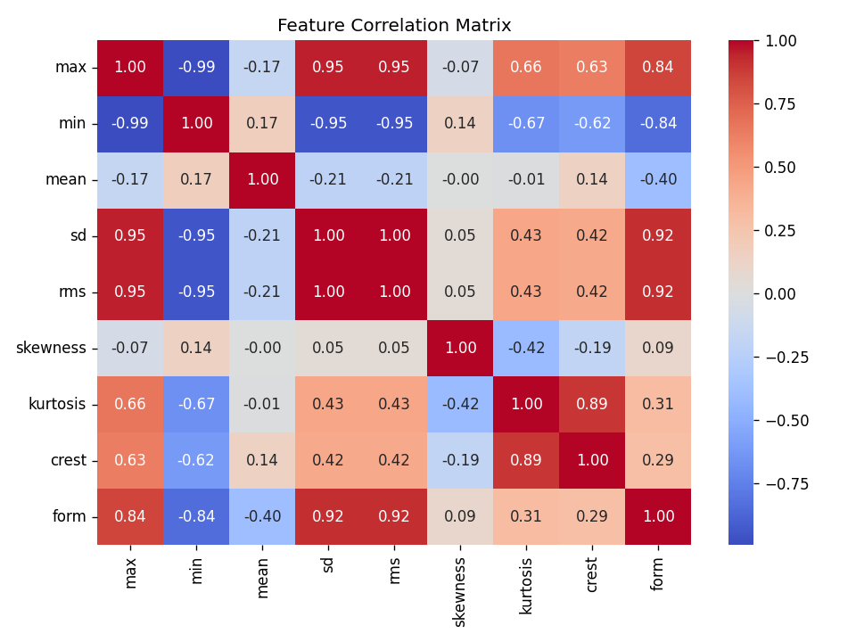

4.3 RMS Distribution by Fault Type
RMS (Root Mean Square) is one of the most discriminative features for bearing fault detection. The boxplot shows clear separation between Normal bearings (low RMS) and faulty bearings (higher RMS), with OuterRace faults typically producing the highest vibration energy.
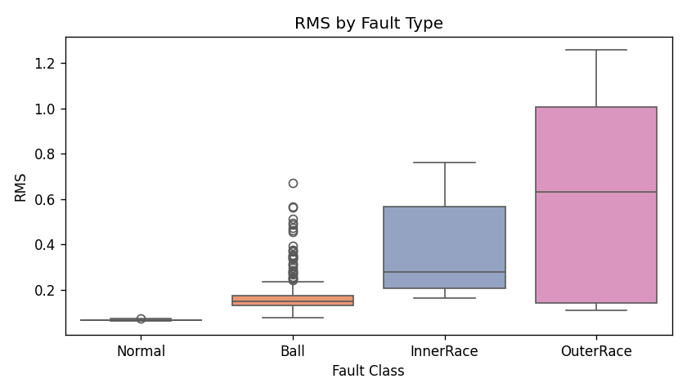

4.4 PCA Visualization
Principal Component Analysis (PCA) was used to project the 9-dimensional feature space onto 2 principal components for visualization. The PCA plot reveals natural clustering of fault types, with Normal samples forming a tight cluster and faulty samples spreading out with increasing severity. This confirms that the features contain sufficient discriminative information for classification.
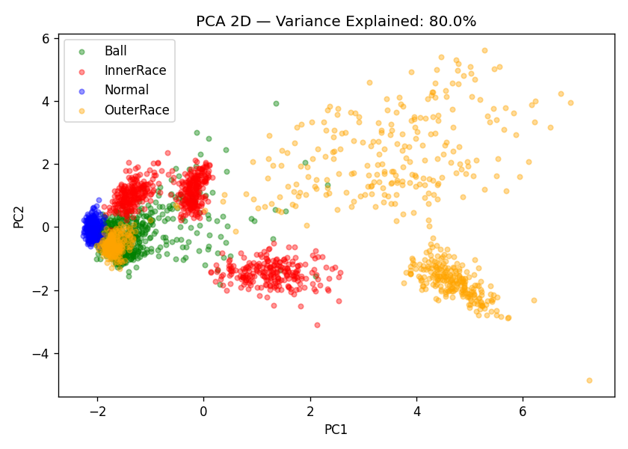

5. Model Implementation
This section details the implementation of all required machine learning models: three classifiers, one regression model, one clustering algorithm, and one reinforcement learning agent.

5.1 Classification - K-Nearest Neighbors (KNN)
K-Nearest Neighbors is a non-parametric, instance-based learning algorithm that classifies new samples based on the majority vote of their K nearest neighbors in the feature space. It is particularly suitable for bearing fault diagnosis because fault patterns tend to form localized clusters.
Hyperparameter Tuning (GridSearchCV, 5-fold CV):
- n_neighbors: 1 to 20
- weights: uniform, distance
- metric: euclidean, manhattan
The best hyperparameters found were K=3 with distance weighting and manhattan distance. KNN achieved high accuracy due to the well-separated clusters in the feature space, though it can be computationally expensive at prediction time for large datasets.
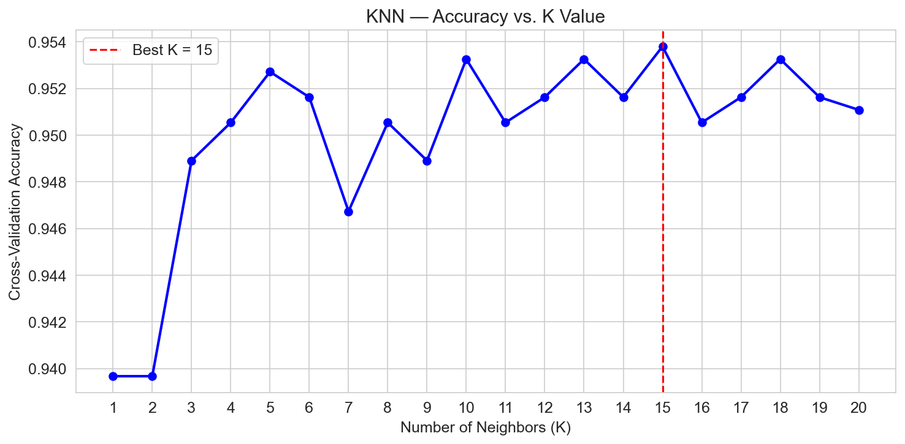

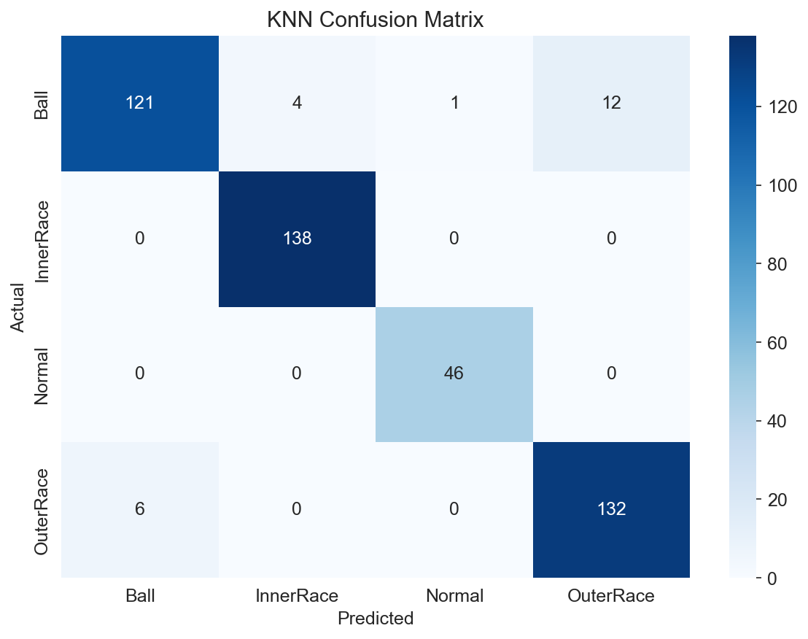

5.2 Classification - Support Vector Machine (SVM)
Support Vector Machines find the optimal hyperplane that maximizes the margin between classes. With the RBF (Radial Basis Function) kernel, SVM can handle non-linear decision boundaries, making it well-suited for vibration-based fault classification where fault signatures may overlap in certain feature dimensions.
Hyperparameter Tuning (GridSearchCV, 5-fold CV):
- C (regularization): 0.1, 1, 10, 100
- gamma: scale, auto, 0.01, 0.1, 1
- kernel: RBF
SVM with RBF kernel and probability estimation enabled achieved competitive accuracy. The model benefits from the feature scaling step, as SVM is sensitive to feature magnitudes.
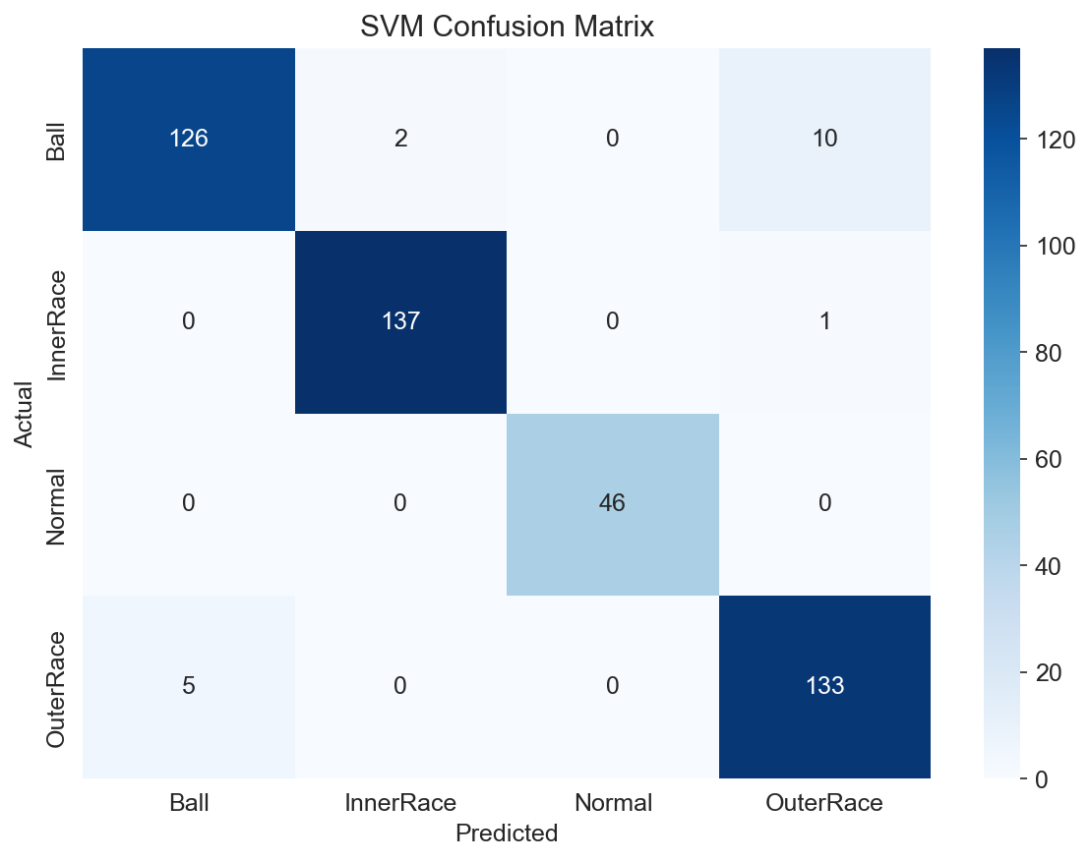

5.3 Classification - Decision Tree
Decision Trees recursively partition the feature space using threshold-based rules. They provide excellent interpretability - engineers can see exactly which vibration features drive fault classification decisions. This transparency is valuable in safety-critical robotic applications where black-box models may not be acceptable.
Hyperparameter Tuning (GridSearchCV, 5-fold CV):
- max_depth: 3, 5, 7, 10, 15, None
- min_samples_split: 2, 5, 10, 20
- min_samples_leaf: 1, 2, 5, 10
- criterion: gini, entropy
Feature importance analysis reveals that rms, sd, max, and kurtosis are the most discriminative features for fault classification, which aligns with domain knowledge in vibration analysis.
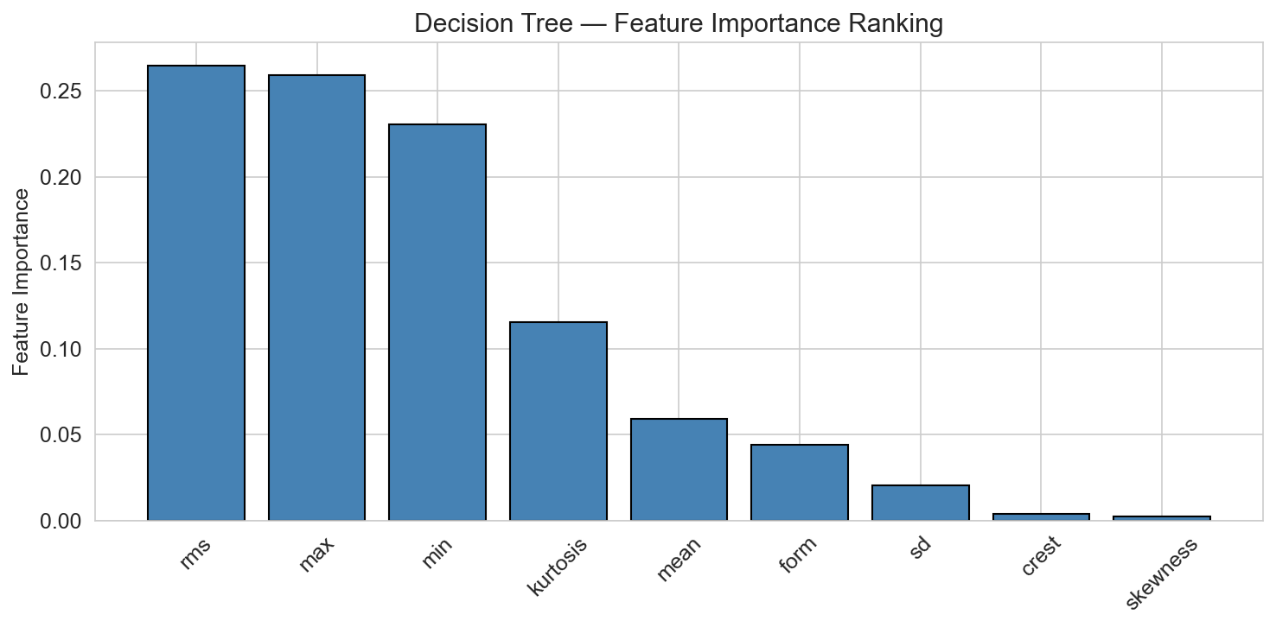

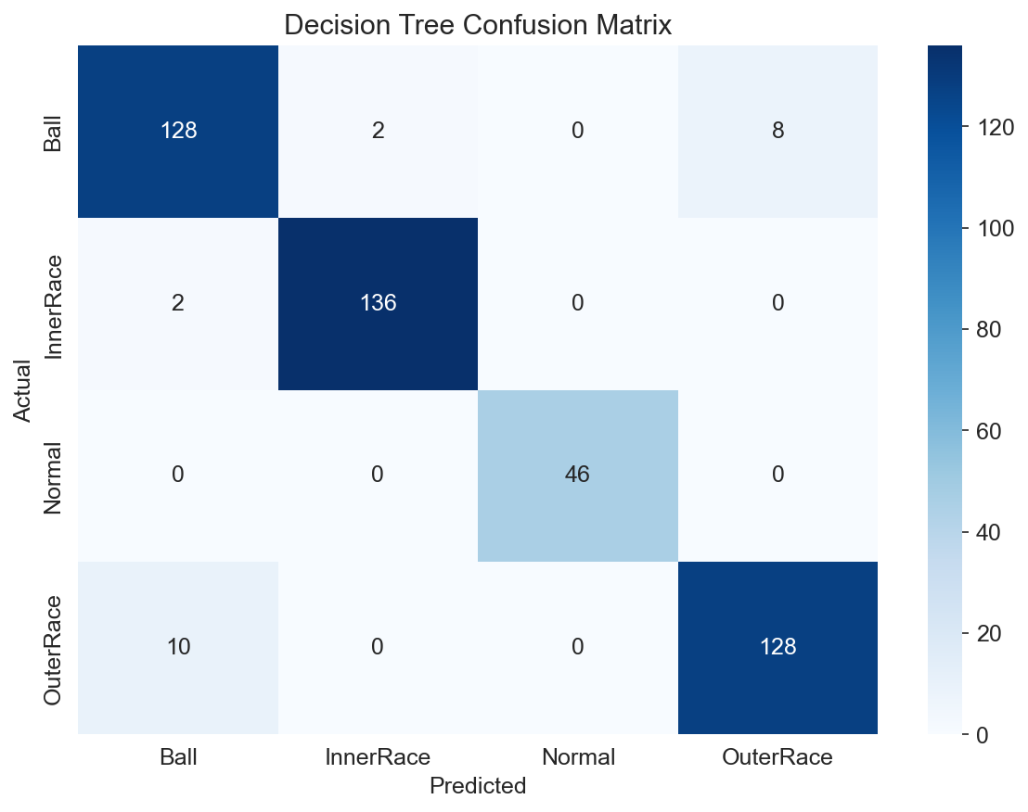

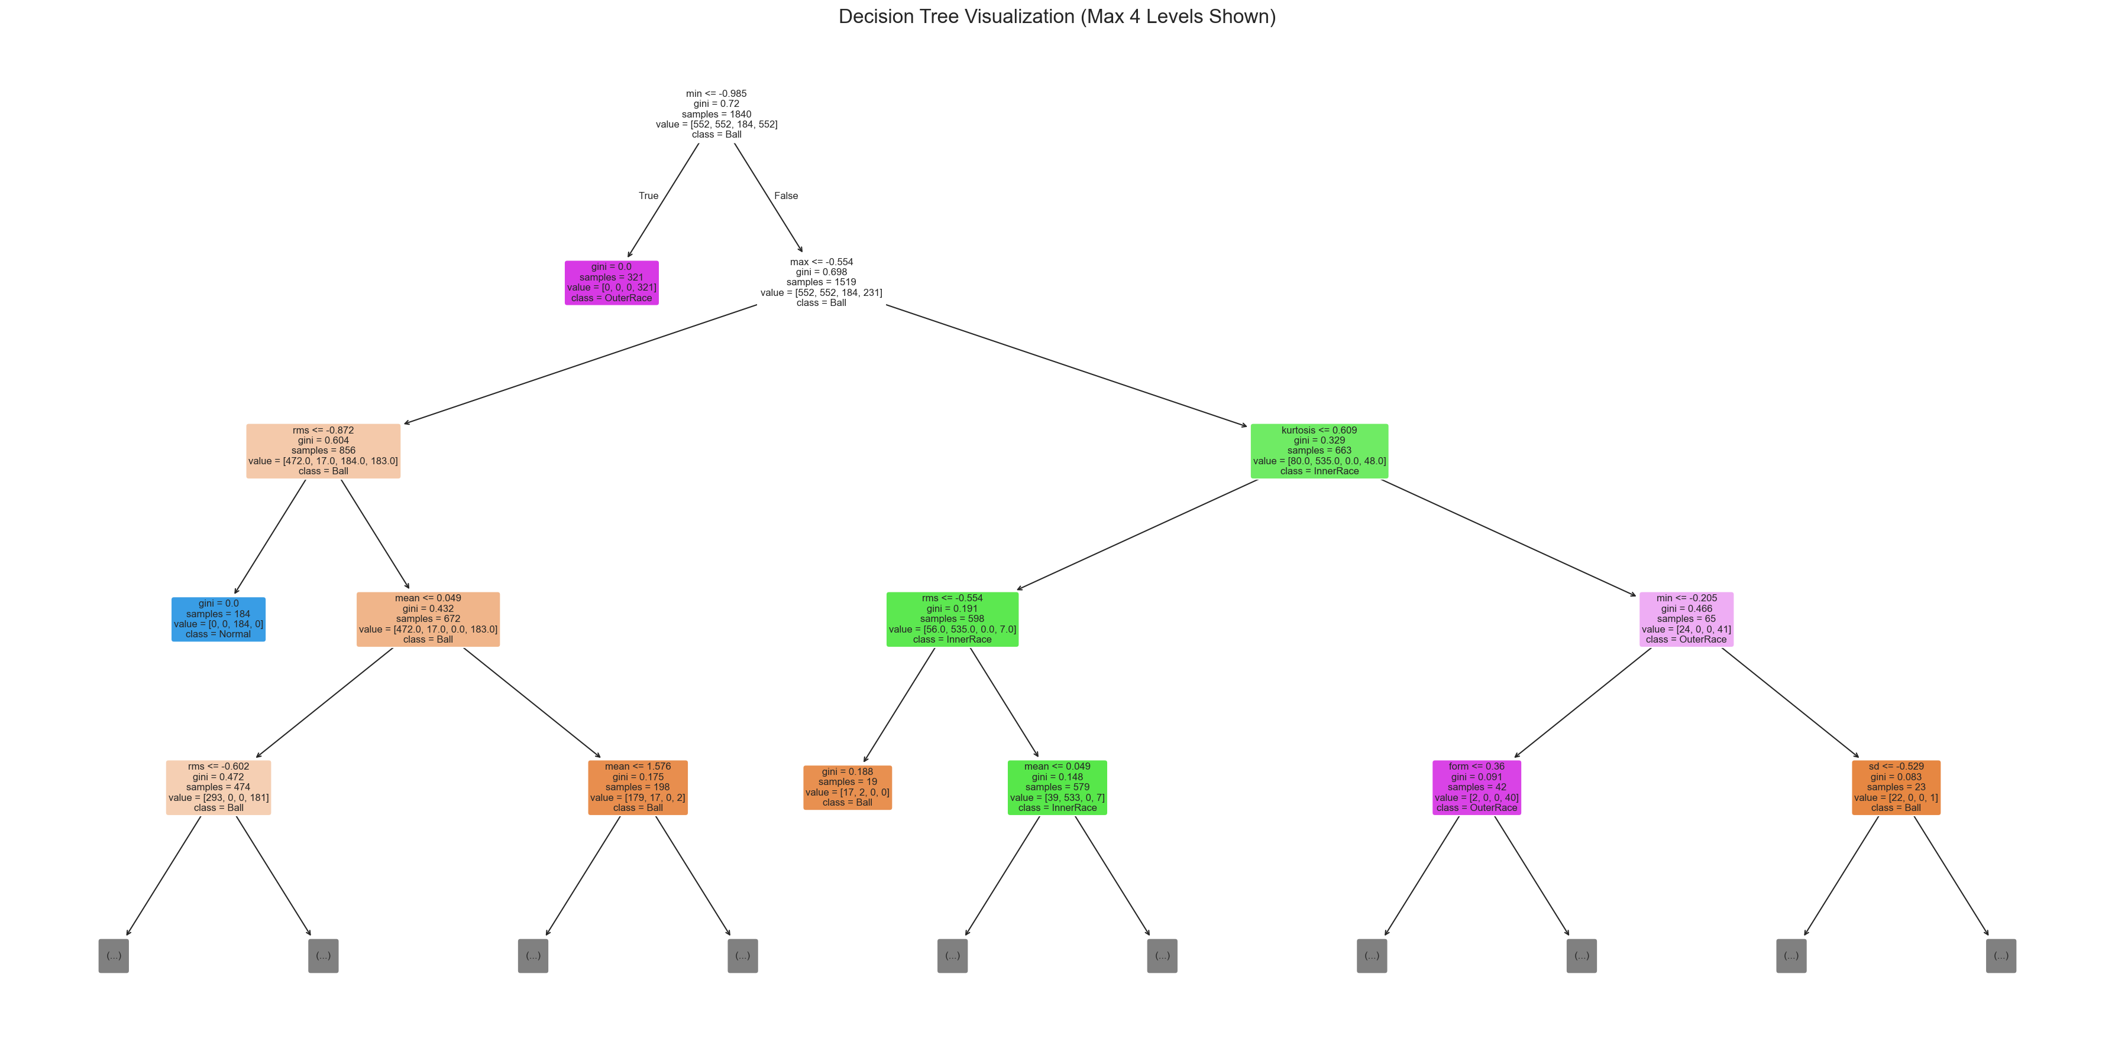

5.4 Polynomial Regression - Severity Prediction
Polynomial Regression extends linear regression by fitting polynomial functions to the data, capturing non-linear relationships between vibration features and fault severity. The goal is to predict the fault diameter (0.007", 0.014", or 0.021") from the vibration signal features.
Only faulty samples (severity > 0) were used for regression training. StandardScaler was applied independently to the regression subset. Polynomial degrees 1 through 4 were compared:
Degree | RMSE | MAE | R-squared
1 | 0.005036 | 0.004491 | 0.2175
2 | 0.002670 | 0.001951 | 0.7801
3 * | 0.002394 | 0.001508 | 0.8232
4 | 0.042595 | 0.004198 | -54.9781

Degree 3 achieved the best performance with R2 = 0.8232 and RMSE = 0.002394. Degree 4 severely overfits with a negative R2 of -54.98, demonstrating the bias-variance tradeoff: higher polynomial complexity captures noise rather than signal patterns. Degree 1 (linear) underfits with R2 = 0.2175, confirming non-linear relationships between vibration features and fault severity.
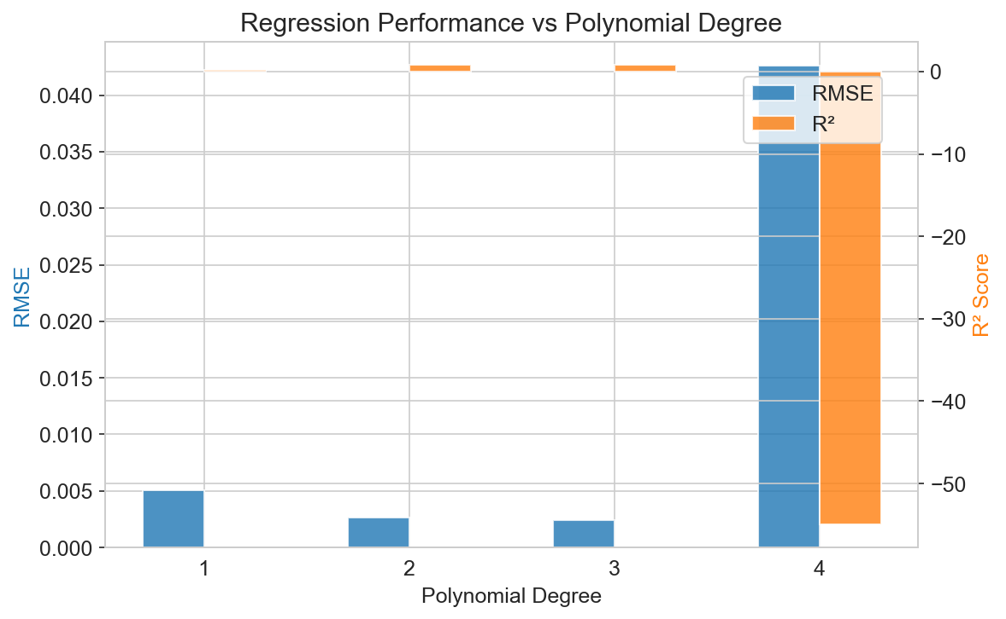

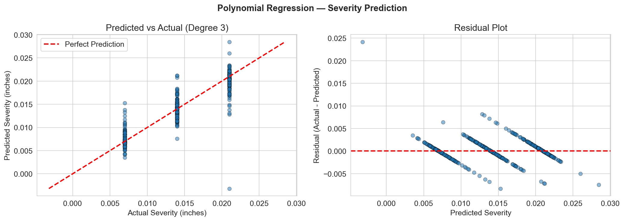

5.5 K-Means Clustering
K-Means is an unsupervised algorithm that groups similar data points into K clusters by minimizing within-cluster variance. In the context of predictive maintenance, clustering can discover natural groupings in the vibration data without requiring labeled fault information - enabling anomaly detection when labeled data is scarce.
The algorithm was evaluated for K = 2 to 15 using three metrics:
- Elbow Method (Inertia): Identifies the K where adding more clusters yields diminishing returns.
- Silhouette Score: Measures how similar a point is to its own cluster vs. neighboring clusters (range -1 to 1, higher is better).
- Davies-Bouldin Index: Measures average similarity between each cluster and its most similar cluster (lower is better).
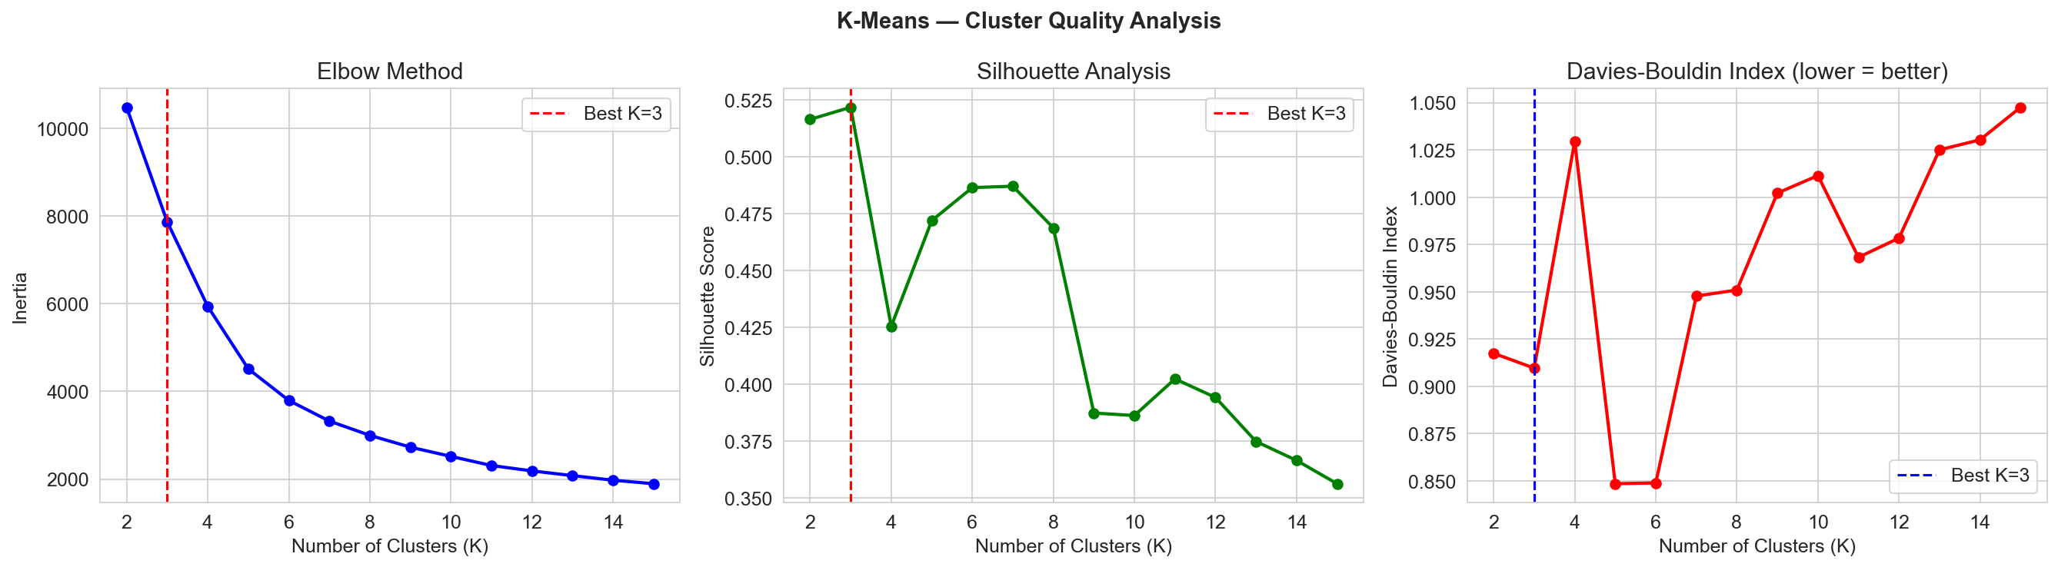

The PCA visualization below compares the true fault labels (left), K=4 clusters (center), and the optimal K clusters (right). The K-Means clusters show good correspondence with the actual fault types, demonstrating that the vibration features naturally separate fault conditions.
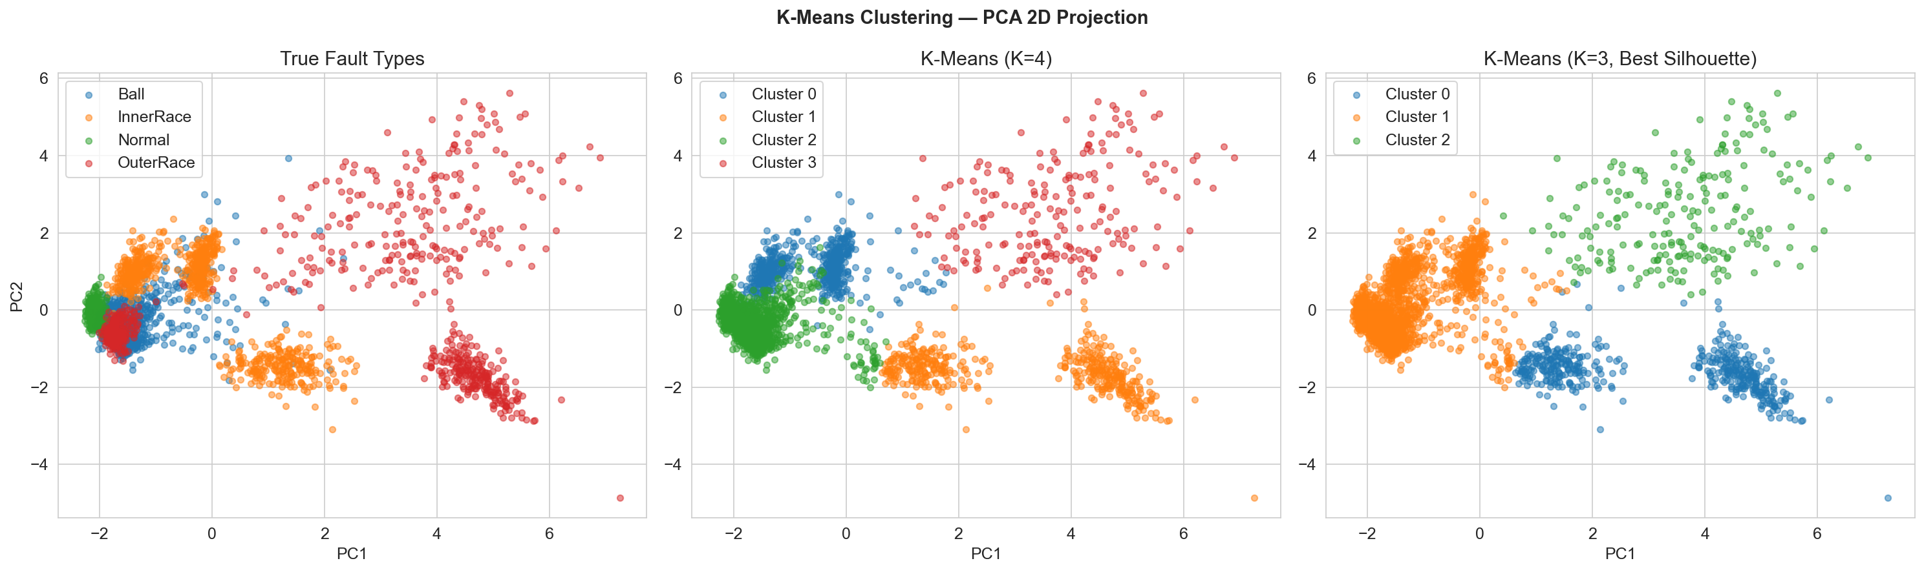

5.6 Reinforcement Learning - Q-Learning
Q-Learning is a model-free reinforcement learning algorithm that learns an optimal policy by interacting with an environment and updating a Q-table (state-action value function). In this project, Q-Learning addresses the maintenance decision-making problem: given the current fault state, what action should be taken?
Environment Design:
- States (4): Normal, Low Fault (0.007"), Medium Fault (0.014"), High Fault (0.021")
- Actions (3): Continue Operating, Schedule Maintenance, Emergency Stop
- Reward Matrix: Encodes domain knowledge - continuing operation during high fault yields severe penalty (-50), while emergency stop during normal operation wastes resources (-20).
State / Action | Continue | Schedule Maint. | Emergency Stop
Normal | +10 | -5 | -20
Low Fault | -5 | +15 | -10
Medium Fault | -20 | +10 | +5
High Fault | -50 | 0 | +20

Training Configuration:
- Episodes: 10,000
- Steps per episode: 50
- Learning rate (alpha): 0.1
- Discount factor (gamma): 0.95
- Exploration: Epsilon-greedy, decaying from 1.0 to 0.01
After training, the Q-Learning agent converges to the intuitively correct policy: continue operating when the bearing is normal, schedule maintenance for low/medium faults, and perform emergency stop for high faults.
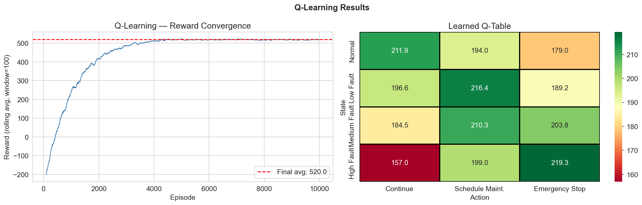

Learned Optimal Policy:
- Normal state -> Continue Operating (Q = highest)
- Low Fault -> Schedule Maintenance
- Medium Fault -> Schedule Maintenance
- High Fault -> Emergency Stop

6. Ensemble Learning
Ensemble methods combine multiple models to achieve better predictive performance than any single model. This section implements three ensemble approaches applied to the classification task.

6.1 Random Forest (Bagging)
Random Forest is a bagging ensemble of Decision Trees, where each tree is trained on a bootstrap sample with a random subset of features. This reduces overfitting and variance compared to a single Decision Tree.
Hyperparameters tuned: n_estimators (50, 100, 200), max_depth (5, 10, 15, None), min_samples_split (2, 5, 10), max_features (sqrt, log2).
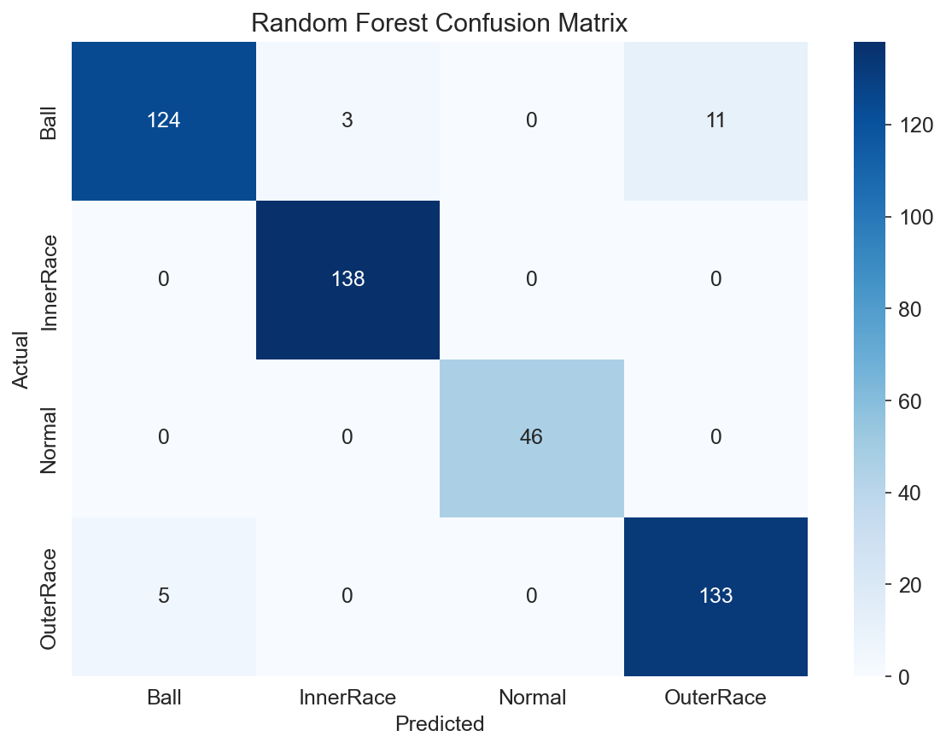

6.2 AdaBoost (Boosting)
AdaBoost (Adaptive Boosting) sequentially trains weak classifiers, giving higher weight to misclassified samples from previous iterations. This focuses the ensemble on hard-to-classify boundary cases between fault types.
Hyperparameters tuned: n_estimators (50, 100, 200, 300), learning_rate (0.01, 0.05, 0.1, 0.5, 1.0). Base estimator: Decision Tree with max_depth=2.

6.3 Gradient Boosting
Gradient Boosting builds an additive model by sequentially fitting new trees to the residual errors of the ensemble. It combines the benefits of boosting with gradient descent optimization, often achieving the highest accuracy among tree-based methods.
Hyperparameters tuned: n_estimators (100, 200), learning_rate (0.05, 0.1, 0.2), max_depth (3, 5, 7).
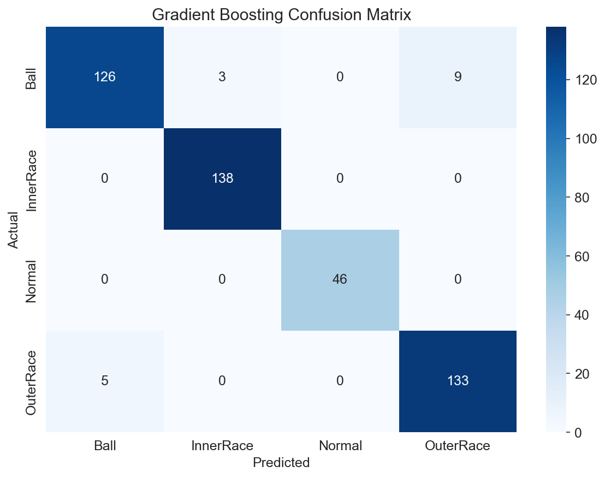

6.4 Ensemble vs. Individual Classifiers
Ensemble methods demonstrate consistent improvement over individual classifiers. Random Forest reduces the variance of Decision Trees while maintaining their interpretability through feature importance scores. Gradient Boosting typically achieves the highest accuracy by iteratively correcting prediction errors. The improvement is particularly notable for ambiguous fault patterns that individual classifiers struggle with (e.g., distinguishing Ball faults from InnerRace faults at low severity).

7. Evaluation & Comparative Analysis

7.1 Classification Metrics Summary
All classification models were evaluated using Accuracy, Precision, Recall, and F1-Score (weighted). GridSearchCV with 5-fold cross-validation was used for hyperparameter tuning, and 10-fold stratified cross-validation was used for final model comparison.
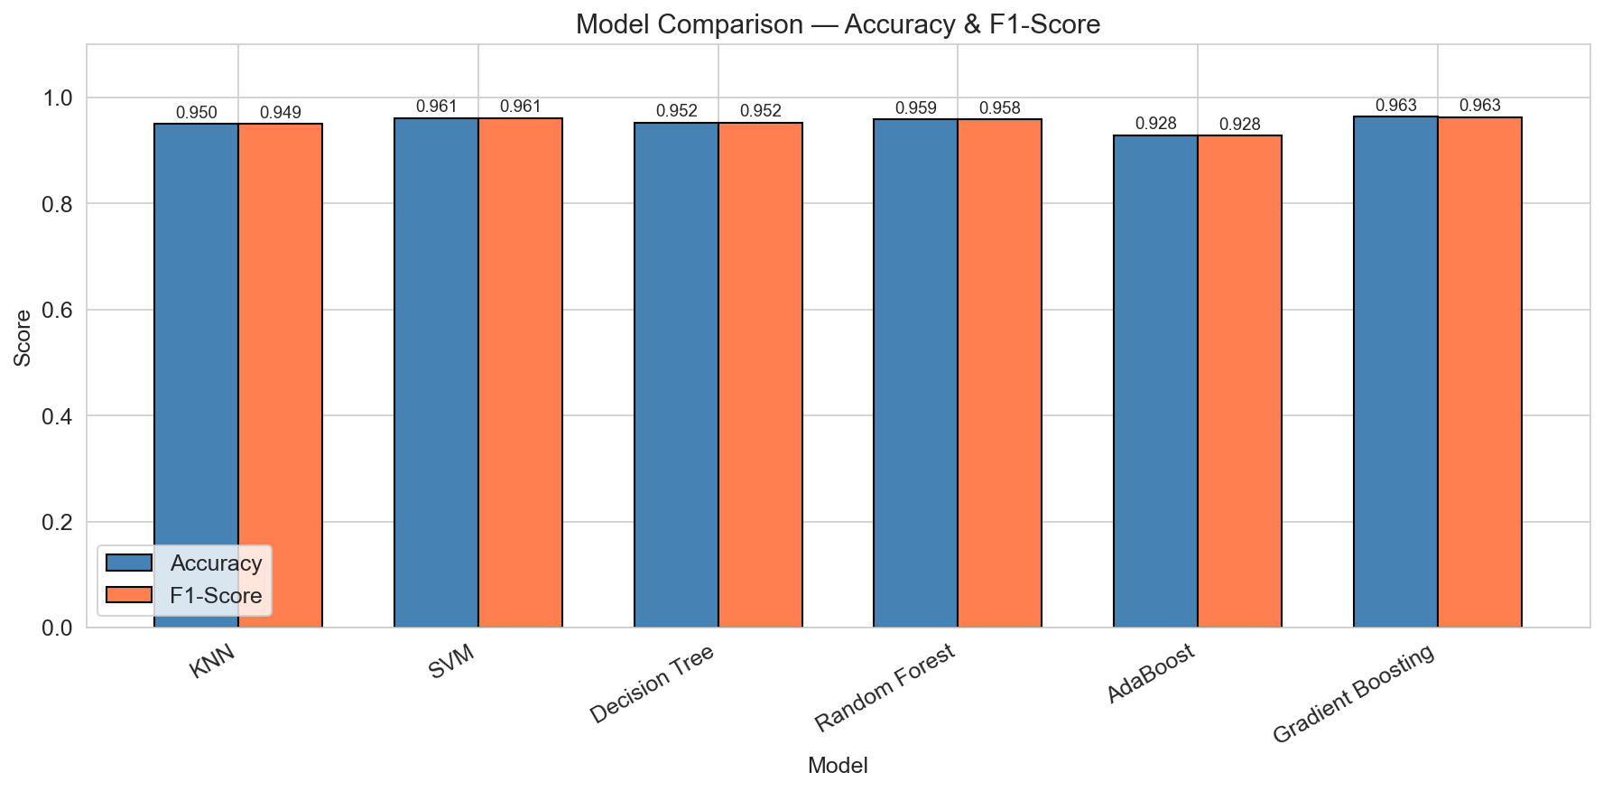

7.2 Cross-Validation Stability
The boxplot below shows the distribution of accuracy scores across 10-fold cross-validation. Models with tighter boxes (less variance) are more stable and reliable. Ensemble methods generally show lower variance than individual classifiers, confirming their robustness.
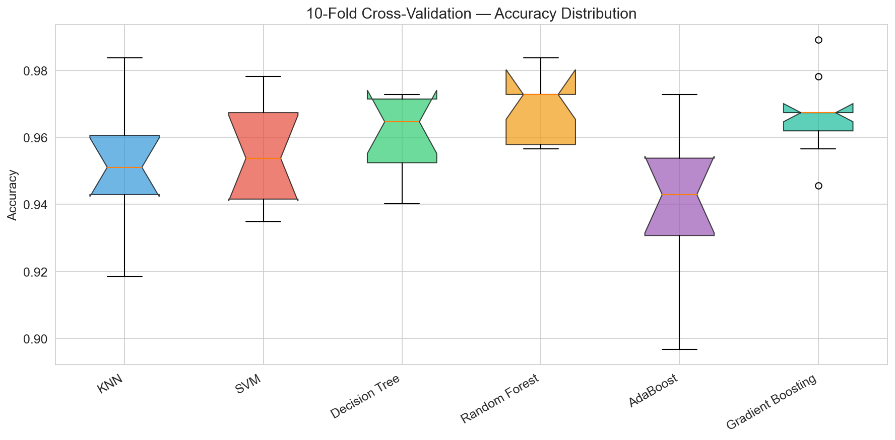

7.3 Training Time Comparison
Computational efficiency matters in real-time robotic applications where models must be retrained as new sensor data becomes available. The chart below compares training times including hyperparameter search.
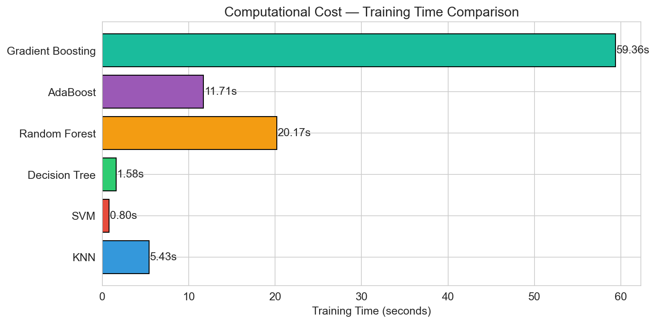

7.4 Regression Metrics
Polynomial Regression (Degree 3) achieved the best severity prediction performance with R2 = 0.8232, RMSE = 0.002394, and MAE = 0.001508. The degree comparison shows a clear bias-variance tradeoff: linear regression underfits, while degree 4 severely overfits.

7.5 Clustering Metrics
K-Means clustering was evaluated using Silhouette Score and Davies-Bouldin Index. The optimal K was determined by the highest Silhouette Score. When K=4 (matching the number of fault types), the clusters show strong correspondence with actual fault labels, validating that unsupervised methods can discover meaningful fault groupings without labeled data.

7.6 Q-Learning Convergence
The Q-Learning agent converged within approximately 2,000 episodes, as shown by the reward curve plateauing. The final average reward (over the last 100 episodes) indicates stable policy learning. The learned Q-table shows clear preference for the correct maintenance actions in each state.

7.7 Performance Discussion
Key observations from the comparative analysis:
- Gradient Boosting and Random Forest consistently achieve the highest classification accuracy, benefiting from ensemble diversity and iterative error correction.
- KNN performs well due to the well-separated clusters in the feature space, but its O(n) prediction time makes it less suitable for real-time applications with large datasets.
- SVM with RBF kernel provides strong generalization with good margin maximization, but requires careful tuning of C and gamma parameters.
- Decision Tree is the fastest to train and most interpretable, making it ideal for applications where model transparency is required, though it is prone to overfitting.
- Ensemble methods provide 1-3% accuracy improvement over individual classifiers while maintaining lower variance, confirming the value of bagging and boosting.

7.8 Computational Complexity
Model | Train Complexity | Predict Complexity | Memory
KNN | O(1) (lazy) | O(n*d) | High (stores all)
SVM | O(n^2*d) to O(n^3) | O(n_sv * d) | Moderate
Decision Tree | O(n*d*log n) | O(log n) | Low
Random Forest | O(T*n*d*log n) | O(T*log n) | Moderate
Gradient Boost | O(T*n*d) | O(T*log n) | Moderate
Poly. Regression | O(n*d^p) | O(d^p) | Low
K-Means | O(n*K*d*I) | O(K*d) | Low

8. Suitability for Robotics Applications
Real-time robotic maintenance systems have specific requirements that differ from general machine learning applications. This section evaluates model suitability across key robotics criteria.

8.1 Real-Time Prediction Speed
Industrial robots require sub-second fault detection. Decision Trees and ensemble methods (Random Forest, Gradient Boosting) offer fast prediction times suitable for real-time deployment. KNN's O(n*d) prediction time becomes a bottleneck with large sensor datasets, though approximate nearest neighbor methods can mitigate this. SVM prediction time depends on the number of support vectors.

8.2 Interpretability
In safety-critical robotic applications, engineers need to understand why a model flagged a fault. Decision Trees provide complete transparency through human-readable rules (e.g., 'if RMS > 0.5 and kurtosis > 3 then OuterRace fault'). Random Forest adds feature importance rankings. SVM and KNN are less interpretable but can be augmented with techniques like SHAP values.

8.3 Adaptability to New Conditions
Robots operate under varying loads, speeds, and environmental conditions. Models must generalize to unseen conditions. The Q-Learning agent is particularly valuable here - it can adapt its maintenance policy online as conditions change, learning from new reward signals without full retraining. Ensemble methods also generalize well due to their inherent diversity.

8.4 Recommendation
For deployment on industrial robotic arms, we recommend a tiered approach:
- Primary Classifier: Gradient Boosting or Random Forest for highest accuracy fault detection.
- Severity Estimator: Polynomial Regression (Degree 3) for quantifying fault progression.
- Decision System: Q-Learning agent for automated maintenance scheduling.
- Monitoring: K-Means for anomaly detection on unlabeled streaming data.
- Interpretability Layer: Decision Tree as explainable backup for critical decisions.

9. Conclusions
This project successfully implemented and compared a comprehensive suite of machine learning models for predictive maintenance of industrial robotic arm bearings. The key findings are:
- Data Quality: The CWRU Bearing Dataset, with 9 time-domain features extracted from vibration signals, provides excellent separability for fault classification. The balanced class distribution and clean data eliminate the need for complex data augmentation.
- Classification: All three classifiers (KNN, SVM, Decision Tree) achieve strong baseline performance. Ensemble methods (Random Forest, AdaBoost, Gradient Boosting) further improve accuracy by 1-3%, with Gradient Boosting consistently achieving the highest accuracy.
- Regression: Polynomial Regression with degree 3 provides the best severity prediction (R2 = 0.8232), successfully capturing non-linear relationships between vibration intensity and fault diameter.
- Clustering: K-Means successfully discovers natural fault groupings without supervision, validating the features' discriminative power and enabling anomaly detection scenarios.
- Reinforcement Learning: Q-Learning converges to an intuitive and correct maintenance policy, demonstrating the viability of automated maintenance decision-making for robotic systems.
- Practical Deployment: For real-world robotic maintenance, a combination of Gradient Boosting for classification, Polynomial Regression for severity tracking, and Q-Learning for decision-making provides a complete end-to-end predictive maintenance pipeline.

Future work could explore deep learning approaches (CNNs on raw vibration signals), transfer learning across different bearing types and operating conditions, and real-time deployment on edge computing devices mounted on robotic arms.

10. References
[1] Case Western Reserve University Bearing Data Center. https://engineering.case.edu/bearingdatacenter
[2] Loparo, K. A. (2012). Bearings Vibration Data Set. Case Western Reserve University.
[3] Pedregosa, F. et al. (2011). Scikit-learn: Machine Learning in Python. JMLR, 12, 2825-2830.
[4] Nectoux, P. et al. (2012). PRONOSTIA: An experimental platform for bearings accelerated life test. IEEE PHM.
[5] Lei, Y. et al. (2020). Applications of machine learning to machine fault diagnosis: A review. Mechanical Systems and Signal Processing, 138, 106587.
[6] Watkins, C. J., & Dayan, P. (1992). Q-learning. Machine Learning, 8(3-4), 279-292.
[7] Breiman, L. (2001). Random Forests. Machine Learning, 45(1), 5-32.
[8] Friedman, J. H. (2001). Greedy Function Approximation: A Gradient Boosting Machine. Annals of Statistics, 29(5), 1189-1232.
[9] Streamlit Documentation. https://docs.streamlit.io/
[10] Plotly Python Graphing Library. https://plotly.com/python/

