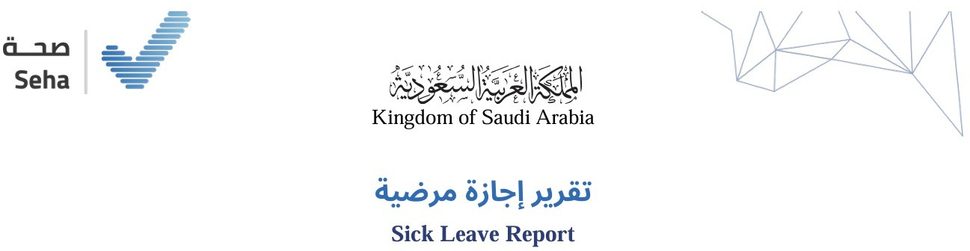

Leave ID | GSL26068743142 |  | رﻣﺰ اﻹﺟﺎزة
Leave Duration | 3 day ( 27-09-2026 to 01-10-2026 ) | 3 ﻳﻮم ) 16-04-1448 إﱃ 20-04-1448 ( | ﻣﺪة اﻹﺟﺎزة
Admission Date | 26-09-2026 | 15-04-1448 | ﺗﺎرﻳﺦ اﻟﺪﺧﻮل
Discharge Date | 28-09-2026 | 17-04-1448 | ﺗﺎرﻳﺦ اﻟﺨﺮوج
Issue Date | 27-09-2026 |  | ﺗﺎرﻳﺦ إﺻﺪار اﻟﺘﻘﺮﻳﺮ
Name | HAFED SHAHER ZAID AL HARTHY | حافظ شاهر زﻳﺪ اﻟﺤﺎرﺛﻲ | اﻻﺳﻢ
National ID / Iqama | 2104762796 |  | رﻗﻢ اﻟﻬﻮﻳﺔ / اﻹﻗﺎﻣﺔ
Nationality | Saudi Arabia | اﻟﺴﻌﻮدﻳﺔ | اﻟﺠﻨﺴﻴﺔ
Employer |  | ﺷﺮﻛﺔ رﻳﺎدة اﻷﺷﻐﺎل ﻟﻠﻤﻘﺎوﻻت | ﺟﻬﺔ اﻟﻌﻤﻞ
Physician Name | SAEED SALEH BAHADRAMI AL-YAMI | ﺳﻌﻴﺪ ﺻﺎﻟﺢ ﺑﺎﺣﻀﺮﻣﻲ اﻟﻴﺎﻣﻲ | اﺳﻢ اﻟﻤﻤﺎرس
Position | General | ﻃﺒﻴﺐ ﻋﺎم | اﻟﻤﺴﻤﻰ اﻟﻮﻇﻴﻔﻲ

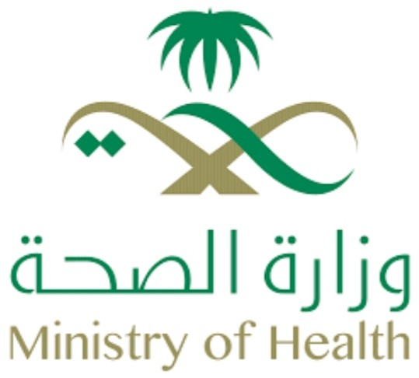

ﻟﻠﺘﺤﻘﻖ ﻣﻦ ﺑﻴﺎﻧﺎت اﻟﺘﻘﺮﻳﺮ ﻳﺮﺟﻰ اﻟﺘﺄﻛﺪ ﻣﻦ زﻳﺎرة ﻣﻮﻗﻊ ﻣﻨﺼﺔ ﺻﺤﺔ اﻟﺮﺳﻤﻲ
To check the report please visit Seha's official website
www.seha.sa/#/inquiries/slenquiry

12:57 AM
Monday , 28 September 2026

ﻣﺴﺘﺸﻔﻰ اﻟﻤﻠﻚ ﻋﺒﺪ اﻟﻌﺰﻳﺰ

KING ABDULAZIZ HOSPITAL


