**ASSIGNMENT # 2**

NAME : SHAHERYAR ASHFAQ

ROLL NO : **20P-0128**

SECTION : BS-CS **4-B**

SUBJECT : OPERATING SYSTEM

HELLO.asm

HELLO2.asm

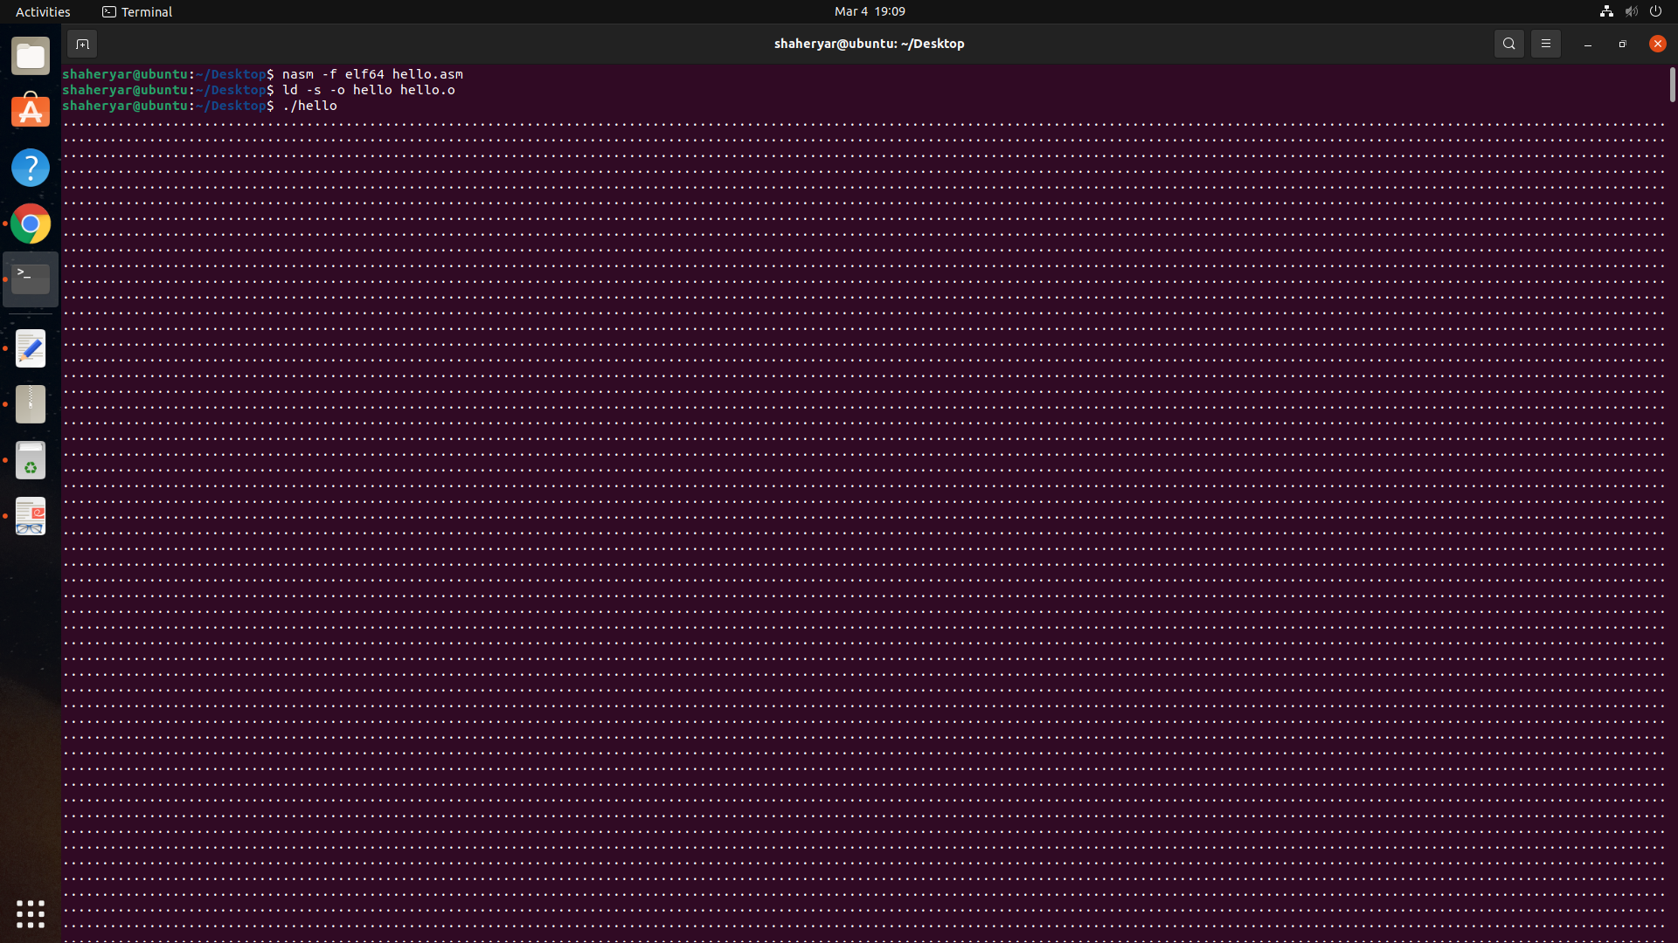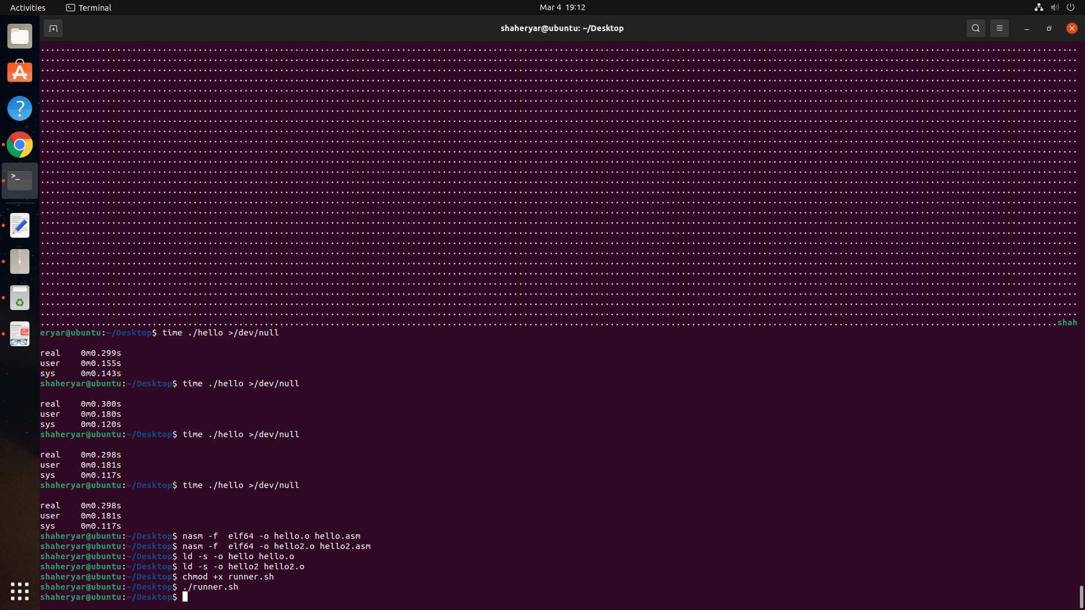

Attempt 01

Number of experiments run: N = 50

Average ‘user time’ for hello (int-based calls) I =**0.18628**

Average ‘user time’ for hello2 (syscall-based calls) S = **0.13916**

**Percentage speedup**: (I-S)*100/I **= 25.26841314150741**

**INT BASED CALL**

(0.140+0.176+0.164+0.156+0.195+0.210+0.188+0.159+0.210+0.252+0.125+0.187+0.200+0.230+0.166+0.155+0.264+0.221+0.209+0.196+0.172+0.185+0.230+0.192+0.185+0.187+0.156+0.185+0.340+0.184+0.146+0.204+0.197+0.181+0.156+0.165+0.199+0.176+0.148+0.161+0.233+0.179+0.177+0.136+0.141+0.170+0.140+0.173+0.213+0.200)/50=**0.18628**

**SYSCALL-BASED CALLS**

(0.116+0.110+0.152+0.149+0.158+0.116+0.101+0.133+0.266+0.160+0.140+0.157+0.132+0.118+0.145+0.168+0.208+0.149+0.136+0.128+0.144+0.131+0.163+0.117+0.116+0.131+0.120+0.308+0.134+0.106+0.094+0.171+0.145+0.151+0.104+0.131+0.144+0.148+0.117+0.124+0.161+0.128+0.125+0.122+0.126+0.118+0.129+0.136+0.172) /50 = **0.13916**

Attempt 02

Number of experiments run: N = 50

Average ‘user time’ for hello (int-based calls) I =**0.** **16858**

Average ‘user time’ for hello2 (syscall-based calls) S = **0. 11258**

**Percentage speedup**: (I-S)*100/I **= 33.21864989915767**

**INT BASED CALL**

(0.147+0.153+0.145+0.173+0.159+0.136+0.156+0.174+0.160+0.156+0.191+0.171+0.136+0.172+0.193+0.169+0.187+0.141+0.148+0.254+0.164+0.176+0.152+0.160+0.165+0.144+0.165+0.196+0.164+0.164+0.1760+0.201+0.335+0.200+0.144+0.163+0.173+0.180+0.173+0.173+0.161+0.196+0.163+0.185+0.158+0.163+0.172+0.168+0.174)/50=**0.16858**

**SYSCALL-BASED CALLS**

(0.141+0.128+0.128+0.148+0.122+0.131+0.105+0.124+0.109+0.116+0.112+0.096+0.112+0.148+0.166+0.092+0.097+0.120+0.084+0.154+0.092+0.116+0.103+0.111+0.104+0.134+0.127+0.155+0.134+0.122+0.112+0.221+0.136+0.011+0.110+0.141+0.138+0.088+0.143+0.092+0.120+0.116+0.106+0.134+0.096+0.116+0.118)/50= **0.11258**

