**ASSIGNMENT # 3**

NAME : SHAHERYAR ASHFAQ

ROLL NO : **20P-0128**

SECTION : BS-CS **4-B**

SUBJECT : OPERATING SYSTEM

**QUESTION -1**  
  
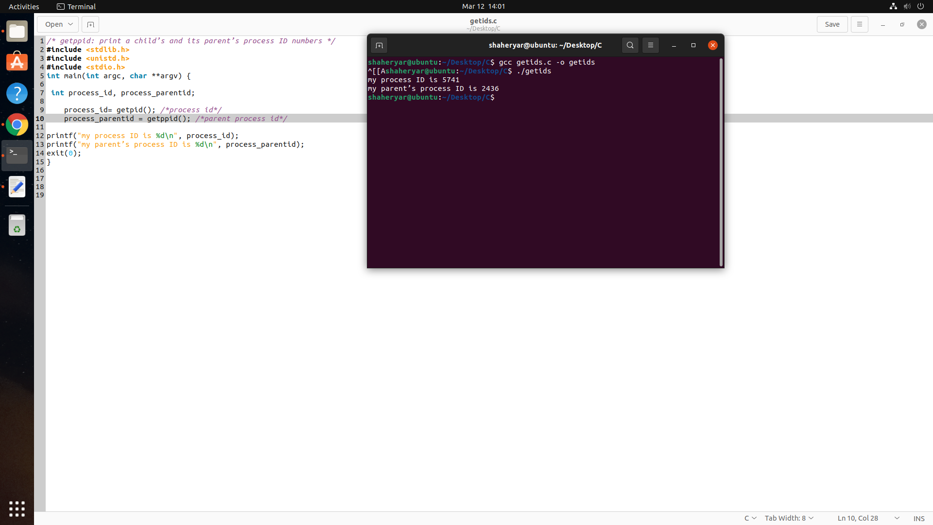

**QUESTION -2**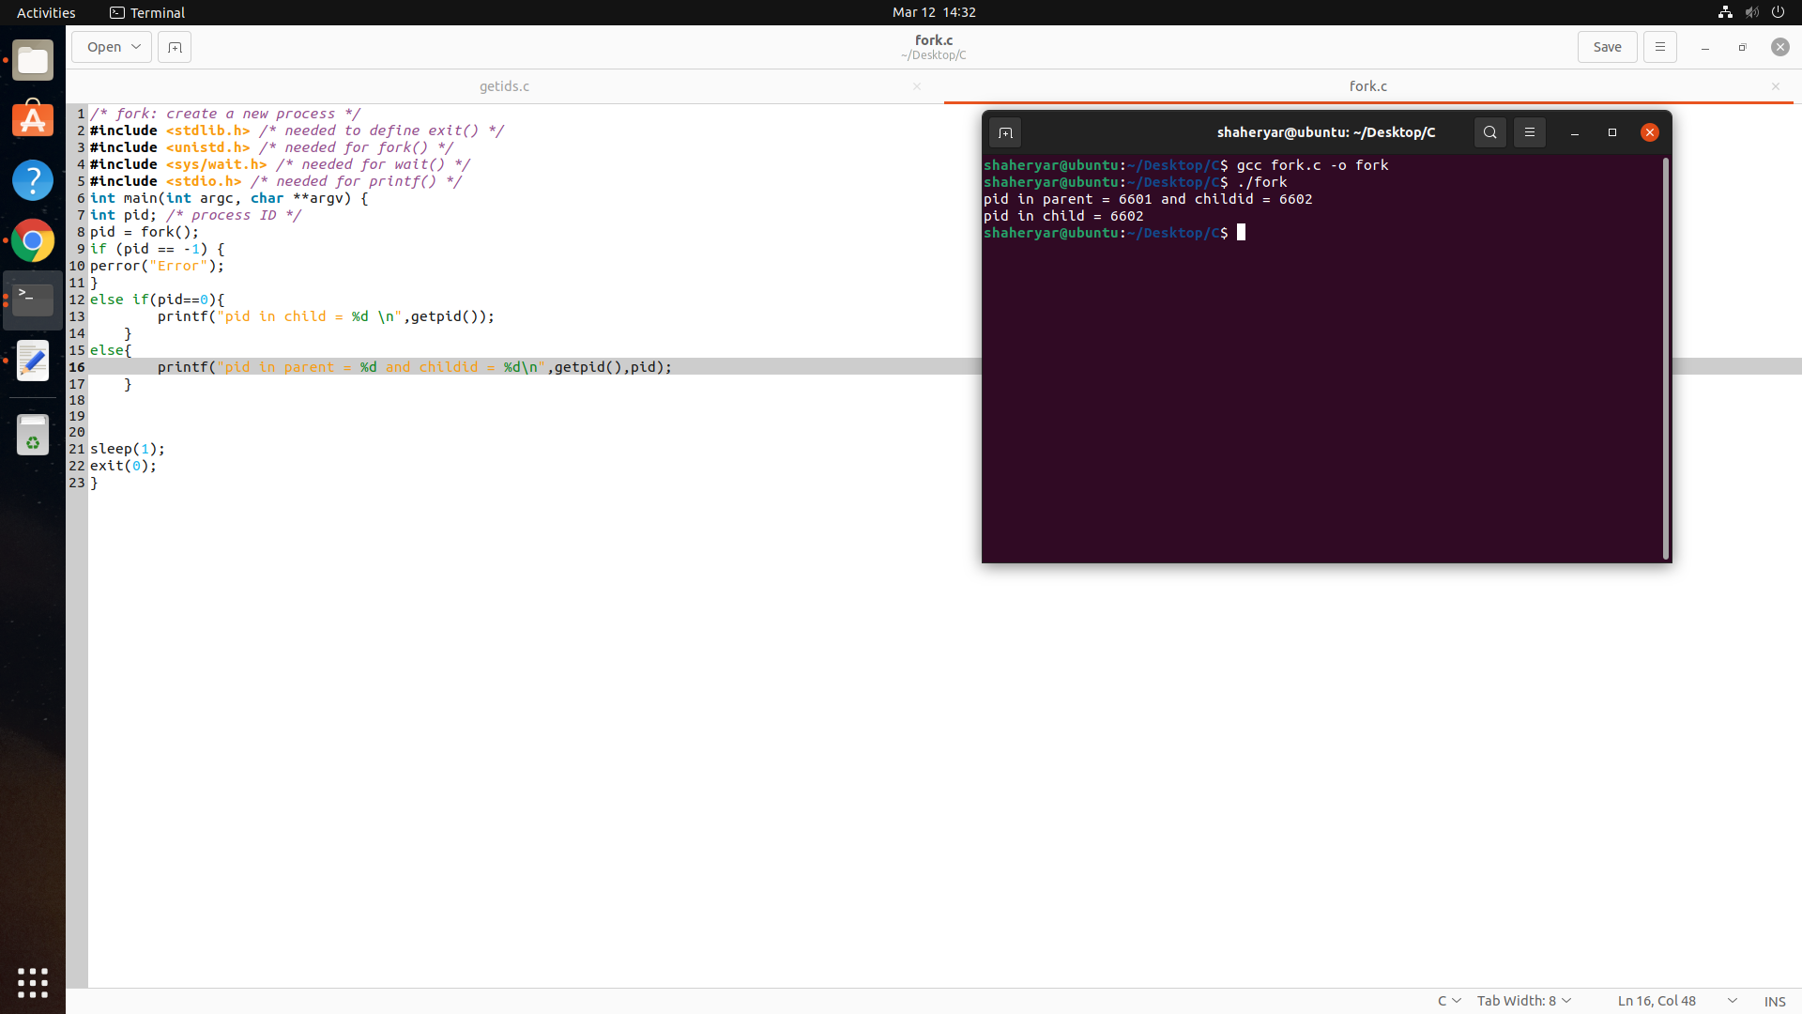

**QUESTION -3**