**ASSIGNMENT # 4**

NAME : SHAHERYAR ASHFAQ

ROLL NO : **20P-0128**

SECTION : BS-CS **4-B**

SUBJECT : OPERATING SYSTEM

***QUESTION 1***

**OUTPUT WITH 2 THREADS**  
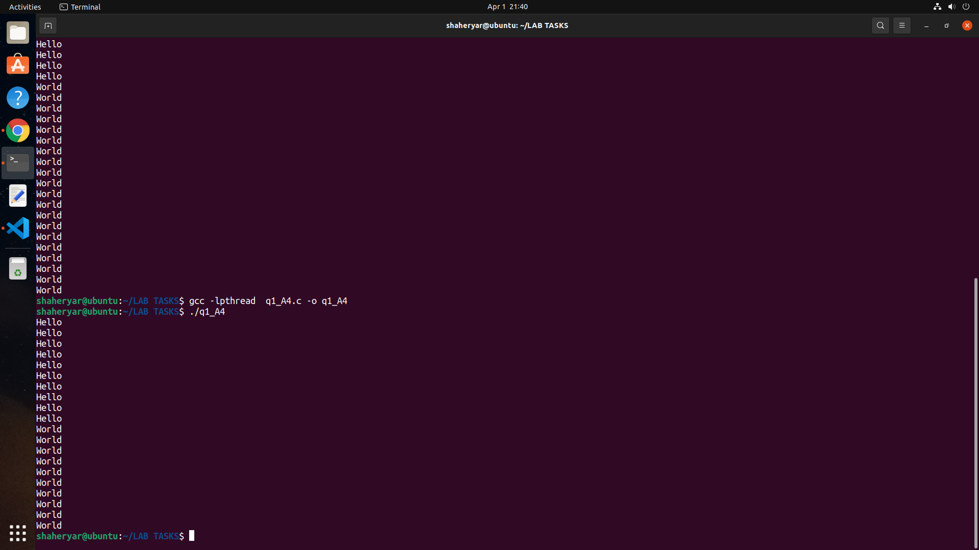

**OUTPUT WITH 4 THREADS**

**OUTPUT EXPLANATION**

The main thread waits till the newly created thread exits. Therefore, the final line of the output is printed only after the new thread exits.

The thread scan terminate independently of each other by not using the pthread_join function.

Q.1 What should be the value of the counter variable at the end?

**Ans 14956756**

Q.2 What is the value you get?

**Thread 0 Counter = 14956756**

**Thread 1 Counter = 11806262**

Q.3 How large is the error and how much does it vary on different runs?

**Ans: Error Value = 5043244.   
Variance = 1,590,707**

Q.4 How much user time (roughly) does the program take to run on your system?

**Ans : 0.175s**