**ASSIGNMENT # 5**

NAME : SHAHERYAR ASHFAQ

ROLL NO : **20P-0128**

SECTION : BS-CS **4-B**

SUBJECT : OPERATING SYSTEM

**OUTPUT**

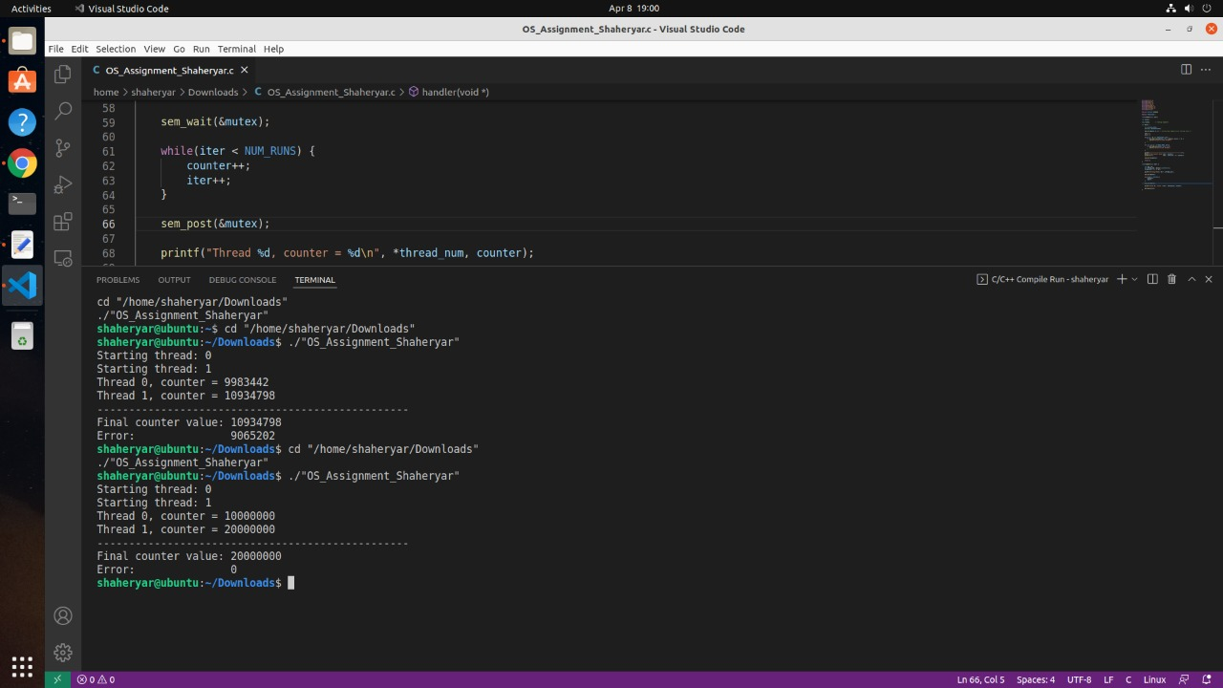

Explanation

**Locks** are one synchronization technique. A lock is an abstraction that allows at most one thread to own it at a time. Holding a lock is how one thread tells other threads: “I’m changing this thing, don’t touch it right now.”