
Case Study Assignment (MKT 302)


SCHOOL OF COMPUTER SCIENCE AND ENGINEERING
TEAM MEMBERS
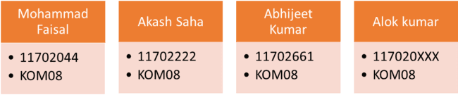
Submitted To

Dr. Vishwas Gupta (Associate Professor @LPU)
[Mittal School of Business]

PEER RATINGS:

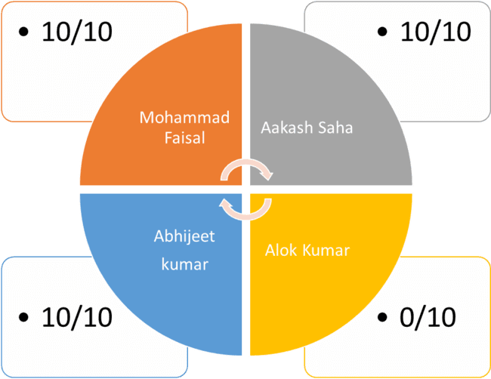

*Alok kumar doesn’t interested in our project. He didn’t do anything even we talked him for his participation.

INDEX TABLE

S.No. | Topics | Page no.
1. | INTRODUCTION | 4
2. | BRAND | 4
3. | CAMPAIGN CONCEPT | 6
4. | OBJECTIVES | 10
5. | MOBILE MARKETING | 10
6. | TYPES OF MEDIA SELECTION | 11
7. | MOBILE MEDIA MARKETING | 15
8. | CONCLUSION | 23
9. | REFERENCE | 23

INTRODUCTION
- Tanishq is a jewellery brand of India. It is a division of Titan Company, a company promoted by the Tata Group in collaboration with the Tamil Nadu Industrial Development Corporation (TIDCO).Tanishq's headquarters is at Bengaluru in Karnataka.
- By the end of the 1980s, the Titan company launched Tanishq in an attempt to earn its own foreign exchange, focused largely on exports. In the early 1990s, India's exchange issue was fixed, and the Titan Company chose to focus the brand on the Indian market.
- The first production plant launched in August 1992, and Tanishq's first store opened in 1996.

BRAND

- Tanishq has emerged as India’s fastest growing jewellery brand and is a name which signifies superior craftsmanship, exclusive designs and superlative product quality.
- The term Tanishq was coined by Mr. Xerxes Desai by marrying the words ‘Tan’ meaning body and ‘Nishk’ meaning a gold ornament.
- Tanishq has brought to the market a whole new standard of business ethics and product reliability, in the process bringing about a transformation in which jewellery is bought or sold in India.
- Not only does it abide by the stringent standards but also adheres to strict and uniform guidelines across all 328 stores across 200 cities.
- It is also the only jeweller in India with a state-of-art factory in Hosur, Tamil Nadu and takes utmost care to ensure that it complies with labour laws and environmental standards. There are 3 other units in Dehradun, Pantnagar and Sikkim as well.
- With retail sales of over Rs. 18600 crores in the last financial year.
- Tanishq was the first jewellery retail brand in India.
- Tanishq made the beauty pageant crowns for the Femina Miss India 2007.
- In May 2015, Tanishq enrolled Deepika Padukone to be the brand's ambassador.
- In 2017, Tanishq launched a sub-brand called Rivaah targeting the wedding segment.
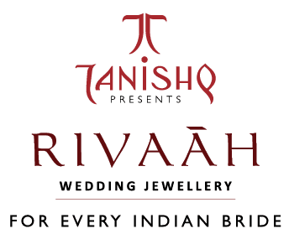

- In January 2017, the Titan group merged its Gold Plus stores with the larger Tanishq retail brand.
- In April 2017, Tanishq launched the sub-brand Mirayah to cater to women under their 40s.
- In December 2017, Tanishq launched the Aveer line, its first line of products for men.

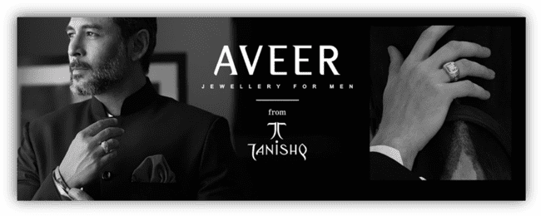
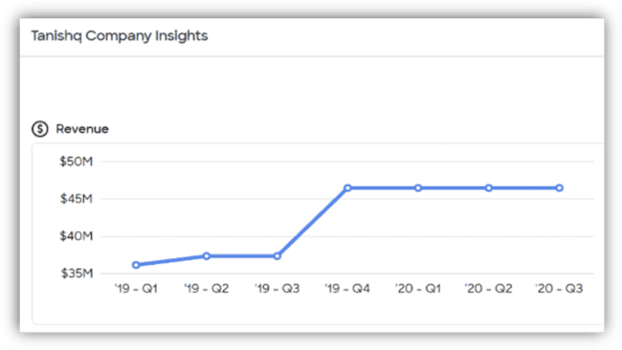

Campaign Concept:

An advertising campaign is a series of advertisement messages that share a single idea and theme which make up an integrated marketing communication (IMC). An IMC is a platform in which a group of people can group their ideas, beliefs, and concepts into one large media base. Advertising campaigns utilize diverse media channels over a particular time frame and target identified audiences.

The campaign theme is the central message that will be received in the promotional activities and is the prime focus of advertising campaign, as it sets the motif for the series of individual advertisements and other marketing communications that will be used. The campaign themes are usually produced with the objective of being used for a significant period but many of them are temporal due to factors like being not effective or market conditions, competition and marketing mix.

KEY TAKE AWAYS

- Marketing campaigns promote products through different types of media, such as television, radio, print, and online platforms.
- Defining a campaign's goal usually dictates how much marketing is needed and what media are most effective for reaching a specific segment of consumers.
- ﻿Companies that lose sales due to major negative press often use marketing campaigns to rehabilitate their image.

The following are the some creative examples of the campaign with seeks for the promotion and attract the best audience.

- One of famous campaign in USA [ Ring-Toc-Toe]
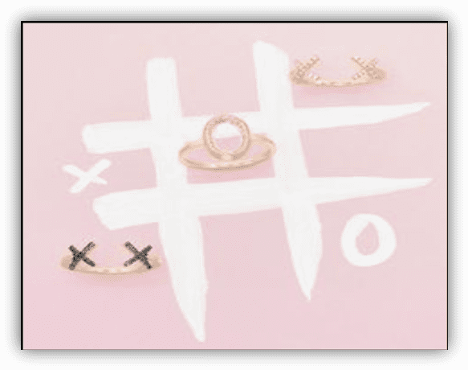


- Love Season is on #beInLove #LoveRings

- One of good campaign In Jewellery

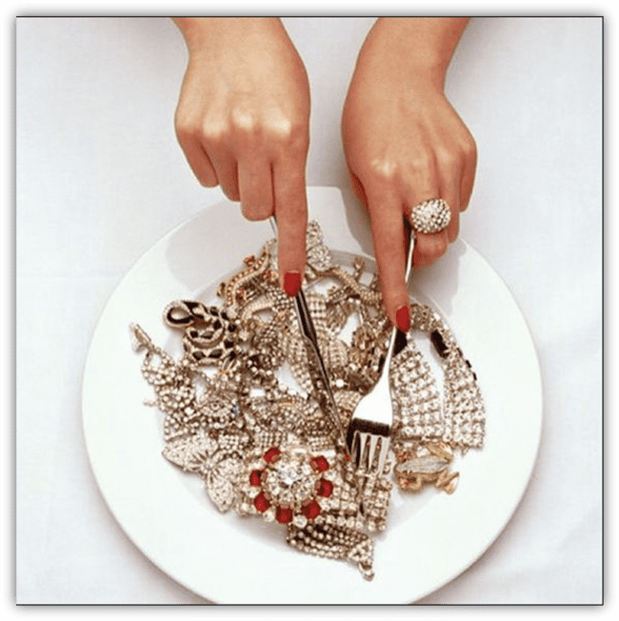

OBJECTIVES

Objectives is the first component of campaign strategy; they describe the intended result or outcome of an effort. Objectives are the target and the foundation for keeping track of your fundraising campaign’s progress. When planning your campaign, first define your objectives; they’re what keep the campaign grounded.

Your objectives should be “SMART“:

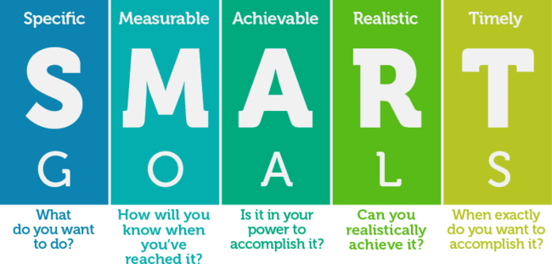

Mobile Marketing
The term mobile advertising refers to any form of advertising that appears on mobile devices such as smartphones and tablets using wireless connections. Companies advertise on these devices through text ads via SMS or through banner advertisements that appear embedded on a mobile web site. They may also be found through downloaded apps including mobile games.

Types of mobile media selection

- Email Advertising
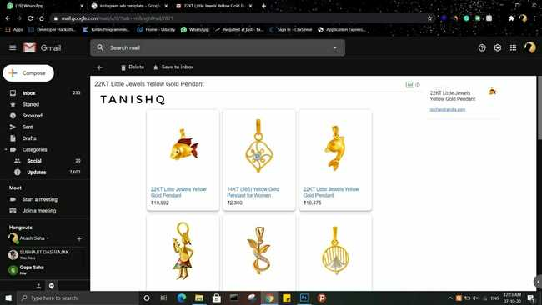

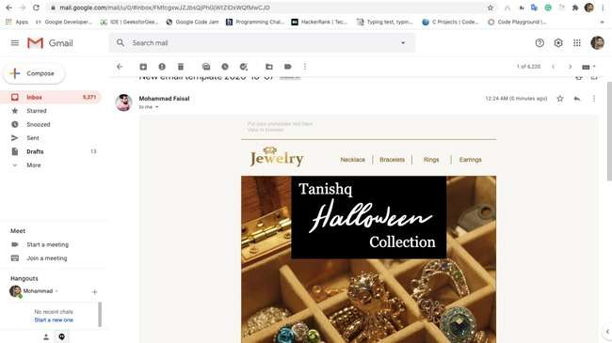

- Sms Advertising
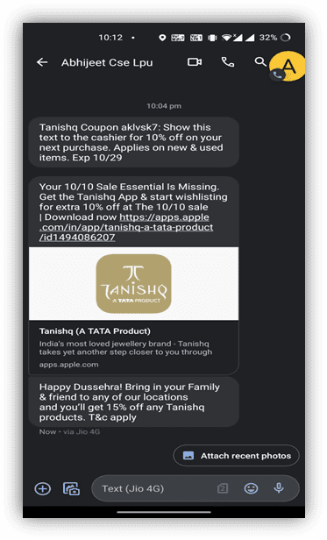
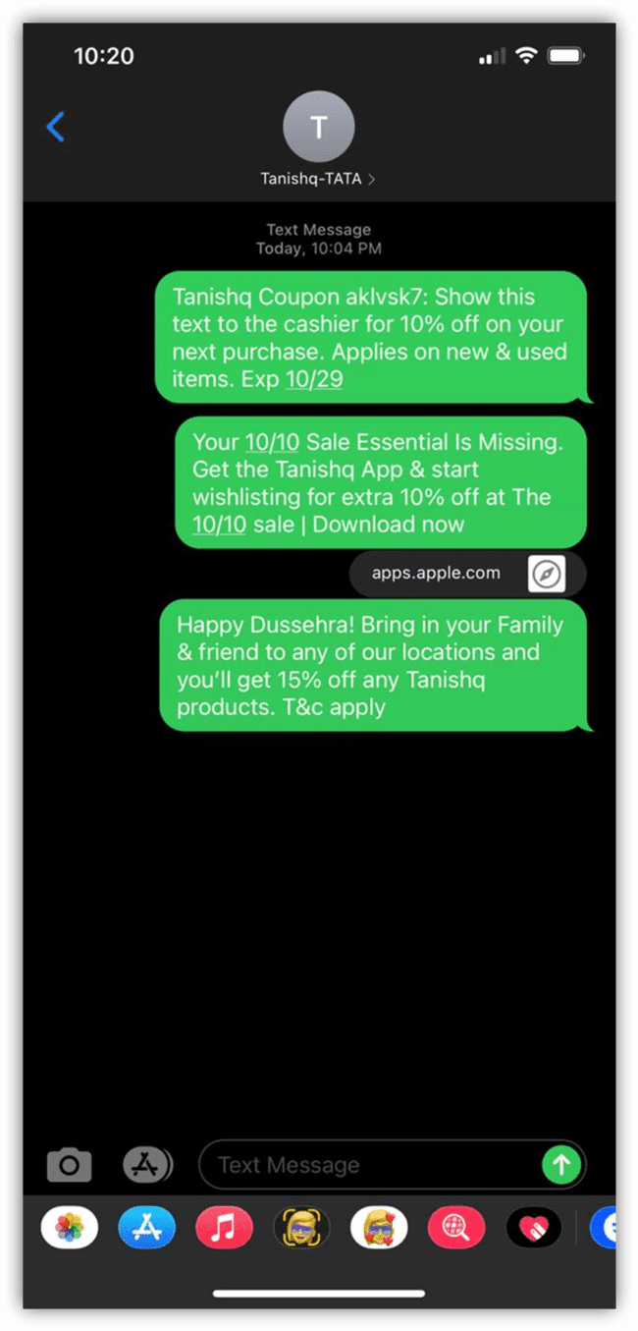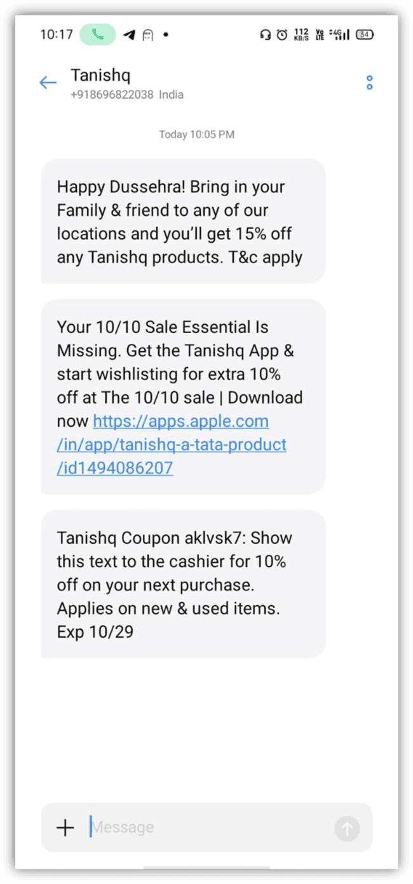

Mobile Social Media Marketing

Mobile social media marketing is a technique of marketing via social media on mobile devices. It is researched that nearly 71% users access social media on mobile devices. Mobile devices are over taking desktops/laptops as they come handy to users; thus, making them a great channel for advertising and so are the social media get influenced by them. Advertisers find mobile devices more convincing ground than web and consider it as the perfect medium for marketing.

- Facebook Advertising
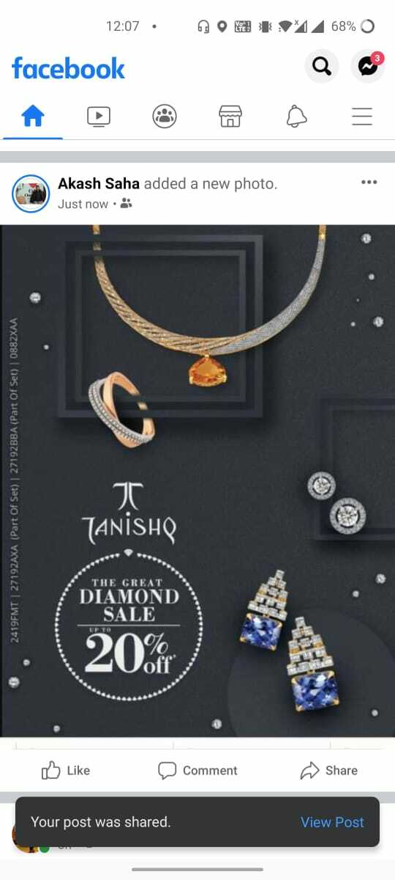
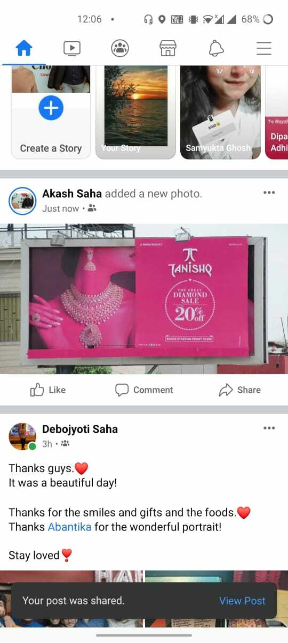

- Instagram Advertising
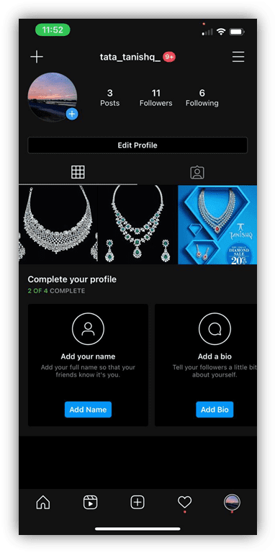
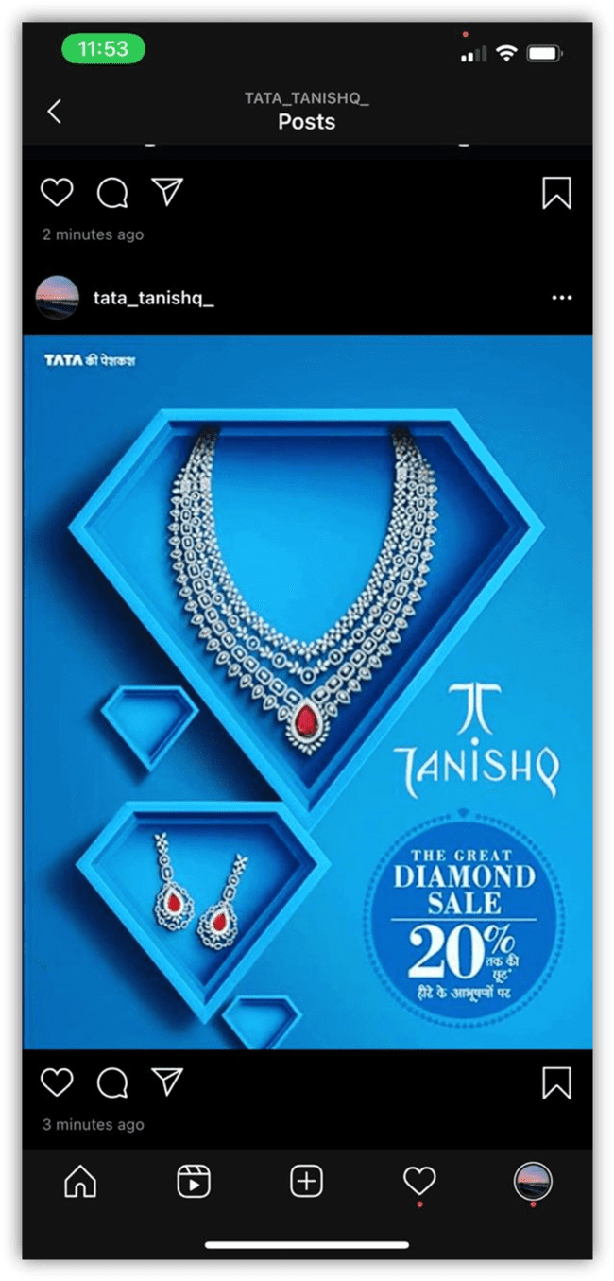
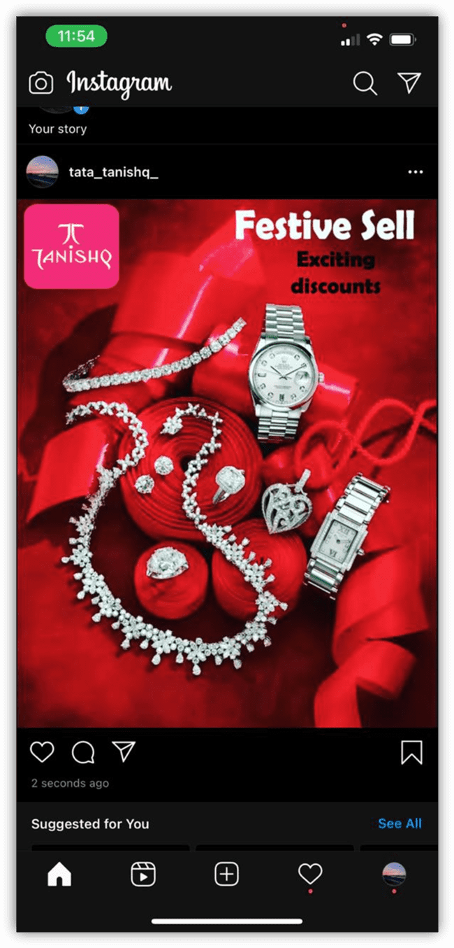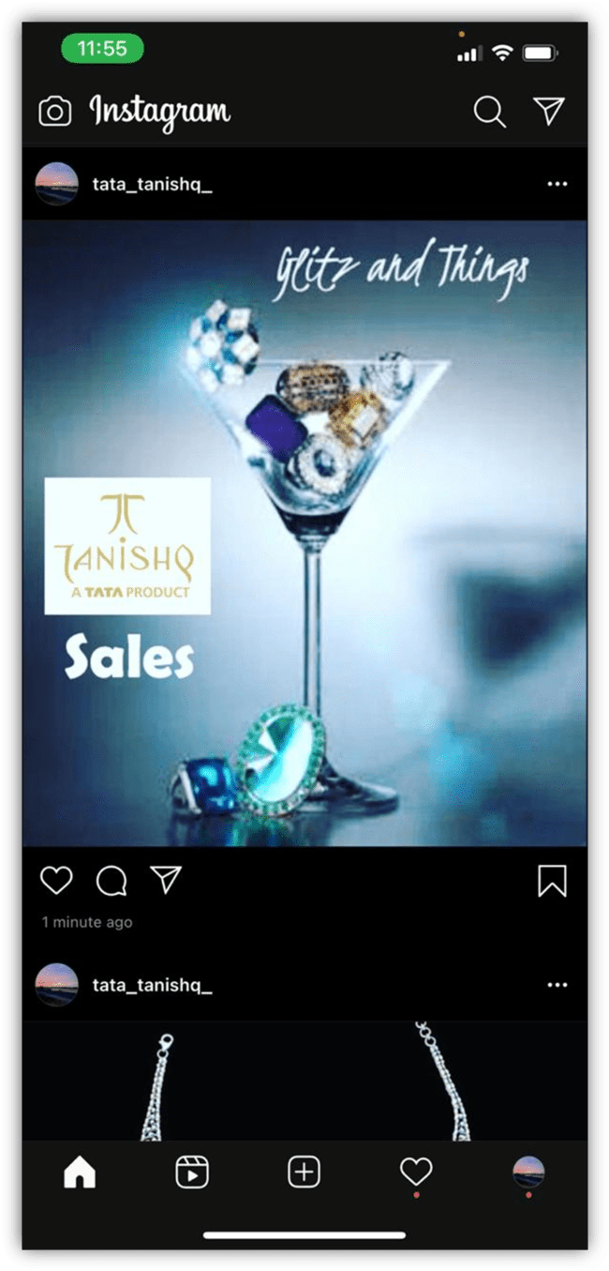

- Whatsapp Advertising
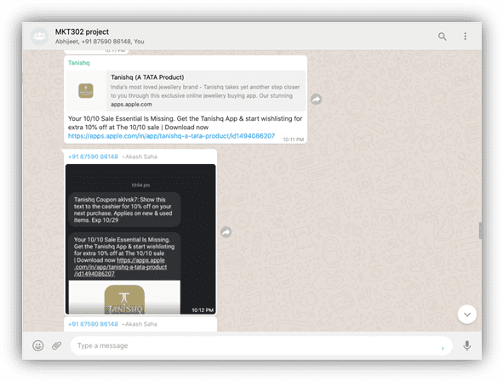

- Youtube Advertising
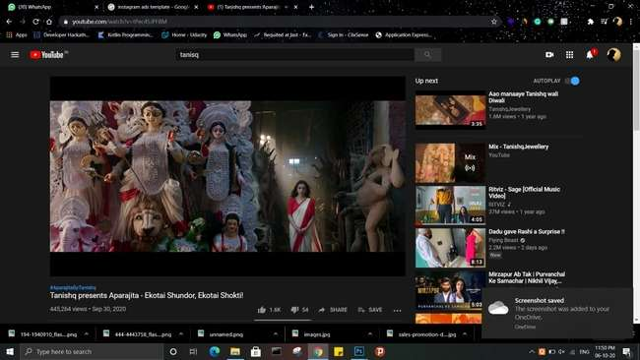

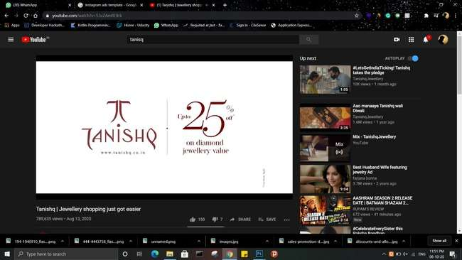

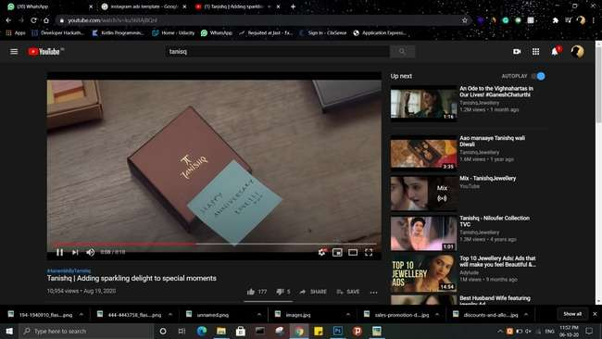

Conclusion:
The empirical results show that intensity of Advertising Creativity is a contributing factor in the effectiveness of an ad. ... In short, the central findings of this study provide a factual basis for the concern that higher Advertising Creativity leads to greater effectiveness.

Reference:

- Textbooks
- Wikipedia
- Investopedia
- Youtube Marketing lectures
- Reports on marketing

