Name: Mohammad Faisal
Section: (KM012) Course Code: INT222 CA(3)
Roll No: B 36
Reg. No. 11702044

Question 1:
Create an express application that has an admin module only which takes employee data (name, email, phone number, city(dropdown) and DOB via form and store all the info in ‘employee.json’ file. On Home page list all employee names with their email id. (Use MVC architecture)

router.get('/submitdata', function(req, res, next) {
res.render('submitdata', { title: 'Employee Data' });
});

router.post('/submitdata',(req,res)=>{

var name=req.body.name;
var email =req.body.email;
var phone=req.body.phone;
var city=req.body.city;
var dob=req.body.dob;

var data={
name:name,
email:email,
phone:phone,
city:city,
dob:dob
}

var file = JSON.stringify(data);

fs.writeFileSync('employee.json',file,finished)

function completed()
{
console.log("success");
}

})

JSON file

{
"name":"amit",
"email":"amit@gmail.com",
"phone":"9087239842",
"dob":"2020-10-19"
},
{
"name":"Rakesh",
"email":"rakhs@gmail.com",
"phone":"9087212342",
"dob":"2020-10-19"
},
{
"name":"akansha",
"email":"akansha@gmail.com",
"phone":"9086239842",
"dob":"2020-10-19"
},

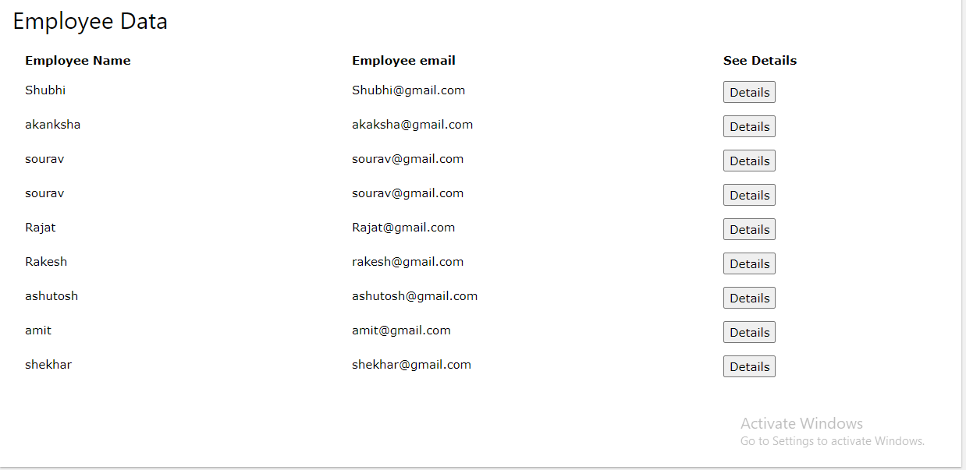

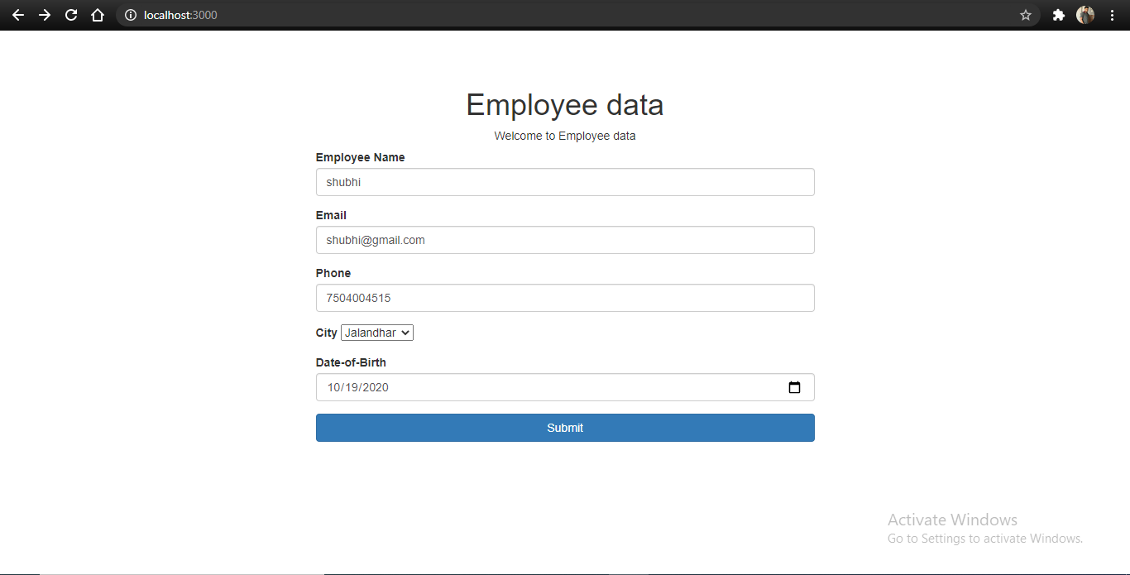

Question 2
In the question above, on home page when admin clicks on any employee, employee details should be fetched and displayed on web page. (Use css to design web page)

router.get('/submitdata', function(req, res, next) {
res.render('submitdata', { title: 'Employee Data' });
});

router.post('/submitdata',(req,res)=>{

var name=req.body.name;
var email =req.body.email;
var phone=req.body.phone;
var city=req.body.city;
var dob=req.body.dob;

var data={
name:name,
email:email,
phone:phone,
city:city,
dob:dob
}

var file = JSON.stringify(data);

fs.writeFileSync('employee.json',file,finished)

function completed()
{
console.log("success");
}

res.render('submitdata',{
name:data.name,
email:data.email,
phone:data.phone,
city:data.city,
dob:data.dob,

title:'employee data'} )

})

On clicking the details button the employee details will be fetched

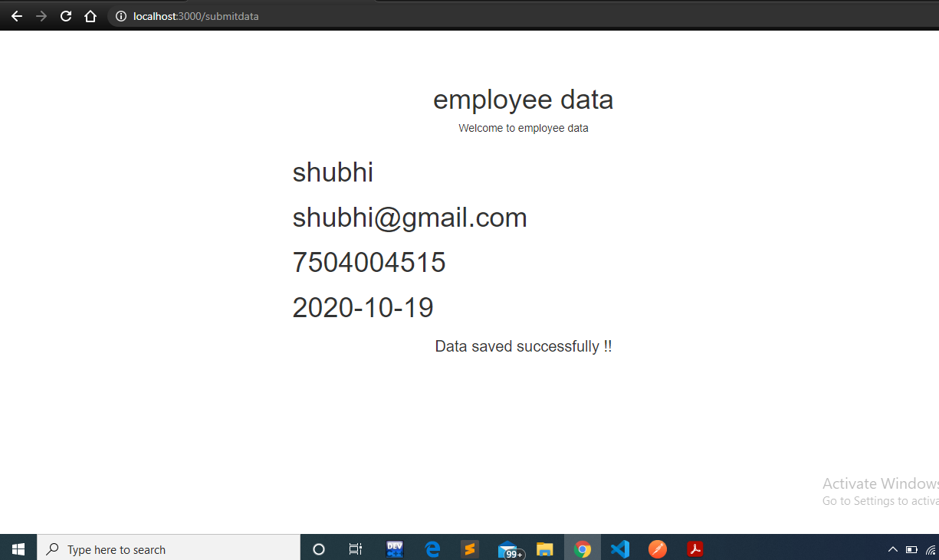

Question 3
Create a REST API endpoint ‘/addNumbers’ which takes two numbers from users and returns the sum. Note: When user submits the request, before displaying the result, a middleware ‘checkNumbers’ should be called which will verify that numbers entered is greater than zero. If not, error message and error code 402 should be returned. (You can use POSTMAN to hit the API)

router.post('/addnumbers',(req,res)=>{
console.log(req.body)
const {first,second}=req.body
// console.log(first)
const a=parseInt(first)
const b=parseInt(second)
console.log(a+b)

if(a<=0 || b<=0)
{
return res.status(404).json({error:"number must be greated than 0 !"})
}
const sum=a+b

return res.status(200).json({message: "The result of two numbers "+sum})
})

