## # Analysis of Data Source Using Autopsy

The Sleuth Kit is a library and a collection of command-line tools used to investigate disk images. Autopsy is the GUI program for TSK. The results of the forensic search carried over the images are displayed here. These results help the investigator to locate relevant sections of data in their investigation. It is used by law enforcement, military, and corporate examiners to investigate the actions taken place on the evidence computer, however, it can be used to recover deleted data from digital devices too

**Getting Started:**

Open Autopsy and create a new case.

Click on **Finish**after completing both the steps.

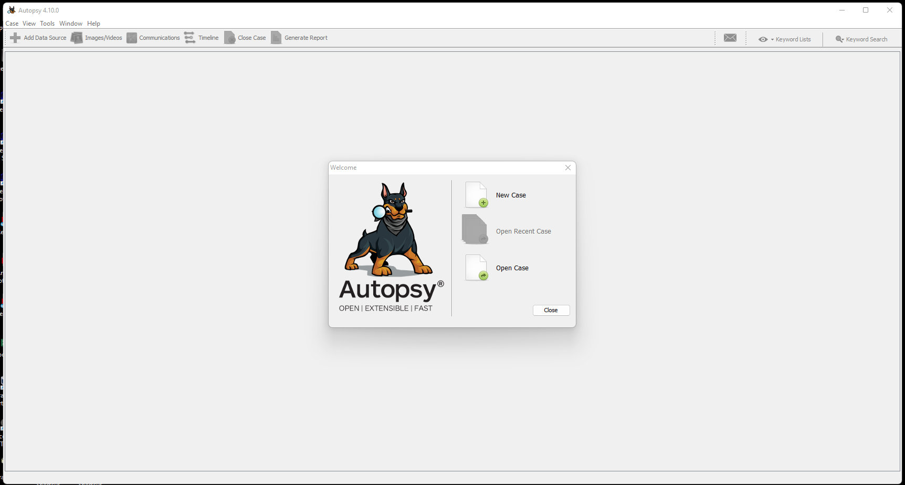

**Add a data source:**

Select the appropriate data source type.

Logical Files. : Includes local folders or files

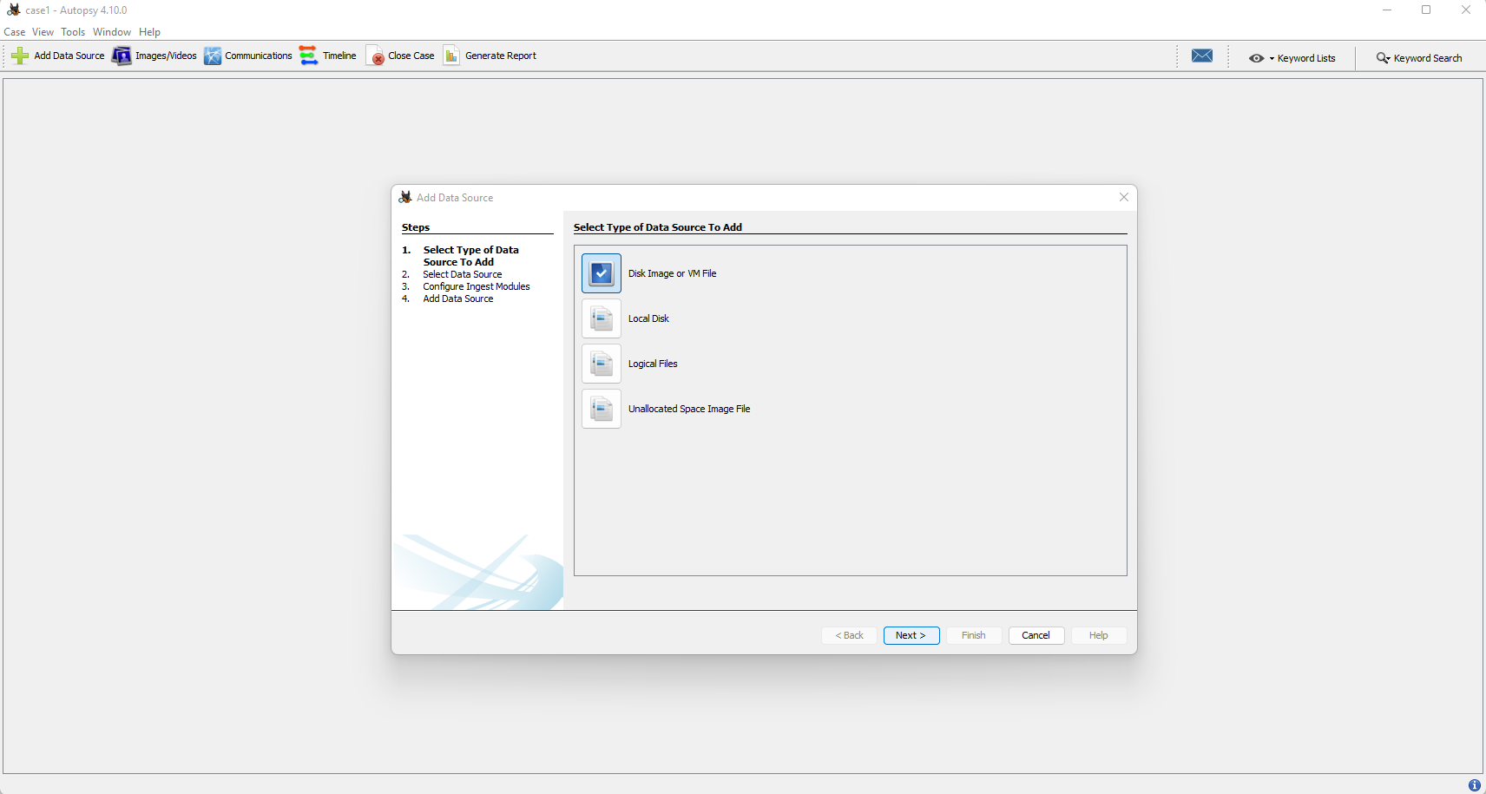

The data source used here is a Logical Files.

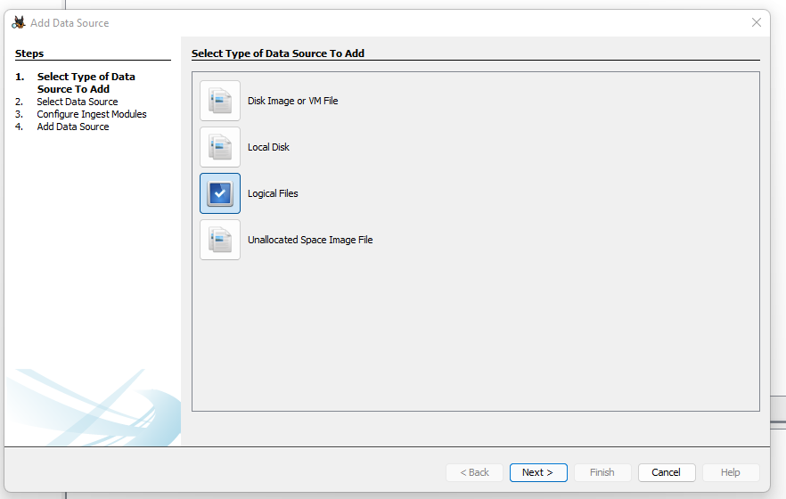

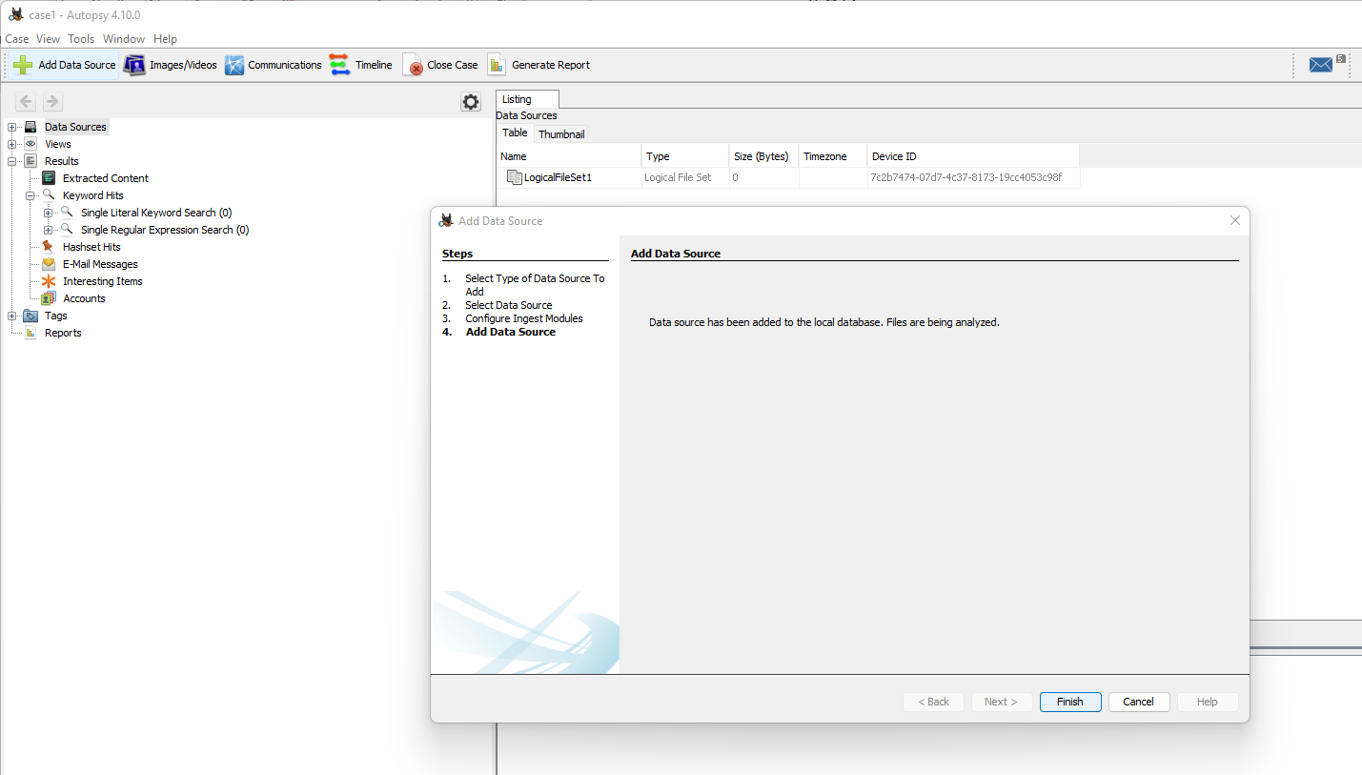Add the data source destination.

Configure ingest modules.

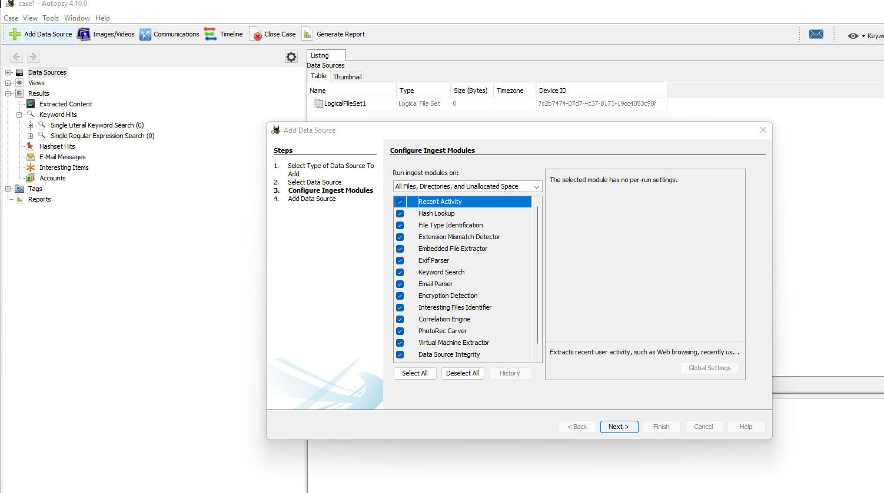

Now to generate a report select the Data that you want a report on

Click on generate report

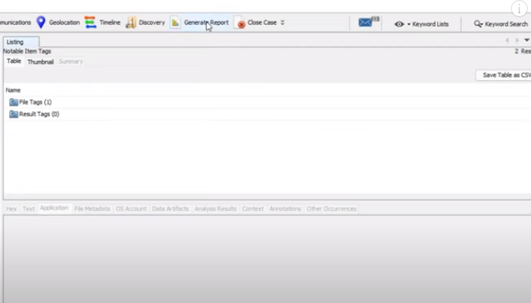

Choose HTML

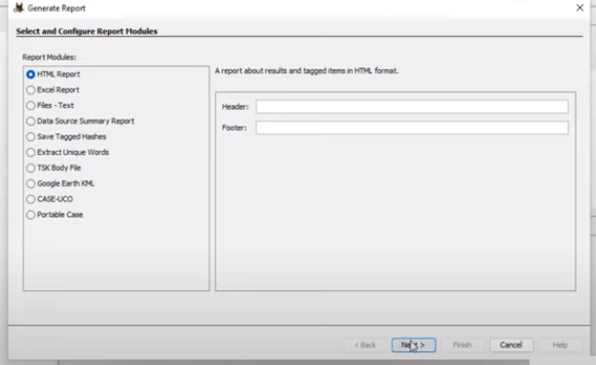

Select all results and click on finish

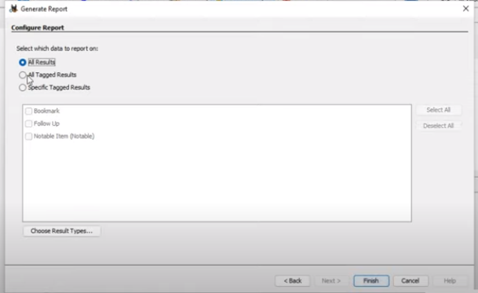

Click on the link to show the report

