Lab 2: Bastion Host

Subnets Created:

Public EC2 Instance with the public subnet created.

Successful login to bastion server.

EC2 Instance B created using private subnet:

Successful login to private server from bastion host server:

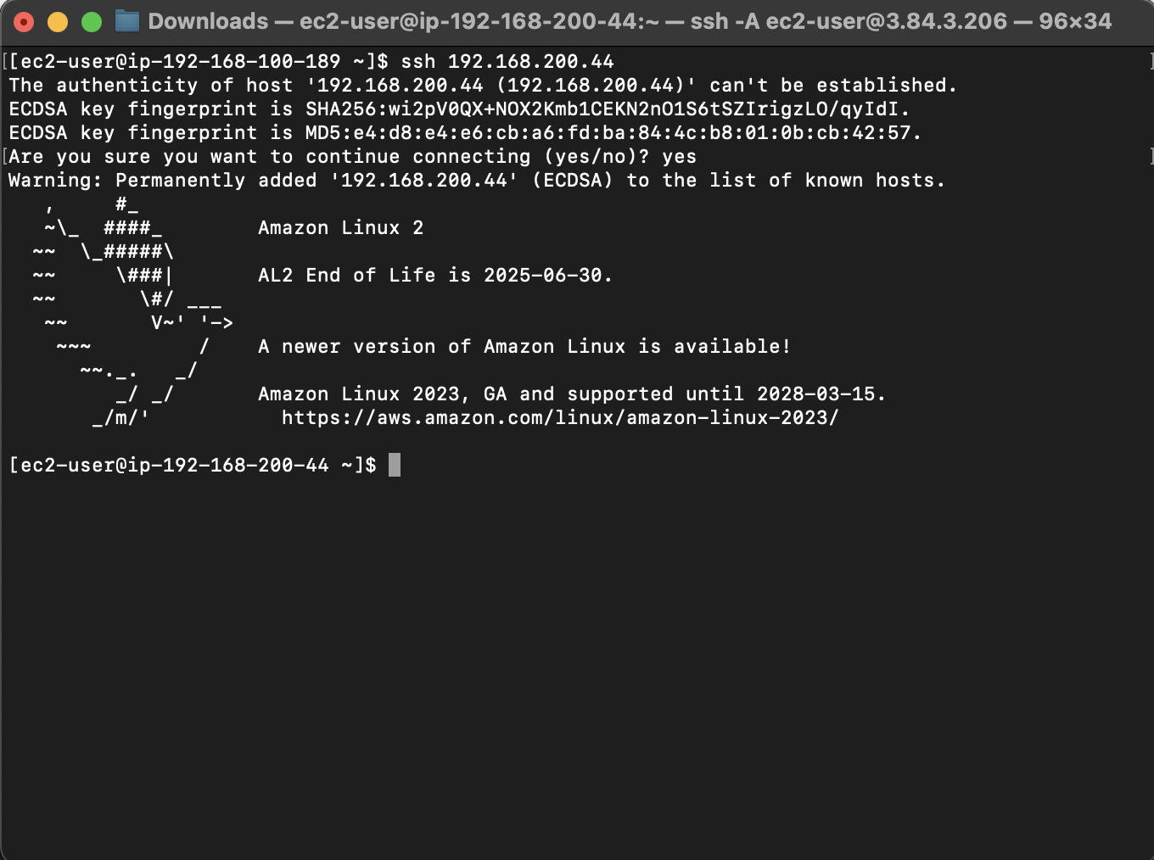

VPC Resource Tab till Endpoint:

Connecting to EC2 Private. Configuring AWS CLI with access key and creating some test files.

List of all S3 bucket:

Uploading some files into lab002-bucket-het:

Downloading a file from S3:

