Contents

Chapter 1 2

Introduction 2

Justification 2

Background of the project 2

Project description 2

Features of the project 2

Project Overview 3

Chapter 2 - Scope of the project 4

Project Scope 4

Limitation 4

Aims 4

Objectives 4

Overview of the scope 4

Chapter- 3- Development Methodology: 5

System Architecture 6

Chapter 4: Project Planning 8

WORK BREAKDOWN STRUCTURE (WBS): 8

Time estimation: 9

Milestones 10

SCHEDULING 11

Chapter 5 - Other project activities: 13

RISK MANAGEMENT: 13

Configuration Management 15

Conclusion 16

References 17

# Chapter 1

## Introduction

Motors International is an online vehicles and vehicles accessories portal which provides various information of vehicles with their features and provides an easy platform for buyers,sellers,dealers to buying and selling Vehicles and its related inventories. This Vehicles Portal only consists two main type of vehicle i.e. bikes and cars at the moment. This website facilities users for online registration of vehicle servicing. It will help people to buy/sell vehicle from anywhere in the country/world. Credit card payment, online payment gateway like esewa, khalti, PayPal, etc is available.

## Justification

This project would become one of the best market place and information source on vehicle bought and sold. This system is meant to being developed to provide a better and trustworthy platform where user can easily buy and sell new as well as old bike/car, vehicle parts and inventory online of their choice without having to come manually to store to purchase the product.

## Background of the project

The proposed project can be beneficial for every possible people who are seeking to buy or sell bike/car and its related accessories or search possible content in the website. This web could work as a *Vehicles portal.* Dealers can add their bike/car details. All required features are also previewed in the website.

## Project description

The main aim of this project is to create a vehicle portal website that provides convenient, affordable, and quick buying and selling of vehicle’s and related sales system. This application is a combination of both sales and inventory management of the bike/cars and bike/cars parts. This system also consists of rental facilities of bikes/cars. I will develop this project with an object oriented approach, PHP and MySQL will be used for data handling and submission and JavaScript for interactive elements and enhancing user experience. Furthermore, its main features are discussed below.

## Features of the project

* **Easy comparison:** Users can easily compare the prices or specification of different vehicles and chose one that fits their budget.
* **Vehicle and its parts listing and Features:** User can view list of vehicle and its parts and specification of the vehicle and its parts.
* **Shopping Cart: -** User can select the product and add to the shopping cart which they wants to purchase.
* **Booking and notification:** User can book the upcoming vehicle before certain time of launch and are notified in the website.
* **Vehicle Blog Section: -** Motors’ can post comment and registered user can comment over it.
* **Sell Vehicle: -** User can even sell their bike/car and get response from other user.
* **Vehicle Servicing: -** User can register for online vehicle service, where admin will get to know about date and time user wants to provide vehicle for service.
* **Easy and secure payment:** The website facilitates an online payment system and card payment system whose security will be ensured to users.
* Appealing UI & UX(User Interface and User Experience)

Project Overview

My project Motors International includes dealing between seller and buyers. It includes a search facility to know the current status of each related website. User can search availability of a deals related website. The user can be entered using a username and password. It is accessible either by a seller or buyer. User can enter their requirements, actually describes what the user want. The data can be retrieved easily. The interface is very user-friendly. The data are well protected for personal use and makes the data processing very fast. Buyer can search any of the vehicle according to his/her required features. User can view dealer feedback and reputation as added by previous buyers. Blog is also added where persons can comment and share their opinion about vehicle.

# Chapter 2 - Scope of the project

## Project Scope

The main goal of this project is designing and developing an interactive Vehicles and its related Sales online System. The current system in use is a paper-based system. It is too slow and cannot provide the information about existing users. The intentions of the system are to reduce over-time pay and increase the number of users that can be treated accurately. Requirements statements in this document are both functional and non-functional. We are going to develop an online project for customers where they can get information about buy or sale of cars easily. The Vehicle Sales System follows closely with other developed Information Systems focusing on achieving better transactions and more customer satisfaction.

## Limitation

* The Servicing of Vehicle will be in limited area.
* There is a limited transactions possible for local online payment gateway due to rules set by government.

## Aims

The aims of my project are simply enlisted below.

* To build easy and trust worthy web based application to buy and sells bikes/cars and related sales system online.
* To uplift the Motors International system and satisfy customers to its top prior.

## Objectives

* To create a database to record details of vehicle, parts, vehicles, and servicing.
* To minimize cost of system through centralized data that requires less staff under controlled environment.
* To provide confidentiality, integrity and security to users data.
* To reduce hard work and time consumption.
* To create simple interface with less data to fill up to encourage more users to use the system.
* To perform user-friendly vehicle trade online system

## Overview of the scope

This project behaves as a portal which gives a platform for the customer to buy or sell bikes/cars and many more. The main aim of the system is to make user satisfy through our services

# Chapter- 3- Development Methodology:

There are various system development methodology which are used to plan, structure and control the development process of a system. Some of them are Waterfall, DSDM (i.e. Dynamic System Development Model), Agile, Prototype, etc. Among them, I have chosen to follow the *Waterfall Model* for this project.

The waterfall model is the traditional model for software development. It is the most relevant methodology for my project as it is well planned and each phase must be completed before the going to next phase and there is no overlapping in the phases which is the principle of waterfall model. Waterfall model consists of following major steps which are shown in diagram below:

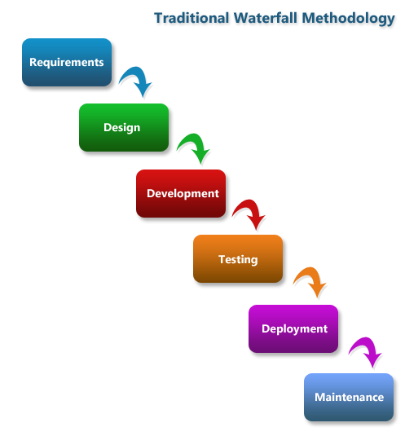

*Figure 1: Waterfall Model*

Some of the reasons of why I choose waterfall model are:

* Simple and easy to use and understand even for beginners.
* Thorough planning and scheduling is ensured.
* Simple enough to handle as model is rigid.
* Easy to keep track of the task due to clearly defined phases.
* Provides easy analysis and testing.

For the design pattern, I have chosen MVC (Model View Controller) pattern. Individual layers can be changed without impacting on others layers. It reduce the code duplication by separating data and business logic. It aids in rapid application development.

* **Model**- Model handles the business logic and the application data. It can be used to perform data validations, process data and store it.
* **View**- Views handles the presentation of the state of the model to the user. This is usually in form of HTML pages.
* **Controller**- Controller allows the user to interact with the model. It handles the user request for resources from the server.

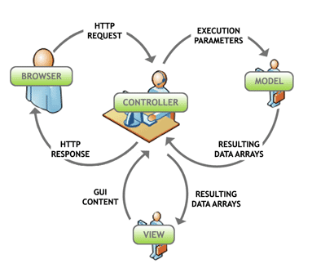

*Figure 2: MVC Design Pattern*

## System Architecture

Three-tier architecture is a well-established client-server software architecture which allows any one of the three tiers to be upgraded or replaced independently. The three tiers in a three-tier architecture are:

* Presentation Tier: It is the top most appearance layer which displays information related to services available on a website. Communication between the tiers are achieved by sending results to the browser in the network.
* Application Tier: It controls application functionality by performing detailed processing.
* Data Tier: It is the data houses where information is stored and retrieved. Data is kept independent of application servers or business logic in this tier.

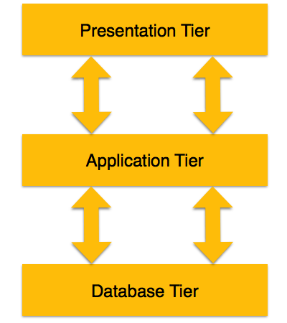

*Figure 3: 3-Tier Architecture*

The Tools that will be used in this project are:

|  |  |
| --- | --- |
| Programming Paradigm | Object Oriented |
| Server Solution Stack | XAMPP |
| Modelling Tool | Visual Paradigm |
| Framework | CodeIgniter (CI) |
| Programming language | PHP |
| Database | MySQL |

# Chapter 4: Project Planning

Undertaking a project we must begin with a project plan if we want it to be successful. Planning at the beginning helps to save time, helps to monitor the progress of the project.

## WORK BREAKDOWN STRUCTURE (WBS):

WBS (i.e. Work Breakdown Structure) defines the work that needs to be fulfilled in order to produce the product. A hierarchical subdivision of a project into work areas is represented. It provides the foundation for all project management work, including cost estimation, resources allocation, scheduling etc. Moreover, it reduces complexity of a project by breaking a project into many parts. The activities that needs to be undertaken individually during this project completion is diagrammatically shown below in the following hierarchical chart given below:

*Figure 4: WBS of Motors International*

## Time estimation:

Following table shows time estimation of the project.

|  |  |  |
| --- | --- | --- |
| **WBS** | **Task name** | **Days** |
|  | **Motors International** | **109** |
| **1** | **Proposal** | **15** |
| 1.1 | Overview | 2 |
| 1.2 | Scope & Development methodology | 2 |
| 1.3 | Project planning | 2 |
| 1.3 | Monitoring and Controlling | 3 |
| 1.4 | Project Scope | 2 |
| 1.5 | Development Method | 2 |
| 1.6 | Conclusion & References | 2 |
| **2** | **Analysis** | **29** |
| 2.1 | Existing system analysis | 11 |
| 2.2 | Business pattern | 12 |
| 2.3 | User requirements | 6 |
| **3** | **Design** | **26** |
| 3.1 | Database design | 11 |
| 3.2 | Structural design | 9 |
| 3.3 | Behavioral design | 6 |
| **4** | **Implementation** | 21 |
| 4.1 | Front-End Coding | 8 |
| 4.2 | Back-End Coding | 8 |
| 4.3 | Database Built | 5 |
| **5** | **Testing** | **7** |
| 5.1 | Black box testing | 4 |
| 5.2 | White box testing | 3 |
| **6** | **Report** | **11** |
| 6.1 | Documentation | 7 |
| 6.2 | Final report | 4 |

*Table 1: Work Breakdown Structure*

## Milestones

It helps us to remind the deadline by calculating the project timeline which acknowledges us to complete our tasks gradually on time. Following table shows milestones of the project:

|  |  |  |  |  |
| --- | --- | --- | --- | --- |
|  | **Topic** | **Start Date** | **Deadline** | **No. of Days** |
| **1** | **Proposal** | **26th March,2019** | **9th April,2019** | **15** |
| 1.1 | Overview | **26th March,2019** | **27th March,2019** | 2 |
| 1.2 | Scope & Development methodology | **28th March,2019** | **29th March,2019** | 2 |
| 1.3 | Project planning | **30th March,2019** | **31th March,2019** | 2 |
| 1.3 | Monitoring and Controlling | **1th April,2019** | **3th April,2019** | 3 |
| 1.4 | Project Scope | **4th April,2019** | **5th April,2019** | 2 |
| 1.5 | Development Method | **6th April,2019** | **7th April,2019** | 2 |
| 1.6 | Conclusion & References | **8th April,2019** | **9th April,2019** | 2 |
| **2** | **Analysis** | **10th April,2019** | **8th May,2019** | **29** |
| 2.1 | Existing system analysis | **10th April,2019** | **20th April,2019** | 11 |
| 2.2 | Business pattern | **21st April,2019** | **2th May,2019** | 12 |
| 2.3 | User requirements | **3th May,2019** | **8th May,2019** | 6 |
| **3** | **Design** | **9th May,2019** | **3rd June,2019** | **26** |
| 3.1 | Database design | **9th May,2019** | **19th May,2019** | 11 |
| 3.2 | Structural design | **20th May,2019** | **28th May,2019** | 9 |
| 3.3 | Behavioral design | **29th May,2019** | **3rd June,2019** | 6 |
| **4** | **Implementation** | **4rd June,2019** | **24rd June,2019** | 21 |
| 4.1 | Front-End Coding | **4rd June,2019** | **11rd June,2019** | 8 |
| 4.2 | Back-End Coding | **12rd June,2019** | **19rd June,2019** | 8 |
| 4.3 | Database Built | **20rd June,2019** | **24rd June,2019** | 5 |
| **5** | **Testing** | **25rd June,2019** | **1st July,2019** | **7** |
| 5.1 | Black box testing | **25rd June,2019** | **28rd June,2019** | 4 |
| 5.2 | White box testing | **29rd June,2019** | **1st July,2019** | 3 |
| **6** | **Report** | **2st July,2019** | **12st July,2019** | **11** |
| 6.1 | Documentation | **2st July,2019** | **8st July,2019** | 7 |
| 6.2 | Final report | **9st July,2019** | **12st July,2019** | 4 |

*Table 2: Milestones of the project*

## SCHEDULING

After the creation of WBS, now scheduling of the project can be initialized. The project schedule contains information about what should be carried out, resources utilized and project due. In a nutshell, it is same as a regular timetable that outlines start and end dates of tasks and milestones that should be fulfilled in order to finish the project on time. Project schedule can be represented using a Gantt chart.

The following Gantt chart displays the scheduling of this project:

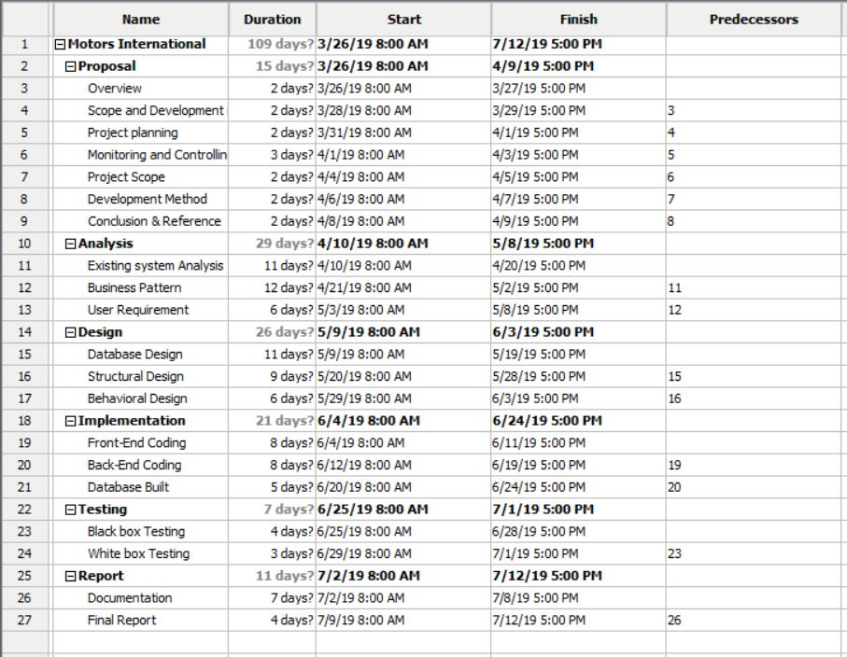

*Figure 5: Scheduling of* ***Motors International*** *project*

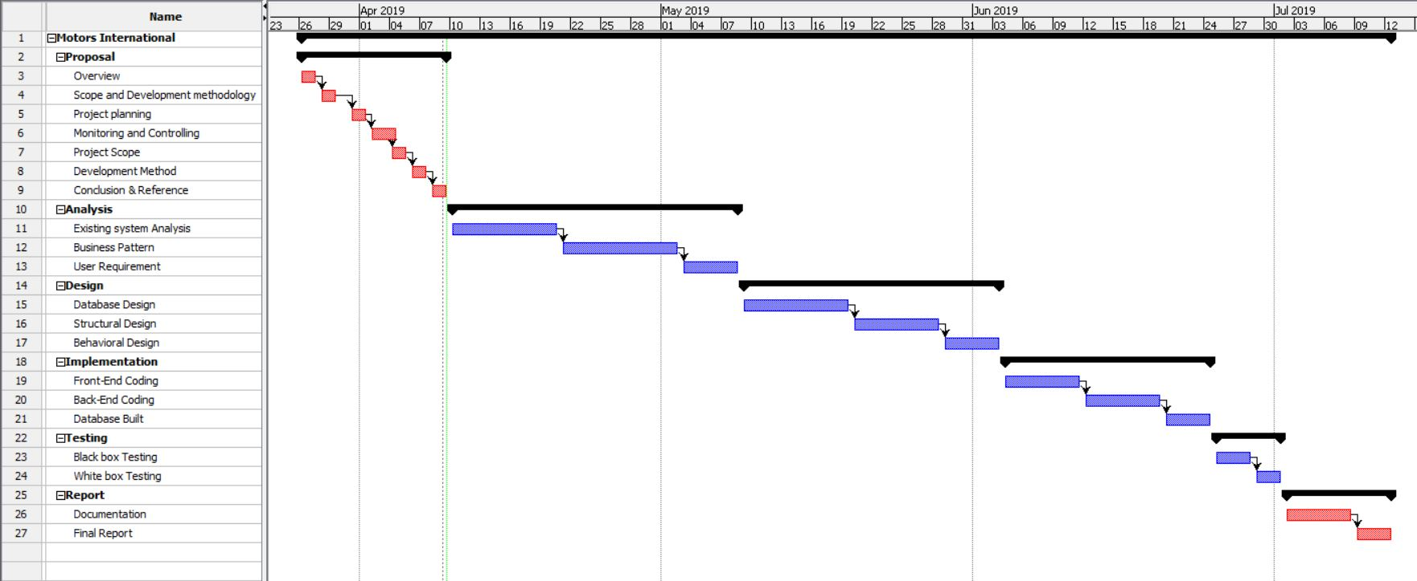

*Figure 6: Gantt chart of* ***Motors International*** *project*

# Chapter 5 - Other project activities:

This part covers risk and configuration management of this project.

## RISK MANAGEMENT:

Risk management involves identification of potential risks at first and then analyzing them and at last precautionary steps are taken to reduce those risks. Risk analysis helps to minimize impact, reduce exposure, address regulatory issues, avoid potential litigation, etc. Risk Management is an important aspect of development of the project which uplift the level of success of the project.

Moreover, the following are the steps for risk management:

* **Identify Risk:** It begins with recognizing and explaining risks and its outcome. Several risk identifying tools/techniques can be used.
* **Analyze Risk:** Here, the likelihood and consequences of each risk identified are determined.
* **Evaluating Risk:** Here, the identified risks are evaluated or ranked by determining the risk magnitude i.e. obtained by the combination of likelihood and consequence.
* **Treat Risk:** Different plans are made to overcome those risks to achieve acceptable risk levels. It aims to cut off the probability of the negative risks and enhance opportunities.
* **Monitor and Review Risk:** With the help of a Project Risk Register, risks are monitored, tracked and reviewed.

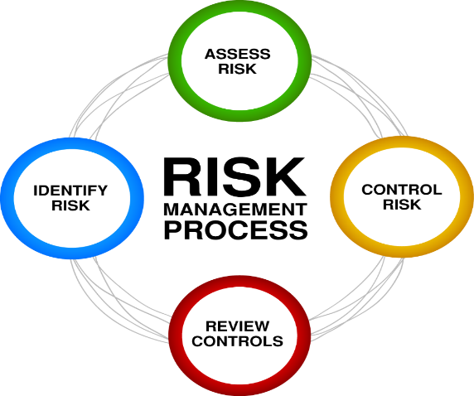

*Figure 7: Risk management process*

To estimate the impact of each identified risk we use

I.e. Impact = Likelihood * Consequences

In this relation, the likelihood and consequence values are assigned based on the scale shown in tables below:

Risk Analysis Lookup table:

|  |  |
| --- | --- |
| **Likelihood** | **Value** |
| Low | 1 |
| Medium | 2 |
| High | 3 |

*Table 3: Risk likelihood*

|  |  |
| --- | --- |
| **Consequence** | **Values** |
| Very low | 1 |
| Low | 2 |
| Medium | 3 |
| High | 4 |
| Very high | 5 |

*Table 4: Risk consequence*

Following are some of the risks for this very project:

|  |  |  |  |  |
| --- | --- | --- | --- | --- |
| **Risks** | **Likelihood** | **Consequence** | **Impact** | **Actions** |
| Hard disk/server failure | 2 | 4 | 8 | Scheduled backup of data in different locations i.e. Google Drive and GitHub. |
| Data breach | 3 | 4 | 12 | Monitoring staff activities and implementing firewalls and antiviruses. |
| Change in user requirements | 3 | 5 | 15 | Certain client agreement. |
| Power cut/shortage | 1 | 4 | 4 | Standby generators and invertors for alternative source of power. |
| Hardware/Software failure | 2 | 4 | 8 | Scheduled maintenance of the system and updates on software should be carried out. |
| Sick Leave | 1 | 5 | 5 | Re-scheduling time and maintain health while working. |
| Data Theft | 3 | 4 | 12 | Strong security system and back up of the data |
| Natural Disaster | 1 | 4 | 4 | Proper backing up data and mirror server in different geographical region. |

## Configuration Management

Configuration management can be considered as asset control and is important whether or not multiple versions of deliverable will be created. Configuration Management means protecting and monitoring project products from unauthorized change. It ensures that adequate process is in place to provide continuing maintenance for the duration of the product life cycle and the deliverables meet the specified performance criteria.

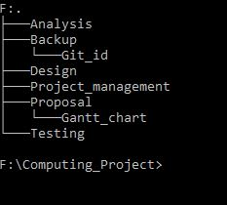

*Figure 8: Directory Structure of* ***Motors International*** *project in local machine*

There is a folder ‘Backup’ where the entire project is backed up. GitLab and Google Drive are used to backup file in this project.

# Conclusion

To conclude, the project will be completed by the deadline following all the planning as discussed in project planning. The final product will be a vehicles Portal website that aims to replace the existing manual system which can be used by users to buy and sell vehicles and their related sales system online. Also, all the aims of this project will be achieved resulting a great uplift in business profit and satisfied customers. Possible risks have also been identified and discussed and so is configuration management. In a nutshell, the project is ready to following the proposal.

# References

SitePoint. (2019). *PHP Master | The MVC Pattern and PHP, Part 1*. [online] Available at: https://www.sitepoint.com/the-mvc-pattern-and-php-1/ [Accessed 8 Apr. 2019].

Techopedia.com. (2019). *What is Three-Tier Architecture? - Definition from Techopedia*. [online] Available at: https://www.techopedia.com/definition/24649/three-tier-architecture [Accessed 9 Apr. 2019].

Workbreakdownstructure.com. (2019). What is a Work Breakdown Structure - Workbreakdownstructure.com. [online] Available at: https://www.workbreakdownstructure.com/ [Accessed 8 Apr. 2019].