# 3 Design

## Introduction

Design is a work process that has user prospective and carries development based on own specific customer’s needs. Design helps to show the whole project how it will be built and works.

## 3.1 Structural Model

Structural model describe the structure of the objects that supports the business processes in an organization. During analysis structural model presents the logical organization of the object without indicating how they are stored, created, or manipulated.

## 3.1.1 Final Class Diagram

A class diagram in the Unified Modelling Language (UML) is atypeofstaticstructurediagram that describes the structure of a system by showing the system's classes, their attributes, operations (or methods), and the relationships among objects.

## Behavioral Model

Behavioral Model mean using the available and relevant customer and business spending data to estimate future behavior.

## Activity Diagram

In UML, activity diagram is defined as the graphical representation of an executed set of procedural system activities and considered a state chart diagram variation.

This approach is taken to describe how the work flow in the system. This approach tells us what the users are capable of accomplishing in the system.

Notations used

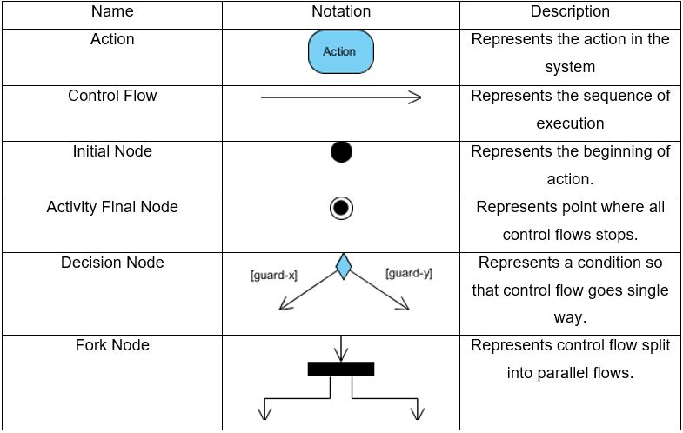

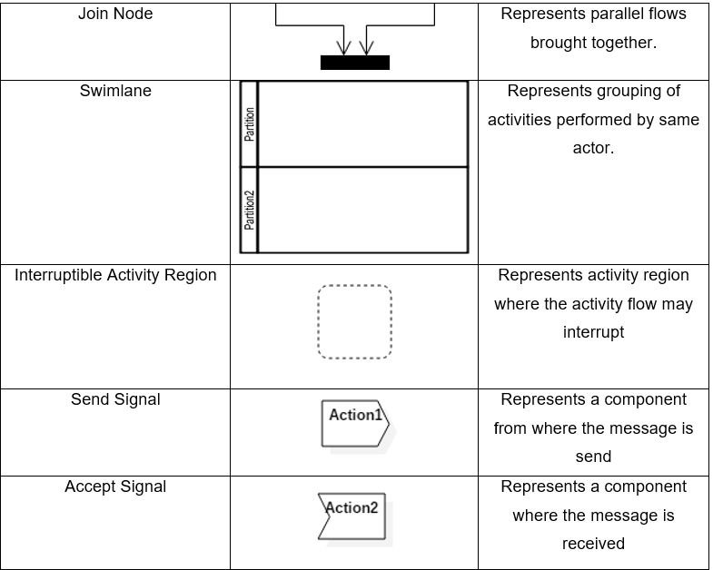

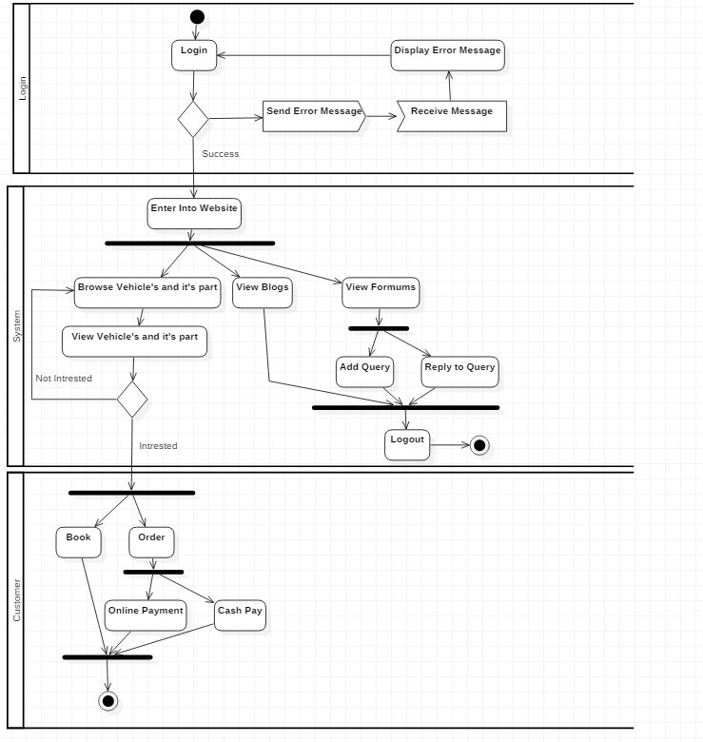

This activity diagram shows general customer can login to the system. If username and password are valid they can enter into the website and can perform different activities like view vehicles and view its accessories, profile, description, and rate. They have access to view blogs and forms they can also add query and reply to query. The user can book and order the product and they can purchase either by cash or online.

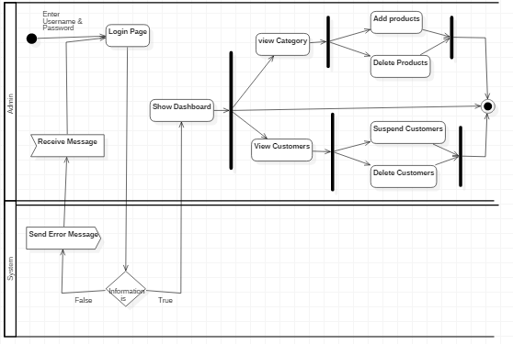

The activity diagram above models is behavior of the system while an admin logs into the system. The activity performed by the admin are all composed in swim lane named Admin. Similarly, the system’s activity is composed in swim lane named System. Admin have access to view customers and they can delete, update and suspend the users if it is necessary.

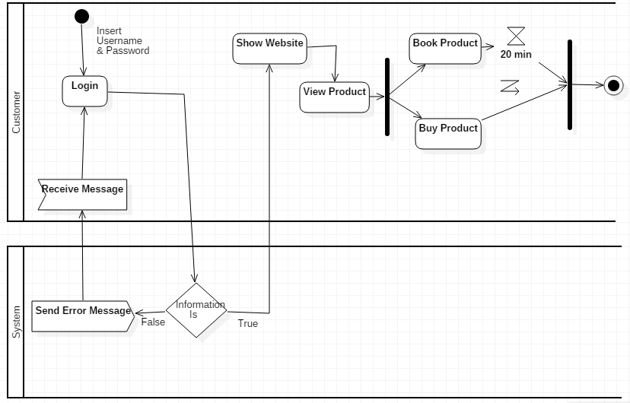

This activity diagram is for the customers for buying the products which are available in the website. Here customers can see different product and can book and buy the products according to their choice. While booking they have time limitation of 20 minutes. Within 20 minutes they should perform booking or else it will be cancelled.

## 3.2.2 Sequence Diagram

Sequence Diagrams are interaction diagrams that detail how operations are carried out. They capture the interaction between objects in the context of a collaboration. Sequence Diagrams are time focus and they show the order of the interaction visually by using the vertical axis of the diagram to represent time what messages are sent and when.

**Symbol and their purpose**

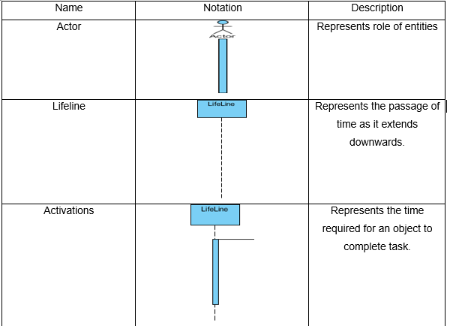

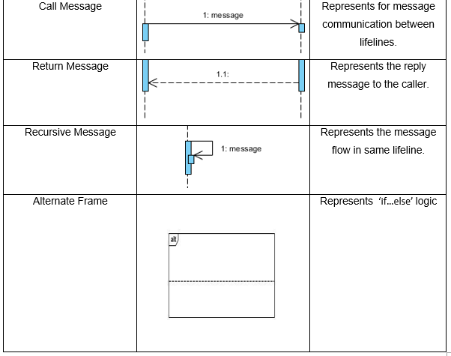

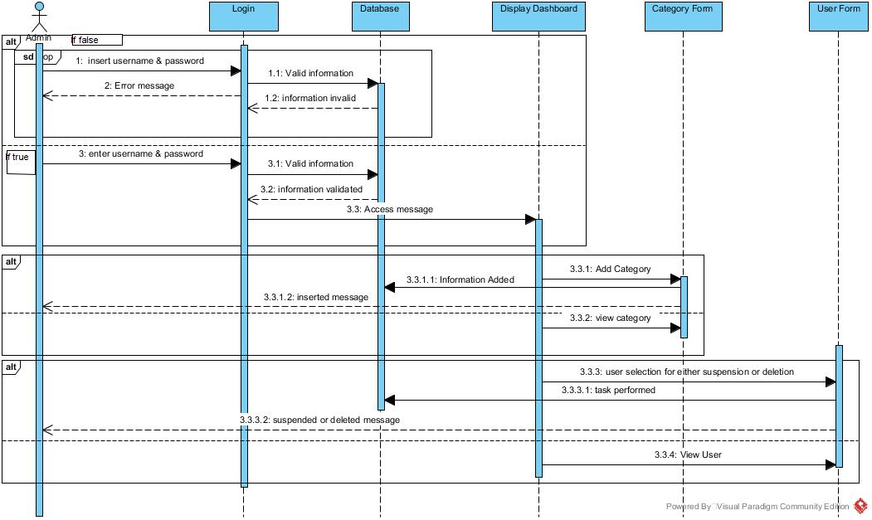

The above sequence diagram show the sequence of the login activity performing in the system. First user enters username and password and goes to database. If the information is not valid the error message of wrong password or username is thrown. If it is correct then user get access to browser or dashboard. They can perform the task like adding and viewing the category.

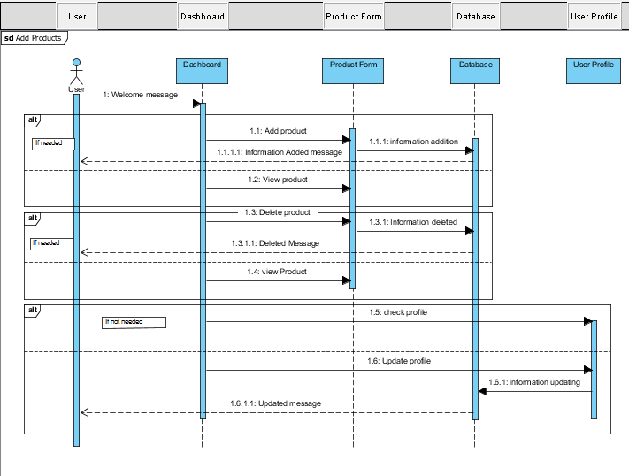

The above sequence diagram shows the sequence of adding, deleting and updating the products. After successfully login into the system admin can goes to product form and add, delete, view and delete product. After performing these tasks it will be updated in the database. Admin can also check user profile, add and update user details. If the task is successful then it will send the message of successful.

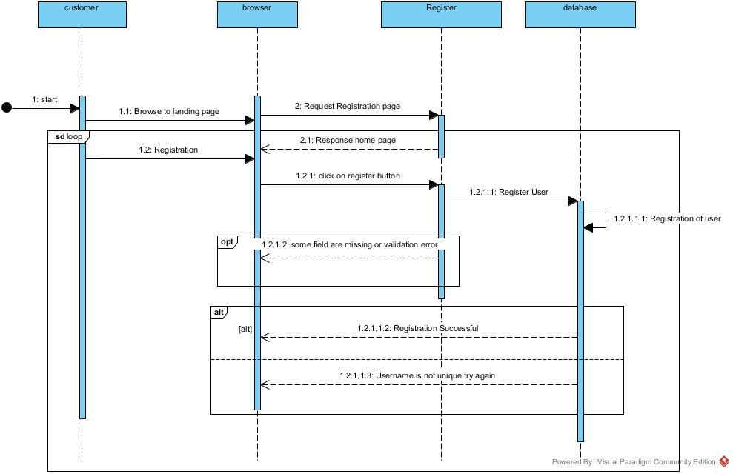

Above sequence diagram shows about the sequence about how user logs into to the system. First user goes to the browser and browse the landing page of the system and request the registration page and enters all the credentials required then forwards it for registration process. If any field in the form is empty then the registration process interrupts with empty message and if all the fields are fulfilled then the user/customer is register and registration success message received.

## 3.3 Database Modeling

A Database model defines the logical design and structure of a database and defines how data will be stored, accessed and updated in a database management system.

## 3.3.1 Data Dictionary

A data dictionary is a file or a set of files that contains a database's metadata. The data dictionary contains records about other objects in the database, such as data ownership, data relationships to other objects, and other data.

1. **For Customer**

|  |  |  |  |  |  |
| --- | --- | --- | --- | --- | --- |
| Column Name | Type | Length | Null | Key | Constraint |
| Customer_id | Int |  | Not null | primary_key | pk_customer_id |
| First_name | Varchar | 50 | Yes |  |  |
| Last_name | Varchar | 50 | Yes |  |  |
| Address | Varchar | 50 | Yes |  |  |
| Phoneno | Varchar | 50 | Yes |  |  |
| Username | Varchar | 50 | Not null |  |  |
| Password | Varchar | 50 | Not null |  |  |

1. **For Orderrpoduct**

|  |  |  |  |  |  |
| --- | --- | --- | --- | --- | --- |
| Column Name | Type | Length | Null | Key | Constraint |
| Order_id | Int |  | Not null | Primary_key | Pk_order_id |
| Order_type | Varchar | 50 | Yes |  |  |
| Quantity | Varchar | 50 | Yes |  |  |
| Delivery_address | Varchar | 50 | Yes |  |  |
| Date_of_order | Date |  | Yes |  |  |
| Date_of_deliver | Date |  | yes |  |  |

1. **For Customer-Order**

|  |  |  |  |  |  |
| --- | --- | --- | --- | --- | --- |
| Column Name | Type | Length | Null | Key | Constraint |
| Customer_id | Int |  | No | Foreign key | Fk_cusid |
| Order_id | Int |  | No | Foreign key | Fk_oid |

1. **For OrderType**

|  |  |  |  |  |  |
| --- | --- | --- | --- | --- | --- |
| Column Name | Type | Length | Null | Key | Constraint |
| Ordertype_id | Int |  | Not | Primary key | Pk_product_no |
| Product_type | Varchar | 50 | Yes |  |  |
| Order_id | Int |  | No | Foreign key | Fk_ordid |

1. **For OrderType_Order**

|  |  |  |  |  |  |
| --- | --- | --- | --- | --- | --- |
| Column Name | Type | Length | Null | Key | Constraint |
| Ordertype_id | Int |  | Not | Foreign key | Fk_ordertype_id |
| Order_id | Int |  | Not | Foreign key | Fk_ordeid |

## 3.3.2 Entity Relationship Diagram

An *entity-relationship (ER) diagram*, is a graphical representation of entities and their relationships to each other, typically used in computing in regard to the organization of data within database or information systems. An entity is a piece of data-an object or concept about which data is stored.

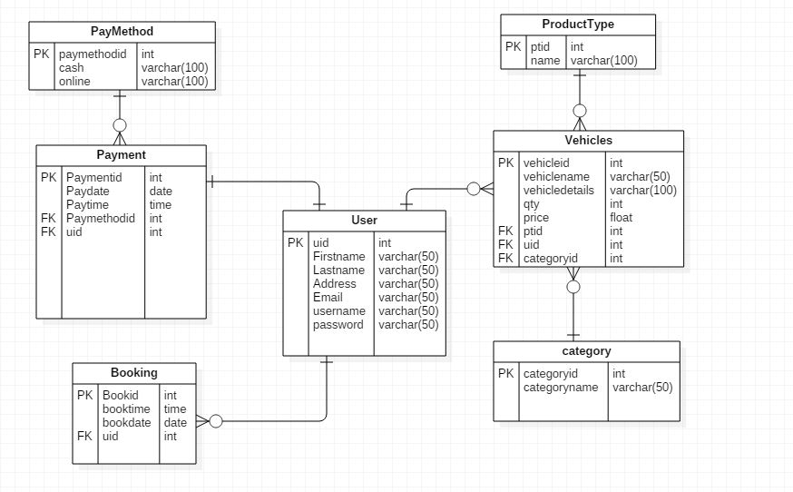

# UI modelling

UI modelling is the approach to model the complex system which does not only provide the guidelines but also the development process including the standardized visual models and notations. One of the best way for modeling the interface is prototyping.

Prototyping

Prototyping is an early approximation of the final project and is performed until an appropriate paradigm is achieved to develop the entire system. Generally, prototyping is considered as the blueprint of the system however many of the details are not built in prototype.

The prototyping has been adopted due to the following benefits:

* Early detection of errors.
* Users get better understanding of the system being developed.
* Usability testing of the system.
* Improve the efficiency in system development.

The prototype that has been built for developing *motors international* is mentioned below:

