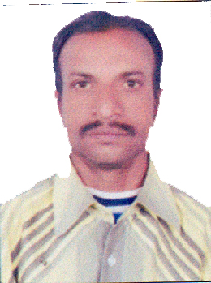

ASHOK KUMAR
Sales / Catering – Restaurant Supervisor

Ashok-393775@2freemail.com

OBJECTIVE

Seeking a good career and holding a responsible position in the reputed organization and ensure credible performance to work towards exceeding the set goals contributes to the organization.

PROFILES

- Hard-working and dedicated
- Can work under pressure with time-bound performance
- Easy adaptability to situations

EDUCATIONAL ATTAINMENT
- Graduation B.COM From Raj. University, Jaipur, India ( 2000 )

d
TECHNICAL QUALIFICATION

- Diploma in Tourism & Resort Management From Jaipur. (2002 )

EXPERIENCE
15th Year Work Experience in Hospitality Industry
- Hospitality Services Jaipur, India
Personal Business Event Management (5 Years 2014-2019)
- Munnas Catering Group, Kolkata
As a Manager ( 2009-2012 )
- CITY PALACE JAIPUR
Restaurant Captain (2006 – 2008 )
- PARK PRIME HOTEL IN F&B DEPARTMENT
(Kitchen Steward (2003 – 2005 )
- Hotel MAYA INTERNATIONAL JAIPUR.
Steward ( 1999 – 2001 )
PERSONAL PROFILE
Gender : Male
Nationality : India
Date of Birth : 02/10/1977
Marital Status : Married
Passport No : T3153494
Language Known : English. Sindhi, Hindi, Rajasthani
Visa Status : Visit visa available till November - 2019)
DECLARATION
I hereby declare that the particulars furnished above are true to the best of my knowledge and belief
ASHOK KUMAR

