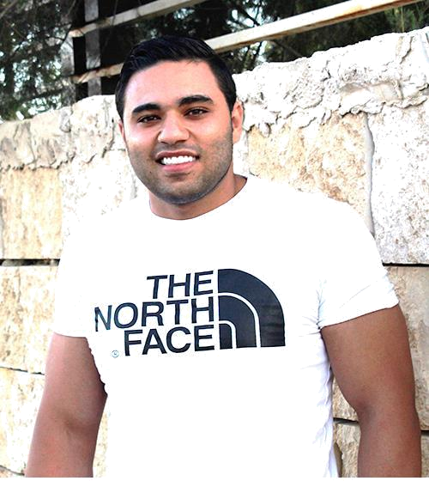

Rasheed

Physical Education Teacher
Fitness / Gym Trainer

rasheed-393655@2freemail.com

Personal information

- Date of Birth: 23rd Mar,1993

- Marital Status: Single

- Gender: Male

- Place of Birth: Nablus city

- Nationality: Jordanian

- Driving License: International Driving Permit

Education

- 2012 - 2017: Bachelor degree in Physical Education-Training |AN-Najah National University, Nablus-Palestine| My Average 2.62 (Good)

- 2007 - 2012: High School Certification (TAWJEHI) | Al-Saadia Secondary School, Qalqilya-Palestine | My Average 79.2

Experiences

May 2018 till now: A planner of nutrition programs for various clients.

May 2014 to June 2019: A personal trainer “Dealt with wide spectrum of People .

Achievements:

- Helping people to obtain their goals and dreams to get a healthy lifestyle of living

- Motivating a group of clients to achieve their fitness goals.

- Group exercise leadership.

- High experience of nutrition and diet advise.

- Exercise modification and injury prevention.

September 2016 to January 2017: A trainee at Al- Shariah Secondary Males School in Qalqilya for 4 months.

Achievements:

- Demonstrated and educated students in the fundamentals of body movement through dance exercise and athletic games.

- Evaluated student’s growth and athletic abilities and developed individualized instruction plans.

- Participated in field trips and extracurricular activities to promote exercise and healthful activities.

- Provided health and physical fitness education in classroom setting.

- Promoted team work through group sport activities and partner-related games.

- Planned educational lessons in coordination with other athletic and related-academic teachers.

- Maintain athletic supply inventory and requisition new sporting goods as needed.

Courses

- Basketball judication course (affiliated to the Palestinian Sports Union)

- CPR, first aid and AED courses.

Qualifications

- Certified Preparation coach.

- Experienced nutrition supplements adviser.

- Intelligible designer of nutrition programs and diets.

- Friendly Customer care assistant.

- Skilled physical therapist.

- Qualified Group Training coach.

- Specialized body building trainer.

Language Skills:

Arabic (Native Language)

English: Reading (Very Good)

Writing: (Very Good)

Conversation: (Very Good)

Understand: (Very Good)

Skills

- Microsoft Office

- Printing Arabic - English

- Internet skills, Social media and Google skills

- Basic PR (Public Relations) skills

- Online counselling

Abilities

- Communication skills and Leadership.

- Ability to work under pressure.

- Ability to work independently and in a team environment

- Problem solving and analysis skills.

- Ability to achieve immediate and long-term goals and meet operational deadlines.

Hobbies

- Sports

- Intercultural learning

- Internet

- Learning Languages

- Photography

- Online purchase

Objectives

- To obtain a position in a stable work environment with growth potential.

- Hard working.

- Looking to utilize my skills and enrich my knowledge.

- Obtain more experience.

