Hurricane Damage Mapper
Automated Building Damage Assessment from Before-and-After Satellite Imagery

Final Project Report
Shahid Abbas
Master of Science in Computer Science
Department of Computer Science, Lamar University, Beaumont, Texas
Advisor: Advisor name
October 2026

Contents
Right-click here and choose Update Field to show the table of contents.
This report has two parts. Part A is the project report: problem, data, method, results and limitations. Part B is a walkthrough of the code, file by file, with a glossary of the terms used.

Abstract
After a hurricane, emergency managers need to know quickly which buildings are damaged and how badly. Today this is done largely by field surveys or by analysts inspecting satellite images by hand, which takes days. This project builds a complete system that does it automatically. Using the public xBD dataset of before-and-after satellite images with expert damage labels, two deep-learning models were trained: a U-Net that finds buildings in the pre-disaster image, and a second U-Net that compares the pre- and post-disaster images and labels each building pixel with one of four damage levels. Building outlines are then extracted, placed on the map, and shown in an interactive web dashboard.
Both models were trained entirely on a laptop (Apple M1 Pro). On the held-out validation split, building localization reached a pixel F1 of 0.792. The first damage model reached an xView2-style score of 0.575 but recognized minor damage poorly (F1 0.22). Fine-tuning it on three times more data with balanced class weights raised the score to 0.711 and roughly doubled minor-damage F1 (to 0.45), at the cost of more false alarms on undamaged buildings; overall, 77.7% of buildings receive the correct damage level. A failed intermediate attempt showed how class weights trade neighbouring damage levels off against each other. The project also found that the georeferencing tags in the xBD GeoTIFF files are offset by 10 to 30 metres, and corrected this using the label coordinates.

Part A — Project Report

1. Introduction

1.1 Motivation
In August 2017, Hurricane Harvey brought record rainfall to southeast Texas, flooding large parts of Houston and Beaumont. In the days after a storm like this, responders must decide where to send search teams, where to set up shelters and how to prioritize aid, and all of these decisions depend on knowing where the damage is. High-resolution satellite images are usually available within days, but turning thousands of square kilometres of imagery into a building-by-building damage map is slow when done by hand.
Deep learning offers a way to automate this step. If a model can look at the same neighbourhood before and after a storm and say which buildings were damaged, the result can be put on a map for responders within hours instead of days.

1.2 Objectives
- Build a model that finds building footprints in satellite images.
- Build a model that classifies each building's damage on the four-level xBD scale: no damage, minor, major, destroyed.
- Evaluate both models with the same metrics as the xView2 challenge, so results are comparable with published work.
- Present the results on an interactive map that a non-specialist can use.
- Do all of this on ordinary hardware (a laptop), without cloud computing.

1.3 Contributions
- A complete, reproducible pipeline from raw xBD GeoTIFFs to a web map, in about 1,000 lines of Python plus one HTML page.
- A compact data format that shrinks the dataset from 130 GB to about 9 GB with negligible quality loss, making training on a laptop practical.
- Two trained U-Net models with results reported per damage level, per building and per hurricane.
- Identification and correction of a georeferencing error in the xBD GeoTIFF metadata.
- An interactive dashboard that compares model predictions with expert labels and ranks the hardest-hit areas.

2. Background

2.1 The xBD dataset and the xView2 challenge
xBD (Gupta et al., 2019) is the largest public dataset for building damage assessment from satellite imagery. It contains pairs of high-resolution images taken before and after 19 natural disasters, including hurricanes, floods, wildfires, earthquakes, tsunamis and volcanic eruptions. Every building is outlined as a polygon, and in the post-disaster image each building is labelled with a damage level from the Joint Damage Scale.
Table 1. Damage levels used in xBD.
Level | Description (summarized from the xBD Joint Damage Scale)
No damage | Undisturbed; no sign of water, structural damage, shingle damage or burn marks.
Minor damage | Building partially burnt, water surrounding it, volcanic flow nearby, roof elements missing, or visible cracks.
Major damage | Partial wall or roof collapse, or encroaching volumes of water or mud.
Destroyed | Completely collapsed, scorched, or no longer present.

The dataset was released with the xView2 challenge, which scored entries on two tasks: finding buildings (localization) and classifying their damage. This project uses the same scoring (Section 5.5).

2.2 U-Net and transfer learning
U-Net (Ronneberger et al., 2015) is a neural network for image segmentation: it outputs a label for every pixel. It has an encoder that progressively shrinks the image into abstract features, a decoder that expands them back to full resolution, and skip connections that pass fine detail from the encoder to the decoder so edges stay sharp. In this project the encoder is a ResNet-34 (He et al., 2016) pretrained on ImageNet. Starting from a network that already recognizes edges, textures and shapes (transfer learning) lets the model learn from far fewer examples than training from scratch.

3. Data

3.1 Splits
The full xBD GeoTIFF release (about 55 GB compressed, 130 GB extracted) contains four splits. Each tile is 1024 × 1024 pixels at roughly 0.5 m per pixel.
Table 2. xBD splits.
Split | Image pairs | Use in this project
tier1 | 2,799 | Training (all models)
tier3 | 6,369 | Extra training data (v2 damage model)
hold | 933 | Validation: choosing the best epoch and reporting results
test | 933 | Reserved for the final evaluation; also shown on the dashboard

3.2 Exploration
Before training, the tier1 split was explored in notebooks/01_explore_xbd.ipynb. It contains 162,787 labelled buildings from 10 disasters. Three findings shaped the modelling choices:
Table 3. Damage labels in tier1.
Damage level | Buildings | Share
No damage | 117,426 | 72.1%
Minor damage | 14,980 | 9.2%
Major damage | 14,161 | 8.7%
Destroyed | 13,227 | 8.1%
Un-classified | 2,993 | 1.8%

- Strong class imbalance. Almost three quarters of buildings are undamaged. A model that always answered "no damage" would be 72% accurate and useless, so damaged classes are given more weight in training and results are reported per class.
- Hurricane damage is mostly flooding. For Hurricane Harvey, 35.8% of buildings are labelled major damage but only 1.7% destroyed: roofs look intact and the damage shows as water around buildings (Figure 2). Fire damage, by contrast, removes buildings entirely.
- Buildings are small. The median building covers 654 pixels (about 25 × 25), and 5% cover fewer than 87 pixels. Images therefore cannot be shrunk before training without losing small buildings.
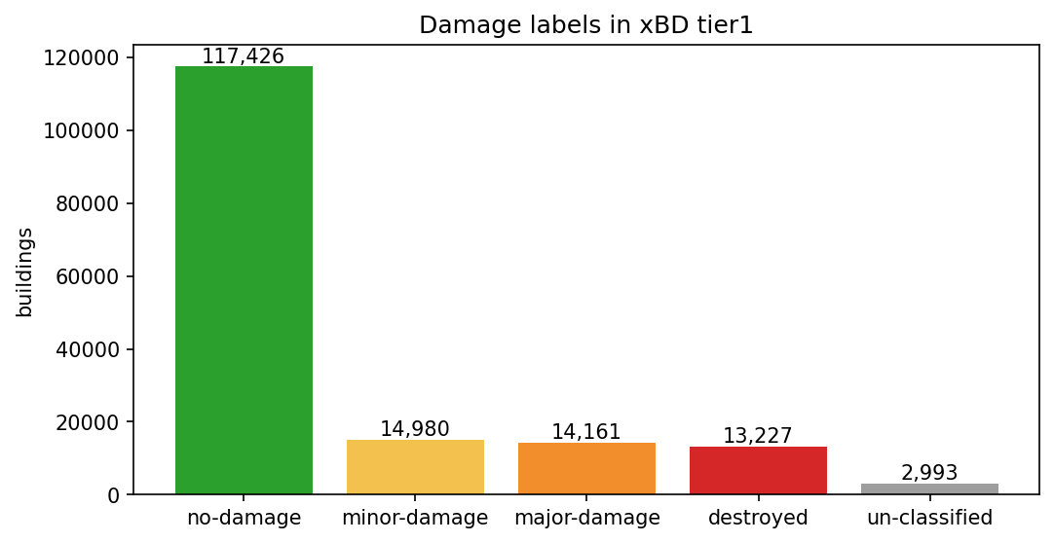
Figure 1. Distribution of damage labels in tier1.
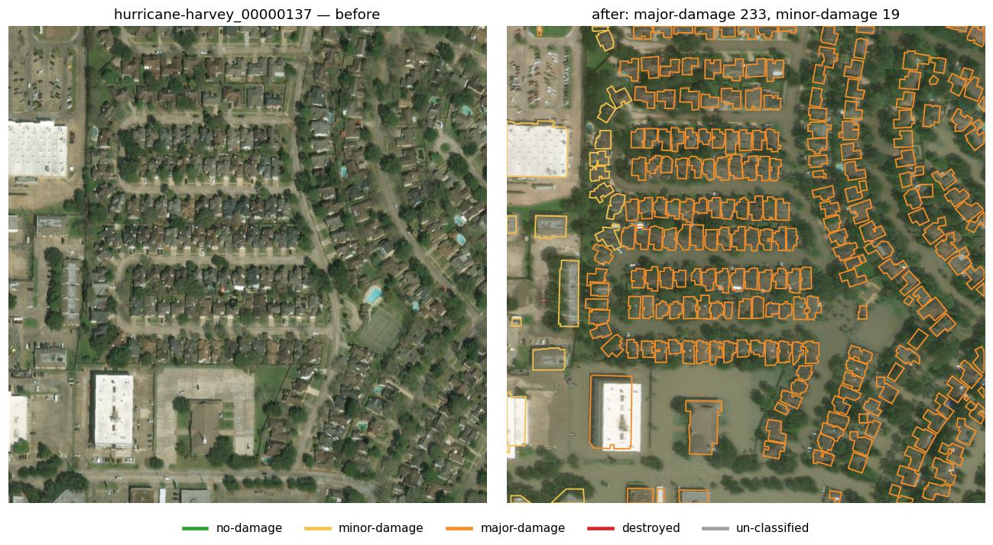
Figure 2. A Hurricane Harvey tile before and after the storm, with labelled building outlines (orange: major damage). The neighbourhood is flooded but roofs are intact.

4. System Overview
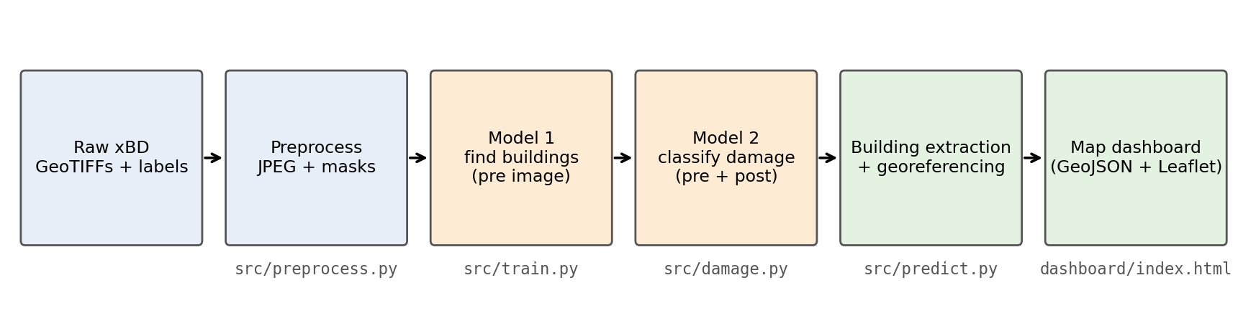
Figure 3. The processing pipeline and the file that implements each step.
- Preprocess. Convert the raw GeoTIFFs into compact JPEG images and per-pixel label masks.
- Model 1, localization. From the pre-disaster image, predict for every pixel whether it belongs to a building.
- Model 2, damage classification. From the pre- and post-disaster images together, predict every pixel's damage level.
- Building extraction and georeferencing. Split building pixels into individual buildings, give each one a damage level, and convert its outline from pixels to longitude and latitude.
- Dashboard. Show the buildings, coloured by damage, on an interactive satellite map.

5. Methodology

5.1 Preprocessing
The GeoTIFF images store pixels as 16-bit integers whose values lie in the 8-bit range 0–255, a format the common Pillow library cannot open. They are read with tifffile, converted to 8-bit colour and saved as JPEG at quality 95. On a sample of tiles this changed pixel values by 1.46 out of 255 on average, which is invisible, while shrinking the dataset from 130 GB to about 9 GB and making images much faster to load during training.
Each label file is turned into a mask image of the same size, in which every pixel holds one number:
Table 4. Encoding of the label masks.
Mask value | Meaning
0 | Background (not a building)
1 | No damage
2 | Minor damage
3 | Major damage
4 | Destroyed
5 | Un-classified building (ignored when training the damage model)

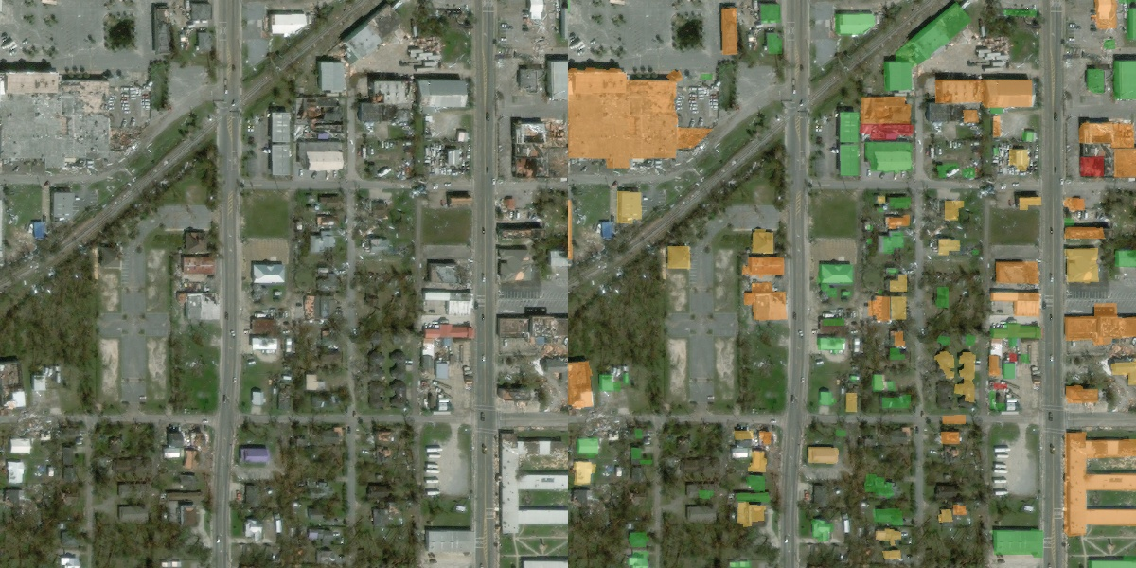
Figure 4. A post-disaster tile (left) and the same tile with its generated mask overlaid (right).

5.2 Localization model
The localization model is a U-Net with a ResNet-34 encoder. It takes the 3-channel pre-disaster image and outputs one value per pixel, the probability that the pixel belongs to a building. The pre-disaster image is used because buildings are intact and easiest to see before the storm. Training uses the sum of two losses:
- Binary cross-entropy, which scores each pixel independently.
- Dice loss, 1 − 2|P ∩ T| / (|P| + |T|), which measures the overlap between predicted and true building areas. Because it is a ratio, small buildings count as much as large stretches of background, which counters the imbalance between building and background pixels.

5.3 Damage classification model
The damage model is also a U-Net with a ResNet-34 encoder, but its input is the pre- and post-disaster images stacked into a single 6-channel image, so the network can compare the two directly. The pretrained first layer is adapted to six channels by the segmentation_models_pytorch library. The output has five channels: background and the four damage levels.
Training uses weighted cross-entropy. The weights are 0.5 for background, 1 for no damage and 3 for each damaged class, so that a mistake on a rare damaged pixel costs more than a mistake on a common undamaged one. Un-classified buildings are excluded from the loss.
Many top xView2 solutions use a Siamese design, in which the same encoder processes each image separately before the features are compared. Stacking the images is simpler, reuses the same architecture as the localization model, and was chosen as a first version.

5.4 Training setup
Table 5. Training configuration (both models).
Setting | Value
Hardware | Apple MacBook Pro, M1 Pro, 16 GB memory (PyTorch MPS backend)
Framework | PyTorch 2.x, segmentation_models_pytorch
Training data | tier1 (2,799 tiles)
Input | Random 512 × 512 crops of the 1024 × 1024 tiles
Augmentation | Random horizontal and vertical flips and 90° rotations
Optimizer | AdamW, learning rate 3 × 10⁻⁴, weight decay 10⁻⁴
Learning-rate schedule | Cosine decay to zero over 30 epochs
Batch size | 8
Model selection | Checkpoint with the best validation score (hold split)
Training time | About 3.5 hours per model (about 7 minutes per epoch)

Training is resumable: after every epoch the model, optimizer and schedule are saved, and rerunning the same command continues from the last finished epoch.

5.5 Evaluation metrics
For a class of interest, precision is the fraction of pixels predicted as that class that truly are, recall is the fraction of true pixels that were found, and F1 is their harmonic mean, 2 × precision × recall / (precision + recall). F1 is high only when both are high. Following the xView2 challenge:
- Localization F1: pixel F1 for building versus background, over the whole validation set.
- Damage F1: for each of the four damage levels, the pixel F1 on building pixels; then the harmonic mean of the four. The harmonic mean is pulled down strongly by any weak class, so a model cannot score well by ignoring rare levels.
- Score: 0.3 × localization F1 + 0.7 × damage F1.
Because pixel scores are hard to interpret, results are also reported per building: each true building is assigned the damage level predicted for the majority of its pixels, giving a confusion matrix of true versus predicted levels.

5.6 From pixels to buildings
The models output per-pixel probabilities, but responders need buildings. For each tile, pixels with building probability above 0.5 are grouped into connected regions, each treated as one building; regions smaller than 30 pixels are discarded as noise. Each building's damage level is the one with the highest average probability over its pixels, and that average is reported as the model's confidence. The outline of each region is traced and simplified to a polygon.

5.7 Georeferencing
To place buildings on a map, pixel positions must be converted to longitude and latitude. The GeoTIFF files contain georeferencing tags for this, but placing buildings with them put them 10 to 30 metres away from their positions in the label files. The label files list every building both in pixel coordinates and in longitude/latitude, and fitting a linear (affine) transform between the two reproduces the label coordinates to within 1 cm.
The label transform is also the physically correct one. At Houston's latitude (about 30°), a square ground pixel spans about 1.15 times as many degrees of longitude as of latitude, because meridians converge towards the poles. The label transform has a ratio of 1.146, while the GeoTIFF tags claim exactly 1.0. The pipeline therefore georeferences each tile from its label coordinates and falls back to the GeoTIFF tags only for tiles with no buildings.

5.8 Dashboard
The dashboard is a single web page built with Leaflet, an open-source mapping library. It loads the exported buildings (GeoJSON) and tile images and provides:
- a satellite basemap, with the before or after tile image shown on top when zoomed in;
- buildings coloured by predicted damage, with a switch to show the expert labels instead;
- filters and counts for each damage level;
- a popup for every building with its predicted level and confidence, or, for labelled buildings, whether the model agreed;
- the share of labelled buildings where the model agreed, per hurricane;
- a ranked list of the hardest-hit tiles, which zooms the map to each one when clicked.

6. Results
All results in this section are on the hold split, which was used to choose the best training epoch. They may therefore be slightly optimistic; the untouched test split is reserved for the final evaluation.

6.1 Building localization
Table 6. Localization results on the hold split.
Metric | Value
Best epoch | 27 of 30
Pixel F1 | 0.792
Precision | 0.818
Recall | 0.767

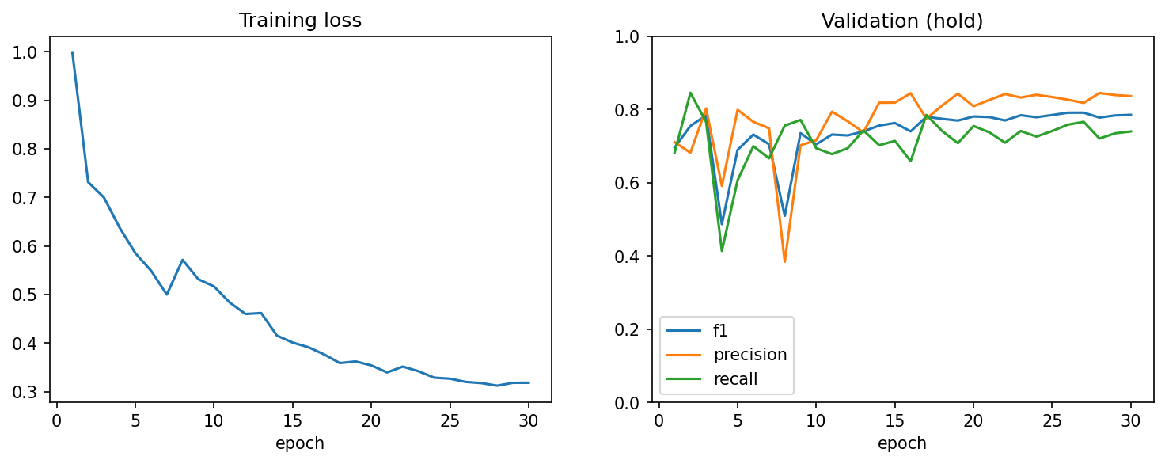
Figure 5. Localization training loss and validation scores per epoch.
The validation score fluctuated strongly in the first half of training (for example 0.78 at epoch 3 and 0.49 at epoch 4) while the learning rate was high, then settled between 0.77 and 0.79 from epoch 17 onwards as the cosine schedule reduced the learning rate. Precision is higher than recall: the model rarely marks non-buildings as buildings, but misses some building pixels.
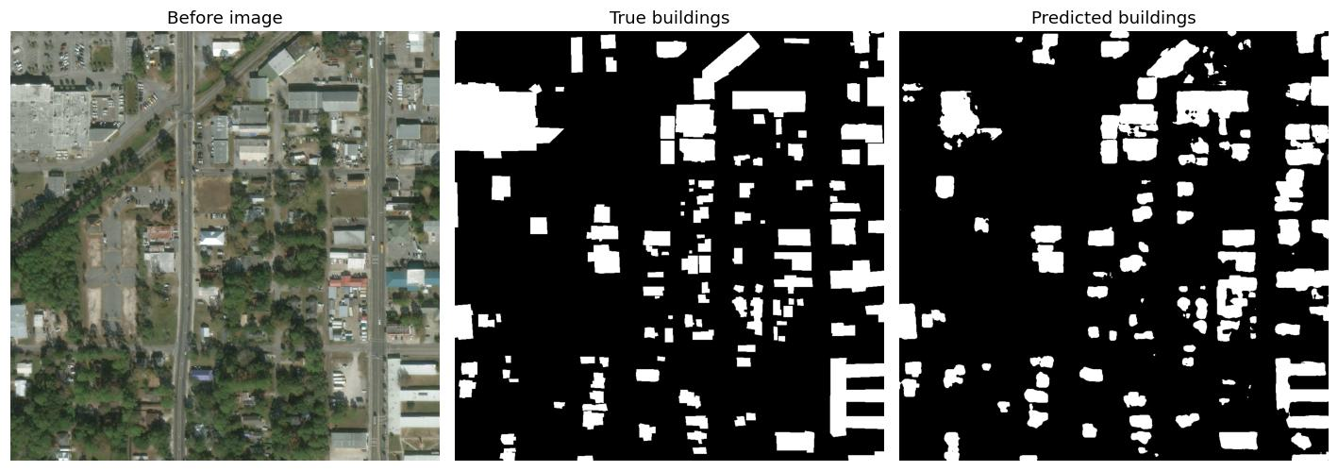
Figure 6. Localization on a validation tile from Hurricane Michael.

6.2 Damage classification (first model, v1)
Table 7. First damage model (v1) on the hold split.
Metric | Value
Best epoch | 26 of 30
Score (0.3 × loc + 0.7 × damage) | 0.575
Localization F1 | 0.819
Damage F1 (harmonic mean) | 0.470
F1 — no damage | 0.930
F1 — minor damage | 0.224
F1 — major damage | 0.594
F1 — destroyed | 0.784
Building-level accuracy | 78.4%

The damage model's own localization F1 (0.819) is higher than the dedicated localization model's (0.792), probably because seeing the post-disaster image as well gives it more evidence of where buildings are.
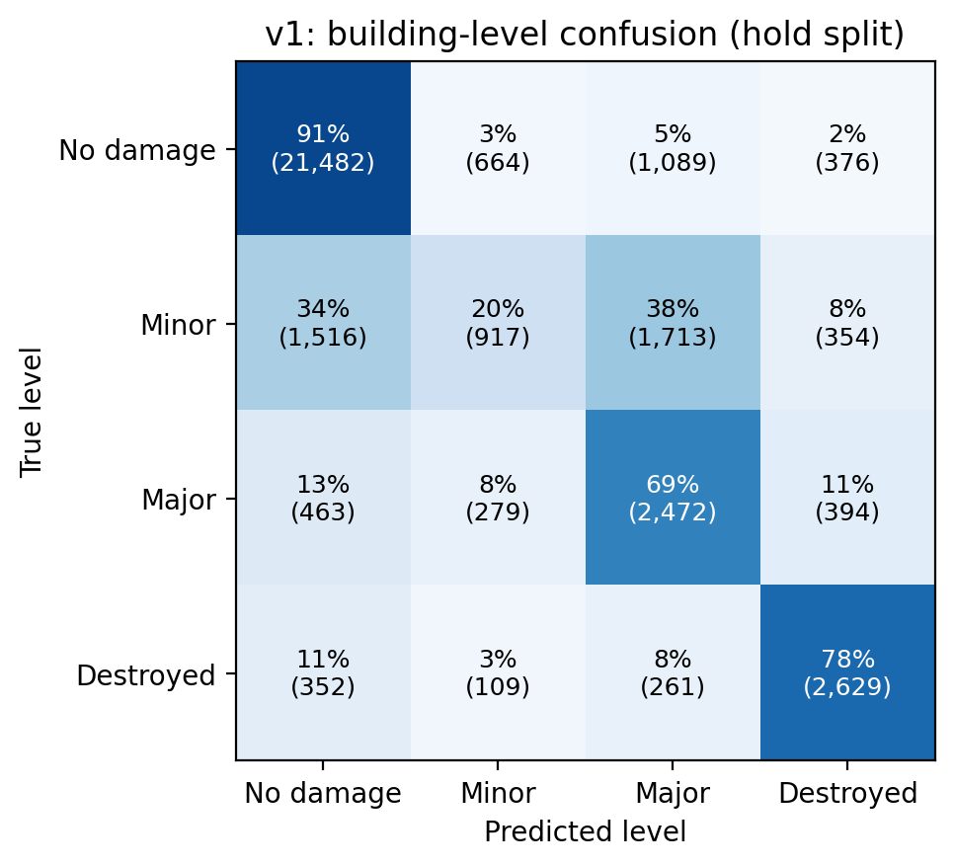
Figure 7. Building-level confusion matrix of v1. Each row shows how the buildings of one true level were classified.
The model is strongest at the two ends of the scale: 91% of undamaged and 78% of destroyed buildings are classified correctly. Minor damage is the clear weakness: only 20% of minor-damage buildings are recognized, with 38% labelled major and 34% labelled no damage. This is consistent with the definition of the class: minor damage is often a few missing roof elements or some water around a building, which is barely visible at 0.5 m per pixel, and it is also the level on which human labellers disagree most. Section 7 describes how this was improved.
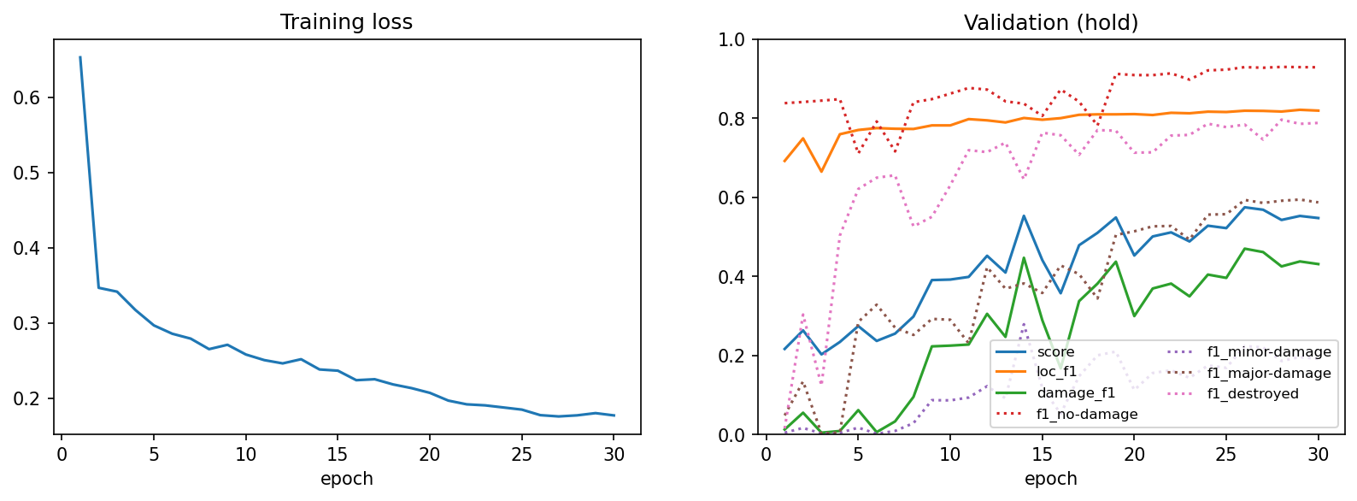
Figure 8. v1 training loss and validation scores per epoch.
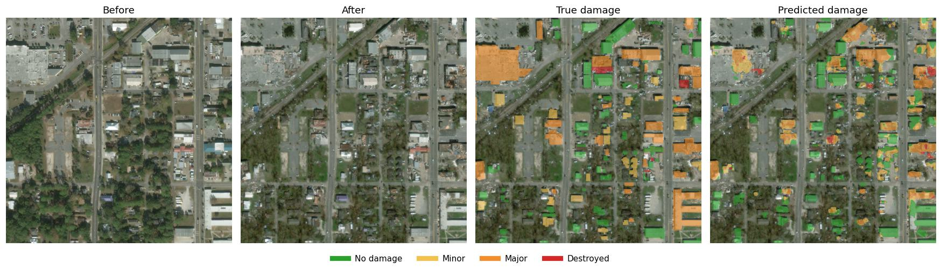
Figure 9. v1 damage prediction on a Hurricane Michael validation tile.

6.3 Context
For orientation only: the official xView2 baseline reported an overall score of roughly 0.27, and the winning solution roughly 0.80, using large ensembles of models verify these figures against the xView2 leaderboard before submission. Those scores are on the challenge's own test set, so they are not directly comparable with the hold-split scores here (v1 0.575, final model 0.711), but they show that a single model trained on a laptop reaches a meaningful level.

7. Improving the Damage Model
The v1 results point to minor damage as the main weakness. Two further versions were trained to address it.
Table 8. Configuration of the three damage models.
 | v1 | v2 | v3
Starting point | ImageNet encoder | ImageNet encoder | v1's trained model
Training data | tier1 (2,799) | tier1 + tier3 (9,168) | tier1 + tier3 (9,168)
Class weights (bg, no, minor, major, destroyed) | 0.5, 1, 3, 3, 3 | 0.5, 1, 6, 3, 3 | 0.5, 1, 4, 4, 3
Learning rate | 3 × 10⁻⁴ | 3 × 10⁻⁴ | 1 × 10⁻⁴
Epochs | 30 | 25 | 10
Training time | 3.5 h | 8 h | 3.3 h

7.1 v2: more data and a higher weight for minor damage
v2 doubled the weight of minor damage, making mistakes on that class twice as costly, and added the tier3 split, which triples the number of training tiles and adds more variety of buildings and disasters.
Minor-damage F1 nearly doubled (0.22 → 0.40), but major-damage F1 collapsed (0.59 → 0.08) and the overall score fell from 0.575 to 0.402. The reason is the weighting: minor and major damage are the two levels the model confuses most, and with minor damage weighted twice as heavily as major, labelling an uncertain building "minor" became the cheaper mistake. The model learned to avoid predicting major damage almost entirely. The experiment shows that class weights trade neighbouring classes off against each other, rather than improving one for free.

7.2 v3: balanced weights, fine-tuned from v1
v3 kept the extra tier3 data but gave minor and major damage equal weight (4 each), so neither is the safer guess. Instead of starting from scratch, it started from v1's trained model, which already separated major damage well, and trained with a three times lower learning rate so that this knowledge is refined rather than overwritten. Starting from an already trained model also made it converge in 10 epochs.
v3 raised the overall score from 0.575 to 0.711, with clear gains for minor damage (0.22 → 0.45), major damage (0.59 → 0.69) and destroyed buildings (0.78 → 0.80), and a small loss for no damage (0.93 → 0.91). It is the final model used by the dashboard.

7.3 Comparison
Table 9. Results of the three damage models.
Metric (hold split, best epoch) | v1 | v2 | v3
Score | 0.575 | 0.402 | 0.711
Localization F1 | 0.819 | 0.817 | 0.821
Damage F1 | 0.470 | 0.224 | 0.664
F1 — no damage | 0.930 | 0.872 | 0.911
F1 — minor damage | 0.224 | 0.403 | 0.448
F1 — major damage | 0.594 | 0.077 | 0.690
F1 — destroyed | 0.784 | 0.783 | 0.801
Building-level accuracy | 78.4% | 68.1% | 77.7%

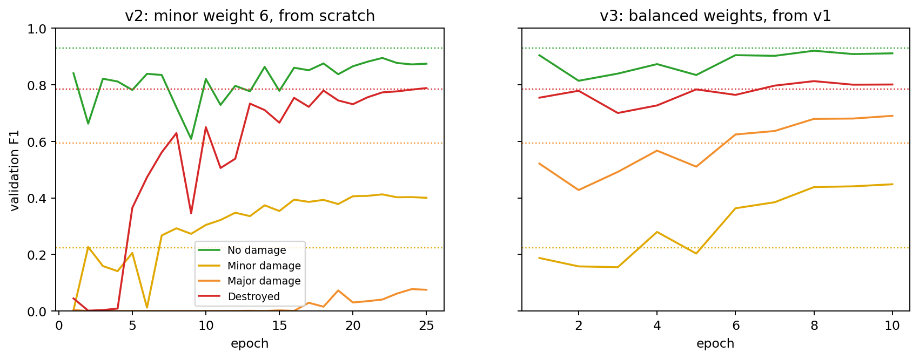
Figure 10. Per-class validation F1 per epoch for v2 (left) and v3 (right). Dotted lines show v1's best values.
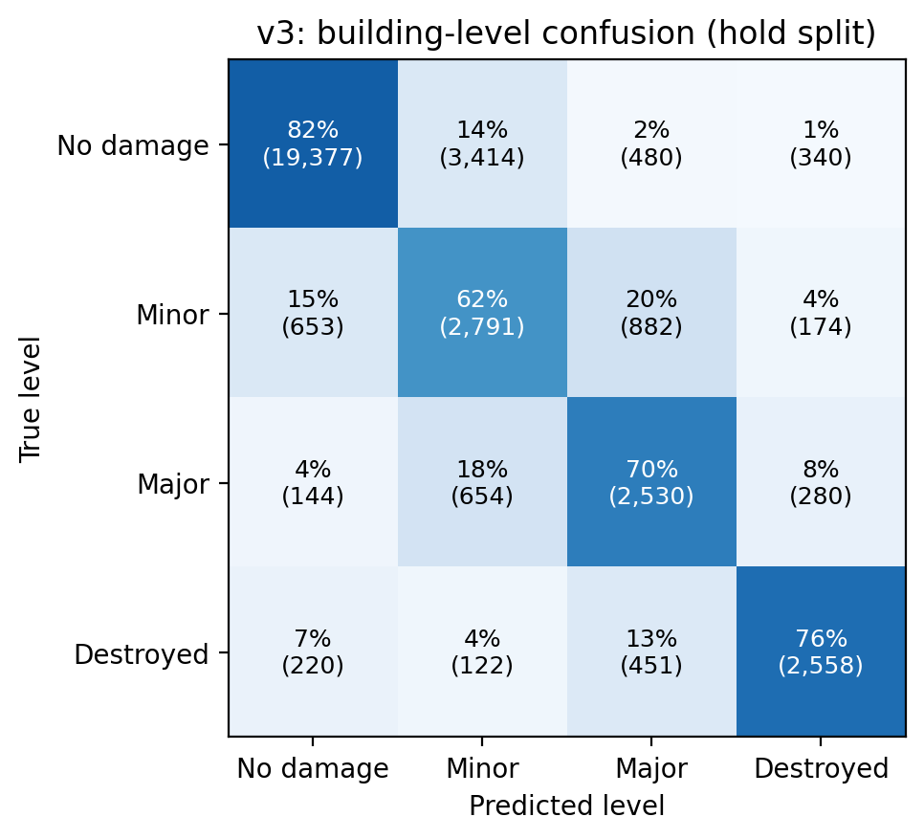
Figure 11. Building-level confusion matrix of the final model (v3).
Compared with v1, the share of buildings recognized correctly changed as follows: no damage 91% → 82%, minor damage 20% → 62%, major damage 69% → 70%, destroyed 78% → 76%.
This is a trade-off rather than a pure gain. v3 recognizes far more minor-damage buildings, but it also labels 14% of undamaged buildings as minor damage (v1: 3%). Because undamaged buildings are the large majority, plain building-level accuracy is about the same (78.4% for v1, 77.7% for v3), while the score, which weights all damage levels equally, rises sharply. For emergency response this trade-off is usually acceptable: a false alarm costs a quick second look, while a missed damaged building may mean a household that receives no help. The decision threshold could also be tuned per use case.

7.4 Final model by hurricane
The dashboard exports cover all hurricane tiles in the hold and test splits. For every labelled building, the damage level the final model predicted inside its true outline was compared with its label:
Table 10. Share of labelled buildings given the same damage level as the experts (hold and test tiles).
Hurricane | Labelled buildings | v1 agreement | Final model (v3)
Florence (Carolinas, 2018) | 4,608 | 85.1% | 80.8%
Harvey (Texas, 2017) | 14,649 | 76.4% | 79.0%
Matthew (Haiti, 2016) | 9,475 | 36.2% | 54.9%
Michael (Florida, 2018) | 12,674 | 58.7% | 47.6%

- Harvey and Matthew improved. In Haiti (Matthew), most buildings are labelled minor damage, and v3 now recognizes most of them; v1 had mostly called them major or destroyed.
- Florence and Michael got worse. These hurricanes have many undamaged buildings, and v3's tendency to call undamaged buildings minor damage shows most here: on Michael, more than half of the undamaged buildings were labelled minor damage.
- Matthew still has the fewest buildings found (about half as many predicted as labelled), because its small, densely packed houses are often merged into one predicted building.

7.5 Dashboard
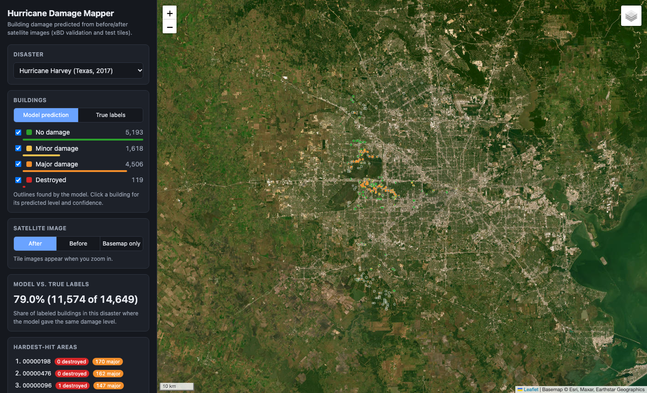
Figure 12. Dashboard overview: Hurricane Harvey tiles in west Houston.
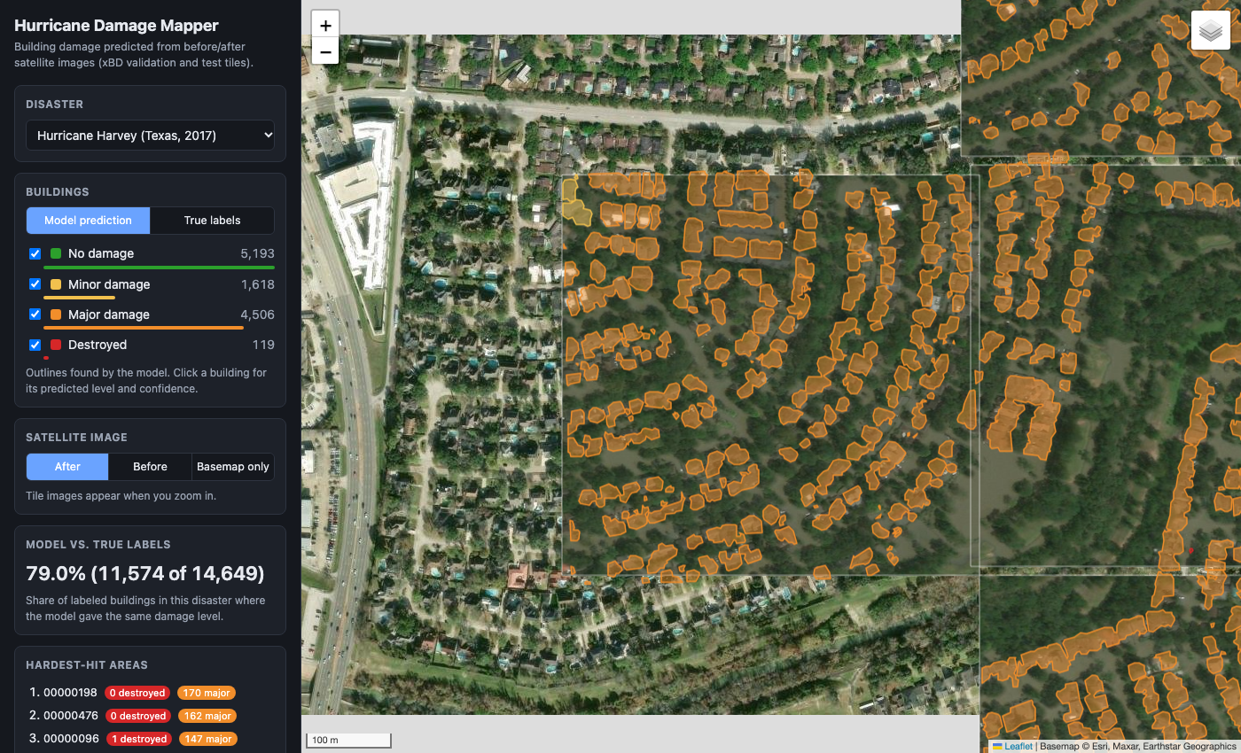
Figure 13. Dashboard zoomed in on a flooded Harvey tile. The after image is placed on the satellite basemap, and predicted buildings sit on the houses, coloured by damage level.

8. Discussion and Limitations
- Minor damage is hard to see. At about 0.5 m per pixel, the difference between no, minor and major damage is often a few pixels. Even human labellers disagree most on this level.
- Touching buildings are merged. Buildings are separated by finding connected regions, so adjacent houses become one predicted building. Top xView2 solutions split them with additional steps such as watershed segmentation.
- Domain shift. The training data is mostly US suburbs; performance drops on very different settlements (Haiti).
- Validation-based results. Results are on the hold split, which was used to pick the best epoch. The final numbers must come from the test split.
- Single runs and combined changes. Each configuration was trained once, so differences of a few points may partly be run-to-run noise. v3 changed several things at once (starting point, data, weights, learning rate), so its improvement cannot be attributed to any single change.
- Simple architecture. A 6-channel U-Net is simpler than the Siamese networks and ensembles used by top solutions.

9. Conclusion and Future Work
This project delivered a complete, working system for building damage assessment after hurricanes: from raw satellite data, through two trained models, to an interactive map. Trained on a single laptop, it finds buildings with a pixel F1 of 0.792, reaches a damage score of 0.711 and assigns the correct damage level to 77.7% of buildings. Minor damage remains the hardest level, but fine-tuning with balanced weights and more data roughly doubled its F1. Along the way the project identified and corrected a georeferencing error in the dataset's GeoTIFF metadata.
Future work, roughly in order of expected benefit:
- Final evaluation on the untouched test split.
- A Siamese architecture that processes before and after images with a shared encoder.
- Separating touching buildings (for example with watershed segmentation).
- Ensembles and test-time augmentation (averaging predictions over flipped and rotated inputs).
- Fine-tuning on data from the region of interest to reduce domain shift.

References
Gupta, R., Goodman, B., Patel, N., Hosfelt, R., Sajeev, S., Heim, E., Doshi, J., Lucas, K., Choset, H., & Gaston, M. (2019). Creating xBD: A dataset for assessing building damage from satellite imagery. CVPR Workshops.
Ronneberger, O., Fischer, P., & Brox, T. (2015). U-Net: Convolutional networks for biomedical image segmentation. MICCAI.
He, K., Zhang, X., Ren, S., & Sun, J. (2016). Deep residual learning for image recognition. CVPR.
Iakubovskii, P. (2019). Segmentation Models PyTorch. GitHub repository, qubvel/segmentation_models.pytorch.
xView2 challenge: Computer vision for building damage assessment. https://xview2.org

Part B — Code Walkthrough
This part explains how the code is organized and what each file does, with the most important functions shown in full. Code excerpts are copied automatically from the source files when this report is built.

B.1 Project structure
fyp/
├── README.md setup, commands and results summary
├── requirements.txt Python libraries
├── src/ all Python code
│ ├── xbd.py reading raw xBD files
│ ├── preprocess.py raw GeoTIFFs -> JPEG images + masks
│ ├── dataset.py feeding images to the localization model
│ ├── train.py localization model: training and scoring
│ ├── damage.py damage model: data, training and scoring
│ ├── predict.py both models -> buildings on the map
│ └── progress.py live training progress in the terminal
├── notebooks/
│ ├── 01_explore_xbd.ipynb dataset exploration
│ ├── 02_building_localization.ipynb localization results
│ └── 03_damage_classification.ipynb damage results
├── dashboard/
│ ├── index.html the map web page
│ ├── data/ exported buildings (generated)
│ └── images/ tile images for the map (generated)
├── docs/ this report and its figures
├── data/ dataset: raw xbd/ and processed/ (not in git)
├── runs/ trained models and logs (not in git)
└── outputs/ charts and tables from notebook 01

B.2 Running the project from scratch
All commands run from the project folder with Anaconda's Python (/opt/anaconda3/bin/python3, written python below):
Table 11. Commands in order.
Step | Command | Time
1. Install libraries | python -m pip install -r requirements.txt | minutes
2. Convert the data | python -m src.preprocess | ~5 min
3. Train localization | python -m src.train --epochs 30 | ~3.5 h
4. Train damage model (v1) | python -m src.damage --epochs 30 | ~3.5 h
4b. Fine-tune (v3) | python -m src.damage --out-dir runs/damage_v3 --train-splits tier1 tier3 --epochs 10 --lr 1e-4 --init-from runs/damage_resnet34/best.pt --class-weights 0.5 1 4 4 3 | ~3.3 h
5. Watch training | python -m src.progress | —
6. Export map data | python -m src.predict | ~25 min
7. Open the dashboard | python -m http.server 8000 -d dashboard, then visit localhost:8000 | —
8. Rebuild this report | python docs/build_report.py | seconds

B.3 How data flows between files
Table 12. Inputs and outputs of each file.
File | Reads | Writes
src/xbd.py | data/xbd/ (raw tiles and labels) | — (library used by the others)
src/preprocess.py | data/xbd/ | data/processed/<split>/images, masks
src/train.py | data/processed/ | runs/loc_resnet34/
src/damage.py | data/processed/ | runs/damage_resnet34/ (v1), damage_v2/, damage_v3/
src/predict.py | data/processed/, data/xbd/ labels, runs/ | dashboard/data/, dashboard/images/
dashboard/index.html | dashboard/data/, dashboard/images/ | — (displays in the browser)

B.4 src/xbd.py — reading the raw dataset
Purpose: everything needed to read the raw xBD files. Each tile has a pre image, a post image and a JSON label file that lists every building as a polygon in WKT text format, for example POLYGON ((807.4 898.1, 760.9 943.3, …)).
Function | What it does
parse_wkt_polygon | Turns a WKT polygon string into an array of (x, y) points.
polygon_area | Area of a polygon in pixels (shoelace formula).
find_pairs | Lists every tile in a split with the paths of its pre image, post image and label.
load_image | Reads a tile as 8-bit RGB; handles the 16-bit GeoTIFFs that Pillow cannot open.
load_buildings | Reads all buildings in a label file: id, damage level and outline.
building_table | One row per building across many tiles (used for the statistics in notebook 01).
show_pair | Draws a before/after pair with buildings outlined in their damage colour.

def load_image(path):
"""RGB image as a (H, W, 3) uint8 array.

The GeoTIFF release stores pixels as int16 that already lie in 0-255, which Pillow cannot open.
"""
path = Path(path)
if path.suffix.lower() in (".tif", ".tiff"):
return np.clip(tifffile.imread(path), 0, 255).astype(np.uint8)
return np.array(Image.open(path).convert("RGB"))

Why: the GeoTIFFs store pixels as 16-bit signed integers even though the values only go up to 255. Clipping and converting to 8-bit gives a normal colour image without any loss.

B.5 src/preprocess.py — compact training data
Purpose: convert every tile once into JPEG images and a mask, so training never touches the slow 130 GB of GeoTIFFs. Tiles are processed in parallel on all CPU cores with multiprocessing.Pool, and existing files are skipped, so the script can be stopped and rerun safely.
def make_mask(label_path, height=1024, width=1024):
mask = np.zeros((height, width), dtype=np.uint8)
for b in load_buildings(label_path):
points = np.round(b["polygon"]).astype(np.int32)
cv2.fillPoly(mask, [points], MASK_VALUES.get(b["damage"], 5))
return mask

How it works: start with an all-zero (background) image and fill each building polygon with its damage value using OpenCV's fillPoly. The result is the mask format described in Section 5.1.

B.6 src/dataset.py — feeding the localization model
Purpose: a PyTorch Dataset, the standard interface that PyTorch uses to load training examples. Given an index it returns one example: the pre-disaster image as a tensor and a mask with 1 for building pixels and 0 elsewhere.
def __getitem__(self, i):
image = read_rgb(self.image_path(i))
mask = (cv2.imread(str(self.mask_paths[i]), cv2.IMREAD_GRAYSCALE) > 0).astype(np.float32)

if self.crop:
h, w = mask.shape
y = np.random.randint(0, h - self.crop + 1)
x = np.random.randint(0, w - self.crop + 1)
image = image[y:y + self.crop, x:x + self.crop]
mask = mask[y:y + self.crop, x:x + self.crop]

if self.augment:
if np.random.rand() < 0.5:
image, mask = image[:, ::-1], mask[:, ::-1]
if np.random.rand() < 0.5:
image, mask = image[::-1], mask[::-1]
k = np.random.randint(4)
image, mask = np.rot90(image, k), np.rot90(mask, k)

return to_tensor(image), torch.from_numpy(mask.copy())[None]

- Random crop: a random 512 × 512 window, so each epoch sees different parts of each tile and batches fit in memory.
- Augmentation: random flips and rotations. A building seen from above looks equally valid when rotated, so this multiplies the variety of training examples for free.
- to_tensor: scales pixels to 0–1 and normalizes them with the ImageNet mean and standard deviation, because the pretrained encoder expects inputs in that range.
- cv2.setNumThreads(0) at the top of the file is required on macOS: without it, OpenCV's own threads deadlock inside PyTorch's background loading processes and training freezes.

B.7 src/train.py — localization training
Purpose: build the localization model, train it, score it after every epoch and save checkpoints.
def build_model(pretrained=True):
return smp.Unet("resnet34", encoder_weights="imagenet" if pretrained else None, in_channels=3, classes=1)

One line builds the whole U-Net: a ResNet-34 encoder with ImageNet weights, 3 input channels (RGB) and 1 output channel (building probability, after a sigmoid).
def dice_loss(logits, target, eps=1.0):
prob = torch.sigmoid(logits)
inter = (prob * target).sum(dim=(1, 2, 3))
union = prob.sum(dim=(1, 2, 3)) + target.sum(dim=(1, 2, 3))
return (1 - (2 * inter + eps) / (union + eps)).mean()

def loss_fn(logits, target):
# BCE learns per-pixel, Dice keeps small buildings from being ignored next to all the background
return F.binary_cross_entropy_with_logits(logits, target) + dice_loss(logits, target)

def evaluate(model, loader, device, threshold=0.5):
model.eval()
tp = fp = fn = 0
for images, masks in loader:
pred = torch.sigmoid(model(images.to(device))) > threshold
masks = masks.to(device) > 0.5
tp += (pred & masks).sum().item()
fp += (pred & ~masks).sum().item()
fn += (~pred & masks).sum().item()
precision = tp / max(tp + fp, 1)
recall = tp / max(tp + fn, 1)
f1 = 2 * precision * recall / max(precision + recall, 1e-9)
return {"f1": f1, "precision": precision, "recall": recall}

How evaluation works: over the whole validation set, count true positives (predicted building, really a building), false positives and false negatives, then compute precision, recall and F1 once at the end. Counting over all pixels of all tiles, rather than averaging per tile, matches the xView2 definition.
The main function, train_localization, follows the standard PyTorch training loop. For each batch it runs forward (compute predictions), computes the loss, runs backward (compute gradients) and takes an optimizer step (update the weights). After each epoch it evaluates on the hold split, appends a row to history.csv, saves best.pt if the score improved and always saves last.pt for resuming.

B.8 src/damage.py — damage training
Purpose: the same structure as train.py, adapted to damage classification. Its DamageDataset returns the pre and post images stacked into 6 channels and the full mask (values 0–4, with un-classified buildings set to 255 so the loss ignores them).
def build_model(pretrained=True):
# smp adapts the pretrained first layer to 6 input channels
return smp.Unet("resnet34", encoder_weights="imagenet" if pretrained else None, in_channels=6, classes=5)

def predict_classes(logits):
"""Building/background from the full output; damage level chosen among classes 1-4 only."""
is_building = logits.argmax(1) > 0
damage = logits[:, 1:5].argmax(1) + 1
return is_building, damage

Why split the decision in two: argmax over all five outputs decides building versus background. For the damage level, only the four damage outputs are compared, so every building pixel always gets a damage level even when the background output is close.
def evaluate(model, loader, device):
model.eval()
loc = np.zeros(3) # tp, fp, fn
dmg = np.zeros((4, 3))
for x, target in loader:
is_building, damage = predict_classes(model(x.to(device)))
target = target.to(device)
true_building = target > 0 # includes un-classified buildings
loc += [(is_building & true_building).sum().item(),
(is_building & ~true_building).sum().item(),
(~is_building & true_building).sum().item()]
scored = (target >= 1) & (target <= 4)
for c in range(1, 5):
pred_c, true_c = (damage == c) & scored, (target == c) & scored
dmg[c - 1] += [(pred_c & true_c).sum().item(),
(pred_c & ~true_c).sum().item(),
(~pred_c & true_c).sum().item()]

loc_f1 = f1(*loc)
class_f1 = [f1(*row) for row in dmg]
damage_f1 = len(class_f1) / sum(1 / max(v, 1e-6) for v in class_f1)
metrics = {"score": 0.3 * loc_f1 + 0.7 * damage_f1, "loc_f1": loc_f1, "damage_f1": damage_f1}
metrics.update({f"f1_{name}": v for name, v in zip(DAMAGE_NAMES, class_f1)})
# plain floats, since numpy scalars in a checkpoint make torch.load refuse it
return {k: float(v) for k, v in metrics.items()}

The function returns the xView2 score, the localization F1, the harmonic-mean damage F1 and the F1 of each damage level. building_confusion computes the building-level confusion matrix used in Section 6.2. The --class-weights command-line option sets the loss weights, --init-from starts training from an existing checkpoint, and --lr sets the learning rate; v2 and v3 were trained with these options (Section 7).

B.9 src/predict.py — from models to the map
Purpose: run both trained models on hurricane tiles and export everything the dashboard needs.
Function | What it does
load_models | Loads the best checkpoint of each model.
predict_maps | Runs both models on one tile: building probability and damage-level probabilities per pixel.
extract_buildings | Splits building pixels into buildings and gives each a level, confidence and outline.
georeference | Builds the pixel → longitude/latitude conversion for a tile (Section 5.7).
true_buildings | Reads labelled buildings and records which level the model predicted inside each one.
export | Loops over all tiles and writes GeoJSON files, tile metadata and small tile images. --damage-run chooses the damage model (default: the final model, runs/damage_v3).

def extract_buildings(building_prob, level_prob, threshold=0.5):
"""Split the building mask into separate buildings, each with a damage level and outline in pixels."""
n, components = cv2.connectedComponents((building_prob > threshold).astype(np.uint8))
buildings = []
for k in range(1, n):
inside = components == k
if inside.sum() < MIN_BUILDING_PIXELS:
continue
mean_prob = level_prob[:, inside].mean(axis=1)
contours, _ = cv2.findContours(inside.astype(np.uint8), cv2.RETR_EXTERNAL, cv2.CHAIN_APPROX_SIMPLE)
outline = cv2.approxPolyDP(max(contours, key=cv2.contourArea), 1.0, True)[:, 0, :]
if len(outline) < 3:
continue
buildings.append({
"damage": int(mean_prob.argmax()) + 1,
"confidence": float(mean_prob.max()),
"outline": outline.astype(np.float64),
})
return buildings

def georeference(label_path, tif_path):
"""Pixel -> (longitude, latitude) function for a tile.

The label file lists every building both in pixels and in longitude/latitude, which fixes an
exact affine transform. The GeoTIFF tags are used only for tiles without buildings: they claim
square pixels in degrees, which is wrong away from the equator and shifts buildings by 10-30 m.
"""
with open(label_path) as f:
features = json.load(f)["features"]
pixel_outlines = {feat["properties"]["uid"]: parse_wkt_polygon(feat["wkt"]) for feat in features["xy"]}
pixels, lnglats = [], []
for feat in features["lng_lat"]:
xy, lnglat = pixel_outlines.get(feat["properties"]["uid"]), parse_wkt_polygon(feat["wkt"])
if xy is not None and len(xy) == len(lnglat):
pixels.append(xy)
lnglats.append(lnglat)

if sum(len(p) for p in pixels) >= 3:
pixels = np.vstack(pixels)
coef = np.linalg.lstsq(np.column_stack([pixels, np.ones(len(pixels))]), np.vstack(lnglats), rcond=None)[0]
else:
with tifffile.TiffFile(tif_path) as tif:
tags = tif.pages[0].tags
scale_x, scale_y = tags["ModelPixelScaleTag"].value[:2]
lon0, lat0 = tags["ModelTiepointTag"].value[3:5]
coef = np.array([[scale_x, 0.0], [0.0, -scale_y], [lon0, lat0]])

def to_lnglat(xy):
return np.column_stack([xy, np.ones(len(xy))]) @ coef

return to_lnglat

How georeference works: for every building, the label file gives the same outline in pixels and in longitude/latitude. Solving a least-squares problem finds the six numbers of the affine transform (lon, lat) = (x, y, 1) · coef that best maps one to the other. For tiles with no buildings it falls back to the GeoTIFF tags.

B.10 src/progress.py — watching training
A small terminal display that reads each run's history.csv every 30 seconds and shows a progress bar, the latest and best scores, and an estimated finish time. It only reads files, so it can be started and stopped at any time without affecting training.

B.11 dashboard/index.html — the map
A single HTML page with embedded JavaScript, using Leaflet for the map. It needs a local web server because browsers block pages opened from disk from loading data files.
Part | What it does
init | Loads tiles.json, fills the disaster menu and opens a tile directly if the link contains one (#tile_id).
selectDisaster | Loads that hurricane's GeoJSON (cached after the first time), draws tile outlines and buildings, updates the statistics.
drawBuildings | Draws the predicted or true buildings for the checked damage levels, coloured by level, each with a popup.
updateImagery | When zoomed in, adds the before or after image of each visible tile and removes those out of view.
drawAgreement | Share of labelled buildings where the model gave the same level.
drawPriority | Ranks tiles by predicted destroyed (×2) and major-damage buildings.

Buildings are drawn on an HTML canvas (preferCanvas: true) rather than as individual SVG elements, which keeps the map responsive with more than 10,000 buildings on screen.

B.12 Notebooks
Notebook | Contents
01_explore_xbd | Tile and building counts, damage distribution per disaster, building sizes, before/after examples.
02_building_localization | Training curves and predicted versus true buildings for the localization model.
03_damage_classification | Training curves, building-level confusion matrix, and coloured damage predictions.

B.13 Glossary
Term | Meaning
Epoch | One pass of training over all training tiles.
Batch | A group of examples (here 8 crops) processed together in one training step.
Loss | A number measuring how wrong the model's predictions are; training adjusts the weights to make it smaller.
Learning rate | How big each weight update is. Large values learn fast but unstably; small values are stable but slow.
Cosine schedule | Lowers the learning rate smoothly from its starting value to zero over training.
Checkpoint | A saved copy of the model weights (best.pt, last.pt).
Encoder / decoder | The parts of a U-Net that shrink the image into features and expand them back to a per-pixel output.
Pretrained (ImageNet) | Weights learned on 1.2 million everyday photos, used as a starting point (transfer learning).
Augmentation | Random changes (flips, rotations) to training images that create more variety.
Class weights | Multipliers in the loss that make mistakes on rare classes cost more.
Precision / recall / F1 | Fraction of predictions that are right / fraction of true cases found / their harmonic mean.
Confusion matrix | Table of true versus predicted classes; the diagonal holds the correct predictions.
Validation split | Data not used for training, used to choose the best epoch (hold).
Test split | Data used only once, for the final reported result (test).
MPS | Metal Performance Shaders: PyTorch's backend for the Apple Silicon GPU.
GeoTIFF | A TIFF image with embedded geographic coordinates.
GeoJSON | A standard text format for map shapes, used by the dashboard.
Georeferencing | Converting image pixel positions to real-world coordinates.

