BlockStore-5: A Distributed File Storage, Fault-Tolerance and Blockchain Integrity Verification System
Complex Engineering Problem — Cloud and Distributed Computing
[Student name] — [Roll number] — [Department], [University]
Submitted to: [Instructor name] — [Date]
Table of Contents

Abstract
Single-server file storage fails completely when that server stops and cannot tell when its copy has been corrupted or changed. This project designs, implements and evaluates BlockStore-5, a small distributed storage system in which every file is replicated to five independent storage nodes running as separate services that communicate over HTTP. A coordinator records each file’s SHA-256 hash at upload time as the trust anchor, re-hashes replicas itself to detect tampering, and serves or restores only copies that match the trusted hash. Every node keeps a copy of a small educational blockchain whose blocks are committed only when at least three of the five nodes return valid, signed accept votes. A controlled malicious-node simulation shows two different attacks: tampering with one stored replica, which is detected while four honest copies remain valid and are used for repair; and proposing invalid ledger blocks, which the four honest nodes reject, leaving the ledger unchanged. Automated tests (37 backend, 5 frontend) and a Docker smoke test passed, and measured operation times for files from 1 KB to 5 MB were between about 80 ms and 400 ms on a two-core virtual machine. The prototype is an educational demonstration of replication, fault tolerance, hash-based integrity and honest-majority voting; it is not a production-grade Byzantine fault-tolerant system.

1. Introduction
Cloud storage services such as object stores keep several copies of data on different machines so that the failure of one machine does not make data unavailable. Replication alone, however, does not say which copy is correct if copies disagree. Blockchains add a tamper-evident, replicated log that several parties agree on. BlockStore-5 combines these ideas in a project small enough for a student to build and explain: five storage nodes, replication, SHA-256 integrity checks, failure detection and recovery, and a simple majority-voted ledger, all shown on a live dashboard.

2. Problem statement
A single storage server is a single point of failure: when it is unavailable, its files are inaccessible, and a corrupted or maliciously modified file may go unnoticed. A replicated system improves availability but cannot by itself guarantee that every copy is trustworthy. The problem is to build a system that (i) keeps files available when a node fails, (ii) detects a corrupted or tampered replica and recovers a verified copy, and (iii) keeps an auditable record that honest nodes agree on and that a single malicious node cannot change.

3. Objectives
- Implement five independent storage node services communicating over a real network protocol (HTTP).
- Replicate uploaded files to all five nodes and verify every replica by SHA-256.
- Detect node failure and continue to serve verified copies from healthy nodes; re-synchronise restarted nodes.
- Detect a tampered replica on one node while the four unchanged replicas remain valid, and repair it.
- Implement an educational blockchain on every node and a 3-of-5 majority vote for committing records.
- Demonstrate that honest nodes reject invalid ledger proposals from a malicious node.
- Provide a dashboard showing real system state, automated tests, measurements and documentation.

4. Scope
In scope: local deployment (Docker Compose or five local processes), files up to 10 MB, full replication on five nodes, one coordinator, one faulty or malicious node at a time, predefined attack simulations on sample data.
Out of scope: user accounts and authentication, encryption, geographic distribution, production consensus (Raft, PBFT), automatic re-replication, versioned backups, public blockchains or cryptocurrency.

5. Requirements
Functional: upload with name/type/size validation; trusted SHA-256; replication with honest partial-failure reporting; listing and details; verified download; integrity verification per node; recovery and repair; node health monitoring; simulated and real node failure and restart; per-node ledger with genesis, linked blocks and seven transaction types; ledger validation and agreement check; signed majority voting with quorum 3; malicious mode, replica corruption, invalid block proposals; event log; REST API with documentation.
Non-functional: free and offline; beginner-readable modular code; timeouts on all node calls; meaningful HTTP status codes and error messages; responsive accessible dashboard; reproducible tests; honest reporting of limitations.

6. System architecture
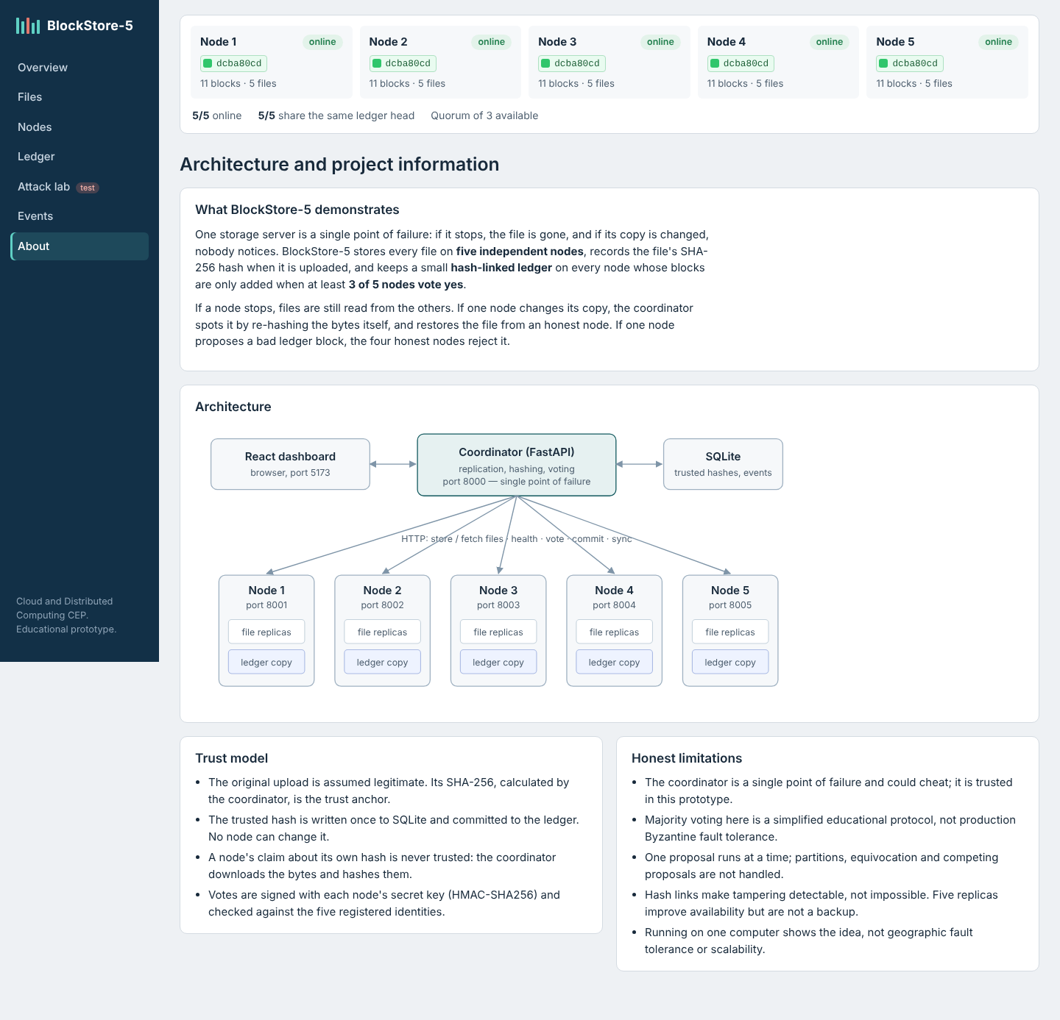
Architecture (dashboard About page)
The system has seven services. The React dashboard calls the coordinator backend (FastAPI, port 8000), which stores trusted metadata, the event log and every consensus round in SQLite. The coordinator talks over HTTP to five storage nodes (ports 8001–8005). Each node is a separate FastAPI service with its own identity, secret key, data volume, file replicas and ledger.json. The blockchain rules (hashing, block and transaction validation, vote signing) are in one shared module so that every node applies exactly the same rules.
Layer | Responsibility
Frontend | Seven pages: overview, files, nodes, ledger, attack lab, events, about; polls the API every 2–5 s
Coordinator API | files, nodes, blockchain, simulation, dashboard routers
Coordinator services | file_service (upload/verify/download/recover), node_client (HTTP + timeouts), health_monitor
Coordinator blockchain | consensus (propose, vote, tally, commit), ledger_view (majority ledger and per-node state)
Node | storage, ledger, consensus (voting), health (flags), main (endpoints)
The coordinator is deliberately a single point of failure in this prototype, which keeps the protocol simple to explain; this is discussed in Section 13.

7. Implementation methodology
The work followed eight phases: (1) environment inspection and design; (2) storage node service; (3) coordinator upload, replication, monitoring and recovery; (4) blockchain and voting; (5) simulations; (6) dashboard; (7) testing and debugging; (8) documentation. Each phase was checked against running services before the next.
Upload. The coordinator validates the file, computes its SHA-256, creates a 128-bit random file id, sends the bytes to all five nodes in parallel, and accepts a replica only if the hash returned by the node equals the trusted hash. With fewer than three verified replicas the upload is rolled back. Otherwise the metadata is stored once and a block containing FILE_UPLOADED and FILE_REPLICATED is put to the vote. Missing replicas are reported, not hidden.
Integrity check. For every node the coordinator downloads the replica and recomputes SHA-256, and separately asks the node which hash it claims. Each replica is classified as match, mismatch, missing or unavailable, and an INTEGRITY_CHECKED record (plus MALICIOUS_ACTIVITY_DETECTED per mismatch) is committed.
Download and recovery. Nodes are tried in turn and the first copy whose recomputed hash equals the trusted hash is returned; otherwise HTTP 503. Recovery additionally re-uploads the verified copy to online nodes with missing or mismatched replicas, re-verifies all five and commits FILE_RECOVERED.
Failure detection. A background thread polls /health on all nodes every 2 s. A change from online to offline commits NODE_FAILURE; from offline to online the node’s ledger is synchronised and NODE_REJOINED is committed. Two kinds of failure are supported and labelled separately: an application-level simulated failure (the node answers HTTP 503) and a real failure (the container or process is stopped from a terminal). The application exposes no shell or Docker control.
Blockchain and voting. Described in Section 9.
Simulation. Malicious mode is an in-memory flag on one node (default Node 3), reversible by switching it off or restarting the node. In this mode the node accepts every proposal without checking, reports false hashes, and allows three test actions: corrupt its replica, build an invalid block, or edit its own ledger file. Destructive actions require explicit confirmation.

8. Distributed computing concepts applied
Concept | Where it appears
Independent nodes, message passing | Five services, HTTP only, separate volumes
Replication | Five full copies per file
Availability | Reads continue with up to four nodes down if one verified copy exists
Fault tolerance | Writes and commits continue with any three nodes
Failure detection | Periodic health checks with timeouts
Quorum | 3 of 5 for writes and ledger commits; two majorities always overlap
Consistency | Same block order on all honest nodes; offline nodes catch up (eventual consistency)
Recovery | Verified re-replication from an honest copy; ledger sync and repair
Single point of failure | The coordinator, documented

9. Blockchain concepts applied
Each block contains index, timestamp, previous hash, transactions, proposer and its own hash, computed as SHA-256 of the canonical JSON of the other fields. The genesis block has fixed contents, so all five nodes produce the same genesis hash. Transactions contain metadata only (file id, name, size, expected hash, node ids, outcome, timestamp); transactions over 2 KB or containing file contents are rejected.
An honest node accepts a proposed block only if its index is the next height, its previous hash equals the node’s head, its stored hash equals the recomputed hash, its proposer is registered and all transactions are valid. A semantic rule prevents a second FILE_UPLOADED for an existing file id, so the trusted hash cannot be overwritten through the ledger.
The voting round is: propose → all five nodes validate and return a vote signed with HMAC-SHA256 using their own secret → the coordinator counts only votes from registered identities with valid signatures for this block, one per node → with at least three accepts the block is sent to every node, which validates it again before appending. Every round is stored with all votes, the reason for each, and the ledger heads before and after. The full chain of every node can be validated (sequential indexes, recomputed hashes, previous-hash links, genesis) and compared with the majority.
This is a simplified, coordinator-based protocol: it demonstrates the honest-majority principle with one faulty node but is not a proven Byzantine fault-tolerant algorithm.

10. Testing and results

10.1 Automated tests
All 17 required behaviours are covered by automated tests: 11 blockchain unit tests, 6 vote-tally unit tests and 20 integration tests that start five real node processes and the backend on separate ports (37 in total, all passed), plus 5 frontend error-handling tests (all passed). The integration tests include really terminating and restarting a node process. A separate smoke test passed against the Docker Compose deployment, including docker compose stop node2 and docker compose start node2. The full test table is in docs/testing.md.
Note on environment: the development machine had no access to package registries, so the Docker images were built on a locally assembled stand-in base image and the frontend container was not built there; all other parts ran unchanged. On a normal machine, docker compose up --build performs the real package installation.

10.2 Demonstration results
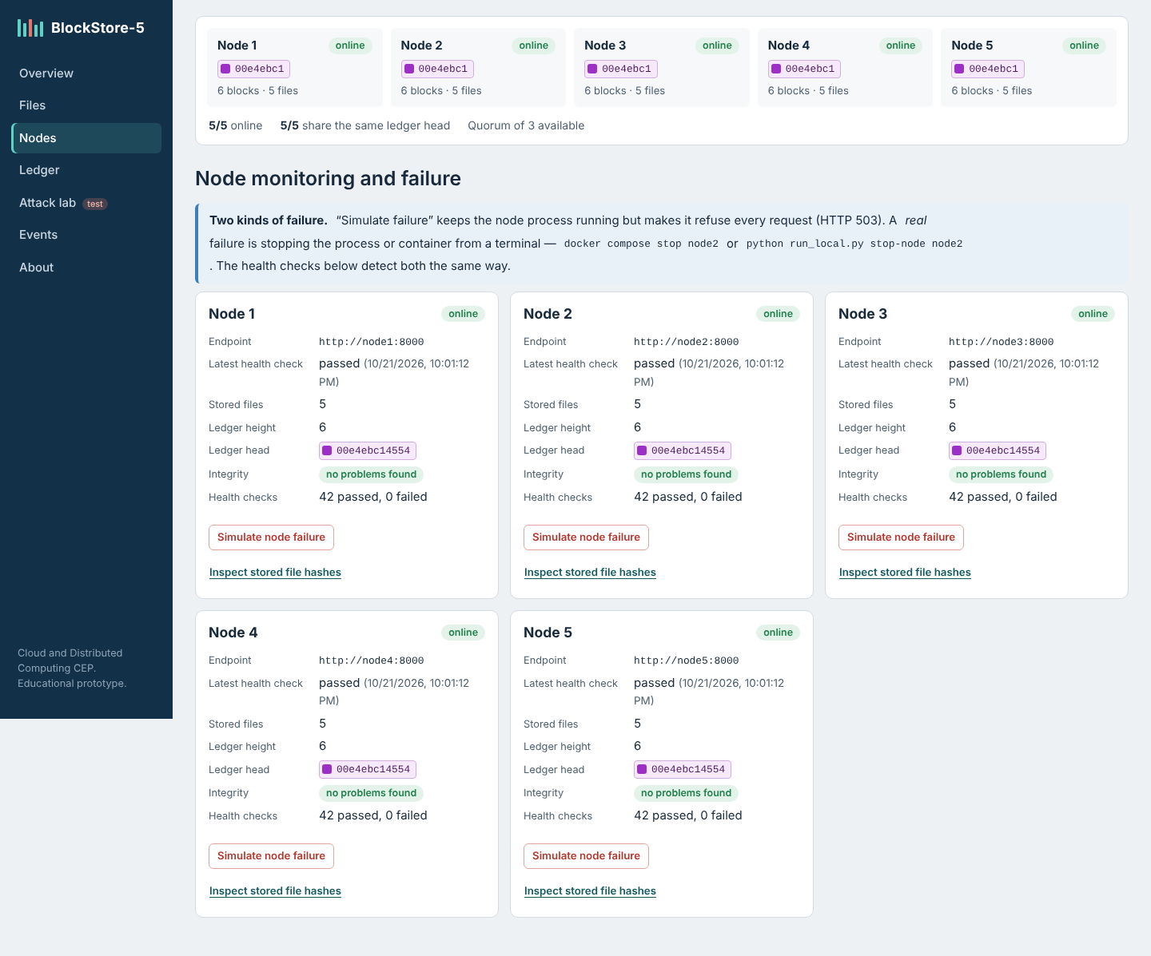
Five nodes online
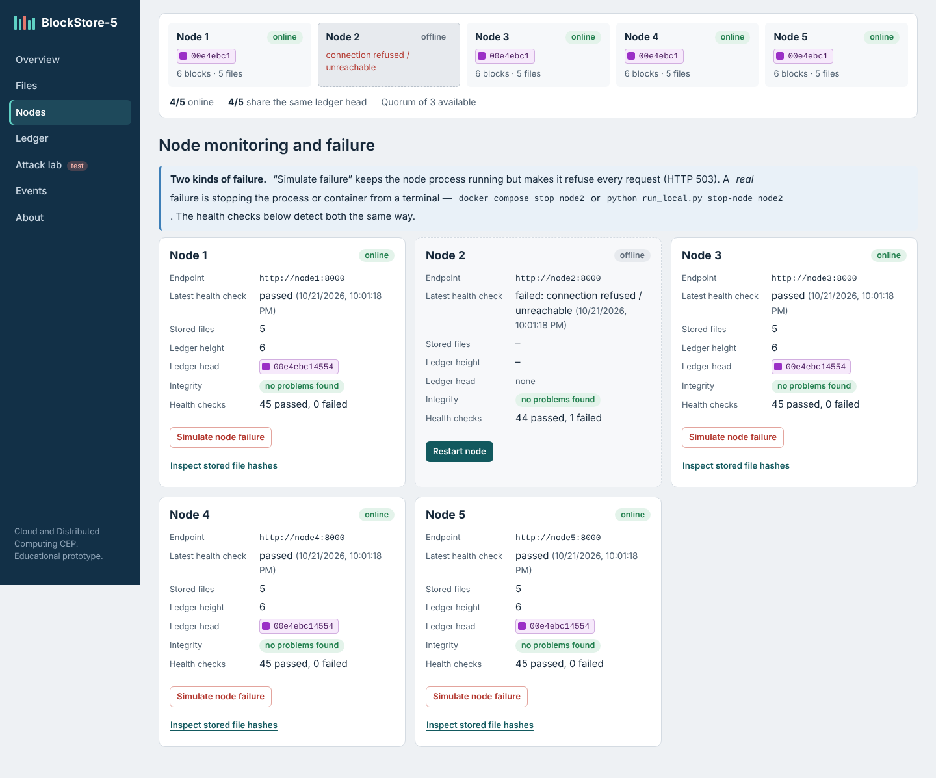
Real failure of Node 2 detected
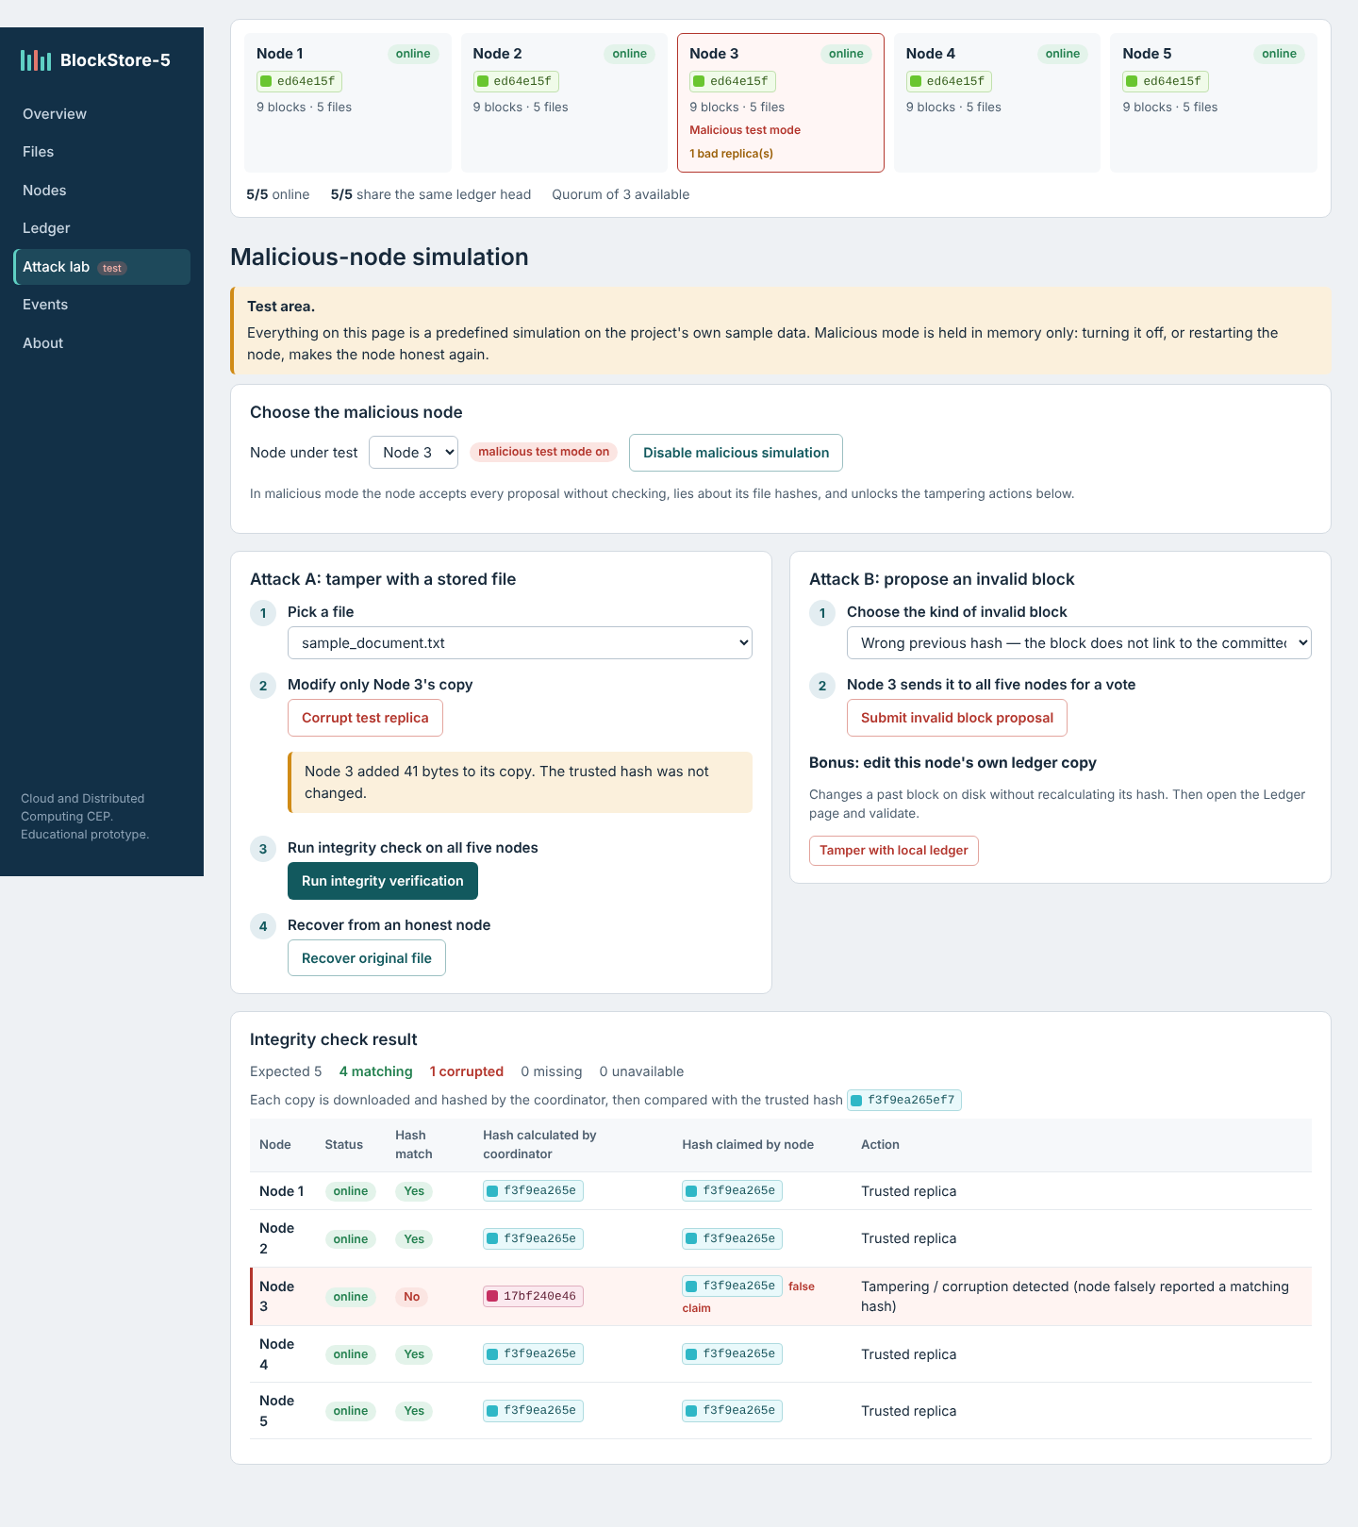
Attack A: Node 3’s tampered replica detected, four trusted copies
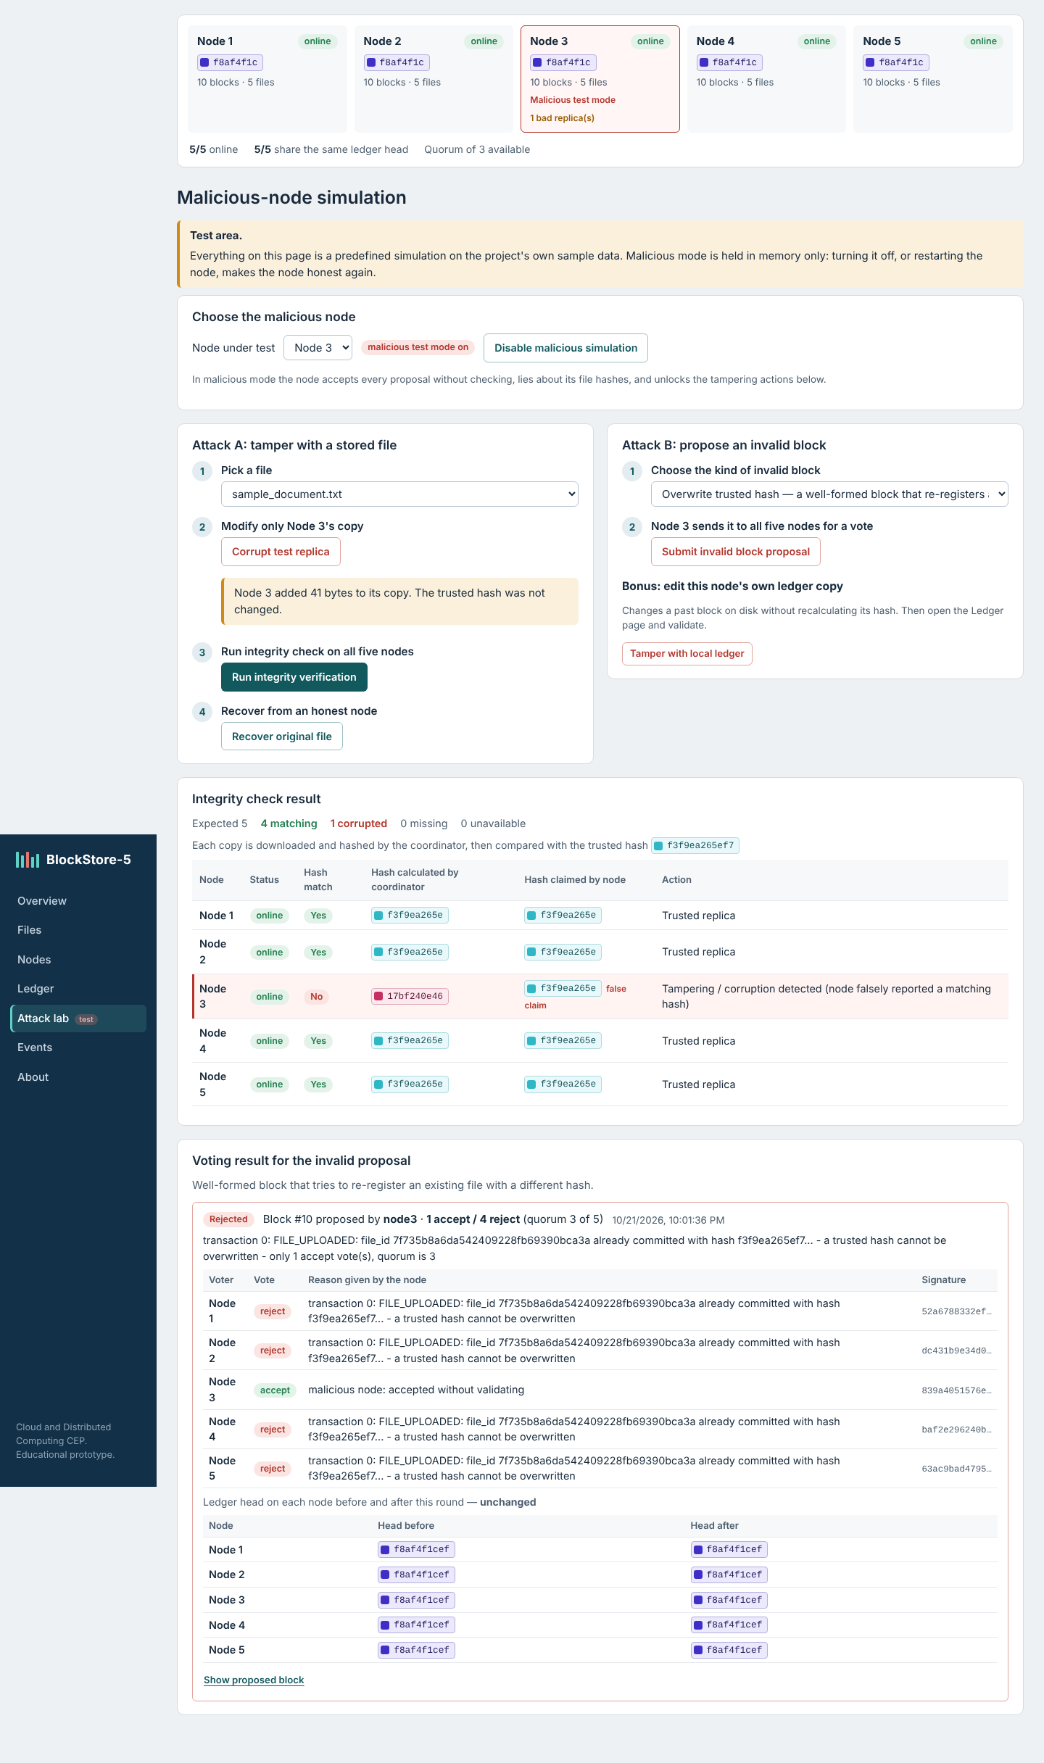
Attack B: invalid proposal rejected by the four honest nodes
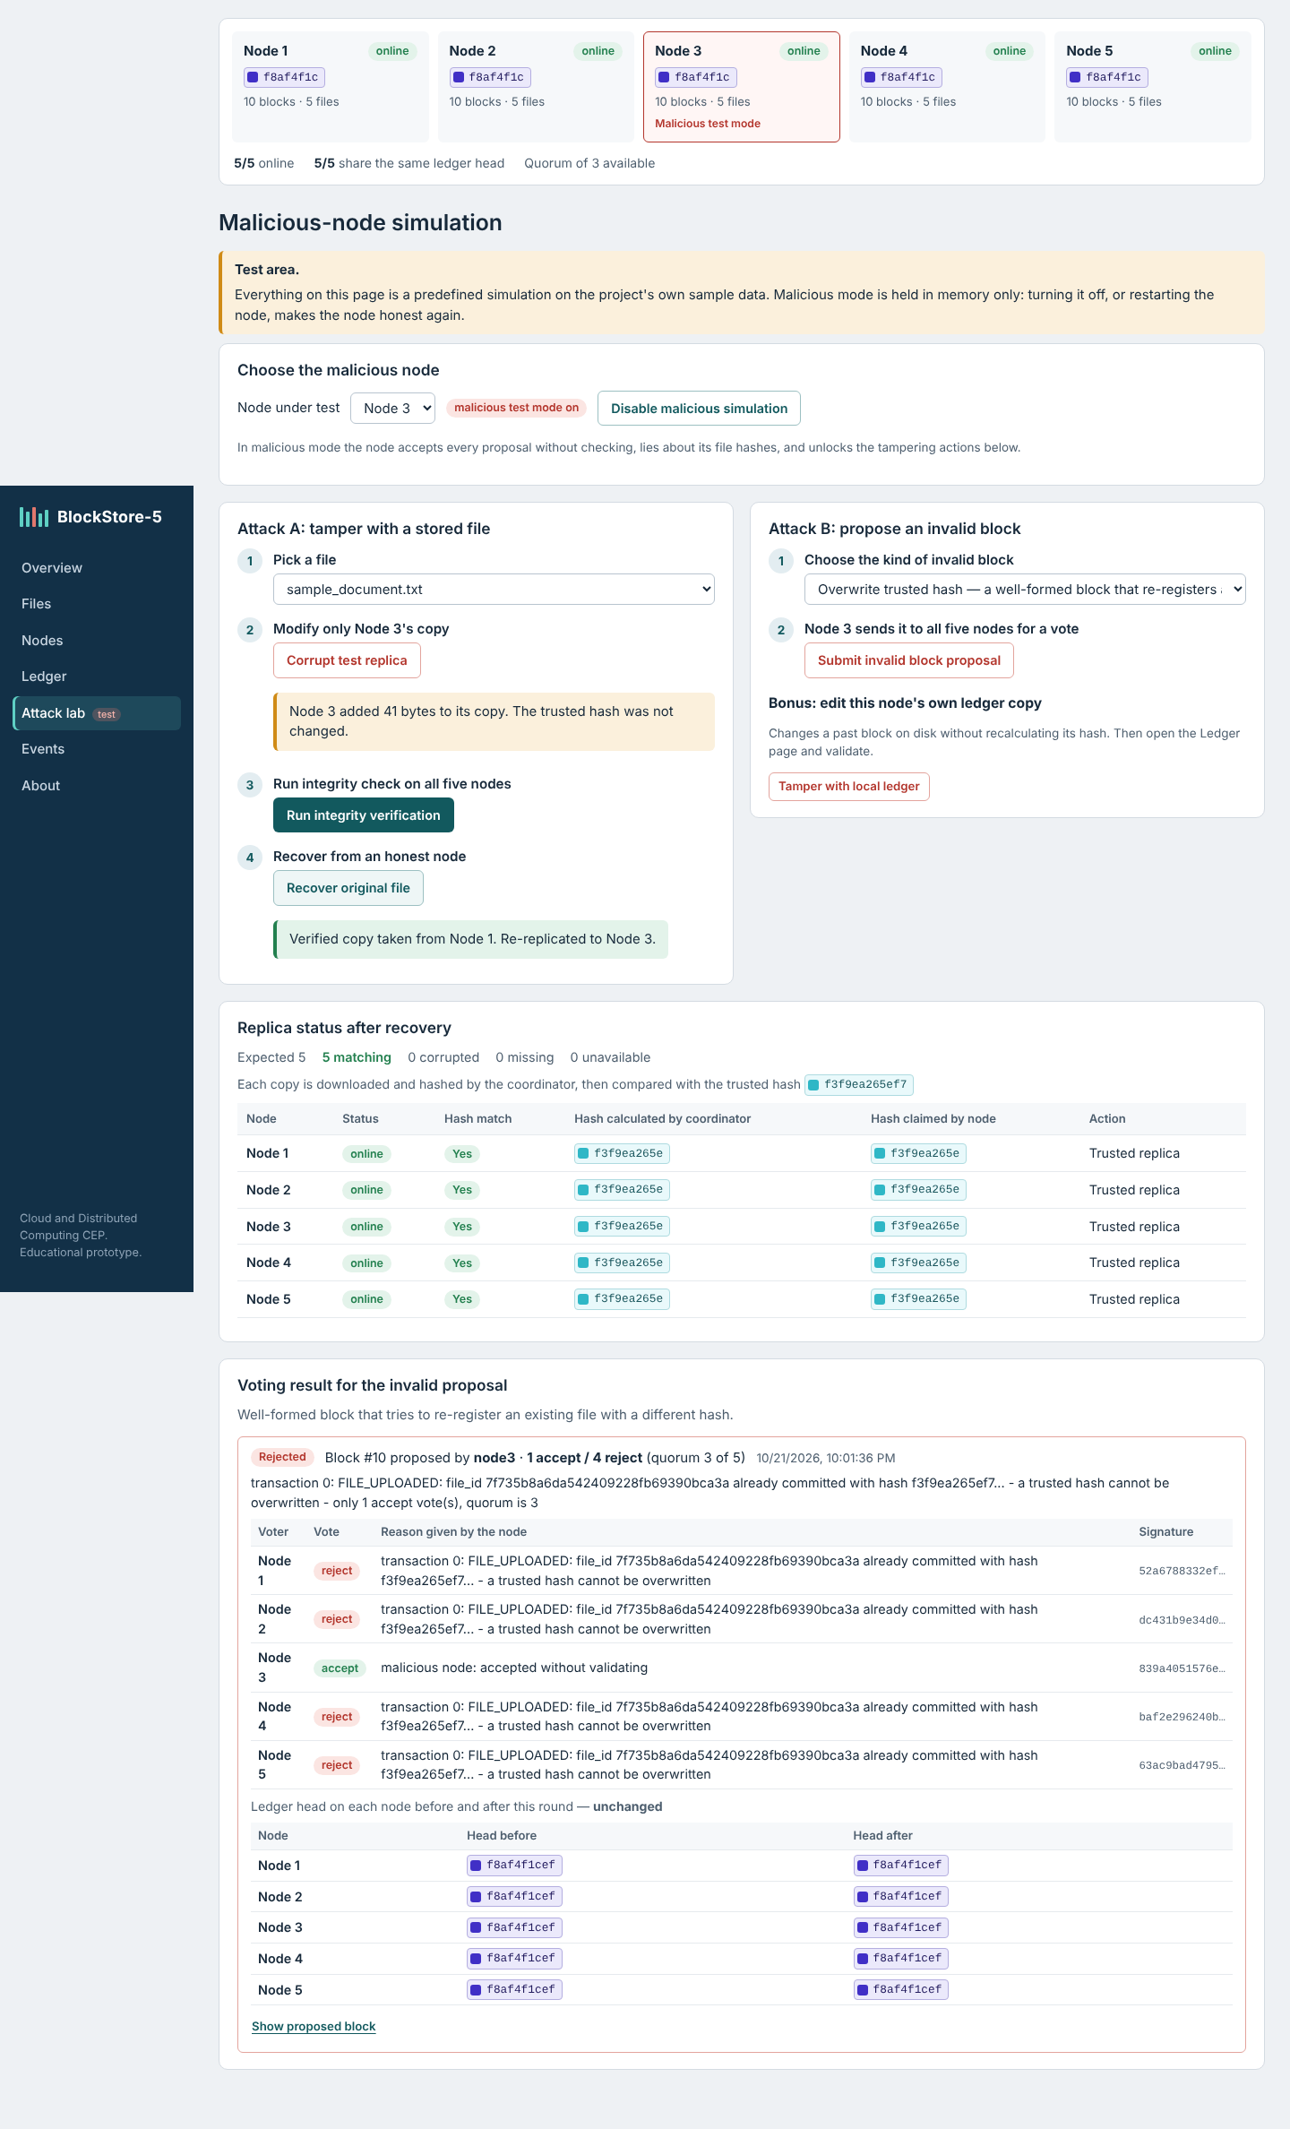
Recovery from an honest node

10.3 Performance evaluation
Measured with scripts/benchmark.py against the Docker deployment (five node containers and the backend on a Linux VM with 2 vCPU and 8 GB RAM), 3 runs per size, times in milliseconds as mean (min–max):
File size | Upload (client) | Upload (server) | Replication to 5 nodes | Ledger vote + commit | Integrity verification | Recovery of 1 corrupted replica
1 KB | 89.4 (78.4–99.6) | 85.6 (75.7–94.1) | 11.4 (10.4–13.3) | 61.6 (56.0–65.4) | 85.9 (80.5–94.9) | 114.1 (103.1–120.3)
100 KB | 103.9 (89.8–120.4) | 100.2 (85.9–117.0) | 12.6 (11.6–13.7) | 73.2 (56.9–90.1) | 90.6 (86.4–96.2) | 111.8 (110.7–113.2)
1 MB | 132.9 (127.3–138.8) | 123.1 (119.4–125.2) | 29.6 (22.9–35.3) | 77.2 (69.5–88.8) | 130.8 (126.8–134.4) | 186.1 (150.5–217.8)
5 MB | 227.0 (197.5–254.4) | 191.7 (178.3–200.9) | 90.6 (74.9–101.2) | 81.4 (74.9–88.9) | 195.9 (188.1–210.6) | 382.2 (338.2–414.3)
Valid replicas of a test file were 5 before, 4 during and 5 after a simulated failure of Node 2; the download during the failure was served (verified) by Node 1. Over the run the coordinator recorded 67–69 successful health checks per node and 0–2 failed checks, the failures corresponding to the deliberate failure tests.
Observations. For small files the ledger vote and commit dominates (about 60–80 ms), because each round reads the five ledger copies, collects five votes and sends five commits. Replication cost grows with file size (11 ms for 1 KB to 91 ms for 5 MB, five copies in parallel). Recovery costs roughly a verification plus a repair plus a second verification. These numbers come from a single local machine and do not represent real network latency.
Trade-offs. More replicas raise availability but multiply storage (5× here) and network traffic. Hashing detects changes but does not identify the attacker. The ledger improves auditability but provides neither confidentiality nor availability by itself. The coordinator simplifies the protocol but is a single point of failure.

11. Limitations
- The coordinator is a single point of failure and is trusted.
- The consensus is a simplified coordinator-based majority vote, not BFT; it does not handle partitions, equivocation, coordinator failure or concurrent proposals (one round at a time).
- At most one faulty node is assumed; three honest nodes must be online for writes.
- HMAC vote tags can be checked by the coordinator but not by other nodes.
- Hash links make tampering detectable, not impossible; a mismatch does not identify its cause.
- No authentication, authorisation, encryption or TLS; demo secrets must be changed for any real use.
- Full replication uses five times the storage; replicas are not backups.
- All nodes run on one computer, so geographic fault tolerance and scalability are not demonstrated.

12. Future improvements
Replace the coordinator with a replicated leader using Raft, or with PBFT among the nodes; use Ed25519 signatures so nodes can verify each other; add user authentication, TLS and encryption at rest; use erasure coding instead of full copies; re-replicate automatically when a node returns; add versioning and off-site backups; deploy the nodes on separate machines or cloud regions and measure under real network conditions.

13. Conclusion
BlockStore-5 meets its objectives as an educational prototype. Five independent node services store replicated files; a node failure is detected within seconds and verified copies continue to be served; a tampered replica on one node is detected by re-hashing, never served, and repaired from an honest node; and a three-of-five signed vote keeps the per-node ledgers in agreement while rejecting invalid blocks from a malicious node. The project also makes the limits of these techniques clear: replication is not backup, hashing is detection rather than prevention, and a coordinator-based majority vote is a teaching model rather than production Byzantine fault tolerance.

14. References
- A. S. Tanenbaum and M. van Steen, Distributed Systems, 3rd ed., 2017.
- G. Coulouris, J. Dollimore, T. Kindberg and G. Blair, Distributed Systems: Concepts and Design, 5th ed., Addison-Wesley, 2011.
- National Institute of Standards and Technology, FIPS 180-4: Secure Hash Standard (SHS), 2015.
- H. Krawczyk, M. Bellare and R. Canetti, RFC 2104: HMAC: Keyed-Hashing for Message Authentication, IETF, 1997.
- S. Nakamoto, “Bitcoin: A Peer-to-Peer Electronic Cash System,” 2008.
- M. Castro and B. Liskov, “Practical Byzantine Fault Tolerance,” in Proc. OSDI, 1999.
- D. Ongaro and J. Ousterhout, “In Search of an Understandable Consensus Algorithm (Raft),” in Proc. USENIX ATC, 2014.
- L. Lamport, R. Shostak and M. Pease, “The Byzantine Generals Problem,” ACM TOPLAS, vol. 4, no. 3, 1982.
- P. Mell and T. Grance, NIST SP 800-145: The NIST Definition of Cloud Computing, 2011.
- FastAPI documentation, https://fastapi.tiangolo.com; React documentation, https://react.dev; Docker Compose documentation, https://docs.docker.com/compose/.

