LB-Daily-Tasks

- Configure Classic Load balancer.

Objective
Configure an internet-facing Classic Load Balancer and distribute HTTP traffic across two EC2 instances deployed in different Availability Zones.

Configuration
- Load Balancer Name: CLB-Assignment
- Load Balancer Type: Classic Load Balancer
- Scheme: Internet-facing
- VPC: LB-Assignment-VPC
- Region: US East (N. Virginia) — us-east-1
- Availability Zones:
  - us-east-1a — LB-pub-sub1
  - us-east-1b — LB-pub-sub2
- Security Group: LB-Assignment-SG
- Listener: HTTP :80
- Instance Protocol/Port: HTTP :80
- Health Check: HTTP :80/index.html
- Registered Instances:
  - LB-Server-1
  - LB-Server-2
- Cross-Zone Load Balancing: Enabled
- Connection Draining: Enabled

Implementation Steps
- Created two public subnets in LB-Assignment-VPC across two Availability Zones.
- Launched two Amazon Linux EC2 instances:
  - LB-Server-1 in us-east-1a
  - LB-Server-2 in us-east-1b
- Installed and configured Apache HTTP Server on both instances.
- Verified that both EC2 instances were serving the application over HTTP on port 80.
- Created the CLB-Assignment Classic Load Balancer.
- Configured the CLB as internet-facing across both public subnets.
- Associated LB-Assignment-SG with the load balancer.
- Configured an HTTP listener on port 80.
- Configured the health check using /index.html.
- Registered both EC2 instances with the CLB.
- Verified that both instances were reported as InService.
- Tested the application using the CLB DNS name.

Validation / Evidence
CLB DNS Name:
CLB-Assignment-1180017017.us-east-1.elb.amazonaws.com
Expected Result:
The application is accessible through the CLB DNS name, and both registered EC2 instances are shown as InService.

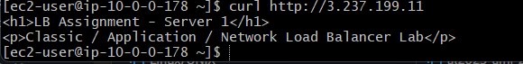
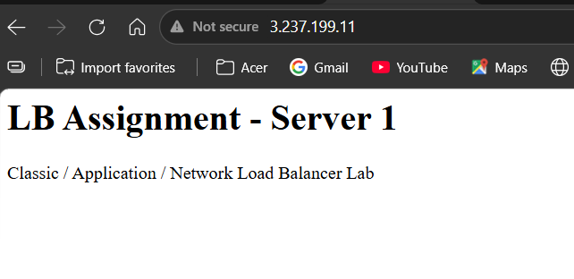

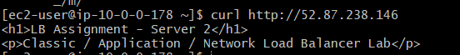
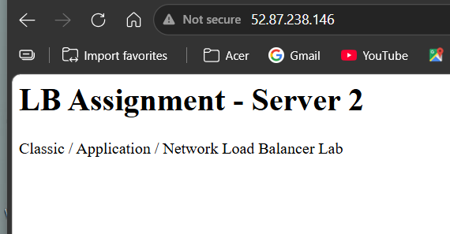

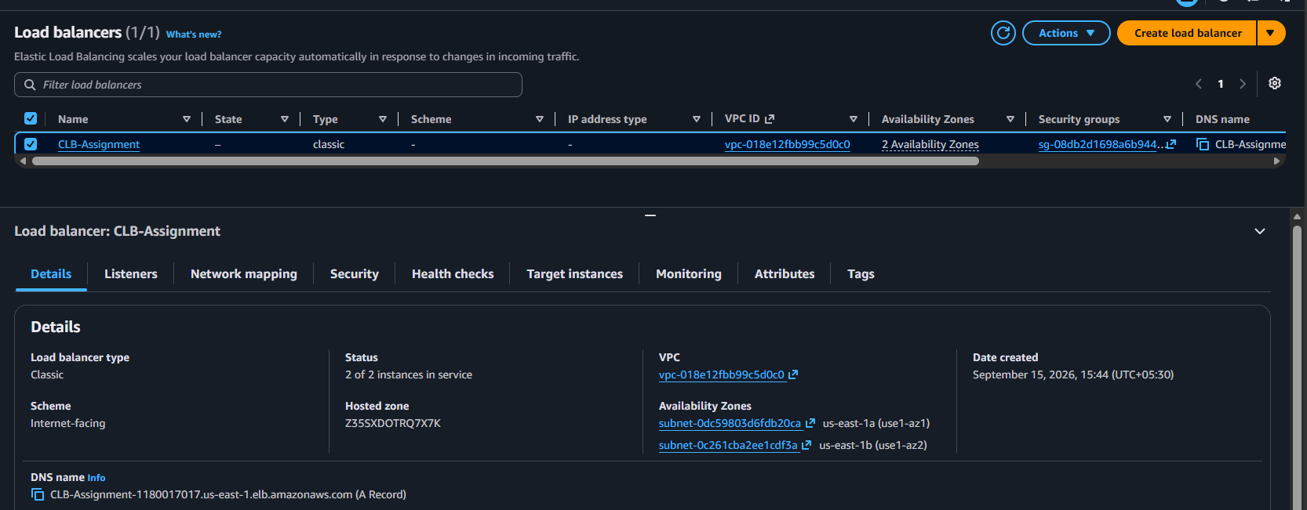

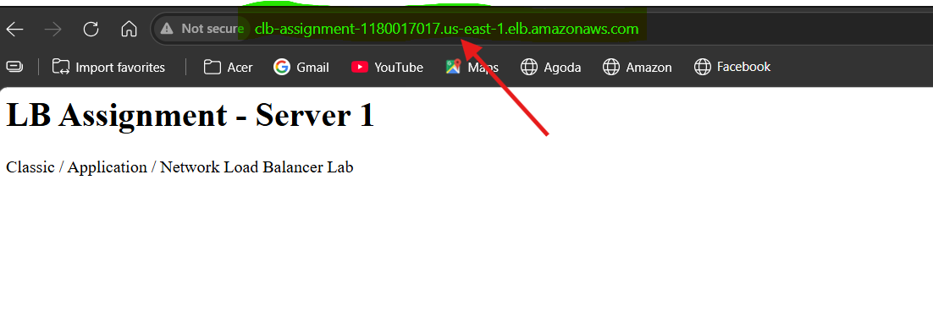

- Configure Application Load balancer.

Objective
Configure an internet-facing Application Load Balancer to distribute HTTP traffic across two EC2 instances in different Availability Zones.

Configuration
- Load Balancer Name: ALB-Assignment
- Load Balancer Type: Application Load Balancer
- Scheme: Internet-facing
- IP Address Type: IPv4
- Region: US East (N. Virginia) — us-east-1
- VPC: LB-Assignment-VPC
- Availability Zones:
  - us-east-1a — LB-pub-sub1
  - us-east-1b — LB-pub-sub2
- Security Group: LB-Assignment-SG
- Listener: HTTP :80
- Target Group: ALB-TG
- Target Type: Instances
- Target Protocol: HTTP
- Target Port: 80
- Health Check Protocol: HTTP
- Health Check Path: /
- Registered Targets:
  - LB-Server-1
  - LB-Server-2

Implementation Steps
- Created an Application Load Balancer target group named ALB-TG.
- Configured the target group to use EC2 instances over HTTP on port 80.
- Registered LB-Server-1 and LB-Server-2 as targets.
- Configured HTTP health checks to verify target availability.
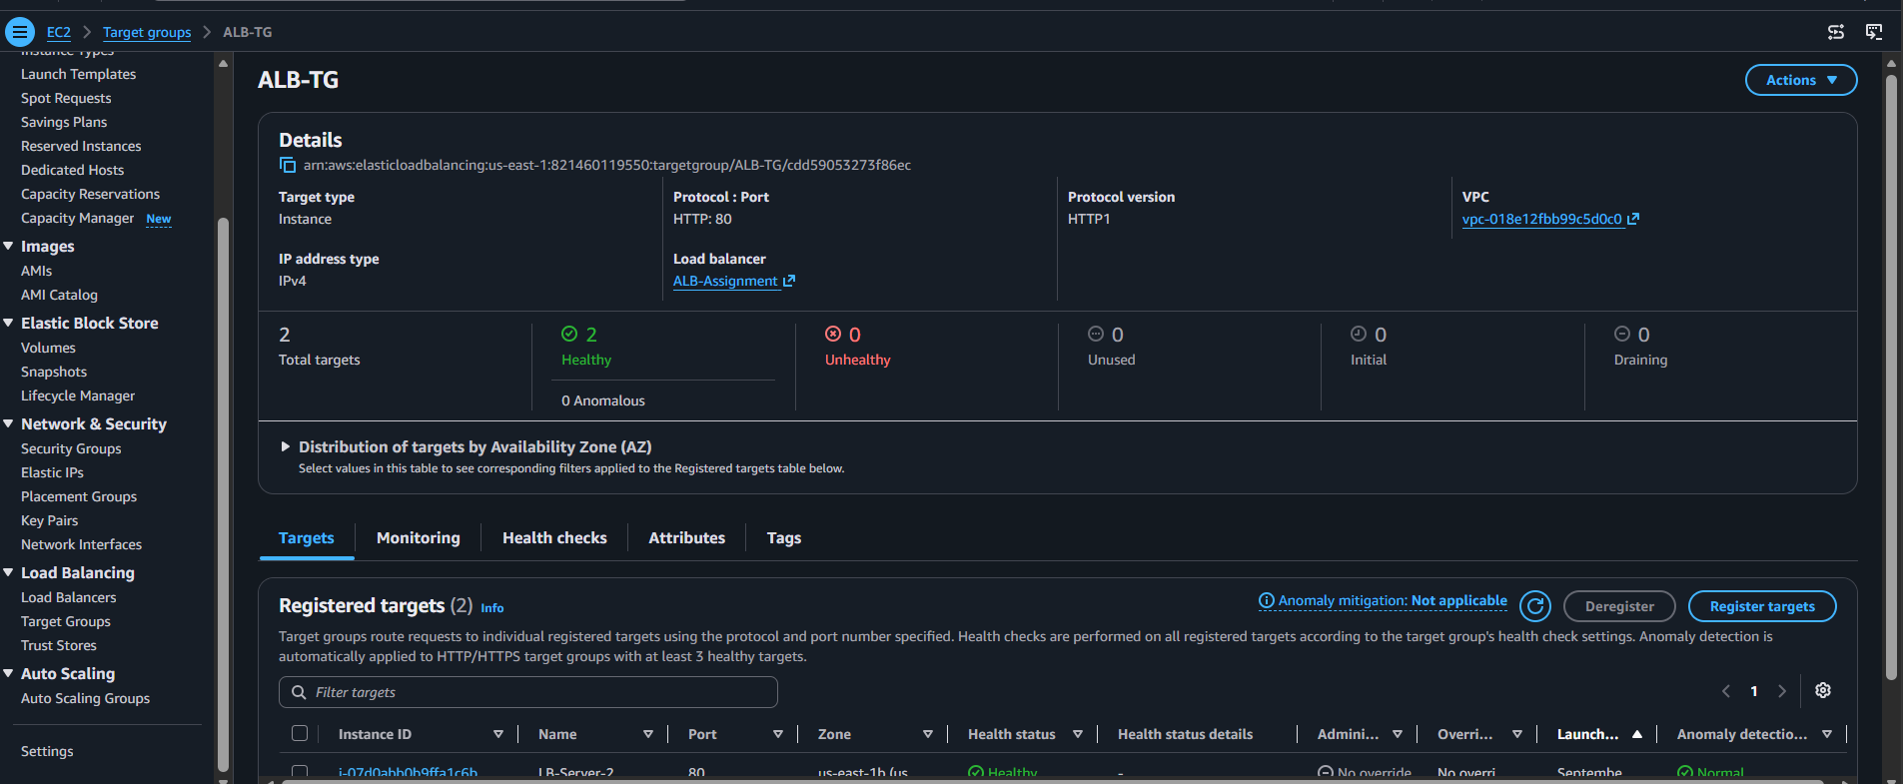

- Created the internet-facing ALB-Assignment.
- Selected LB-Assignment-VPC and both public subnets across two Availability Zones.
- Associated LB-Assignment-SG with the ALB.
- Created an HTTP listener on port 80.
- Configured the listener to forward requests to ALB-TG.
- Verified that the ALB became Active.
- Verified that the registered EC2 instances were Healthy.
- Tested the application using the ALB DNS name.
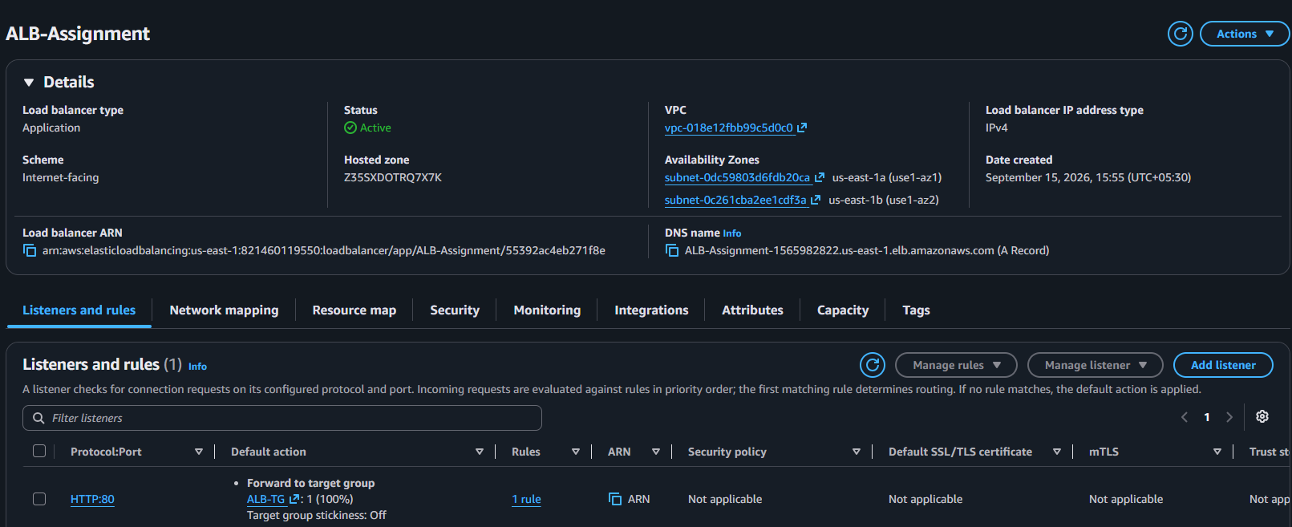

Validation / Evidence
ALB DNS Name:
ALB-Assignment-1565982822.us-east-1.elb.amazonaws.com
Expected Result:
The application is successfully accessible through the ALB DNS name, and both registered EC2 instances report a Healthy status.

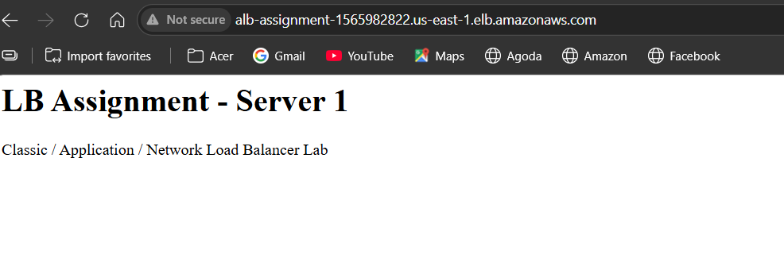

- Configure Network Load balancer.

Objective
Configure a Network Load Balancer to distribute TCP traffic across the application servers.

Configuration
- NLB Name: NLB-Assignment
- Scheme: Internet-facing
- IP Address Type: IPv4
- VPC: LB-Assignment-VPC
- Subnet 1: LB-pub-sub1 – us-east-1a
- Subnet 2: LB-pub-sub2 – us-east-1b
- Listener Protocol: TCP
- Listener Port: 80
- Target Group: NLB-TG
- Target Type: Instance
- Targets: LB-Server-1, LB-Server-2

Steps Performed
- Created the target group NLB-TG.
- Selected Instance as the target type.
- Configured the target group protocol as TCP on port 80.
- Selected the existing LB-Assignment-VPC.
- Registered the existing EC2 instances:
  - LB-Server-1
  - LB-Server-2
- Started creating the NLB-Assignment.
- Selected Internet-facing and IPv4.
- Selected the existing VPC and two public subnets.
- Configured a TCP :80 listener.
- Configured the listener to forward traffic to NLB-TG.
- Attempted to create the Network Load Balancer.

Issue Encountered
NLB creation failed with the following AWS error:
OperationNotPermittedException: This AWS account currently does not support creating load balancers.
The issue occurred on the AWS account/service side. The existing VPC, subnets, EC2 instances, and target group were already configured correctly.

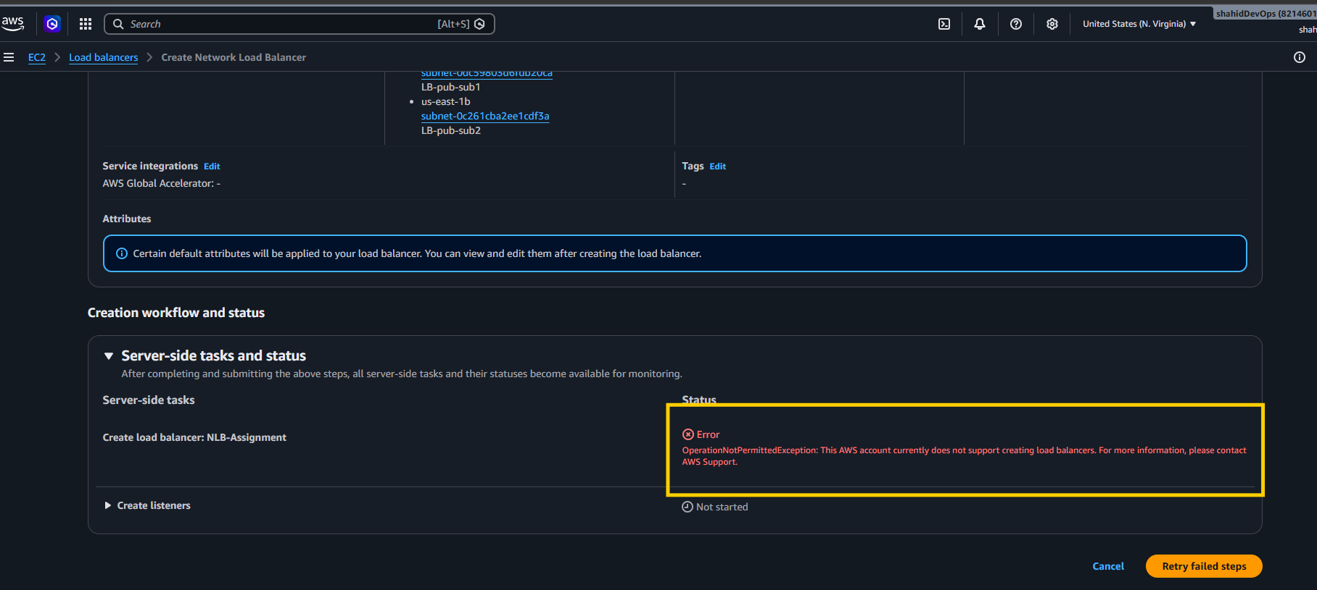

Evidence
- NLB target group configuration and registered targets.
- NLB creation configuration.
- AWS error showing the account-level restriction.

Note: Additional NLB evidence was taken using the teammate's successfully created NLB because the current AWS account does not permit NLB creation.
Listening and rules:
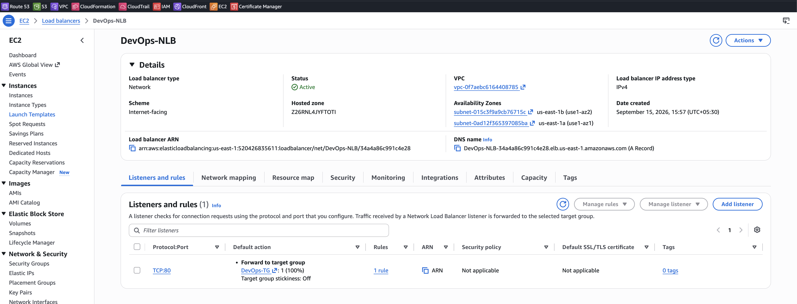
Network Mapping:
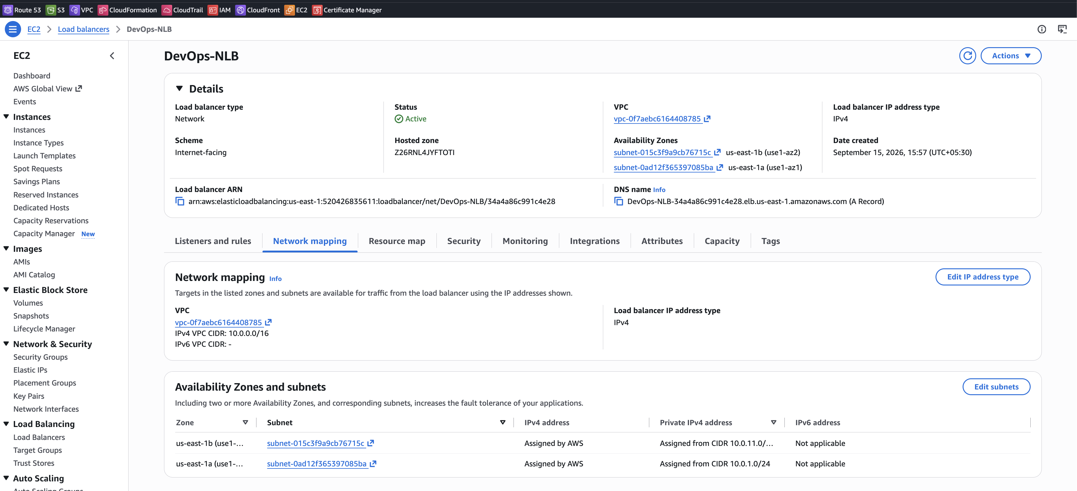

Resource Map:
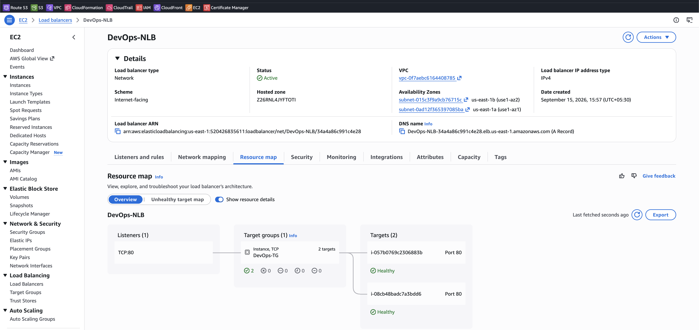

Security:
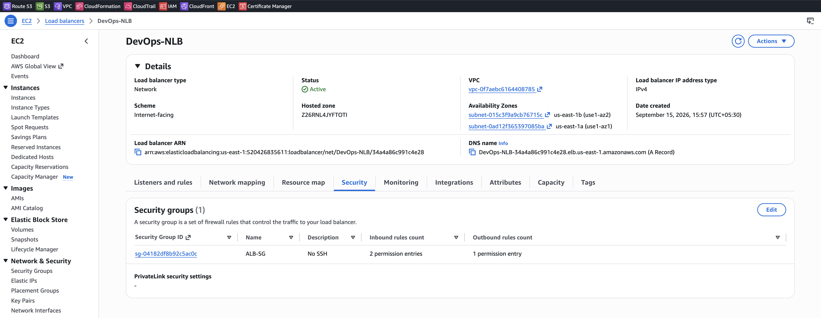

Result
The NLB configuration and target group setup were completed, but the final NLB creation could not be completed due to an AWS account-level service restriction.

Status
Blocked — AWS Account Restriction

- Attach SSL for application load balancer.

Objective
Configure HTTPS for the Application Load Balancer (ALB) by attaching an SSL/TLS certificate using AWS Certificate Manager (ACM).

Configuration
- Load Balancer: ALB-Assignment
- Protocol: HTTPS
- Port: 443
- Target Group: ALB-TG
- SSL/TLS Certificate: shahid8256.online
- Certificate Source: AWS Certificate Manager (ACM)
- Security Policy: ELBSecurityPolicy-TLS13-1-2-Res-PQ-2025-09
- Security Group: LB-Assignment-SG
- Inbound HTTPS: TCP 443 from 0.0.0.0/0

Steps Performed
- Opened EC2 → Load Balancers.
- Selected the existing ALB-Assignment.
- Opened Listeners and rules.
- Added a new listener with:
  - Protocol: HTTPS
  - Port: 443
- Configured the default action to Forward to target group.
- Selected the existing ALB-TG target group.
- Selected the existing ACM certificate for shahid8256.online.
- Updated the security group to allow inbound HTTPS (443) traffic.
- Verified that the HTTPS listener became reachable.

Validation / Evidence
- HTTPS listener 443 is configured on the ALB.
- SSL/TLS certificate for shahid8256.online is attached.
- HTTPS traffic is forwarded to ALB-TG.
- HTTPS listener is reachable successfully.

Status
Completed — Successful

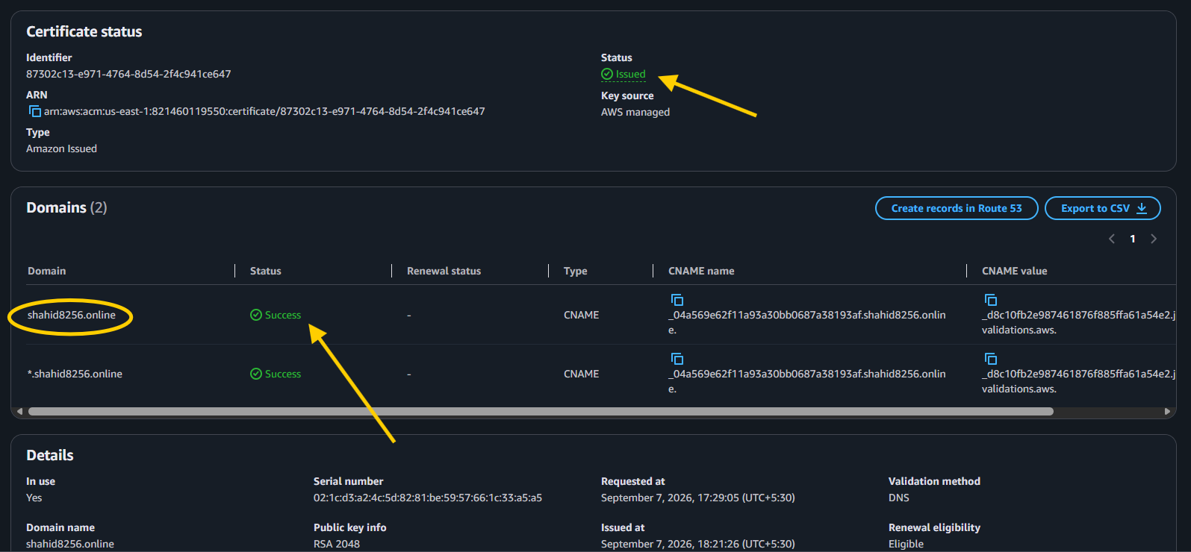
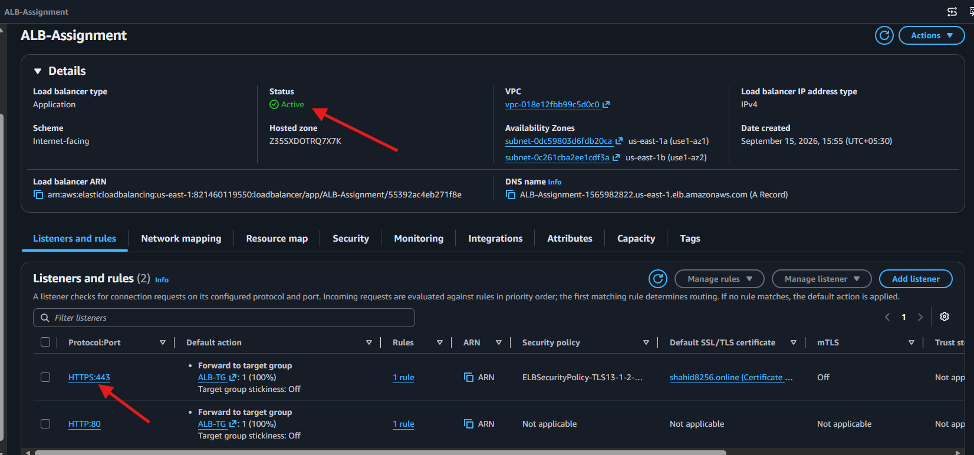

- Map Application load balancer to R53.

Objective
Map the existing Application Load Balancer (ALB) to the custom domain using Amazon Route 53.

Configuration
- Domain: shahid8256.online
- Hosted Zone: shahid8256.online
- Routing Policy: Simple Routing
- Record Type: A – IPv4
- Alias: Yes
- Alias Target: ALB-Assignment
- Region: US East (N. Virginia)
- Evaluate Target Health: No

Steps Performed
- Opened Route 53 → Hosted zones.
- Selected the hosted zone shahid8256.online.
- Clicked Create record.
- Selected Simple routing.
- Created an A record for the root domain.
- Enabled Alias.
- Selected Application Load Balancer as the target.
- Selected the existing ALB-Assignment.
- Created the record successfully.

Result
The domain is mapped to the Application Load Balancer:
shahid8256.online → Route 53 A (Alias) Record → ALB-Assignment

Evidence
- Screenshot of the Route 53 Hosted Zone showing the A record pointing to ALB-Assignment.

Status
Completed — Successful

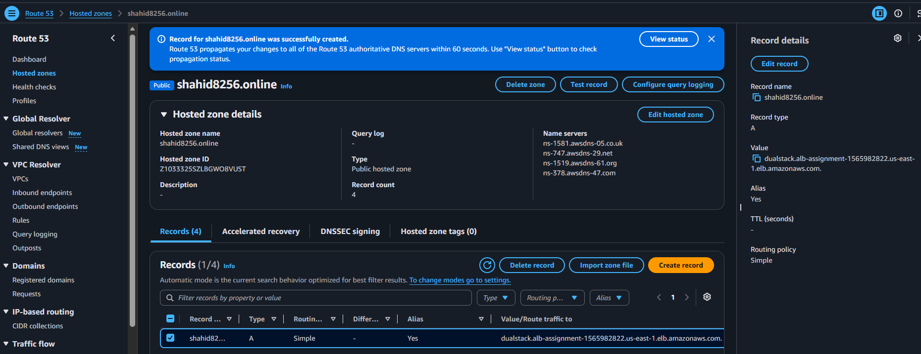

- Push the application load balancer logs to S3.

Objective
Enable access logging for the Application Load Balancer and store the logs in an Amazon S3 bucket.

Configuration
- Load Balancer: ALB-Assignment
- Access Logs: Enabled
- S3 Bucket: alb-access-logs-shahid8256
- S3 URI: s3://alb-access-logs-shahid8256
- Region: us-east-1
- Connection Logs: Disabled
- Health Check Logs: Disabled

Steps Performed
- Created an S3 bucket named alb-access-logs-shahid8256.
- Added the required S3 bucket policy to allow ALB log delivery.
- Opened EC2 → Load Balancers → ALB-Assignment → Attributes.
- Enabled Access Logs.
- Configured the S3 destination as:
s3://alb-access-logs-shahid8256
- Successfully modified the ALB logging attributes.
- Generated traffic through the ALB.
- Verified that AWS created the log directory structure:
AWSLogs/821460119550/elasticloadbalancing/us-east-1/2026/09/15/
- Verified an actual ALB access log file with .log.gz extension.

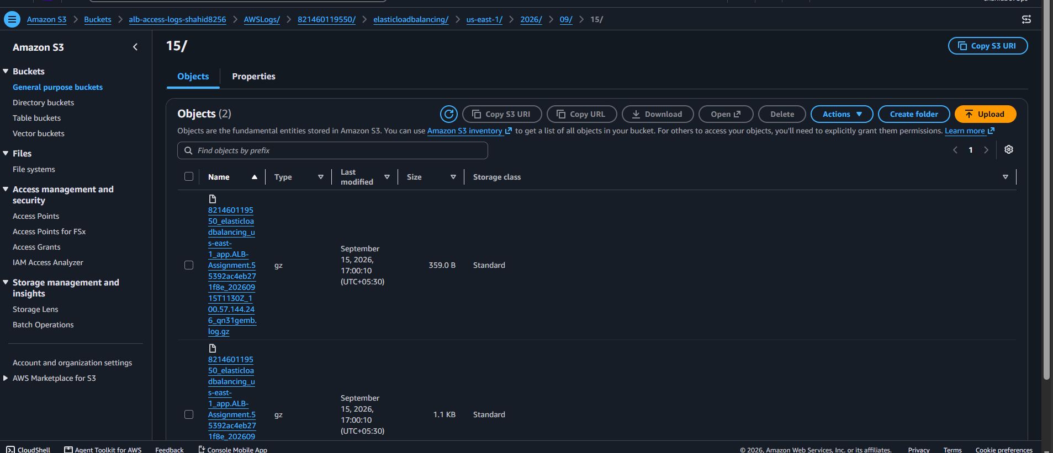

Validation / Evidence
- ALB Attributes page showing Access Logs: Enabled and the S3 URI.
- S3 bucket showing the actual .log.gz ALB access log file.
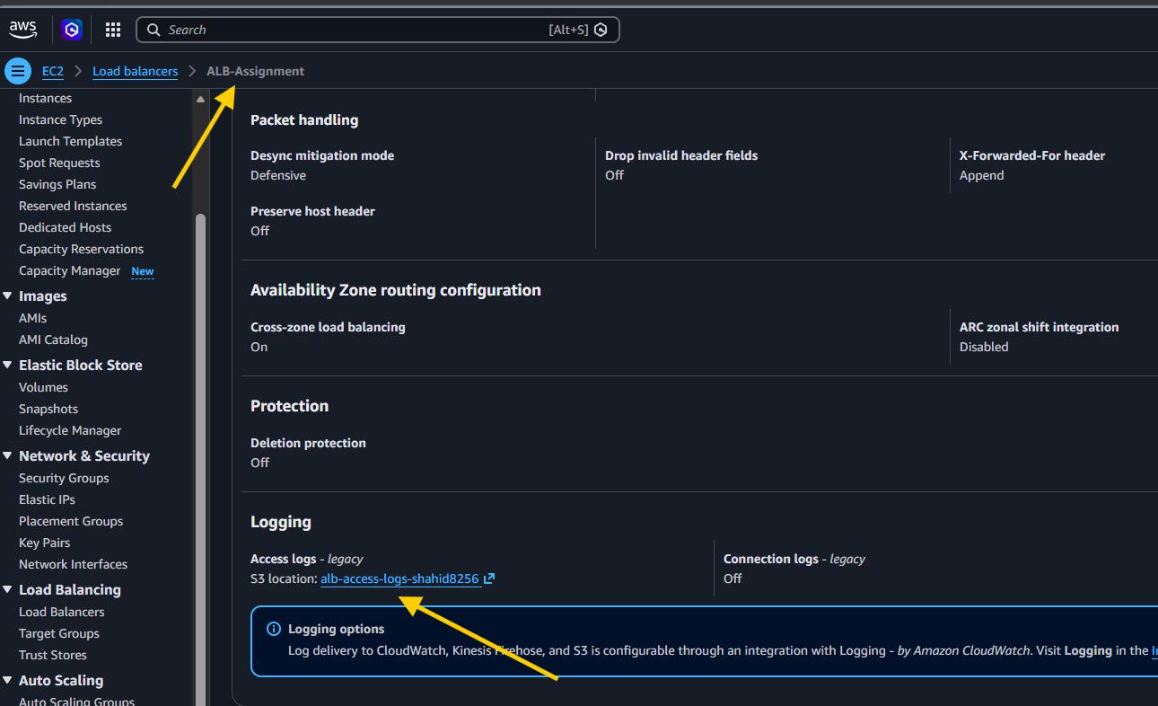

Result
ALB access logs are successfully generated and delivered to Amazon S3.

Status
Completed — Successful ✅

