AWS Self-Learning Notes — SQS, Amazon MQ & Secrets Manager

1. Amazon SQS — Simple Queue Service

What is SQS?
Amazon SQS is a fully managed message queuing service used to decouple applications.
Instead of Application A directly communicating with Application B:
Application A ───────────> Application B
we put a queue in between:
Application A
|
| Message
↓
SQS Queue
|
| Message
↓
Application B
Application A is called the Producer.
Application B is called the Consumer.

Why do we need SQS?
Suppose an e-commerce application receives 10,000 orders at once.
If the order-processing application can process only 1,000 orders at a time, sending everything directly can overload it.
With SQS:
10,000 Orders
↓
SQS Queue
↓
Consumers process gradually
The queue acts as a buffer.

Main benefits
- Decouples applications
- Handles traffic spikes
- Prevents applications from directly depending on each other
- Provides reliable message delivery
- Allows asynchronous processing
- Consumers can process messages independently

SQS Architecture
AWS
|
+-----------+
| SQS |
| Queue |
+-----------+
↑ ↓
Send Receive
↑ ↓
Producer Consumer
Example:
EC2 / Lambda / Application
|
| SendMessage
↓
SQS Queue
|
| ReceiveMessage
↓
EC2 / Lambda / Application

Important SQS Components

1. Queue
The place where messages are stored.
Example:
OrderQueue

2. Producer
Application that sends messages.
Producer → SQS

3. Consumer
Application that receives/processes messages.
SQS → Consumer

4. Message
The actual data sent through the queue.
Example:
Order ID: 1001
Customer: Afrid
Product: Laptop

Types of SQS Queues
There are two important types:

1. Standard Queue
Provides:
- Very high throughput
- At-least-once delivery
- Best-effort ordering
Important point:
Messages can occasionally be delivered more than once and ordering isn't guaranteed.
Use when maximum throughput is important.

2. FIFO Queue
FIFO = First In, First Out
Message 1
Message 2
Message 3

↓

Message 1
Message 2
Message 3
Provides:
- Ordered processing
- Exactly-once processing support through deduplication
- Lower throughput than Standard queues
Use when message order matters.
Example:
Bank transaction 1
Bank transaction 2
Bank transaction 3
Processing them out of order could be problematic.

Visibility Timeout
This is one of the most important SQS concepts.
Suppose:
Message
↓
Consumer receives it
The message isn't immediately deleted.
Instead, SQS temporarily hides it from other consumers.
That's the Visibility Timeout.
Example:
SQS
|
| Message
↓
Consumer A
|
| Processing
|
| Visibility Timeout = 30 sec
During those 30 seconds, other consumers normally won't see that message.

Why?
To prevent multiple consumers from processing the same message simultaneously.
After successful processing:
Consumer
↓
DeleteMessage
↓
Message removed
If processing fails and the message isn't deleted:
Visibility Timeout expires
↓
Message becomes visible again
↓
Consumer can retry

Dead-Letter Queue — DLQ
Suppose a message repeatedly fails processing.
Instead of retrying forever:
SQS
↓
Consumer
↓
FAIL
↓
Retry
↓
FAIL
↓
Retry
↓
FAIL
We can configure a Dead-Letter Queue.
Main Queue
|
| Failed multiple times
↓
Dead-Letter Queue
This allows you to investigate problematic messages separately.
Important term:
Maximum Receive Count
Example:
Maximum Receive Count = 3
After the message reaches the configured failure threshold, it can be moved to the DLQ.

Long Polling
Normally, a consumer can repeatedly ask:
"Any message?"
"Any message?"
"Any message?"
This creates unnecessary requests.
With Long Polling, SQS waits for a message to become available for a specified period.
Benefits:
- Reduces empty responses
- Reduces API calls
- Can reduce cost

SQS Important Terms
Term | Meaning
Producer | Sends messages
Consumer | Receives/processes messages
Queue | Stores messages
Standard | High throughput, best-effort ordering
FIFO | Ordered message processing
Visibility Timeout | Temporarily hides received message
DLQ | Stores repeatedly failed messages
Long Polling | Waits for messages instead of immediately returning
Message Retention | How long SQS keeps a message
Delay Queue | Delays delivery of new messages

2. Amazon MQ

What is Amazon MQ?
Amazon MQ is a managed message broker service provided by AWS.
It supports popular open-source/commercial messaging technologies such as:
- Apache ActiveMQ
- RabbitMQ
The key difference from SQS:
SQS is an AWS-native queue service, whereas Amazon MQ provides a managed message broker compatible with established messaging protocols and applications.

Why Amazon MQ?
Imagine your company already has an application using:
ActiveMQ
Migrating the application to SQS could require significant changes.
Instead, Amazon MQ allows you to run a managed broker using technologies such as ActiveMQ or RabbitMQ.
Existing Application
|
| Existing messaging protocol
↓
Amazon MQ
|
↓
Other Applications

Amazon MQ Architecture
AWS VPC
|
+----------------+
| Amazon MQ |
| Broker |
+----------------+
↑ ↓
Producer Consumer
| |
Application Application
The broker handles messaging between applications.

What is a Message Broker?
A message broker is software that receives, routes, and delivers messages between applications.
Example:
Application A
|
↓
Message Broker
|
↓
Application B
The broker can provide messaging patterns and protocols that applications already understand.

Amazon MQ Broker
A broker is the actual messaging server managed by Amazon MQ.
When you create Amazon MQ, you're essentially creating a managed broker environment.
Depending on the engine, the broker can support different messaging protocols and APIs.

ActiveMQ vs RabbitMQ

ActiveMQ
Apache ActiveMQ is a message broker.
Commonly associated with:
- JMS
- AMQP
- MQTT
- STOMP
- OpenWire
It is commonly used in Java-based enterprise applications.

RabbitMQ
RabbitMQ is a popular open-source message broker.
It uses concepts such as:
Producer
↓
Exchange
↓
Queue
↓
Consumer
The Exchange decides how messages are routed to queues.

RabbitMQ Basic Architecture
Producer
|
↓
Exchange
|
| Routing
↓
Queue
|
↓
Consumer
This is an important difference from basic SQS architecture.

Amazon MQ Networking
Amazon MQ brokers are deployed within an AWS VPC.
Therefore, networking matters.
Typical architecture:
VPC
|
+-- Private Subnet
| |
| +-- Amazon MQ
|
+-- Application
Applications need appropriate network connectivity and security-group rules to communicate with the broker.

Security in Amazon MQ
Important components include:

Security Groups
Control network access to the broker.

Credentials
Username/password can be used to authenticate clients.

Encryption
Amazon MQ supports encryption for data in transit and at rest depending on configuration/engine.

SQS vs Amazon MQ
This is an important interview question.
SQS | Amazon MQ
Fully managed queue service | Managed message broker
AWS-native | Supports established broker technologies
No broker management | Managed broker
Simple queue-based architecture | Rich messaging/broker capabilities
Standard/FIFO queues | ActiveMQ/RabbitMQ engines
Good for cloud-native applications | Useful for existing applications using supported messaging protocols
AWS API based | Protocol/API compatibility is a major feature

Simple way to remember
SQS → Queue
Amazon MQ → Broker

3. AWS Secrets Manager

What is Secrets Manager?
AWS Secrets Manager is a service used to securely store, manage, and retrieve sensitive information.
Examples:
- Database passwords
- Database usernames
- API keys
- Application credentials
- Tokens
- Other secrets

The Problem
Suppose your application has:
DB_USERNAME=admin
DB_PASSWORD=MyPassword123
If you hard-code these in your application:
username = "admin"
password = "MyPassword123"
that's a security risk.
Instead:
Application
|
| Request secret
↓
Secrets Manager
|
↓
Username + Password
The application doesn't need to hard-code the secret.

Secrets Manager Architecture
Application
|
| IAM permission
↓
AWS Secrets Manager
|
↓
Encrypted Secret
|
↓
Username / Password

How Secrets Manager Works

Step 1 — Create a secret
Example:
Secret Name:
production/database

Username:
admin

Password:
********

Step 2 — Secrets Manager stores it securely
The secret is encrypted.

Step 3 — Application requests the secret
Application uses AWS APIs/SDK/CLI.
Application
|
| GetSecretValue
↓
Secrets Manager

Step 4 — Secret is returned
The application can then use the credentials.

IAM and Secrets Manager
This is extremely important.
Just because a secret exists doesn't mean every AWS resource can access it.
IAM permissions control access.
Example:
EC2
|
| IAM Role
|
| secretsmanager:GetSecretValue
↓
Secrets Manager
The EC2 role needs appropriate permission to retrieve the secret.
Example permission concept:
secretsmanager:GetSecretValue

Encryption
Secrets Manager encrypts secrets using AWS Key Management Service (AWS KMS).
Conceptually:
Secret
↓
KMS Encryption
↓
Encrypted Secret
When an authorized application retrieves it, AWS decrypts it as part of the retrieval process.

Secret Rotation
One of the major features of Secrets Manager is secret rotation.
Instead of keeping the same database password forever:
Old Password
↓
Rotation
↓
New Password
Secrets Manager can automate rotation for supported use cases when properly configured.

Why rotation?
If credentials remain unchanged for years, the impact of a credential leak can be much larger.
Regular rotation reduces that exposure.

Secrets Manager vs Parameter Store
Another common interview question.
Secrets Manager | Systems Manager Parameter Store
Designed specifically for secrets | General configuration/parameter storage
Secret rotation capabilities | More basic parameter management
Strong secret-management features | Useful for configuration values
Typically higher cost | Standard parameters can be lower/no additional cost
KMS encryption supported | KMS encryption supported for SecureString

Easy memory trick
Secrets Manager → Secrets
Parameter Store → Configuration/parameters

The 3 Services Together
Now understand where these services can appear in a real architecture.

Users
|
↓
Application
|
+-----------+-----------+
| |
↓ ↓
SQS Queue Secrets Manager
| |
↓ ↓
Consumer DB Credentials
|
↓
Database
Amazon MQ can be used instead of SQS when the application requires a supported message-broker technology/protocol:
Application
|
+----------→ SQS
|
+----------→ Amazon MQ
|
+----------→ Secrets Manager
|
↓
DB Credentials

SOME HANDS ON IMPLEMENTATIONS FOR THESE SERVICES:

SQS — Task 1: Create SQS Queue

Objective
Create a Standard SQS queue that will be used to store messages between a producer and consumer.

Configuration
Setting | Value
Service | Amazon SQS
Queue Type | Standard
Queue Name | Afrid-SQS-Queue
Other settings | Default

Implementation Steps
- Open AWS Management Console.
- Search for SQS.
- Open Amazon Simple Queue Service.
- Click Create queue.
- Select Standard queue.
- Enter the queue name:
Afrid-SQS-Queue
- Keep the remaining settings as default.
- Click Create queue.

Architecture
Producer
|
| Message
↓
Afrid-SQS-Queue
At this stage, we have only created the queue. No messages have been sent yet.

Observation
- The SQS queue was successfully created.
- Standard Queue was selected because it provides high throughput and is suitable for general asynchronous messaging.
- The queue is ready to receive messages from a producer.

Screenshot
📸 Screenshot 1: Created Afrid-SQS-Queue showing its queue type and details.
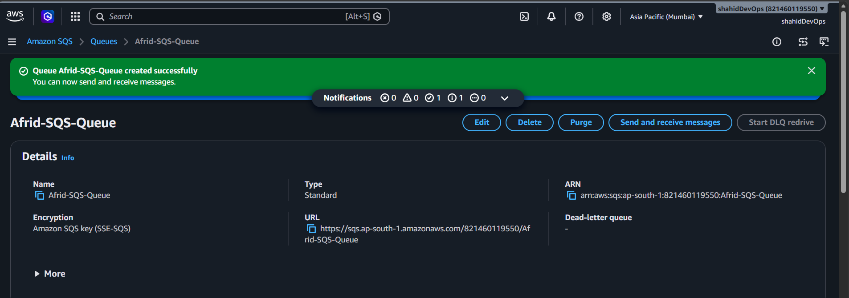

Key Point
SQS Queue = temporary storage for messages between a producer and consumer.

SQS — Task 2: Send Message

Objective
Send a message from the producer to the SQS queue.

Message Details
Setting | Value
Queue | Afrid-SQS-Queue
Message | Hello from Afrid - SQS Hands-on
Action | Send Message

Implementation Steps
- Open Amazon SQS.
- Select Afrid-SQS-Queue.
- Click Send and receive messages.
- Enter the following in Message body:
Hello from Afrid - SQS Hands-on
- Click Send message.

Architecture
Producer
|
| Send Message
↓
Afrid-SQS-Queue

Observation
- The message was successfully sent to the SQS queue.
- The message is now stored in the queue and is available for a consumer to retrieve.
- The producer and consumer do not need to communicate directly.

Screenshot
📸 Screenshot 2: Show the message successfully sent to Afrid-SQS-Queue.
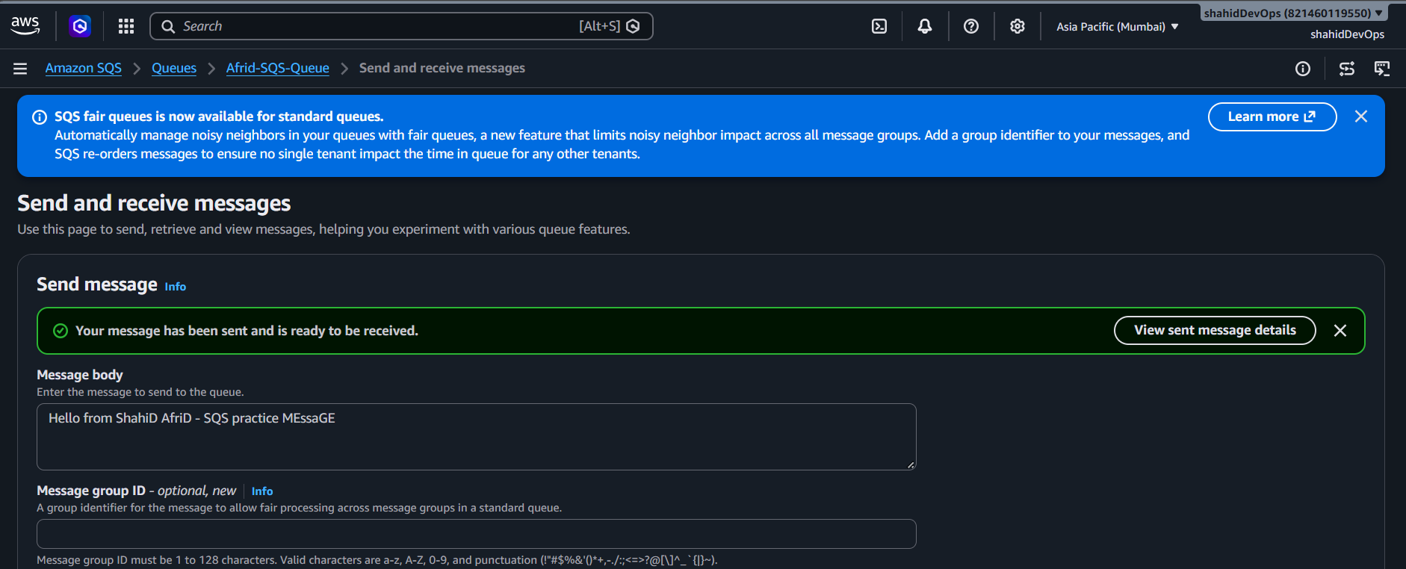

Key Point
Producer → SQS Queue
The producer sends the message to SQS, and SQS stores it until a consumer retrieves it.

SQS — Task 3: Receive the Message

Objective
Retrieve the message from the SQS queue and understand the consumer side.

Steps
- Open SQS → Queues.
- Select:
Afrid-SQS-Queue
- Click Send and receive messages.
- Click Poll for messages.
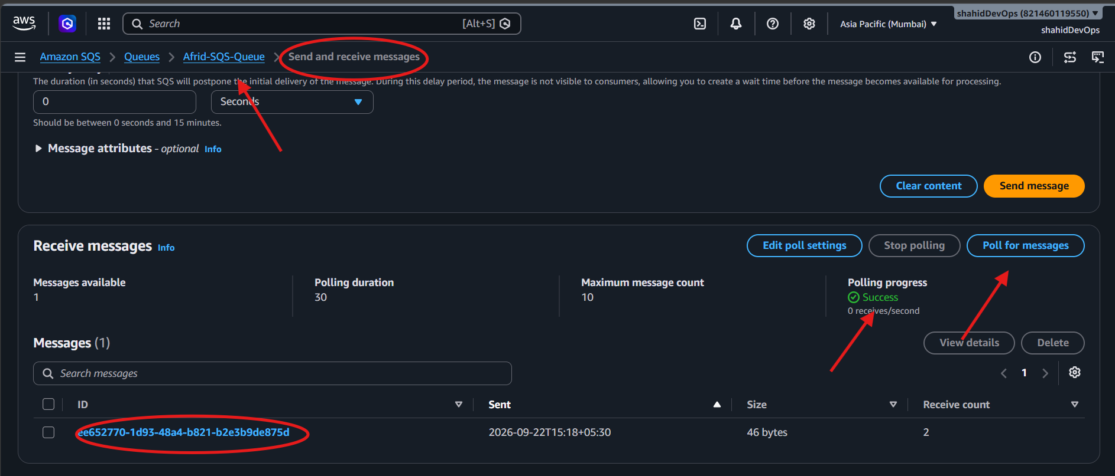
- You should see:
Hello from Afrid - SQS Hands-on

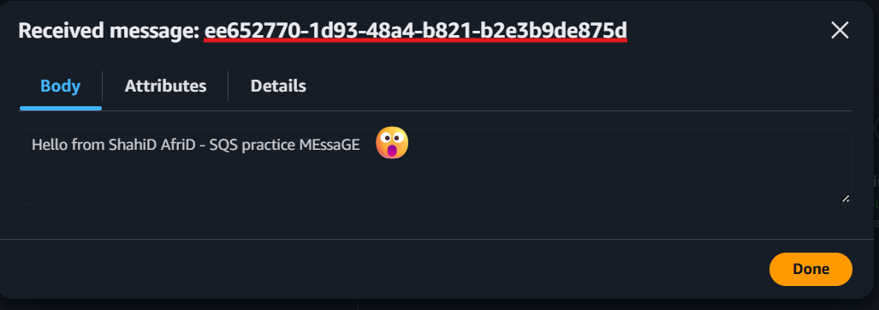

Architecture
Afrid-SQS-Queue
|
| Receive Message
↓
Consumer

Important
When you receive the message, don't delete it yet.
SQS temporarily makes the message invisible to other consumers using the Visibility Timeout.
We'll use this same message for the next task.

SQS — Task 4: Delete the Processed Message

1. Objective
Delete the message from the SQS queue after the consumer has successfully processed it.
This demonstrates the complete basic flow:
Producer
↓
SQS Queue
↓
Consumer
↓
Delete Message

2. Use Case
After a consumer successfully processes an order, payment request, notification, etc., it should delete the corresponding message from SQS.
If it doesn't delete the message, it can become visible again after the Visibility Timeout.

3. Architecture
Afrid-SQS-Queue
|
| Receive
↓
Consumer
|
| Successfully processed
↓
Delete Message

4. Configuration / Implementation
- Open Amazon SQS.
- Open:
Afrid-SQS-Queue
- Click Send and receive messages.
- Click Poll for messages.
- Select the message:
Hello from Afrid - SQS Hands-on
- Click Delete.
The message should disappear from the queue.

5. Screenshot
📸 Screenshot 4: Capture the message before/while performing the delete operation, showing that it was received successfully.
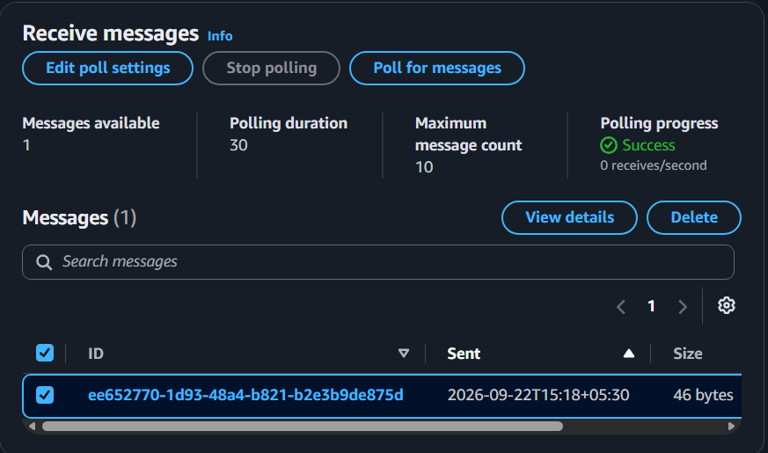

If the console displays the queue with no available messages after deletion, you can also capture that as evidence.
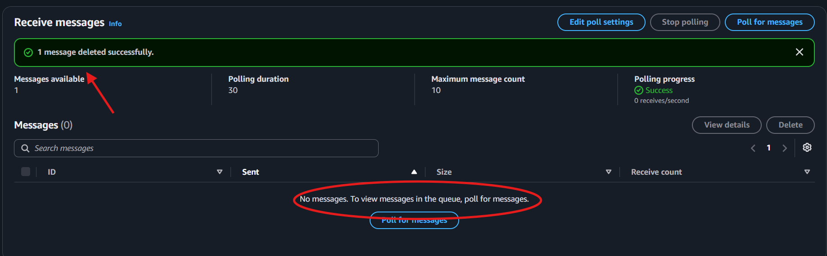

6. Observation
- The consumer successfully received the message.
- After processing, the message was deleted from the queue.
- Once deleted, the message will no longer be available for normal retrieval.
- This completes the basic send → receive → delete SQS workflow.

7. Key Takeaway
A message should be deleted only after the consumer successfully processes it.
Send → Receive → Process → Delete
This is the core SQS workflow we needed to implement.

8. Result / Conclusion
The message was successfully received and deleted from the SQS queue after processing. This demonstrated the basic SQS message lifecycle:
Producer → SQS Queue → Consumer → Delete Message
The task confirmed that messages remain in the queue until they are successfully processed and explicitly deleted by the consumer.

SQS — Task 5: Test Visibility Timeout

1. Objective
To understand how Visibility Timeout works when a consumer receives an SQS message but does not delete it.

2. Use Case
Visibility Timeout prevents a message that is currently being processed by one consumer from immediately being processed by another consumer.
If the consumer fails to process the message or does not delete it, the message becomes available again after the visibility timeout expires.

3. Architecture
SQS Queue
|
| Receive Message
↓
Consumer
|
No DeleteMessage
|
↓
Visibility Timeout
|
↓
Message becomes visible
|
↓
Consumer receives again

4. Configuration / Implementation Steps
- Sent a test message to Afrid-SQS-Queue:
Visibility Timeout Test
- Used Poll for messages to receive the message.
- Did not delete the message after receiving it.
- Waited for the Visibility Timeout to expire.
- Polled the queue again.
- The same message became available again.
- Repeated the process and observed the Receive Count increasing.

Observed Receive Count
1 → 2 → 3
The message was received three times because it was not deleted after processing.

5. Screenshot
📸 Capture the SQS Receive messages screen showing:
- Messages available
- The test message
- Receive count = 3
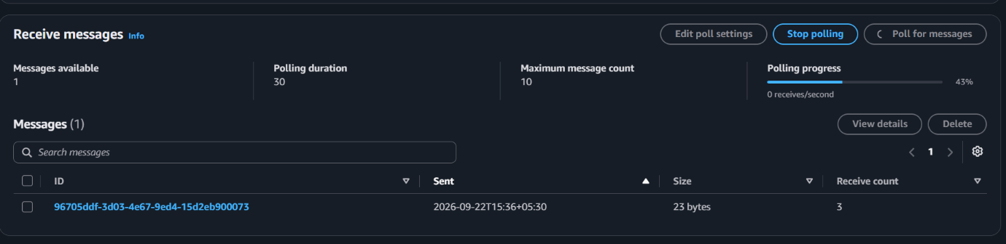
If poll again receive count will increase for every 30 seconds
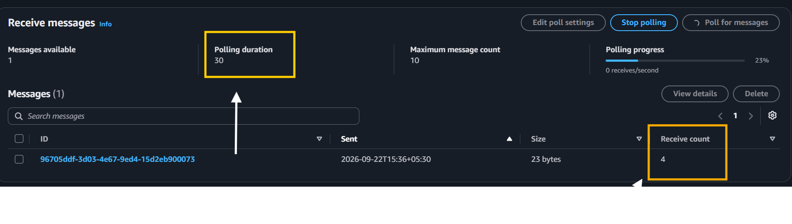
This is the main evidence for this task.

6. Observation
- The message was not deleted after being received.
- After the Visibility Timeout expired, the message became available again.
- Each subsequent retrieval increased the Receive Count.
- The Receive Count reached 3, confirming that the same message was delivered multiple times.

7. Key Takeaway
Receiving a message does not delete it.
The consumer must explicitly delete the message after successful processing.
Receive
↓
Process
↓
Successful?
↓ Yes
Delete Message
If processing fails:
Receive
↓
Processing fails
↓
No Delete
↓
Visibility Timeout expires
↓
Message available again

8. Result / Conclusion
The Visibility Timeout mechanism was successfully tested. The message became visible again when it was not deleted, and its Receive Count increased from 1 to 3.
This demonstrates how SQS supports message retry and recovery when a consumer fails to process a message successfully.

SQS — Task 6: Configure and Test Dead-Letter Queue (DLQ)

1. Objective
To configure a Dead-Letter Queue (DLQ) and test how SQS handles messages that repeatedly fail to be processed.

2. Use Case
A message may repeatedly fail because of invalid data, application errors, or other processing problems.
Instead of allowing the message to continuously retry in the main queue, SQS can move it to a Dead-Letter Queue for further investigation.

3. Architecture
Main Queue
Afrid-SQS-Queue
|
| Receive
↓
Consumer
|
No Delete
|
↓
Retry / Receive
|
↓
Maximum Receives = 3
|
↓
DLQ
Afrid-SQS-DLQ

4. Configuration / Implementation Steps

Step 1 — Create DLQ
Created a Standard SQS queue:
Afrid-SQS-DLQ

Step 2 — Configure Main Queue
Edited:
Afrid-SQS-Queue
Under Dead-letter queue:
- Enabled DLQ
- Selected Afrid-SQS-DLQ
- Maximum receives: 3
The existing Visibility Timeout was:
30 seconds

Step 3 — Test DLQ
Sent the test message:
DLQ Test Message
The message was received repeatedly without being deleted.
The Receive Count progressed:
1 → 2 → 3
After reaching the configured threshold, the message was moved from the main queue to:
Afrid-SQS-DLQ

5. Screenshots
📸 Screenshot 1: Main queue showing the test message with Receive Count = 3.
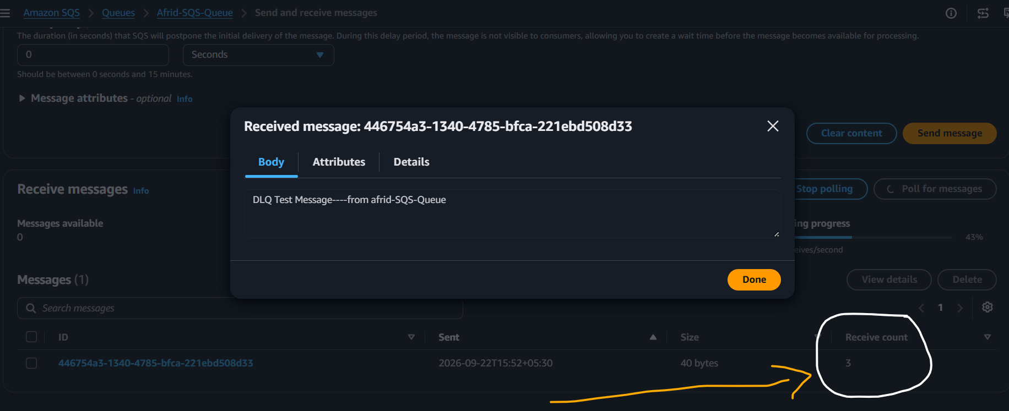
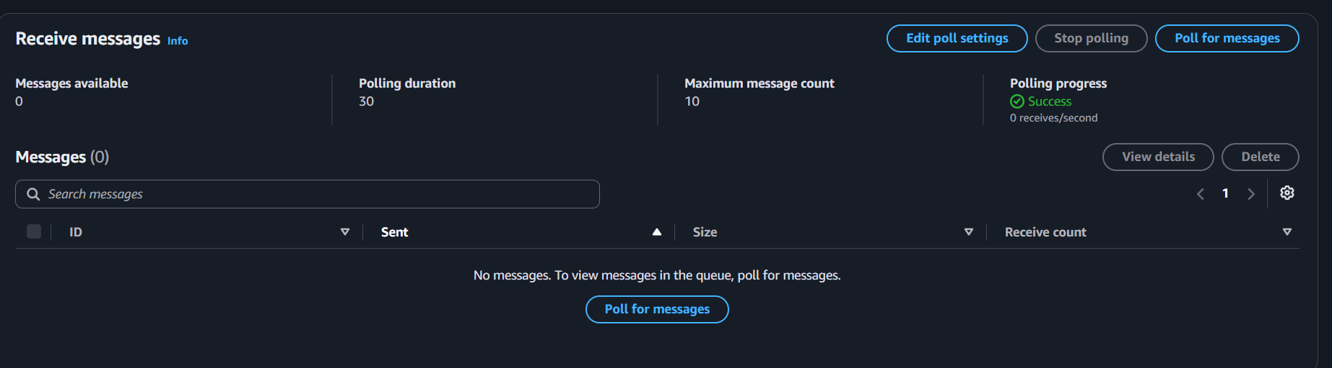📸 Screenshot 2: Afrid-SQS-DLQ showing the DLQ Test Message.
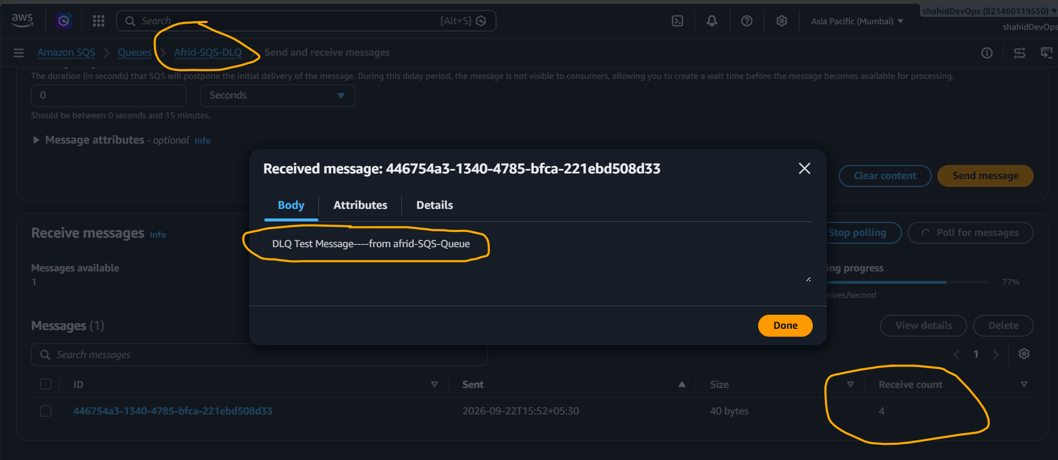
The second screenshot is the most important proof that the DLQ worked.

6. Observation
- A separate DLQ was successfully created.
- The DLQ was associated with the main SQS queue.
- Maximum receive count was configured as 3.
- The test message was intentionally not deleted.
- The message was received repeatedly and its Receive Count increased to 3.
- After reaching the configured redrive threshold, it was moved from the main queue to the DLQ.
- The message was therefore not permanently lost; it was redirected to the DLQ for investigation.

7. Key Takeaway
A Dead-Letter Queue stores messages that cannot be successfully processed after the configured number of receive attempts.
Main Queue
↓
Repeated Failure
↓
Maximum Receive Count
↓
Dead-Letter Queue

8. Result / Conclusion
The Dead-Letter Queue was successfully configured and tested. A message that was repeatedly received without being deleted was eventually moved from Afrid-SQS-Queue to Afrid-SQS-DLQ after reaching the configured maximum receive count of 3.

SQS — Important Interview Questions & Answers

1. What is Amazon SQS?
Amazon SQS (Simple Queue Service) is a fully managed message queuing service used to decouple applications and enable asynchronous communication.

2. Why do we use SQS?
Main reasons:
- Application decoupling
- Asynchronous processing
- Handling traffic spikes
- Reliable message delivery
- Buffering messages between producers and consumers

3. What is a Producer?
A Producer is an application or service that sends messages to an SQS queue.
Producer → SQS

4. What is a Consumer?
A Consumer is an application or service that retrieves and processes messages from an SQS queue.
SQS → Consumer

5. What is the difference between Standard and FIFO queues?
Standard | FIFO
Very high throughput | Ordered processing
Best-effort ordering | Maintains message order
At-least-once delivery | Exactly-once processing support through deduplication
Suitable for general workloads | Suitable when ordering matters
Interview answer:
Standard queues are used when high throughput is more important, while FIFO queues are used when message ordering and deduplication are required.

6. What is Visibility Timeout?
Visibility Timeout is the period during which a message becomes invisible to other consumers after being received.
Example:
Receive
↓
Message hidden
↓
30 seconds
↓
If not deleted → visible again
It prevents multiple consumers from processing the same message simultaneously under normal conditions.

7. What happens if a consumer fails while processing a message?
If the consumer doesn't delete the message before the Visibility Timeout expires, the message becomes available again and can be received again.

8. Does receiving a message delete it from SQS?
No.
Receiving and deleting are separate operations.
Receive → Process → Delete
The consumer should delete the message after successful processing.

9. What is a Dead-Letter Queue?
A DLQ is a separate SQS queue used to store messages that cannot be successfully processed after a configured number of receive attempts.
Main Queue
↓
Repeated failures
↓
DLQ

10. What is Maximum Receive Count?
It defines how many times a message can be received from the source queue before it is moved to the DLQ.
In our lab:
Maximum Receive Count = 3

11. What is Long Polling?
Long Polling allows SQS to wait for messages to become available instead of immediately returning an empty response.
Benefits:
- Reduces empty responses
- Reduces unnecessary API requests
- Can reduce costs
The Receive Message Wait Time can be configured up to 20 seconds.

12. What is Message Retention Period?
It defines how long SQS keeps a message if it isn't deleted.
SQS message retention can be configured from 1 minute to 14 days.

13. What is Delay Queue?
A Delay Queue temporarily delays the delivery of newly added messages to consumers.
Example:
Message sent
↓
Delay = 30 seconds
↓
Consumer can receive it

14. What happens when a message is successfully processed?
The consumer should explicitly delete the message.
Receive
↓
Process successfully
↓
Delete
↓
Message removed

15. SQS vs Amazon MQ?
SQS:
AWS-managed message queue designed for simple, scalable, asynchronous communication.
Amazon MQ:
AWS-managed message broker supporting broker technologies such as ActiveMQ and RabbitMQ and their associated protocols/APIs.
Simple memory trick:
SQS → Queue
Amazon MQ → Message Broker

16. Can SQS directly call another application?
SQS itself doesn't directly "call" the application.
Instead:
Producer
↓
SQS
↓
Consumer polls/receives message
↓
Application processes it
The consumer retrieves the message and performs the required action.

17. Is SQS a database?
No.
SQS is a message queuing service, not a database.
Its purpose is to temporarily hold and deliver messages between applications.

18. What happens if the same SQS message is received more than once?
With a Standard Queue, duplicate delivery can occur. Therefore, applications should ideally be idempotent, meaning processing the same message more than once should not produce an incorrect result.

Amazon MQ — Task 1: Create Amazon MQ Broker

1. Objective
Create a managed RabbitMQ message broker using Amazon MQ.

2. Concept
Amazon MQ is a managed message broker service that supports established messaging technologies such as RabbitMQ and ActiveMQ.
For this implementation, we selected RabbitMQ.
The broker acts as an intermediary between applications that send and receive messages.

3. Use Case
Amazon MQ is useful when an application requires a managed message broker and compatibility with established messaging protocols and broker technologies.
Example:
Producer
|
↓
Amazon MQ Broker
|
↓
Consumer

4. Architecture
AWS
|
VPC
|
Amazon MQ Broker
|
Afrid-RabbitMQ-Broker
|
RabbitMQ Engine
/ \
/ \
Producer Consumer
For this learning activity, we selected a single-instance broker with public accessibility to keep the implementation simple.

5. Configuration
Configuration | Selected Value
Service | Amazon MQ
Broker Engine | RabbitMQ
Broker Name | Afrid-RabbitMQ-Broker
Deployment | Single instance
Network | Public accessibility
Status | Running

Credentials
An administrator username and password were configured during broker creation.
Note: Passwords and other sensitive credentials should never be included in screenshots or documentation.

6. Implementation Steps
- Open AWS Management Console.
- Search for Amazon MQ.
- Open Amazon MQ.
- Click Create broker.
- Select RabbitMQ as the broker engine.
- Select the single-instance deployment option.
- Enter:
Afrid-RabbitMQ-Broker
- Configure the administrator credentials.
- Select the required network configuration.
- For this learning implementation, use public accessibility.
- Review the configuration.
- Click Create broker.
- Wait for AWS to provision the broker.
- Verify that the broker status changes from:
Creating
to:
Running

7. Screenshot
📸 Screenshot 1 — Broker Created
Capture the Amazon MQ broker details page showing:
- Broker name
- RabbitMQ engine
- Single-instance deployment
- Status: Running

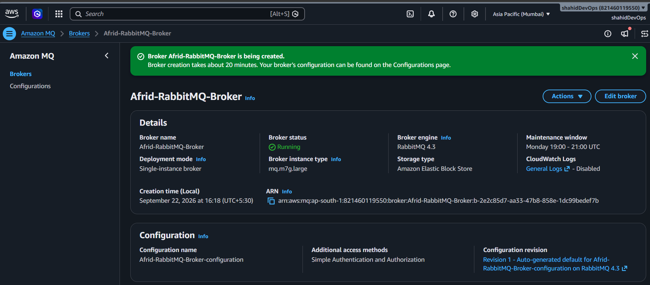
Do not capture passwords.

8. Observation
- Amazon MQ successfully created a managed RabbitMQ broker.
- Broker provisioning took approximately 20 minutes.
- The broker status changed from Creating to Running.
- The broker is now ready for further configuration and messaging tests.

9. Key Takeaway
A broker is the central messaging component that receives, routes, and delivers messages between applications.
In our implementation:
Afrid-RabbitMQ-Broker
↓
RabbitMQ
↓
Messaging between
applications

10. Result / Conclusion
The Amazon MQ RabbitMQ broker was successfully created and is in the Running state.
The broker is now ready to be accessed through its available endpoints and used for the next stage of the hands-on implementation.

Amazon MQ — Task 2: Access RabbitMQ Management Console

1. Objective
Access the RabbitMQ Management Console of the Amazon MQ broker and verify that the broker is accessible and operational.

2. Use Case
The RabbitMQ Management Console provides a web interface to monitor and manage the broker.
It can be used to view and manage:
- Queues
- Exchanges
- Connections
- Channels
- Users
- Broker status

3. Architecture
Administrator / Browser
|
| HTTPS
↓
RabbitMQ Management Console
|
↓
Amazon MQ RabbitMQ Broker

4. Configuration / Implementation Steps
- Open AWS Management Console.
- Navigate to:
Amazon MQ → Brokers.
- Select:
Afrid-RabbitMQ-Broker
- Open the broker details.
- Locate the Endpoints section.
- Identify the RabbitMQ management console endpoint.
- Open the endpoint in a browser.
- Enter the administrator username and password configured during broker creation.
- Successfully log in to the RabbitMQ Management Console.

5. RabbitMQ Management Console
After successful login, the console provides sections such as:
Overview
Connections
Channels
Exchanges
Queues and Streams
Admin
These sections allow administrators to monitor and manage the RabbitMQ broker.

6. Screenshot
📸 Screenshot 2 — RabbitMQ Management Console
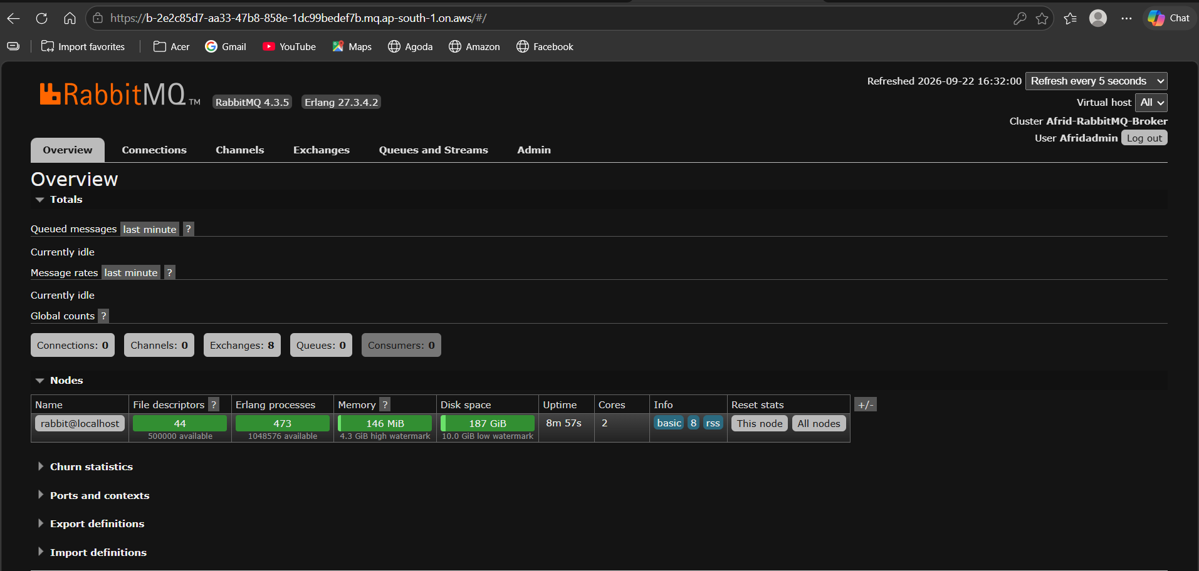

7. Observation
- The Amazon MQ broker endpoint was accessed successfully.
- Authentication was performed using the administrator credentials.
- The RabbitMQ Management Console was accessible.
- The console provides visibility into broker components such as queues, exchanges, connections, and channels.

8. Key Takeaway
The RabbitMQ Management Console provides a graphical interface to monitor and manage the Amazon MQ RabbitMQ broker.
It is useful for checking the broker's queues, exchanges, connections, channels, and users.

9. Result / Conclusion
The RabbitMQ Management Console was successfully accessed using the Amazon MQ broker endpoint and administrator credentials. This confirmed that the broker is operational and accessible for further messaging configuration and testing.

Amazon MQ — Task 3: Create a Queue

1. Objective
Create a RabbitMQ queue inside the Amazon MQ broker to store messages until they are consumed by a consumer.

2. Concept
A queue is a temporary storage location for messages.
In RabbitMQ:
Producer
↓
RabbitMQ Broker
↓
Queue
↓
Consumer
The queue holds messages until a consumer retrieves and processes them.

3. Use Case
Queues are useful when a producer and consumer don't need to communicate directly.
For example:
Order Application
↓
RabbitMQ Queue
↓
Order Processing Service
The order application can send a message without waiting for the processing service to immediately process it.

4. Architecture
Amazon MQ
|
RabbitMQ Broker
|
↓
Afrid-MQ-Queue
|
↓
Consumer

5. Configuration
Setting | Value
Broker | Afrid-RabbitMQ-Broker
Engine | RabbitMQ
Queue Name | Afrid-MQ-Queue
Queue Type | Default configuration
Purpose | Store messages for consumers

6. Implementation Steps
- Open the RabbitMQ Management Console.
- Navigate to:
Queues and Streams.
- Click Add a new queue.
- Enter:
Afrid-MQ-Queue
- Leave the remaining settings at their default values.
- Click Add queue.
- Verify that Afrid-MQ-Queue appears in the queue list.

7. Screenshot
📸 Screenshot 3 — RabbitMQ Queue
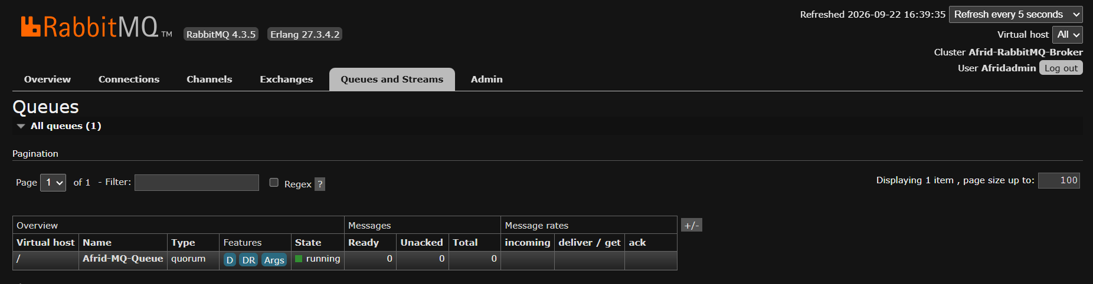

8. Observation
- A RabbitMQ queue was successfully created inside the Amazon MQ broker.
- The queue is ready to receive and store messages.
- No messages are currently being processed because we haven't performed the messaging test yet.

9. Key Takeaway
A RabbitMQ queue temporarily stores messages until they are delivered to and processed by a consumer.
Queue ≠ Broker
Broker
↓
Manages messaging
↓
Queue
↓
Stores messages

10. Result / Conclusion
The Afrid-MQ-Queue was successfully created inside the Afrid-RabbitMQ-Broker. The queue is now ready for the next step, where we will send and receive a test message.

Amazon MQ — Task 4: Create Exchange and Binding & Publish Message

1. Objective
Create a Direct Exchange, bind it to the existing queue, and publish a message using a routing key.
This demonstrates the basic RabbitMQ message-routing process.

2. Concept
In RabbitMQ, a producer normally sends a message to an Exchange, not directly to a queue.
The Exchange routes the message to the appropriate queue using a binding and routing key.
Producer
|
| Message + Routing Key
↓
Exchange
|
| Binding
↓
Queue
|
↓
Consumer

Important Components
Component | Purpose
Producer | Sends messages
Exchange | Routes messages
Binding | Connects exchange to queue
Routing Key | Determines routing
Queue | Stores messages
Consumer | Processes messages

3. Use Case
Suppose an application sends different types of messages:
orders
payments
notifications
An exchange can route these messages to appropriate queues using routing keys.
For our simple implementation, we'll use:
Routing Key = orders

4. Architecture
Producer
|
| orders
↓
Afrid-MQ-Exchange
Direct Exchange
|
Binding: orders
|
↓
Afrid-MQ-Queue
|
↓
Consumer

5. Configuration

Exchange
Setting | Value
Exchange Name | Afrid-MQ-Exchange
Type | Direct
Purpose | Route messages to the queue

Binding
Setting | Value
Source | Afrid-MQ-Exchange
Destination | Afrid-MQ-Queue
Routing Key | orders

Message
Setting | Value
Routing Key | orders
Payload | Hello from Afrid - Amazon MQ Hands-on

6. Implementation Steps

Step 1 — Create Exchange
- Open RabbitMQ Management Console.
- Go to Exchanges.
- Click Add a new exchange.
- Enter:
Afrid-MQ-Exchange
- Select:
Direct
- Leave other settings at their defaults.
- Click Add exchange.

Step 2 — Create Binding
- Open:
Afrid-MQ-Exchange
- Find the Bindings section.
- Select Add binding from this exchange.
- Select destination queue:
Afrid-MQ-Queue
- Enter routing key:
orders
- Click Bind.
The binding is now:
Afrid-MQ-Exchange
|
| orders
↓
Afrid-MQ-Queue

Step 3 — Publish Message
- Stay on:
Exchanges → Afrid-MQ-Exchange
- Find Publish message.
- Enter routing key:
orders
- Enter payload:
Hello from Afrid - Amazon MQ Hands-on
- Click Publish message.

7. Message Flow
The message follows:
Producer
|
| Routing Key = orders
↓
Afrid-MQ-Exchange
|
| Binding Key = orders
↓
Afrid-MQ-Queue
Because the routing key matches the binding key, the Direct Exchange routes the message to Afrid-MQ-Queue.

8. Screenshots
📸 Screenshot 4 — Exchange and Binding
Show:
Afrid-MQ-Exchange
↓
Binding
↓
Afrid-MQ-Queue
Routing Key: orders

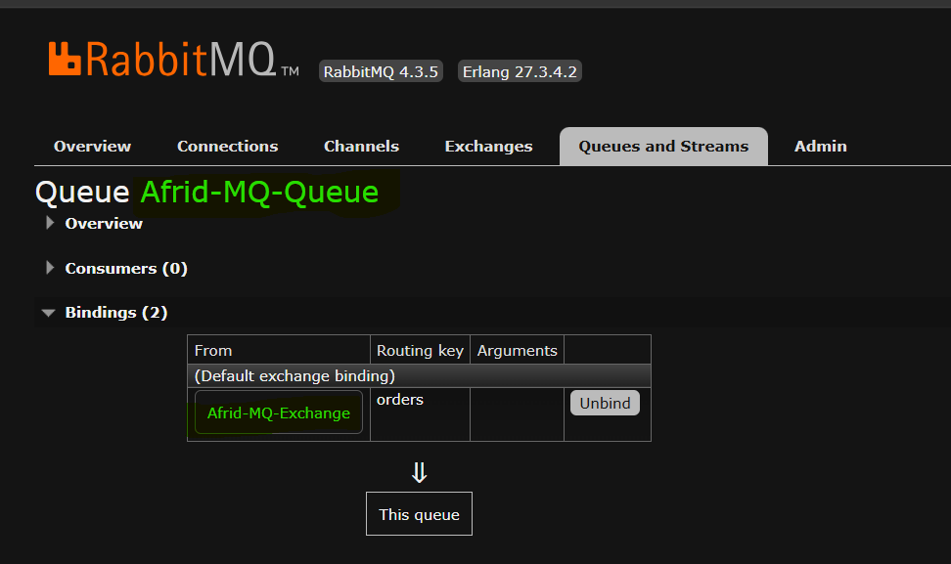

📸 Screenshot 5 — Published Message
Show the queue with the message available/ready after publishing.
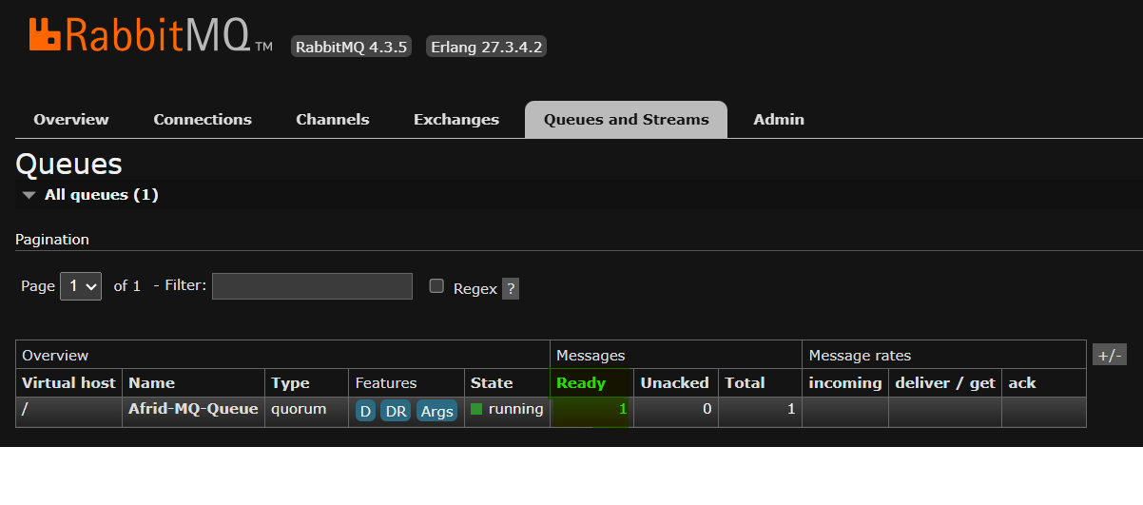

9. Observation
- A Direct Exchange was successfully created.
- Afrid-MQ-Queue was bound to the exchange.
- The binding used the routing key orders.
- A message was published to the exchange using the same routing key.
- The exchange successfully routed the message to Afrid-MQ-Queue.

10. Key Takeaway
The Exchange receives messages from producers and routes them to queues using bindings and routing keys.
For a Direct Exchange, the routing key must match the binding key.
Routing Key = orders
↓
Binding Key = orders
↓
Message reaches queue

11. Result / Conclusion
The Direct Exchange, binding, and message-routing workflow were successfully implemented.
The message was published to Afrid-MQ-Exchange and routed to Afrid-MQ-Queue because the routing key orders matched the binding key orders.
This demonstrates the basic RabbitMQ messaging architecture:
Producer → Exchange → Binding → Queue → Consumer

Amazon MQ — Task 5: Consume / Retrieve Message

1. Objective
Retrieve the message from Afrid-MQ-Queue and verify that the message sent through the RabbitMQ exchange was successfully delivered to the queue and consumed.

2. Use Case
After a producer publishes a message and the exchange routes it to a queue, a consumer retrieves the message for processing.
Producer
↓
Exchange
↓
Queue
↓
Consumer
This completes the basic RabbitMQ messaging workflow.

3. Architecture
Producer
|
| Publish
↓
Afrid-MQ-Exchange
Direct Exchange
|
Binding: orders
|
↓
Afrid-MQ-Queue
|
| Get Message
↓
Consumer

4. Configuration / Implementation Steps
- Open the RabbitMQ Management Console.
- Navigate to:
Queues and Streams → Afrid-MQ-Queue.
- Scroll to Get messages.
- Retrieve the available message.
- Verify the message details.
The retrieved message showed:
Exchange : Afrid-MQ-Exchange
Routing Key : orders
Payload : Hello from Afrid - Amazon MQ Hands-on
The console also reported:
0 messages remaining
This confirms that the message was retrieved and is no longer waiting in the queue.

5. Screenshot
📸 Screenshot 6 — Message Retrieved
Capture the Get messages section showing:
- Exchange: Afrid-MQ-Exchange
- Routing Key: orders
- Payload: Hello from Afrid - Amazon MQ Hands-on
- 0 messages remaining
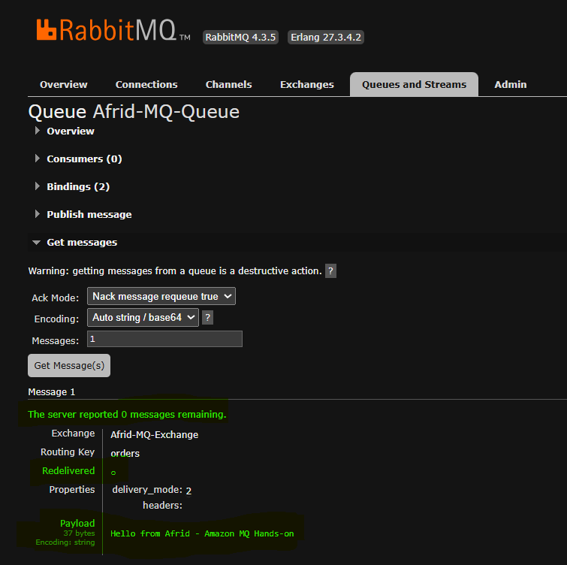
This is the main evidence for this task.

6. Observation
- The message published to Afrid-MQ-Exchange was successfully routed to Afrid-MQ-Queue.
- The routing key was orders.
- The message was successfully retrieved from the queue.
- The payload was displayed correctly.
- The server reported 0 messages remaining, confirming that the message was no longer waiting in the queue.

Important observation
The RabbitMQ console showed:
Consumers: 0
This is not an error. We used the Get messages functionality of the management console to retrieve the message instead of running a separate consumer application.

7. Key Takeaway
A RabbitMQ consumer retrieves messages from a queue after they have been routed by an exchange.
Our complete flow was:
Producer
↓
Exchange
↓
Binding
↓
Queue
↓
Consumer

8. Result / Conclusion
The message was successfully routed through Afrid-MQ-Exchange using the orders routing key and retrieved from Afrid-MQ-Queue.
The successful retrieval of the message confirms that the complete basic RabbitMQ messaging workflow was implemented successfully.

Amazon MQ — Important Interview Questions & Answers
.

1. What is Amazon MQ?
Amazon MQ is a managed message broker service provided by AWS. It supports established messaging technologies such as Apache ActiveMQ and RabbitMQ, allowing applications to use familiar broker protocols and APIs.

2. Why use Amazon MQ instead of SQS?
Use SQS when you want a simple, highly scalable AWS-native queue.
Use Amazon MQ when your application already depends on a supported message broker, protocols, or messaging APIs such as RabbitMQ or ActiveMQ.
SQS → Managed AWS queue
Amazon MQ → Managed message broker

3. What is a message broker?
A message broker is software that receives, routes, and delivers messages between applications.
Producer
↓
Message Broker
↓
Consumer
Amazon MQ provides a managed broker so you don't have to manage the underlying broker infrastructure yourself.

4. What is a broker in Amazon MQ?
A broker is the managed messaging server/environment created by Amazon MQ.
In our implementation:
Afrid-RabbitMQ-Broker
was our RabbitMQ broker.

5. What is RabbitMQ?
RabbitMQ is an open-source message broker that supports messaging protocols and concepts such as:
- Exchanges
- Queues
- Bindings
- Routing keys
- Producers
- Consumers

6. What is a queue in RabbitMQ?
A queue stores messages until consumers retrieve and process them.
Our queue was:
Afrid-MQ-Queue

7. What is an exchange?
An exchange receives messages from producers and routes them to queues based on exchange type, bindings, and routing keys.
Producer
↓
Exchange
↓
Queue

8. What is a binding?
A binding defines a relationship between an exchange and a queue.
It tells the exchange how messages should be routed to that queue.
Our binding was:
Exchange: Afrid-MQ-Exchange
Queue: Afrid-MQ-Queue
Binding key: orders

9. What is a routing key?
A routing key is a value used by an exchange to determine how a message should be routed.
In our implementation:
Routing Key = orders
Binding Key = orders
Because they matched, the Direct Exchange routed the message to our queue.

10. Why did we use a Direct Exchange?
A Direct Exchange routes messages when the routing key matches the binding key.
Our example:
Message routing key = orders
↓
Direct Exchange
↓
Binding key = orders
↓
Queue

11. What are the main RabbitMQ exchange types?
The important ones are:
Exchange | Routing behavior
Direct | Exact routing-key match
Fanout | Sends to all bound queues
Topic | Pattern-based routing
Headers | Routes based on message headers
For our hands-on, we used Direct.

12. What is the difference between Exchange and Queue?
Exchange:
Decides where messages should go.
Queue:
Stores messages until they are consumed.
Producer
↓
Exchange → Routing
↓
Queue → Storage
↓
Consumer

13. What is a Producer?
A producer is an application that sends messages to the broker/exchange.
Producer → Exchange

14. What is a Consumer?
A consumer is an application/service that retrieves and processes messages from a queue.
Queue → Consumer

15. Explain the message flow in your hands-on.
This is one you should definitely practice saying:
"I created a RabbitMQ broker in Amazon MQ. Inside the RabbitMQ management console, I created a queue and a Direct Exchange. I created a binding between them using the routing key orders. I then published a message to the exchange using the same routing key. The exchange routed the message to the queue, and I retrieved the message from the queue using the management console."
That's a strong answer because you're describing something you actually implemented.

16. What is acknowledgement in RabbitMQ?
An acknowledgement (ACK) tells RabbitMQ that the consumer has successfully processed a message.
Conceptually:
Queue
↓
Consumer
↓
Process
↓
ACK
If a message isn't successfully acknowledged, depending on the consumer/acknowledgement configuration, it may be requeued or otherwise handled as unacknowledged.

17. What happens if a consumer fails?
If a consumer fails before successfully acknowledging a message, RabbitMQ can make the message available for another consumer depending on the acknowledgement/requeue behavior.
This helps prevent messages from simply disappearing when a consumer crashes.

18. What is Amazon MQ vs RabbitMQ?
Don't treat them as the same thing.
Amazon MQ = AWS managed service.
RabbitMQ = message broker software/engine.
AWS
↓
Amazon MQ
↓
RabbitMQ Broker

19. Is Amazon MQ serverless?
No. Amazon MQ provides managed broker infrastructure. AWS manages much of the underlying infrastructure and broker operations, but you're still working with broker instances/deployments and their networking/configuration.

20. How is Amazon MQ secured?
Important security areas include:
- Authentication
- Authorization
- Network security
- Security Groups
- Encryption
- TLS for secure communication
- IAM/AWS security controls where applicable
For a VPC-based deployment, network access is controlled using appropriate networking and security configuration.

21. Why shouldn't we expose Amazon MQ publicly in production?
A publicly accessible broker increases the network attack surface.
For production, applications should generally communicate with the broker through appropriately controlled private networking and security rules.
Our lab used public accessibility to simplify the hands-on access, not as a recommendation for production architecture.

22. Can Amazon MQ replace SQS?
Not always.
They solve related but different problems.
SQS:
Simple AWS-native queue
Amazon MQ:
Managed traditional message broker
The choice depends on application requirements, existing technology, protocols, and architecture.

AWS Secrets Manager

Task 1: Create a Secret

1. Objective
To create and securely store application credentials using AWS Secrets Manager.

2. Use Case
Instead of hardcoding sensitive information such as usernames and passwords in application code, we store them securely in AWS Secrets Manager.
Example:
Application → Secrets Manager → Retrieve credentials

3. Architecture
Application
|
| Get Secret
↓
AWS Secrets Manager
|
↓
Encrypted Secret
┌───────────────────┐
│ username = admin │
│ password = ****** │
└───────────────────┘

4. Configuration / Implementation Steps
- Open AWS Management Console.
- Navigate to AWS Secrets Manager.
- Select Store a new secret.
- Under Secret type, select:
Other type of secret
- Add key/value pairs:
- username = admin
password = <your password>
- Click Next.
- Enter the secret name:
Afrid/ApplicationCredentials
- Add an optional description:
Application username and password
- Leave Tags as default.
- Leave Resource permissions unchanged.
- Do not enable Replicate secret.
- For Configure rotation, leave automatic rotation disabled.
- Do not create a Lambda rotation function.
- Click Store.

5. Screenshot
Take a screenshot showing:
- Secret name: Afrid/ApplicationCredentials
- Secret status/details
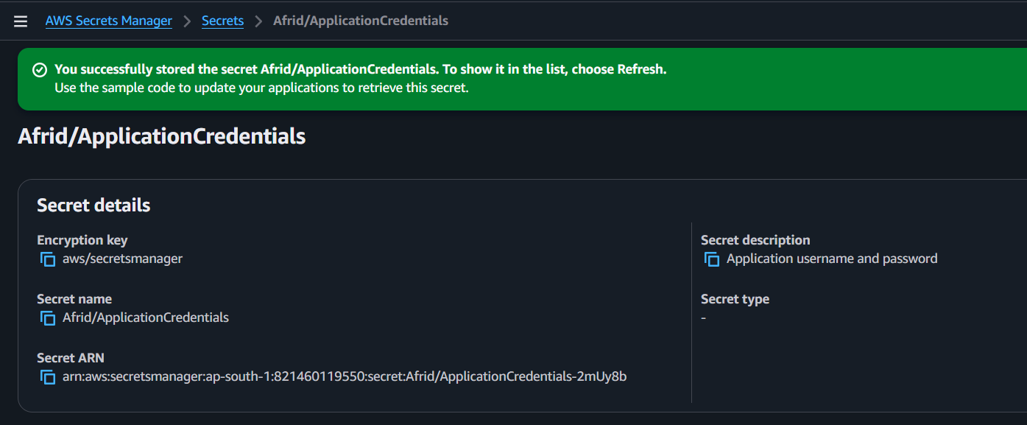

6. Observation
- The secret was successfully created in AWS Secrets Manager.
- Credentials are stored securely instead of being hardcoded in an application.
- AWS Secrets Manager encrypts the stored secret.

7. Key Takeaway
AWS Secrets Manager is used to securely store, manage, and retrieve sensitive information such as passwords, API keys, and database credentials.

8. Result / Conclusion
The Afrid/ApplicationCredentials secret was successfully created in AWS Secrets Manager with username and password credentials stored securely.

Task 2: Retrieve the Secret

1. Objective
To retrieve and verify the secret value stored in AWS Secrets Manager.

2. Use Case
Applications can retrieve sensitive credentials from Secrets Manager when required instead of storing passwords directly in application code or configuration files.

3. Architecture
Application
|
| GetSecretValue
↓
AWS Secrets Manager
|
↓
Stored Secret
(username + password)

4. Configuration / Implementation Steps
- Open AWS Secrets Manager.
- Go to Secrets.
- Select:
Afrid/ApplicationCredentials
- Open the secret details page.
- Locate Secret value.
- Click Retrieve secret value.
- Verify that the stored key/value pairs are displayed:
- username = admin
password = ********

5. Screenshot
Take a screenshot showing:
- Secret name: Afrid/ApplicationCredentials
- Secret value section
- Retrieved username
- Password should be hidden/blurred if visible.

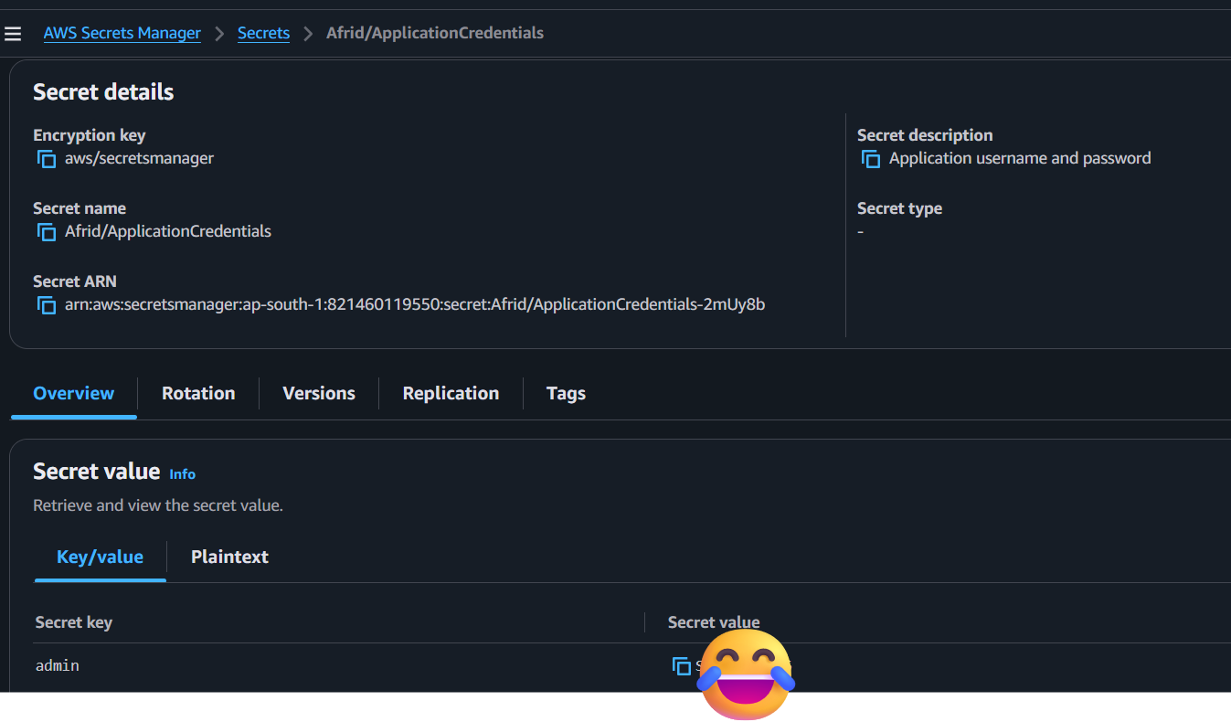

6. Observation
- The secret was successfully retrieved from Secrets Manager.
- The stored credentials can be accessed when required.
- The application does not need to keep the credentials directly in its source code.

7. Key Takeaway
Secrets Manager allows applications to securely retrieve sensitive information using APIs such as GetSecretValue.

8. Result / Conclusion
The Afrid/ApplicationCredentials secret was successfully retrieved from AWS Secrets Manager, confirming that the stored credentials are accessible when required.

Task 3: Retrieve Secret Using AWS CLI

1. Objective
To retrieve a secret from AWS Secrets Manager using AWS CLI with IAM-based authentication.

2. Use Case
In DevOps, applications, EC2 instances, scripts, and CI/CD pipelines can retrieve secrets programmatically instead of storing credentials directly in application code.

3. Architecture
AWS CLI
↓
IAM User
Afrid-Secrets-CLI
↓
IAM Policy
Afrid-SecretsManager-Read
↓
AWS Secrets Manager
↓
Afrid/ApplicationCredentials
↓
Secret Value

4. Configuration / Implementation Steps
Step 1 — Create IAM User
Created:
Afrid-Secrets-CLI
Step 2 — Create IAM Policy
Created:
Afrid-SecretsManager-Read
The policy allows:
secretsmanager:GetSecretValue
for the secret in the ap-south-1 region.
Step 3 — Attach Policy
Attached Afrid-SecretsManager-Read to the IAM user.
Step 4 — Generate Access Keys
Generated an Access Key ID and Secret Access Key for CLI authentication.
Never share the Secret Access Key.
Step 5 — Configure AWS CLI
aws configure
Configured:
Access Key ID
Secret Access Key
Region: ap-south-1
Output: json
Step 6 — Verify IAM Identity
aws sts get-caller-identity
This confirmed that the CLI was authenticated with the IAM user.
Step 7 — Retrieve the Secret
aws secretsmanager get-secret-value \
--secret-id "Afrid/ApplicationCredentials" \
--region ap-south-1
The command successfully retrieved the secret.

5. Screenshot
Take a screenshot showing:
- Successful CLI command
- Secret name
- Successful response
Hide/blur the actual password or SecretString.
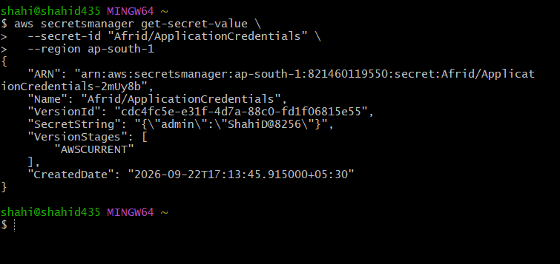

6. Observation
- AWS CLI successfully authenticated using the IAM user's credentials.
- The IAM policy allowed GetSecretValue.
- The secret was successfully retrieved from Secrets Manager.
- Access was restricted using a least-privilege permission.

7. Key Takeaway
AWS CLI provides a programmatic way to retrieve Secrets Manager secrets, making it useful for DevOps automation, deployment scripts, EC2, and CI/CD pipelines.

8. Result / Conclusion
The Afrid/ApplicationCredentials secret was successfully retrieved using AWS CLI through an IAM user with least-privilege GetSecretValue permission.

AWS Secrets Manager — Task 4: Secret Versioning

1. Objective
To understand and demonstrate secret versioning in AWS Secrets Manager by creating a new version of an existing secret.

2. Use Case
Secret versioning is useful when credentials need to be updated or changed without losing the previous version.
For example, when a password is changed, Secrets Manager can maintain the old and new versions.

3. Architecture
Application
↓
Secrets Manager
↓
Secret
┌─────────────────────┐
│ Version 1 │
│ AWSPREVIOUS │
│ │
│ Version 2 │
│ AWSCURRENT │
└─────────────────────┘

4. Configuration / Implementation Steps
- Open AWS Secrets Manager.
- Open:
Afrid/ApplicationCredentials
- Open Secret value.
- Select Edit.
- Modify the secret value, for example:
username = admin-v2
- Keep the password unchanged.
- Save the secret as a new version.
- Open Secret versions.
- Verify that two versions are available.
- Verify that the latest version has:
AWSCURRENT
- The previous version can be identified using:
AWSPREVIOUS

5. Screenshot
Take a screenshot of the Secret versions section showing:
- Two Version IDs
- AWSCURRENT
- AWSPREVIOUS
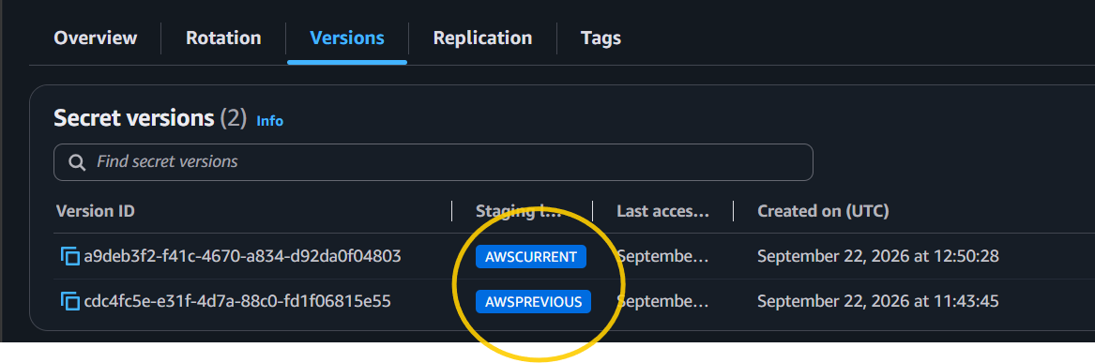
Do not include the actual secret values.

6. Observation
- Initially, the secret had one version marked AWSCURRENT.
- After editing and saving the secret, a second version was created.
- The new version became AWSCURRENT.
- The previous version can be identified as AWSPREVIOUS.

7. Key Takeaway
AWS Secrets Manager uses versions and staging labels such as AWSCURRENT and AWSPREVIOUS to manage changes to secrets.
This allows applications to use the current secret while maintaining previous versions during updates or rotation.

8. Result / Conclusion
A new version of Afrid/ApplicationCredentials was successfully created, and Secrets Manager successfully maintained the current and previous versions using staging labels.

AWS Secrets Manager — Interview Questions
.

1. What is AWS Secrets Manager?
AWS Secrets Manager is an AWS service used to securely store, manage, and retrieve sensitive information such as passwords, API keys, database credentials, and tokens.

2. Why do we use Secrets Manager?
Instead of hardcoding credentials in application code or configuration files, we store them securely in Secrets Manager.
Example:
Application → Secrets Manager → Credentials

3. What type of information can we store?
Examples:
- Database username/password
- API keys
- Application credentials
- Tokens
- Other sensitive configuration values

4. How is a secret protected?
Secrets Manager encrypts secrets at rest using AWS KMS.
Access is controlled using IAM permissions.

5. How does an application retrieve a secret?
The application uses the Secrets Manager API, for example:
GetSecretValue
It can also be retrieved through:
aws secretsmanager get-secret-value

6. What IAM permission is required to retrieve a secret?
The main permission is:
secretsmanager:GetSecretValue
For our hands-on, we created:
Afrid-SecretsManager-Read
with GetSecretValue permission.

7. What is Secret Versioning?
Secrets Manager maintains different versions when a secret is changed.
Important staging labels:
AWSCURRENT
AWSPREVIOUS
AWSCURRENT identifies the version currently being used.

8. What is AWSCURRENT?
AWSCURRENT is the staging label attached to the current version of a secret.

9. What is AWSPREVIOUS?
AWSPREVIOUS identifies the previous version of a secret after a new version becomes current.

10. What is Secret Rotation?
Secret rotation means automatically changing credentials periodically.
Secrets Manager can use an AWS Lambda rotation function to perform the rotation.
Secrets Manager
↓
Lambda
↓
Update Credential

11. What is the difference between versioning and rotation?
Versioning: Keeps different versions of a secret.
Rotation: Changes the actual credential periodically, usually automatically.
They are related but not the same thing.

12. Secrets Manager vs Parameter Store?
Secrets Manager | Parameter Store
Designed specifically for secrets | General configuration management
Supports automatic rotation | More limited secret-management features
Integrates with Lambda rotation | No built-in rotation equivalent
Generally used for credentials | Commonly used for configuration values

13. Why shouldn't we store AWS Access Keys inside an application?
Because long-term credentials can be exposed through:
- Source code
- GitHub
- Configuration files
- Logs
- Server compromise
Instead, use IAM roles where possible.

14. How would EC2 retrieve a secret securely?
A common DevOps architecture is:
EC2
↓
IAM Role
↓
secretsmanager:GetSecretValue
↓
Secrets Manager
↓
Secret
The EC2 instance doesn't need an IAM user's access keys stored on the server.

15. Explain your Secrets Manager hands-on.
Interview answer:
"I created a secret called Afrid/ApplicationCredentials containing application credentials. I retrieved the secret through the AWS Console and then created a least-privilege IAM user with GetSecretValue permission and retrieved the secret using AWS CLI. I also created a second version of the secret and verified the versioning concept using AWSCURRENT and AWSPREVIOUS."

