Basic Shell Scripts:
Output to screen
#!/bin/bash
# Simple output script
echo "Hello World”
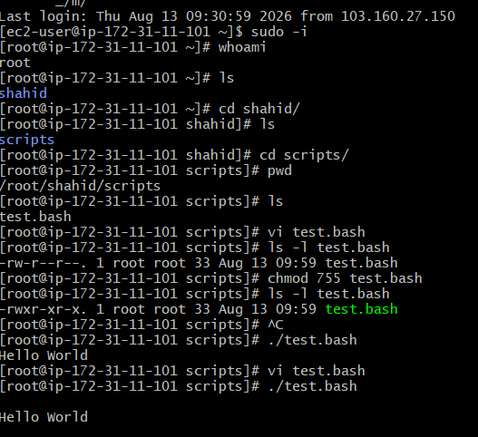
Defining Tasks
#!/bin/bash
# Define small tasks
whoami
echo
pwd
echo
hostname
echo
ls -ltr
echo
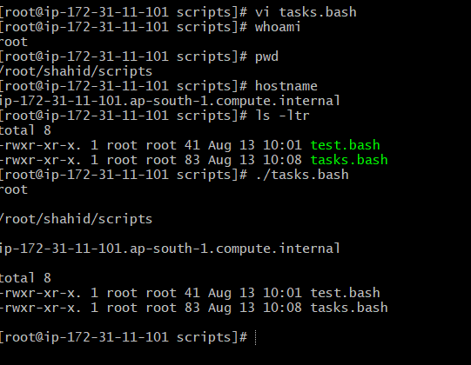

Defining variables
#!/bin/bash
# Example of defining variables
a=Imran
b=Afzal
c=’Linux class’
echo "My first name is $a"
echo "My surname is $b"
echo “My class is $c”

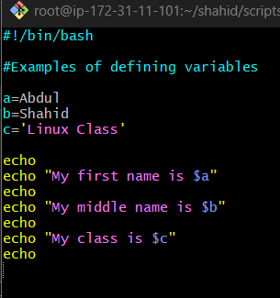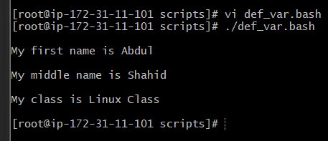

Read Input
#!/bin/bash
# Read user input
echo "What is your first name?"
read a
echo
echo "What is your last name?"
read b
echo
echo Hello $a $b

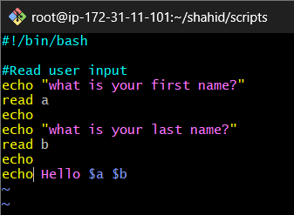
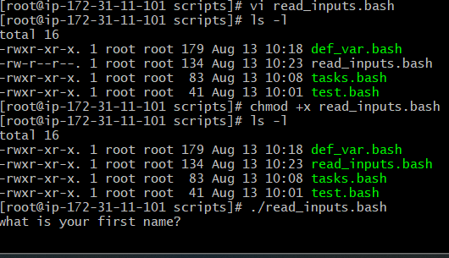
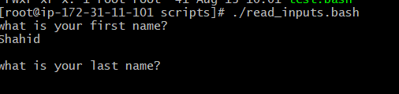
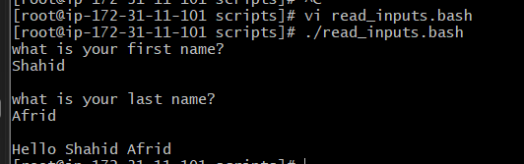

Scripts to run commands within
#!/bin/bash
# Script to run commands within
clear
echo "Hello `whoami`"
echo
echo "Today is `date`"
echo
echo "Number of user login: `who | wc -l `"

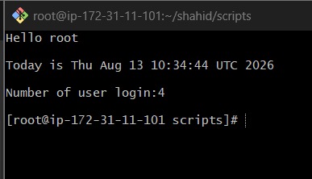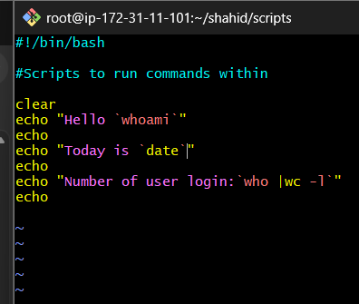

Read input and perform a task
#!/bin/bash
# This script will rename a file
echo Enter the file name to be renamed
read oldfilename
echo Enter the new file name
read newfilename
mv $oldfilename $newfilename
echo The file has been renamed as $newfilenam

