Challenge-24/08/2026

First Challenge
Launch oneEC2 instance using Amazon Linux 2.
Install Docker.
Install Jenkins.
Install Apache.
Install Nginx.
Install Apache Tomcat.
Everything needs to be setup and running on the same EC2.

You can change the port numbers as required.

1. EC2 Instance Setup
- Launched an EC2 instance using Amazon Linux 2023.
- Connected to the instance from the local machine using SSH.
- Switched to the root user.
- Verified the operating system using:
cat /etc/os-release

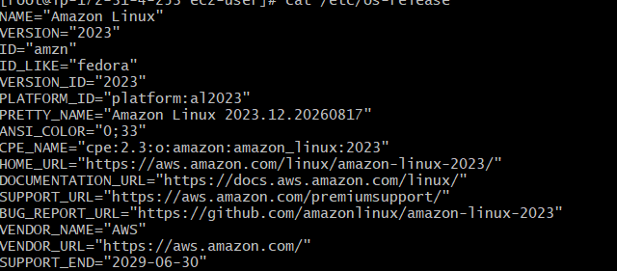

2. Docker Installation
Installed Docker using:
dnf install docker -y
Started Docker:
systemctl start docker
Enabled Docker to start automatically after reboot:
systemctl enable docker
Verified Docker and service status:
docker --version
systemctl status docker

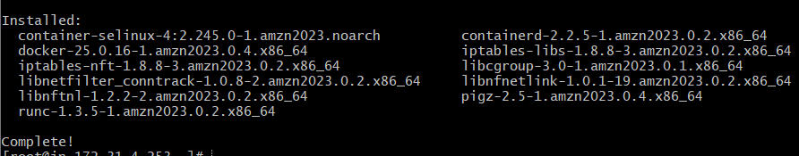

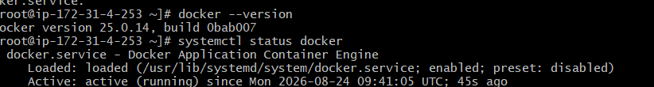

2. Install Jenkins
dnf install jenkins -y

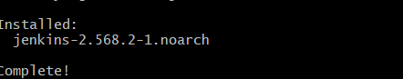

3. Start Jenkins
systemctl start jenkins
4. Enable Jenkins at boot
systemctl enable jenkins
5. Verify Jenkins
systemctl status Jenkins

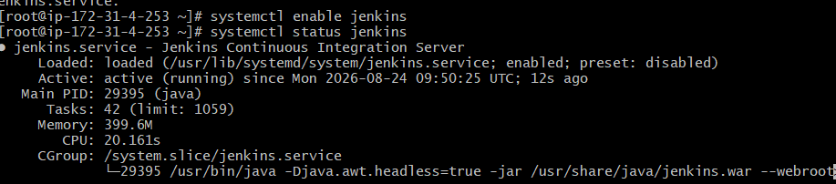
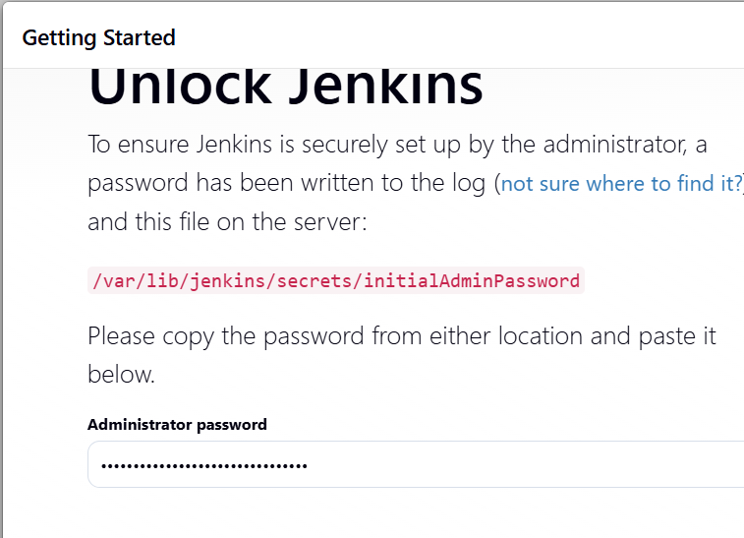

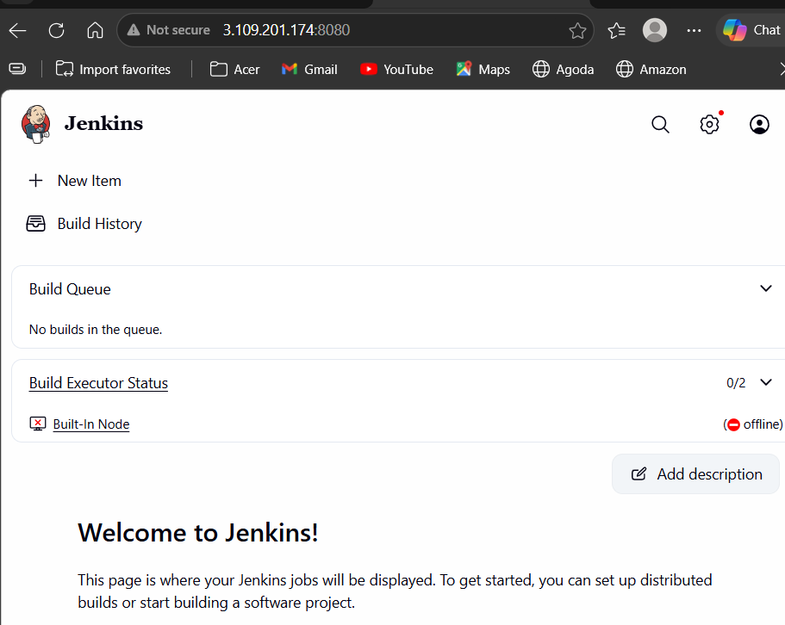
Installed Apache HTTPD:
dnf install httpd -y
Started and enabled the Apache service:
systemctl start httpd
systemctl enable httpd
Initially, Apache was running on the default port 80. Since another web server would also use port 80, the Apache port was changed to 8081.
Edited the Apache configuration file:
vi /etc/httpd/conf/httpd.conf
Changed:
Listen 80
to:
Listen 8081
Restarted the Apache service:
systemctl restart httpd
Verify:
systemctl status htpd
Active: active (running)
Then open in browser:
http:// 3.109.201.174:8081
Httpd uses port 80, while Apache is already running on 8081, so there should be no conflict.

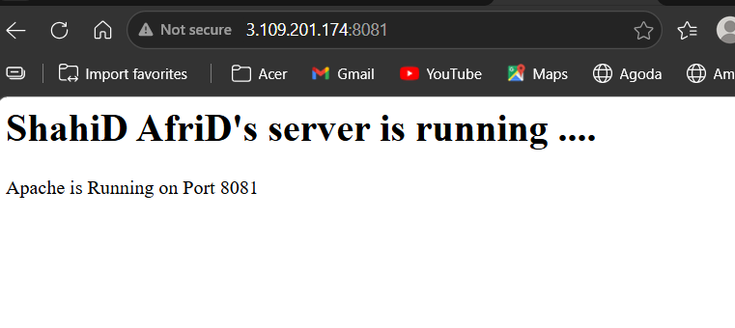

Now continue with Nginx:
dnf install nginx -y
Then:
systemctl start nginx
systemctl enable nginx
Verify:
systemctl status nginx

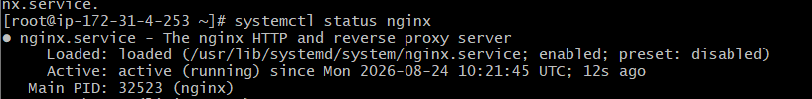

Then open http://3.109.201.174
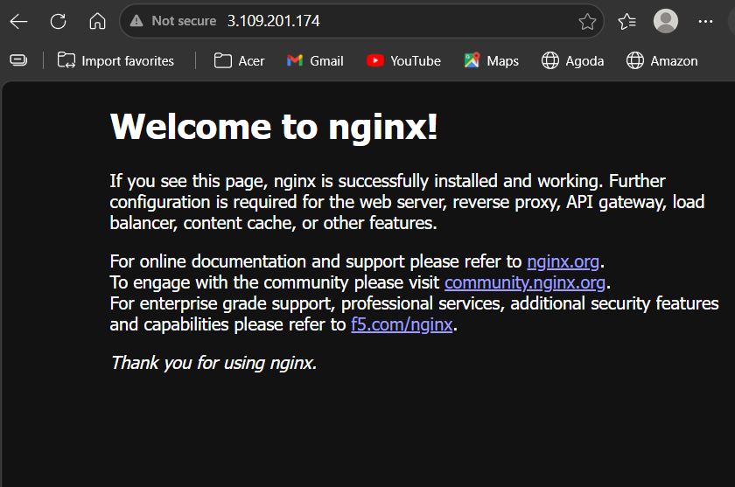

Apache Tomcat – Implementation Notes
Verified Java:
java -version
Moved to the /opt directory:
cd /opt
Downloaded Apache Tomcat 11.0.24:
wget https://archive.apache.org/dist/tomcat/tomcat-11/v11.0.24/bin/apache-tomcat-11.0.24.tar.gz
Extracted the Tomcat package:
tar -xvzf apache-tomcat-11.0.24.tar.gz
Moved into the Tomcat directory:
cd apache-tomcat-11.0.24
Edited the Tomcat configuration file:
vi conf/server.xml
Changed the default port from 8080 to 8082 because Jenkins was already using port 8080.
Started Tomcat:
bin/startup.sh
Verified Tomcat:
ss -tulpn | grep 8082
Accessed Tomcat in the browser:
http://3.109.201.174:8082

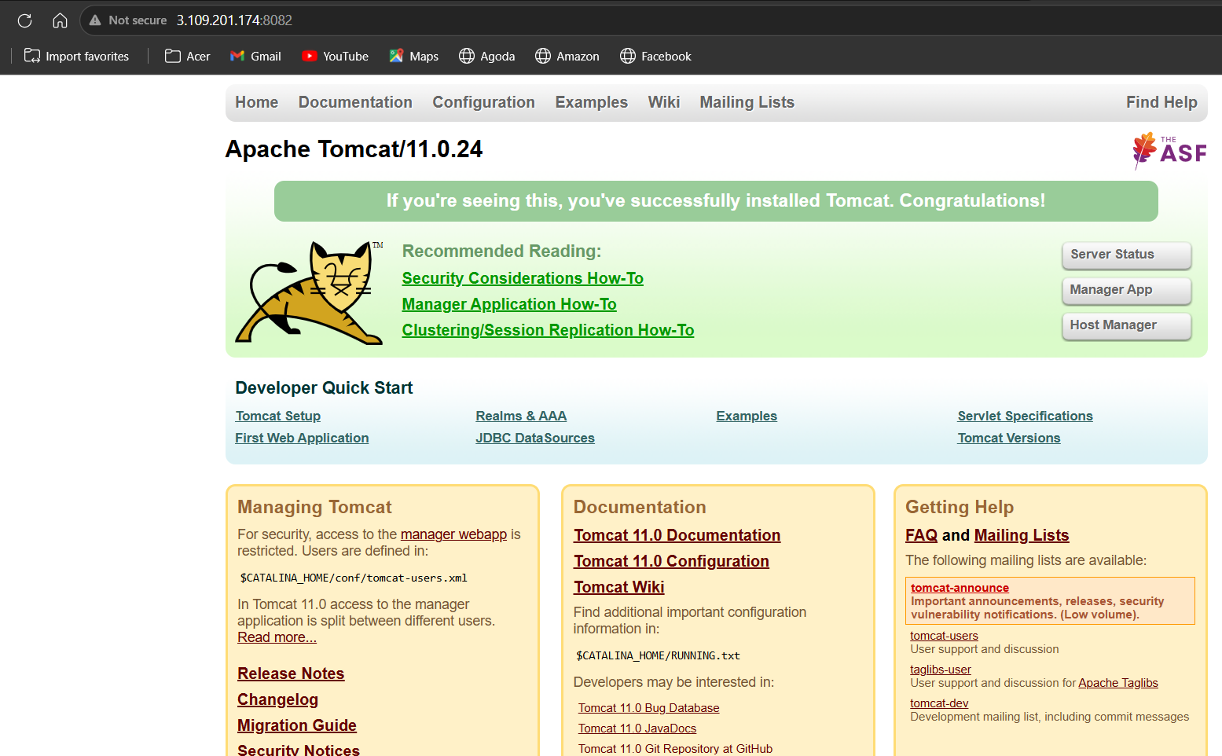

Final check

