Jenkins-3-(01/10/2026)

1.Create one Jenkins job using the below code and create three stages.
- stage1: Git clone to download the source code.
- stage2: Sonarqube Integration to check the quality of code.
- stage3: Slack Integration to send the alerts to slack.
Source Code: https://github.com/betawins/VProfile-1.git

V-Profile Jenkins + SonarQube + Slack Integration

1. Objective
Create one Jenkins Pipeline job with three stages:
- Git Clone
- SonarQube Integration
- Slack Integration
Source code:
https://github.com/betawins/VProfile-1.git
Branch used:
vp-docker

2. Jenkins Job
Created Jenkins Pipeline job:
V-Profile
The pipeline runs on the Jenkins built-in node.
Workspace:
/var/lib/jenkins/workspace/V-Profile

3. Docker Installation
Installed Docker:
sudo yum -y install docker
Started Docker:
sudo systemctl start docker
Pulled SonarQube image:
sudo docker pull sonarqube
Checked images:
sudo docker images

4. SonarQube Docker Container
Created SonarQube container:
sudo docker run -d --name sonarqube -p 9002:9000 sonarqube
Checked running containers:
sudo docker ps
SonarQube was accessed using:
http://<EC2-Public-IP>:9002

5. Jenkins SonarQube Configuration
Go to:
Manage Jenkins → System → SonarQube servers
Configured:
Name: jenkins_1
Server URL: http://localhost:9002
Added the SonarQube authentication token through Jenkins Credentials.

6. Slack Workspace and Channel
Created Slack workspace:
devOps_Mine
Created channel:
#jenkins-builds

7. Slack Bot
Created Slack application:
Jenkins Bot
Added Bot Token Scopes:
chat:write
chat:write.public
Installed the application into the Slack workspace.

8. Slack Credential in Jenkins
Created Jenkins credential:
Kind: Secret text
ID: slack-token
Description: Slack Bot Token
The Slack token was stored as a Jenkins secret.

9. Jenkins Slack Configuration
Go to:
Manage Jenkins → System → Slack
Configured:
Workspace: devOps_Mine
Credential: slack-token
Default channel: #jenkins-builds
Custom slack app bot user: Enabled
Used Test Connection and confirmed the Slack connection was successful.

10. Jenkins Pipeline — 3 Stages
pipeline {
agent any

stages {

stage('Git Clone') {
steps {
git branch: 'vp-docker',
url: 'https://github.com/betawins/VProfile-1.git'
}
}

stage('SonarQube Analysis') {
steps {
script {
def mvn = tool 'Default Maven'

withSonarQubeEnv('jenkins_1') {
sh """
${mvn}/bin/mvn clean package \
-DskipTests \
-Djacoco.skip=true \
org.sonarsource.scanner.maven:sonar-maven-plugin:sonar \
-Dsonar.projectKey=v-profile \
-Dsonar.projectName=v-profile
"""
}
}
}
}

stage('Slack Integration') {
steps {
slackSend(
channel: '#jenkins-builds',
message: "V-Profile Build #${BUILD_NUMBER} completed successfully."
)
}
}
}
}

11. Stage 1 — Git Clone
Jenkins connects to:
https://github.com/betawins/VProfile-1.git
and checks out:
vp-docker
The checkout was successful.
Commit checked out:
65fac59a3a5d5bc04ce1606dd0507ca7ae0fb9d2
Commit message:
latest db file

12. Stage 2 — SonarQube Analysis
Maven executes:
mvn clean package \
-DskipTests \
-Djacoco.skip=true \
org.sonarsource.scanner.maven:sonar-maven-plugin:sonar \
-Dsonar.projectKey=v-profile \
-Dsonar.projectName=v-profile
The application is compiled and packaged as:
target/vprofile-v1.war
-DskipTests skips test execution.
-Djacoco.skip=true skips JaCoCo execution.
SonarQube analysis is executed using:
jenkins_1

13. Stage 3 — Slack Integration
After the previous stages complete successfully, Jenkins sends a message to:
#jenkins-builds
using the configured Slack integration.

Issues Faced and Solutions

1. Wrong Git repository
Initially the wrong repository was used.
Solution:
https://github.com/betawins/VProfile-1.git

2. Wrong branch
Initially main was used.
Solution:
Changed to:
vp-docker

3. JaCoCo failure
The project uses an old JaCoCo version:
0.7.2.201409121644
It caused a Java 21 instrumentation failure.
Solution:
Added:
-Djacoco.skip=true

4. Maven test failures
The project's tests produced Mockito-related errors.
Solution:
Added:
-DskipTests
Jenkins then showed:
Tests are skipped.

5. SonarQube connection timeout
Jenkins initially used:
http://3.109.139.19:9002
SonarQube analysis failed with:
HTTP connect timed out
Tested locally:
curl -I --max-time 10 http://localhost:9002
Result:
HTTP/1.1 200
This confirmed SonarQube was running correctly.
Solution:
Changed the Jenkins SonarQube Server URL to:
http://localhost:9002
After this change, the SonarQube connectivity issue was resolved.

Final Result
GitHub
↓
Jenkins
↓
Git Clone
↓
Maven Build
↓
SonarQube Analysis
↓
Slack Notification
Configuration:
Job: V-Profile
Repository: VProfile-1.git
Branch: vp-docker
SonarQube: jenkins_1
SonarQube URL: http://localhost:9002
Sonar Project: v-profile
Slack Workspace: devOps_Mine
Slack Channel: #jenkins-builds

SonarQube:
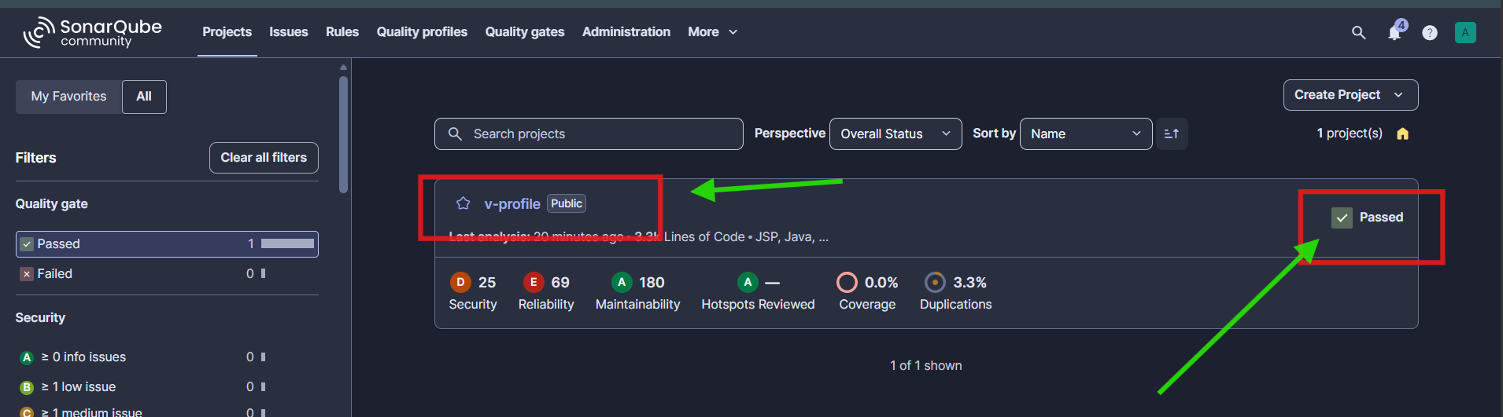

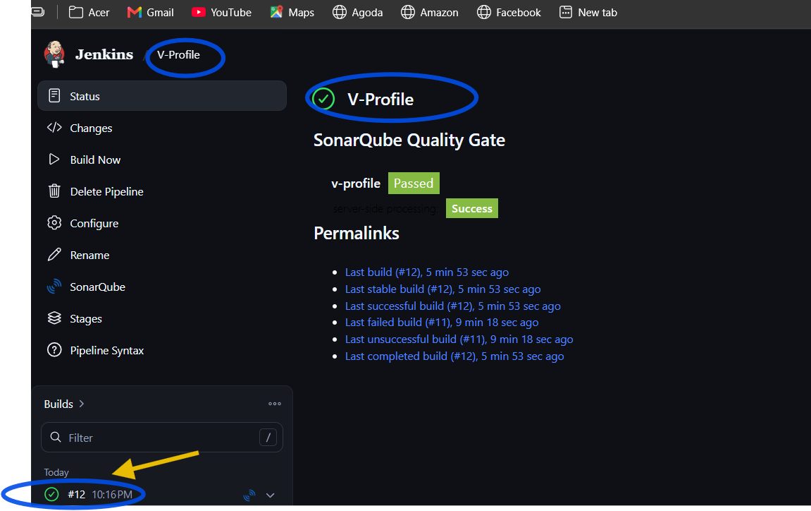
Console output:
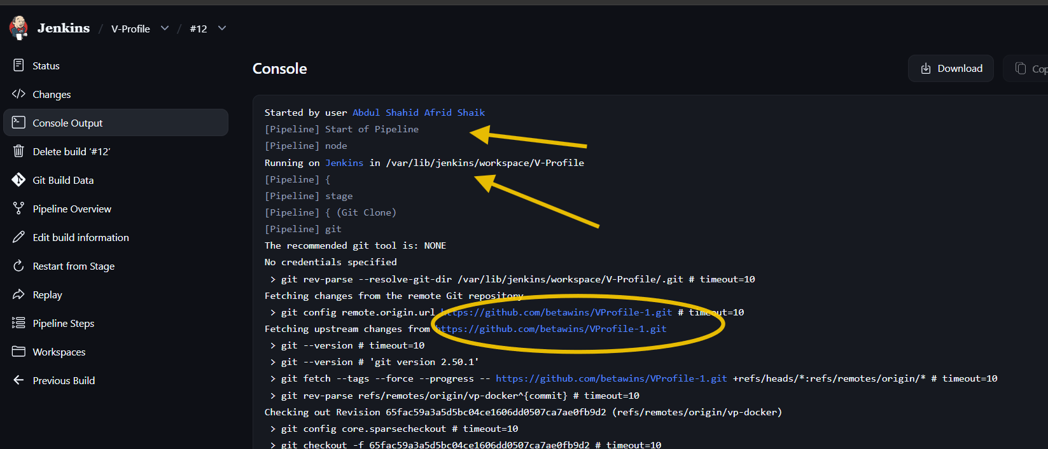
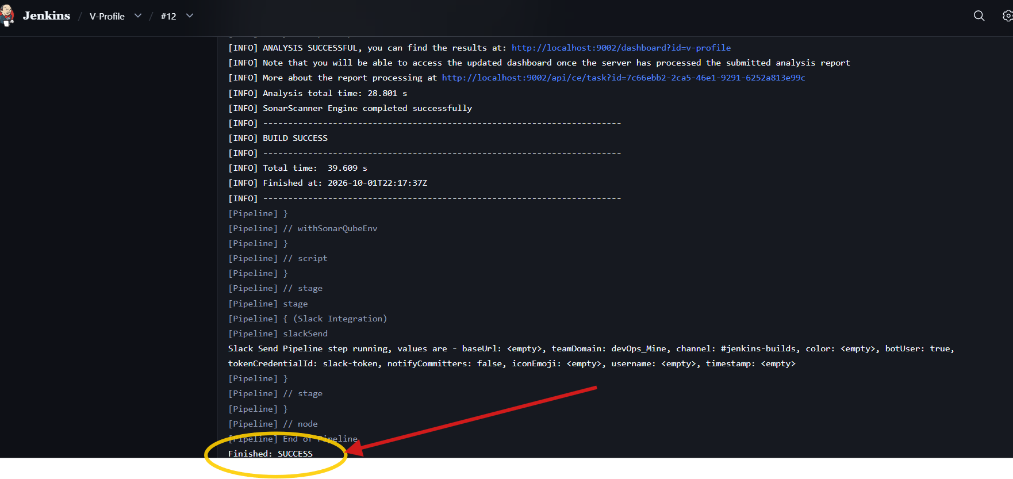

SLACK NOTIFICATIONS:
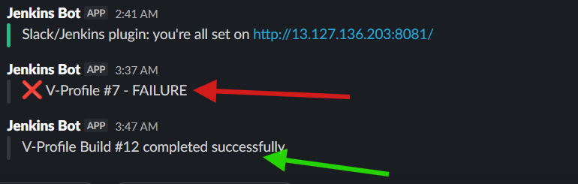
2. Create one Jenkins job using the below code and create three stages.
- stage1: Git clone to download the source code.
- stage2: Sonarqube Integration to check the quality of code.
- stage3: Slack Integration to send the alerts to slack.
Source Code: https://github.com/betawins/hiring-app.git

1. Project Objective
The objective was to create a Jenkins CI pipeline with three stages/functions:
- Git Clone — download source code from GitHub.
- SonarQube Analysis — build the application and analyze code quality.
- Slack Integration — send build status notifications to Slack.
Source repository:
https://github.com/betawins/hiring-app.git
The final workflow is:
GitHub
↓
Jenkins
↓
Git Clone
↓
Maven Build
↓
SonarQube Analysis
↓
Build Result
↓
Slack Notification
The task document describes the same overall three-part requirement: Git clone, SonarQube integration, and Slack alerts. Pasted text

2. Launch Jenkins EC2 Instance
First, launch an EC2 instance for Jenkins.

Jenkins server details
Instance Name : jenkins-first
Region : Mumbai (ap-south-1)
OS : Amazon Linux 2023
Initial Type : t3.micro
Final Type : c7i.large
Private IP : 10.0.1.248
Initially Jenkins was running on a t3.micro.
During the Maven/SonarQube build, the server became slow, so the instance type was changed to:
c7i.large
This provided more CPU and memory for Jenkins and the Maven/SonarQube workload.
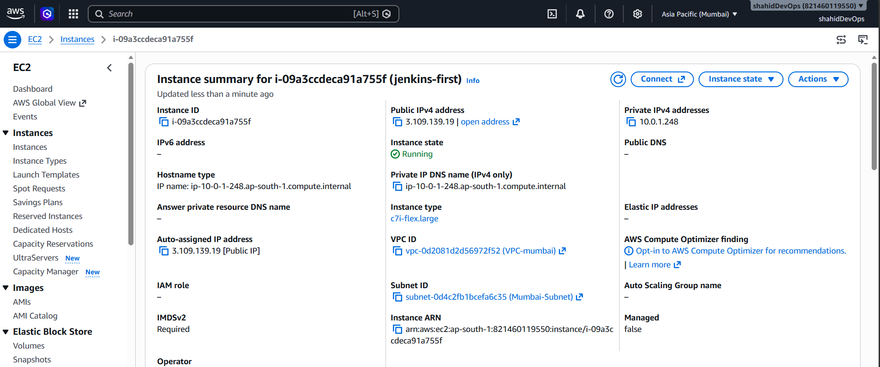

3. Install Jenkins
Connect to the Jenkins EC2 instance using SSH.
Install the required Java/Jenkins dependencies and Jenkins.
After installation, Jenkins was accessed through the browser using:
http://<JENKINS_PUBLIC_IP>:8081
Jenkins was configured to run on:
Port: 8081
The Jenkins dashboard was then accessible through the browser.

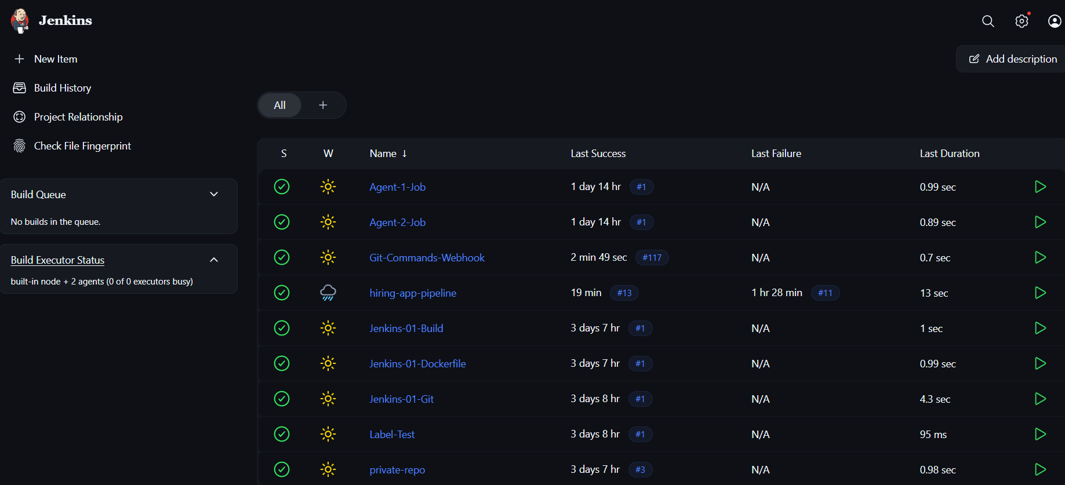

4. Configure Maven in Jenkins
Maven is required to build the Java web application before SonarQube analysis.
In Jenkins:
Manage Jenkins
↓
Tools
↓
Maven installations
A Maven installation was configured with the name:
Default Maven
The pipeline later retrieves this installation using:
def mvn = tool 'Default Maven'
The Maven executable used by Jenkins was resolved under:
/var/lib/jenkins/tools/hudson.tasks.Maven_MavenInstallation/Default_Maven/bin/mvn

5. Launch SonarQube EC2 Instance
A separate EC2 instance was launched for SonarQube.

SonarQube server
Private IP : 10.0.1.200
SonarQube and Jenkins were therefore running on separate servers.
Architecture:
Jenkins EC2
10.0.1.248
|
| HTTP
↓
SonarQube EC2
10.0.1.200

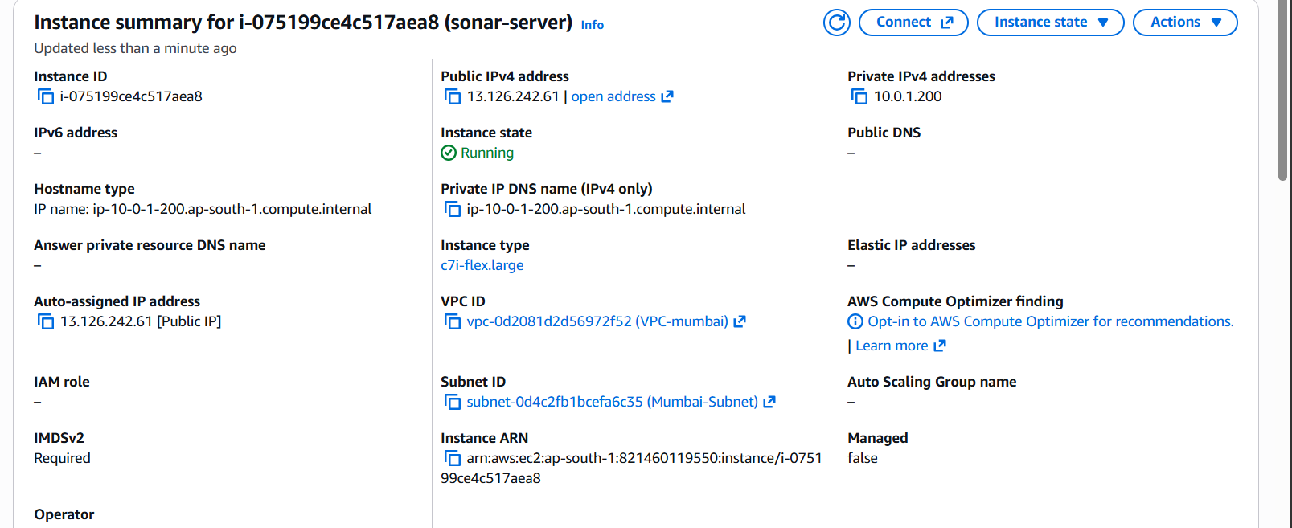

6. Connect to SonarQube Server
SSH into the SonarQube EC2 instance.
The SonarQube installation was located under:
/opt/sonarqube/app/sonarqube-26.8.0.126808/
The SonarQube startup script is:
/opt/sonarqube/app/sonarqube-26.8.0.126808/bin/linux-x86-64/sonar.sh

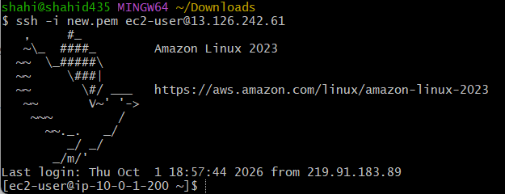

7. Install Java 21
SonarQube requires Java.
Java 21 was installed on the SonarQube server.
The project documentation also specifies Java 21 as the runtime environment for SonarQube.
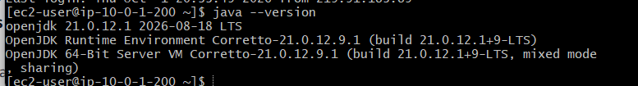

8. Install PostgreSQL 17
PostgreSQL was installed on the SonarQube server.
PostgreSQL is used as the external database for SonarQube.
The database architecture is:
SonarQube
|
| JDBC
↓
PostgreSQL 17
|
↓
sonarqube database
The important components are:
Database : sonarqube
User : sonar
Password : configured during setup
The supplied task material documents creating a dedicated SonarQube database and user and granting privileges to that user. Pasted text

9. Initialize and Start PostgreSQL
After installing PostgreSQL:
sudo postgresql-setup --initdb
Start PostgreSQL:
sudo systemctl start postgresql
Enable PostgreSQL at boot:
sudo systemctl enable postgresql
Check the service:
sudo systemctl status postgresql

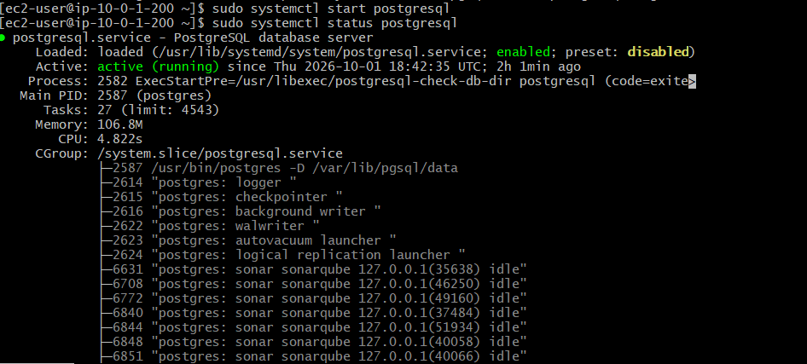

10. Login to PostgreSQL
Login as the PostgreSQL administrator:
sudo -i -u postgres psql
This opens the PostgreSQL shell:
postgres=#

11. Create SonarQube Database
Create the database:
CREATE DATABASE sonarqube;
Check databases:
\l
The database should appear as:
Sonarqube

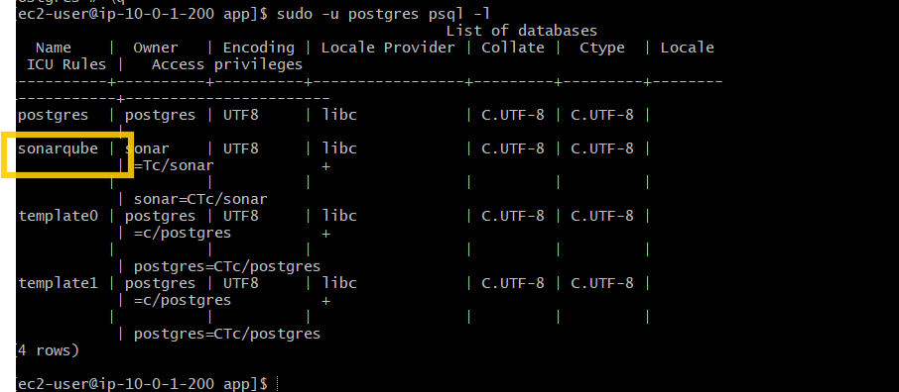

12. Create SonarQube Database User
Create a dedicated database user:
CREATE USER sonar WITH PASSWORD '<your-password>';
Grant privileges:
GRANT ALL PRIVILEGES ON DATABASE sonarqube TO sonar;
Check users:
\du
The sonar user should appear.
In the final notes, never store the real database password. Use <your-password> or another placeholder.

13. Configure PostgreSQL Authentication
PostgreSQL uses pg_hba.conf to control client authentication.
Find the configuration file:
sudo -i -u postgres psql -c "SHOW hba_file;"
The configuration file used in the setup was:
/var/lib/pgsql/data/pg_hba.conf
Edit it:
sudo vi /var/lib/pgsql/data/pg_hba.conf
The local TCP connections were configured to use:
scram-sha-256
Example configuration:
# TYPE DATABASE USER ADDRESS METHOD

local all all peer

host all all 127.0.0.1/32 scram-sha-256

host all all ::1/128 scram-sha-256

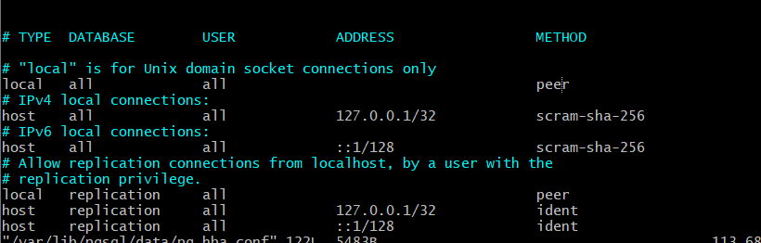

Why SCRAM?
SCRAM-SHA-256 is PostgreSQL's password authentication mechanism used for secure password-based authentication.
The important configuration change we made was:
scram-sha-256
The supplied setup material specifically identifies this as the important authentication method. Pasted text

14. Restart PostgreSQL
After modifying pg_hba.conf:
sudo systemctl restart postgresql
Verify:
sudo systemctl status postgresql

15. Set SonarQube Database Password
Login again as PostgreSQL administrator:
sudo -i -u postgres psql
Set the password:
ALTER USER sonar WITH PASSWORD '<your-password>';
Expected result:
ALTER ROLE
Exit:
\q
PostgreSQL applies role/password changes immediately; there is no need for MySQL's FLUSH PRIVILEGES.

16. Test PostgreSQL Login
Test the database connection using the SonarQube user:
psql -U sonar -h 127.0.0.1 -d sonarqube
Enter the configured password.
If successful:
sonarqube=>
Verify the current user:
SELECT current_user;
Expected:
sonar
Exit:
\q
This confirms that PostgreSQL authentication is working for the SonarQube database user. Pasted text

17. Install SonarQube
The SonarQube package was installed under:
/opt/sonarqube/app/sonarqube-26.8.0.126808/
The setup used SonarQube Community Build.
The final Jenkins analysis log confirms communication with:
SonarQube Community Build 26.8.0.126808
Pasted markdown

18. Configure SonarQube Ownership
SonarQube should not be run as root.
During our setup, SonarQube was initially started incorrectly with sudo.
This caused Elasticsearch to fail with:
can not run elasticsearch as root
The logs showed the root-user startup problem. Pasted text
Because some files became owned by root, permissions were corrected using:
sudo chown -R ec2-user:ec2-user /opt/sonarqube/app/sonarqube-26.8.0.126808
Then SonarQube was started as the normal user rather than root.

19. Configure Linux Kernel Parameters
SonarQube/Elasticsearch requires appropriate Linux kernel limits.
Edit:
sudo vi /etc/sysctl.conf
Add/configure:
vm.max_map_count=524288
fs.file-max=131072
Apply the changes:
sudo sysctl -p
The supplied SonarQube setup material specifies these kernel parameters. Pasted text

20. Configure SonarQube Database Connection
SonarQube's main configuration file is:
/opt/sonar/conf/sonar.properties
The setup configured the PostgreSQL connection with:
sonar.jdbc.username=sonar
sonar.jdbc.password=<your-password>
sonar.jdbc.url=jdbc:postgresql://localhost:5432/sonarqube

Meaning
sonar.jdbc.username
Specifies the PostgreSQL user.
sonar.jdbc.password
Specifies the PostgreSQL password.
sonar.jdbc.url
Specifies the PostgreSQL database connection.
The supplied setup document records this database configuration. Pasted text

21. Configure SonarQube Web Server
The SonarQube web configuration was also modified.
The web server was configured to listen on the required interface and the 52xx-series web port that we configured during the setup.
The important distinction is:
PostgreSQL → 5432
SonarQube Web → configured 52xx port
Do not confuse the PostgreSQL port with the SonarQube web port.

22. Start SonarQube
The SonarQube startup script:
/opt/sonarqube/app/sonarqube-26.8.0.126808/bin/linux-x86-64/sonar.sh start
We learned an important point during troubleshooting:

Incorrect
sudo .../sonar.sh start
This caused Elasticsearch to attempt to run as root.

Correct
Run SonarQube as the appropriate non-root user:
.../sonar.sh start

23. Verify SonarQube
Check the SonarQube process/status and verify the web port is listening.
The SonarQube server eventually became accessible from the Jenkins server.
From Jenkins:
curl -I http://10.0.1.200:9000
The successful response was:
HTTP/1.1 200
This confirmed that Jenkins could communicate with SonarQube. 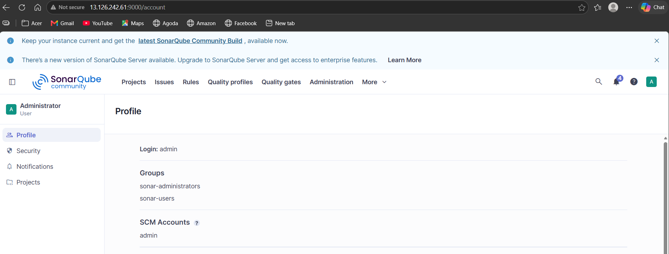

24. Configure GitHub Repository
The source repository used:
https://github.com/betawins/hiring-app.git
Branch:
main
The Jenkins pipeline checks out this repository.
The successful Jenkins log showed the Git fetch and checkout of the repository's main branch. Pasted markdown

25. Create Jenkins Pipeline Job
Create a new Jenkins item:
New Item
↓
Pipeline
The pipeline job used was:
hiring-app-pipeline
Pipeline definition:
Pipeline script
The pipeline uses:
agent any
This means Jenkins can execute the pipeline on any available agent matching the configuration.
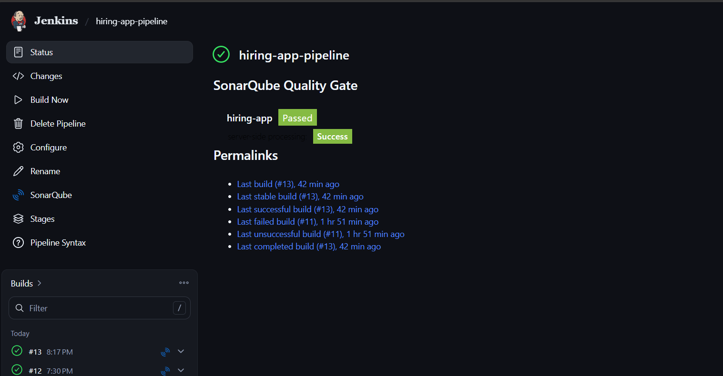

26. First Pipeline Stage — Git Clone
The first stage downloads the application source code.
stage('Git Clone') {
steps {
git branch: 'main',
url: 'https://github.com/betawins/hiring-app.git'
}
}

What happens?
Jenkins:
- Contacts GitHub.
- Fetches the repository.
- Checks out the main branch.
- Places the source code into the Jenkins workspace.
Workspace observed:
/var/lib/jenkins/workspace/hiring-app-pipeline@2

27. Second Stage — Maven + SonarQube
The second stage performs the Maven build and SonarQube analysis.
stage('SonarQube Analysis') {
steps {
script {
def mvn = tool 'Default Maven'

withSonarQubeEnv('SonarQube') {
sh """
${mvn}/bin/mvn clean verify \
org.sonarsource.scanner.maven:sonar-maven-plugin:sonar \
-Dsonar.projectKey=hiring-app \
-Dsonar.projectName=hiring-app
"""
}
}
}
}

28. Maven Build
The Maven command starts with:
mvn clean verify

clean
Removes previous build output.

verify
Runs the Maven build lifecycle up to the verification phase.
The application was packaged as:
target/hiring.war
The Jenkins build log confirms that Maven assembled the web application and created:
target/hiring.war
Pasted markdown
There were no application tests:
No tests to run.

29. SonarQube Maven Scanner
The pipeline invokes:
org.sonarsource.scanner.maven:sonar-maven-plugin:sonar
The scanner version observed during the successful build was:
5.8.0.7211
The scanner communicates with the configured SonarQube server.
The project was configured as:
Project Key : hiring-app
Project Name : hiring-app

30. Jenkins SonarQube Configuration
Jenkins was configured with the SonarQube server name:
SonarQube
The Jenkinsfile uses:
withSonarQubeEnv('SonarQube')
This provides the pipeline with the configured SonarQube server environment.
The successful build log confirms the withSonarQubeEnv('SonarQube') stage configuration. Pasted markdown

31. SonarQube Analysis
During analysis, SonarQube:
- Loaded global settings.
- Loaded plugins.
- Loaded quality profiles.
- Loaded active rules.
- Loaded project settings.
- Scanned project files.
- Uploaded the analysis report.
The scanner identified the project as:
Project key: hiring-app
The final log confirmed successful communication with SonarQube Community Build. Pasted markdown

32. SonarQube Analysis Success
The final successful pipeline reported:
ANALYSIS SUCCESSFUL
and:
BUILD SUCCESS
The Jenkins pipeline finished with:
Finished: SUCCESS
The analysis report was uploaded to the SonarQube server. Pasted markdown

33. Create Slack Workspace
After GitHub + SonarQube was working, Slack integration was configured.
Slack workspace created:
devOps_Mine

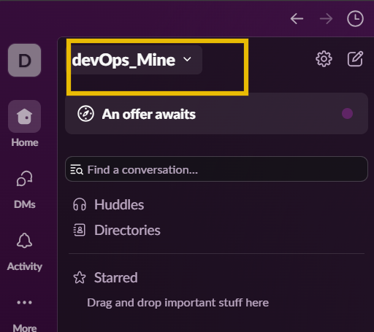

34. Create Slack Channel
Channel created:
#jenkins-builds
This channel receives Jenkins build notifications.
The task document also specifies a jenkins-builds channel for Jenkins notifications. Pasted text

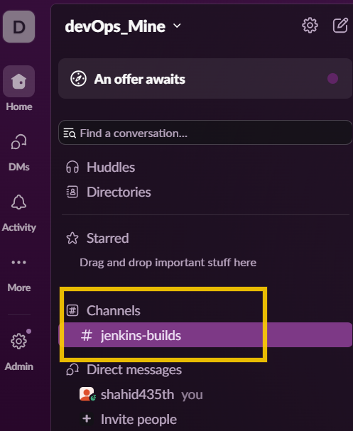

35. Create Slack Jenkins Bot
In Slack:
Create New App
↓
Blank app
↓
Jenkins Bot
↓
devOps_Mine
The current Slack UI uses Blank app for creating the application.

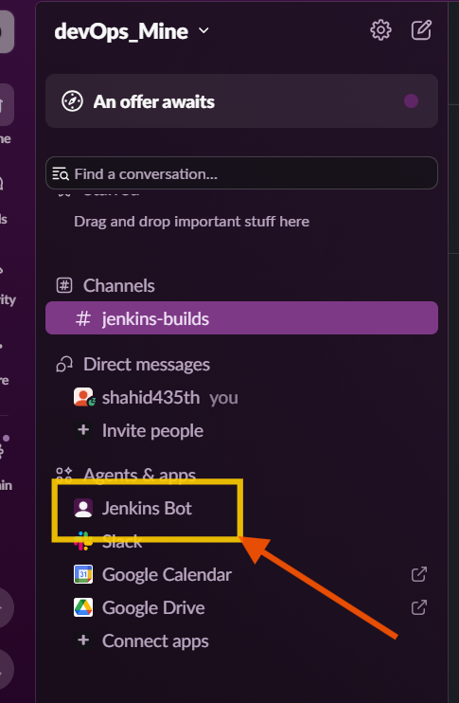

36. Add Slack Bot Permissions
Under:
OAuth & Permissions
Bot Token Scopes were added:
chat:write
chat:write.public
These permissions allow the bot to send messages to Slack channels.
The supplied Slack instructions specify these two scopes. Pasted text

37. Install Slack App
The Slack app was installed into:
devOps_Mine
Slack generated a Bot User OAuth Token beginning with:
xoxb-

Security
The actual token must never be placed directly inside the Jenkinsfile.
It should be stored securely in Jenkins Credentials.
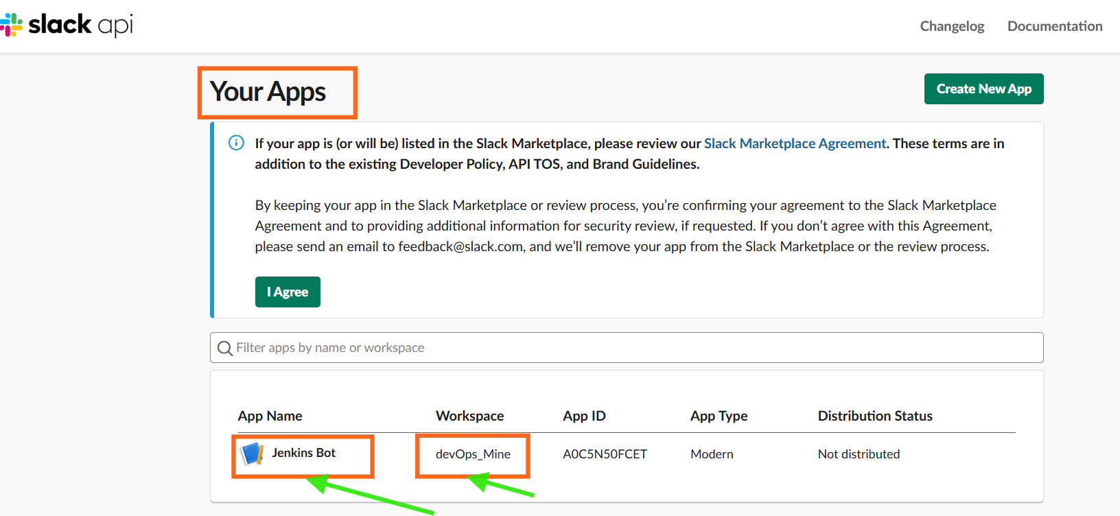

38. Add Slack Token to Jenkins Credentials
Go to:
Jenkins
↓
Manage Jenkins
↓
Credentials
↓
Global
↓
Add Credentials
Configure:
Kind : Secret text
Secret : Slack Bot OAuth token
ID : slack-token
Description : Slack Bot Token
The teammate setup document specifies this credential configuration. Pasted text

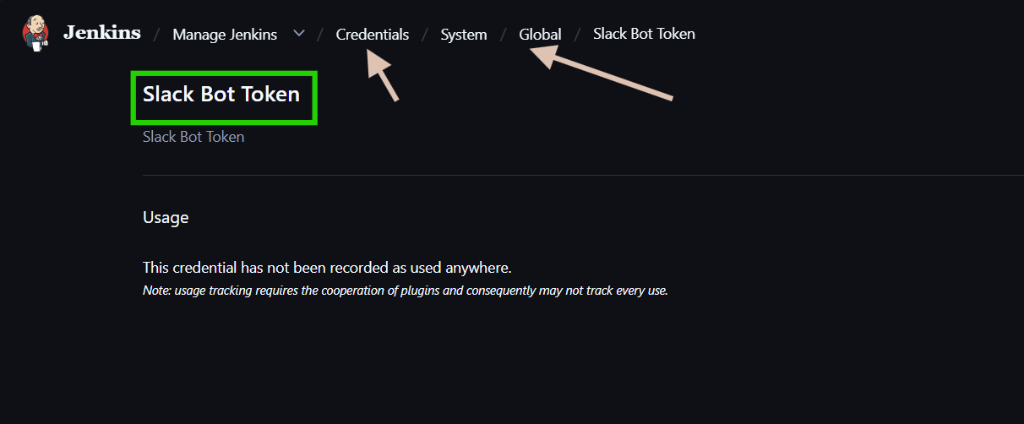

39. Install Slack Notification Plugin
Initially, Jenkins did not show the Slack configuration section.
Therefore the Jenkins plugin was installed:
Slack Notification
After installation, Slack configuration became available under Jenkins system configuration.

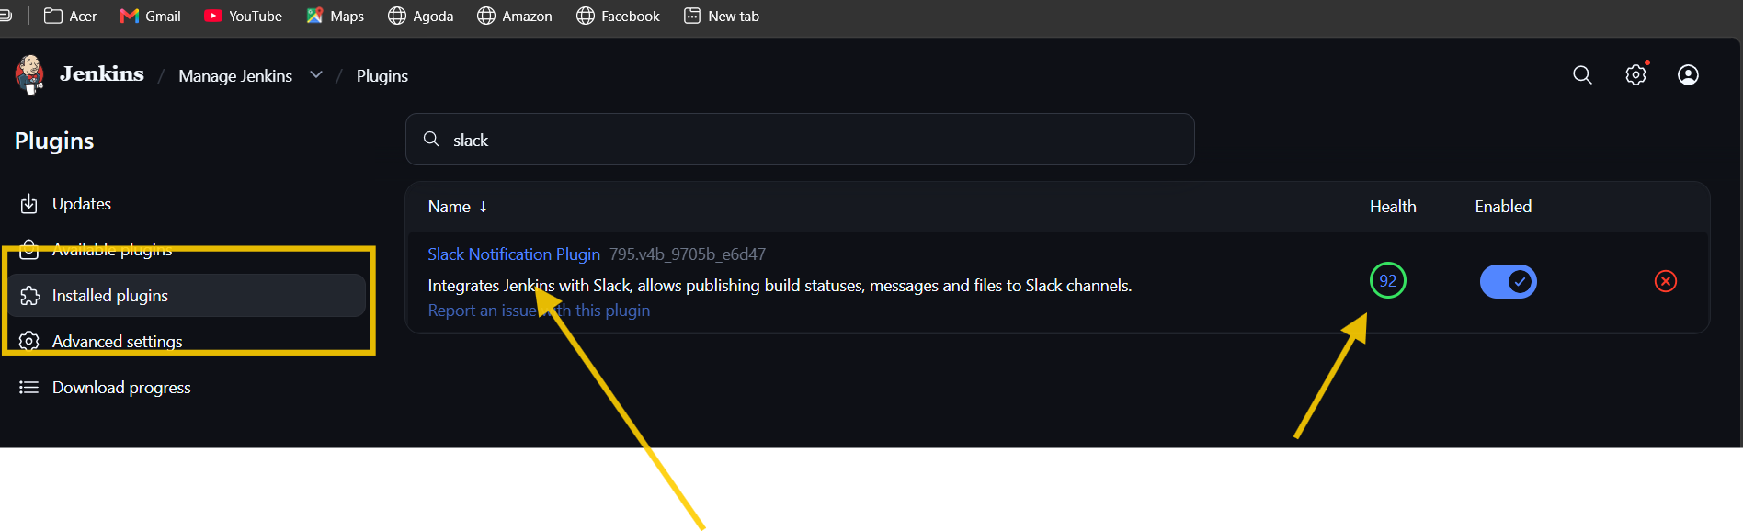

40. Configure Slack in Jenkins
Go to:
Manage Jenkins
↓
System
Configure Slack:
Workspace : devOps_Mine
Credential : slack-token
Default channel : #jenkins-builds
Enable:
Custom slack app bot user
The supplied Slack procedure documents configuring the workspace, credential, default channel and custom bot option. Pasted text

41. Test Slack Connection
Click:
Test Connection
The connection succeeded.
A test message was received in:
#jenkins-builds
This confirmed:
Jenkins → Slack
communication.

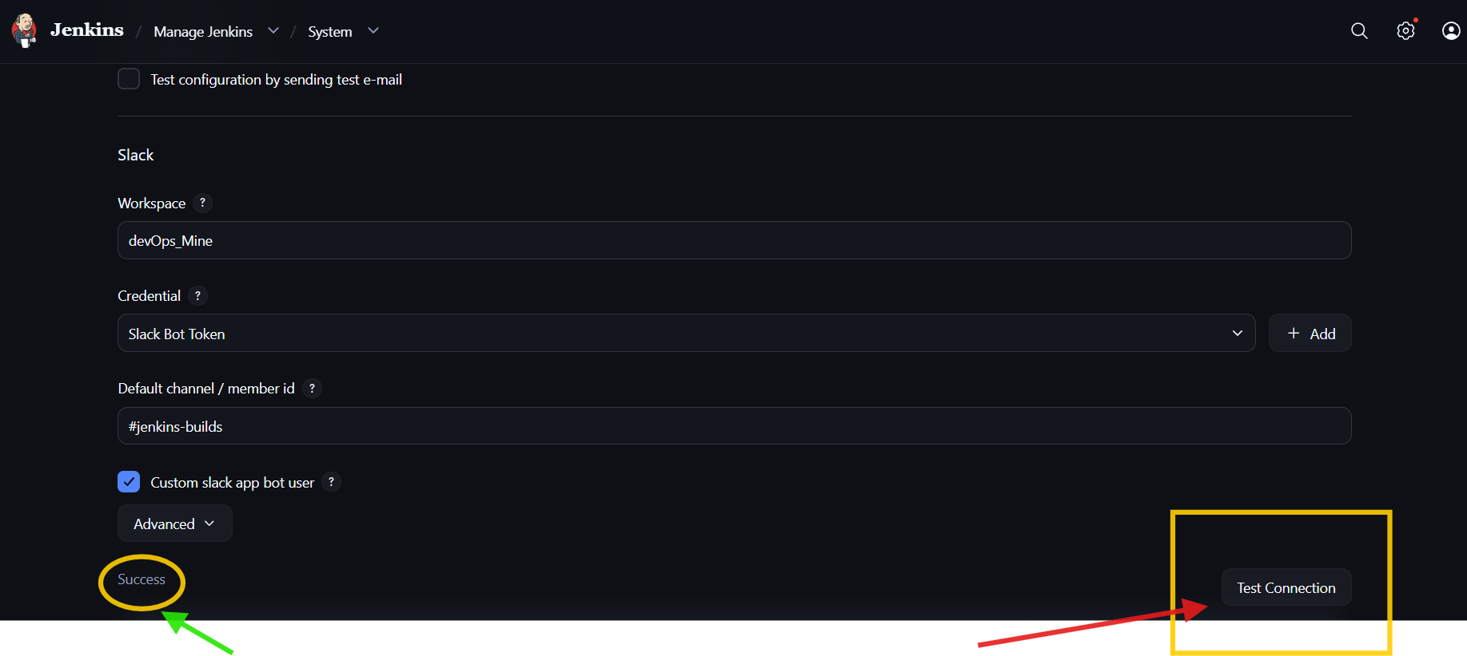

42. Add Slack Notifications to Jenkinsfile
Instead of creating a separate pipeline stage for Slack, Slack was implemented using the Jenkins Pipeline post block.

Success notification
post {
success {
slackSend(
channel: '#jenkins-builds',
message: "✅ SUCCESS: ${env.JOB_NAME} #${env.BUILD_NUMBER}"
)
}

Failure notification
failure {
slackSend(
channel: '#jenkins-builds',
message: "❌ FAILURE: ${env.JOB_NAME} #${env.BUILD_NUMBER}"
)
}
}
Therefore:
Build SUCCESS
↓
Slack SUCCESS message

Build FAILURE
↓
Slack FAILURE message

43. Final Jenkinsfile
The final Jenkinsfile was:
pipeline {

agent any

stages {

stage('Git Clone') {
steps {
git branch: 'main',
url: 'https://github.com/betawins/hiring-app.git'
}
}

stage('SonarQube Analysis') {
steps {
script {
def mvn = tool 'Default Maven'

withSonarQubeEnv('SonarQube') {
sh """
${mvn}/bin/mvn clean verify \
org.sonarsource.scanner.maven:sonar-maven-plugin:sonar \
-Dsonar.projectKey=hiring-app \
-Dsonar.projectName=hiring-app
"""
}
}
}
}
}

post {

success {
slackSend(
channel: '#jenkins-builds',
message: "✅ SUCCESS: ${env.JOB_NAME} #${env.BUILD_NUMBER}"
)
}

failure {
slackSend(
channel: '#jenkins-builds',
message: "❌ FAILURE: ${env.JOB_NAME} #${env.BUILD_NUMBER}"
)
}
}
}

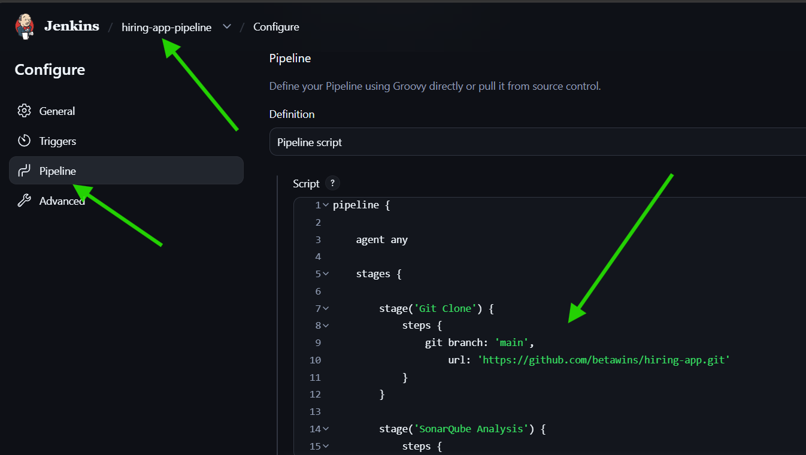

44. Final Pipeline Execution
When Build Now was selected, Jenkins executed:
Pipeline
│
├── Git Clone
│
├── Maven Build
│
├── SonarQube Analysis
│
└── Post Actions
│
└── Slack Notification

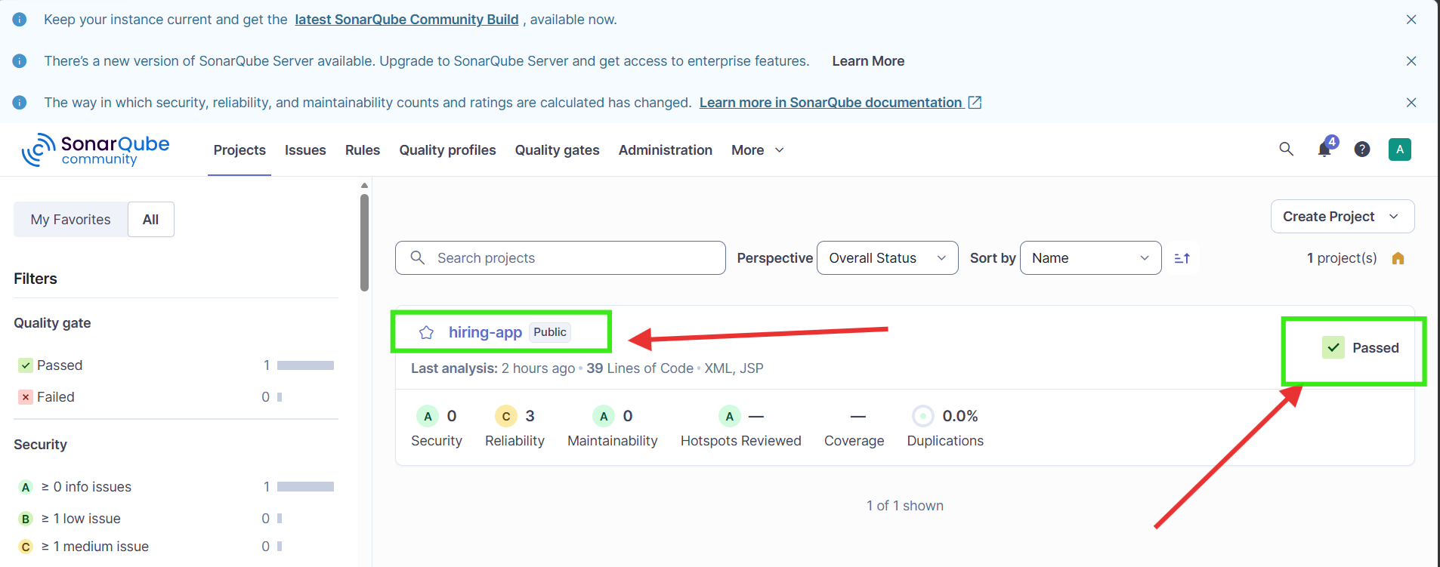
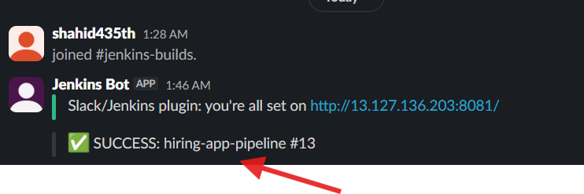

45. Final Result
The complete integration was successfully tested.

GitHub
GitHub → Jenkins
Successfully cloned:
betawins/hiring-app

Maven
Maven → Build
Successfully generated:
target/hiring.war

SonarQube
Jenkins → SonarQube
Successfully completed code analysis.

Slack
Jenkins → Slack
Successfully sent the build notification to:
#jenkins-builds

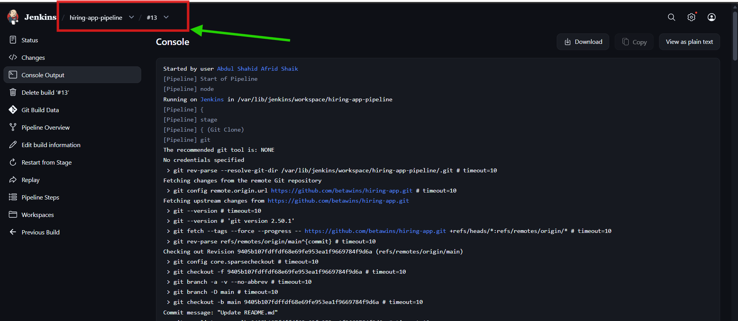

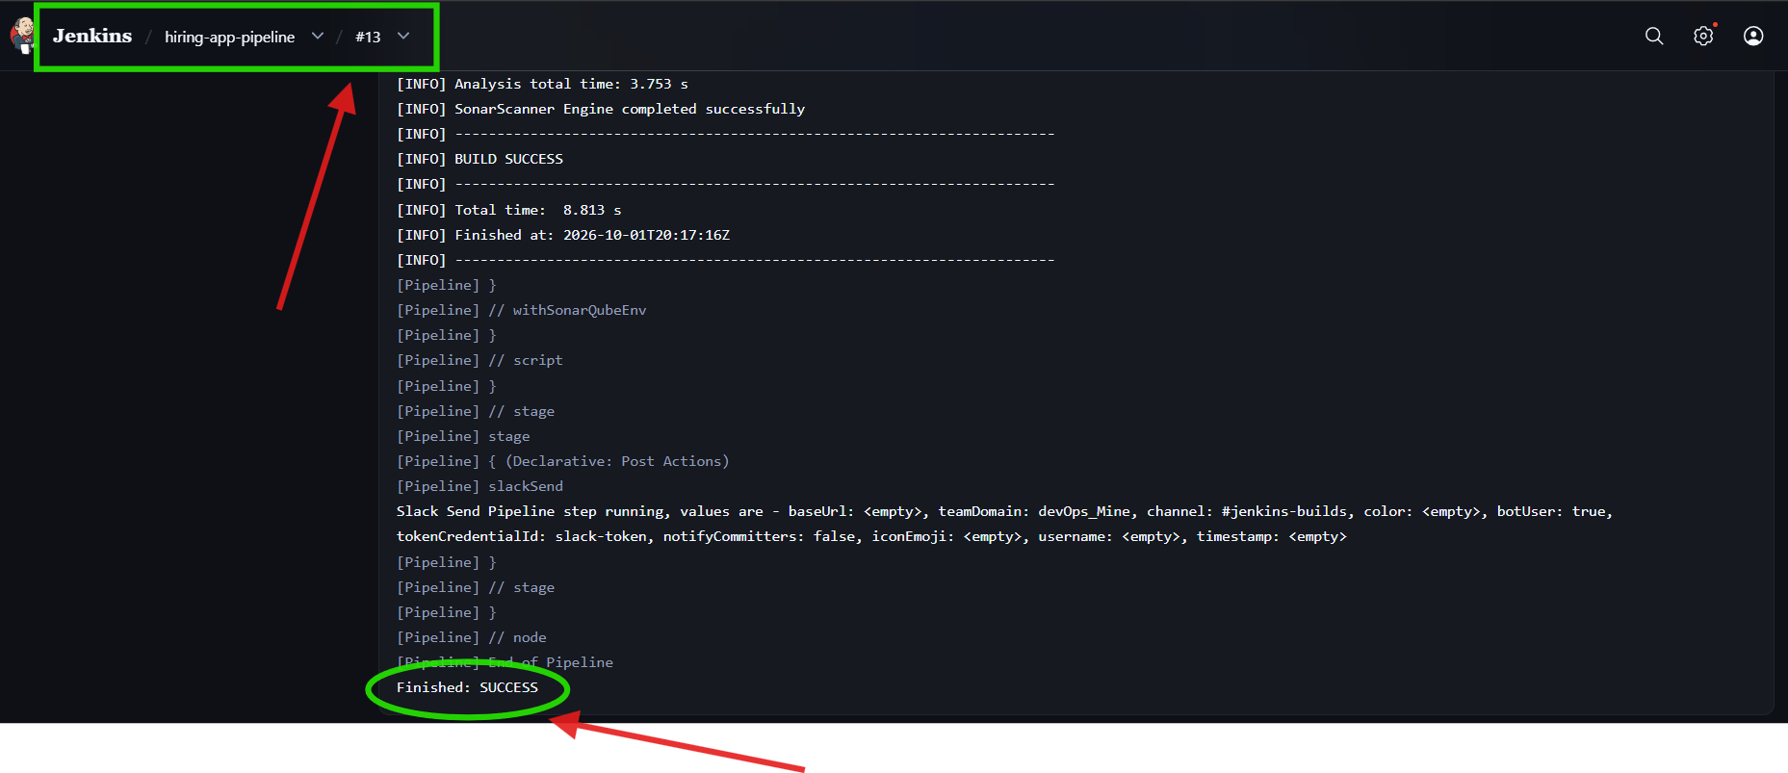

46. Final Architecture
GitHub
│
│ git clone
▼
┌─────────────────┐
│ Jenkins EC2 │
│ 10.0.1.248 │
│ │
│ Jenkins │
│ Maven │
└────────┬────────┘
│
│ SonarQube Analysis
▼
┌─────────────────┐
│ SonarQube EC2 │
│ 10.0.1.200 │
│ │
│ SonarQube │
└────────┬────────┘
│
│ JDBC
▼
┌─────────────────┐
│ PostgreSQL 17 │
│ │
│ DB: sonarqube │
│ User: sonar │
│ SCRAM-SHA-256 │
└─────────────────┘

Jenkins
│
│ slackSend()
▼
┌────────────────┐
│ Slack │
│ devOps_Mine │
│ #jenkins-builds│
└────────────────┘

What you actually implemented
Infrastructure
- Jenkins EC2
- Separate SonarQube EC2
- PostgreSQL 17
SonarQube
- Java 21
- PostgreSQL database
- sonar database user
- SCRAM-SHA-256 authentication
- SonarQube database configuration
- SonarQube web configuration
- Linux kernel parameters
- Non-root SonarQube startup
Jenkins
- Jenkins
- Maven
- GitHub integration
- Pipeline job
- Git clone
- Maven build
- SonarQube analysis
Slack
- Slack workspace
- #jenkins-builds
- Jenkins Bot
- chat:write
- chat:write.public
- Jenkins secret credential
- Slack Notification plugin
- Jenkins Slack configuration
- Success/failure notifications
Final flow:
GitHub
↓
Jenkins
↓
Git Clone
↓
Maven Build
↓
SonarQube Analysis
↓
SUCCESS / FAILURE
↓
Slack
The final Jenkins execution confirmed analysis successful, build successful, and pipeline finished successfully. Pasted markdown

