Auto Scaling Group-DailyTasks

- Create one VPC in N. Virginia region.

Objective
Create an isolated virtual network in the N. Virginia (us-east-1) region to host the AWS resources for the project.

Configuration
- VPC Name: Afrid-VPC
- IPv4 CIDR: 10.0.0.0/16
- IPv6: No IPv6 CIDR block
- Tenancy: Default
- Region: N. Virginia (us-east-1)

Implementation Steps
- Open AWS Console → VPC.
- Select Your VPCs.
- Click Create VPC.
- Select VPC only.
- Enter the VPC name as Afrid-VPC.
- Enter IPv4 CIDR as 10.0.0.0/16.
- Keep tenancy as Default.
- Click Create VPC.

Result
The VPC Afrid-VPC is created with the CIDR range:
10.0.0.0/16
This VPC will later contain the public and private subnets.

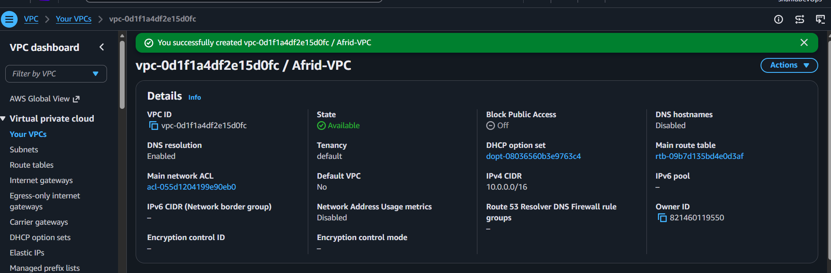
- Create two subnets: one public subnet and one private subnet.

Objective
Create separate public and private subnets inside the VPC to organize resources based on their internet-access requirements.

Configuration
Subnet | Name | CIDR | Availability Zone
Public | Afrid-Public-Subnet | 10.0.1.0/24 | us-east-1a
Private | Afrid-Private-Subnet | 10.0.2.0/24 | us-east-1b

Implementation Steps
- Go to AWS Console → VPC → Subnets.
- Click Create subnet.
- Select VPC:
Afrid-VPC
- Create the public subnet:
  - Name: Afrid-Public-Subnet
  - AZ: us-east-1a
  - CIDR: 10.0.1.0/24
- Create the private subnet:
  - Name: Afrid-Private-Subnet
  - AZ: us-east-1b
  - CIDR: 10.0.2.0/24

Result
Two subnets are created inside Afrid-VPC:
Afrid-VPC
10.0.0.0/16
│
├── Afrid-Public-Subnet
│ └── 10.0.1.0/24
│
└── Afrid-Private-Subnet
└── 10.0.2.0/24
The public subnet will later host the NAT Gateway and public EC2 instance.
The private subnet will later host the private EC2 instance.

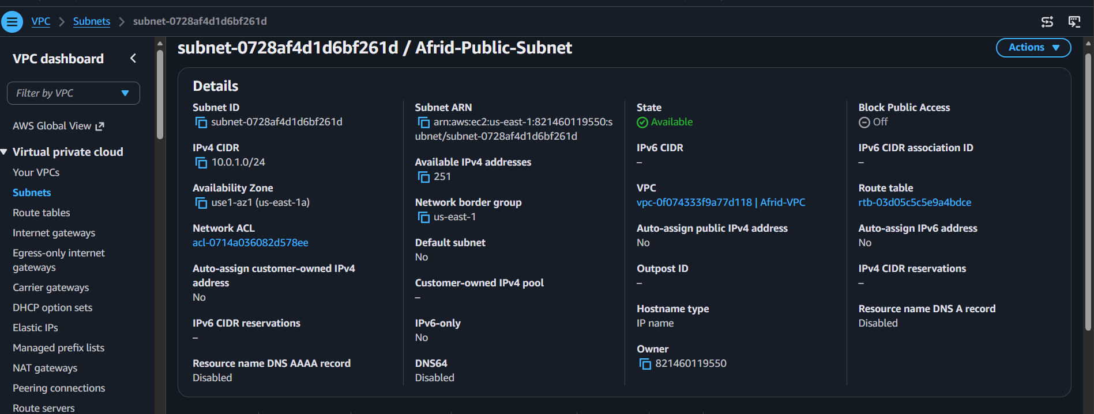

private subnet:
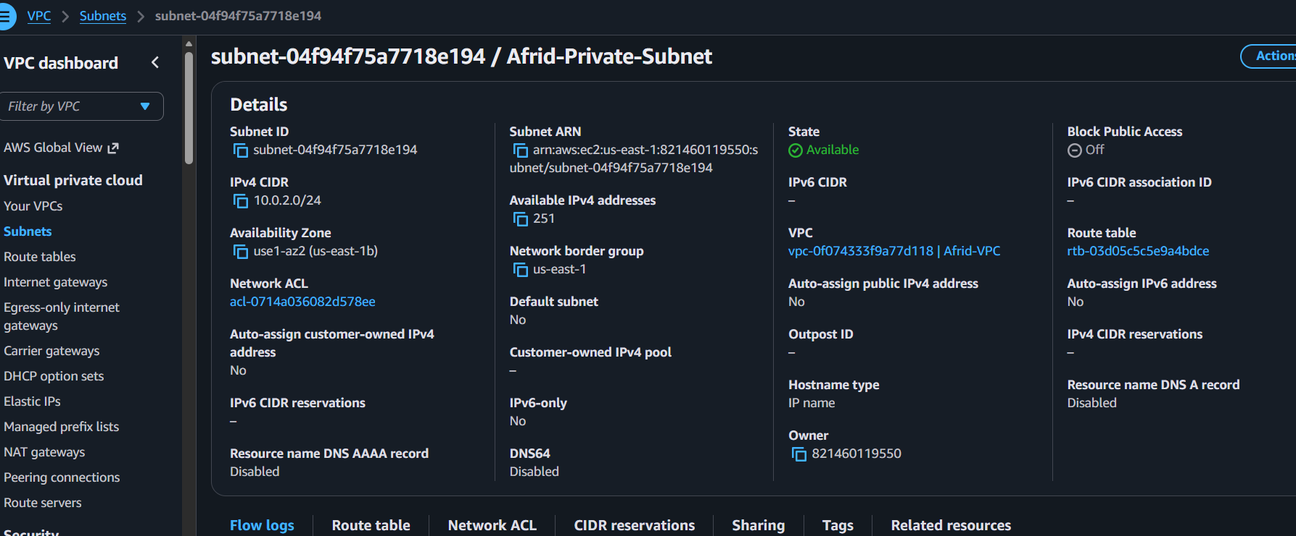

- Attach an IGW to the VPC.

Objective
Create an Internet Gateway and attach it to the VPC to provide a path for internet communication.

Configuration
- Internet Gateway: Afrid-IGW
- VPC: Afrid-VPC

Implementation Steps
- Go to AWS Console → VPC → Internet Gateways.
- Click Create internet gateway.
- Enter the name:
Afrid-IGW
- Click Create internet gateway.
- Select Afrid-IGW.
- Click Actions → Attach to a VPC.
- Select:
Afrid-VPC
- Click Attach internet gateway.

Result
The Internet Gateway Afrid-IGW is attached to Afrid-VPC.
The IGW provides the VPC with a connection to the internet, but internet access will only work after configuring the appropriate route table routes.

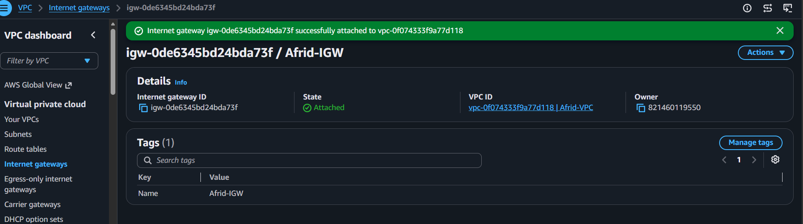

- Create one public route table (RT) and one private route table.

Objective
Create separate route tables for the public and private subnets and configure their routing behavior.

Configuration
Route Table | Name | Associated Subnet
Public RT | Afrid-Public-RT | Afrid-Public-Subnet
Private RT | Afrid-Private-RT | Afrid-Private-Subnet

Implementation Steps

1. Create Public Route Table
- Go to AWS Console → VPC → Route Tables.
- Click Create route table.
- Enter:
  - Name: Afrid-Public-RT
  - VPC: Afrid-VPC
- Click Create route table.

Add Internet Route
- Select Afrid-Public-RT.
- Go to Routes → Edit routes.
- Click Add route.
- Configure:
  - Destination: 0.0.0.0/0
  - Target: Afrid-IGW
- Save changes.

Associate Public Subnet
- Go to Subnet associations.
- Click Edit subnet associations.
- Select:
Afrid-Public-Subnet
- Click Save associations.

2. Create Private Route Table
- Click Create route table.
- Enter:
  - Name: Afrid-Private-RT
  - VPC: Afrid-VPC
- Click Create route table.

Associate Private Subnet
- Select Afrid-Private-RT.
- Go to Subnet associations → Edit subnet associations.
- Select:
Afrid-Private-Subnet
- Click Save associations.

Final Routing
Public Route Table:
10.0.0.0/16 → local
0.0.0.0/0 → Afrid-IGW
Private Route Table:
10.0.0.0/16 → local

Result
The public subnet has a route to the Internet Gateway, while the private subnet currently has only local VPC connectivity.

Public_RT:
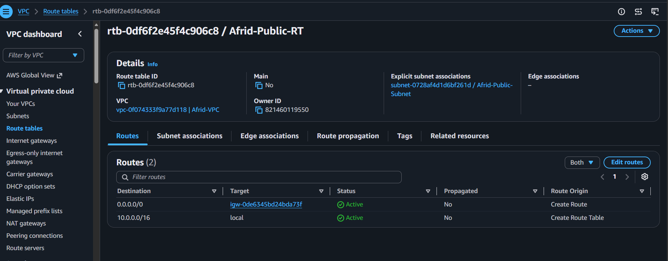
Private_RT:
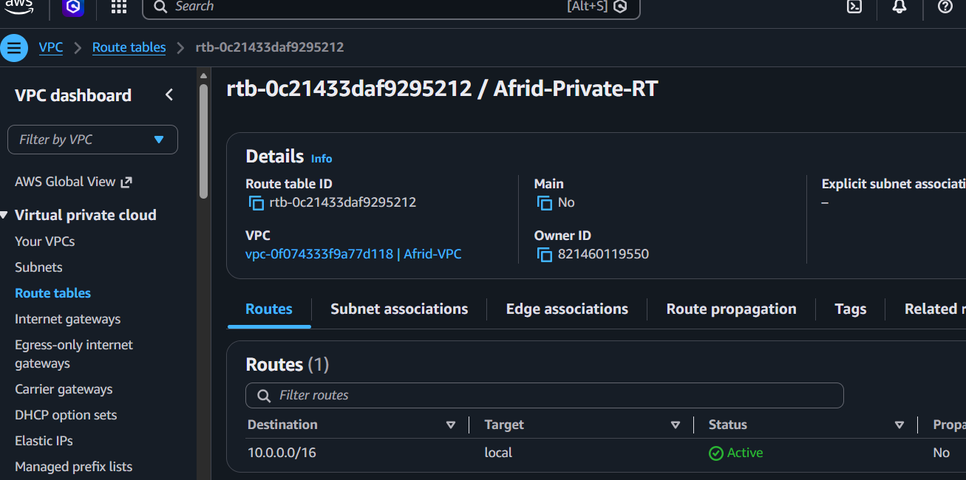
- Deploy a NAT gateway in the public subnet and attach the NAT gateway to the private subnet.

Objective
Create a NAT Gateway in the public subnet to allow resources in the private subnet to access the internet for outbound connections without assigning public IP addresses to private instances.

Configuration
- NAT Gateway Name: Afrid-NAT-GW
- Subnet: Afrid-Public-Subnet
- Connectivity Type: Public
- Elastic IP: New Elastic IP
- Private Route Table: Afrid-Private-RT

Implementation Steps

1. Allocate Elastic IP
- Go to AWS Console → VPC → Elastic IPs.
- Click Allocate Elastic IP address.
- Keep the network border group as us-east-1.
- Click Allocate.

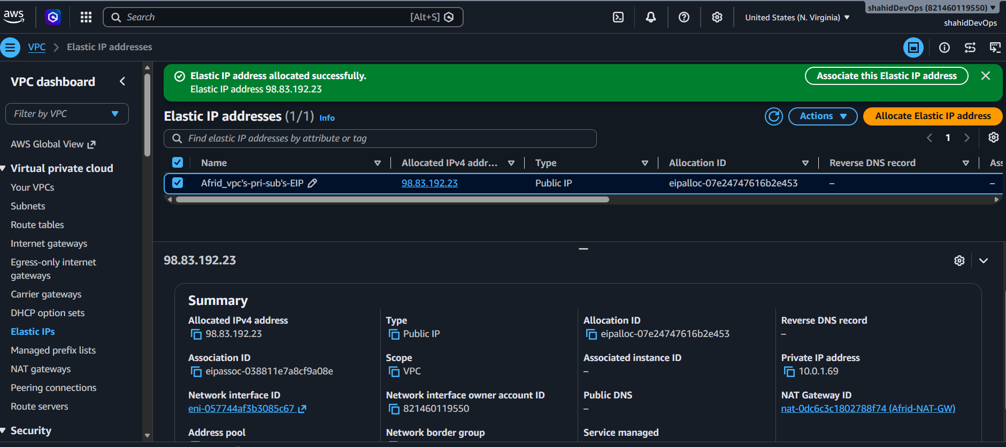

2. Create NAT Gateway
- Go to VPC → NAT Gateways.
- Click Create NAT gateway.
- Configure:
  - Name: Afrid-NAT-GW
  - Subnet: Afrid-Public-Subnet
  - Connectivity type: Public
  - Elastic IP allocation: Select the allocated Elastic IP.
- Click Create NAT gateway.
- Wait until the NAT Gateway status becomes Available.

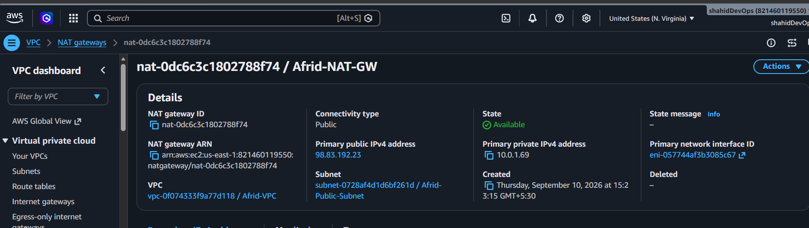

3. Update Private Route Table
- Go to VPC → Route Tables.
- Select Afrid-Private-RT.
- Go to Routes → Edit routes.
- Add:
Destination: 0.0.0.0/0
Target: NAT Gateway → Afrid-NAT-GW
- Save changes.

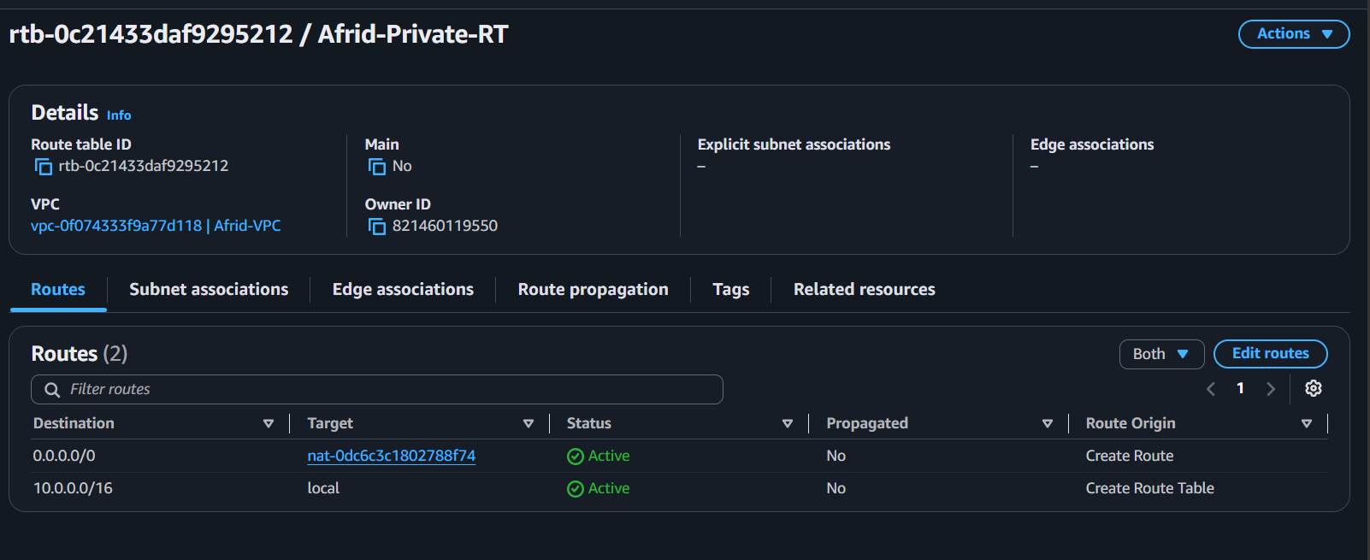

Final Routing
Public Route Table:
10.0.0.0/16 → local
0.0.0.0/0 → Afrid-IGW
Private Route Table:
10.0.0.0/16 → local
0.0.0.0/0 → Afrid-NAT-GW

Result
The private subnet can now access the internet through the NAT Gateway:
Private EC2
↓
Private Route Table
↓
NAT Gateway
↓
Internet Gateway
↓
Internet
The NAT Gateway must be in the public subnet, while the private subnet uses it through its route table.

- Create two instances, one in the public subnet and one in the private subnet.

Objective
Launch two EC2 instances inside Afrid-VPC: one in the public subnet and one in the private subnet.

Configuration
Resource | Public EC2 | Private EC2
Name | Afrid-Public-EC2 | Afrid-Private-EC2
AMI | Amazon Linux 2023 | Amazon Linux 2023
Instance Type | t3.micro | t3.micro
VPC | Afrid-VPC | Afrid-VPC
Subnet | Afrid-Public-Subnet | Afrid-Private-Subnet
Public IP | Enable | Disable
Key Pair | Create/Select existing | Same Key Pair

Security Groups

Public Security Group
Name: Afrid-Public-SG
Type | Port | Source
SSH | 22 | My IP
HTTP | 80 | Anywhere (0.0.0.0/0)

Private Security Group
Name: Afrid-Private-SG
Type | Port | Source
HTTP | 80 | 10.0.0.0/16
SSH is not opened to the internet because the private instance has no public IP.

Implementation Steps

Launch Public EC2
- Open EC2 → Instances.
- Click Launch Instance.
- Enter name: Afrid-Public-EC2.
- Select Amazon Linux 2023.
- Choose instance type t3.micro.
- Select VPC: Afrid-VPC.
- Select subnet: Afrid-Public-Subnet.
- Enable Auto-assign Public IP.
- Attach Afrid-Public-SG.
- Select key pair and launch the instance.

Launch Private EC2
- Click Launch Instance again.
- Enter name: Afrid-Private-EC2.
- Select Amazon Linux 2023.
- Choose instance type t3.micro.
- Select VPC: Afrid-VPC.
- Select subnet: Afrid-Private-Subnet.
- Disable Auto-assign Public IP.
- Attach Afrid-Private-SG.
- Select the same key pair and launch the instance.

Result
Afrid-VPC
│
├── Public Subnet
│ └── Afrid-Public-EC2
│ Public IP Enabled
│
└── Private Subnet
└── Afrid-Private-EC2
Public IP Disabled
The public instance is accessible from the internet through the Internet Gateway, while the private instance remains isolated and will use the NAT Gateway for outbound internet access.

Ec2-instance in {Public-subnet}:
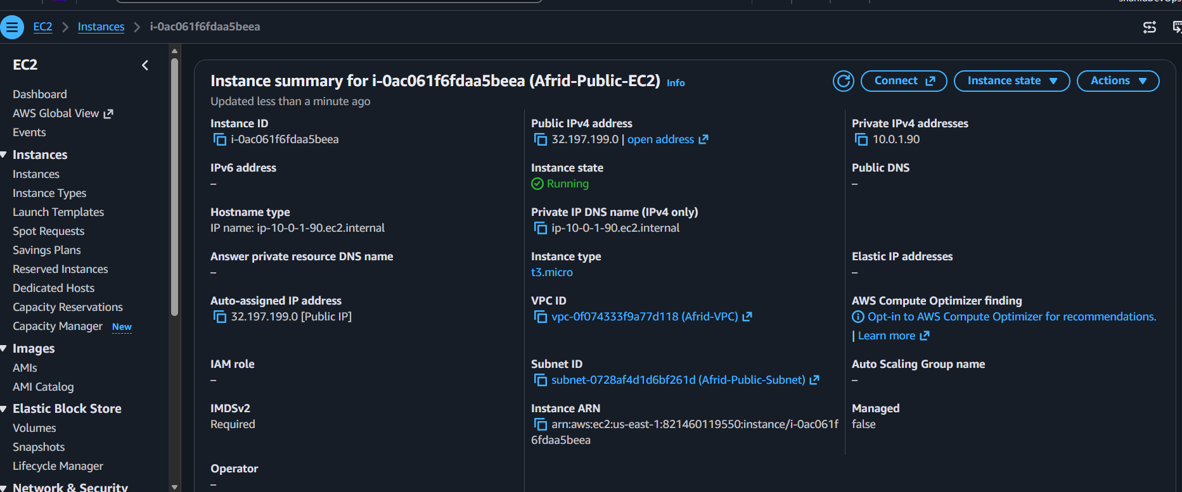
Ec2-instance in {private-subnet}:
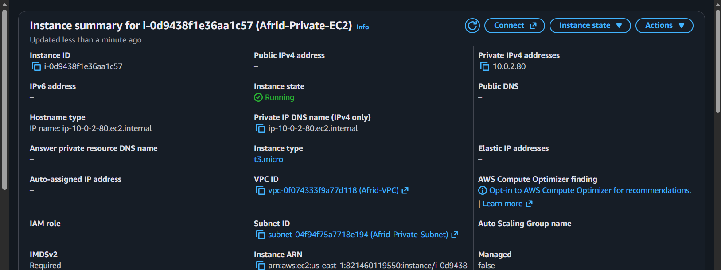

- Deploy Apache server on both EC2 instances with a sample index.html file.

Objective
Install and configure the Apache HTTP Server on both EC2 instances and create a sample index.html file to verify that the web servers are working.

1. Public EC2 — Afrid-Public-EC2
Connect to the public EC2:
ssh -i IAM_EBS_EC2-key.pem ec2-user@<PUBLIC-IP>
Install Apache:
sudo dnf install httpd -y
Start Apache and enable it at boot:
sudo systemctl enable --now httpd
Check the service:
sudo systemctl status httpd
Create the sample webpage:
sudo tee /var/www/html/index.html > /dev/null <<'EOF'
<html>
<head><title>Afrid Public Server</title></head>
<body>
<h1>Hello from Public EC2</h1>
<p>Apache is running on the public server.</p>
</body>
</html>
EOF
Test locally:
curl http://localhost
The public server can also be tested from a browser using its public IPv4 address:
http://<PUBLIC-EC2-PUBLIC-IP>

2. Private EC2 — Afrid-Private-EC2
The private EC2 has no public IP, so it cannot be accessed directly from the internet.
Connect through the public EC2:
Laptop
↓
Public EC2
↓
Private EC2
From the public EC2:
ssh -i IAM_EBS_EC2-key.pem ec2-user@10.0.2.80
Install Apache:
sudo dnf install httpd -y
Start and enable Apache:
sudo systemctl enable --now httpd
Check the service:
sudo systemctl status httpd
Create the sample webpage:
sudo tee /var/www/html/index.html > /dev/null <<'EOF'
<html>
<head><title>Afrid Private Server</title></head>
<body>
<h1>Hello from Private EC2</h1>
<p>Apache is running on the private server.</p>
</body>
</html>
EOF
Test Apache:
curl http://localhost
You can also test the private EC2 from the public EC2:
curl http://10.0.2.80

Important
The private EC2 cannot be opened directly in your laptop browser using:
http://10.0.2.80
because 10.0.2.80 is a private IP.
Later, the Application Load Balancer will provide browser access to the private EC2.

Final Result
Afrid-VPC
│
┌──────────┴──────────┐
│ │
Public Subnet Private Subnet
10.0.1.0/24 10.0.2.0/24
│ │
Afrid-Public-EC2 Afrid-Private-EC2
│ │
Apache Apache
│ │
index.html index.html
Both EC2 instances now have Apache installed, running, and serving a sample webpage.

Apache in public ec2:
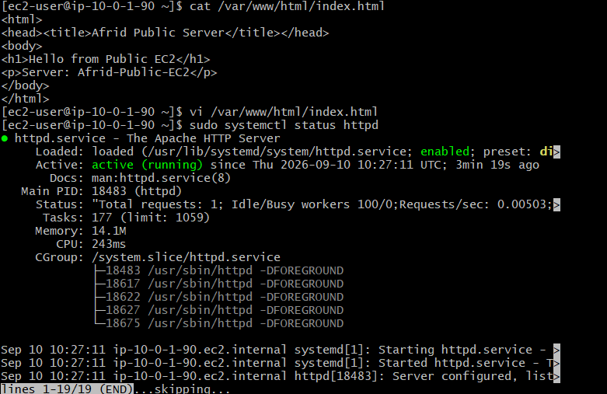
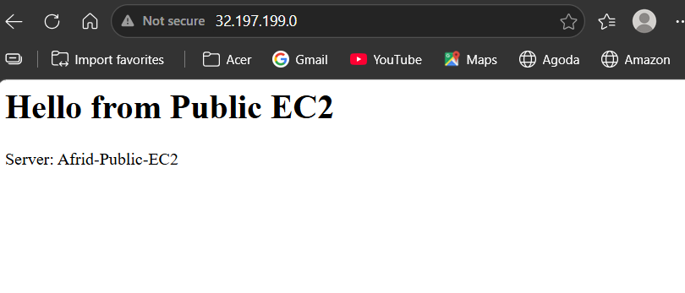

Apache in private ec2:
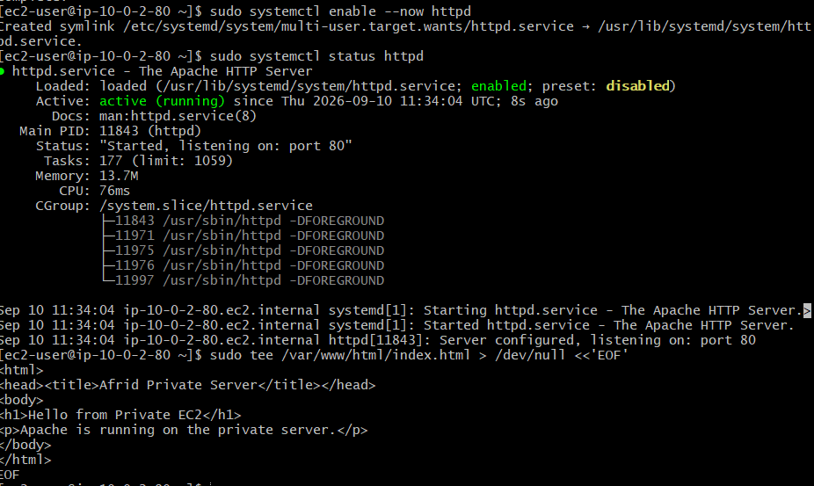
We can’t check from browser so from public ec2 culr it:
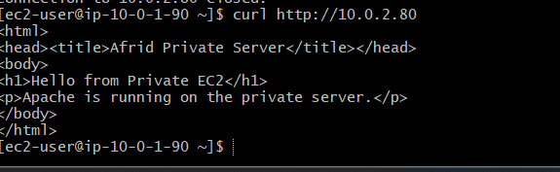
- Create one application load balancer and attach it to both EC2 instances.

Objective
Create an Application Load Balancer to receive HTTP requests and distribute traffic between the two Apache EC2 instances.

Configuration
Setting | Value
Name | Afrid-ALB
Type | Application Load Balancer
Scheme | Internet-facing
IP Address Type | IPv4
VPC | Afrid-VPC
Target Group | Afrid-TG
Protocol | HTTP
Port | 80

1. Create Target Group
- Go to EC2 → Target Groups.
- Click Create target group.
- Select Instances as the target type.
- Enter:
  - Name: Afrid-TG
  - Protocol: HTTP
  - Port: 80
  - VPC: Afrid-VPC
- Configure health check:
  - Protocol: HTTP
  - Path: /
- Register:
  - Afrid-Public-EC2
  - Afrid-Private-EC2
- Create the target group.

2. Create Application Load Balancer
- Go to EC2 → Load Balancers.
- Click Create Load Balancer.
- Select Application Load Balancer.
- Configure:
  - Name: Afrid-ALB
  - Scheme: Internet-facing
  - IP address type: IPv4
  - VPC: Afrid-VPC

3. Configure Network Mapping
Select the two public subnets:
Afrid-Public-Subnet → us-east-1a
Afrid-Public-Subnet-2 → us-east-1b
Both subnets use Afrid-Public-RT.

4. Configure Security Group
Create:
Afrid-ALB-SG
Inbound rules:
HTTP → TCP 80 → 0.0.0.0/0
HTTPS → TCP 443 → 0.0.0.0/0

5. Configure Listener
Create an HTTP listener:
Protocol: HTTP
Port: 80
Default action: Forward to Afrid-TG
The listener forwards 100% of the traffic to Afrid-TG.

6. Verify Target Health
Target group status:
Afrid-Public-EC2 → Healthy
Afrid-Private-EC2 → Healthy

Architecture
Internet
│
↓
Afrid-ALB
HTTP : 80
│
↓
Afrid-TG
/ \
↓ ↓
Public EC2 Private EC2
Apache Apache
10.0.1.x 10.0.2.80

Result
The Application Load Balancer is configured and distributes incoming HTTP traffic to both Apache EC2 instances through the Afrid-TG target group. Both registered targets are Healthy.

Target group:
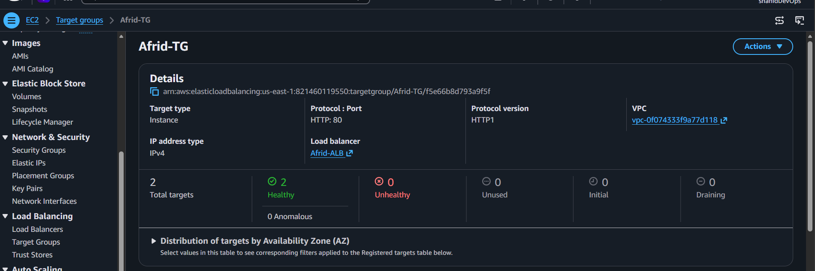
ALB:
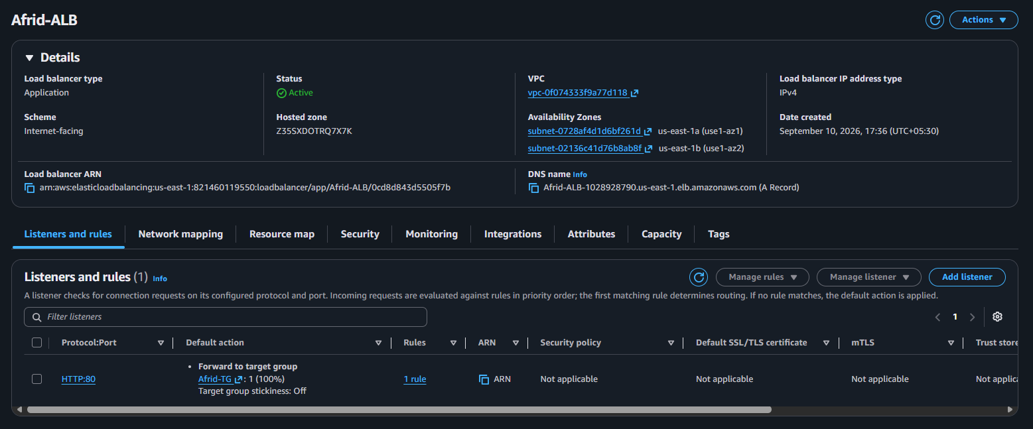

- Store application load balancer logs in S3.

Objective
Enable Application Load Balancer access logging and store the generated logs in an Amazon S3 bucket for monitoring, troubleshooting, and analysis.

Configuration
Resource | Name / Value
Load Balancer | Afrid-ALB
S3 Bucket | afrid-alb-logs-2026
Log Type | Access Logs
Region | us-east-1
Log Format | .log.gz

1. Create S3 Bucket
- Go to Amazon S3 → Buckets.
- Click Create bucket.
- Enter bucket name:
afrid-alb-logs-2026
- Select region:
US East (N. Virginia) — us-east-1
- Keep Block all public access enabled.
- Keep the default encryption settings.
- Click Create bucket.

2. Configure S3 Bucket Policy
The ALB requires permission to write access logs to the S3 bucket.
Go to:
S3 → afrid-alb-logs-2026 → Permissions → Bucket policy
Add a policy allowing the ELB log delivery service to write objects:
{
"Version": "2012-10-17",
"Statement": [
{
"Sid": "AllowALBLogDelivery",
"Effect": "Allow",
"Principal": {
"Service": "logdelivery.elasticloadbalancing.amazonaws.com"
},
"Action": "s3:PutObject",
"Resource": "arn:aws:s3:::afrid-alb-logs-2026/AWSLogs/821460119550/*"
}
]
}

3. Enable ALB Access Logs
- Go to EC2 → Load Balancers.
- Select Afrid-ALB.
- Open Attributes.
- Click Edit.
- Under Logging → Access logs, enable access logs.
- Select S3 as the destination.
- Enter:
afrid-alb-logs-2026
- Save the changes.

4. Generate ALB Traffic
Access the ALB DNS name through a browser or use:
curl http://<ALB-DNS-NAME>
Generate multiple requests so that access log entries are created.

5. Verify Logs in S3
Go to:
S3 → afrid-alb-logs-2026
The logs are stored under a structure similar to:
AWSLogs/
└── 821460119550/
└── elasticloadbalancing/
└── us-east-1/
└── 2026/
└── 09/
└── 10/
└── *.log.gz
The .log.gz files confirm that ALB access logs are being delivered successfully.

Result
ALB access logging is enabled and the generated logs are successfully stored in the S3 bucket:
Afrid-ALB
↓
Access Logs
↓
S3
↓
afrid-alb-logs-2026
↓
AWSLogs/821460119550/elasticloadbalancing/

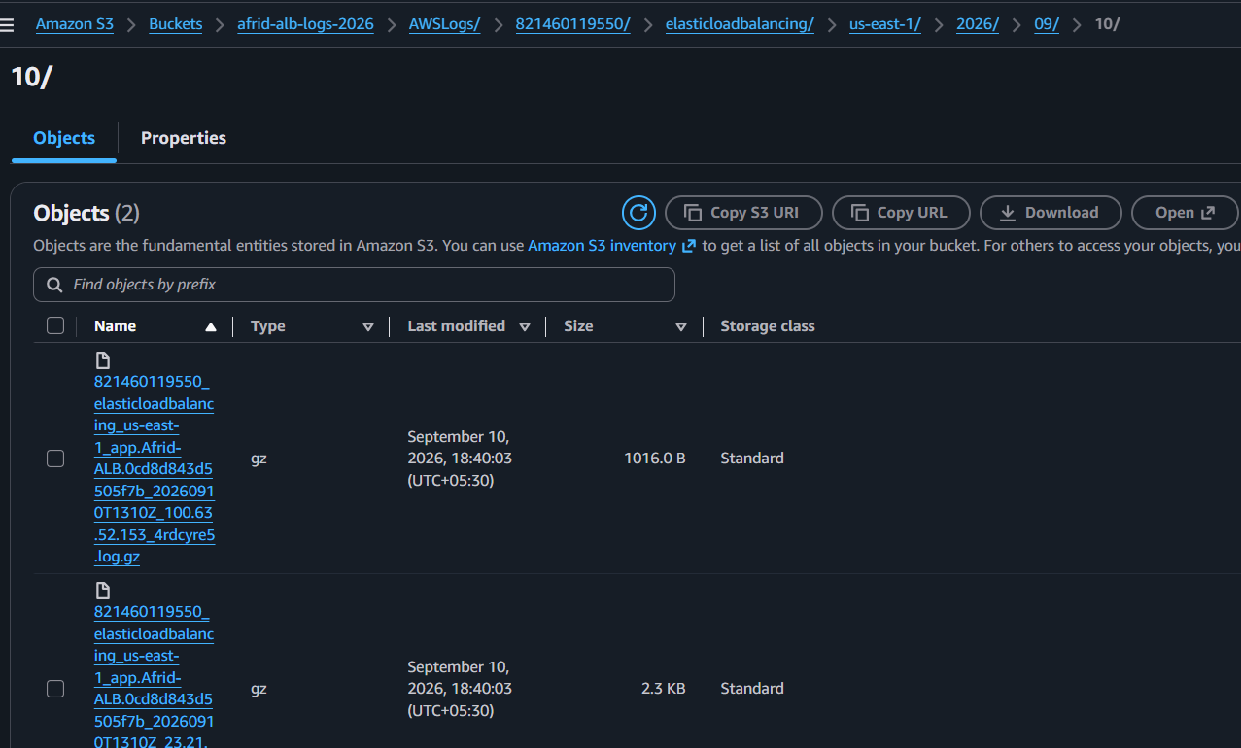

- Store the VPC flow logs in a CloudWatch log group.

Objective
To monitor and capture network traffic information from the VPC using VPC Flow Logs and store the logs in Amazon CloudWatch Logs.

Implementation
- Created CloudWatch Log Group:
  - Log Group: Afrid-VPC-FlowLogs
  - Log Class: Standard
- Created VPC Flow Log for:
  - VPC: Afrid-VPC
- Configured:
  - Destination: Send to CloudWatch Logs
  - Destination Log Group: Afrid-VPC-FlowLogs
  - Service Access: Create and use a new service role
  - Log Format: AWS default
  - Additional metadata: Not selected

Flow
Afrid-VPC
↓
VPC Flow Logs
↓
CloudWatch
↓
Afrid-VPC-FlowLogs
↓
Log Streams

Result
VPC Flow Logs were successfully enabled for Afrid-VPC and configured to send network traffic logs to the Afrid-VPC-FlowLogs CloudWatch Log Group.

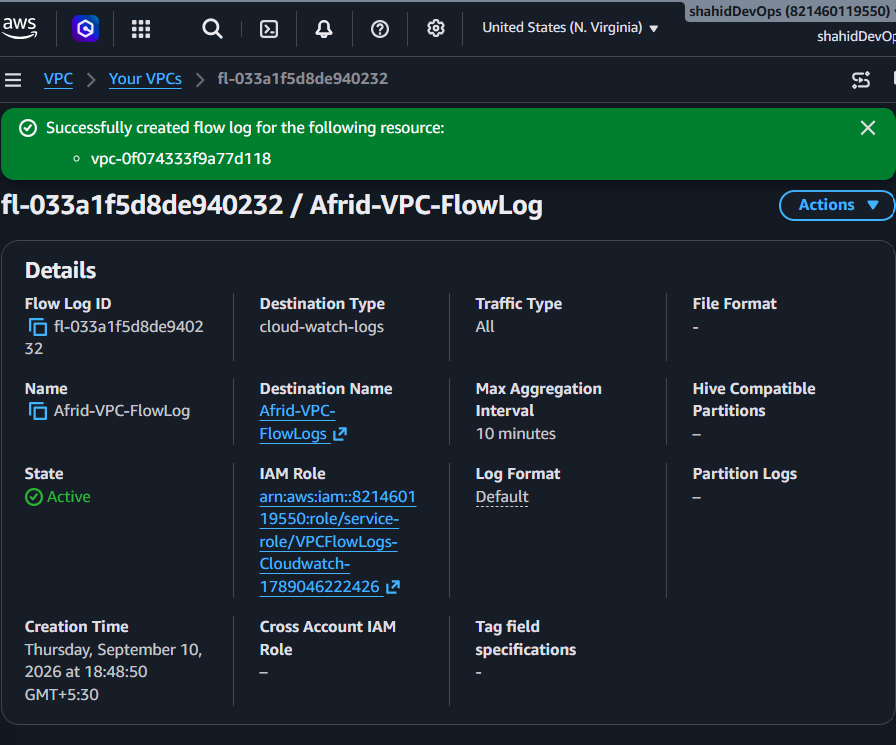

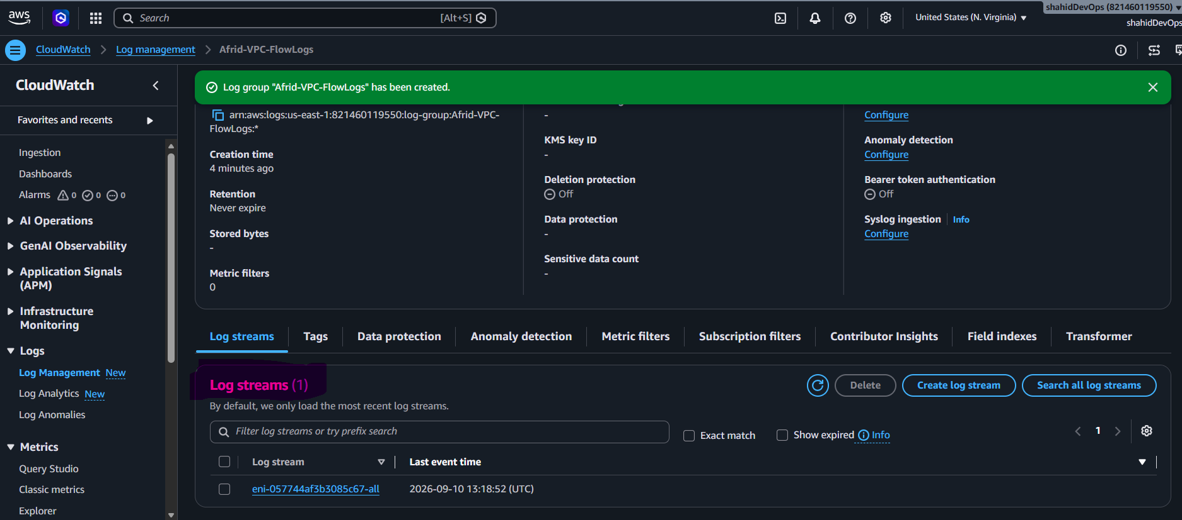

- Create monitoring dashboards to monitor CPU utilization and to monitor the Apache service.

Objective
To monitor EC2 CPU utilization and Apache (httpd) service status using Amazon CloudWatch.

Implementation

1. Created CloudWatch Dashboard
- Dashboard: Afrid-CloudWatch-Dashboard

2. Added CPU Utilization
Added the CPUUtilization metric for:
- Afrid-Public-EC2
- Afrid-Private-EC2

3. Configured Apache Monitoring
- Installed CloudWatch Agent on both EC2 instances.
- Created an IAM role:
  - Afrid-CloudWatch-Agent-Role
  - Policy: CloudWatchAgentServerPolicy
- Attached the role to both EC2 instances.
- Configured the CloudWatch Agent to monitor the httpd process.
- Custom namespace:
  - Afrid/Apache
- Metric:
  - procstat_lookup_pid_count

4. Added Apache Metrics to Dashboard
Added Apache metrics for both EC2 instances to Afrid-CloudWatch-Dashboard.

Architecture
Public EC2 ──┐
├── CloudWatch Agent ──→ Afrid/Apache
Private EC2 ─┘ │
↓
CloudWatch Dashboard
↑
CPUUtilization

Result
The dashboard successfully monitors CPU utilization and Apache process status for both EC2 instances.

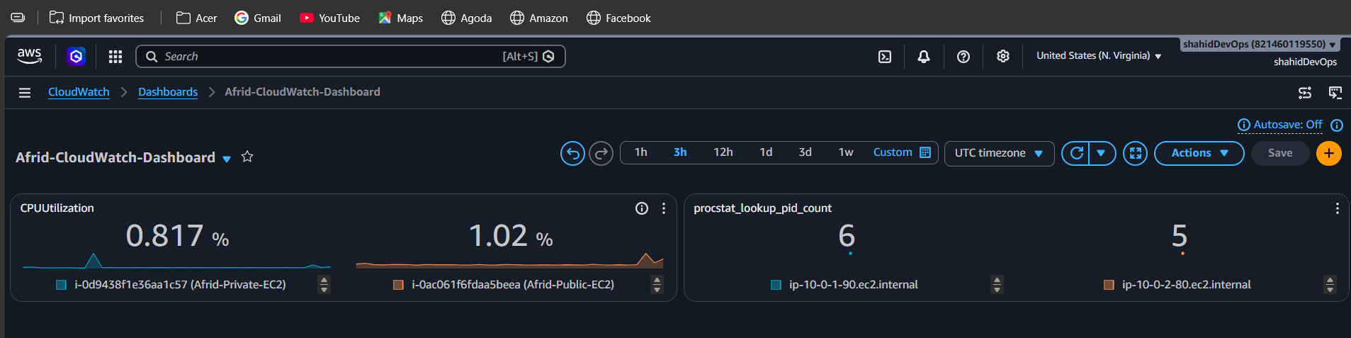

- If CPU utilization is more than 70%, then it should trigger auto scaling and launch new instance.

Objective
To automatically increase the number of EC2 instances when CPU utilization reaches the defined threshold.

Implementation

1. Created Launch Template
- Launch Template: Afrid-Launch-Template
- AMI: Amazon Linux 2023
- Instance Type: t3.micro
- Key Pair: Existing project key pair
- Security Group: Afrid-Public-SG
- Subnet was not specified in the template so the Auto Scaling Group can select the required subnets.

2. Created Auto Scaling Group
- ASG Name: Afrid-ASG
- VPC: Afrid-VPC
- Subnets:
  - Afrid-Public-Subnet – us-east-1a
  - Afrid-Public-Subnet-2 – us-east-1b

3. Load Balancer Integration
Attached the existing:
- ALB: Afrid-ALB
- Target Group: Afrid-TG
Enabled Elastic Load Balancing health checks.

4. Scaling Configuration
Setting | Value
Desired Capacity | 1
Minimum Capacity | 1
Maximum Capacity | 2
Scaling Policy | Target Tracking
Metric | Average CPU Utilization
Target Value | 70%

Architecture
EC2 CPU Utilization
↓
CloudWatch
↓
CPU Target: 70%
↓
Afrid-ASG
↓
Scale Out
↓
New EC2 Instance
↓
Afrid-TG
↓
Afrid-ALB

Result
An Auto Scaling Group was successfully configured to maintain 1–2 EC2 instances and automatically scale based on average CPU utilization of 70%, with instances integrated into the existing Application Load Balancer.

