VPC-CHALLENGE -01/09/2026

Use Case: Setting up Transit Gateway and VPC Endpoints for a Multi-VPC Architecture
Scenario:
A large organization is migrating its on-premises infrastructure to the AWS cloud.
The organization's architecture involves multiple VPCs for different departments and applications, each requiring secure communication with centralized services and external resources.
The IT team needs to design and implement a scalable and efficient network architecture to accommodate the organization's growth and ensure robust connectivity between VPCs and external services.
1.Objectives:
- Design and deploy a scalable network architecture using AWS Transit Gateway to simplify network connectivity between multiple VPCs.
The objective of this task was to design and implement a scalable Multi-VPC network architecture using AWS Transit Gateway.
The goal was to:
- Connect multiple VPCs through a central Transit Gateway.
- Avoid complex multiple VPC peering connections.
- Enable secure communication between EC2 instances in different VPCs.
- Configure route tables for proper traffic flow.
- Verify connectivity using CLI commands.

2. Required Solution
The organization has multiple departments and applications that require communication across different VPCs.
Instead of creating multiple VPC Peering connections, AWS Transit Gateway was used as a central network hub.

VPCs Used
VPC | Department | CIDR
VPC-A-Engineering | Engineering | 10.0.0.0/16
VPC-B-HR | HR | 10.1.0.0/16
VPC-C-Finance | Finance | 10.2.0.0/16
VPC-D-CentralServices | Central Services | 10.3.0.0/16
Each VPC was connected directly to:
Multi-VPC-TGW

3. Architecture
AWS CLOUD

┌─────────────────┐
│ TRANSIT GATEWAY │
│ Multi-VPC-TGW │
└────────┬────────┘
│
┌─────────────────┼─────────────────┐
│ │ │
│ │ │
┌────▼────┐ ┌────▼────┐ ┌────▼────┐
│ VPC-A │ │ VPC-B │ │ VPC-C │
│10.0/16 │ │10.1/16 │ │10.2/16 │
│ EC2 │ │ EC2 │ │ EC2 │
└─────────┘ └─────────┘ └─────────┘

│
┌────▼────┐
│ VPC-D │
│10.3/16 │
│ EC2 │
└─────────┘

4. Network Plan

VPC and Subnet Details
VPC | VPC CIDR | Subnet | Subnet CIDR
VPC-A-Engineering | 10.0.0.0/16 | Subnet-A-Engineering | 10.0.1.0/24
VPC-B-HR | 10.1.0.0/16 | Subnet-B-HR | 10.1.1.0/24
VPC-C-Finance | 10.2.0.0/16 | Subnet-C-Finance | 10.2.1.0/24
VPC-D-CentralServices | 10.3.0.0/16 | Subnet-D-CentralServices | 10.3.1.0/24
All CIDR ranges are non-overlapping, which is required for proper routing through Transit Gateway.

5. Plan of Flow
The traffic flow between VPCs is:
Source EC2
↓
Source Subnet
↓
Source VPC Route Table
↓
Transit Gateway
↓
Transit Gateway Route Table
↓
Destination VPC Attachment
↓
Destination VPC
↓
Destination EC2

Example
When EC2-A communicates with EC2-C:
EC2-A
10.0.1.222
↓
RT-A-Engineering
Destination: 10.2.0.0/16
Target: Multi-VPC-TGW
↓
Transit Gateway
↓
TGW Route Table
Finds: 10.2.0.0/16
↓
VPC-C Attachment
↓
VPC-C
↓
EC2-C
10.2.1.75
The response follows the reverse path.

6. Implementation Steps

Step 1: Created Four VPCs
Four separate VPCs were created for different departments.
VPC-A-Engineering → 10.0.0.0/16

VPC-B-HR → 10.1.0.0/16

VPC-C-Finance → 10.2.0.0/16

VPC-D-CentralServices → 10.3.0.0/16

Step 2: Created Subnets
One subnet was created inside each VPC.
Subnet-A-Engineering → 10.0.1.0/24

Subnet-B-HR → 10.1.1.0/24

Subnet-C-Finance → 10.2.1.0/24

Subnet-D-CentralServices → 10.3.1.0/24

Step 3: Created Route Tables
A dedicated route table was created for each VPC.
RT-A-Engineering

RT-B-HR

RT-C-Finance

RT-D-CentralServices
Each subnet was associated with its corresponding route table.
Subnet-A → RT-A
Subnet-B → RT-B
Subnet-C → RT-C
Subnet-D → RT-D

7. Created the Transit Gateway
A Transit Gateway was created with the following details:
Name: Multi-VPC-TGW

Description:
Central Transit Gateway for Multi-VPC Architecture
The following settings were enabled:
Default Route Table Association: Enabled

Default Route Table Propagation: Enabled
This allows VPC attachment routes to automatically propagate to the default Transit Gateway route table.

8. Created Transit Gateway Attachments
Each VPC was attached to the Transit Gateway.
TGW-Attachment-A-Engineering
↓
VPC-A-Engineering

TGW-Attachment-B-HR
↓
VPC-B-HR

TGW-Attachment-C-Finance
↓
VPC-C-Finance

TGW-Attachment-D-CentralServices
↓
VPC-D-CentralServices
Therefore:
VPC-A ──┐
VPC-B ──┤
VPC-C ──┼── Multi-VPC-TGW
VPC-D ──┘

9. Configured VPC Route Tables
The VPC route tables were configured to send traffic for other VPC CIDRs to the Transit Gateway.

RT-A-Engineering
10.0.0.0/16 → Local

10.1.0.0/16 → Multi-VPC-TGW
10.2.0.0/16 → Multi-VPC-TGW
10.3.0.0/16 → Multi-VPC-TGW

RT-B-HR
10.1.0.0/16 → Local

10.0.0.0/16 → Multi-VPC-TGW
10.2.0.0/16 → Multi-VPC-TGW
10.3.0.0/16 → Multi-VPC-TGW

RT-C-Finance
10.2.0.0/16 → Local

10.0.0.0/16 → Multi-VPC-TGW
10.1.0.0/16 → Multi-VPC-TGW
10.3.0.0/16 → Multi-VPC-TGW

RT-D-CentralServices
10.3.0.0/16 → Local

10.0.0.0/16 → Multi-VPC-TGW
10.1.0.0/16 → Multi-VPC-TGW
10.2.0.0/16 → Multi-VPC-TGW

10. Transit Gateway Route Propagation
The Transit Gateway route table automatically received propagated routes from all four VPC attachments.
The TGW Route Table contained:
10.0.0.0/16 → VPC-A Attachment

10.1.0.0/16 → VPC-B Attachment

10.2.0.0/16 → VPC-C Attachment

10.3.0.0/16 → VPC-D Attachment
All routes were:
Route Type: Propagated
Route State: Active
This confirmed that the Transit Gateway knew how to reach all four VPC networks.

11. Internet Gateways
Internet Gateways were created and attached to each VPC.
IGW-A-Engineering → VPC-A

IGW-B-HR → VPC-B

IGW-C-Finance → VPC-C

IGW-D-CentralServices → VPC-D
Routes were added:
0.0.0.0/0 → Corresponding Internet Gateway

Purpose
The Internet Gateways were used to allow SSH access to the EC2 instances from the local machine.
They were not required for Transit Gateway communication.

12. Created Security Groups
Four Security Groups were created.
SG-A-Engineering

SG-B-HR

SG-C-Finance

SG-D-CentralServices
The following inbound rules were configured:

SSH
Type: SSH
Protocol: TCP
Port: 22
Source: My IP
This allowed SSH access from the local machine.

ICMP
Type: All ICMP - IPv4
Source: 10.0.0.0/8
This allowed ping communication between the lab VPCs.

13. Launched EC2 Instances
One EC2 instance was launched inside each VPC.
Instance | VPC | Private IP
EC2-A-Engineering | VPC-A | 10.0.1.222
EC2-B-HR | VPC-B | 10.1.1.79
EC2-C-Finance | VPC-C | 10.2.1.75
EC2-D-CentralServices | VPC-D | 10.3.1.43
Each instance used:
Amazon Linux 2023
Existing .pem Key Pair
Corresponding Security Group
Public IP enabled

14. Connectivity Testing Using CLI
SSH was used to connect to EC2-A:
ssh -i servers-key.pem ec2-user@<EC2-A-Public-IP>
Once connected to EC2-A, connectivity was tested using private IP addresses.

Test VPC-A → VPC-B
ping -c 4 10.1.1.79
Result:
4 packets transmitted
4 received
0% packet loss

Test VPC-A → VPC-C
ping -c 4 10.2.1.75
Result:
4 packets transmitted
4 received
0% packet loss

Test VPC-A → VPC-D
ping -c 4 10.3.1.43
Result:
4 packets transmitted
4 received
0% packet loss

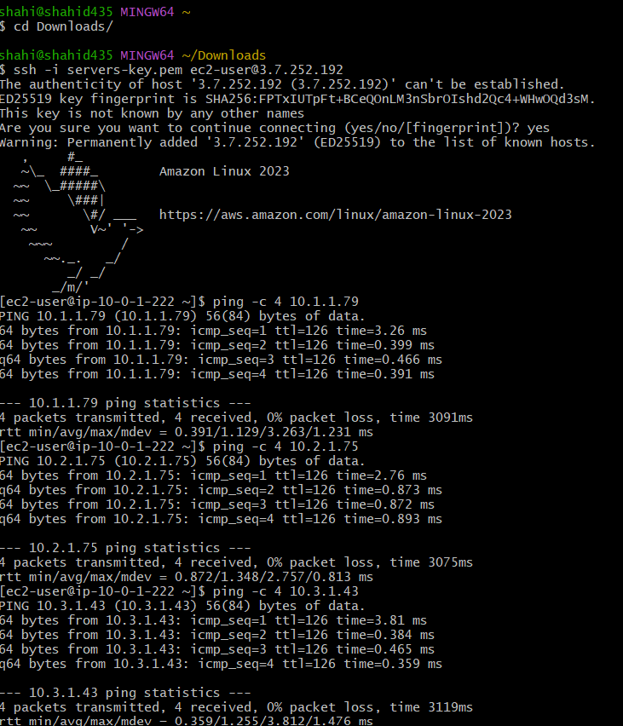

If we want we can check
BA,C,D
CA,B,D
DA,B,C

15. Result
The Transit Gateway implementation was successfully completed.
The following was verified:
✅ Four VPCs were created with non-overlapping CIDR ranges.
✅ Each VPC was attached to the AWS Transit Gateway.
✅ VPC route tables were configured to send inter-VPC traffic to the Transit Gateway.
✅ The Transit Gateway route table contained propagated routes for all four VPCs.
✅ Four EC2 instances were deployed.
✅ Security Groups allowed ICMP communication between the VPCs.
✅ Connectivity was successfully tested using CLI.

Final Connectivity Result
From:
EC2-A
10.0.1.222
Successful communication was established with:
EC2-B
10.1.1.79
→ 0% Packet Loss

EC2-C
10.2.1.75
→ 0% Packet Loss

EC2-D
10.3.1.43
→ 0% Packet Loss

Conclusion
AWS Transit Gateway successfully provided a centralized and scalable network architecture for connecting multiple VPCs.
Instead of creating multiple VPC Peering connections, each VPC was attached to a single Transit Gateway.
The architecture successfully enabled:
VPC-to-VPC Connectivity
+
Centralized Routing
+
Scalability
+
Simplified Network Management
The CLI connectivity tests confirmed successful communication between the different VPCs through the Transit Gateway.

- Configure VPC endpoints to securely access AWS services without internet gateways or NAT gateways, ensuring data privacy and minimizing exposure to external threats.

Objective
Configure an S3 Gateway VPC Endpoint to allow secure S3 access from an EC2 instance without using a NAT Gateway or Internet Gateway for S3 traffic.

Required Solution
EC2-A → Route Table → S3 Gateway Endpoint → Amazon S3

Implementation Steps
- Created an S3 bucket:
multivpc-s3-endpoint-afrid-2026

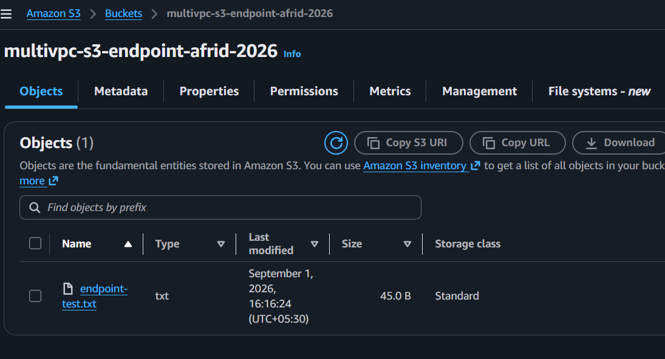

- Created IAM Role:
EC2-S3-Endpoint-Role
Attached AmazonS3FullAccess.
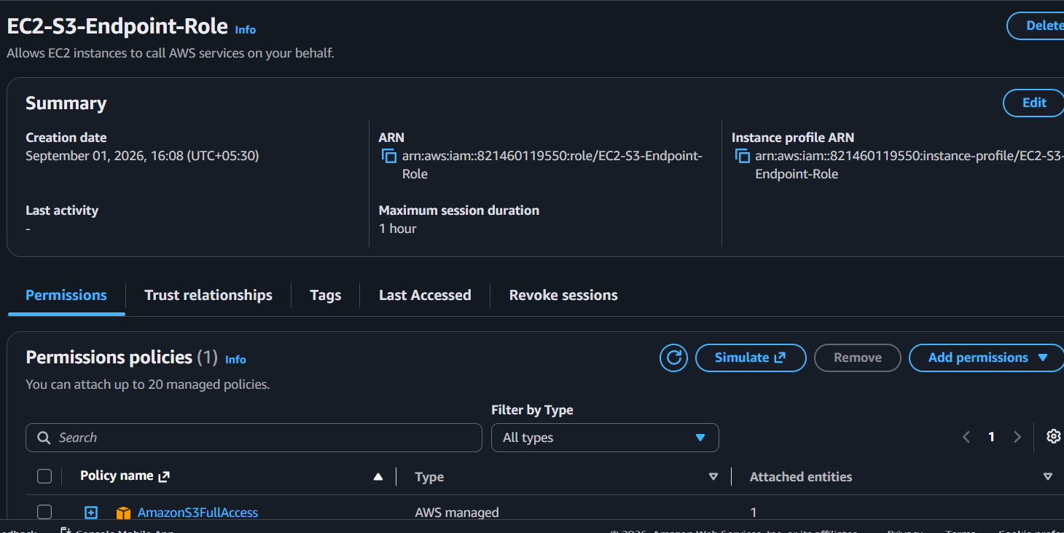

- Attached the IAM Role to EC2-A-Engineering.
- Created a VPC Endpoint:
- Service: com.amazonaws.ap-south-1.s3
- Type: Gateway
- VPC: VPC-A-Engineering
Route Table: RT-A-Engineering
- Verified the S3 Prefix List route was automatically added to the route table.

Testing
Verified IAM role:
aws sts get-caller-identity
Verified S3 access:
aws s3 ls
Created and uploaded a test file:
echo "S3 VPC Endpoint connectivity test successful" > endpoint-test.txt

aws s3 cp endpoint-test.txt s3://multivpc-s3-endpoint-afrid-2026/

aws s3 ls s3://multivpc-s3-endpoint-afrid-2026/
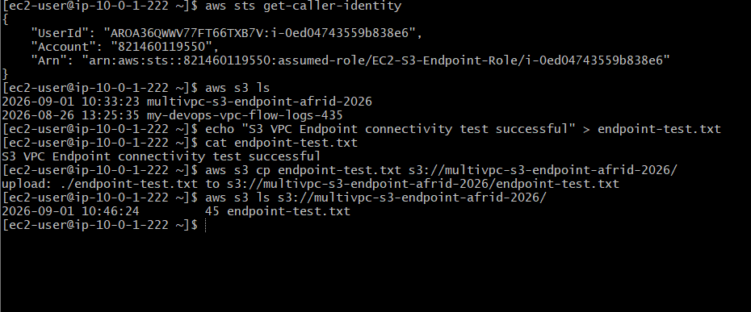

Result
The EC2 instance successfully accessed Amazon S3 and uploaded a file.
EC2-A
↓
RT-A-Engineering
↓
S3 Gateway VPC Endpoint
↓
Amazon S3
For S3 traffic:
NAT Gateway: Not used
Internet Gateway: Not used
S3 Gateway Endpoint: Used

